# Australian Commission on Safety and Quality logotypeOn the Radar

Issue 560

6 June 2022

*On the Radar* is a summary of some of the recent publications in the areas of safety and quality in health care. Inclusion in this document is not an endorsement or recommendation of any publication or provider. Access to particular documents may depend on whether they are Open Access or not, and/or your individual or institutional access to subscription sites/services. Material that may require subscription is included as it is considered relevant.

*On the Radar* is available online, via email or as a PDF or Word document from <https://www.safetyandquality.gov.au/publications-and-resources/newsletters/radar>

If you would like to receive *On the Radar* via email, you can subscribe on our website <https://www.safetyandquality.gov.au/publications-and-resources/newsletters>  
or by emailing us at H[Umail@safetyandquality.gov.auU](mailto:mail@safetyandquality.gov.au).   
You can also send feedback and comments to H[Umail@safetyandquality.gov.auU](mailto:mail@safetyandquality.gov.au).

For information about the Commission and its programs and publications, please visit <https://www.safetyandquality.gov.au>

You can also follow us on Twitter @ACSQHC.

**On the Radar**

Editor: Dr Niall Johnson [niall.johnson@safetyandquality.gov.au](mailto:niall.johnson@safetyandquality.gov.au)

Contributors: Niall Johnson

**Reports**

*Shared or brokered care: A paradigm shift for clinical governance frameworks*

Deeble Institute Perspectives Brief No. 21.

Thomson S

Canberra: Australian Healthcare and Hospitals Association; 2022. p. 29.

|  |  |
| --- | --- |
| URL | <https://ahha.asn.au/news/new-framework-ensuring-successful-models-shared-care> |
| Notes | This Perspectives Brief from the Australian Healthcare and Hospitals Association’s Deeble Institute looks at the issue of clinical governance, particularly in the context of shared or brokered care where the delivery of care may be care shared among professionals and providers across the acute public, private, community, primary care, not for profit, aged, and disability sectors. The Brief offers a framework that seeks to better support the use of shared or brokered care models. |

For information on the Commission’s work on clinical governance, including the *National Model Clinical Governance Framework*, see <https://www.safetyandquality.gov.au/our-work/clinical-governance/national-model-clinical-governance-framework>

*Integrating shared care teams into cancer follow-up care models*

Deeble Institute for Health Policy Research Issues Brief No. 46

Crawford-Williams F, Haddock R

Canberra: Australian Healthcare and Hospitals Association; 2022. p. 34.

|  |  |
| --- | --- |
| URL | <https://ahha.asn.au/publication/health-policy-issue-briefs/deeble-issues-brief-no-46-integrating-shared-care-teams> |
| Notes | This Issues brief from the Australian Healthcare and Hospitals Association’s Deeble Institute examines issues surrounding the implementation of shared care cancer follow-up models in Australia. It focuses on some of the key considerations for implementing shared care including the need to collect primary care data and link this to patient health outcomes data; mapping of the health care workforce involved in delivery to identify gaps in services; and developing national clinical governance frameworks that enable continued monitoring and quality improvement. |

*Valuing Lived Experience - Learning Report. Are you ready to commit to the work of co-production?*

Cain L

London: National Voices; 2022. p. 27.

|  |  |
| --- | --- |
| URL | <https://www.nationalvoices.org.uk/publications/our-publications/valuing-lived-experience-learning-report> |
| Notes | This report from the UK National Voices organisation stems from a Voices for Improvement project that ‘seeks to strengthen collaboration between those with lived experience and decision-makers, in the service of improving health and social care.’ The project, and this report, seek to enable people to embed strategic co production and improve healthcare services as a result.  [Image from the Valuing Lived Experience - Learning Report. Are you ready to commit to the work of co-production? report](https://www.nationalvoices.org.uk/publications/our-publications/valuing-lived-experience-learning-report) |

For information on the Commission’s work on partnering with consumers, see <https://www.safetyandquality.gov.au/our-work/partnering-consumers>

**Journal articles**

*Discharge summary medication list accuracy across five metropolitan hospitals: a retrospective medical record audit*

Wembridge P, Rashed S

Australian Health Review. 2022;46(3):338-345.

|  |  |
| --- | --- |
| DOI | <https://doi.org/10.1071/AH22012> |
| Notes | There have been various efforts to improve the accuracy, utility and timeliness of discharge summaries. This study examined the accuracy of discharge summary (DS) medication lists from a sample of 801 discharge summaries from 5 metropolitan hospitals in Australia. The review found 66% had one or more medication errors and 27% had one or more high-risk medication errors. Further, ‘A higher proportion of patients with polypharmacy (five or more medications) had one or more errors compared to patients without polypharmacy (67% vs 54%, P < 0.01).’ |

For information on the Commission’s work on electronic discharge summary (EDS) systems, including the 2017 *National Guidelines for On-Screen Presentation of Discharge Summaries*, see <https://www.safetyandquality.gov.au/our-work/e-health-safety/electronic-discharge-summary-eds-systems>

For information on the Commission’s work on medication safety, see <https://www.safetyandquality.gov.au/our-work/medication-safety>

*Persistent opioid use after hospital discharge in Australia: a systematic review*

Suckling B, Pattullo C, Liu S, James P, Donovan P, Patanwala A, et al.

Australian Health Review. 2022;46(3):367-380.

|  |  |
| --- | --- |
| DOI | <https://doi.org/10.1071/AH21353> |
| Notes | The use (and misuse) of opioids has become a critical issue in some nations. This paper reports on a systematic review that sough to identify studies to inform an estimate of persistent opioid use following patient discharge from hospital settings in Australia. The review focused on 13 publications and found that these were heterogeneous. The authors report that ‘Persistent opioid use among surgical patients generally ranged from 3.9 to 10.5% at between 2 and 4 months after discharge.’ |

For information on the Commission’s *Opioid Analgesic Stewardship in Acute Pain Clinical Care Standard*, see <https://www.safetyandquality.gov.au/standards/clinical-care-standards/opioid-analgesic-stewardship-acute-pain-clinical-care-standard>

*Association of Inappropriate Outpatient Pediatric Antibiotic Prescriptions With Adverse Drug Events and Health Care Expenditures*

Butler AM, Brown DS, Durkin MJ, Sahrmann JM, Nickel KB, O’Neil CA, et al

JAMA Network Open. 2022;5(5) e2214153-e2214153.

|  |  |
| --- | --- |
| DOI | <https://doi.org/10.1001/jamanetworkopen.2022.14153> |
| Notes | In recent years there has been interest in the appropriate or otherwise use of antimicrobials. Some of this concern has been driven by the spectre of antimicrobial resistance, while other issues have included risk adverse events and excess costs. This US cohort study examined more than 2.8 children (with ‘commercial insurance’ cover). The study found that children who received inappropriate or non-recommended antibiotics for common viral and bacterial infections had an increased risk of adverse side effects such as *Clostridioides difficile* infection, severe allergic reactions, and rashes. The additional medical care needed to address these adverse events resulted in roughly USD $74 million in excess healthcare costs in 2017. In the cohort, ‘31% to 36% received inappropriate antibiotics for bacterial infections and 4% to 70% for viral infections.’ |

For information on the Commission’s work on antimicrobial stewardship, see <https://www.safetyandquality.gov.au/our-work/antimicrobial-stewardship>

*Checklists to reduce diagnostic error: a systematic review of the literature using a human factors framework*

Al-Khafaji J, Townshend RF, Townsend W, Chopra V, Gupta A

BMJ Open. 2022;12(4):e058219.

|  |  |
| --- | --- |
| DOI | <https://doi.org/10.1136/bmjopen-2021-058219> |
| Notes | Checklists have been seen as a mechanism by which to address a number of safety and quality issues, for example the WHO Surgical Safety Checklist. This paper reports on a review that examined checklists designed to address diagnostic error. The study sought to apply the Systems Engineering Initiative for Patient Safety 2.0 (SEIPS 2.0) human factors framework to understand ‘whether checklists to reduce clinical diagnostic error have (1) gaps in composition; and (2) components that may be more likely to reduce errors’. Having examined 25 unique checklists, the authors report that ‘Most diagnostic checklists incorporated few human factors components’ and that checklists ‘addressing the SEIPS 2.0 Tasks subcomponent were more often associated with a reduction in diagnostic errors.’ |

*Australian Health Review*

Volume 46, Number 3, June 2022

|  |  |
| --- | --- |
| URL | <https://www.publish.csiro.au/ah/issue/10700> |
|  | A new issue of the *Australian Health Review* has been published. Articles in this issue of the *Australian Health Review* include:   * **Leading through a pandemic** (Sue Matthews) * **Federated** **health system governance in the post-COVID-19 era** (Mark Cormack) * The **role of private hospitals in responding to the COVID-19 pandemic** – focus on digital health (Martin Bowles) * **Telehealth, care access and workforce** – are the stars finally aligning? (Claire Jackson) * **Policy Reflections on digital health** (Stephen Ayre) * **Hospital design features that optimise pandemic response (**Elke Kropf and Kathryn Zeitz) * **Digital health to support primary care provision** during a global pandemic (Elizabeth Sturgiss, Jane Desborough, Sally Hall Dykgraaf, Sethunya Matenge, Garang Dut, Stephanie Davis, Lucas de Toca, Paul Kelly and Michael Kidd) * **In-house testing for COVID-19**: effects on length of stay, isolation and the need for inpatient rehabilitation (Cian Scanlon, Ryan Cheng, Evan McRobb and Murad Ibrahim) * **Digital health and precision prevention**: shifting from disease-centred care to consumer-centred health (Oliver J Canfell, Robyn Littlewood, Andrew Burton-Jones and Clair Sullivan) * **Virtual visiting in the intensive care unit**: implementation, utilisation and provider acceptance in an Australian metropolitan health service (Sing Chee Tan and Anthony Cross) * A framework for de-identification of **free-text data in electronic medical records** enabling secondary use (Louis Mercorelli, Harrison Nguyen, Nicole Gartell, Martyn Brookes, Jonathan Morris and Charmaine S Tam) * Cost-effectiveness of the **Victorian Stroke Telemedicine program** (Joosup Kim, Elise Tan, Lan Gao, Marj Moodie, Helen M Dewey, Kathleen L Bagot, Nancy Pompeani, Lauren Sheppard, Christopher F Bladin and D A Cadilhac) * **Remoteness, models of primary care and inequity**: Medicare under-expenditure in the Northern Territory (Yuejen Zhao, John Wakerman, Xiaohua Zhang, Jo Wright, M VanBruggen, R Nasir, S Duckett and P Burgess) * Use of priority and provisional approval pathways by the Australian Therapeutic Goods Administration in **approving new medicines**: a cross-sectional study (Joel Lexchin) * Navigating the Pharmaceutical Benefits Scheme: **federal versus state government funding for high-cost medicines** – a problem for public hospitals (Jeanie Misko, Barry Jenkins and Matt Rawlins) * Creating a **culture of safety and respect through professional accountability**: case study of the Ethos program across eight Australian hospitals (Kate Churruca, Antoinette Pavithra, Ryan McMullan, Rachel Urwin, Stephen Tippett, Neil Cunningham, Erwin Loh and Johanna Westbrook) * The **impact of standardised goals of care documentation on the use of cardiopulmonary resuscitation, mechanical ventilation, and intensive care unit admissions** in older patients: a retrospective observational analysis (Colette Dignam, Margaret Brown, Chris Horwood and C H Thompson) * **Implementing patient-reported outcomes into routine care**: an audit of cancer patients from two local health districts in New South Wales to understand their capabilities and preferences (Adeola Bamgboje-Ayodele, Belinda Arnold, Ivana Durcinoska, Sandra Avery, Shalini Vinod, Orlando Rincones, Tien Thomas, J Descallar, B Smith, G P Delaney and A Girgis) * **Discharge summary medication list accuracy** across five metropolitan hospitals: a retrospective medical record audit (Paul Wembridge and S Rashed) * Qualitative exploration of **Australian Muslim patients’ perceptions and experiences surrounding medication management during Ramadan** (The-Phung To, Simone E Taylor, Ayat Abdullah, Nur Abdullah, Kerry Huang, Naemah Khan, Sakinah Shirzad, Huda Elmi and Iman Zayegh) * Where to next? An exploration of patients with disability and complex needs who leave acute care hospitals via an **interim discharge pathway** (Michele M Foster, Jessica Bowley, Vivien Houston and David N Borg) * Implementation of an organisational wide approach to **improving policy documents using plain language**: a case study (Kelly Lambert, Ceinwen Johnstone, Lucia Vellar and Natalie Berg) * **Persistent opioid use after hospital discharge** in Australia: a systematic review (Benita Suckling, Champika Pattullo, Shania Liu, Prudence James, Peter Donovan, Asad Patanwala and Jonathan Penm) * Implications of **increased telehealth use on organisations providing mental health services during COVID-19** (Centaine L Snoswell, Liam J Caffery, Helen M Haydon, Annie Banbury and Anthony C Smith) * It is time to **stop blaming the pandemic** (Geetha Ranmuthugala) |

*BMJ Quality & Safety*

June 2022 Volume 31 Issue 6

|  |  |
| --- | --- |
| URL | <https://qualitysafety.bmj.com/content/31/6> |
| Notes | A new issue of *BMJ Quality & Safety* has been published. Many of the papers in this issue have been referred to in previous editions of *On the Radar* (when they were released online). Articles in this issue of *BMJ Quality & Safety* include:   * Editorial: Reaching 95%: **decision support tools are the surest way to improve diagnosis** now (Mark L Graber) * Editorial: **Mental health services: quality, safety and suicide** (Nav Kapur, Louise S Gorman, Leah Quinlivan, Roger T Webb) * Editorial: Beyond improvement skills: what do clinicians, managers, patients and others need to do to **make improvement happen**? (Graham P Martin) * Should **electronic differential diagnosis support** be used early or late in the diagnostic process? A multicentre experimental study of Isabel (Matt Sibbald, Sandra Monteiro, Jonathan Sherbino, A LoGiudice, C Friedman, G Norman) * National cross-sectional cohort study of the relationship between **quality of mental healthcare and death by suicide** (Brian Shiner, Daniel J Gottlieb, Maxwell Levis, T Peltzman, N B Riblet, S L Cornelius, C J Russ, B V Watts) * Association between **acute psychiatric bed availability in the Veterans Health Administration and veteran suicide risk**: a retrospective cohort study (Peter J Kaboli, Matthew R Augustine, Bjarni Haraldsson, Nicholas M Mohr, M Bryant Howren, Michael P Jones, Ranak Trivedi) * Determining the **skills needed by frontline NHS staff to deliver quality improvement**: findings from six case studies (David Wright, John Gabbay, Andrée Le May) * Effect of the **surgical safety checklist on provider and patient outcomes**: a systematic review (Bonnie A. Armstrong, Ilinca A. Dutescu, Lori Nemoy, Ekta Bhavsar, Diana N. Carter, K-D Ng, S Boet, P Trbovich, V Palter) |

*Journal of Patient Safety*

Volume 18, Issue 4, June2022

|  |  |
| --- | --- |
| URL | <https://journals.lww.com/journalpatientsafety/toc/2022/06000> |
|  | A new issue of the *Journal of Patient Safety* has been published. Articles in this issue of the *Journal of Patient Safety* include:   * Is **Elective Nighttime Operation** Associated With Adverse Outcomes? Analysis in Immediate Tissue Expander–Based Breast Reconstruction (Woo-Ju Kim, Jai-Kyong Pyon, Goo-Hyun Mun, Sa-Ik Bang, Byung-Joon Jeon, Kyeong-Tae Lee) * **Ultrasonic Device Complications in Endodontics**: An Analysis of Adverse Events From the Food and Drug Administration Manufacturer and User Facility Device Experience (S Craig Rhodes) * **Surgical Error Compensation Claims as a Patient Safety Indicator**: Causes and Economic Consequences in the Murcia Health System, 2002 to 2018 (Jorge Vicente-Guijarro, José Lorenzo Valencia-Martín, Carlos Fernández-Herreruela, Paulo Sousa, José Joaquín Mira Solves, Jesús María Aranaz-Andrés, SOBRINA Working Group) * **Responding to COVID-19 Through Interhospital Resource Coordination**: A Mixed-Methods Evaluation (Michael G Usher, Christopher J Tignanelli, Brian Hilliard, Zachary P Kaltenborn, Monica I Lupei, Gyorgy Simon, Surbhi Shah, Jonathan D Kirsch, G B Melton, N E Ingraham, A P J Olson, K D Baum) * Safety of High-Intensity, Low-Volume Interval Training or Continuous Aerobic **Training in Adults With Metabolic Syndrome** (Jaime Gallo-Villegas, Daniel Restrepo, Laura Pérez, Leonardo A. Castro-Valencia, Raúl Narvaez-Sanchez, Jorge Osorio, Daniel C Aguirre-Acevedo, Juan C Calderón) * In Situ Simulation for Adoption of New Technology to Improve **Sepsis Care in Rural Emergency Departments** (Emilie S Powell, William F Bond, Lisa T Barker, Kimberly Cooley, Julia Lee, Andrew L Vincent, John A Vozenilek) * **Adverse Drug Reactions at Nonelective Hospital Admission in Children and Adolescents**: Comparison of 4 Causality Assessment Methods (Martina Patrizia Neininger, Raphaela Wehr, Lisa Marie Kiesel, Antje Neubert, Wieland Kiess, Astrid Bertsche, Thilo Bertsche) * Monitoring **Preventable Adverse Events and Near Misses**: Number and Type Identified Differ Depending on Method Used (Stina Isaksson, Anneli Schwarz, Marie Rusner, Sophia Nordström, Ulrika Källman) * **Patient Preferences for Rituximab** Additional Risk Minimization Measures: Results From an International Online Survey (Kristyna Schneiderova, Nathalie Bere, Doris Irene Stenver, Sabine M J M Straus) * Eight-Year Trends in **Direct-Acting Oral Anticoagulant Dosing**, Based on Age and Kidney Function, in Patients With Atrial Fibrillation (Woldesellassie M Bezabhe, Luke R Bereznicki, Jan Radford, Barbara C Wimmer, Mohammed S Salahudeen, Gregory M Peterson) * **Root Cause Analysis** Using the Prevention and Recovery Information System for Monitoring and Analysis Method in Healthcare Facilities: A Systematic Literature Review (Babiche E J M Driesen, Mees Baartmans, Hanneke Merten, René Otten, C Walker, P W B Nanayakkara, C Wagner) * Developing and Aligning a **Safety Event Taxonomy for Inpatient Psychiatry** (Todd Barnes, Thomas Fontaine, C Bautista, J Lee, R Stanley) * Is a **High Medication Risk Score** Associated With Increased Risk of 30-Day Readmission? A Population-Based Cohort Study From CROSS-TRACKS (Trine Worm Thoegersen, Eva Aggerholm Saedder, Marianne Lisby) * “**Palliative Syringe Driver**”? A Mixed-Methods Study in Different Hospital Departments on Continuous Infusions of Sedatives and/or Opioids in End-of-Life Care (Sophie Meesters, Bettina Grüne, C Bausewein, E Schildmann) * **Critical Care Simulation Education Program** During the COVID-19 Pandemic (Evan S Leibner, Elvera L Baron, Ronak S Shah, Yoland Philpotts, Divya Sreeramoju, Yasir Jawaid, Anthony DeVivo, Samuel Acquah, Jean Hsieh, Umesh Gidwani, Andrew B Leibowitz, Daniel Katz, Roopa Kohli-Seth) * Concordance Among 10 Different **Anticholinergic Burden Scales** in At-Risk Older Populations (Ángela Tristancho-Pérez, Ángela Villalba-Moreno, María Dolores Santos-Rubio, Susana Belda-Rustarazo, Bernardo Santos-Ramos, Susana Sánchez-Fidalgo) * Impact of **Variation in Pill/Package Appearance of Drugs** on Patients’ Behavior: A Systematic Review (Blanca Lumbreras, Javier Sanz-Valero, Elsa López-Pintor) * **Adverse Event Reporting Priorities**: An Integrative Review (Maureen L Falcone, Stephanie K Van Stee, Umit Tokac, Anne F Fish) * Evaluating the Costs of **Nurse Burnout-Attributed Turnover**: A Markov Modeling Approach (K Jane Muir, Tanya N Wanchek, Jennifer M Lobo, Jessica Keim-Malpass) * A Retrospective Review of **Serious Surgical Incidents in 5 Large UK Teaching Hospitals**: A System-Based Approach (Naresh Serou, Robert D Slight, Andy K Husband, Simon P Forrest, Sarah P Slight) * Working Experience of **Managers Who Are Responsible for Promoting and Monitoring Patient Safety** in South Korea: Focusing on Small- and Medium-Sized Hospitals (Yea Seul Yoon, Won Lee, Sunjoo Kang, In Sook Kim, Seung Gyeong Jang) * Influence of Psychological Safety and Organizational Support on the **Impact of Humiliation on Trainee Well-Being** (Nital P Appelbaum, Sally A Santen, Robert A Perera, William Rothstein, Jordan B Hylton, Robin R Hemphill) * Idea of **Applying “Broken Windows Theory” to Clinical Laboratories** as a Quality Tool to Increase the Success of Proactive Risk Management Strategies (Ozlem Goruroglu Ozturk, Gulcin Daglioglu, Tamer Cevat Inal) * Relationships Between **Pediatric Safety Indicators** Across a National Sample of Pediatric Hospitals: Dispelling the Myth of the “Safest” Hospital (Carly E. Milliren, George Bailey, Dionne A. Graham, Al Ozonoff * Implementation of a **Preoperative Huddle** at a Level 1 Trauma Center (Harrison Scofield, Kari Teigen, Somer Blair, Griffin R. Rechter, Brian Webb) * Evaluation of the **Culture of Safety and Quality in Pediatric Primary Care Practices** (Sarah Oyegoke, Kristin Hittle Gigli) * Measuring What Matters at **Morbidity and Mortality Conferences**: A Scoping Review of Effectiveness Measures (Merel J Verhagen, Marit S de Vos, Andrew Smaggus, Jaap F Hamming) * **Governance for Patient Safety**: A Framework of Strategy Domains for Risk Management (Alessandra Buja, Gianfranco Damiani, Mariagiovanna Manfredi, Chiara Zampieri, Elena Dentuti, Giulia Grotto, Giuseppe Sabatelli) |

*Healthcare Policy*

Volume 17, Number 42, 2022

|  |  |
| --- | --- |
| URL | <https://www.longwoods.com/publications/healthcare-policy/26736> |
|  | A new issue of *Healthcare Policy* has been published. Articles in this issue of *Healthcare Policy* include:   * Editorial: **New Spending Programs and Old Frustrations**: Where Is the Vision? (Jason M Sutherland) * University Technology Transfer Has Failed to Improve **Access to Global Health Products** during the COVID-19 Pandemic (Matthew Herder, E Richard Gold and Srinivas Murthy) * Commentary: **University Technology Transfer** Has Made a Significant Contribution to Fighting COVID-19 while Ensuring Global Access (Ashley J Stevens) * Commentary: Fulfilling the Promise of **Global Access Licensing Principles** to Enable Equitable Access (Reshma Ramachandran) * Authors’ Response: A Status Quo of Failure: Time to Fix **University Technology Transfer** to Address Global Health (Matthew Herder, E Richard Gold and Srinivas Murthy) * Propelled by the Pandemic: Responses and Shifts in **Primary Healthcare Models for Indigenous Peoples** (Cheryl Barnabe, Stephanie Montesanti, Chris Sarin, Tyler White, Reagan Bartel, Rita Henderson, Andrea Kennedy, Adam Murry, Pamela Roach and Lynden Crowshoe) * Commentary: **Developing Relationships through Trust in Indigenous Health Research** (Richard T Oster and Patrick Lightning) * Regulating the **Safety of Health-Related Artificial Intelligence** (Michael Da Silva, Colleen M. Flood, Anna Goldenberg and Devin Singh) |

*Health Expectations*

Volume 25, Number 3, June 2022

|  |  |
| --- | --- |
| URL | <https://onlinelibrary.wiley.com/toc/13697625/2022/25/3> |
|  | A new issue of *Health Expectations* has been published. Articles in this issue of *Health Expectations* include:   * Mapping the role of **patient and public involvement during the different stages of healthcare innovation**: A scoping review (Victoria Cluley, Alexandra Ziemann, Claire Feeley, Ellinor K Olander, Shani Shamah, C Stavropoulou) * **Centredness in health care**: A systematic overview of reviews (Caroline Feldthusen, Emma Forsgren, Sara Wallström, Viktor Andersson, Noah Löfqvist, Richard Sawatzky, Joakim Öhlén, Eva J Ung) * Mapping definitions of **co-production and co-design in health and social care**: A systematic scoping review providing lessons for the future (Daniel Masterson, Kristina Areskoug Josefsson, G Robert, E Nylander, S Kjellström) * **Osteoarthritis management**: Does the pharmacist play a role in bridging the gap between what patients actually know and what they ought to know? Insights from a national online survey (Andrew J McLachlan, Peter R Carroll, David J Hunter, Tom A N Wakefield) * The **chronic disease Self-Management** Programme: A phenomenological study for empowering vulnerable patients with chronic diseases included in the EFFICHRONIC project (Dallal Fracso, Gérard Bourrel, Christian Jorgensen, Hélène Fanton, Hein Raat, Alberto Pilotto, Graham Baker, Marta M Pisano, Rosanna Ferreira, Verushka Valsecchi, Yves-Marie Pers, Agnes O Engberink) * Using financial incentives to support service **engagement of adults experiencing homelessness and mental illness**: A qualitative analysis of key stakeholder perspectives (Nadine Reid, Rebecca Brown, Cheryl Pedersen, Nicole Kozloff, Alexandra Sosnowski, Vicky Stergiopoulos) * Assessing the **experience of person-centred coordinated care of people with chronic conditions** in the Netherlands: Validation of the Dutch P3CEQ (Mieke Rijken, James Close, Juliane Menting, Manon Lette, Annerieke Stoop, Nick Zonneveld, Simone R de Bruin, Helen Lloyd, Monique Heijmans) * **Pain self-management** intervention supports successful attainment of self-selected rehabilitation goals—secondary analysis of a randomized controlled trial (Catharina Gustavsson, Lena von Koch) |

*BMJ Quality & Safety* online first articles

|  |  |
| --- | --- |
| URL | <https://qualitysafety.bmj.com/content/early/recent> |
| Notes | *BMJ Quality &Safety* has published a number of ‘online first’ articles, including:   * **Prioritising Responses Of Nurses To deteriorating patient Observations (PRONTO)**: a pragmatic cluster randomised controlled trial evaluating the effectiveness of a facilitation intervention on recognition and response to clinical deterioration (Tracey K Bucknall, Julie Considine, Gillian Harvey, Ian D Graham, Jo Rycroft-Malone, Imogen Mitchell, Bridey Saultry, Jennifer J Watts, Mohammadreza Mohebbi, Shalika Bohingamu Mudiyanselage, Mojtaba Lotfaliany, Alison Hutchinson) * **Outcome differences between surgeons performing first and subsequent** coronary artery bypass grafting procedures in a day: a retrospective comparative cohort study (Danwei Zhang, Dachuan Gu, Chenfei Rao, Heng Zhang, Xiaoting Su, Sipeng Chen, Hanping Ma, Yan Zhao, Wei Feng, Hansong Sun, Zhe Zheng) * Striving for high reliability in healthcare: a qualitative study of the **implementation of a hospital safety programme** (Leahora Rotteau, Joanne Goldman, Kaveh G. Shojania, Timothy J. Vogus, Marlys Christianson, G. Ross Baker, Paula Rowland, Maitreya Coffey) * **Addressing social determinants of health in primary care**: a quasi-experimental study using unannounced standardised patients to evaluate the impact of audit/feedback on physicians' rates of identifying and responding to social needs (Colleen Gillespie, Jeffrey A Wilhite, Kathleen Hanley, Khemraj Hardowar, Lisa Altshuler, Harriet Fisher, Barbara Porter, Andrew Wallach, Sondra Zabar) * **Nursing implications of an early warning system** implemented to reduce adverse events: a qualitative study (Emilie J Braun, Siddhartha Singh, Annie C Penlesky, Erin A Strong, Jeana M Holt, Kathlyn E Fletcher, Michael E Stadler, Ann B Nattinger, Bradley H Crotty) * Evaluation of the **NHS England evidence-based interventions programme**: a difference-in-difference analysis (Michael Anderson, Aoife Molloy, Laia Maynou, Ilias Kyriopoulos, Alistair McGuire, Elias Mossialos) |

*International Journal for Quality in Health Care* online first articles

|  |  |
| --- | --- |
| URL | <https://academic.oup.com/intqhc/advance-articles> |
| Notes | *International Journal for Quality in Health Care* has published a number of ‘online first’ articles, including:   * Time to Review **Reflective Practice**? (Terry Quilty, Lyn Murphy) * **Nosocomial COVID** - The Moral and Clinical Imperative for Worldwide Data Collection and Action (Fatima Junaid, Padmanabhan Badrinath) |

**Online resources**

*[UK] NICE Guidelines and Quality Standards*

<https://www.nice.org.uk/guidance>

The UK’s National Institute for Health and Care Excellence (NICE) has published new (or updated) guidelines and quality standards. The latest reviews or updates are:

* NICE Guideline NG216 *Social work with* ***adults experiencing complex needs***<https://www.nice.org.uk/guidance/ng216>

*[UK] NIHR Evidence alerts*

<https://evidence.nihr.ac.uk/>alerts/

The UK’s National Institute for Health Research (NIHR) has posted new evidence alerts on its site. Evidence alerts are short, accessible summaries of health and care research which is funded or supported by NIHR. This is research which could influence practice and each Alert has a message for people commissioning, providing or receiving care. The latest alerts include:

* Expensive antiseptics and sutures do not reduce the risk of **surgical infections**
* **Smoking bans in prisons** improve health and reduce medications
* Mobile app combined with face-to-face therapy helped **people with psychosis**
* Many children and teenagers are reluctant to have a **COVID-19 vaccine**
* Older adults had poorer **mental health during the pandemic** than previous reports suggest.

*[USA] Declaration to Advance Patient Safety*

<http://www.ihi.org/Engage/Initiatives/National-Steering-Committee-Patient-Safety/Pages/Declaration-to-Advance-Patient-Safety.aspx>

The Institute for Healthcare Improvement (IHI) in the USA notes that ‘In May 2022, the National Steering Committee for Patient Safety (NSC) issued the Declaration to Advance Patient Safety to urge health care leaders across the continuum of care to recommit to advancing patient and workforce safety. The NSC called for immediate action to address safety from a total systems approach, as presented in the National Action Plan to Advance Patient Safety, and implored leaders to adopt safety as a core value and foster collective action to uphold this value.’

**COVID-19 resources**

https://www.safetyandquality.gov.au/covid-19

The Australian Commission on Safety and Quality in Health Care has developed a number of resources to assist healthcare organisations, facilities and clinicians. These and other material on COVID-19 are available at <https://www.safetyandquality.gov.au/covid-19>

These resources include:

* ***OVID-19 infection prevention and control risk management*** This primer provides an overview of three widely used tools for investigating and responding to patient safety events and near misses. Tools covered in this primer include incident reporting systems, Root Cause Analysis (RCA), and Failure Modes and Effects Analysis (FMEA).   
  <https://www.safetyandquality.gov.au/publications-and-resources/resource-library/covid-19-infection-prevention-and-control-risk-management-guidance>
* ***Poster – Combined contact and droplet precautions*** <https://www.safetyandquality.gov.au/publications-and-resources/resource-library/poster-combined-contact-and-droplet-precautions>  
  [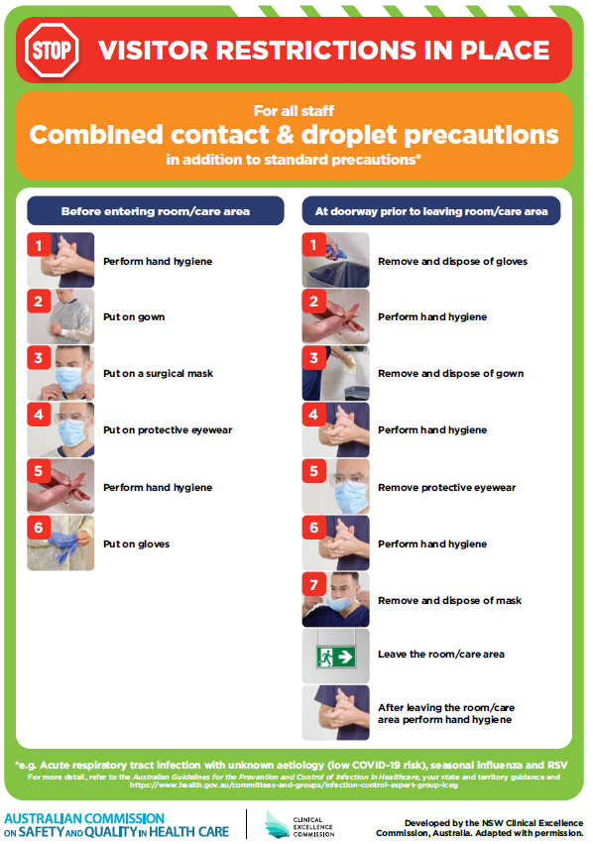](https://www.safetyandquality.gov.au/publications-and-resources/resource-library/poster-combined-contact-and-droplet-precautions)
* ***Poster – Combined airborne and contact precautions*** <https://www.safetyandquality.gov.au/publications-and-resources/resource-library/poster-combined-airborne-and-contact-precautions>   
  [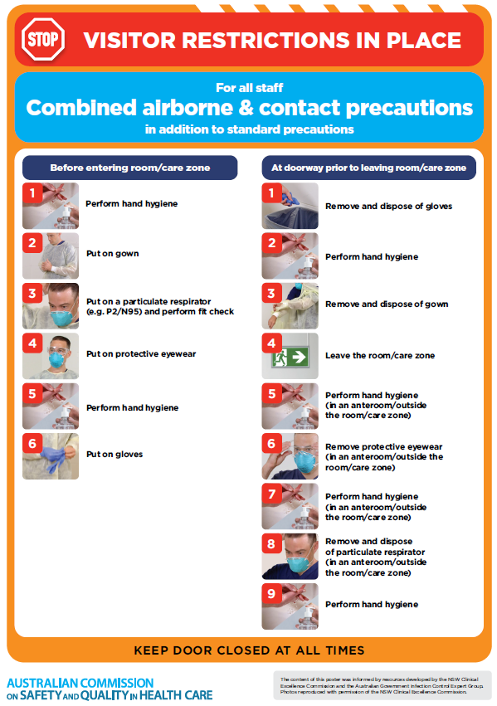](https://www.safetyandquality.gov.au/publications-and-resources/resource-library/poster-combined-airborne-and-contact-precautions)
* ***Environmental Cleaning and Infection Prevention and Control*** [www.safetyandquality.gov.au/environmental-cleaning](http://www.safetyandquality.gov.au/environmental-cleaning)
* ***COVID-19 infection prevention and control risk management – Guidance*** <https://www.safetyandquality.gov.au/publications-and-resources/resource-library/covid-19-infection-prevention-and-control-risk-management-guidance>
* ***Safe care for people with cognitive impairment during COVID-19***<https://www.safetyandquality.gov.au/our-work/cognitive-impairment/cognitive-impairment-and-covid-19>
* ***Stop COVID-19: Break the chain of infection*** posterhttps://www.safetyandquality.gov.au/publications-and-resources/resource-library/break-chain-infection-poster-a3  
  **[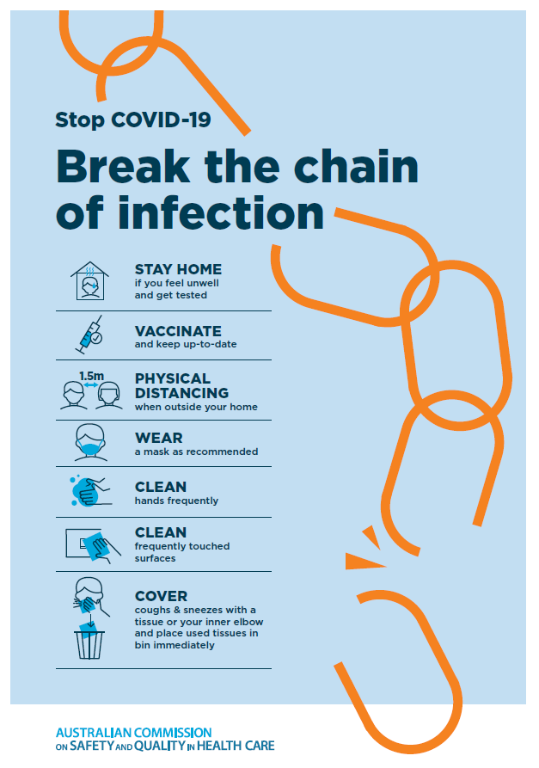](https://www.safetyandquality.gov.au/publications-and-resources/resource-library/break-chain-poster-a3https:/www.safetyandquality.gov.au/publications-and-resources/resource-library/break-chain-poster-a3)**
* ***FAQs for clinicians on elective surgery*** <https://www.safetyandquality.gov.au/node/5724>
* ***FAQs for consumers on elective surgery*** <https://www.safetyandquality.gov.au/node/5725>
* ***COVID-19 and face masks – Information for consumers*** <https://www.safetyandquality.gov.au/publications-and-resources/resource-library/covid-19-and-face-masks-information-consumers>

[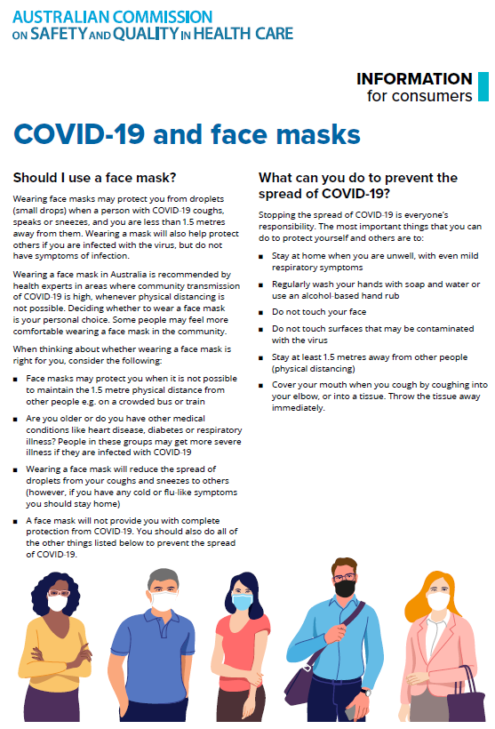](https://www.safetyandquality.gov.au/sites/default/files/2020-07/covid-19_and_face_masks_-_information_for_consumers.pdf)

*National COVID-19 Clinical Evidence Taskforce*

<https://covid19evidence.net.au/>

The National COVID-19 Clinical Evidence Taskforce is a collaboration of peak health professional bodies across Australia whose members are providing clinical care to people with COVID-19. The taskforce is undertaking continuous evidence surveillance to identify and rapidly synthesise emerging research in order to provide national, **evidence-based guidelines and clinical flowcharts for the clinical care of people with COVID-19**. The guidelines address questions that are specific to managing COVID-19 and cover the full disease course across mild, moderate, severe and critical illness. These are ‘living’ guidelines, updated with new research in near real-time in order to give reliable, up-to-the minute advice to clinicians providing frontline care in this unprecedented global health crisis.

*COVID-19 Critical Intelligence Unit*

<https://www.aci.health.nsw.gov.au/covid-19/critical-intelligence-unit>

The Agency for Clinical Innovation (ACI) in New South Wales has developed this page summarising rapid, evidence-based advice during the COVID-19 pandemic. Its operations focus on systems intelligence, clinical intelligence and evidence integration. The content includes a daily evidence digest, a COVID status monitor, a risk monitoring dashboard and evidence checks on a discrete topic or question relating to the current COVID-19 pandemic. There is also a ‘Living evidence’ section summarising key studies and emerging evidence on **COVID-19 vaccines** and **SARS-CoV-2 variants**. The most recent updates include:

* ***Emerging variants*** – What is the available evidence for emerging variants?
* ***Chest pain or dyspnoea following COVID-19 vaccination*** – What is evidence for chest pain or dyspnoea following COVID-19 vaccination?
* ***Cardiac investigations and elective surgery post-COVID-19*** – What is evidence for cardiac investigations and elective surgery post-COVID-19?
* ***Breathlessness post COVID-19*** – How to determine those patients who present with ongoing breathlessness in need of urgent review or intervention due to suspected pulmonary embolus?
* ***COVID-19 pandemic and influenza*** – What is the evidence for COVID-19 pandemic and influenza?
* ***Post-acute sequelae of COVID-19*** – What is the evidence on the post-acute sequelae of COVID-19?
* ***Budesonide and aspirin for pregnant women with COVID-19 –*** What is the evidence for the use of Budesonide for pregnant women with COVID-19? What is the evidence for aspirin prophylaxis for pre-eclampsia in pregnant women with a COVID-19 infection?
* ***COVID-19 vaccines in Australia*** – What is the evidence on COVID-19 vaccines in Australia?
* ***COVID-19 pandemic and wellbeing of critical care and other healthcare workers*** – Evidence in brief on the impact of the COVID-19 pandemic on the wellbeing of critical care and other healthcare workers.
* ***Surgery post COVID-19*** – What is the evidence for the timing of surgery, and outcomes following surgery, for people who have recovered from COVID-19?
* ***Disease modifying treatments for COVID-19 in children*** – What is the evidence for disease modifying treatments for COVID-19 in children?
* ***Mask type for COVID-19 positive wearer*** – What is the evidence for different mask types for COVID-19 positive wearers?
* ***Post acute and subacute COVID-19 care*** – What published advice and models of care are available regarding post-acute and subacute care for COVID-19 patients?
* ***Hospital visitor policies*** – What is the evidence for hospital visitor policies during and outside of the COVID-19 pandemic?
* ***Surgical masks, eye protection and PPE guidance*** –What is the evidence for surgical masks in the endemic phase in hospitals and for eyewear to protect against COVID-19?

**Disclaimer**

On the Radar is an information resource of the Australian Commission on Safety and Quality in Health Care. The Commission is not responsible for the content of, nor does it endorse, any articles or sites listed. The Commission accepts no liability for the information or advice provided by these external links. Links are provided on the basis that users make their own decisions about the accuracy, currency and reliability of the information contained therein. Any opinions expressed are not necessarily those of the Australian Commission on Safety and Quality in Health Care.