# Australian Commission on Safety and Quality logotypeOn the Radar

Issue 561

Tuesday 14 June 2022

*On the Radar* is a summary of some of the recent publications in the areas of safety and quality in health care. Inclusion in this document is not an endorsement or recommendation of any publication or provider. Access to particular documents may depend on whether they are Open Access or not, and/or your individual or institutional access to subscription sites/services. Material that may require subscription is included as it is considered relevant.

*On the Radar* is available online, via email or as a PDF or Word document from <https://www.safetyandquality.gov.au/publications-and-resources/newsletters/radar>

If you would like to receive *On the Radar* via email, you can subscribe on our website <https://www.safetyandquality.gov.au/publications-and-resources/newsletters>  
or by emailing us at H[Umail@safetyandquality.gov.auU](mailto:mail@safetyandquality.gov.au).   
You can also send feedback and comments to H[Umail@safetyandquality.gov.auU](mailto:mail@safetyandquality.gov.au).

For information about the Commission and its programs and publications, please visit <https://www.safetyandquality.gov.au>

You can also follow us on Twitter @ACSQHC.

**On the Radar**

Editor: Dr Niall Johnson [niall.johnson@safetyandquality.gov.au](mailto:niall.johnson@safetyandquality.gov.au)

Contributors: Niall Johnson, Jackie Coleman, Jennifer Caldwell, Amy Forsyth.

[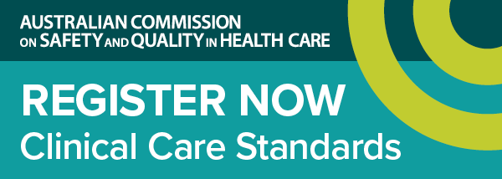](https://www.safetyandquality.gov.au/standards/clinical-care-standards/sepsis-clinical-care-standard)

***Launch of the first national standard of care for sepsis***

<https://www.safetyandquality.gov.au/standards/clinical-care-standards/sepsis-clinical-care-standard>

The Australian Commission on Safety and Quality in Health Care will launch the first national *Sepsis Clinical Care Standard* on **Thursday, 30 June 2022**.

Every year, there are over 55,000 cases of sepsis in Australia and more than 8,700 sepsis-related deaths.

The new clinical care standard provides guidance to ensure we spot the warning signs early and act quickly to stop sepsis and save lives.

Join our webcast to hear the experts discuss timely recognition of sepsis, systems to support time-critical management, the ongoing effects of sepsis, and the importance of multidisciplinary, coordinated sepsis care.

Hosted by Ms Julie McCrossin AM, Broadcaster and Commentator, the panellists include:

* Dr Carolyn Hullick – Clinical Director, Australian Commission on Safety and Quality in Health Care and Emergency Physician, Hunter New England Health NSW
* Professor Simon Finfer AO – Professorial Fellow in the Critical Care Division at The George Institute for Global Health. Adjunct Professor, University of New South Wales and Chair of Critical Care, School of Public Health, Imperial College London
* Associate Professor Paula Lister – Director Paediatric Critical Care, Sunshine Coast University Hospital QLD & Medical Co-Chair, Queensland Paediatric Sepsis Program
* Dr Lorraine Anderson – Medical Director, Kimberley Aboriginal Medical Services WA

Date: **Thursday, 30 June 2022**

Time: **12:00pm – 1:00pm AEST**

Location: Online

Click [here](https://safetyandquality.tv/home/) to register

For more information, email ccs@safetyandquality.gov.au or visit our web page at <https://www.safetyandquality.gov.au/standards/clinical-care-standards/sepsis-clinical-care-standard>

***Updated Basics of surveillance and quality improvement in healthcare eLearning module***

<https://nhhi.southrock.com>

The Australian Commission on Safety and Quality in Health Care continues to develop and support online learning for infection prevention and control (IPC) and hand hygiene for healthcare workers through its centralised online Learning Management System (LMS).

The Commission is working to ensure that the content of the modules is current and improves the learner experience. Most recently the *Basics of surveillance and quality improvement in healthcare* eLearning module has been updated to ensure consistency with the National Safety and Quality Health Service Standards, specifically the *Preventing and Controlling Infections Standard*, and the *Australian Guidelines for the Prevention and Control of Infection in Healthcare*.

The module is available in the National Hand Hygiene Initiative (NHHI) LMS at <https://nhhi.southrock.com>. Access to the NHHI LMS is free for all users and modules can be accessed after a learner has registered a profile on the system.

[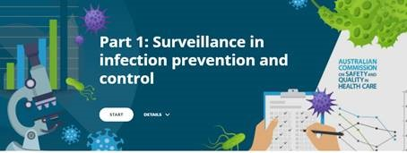](https://nhhi.southrock.com)

**Reports**

*Informing COVID service responses that impact on rehabilitation care*

Deeble Institute Perspectives Brief No. 22

Kuipers P, Finch J, Gavaghan B, Farrow E, McBride L-J, Foster M

Canberra: Australian Healthcare and Hospitals Association; 2022. p. 6.

|  |  |
| --- | --- |
| URL | <https://ahha.asn.au/deeble-institute-perspective-briefs>  <https://ahha.asn.au/sites/default/files/docs/policy-issue/perspectives_brief_no_22._informing_covid_service_responses_0.pdf> |
| Notes | This short Perspectives Brief from the Australian Healthcare and Hospitals Association’s Deeble Institute looks at how rehabilitation and sub-acute services in Queensland fared in the early wave of the COVID-19 pandemic, responses and changes in the light of that experience and the impact of later waves. The authors observe that the ‘Health service responses to the first wave of COVID-19 resulted in negative impacts on rehabilitation and subacute services in Queensland.’ This led to ‘an alliance of stakeholders sought to understand these impacts and develop policy recommendations to mitigate these impacts during predicted future waves’. The policy recommendations led to changes and ‘s indicate that there is a role for a partnered approach that includes clinicians and consumers to drive policy change. It also underscores that the value and role of rehabilitation within the health system must be carefully profiled, clearly prioritised, and strongly advocated for, especially given the competing pressures on our health system.’ |

**Journal articles**

*Evaluation of a national database of completed investigations into radiology service complaints in New Zealand: What can the radiologist, and radiology service providers, learn?*

Ruppeldt P, Baker M, Wheeler LD

Journal of Medical Imaging and Radiation Oncology. 2022.

|  |  |
| --- | --- |
| DOI | <https://doi.org/10.1111/1754-9485.13417> |
| Notes | The Health and Disability Commissioner (HDC) in New Zealand has evaluated complaints about radiology services and radiologists to gain insights that might promote safer working across the radiology community. The authors observed that 63% of complaints involved private radiology providers while 37% involved public providers. The HDC identified errors in 89% of complaints. A majority of complaints involved ultrasound. The errors are often multifactorial and systemic. A reflection on the myriad of error types and contributing factors is imperative to reduce error. Multifaceted strategies are likely required for radiologists to enhance their systems and practice. |

*Living clinical guidelines for stroke: updates, challenges and opportunities*

English C, Hill K, Cadilhac DA, Hackett ML, Lannin NA, Middleton S, et al

Medical Journal of Australia. 2022;216(10):510-514.

*The acute telestroke model of care in Australia: a potential roadmap for other emergency medical services?*

Garcia-Esperon C, Bladin CF, Kleinig TJ, Brown H, Majersik JJ, Wesseldine A, et al

Medical Journal of Australia. 2022;216(10):498-500.

*Time to antithrombotic therapy after transient ischaemic attack and ischaemic stroke*

Phan TG, Clissold B, Ma H

Medical Journal of Australia. 2022;216(10):495-497.

|  |  |
| --- | --- |
| DOI | English et al <https://doi.org/10.5694/mja2.51520>  Garcia-Esperon et al <https://doi.org/10.5694/mja2.51519>  Phan et al <https://doi.org/10.5694/mja2.51532> |
| Notes | A recent issue of the *Medical Journal of Australia* carried a number of items relating to stroke and the delivery of stroke care.  English et al noted the changes to how the Australian and *New Zealand Clinical Guidelines for Stroke Management* (<https://informme.org.au/guidelines/clinical-guidelines-for-stroke-management>) are now maintained and updated to reflect the continual evidence surveillance and timely updates to recommendations as new research is published.  Garcia-Esperon et al describe how acute stroke care has adopted a ‘telestroke’ model of care. ‘Stroke telemedicine, or “telestroke”, refers to the diagnosis and treatment of patients using telecommunications technology.’ They suggest it may offer a template for other emergency medical services.  Phan et al look at the issue of antithrombotic therapy after transient ischaemic attack and ischaemic stroke. |

For information on the Commission’s *Acute Stroke Clinical Care Standard*, see <https://www.safetyandquality.gov.au/our-work/clinical-care-standards/acute-stroke-clinical-care-standard>

*Medical Journal of Australia*

Volume 216, Issue S10, June 2022

|  |  |
| --- | --- |
| URL | <https://onlinelibrary.wiley.com/toc/13265377/2022/216/S10> |
|  | This supplement to the *Medical Journal of Australia* has the theme ‘**Achieving person-centred primary health care**’. Articles in this supplementary issue of the *Medical Journal of Australia* include:   * **Creating person-centred health care value together** (Paresh Dawda, Tina Janamian, Leanne Wells) * **Activating people to partner in health and self-care**: use of the Patient Activation Measure (Tina Janamian, Michael Greco, David Cosgriff, Laurence Baker, Paresh Dawda) * **Co-creating education and training programs that build workforce capacity** to support the implementation of integrated health care initiatives (Tina Janamian, Angelene True, Paresh Dawda, Melanie Wentzel, Tamieka Fraser) * **Building capacity in those who deliver palliative care services** to Aboriginal and Torres Strait Islander peoples (Tina Janamian, Paresh Dawda, Gregory Crawford, Angelene True, Melanie Wentzel, Donald Whaleboat, Tamieka Fraser, Christopher Edwards) * Lessons from the implementation of the **Health Care Homes** program (Angelene True, Tina Janamian, Paresh Dawda, Tracey Johnson, Gary Smith) * **Value in primary care clinics**: a service ecosystem perspective (Janet R McColl-Kennedy, Teegan Green, Mieke L van Driel) * **Value-based primary care** in Australia: how far have we travelled? (Paresh Dawda, Angelene True, Helen Dickinson, Tina Janamian, Tracey Johnson) |

*Journal of Patient Safety and Risk Management*

Volume 27, Number 3, June 2022

|  |  |
| --- | --- |
| URL | <https://journals.sagepub.com/toc/cric/27/3> |
|  | A new issue of the *Journal of Patient Safety and Risk Management* has been published. Articles in this issue of the *Journal of Patient Safety and Risk Management* include:   * Editorial: Supply and Demand: Meeting the Need for **Graduate Training in Patient Safety** (Albert W Wu) * Evaluation of patient relatives’ opinions on **physical restraint** (Ömer Fahri Özdemir and Ayla Keçeci) * Stakeholder perspectives on ‘Swiss quality’ healthcare in the context of inbound **medical tourism to Switzerland**: An exploratory qualitative study (João Couceiro, Bernice S. Elger, and Priya Satalkar) * **Safety-II and the study of healthcare safety routines**: Two paths forward for research (Christofer Rydenfält) * **Risk management of smart healthcare systems**: Delimitation, state-of-arts, process, and perspectives (Yiliu Liu) * A case report a **delayed diagnosis of tracheomalacia** resulting in prolonged steroid therapy, repeated hospital admissions and CT scans (Chris Hardy and Gwynedd Clark) |

*Health Affairs*

Volume 41, Number 6, June 2022

|  |  |
| --- | --- |
| URL | <https://www.healthaffairs.org/toc/hlthaff/41/6> |
| Notes | A new issue of *Health Affairs* has been published with the themes “Costs, Care Delivery, COVID-19 & More”. Articles in this issue of *Health Affairs* include:   * In New Orleans, **Navigating Dementia** With A Guide (Harris Meyer) * **Patents And Regulatory Exclusivities On Inhalers For Asthma And COPD**, 1986–2020 (William B. Feldman, Doni Bloomfield, Reed F. Beall, and Aaron S. Kesselheim) * Fixing The **FDA’s Orange Book** (C. Scott Hemphill and Bhaven N. Sampat) * **Understanding ‘Evergreening’**: Making Minor Modifications Of Existing Medications To Extend Protections (Robin Feldman) * Frequency Of Indirect Billing To Medicare For **Nurse Practitioner And Physician Assistant Office Visits** (Sadiq Y Patel, H A Huskamp, A B Frakt, D I Auerbach, H T Neprash, M L Barnett, H O James, and A Mehrotra) * **Health Savings Accounts** No Longer Promote Consumer Cost-Consciousness (Sherry A Glied, Dahlia K Remler, and Mikaela Springsteen) * Hospice Improves **Care Quality For Older Adults With Dementia** In Their Last Month Of Life (Krista L Harrison, Irena Cenzer, Claire K Ankuda, Lauren J Hunt, and Melissa D Aldridge) * Beyond Compliance: A More **Integrated Public Health Approach To Outbreaks In Nursing Homes And Other Disasters** (Michael Wasserman and R Tamara Konetzka) * **Interstate Telehealth** Use By Medicare Beneficiaries Before And After COVID-19 Licensure Waivers, 2017–20 (Juan J Andino, Ziwei Zhu, Mihir Surapaneni, Rodney L Dunn, and Chad Ellimoottil) * **COVID-19 Vaccination** Of People Experiencing Homelessness And Incarceration In Minnesota (Riley D Shearer, Katherine Diaz Vickery, Peter Bodurtha, Paul E Drawz, Steve Johnson, Jessica Jeruzal, Stephen Waring, Alanna M Chamberlain, Anupam B Kharbanda, Josh Leopold, Blair Harrison, Hattie Hiler, Rohan Khazanchi, Rebecca Rossom, K L Margolis, N K Rai, M H Muscoplat, Y Yu, R Adams Dudley, N A M Klyn, and T N A Winkelman) * The Association Between **COVID-19 Mortality And The County-Level Partisan Divide** In The United States (Neil Jay Sehgal, Dahai Yue, Elle Pope, Ren Hao Wang, and Dylan H Roby) * **School Reopening And COVID-19 In The Community**: Evidence From A Natural Experiment In Ontario, Canada (Tiffany Fitzpatrick, Andrew Wilton, Eyal Cohen, Laura Rosella, and Astrid Guttmann) * **High Job Flexibility And Paid Sick Leave Increase Health Care Access And Use** Among US Workers (Thomas A Hegland and Terceira A Berdahl) * Examining **Health Care Access And Health Of Children** Living In Homes Subsidized By The Low-Income Housing Tax Credit (Sarah G Gensheimer, Matthew D Eisenberg, Daniel Hindman, Albert W Wu, and Craig E Pollack) * **Medicare’s Specialty-Oriented Accountable Care Organization**: First-Year Results For People With End-Stage Renal Disease (Darin F Ullman, Gregory J Boyer, Brighita Negrusa, Richard A Hirth, J Wiens, and G Marrufo) * **Medicaid Managed Care**: Access To Primary Care Providers Who Prescribe Buprenorphine (Mark Katz Meiselbach, Coleman Drake, Brendan Saloner, Jane M Zhu, Bradley D Stein, and Daniel Polsky) * Pushy Patients Or Pushy Providers? Effect Of Patient Knowledge On **Antibiotic Prescribing In Tanzania** (Jessica King, Timothy Powell-Jackson, James Hargreaves, Christina Makungu, and Catherine Goodman) * As Hospitals Restrict Visitors, **What Constitutes A ‘Good Death’?** (Nora Osman Segar) |

*International Journal for Quality in Health Care* online first articles

|  |  |
| --- | --- |
| URL | <https://academic.oup.com/intqhc/advance-articles> |
| Notes | *International Journal for Quality in Health Care* has published a number of ‘online first’ articles, including:   * **Developing Clinical Care Programs**: Experience from a Colombian Clinical Center (Alejandro De La Torre, Carolina Ayola, Astolfo Franco, Rafael González Molina) |

**Online resources**

*[UK] NICE Guidelines and Quality Standards*

<https://www.nice.org.uk/guidance>

The UK’s National Institute for Health and Care Excellence (NICE) has published new (or updated) guidelines and quality standards. The latest reviews or updates are:

* NICE Guideline NG219 ***Gout****: diagnosis and management* <https://www.nice.org.uk/guidance/ng219>

**COVID-19 resources**

https://www.safetyandquality.gov.au/covid-19

The Australian Commission on Safety and Quality in Health Care has developed a number of resources to assist healthcare organisations, facilities and clinicians. These and other material on COVID-19 are available at <https://www.safetyandquality.gov.au/covid-19>

These resources include:

* ***OVID-19 infection prevention and control risk management*** This primer provides an overview of three widely used tools for investigating and responding to patient safety events and near misses. Tools covered in this primer include incident reporting systems, Root Cause Analysis (RCA), and Failure Modes and Effects Analysis (FMEA).   
  <https://www.safetyandquality.gov.au/publications-and-resources/resource-library/covid-19-infection-prevention-and-control-risk-management-guidance>
* ***Poster – Combined contact and droplet precautions*** <https://www.safetyandquality.gov.au/publications-and-resources/resource-library/poster-combined-contact-and-droplet-precautions>  
  [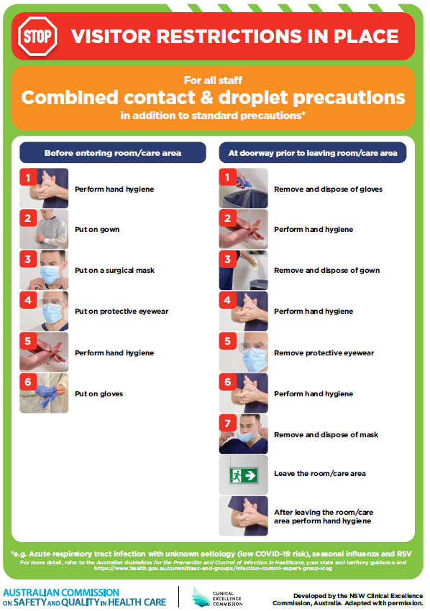](https://www.safetyandquality.gov.au/publications-and-resources/resource-library/poster-combined-contact-and-droplet-precautions)
* ***Poster – Combined airborne and contact precautions*** <https://www.safetyandquality.gov.au/publications-and-resources/resource-library/poster-combined-airborne-and-contact-precautions>   
  [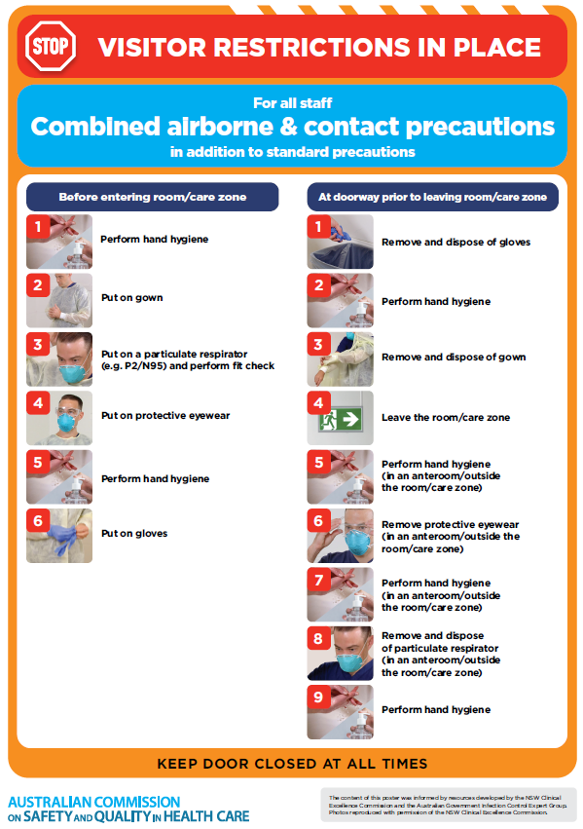](https://www.safetyandquality.gov.au/publications-and-resources/resource-library/poster-combined-airborne-and-contact-precautions)
* ***Environmental Cleaning and Infection Prevention and Control*** [www.safetyandquality.gov.au/environmental-cleaning](http://www.safetyandquality.gov.au/environmental-cleaning)
* ***COVID-19 infection prevention and control risk management – Guidance*** <https://www.safetyandquality.gov.au/publications-and-resources/resource-library/covid-19-infection-prevention-and-control-risk-management-guidance>
* ***Safe care for people with cognitive impairment during COVID-19***<https://www.safetyandquality.gov.au/our-work/cognitive-impairment/cognitive-impairment-and-covid-19>
* ***Stop COVID-19: Break the chain of infection*** posterhttps://www.safetyandquality.gov.au/publications-and-resources/resource-library/break-chain-infection-poster-a3  
  **[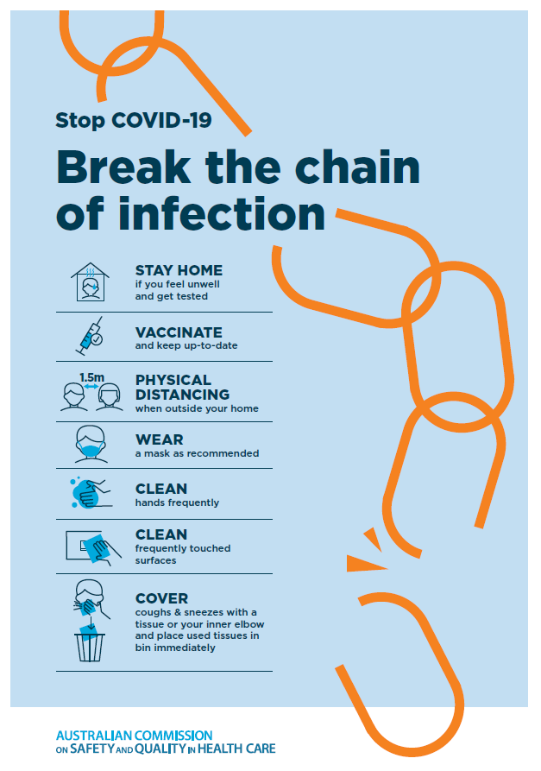](https://www.safetyandquality.gov.au/publications-and-resources/resource-library/break-chain-poster-a3https:/www.safetyandquality.gov.au/publications-and-resources/resource-library/break-chain-poster-a3)**
* ***FAQs for clinicians on elective surgery*** <https://www.safetyandquality.gov.au/node/5724>
* ***FAQs for consumers on elective surgery*** <https://www.safetyandquality.gov.au/node/5725>
* ***COVID-19 and face masks – Information for consumers*** <https://www.safetyandquality.gov.au/publications-and-resources/resource-library/covid-19-and-face-masks-information-consumers>

[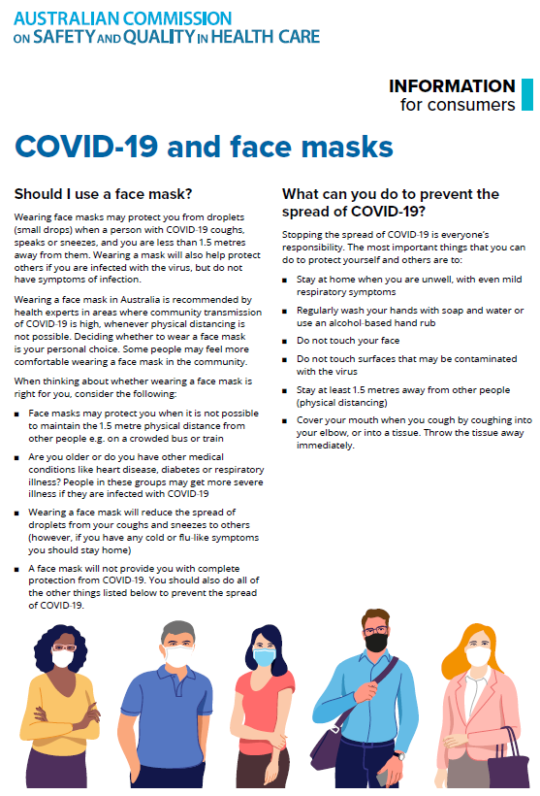](https://www.safetyandquality.gov.au/sites/default/files/2020-07/covid-19_and_face_masks_-_information_for_consumers.pdf)

*National COVID-19 Clinical Evidence Taskforce*

<https://covid19evidence.net.au/>

The National COVID-19 Clinical Evidence Taskforce is a collaboration of peak health professional bodies across Australia whose members are providing clinical care to people with COVID-19. The taskforce is undertaking continuous evidence surveillance to identify and rapidly synthesise emerging research in order to provide national, **evidence-based guidelines and clinical flowcharts for the clinical care of people with COVID-19**. The guidelines address questions that are specific to managing COVID-19 and cover the full disease course across mild, moderate, severe and critical illness. These are ‘living’ guidelines, updated with new research in near real-time in order to give reliable, up-to-the minute advice to clinicians providing frontline care in this unprecedented global health crisis.

*COVID-19 Critical Intelligence Unit*

<https://www.aci.health.nsw.gov.au/covid-19/critical-intelligence-unit>

The Agency for Clinical Innovation (ACI) in New South Wales has developed this page summarising rapid, evidence-based advice during the COVID-19 pandemic. Its operations focus on systems intelligence, clinical intelligence and evidence integration. The content includes a daily evidence digest, a COVID status monitor, a risk monitoring dashboard and evidence checks on a discrete topic or question relating to the current COVID-19 pandemic. There is also a ‘Living evidence’ section summarising key studies and emerging evidence on **COVID-19 vaccines** and **SARS-CoV-2 variants**. The most recent updates include:

* ***Emerging variants*** – What is the available evidence for emerging variants?
* ***Chest pain or dyspnoea following COVID-19 vaccination*** – What is evidence for chest pain or dyspnoea following COVID-19 vaccination?
* ***Cardiac investigations and elective surgery post-COVID-19*** – What is evidence for cardiac investigations and elective surgery post-COVID-19?
* ***Breathlessness post COVID-19*** – How to determine those patients who present with ongoing breathlessness in need of urgent review or intervention due to suspected pulmonary embolus?
* ***COVID-19 pandemic and influenza*** – What is the evidence for COVID-19 pandemic and influenza?
* ***Post-acute sequelae of COVID-19*** – What is the evidence on the post-acute sequelae of COVID-19?
* ***Budesonide and aspirin for pregnant women with COVID-19 –*** What is the evidence for the use of Budesonide for pregnant women with COVID-19? What is the evidence for aspirin prophylaxis for pre-eclampsia in pregnant women with a COVID-19 infection?
* ***COVID-19 vaccines in Australia*** – What is the evidence on COVID-19 vaccines in Australia?
* ***COVID-19 pandemic and wellbeing of critical care and other healthcare workers*** – Evidence in brief on the impact of the COVID-19 pandemic on the wellbeing of critical care and other healthcare workers.
* ***Surgery post COVID-19*** – What is the evidence for the timing of surgery, and outcomes following surgery, for people who have recovered from COVID-19?
* ***Disease modifying treatments for COVID-19 in children*** – What is the evidence for disease modifying treatments for COVID-19 in children?
* ***Mask type for COVID-19 positive wearer*** – What is the evidence for different mask types for COVID-19 positive wearers?
* ***Post acute and subacute COVID-19 care*** – What published advice and models of care are available regarding post-acute and subacute care for COVID-19 patients?
* ***Hospital visitor policies*** – What is the evidence for hospital visitor policies during and outside of the COVID-19 pandemic?
* ***Surgical masks, eye protection and PPE guidance*** –What is the evidence for surgical masks in the endemic phase in hospitals and for eyewear to protect against COVID-19?

**Disclaimer**

On the Radar is an information resource of the Australian Commission on Safety and Quality in Health Care. The Commission is not responsible for the content of, nor does it endorse, any articles or sites listed. The Commission accepts no liability for the information or advice provided by these external links. Links are provided on the basis that users make their own decisions about the accuracy, currency and reliability of the information contained therein. Any opinions expressed are not necessarily those of the Australian Commission on Safety and Quality in Health Care.