# Australian Commission on Safety and Quality logotypeOn the Radar

Issue 562

20 June 2022

*On the Radar* is a summary of some of the recent publications in the areas of safety and quality in health care. Inclusion in this document is not an endorsement or recommendation of any publication or provider. Access to particular documents may depend on whether they are Open Access or not, and/or your individual or institutional access to subscription sites/services. Material that may require subscription is included as it is considered relevant.

*On the Radar* is available online, via email or as a PDF or Word document from <https://www.safetyandquality.gov.au/publications-and-resources/newsletters/radar>

If you would like to receive *On the Radar* via email, you can subscribe on our website <https://www.safetyandquality.gov.au/publications-and-resources/newsletters>  
or by emailing us at H[Umail@safetyandquality.gov.auU](mailto:mail@safetyandquality.gov.au).   
You can also send feedback and comments to H[Umail@safetyandquality.gov.auU](mailto:mail@safetyandquality.gov.au).

For information about the Commission and its programs and publications, please visit <https://www.safetyandquality.gov.au>

You can also follow us on Twitter @ACSQHC.

**On the Radar**

Editor: Dr Niall Johnson [niall.johnson@safetyandquality.gov.au](mailto:niall.johnson@safetyandquality.gov.au)

Contributors: Niall Johnson, Amy Forsyth.

[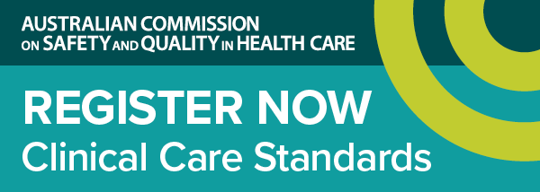](https://www.safetyandquality.gov.au/standards/clinical-care-standards/sepsis-clinical-care-standard)

***Launch of the first national standard of care for sepsis***

<https://www.safetyandquality.gov.au/standards/clinical-care-standards/sepsis-clinical-care-standard>

The Australian Commission on Safety and Quality in Health Care will launch the first national *Sepsis Clinical Care Standard* on **Thursday, 30 June 2022**.

Every year, there are over 55,000 cases of sepsis in Australia and more than 8,700 sepsis-related deaths.

The new clinical care standard provides guidance to ensure we spot the warning signs early and act quickly to stop sepsis and save lives.

Join our webcast to hear the experts discuss timely recognition of sepsis, systems to support time-critical management, the ongoing effects of sepsis, and the importance of multidisciplinary, coordinated sepsis care.

Hosted by Ms Julie McCrossin AM, Broadcaster and Commentator, the panellists include:

* Dr Carolyn Hullick – Clinical Director, Australian Commission on Safety and Quality in Health Care and Emergency Physician, Hunter New England Health NSW
* Professor Simon Finfer AO – Professorial Fellow in the Critical Care Division at The George Institute for Global Health. Adjunct Professor, University of New South Wales and Chair of Critical Care, School of Public Health, Imperial College London
* Associate Professor Paula Lister – Director Paediatric Critical Care, Sunshine Coast University Hospital QLD & Medical Co-Chair, Queensland Paediatric Sepsis Program
* Dr Lorraine Anderson – Medical Director, Kimberley Aboriginal Medical Services WA

Date: **Thursday, 30 June 2022**

Time: **12:00pm – 1:00pm AEST**

Location: Online

Click [here](https://safetyandquality.tv/home/) to register

For more information, email ccs@safetyandquality.gov.au or visit our web page at <https://www.safetyandquality.gov.au/standards/clinical-care-standards/sepsis-clinical-care-standard>

**Reports**

*The courage of compassion: Supporting nurses and midwives to deliver high-quality care*

West M, Bailey S, Williams E

London: The King's Fund; 2022. p. 156.

|  |  |
| --- | --- |
| URL | <https://www.kingsfund.org.uk/publications/courage-compassion-supporting-nurses-midwives> |
| Notes | This report from the King’s Fund in the UK commissioned by the Royal College of Nursing Foundation. The review ‘investigated how to transform nurses’ and midwives’ workplaces so that they can thrive and flourish and are better able to provide the compassionate, high-quality care that they wish to offer.’  ‘To ensure wellbeing and motivation at work, and to minimise workplace stress, research evidence suggests that people have three core needs:   * **autonomy** – the need to have control over their work lives, and to be able to act consistently with their values * **belonging** – the need to be connected to, cared for, and caring of others around them at work, and to feel valued, respected and supported * **contribution**– the need to experience effectiveness in what they do and deliver valued outcomes.   All three must be met for people to flourish and thrive at work. The review identified eight key areas where action is needed to ensure that these three core needs are met for nurses and midwives’ (see below).  The report includes eight recommendations designed to meet these three core work needs. These recommendations focus on: authority, empowerment and influence; justice and fairness; work conditions and working schedules; teamworking; culture and leadership; workload; management and supervision; and learning, education and development.  [Figure setting out the ABC framework of nurses' and midwivess' core work needs.](https://www.kingsfund.org.uk/publications/courage-compassion-supporting-nurses-midwives) |

*National Guidance on Quality Risk Response and Escalation in Integrated Care Systems*

National Quality Board

London: NHS England; 2022. p. 20.

|  |  |
| --- | --- |
| URL | <https://www.england.nhs.uk/publication/national-guidance-on-quality-risk-response-and-escalation-in-integrated-care-systems> |
| Notes | Guidance from the NHS England’s National Quality Board for integrated care systems leadership. The guidance is intended to support approaches to ‘quality management, providing clarity on how quality concerns and risks should be managed’. |

**Journal articles**

*Diagnostic Excellence and Patient Safety: Strategies and Opportunities*

Shah NR, Gandhi TK, Bates DW

Journal of the American Medical Association. 2022 [epub].

|  |  |
| --- | --- |
| DOI | <https://doi.org/10.1001/jama.2022.9629> |
| Notes | The latest in JAMA’s series of items on diagnostic excellence. In this short piece, the authors observe that ‘errors in the use and performance of diagnostic tests can harm patients, both from delayed and missed diagnoses and from the preventable harm from unnecessary diagnostic tests’. They seek to examine ‘diagnostic safety issues in various clinical scenarios across the care continuum, with selected examples illustrating successful strategies for improvement’. Examples include cancer screening in primary care, sepsis diagnosis in the ED, inpatient pulmonary embolism, and telehealth. |

*Diagnostic Trajectories in Primary Care at 12 Months: An Observational Cohort Study*

Fontil V, Khoong EC, Lyles C, Rivadeneira NA, Olazo K, Hoskote M, et al

The Joint Commission Journal on Quality and Patient Safety. 2022 [epub].

|  |  |
| --- | --- |
| DOI | <https://doi.org/10.1016/j.jcjq.2022.04.010> |
| Notes | Paper reporting on a prospective observational cohort study of adults presenting to primary care clinics across two health systems in the USA with an undiagnosed medical problem. In the 410 cases, ‘206 (50.2%) reached a final diagnosis within 12 months, with a median time to diagnosis of 5 days (interquartile range = 0–46). Among these cases, 32.4% reached a diagnosis within the first month. A majority of cases not diagnosed within a month of the first presentation remained undiagnosed at 12 months.’ The authors observe ‘Patients presenting with new or unresolved problems in ambulatory primary care often remain undiagnosed after a year. There were no provider or patient-level variables associated with such lack of diagnosis.’ |

*Public Health Research & Practice*

Volume 32, Issue 2, June 2022

|  |  |
| --- | --- |
| URL | <https://www.phrp.com.au/issues/June-2022-volume-32-issue-2/> |
|  | A new issue of *Public Health Research & Practice* has been published with a theme ‘Co-production of research: aspirations, challenges, and the way ahead’. Articles in this issue of *Public Health Research & Practice* include:   * Editorial: **Co-production**: aspirations, challenges, and the way ahead for **public health and health services research** (Nicholas Mays, Ben Harris-Roxas) * Launching a **global movement for societal wellbeing** (Vivian Lin, Colin Sindall, Carmel Williams, Tony Capon) * A personal reflection on **co-creation in public health**: a dream partly realised (Adrian Bauman) * **Co-creation, co-design, co-production for public health** – a perspective on definition and distinctions (Carmen Vargas, Jill Whelan, Julie Brimblecombe, Steven Allender) * Establishing an enduring **co-production platform in Aboriginal health** (Sandra Bailey, Deanna Kalucy, Janice Nixon, Anna Williamson, Darryl Wright, Jamie Newman, Martin McNamara, Sumithra Muthayya) * **Ethics and the co-production of knowledge** (Katie Page) * Enabling the space and conditions for **co-leadership in co-design**: an evaluation of co-facilitator training for culturally and linguistically diverse consumers (Bróna Nic Giolla Easpaig, Éidín Ní Shé, Ashfaq Chauhan, Bronwyn Newman, Kathryn Joseph, Nyan Thit Tieu, Reema Harrison) * **Applying collective impact in Aboriginal health services and research**: three case studies tell an important story (Kylie Gwynne, Boe Rambaldini, Vita Christie, David Meharg, Josephine D Gwynn, Yvonne Dimitropoulos, Carmen Parter, John C Skinner) * A COVID-19-era rapid review: using **Zoom and Skype for qualitative group research** (Joshua Boland, Susan Banks, Robin Krabbe, Suanne Lawrence, Therese Murray, Terese Henning, Miriam Vandenberg) * Alcohol brands’ use of **age-restriction controls on Facebook and Instagram** in Australia (Hannah Pierce, Abbie-Clare Vidler, Julia Stafford, Danica Keric) * **Influenza vaccination among pregnant women** in two hospitals in Sydney, NSW: what we can learn from women who decline vaccination (Jocelynne E McRae, Aditi Dey, Samantha Carlson, John Sinn, Peter McIntyre, Frank Beard, Kristine Macartney, Nicholas Wood) * **Co-producing research with people impacted by dementia and service providers**: issues and challenges (Ellen Gaffy, Bianca Brijnath, Briony Dow) * **Co-production of a transdisciplinary assessment** by researchers and healthcare professionals: a case study (Aleysha K Martin, Theresa L Green, Alexandra L McCarthy, P Marcin Sowa, E-Liisa Laakso) * Absence of **COVID-19 workplace transmission from hairdressers** in Victoria, Australia (Ericka Swaney, Brittany Murnane, Lauren Heard, N Deborah Friedman, Daniel P O'Brien) * Effectiveness and costs of **strategies to recruit Australian adults with type 2 diabetes** into a text message intervention (DTEXT) study )(Karen Waller, Susan Furber, Rebecca Cook, Margaret Allman-Farinelli, Stephen Colagiuri, Lisa Franco, Robert Moses, Alison Webb, Adrian Bauman) * Righting a wrong: turning the tide on **geopolitics in healthcare** (Frances Rapport) |

*Australian Journal of Primary Health*

Volume 28, Number 3, June 2022

|  |  |
| --- | --- |
| URL | <https://www.publish.csiro.au/py/issue/10794> |
|  | A new issue of the *Australian Journal of Primary Health* has been published. Articles in this issue of the *Australian Journal of Primary Health* include:   * A systematic review on assessment and management of **preventive cardiovascular care in primary health for Aboriginal and Torres Strait Islander women and men** (Katharine McBride, Jayden Nguyen, Anna Dowling, Natasha J Howard, Christine Franks, Susan Hillier, Vicki Wade, Veronica King, Janice Rigney, Nyunmiti Burton, Julie Anne Mitchell, Stephen J Nicholls, Catherine Paquet and Alex Brown * **Implications of the ongoing coronavirus disease 2019 pandemic for primary care** (Pathiyil Ravi Shankar, Vishna D Nadarajah and Ian G Wilson) * Clinical software packages can be improved to help general practitioners increase the **provision of preventive care** (Oliver R Frank) * Integrating cultural considerations and developmental screening into an **Australian First Nations child health check** (Natasha Reid, Marjad Page, Theresa McDonald, Erinn Hawkins, Wei Liu, Heidi Webster, Codi White, Doug Shelton, Mary Katsikitis, Andrew Wood, Bronwyn Draper, Karen Moritz and Dianne C Shanley) * Developing **indicators and measures of high-quality for Australian general practice** (Christine Metusela, Natalie Cochrane, Hannah van Werven, Tim Usherwood, Shahana Ferdousi, Ray Messom, Diana O’Halloran, Michael Fasher, Andrew Page, Steven Trankle, Penelope Abbott, W. Kathy Tannous, Kath Peters, Kirsten Meisinger and Jennifer Reath) * **Primary care consumers’ experiences and opinions of a telehealth consultation** delivered via video during the COVID-19 pandemic (Jo-Anne Manski-Nankervis, Sandra Davidson, Harriet Hiscock, Christine Hallinan, Jemimah Ride, Vignesh Lingam, Jessica Holman, Andrew Baird, Emma McKeown and Lena Sanci) * **After-hours presentations to community-based primary care** in the Australian Capital Territory (Katelyn Barnes, Jason Agostino, Dagmar Ceramidas and Kirsty Douglas) * Barriers and enablers to **hepatitis C treatment among clients of Aboriginal Community Controlled Health Services** in South East Queensland, Australia: a qualitative enquiry (Cheneal Puljevic, Luciana Massi, Renee Brown, Richard Mills, Lyle Turner, Andrew Smirnov and Linda A Selvey) * Qualitative analysis of the barriers and facilitators influencing uptake of direct-acting **antiviral therapy for hepatitis C** in a primary healthcare environment (Kevin Jia 0000-0001-5698-6647, Harsha Venkateshan and Michael Burke * Community participation in **Australia’s National Suicide Prevention Trial** (Kylie King, Teresa Hall, Sanne Oostermeijer and Dianne Currier) * Impact of dual diagnosis on **healthcare and criminal justice costs after release from Queensland prisons**: a prospective cohort study (K J Snow, D Petrie, J T. Young, D B Preen, E Heffernan and S A Kinner) |

*Pediatric Quality & Safety*

Volume 7, Number 3, May/June 2022

|  |  |
| --- | --- |
| URL | <https://journals.lww.com/pqs/toc/2022/05000> |
|  | A new issue of *Pediatric Quality & Safety* has been published. Articles in this issue of *Pediatric Quality & Safety* include:   * Erratum: Quality Improvement Effort to Decrease **Unplanned Extubations in a Cardiac Neonatal Intensive Care Unit** * Utilization of Family as Faculty: A Patient Directed Simulation Education to Improve **Patient and Family Communication during Patient-Family Centered Rounds** (PFCR) (Asuncion, Arsenia M; Quintos-Alagheband, Maria Lyn; Leavens-Maurer, Jill; Akerman, Meredith; Janicke, Patricia; Cavanaugh, S) * Rethinking **Blood Testing in Pediatric Cancer Patients**: A Quality Improvement Approach (Grant, Andrew M; Wright, Felicity A; Chapman, Laura R M; Cook, Eleanor; Byrne, Renee; O’Brien, Tracey A) * Improving Adherence to AAP **Acute Otitis Media Guidelines** in an Academic Pediatrics Practice through a Quality Improvement Project (Wolf, Ryan M; Langford, Kyle T; Patterson, Barron L) * **High-stage Device-related Pressure Injury Reduction** in a Neonatal Intensive Care Unit: A Quality Improvement Project (Moyer, Laurel B; Lauderbaugh, Denise L; Worten, Katherine; Carter, Chelsea; Holub, Peggy; Santos Manrique, Rose A; Bergman, J H; Dilloway, M A; Hamid, M; Glenn, L) * Reducing **Antibiotic Use in a Level III and Two Level II Neonatal Intensive Care Units** Targeting Prescribing Practices for Both Early and Late-onset Sepsis: A Quality Improvement Project (Kahn, Doron J; Perkins, Beckett S; Barrette, Claire E; Godin, Robert) * **Therapeutic Hypothermia on Transport**: The Quest for Efficiency: Results of a Quality Improvement Project (Redpath, Stephanie; Moore, Heather; Sucha, Ewa; Agarwal, Amisha; Barrowman, N; Lemyre, B; St Germain, L) * Reducing **Wait Time in a High-volume Pediatric Neuro-oncology Clinic** by Optimizing Process Flow: A Quality Improvement Project (Vinitsky, Anna; David, Barbara; Michalik, Layna; Ramirez, Nicole; Risinger, Adam; Burlison, Jonathan D.; Zanders, Jacky; Mans, Bridget; Heady, Katie; Holdiness, Joni; Qaddoumi, Ibrahim; Robinson, G W; Moreira, D; Upadhyaya, S A; Gajjar, A) * Response Time in the **Transport of Pediatric Patients to a Tertiary Critical Care Unit** (Villacrés, Sindy; Katyal, Chhavi; Gomez, James; Longani, Neha; Chang, Deidre; Velasco, Susan; Zeiman, Linda; Choi, Steven) * Improving **Blood Pressure Screening in Neonatal Follow-up Clinic**: A Quality Improvement Initiative (Flynn, Rachel .; Zedalis, Jacqueline; Denburg, Michelle R; Bernbaum, Judy C; DeMauro, Sara B) * Increasing Pediatric Infectious Diseases Consultation Rates for ***Staphylococcus aureus* Bacteremia** (Gordon, Oren; Peart Akindele, Nadine; Schumacher, C; Hanlon, A; Simner, P J; Carroll, K C; Sick-Samuels, A C) * Practicing What We Preach: An Effort to Improve **Safe Sleep of Hospitalized Infants** (Salada, Katherine O; Arzu, Jennifer; Unti, Sharon M; Tanz, Robert R; Badke, Colleen M) * Standardized Scoring Tool and Weaning Guideline to **Reduce Opioids in Critically Ill Neonates** (Vyas, Dipen; Quinones Cardona, Vilmaris; Carroll, Amanda; Markel, Catherine; Young, Megan; Fleishman, Rachel) * Reducing the **Time to Blood Administration after Pediatric Injury**: A Quality Improvement Initiative (Sullivan, Travis M; Milestone, Zachary P; Alberto, Emily C; Waibel, Elizabeth M; Gestrich-Thompson, Waverly V; Tempel, Peyton E; Fritzeen, Jennifer L; O’Connell, K J; Cheng, J; Burd, R S) * A Quality Improvement Approach to Ensuring **Access to Specialty Care for Pediatric Patients** (Vora, Sheetal S; Buitrago-Mogollon, Talia L; Mabus, S C) * Improving **Follow-Up Skeletal Survey Completion in Children with Suspected Nonaccidental Trauma** (Ashraf, Iram J; Faivus Ackley, Danielle; Razawich, Kristin; Botash, Ann; Schafer, Melissa; Pekarsky, Alicia) * Unexpected Benefits in Single Institution Experience With Successful Implementation of a **Standardized Perioperative Protocol in Pediatric Thyroidectomy** (Cossen, Kristina; Santore, Matthew T; Prickett, Kara K; Goudy, Steven L; Heiss, Kurt F; Shanker, K; Alazraki, A L; Patterson, B C) * Improving **Knowledge of Active Safety and QI Projects Amongst Practitioners in a Pediatric ICU** (Flaherty, Brian F; Hummel, Kevin; Vijayarajah, Senthuran; White, Benjamin R; Outsen, Shad; Larsen, Gitte Y) * Assessing **Suicide Risk in a Pediatric Outpatient Behavioral Health System**: A Quality Improvement Report (Soffer, Stephen L; Lewis, Jason; Lawrence, O’Nisha S; Marroquin, Yesenia A; Doupnik, S K; Benton, T D) * Improving **Blood Product Transfusion Premedication Plan Documentation**: A Single-institution Quality Improvement Effort (Sitthi-amorn, Jitsuda; Denton, Emily; Harper, Erin; Carias, Delia; Hashmi, Saman; Bami, Sakshi; Ast, Allison; Landry, Taylor; Pettit, Kenneth L Jr; Gorantla, Shilpa; Vinitsky, Anna; Zheng, Yan; Johnson, Liza-Marie) |

*BMJ Quality & Safety* online first articles

|  |  |
| --- | --- |
| URL | <https://qualitysafety.bmj.com/content/early/recent> |
| Notes | *BMJ Quality &Safety* has published a number of ‘online first’ articles, including:   * Editorial: Addressing **long-term and repeat antibiotic prescriptions in primary care**: considerations for a behavioural approach (Eva M Krockow, Eleanor J Harvey, Diane Ashiru-Oredope) * Editorial: Reporting on **implementation trials with null findings**: the need for concurrent process evaluation reporting (Anne Sales) * Editorial: **High reliability organising in healthcare**: still a long way left to go (Christopher G Myers, Kathleen M Sutcliffe) * Eszter P Vamos, Kamlesh KhuntiEditorial: **Indirect effects of the COVID-19 pandemic on people with type 2 diabetes**: time to urgently move into a recovery phase (Eszter P Vamos, Kamlesh Khunti) |

**Online resources**

***[UK] NICE Guidelines and Quality Standards***

<https://www.nice.org.uk/guidance>

The UK’s National Institute for Health and Care Excellence (NICE) has published new (or updated) guidelines and quality standards. The latest reviews or updates are:

* NICE Guideline NG25 ***Preterm labour and birth***  <https://www.nice.org.uk/guidance/ng25>
* NICE Guideline NG221 ***Reducing sexually transmitted infections*** <https://www.nice.org.uk/guidance/ng221>
* NICE Guideline NG191 *COVID-19 rapid guideline:* ***managing COVID-19*** <https://www.nice.org.uk/guidance/ng191>

***[USA] Effective Health Care Program reports***

<https://effectivehealthcare.ahrq.gov/>

The US Agency for Healthcare Research and Quality (AHRQ) has an Effective Health Care (EHC) Program. The EHC has released the following final reports and updates:

* *Telehealth for Women’s Preventive Services*   
  <https://effectivehealthcare.ahrq.gov/products/telehealth-women/research>
* *Transitions of Care From Pediatric to Adult Services for Children With Special Healthcare Needs* <https://effectivehealthcare.ahrq.gov/products/transitions-care-pediatric-adult/research>

**COVID-19 resources**

https://www.safetyandquality.gov.au/covid-19

The Australian Commission on Safety and Quality in Health Care has developed a number of resources to assist healthcare organisations, facilities and clinicians. These and other material on COVID-19 are available at <https://www.safetyandquality.gov.au/covid-19>

These resources include:

* ***OVID-19 infection prevention and control risk management*** This primer provides an overview of three widely used tools for investigating and responding to patient safety events and near misses. Tools covered in this primer include incident reporting systems, Root Cause Analysis (RCA), and Failure Modes and Effects Analysis (FMEA).   
  <https://www.safetyandquality.gov.au/publications-and-resources/resource-library/covid-19-infection-prevention-and-control-risk-management-guidance>
* ***Poster – Combined contact and droplet precautions*** <https://www.safetyandquality.gov.au/publications-and-resources/resource-library/poster-combined-contact-and-droplet-precautions>  
  [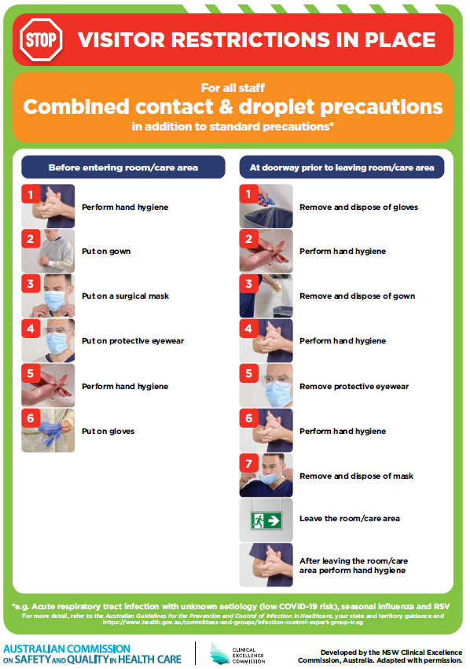](https://www.safetyandquality.gov.au/publications-and-resources/resource-library/poster-combined-contact-and-droplet-precautions)
* ***Poster – Combined airborne and contact precautions*** <https://www.safetyandquality.gov.au/publications-and-resources/resource-library/poster-combined-airborne-and-contact-precautions>   
  [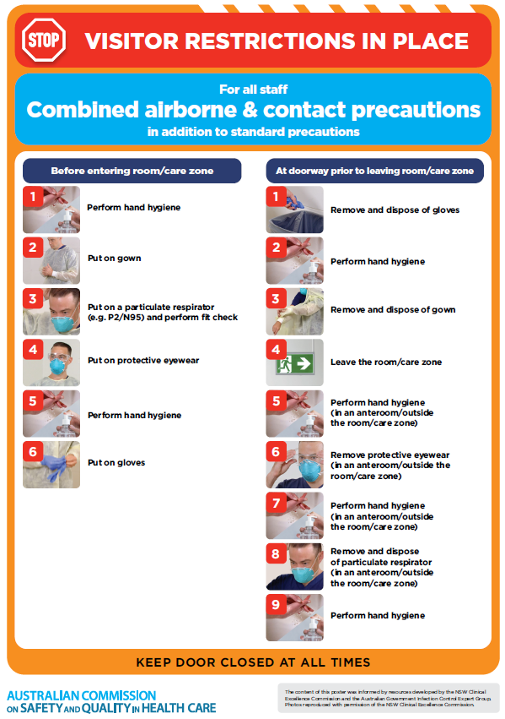](https://www.safetyandquality.gov.au/publications-and-resources/resource-library/poster-combined-airborne-and-contact-precautions)
* ***Environmental Cleaning and Infection Prevention and Control*** [www.safetyandquality.gov.au/environmental-cleaning](http://www.safetyandquality.gov.au/environmental-cleaning)
* ***COVID-19 infection prevention and control risk management – Guidance*** <https://www.safetyandquality.gov.au/publications-and-resources/resource-library/covid-19-infection-prevention-and-control-risk-management-guidance>
* ***Safe care for people with cognitive impairment during COVID-19***<https://www.safetyandquality.gov.au/our-work/cognitive-impairment/cognitive-impairment-and-covid-19>
* ***Stop COVID-19: Break the chain of infection*** posterhttps://www.safetyandquality.gov.au/publications-and-resources/resource-library/break-chain-infection-poster-a3  
  **[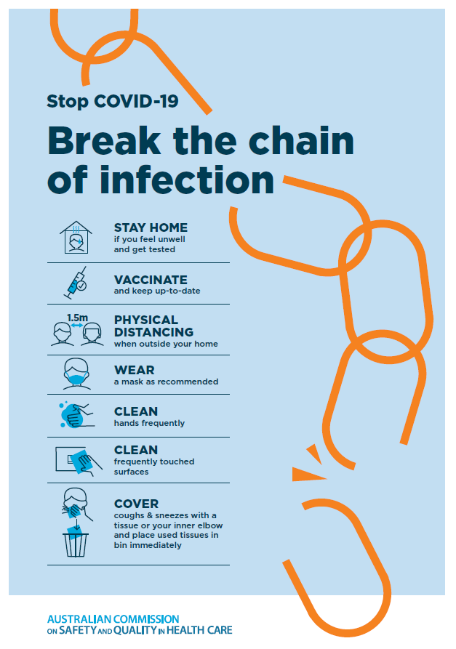](https://www.safetyandquality.gov.au/publications-and-resources/resource-library/break-chain-poster-a3https:/www.safetyandquality.gov.au/publications-and-resources/resource-library/break-chain-poster-a3)**
* ***FAQs for clinicians on elective surgery*** <https://www.safetyandquality.gov.au/node/5724>
* ***FAQs for consumers on elective surgery*** <https://www.safetyandquality.gov.au/node/5725>
* ***COVID-19 and face masks – Information for consumers*** <https://www.safetyandquality.gov.au/publications-and-resources/resource-library/covid-19-and-face-masks-information-consumers>

[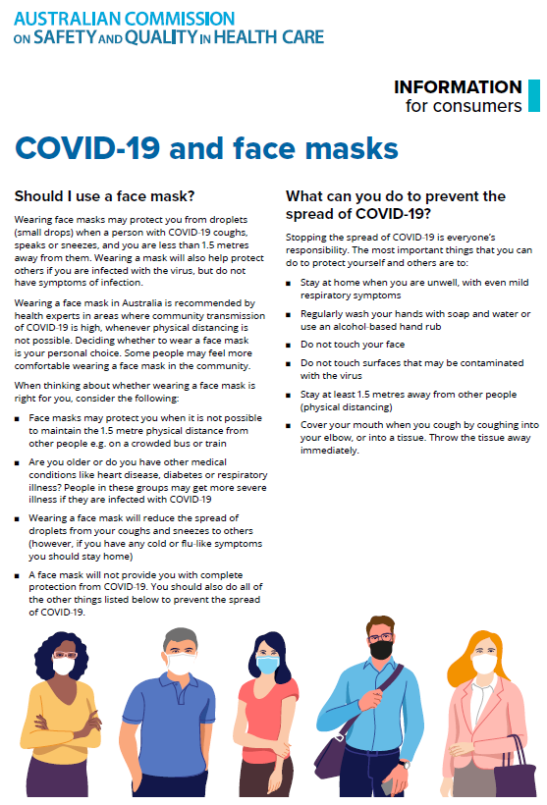](https://www.safetyandquality.gov.au/sites/default/files/2020-07/covid-19_and_face_masks_-_information_for_consumers.pdf)

*National COVID-19 Clinical Evidence Taskforce*

<https://covid19evidence.net.au/>

The National COVID-19 Clinical Evidence Taskforce is a collaboration of peak health professional bodies across Australia whose members are providing clinical care to people with COVID-19. The taskforce is undertaking continuous evidence surveillance to identify and rapidly synthesise emerging research in order to provide national, **evidence-based guidelines and clinical flowcharts for the clinical care of people with COVID-19**. The guidelines address questions that are specific to managing COVID-19 and cover the full disease course across mild, moderate, severe and critical illness. These are ‘living’ guidelines, updated with new research in near real-time in order to give reliable, up-to-the minute advice to clinicians providing frontline care in this unprecedented global health crisis.

*COVID-19 Critical Intelligence Unit*

<https://www.aci.health.nsw.gov.au/covid-19/critical-intelligence-unit>

The Agency for Clinical Innovation (ACI) in New South Wales has developed this page summarising rapid, evidence-based advice during the COVID-19 pandemic. Its operations focus on systems intelligence, clinical intelligence and evidence integration. The content includes a daily evidence digest, a COVID status monitor, a risk monitoring dashboard and evidence checks on a discrete topic or question relating to the current COVID-19 pandemic. There is also a ‘Living evidence’ section summarising key studies and emerging evidence on **COVID-19 vaccines** and **SARS-CoV-2 variants**. The most recent updates include:

* ***Emerging variants*** – What is the available evidence for emerging variants?
* ***Chest pain or dyspnoea following COVID-19 vaccination*** – What is evidence for chest pain or dyspnoea following COVID-19 vaccination?
* ***Cardiac investigations and elective surgery post-COVID-19*** – What is evidence for cardiac investigations and elective surgery post-COVID-19?
* ***Breathlessness post COVID-19*** – How to determine those patients who present with ongoing breathlessness in need of urgent review or intervention due to suspected pulmonary embolus?
* ***COVID-19 pandemic and influenza*** – What is the evidence for COVID-19 pandemic and influenza?
* ***Post-acute sequelae of COVID-19*** – What is the evidence on the post-acute sequelae of COVID-19?
* ***Budesonide and aspirin for pregnant women with COVID-19 –*** What is the evidence for the use of Budesonide for pregnant women with COVID-19? What is the evidence for aspirin prophylaxis for pre-eclampsia in pregnant women with a COVID-19 infection?
* ***COVID-19 vaccines in Australia*** – What is the evidence on COVID-19 vaccines in Australia?
* ***COVID-19 pandemic and wellbeing of critical care and other healthcare workers*** – Evidence in brief on the impact of the COVID-19 pandemic on the wellbeing of critical care and other healthcare workers.
* ***Surgery post COVID-19*** – What is the evidence for the timing of surgery, and outcomes following surgery, for people who have recovered from COVID-19?
* ***Disease modifying treatments for COVID-19 in children*** – What is the evidence for disease modifying treatments for COVID-19 in children?
* ***Mask type for COVID-19 positive wearer*** – What is the evidence for different mask types for COVID-19 positive wearers?
* ***Post acute and subacute COVID-19 care*** – What published advice and models of care are available regarding post-acute and subacute care for COVID-19 patients?
* ***Hospital visitor policies*** – What is the evidence for hospital visitor policies during and outside of the COVID-19 pandemic?
* ***Surgical masks, eye protection and PPE guidance*** –What is the evidence for surgical masks in the endemic phase in hospitals and for eyewear to protect against COVID-19?

**Disclaimer**

On the Radar is an information resource of the Australian Commission on Safety and Quality in Health Care. The Commission is not responsible for the content of, nor does it endorse, any articles or sites listed. The Commission accepts no liability for the information or advice provided by these external links. Links are provided on the basis that users make their own decisions about the accuracy, currency and reliability of the information contained therein. Any opinions expressed are not necessarily those of the Australian Commission on Safety and Quality in Health Care.