# Australian Commission on Safety and Quality logotypeOn the Radar

Issue 563

27 June 2022

*On the Radar* is a summary of some of the recent publications in the areas of safety and quality in health care. Inclusion in this document is not an endorsement or recommendation of any publication or provider. Access to particular documents may depend on whether they are Open Access or not, and/or your individual or institutional access to subscription sites/services. Material that may require subscription is included as it is considered relevant.

*On the Radar* is available online, via email or as a PDF or Word document from <https://www.safetyandquality.gov.au/publications-and-resources/newsletters/radar>

If you would like to receive *On the Radar* via email, you can subscribe on our website <https://www.safetyandquality.gov.au/publications-and-resources/newsletters>  
or by emailing us at H[Umail@safetyandquality.gov.auU](mailto:mail@safetyandquality.gov.au).   
You can also send feedback and comments to H[Umail@safetyandquality.gov.auU](mailto:mail@safetyandquality.gov.au).

For information about the Commission and its programs and publications, please visit <https://www.safetyandquality.gov.au>

You can also follow us on Twitter @ACSQHC.

**On the Radar**

Editor: Dr Niall Johnson [niall.johnson@safetyandquality.gov.au](mailto:niall.johnson@safetyandquality.gov.au)

Contributors: Niall Johnson, Amy Forsyth, Jennifer Caldwell

***Updated Epidemiology and outbreak prevention and management eLearning module***

<https://nhhi.southrock.com>

The Australian Commission on Safety and Quality in Health Care continues to develop and support online learning for infection prevention and control (IPC) and hand hygiene for healthcare workers through its centralised online Learning Management System (LMS).

The Commission is working the ensure that the content of the modules is current and improves the learner experience. Most recently the *Epidemiology and outbreak prevention and management* eLearning module has been updated to ensure consistency with the National Safety and Quality Health Service Standards, specifically the *Preventing and Controlling Infections Standard*, and the *Australian Guidelines for the Prevention and Control of Infection in Healthcare*.

The module is available in the National Hand Hygiene Initiative (NHHI) LMS at <https://nhhi.southrock.com>. Access to the NHHI LMS is free for all users and modules can be accessed after a learner has registered a profile on the system.

[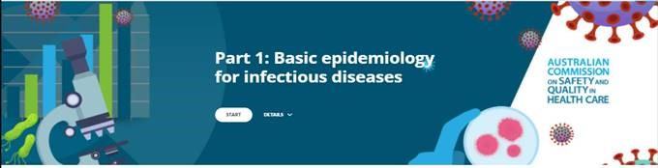](https://nhhi.southrock.com)

[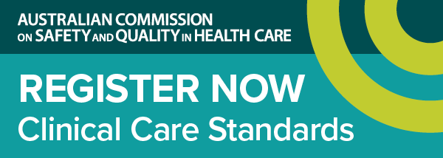](https://www.safetyandquality.gov.au/standards/clinical-care-standards/sepsis-clinical-care-standard)

***Launch of the first national standard of care for sepsis***

<https://www.safetyandquality.gov.au/standards/clinical-care-standards/sepsis-clinical-care-standard>

The Australian Commission on Safety and Quality in Health Care will launch the first national *Sepsis Clinical Care Standard* on **Thursday, 30 June 2022**.

Every year, there are over 55,000 cases of sepsis in Australia and more than 8,700 sepsis-related deaths.

The new clinical care standard provides guidance to ensure we spot the warning signs early and act quickly to stop sepsis and save lives.

Join our webcast to hear the experts discuss timely recognition of sepsis, systems to support time-critical management, the ongoing effects of sepsis, and the importance of multidisciplinary, coordinated sepsis care.

Hosted by Ms Julie McCrossin AM, Broadcaster and Commentator, the panellists include:

* Dr Carolyn Hullick – Clinical Director, Australian Commission on Safety and Quality in Health Care and Emergency Physician, Hunter New England Health NSW
* Professor Simon Finfer AO – Professorial Fellow in the Critical Care Division at The George Institute for Global Health. Adjunct Professor, University of New South Wales and Chair of Critical Care, School of Public Health, Imperial College London
* Associate Professor Paula Lister – Director Paediatric Critical Care, Sunshine Coast University Hospital QLD & Medical Co-Chair, Queensland Paediatric Sepsis Program
* Dr Lorraine Anderson – Medical Director, Kimberley Aboriginal Medical Services WA

Date: **Thursday, 30 June 2022**

Time: **12:00pm – 1:00pm AEST**

Location: Online

Click [here](https://safetyandquality.tv/home/) to register

For more information, email ccs@safetyandquality.gov.au or visit our web page at <https://www.safetyandquality.gov.au/standards/clinical-care-standards/sepsis-clinical-care-standard>

**Journal articles**

*Prioritising Responses Of Nurses To deteriorating patient Observations (PRONTO): a pragmatic cluster randomised controlled trial evaluating the effectiveness of a facilitation intervention on recognition and response to clinical deterioration*

Bucknall TK, Considine J, Harvey G, Graham ID, Rycroft-Malone J, Mitchell I, et al

BMJ Quality & Safety. 2022 [epub].

|  |  |
| --- | --- |
| DOI | <https://doi.org/10.1136/bmjqs-2021-013785> |
| Notes | Paper reporting on ‘a pragmatic cluster randomised controlled trial evaluating the effectiveness of a facilitation intervention on recognition and response to clinical deterioration’. This Australian study involved and compared standard clinical practice guideline (CPG) dissemination to ward staff (n=18) with a facilitated implementation for 6 months following standard dissemination (n=18). The primary outcome was escalation of care as per hospital policy at 6 and 12 months after implementation.  The authors report that ‘From 10 383 audits, improved escalation as per hospital policy was evident in the intervention group at 6 months (OR 1.47, 95% CI (1.06 to 2.04)) with a complete set of vital sign measurements sustained at 12 months (OR 1.22, 95% CI (1.02 to 1.47)).’ However, the authors also found that ‘Multi-level facilitation significantly improved escalation as per hospital policy at 6 months in the intervention group that was not sustained at 12 months. The intervention group had increased vital sign measurement by nurses, as well as shorter lengths of stay for patients at 12 months.’ They also note that ‘The study highlights the potential for targeted behavioural change interventions, supported by electronic decision support systems, to decrease cognitive burden and improve patient safety.’  The issue of clinical deterioration and the importance of timely recognition and response has been known for some time with a range of approaches to addressing this issue adopted. This study suggests that there remains room for improvement.  The Australian Commission on Safety and Quality in Health Care was a research partner on this work. |

For information on the Commission’s work on recognising and responding to deterioration, see <https://www.safetyandquality.gov.au/our-work/recognising-and-responding-deterioration>

*Vitamin, Mineral, and Multivitamin Supplementation to Prevent Cardiovascular Disease and Cancer*

*US Preventive Services Task Force Recommendation Statement*

US Preventive Services Task Force

JAMA. 2022;327(23):2326-2333.

*Multivitamins and Supplements—Benign Prevention or Potentially Harmful Distraction?*

Jia J, Cameron NA, Linder JA

JAMA. 2022;327(23):2294-2295.

*Why Too Many Vitamins Feels Just About Right*

Ubel PA

JAMA Internal Medicine. 2022.

*Vitamins and Minerals to Prevent Cardiovascular Disease and Cancer*

Jin J

JAMA. 2022;327(23):2364-2364.

|  |  |
| --- | --- |
| DOI | US Preventive Services Task Force <https://doi.org/10.1001/jama.2022.8970>  Jia et al <https://doi.org/10.1001/jama.2022.9167>  Ubel <https://10.1001/jamainternmed.2022.0119>  Jin <https://doi.org/10.1001/jama.2022.10009> |
| Notes | The U.S. Preventive Services Task Force has issued its latest recommendation. This recommendation statement is an update on a 2014 recommendation for which ‘the US Preventive Services Task Force (USPSTF) commissioned a review of the evidence on the efficacy of supplementation with single nutrients, functionally related nutrient pairs, or multivitamins for reducing the risk of cardiovascular disease, cancer, and mortality in the general adult population, as well as the harms of supplementation.’  JAMA journals also have related editorials, including Jia et al and Ubel. Ubel observes that ‘US adults spend more than $10 billion per year on vitamins and dietary supplements’. While ‘Vitamins are necessary for life’ … the recent US Preventive Services Task Force (USPSTF) recommendation statement and updated evidence report and systematic review show, there is little evidence that supplemental vitamins and minerals prevent cancer, cardiovascular disease, or mortality.’  JAMA have also published a ‘patient page’ on the recommendation (Jin) that summarises the recommendation for patients. This reiterates that the USPSTF:   * recommends against the use of beta carotene or vitamin E supplements for the prevention of cardiovascular disease or cancer. (D recommendation) * concludes that the current evidence is insufficient to assess the balance of benefits and harms of the use of multivitamin supplements for the prevention of cardiovascular disease or cancer. (I statement) * concludes that the current evidence is insufficient to assess the balance of benefits and harms of the use of single- or paired-nutrient supplements (other than beta carotene and vitamin E) for the prevention of cardiovascular disease or cancer. (I statement).   [Image summarising recommendation from JAMA's Patient Page.](https://doi.org/10.1001/jama.2022.10009) |

*BMJ Quality & Safety* online first articles

|  |  |
| --- | --- |
| URL | <https://qualitysafety.bmj.com/content/early/recent> |
| Notes | *BMJ Quality &Safety* has published a number of ‘online first’ articles, including:   * Effectiveness of a multifaceted quality improvement intervention to improve **patient outcomes after total hip and knee arthroplasty**: a registry nested cluster randomised controlled trial (Peter van Schie, Leti van Bodegom-Vos, Tristan M Zijdeman, Rob G H H Nelissen, Perla J Marang-van de Mheen) * A scoping review of **real-time automated clinical deterioration alerts and evidence of impacts** on hospitalised patient outcomes (Robin Blythe, Rex Parsons, Nicole M White, David Cook, Steven McPhail) |

*International Journal for Quality in Health Care* online first articles

|  |  |
| --- | --- |
| URL | <https://academic.oup.com/intqhc/advance-articles> |
| Notes | *International Journal for Quality in Health Care* has published a number of ‘online first’ articles, including:   * Finding Space for Kindness: **Public Protection and Health Professional Regulation** (Susan Biggar, Martin Fletcher, Anna van der Gaag, Zubin Austin) |

**Online resources**

***[UK] NICE Guidelines and Quality Standards***

<https://www.nice.org.uk/guidance>

The UK’s National Institute for Health and Care Excellence (NICE) has published new (or updated) guidelines and quality standards. The latest reviews or updates are:

* NICE Guideline NG220 ***Multiple sclerosis*** *in adults: management* <https://www.nice.org.uk/guidance/ng220>
* NICE Guideline NG200 *COVID-19 rapid guideline:* ***vaccine-induced immune thrombocytopenia and thrombosis*** *(VITT)*   
  <https://www.nice.org.uk/guidance/ng200>

**w**

**COVID-19 resources**

https://www.safetyandquality.gov.au/covid-19

The Australian Commission on Safety and Quality in Health Care has developed a number of resources to assist healthcare organisations, facilities and clinicians. These and other material on COVID-19 are available at <https://www.safetyandquality.gov.au/covid-19>

These resources include:

* ***OVID-19 infection prevention and control risk management*** This primer provides an overview of three widely used tools for investigating and responding to patient safety events and near misses. Tools covered in this primer include incident reporting systems, Root Cause Analysis (RCA), and Failure Modes and Effects Analysis (FMEA).   
  <https://www.safetyandquality.gov.au/publications-and-resources/resource-library/covid-19-infection-prevention-and-control-risk-management-guidance>
* ***Poster – Combined contact and droplet precautions*** <https://www.safetyandquality.gov.au/publications-and-resources/resource-library/poster-combined-contact-and-droplet-precautions>  
  [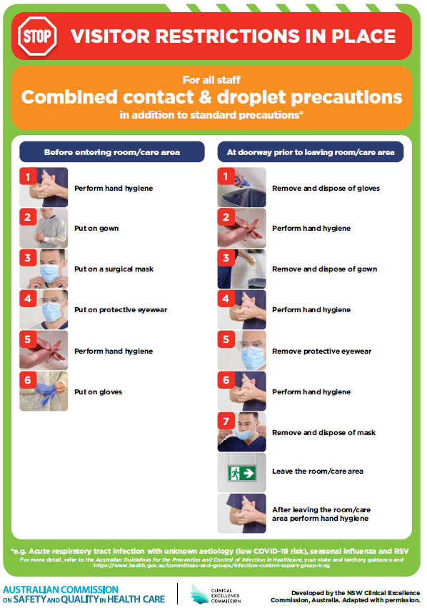](https://www.safetyandquality.gov.au/publications-and-resources/resource-library/poster-combined-contact-and-droplet-precautions)
* ***Poster – Combined airborne and contact precautions*** <https://www.safetyandquality.gov.au/publications-and-resources/resource-library/poster-combined-airborne-and-contact-precautions>   
  [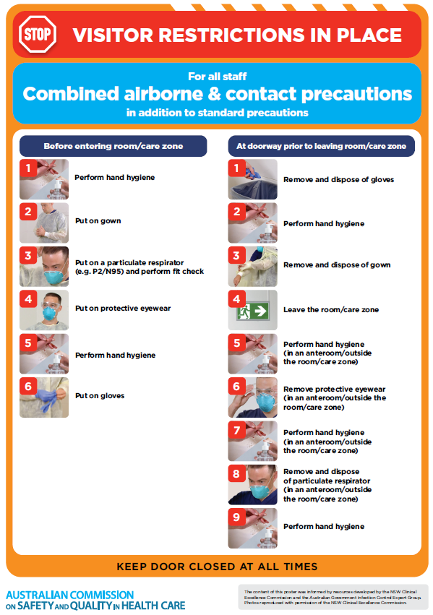](https://www.safetyandquality.gov.au/publications-and-resources/resource-library/poster-combined-airborne-and-contact-precautions)
* ***Environmental Cleaning and Infection Prevention and Control*** [www.safetyandquality.gov.au/environmental-cleaning](http://www.safetyandquality.gov.au/environmental-cleaning)
* ***COVID-19 infection prevention and control risk management – Guidance*** <https://www.safetyandquality.gov.au/publications-and-resources/resource-library/covid-19-infection-prevention-and-control-risk-management-guidance>
* ***Safe care for people with cognitive impairment during COVID-19***<https://www.safetyandquality.gov.au/our-work/cognitive-impairment/cognitive-impairment-and-covid-19>
* ***Stop COVID-19: Break the chain of infection*** posterhttps://www.safetyandquality.gov.au/publications-and-resources/resource-library/break-chain-infection-poster-a3  
  **[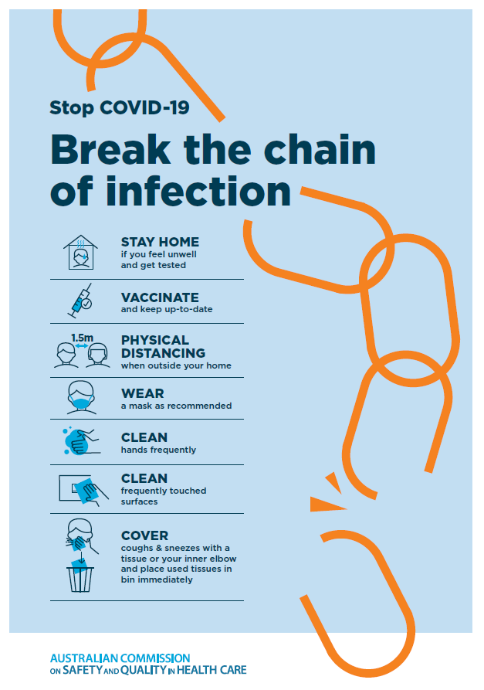](https://www.safetyandquality.gov.au/publications-and-resources/resource-library/break-chain-poster-a3https:/www.safetyandquality.gov.au/publications-and-resources/resource-library/break-chain-poster-a3)**
* ***FAQs for clinicians on elective surgery*** <https://www.safetyandquality.gov.au/node/5724>
* ***FAQs for consumers on elective surgery*** <https://www.safetyandquality.gov.au/node/5725>
* ***COVID-19 and face masks – Information for consumers*** <https://www.safetyandquality.gov.au/publications-and-resources/resource-library/covid-19-and-face-masks-information-consumers>

[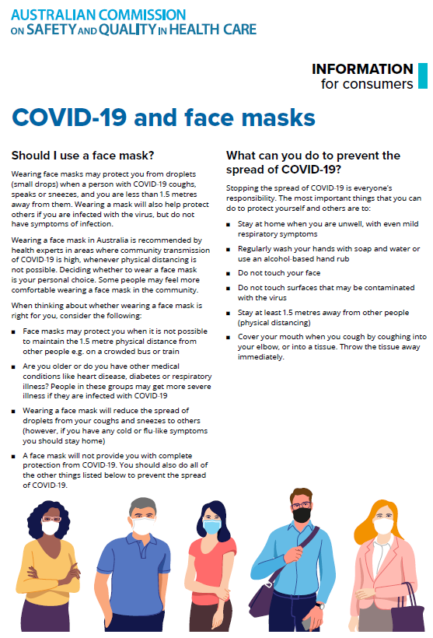](https://www.safetyandquality.gov.au/sites/default/files/2020-07/covid-19_and_face_masks_-_information_for_consumers.pdf)

*National COVID-19 Clinical Evidence Taskforce*

<https://covid19evidence.net.au/>

The National COVID-19 Clinical Evidence Taskforce is a collaboration of peak health professional bodies across Australia whose members are providing clinical care to people with COVID-19. The taskforce is undertaking continuous evidence surveillance to identify and rapidly synthesise emerging research in order to provide national, **evidence-based guidelines and clinical flowcharts for the clinical care of people with COVID-19**. The guidelines address questions that are specific to managing COVID-19 and cover the full disease course across mild, moderate, severe and critical illness. These are ‘living’ guidelines, updated with new research in near real-time in order to give reliable, up-to-the minute advice to clinicians providing frontline care in this unprecedented global health crisis.

*COVID-19 Critical Intelligence Unit*

<https://www.aci.health.nsw.gov.au/covid-19/critical-intelligence-unit>

The Agency for Clinical Innovation (ACI) in New South Wales has developed this page summarising rapid, evidence-based advice during the COVID-19 pandemic. Its operations focus on systems intelligence, clinical intelligence and evidence integration. The content includes a daily evidence digest, a COVID status monitor, a risk monitoring dashboard and evidence checks on a discrete topic or question relating to the current COVID-19 pandemic. There is also a ‘Living evidence’ section summarising key studies and emerging evidence on **COVID-19 vaccines** and **SARS-CoV-2 variants**. The most recent updates include:

* ***Influenza and seasonal prophylaxis with oseltamivir*** – What is the place or evidence for seasonal influenza prophylaxis (such as taking oseltamivir for 10 to 12 weeks continuously) in healthcare and aged care settings?
* ***Rapid access models of care for respiratory illnesses*** – What is the evidence for rapid access models of care for respiratory illnesses, especially during winter seasons, in emergency departments?
* ***Current and emerging patient safety issues during COVID-19*** – What is the evidence on the current and emerging patient safety issues arising from the COVID-19 pandemic?
* ***Post-acute sequelae of COVID-19*** – What is the evidence on the post-acute sequelae of COVID-19?
* ***Emerging variants*** – What is the available evidence for emerging variants?
* ***Chest pain or dyspnoea following COVID-19 vaccination*** – What is evidence for chest pain or dyspnoea following COVID-19 vaccination?
* ***Cardiac investigations and elective surgery post-COVID-19*** – What is evidence for cardiac investigations and elective surgery post-COVID-19?
* ***Breathlessness post COVID-19*** – How to determine those patients who present with ongoing breathlessness in need of urgent review or intervention due to suspected pulmonary embolus?
* ***COVID-19 pandemic and influenza*** – What is the evidence for COVID-19 pandemic and influenza?
* ***Budesonide and aspirin for pregnant women with COVID-19 –*** What is the evidence for the use of Budesonide for pregnant women with COVID-19? What is the evidence for aspirin prophylaxis for pre-eclampsia in pregnant women with a COVID-19 infection?
* ***COVID-19 vaccines in Australia*** – What is the evidence on COVID-19 vaccines in Australia?
* ***COVID-19 pandemic and wellbeing of critical care and other healthcare workers*** – Evidence in brief on the impact of the COVID-19 pandemic on the wellbeing of critical care and other healthcare workers.
* ***Surgery post COVID-19*** – What is the evidence for the timing of surgery, and outcomes following surgery, for people who have recovered from COVID-19?
* ***Disease modifying treatments for COVID-19 in children*** – What is the evidence for disease modifying treatments for COVID-19 in children?
* ***Mask type for COVID-19 positive wearer*** – What is the evidence for different mask types for COVID-19 positive wearers?
* ***Post acute and subacute COVID-19 care*** – What published advice and models of care are available regarding post-acute and subacute care for COVID-19 patients?
* ***Hospital visitor policies*** – What is the evidence for hospital visitor policies during and outside of the COVID-19 pandemic?
* ***Surgical masks, eye protection and PPE guidance*** –What is the evidence for surgical masks in the endemic phase in hospitals and for eyewear to protect against COVID-19?

**Disclaimer**

On the Radar is an information resource of the Australian Commission on Safety and Quality in Health Care. The Commission is not responsible for the content of, nor does it endorse, any articles or sites listed. The Commission accepts no liability for the information or advice provided by these external links. Links are provided on the basis that users make their own decisions about the accuracy, currency and reliability of the information contained therein. Any opinions expressed are not necessarily those of the Australian Commission on Safety and Quality in Health Care.