# Australian Commission on Safety and Quality logotypeOn the Radar

Issue 564

4 July 2022

*On the Radar* is a summary of some of the recent publications in the areas of safety and quality in health care. Inclusion in this document is not an endorsement or recommendation of any publication or provider. Access to particular documents may depend on whether they are Open Access or not, and/or your individual or institutional access to subscription sites/services. Material that may require subscription is included as it is considered relevant.

*On the Radar* is available online, via email or as a PDF or Word document from <https://www.safetyandquality.gov.au/publications-and-resources/newsletters/radar>

If you would like to receive *On the Radar* via email, you can subscribe on our website <https://www.safetyandquality.gov.au/publications-and-resources/newsletters>  
or by emailing us at H[Umail@safetyandquality.gov.auU](mailto:mail@safetyandquality.gov.au).   
You can also send feedback and comments to H[Umail@safetyandquality.gov.auU](mailto:mail@safetyandquality.gov.au).

For information about the Commission and its programs and publications, please visit <https://www.safetyandquality.gov.au>

You can also follow us on Twitter @ACSQHC.

**On the Radar**

Editor: Dr Niall Johnson [niall.johnson@safetyandquality.gov.au](mailto:niall.johnson@safetyandquality.gov.au)

Contributors: Niall Johnson, Dawn Astles, Amy Forsyth

[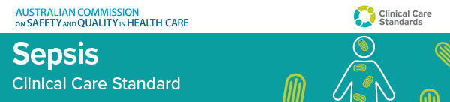](https://www.safetyandquality.gov.au/standards/clinical-care-standards/sepsis-clinical-care-standard)

**First national care standard on sepsis will save lives**

<https://www.safetyandquality.gov.au/sepsis-ccs>

The new *Sepsis Clinical Care Standard* was launched by the Australian Commission on Safety and Quality in Health Care on Thursday 30 June via a live-streamed event. The panel discussion was hosted by broadcaster and commentator Julie McCrossin AM and included the Commission’s Clinical Director, Dr Carolyn Hullick, Professor Simon Finfer AO from The George Institute, Dr Lorraine Anderson from Kimberly Aboriginal Medical Services and Associate Professor Paula Lister from Sunshine Coast University Hospital.

The new standard of care for sepsis will improve the recognition and management of sepsis and its after-effects. Knowing the signs and symptoms of sepsis can be difficult because they can overlap with other health conditions.

Each year more than 8,700 Australians will lose their lives from sepsis, which kills more people every year than road traffic accidents or stroke.

The standard outlines optimal care for patients in hospital with suspected sepsis – from the onset of symptoms, through to discharge from hospital and follow-up care.

The [*Sepsis Clinical Care Standard*](https://www.safetyandquality.gov.au/standards/clinical-care-standards/sepsis-clinical-care-standard) was developed by the Australian Commission on Safety and Quality in Health Care, in partnership with The George Institute for Global Health.

Learn more about Australia’s first national standard for sepsis, access the new standard, case studies and other resources at <https://www.safetyandquality.gov.au/sepsis-ccs>

**Journal articles**

*Adolescents’ self-efficacy and digital health literacy: a cross-sectional mixed methods study*

Taba M, Allen TB, Caldwell PHY, Skinner SR, Kang M, McCaffery K, et al

BMC Public Health 2022;22:1223.

|  |  |
| --- | --- |
| DOI | <https://doi.org/10.1186/s12889-022-13599-7> |
| Notes | Australian study that looked at how adolescents (aged 12 to 17) used the internet and social media for health information purposes. The study found that the ‘participants generally had high self-efficacy using online health information but perceived their digital health literacy to be higher than demonstrated’. So while adolescents are digital-native and view sources somewhat critically they do ‘desire increased digital health literacy so they can confidently appraise health information they find online and on social media’ The authors suggest ‘Co-designed educational interventions with adolescents and health providers are required.’  Image from Twitter post about this article. |

*Healthcare Papers*

Volume 20, Number 3, April 2022

|  |  |
| --- | --- |
| URL | <https://www.longwoods.com/publications/healthcarepapers/26839/> |
|  | A new issue of *Healthcare Papers* has been published. Articles in this issue of *Healthcare Papers* include:   * Editorial: Health Services Policy Research: Uniquely Positioned to Drive **Equitable System Transformation** * Accelerating **Health System Transformation through Research** to Achieve the Quadruple Aim and Health Equity (Meghan McMahon, Jessica Nadigel, Erin Thompson, Nida Shahid, Bahar Kasaai, J Richard and R H Glazer) * The Value of and Need for **Health Services and Policy Research that Focuses on Macro System-Level Challenges** (Kimberlyn McGrail, Fiona Clement and Michael Law) * The **Network of Scholars Strategy**: A Case Study of Embedded Research Activities in Nova Scotia to Advance Health System Impact and Outcomes (Gail Tomblin Murphy, Tara Sampalli, Mark Embrett, Meaghan Sim, Jennifer Murdoch, Kathryn McIsaac, Logan Lawrence, Julia Guk, Andrea Carson, Caroline Chamberland-Rowe, Maggie MacLellan, M MacInnis and R Urban) * How Do We Build the **Human Capital for a True Learning Healthcare System**? (Meghan McMahon, Stephen Bornstein, Shanthi Johnson, Carl-Ardy Dubois, Erin Thompson and Adalsteinn Brown) * Can a **Focus on Equity, Diversity and Inclusion Transform Health Service Research**? (Andrew D Pinto) * **Modernize the Healthcare System**: Stewardship of a Strong Health Data Foundation (Vivek Goel and Kimberlyn McGrail) * **Strategizing Research for Impact** (Denis A Roy, Matthew Menear, Hassane Alami and Jean-Louis Denis) * From Strategy to Implementation: Optimizing the Contribution of Health Services and Policy Research to **Equitable Healthcare System Transformation** (Meghan McMahon, Jessica Nadigel, Bahar Kasaai, Nida Shahid, Erin Thompson and Richard H Glazier) |

*Journal for Healthcare Quality*

Volume 44, Number 4, July/August 2022

|  |  |
| --- | --- |
| URL | <https://journals.lww.com/jhqonline/toc/2022/08000> |
|  | A new issue of the *Journal for Healthcare Quality* has been published. Articles in this issue of the *Journal for Healthcare Quality* include:   * Applying the **Value Transformation Framework** in Federally Qualified Health Centers to Increase Clinical Measures Performance (Modica, Cheryl; Bay, Curt; Lewis, Joy H.; Silva, Camila) * Impact of **Discharge Medication Reconciliation** Across a Five-Hospital Health System (Lee, Veronica; Kowalski, Jaclyn; Liu, Michael; Thayer, Bailey) * **COVID-19 Vaccine Clinic Real-Time Throughput Analysis**: Development and Implementation of an Innovative Data Collection Tool (Skaggs, Michael D; Wendel, Sarah K; Zane, Richard D; Resnick-Ault, Daniel) * **Insulin for Hospitalized Patients With Well-Controlled Type 2 Diabetes Mellitus**: A Quality Improvement Initiative (Goyal, Noopur; Rose, Richard; Johnson, Stacy A.; Babbel, Danielle; Plugge, Thomas; Hodgkin, Jonathan; Simmons, Debra; Yarbrough, Peter) * Development of **Quality Measures for Pediatric Agitation Management in the Emergency Department** (Hoffmann, Jennifer A; Johnson, Julie K; Pergjika, Alba; Alpern, Elizabeth R; Corboy, Jacqueline B) * Patient Characteristics Associated With **Missed Appointments in Pediatric Subspecialty Clinics** (Jones, Michael K; O'Connell, Nathaniel S; Skelton, Joseph A; Halvorson, Elizabeth E) * Cost-Effectiveness Analysis: Personal Systems Approach in Improving **Medication Adherence in Adult Kidney Transplant Patients** (Whittington, Melanie; Goggin, Kathy; Noel-MacDonnell, Janelle; Hathaway, Donna; Remy, Laura; Aholt, Dana; Clark, Debra; Miller, Courtney; Ashbaugh, Catherine; Wakefield, Mark; Ellis, Rebecca B; Russell, Cynthia) |

*BMJ Quality & Safety* online first articles

|  |  |
| --- | --- |
| URL | <https://qualitysafety.bmj.com/content/early/recent> |
| Notes | *BMJ Quality &Safety* has published a number of ‘online first’ articles, including:   * **Economic evaluations of audit and feedback interventions**: a systematic review (Lynne Moore, Jason Robert Guertin, Pier-Alexandre Tardif, Noah Michael Ivers, Jeffrey Hoch, Blanchard Conombo, Jesmin Antony, Henry Thomas Stelfox, Simon Berthelot, Patrick Archambault, Alexis Turgeon, Rohit Gandhi, JM Grimshaw) * Retrospective evaluation of an intervention based on training sessions to increase the **use of control charts in hospitals** (Laura Kudrna, Paul Bird, Karla Hemming, Laura Quinn, Kelly Schmidtke, Richard Lilford) * Impact of **COVID-19 on opioid use in those awaiting hip and knee arthroplasty**: a retrospective cohort study (Luke Farrow, William T Gardner, Chee Chee Tang, Rachel Low, Patrice Forget, George Patrick Ashcroft) |

*International Journal for Quality in Health Care* online first articles

|  |  |
| --- | --- |
| URL | <https://academic.oup.com/intqhc/advance-articles> |
| Notes | *International Journal for Quality in Health Care* has published a number of ‘online first’ articles, including:   * A Quality Improvement Initiative Using Peer Audit and Feedback to Improve **Compliance with the Surgical Safety Checklist** (Annemarie Fridrich, Anita Imhof, Sven Staender, Mirko Brenni, David Schwappach) * Factors Associated with Having **Home Care Physicians as an Integrated Source of Medications** for Chronic Conditions Among Homebound Patients (Jason Jiunshiou Lee, Hsiao-Yun Hu, Shu-Yi Lin, Chao-Ming Huang, Sheng-Jean Huang, Nicole Huang) |

**Online resources**

***How technology can help you look after your health***

<https://www.racgp.org.au/running-a-practice/practice-resources/practice-tools/how-technology-can-help-you-look-after-health>

The Royal Australian College of General Practitioners (RACGP) provides advice and resources to GPs and their practices on various issues, including health ICT. This web page has patient information templates that the RACGP has developed for GP practices to use to provide patients with information on digital health tools and to encourage improved digital health literacy and uptake amongst patients. Current templates include information on:

* online appointment bookings
* telehealth
* health apps
* electronic prescriptions
* My Health Record
* electronic pathology and diagnostic imaging requests
* accessing online proof of CCOVID-19 vaccinations.

***[UK] NICE Guidelines and Quality Standards***

<https://www.nice.org.uk/guidance>

The UK’s National Institute for Health and Care Excellence (NICE) has published new (or updated) guidelines and quality standards. The latest reviews or updates are:

* NICE Guideline NG222 ***Depression*** *in adults: treatment and management* <https://www.nice.org.uk/guidance/ng222>
* NICE Guideline NG28 ***Type 2 diabetes*** *in adults: management* <https://www.nice.org.uk/guidance/ng28>
* NICE Guideline NG17 ***Type 1 diabetes*** *in adults: diagnosis and management* <https://www.nice.org.uk/guidance/ng17>
* NICE Guideline NG18 ***Diabetes*** *(type 1 and type 2) in children and young people: diagnosis and management* <https://www.nice.org.uk/guidance/ng18>

*[UK] NIHR Evidence alerts*

<https://evidence.nihr.ac.uk/>alerts/

The UK’s National Institute for Health Research (NIHR) has posted new evidence alerts on its site. Evidence alerts are short, accessible summaries of health and care research which is funded or supported by NIHR. This is research which could influence practice and each Alert has a message for people commissioning, providing or receiving care. The latest alerts include:

* Open spaces and a sense of belonging improve **wellbeing**
* What does it take to lead an **integrated care system**?
* What support do people with **kidney failure** need?
* People with **polymyalgia rheumatica** need a falls assessment and regular treatment reviews
* Simple tool identifies the people with **diabetes** most likely to develop **foot ulcers**
* Tool helps identify **abuse in young children with burns**
* How to improve discussions about **osteoarthritis in primary care**.

**COVID-19 resources**

https://www.safetyandquality.gov.au/covid-19

The Australian Commission on Safety and Quality in Health Care has developed a number of resources to assist healthcare organisations, facilities and clinicians. These and other material on COVID-19 are available at <https://www.safetyandquality.gov.au/covid-19>

These resources include:

* ***OVID-19 infection prevention and control risk management*** This primer provides an overview of three widely used tools for investigating and responding to patient safety events and near misses. Tools covered in this primer include incident reporting systems, Root Cause Analysis (RCA), and Failure Modes and Effects Analysis (FMEA).   
  <https://www.safetyandquality.gov.au/publications-and-resources/resource-library/covid-19-infection-prevention-and-control-risk-management-guidance>
* ***Poster – Combined contact and droplet precautions*** <https://www.safetyandquality.gov.au/publications-and-resources/resource-library/poster-combined-contact-and-droplet-precautions>  
  [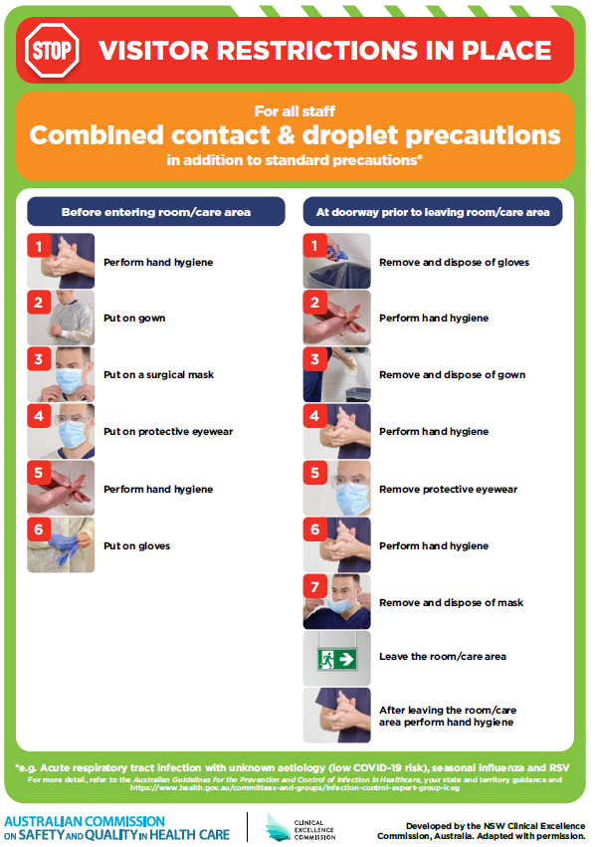](https://www.safetyandquality.gov.au/publications-and-resources/resource-library/poster-combined-contact-and-droplet-precautions)
* ***Poster – Combined airborne and contact precautions*** <https://www.safetyandquality.gov.au/publications-and-resources/resource-library/poster-combined-airborne-and-contact-precautions>   
  [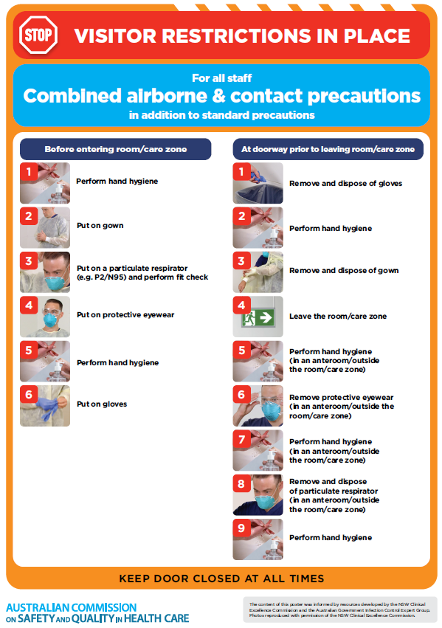](https://www.safetyandquality.gov.au/publications-and-resources/resource-library/poster-combined-airborne-and-contact-precautions)
* ***Environmental Cleaning and Infection Prevention and Control*** [www.safetyandquality.gov.au/environmental-cleaning](http://www.safetyandquality.gov.au/environmental-cleaning)
* ***COVID-19 infection prevention and control risk management – Guidance*** <https://www.safetyandquality.gov.au/publications-and-resources/resource-library/covid-19-infection-prevention-and-control-risk-management-guidance>
* ***Safe care for people with cognitive impairment during COVID-19***<https://www.safetyandquality.gov.au/our-work/cognitive-impairment/cognitive-impairment-and-covid-19>
* ***Stop COVID-19: Break the chain of infection*** posterhttps://www.safetyandquality.gov.au/publications-and-resources/resource-library/break-chain-infection-poster-a3  
  **[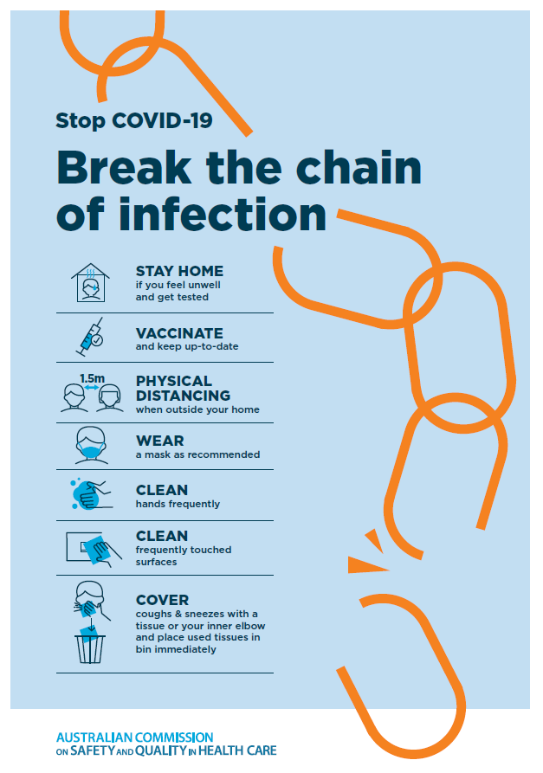](https://www.safetyandquality.gov.au/publications-and-resources/resource-library/break-chain-poster-a3https:/www.safetyandquality.gov.au/publications-and-resources/resource-library/break-chain-poster-a3)**
* ***FAQs for clinicians on elective surgery*** <https://www.safetyandquality.gov.au/node/5724>
* ***FAQs for consumers on elective surgery*** <https://www.safetyandquality.gov.au/node/5725>
* ***COVID-19 and face masks – Information for consumers*** <https://www.safetyandquality.gov.au/publications-and-resources/resource-library/covid-19-and-face-masks-information-consumers>

[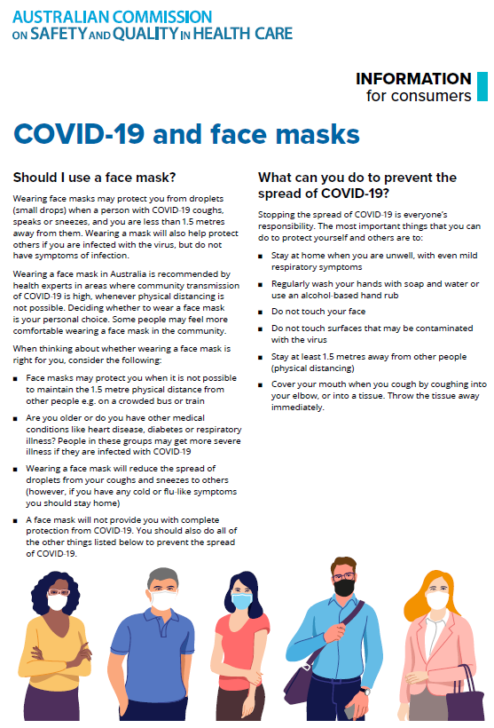](https://www.safetyandquality.gov.au/sites/default/files/2020-07/covid-19_and_face_masks_-_information_for_consumers.pdf)

*National COVID-19 Clinical Evidence Taskforce*

<https://covid19evidence.net.au/>

The National COVID-19 Clinical Evidence Taskforce is a collaboration of peak health professional bodies across Australia whose members are providing clinical care to people with COVID-19. The taskforce is undertaking continuous evidence surveillance to identify and rapidly synthesise emerging research in order to provide national, **evidence-based guidelines and clinical flowcharts for the clinical care of people with COVID-19**. The guidelines address questions that are specific to managing COVID-19 and cover the full disease course across mild, moderate, severe and critical illness. These are ‘living’ guidelines, updated with new research in near real-time in order to give reliable, up-to-the minute advice to clinicians providing frontline care in this unprecedented global health crisis.

*COVID-19 Critical Intelligence Unit*

<https://www.aci.health.nsw.gov.au/covid-19/critical-intelligence-unit>

The Agency for Clinical Innovation (ACI) in New South Wales has developed this page summarising rapid, evidence-based advice during the COVID-19 pandemic. Its operations focus on systems intelligence, clinical intelligence and evidence integration. The content includes a daily evidence digest, a COVID status monitor, a risk monitoring dashboard and evidence checks on a discrete topic or question relating to the current COVID-19 pandemic. There is also a ‘Living evidence’ section summarising key studies and emerging evidence on **COVID-19 vaccines** and **SARS-CoV-2 variants**. The most recent updates include:

* ***Influenza and seasonal prophylaxis with oseltamivir*** – What is the place or evidence for seasonal influenza prophylaxis (such as taking oseltamivir for 10 to 12 weeks continuously) in healthcare and aged care settings?
* ***Rapid access models of care for respiratory illnesses*** – What is the evidence for rapid access models of care for respiratory illnesses, especially during winter seasons, in emergency departments?
* ***Current and emerging patient safety issues during COVID-19*** – What is the evidence on the current and emerging patient safety issues arising from the COVID-19 pandemic?
* ***Post-acute sequelae of COVID-19*** – What is the evidence on the post-acute sequelae of COVID-19?
* ***Emerging variants*** – What is the available evidence for emerging variants?
* ***Chest pain or dyspnoea following COVID-19 vaccination*** – What is evidence for chest pain or dyspnoea following COVID-19 vaccination?
* ***Cardiac investigations and elective surgery post-COVID-19*** – What is evidence for cardiac investigations and elective surgery post-COVID-19?
* ***Breathlessness post COVID-19*** – How to determine those patients who present with ongoing breathlessness in need of urgent review or intervention due to suspected pulmonary embolus?
* ***COVID-19 pandemic and influenza*** – What is the evidence for COVID-19 pandemic and influenza?
* ***Budesonide and aspirin for pregnant women with COVID-19 –*** What is the evidence for the use of Budesonide for pregnant women with COVID-19? What is the evidence for aspirin prophylaxis for pre-eclampsia in pregnant women with a COVID-19 infection?
* ***COVID-19 vaccines in Australia*** – What is the evidence on COVID-19 vaccines in Australia?
* ***COVID-19 pandemic and wellbeing of critical care and other healthcare workers*** – Evidence in brief on the impact of the COVID-19 pandemic on the wellbeing of critical care and other healthcare workers.
* ***Surgery post COVID-19*** – What is the evidence for the timing of surgery, and outcomes following surgery, for people who have recovered from COVID-19?
* ***Disease modifying treatments for COVID-19 in children*** – What is the evidence for disease modifying treatments for COVID-19 in children?
* ***Mask type for COVID-19 positive wearer*** – What is the evidence for different mask types for COVID-19 positive wearers?
* ***Post acute and subacute COVID-19 care*** – What published advice and models of care are available regarding post-acute and subacute care for COVID-19 patients?
* ***Hospital visitor policies*** – What is the evidence for hospital visitor policies during and outside of the COVID-19 pandemic?
* ***Surgical masks, eye protection and PPE guidance*** –What is the evidence for surgical masks in the endemic phase in hospitals and for eyewear to protect against COVID-19?

**Disclaimer**

On the Radar is an information resource of the Australian Commission on Safety and Quality in Health Care. The Commission is not responsible for the content of, nor does it endorse, any articles or sites listed. The Commission accepts no liability for the information or advice provided by these external links. Links are provided on the basis that users make their own decisions about the accuracy, currency and reliability of the information contained therein. Any opinions expressed are not necessarily those of the Australian Commission on Safety and Quality in Health Care.