# Australian Commission on Safety and Quality logotypeOn the Radar

Issue 566

18 July 2022

*On the Radar* is a summary of some of the recent publications in the areas of safety and quality in health care. Inclusion in this document is not an endorsement or recommendation of any publication or provider. Access to particular documents may depend on whether they are Open Access or not, and/or your individual or institutional access to subscription sites/services. Material that may require subscription is included as it is considered relevant.

*On the Radar* is available online, via email or as a PDF or Word document from <https://www.safetyandquality.gov.au/publications-and-resources/newsletters/radar>

If you would like to receive *On the Radar* via email, you can subscribe on our website <https://www.safetyandquality.gov.au/publications-and-resources/newsletters>  
or by emailing us at H[Umail@safetyandquality.gov.auU](mailto:mail@safetyandquality.gov.au).   
You can also send feedback and comments to H[Umail@safetyandquality.gov.auU](mailto:mail@safetyandquality.gov.au).

For information about the Commission and its programs and publications, please visit <https://www.safetyandquality.gov.au>

You can also follow us on Twitter @ACSQHC.

**On the Radar**

Editor: Dr Niall Johnson [niall.johnson@safetyandquality.gov.au](mailto:niall.johnson@safetyandquality.gov.au)

Contributors: Niall Johnson, Jennifer Caldwell

***Updated Health workforce screening and immunisation for vaccine-preventable diseases eLearning module***

<https://nhhi.southrock.com>

The Australian Commission on Safety and Quality in Health Care continues to develop and support online learning for infection prevention and control (IPC) and hand hygiene for healthcare workers through its centralised online Learning Management System (LMS).

The Commission is working the ensure that the content of the modules is current and improves the learner experience. Most recently the *Health workforce screening and immunisation for vaccine-preventable diseases* eLearning module has been updated to ensure consistency with the National Safety and Quality Health Service Standards, specifically the *Preventing and Controlling Infections Standard*, and the *Australian Guidelines for the Prevention and Control of Infection in Healthcare*.

The module is available in the National Hand Hygiene Initiative (NHHI) LMS at <https://nhhi.southrock.com>. Access to the NHHI LMS is free for all users and modules can be accessed after a learner has registered a profile on the system.

[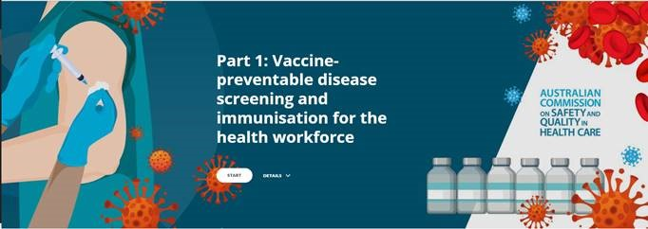](https://nhhi.southrock.com)

**Reports**

*Value-based healthcare in psychology private practice: Paving the way for improved client value*

Deeble Institute Perspectives Brief No. 23

Castle N

Canberra: Australian Healthcare and Hospitals Association; 2022. p. 10.

|  |  |
| --- | --- |
| URL | <https://ahha.asn.au/deeble-institute-perspective-briefs>  <https://ahha.asn.au/sites/default/files/docs/policy-issue/perspectives_brief_no_23._vbhc_in_private_psychology_practice_1.pdf> |
| Notes | This Perspectives Brief from the Australian Healthcare and Hospitals Association’s Deeble Institute looks at how taking a value-based approach may change the delivery of psychology. Written by a psychologist reflecting on his own experiences, the brief examines methods to enact the principles of value-based healthcare through evaluation of the effectiveness and efficiency of care, and engagement of clients. |

*Administering high-strength insulin from a pen device in hospital*

Independent report by the Healthcare Safety Investigation Branch I2020/007

Healthcare Safety Investigation Branch

Farnborough: HSIB; 2022. p. 48.

|  |  |
| --- | --- |
| URL | <https://www.hsib.org.uk/investigations-and-reports/administering-high-strength-insulin-from-a-pen-device-in-hospital/> |
| Notes | This latest investigation report from the UK’s Healthcare Safety Investigation Branch examined the issue of high-strength insulin pens. Where patients were using such insulin pens were then hospitalised there had been instances of insulin overdose and hypoglycaemia. The report’s ‘findings and safety observations aim to prevent future occurrences of hypoglycaemia as a result of an insulin overdose among hospitalised patients receiving insulin from a pen device.’ |

**Journal articles**

*Improvements in Hospital Adverse Event Rates: Achieving Statistically Significant and Clinically Meaningful Results*

Padula WV, Pronovost PJ

JAMA. 2022;328(2):148-150.

*Trends in Adverse Event Rates in Hospitalized Patients, 2010-2019*

Eldridge N, Wang Y, Metersky M, Eckenrode S, Mathew J, Sonnenfeld N, et al

JAMA. 2022;328(2):173-183.

|  |  |
| --- | --- |
| DOI | Padula and Pronovost <https://doi.org/10.1001/jama.2022.10281>  Eldridge et al <https://doi.org/10.1001/jama.2022.9600> |
| Notes | Padula and Pronovost provide an editorial in the *Journal of the American Medical Association* (JAMA) responding to an article (Eldridge et al) suggesting that the rate adverse events in hospitalised patients in the USA had fallen across the period 2010–2019. Padula and Pronovost observe that while that paper ‘reported statistically significant decreases across adverse events from 2010 through 2019, patients may be less convinced that risk-adjusted annual declines of 6% in the rates of acute myocardial infarction or pneumonia, for instance, imply that hospitals are adequately safer today.’ Citing the 2022 US Office of Inspector General’s report (<https://oig.hhs.gov/oei/reports/OEI-06-18-00400.asp>) that estimated 25% of hospitalized Medicare patients experienced harms in October 2018 alone, along with other sources that record various forms of harms are persistently prevalent, they call for renewed efforts to address harms. This includes better measures, including measuring outcomes, changes to payment systems, improved communication of guidelines and interventions that work, better management and accountability, innovation, and investigation of adverse events. |

*Distinguishing High-Performing From Low-Performing Hospitals for Severe Maternal Morbidity: A Focus on Quality and Equity*

Howell EA, Sofaer S, Balbierz A, Kheyfets A, Glazer KB, Zeitlin J

Obstetrics & Gynecology. 2022;139(6):1061-1069.

|  |  |
| --- | --- |
| DOI | <https://doi.org/10.1097/AOG.0000000000004806> |
| Notes | While maternity care in many countries may be considered to have better outcomes than in the USA, this examination of the ‘organizational factors, policies, and practices distinguish hospitals with high compared with low risk-adjusted rates of severe maternal morbidity’ in New York City may be useful. From analyses of the interviews with health care professionals, the study identified six themes. The authors report that ‘High-performing hospitals were more likely to have:  1) senior leadership involved in day-to-day quality activities and dedicated to quality improvement,  2) a strong focus on standards and standardized care,  3) strong nurse–physician communication and teamwork,  4) adequate physician and nurse staffing and supervision,  5) sharing of performance data with nurses and other frontline clinicians, and  6) explicit awareness that racial and ethnic disparities exist and that racism and bias in the hospital can lead to differential treatment.’ |

*Exemplars in Long-Term Care during COVID-19: The Importance of Leadership*

Baumann A, Crea-Arsenio M, Lavoie-Tremblay M, Meershoek A, Norman P, Deber R

Healthcare Policy. 2022;17(Special Issue):27-39.

|  |  |
| --- | --- |
| DOI | <https://doi.org/10.12927/hcpol.2022.26856>  <https://www.longwoods.com/content/26856/healthcare-policy/exemplars-in-long-term-care-during-covid-19-the-importance-of-leadership> |
| Notes | This paper comes from a special issue of Healthcare Policy focussing on ‘Long-Term Care during COVID 19’. This piece examined those long term care (LTC) homes that provided exemplary care and remained free of COVID-19 in the first wave of the pandemic in Ontario, Canada. The authors conclude that ‘Throughout the study, the role and involvement of leadership were evident. The homes that did well focused on empowering, educating and supporting employees and used agile and innovative strategies for staffing. They also prioritized resident-focused care, built on existing partnerships, established new links with both community and health services and enabled staff and families to participate more fully in meeting the needs of a vulnerable population. The decisions and approaches implemented by the exemplar homes in our study provide evidence for what works in practice and, more importantly, in a crisis.’ |

*Measuring Performance of the Diagnostic Process*

Burstin H, Cosby K

JAMA. 2022;328(2):143-144.

|  |  |
| --- | --- |
| DOI | <https://doi.org/10.1001/jama.2022.10166> |
| Notes | The latest in *JAMA*’s articles on diagnostic excellence focuses on the issue of measurement and the difficulties in measuring diagnostic performance. The key points identified include:   1. ‘Measurement is necessary to assess diagnostic safety, quality, and equity and can be a valuable guide to identify improvement strategies that work for patients and clinicians. 2. Diagnostic measurement has been limited by the lack of shared definitions for diagnostic performance or standards for excellence and inadequate data infrastructure designed for that purpose. 3. An evolving model for diagnostic measurement should consider new and novel data sources and measurement approaches. 4. Diagnostic measurement should drive toward real-time monitoring, feedback, and diagnostic support while minimizing measurement burden and avoiding unintended consequences.’ |

*Healthcare Policy*

Volume. 17, Special Issue June 2022

|  |  |
| --- | --- |
| URL | <https://www.longwoods.com/publications/healthcare-policy/26848/1/vol.-17-special-issue-long-term-care-in-crisis-the-reality-of-covid-19> |
|  | A new issue of *Healthcare Policy* has been published. This is a special issue with a theme of “**Long-Term Care in Crisis: The Reality of COVID-19**”. Articles in this special issue of *Healthcare Policy* include:   * Editorial: **Long-Term Care during COVID-19**: A Special Look under the Hood (Jason M Sutherland) * Introduction – **COVID-19 and Long-Term Care**: What Have We Learned? (Raisa Deber, Mary Crea-Arsenio, Mélanie Lavoie-Tremblay and A Baumann) * Perspectives from the Netherlands: Responses from, **Strategies of and Challenges for Long-Term Care Health Personnel** (Agnes Meershoek, Laura Broek and Mary Crea-Arsenio) * **Exemplars in Long-Term Care** during COVID-19: The Importance of Leadership (Andrea Baumann, Mary Crea-Arsenio, Mélanie Lavoie-Tremblay, Agnes Meershoek, Pat Norman and Raisa Deber) * **Lessons from Long-Term Care Facilities** without COVID-19 Outbreaks (Mélanie Lavoie-Tremblay, Guylaine Cyr, Thalia Aubé and Geneviève Lavigne) * **COVID-19 Issues in Long-Term Care** in Ontario: A Document Analysis (David Oldenburger, A Baumann, M Crea-Arsenio, R Deber and V Baba) * What is Old is New Again: **Global Issues Influencing Workers and Their Work in Long-Term Care** (Whitney B. Berta, Cal Stewart and A Baumann) * **Forecasting Staffing Needs** for Ontario’s Long-Term Care Sector (Adrian Rohit Dass, Raisa Deber and Audrey Laporte) * Frequency of **Neglect and Its Effect on Mortality in Long-Term Care** before and during the COVID-19 Pandemic (Noori Akhtar-Danesh, Andrea Baumann, Mary Crea-Arsenio and Valentina Antonipillai) * **Inspection Reports**: The Canary in the Coal Mine (Mary Crea-Arsenio, Andrea Baumann and Victoria Smith) * Rights versus Risks: The **Impact of Isolation on Residents and Families in Long-Term Care** (Andrea Baumann and Mary Crea-Arsenio) |

*Journal of Health Services Research & Policy*

Volume 27, Number 3, July 2022

|  |  |
| --- | --- |
| URL | <https://journals.sagepub.com/toc/hsrb/27/3> |
|  | A new issue of the *Journal of Health Services Research & Policy* has been published. Articles in this issue of the *Journal of Health Services Research & Policy* include:   * Examining organization and provider challenges with the adoption of **virtual domestic violence and sexual assault interventions** in Alberta, Canada, during the COVID-19 pandemic (Stephanie Montesanti, Winta Ghidei, Peter Silverstone, Lana Wells, Suzanne Squires, Allan Bailey) * **Socioeconomic inequalities in health care utilization** in Paraguay: Description of trends from 1999 to 2018 (Diego A Capurro, Sam Harper) * Variations in policies for **accessing elective musculoskeletal procedures** in the English National Health Service: A documentary analysis (Leila Rooshenas, Sharea Ijaz, Alison Richards, Alba Realpe, Jelena Savovic, Tim Jones, William Hollingworth, Jenny L Donovan) * Perceived impact of **formulating, implementing and enacting national mental health policies recommendations in practice**: An exploratory qualitative study within child and adolescent mental health services in Scotland (Madalina Toma, Julie Anderson, Sarah Forster, Paula Shiels, Shirley Windsor, Nicola M Gray) * **Inter-organisational collaboration enabling care delivery** in a specialist cancer surgery provider network: A qualitative study (Cecilia Vindrola-Padros, Angus IG Ramsay, Georgia Black, Ravi Barod, John Hines, Muntzer Mughal, David Shackley, Naomi J Fulop) * Village health worker motivation for **better performance in a maternal and child health programme** in Nigeria: A realist evaluation (Chinyere Mbachu, Enyi Etiaba, Bassey Ebenso, Udochukwu Ogu, Obinna Onwujekwe, Benjamin Uzochukwu, Ana Manzano, Tolib Mirzoev) * Unseen patterns of **preventable emergency care**: Emergency department visits for ambulatory care sensitive conditions (Beth Parkinson, Rachel Meacock, Katherine Checkland, Matt Sutton) * The **social networks of hospital staff**: A realist synthesis (Claire Blacklock, Amy Darwin, Mike English, Jacob McKnight, Lisa Hinton, Elinor Harriss, Geoff Wong) |

*BMJ Quality & Safety* online first articles

|  |  |
| --- | --- |
| URL | <https://qualitysafety.bmj.com/content/early/recent> |
| Notes | *BMJ Quality &Safety* has published a number of ‘online first’ articles, including:   * Engagement and fidelity of a **cardiovascular disease prevention-focused digital health intervention** in cardiology outpatient waiting rooms: a mixed-methods study (Daniel Mcintyre, Jason Chiang, Aravinda Thiagalingam, Allison Tong, Clara Kayei Chow) |

**Online resources**

***Clinical Communiqué***

<https://www.thecommuniques.com/post/clinical-communiqu%C3%A9-volume-9-issue-2-june-2022>

Volume 9 Issue 2, June 2022

This issue of *Clinical Communiqué* includes a number of reflections on the evolution of quality and patient safety in Australia and overseas to mark 20 years of work on the publication.

***[UK] NICE Guidelines and Quality Standards***

<https://www.nice.org.uk/guidance>

The UK’s National Institute for Health and Care Excellence (NICE) has published new (or updated) guidelines and quality standards. The latest reviews or updates are:

* NICE Guideline NG187 *COVID-19 rapid guideline:* ***vitamin D*** <https://www.nice.org.uk/guidance/ng187>
* NICE Guideline NG191 *COVID-19 rapid guideline:* ***managing COVID-19*** <https://www.nice.org.uk/guidance/ng191>

**[UK] Flooding and public mental health: assessment and management**

<https://www.gov.uk/government/publications/flooding-and-public-mental-health-assessment-and-management>

While this guidance document has been produced by the UK Health Security Agency for public health authorities in the UK, given recent events in parts of Australia it may have relevance elsewhere. This guide ‘aims to provide information on the measures needed to prevent major effects on health arising from floods in England.’

**COVID-19 resources**

https://www.safetyandquality.gov.au/covid-19

The Australian Commission on Safety and Quality in Health Care has developed a number of resources to assist healthcare organisations, facilities and clinicians. These and other material on COVID-19 are available at <https://www.safetyandquality.gov.au/covid-19>

These resources include:

* ***OVID-19 infection prevention and control risk management*** This primer provides an overview of three widely used tools for investigating and responding to patient safety events and near misses. Tools covered in this primer include incident reporting systems, Root Cause Analysis (RCA), and Failure Modes and Effects Analysis (FMEA).   
  <https://www.safetyandquality.gov.au/publications-and-resources/resource-library/covid-19-infection-prevention-and-control-risk-management-guidance>
* ***Poster – Combined contact and droplet precautions*** <https://www.safetyandquality.gov.au/publications-and-resources/resource-library/infection-prevention-and-control-poster-combined-contact-and-droplet-precautions>  
  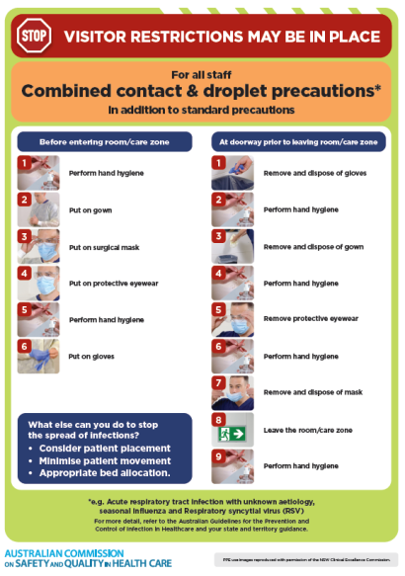
* ***Poster – Combined airborne and contact precautions*** <https://www.safetyandquality.gov.au/publications-and-resources/resource-library/poster-combined-airborne-and-contact-precautions>   
  [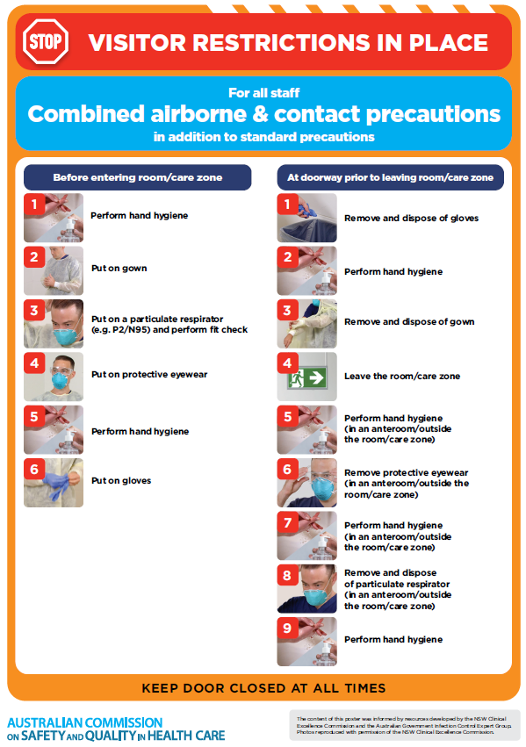](https://www.safetyandquality.gov.au/publications-and-resources/resource-library/poster-combined-airborne-and-contact-precautions)
* ***Environmental Cleaning and Infection Prevention and Control*** [www.safetyandquality.gov.au/environmental-cleaning](http://www.safetyandquality.gov.au/environmental-cleaning)
* ***COVID-19 infection prevention and control risk management – Guidance*** <https://www.safetyandquality.gov.au/publications-and-resources/resource-library/covid-19-infection-prevention-and-control-risk-management-guidance>
* ***Safe care for people with cognitive impairment during COVID-19***<https://www.safetyandquality.gov.au/our-work/cognitive-impairment/cognitive-impairment-and-covid-19>
* ***Stop COVID-19: Break the chain of infection*** posterhttps://www.safetyandquality.gov.au/publications-and-resources/resource-library/break-chain-infection-poster-a3  
  **[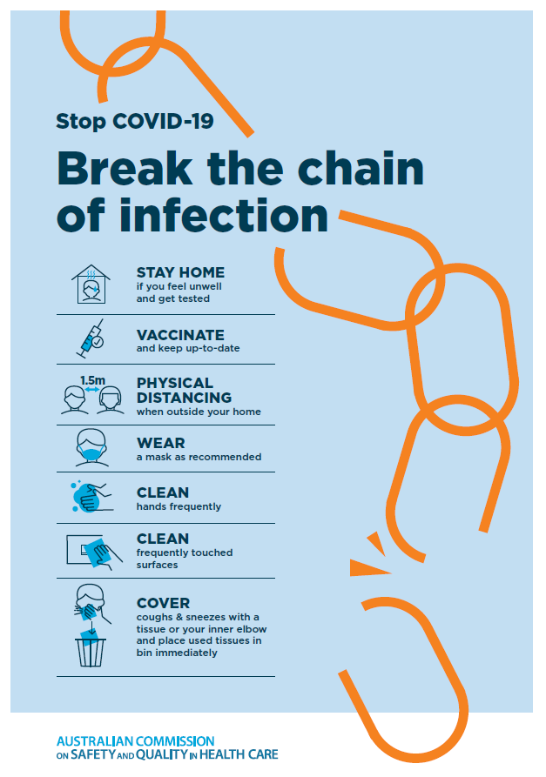](https://www.safetyandquality.gov.au/publications-and-resources/resource-library/break-chain-poster-a3https:/www.safetyandquality.gov.au/publications-and-resources/resource-library/break-chain-poster-a3)**
* ***FAQs for clinicians on elective surgery*** <https://www.safetyandquality.gov.au/node/5724>
* ***FAQs for consumers on elective surgery*** <https://www.safetyandquality.gov.au/node/5725>
* ***COVID-19 and face masks – Information for consumers*** <https://www.safetyandquality.gov.au/publications-and-resources/resource-library/covid-19-and-face-masks-information-consumers>

[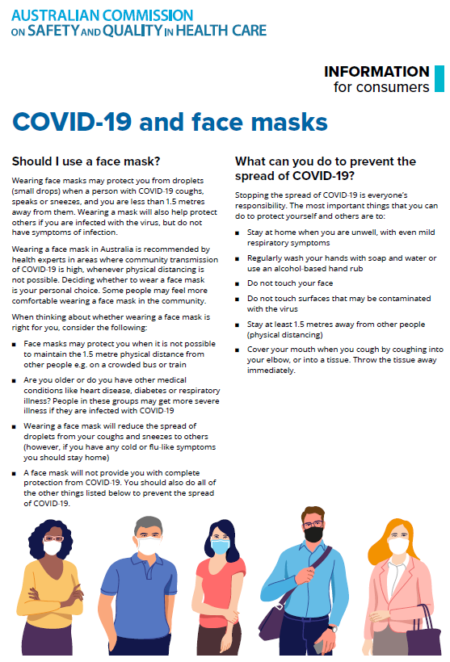](https://www.safetyandquality.gov.au/sites/default/files/2020-07/covid-19_and_face_masks_-_information_for_consumers.pdf)

*National COVID-19 Clinical Evidence Taskforce*

<https://covid19evidence.net.au/>

The National COVID-19 Clinical Evidence Taskforce is a collaboration of peak health professional bodies across Australia whose members are providing clinical care to people with COVID-19. The taskforce is undertaking continuous evidence surveillance to identify and rapidly synthesise emerging research in order to provide national, **evidence-based guidelines and clinical flowcharts for the clinical care of people with COVID-19**. The guidelines address questions that are specific to managing COVID-19 and cover the full disease course across mild, moderate, severe and critical illness. These are ‘living’ guidelines, updated with new research in near real-time in order to give reliable, up-to-the minute advice to clinicians providing frontline care in this unprecedented global health crisis.

*COVID-19 Critical Intelligence Unit*

<https://www.aci.health.nsw.gov.au/covid-19/critical-intelligence-unit>

The Agency for Clinical Innovation (ACI) in New South Wales has developed this page summarising rapid, evidence-based advice during the COVID-19 pandemic. Its operations focus on systems intelligence, clinical intelligence and evidence integration. The content includes a daily evidence digest, a COVID status monitor, a risk monitoring dashboard and evidence checks on a discrete topic or question relating to the current COVID-19 pandemic. There is also a ‘Living evidence’ section summarising key studies and emerging evidence on **COVID-19 vaccines** and **SARS-CoV-2 variants**. The most recent updates include:

* ***Influenza and seasonal prophylaxis with oseltamivir*** – What is the place or evidence for seasonal influenza prophylaxis (such as taking oseltamivir for 10 to 12 weeks continuously) in healthcare and aged care settings?
* ***Rapid access models of care for respiratory illnesses*** – What is the evidence for rapid access models of care for respiratory illnesses, especially during winter seasons, in emergency departments?
* ***Current and emerging patient safety issues during COVID-19*** – What is the evidence on the current and emerging patient safety issues arising from the COVID-19 pandemic?
* ***Post-acute sequelae of COVID-19*** – What is the evidence on the post-acute sequelae of COVID-19?
* ***Emerging variants*** – What is the available evidence for emerging variants?
* ***Chest pain or dyspnoea following COVID-19 vaccination*** – What is evidence for chest pain or dyspnoea following COVID-19 vaccination?
* ***Cardiac investigations and elective surgery post-COVID-19*** – What is evidence for cardiac investigations and elective surgery post-COVID-19?
* ***Breathlessness post COVID-19*** – How to determine those patients who present with ongoing breathlessness in need of urgent review or intervention due to suspected pulmonary embolus?
* ***COVID-19 pandemic and influenza*** – What is the evidence for COVID-19 pandemic and influenza?
* ***Budesonide and aspirin for pregnant women with COVID-19 –*** What is the evidence for the use of Budesonide for pregnant women with COVID-19? What is the evidence for aspirin prophylaxis for pre-eclampsia in pregnant women with a COVID-19 infection?
* ***COVID-19 vaccines in Australia*** – What is the evidence on COVID-19 vaccines in Australia?
* ***COVID-19 pandemic and wellbeing of critical care and other healthcare workers*** – Evidence in brief on the impact of the COVID-19 pandemic on the wellbeing of critical care and other healthcare workers.
* ***Surgery post COVID-19*** – What is the evidence for the timing of surgery, and outcomes following surgery, for people who have recovered from COVID-19?
* ***Disease modifying treatments for COVID-19 in children*** – What is the evidence for disease modifying treatments for COVID-19 in children?
* ***Mask type for COVID-19 positive wearer*** – What is the evidence for different mask types for COVID-19 positive wearers?
* ***Post acute and subacute COVID-19 care*** – What published advice and models of care are available regarding post-acute and subacute care for COVID-19 patients?
* ***Hospital visitor policies*** – What is the evidence for hospital visitor policies during and outside of the COVID-19 pandemic?
* ***Surgical masks, eye protection and PPE guidance*** –What is the evidence for surgical masks in the endemic phase in hospitals and for eyewear to protect against COVID-19?

**Disclaimer**

On the Radar is an information resource of the Australian Commission on Safety and Quality in Health Care. The Commission is not responsible for the content of, nor does it endorse, any articles or sites listed. The Commission accepts no liability for the information or advice provided by these external links. Links are provided on the basis that users make their own decisions about the accuracy, currency and reliability of the information contained therein. Any opinions expressed are not necessarily those of the Australian Commission on Safety and Quality in Health Care.