# Australian Commission on Safety and Quality logotypeOn the Radar

Issue 569

8 August 2022

*On the Radar* is a summary of some of the recent publications in the areas of safety and quality in health care. Inclusion in this document is not an endorsement or recommendation of any publication or provider. Access to particular documents may depend on whether they are Open Access or not, and/or your individual or institutional access to subscription sites/services. Material that may require subscription is included as it is considered relevant.

*On the Radar* is available online, via email or as a PDF or Word document from <https://www.safetyandquality.gov.au/publications-and-resources/newsletters/radar>

If you would like to receive *On the Radar* via email, you can subscribe on our website <https://www.safetyandquality.gov.au/publications-and-resources/newsletters>  
or by emailing us at H[Umail@safetyandquality.gov.auU](mailto:mail@safetyandquality.gov.au).   
You can also send feedback and comments to H[Umail@safetyandquality.gov.auU](mailto:mail@safetyandquality.gov.au).

For information about the Commission and its programs and publications, please visit <https://www.safetyandquality.gov.au>

You can also follow us on Twitter @ACSQHC.

**On the Radar**

Editor: Dr Niall Johnson [niall.johnson@safetyandquality.gov.au](mailto:niall.johnson@safetyandquality.gov.au)

Contributors: Niall Johnson

**Journal articles**

*Disease and economic burden of infections in hospitalised children in New South Wales, Australia*

McMullan BJ, Valentine JC, Hall L, Thursky K

Australian Health Review. 2022;46(4):471-477.

|  |  |
| --- | --- |
| DOI | <https://doi.org/10.1071/AH21360> |
| Notes | Paper reporting on a study examining ‘the burden of disease and hospitalisation costs in children with common infections using statewide administrative data.’ The study ‘analysed hospitalisation prevalence and costs for 10 infections: appendicitis, cellulitis, cervical lymphadenitis, meningitis, osteomyelitis, pneumonia, pyelonephritis, sepsis, septic arthritis, and urinary tract infections in children aged <18 years admitted to hospital within New South Wales…over three financial years (1 July 2016–30 June 2019)’. The ‘ten infectious conditions contributed to almost 10% of all paediatric hospitalisations, and costs were increased with additional bed-days, paediatric hospital admission, and intensive care use’ |

*Incidence of adverse incidents in residential aged care*

St Clair B, Jorgensen M, Georgiou A

Australian Health Review. 2022;46(4):405-413.

|  |  |
| --- | --- |
| DOI | <https://doi.org/10.1071/AH21090> |
| Notes | Paper reporting on a study that examined 3 years of incident management report data from 72 Residential Aged Care Facilities (RACFs) in New South Wales and the Australian Capital Territory in order to quantify the types and rates of adverse incidents experienced by residents of such facilities. Using the deidentified records of 11,987 permanent residents, the study found:   * ‘Of the 60 268 adverse incidents, falls were the most common event (36%), followed by behaviour-related events (33%), other impacts and injuries (22%) and medication errors (9%). * The number of adverse incidents per resident ranged from 0 (42%) to 171, with a median of 2. * Women (IRR 0.804; P < 0.001) and residents with low care needs (IRR 0.652; P < 0.001) were significantly less likely to adverse incidents compared with men and residents with high care needs respectively.’ |

*Emergency department presentations and 30-day mortality in patients from residential aged care facilities*

Chiswell K, Bein K, Simpkins D, Latt M, Dinh M

Australian Health Review. 2022;46(4):414-420.

|  |  |
| --- | --- |
| DOI | <https://doi.org/10.1071/AH21275> |
| Notes | Paper reporting on a retrospective analysis of linked state-wide emergency, inpatient and death data from 136 public hospitals in New South Wales that sought to examine ‘patterns of emergency department (ED) presentations and predictors of 30-day mortality in patients referred from a residential aged care facility (RACF).’  The study identified 43428 presentations and the ‘most common ED diagnosis categories were: injury (26.48%), respiratory conditions (14.12%) and cardiovascular conditions (10.74%).’ The authors observe that ‘Both the 30-day mortality and re-admission rates were high for patients from RACFs. Predictors of increased mortality included prolonged length of stay in the ED and re-admission within 30 days.’ |

*Everyone’s a winner if we test less: the* CODA *action plan*

Walsh O, Harris R, Flower O, Anstey M, McGain F

Australian Health Review. 2022;46(4):460-462.

|  |  |
| --- | --- |
| DOI | <https://doi.org/10.1071/AH22145> |
| Notes | The authors of this piece asset that ‘Pathology testing is expensive and carbon-intensive. Up to half of all tests are unnecessary, and rationalising testing is easily achievable.’ The authors, who are all clinicians, describe themselves as ‘experts from the CODA group; a medical education and health-promotion charity that aims to build on the Choosing Wisely initiative to provide meaningful and sustainable actions to reduce the carbon footprint of healthcare, globally’ In this piece, they seek to present a simple four-step action plan to reduce unnecessary pathology testing and the associated patient harm, economic and environmental costs, and offer a unique platform to facilitate international collaboration.’  ‘The four key steps for action are:   1. auditing local practice; 2. defining unnecessary testing including developing a clinical guideline for rational ordering; 3. educating stakeholders; and 4. measuring the impact of the intervention through re-audit.’ |

*Australian Health Review*

Volume 46, Number 4, August 2022

|  |  |
| --- | --- |
| URL | <https://www.publish.csiro.au/ah/issue/10702> |
|  | A new issue of *Australian Health Review* has been published with a focus on **aged care**. Articles in this issue of *Australian Health Review* include:   * Editorial (Sonĵ Hall) * **Patient leadership in aged care** (Leonie M Short) * Royal Commission into Aged Care recommendations on **minimum staff time standard for nursing homes** (Micah D J Peters, Casey Marnie and Annie Butler) * Considering the new **minimum staffing standards for Australian residential aged care** (Nicole Sutton, Nelson Ma, Jin Sug Yang, Olivia Rawlings-Way, David Brown, Gillian McAllister, Deborah Parker and R Lewi) * Actual and projected **gaps in the provision of residential aged care** in New South Wales, Australia (Adam Austin, Thomas-Hoang Le, Thomas Moss and Stuart Wark) * Incidence of **adverse incidents in residential aged care** (Bella St Clair, Mikaela Jorgensen and Andrew Georgiou) * **Emergency department presentations and 30-day mortality in patients from residential aged care facilities** (Kate Chiswell, Kendall Bein, Daniel Simpkins, Mark Latt and Michael Dinh) * **Re-admission following discharge from a Geriatric Evaluation and Management Unit**: identification of risk factors (Sally Yin, Jennifer Paratz and Michelle Cottrell) * Implementing **recovery-oriented practice in older people’s mental health services**: the NSW experience (Roderick McKay, Kate Jackson and John Stevens) * Government-subsidised **mental health services are underused in Australian residential aged care facilities** (Monica Cations, Luke R Collier, Gillian Caughey, Jonathan Bartholomaeus, Catherine Lang, Maria Crotty, Gillian Harvey, Steven Wesselingh, Megan Corlis and Maria C Inacio) * A whole-of-community program of **advance care planning for end-of-life care** (Ian A Scott, Liz Reymond, Xanthe Sansome and Leyton Miller) * COVID-19 revisited – is **a national pandemic plan** possible? (Peter Lewis-Hughes and Peter Brooks) * Evaluation of **virtual accreditation of medical specialist training sites for ophthalmology** in Australia and New Zealand during the COVID-19 pandemic (Santosh Khanal, Glen Gole and David Kaufman) * **Everyone’s a winner if we test less**: the CODA action plan (Oliver Walsh, Roger Harris, Oliver Flower, Matthew Anstey and Forbes McGain) * **Hospitalisation costs of primary liver cancer** in Australia: evidence from a data-linkage study (Anh Le Tuan Nguyen, Christopher Leigh Blizzard, Kwang Chien Yee, Julie A. Campbell, Andrew J. Palmer and Barbara de Graaff) * Disease and economic **burden of infections in hospitalised children in New South Wales**, Australia (Brendan J. McMullan, Jake C. Valentine, Lisa Hall and Karin Thursky) * A scoping review to inform the use of **continuous quality improvement in Australian Aboriginal oral health care** (Jilen Patel, Angela Durey, Steven Naoum, Estie Kruger and Linda Slack-Smith) * Perceptions of **service quality in Victorian public dental clinics** using Google patient reviews (Boxi Feng, Joon Soo Park, Joshua Lee, Marc Tennant and Estie Kruger) * Enhancing the capacity of the health workforce to deliver **best practice diabetes care** (Giuliana Murfet, Ashley H Ng, Virginia Hagger, Susan Davidson, Grace Ward, Brett Fenton and Bodil Rasmussen) * **Digital dashboards**: a speech pathology case study (Maria Schwarz, Elizabeth C Ward, Anne Coccetti, Kate Burton, Marnie Seabrook, Siobhan Newnham, Jordan McCamley and Carina Hartley) * We have to set the bar higher: towards **consumer leadership**, beyond engagement or involvement (Brett Scholz) * Physiotherapy-led **bronchoscopy in the ICU** (Jane Lockstone and Matt Brain) |

*Nursing Leadership*

Volume 35, Number 2, 2022

|  |  |
| --- | --- |
| URL | <https://www.longwoods.com/publications/nursing-leadership/26868/1/vol.-35-no.-2-2022> |
|  | A new issue of *Nursing Leadership* has been published. This issue has been deemed the Respect issue with a special focus on **Respect For Nurses**. Articles in this issue of *Nursing Leadership* include:   * Editorial: **R-E-S-P-E-C-T: A Key to Nurse Retention** (Joan Almost and Barbara Mildon) * Commentary: **Reflecting on Respect** through My 45-Year Nursing Career (Marlene Smadu) * Commentary: **Respect in Nursing** – Reflections (Natasha Prodan-Bhalla) * Commentary: **Respect for Nurses** Requires Many Engaged Voices Amplified for Action (Annette Elliott Rose) * Commentary: The **Key to R-E-S-P-E-C-T Is Human-Centred Design** (Lindsay Clarke and Connie Cameron) * “It’s as Important as Biology”: **Politics and Nursing**, a Discussion with Nurse and Mayor Gracia Kasoki Katahwa (Natalie Stake-Doucet and Sophia Cérat) * Embedding a **Global Perspective into Canadian Nursing’s Policy Priorities**: Observations from the International Council of Nurses’ 2021 Congress (Patrick Chiu, Angela Wignall, Susan M. Duncan and Nora Whyte) * Leading Canadian **Nurses into the Genomic Era of Healthcare** (Jacqueline Limoges, April Pike, Sarah Dewell, Ann Meyer, Rebecca Puddester and Lindsay Carlsson) |

*Patient Experience Journal*

Volume 9, Issue 2, 2022

|  |  |
| --- | --- |
| URL | https://pxjournal.org/journal/vol9/iss2/ |
|  | A new issue of *Patient Experience Journal* (PXJ)has been published. Articles in this issue of *Patient Experience Journal* include:   * Editorial: **Human experience is not a line item** (Jason A Wolf) * Leveraging the **power of peer support**: The story and impact of Team Lavender (Agnes Barden) * **Dyad rounding on inpatients admitted from Emergency Department**: Rehumanizing the patient & clinician experience in a post pandemic world (Julie Oehlert, Christine Walden, and Leigh Patterson) * Views on **happiness and mental health**: A comparison between residents and staff at a senior care facility (Alexis C Schafer, Aubrey K DeVeau, and Susan E Mason) * **Improving workforce experiences** at United States Federally Qualified Health Centers: Exploring the perceived impact of generational diversity on employee engagement (Verneda Bachus, Lihua Dishman, and John W Fick) * Effect of **wearing masks in the hospital on patient-provider interaction**: “They (providers) need to stay safe for their family and keep us safe.” (Jana L Wardian, Mikayla Peralta, Chad Vokoun, and Sarah E Richards) * Rules of engagement: The role of **mistreatment from patients** in the nurse, physician and advanced practice provider experience (Katherine A Meese, Alejandra Colón-López, Aoyjai P Montgomery, Laurence M Boitet, David A Rogers, and Patricia A Patrician) * Understanding modern drivers of the **employee experience in healthcare** (Antonio Pangallo, Tim Atwell, Kristi Roe, and Adrienne Boissy) * **Patient and provider experiences with virtual care** during the COVID-19 pandemic: A mixed methods study (Mars Zhao, Hisham Elshoni, Jennifer O'Brien, Erin Barbour-Tuck, Mary Ellen Walker, Heather Dyck, Andrea Vasquez, Eric Sy, Angela Baerwald, Clara Michaels, Rejina Kamrul, Olivia Reis, Brenda Schuster, Barb Beaurivage, Adam Clay, M Lees, and J Gamble) * Understanding **patient and caregiver perspectives using a dyad approach for data collection**: A systematic review of the literature (Jane Loftus, Andrew Yaworsky, Diane M Turner-Bowker, Andrew Palladino, Roger Lamoureux, Emily Love, and Andreas M Pleil) * **Global child and family-centered care** fellowship, education and mentorship for pediatric healthcare professionals: A literature review (Ashley Zheng and BobbiJo Pansier) * Beyond service education: Impacting the human experience with sustained training utilizing the **Experience Model of Communication** (Jennifer S Packard, Rebecca A Brustad, Jane M Hoplin, and Sheila K Stevens) * **Teamwork that affects outcomes**: A method to enhance team ownership (Brian Carlson, Richelle Graham, Brad Stinson, and Jordan LaRocca) * **Caring for the caregiver** during COVID-19 suspended visitation (Melissa D Rouse, Lorie K Shoemaker, Priscilla Kyle, Chris Tenold, Whitney Anthony, and Jordan White) * **Tranquility rooms for team member well-being**: Implementation during COVID-19 pandemic (Julie A Kennedy Oehlert, Christina M Bowen, Holly Wei, and Wendy Leutgens) |

*Health Expectations*

Volume 25 Issue 4 August 2022

|  |  |
| --- | --- |
| URL | <https://onlinelibrary.wiley.com/toc/13697625/2022/25/4> |
|  | A new issue of *Health Expectations* has been published. Articles in this issue of *Health Expectations* include:   * Editorial: Keys to improving the **informed consent process in research**: Highlights of the i‐CONSENT project (Jaime Fons-Martinez, Cristina Ferrer-Albero, Javier Diez-Domingo) * Editorial: Unpacking the potential of **developmental evaluation in codesign work** (Alexis Buettgen, S K Micsinszki, M Phoenix, G Mulvale, M Wyndham-West, S Park, E Bruce, R Fleisig, K Rogerson, L Murray-Leung, S Moll) * **Representation in participatory healthcare decision‐making** (Emma L Moore, Lakshmi Chandrasekaran, Holly Sheldon-Wilson, Janneke Scholtz) * Humanizing harm: Using a **restorative approach to heal and learn from adverse events** (Jo Wailling, Allison Kooijman, Joanne Hughes, J K O'Hara) * Delivery of supported self‐management in **remote asthma reviews**: A systematic rapid realist review (Emma Kinley, Imogen Skene, Elizabeth Steed, Hilary Pinnock, Kirstie McClatchey) * Barriers and facilitators to the use of **personal information documents in health and social care settings for people living with dementia**: A thematic synthesis and mapping to the COM‐B framework (Emily Clark, Fiona Wood, Suzanne Wood) * Meaningful **patient and public involvement in digital health innovation, implementation and evaluation**: A systematic review (Rebecca Baines, Hannah Bradwell, Katie Edwards, Sebastian Stevens, Samantha Prime, John Tredinnick-Rowe, Miles Sibley, Arunangsu Chatterjee) * Leveraging the timing and frequency of **patient decision aids in longitudinal shared decision‐making**: A narrative review and applied model (Lara R LoBrutto, Gemmae Fix, Renda S Wiener, Amy M. Linsky) * Exploring motivations and resistances for **implementing shared decision‐making in clinical practice**: A systematic review based on a structure–process–outcome model (Changhai Tang, Anqi Wang, Jingjing Yan) * Factors influencing **oral health behaviours, access and delivery of dental care for autistic children and adolescents**: A mixed‐methods systematic review (Jo Erwin, Martha Paisi, Sarah Neill, Lorna Burns, Isaac Vassallo, Abigail Nelder, Jemma Facenfield, Urshla Devalia, Tara Vassallo, R Witton) * **Codesigning a patient support portal** with health professionals and men with prostate cancer: An action research study (Benjamin Shemesh, Jacinta Opie, Ellie Tsiamis, Darshini Ayton, P Satasivam, P Wilton, K Gough, K Lewis, C O'Brien, M Shub, A Pomery, C Mac Manus, J Millar, S Evans) * Experiences of men who have sex with men when initiating, implementing and persisting with **HIV pre‐exposure prophylaxis** (David Gillespie, F Wood, A Williams, R Ma, M de Bruin, D A Hughes, A T Jones, Z Couzens, K Hood) * Clinician perspectives on **clinical decision support systems in lung cancer**: Implications for shared decision‐making (Anshu Ankolekar, Britt van der Heijden, Andre Dekker, Cheryl Roumen, Dirk De Ruysscher, Bart Reymen, Adriana Berlanga, Cary Oberije, Rianne Fijten) * Experiences of parents whose children participated in a **longitudinal follow‐up study** (Nike Franke, Jennifer Rogers, Trecia Wouldes, Kim Ward, Gavin Brown, Monique Jonas, Peter Keegan, Jane Harding) * Assessment of functioning in Dutch primary care: Development study of a **consultation tool for patients with chronic conditions and multimorbidity** (Simone Postma, Henk Schers, Tom van de Belt, Kees van Boven, Huib ten Napel, Hugo Stappers, Debby Gerritsen, Tim Olde Hartman) * The socioemotional challenges and consequences for caregivers of **Aboriginal and Torres Strait Islander children with otitis media**: A qualitative study (Letitia Campbell, Jennifer Reath, Wendy Hu, Hasantha Gunasekera, Deborah Askew, C Watego, K Kong, R Walsh, K Doyle, A Leach, C Tyson, P Abbott) * ‘Opportunity to bond and a sense of normality’: Parent and staff views of **cuddling babies undergoing therapeutic hypothermia** in neonatal intensive care: ‘CoolCuddle’ (Jenny Ingram, Lucy Beasant, David Odd, Ela Chakkarapani) * Adapting a codesign process with young people to prioritize outcomes for a systematic review of **interventions to prevent self‐harm and suicide** (Sarah Knowles, Vartika Sharma, Sarah Fortune, R Wadman, R Churchill, S Hetrick) * Implementation of the **Recovery Guide in inpatient mental health services** in Sweden—A process evaluation study (Ulrika Bejerholm, Conny Allaskog, Jessica Andersson, Linda Nordström, David Roe) * Ethical issues experienced by persons with **rheumatoid arthritis in a wearable‐enabled physical activity intervention study** (Jenny Leese, Siyi Zhu, Anne F Townsend, Catherine L Backman, Laura Nimmon, Linda C Li) * ‘He or she maybe doesn't know there is such a thing as a review’: A qualitative investigation exploring barriers and facilitators to **accessing medication reviews** from the perspective of people from ethnic minority communities (Anna Robinson, Laura Sile, Thorrun Govind, Harpreet Kaur Guraya, Nicola O'Brien, Vicki Harris, Guy Pilkington, Adam Todd, Andy Husband) * Representation in **participatory health care decision‐making**: Reflections on an Application‐Oriented Model (Tim Holetzek, Christine Holmberg) * Supporting the involvement of older adults with complex needs in **evaluation of outcomes in long‐term care at home** programmes (Lyn Phillipson, Ann-Marie Towers, James Caiels, Louisa Smith) * **Young peoples' involvement in welfare service development**—Is voice enough?—A thematic synthesis of qualitative studies (Line Nortvedt, Cecilie F Olsen, Hege Sjølie) * Adapting a conceptual framework to **engage diverse stakeholders in genomic/precision medicine research** (Karriem S Watson, Elizabeth G Cohn, Alecia Fair, Usha Menon, L A Szalacha, S M Carpenter, C H Wilkins) * A patient‐led, peer‐to‐peer qualitative study on the psychosocial relationship between **young adults with inflammatory bowel disease** and food (Jenna Rines, Kim Daley, Sunny Loo, Kwestan Safari, Deirdre Walsh, Marlyn Gill, Paul Moayyedi, Aida Fernandes, Nancy Marlett, Deborah Marshall) * ‘I Don't Like Uncertainty, I Like to Know’: How and why **uveal melanoma patients consent to life expectancy prognostication** (Stephen L Brown, Peter L Fisher, Andrew Morgan, Cari Davies, Yasmin Olabi, Laura Hope-Stone, Heinrich Heimann, Rumana Hussain, Mary Gemma Cherry) * **Patient participation in electronic nursing documentation**: An interview study among home‐care patients (Kim De Groot, Judith Douma, Wolter Paans, Anneke L Francke) * Similar values, different expectations: **How do patients and providers view ‘health’ and perceive the healthcare experience?** (Nabil Natafgi, Olayinka Ladeji, Shanikque Blackwell, Y Duk Hong, G Graham, M Cort, C DMullins) * Development and content validity of the **Experienced Patient‐Centeredness Questionnaire (EPAT**)—A best practice example for generating patient‐reported measures from qualitative data (Eva Christalle, Stefan Zeh, Pola Hahlweg, Levente Kriston, Martin Härter, J Zill, I Scholl) * The association between **lung cancer stigma and race**: A descriptive correlational study (Karen Kane McDonnell, Lisa A Webb, Swann A Adams, , Tisha M Felder, Rachel E Davis) * Different information needs—The major reasons for calling the helpline when invited to **colorectal cancer screening** (Kaisa Fritzell, A Kottorp, A Jervaeus) * Trends in the **psychosocial and mental health of HIV‐positive women in China** from 2015 to 2020: Results from two cross‐sectional surveys (Qian Wang, Vivian W I Fong, Qinghua Qin, Hui Yao, Jiarui Zheng, Xiaoyan Wang, Ailing Wang, Qun Gao, Phoenix K H Mo) * Refining a capability development framework for building successful **consumer and staff partnerships in healthcare quality improvement**: A coproduced eDelphi study (Ruth Cox, Melissa Kendall, Matthew Molineux, Elizabeth Miller, Bernadette Tanner) * Perspectives of people living with Parkinson's disease on **personalized prediction models** (Lieneke van den Heuvel, Marjan Knippenberg, Bart Post, Marjan J Meinders, Bastiaan R Bloem, Anne M Stiggelbout) * **Coding the negative emotions** of family members and patients among the **high‐risk preoperative conversations** with the Chinese version of VR‐CoDES (Liru Qian, Xinchun Liu, Meng Yin, Ya Zhao, Bingyu Tie, Qingyan Wang, Yi Zhang, Siyang Yuan) * The effects of a **mobile application for patient participation to improve patient safety** (Nam-Ju Lee, Shinae Ahn, Miseon Lee) * Developing an **obesity research agenda with British Pakistani women** living in deprived areas with involvement from multisectoral stakeholders: Research priority setting with a seldom heard group (Halima Iqbal, Jane West, Rosemary R C McEachan, Melanie Haith-Cooper) * What's Up With Everyone? A qualitative study on young people's perceptions of cocreated online animations to promote **mental health literacy** (Sachiyo Ito-Jaeger, Elvira Perez Vallejos, Thomas Curran, Paul Crawford) * Feasibility of a best–worst scaling exercise to set priorities for **autism research** (Scott A Davis, Kirsten Howard, Alan R Ellis, Daniel E Jonas, Timothy S Carey, Joseph P Morrissey, Kathleen C Thomas) * **Question prompt lists and endorsement of question‐asking** support patients to get the information they seek—A longitudinal qualitative study (Marguerite Tracy, Julie Ayre, Olivia Mac, T Copp, L Trevena, H Shepherd) * Cocreation with Dutch patients of decision‐relevant information to support **shared decision‐making about adjuvant treatment in breast cancer care** (Inge S van Strien-Knippenberg, Marieke C S Boshuizen, Domino Determann, Jasmijn H de Boer, Olga Damman) * ‘Get your own house in order’: **Qualitative dialogue groups with nonvaccinating parents on how measles outbreaks** in their community should be managed (Kerrie Wiley, Penelope Robinson, Chris Degeling, Paul Ward, Julie Leask, Stacy Carter) * More than a feeling? What does **compassion in healthcare ‘look like’ to patients**? (Sofie I Baguley, Alina Pavlova, Nathan S Consedine) * Attitudes towards the **integration of smoking cessation into lung cancer screening** in the United Kingdom: A qualitative study of individuals eligible to attend (Samantha Groves, Grace McCutchan, S L Quaife, R L Murray, J S Ostroff, K Brain, P A J Crosbie, J Yorke, D Baldwin, J K Field, L McWilliams) * The lived experiences of women exploring a **healthy lifestyle, gestational weight gain and physical activity throughout pregnancy** (Lisa Newson, Kathryn Bould, Bronte Aspin-Wood, Lauren Sinclair, Zainab Ikramullah, Julie Abayomi) * **Patient, family member and caregiver engagement in shaping policy for primary health care** teams in three Canadian Provinces (Peter Hirschkorn, Ashmita Rai, Simone Parniak, Caillie Pritchard, Judy Birdsell, Stephanie Montesanti, Sharon Johnston, Catherine Donnelly, Nelly D Oelke) * **Transitional care for patients with acute stroke**—A priority‐setting project (Liss Marita Solbakken, Birgitta Langhammer, Antje Sundseth, T Brovold) * Exploring **invisibility and epistemic injustice in Long Covid**—A citizen science qualitative analysis of patient stories from an online Covid community (Jane Ireson, Amy Taylor, Ed Richardson, Beatrice Greenfield, G Jones) * **Communicating decisions about care with patients and companions in emergency department** consultations (Silvie Cooper, Fiona Stevenson) * Acceptability of a **standalone written leaflet for the National Health Service for England Targeted Lung Health Check Programme:** A concurrent, think‐aloud study (Mbasan Jallow, Georgia Black, Sandra van Os, David R Baldwin, Kate E Brain, Michael Donnelly, Samuel M Janes, Clara Kurtidu, Grace McCutchan, Kathryn A Robb, Mamta Ruparel, S L Quaife) * A community jury study exploring the public acceptability of using risk stratification to determine **eligibility for cancer screening** (Rebecca A Dennison, Rachel A Boscott, Rae Thomas, Simon J Griffin, Hannah Harrison, Stephen D John, Sowmiya A Moorthie, Stephen Morris, Sabrina H Rossi, Grant D Stewart, Chloe V Thomas, Juliet A Usher-Smith) * Creating opportunities for **patient participation in managing medications across transitions of care t**hrough formal and informal modes of communication (Guncag Ozavci, Tracey Bucknall, Robyn Woodward-Kron, Carmel Hughes, Christine Jorm, Elizabeth Manias) * Exploring the **obesity concerns of British Pakistani women** living in deprived inner‐city areas: A qualitative study (Halima Iqbal, Jane West, Rosemary R C McEachan, Melanie Haith-Cooper) * Insights into the challenges and facilitators to physical activity among Brooklyn **teens enrolled in a weight management programme** (Viola R Browne, Denise M Bruno, Sarita Dhuper, Aimee Afable) * Multiple stakeholders' perspectives on **patient and public involvement in community mental health services research**: A qualitative analysis (Sosei Yamaguchi, Makiko Abe, Takayuki Kawaguchi, Momoka Igarashi, Takuma Shiozawa, Makoto Ogawa, Naonori Yasuma, S Sato, Y Miyamoto, C Fujii) * Including **the voice of paediatric patients**: Cocreation of an engagement game (Lorynn Teela, Lieke E Verhagen, Mariken P Gruppen, Maria J Santana, Martha A Grootenhuis, Lotte Haverman) * The **healthcare experiences of women with cardiac disease in pregnancy and postpartum**: A qualitative study (Jane Hutchens, J Frawley, E A Sullivan) * The role of advocacy and empowerment in shaping **service development for families raising children with developmental disabilities** (Zsofia Szlamka, Bethlehem Tekola, Rosa Hoekstra, Charlotte Hanlon) * The influence of social relationships and activities on the **health of adults with obesity**: A qualitative study (N Serrano-Fuentes, A Rogers, M C Portillo) * Supporting safe and gradual reduction of **long‐term benzodiazepine receptor agonist use**: Development of the SAFEGUARDING‐BZRAs toolkit using a codesign approach (Tom Lynch, Cristín Ryan, Colin Bradley, D Foster, Christy Huff, Sharon Hutchinson, N Lamberson, L Lynch, C Cadogan) * Shifting responsibilities: A qualitative study of how young people assume responsibility from their parents for **self‐management of their chronic kidney disease** (Ruth Nightingale, G A McHugh, V Swallow, S Kirk) * Using **cocreated visually informed community mental health education in low‐ and middle‐income countries**: A case study of youth substance misuse in Assam, India (Raginie Duara, Diptarup Chowdhury, Ratul Dey, Sangeeta Goswami, Anna Madill) * Physicians' perceptions of **patient participation and the involvement of family caregivers in the palliative care pathway** (Anett S Tarberg, Morten Thronæs, Bodil J Landstad, Marit Kvangarsnes, Torstein Hole) * Rapid development of a **COVID‐19 care planning decision‐aid for family carers** of people living with dementia (Emily West, Pushpa Nair, N Aker, E L Sampson, K Moore, J Manthorpe, G Rait, K Walters, N Kupeli, N Davies) * **Epistemic justice in public involvement and engagement**: Creating conditions for impact (Kristin Liabo, Emma J Cockcroft, Kate Boddy, Leon Farmer, Silvia Bortoli, Nicky Britten) * **Improving diversity in study participation**: Patient perspectives on barriers, racial differences and the role of communities (Lisa Shea, Jacqueline Pesa, Gabrielle Geonnotti, Valerie Powell, Caryl Kahn, Wesley Peters) * **Reimagining consumer involvement**: Resilient system indicators in the COVID‐19 pandemic response in New South Wales, Australia (Patti Shih, Laila Hallam, Robyn Clay-Williams, Stacy M Carter, Anthony Brown) * Exploring patient acceptability of a **short‐stay care pathway in hospital post arthroplasty**: A theory‐informed qualitative study (Cassie E McDonald, Camille Paynter, Jill J Francis, Daevyd Rodda, S Bajwa, D Jackson, D Story) |

*Health Affairs*

Volume 41, Number 8, August 2022

|  |  |
| --- | --- |
| URL | <https://www.healthaffairs.org/toc/hlthaff/41/8> |
| Notes | A new issue of *Health Affairs* has been published with the themes “Spending, Payment & More”. Articles in this issue of *Health Affairs* include:   * Supreme Court Ends **Right To Abortion** (Katie Keith) * Patients Lift Their Voices To Advance **Maternal Health** (M Cohen Marill) * Varied **Health Spending Growth Across US States** Was Associated With Incomes, Price Levels, And Medicaid Expansion, 2000–19 (Emily K Johnson, Matthew A Wojtesta, Sawyer W Crosby, Herbert C Duber, Eunice Jun, Haley Lescinsky, Phong Nguyen, Maitreyi Sahu, Azalea Thomson, Golsum Tsakalos, M S Weil, A Haakenstad, A H Mokdad, C J L Murray, and J L Dieleman) * **Billing And Insurance–Related Administrative Costs**: A Cross-National Analysis (B D Richman, R S Kaplan, J Kohli, D Purcell, M Shah, I Bonfrer, B Golden, R Hannam, W Mitchell, D Cehic, G Crispin, and K A Schulman) * Medicare Advantage Plans Pay Large Markups To **Consolidated Dialysis Organizations** (Eugene Lin, Bich Ly, Erin Duffy, and Erin Trish) * Characteristics Of Key Patents Covering **Recent FDA-Approved Drugs** (Victor L Van de Wiele, Andrew W Torrance, and Aaron S Kesselheim) * Impact Of The **New Jersey COVID-19 Temporary Emergency Reciprocity Licensure Program** On Health Care Workforce Supply (Ann M Nguyen, Magda Schaler-Haynes, Jolene Chou, Matthew Wetzel, Margaret Koller, Michael J Yedidia, and Joel C Cantor) * **Interstate Licensure**: Has The Time Come? (Brendan G Carr and N Gavin) * **Expanding Licensure Portability And Access To Care**: Lessons Learned During COVID-19 (Humayun J Chaudhry) * Patients Receive Flexible And Accessible Care When **State Workforce Barriers** Are Removed (Bianca K Frogner) * Health Insurance Coverage In Low- And Middle-Income Countries Remains Far From The **Goal Of Universal Coverage** (Simiao Chen, P Geldsetzer, Q Chen, M Moshabela, L Jiao, O Ogbuoji, A Sie, R Atun, and T Bärnighausen) * Predicting Race And Ethnicity To Ensure **Equitable Algorithms For Health Care Decision Making** (Irineo Cabreros, Denis Agniel, Steven C Martino, Cheryl L Damberg, and Marc N Elliott) * Alcohol-Attributable Deaths Help Drive Growing **Socioeconomic Inequalities In US Life Expectancy**, 2000–18 (Charlotte Probst, Miriam Könen, Jürgen Rehm, and Nikkil Sudharsanan) * State Mandatory **Paid Sick Leave Associated With A Decline In Emergency Department Use** In The US, 2011–19 (Yanlei Ma, Kenton J Johnston, Hao Yu, J Frank Wharam, and Hefei Wen) * The **Impact Of COVID-19 On The Health Of Incarcerated Older Adults** In California State Prisons (Ada Kwan, Ilana Garcia-Grossman, David Sears, Stefano M Bertozzi, and Brie A Williams) * Racial And Ethnic Disparities In **COVID-19 Booster Uptake** (Lawrence Baker, Brian Phillips, Laura J Faherty, Jeanne S Ringel, and Ashley M Kranz) * Echoes Of Trauma: **Post–Intensive Care Syndrome** (Joanna Bayes) |

*BMJ Quality & Safety* online first articles

|  |  |
| --- | --- |
| URL | <https://qualitysafety.bmj.com/content/early/recent> |
| Notes | *BMJ Quality &Safety* has published a number of ‘online first’ articles, including:   * Editorial: Beyond mixed case lettering: **reducing the risk of wrong drug errors requires a multimodal response** (Bruce L Lambert, Scott Ryan Schroeder, Michael R Cohen, Susan Paparella) * Indirect effect of the **COVID-19 pandemic on hospital mortality in patients with hip fracture**: a competing risk survival analysis using linked administrative data (Fiona Grimm, Antony Johansen, Hannah Knight, Richard Brine, Sarah R Deeny) |

**Online resources**

***[UK] Towards a new partnership between disabled people and health and care services: getting our voices heard***

<https://www.kingsfund.org.uk/publications/partnership-disabled-people-health-care-services>

This ‘long read’ piece on the website of the UK’s The King’s Fund ‘sets out the findings of research carried out by The King's Fund and Disability Rights UK into how disabled people are currently involved in health and care system design, and what good might look like.’

***[UK] NICE Guidelines and Quality Standards***

<https://www.nice.org.uk/guidance>

The UK’s National Institute for Health and Care Excellence (NICE) has published new (or updated) guidelines and quality standards. The latest reviews or updates are:

* NICE Guideline NG209 ***Tobacco****: preventing uptake, promoting quitting and treating dependence*<https://www.nice.org.uk/guidance/ng209>

***[UK] NIHR Evidence alerts***

<https://evidence.nihr.ac.uk/>alerts/

The UK’s National Institute for Health Research (NIHR) has posted new evidence alerts on its site. Evidence alerts are short, accessible summaries of health and care research which is funded or supported by NIHR. This is research which could influence practice and each Alert has a message for people commissioning, providing or receiving care. The latest alerts include:

* A best practice guide for managing **plantar heel pain**
* **Chronic kidney disease** is often undiagnosed and untreated
* Negative attitudes to **dementia** are widespread on Twitter
* Enhanced **breast screening** improved survival among women at increased risk of cancer
* **Neonatal care**: parents may need long-term psychological support
* Group exercise sessions improve **long-term mobility in older people**
* A plaster cast can safely and cost-effectively treat a **broken wrist**.

**COVID-19 resources**

https://www.safetyandquality.gov.au/covid-19

The Australian Commission on Safety and Quality in Health Care has developed a number of resources to assist healthcare organisations, facilities and clinicians. These and other material on COVID-19 are available at <https://www.safetyandquality.gov.au/covid-19>

These resources include:

* ***OVID-19 infection prevention and control risk management*** This primer provides an overview of three widely used tools for investigating and responding to patient safety events and near misses. Tools covered in this primer include incident reporting systems, Root Cause Analysis (RCA), and Failure Modes and Effects Analysis (FMEA).   
  <https://www.safetyandquality.gov.au/publications-and-resources/resource-library/covid-19-infection-prevention-and-control-risk-management-guidance>
* ***Poster – Combined contact and droplet precautions*** <https://www.safetyandquality.gov.au/publications-and-resources/resource-library/infection-prevention-and-control-poster-combined-contact-and-droplet-precautions>  
  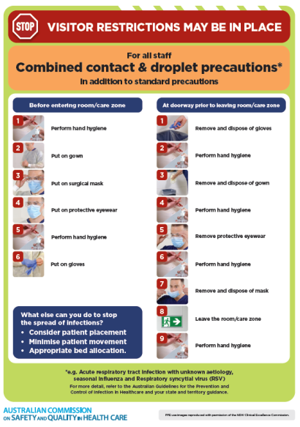
* ***Poster – Combined airborne and contact precautions*** <https://www.safetyandquality.gov.au/publications-and-resources/resource-library/poster-combined-airborne-and-contact-precautions>   
  [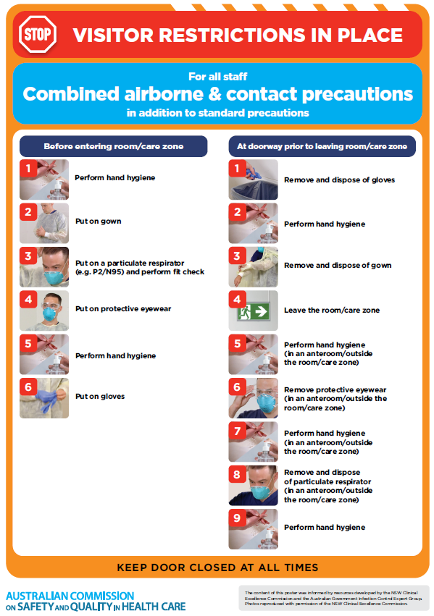](https://www.safetyandquality.gov.au/publications-and-resources/resource-library/poster-combined-airborne-and-contact-precautions)
* ***Environmental Cleaning and Infection Prevention and Control*** [www.safetyandquality.gov.au/environmental-cleaning](http://www.safetyandquality.gov.au/environmental-cleaning)
* ***COVID-19 infection prevention and control risk management – Guidance*** <https://www.safetyandquality.gov.au/publications-and-resources/resource-library/covid-19-infection-prevention-and-control-risk-management-guidance>
* ***Safe care for people with cognitive impairment during COVID-19***<https://www.safetyandquality.gov.au/our-work/cognitive-impairment/cognitive-impairment-and-covid-19>
* ***Stop COVID-19: Break the chain of infection*** posterhttps://www.safetyandquality.gov.au/publications-and-resources/resource-library/break-chain-infection-poster-a3  
  **[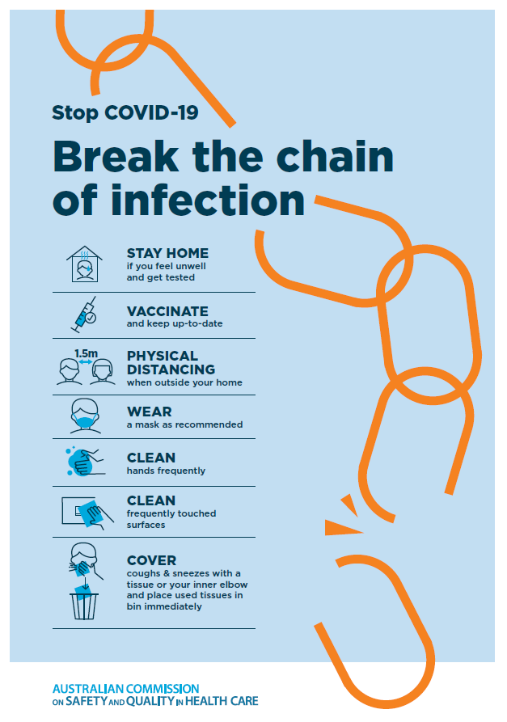](https://www.safetyandquality.gov.au/publications-and-resources/resource-library/break-chain-poster-a3https:/www.safetyandquality.gov.au/publications-and-resources/resource-library/break-chain-poster-a3)**
* ***FAQs for clinicians on elective surgery*** <https://www.safetyandquality.gov.au/node/5724>
* ***FAQs for consumers on elective surgery*** <https://www.safetyandquality.gov.au/node/5725>
* ***COVID-19 and face masks – Information for consumers*** <https://www.safetyandquality.gov.au/publications-and-resources/resource-library/covid-19-and-face-masks-information-consumers>

[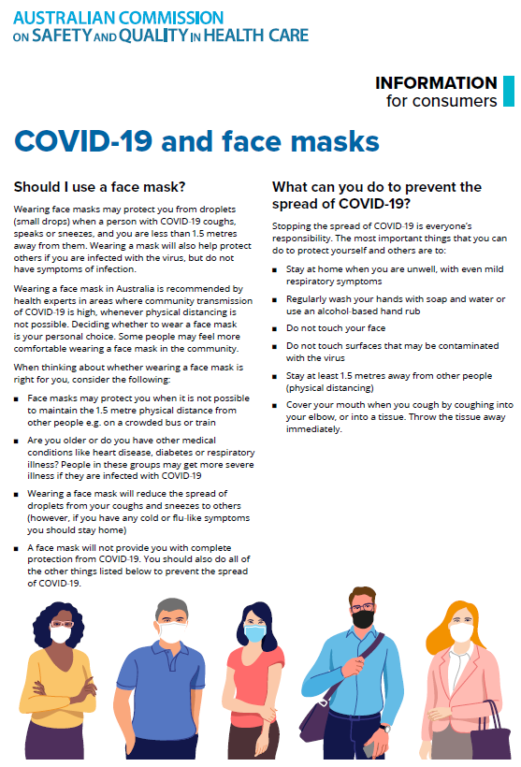](https://www.safetyandquality.gov.au/sites/default/files/2020-07/covid-19_and_face_masks_-_information_for_consumers.pdf)

*National COVID-19 Clinical Evidence Taskforce*

<https://covid19evidence.net.au/>

The National COVID-19 Clinical Evidence Taskforce is a collaboration of peak health professional bodies across Australia whose members are providing clinical care to people with COVID-19. The taskforce is undertaking continuous evidence surveillance to identify and rapidly synthesise emerging research in order to provide national, **evidence-based guidelines and clinical flowcharts for the clinical care of people with COVID-19**. The guidelines address questions that are specific to managing COVID-19 and cover the full disease course across mild, moderate, severe and critical illness. These are ‘living’ guidelines, updated with new research in near real-time in order to give reliable, up-to-the minute advice to clinicians providing frontline care in this unprecedented global health crisis.

*COVID-19 Critical Intelligence Unit*

<https://www.aci.health.nsw.gov.au/covid-19/critical-intelligence-unit>

The Agency for Clinical Innovation (ACI) in New South Wales has developed this page summarising rapid, evidence-based advice during the COVID-19 pandemic. Its operations focus on systems intelligence, clinical intelligence and evidence integration. The content includes a daily evidence digest, a COVID status monitor, a risk monitoring dashboard and evidence checks on a discrete topic or question relating to the current COVID-19 pandemic. There is also a ‘Living evidence’ section summarising key studies and emerging evidence on **COVID-19 vaccines** and **SARS-CoV-2 variants**. The most recent updates include:

* ***Long COVID –*** What is the evidence on the prevalence, presentation and management of long-COVID?
* ***Oseltamivir (Tamiflu) use in healthcare settings*** – What is the evidence that use of oseltamivir in healthcare workers with a symptomatic influenza diagnosis result in an earlier return to work and reduced absenteeism? What is the evidence that use of oseltamivir in adults and children with symptomatic influenza reduces influenza transmission in health care settings?
* ***Alternative models of care for acute medical conditions*** – What is the evidence on alternative models of care for managing patients with acute medical conditions outside of emergency or inpatient hospital settings?
* ***Exercise and long COVID*** – Is exercise helpful in individuals with long COVID? Is post-exertional symptom exacerbation a risk in long COVID?
* ***Influenza and seasonal prophylaxis with oseltamivir*** – What is the place or evidence for seasonal influenza prophylaxis (such as taking oseltamivir for 10 to 12 weeks continuously) in healthcare and aged care settings?
* ***Rapid access models of care for respiratory illnesses*** – What is the evidence for rapid access models of care for respiratory illnesses, especially during winter seasons, in emergency departments?
* ***Current and emerging patient safety issues during COVID-19*** – What is the evidence on the current and emerging patient safety issues arising from the COVID-19 pandemic?
* ***Post-acute sequelae of COVID-19*** – What is the evidence on the post-acute sequelae of COVID-19?
* ***Emerging variants*** – What is the available evidence for emerging variants?
* ***Chest pain or dyspnoea following COVID-19 vaccination*** – What is evidence for chest pain or dyspnoea following COVID-19 vaccination?
* ***Cardiac investigations and elective surgery post-COVID-19*** – What is evidence for cardiac investigations and elective surgery post-COVID-19?
* ***Breathlessness post COVID-19*** – How to determine those patients who present with ongoing breathlessness in need of urgent review or intervention due to suspected pulmonary embolus?
* ***COVID-19 pandemic and influenza*** – What is the evidence for COVID-19 pandemic and influenza?
* ***Budesonide and aspirin for pregnant women with COVID-19 –*** What is the evidence for the use of Budesonide for pregnant women with COVID-19? What is the evidence for aspirin prophylaxis for pre-eclampsia in pregnant women with a COVID-19 infection?
* ***COVID-19 vaccines in Australia*** – What is the evidence on COVID-19 vaccines in Australia?
* ***COVID-19 pandemic and wellbeing of critical care and other healthcare workers*** – Evidence in brief on the impact of the COVID-19 pandemic on the wellbeing of critical care and other healthcare workers.
* ***Surgery post COVID-19*** – What is the evidence for the timing of surgery, and outcomes following surgery, for people who have recovered from COVID-19?
* ***Disease modifying treatments for COVID-19 in children*** – What is the evidence for disease modifying treatments for COVID-19 in children?
* ***Mask type for COVID-19 positive wearer*** – What is the evidence for different mask types for COVID-19 positive wearers?
* ***Post acute and subacute COVID-19 care*** – What published advice and models of care are available regarding post-acute and subacute care for COVID-19 patients?
* ***Hospital visitor policies*** – What is the evidence for hospital visitor policies during and outside of the COVID-19 pandemic?
* ***Surgical masks, eye protection and PPE guidance*** –What is the evidence for surgical masks in the endemic phase in hospitals and for eyewear to protect against COVID-19?

**Disclaimer**

On the Radar is an information resource of the Australian Commission on Safety and Quality in Health Care. The Commission is not responsible for the content of, nor does it endorse, any articles or sites listed. The Commission accepts no liability for the information or advice provided by these external links. Links are provided on the basis that users make their own decisions about the accuracy, currency and reliability of the information contained therein. Any opinions expressed are not necessarily those of the Australian Commission on Safety and Quality in Health Care.