# Australian Commission on Safety and Quality logotypeOn the Radar

Issue 570

15 August 2022

*On the Radar* is a summary of some of the recent publications in the areas of safety and quality in health care. Inclusion in this document is not an endorsement or recommendation of any publication or provider. Access to particular documents may depend on whether they are Open Access or not, and/or your individual or institutional access to subscription sites/services. Material that may require subscription is included as it is considered relevant.

*On the Radar* is available online, via email or as a PDF or Word document from <https://www.safetyandquality.gov.au/publications-and-resources/newsletters/radar>

If you would like to receive *On the Radar* via email, you can subscribe on our website <https://www.safetyandquality.gov.au/publications-and-resources/newsletters>  
or by emailing us at H[Umail@safetyandquality.gov.auU](mailto:mail@safetyandquality.gov.au).   
You can also send feedback and comments to H[Umail@safetyandquality.gov.auU](mailto:mail@safetyandquality.gov.au).

For information about the Commission and its programs and publications, please visit <https://www.safetyandquality.gov.au>

You can also follow us on Twitter @ACSQHC.

**On the Radar**

Editor: Dr Niall Johnson [niall.johnson@safetyandquality.gov.au](mailto:niall.johnson@safetyandquality.gov.au)

Contributors: Niall Johnson

**Launch of the first clinical care standard on low back pain**

<https://www.safetyandquality.gov.au/standards/clinical-care-standards/low-back-pain-clinical-care-standard>

You are invited to the virtual launch of the first national *Low Back Pain Clinical Care Standard*, hosted by the Australian Commission on Safety and Quality in Health Care.

Low back pain is a leading cause of disability worldwide. This burden is increasing despite a burgeoning number of treatment options. Back problems and back pain are the second most common reason Australians seek care from their general practitioner, and one of the top five presentations to emergency departments.

Early appropriate management of people experiencing an acute episode is important to reduce the chance of developing chronic low back pain.

Join the webcast to hear the experts discuss the challenges presented by this common condition, and how the standard will improve patient-centred care, while reducing investigations and treatments that may be ineffective or unnecessary.

The event will be hosted by journalist and broadcaster Geraldine Doogue AO.

The *Low Back Pain Clinical Care Standard* will be launched via webcast on **Thursday, 1 September 2022 at 12pm AEST**.

Register at <https://safetyandquality.tv>

Expert panellists:

* Associate Professor Liz Marles – Clinical Director, Australian Commission on Safety and Quality in Health Care and General Practitioner, Hornsby-Brooklyn GP Unit
* Professor Peter O’Sullivan – Professor of Musculoskeletal Physiotherapy, Curtin University
* Professor Michael Nicholas – Director and Professor, Pain Education Unit, The Kolling Institute, University of Sydney and Director, Pain Management Programs, Pain Management and Research Centre, Royal North Shore Hospital
* Dr James Edwards – Director, Emergency Department, Royal Prince Alfred Hospital and Medical Lead, NSW Health Vaccination Centre.

This event is relevant to all healthcare professionals involved in the early management of people with low back pain, especially general practitioners, physiotherapists and other allied health professionals, emergency physicians, nurses and nurse practitioners.

For more information, email ccs@safetyandquality.gov.au or visit our web page <https://www.safetyandquality.gov.au/standards/clinical-care-standards/low-back-pain-clinical-care-standard>

[The Low Back Pain Clinical Care Standard will be launched via webcast on Thursday, 1 September 2022 at 12pm AEST.
Register at https://safetyandquality.tv](https://safetyandquality.tv)

**Reports**

*Implications of the COVID-19 pandemic for patient safety: a rapid review*

World Health Organization

Geneva: World Health Organization; 2022. p. 64.

|  |  |
| --- | --- |
| URL | <https://www.who.int/publications/i/item/9789240055094> |
| Notes | The COVID-19 pandemic has been possibly one of the most challenging and transformative periods for all of us, including our health systems. This short report from the WHO ‘explores impacts that the COVID-19 pandemic did have on patient safety in terms of risks and avoidable harm, specifically in terms of diagnostic, treatment and care management related issues as well as highlights the main patterns of these implications within the broader health system context.’  The report’s key observations include:   1. The COVID-19 pandemic revealed a range of safety gaps across all core components of health systems, at all levels. 2. The risks and magnitude of avoidable harm from the COVID-19 pandemic still need to be understood. 3. Disruptions to systems and processes of care affected previously known safety risks and sources of harm in health care and introduced new ones. 4. The capacity of health systems to continue the delivery of essential health services has implications for patient safety. 5. Managing COVID-19 in countries experiencing fragility, conflict and violence has been even more challenging. 6. The pandemic caused substantial disruptive impacts on the health workforce. 7. Misinformation and disinformation have been prevalent during the pandemic. 8. Safety and equity are inextricably linked, and the pandemic exposed long-standing structural drivers of health inequities and gaps in outcomes for certain population groups. 9. Interaction between patients and families and health workers was severely constrained. 10. While most of the consequences have been negative, several positive developments have also occurred. |

*Distributed Cognition and the Role of Nurses in Diagnostic Safety in the Emergency Department*

Manojlovich M, Krein SL, Kronick SL, Mahajan P, Graber Mark L

Rockville MD: Agency for Healthcare Research and Quality; 2022. p.18.

|  |  |
| --- | --- |
| URL | <https://www.ahrq.gov/patient-safety/reports/issue-briefs/distributed-cognition-er-nurses.html> |
| Notes | The US Agency for Healthcare Research and Quality has released this Issue Brief that ‘highlights nurses’ unique position to contribute to the diagnostic process in emergency departments. Diagnosis traditionally has been viewed as an individual activity, usually performed by physicians, and has not always capitalized on the wisdom of nurses, trainees and patients and families. The brief describes the theory of distributed cognition, which asserts that knowledge can be distributed effectively over a community of individuals. It highlights how nurses can contribute to the diagnostic process based on their understanding of the organization of work in emergency departments, the flow of information, and the diverse tools and supportive materials used in care.’ |

**Journal articles**

*Spinal Cord Stimulators: An Analysis of the Adverse Events Reported to the Australian Therapeutic Goods Administration*

Jones CMP, Shaheed CA, Ferreira G, Mannix L, Harris IA, Buchbinder R, et al

Journal of Patient Safety. 2022;18(5):507-511.

|  |  |
| --- | --- |
| DOI | <https://doi.org/10.1097/PTS.0000000000000971> |
| Notes | Paper reporting on a study that examined adverse events relating to spinal cord stimulators reported to the Therapeutic Goods Administration between July 2012 and January 2019. Spinal cord stimulators are used to treat intractable pain, but this study found that in the period reviewed some 520 adverse events were reported for spinal cord stimulators and that 79% were rated as severe and 13% as life-threatening. .Device malfunction was the most common event reported (56.5%). The authors report that ‘The ratio of removals to implants was 4 per every 10 implanted’. The authors suggest that with the potential for serious harm, the rate of removal and ‘the low certainty evidence of their long-term safety and effectiveness’, the study’s ‘results raise questions about their role in providing long-term management of intractable pain.’ |

*Journal of Patient Safety*

Volume 18, Number 5, August 2022

|  |  |
| --- | --- |
| URL | <https://journals.lww.com/journalpatientsafety/toc/2022/08000> |
|  | A new issue of the *Journal of Patient Safety* has been published. Articles in this issue of *Journal of Patient Safety* include:   * Observation and **Patients’ Perceptions of Incorporating Their Photograph Into the Electronic Health Record** (Brian D. Reuland, Chelsea T. Redman, Jerard Z. Kneifati-Hayek, Yelstin Fernandes, Rashid Kosber, Claudia Ortuno-Garcia, Daniel J. Crossman, Hojjat Salmasian, Allen R. Chen, Daniel J. Barchi, Jo R. Applebaum, Robert A. Green, Jason S. Adelman) * The **Korea National Patient Safety Incidents Inquiry Survey**: Characteristics of Adverse Events Identified Through Medical Records Review in Regional Public Hospitals (Min Ji Kim, Hee Jung Seo, Hong Mo Koo, Minsu Ock, Jee-In Hwang, Sang-Il Lee) * The Korea National Patient Safety Incidents Inquiry Survey: Feasibility of **Medical Record Review for Detecting Adverse Events** in Regional Public Hospitals (Min Ji Kim, Hee Jung Seo, Hong Mo Koo, Minsu Ock, Jee-In Hwang, Sang-Il Lee) * Feasibility of **Capturing Adverse Events From Insurance Claims Data** Using International Classification of Diseases, Tenth Revision, Codes Coupled to Present on Admission Indicators (Juyoung Kim, Eun Young Choi, Won Lee, Hae Mi Oh, Jeehee Pyo, Minsu Ock, So Yoon Kim, Sang-il Lee) * Capturing Parents’ Perspectives of Child Wellness to Support **Identification of Acutely Unwell Children in the Emergency Department** (Abigail Albutt, Damian Roland, Rebecca Lawton, Mark Conner, Jane O’Hara) * Feelings of Trust and of Safety Are Related Facets of the **Patient’s Experience in Surgery**: A Descriptive Qualitative Study in 80 Patients (Pauline Occelli, F Mougeot, M Robelet, K Buchet-Poyau, S Touzet, Michel) * Development and Adjustment of an Algorithm for **Identifying Drug-Related Hospital Admissions in Pediatrics** (Christopher Schulze, Irmgard Toni, Katrin Moritz, Sonja Eberl, Wolfgang Rascher, Antje Neubert) * **Free-Text Computerized Provider Order Entry Orders Used as Workaround** for Communicating Medication Information (S Kandaswamy, J Grimes, D Hoffman, J Marquard, R M Ratwani, A Z Hettinger) * **High-Risk Medication in Home Care Nursing**: A Delphi Study (Irina Dumitrescu, Minne Casteels, Kristel De Vliegher, Lorenz Van Der Linden, Ellen Van Leeuwen, Tinne Dilles) * Strength of Safety Measures Introduced by Medical Practices to **Prevent a Recurrence of Patient Safety Incidents**: An Observational Study (Beate S Müller, Dagmar Lüttel, Dania Schütze, Tatjana Blazejewski, Marina Pommée, Hardy Müller, Katharina Rubin, Christian Thomeczek, Romy Schadewitz, A Kintrup, R Heuzeroth, M Beyer, D Schwappach, R Hecker, F M Gerlach) * Safety Attitude of Operating Room Personnel Associated With **Accurate Completion of a Surgical Checklist**: A Cross-sectional Observational Study (Florence Sens, Marie Viprey, Vincent Piriou, Jean-Louis Peix, Eléonore Herquelot, Pauline Occelli, Stéphanie Bourdy, Atul A. Gawande, Matthew J. Carty MJ, Philippe Michel, Jean-Christophe Lifante, Cyrille Colin, Antoine Duclos, on behalf of the IDILIC Study Group) * Evaluating **Potentially Inappropriate Medications in Older Kidney Transplant Recipients** (Elizabeth A Cohen, Lena M DeVietro, Brock A Richardson, J S Odinet, Alexander H Toledo, E P Marin, K R Szempruch) * **Postdischarge Adverse Events Among Neonates** Admitted to the Neonatal Intensive Care Unit (Dennis Tsilimingras, Girija Natarajan, Monika Bajaj, Prashant Agarwal, Jorge Lua, Amanda Deriemacker, Areeg Zuair, Dawn Misra, James Janisse, Liying Zhang, Jeffrey Schnipper) * Building Consensus for a **Shared Definition of Adverse Events**: A Case Study in the Profession of **Dentistry** (Amy Franklin, Elsbeth Kalenderian, Nutan Hebballi, Veronique Delattre, Jini Etoule, Joel White, Ram Vaderhobli, Denice Stewart, Karla Kent, Alfa Yansane, Muhammad Walji) * Applying Healthcare Failure Mode and Effect Analysis and the Development of a Real-Time Mobile Application for Modified Early Warning Score Notification to Improve **Patient Safety During Hemodialysis** (Chang-Hung Lin, Tsing-Fen Ho, Hui-Fen Chen, Hsin-Yi Chang, Ju-Huei Chien) * **Patient Safety Culture in Dentistry** Analysis Using the Safety Attitude Questionnaire in DKI Jakarta, Indonesia: A Cross-Cultural Adaptation and Validation Study (Mita Juliawati, Risqa R. Darwita, M Adiatman, F Lestari) * Development of a **Quality Improvement Dental Chart Review Training Program** (Elsbeth Kalenderian, Nutan B Hebballi, Amy Franklin, Alfa Yansane, Ana M Ibarra Noriega, Joel White, Muhammad F Walji) * Identification of Inappropriate Antibiotic Orders During Implementation of a **Multidisciplinary Antimicrobial Stewardship Program Within the Primary Care Setting** (Devada Singh-Franco, Sheerida Hosein Mohammed, Paula A. Eckardt, Jennifer Goldman, William R Wolowich) * Should Pharmacists Lead **Medication Reconciliation in Critical Care**? A One-Stem Interventional Study in an Egyptian Intensive Care Unit (Seif El Hadidi, Mohamed Hamdi, Nirmeen Sabry) * Developing Methods to **Support Collaborative Learning and Co-creation of Resilient Healthcare**—Tips for Success and Lessons Learned From a Norwegian Hospital Cancer Care Study (Inger Johanne Bergerød, Robyn Clay-Williams, Siri Wiig) * Machine Learning–Based **Mortality Prediction of Patients at Risk During Hospital Admission** (Kevin M. Trentino, Karin Schwarzbauer, Andreas Mitterecker, Axel Hofmann, Adam Lloyd, Michael F. Leahy, Thomas Tschoellitsch, Carl Böck, Sepp Hochreiter, Jens Meier) * **Psychological Impact and Risk of Suicide in Hospitalized COVID-19 Patients**, During the Initial Stage of the Pandemic: A Cross-Sectional Study (Alberto Benavente-Fernández, Luis Gutiérrez-Rojas, Úrsula Torres-Parejo, Ana Isabel Parejo Morón, Sergio Fernández Ontiveros, David Vinuesa García, Pablo González-Domenech, Antonio Jesús Laínez Ramos-Bossini) * **Spinal Cord Stimulators**: An Analysis of the **Adverse Events** Reported to the Australian Therapeutic Goods Administration (Caitlin M P Jones, Christina Abdel Shaheed, Giovanni Ferreira, Liam Mannix, Ian A Harris, Rachelle Buchbinder, Chris G Maher) * Use of Diagnosis Codes to Find **Blood Transfusion Adverse Events in Electronic Health Records** (Roselie A Bright, Susan J Bright-Ponte, Lee Anne M Palmer, Summer K Rankin, Sergey V Blok) * An Intervention to Optimize **Attitudes Toward Adverse Events Reporting** Among Tunisian Critical Care Nurses (Mohamed Ayoub Tlili, Wiem Aouicha, Jihene Sahli, Ali Mtiraoui, Thouraya Ajmi, Houyem Laatiri, Souad Chelbi, Mohamed Ben Rejeb, Manel Mallouli) * **Unexpected Mechanical Ventilation Dysfunction in a Coronavirus Disease Patient** With Severe Pneumonia Due to the Oxygen Flowsensor Failure (Koji Morishita, Atsushi Kudo, Tokujiro Uchida, Naoki Kurashima, Mikayo Toba, Kei Ito, Yasuhiro Otomo) * Increasing **Hospital Fires During the COVID-19 Pandemic** in India: Are the Current Policies and Infrastructure Adequate? (Amit K Malviya, Manish Mulchandani, Jasmeet Singh, Abhishek Singh, Anju Gupta) * **Patient Safety:** Where to Aim When Zero Harm Is Not the Target–A Case for **Learning and Resilience** (David C Stockwell, D. C Kayes, E J Thomas) |

*Pediatric Quality & Safety*

Volume 7, Issue 4, July/August 2022

|  |  |
| --- | --- |
| URL | <https://journals.lww.com/pqs/toc/2022/07000> |
|  | A new issue of *Pediatric Quality & Safety* has been published. Articles in this issue of *Pediatric Quality & Safety* include:   * Implementation of SEEK in a Children’s Advocacy Center: A **Process Improvement Initiative** (Megan M Letson, Farah W Brink, Alicia Daniels, Sandra Thompson, Kathryn G Wolf, Nichole L Michaels) * Improving **Hepatitis B Vaccination** Rates among At-risk Children and Adolescents with Inflammatory Bowel Disease (Megan Megan McNicol, Amy Donegan, Kate Hawa, Angelique E Boutzoukas, Barb Drobnic, Melanie Oates, Maudie Orraca-Tetteh, Hilary K Michel, Ross M Maltz, Jennifer L Dotson, Don Buckingham, Brendan Boyle, Monica I Ardura) * Sustaining Improvements in **CLABSI Reduction in a Pediatric Cardiac Intensive Care Unit** (Jennifer Gauntt, Sarah Brandt, Kevin Dolan, Jaime Manley, Roxann Tyner, Wendi Beauseau, Janet M. Simsic) * **Adverse Events in Infants** **Less Than 6 Months** of Age After Ambulatory Surgery and Diagnostic Imaging Requiring Anesthesia (Joshua C Uffman, Stephani S Kim, Loan N Quan, Thomas Shelton, Ralph J Beltran, Kris R Jatana, Tendy Chiang, Joseph D Tobias) * Improving **Delirium Assessments** in Vanderbilt Pediatric and Pediatric Cardiovascular Intensive Care Units (H Nur Eken, Kristina A Betters, D Catherine Fuchs, Heidi A B Smith, Stacey R Williams) * Quality Improvement Project to Improve the Timeliness of Care for Children With **Testicular Torsion** in the Emergency Department (Sri S Chinta, Matthew P Gray, Matthew Kopetsky, Shannon H Baumer-Mouradian, Amy L Drendel, Elizabeth Roth, C C Ferguson, M Nimmer, K Boyd, D C Brousseau) * A Quality Improvement Project Aimed at Standardizing the Prescribing of **Fluconazole Prophylaxis** in a Level IV Neonatal Intensive Care Unit (Brandi Smith, Nipunie Rajapakse, H E Sauer, K Ellsworth, L Dinnes, T Madigan) * **Decreasing Intubation for Ineffective Ventilation after Birth** for Very Low Birth Weight Neonates (Heidi M Herrick, Danielle D Weinberg, J James, A Murray, L Brown-Jackson, A Chaudhary, M A Posencheg, E E Foglia) * Under-triage: A New Trigger to Drive **Quality Improvement in the Emergency Department** (Deena Berkowitz, S Morrison, H Shaukat, K Button, M Stevenson, D LaViolette, Y Meisler, K A Gallagher, J Chamberlain) * Improving the Evidence-based Care of **Febrile Neonates**: A Quality Improvement Initiative (Lily Yu, Rachel S Bensman, Selena L. Hariharan, Constance M. McAneney, Victoria Wurster Ovalle, Eileen Murtagh Kurowski) * Sustained Reduction in **Intravenous Pump Turnaround Time** Using Lean Methodology (Smriti Neogi, Glenn Schneider, Joshua K. Schaffzin) * Successful Implementation of Single Urine Polymerase Chain Reaction Test for Evaluating Suspected **Cytomegalovirus Infection in Neonates** (Shabih Manzar, Patricia Pichilingue-Reto, Ramachandra Bhat) * Quality Improvement Initiative **Increasing Early Discharges From an Acute Care Cardiology Unit** for Cardiac Surgery and Cardiology Patients–Associated With Reduced Hospital Length of Stay (Jessica Colyer, Lisa Ring, S Gallagher, M Mullenholz, J Robison, K Rigney-Radford, A S Harahsheh) |

**Online resources**

***[UK] NICE Guidelines and Quality Standards***

<https://www.nice.org.uk/guidance>

The UK’s National Institute for Health and Care Excellence (NICE) has published new (or updated) guidelines and quality standards. The latest reviews or updates are:

* NICE Guideline NG122 ***Lung cancer****: diagnosis and management* <https://www.nice.org.uk/guidance/ng122>
* NICE Guideline NG161 *COVID-19 rapid guideline: delivery of* ***systemic anticancer treatments*** <https://www.nice.org.uk/guidance/ng161>

***[USA] AHRQ Perspectives on Safety***

<https://psnet.ahrq.gov/psnet-collection/perspectives>

The US Agency for Healthcare Research and Quality (AHRQ) publishes Perspectives on Safety essays. Recent essays include:

* *Emergence of* ***Application-based Healthcare***   
  <https://psnet.ahrq.gov/perspective/emergence-application-based-healthcare>
* ***Patient Safety in the Ambulatory Care Setting*** <https://psnet.ahrq.gov/perspective/patient-safety-ambulatory-care-setting>

**COVID-19 resources**

https://www.safetyandquality.gov.au/covid-19

The Australian Commission on Safety and Quality in Health Care has developed a number of resources to assist healthcare organisations, facilities and clinicians. These and other material on COVID-19 are available at <https://www.safetyandquality.gov.au/covid-19>

These resources include:

* ***OVID-19 infection prevention and control risk management*** This primer provides an overview of three widely used tools for investigating and responding to patient safety events and near misses. Tools covered in this primer include incident reporting systems, Root Cause Analysis (RCA), and Failure Modes and Effects Analysis (FMEA).   
  <https://www.safetyandquality.gov.au/publications-and-resources/resource-library/covid-19-infection-prevention-and-control-risk-management-guidance>
* ***Poster – Combined contact and droplet precautions*** <https://www.safetyandquality.gov.au/publications-and-resources/resource-library/infection-prevention-and-control-poster-combined-contact-and-droplet-precautions>  
  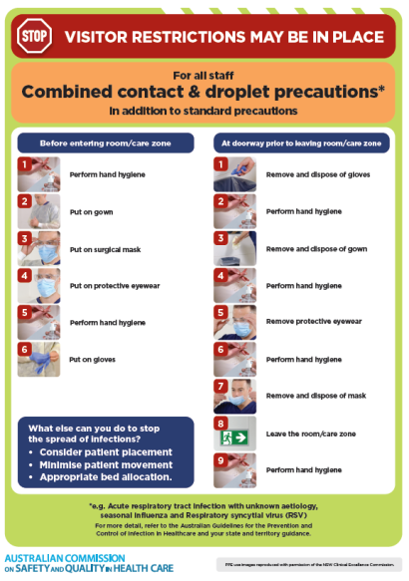
* ***Poster – Combined airborne and contact precautions*** <https://www.safetyandquality.gov.au/publications-and-resources/resource-library/poster-combined-airborne-and-contact-precautions>   
  [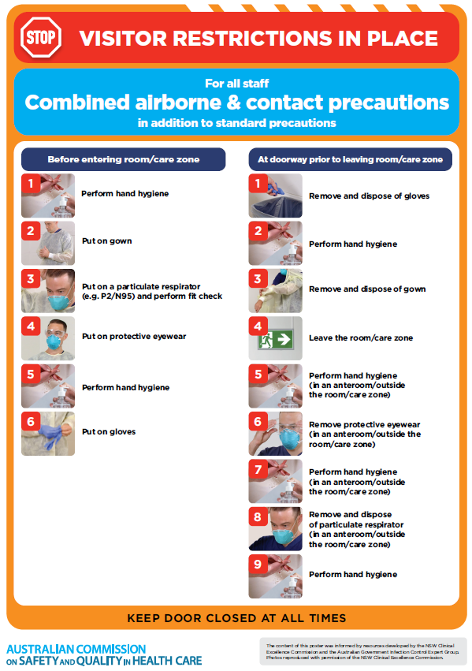](https://www.safetyandquality.gov.au/publications-and-resources/resource-library/poster-combined-airborne-and-contact-precautions)
* ***Environmental Cleaning and Infection Prevention and Control*** [www.safetyandquality.gov.au/environmental-cleaning](http://www.safetyandquality.gov.au/environmental-cleaning)
* ***COVID-19 infection prevention and control risk management – Guidance*** <https://www.safetyandquality.gov.au/publications-and-resources/resource-library/covid-19-infection-prevention-and-control-risk-management-guidance>
* ***Safe care for people with cognitive impairment during COVID-19***<https://www.safetyandquality.gov.au/our-work/cognitive-impairment/cognitive-impairment-and-covid-19>
* ***Stop COVID-19: Break the chain of infection*** posterhttps://www.safetyandquality.gov.au/publications-and-resources/resource-library/break-chain-infection-poster-a3  
  **[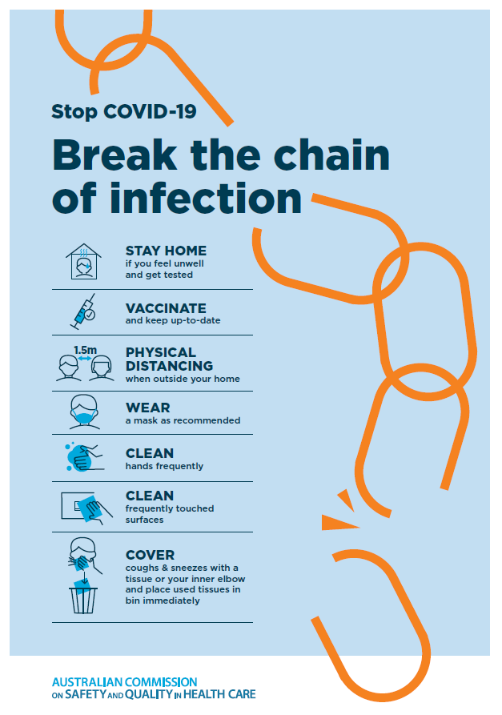](https://www.safetyandquality.gov.au/publications-and-resources/resource-library/break-chain-poster-a3https:/www.safetyandquality.gov.au/publications-and-resources/resource-library/break-chain-poster-a3)**
* ***FAQs for clinicians on elective surgery*** <https://www.safetyandquality.gov.au/node/5724>
* ***FAQs for consumers on elective surgery*** <https://www.safetyandquality.gov.au/node/5725>
* ***COVID-19 and face masks – Information for consumers*** <https://www.safetyandquality.gov.au/publications-and-resources/resource-library/covid-19-and-face-masks-information-consumers>

[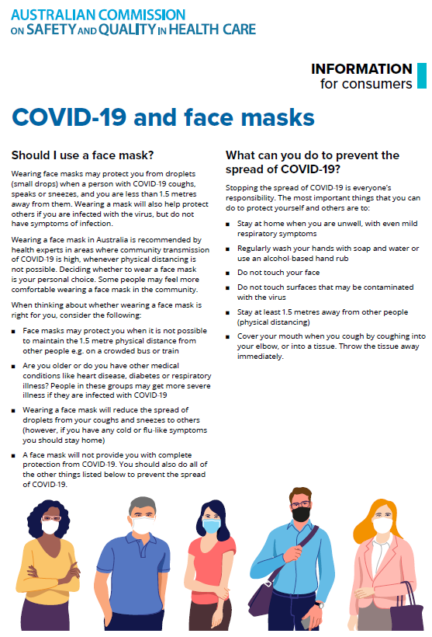](https://www.safetyandquality.gov.au/sites/default/files/2020-07/covid-19_and_face_masks_-_information_for_consumers.pdf)

*National COVID-19 Clinical Evidence Taskforce*

<https://covid19evidence.net.au/>

The National COVID-19 Clinical Evidence Taskforce is a collaboration of peak health professional bodies across Australia whose members are providing clinical care to people with COVID-19. The taskforce is undertaking continuous evidence surveillance to identify and rapidly synthesise emerging research in order to provide national, **evidence-based guidelines and clinical flowcharts for the clinical care of people with COVID-19**. The guidelines address questions that are specific to managing COVID-19 and cover the full disease course across mild, moderate, severe and critical illness. These are ‘living’ guidelines, updated with new research in near real-time in order to give reliable, up-to-the minute advice to clinicians providing frontline care in this unprecedented global health crisis.

*COVID-19 Critical Intelligence Unit*

<https://www.aci.health.nsw.gov.au/covid-19/critical-intelligence-unit>

The Agency for Clinical Innovation (ACI) in New South Wales has developed this page summarising rapid, evidence-based advice during the COVID-19 pandemic. Its operations focus on systems intelligence, clinical intelligence and evidence integration. The content includes a daily evidence digest, a COVID status monitor, a risk monitoring dashboard and evidence checks on a discrete topic or question relating to the current COVID-19 pandemic. There is also a ‘Living evidence’ section summarising key studies and emerging evidence on **COVID-19 vaccines** and **SARS-CoV-2 variants**. The most recent updates include:

* ***Long COVID –*** What is the evidence on the prevalence, presentation and management of long-COVID?
* ***Oseltamivir (Tamiflu) use in healthcare settings*** – What is the evidence that use of oseltamivir in healthcare workers with a symptomatic influenza diagnosis result in an earlier return to work and reduced absenteeism? What is the evidence that use of oseltamivir in adults and children with symptomatic influenza reduces influenza transmission in health care settings?
* ***Alternative models of care for acute medical conditions*** – What is the evidence on alternative models of care for managing patients with acute medical conditions outside of emergency or inpatient hospital settings?
* ***Exercise and long COVID*** – Is exercise helpful in individuals with long COVID? Is post-exertional symptom exacerbation a risk in long COVID?
* ***Influenza and seasonal prophylaxis with oseltamivir*** – What is the place or evidence for seasonal influenza prophylaxis (such as taking oseltamivir for 10 to 12 weeks continuously) in healthcare and aged care settings?
* ***Rapid access models of care for respiratory illnesses*** – What is the evidence for rapid access models of care for respiratory illnesses, especially during winter seasons, in emergency departments?
* ***Current and emerging patient safety issues during COVID-19*** – What is the evidence on the current and emerging patient safety issues arising from the COVID-19 pandemic?
* ***Post-acute sequelae of COVID-19*** – What is the evidence on the post-acute sequelae of COVID-19?
* ***Emerging variants*** – What is the available evidence for emerging variants?
* ***Chest pain or dyspnoea following COVID-19 vaccination*** – What is evidence for chest pain or dyspnoea following COVID-19 vaccination?
* ***Cardiac investigations and elective surgery post-COVID-19*** – What is evidence for cardiac investigations and elective surgery post-COVID-19?
* ***Breathlessness post COVID-19*** – How to determine those patients who present with ongoing breathlessness in need of urgent review or intervention due to suspected pulmonary embolus?
* ***COVID-19 pandemic and influenza*** – What is the evidence for COVID-19 pandemic and influenza?
* ***Budesonide and aspirin for pregnant women with COVID-19 –*** What is the evidence for the use of Budesonide for pregnant women with COVID-19? What is the evidence for aspirin prophylaxis for pre-eclampsia in pregnant women with a COVID-19 infection?
* ***COVID-19 vaccines in Australia*** – What is the evidence on COVID-19 vaccines in Australia?
* ***COVID-19 pandemic and wellbeing of critical care and other healthcare workers*** – Evidence in brief on the impact of the COVID-19 pandemic on the wellbeing of critical care and other healthcare workers.
* ***Surgery post COVID-19*** – What is the evidence for the timing of surgery, and outcomes following surgery, for people who have recovered from COVID-19?
* ***Disease modifying treatments for COVID-19 in children*** – What is the evidence for disease modifying treatments for COVID-19 in children?
* ***Mask type for COVID-19 positive wearer*** – What is the evidence for different mask types for COVID-19 positive wearers?
* ***Post acute and subacute COVID-19 care*** – What published advice and models of care are available regarding post-acute and subacute care for COVID-19 patients?
* ***Hospital visitor policies*** – What is the evidence for hospital visitor policies during and outside of the COVID-19 pandemic?
* ***Surgical masks, eye protection and PPE guidance*** –What is the evidence for surgical masks in the endemic phase in hospitals and for eyewear to protect against COVID-19?

**Disclaimer**

On the Radar is an information resource of the Australian Commission on Safety and Quality in Health Care. The Commission is not responsible for the content of, nor does it endorse, any articles or sites listed. The Commission accepts no liability for the information or advice provided by these external links. Links are provided on the basis that users make their own decisions about the accuracy, currency and reliability of the information contained therein. Any opinions expressed are not necessarily those of the Australian Commission on Safety and Quality in Health Care.