# Australian Commission on Safety and Quality logotypeOn the Radar

Issue 574

12 September 2022

*On the Radar* is a summary of some of the recent publications in the areas of safety and quality in health care. Inclusion in this document is not an endorsement or recommendation of any publication or provider. Access to particular documents may depend on whether they are Open Access or not, and/or your individual or institutional access to subscription sites/services. Material that may require subscription is included as it is considered relevant.

*On the Radar* is available online, via email or as a PDF or Word document from <https://www.safetyandquality.gov.au/publications-and-resources/newsletters/radar>

If you would like to receive *On the Radar* via email, you can subscribe on our website <https://www.safetyandquality.gov.au/publications-and-resources/newsletters>  
or by emailing us at H[Umail@safetyandquality.gov.auU](mailto:mail@safetyandquality.gov.au).   
You can also send feedback and comments to H[Umail@safetyandquality.gov.auU](mailto:mail@safetyandquality.gov.au).

For information about the Commission and its programs and publications, please visit <https://www.safetyandquality.gov.au>

You can also follow us on Twitter @ACSQHC.

**On the Radar**

Editor: Dr Niall Johnson [niall.johnson@safetyandquality.gov.au](mailto:niall.johnson@safetyandquality.gov.au)

Contributors: Niall Johnson, Jennifer Caldwell, Patricia Van Ritten

**Support for the implementation of the Preventing and Controlling Infections Standard – Infection Prevention and Control**

Australian Commission on Safety and Quality in Health Care

Sydney: ACSQHC; 2022. p. 22.

<https://www.safetyandquality.gov.au/publications-and-resources/resource-library/support-implementation-preventing-and-controlling-infections-standards>

The Commission has produced [*Support for the implementation of Preventing and Controlling Infections Standard*](https://www.safetyandquality.gov.au/publications-and-resources/resource-library/support-implementation-preventing-and-controlling-infections-standards) to provide health service organisations with practical guidance on the resources available to assist them to meet each action of the [*NSQHS Preventing and Controlling Infections Standard*](https://www.safetyandquality.gov.au/standards/nsqhs-standards/preventing-and-controlling-infections-standard).

This resource complements [*Options for implementation of antimicrobial stewardship in a range of facilities*](https://www.safetyandquality.gov.au/publications-and-resources/resource-library/options-implementation-antimicrobial-stewardship-range-facilities), which provides guidance for meeting actions specific to antimicrobial stewardship.

Readers may contact [hai@safetyandquality.gov.au](mailto:hai@safetyandquality.gov.au) if they have any enquiries in relation to these resources.

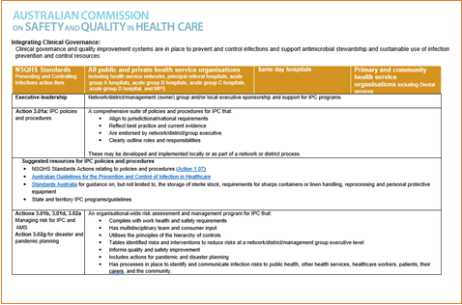

**Journal articles**

*Antibiotic documentation: death by a thousand clicks*

Ciarkowski C, Vaughn VM

BMJ Quality & Safety. 2022 [epub].

*Documenting the indication for antimicrobial prescribing: a scoping review*

Saini S, Leung V, Si E, Ho C, Cheung A, Dalton D, et al.

BMJ Quality & Safety. 2022 [epub]

|  |  |
| --- | --- |
| DOI | Ciarkowski and Vaughn <https://dx.doi.org/10.1136/bmjqs-2022-015020>  Saini et al <https://dx.doi.org/10.1136/bmjqs-2021-014582> |
| Notes | Ciarkowski and Vaughn’s editorial in *BMJ Quality & Safety* opens with the quip ‘Bacteria and clinicians have one thing in common: resistance.’ The editorial reflects on a systematic review paper (Saini et al) whose ‘findings support a seemingly simple antimicrobial stewardship tool: documentation of antibiotic indications so that explicit reasons for the prescription are recorded.’ However, as observed in this editorial, ‘critical barriers—often in the form of clinician resistance—diminish the ability of many antibiotic stewards to implement the documentation of antibiotic indication.’ The editorial discusses a number of the issues around antibiotic/antimicrobial documentation and communication. |

For information on the Commission’s work on antimicrobial stewardship, see <https://www.safetyandquality.gov.au/our-work/antimicrobial-stewardship>

For information on the Commission’s work on antimicrobial resistance, see <https://www.safetyandquality.gov.au/our-work/antimicrobial-resistance>

*Overcoming the ‘self-limiting’ nature of QI: can we improve the quality of patient care while caring for staff?*

Lawton R, Thomas EJ

BMJ Quality & Safety. 2022.

*Quality improvement as a primary approach to change in healthcare: a precarious, self-limiting choice?*

Mandel KE, Cady SH

BMJ Quality & Safety. 2022.

|  |  |
| --- | --- |
| DOI | Lawton and Thomas <https://dx.doi.org/10.1136/bmjqs-2022-015272>  Mandel and Coady <https://dx.doi.org/10.1136/bmjqs-2021-014447> |
| Notes | In another *BMJ Quality & Safety* editorial, Lawton and Thomas respond to a piece that draws ‘on organisational change theories to argue that quality improvement (QI), as currently deployed, is self-limiting’. In the course of their response, they offer ‘Recommendations for avoiding the negative side effects of quality improvement (QI)   * As noted by Mandel and Cady, leaders must pay attention to the impact of QI projects on staff well-being to prevent burnout and turnover, and to maintain and improve quality and safety. * Also endorsed strongly by Mandel and Cady is thinking differently about measurement for QI. QI initiatives should include measures of staff well-being, team relationships and culture. * Leaders should adopt a leadership framework, such as adaptive leadership, that explicitly calls for them to pay attention to the ‘pressure’ in an organisation, and thereby gauge if additional QI work is feasible at any given time. * QI initiatives should draw more on approaches that focus on how staff routinely create positive outcomes (eg, appreciative inquiry, positive deviance, Safety-II). * QI initiatives should focus more on subtractive change, working with teams to deimplement low-value care or processes. * There should be a greater focus on socio-behavioural elements as ingredients for success when leading QI: recognising the value of collective action, seeing things from others’ perspectives, getting the right people in the room and mutual respect. * Organisations should have a diverse portfolio of QI initiatives that include projects that make it easier for staff to care for patients (eg, simplifying or deimplementing cumbersome policies and procedures, improving turnaround time for radiology reports or making it easier to access supplies needed for patient care).’ |

*Surviving and thriving after breast cancer treatment*

Saunders CM, Stafford L, Hickey M

Medical Journal of Australia. 2022;217(5):225-227.

|  |  |
| --- | --- |
| DOI | <https://doi.org/10.5694/mja2.51671> |
| Notes | This Perspectives piece in the *Medical Journal of Australia* is a reminder that treatment and survival are only part of the cancer experience and that the patient needs to be supported throughout that journey. The piece ends with the observation that ‘Every experience of breast cancer will vary, but for the majority there will be some long-lasting disease and treatment side effects which will impair a return to full health and diminish physical, social, psychological, sexual and occupational wellbeing. If a patient who is unable to tolerate treatment ceases it early, this can potentially affect survival. The key is communicating with the patient and treatment team, including the GP, regarding potential side effects, early identification, and effective interventions.’ |

*The influence of ambulance offload time on 30-day risks of death and re-presentation for patients with chest pain*

Dawson LP, Andrew E, Stephenson M, Nehme Z, Bloom J, Cox S, et al

Medical Journal of Australia. 2022;217(5):253-259.

|  |  |
| --- | --- |
| DOI | <https://doi.org/10.5694/mja2.51613> |
| Notes | The issue of ambulance offload time and “ramping” keep recurring. This study sought to examine ‘whether ambulance offload time influences the risks of death or ambulance re-attendance within 30 days of initial emergency department (ED) presentations by adults with non-traumatic chest pain.’ This was a ‘Population-based observational cohort study of consecutive presentations by adults with non-traumatic chest pain transported by ambulance to Victorian EDs, 1 January 2015 – 30 June 2019’ that included 213,544 people. Observing that the ‘median offload time increased from 21 (IQR, 15–30) minutes in 2015 to 24 (IQR, 17–37) minutes during the first half of 2019’, the authors conclude that ‘Longer ambulance offload times are associated with greater 30-day risks of death and ambulance re-attendance for people presenting to EDs with chest pain. Improving the speed of ambulance-to-ED transfers is urgently required.’ |

*Healthcare Policy*

Volume 18, Number 1, August 2022

|  |  |
| --- | --- |
| URL | <https://www.longwoods.com/publications/healthcare-policy/26902/1/vol.-18-no.-1-2022> |
|  | A new issue of *Healthcare Policy* has been published. Articles in this issue of *Healthcare Policy* include:   * Editorial: **Provincial Health Systems: Are They Imploding?** (Jason M Sutherland) * **Pan-Canadian Registration and Licensure of Health Professionals:** A Path Forward Emerging from a Best Brains Exchange Policy Dialogue (Kathleen Leslie, Chantal Demers, Richard Steinecke and Ivy L Bourgeault) * Commentary: Burning Platforms, Icebergs and Tipping Points – Canada Needs **a Single Socially Accountable Healthcare System** (Roger Strasser) * Leaving the Walkman and ICD-9 Behind: **Modernizing the Disease Classification System** Used by Canadian Physicians (Stephanie Garies, Phoebe Ng, James A Dickinson, Terrence McDonald, Maeve O’beirne, Kerry A McBrien, Catherine Eastwood, D A Southern, N Drummond and H Quan) * Commentary – From Mixtapes to Playlists: Evolving Options for **Capturing Diagnoses in Canadian Physicians’ Data (**Keith Denny) * **Are Family Medicine Clinics Improving Access to Care** through Organizational Changes Driven by Healthcare Reform? (Isabel Rodrigues and Marie Authier) * Building Blocks to **Sustainable Rural Maternity Care**: Toward a Systems Approach to Service Planning (Jude Kornelsen and Kira Koepke) * **Public Health Messaging during the COVID-19 Pandemic** and Its Impact on Family Caregivers’ COVID-19 Knowledge (Deirdre McCaughey, Gwen McGhan, Kristin Flemons, Whitney Hindmarch and Kim Brundrit) |

*Health Affairs*

Volume 41, Number 9, September 2022

|  |  |
| --- | --- |
| URL | <https://www.healthaffairs.org/toc/hlthaff/41/9> |
| Notes | A new issue of *Health Affairs* has been published with the themes “Nurses, Care Delivery, Pharmaceuticals & More”. Articles in this issue of *Health Affairs* include:   * **Trends In Mental Health Care Delivery By Psychiatrists And Nurse Practitioners** In Medicare, 2011–19 (Arno Cai, Ateev Mehrotra, Hayley D Germack, Alisa B Busch, Haiden A Huskamp, and Michael L. Barnett) * **Buprenorphine Treatment**: Advanced Practice Nurses Add Capacity (Joanne Spetz, Laurie Hailer, Caryl Gay, Matthew Tierney, Laura A Schmidt, Bethany Phoenix, and Susan A Chapman) * Rapid Growth Of **Remote Patient Monitoring** Is Driven By A Small Number Of Primary Care Providers (Mitchell Tang, Ateev Mehrotra, and Ariel D Stern) * **Comprehensive Primary Care Plus** Did Not Improve Quality Or Lower Spending For The Privately Insured (Adam A Markovitz, Roslyn C Murray, and Andrew M Ryan) * Giving A Buck Or Making A Buck? **Donations By Pharmaceutical Manufacturers To Independent Patient Assistance Charities** (Leemore Dafny, Christopher Ody, and Teresa Rokos) * **Accelerated Approval Of Cancer Drugs**: No Economic Reward For Drug Makers That Conduct Confirmatory Trials (Richard G Frank, Mahnum Shahzad, and Ezekiel J Emanuel) * **State-Level Variation In Low-Value Care** For Commercially Insured And Medicare Advantage Populations (Lauren A Do, Benjamin C Koethe, Allan T Daly, James D Chambers, Daniel A Ollendorf, John B Wong, A Mark Fendrick, Peter J Neumann, and David D Kim) * **Private Equity Acquisitions Of Ambulatory Surgical Centers** Were Not Associated With Quality, Cost, Or Volume Changes (Joseph Dov Bruch, Sameer Nair-Desai, E John Orav, and Thomas C Tsai) * A Proposed Policy Agenda For **Electronic Cigarettes In The US**: Product, Price, Place, And Promotion (Kenneth E Warner, Karalyn A Kiessling, Clifford E Douglas, and Alex C Liber) * Social Risk Adjustment In The **Hospital Readmissions Reduction Program**: A Systematic Review And Implications For Policy (Teresa L Rogstad, Shweta Gupta, John Connolly, William H Shrank, and E T Roberts) * **Provider Charges And State Surprise Billing Laws**: Evidence From New York And California (Aliza S Gordon, Ying Liu, Benjamin L Chartock, and Winnie C Chi) * Evaluating The Accuracy Of **Medicare Risk Adjustment For Alzheimer’s Disease And Related Dementias** (Natalia Festa, Mary Price, Max Weiss, Lidia M V R Moura, Nicole M Benson, Sahar Zafar, Deborah Blacker, Sharon-Lise T Normand, Joseph P Newhouse, and John Hsu) * **Corruption In Health Care Systems**: Trends In Informal Payments Across Twenty-Eight EU Countries, 2013–19 (Giulia Dallera, Raffaele Palladino, and Filippos T Filippidis) * **A Health System That Won’t Learn From Its Mistakes** (Chandra Keller) |

*BMJ Quality & Safety* online first articles

|  |  |
| --- | --- |
| URL | <https://qualitysafety.bmj.com/content/early/recent> |
| Notes | *BMJ Quality &Safety* has published a number of ‘online first’ articles, including:   * Editorial: **Antibiotic documentation**: death by a thousand clicks (Claire Ciarkowski, Valerie M Vaughn) * Editorial: ‘You can’t do quality between surgical cases and tea time’: barriers to **surgeon engagement in quality improvement** (Jesse Isaac Wolfstadt, Anna Cohen-Rosenblum) * **Effect on diagnostic accuracy of cognitive reasoning tools** for the workplace setting: systematic review and meta-analysis (Justine Staal, Jacky Hooftman, Sabrina T G Gunput, Sílvia Mamede, Maarten A Frens, Walter W Van den Broek, Jelmer Alsma, Laura Zwaan) * Editorial: **Overcoming the ‘self-limiting’ nature of QI**: can we improve the quality of patient care while caring for staff? (Rebecca Lawton, Eric J Thomas) * **Negotiating the polypharmacy paradox**: a video-reflexive ethnography study of polypharmacy and its practices in primary care (Deborah Swinglehurst, Lucie Hogger, Nina Fudge) |

*International Journal for Quality in Health Care* online first articles

|  |  |
| --- | --- |
| URL | <https://academic.oup.com/intqhc/advance-articles> |
| Notes | *International Journal for Quality in Health Care* has published a number of ‘online first’ articles, including:   * The Evolving Personal, Professional and Physical **Impact on Healthcare Professionals During Three Covid-19 Waves**: A Cross-Sectional Study (Deborah Seys, Bart Peeters, Kris Doggen, Kris Vanhaecht) * **Protecting Health Professionals from Workplace Violence** in the Context of COVID-19 Epidemic (Yu Xiao, Jia Chen, Ting-ting Chen) * Israeli **COVID Lockdowns Mildly Reduced Overall Use of Preventive Health Services**, But Exacerbated Some Disparities (Adam J Rose, Eliana Ein Mor, Michal Krieger, Arie Ben-Yehuda, Arnon Cohen , Eran Matz, Edna Bar Ratson, Ronen Bareket, Ora Paltiel, Ronit Calderon-Margalit) |

**Online resources**

***Australian health regulation, key legal instruments and agencies***

<https://www.smh.com.au/interactive/hub/media/tearout-excerpt/9135/Australian-Healthcare-system.pdf>

An infographic produced by the Nine newspapers depicting the health regulatory universe in Australia.

**[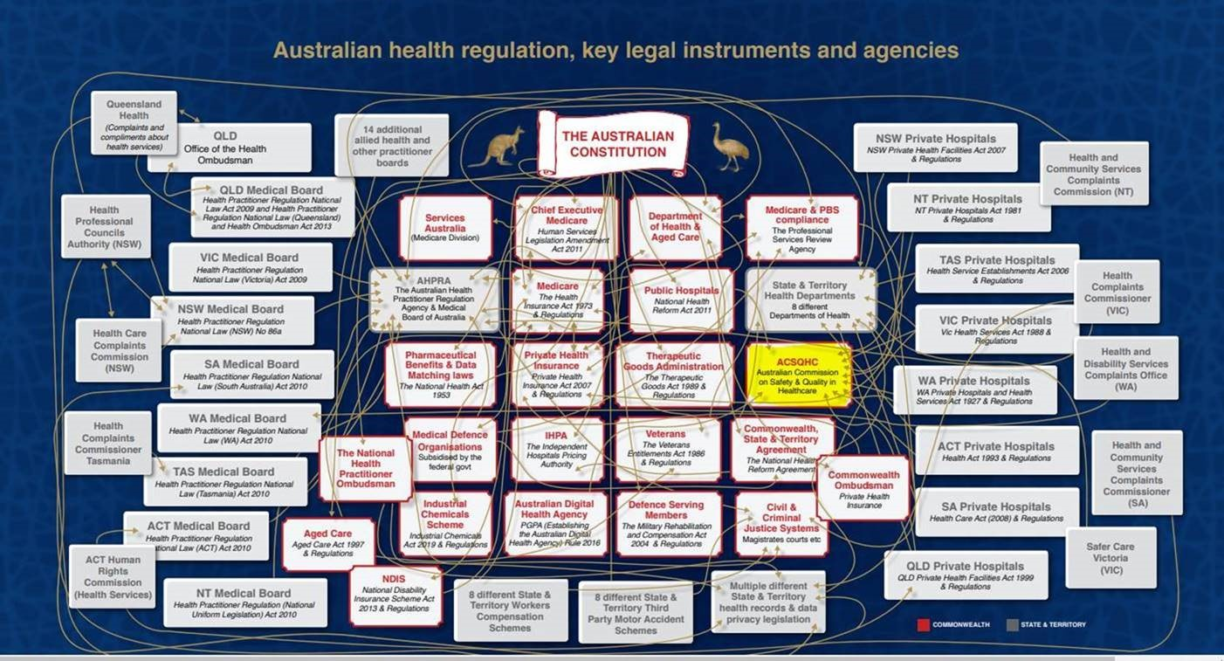](https://www.smh.com.au/interactive/hub/media/tearout-excerpt/9135/Australian-Healthcare-system.pdf)**

***[UK] NICE Guidelines and Quality Standards***

<https://www.nice.org.uk/guidance>

The UK’s National Institute for Health and Care Excellence (NICE) has published new (or updated) guidelines and quality standards. The latest reviews or updates include:

* Quality Standard QS34 ***Self-harm*** <https://www.nice.org.uk/guidance/qs34>
* NICE Guideline NG225 ***Self-harm****: assessment, management and preventing recurrence* <https://www.nice.org.uk/guidance/ng225>
* Clinical Guideline CG189 ***Obesity****: identification, assessment and management* <https://www.nice.org.uk/guidance/cg189>

**COVID-19 resources**

https://www.safetyandquality.gov.au/covid-19

The Australian Commission on Safety and Quality in Health Care has developed a number of resources to assist healthcare organisations, facilities and clinicians. These and other material on COVID-19 are available at <https://www.safetyandquality.gov.au/covid-19>

These resources include:

* ***OVID-19 infection prevention and control risk management*** This primer provides an overview of three widely used tools for investigating and responding to patient safety events and near misses. Tools covered in this primer include incident reporting systems, Root Cause Analysis (RCA), and Failure Modes and Effects Analysis (FMEA).   
  <https://www.safetyandquality.gov.au/publications-and-resources/resource-library/covid-19-infection-prevention-and-control-risk-management-guidance>
* ***Poster – Combined contact and droplet precautions*** <https://www.safetyandquality.gov.au/publications-and-resources/resource-library/infection-prevention-and-control-poster-combined-contact-and-droplet-precautions>  
  [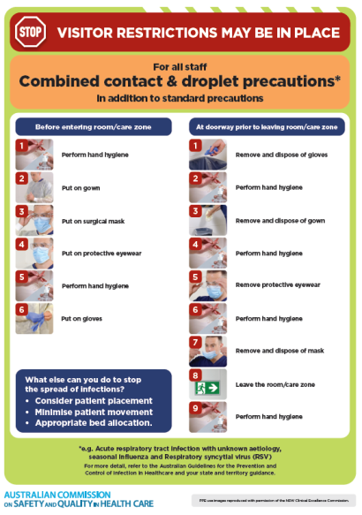](https://www.safetyandquality.gov.au/publications-and-resources/resource-library/infection-prevention-and-control-poster-combined-contact-and-droplet-precautions)
* ***Poster – Combined airborne and contact precautions*** <https://www.safetyandquality.gov.au/publications-and-resources/resource-library/poster-combined-airborne-and-contact-precautions>   
  [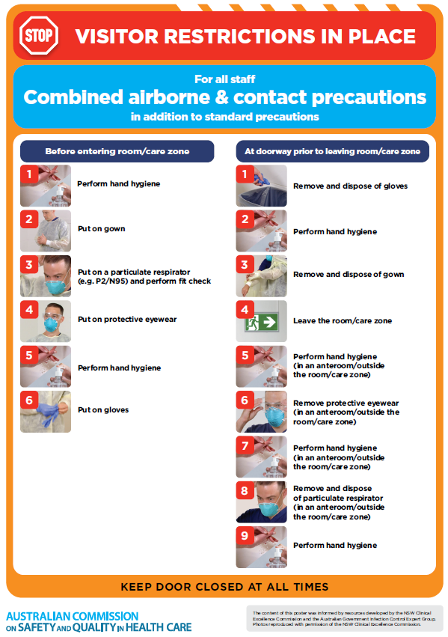](https://www.safetyandquality.gov.au/publications-and-resources/resource-library/poster-combined-airborne-and-contact-precautions)
* ***Environmental Cleaning and Infection Prevention and Control*** [www.safetyandquality.gov.au/environmental-cleaning](http://www.safetyandquality.gov.au/environmental-cleaning)
* ***COVID-19 infection prevention and control risk management – Guidance*** <https://www.safetyandquality.gov.au/publications-and-resources/resource-library/covid-19-infection-prevention-and-control-risk-management-guidance>
* ***Safe care for people with cognitive impairment during COVID-19***<https://www.safetyandquality.gov.au/our-work/cognitive-impairment/cognitive-impairment-and-covid-19>
* ***Stop COVID-19: Break the chain of infection*** posterhttps://www.safetyandquality.gov.au/publications-and-resources/resource-library/break-chain-infection-poster-a3  
  **[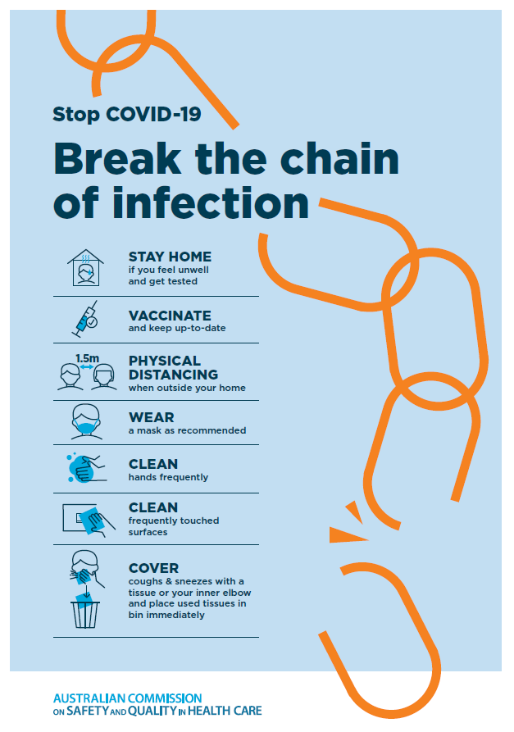](https://www.safetyandquality.gov.au/publications-and-resources/resource-library/break-chain-poster-a3https:/www.safetyandquality.gov.au/publications-and-resources/resource-library/break-chain-poster-a3)**
* ***FAQs for clinicians on elective surgery*** <https://www.safetyandquality.gov.au/node/5724>
* ***FAQs for consumers on elective surgery*** <https://www.safetyandquality.gov.au/node/5725>
* ***COVID-19 and face masks – Information for consumers*** <https://www.safetyandquality.gov.au/publications-and-resources/resource-library/covid-19-and-face-masks-information-consumers>

[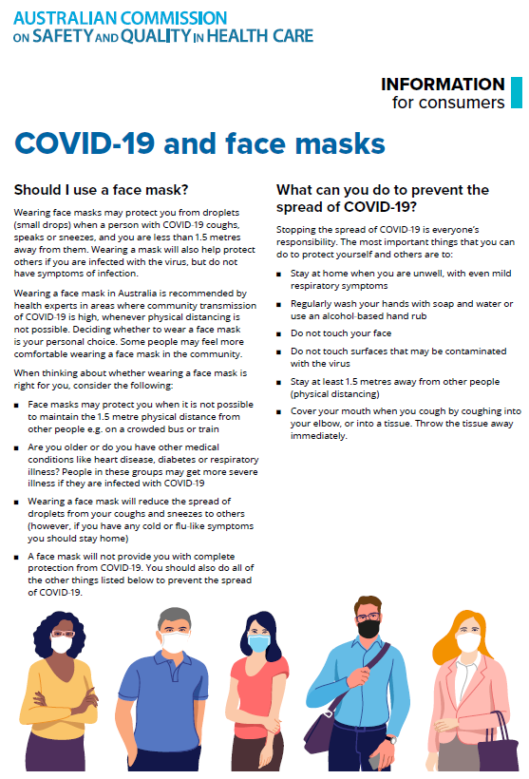](https://www.safetyandquality.gov.au/sites/default/files/2020-07/covid-19_and_face_masks_-_information_for_consumers.pdf)

*National COVID-19 Clinical Evidence Taskforce*

<https://covid19evidence.net.au/>

The National COVID-19 Clinical Evidence Taskforce is a collaboration of peak health professional bodies across Australia whose members are providing clinical care to people with COVID-19. The taskforce is undertaking continuous evidence surveillance to identify and rapidly synthesise emerging research in order to provide national, **evidence-based guidelines and clinical flowcharts for the clinical care of people with COVID-19**. The guidelines address questions that are specific to managing COVID-19 and cover the full disease course across mild, moderate, severe and critical illness. These are ‘living’ guidelines, updated with new research in near real-time in order to give reliable, up-to-the minute advice to clinicians providing frontline care in this unprecedented global health crisis.

*COVID-19 Critical Intelligence Unit*

<https://www.aci.health.nsw.gov.au/covid-19/critical-intelligence-unit>

The Agency for Clinical Innovation (ACI) in New South Wales has developed this page summarising rapid, evidence-based advice during the COVID-19 pandemic. Its operations focus on systems intelligence, clinical intelligence and evidence integration. The content includes a daily evidence digest, a COVID status monitor, a risk monitoring dashboard and evidence checks on a discrete topic or question relating to the current COVID-19 pandemic. There is also a ‘Living evidence’ section summarising key studies and emerging evidence on **COVID-19 vaccines** and **SARS-CoV-2 variants**. The most recent updates include:

* ***Eating disorders and COVID-19*** – What is the impact of the COVID-19 pandemic on the prevalence of eating disorders?
* ***Long COVID –*** What is the evidence on the prevalence, presentation and management of long-COVID?
* ***Oseltamivir (Tamiflu) use in healthcare settings*** – What is the evidence that use of oseltamivir in healthcare workers with a symptomatic influenza diagnosis result in an earlier return to work and reduced absenteeism? What is the evidence that use of oseltamivir in adults and children with symptomatic influenza reduces influenza transmission in health care settings?
* ***Alternative models of care for acute medical conditions*** – What is the evidence on alternative models of care for managing patients with acute medical conditions outside of emergency or inpatient hospital settings?
* ***Exercise and long COVID*** – Is exercise helpful in individuals with long COVID? Is post-exertional symptom exacerbation a risk in long COVID?
* ***Influenza and seasonal prophylaxis with oseltamivir*** – What is the place or evidence for seasonal influenza prophylaxis (such as taking oseltamivir for 10 to 12 weeks continuously) in healthcare and aged care settings?
* ***Rapid access models of care for respiratory illnesses*** – What is the evidence for rapid access models of care for respiratory illnesses, especially during winter seasons, in emergency departments?
* ***Current and emerging patient safety issues during COVID-19*** – What is the evidence on the current and emerging patient safety issues arising from the COVID-19 pandemic?
* ***Post-acute sequelae of COVID-19*** – What is the evidence on the post-acute sequelae of COVID-19?
* ***Emerging variants*** – What is the available evidence for emerging variants?
* ***Chest pain or dyspnoea following COVID-19 vaccination*** – What is evidence for chest pain or dyspnoea following COVID-19 vaccination?
* ***Cardiac investigations and elective surgery post-COVID-19*** – What is evidence for cardiac investigations and elective surgery post-COVID-19?
* ***Breathlessness post COVID-19*** – How to determine those patients who present with ongoing breathlessness in need of urgent review or intervention due to suspected pulmonary embolus?
* ***COVID-19 pandemic and influenza*** – What is the evidence for COVID-19 pandemic and influenza?
* ***Budesonide and aspirin for pregnant women with COVID-19 –*** What is the evidence for the use of Budesonide for pregnant women with COVID-19? What is the evidence for aspirin prophylaxis for pre-eclampsia in pregnant women with a COVID-19 infection?
* ***COVID-19 vaccines in Australia*** – What is the evidence on COVID-19 vaccines in Australia?
* ***COVID-19 pandemic and wellbeing of critical care and other healthcare workers*** – Evidence in brief on the impact of the COVID-19 pandemic on the wellbeing of critical care and other healthcare workers.
* ***Surgery post COVID-19*** – What is the evidence for the timing of surgery, and outcomes following surgery, for people who have recovered from COVID-19?
* ***Disease modifying treatments for COVID-19 in children*** – What is the evidence for disease modifying treatments for COVID-19 in children?
* ***Mask type for COVID-19 positive wearer*** – What is the evidence for different mask types for COVID-19 positive wearers?
* ***Post acute and subacute COVID-19 care*** – What published advice and models of care are available regarding post-acute and subacute care for COVID-19 patients?
* ***Hospital visitor policies*** – What is the evidence for hospital visitor policies during and outside of the COVID-19 pandemic?
* ***Surgical masks, eye protection and PPE guidance*** –What is the evidence for surgical masks in the endemic phase in hospitals and for eyewear to protect against COVID-19?

**Disclaimer**

On the Radar is an information resource of the Australian Commission on Safety and Quality in Health Care. The Commission is not responsible for the content of, nor does it endorse, any articles or sites listed. The Commission accepts no liability for the information or advice provided by these external links. Links are provided on the basis that users make their own decisions about the accuracy, currency and reliability of the information contained therein. Any opinions expressed are not necessarily those of the Australian Commission on Safety and Quality in Health Care.