# Australian Commission on Safety and Quality logotypeOn the Radar

Issue 575

19 September 2022

*On the Radar* is a summary of some of the recent publications in the areas of safety and quality in health care. Inclusion in this document is not an endorsement or recommendation of any publication or provider. Access to particular documents may depend on whether they are Open Access or not, and/or your individual or institutional access to subscription sites/services. Material that may require subscription is included as it is considered relevant.

*On the Radar* is available online, via email or as a PDF or Word document from <https://www.safetyandquality.gov.au/publications-and-resources/newsletters/radar>

If you would like to receive *On the Radar* via email, you can subscribe on our website <https://www.safetyandquality.gov.au/publications-and-resources/newsletters>  
or by emailing us at H[Umail@safetyandquality.gov.auU](mailto:mail@safetyandquality.gov.au).   
You can also send feedback and comments to H[Umail@safetyandquality.gov.auU](mailto:mail@safetyandquality.gov.au).

For information about the Commission and its programs and publications, please visit <https://www.safetyandquality.gov.au>

You can also follow us on Twitter @ACSQHC.

**On the Radar**

Editor: Dr Niall Johnson [niall.johnson@safetyandquality.gov.au](mailto:niall.johnson@safetyandquality.gov.au)

Contributors: Niall Johnson

**Reports**

*Nurse and midwife staffing models*

e-brief Issue 2/2022

Gotsis T

Sydney: NSW Parliamentary Research Service; 2022. p. 30.

|  |  |
| --- | --- |
| URL | <https://www.parliament.nsw.gov.au/researchpapers/Pages/Nurse-and-midwife-staffing-models.aspx> |
| Notes | Research paper from the NSW Parliamentary Research Service summarising the issue of nurse and midwife staffing models in Australia. This e-brief sets out the main features of legislated ratios and Nursing Hours Per Patient Day (NHPPDs), and the manner in which they are applied. It shows where in Australia each model is used and notes that in many States and Territories the NHPPD model is being actively reviewed. The brief observes that ‘There is a substantial and growing body of research about the association between nurse/midwife staffing levels and patient outcomes. Overall, this research indicates that low nurse/midwife staffing levels are associated with poor patient outcomes and adverse hospital events’. |

**Journal articles**

*Embedding pharmacists in residential aged care: Why it's important to integrate resident- and system-level services*

Cross AJ, La Caze A, Steeper M, Bell JS

Journal of Pharmacy Practice and Research. 2022;52(4):263-265.

|  |  |
| --- | --- |
| DOI | <https://doi.org/10.1002/jppr.1821> |
| Notes | This editorial reflects on the Royal Commission into Aged Care Quality and Safety and the many issues around medication usage in residential care. The authors ‘advocate for integrated resident- and system-level pharmacy services’ and see embedded pharmacists having a number of roles and functions, including ‘providing medication information and follow-up to residents and carers, medical practitioners, nurses, and care staff’, ‘’as knowledge brokers’ with roles “knowledge manager” (e.g. translate evidence-based guideline recommendations to local RACF policies and procedures), “linking agent” (e.g. facilitate collaboration between all stakeholders in medication management), and “capacity builder” (e.g. develop competencies related to quality use of medicines [QUM]’. They argue that there is ‘a responsibility to use this opportunity to elicit the real system-level changes needed to optimise medication management to the benefit of residents and carers.’ |

For information on the Commission’s work on Aged Care Quality Standards – Clinical Care, see <https://www.safetyandquality.gov.au/standards/aged-care-quality-standards-clinical-care>

For information on the Commission’s work on medication safety, see <https://www.safetyandquality.gov.au/our-work/medication-safety>

*A framework for digital health equity*

Richardson S, Lawrence K, Schoenthaler AM, Mann D

npj Digital Medicine. 2022;5(1):119.

|  |  |
| --- | --- |
| DOI | <https://doi.org/10.1038/s41746-022-00663-0> |
| Notes | This piece offers a possible framework for digital health equity. It identifies ‘digital determinants of health’, including those at e individual, interpersonal, community, and societal levels. The authors suggest that ‘The digital transformation of health requires leaders and developers to understand how digital determinants impact health equity’.  Digital determinants of health (DDoH) are defined as ‘conditions in the digital environment that affect a wide range of health, functioning, and quality of life outcomes and risks. The DDoH includes access to technological tools, digital literacy, and community infrastructure like broadband internet and operates at the individual, interpersonal, community, and societal levels. They impact digital health equity, which is equitable access to digital healthcare, equitable outcomes from and experience with digital healthcare, and equity in the design of digital health solutions’.  [Framework for digital health equity. National Institute on Minority Health and Health Disparities Research Framework Expanded for Digital Health Equity.](https://doi.org/10.1038/s41746-022-00663-0) |

*BMJ Quality & Safety* online first articles

|  |  |
| --- | --- |
| URL | <https://qualitysafety.bmj.com/content/early/recent> |
| Notes | *BMJ Quality &Safety* has published a number of ‘online first’ articles, including:   * Mixed-methods study examining family carers’ perceptions of the relationship between **intrahospital transitions and patient readiness for discharge** (Alycia A Bristol, Catherine E Elmore, Marianne E Weiss, Lisa A. Barry, Eli Iacob, Erin P Johnson, Andrea S Wallace) * Editorial: **Grand Rounds in Methodology**: a new series to contribute to continuous improvement of methodology and scientific rigour in quality and safety (Perla J Marang-van de Mheen, John P Browne, Eric J Thomas, Bryony Dean Franklin) * Grand rounds in methodology: four critical decision points in **statistical process control evaluations of quality improvement initiatives** (Perla J Marang-van de Mheen, Thomas Woodcock) |

*International Journal for Quality in Health Care* online first articles

|  |  |
| --- | --- |
| URL | <https://academic.oup.com/intqhc/advance-articles> |
| Notes | *International Journal for Quality in Health Care* has published a number of ‘online first’ articles, including:   * **COVID-19 lockdown impact on quality of treatment and outcomes of STEMI and Stroke patients** in a large tertiary medical center: an observational study (Alex Galper, Racheli Magnezi, Anat Ekka Zohar, Bernice Oberman, Eyal Zimlichman) * A Quality Assurance Initiative on Improving **Cefazolin Peri-operative Redose Compliance** (Faiza Qureshi, Jamie Lee Romeiser, Paul F Murphy, Roderick Go, Ramon Abola) |

**Online resources**

***My life after ICU***

<https://www.mylifeaftericu.com/>

This website provides information and resources for patients, families and caregivers who have experienced an ICU journey.

Designed for patients who have survived an Intensive Care admission, their families and care givers, Mylifeaftericu.com supports consumers as they navigate the challenges of recovery from critical illness.

The site provides information on common conditions such as fatigue, flashbacks and memory changes to help provide context and allay anxiety. The ICU experience is explained, along with relevant topics for both children and adults to clarify medical terminology, procedures and machines frequently used in the ICU.

***Tips For New Pharmacists – From An Antimicrobial Stewardship Pharmacist***

<https://www.idstewardship.com/tips-new-pharmacists-antimicrobial-stewardship-pharmacist/>

Webpage offering key tips for new pharmacists. The page also includes links to a number of resources. The tips include:

1. Prioritize patients that have urgent drug therapy issues
2. Prioritize review of patients on discharge
3. Look up any unfamiliar conditions and terms
4. Be aware not to assume that a positive culture is the same thing as an infection
5. Do not overlook basic antimicrobial stewardship principles.

**COVID-19 resources**

https://www.safetyandquality.gov.au/covid-19

The Australian Commission on Safety and Quality in Health Care has developed a number of resources to assist healthcare organisations, facilities and clinicians. These and other material on COVID-19 are available at <https://www.safetyandquality.gov.au/covid-19>

These resources include:

* ***OVID-19 infection prevention and control risk management*** This primer provides an overview of three widely used tools for investigating and responding to patient safety events and near misses. Tools covered in this primer include incident reporting systems, Root Cause Analysis (RCA), and Failure Modes and Effects Analysis (FMEA).   
  <https://www.safetyandquality.gov.au/publications-and-resources/resource-library/covid-19-infection-prevention-and-control-risk-management-guidance>
* ***Poster – Combined contact and droplet precautions*** <https://www.safetyandquality.gov.au/publications-and-resources/resource-library/infection-prevention-and-control-poster-combined-contact-and-droplet-precautions>  
  [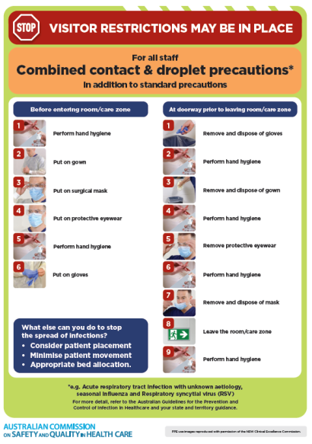](https://www.safetyandquality.gov.au/publications-and-resources/resource-library/infection-prevention-and-control-poster-combined-contact-and-droplet-precautions)
* ***Poster – Combined airborne and contact precautions*** <https://www.safetyandquality.gov.au/publications-and-resources/resource-library/poster-combined-airborne-and-contact-precautions>   
  [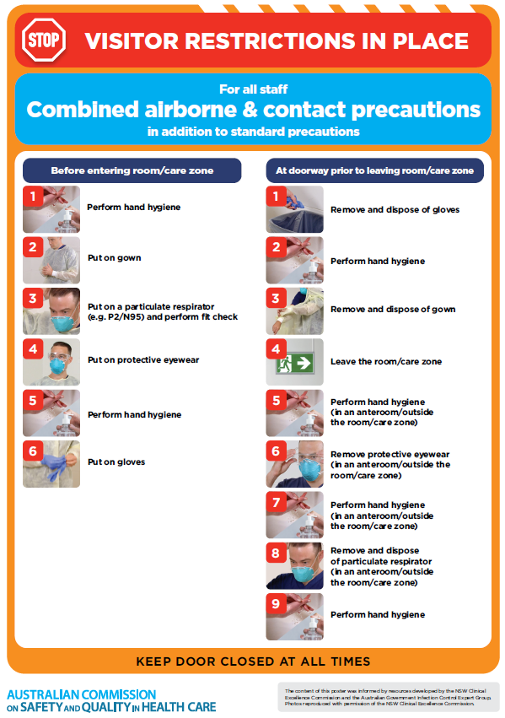](https://www.safetyandquality.gov.au/publications-and-resources/resource-library/poster-combined-airborne-and-contact-precautions)
* ***Environmental Cleaning and Infection Prevention and Control*** [www.safetyandquality.gov.au/environmental-cleaning](http://www.safetyandquality.gov.au/environmental-cleaning)
* ***COVID-19 infection prevention and control risk management – Guidance*** <https://www.safetyandquality.gov.au/publications-and-resources/resource-library/covid-19-infection-prevention-and-control-risk-management-guidance>
* ***Safe care for people with cognitive impairment during COVID-19***<https://www.safetyandquality.gov.au/our-work/cognitive-impairment/cognitive-impairment-and-covid-19>
* ***Stop COVID-19: Break the chain of infection*** posterhttps://www.safetyandquality.gov.au/publications-and-resources/resource-library/break-chain-infection-poster-a3  
  **[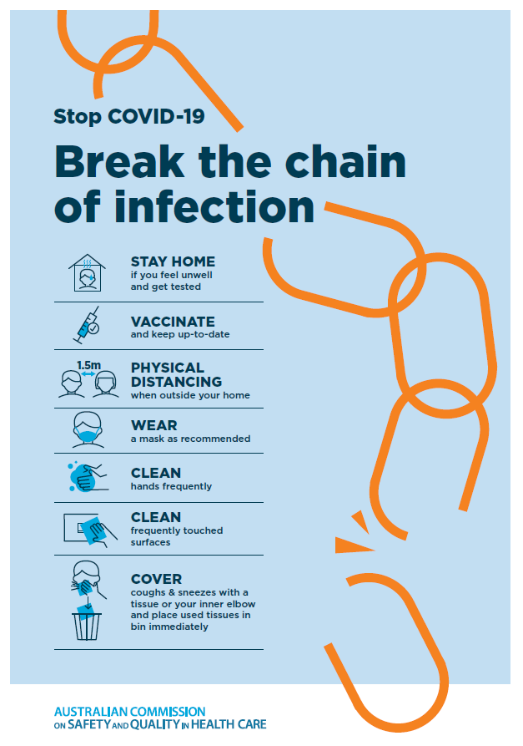](https://www.safetyandquality.gov.au/publications-and-resources/resource-library/break-chain-poster-a3https:/www.safetyandquality.gov.au/publications-and-resources/resource-library/break-chain-poster-a3)**
* ***FAQs for clinicians on elective surgery*** <https://www.safetyandquality.gov.au/node/5724>
* ***FAQs for consumers on elective surgery*** <https://www.safetyandquality.gov.au/node/5725>
* ***COVID-19 and face masks – Information for consumers*** <https://www.safetyandquality.gov.au/publications-and-resources/resource-library/covid-19-and-face-masks-information-consumers>

[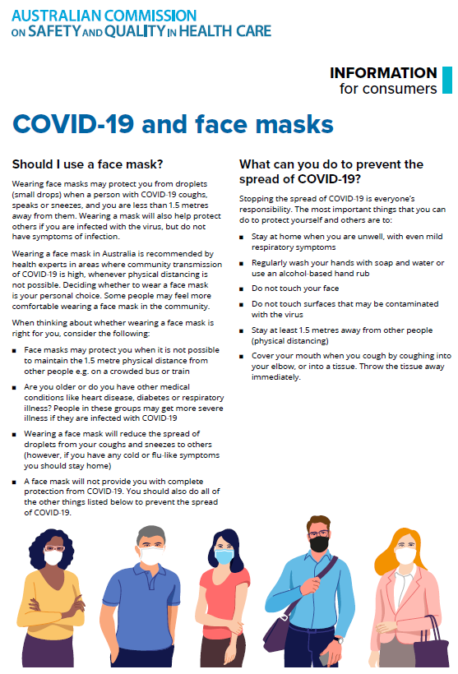](https://www.safetyandquality.gov.au/sites/default/files/2020-07/covid-19_and_face_masks_-_information_for_consumers.pdf)

*National COVID-19 Clinical Evidence Taskforce*

<https://covid19evidence.net.au/>

The National COVID-19 Clinical Evidence Taskforce is a collaboration of peak health professional bodies across Australia whose members are providing clinical care to people with COVID-19. The taskforce is undertaking continuous evidence surveillance to identify and rapidly synthesise emerging research in order to provide national, **evidence-based guidelines and clinical flowcharts for the clinical care of people with COVID-19**. The guidelines address questions that are specific to managing COVID-19 and cover the full disease course across mild, moderate, severe and critical illness. These are ‘living’ guidelines, updated with new research in near real-time in order to give reliable, up-to-the minute advice to clinicians providing frontline care in this unprecedented global health crisis.

*COVID-19 Critical Intelligence Unit*

<https://www.aci.health.nsw.gov.au/covid-19/critical-intelligence-unit>

The Agency for Clinical Innovation (ACI) in New South Wales has developed this page summarising rapid, evidence-based advice during the COVID-19 pandemic. Its operations focus on systems intelligence, clinical intelligence and evidence integration. The content includes a daily evidence digest, a COVID status monitor, a risk monitoring dashboard and evidence checks on a discrete topic or question relating to the current COVID-19 pandemic. There is also a ‘Living evidence’ section summarising key studies and emerging evidence on **COVID-19 vaccines** and **SARS-CoV-2 variants**. The most recent updates include:

* ***Eating disorders and COVID-19*** – What is the impact of the COVID-19 pandemic on the prevalence of eating disorders?
* ***Long COVID –*** What is the evidence on the prevalence, presentation and management of long-COVID?
* ***Oseltamivir (Tamiflu) use in healthcare settings*** – What is the evidence that use of oseltamivir in healthcare workers with a symptomatic influenza diagnosis result in an earlier return to work and reduced absenteeism? What is the evidence that use of oseltamivir in adults and children with symptomatic influenza reduces influenza transmission in health care settings?
* ***Alternative models of care for acute medical conditions*** – What is the evidence on alternative models of care for managing patients with acute medical conditions outside of emergency or inpatient hospital settings?
* ***Exercise and long COVID*** – Is exercise helpful in individuals with long COVID? Is post-exertional symptom exacerbation a risk in long COVID?
* ***Influenza and seasonal prophylaxis with oseltamivir*** – What is the place or evidence for seasonal influenza prophylaxis (such as taking oseltamivir for 10 to 12 weeks continuously) in healthcare and aged care settings?
* ***Rapid access models of care for respiratory illnesses*** – What is the evidence for rapid access models of care for respiratory illnesses, especially during winter seasons, in emergency departments?
* ***Current and emerging patient safety issues during COVID-19*** – What is the evidence on the current and emerging patient safety issues arising from the COVID-19 pandemic?
* ***Post-acute sequelae of COVID-19*** – What is the evidence on the post-acute sequelae of COVID-19?
* ***Emerging variants*** – What is the available evidence for emerging variants?
* ***Chest pain or dyspnoea following COVID-19 vaccination*** – What is evidence for chest pain or dyspnoea following COVID-19 vaccination?
* ***Cardiac investigations and elective surgery post-COVID-19*** – What is evidence for cardiac investigations and elective surgery post-COVID-19?
* ***Breathlessness post COVID-19*** – How to determine those patients who present with ongoing breathlessness in need of urgent review or intervention due to suspected pulmonary embolus?
* ***COVID-19 pandemic and influenza*** – What is the evidence for COVID-19 pandemic and influenza?
* ***Budesonide and aspirin for pregnant women with COVID-19 –*** What is the evidence for the use of Budesonide for pregnant women with COVID-19? What is the evidence for aspirin prophylaxis for pre-eclampsia in pregnant women with a COVID-19 infection?
* ***COVID-19 vaccines in Australia*** – What is the evidence on COVID-19 vaccines in Australia?
* ***COVID-19 pandemic and wellbeing of critical care and other healthcare workers*** – Evidence in brief on the impact of the COVID-19 pandemic on the wellbeing of critical care and other healthcare workers.
* ***Surgery post COVID-19*** – What is the evidence for the timing of surgery, and outcomes following surgery, for people who have recovered from COVID-19?
* ***Disease modifying treatments for COVID-19 in children*** – What is the evidence for disease modifying treatments for COVID-19 in children?
* ***Mask type for COVID-19 positive wearer*** – What is the evidence for different mask types for COVID-19 positive wearers?
* ***Post acute and subacute COVID-19 care*** – What published advice and models of care are available regarding post-acute and subacute care for COVID-19 patients?
* ***Hospital visitor policies*** – What is the evidence for hospital visitor policies during and outside of the COVID-19 pandemic?
* ***Surgical masks, eye protection and PPE guidance*** –What is the evidence for surgical masks in the endemic phase in hospitals and for eyewear to protect against COVID-19?

**Disclaimer**

On the Radar is an information resource of the Australian Commission on Safety and Quality in Health Care. The Commission is not responsible for the content of, nor does it endorse, any articles or sites listed. The Commission accepts no liability for the information or advice provided by these external links. Links are provided on the basis that users make their own decisions about the accuracy, currency and reliability of the information contained therein. Any opinions expressed are not necessarily those of the Australian Commission on Safety and Quality in Health Care.