# Australian Commission on Safety and Quality logotypeOn the Radar

Issue 578

10 October 2022

*On the Radar* is a summary of some of the recent publications in the areas of safety and quality in health care. Inclusion in this document is not an endorsement or recommendation of any publication or provider. Access to particular documents may depend on whether they are Open Access or not, and/or your individual or institutional access to subscription sites/services. Material that may require subscription is included as it is considered relevant.

*On the Radar* is available online, via email or as a PDF or Word document from <https://www.safetyandquality.gov.au/publications-and-resources/newsletters/radar>

If you would like to receive *On the Radar* via email, you can subscribe on our website <https://www.safetyandquality.gov.au/publications-and-resources/newsletters>  
or by emailing us at H[Umail@safetyandquality.gov.auU](mailto:mail@safetyandquality.gov.au).   
You can also send feedback and comments to H[Umail@safetyandquality.gov.auU](mailto:mail@safetyandquality.gov.au).

For information about the Commission and its programs and publications, please visit <https://www.safetyandquality.gov.au>

You can also follow us on Twitter @ACSQHC.

**On the Radar**

Editor: Dr Niall Johnson [niall.johnson@safetyandquality.gov.au](mailto:niall.johnson@safetyandquality.gov.au)

Contributors: Niall Johnson, Kim Stewart

***Antimicrobial stewardship in private hospitals***

*Antimicrobial Stewardship in Australian Health Care.*

Australian Commission on Safety and Quality in Health Care

Sydney: ACSQHC; 2022

<https://www.safetyandquality.gov.au/publications-and-resources/resource-library/antimicrobial-stewardship-australian-health-care>

Chapter 19 of *Antimicrobial Stewardship in Australian Health Care* (the AMS Book) is now available on the Commission’s website. The publication of this chapter *Antimicrobial stewardship in private hospitals* provides an opportunity to highlight issues specific to AMS in private hospitals and complements the other recently published chapters on antimicrobial stewardship in specific healthcare settings.

The chapter focuses on:

* Factors that influence prescribing of antimicrobials in private hospitals.
* Resources to support appropriate prescribing of antimicrobials in private hospitals.
* Strategies that can be implemented in private hospitals to improve AMS.
* Role of the multidisciplinary team and clinical governance and leadership in AMS relating specifically to private hospitals.

**Journal articles**

*How do hospital inpatients conceptualise patient safety? A qualitative interview study using constructivist grounded theory*

Barrow E, Lear RA, Morbi A, Long S, Darzi A, Mayer E, et al

BMJ Quality & Safety. 2022:[epub].

|  |  |
| --- | --- |
| DOI | <https://doi.org/10.1136/bmjqs-2022-014695> |
| Notes | Paper on a qualitative semi-structured interview study conducted with 24 inpatients at a large central London teaching hospital that sought to understand how hospital inpatients conceptualise patient safety and develop a conceptual model that reflects their perspectives. The authors report that ‘**patients** predominantly **conceptualised patient safety in the context of what made them ‘feel safe’**. Patients’ feelings of safety arose from a range of care experiences involving specific actors: hospital staff, the patient, their friends/family/carers, and the healthcare organisation. Four types of experiences contributed to how patients conceptualise safety: actions observed by patients; actions received by patients; actions performed by patients themselves; and shared actions involving patients and other actors in their care.’ |

*Toward Zero Harm: Mackenzie Health’s Journey Toward Becoming a High Reliability Organization and Eliminating Avoidable Harm*

Wilson M-A, Sinno M, Hacker Teper M, Courtney K, Nuseir D, Schonewille A, et al

Journal of Patient Safety. 2022;18(7):680-685.

|  |  |
| --- | --- |
| DOI | <https://doi.org/10.1097/PTS.0000000000000978> |
| Notes | Paper describing an initiative that sought to introduce system-wide changes to practice and patient safety culture within 5 years in a Canadian health service. The initiative ‘developed a 5-part strategy for cultural and process redesign that included   1. engaging leadership; 2. developing an organization-specific patient safety framework; 3. monitoring specific quality aims based on high-risk, high-volume, high-cost, and problem-prone areas; 4. standardizing a 3-part review process that includes a root cause analysis for moderate and critical patient safety incidents; and 5. communicating progress to staff in real time via unit-specific electronic dashboards.’   The authors note increased patient safety incident reporting, decreasing falls, pressure injury rates central line–associated blood stream infections, improved medication reconciliation rate and increased awareness around patient safety within clinical teams. |

*Emotional Exhaustion Among US Health Care Workers Before and During the COVID-19 Pandemic, 2019-2021*

Sexton JB, Adair KC, Proulx J, Profit J, Cui X, Bae J, et al

JAMA Network Open. 2022;5(9):e2232748-e2232748.

|  |  |
| --- | --- |
| DOI | <https://doi.org/10.1001/jamanetworkopen.2022.32748> |
| Notes | Paper reporting on a US 3-year survey study with a sample of 107 122 responses from US health care workers before and twice during the COVID-19 pandemic. The authors report that ‘increases were reported in assessments of emotional exhaustion in oneself and in one’s colleagues overall and for every role; nurses reported increases each year, but physicians reported decreases in 2020 followed by sharp increases in 2021. Exhaustion score clustering in work settings was suggestive of a social contagion effect of exhaustion.’ The authors consider that ‘These findings indicate that emotional exhaustion among health care workers, which was problematic before the pandemic, has become worse; increases in emotional exhaustion may jeopardize care quality and necessitate additional support for the workforce.’ |

*Australia needs to implement a national health strategy for doctors*

Wijeratne C, Kay MP, Arnold MH, Looi JCL

Medical Journal of Australia. 2022;217(7):338-341.

|  |  |
| --- | --- |
| DOI | <https://doi.org/10.5694/mja2.51714> |
| Notes | Piece in the *Medical Journal of Australia* that observes ‘there has been growing recognition of the prevalence of psychological distress across the medical profession and that practitioner wellbeing has significant implications for patient safety’. These have been reflected in ‘The fact that burnout, anxiety, depression, suicidal ideation, and completed suicide are higher in doctors than in the general population’. The COVID-19 pandemic has exacerbated many of these pressures. The authors argue that ‘A well resourced and well governed national response is required’. The purposes for this suggested strategy include:   * Promote concrete interventions to improve the health of medical students and doctors that focus on organisational/cultural change, as well as those that support individual resilience and wellbeing * Reduce the barriers that doctors experience when accessing health care for themselves across all regions for all doctors and across the career cycle * Improve treatment provided to doctors for their physical and mental health care * Enhance access to doctor-peer support for doctors * Ensure investment in evaluation of specific interventions to ensure a wellbeing focus informs future initiatives, including new workplace technologies * Endorse the inclusion of medical students’ and doctors’ health in the design of all future changes within health services, educational institutions, and other organisations where doctors work and learn. |

*Finding space for kindness: public protection and health professional regulation*

Biggar S, Fletcher M, Van Der Gaag A, Austin Z

International Journal for Quality in Health Care. 2022;34(3).

|  |  |
| --- | --- |
| DOI | <https://doi.org/10.1093/intqhc/mzac057> |
| Notes | Paper whose authors include staff of the Australian Health Practitioner Regulation Agency (AHPRA) examining ‘ways of integrating kindness into regulatory practice while still maintaining a strong focus on patient safety’. The piece concludes ‘Kindness in regulation does not mean diminishing practitioners’ accountability or reducing scrutiny of them. Instead, we believe kindness in regulation means assessing each complaint individually by risk, being quicker and more transparent and ensuring respect for both parties. It should also mean moving away from blame as a default position and towards a culture focused on patient safety which encourages disclosure, cooperation and accountability.’ |

*‘I Am Not The Doctor For You’: Physicians’ Attitudes About Caring For People With Disabilities*

Lagu T, Haywood C, Reimold K, DeJong C, Walker Sterling R, Iezzoni LI

Health Affairs. 2022;41(10):1387-1395.

*Patient And Coworker Mistreatment Of Physicians With Disabilities*

Meeks LM, Conrad SS, Nouri Z, Moreland CJ, Hu X, Dill MJ

Health Affairs. 2022;41(10):1396-1402.

*Assessing The Dangers Of A Hospital Stay For Patients With Developmental Disability In England, 2017–19*

Friebel R, Maynou L

Health Affairs. 2022;41(10):1486-1495.

|  |  |
| --- | --- |
| DOI | Lagu et al <https://doi.org/10.1377/hlthaff.2022.00475>  Meeks et al <https://doi.org/10.1377/hlthaff.2022.00502>  Friebel and Maynou <https://doi.org/10.1377/hlthaff.2022.00493> |
| Notes | A recent issue of *Health Affairs* had the theme ‘disability and health’ These articles all appeared in that issue and all consider how disabilities can impact the experience of health care for the individual.  Lagu et al observe that ‘People with disabilities face barriers when attempting to gain access to health care settings.’ From analysis of three physician focus groups in the USA, they identified physical, communication, knowledge, structural, and attitudinal barriers to care for people with disabilities. The authors suggest that ‘Increasing health care access for people with disabilities will require increasing the accessibility of space and the availability of proper equipment, improving the education of clinicians about the care of people with disabilities, and removing structural barriers in the health care delivery system. Our findings also suggest that physicians’ bias and general reluctance to care for people with disabilities play a role in perpetuating the health care disparities they experience.’  Meeks et al considered the experience of physicians who have disabilities. Using data nationally (USA) representative sample, they report ‘Compared with their nondisabled peers, physicians with disabilities had a significantly higher likelihood of experiencing every type of mistreatment from both patients and coworkers.’  Friebel and Maynou report on ‘the prevalence of five avoidable in-hospital patient safety incidents (adverse drug reactions, hospital-acquired infections, pressure ulcers, postoperative pulmonary embolism or deep vein thrombosis, and postoperative sepsis) for four developmental disability groups (people with intellectual disability, chromosomal abnormalities, pervasive developmental disorders, and congenital malformation syndrome) in the English National Health Service during the period April 2017–March 2019.’ They report that ‘the likelihood of experiencing harm in disability groups was up to 2.7-fold higher than in patients without developmental disability. Patient safety incidents led to an excess length-of-stay in hospital of 3.6–15.4 days and an increased mortality risk of 1.4–15.0 percent.’ |

*Practice and system improvements for better physical health and longer lives for people living with serious mental illness*

Calder RV, Dunbar JA, de Courten MP.

Medical Journal of Australia. 2022;217(7):350-351.

|  |  |
| --- | --- |
| DOI | <https://doi.org/10.5694/mja2.51713> |
| Notes | This piece opens with the observation that ‘People living with serious mental illness die up to 20 years prematurely from chronic physical health conditions’. The authors observe that the ‘The Being Equally Well policy roadmap seeks to end the neglect of physical health for people living with serious mental illness’ and introducing a supplement to the *Medial Journal of Australia* that ‘comprises evidence reviews and discussion that fill gaps in knowledge about effective physical health care for people living with serious mental illness.’ Articles in the supplement (<https://onlinelibrary.wiley.com/toc/13265377/2022/217/S7>) include:   * Effectiveness of nutrition and dietary interventions for people with serious mental illness: systematic review and meta-analysis (Tetyana Rocks, Scott B Teasdale, Caitlin Fehily, Claire Young, Gina Howland, Blair Kelly, Samantha Dawson, Felice Jacka, James A Dunbar, Adrienne O’Neil) * Peer-facilitated interventions for improving the physical health of people with schizophrenia spectrum disorders: systematic review and meta-analysis (Alexandria Coles, Kateryna Maksyutynska, Dunja Knezevic, Sri Mahavir Agarwal, Gillian Strudwick, James A Dunbar, Benjamin Druss, Peter Selby, Michelle Banfield, Margaret K Hahn, David Castle) * Should antidiabetic medicines be considered to reduce cardiometabolic risk in patients with serious mental illness? (Kevin P Mc Namara, Hamzah Alzubaidi, Margaret Murray, Catarina Samorinha, James A Dunbar, Vincent L Versace, David Castle) * Shared guidelines and protocols to achieve better health outcomes for people living with serious mental illness (Mark Morgan, Malcolm J Hopwood, James A Dunbar) * Clozapine shared care: mental health services and GPs working together for better outcomes for people with schizophrenia (Akanksha Sharma, Shoshana Buckhalter, Dan J Siskind, David Castle) * Workforce development for better management of physical comorbidities among people with serious mental illness (Kevin P Mc Namara, Simon Rosenbaum, Tetyana Rocks, Elizabeth Manias, Christopher R Freeman, Anna Wong Shee, Katherine G Schlicht, Rosemary V Calder, Johanna Moloney, Mark Morgan) |

For information on the Commission’s work on mental health, see <https://www.safetyandquality.gov.au/our-work/mental-health>

*Awareness of Peripheral Intravenous Catheters Among Nurses, Physicians, and Students*

Marsh N, Ray-Barruel G, Adzemovic T, Larsen EN, Rickard CM, Pelecanos A, et al

Journal of Patient Safety. 2022;18(7):e1041-e1046.

|  |  |
| --- | --- |
| DOI | <https://doi.org/10.1097/PTS.0000000000001020> |
| Notes | Peripheral Intravenous Catheters (PIVCs) or cannulas have a range of uses. However, they have also been reports of significant safety events. As the authors note, ‘many PIVCs are not promptly removed at the completion of treatment, placing patients at risk of avoidable harm from serious complications including local and systemic infection’. This study sought to examine the proportion and accuracy of health care staff/students awareness of the presence of their patient’s PIVC. The study used face-to-face interviews clinical staff/students at 2 adult hospitals. ‘Overall, 90% (n = 216) of staff responses (94% of nurses, 100% of nursing students, 76% of medical staff) correctly identified the presence/absence of a PIVC. Clinicians correctly identified the PIVC location 55% (n = 71) of the time. |

For further information on the Commission’s work, including the *Management of Peripheral Intravenous Catheters Clinical Care Standard,* see <https://www.safetyandquality.gov.au/standards/clinical-care-standards>

*Australian Health Review*

Volume 46, Number 5, October 2022

|  |  |
| --- | --- |
| URL | <https://www.publish.csiro.au/ah/issue/10704> |
| Notes | A new issue of *Australian Health Review* has been published. Articles in this issue of *Australian Health Review* include:   * Challenges for **mental health planning in Australia** (Harvey Whiteford) * Optimising **emergency department and acute care for people experiencing mental health problems**: a nominal group study (Donna Marynowski-Traczyk, Marianne Wallis, Marc Broadbent, Paul Scuffham, Jesse T Young, Amy N B Johnston, Gerard FitzGerald, Ed Heffernan, Stuart A Kinner, Ping Zhang, Gerben Keijzers, Emma Bosley, Melinda Martin-Khan, Laurie Shevlin and Julia Crilly) * Association between **COVID-19 restrictions and emergency department presentations for paediatric mental health** in Victoria, Australia (Harriet Hiscock, W Chu, G O’Reilly, G L Freed, M White, M Danchin and S Craig) * How the experience of different **non-acute bed-based mental health services** reinforces the need for tailored stepped care (Liza Hopkins, Stuart Lee, Laura Collister, Paul Smart and Susanne Birks) * Increase in **telemental health services** on the Medicare Benefits Schedule after the start of the coronavirus pandemic: data from 2019 to 2021 (Centaine L Snoswell, Urska Arnautovska, Helen M Haydon, D Siskind and A C Smith) * Examining the **workplace rights of mental health consumer workers** (Simon Katterl) * Perspectives on an **exhausted medical radiation practitioner workforce**: emotional labour and the impact of compassion fatigue (Min Ku, Jillian Cavanagh, Timothy Bartram and Beni Halvorsen) * **Australian maternity service provision**: a comparative analysis of state and territory maternity care frameworks (Kath Brundell, Vidanka Vasilevski, Tanya Farrell and Linda Sweet) * **Patient and family complaints concerning nursing and midwifery care**: applying a taxonomy to classify and analyse consumer complaints (Maryann Street, Lahiru Russell and Julie Considine) * Perceived benefits of accessing a **children’s sensory garden** in a healthcare setting (Claire Henderson-Wilson, Amy Shaw and Rona Weerasuriya) * **Maternity research priorities in country Western Australia**: a Delphi study (Zoe Bradfield, Giselle O’Connor, Tarryn Sharp, Kate Reynolds, Sarah Moore, Jared Watts, Karen Coyle, Janinne Gliddon and Yvonne Hauck) * Strengths and risks of the **Primary Health Network commissioning** model (Shona Bates, Michael Wright and Ben Harris-Roxas) * **General practice experiences of Australia’s COVID-19 vaccine rollout**: lessons for primary care reform (Michael Wright, Rebekah Hoffman, M. John Petrozzi and Sarah Wise) * The impact of **telehealth policy changes on general practitioner consultation activity** in Australia: a time-series analysis (Keshia R. De Guzman, Centaine L Snoswell and Anthony C Smith) * Effect of **comorbidities on inpatient rehabilitation outcomes** following non-traumatic lower limb amputations in Australia and New Zealand (Jack Peter Archer, Jacquelin Capell, Judy Mullan and Tara Alexander) * Development of the **‘AusPROM’ recommendations for elective surgery patients** (Natasha K Brusco, Paul S Myles, Victoria Atkinson, Jeffrey Woods, Anita Hodge, Cathy Jones, Damien Lloyd, Vincent Rovtar, Amanda M Clifford, Tom Wood and Meg E Morris) * A whole-of-health system approach to improving **care of frail older persons** (Elizabeth Whiting, Ian A Scott, Laureen Hines, Tamara Ward, Ellen Burkett, Erin Cranitch, Alison Mudge, Elizabeth Reymond, Andrea Taylor, Ruth E Hubbard and On behalf of the Frail Older Persons’ Collaborative Program) * Australian health policies related to **diagnostic imaging**: too much of a good thing? (Sean Docking, Rebecca Haddock and Rachelle Buchbinder) * One career, many pathways, no direction: the challenge facing **Allied Health clinician researchers** (Caitlin Brandenburg and Elizabeth C Ward) * **Telehealth sustainability after COVID-19** – can you see me by video? (Keshia R De Guzman, Centaine L Snoswell and Anthony C Smith) |

*International Journal for Quality in Health Care*

Volume 34, Issue 3, 2022

|  |  |
| --- | --- |
| URL | <https://academic.oup.com/intqhc/issue/34/3> |
|  | A new issue of the *International Journal for Quality in Health Care* has been published. Articles in this issue of the *International Journal for Quality in Health Care* include:   * Trends of **in-hospital and ICU mortality in COVID-19 patients** over the fourth and fifth COVID-19 surges in Iran: a retrospective cohort study from Iran (Sepideh Abdi, Saeed Nemati, Nader Nederi darbaghshahi, Mehdi Mohammadi, Elnaz Saeedi, Parnian Naji, Negar Taheri, Ali Qandian, Narges Joshang, Pedram Fattahi, Peyman Namdar, Mojtaba Vand rajabpour) * Public expectations on **regulatory requirements for the management of hospital ‘never events’** in Germany (David Schwappach, Hardy Müller, Beate S Müller) * **Redesigning patient flow in orthopedics and radiology clinics** via a three-phase ‘Kaizen’ improvement approach and interrupted time series analysis (Kali Sullivan, Langley Topper, Aliysa Rajwani) * The cost of a first and second **hospital-wide accreditation** in Flanders, Belgium (Jonas Brouwers, Deborah Seys, Fien Claessens, Astrid Van Wilder, Luk Bruyneel, Dirk De Ridder, Kristof Eeckloo, Kris Vanhaecht, K Kesteloot) * **Careggi Re-Engineered Discharge** project: standardize discharge and improve care coordination between healthcare professionals (Diana Paolini, Guglielmo Bonaccorsi, Chiara Lorini, Silvia Forni, Michela Tanzini, Giulio Toccafondi, Sara D’arienzo, Bassam Dannaoui, Fabrizio Niccolini, Matteo Tomaiuolo, Alessandro Bussotti, Alessandra Petrioli, Alessandro Morettini) * The attitudes of hospital directors towards **normalising accreditation standards**: A qualitative descriptive study for Saudi Arabia (Mohammed Hussein, Milena Pavlova, Wim Groot) * **Protecting health professionals from workplace violence** in the context of COVID-19 epidemic (Y U Xiao, Jia Chen, Ting-ting Chen) * Factors associated with having **home care physicians** as an integrated source of medications for chronic conditions among homebound patients (Jason Jiunshiou Lee, Hsiao-Yun Hu, Shu-Yi Lin, C-M Huang, S-J Huang, N Huang) * Medical visits and health-care expenditures of patients attending **orthopedic clinics during the COVID-19 pandemic in Japan**: LIFE Study (Naomichi Tani, Haruhisa Fukuda) * Epidemiology of **falls in 25 Australian residential aged care facilities**: a retrospective longitudinal cohort study using routinely collected data (Nasir Wabe, Karla L Seaman, Amy D Nguyen, Joyce Siette, Magdalena Z Raban, Peter Hibbert, Jacqueline C T Close, Stephen R Lord, Johanna I Westbrook) * A quality improvement initiative using **peer audit and feedback to improve compliance** (Annemarie Fridrich, Anita Imhof, Sven Staender, Mirko Brenni, David Schwappach) * Psychometric properties of the **person-centred coordinated care experience questionnaire (P3CEQ)** in a Norwegian radiotherapy setting (May ingvild volungholen Sollid, Marit Slaaen, Signe Danielsen, Øyvind Kirkevold) * The evolving **personal, professional and physical impact on healthcare professionals during three COVID-19 waves**: A cross-sectional study (Deborah Seys, Bart Peeters, Kris Doggen, Kris Vanhaecht) * Israeli **COVID lockdowns** mildly reduced overall use of preventive health services, but exacerbated some disparities (Adam J Rose, Eliana Ein mor, Michal Krieger, Arie Ben-yehuda, Arnon D Cohen, Eran Matz, Edna Bar-Ratson, Ronen Bareket, Ora Paltiel, Ronit Calderon-Margalit) * Finding space for **kindness: public protection and health professional regulation** (Susan Biggar, Martin Fletcher, Anna Van Der Gaag, Z Austin) * Exploring the impact of **employee engagement and patient safety** (Grace Scott, Anne Hogden, Robyn Taylor, Emily Mauldon) * **Environmental sustainability and quality care**: Not one without the other (Nina Putnis, Matthew Neilson) * Measure Dx: Implementing pathways to **discover and learn from diagnostic errors** (Andrea Bradford, Marjorie Shofer, Hardeep Singh) |

*Health Affairs*

Volume 41, Number 10, October 2022

|  |  |
| --- | --- |
| URL | <https://www.healthaffairs.org/toc/hlthaff/41/10> |
| Notes | A new issue of *Health Affairs* has been published with the theme “**Disability & Health**”. Articles in this issue of *Health Affairs* include:   * **A Foundation For Health And Well-Being: Meaningful Employment** (Heather Tirado Gilligan) * Have Almost Fifty Years Of **Disability Civil Rights Laws Achieved Equitable Care**? (Lisa I Iezzoni, Michael M McKee, Michelle A Meade, Megan A Morris, and Elizabeth Pendo) * Advancing **Health Equity And Reducing Health Disparities For People With Disabilities** In The United States (Monika Mitra, Linda Long-Bellil, Ian Moura, Angel Miles, and H Stephen Kaye) * ‘I Am Not The Doctor For You’: **Physicians’ Attitudes About Caring For People With Disabilities** (Tara Lagu, Carol Haywood, Kimberly Reimold, Christene DeJong, Robin Walker Sterling, and Lisa I Iezzoni) * Patient And Coworker **Mistreatment Of** **Physicians With Disabilities** (Lisa M Meeks, Sarah S Conrad, Zakia Nouri, Christopher J Moreland, Xiaochu Hu, and Michael J Dill) * **Personal Care Aides**: Assessing Self-Care Needs And Worker Shortages In Rural Areas (Susan A Chapman, Lillie Greiman, Timothy Bates, Laura M Wagner, Ari Lissau, Kirsi Toivanen-Atilla, and Rayna Sage) * **Communication Access** In Mental Health And Substance Use Treatment Facilities For Deaf American **Sign Language Users** (Tyler G James, Michael S Argenyi, Donna L Guardino, Michael M McKee, Jaime A B Wilson, Meagan K. Sullivan, Eiryn Griest Schwartzman, and Melissa L Anderson) * **Excluding People With Disabilities From Clinical Research**: Eligibility Criteria Lack Clarity And Justification (Willyanne DeCormier Plosky, Ari Ne’eman, Benjamin C Silverman, David H Strauss, Leslie P Francis, Michael A Stein, and Barbara E Bierer) * **Comparing Measures Of Functional Difficulty With Self-Identified Disability**: Implications For Health Policy (Jean P Hall, Noelle K Kurth, Catherine Ipsen, Andrew Myers, and Kelsey Goddard) * Harmonizing **Disability Data To Improve Disability Research And Policy** (Daniel Mont, Jennifer Madans, Julie D Weeks, and Heidi Ullmann) * **Nursing Home Residents Younger Than Age Sixty-Five** Are Unique And Would Benefit From Targeted Policy Making (Ari Ne’eman, Michael Stein, and David C Grabowski) * The Links Between **Disability, Incarceration, And Social Exclusion** (Laurin Bixby, Stacey Bevan, and Courtney Boen) * **Transgender Adults Have Higher Rates Of Disability** Than Their Cisgender Counterparts (Madeline Smith-Johnson) * **Perinatal Health Risks And Outcomes Among US Women With Self-Reported Disability**, 2011–19 (Willi Horner-Johnson, Mekhala Dissanayake, Nicole Marshall, and Jonathan M Snowden) * Assessing The **Dangers Of A Hospital Stay For Patients With Developmental Disability** In England, 2017–19 (R Friebel and L Maynou) * **Global Disability Justice In Climate Disasters**: Mobilizing People With Disabilities As Change Agents (Alina Engelman, Leyla Craig, and Alastair Iles) * **Delayed Medical Care And Unmet Care Needs Due To The COVID-19 Pandemic Among Adults With Disabilities** In The US (Ilhom Akobirshoev, Michael Vetter, Lisa I Iezzoni, Sowmya R Rao, and M Mitra) * Identifying And Exploring Bias In Public Opinion On **Scarce Resource Allocation During The COVID-19 Pandemic** (Ari Ne’eman, Elizabeth Bell, Monica C Schneider, and Dara Strolovitch) * **Standing Up For My Sister** (Courtney H. Van Houtven) |

*BMJ Quality & Safety* online first articles

|  |  |
| --- | --- |
| URL | <https://qualitysafety.bmj.com/content/early/recent> |
| Notes | *BMJ Quality &Safety* has published a number of ‘online first’ articles, including:   * **How do hospital inpatients conceptualise patient safety?** A qualitative interview study using constructivist grounded theory (Emily Barrow, Rachael A Lear, Abigail Morbi, Susannah Long, Ara Darzi, Erik Mayer, S Archer) * Approach to systematically examine the usefulness of quality measures in practice: Minnesota’s **nursing home quality indicators** and scoring approach (Dongjuan Xu, Teresa Lewis, Marissa Rurka, Greg Arling) * Development and validation of a new ICD-10-based screening **colonoscopy overuse measure** in a large integrated healthcare system: a retrospective observational study (Megan A Adams, Eve A Kerr, Jason A Dominitz, Yuqing Gao, Nicholas Yankey, Folasade P May, John Mafi, Sameer D Saini) * **Delayed diagnosis of serious paediatric conditions** in 13 regional emergency departments (Kenneth A Michelson, Finn L E McGarghan, Emma E Patterson, Margaret E Samuels-Kalow, Mark L Waltzman, Kimberly F Greco) |

*International Journal for Quality in Health Care* online first articles

|  |  |
| --- | --- |
| URL | <https://academic.oup.com/intqhc/advance-articles> |
| Notes | *International Journal for Quality in Health Care* has published a number of ‘online first’ articles, including:   * *I Got your Back!* **Social Support against Workplace Violence for Health Professionals** (Dalmacito A Cordero Jr) * A regional approach to reduce **postoperative opioid prescribing** in Ontario, Canada (Timothy Jackson, Azusa Maeda, Tricia Beath, Nancy Ahmad, Pierrette Price Arsenault, Hui Jia, Jonathan LAM, David Schramm) * The Future of **AI in Health Care Quality**: Defining the Challenges and Opportunities Moving Forward (Phillip H Phan, Cybele Lara Abad) |

**Online resources**

***[UK] Building an organisational culture of continuous improvement***

<https://www.health.org.uk/publications/long-reads/building-an-organisational-culture-of-continuous-improvement>

The Health Foundation in the UK has published this ‘long read’ on their website that draws on the evaluation of the NHS partnership with Virginia Mason Institute that examined how five NHS trusts in England attempted to build a culture of continuous improvement. the evaluation found that a strong culture of peer learning and knowledge sharing is a critical enabler of organisation-wide improvement. It is also reported that ‘Another key lesson is that visible and sustained commitment to improvement programmes from trust leaders is essential if they are to gain organisation-wide traction and support.’ Further, the local improvement priorities and metrics should be aligned with organisational and national objectives.

***[UK] What is digital health technology and what can it do for me?***

<https://doi.org/10.3310/nihrevidence_53447>

The UK’s National Institute for Health and Care Research (NIHR) has produced this ‘collection’ as a summary of research into digital health technology, and how these technologies can help manage individual’s conditions. Topics discussed include:

* How can digital health technology help me stay on track with my health goals?
* Is sharing electronic medical records helpful?
* Does digital therapy work?
* How can games help young people manage their long-term health conditions?
* Can digital health technology help overcome loneliness?

***[USA] Effective Health Care Program reports***

<https://effectivehealthcare.ahrq.gov/>

The US Agency for Healthcare Research and Quality (AHRQ) has an Effective Health Care (EHC) Program. The EHC has released the following final reports and updates:

* *Living Systematic Review on* ***Cannabis and Other Plant-Based Treatments for Chronic Pain*** <https://effectivehealthcare.ahrq.gov/products/plant-based-chronic-pain-treatment/living-review>

**COVID-19 resources**

https://www.safetyandquality.gov.au/covid-19

The Australian Commission on Safety and Quality in Health Care has developed a number of resources to assist healthcare organisations, facilities and clinicians. These and other material on COVID-19 are available at <https://www.safetyandquality.gov.au/covid-19>

These resources include:

* ***OVID-19 infection prevention and control risk management*** This primer provides an overview of three widely used tools for investigating and responding to patient safety events and near misses. Tools covered in this primer include incident reporting systems, Root Cause Analysis (RCA), and Failure Modes and Effects Analysis (FMEA).   
  <https://www.safetyandquality.gov.au/publications-and-resources/resource-library/covid-19-infection-prevention-and-control-risk-management-guidance>
* ***Poster – Combined contact and droplet precautions*** <https://www.safetyandquality.gov.au/publications-and-resources/resource-library/infection-prevention-and-control-poster-combined-contact-and-droplet-precautions>  
  [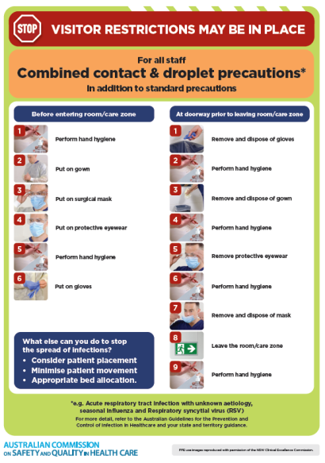](https://www.safetyandquality.gov.au/publications-and-resources/resource-library/infection-prevention-and-control-poster-combined-contact-and-droplet-precautions)
* ***Poster – Combined airborne and contact precautions*** <https://www.safetyandquality.gov.au/publications-and-resources/resource-library/poster-combined-airborne-and-contact-precautions>   
  [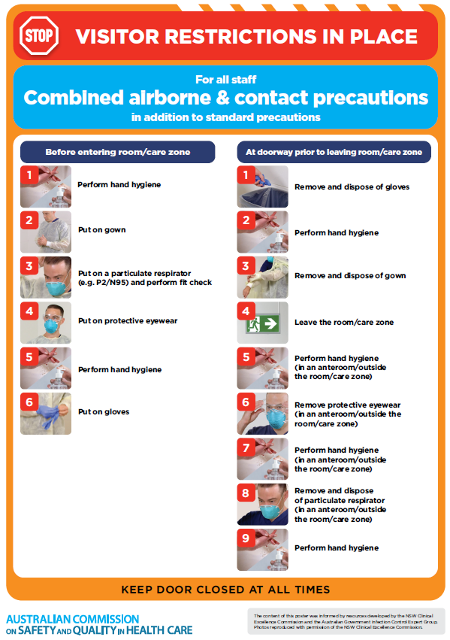](https://www.safetyandquality.gov.au/publications-and-resources/resource-library/poster-combined-airborne-and-contact-precautions)
* ***Environmental Cleaning and Infection Prevention and Control*** [www.safetyandquality.gov.au/environmental-cleaning](http://www.safetyandquality.gov.au/environmental-cleaning)
* ***COVID-19 infection prevention and control risk management – Guidance*** <https://www.safetyandquality.gov.au/publications-and-resources/resource-library/covid-19-infection-prevention-and-control-risk-management-guidance>
* ***Safe care for people with cognitive impairment during COVID-19***<https://www.safetyandquality.gov.au/our-work/cognitive-impairment/cognitive-impairment-and-covid-19>
* ***Stop COVID-19: Break the chain of infection*** posterhttps://www.safetyandquality.gov.au/publications-and-resources/resource-library/break-chain-infection-poster-a3  
  **[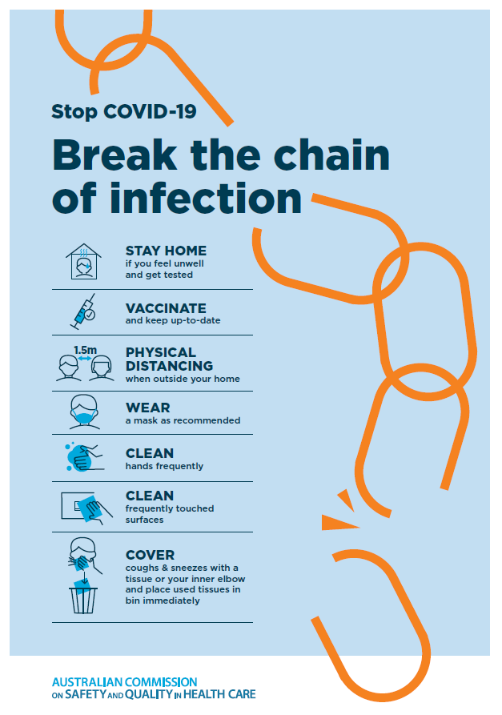](https://www.safetyandquality.gov.au/publications-and-resources/resource-library/break-chain-poster-a3https:/www.safetyandquality.gov.au/publications-and-resources/resource-library/break-chain-poster-a3)**
* ***FAQs for clinicians on elective surgery*** <https://www.safetyandquality.gov.au/node/5724>
* ***FAQs for consumers on elective surgery*** <https://www.safetyandquality.gov.au/node/5725>
* ***COVID-19 and face masks – Information for consumers*** <https://www.safetyandquality.gov.au/publications-and-resources/resource-library/covid-19-and-face-masks-information-consumers>

[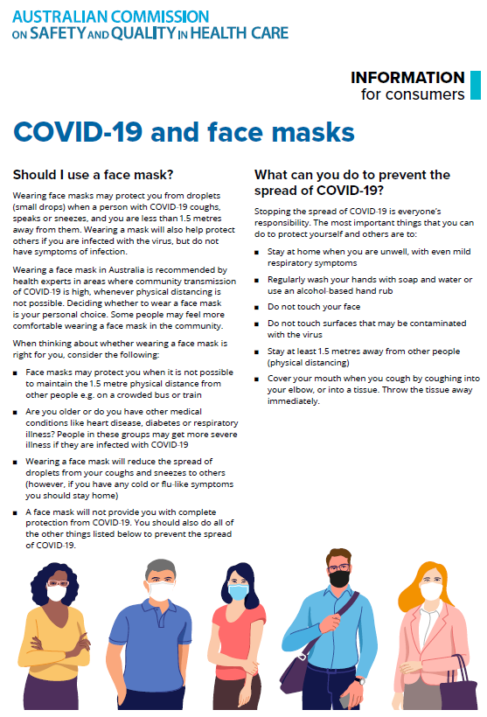](https://www.safetyandquality.gov.au/sites/default/files/2020-07/covid-19_and_face_masks_-_information_for_consumers.pdf)

*National COVID-19 Clinical Evidence Taskforce*

<https://covid19evidence.net.au/>

The National COVID-19 Clinical Evidence Taskforce is a collaboration of peak health professional bodies across Australia whose members are providing clinical care to people with COVID-19. The taskforce is undertaking continuous evidence surveillance to identify and rapidly synthesise emerging research in order to provide national, **evidence-based guidelines and clinical flowcharts for the clinical care of people with COVID-19**. The guidelines address questions that are specific to managing COVID-19 and cover the full disease course across mild, moderate, severe and critical illness. These are ‘living’ guidelines, updated with new research in near real-time in order to give reliable, up-to-the minute advice to clinicians providing frontline care in this unprecedented global health crisis.

*COVID-19 Critical Intelligence Unit*

<https://www.aci.health.nsw.gov.au/covid-19/critical-intelligence-unit>

The Agency for Clinical Innovation (ACI) in New South Wales has developed this page summarising rapid, evidence-based advice during the COVID-19 pandemic. Its operations focus on systems intelligence, clinical intelligence and evidence integration. The content includes a daily evidence digest, a COVID status monitor, a risk monitoring dashboard and evidence checks on a discrete topic or question relating to the current COVID-19 pandemic. There is also a ‘Living evidence’ section summarising key studies and emerging evidence on **COVID-19 vaccines** and **SARS-CoV-2 variants**. The most recent updates include:

* ***Paxlovid*** – What is the evidence for Paxlovid for treatment of COVID-19?
* ***Molnupiravir*** –What is the evidence for and regulatory context of molnupiravir for treatment of COVID-19?
* ***Eating disorders and COVID-19*** – What is the impact of the COVID-19 pandemic on the prevalence of eating disorders?
* ***Long COVID –*** What is the evidence on the prevalence, presentation and management of long-COVID?
* ***Oseltamivir (Tamiflu) use in healthcare settings*** – What is the evidence that use of oseltamivir in healthcare workers with a symptomatic influenza diagnosis result in an earlier return to work and reduced absenteeism? What is the evidence that use of oseltamivir in adults and children with symptomatic influenza reduces influenza transmission in health care settings?
* ***Alternative models of care for acute medical conditions*** – What is the evidence on alternative models of care for managing patients with acute medical conditions outside of emergency or inpatient hospital settings?
* ***Exercise and long COVID*** – Is exercise helpful in individuals with long COVID? Is post-exertional symptom exacerbation a risk in long COVID?
* ***Influenza and seasonal prophylaxis with oseltamivir*** – What is the place or evidence for seasonal influenza prophylaxis (such as taking oseltamivir for 10 to 12 weeks continuously) in healthcare and aged care settings?
* ***Rapid access models of care for respiratory illnesses*** – What is the evidence for rapid access models of care for respiratory illnesses, especially during winter seasons, in emergency departments?
* ***Current and emerging patient safety issues during COVID-19*** – What is the evidence on the current and emerging patient safety issues arising from the COVID-19 pandemic?
* ***Post-acute sequelae of COVID-19*** – What is the evidence on the post-acute sequelae of COVID-19?
* ***Emerging variants*** – What is the available evidence for emerging variants?
* ***Chest pain or dyspnoea following COVID-19 vaccination*** – What is evidence for chest pain or dyspnoea following COVID-19 vaccination?
* ***Cardiac investigations and elective surgery post-COVID-19*** – What is evidence for cardiac investigations and elective surgery post-COVID-19?
* ***Breathlessness post COVID-19*** – How to determine those patients who present with ongoing breathlessness in need of urgent review or intervention due to suspected pulmonary embolus?
* ***COVID-19 pandemic and influenza*** – What is the evidence for COVID-19 pandemic and influenza?
* ***Budesonide and aspirin for pregnant women with COVID-19 –*** What is the evidence for the use of Budesonide for pregnant women with COVID-19? What is the evidence for aspirin prophylaxis for pre-eclampsia in pregnant women with a COVID-19 infection?
* ***COVID-19 vaccines in Australia*** – What is the evidence on COVID-19 vaccines in Australia?
* ***COVID-19 pandemic and wellbeing of critical care and other healthcare workers*** – Evidence in brief on the impact of the COVID-19 pandemic on the wellbeing of critical care and other healthcare workers.
* ***Surgery post COVID-19*** – What is the evidence for the timing of surgery, and outcomes following surgery, for people who have recovered from COVID-19?
* ***Disease modifying treatments for COVID-19 in children*** – What is the evidence for disease modifying treatments for COVID-19 in children?
* ***Mask type for COVID-19 positive wearer*** – What is the evidence for different mask types for COVID-19 positive wearers?
* ***Post acute and subacute COVID-19 care*** – What published advice and models of care are available regarding post-acute and subacute care for COVID-19 patients?
* ***Hospital visitor policies*** – What is the evidence for hospital visitor policies during and outside of the COVID-19 pandemic?
* ***Surgical masks, eye protection and PPE guidance*** –What is the evidence for surgical masks in the endemic phase in hospitals and for eyewear to protect against COVID-19?

**Disclaimer**

On the Radar is an information resource of the Australian Commission on Safety and Quality in Health Care. The Commission is not responsible for the content of, nor does it endorse, any articles or sites listed. The Commission accepts no liability for the information or advice provided by these external links. Links are provided on the basis that users make their own decisions about the accuracy, currency and reliability of the information contained therein. Any opinions expressed are not necessarily those of the Australian Commission on Safety and Quality in Health Care.