# Australian Commission on Safety and Quality logotypeOn the Radar

Issue 579

17 October 2022

*On the Radar* is a summary of some of the recent publications in the areas of safety and quality in health care. Inclusion in this document is not an endorsement or recommendation of any publication or provider. Access to particular documents may depend on whether they are Open Access or not, and/or your individual or institutional access to subscription sites/services. Material that may require subscription is included as it is considered relevant.

*On the Radar* is available online, via email or as a PDF or Word document from <https://www.safetyandquality.gov.au/publications-and-resources/newsletters/radar>

If you would like to receive *On the Radar* via email, you can subscribe on our website <https://www.safetyandquality.gov.au/publications-and-resources/newsletters>  
or by emailing us at H[Umail@safetyandquality.gov.auU](mailto:mail@safetyandquality.gov.au).   
You can also send feedback and comments to H[Umail@safetyandquality.gov.auU](mailto:mail@safetyandquality.gov.au).

For information about the Commission and its programs and publications, please visit <https://www.safetyandquality.gov.au>

You can also follow us on Twitter @ACSQHC.

**On the Radar**

Editor: Dr Niall Johnson [niall.johnson@safetyandquality.gov.au](mailto:niall.johnson@safetyandquality.gov.au)

Contributors: Niall Johnson, Jenni Caldwell, Kristin Xenos

***Infection Prevention and Control Week 2022***

<https://www.safetyandquality.gov.au/ipcweek>

***Infection prevention and control is safe health care, for everyone, all the time.***

Infection Prevention and Control (IPC) Week is held during the third week of October each year. IPC Week highlights the importance of protecting patients, healthcare workers and the community from infection, and recognising the efforts of all healthcare workers to reduce the risk of infections in health services.

The overarching theme for IPC Week in Australia is “**Infection prevention and control is safe health care, for everyone, all the time**”.

The Commission’s focus for IPC Week 2022 is supporting health service organisations to meet the requirements of the *Preventing and Controlling Infections Standard* of the [National Safety and Quality Health Services (NSQHS) Standards](https://www.safetyandquality.gov.au/publications-and-resources/resource-library/national-safety-and-quality-health-service-standards-second-edition) and preventing the spread of [COVID-19](https://www.safetyandquality.gov.au/covid-19-resources) and other infections to patients, the community and members of the health workforce.

The actions of the [*Preventing and Controlling Infections Standards*](https://www.safetyandquality.gov.au/standards/nsqhs-standards/preventing-and-controlling-infections-standard):

* Ensure patient and healthcare worker safety
* Promote quality improvement for infection prevention and control
* Promote effective risk identification and management of infection risks
* Reducing harm to patients, visitors and members of the health workforce from infection
* Achieve good health outcomes for patients.

Information and resources to promote IPC Week, including a quiz and PowerPoint presentation can be found at <https://www.safetyandquality.gov.au/ipcweek>

**Reports**

*Calibrate Dx: A Resource To Improve Diagnostic Decisions*

Agency for Healthcare Research and Quality

Rockville MD: Agency for Healthcare Research and Quality,; 2022. p. 38.

|  |  |
| --- | --- |
| URL | <https://www.ahrq.gov/patient-safety/settings/multiple/calibrate-dx.html> |
| Notes | The US Agency for Healthcare Research and Quality (AHRQ) has developed this resource to provide clinicians with guidance for evaluating and calibrating diagnostic performance for the purposes of learning and improvement. *Calibrate* Dx is designed to be used by clinicians, but may be of interest to healthcare organisation leaders, quality and safety personnel, educators, and trainees. The tool provides practical recommendations for implementing calibration strategies that can be applied in operational settings. The guide and additional materials are available at <https://www.ahrq.gov/patient-safety/settings/multiple/calibrate-dx.html>. The additional resources include:   * Clinician's Quick-Start Guide to Calibrate Dx * Guide for Clinical Leaders * Diagnostic Calibration Debrief Tool * Revised Safer Dx Instrument. |

*Reinforcing the Value and Roles of Nurses in Diagnostic Safety: Pragmatic Recommendations for Nurse Leaders and Educators*

Tran AK, Calabrese M, Quatrara B, Goeschel C

Rockville, MD: Agency for Healthcare Research and Quality; 2022.

|  |  |
| --- | --- |
| DOI | <https://www.ahrq.gov/patient-safety/reports/issue-briefs/nurse-role-dxsafety.html> |
| Notes | Also from AHRQ on the subject of diagnostic performance and safety is this resource on the value and role nurses can play. The authors state ‘This issue brief describes pragmatic approaches for nurse educators and leaders to convey the urgent need to improve diagnosis among their nurses and care teams and to guide nurses to embrace their leadership roles in the diagnostic process. Informed by the literature and professional experience, we offer action-oriented steps and learning strategies, including patient cases that facilitate discussion and promote problem solving, to recognize and encourage nurses as important contributors to reducing diagnostic errors and improving diagnostic safety.’ |

**Journal articles**

*Measuring and Improving Patient Safety in Canada*

Popescu I

Patient Safety. 2022;4(3):48-57.

|  |  |
| --- | --- |
| DOI | <https://doi.org/10.33940/med/2022.9.7> |
| Notes | Summary article from Healthcare Excellence Canada on the current and recent history of patient safety in Canada. The paper, and the conclusion, indicate that Canada’s experience is similar to a number of other nations: ‘Over the past decades, there have been large improvements in how patient safety incidents are approached in Canada and worldwide. Collecting data, coordinating measuring and reporting, sharing learnings internally and externally, and implementing actions for improvement are becoming the norm; however, much more remains to be done. Healthcare leaders have come to understand the importance of keeping a constant focus on improving by learning from safety reporting and beyond. The increased engagement of all people impacted, especially patients and families, provides renewed optimism that soon everyone in Canada will receive safe care.’  Visual abstract for Measuring and Improving Patient Safety in Canada |

*Antibiotic review kit for hospitals (ARK-Hospital): a stepped-wedge cluster-randomised controlled trial*

Llewelyn MJ, Budgell EP, Laskawiec-Szkonter M, Cross ELA, Alexander R, Bond S, et al

The Lancet Infectious Diseases. 2022.

|  |  |
| --- | --- |
| DOI | <https://doi.org/10.1016/S1473-3099(22)00508-4> |
| Notes | This study evaluated an intervention called the antibiotic review kit. Thirty nine (39) hospitals in the UK were included in the study. The antibiotic review kit ‘comprised a decision aid that was intended to be embedded in the hospital prescription process, prompting prescribers to clarify the level of diagnostic uncertainty at antibiotic initiation by classifying infection risk as possible or probable, and then either stopping the prescription if a clear indication for ongoing antibiotic treatment could not be established at 48–72 h review or finalising the prescription if a clear indication could be established’. The Antibiotic review kit tools are freely available online at <https://www.antibioticreviewkit.org.uk/>. Interestingly, ‘consistent reductions were seen in Access, Watch, narrow-spectrum, and oral antibiotics, but not in broad-spectrum or parenteral antibiotics, antibiotics considered Access or Watch depending on indication, and piperacillin–tazobactam, and there was a significant increase in DDDs for carbapenems and Reserve classes.’ The impact on mortality was difficult to determine due to the COVID-19 pandemic. The intervention focused on decisions to stop rather than decisions to start antibiotics, as the aim was to ‘reduce overall use without withholding empirical antibiotics from patients with acute illness.’ |

For information on the Commission’s work on antimicrobial stewardship, see <https://www.safetyandquality.gov.au/our-work/antimicrobial-stewardship>

*Turning the tide on depression: A vision that starts with Australia’s youth*

Black Dog Institute

Sydney: Black Dog Institute; 2022. p. 80.

*Screening for Anxiety in Children and Adolescents: US Preventive Services Task Force Recommendation Statement*

U. S. Preventive Services Task Force

Journal of the American Medical Association. 2022;328(14):1438-1444.

*Screening for Anxiety in Children and Adolescents*

Jin J

Journal of the American Medical Association. 2022;328(14):1469-1470.

*Screening for Depression and Suicide Risk in Children and Adolescents: US Preventive Services Task Force Recommendation Statement*

U. S. Preventive Services Task Force

Journal of the American Medical Association. 2022 [epub].

*Screening for Depression and Suicide Risk in Children and Adolescents*

Jin J

Journal of the American Medical Association. 2022 [epub].

|  |  |
| --- | --- |
| DOI | Black Dog Institute <https://www.blackdoginstitute.org.au/wp-content/uploads/2022/10/Youth-Depression-Report_Full.pdf>  US Preventive Services Task Force <https://doi.org/10.1001/jama.2022.16936>  Jin <https://doi.org/10.1001/jama.2022.18184>  U. S. Preventive Services Task Force <https://doi.org/10.1001/jama.2022.16946>  Jin <https://doi.org/10.1001/jama.2022.18187> |
| Notes | Mental health concerns among children, adolescents and young people have been gaining increased attention, with concerns that they have been growing in prevalence. For example, the Black Dog Institute’s recent report focused on depressing in these groups.  The U.S. Preventive Services Task Force (USPSTF) commissioned a systematic review to evaluate the benefits and harms of screening for anxiety disorders in children and adolescents. From that review the USPSTF ‘concludes with moderate certainty that **screening for anxiety in children and adolescents aged 8 to 18 years has a moderate net benefit**. The USPSTF concludes that the evidence is insufficient on screening for anxiety in children 7 years or younger.’ The recommendation is also summarised in a JAMA Patient Page (Jin).  [Image from Jama patient page (Jin) summarising the recommendation on screening for anxiety in children and adolescents.](https://doi.org/10.1001/jama.2022.18184)  The USPSTF has updated its recommendation on Screening for Depression and Suicide Risk in Children and Adolescents. Here the USPTF ‘concludes with moderate certainty that **screening for MDD [major depressive disorder] in adolescents aged 12 to 18 years has a moderate net benefit**. The USPSTF concludes that the evidence is insufficient on screening for MDD in children 11 years or younger. The USPSTF concludes that the evidence is insufficient on the benefit and harms of screening for suicide risk in children and adolescents owing to a lack of evidence.’  This recommendation is also summarised in a JAMA Patient Page (Jin).  [Image from Jama patient page (Jin) summarising the recommendation on screening for depression and suicide risk in children and adolescents.](https://doi.org/10.1001/jama.2022.18187) |

*Pediatric Quality & Safety*

Volume 7, Number 5, September/October 2022

|  |  |
| --- | --- |
| URL | <https://journals.lww.com/pqs/toc/2022/09000> |
| Notes | A new issue of *Pediatric Quality & Safety* has been published. Articles in this issue of *Pediatric Quality & Safety* include:   * Implementation of Standardized Care for the **Medical Stabilization of Patients With Anorexia Nervosa** (Taraneh Shafii, Alex Morrison, Pingping Qu, Lori Rutman, Ron Kaplan) * Financial and Safety Impact of Simulation-based Clinical Systems Testing on **Pediatric Trauma Center Transitions** (Sacha A Williams, Katie Fitzpatrick, Nicole M Chandler, Jennifer L Arnold, Christopher W Snyder) * Improving Care at Emergency Department **Discharge for Pediatric Patients with Anaphylaxis** Using a Quality Improvement Framework (Chisom Agbim, Marci Fornari, Emily Willner, Sarah Isbey, Deena Berkowitz, Katura Palacious, Gia Badolato, Mandisa McIver) * **Reducing Admission for Anaphylaxis** in a Pediatric Emergency Department Using a Clinical Decision Support Tool (Katherine H Wolpert, Rebecca Kestle, Nicholas Weaver, Kelly Huynh, M Yoo, R Nelson, R D Lane) * Improving **Vitamin D Screening in a Pediatric Rheumatology Clinic** Using Structured Quality Improvement Process (Aliese Sarkissian, Edward Oberle, O Al Ahmed, D Piccinich, F Barbar-Smiley, H Zak, V Sivaraman) * Independent Double-check of **Infusion Pump Programming**: An Anesthesia Improvement Effort to Reduce harm.(Kavitha C Raghavan, Jonathan D Burlison, Edward M Sanders II, Michael G Rossi) * Using QI Methodology to Improve a Program’s **QI Curriculum**: An Educational Improvement Project (Courtney M Port, Kathleen M Donnelly) * Comprehensive Improvement of **Cardiology Inpatient Transfers**: A Bed-availability Triggered Approach (Judson A Moore, Lindsay F Eilers, A J Willis, M D Chance, J A La Salle, E H Delgado, K M Bien, J R Goldman, S S Sheth) * Counseling **Tobacco Smoke Exposure Reduction Measures in Pediatrics**: A Quality Improvement Project (Kevin Ferguson, Sankaran Krishnan, Emily Sullivan, Shyall Bhela, Allen J Dozor, John J Welter) * Pausing TPN to **Decrease Abnormal Newborn Screens**: A NICU Quality Initiative (Jaclyn B Wiggins, Marium Khan, Brooke D Vergales) * Leveraging Real-world Data to Increase **Procedure Room Capacity**: A Multidisciplinary Quality Improvement Project (Rachel Feldman, Daniel Low, Irina Gorbounova, Lusine Ambartsumyan, Lynn Martin) * BLOSSoM: Improving **Human Milk Provision in Preterm Infants** Through Texting Support (Madoka Hayashi, Kelly Huber, Colette Rankin, Brittany Boyajian, Angelena Martinez, Theresa Grover, Genie Roosevelt) * Testing an Automated Approach to Identify **Variation in Outcomes among Children with Type 1 Diabetes** across Multiple Sites (Jessica Addison, Hanieh Razzaghi, Charles Bailey, Kimberley Dickinson, Sarah D Corathers, David M Hartley, Levon Utidjian, Adam C Carle, Erinn T Rhodes, G Todd Alonso, Michael J Haller, Anthony W Gannon, Justin A Indyk, A M Arbeláez, E Shenkman, C B Forrest, D Eckrich, B Magnusen, S D Davies, K E Walsh) |

*Australian Journal of Primary Health*

Volume 28, Number 5, October 2022

|  |  |
| --- | --- |
| URL | <https://www.publish.csiro.au/py/issue/10798> |
| Notes | A new issue of the *Australian Journal of Primary Health* has been published. Articles in this issue of the *Australian Journal of Primary Health* include:   * **Health literacy assessment in the clinic**: benefits, pitfalls and practicalities (Claire M Ellender, Mary Boyde and Ian A Scott) * **Challenges of conducting kidney health checks** among patients at risk of chronic kidney disease and attending an urban Aboriginal and Torres Strait Islander primary healthcare service (Prabha Lakhan, Anna Cooney, Dharmenaan Palamuthusingam, Gary Torrens, Geoffrey Spurling, Antonio Martinez and David Johnson) * How immersion in remote Aboriginal communities influences **medical students’ career intentions** (Jessica Mitchell, Jack Rumbelow, Amy Broadley, Laura Sharley, Millicent Osti and Jill Benson) * **Mental health symptoms in Australian general practitioners during the COVID-19 pandemic** (Irene Ng, Kate Robins-Browne, Mark Putland, Amy Pascoe, Eldho Paul, Karen Willis and Natasha Smallwood) * **COVID-19 vaccinations and counselling**: a mixed-methods survey of Australian general practice in July 2021 (Kathleen O’Brien, Katelyn Barnes, Sally Hall Dykgraaf and Kirsty A Douglas) * **Demographic and health profiles of people with severe mental illness in general practice in Australia**: a cross-sectional study (Catherine Spooner, Samira Afrazi, Juliana de Oliveira Costa and Mark F Harris) * Health and service needs, priorities and initiatives of **primary health networks related to** **chronic pain** (Simone De Morgan, Pippy Walker, Fiona M Blyth, Leah Marks, Lucie Rychetnik, Michael Nicholas, Duncan Sanders and Andrew Wilson) * Development of an individualised **primary care program for acute low back pain** using a hybrid co-design framework (Malene Ahern, Catherine M Dean, Blake F Dear, Simon M Willcock and Julia M Hush) * **My Back My Plan** is a feasible and acceptable individualised program for acute low back pain in primary care (Malene Ahern, Catherine M Dean, Blake F Dear, Simon M Willcock and Julia M Hush) * What role do Australian health professionals play in helping people choose their **home care package services**? (Victoria Cornell, Braam Lowies, Kurt Lushington and Christine Helliar) |

*Public Health Research & Practice*

Volume 32, Issue 3, October 2022

|  |  |
| --- | --- |
| URL | <https://www.phrp.com.au/issues/october-2022-volume-32-issue-3/> |
|  | A new issue of *Public Health Research & Practice* has been published with a theme ‘**reframing the obesity narrative**’. Articles in this issue of *Public Health Research & Practice* include:   * Editorial: **Addressing obesity**: determined action and bold leadership required for change (Michelle Gooey, Louise A Baur, Zuleika Arashiro, Tiffany Petre, Jane Martin, Jo Mitchell, Samantha Hocking, Johanna Ralston, Helen Skouteris) * A better understanding of **the science and reality of obesity** is urgently needed (Tiffany Petre, Adrian Bauman, Priya Sumithran, Gary Sacks, Tim Lobstein, Carel Le Roux, Clare Mullen, Brian Oldfield) * The **commercial determinants of unhealthy diets** (Alex Chung, Lucy Westerman, Jane Martin, Sharon Friel) * **Optimising weight gain in pregnancy**: key challenges and solutions for maternal obesity prevention (Briony Hill, Helen Skouteris, Helena Teede, Melissa Savaglio, Cheryce L Harrison) * Adolescence and young adulthood: an untapped window of opportunity for **obesity prevention** (Stephanie R Partridge, Kyra A Sim, Natasha Armaghanian, Kate S Steinbeck, Hoi Lun Cheng) * **Weight stigma** in Australia: a public health call to action (Blake J Lawrence, Xochitl de la Piedad Garcia, James Kite, Briony Hill, Kelly Cooper, Stuart W Flint, John B Dixon) * **Inequities in obesity**: Indigenous, culturally and linguistically diverse, and disability perspectives (Ray Kelly, Kostas Hatzikiriakidis, Konsita Kuswara) * The true cost of **hidden waiting times for cataract surgery** in Australia (Jessie Huang-Lung, Blake Angell, Anna Palagyi, Hugh R Taylor, Andrew White, Peter McCluskey, Lisa Keay) * A call for joined-up action to promote **nutrition across the first 2000 days of life** using a food systems approach (Penelope Love, Rachel Laws, Megan Adam, Emma Esdaile, Karen J Campbell) * Changes in public support for **alcohol policies in NSW**, Australia, 2013–2019 (Wendy L Watson, Natalie Stapleton, Penny Buykx, Clare Hughes, Anita Dessaix) * Online liquor gets audited: a review of **regulatory controls and supply practices of online liquor retailers** in NSW, Australia (Jonathon Noyes, Melissa Palermo, Arlita Willman, Jenna Harkness, Rachel Bienenstock, Paul Klarenaar) * Policies and healthcare to support **preconception planning and weight management**: optimising long-term health for women and children (Jacqueline A Boyle, Jodie Dodd, Adrienne Gordon, Brian W Jack, Helen Skouteris) * Health service approaches to **providing care for people who seek treatment for obesity**: identifying challenges and ways forward (Michelle Gooey, Catherine A Bacus, Divya Ramachandran, Milan K Piya, Louise A Baur) * Nutrition, physical activity and screen time policies and practices in **family day care** in NSW, Australia (Erin M Kerr, Bridget Kelly, Jennifer Norman, Susan Furber, Lara Hernandez, Megan L Hammersley, Sarah Ryan, Lisa Franco, Cecilia Vuong, Anthony D Okely) |

*Journal of Health Services Research & Policy*

Volume 27, Number 4, October 2022

|  |  |
| --- | --- |
| URL | <https://journals.sagepub.com/toc/hsrb/27/4> |
| Notes | A new issue of the *Journal of Health Services Research & Policy* has been published. Articles in this issue of the *Journal of Health Services Research & Policy* include:   * Editorial: **Towards sustainability for medical devices and consumables**: The radical and incremental challenges in the technology ecosystem (Saba Hinrichs-Krapels, Jan-Carel Diehl, Nicole Hunfeld, and Erik van Raaij) * **Operating room waste management**: A case study of primary hip operations at a leading National Health Service hospital in the United Kingdom (Melissa Pegg, Rebecca Rawson, and Uchechukwu Okere) * Implementing joint training sessions of general practitioners and specialists aimed at improving **clinical coordination** in Colombia: Contributions from participatory action research (Heisel G León-Arce, Josefina Chávez Chávez, Amparo-Susana Mogollón-Pérez, Ingrid Vargas, and María-Luisa Vázquez) * Processes supporting effective **skill-mix implementation in general practice**: A qualitative study (Sharon Spooner, Imelda McDermott, Mhorag Goff, Damian Hodgson, Anne McBride, and Katherine Checkland) * Age-varying effects of **repeated emergency department presentations for children** in Canada (Rhonda J Rosychuk, Anqi A Chen, Andrew McRae, Patrick McLane, Maria B Ospina, and X Joan Hu) * Staff perspectives on barriers to and facilitators of quality of life, health, wellbeing, recovery and reduced risk for **older forensic mental-health patients**: A qualitative interview study (Kate Walker, Jen Yates, Tom Dening, Birgit Völlm, Jack Tomlin, and Chris Griffiths) * Loss associated with subtractive health service change: The case of **specialist cancer centralization** in England (Georgia B Black, Victoria J Wood, Angus I G Ramsay, Cecilia Vindrola-Padros, Catherine Perry, Caroline S Clarke, Claire Levermore, Kathy Pritchard-Jones, Axel Bex, Maxine G B Tran, David C Shackley, John Hines, Muntzer M Mughal, and Naomi J Fulop) * Implementing **patient navigator programmes within a hospital setting** in Toronto, Canada: A qualitative interview study (Kristina M Kokorelias, Sarah Gould, Tracey Das Gupta, Naomi Ziegler, Dan Cass, and Sander L Hitzig) * The experience of **informal caregivers in providing patient care in hospitals** in low- and middle-income countries: A qualitative meta-synthesis (Unarose Hogan, Amanda Bingley, Hazel Morbey, and Catherine Walshe) |

*BMJ Quality & Safety* online first articles

|  |  |
| --- | --- |
| URL | <https://qualitysafety.bmj.com/content/early/recent> |
| Notes | *BMJ Quality &Safety* has published a number of ‘online first’ articles, including:   * Editorial: **Polypharmacy and continuity of care**: medicines optimisation in the era of multidisciplinary teams (Carolyn Tarrant, Rachel Lewis, Natalie Armstrong) |

*International Journal for Quality in Health Care* online first articles

|  |  |
| --- | --- |
| URL | <https://academic.oup.com/intqhc/advance-articles> |
| Notes | *International Journal for Quality in Health Care* has published a number of ‘online first’ articles, including:   * A Delphi consensus study to identify priorities for improving and measuring **medication safety for intensive care patients on transfer to a hospital ward** (Richard S Bourne, Jennifer K Jennings, Darren M Ashcroft) |

**COVID-19 resources**

https://www.safetyandquality.gov.au/covid-19

The Australian Commission on Safety and Quality in Health Care has developed a number of resources to assist healthcare organisations, facilities and clinicians. These and other material on COVID-19 are available at <https://www.safetyandquality.gov.au/covid-19>

These resources include:

* ***OVID-19 infection prevention and control risk management*** This primer provides an overview of three widely used tools for investigating and responding to patient safety events and near misses. Tools covered in this primer include incident reporting systems, Root Cause Analysis (RCA), and Failure Modes and Effects Analysis (FMEA).   
  <https://www.safetyandquality.gov.au/publications-and-resources/resource-library/covid-19-infection-prevention-and-control-risk-management-guidance>
* ***Poster – Combined contact and droplet precautions*** <https://www.safetyandquality.gov.au/publications-and-resources/resource-library/infection-prevention-and-control-poster-combined-contact-and-droplet-precautions>  
  [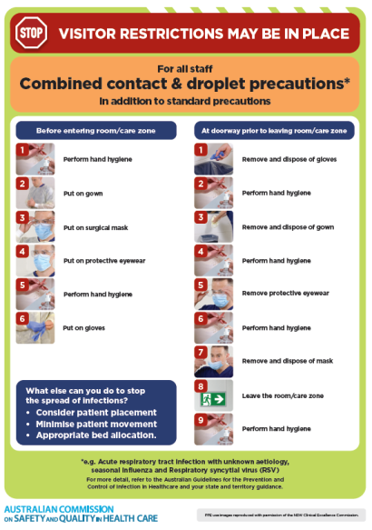](https://www.safetyandquality.gov.au/publications-and-resources/resource-library/infection-prevention-and-control-poster-combined-contact-and-droplet-precautions)
* ***Poster – Combined airborne and contact precautions*** <https://www.safetyandquality.gov.au/publications-and-resources/resource-library/poster-combined-airborne-and-contact-precautions>   
  [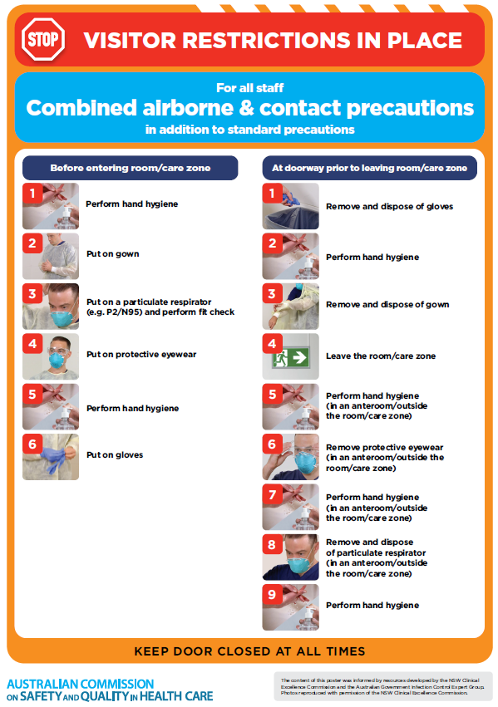](https://www.safetyandquality.gov.au/publications-and-resources/resource-library/poster-combined-airborne-and-contact-precautions)
* ***Environmental Cleaning and Infection Prevention and Control*** [www.safetyandquality.gov.au/environmental-cleaning](http://www.safetyandquality.gov.au/environmental-cleaning)
* ***COVID-19 infection prevention and control risk management – Guidance*** <https://www.safetyandquality.gov.au/publications-and-resources/resource-library/covid-19-infection-prevention-and-control-risk-management-guidance>
* ***Safe care for people with cognitive impairment during COVID-19***<https://www.safetyandquality.gov.au/our-work/cognitive-impairment/cognitive-impairment-and-covid-19>
* ***Stop COVID-19: Break the chain of infection*** posterhttps://www.safetyandquality.gov.au/publications-and-resources/resource-library/break-chain-infection-poster-a3  
  **[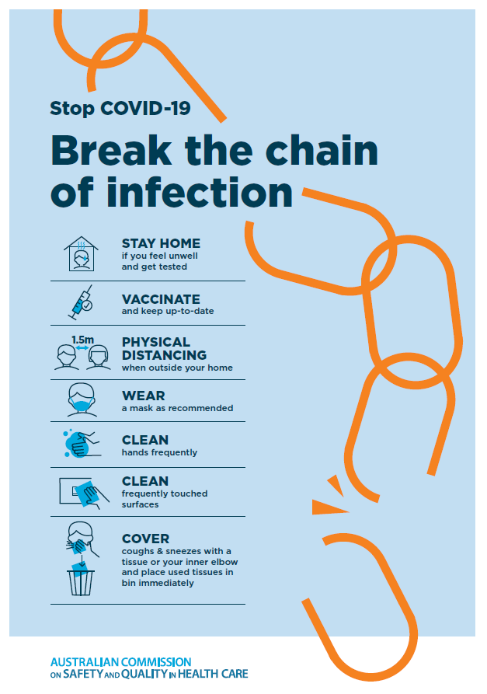](https://www.safetyandquality.gov.au/publications-and-resources/resource-library/break-chain-poster-a3https:/www.safetyandquality.gov.au/publications-and-resources/resource-library/break-chain-poster-a3)**
* ***FAQs for clinicians on elective surgery*** <https://www.safetyandquality.gov.au/node/5724>
* ***FAQs for consumers on elective surgery*** <https://www.safetyandquality.gov.au/node/5725>
* ***COVID-19 and face masks – Information for consumers*** <https://www.safetyandquality.gov.au/publications-and-resources/resource-library/covid-19-and-face-masks-information-consumers>

[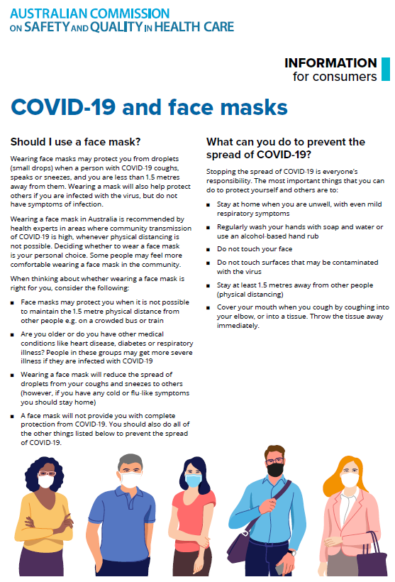](https://www.safetyandquality.gov.au/sites/default/files/2020-07/covid-19_and_face_masks_-_information_for_consumers.pdf)

*National COVID-19 Clinical Evidence Taskforce*

<https://covid19evidence.net.au/>

The National COVID-19 Clinical Evidence Taskforce is a collaboration of peak health professional bodies across Australia whose members are providing clinical care to people with COVID-19. The taskforce is undertaking continuous evidence surveillance to identify and rapidly synthesise emerging research in order to provide national, **evidence-based guidelines and clinical flowcharts for the clinical care of people with COVID-19**. The guidelines address questions that are specific to managing COVID-19 and cover the full disease course across mild, moderate, severe and critical illness. These are ‘living’ guidelines, updated with new research in near real-time in order to give reliable, up-to-the minute advice to clinicians providing frontline care in this unprecedented global health crisis.

*COVID-19 Critical Intelligence Unit*

<https://www.aci.health.nsw.gov.au/covid-19/critical-intelligence-unit>

The Agency for Clinical Innovation (ACI) in New South Wales has developed this page summarising rapid, evidence-based advice during the COVID-19 pandemic. Its operations focus on systems intelligence, clinical intelligence and evidence integration. The content includes a daily evidence digest, a COVID status monitor, a risk monitoring dashboard and evidence checks on a discrete topic or question relating to the current COVID-19 pandemic. There is also a ‘Living evidence’ section summarising key studies and emerging evidence on **COVID-19 vaccines** and **SARS-CoV-2 variants**. The most recent updates include:

* ***Paxlovid*** – What is the evidence for Paxlovid for treatment of COVID-19?
* ***Molnupiravir*** –What is the evidence for and regulatory context of molnupiravir for treatment of COVID-19?
* ***Eating disorders and COVID-19*** – What is the impact of the COVID-19 pandemic on the prevalence of eating disorders?
* ***Long COVID –*** What is the evidence on the prevalence, presentation and management of long-COVID?
* ***Oseltamivir (Tamiflu) use in healthcare settings*** – What is the evidence that use of oseltamivir in healthcare workers with a symptomatic influenza diagnosis result in an earlier return to work and reduced absenteeism? What is the evidence that use of oseltamivir in adults and children with symptomatic influenza reduces influenza transmission in health care settings?
* ***Alternative models of care for acute medical conditions*** – What is the evidence on alternative models of care for managing patients with acute medical conditions outside of emergency or inpatient hospital settings?
* ***Exercise and long COVID*** – Is exercise helpful in individuals with long COVID? Is post-exertional symptom exacerbation a risk in long COVID?
* ***Influenza and seasonal prophylaxis with oseltamivir*** – What is the place or evidence for seasonal influenza prophylaxis (such as taking oseltamivir for 10 to 12 weeks continuously) in healthcare and aged care settings?
* ***Rapid access models of care for respiratory illnesses*** – What is the evidence for rapid access models of care for respiratory illnesses, especially during winter seasons, in emergency departments?
* ***Current and emerging patient safety issues during COVID-19*** – What is the evidence on the current and emerging patient safety issues arising from the COVID-19 pandemic?
* ***Post-acute sequelae of COVID-19*** – What is the evidence on the post-acute sequelae of COVID-19?
* ***Emerging variants*** – What is the available evidence for emerging variants?
* ***Chest pain or dyspnoea following COVID-19 vaccination*** – What is evidence for chest pain or dyspnoea following COVID-19 vaccination?
* ***Cardiac investigations and elective surgery post-COVID-19*** – What is evidence for cardiac investigations and elective surgery post-COVID-19?
* ***Breathlessness post COVID-19*** – How to determine those patients who present with ongoing breathlessness in need of urgent review or intervention due to suspected pulmonary embolus?
* ***COVID-19 pandemic and influenza*** – What is the evidence for COVID-19 pandemic and influenza?
* ***Budesonide and aspirin for pregnant women with COVID-19 –*** What is the evidence for the use of Budesonide for pregnant women with COVID-19? What is the evidence for aspirin prophylaxis for pre-eclampsia in pregnant women with a COVID-19 infection?
* ***COVID-19 vaccines in Australia*** – What is the evidence on COVID-19 vaccines in Australia?
* ***COVID-19 pandemic and wellbeing of critical care and other healthcare workers*** – Evidence in brief on the impact of the COVID-19 pandemic on the wellbeing of critical care and other healthcare workers.
* ***Surgery post COVID-19*** – What is the evidence for the timing of surgery, and outcomes following surgery, for people who have recovered from COVID-19?
* ***Disease modifying treatments for COVID-19 in children*** – What is the evidence for disease modifying treatments for COVID-19 in children?
* ***Mask type for COVID-19 positive wearer*** – What is the evidence for different mask types for COVID-19 positive wearers?
* ***Post acute and subacute COVID-19 care*** – What published advice and models of care are available regarding post-acute and subacute care for COVID-19 patients?
* ***Hospital visitor policies*** – What is the evidence for hospital visitor policies during and outside of the COVID-19 pandemic?
* ***Surgical masks, eye protection and PPE guidance*** –What is the evidence for surgical masks in the endemic phase in hospitals and for eyewear to protect against COVID-19?

**Disclaimer**

On the Radar is an information resource of the Australian Commission on Safety and Quality in Health Care. The Commission is not responsible for the content of, nor does it endorse, any articles or sites listed. The Commission accepts no liability for the information or advice provided by these external links. Links are provided on the basis that users make their own decisions about the accuracy, currency and reliability of the information contained therein. Any opinions expressed are not necessarily those of the Australian Commission on Safety and Quality in Health Care.