# Australian Commission on Safety and Quality logotypeOn the Radar

Issue 584

21 November 2022

*On the Radar* is a summary of some of the recent publications in the areas of safety and quality in health care. Inclusion in this document is not an endorsement or recommendation of any publication or provider. Access to particular documents may depend on whether they are Open Access or not, and/or your individual or institutional access to subscription sites/services. Material that may require subscription is included as it is considered relevant.

*On the Radar* is available online, via email or as a PDF or Word document from <https://www.safetyandquality.gov.au/publications-and-resources/newsletters/radar>

If you would like to receive *On the Radar* via email, you can subscribe on our website <https://www.safetyandquality.gov.au/publications-and-resources/newsletters>  
or by emailing us at H[Umail@safetyandquality.gov.auU](mailto:mail@safetyandquality.gov.au).   
You can also send feedback and comments to H[Umail@safetyandquality.gov.auU](mailto:mail@safetyandquality.gov.au).

For information about the Commission and its programs and publications, please visit <https://www.safetyandquality.gov.au>

You can also follow us on Twitter @ACSQHC.

**On the Radar**

Editor: Dr Niall Johnson [niall.johnson@safetyandquality.gov.au](mailto:niall.johnson@safetyandquality.gov.au)

Contributors: Niall Johnson, Rebecca Peters, Amy Forsyth, Angie Dalli

**Online launch of the National Safety and Quality Mental Health Standards for Community Managed Organisations**

<https://safetyandquality.tv/mh-cmos/>

The new National Safety and Quality Mental Health #NSQMH Standards for Community Managed Organisations will be released later this month.

Join our webcast event on Wednesday **23 November** at **12pm AEDT** to find out how the standards will make a difference to the #CMOs sector. <https://safetyandquality.tv/mh-cmos/> #mentalhealth

The Standards are a significant step in providing safety and quality assurance for consumers, their families and carers who use mental health services, and best practice guidance for community managed service providers.

The Commission is releasing the Standards following extensive consultation with consumers, families and carers, community managed organisations, peak bodies, healthcare providers, professional bodies, Primary Health Networks and funders.

Join the launch to hear from guest speakers during our 30-minute webcast on how the new Standards will benefit consumers, why mental health community organisations should implement them and next steps for accreditation.

**When**: Wednesday **23 November**, **12:00pm**–12:30pm AEDT.

**[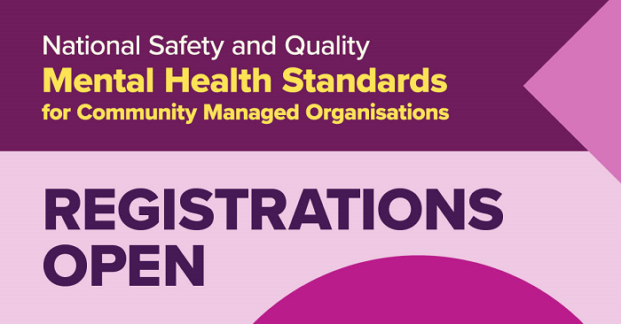](https://safetyandquality.tv/mh-cmos/)**

**Consultation - National Consensus Statement: Essential elements for safe and high-quality end-of-life care**

<https://www.safetyandquality.gov.au/our-work/end-life-care/consultation-national-consensus-statement-essential-elements-safe-and-high-quality-end-life-care>

The Commission developed the *National Consensus Statement: Essential elements for safe and high-quality end-of-life care* (the Consensus Statement) which was endorsed by Health Ministers in 2015. The essential elements are the features that are required in systems to ensure safe and high-quality care for patients who are approaching the end of life. However, these elements do not prescribe how care should be delivered.

The Commission has undertaken a review of the Consensus Statement. Two recent literature reviews highlighted gaps in the current Consensus Statement that have been included in the revision and tested through the initial consultation processes. The consultation will provide an opportunity to broaden the content to enable its use in all settings where health care is provided including primary and community care and residential aged care facilities.

In response to evidence from the literature and preliminary feedback, significant changes that have been made to the Consensus Statement include:

* Guidance for specific patient groups where care may differ from usual end-of-life care including paediatrics which has been a separate document until now
* Adapting language and terminology so it applies in all end-of-life care settings and increasing the information around the role of family
* Changing the essential element Components of Care to Comprehensive Care, in alignment with language used in the National Safety and Quality Health Service (NSQHS) and Primary and Community Healthcare Standards
* Combining Education and Training, and Supervision and Support, into one element
* Physical space to meet the individual needs of the patient and the family, including spaces where families can gather has been added as an organisational requirement
* Inclusion of bereavement processes
* Strengthening a number of elements including Person-Centred Communication and Shared Decision Making, Systems to Support High-quality Care and Leadership and Governance
* Consideration of pandemics on care provision.

[Public consultation](https://www.safetyandquality.gov.au/our-work/end-life-care/consultation-national-consensus-statement-essential-elements-safe-and-high-quality-end-life-care) on the revised Consensus Statement will be open until **14 January 2023.**

**Stillbirth Clinical Care Standard**

Australian Commission on Safety and Quality in Health Care

Sydney: ACSQHC; 2022. P. 86.

<https://www.safetyandquality.gov.au/standards/clinical-care-standards/stillbirth-clinical-care-standard>

***New standard to reduce the pain and silence of stillbirth***

The new [*Stillbirth Clinical Care Standard*](https://www.safetyandquality.gov.au/standards/clinical-care-standards/stillbirth-clinical-care-standard) was launched by the Australian Commission on Safety and Quality in Health Care (the Commission) on Friday 4 November at the Annual National Stillbirth Forum in Brisbane. The panel discussion covered issues ranging from stillbirth prevention during pre-conception care and pregnancy, to investigations and follow-up for bereaved parents. The [launch discussion](https://www.safetyandquality.gov.au/standards/clinical-care-standards/stillbirth-clinical-care-standard#national-launch-and-live-webcast) was hosted by journalist and broadcaster Tegan Taylor and included the Commission’s Clinical Director Associate Professor Liz Marles, Professor Adrienne Gordon, Professor Caroline Homer AO, Professor David Ellwood and Ms Deanna Stuart-Butler.

The standard aims to reduce stillbirth rates and the stigma attached to the experience.

More than 2,000 Australian families each year who experience the tragic loss of a baby to stillbirth will receive better care following the introduction of a new standard.

***Find out more***

Lean more about Australia’s first national standard for stillbirth and access [implementation resources](https://www.safetyandquality.gov.au/standards/clinical-care-standards/stillbirth-clinical-care-standard/implementation-resources) for consumers, clinicians and health services at <https://www.safetyandquality.gov.au/standards/clinical-care-standards/stillbirth-clinical-care-standard>

[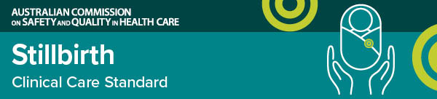](https://www.safetyandquality.gov.au/standards/clinical-care-standards/stillbirth-clinical-care-standard)

**Reports**

*WHO recommendations for care of the preterm or low-birth-weight infant*

World Health Organization

Geneva: World Health Organization; 2022. P. 137.

|  |  |
| --- | --- |
| URL | <https://apps.who.int/iris/bitstream/handle/10665/363697/9789240058262-eng.pdf> |
| Notes | The World Health Organization (WHO) launched their recommendations for care of the preterm or low-birth-weight infant on World Prematurity Day 2022, 17 November 2022. There are 25 recommendations which substantially expand the ‘what’, ‘where’ and ‘how’ for improving the survival, health and well-being of preterm and low birth weight babies. |

*Health literacy development for the prevention and control of noncommunicable diseases*

World Health Organization

Geneva: WHO; 2022.

|  |  |
| --- | --- |
| URL | <https://www.who.int/publications/i/item/9789240055339> |
| Notes | The World Health Organization (WHO) has published this four-volume report on health literacy for the prevention and control of noncommunicable diseases (NCDs).  The four volumes are:   * *Health literacy development for the prevention and control of noncommunicable diseases: Volume 1: Overview* <https://www.who.int/publications/i/item/9789240055339> * *Health literacy development for the prevention and control of noncommunicable diseases: Volume 2. A globally relevant perspective* <https://www.who.int/publications/i/item/9789240055353> * *Health literacy development for the prevention and control of noncommunicable diseases: Volume 3. Recommended actions* <https://www.who.int/publications/i/item/9789240055377> * *Health literacy development for the prevention and control of noncommunicable diseases: Volume 4. Case studies from WHO National Health Literacy Demonstration Projects* <https://www.who.int/publications/i/item/9789240055391> |

For information on the Commission’s work on health literacy, see <https://www.safetyandquality.gov.au/our-work/patient-and-consumer-centred-care/health-literacy>

**Journal articles**

*Experiences, perceptions and expectations of health services amongst marginalized populations in urban Australia: A meta-ethnographic review of the literature*

Baker K, Adams J, Steel A

Health Expectations. 2022;25(5):2166-2187.

|  |  |
| --- | --- |
| DOI | <https://doi.org/10.1111/hex.13386> |
| Notes | The authors of this piece note that ‘Poor health outcomes amongst marginalized groups result in part from health inequities related to social and structural determinants of health. Marginalized people report higher incidences of comorbidities, chronic disease and adverse health behaviours than their nondisadvantaged peers.' This paper reports on a review that sought to ‘examine marginalized Australians' experiences of and access to community-based primary health services in urban locations’. Based on 26 studies, the authors identified seven major themes:   1. Understanding the patient within the context of family and community 2. Health and cultural beliefs influence health-seeking 3. Lack of information and poor cultural competence limit utilization of services 4. Motivation for treatment influences health service engagement 5. Accessing services, a spectrum of experience—from discrimination to validation 6. Navigating a complex system in a complex society 7. Preferences for health care and expectations for systemic change. |

For information on the Commission’s work on person-centred care, see <https://www.safetyandquality.gov.au/our-work/partnering-consumers/person-centred-care>

*Using automated methods to detect safety problems with health information technology: a scoping review*

Surian D, Wang Y, Coiera E, Magrabi F

Journal of the American Medical Informatics Association. 2022 [epub].

|  |  |
| --- | --- |
| DOI | <https://doi.org/10.1093/jamia/ocac220> |
| Notes | Various health information technologies have been developed and implemented to address or ameliorate various safety and quality issues. However, it is also recognised that the introduction of new technologies and methodologies can lead to new or altered safety issues. This paper reports on an Australian group’s examination of the literature on how automated methods may aid in the detection of safety issues with health information technology. Based on 45 studies, the authors report ‘the majority (n = 27, 60%) focused on detecting use errors involving electronic health records and order entry systems. Machine learning (n = 22) and statistical modeling (n = 17) were the most common methods. Unsupervised learning was used to detect use errors in laboratory test results, prescriptions, and patient records while supervised learning was used to detect technical errors arising from hardware or software issues. Statistical modeling was used to detect use errors, unauthorized access, and clinical decision support system malfunctions while rule-based methods primarily focused on use errors.’ |

For information on the Commission’s work on e-health safety, see <https://www.safetyandquality.gov.au/our-work/e-health-safety>

*The neglected barrier to medication use: a systematic review of difficulties associated with opening medication packaging*

Angel M, Bechard L, Pua YH, Thilarajah S, Newton C, Sorensen A, et al

Age and Ageing. 2022;51(10):afac225.

|  |  |
| --- | --- |
| DOI | <https://doi.org/10.1093/ageing/afac225> |
| Notes | Paper examining a ‘neglected barrier’ or factor that can contribute to sub-optimal medication use or compliance, that of medication packaging. The authors note that ‘Difficulty opening medication packaging can have serious consequences that can lead to patient harm via medication mismanagement or poor adherence.’ The paper reports on a systematic review that could only 12 studies examining the issue. The studies all ‘reported a non-negligible proportion of participants unable to open packaging, with the most difficulty associated with child-resistant containers’. The authors observe ‘Despite these studies spanning >40 years, the packaging types examined remained largely the same. This suggests that, despite decades of research demonstrating that packaging is problematic, there has been a stagnation in medication packaging development.’ |

For information on the Commission’s work on medication safety, see <https://www.safetyandquality.gov.au/our-work/medication-safety>

*BMJ Quality & Safety*

December 2022 Volume 31 Issue 12

|  |  |
| --- | --- |
| URL | <https://qualitysafety.bmj.com/content/31/12> |
| Notes | A new issue of *BMJ Quality & Safety* has been published. Many of the papers in this issue have been referred to in previous editions of *On the Radar* (when they were released online). Articles in this issue of *BMJ Quality & Safety* include:   * Editorial: **High reliability organising in healthcare**: still a long way left to go (Christopher G Myers, Kathleen M Sutcliffe) * Editorial: **Medication safety in nursing home patients** (David W Bates, Jonathan Zebrowski) * Editorial: **Medication review in hospitalised older people**: what have we learnt? (Nina Lee Barnett, Lelly Oboh) * Editorial: Overcoming the ‘self-limiting’ nature of QI: **can we improve the quality of patient care while caring for staff?** (Rebecca Lawton, Eric J Thomas) * **Quality improvement as a primary approach to change in healthcare**: a precarious, self-limiting choice? (Keith E Mandel, Steven H Cady) * Striving for **high reliability in healthcare**: a qualitative study of the implementation of a hospital safety programme (Leahora Rotteau, Joanne Goldman, Kaveh G Shojania, Timothy J Vogus, Marlys Christianson, G Ross Baker, Paula Rowland, Maitreya Coffey) * Epidemiology of **adverse drug events and medication errors in four nursing homes in Japan**: the Japan Adverse Drug Events (JADE) Study (Nobutaka Ayani, Nozomu Oya, Riki Kitaoka, Akiko Kuwahara, Takeshi Morimoto, Mio Sakuma, Jin Narumoto) * Experience of **hospital-initiated medication changes in older people with multimorbidity**: a multicentre mixed-methods study embedded in the OPtimising thERapy to prevent Avoidable hospital admissions in Multimorbid older people (OPERAM) trial (Stefanie Thevelin, Catherine Pétein, Beatrice Metry, Luise Adam, Anniek van Herksen, Kevin Murphy, Wilma Knol, Denis O'Mahony, Nicolas Rodondi, Anne Spinewine, Olivia Dalleur) * Effect on diagnostic accuracy of **cognitive reasoning tools for the workplace setting**: systematic review and meta-analysis (Justine Staal, Jacky Hooftman, Sabrina T G Gunput, Sílvia Mamede, Maarten A Frens, Walter W Van den Broek, Jelmer Alsma, Laura Zwaan) |

*Journal of Patient Safety and Risk Management*

Volume 27, Issue 5, October 2022

|  |  |
| --- | --- |
| URL | <https://journals.sagepub.com/toc/cric/27/5> |
| Notes | A new issue of the *Journal of Patient Safety and Risk Management* has been published. Articles in this issue of the *Journal of Patient Safety and Risk Management* include:   * Editorial: Pursuing a **saboteur of patient safety**: The hidden curriculum (Albert W Wu) * **Alcoholism and American healthcare**: The case for a patient safety approach: (Lorri Zipperer, Ruth Ryan, and Barbara Jones) * **Features of incident reports that prompt reviewer feedback and organisational change**: A retrospective review (Aathavan Shanmuga Anandan and David Johnson) * Assessing **managerial patient safety practices that influence adverse events reporting** among nurses in the Savannah Region, Ghana (Samson Alhassan, Atswei Adzo Kwashie, Yennuten Paarima, and Adelaide Maria Ansah Ofei) * “I’m concerned”: A multi-site assessment of **emergency medicine resident speaking up behaviors** (Nicola Feldman, Nico Volz, Tim Snow, Lillian Wong, Sara M Hock, David K Barnes, and Suzanne Bentley) * **Are shifting communication styles crumbling old silos?** (Gayla Miles, Ann Quinlan, Nicole Frederick, and Aaron Brown) |

*Healthcare Papers*

Volume 20, Number 4, 2022

|  |  |
| --- | --- |
| URL | <https://www.longwoods.com/publications/healthcarepapers/26954> |
| Notes | A new issue of *Healthcare Papers* has been published with a theme of ‘Virtual Care in Canada as of the sixth wave of COVID-19’. Articles in this issue of *Healthcare Papers* include:   * **Never Let a Crisis Go to Waste** (Owen Adams) * **Virtual Care in Canada** as of the Sixth Wave of the COVID-19 Pandemic: Finding the Right Balance (William Falk) * Looking at the Big Picture to Find the **Optimal Fit for Virtual Care** (T Price) * **Inequity in Digital Health Planning** in Canada (Ewan Affleck) * **Interoperability**: A National Person-Centred View (Trevor Jamieson and Denise Zarn) * Finding **the Right Balance in Virtual Care**: Insights from Canadian Physicians (Sukirtha Tharmalingam and Simon Hagens) * Leveraging the Five Perspectives of Health Professional Education to Advance **Change Management in Virtual Care** (Kendall Ho) * **Financing Models for Virtual Care** (Robert S Bell and Matthew Chow) * **Collaborations in Care**: Working Together to Give Canadians the Healthcare They Need and Deserve (Erik Sande) * What Is Possible If We **Focus on Where Healthcare Is Going** Instead of Where Medicine Has Been (Timothy M Foggin and Zayna A. Khayat) * **Virtual Care** in Canada as of the Sixth Wave of the COVID-19 Pandemic: Finding the Right Balance – **An Indigenous Perspective** (Michael A B Anderson * The Author Responds. **Response to Commentaries on Virtual Care** as of the Sixth Wave of the COVID-19 Pandemic (William Falk) |

*International Journal for Quality in Health Care* online first articles

|  |  |
| --- | --- |
| URL | <https://academic.oup.com/intqhc/advance-articles> |
| Notes | *International Journal for Quality in Health Care* has published a number of ‘online first’ articles, including:   * The impact of **outsourcing bed-based aged care services on quality of care**: a multisite observational study (Anne Horne-Thompson, Hanan Khalil, Katherine Harding, Richard Kane, Nicholas F Taylor) * Application of **DRGs in hospital medical record management and its impact on service quality** (Qin Zhang, Xiaodong Li) * **Impact of COVID-19 Lockdowns on Health Disparities**: Lessons from Israel on Preventive Health Utilization (Richard G Greenhill, Poonam Gupta) |

**Online resources**

***[USA] AHRQ Perspectives on Safety***

<https://psnet.ahrq.gov/psnet-collection/perspectives>

The US Agency for Healthcare Research and Quality (AHRQ) publishes occasional Perspectives on Safety essays. Recent essays include:

* *Using Human Factors Engineering and the SEIPS Model to Advance* ***Patient Safety in Care Transitions***<https://psnet.ahrq.gov/perspective/using-human-factors-engineering-and-seips-model-advance-patient-safety-care-transitions>

**COVID-19 resources**

https://www.safetyandquality.gov.au/covid-19

The Australian Commission on Safety and Quality in Health Care has developed a number of resources to assist healthcare organisations, facilities and clinicians. These and other material on COVID-19 are available at <https://www.safetyandquality.gov.au/covid-19>

These resources include:

* ***OVID-19 infection prevention and control risk management*** This primer provides an overview of three widely used tools for investigating and responding to patient safety events and near misses. Tools covered in this primer include incident reporting systems, Root Cause Analysis (RCA), and Failure Modes and Effects Analysis (FMEA).   
  <https://www.safetyandquality.gov.au/publications-and-resources/resource-library/covid-19-infection-prevention-and-control-risk-management-guidance>
* ***Poster – Combined contact and droplet precautions*** <https://www.safetyandquality.gov.au/publications-and-resources/resource-library/infection-prevention-and-control-poster-combined-contact-and-droplet-precautions>  
  [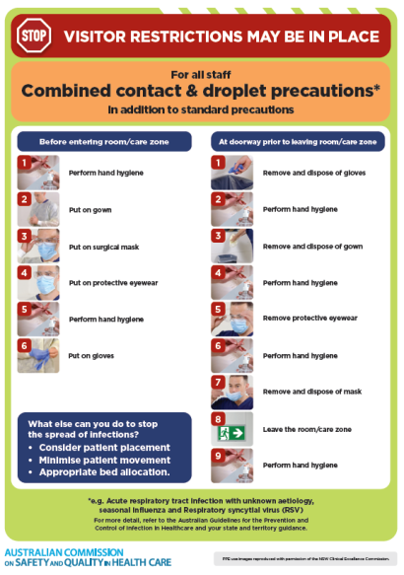](https://www.safetyandquality.gov.au/publications-and-resources/resource-library/infection-prevention-and-control-poster-combined-contact-and-droplet-precautions)
* ***Poster – Combined airborne and contact precautions*** <https://www.safetyandquality.gov.au/publications-and-resources/resource-library/poster-combined-airborne-and-contact-precautions>   
  [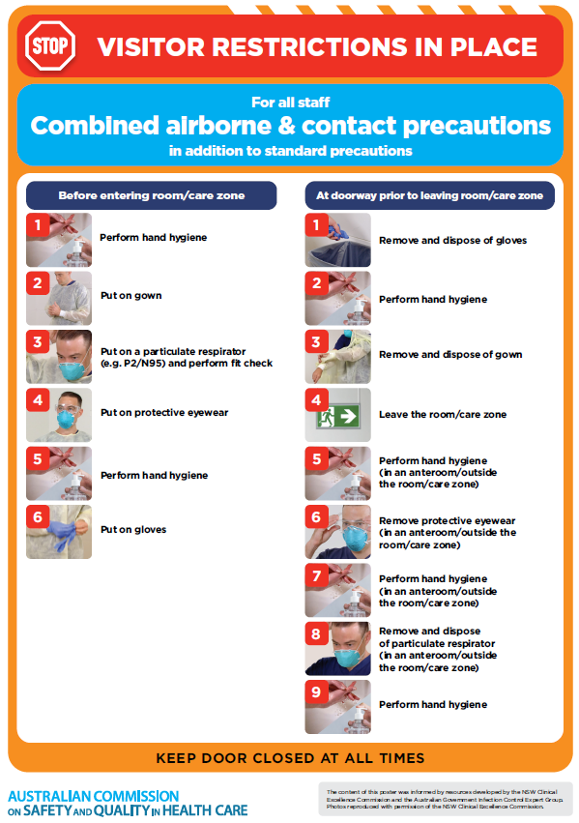](https://www.safetyandquality.gov.au/publications-and-resources/resource-library/poster-combined-airborne-and-contact-precautions)
* ***Environmental Cleaning and Infection Prevention and Control*** [www.safetyandquality.gov.au/environmental-cleaning](http://www.safetyandquality.gov.au/environmental-cleaning)
* ***COVID-19 infection prevention and control risk management – Guidance*** <https://www.safetyandquality.gov.au/publications-and-resources/resource-library/covid-19-infection-prevention-and-control-risk-management-guidance>
* ***Safe care for people with cognitive impairment during COVID-19***<https://www.safetyandquality.gov.au/our-work/cognitive-impairment/cognitive-impairment-and-covid-19>
* ***Stop COVID-19: Break the chain of infection*** posterhttps://www.safetyandquality.gov.au/publications-and-resources/resource-library/break-chain-infection-poster-a3  
  **[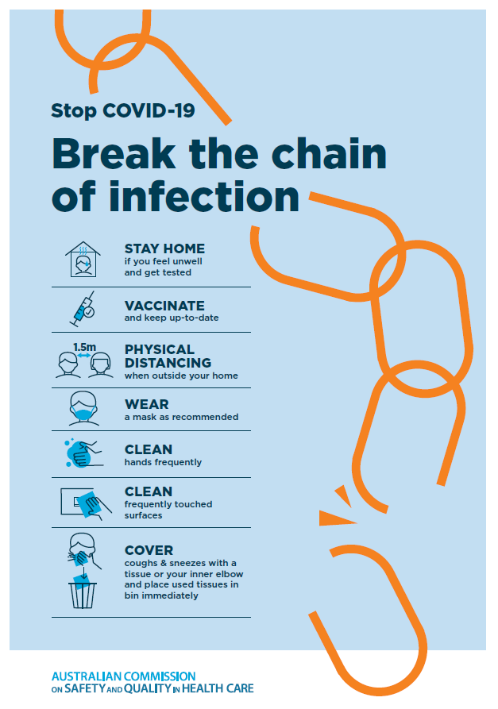](https://www.safetyandquality.gov.au/publications-and-resources/resource-library/break-chain-poster-a3https:/www.safetyandquality.gov.au/publications-and-resources/resource-library/break-chain-poster-a3)**
* ***FAQs for clinicians on elective surgery*** <https://www.safetyandquality.gov.au/node/5724>
* ***FAQs for consumers on elective surgery*** <https://www.safetyandquality.gov.au/node/5725>
* ***COVID-19 and face masks – Information for consumers*** <https://www.safetyandquality.gov.au/publications-and-resources/resource-library/covid-19-and-face-masks-information-consumers>

[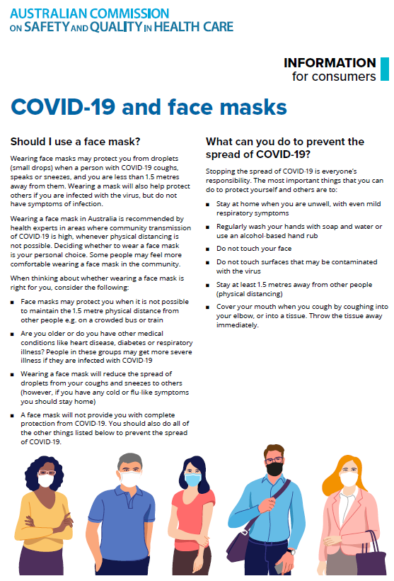](https://www.safetyandquality.gov.au/sites/default/files/2020-07/covid-19_and_face_masks_-_information_for_consumers.pdf)

*National COVID-19 Clinical Evidence Taskforce*

<https://covid19evidence.net.au/>

The National COVID-19 Clinical Evidence Taskforce is a collaboration of peak health professional bodies across Australia whose members are providing clinical care to people with COVID-19. The taskforce is undertaking continuous evidence surveillance to identify and rapidly synthesise emerging research in order to provide national, **evidence-based guidelines and clinical flowcharts for the clinical care of people with COVID-19**. The guidelines address questions that are specific to managing COVID-19 and cover the full disease course across mild, moderate, severe and critical illness. These are ‘living’ guidelines, updated with new research in near real-time in order to give reliable, up-to-the minute advice to clinicians providing frontline care in this unprecedented global health crisis.

*COVID-19 Critical Intelligence Unit*

<https://www.aci.health.nsw.gov.au/covid-19/critical-intelligence-unit>

The Agency for Clinical Innovation (ACI) in New South Wales has developed this page summarising rapid, evidence-based advice during the COVID-19 pandemic. Its operations focus on systems intelligence, clinical intelligence and evidence integration. The content includes a daily evidence digest, a COVID status monitor, a risk monitoring dashboard and evidence checks on a discrete topic or question relating to the current COVID-19 pandemic. There is also a ‘Living evidence’ section summarising key studies and emerging evidence on **COVID-19 vaccines** and **SARS-CoV-2 variants**. The most recent updates include:

* ***Bivalent COVID-19 vaccines*** – What is the available regulatory and research evidence for bivalent COVID-19 vaccines?
* ***Surgery post COVID-19*** – What is the evidence for the timing of surgery, and outcomes following surgery, for people who have recovered from COVID-19?
* ***Paxlovid*** – What is the evidence for Paxlovid for treatment of COVID-19?
* ***Molnupiravir*** –What is the evidence for and regulatory context of molnupiravir for treatment of COVID-19?
* ***Eating disorders and COVID-19*** – What is the impact of the COVID-19 pandemic on the prevalence of eating disorders?
* ***Long COVID –*** What is the evidence on the prevalence, presentation and management of long-COVID?
* ***Oseltamivir (Tamiflu) use in healthcare settings*** – What is the evidence that use of oseltamivir in healthcare workers with a symptomatic influenza diagnosis result in an earlier return to work and reduced absenteeism? What is the evidence that use of oseltamivir in adults and children with symptomatic influenza reduces influenza transmission in health care settings?
* ***Alternative models of care for acute medical conditions*** – What is the evidence on alternative models of care for managing patients with acute medical conditions outside of emergency or inpatient hospital settings?
* ***Exercise and long COVID*** – Is exercise helpful in individuals with long COVID? Is post-exertional symptom exacerbation a risk in long COVID?
* ***Influenza and seasonal prophylaxis with oseltamivir*** – What is the place or evidence for seasonal influenza prophylaxis (such as taking oseltamivir for 10 to 12 weeks continuously) in healthcare and aged care settings?
* ***Rapid access models of care for respiratory illnesses*** – What is the evidence for rapid access models of care for respiratory illnesses, especially during winter seasons, in emergency departments?
* ***Current and emerging patient safety issues during COVID-19*** – What is the evidence on the current and emerging patient safety issues arising from the COVID-19 pandemic?
* ***Post-acute sequelae of COVID-19*** – What is the evidence on the post-acute sequelae of COVID-19?
* ***Emerging variants*** – What is the available evidence for emerging variants?
* ***Chest pain or dyspnoea following COVID-19 vaccination*** – What is evidence for chest pain or dyspnoea following COVID-19 vaccination?
* ***Cardiac investigations and elective surgery post-COVID-19*** – What is evidence for cardiac investigations and elective surgery post-COVID-19?
* ***Breathlessness post COVID-19*** – How to determine those patients who present with ongoing breathlessness in need of urgent review or intervention due to suspected pulmonary embolus?
* ***COVID-19 pandemic and influenza*** – What is the evidence for COVID-19 pandemic and influenza?
* ***Budesonide and aspirin for pregnant women with COVID-19 –*** What is the evidence for the use of Budesonide for pregnant women with COVID-19? What is the evidence for aspirin prophylaxis for pre-eclampsia in pregnant women with a COVID-19 infection?
* ***COVID-19 vaccines in Australia*** – What is the evidence on COVID-19 vaccines in Australia?
* ***COVID-19 pandemic and wellbeing of critical care and other healthcare workers*** – Evidence in brief on the impact of the COVID-19 pandemic on the wellbeing of critical care and other healthcare workers.
* ***Disease modifying treatments for COVID-19 in children*** – What is the evidence for disease modifying treatments for COVID-19 in children?
* ***Mask type for COVID-19 positive wearer*** – What is the evidence for different mask types for COVID-19 positive wearers?
* ***Post acute and subacute COVID-19 care*** – What published advice and models of care are available regarding post-acute and subacute care for COVID-19 patients?
* ***Hospital visitor policies*** – What is the evidence for hospital visitor policies during and outside of the COVID-19 pandemic?
* ***Surgical masks, eye protection and PPE guidance*** –What is the evidence for surgical masks in the endemic phase in hospitals and for eyewear to protect against COVID-19?

**Disclaimer**

On the Radar is an information resource of the Australian Commission on Safety and Quality in Health Care. The Commission is not responsible for the content of, nor does it endorse, any articles or sites listed. The Commission accepts no liability for the information or advice provided by these external links. Links are provided on the basis that users make their own decisions about the accuracy, currency and reliability of the information contained therein. Any opinions expressed are not necessarily those of the Australian Commission on Safety and Quality in Health Care.