 



AUSTRALIAN GROUP ON ANTIMICROBIAL RESISTANCE

Surveillance Outcome Programs

Bloodstream infections

**2021 report**

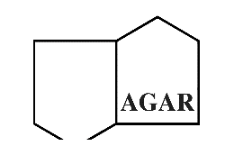

November 2022

Published by the Australian Commission on Safety and Quality in Health Care  
Level 5, 255 Elizabeth Street, Sydney NSW 2000

Phone: (02) 9126 3600  
Fax: (02) 9126 3613

Email: mail@safetyandquality.gov.au   
Website: www.safetyandquality.gov.au

ISBN: 978-1-922880-13-0

© Australian Commission on Safety and Quality in Health Care 2022

All material and work produced by the Australian Commission on Safety and Quality in Health Care (the Commission) is protected by copyright. The Commission reserves the right to set out the terms and conditions for the use of such material.

As far as practicable, material for which the copyright is owned by a third party will be clearly labelled. The Commission has made all reasonable efforts to ensure that this material has been reproduced in this publication with the full consent of the copyright owners.

With the exception of any material protected by a trademark, any content provided by third parties and where otherwise noted, all material presented in this publication is licensed under a [Creative Commons Attribution–NonCommercial–NoDerivatives 4.0 International licence](http://creativecommons.org/licenses/by-nc-nd/4.0/).

P27#yIS1

Enquiries about the licence and any use of this publication are welcome and can be sent to [aura@safetyandquality.gov.au](mailto:aura@safetyandquality.gov.au).

The Commission’s preference is that you attribute this publication (and any material sourced from it) using the following citation:

Coombs G, Bell JM, Daley D, Collignon P, Cooley L, Gottlieb T, Iredell J, Warner M, and Robson J on behalf of the Australian Group on Antimicrobial Resistance and Australian Commission on Safety and Quality in Health Care. Australian Group on Antimicrobial Resistance Surveillance Outcomes Programs: 2021 Report. Sydney: ACSQHC; 2022

**Disclaimer**

The content of this document is published in good faith by the Commission for information purposes. The document is not intended to provide guidance on particular healthcare choices. You should contact your healthcare provider for information or advice on particular healthcare choices.

The Commission does not accept any legal liability for any injury, loss or damage incurred by the use of, or reliance on, this document.

Contents

Overview iv

Key findings and implications for health care: 2021 AGAR data v

1. Background and objectives 1

1.1. Australian Enterococcal Surveillance Outcome Program 3

1.2. Australian *Staphylococcus aureus* Surveillance Outcome Program 3

1.3. Gram-negative Surveillance Outcome Program 4

2. Summary of methods 5

2.1. Data fields 5

2.2. Species identification 5

2.3. Susceptibility testing 6

2.4. PCR screening and whole genome sequencing 6

2.5. Statistical analysis 6

3. Results 7

3.1. Isolates recovered 7

3.2. Place of onset of bacteraemia 9

3.3. Onset versus 30-day all-cause mortality 11

3.4. Patient age and sex 13

3.5. Principal clinical manifestation 15

3.6. Length of hospital stay following bacteraemic episode 19

3.7. Susceptibility testing results 21

3.8. Multi-drug resistance 33

3.9. PCR and whole genome sequencing 40

3.9.1. Molecular epidemiology of *Enterococcus faecium* 40

3.9.2. Gram-negative organisms 43

3.9.3. Molecular epidemiology of methicillin-resistant *Staphylococcus aureus* 56

3.10. Trend analysis (2013–2021) 59

3.10.1. *Enterococcus* species 59

3.10.2. Gram-negative species 65

3.10.3. *Staphylococcus aureus* 75

4. International comparisons 79

5. Limitations of the study 85

6. Discussion and conclusions 86

Abbreviations 89

Acknowledgements 90

References 92

Appendix A. Study design 96

Appendix B. Methods 98

Appendix C. Susceptibility to antimicrobial agents 105

Appendix D. Multiple acquired resistance by species and state or territory 120

Overview

The Australian Group on Antimicrobial Resistance (AGAR), which is auspiced by the Australian Society for Antimicrobials (ASA), conducts targeted surveillance of selected pathogens in Australia via the:

* Australian Enterococcal Surveillance Outcome Program (AESOP)
* Australian *Staphylococcus aureus* Surveillance Outcome Program (ASSOP)
* Gram-negative Surveillance Outcome Program (GnSOP).

AGAR collects data on antimicrobial resistance (AMR) in bacteria that cause life-threatening infections, and analyses and reports on these as part of the Antimicrobial Use and Resistance in Australia (AURA) Surveillance System. These data complement two AMR surveillance programs developed and managed by the Australian Commission on Safety and Quality in Health Care (the Commission) that also contribute to AURA: the National Alert System for Critical Antimicrobial Resistances (CARAlert) and Australian Passive AMR Surveillance (APAS). Funding for the Commission’s AURA program and AGAR is provided by the Australian Government Department of Health and Aged Care and state and territory health departments.

Implications for health care identified by analyses of 2021 AGAR data include:

* A longitudinal trend of increasing resistance in gram-negative organisms
* Prevalence of extended spectrum β-lactamases
* Uncommon, but concerning, carbapenemase-producing gram-negative organisms
* Changing patterns of resistance in *Enterococcus* species
* Methicillin resistance in *S. aureus*
* Epidemiology of clinical manifestations of bacteraemia
* Variation across states and territories in patterns of resistance
* Variation between hospital and community settings in patterns of resistance – overwhelmingly, onset of episodes of bacteraemia was in the community.

To ensure that patients receive the best possible care, the Commission will continue to support states and territories and the private health sector to use AGAR and other AURA data to refine and strengthen their approaches to infection prevention and control and antimicrobial stewardship (AMS), and implementation of the National Safety and Quality Health Service (NSQHS) Standards.1 The Commission also continues to work with Therapeutic Guidelines Limited and other expert guideline development groups to ensure consideration of data such as the rates of gram-negative resistance.

Key findings and implications for health care: 2021 AGAR data

1. **Key findings**

***Enterococcus* species**

* Between 1 January to 31 December 2021, a total of 1,297 episodes of enterococcal bacteraemia were reported; the majority (94.4%) of enterococcal bacteraemia episodes were caused by *E. faecalis* or *E. faecium*.
* The majority of *E. faecalis* bacteraemias were community-onset (68.7%), while in *E. faecium* bacteraemias only 32.1% were community-onset.
* The most frequent source of bacteraemia or clinical manifestation for *E. faecalis* was urinary tract infection (21.8%); for *E. faecium*, it was intra-abdominal infection other than biliary tract (19.3%), febrile neutropenia (19.1%), and biliary tract infection (including cholangitis) (18.3%).
* The combined 30-day all-cause mortality for *E. faecalis* and *E. faecium* was 19.1%.
* There was significant difference in 30-day all-cause mortality between *E. faecalis* (14.5%) and *E. faecium* (25.2%) (*P* < 0.01), and between vancomycin-resistant and vancomycin-susceptible *E. faecium* episodes (31.0% and 21.3%, respectively, *P* = 0.0267).
* The length of stay in hospital following enterococcal bacteraemia was more than 30 days for 22.7% of patients.
* Of bloodstream infections caused by *E. faecium*, 37.9% were phenotypically vancomycin-resistant. There has been a noticeable decline in vancomycin resistance in Australia since 2017.
* In 2021, 39.6% of *E. faecium* harboured *vanA* and/or *vanB* genes (*vanA* 14.2%; *vanB* 25.4%). In 2020, 35.2% of *E. faecium* harboured *vanA* and/or *vanB* genes.
* Of vancomycin-resistant *E. faecium* (VRE) bacteraemias, 36.4% were due to *vanA*-harbouring isolates. This is the dominant genotype in New South Wales, Queensland, and Western Australia.
* There were 73 *E. faecium* multi-locus sequence types, of which ST17, ST1424, ST796, ST78, ST80, ST1421 and ST555 were the most frequently identified.
* v*anA* genes were detected in five STs, and *vanB* genes were detected in 13 STs. The clonal diversity of *E. faecium* harbouring van genes varied across Australia.
* In 2021, for rates of resistance to vancomycin in *E. faecium*, compared to the European Antimicrobial Resistance Surveillance Network (EARS-Net) countries, Australia ranked eighth. From 2017 to 2020, Australia has ranked first, second, fourth and 10th, respectively.

**Gram-negative species**

* From 1 January 2021 to 31 December 2021, a total of 8,947 episodes of gram-negative bacteraemia were reported, including *Enterobacterales* (90.6%), *Pseudomonas aeruginosa* (8.3%) and *Acinetobacter* (1.1%). Of the *Enterobacterales*, three genera – *Escherichia* (61.4%), *Klebsiella* (20.5%) and *Enterobacter* (5.8%) – contributed 87.6% of all *Enterobacterales* bacteraemias.
* The all-cause 30-day mortality rate for gram-negative bacteraemia was 12.4% (10.4% for *E. coli*; 19.0% for *P. aeruginosa*).
* Urinary tract infection was the most frequent source bloodstream infection (*Enterobacterales* 45.0%; *P. aeruginosa* 23.4%). For *Enterobacterales*, device-related urinary tract infections were more common with hospital-onset (HO) than community-onset (CO) episodes (23.0% versus 9.7%, *P* < 0.01).
* Of *E. coli* isolates causing community-onset bacteraemia, which accounted for 85% of all *E. coli* bacteraemia cases, 11.5% were ceftriaxone-resistant.
* There was a significant difference in 30-day all-cause mortality between community-onset and hospital-onset (9.8% versus 13.3%, *P* < 0.01) *E. coli* bacteraemia episodes.
* In 2021, 14.2% of *E. coli* (CO 13.1%; HO 20.7%)and 7.9% of *K. pneumoniae* complex (CO 7.0%; HO 10.2%) had an extended-spectrum β-lactamase (ESBL) phenotype.
* *K. pneumoniae* complex with an ESBL phenotype was significantly more common among paediatrics (10/56, 17.9%,) compared to adults (88/1,182, 7.4%, *P* < 0.01).
* Fluoroquinolone resistance in *E. coli* decreased in 2021 (16.1% in 2020; 12.3% in 2021, down 23.3%), most notably in New South Wales (155/1,281, 12.1%, down 30.8%) and Victoria (143/1,085, 13.2%, down 34.2%).
* Fluoroquinolone resistance is commonly linked to cephalosporin resistance caused by ESBLs of the CTX-M type. Just over three-quarters (256/321, 79.8%) of *E. coli* that were ciprofloxacin-resistant and had confirmed ESBL β‑lactamase genes belonged to ST131 (210, 65.4%) or ST1193 (*n* = 46, 14.3%).
* Almost 1 in 5 *E. coli* were classified as multidrug-resistant (MDR), a proportion little changed from the 2020 survey. The proportion of *K. pneumoniae* complex isolates classed as MDR fell to 6.2% in 2021, the lowest level recorded since the Gram-negative surveys commenced.
* The low rates of carbapenemase-producing *Enterobacterales* (CPE) bacteraemia are encouraging (0.2% overall, mostly carrying *bla*IMP-4). For *Enterobacter cloacae* complex the figure is higher at 1.8% overall (CO 1.2%; HO 2.6%).
* The only *mcr* genes detected among referred isolates were *mcr-9*, which is not associated with a colistin resistant phenotype but typically found on HI2 plasmids that may carry blaIMP‑4, and *mcr-10*.
* The impact of the COVID-19 pandemic on the reduction in AMR remains unclear, as it may be due to a number of contributing factors.

***Staphylococcus aureus***

* A total of 2,928 *S. aureus* bacteraemia (SAB) episodes were reported from 1 January to 31 December 2021, 78.4% of which were community-onset. Of all episodes 16.9% were due to methicillin-resistant isolates.
* The 30-day all-cause mortality was 14.5%. There was no significant difference in mortality for methicillin-resistant *S. aureus* (MRSA) (15.0%) and methicillin-susceptible *S. aureus* (MSSA) (14.4%); or in hospital-onset (15.8%) and community-onset (14.1%) bacteraemia.
* The 30-day all-cause mortality for *S. aureus* was significantly lower among paediatrics (<18 years) (2/236, 0.8%) compared to adults (342/2,139, 16.0%) (*P* < 0.01).
* Osteomyelitis/septic arthritis (22.6%) and skin and skin structure infections (19.0%) were the most common principal clinical manifestations.
* The hospital length of stay was more than 30 days in 23.6% of patients (25.2% in MRSA; 23.2% in MSSA).
* Additional resistances in MRSA have continued to decline overall, largely due to the substantial decline in the multi-resistant ST239-III clone.
* Community-associated methicillin-resistant *S. aureus* (CA-MRSA) strains were the dominant cause of MRSA bacteraemia.
* Three healthcare-associated methicillin-resistant *S. aureus* (HA-MRSA) clones were identified; the dominant HA-MRSA clone was ST22-IV (EMRSA-15). No HA-MRSA isolates harboured the Panton-Valentine leucocidin (PVL)-associated genes.
* The majority of EMRSA-15 bacteraemias were community-onset.
* Sixty-seven CA-MRSA clones were identified; the dominant CA-MRSA clone was ST93-IV (Queensland clone).
* Overall, 37.9% of CA-MRSA isolates harboured PVL genes.
* The Queensland clone of CA-MRSA (ST93-IV), which harbours PVL genes, was seen in all states and territories except Tasmania; it is now the most common CA-MRSA clone in Queensland, South Australia, Western Australia and the Northern Territory.
* The multi-resistant ST45-V CA-MRSA clone remains prominent in New South Wales, Victoria and the Australian Capital Territory and is associated with both community-onset and hospital-onset infections.

1. **Implications of key findings for health care**

When interpreting AGAR data, it is important to consider changes in surveillance coverage between 2013 and 2021. The number of hospitals that contribute to AGAR increased from 27 in 2013 to 46 in 2018, 49 in 2020, and 48 in 2021. In addition, the relative distribution of sites has changed. Paediatric and/or facilities providing specialist obstetric services increased from two in 2013, to five in 2015, six in 2019 and seven in 2020. Since 2015, seven sites have been added and hospitals from north-west regional Western Australia have also been included.

Several themes, which have implications for the delivery of health care services and the safety of care provided patients, have been identified from the analyses of AGAR data.

**Gram-negative resistance**

The percentage resistance in *E. coli* in 2021 was similar to 2020 for all antimicrobial agents tested except for ciprofloxacin, where a 23.3% decrease in resistance was observed. In 2021, there was a significant decrease in resistance rates in *K. pneumoniae* complex for third-generation cephalosporins, gentamicin and ciprofloxacin.

AGAR data show a longitudinal trend of increasing *E. coli* resistance to key anti-gram-negative antimicrobial agents, such as ceftriaxone and ciprofloxacin from 2013 to 2021. Resistance to both agents stabilised in 2018 to 2020 and declined in 2021. The steady rise in resistance to fluoroquinolones is more striking in hospital-onset bacteraemia, with a change from 13.7% to 19.8% between 2013 and 2018, to 21.3% in 2019, and to 21.8% in 2020, falling to 16.7% in 2021.

Increasing resistance to third-generation cephalosporins and fluoroquinolones in *E. coli* strainsin the community is of concern, given that access to these agents on the Pharmaceutical Benefits Scheme is quite restricted. It is likely that high community use of unrestricted agents to which these strains are co-resistant such as amoxicillin and cefalexin, is fuelling this increase.

**Prevalence of** **extended spectrum β-lactamases**

The emergence of specific types of ESBLs (CTX-M enzymes) in *E. coli* from the community is part of a global epidemic.2-4 It is unclear what is driving the community expansion of CTX-M ESBLs in Australia, as third-generation cephalosporins are not widely used in that setting; it is thought to be driven by cross-resistance and co-resistance to agents used in community practice. There is also increasing recognition that ESBLs are becoming established in long-term care facilities in Australia.5

ESBLs in gram-negative organisms have a considerable impact on resistance patterns and limit choices for therapy. Almost 1 in 7 (14.2%) *E. coli* isolatesdisplayed this phenotype in 2021, with little change since 2018. This phenotype is significantly more common in hospital-onset compared to community-onset *E. coli* infection, with 1 in 5 (20.7%) demonstrating this pattern in hospital-onset infection compared to 13.1% for community-onset isolates in 2021. In hospital-onset *K. pneumoniae* complex isolates, this phenotype is also more common than for community-onset isolates (10.2% versus 7.0%), although the difference was not significant. Whilst CTX-M-type enzymes occur in community-associated infections, the higher rates in hospital-onset infection suggest opportunities for further control.

The prevalence of ESBLs also varies by state and territory. These variations are small for *E. coli* but for *K. pneumoniae,* proportions are noticeably higher in New South Wales and the Northern Territory.

**Carbapenemase-producing gram-negative organisms**

Carbapenem resistance attributable to acquired carbapenemase genes is still uncommon in patients with bacteraemia in Australia. Carbapenemase types (IMP, NDM, OXA-48-like, and KPC) were detected in isolates from 13 of the contributing hospitals from five states and territories. blaIMP‑4 accounted for 70.6% (12/17) of all CPE in 2021. No CPE were found in South Australia, Tasmania, and the Northern Territory.

In addition to the *Australian Guidelines for the Prevention and Control of Infection in Healthcare*6 (AICGs), specific guidance about reducing acquisition and subsequent invasive infection due to carbapenem-resistant organisms and CPE is available in *Recommendations for the control of carbapenemase-producing* Enterobacterales *(CPE): a guide for acute care health facilities*.7

**Changing patterns in *Enterococcus* species**

Total numbers of enterococcal bacteraemias identified by AGAR, excluding those from three institutions that contributed in 2020 or 2021 only, increased in 2021 compared to 2020 (1,158 in 2020; 1,234 in 2021, up 6.6%). The increase was mostly in the number of *E. faecium* (443 in 2020; 492 in 2021, up 11.1%) rather than *E. faecalis* (642 in 2020; 675 in 2021, up 5.1%).

The number of VRE isolates increased (158 in 2020 to 198 in 2021, up 25%). There was an increase in overall vancomycin resistance rates in *E. faecium* from 32.6% to 37.9% from 2020 to 2021 (not statistically significant). There was an increase in VRE as a proportion of all enterococcal isolates (15.3% in 2021, compared to 12.8% in 2020). The overall contribution of *vanA* and *vanB* genes to VRE varied according to jurisdiction. *vanA*-harbouring types are dominant in New South Wales, Queensland, and Western Australia, whilst *vanB*-harbouring types aredominant in Victoria, South Australia, the Northern Territory and Tasmania.

The gradual shift to *vanA*-harbouring *E. faecium* creates the potential for the loss of a valuable treatment choice, namely teicoplanin, which is active only against *vanB*-harbouring types. Optimising all VRE prevention and control mechanisms will be required to respond effectively to resistance in *E. faecium* in Australia.

**Methicillin resistance in *Staphylococcus aureus***

The proportion of *S. aureus* that was methicillin-resistant throughout Australia remained stable from 2013 to 2021, although there were notable variations at state and territory level.

The total number of SAB identified by AGAR, excluding isolates from three institutions that contributed in 2020 or 2021 only, increased in 2021 compared to 2020 (2,587 in 2020; 2,815 in 2021, up 8.8%). This trend was seen in all states and territories except in South Australia and Tasmania where there was a slight decrease in the total number. Overall, between 2020 and 2021, the proportion of MRSA decreased by 0.4 percentage points, from 17.6% to 17.2% (down 2.7%). Over the same period, hospital-onset infections increased from 19.6% to 21.6%, whilst community MRSA rates decreased from 80.4% to 78.4%.

Relative to 2020, there were no significant differences in the proportion of MRSA in all states and territories, except South Australia, which saw an increase in the proportion of MRSA (10.9% in 2020; 18.1% in 2021, up 66.4%).

Since 2013, there have been significant increases in the proportion of CA-MRSA clones nationally, notably in New South Wales, Western Australia, and the Northern Territory. The proportion of HA-MRSA clones declined nationally, in all states and territories except Tasmania.

In 2021, CA-MRSA clones accounted for 13.8% (401/2,905) of all *S. aureus*; in 2020, it was 14.3% (387/2,709). ST93-IV was the most prevalent CA-MRSA clone (99/401, 24.7%), and was found in all states and territories except Tasmania.

HA-MRSA clones accounted for 2.4% (71/2,905) of all *S. aureus* in 2021. ST22-IV was the most common HA-MRSA clone (64/71, 90.1%); it was found in all states and territories.

Strategies for control of MRSA in all settings, particularly in the community and in northern Australia where rates are higher, continue to be a priority.

**Epidemiology of clinical manifestations**

Urinary tract infection remains the most common manifestation associated with bloodstream infection in *Enterobacterales*, *P. aeruginosa*, and *E. faecalis* episodes. In 2021, biliary and non-biliary intra-abdominal infections and febrile neutropenia, were the most common clinical manifestations associated with *E. faecium*.

Device-related bacteraemia accounted for 9.2% (1,069/11,665) of bacteraemia across all the AGAR surveillance programs in 2021. The rate was 8.2% in 2020. The increase was notable for staphylococcal episodes (16.2% in 2020; 19.0% in 2021) and enterococcal episodes (10.7% in 2020; 14.0% in 2021). Total numbers are dominated by gram-negative (*n* = 390) bacteria and *S. aureus* (*n* = 511) infections.

Gram-negative infections commonly arise from urinary infections associated with the use of indwelling catheters and urinary stents, as well as from biliary stent infections. In contrast, SABis commonly associated with intra-vascular catheters and/or devices and prosthetic joints. Continuing attention to the requirements of the NSQHS Standards and the AICGs for optimum medical device management6 as well as the Commission’s *Management of Peripheral Intravenous Catheters Clinical Care Standard*8 are important for all health service organisations to prevent these type of infections.

**Variation across states and territories**

Resistance rates vary considerably across states and territories. Methicillin resistance in *S. aureus* ranged from 7.8% in Tasmania to 43.0% in the Northern Territory.

*E. coli* resistance to third-generation cephalosporins ranged from 6.0% in Tasmania to 14.4% in Western Australia; fluoroquinolone resistance ranged from 8.5% in South Australia to 17.0% in the Northern Territory; and aminoglycoside resistance ranged from 3.2% in Tasmania to 17.4% in the Northern Territory.

For *K. pneumoniae* complex, resistance to third-generation cephalosporins ranged from 2.5% in Queensland to 15.2% in the Northern Territory; fluoroquinolone resistance ranged from 3.9% in Western Australia to 9.6% in South Australia; and aminoglycoside resistance ranged from 0.0% in Tasmania to 9.1% in the Northern Territory.

Rates ofvancomycin resistance in *E. faecium* ranged from 12.7% in Western Australia to 87.5% in the Northern Territory. Teicoplanin resistance ranged from 0.0% in the Northern Territory to 21.2% in New South Wales.

Appropriate adaptation of national treatment guidelines should be considered in order to minimise the use of broad-spectrum antimicrobials whilst balancing delivery of the most appropriate antimicrobial for severe infections.

**Variations between hospital and community settings**

Bacteraemia and associated resistance varied between hospital and community settings. Organisms such as *E. cloacae* complex, *P. aeruginosa* and *Acinetobacter* species were evenly distributed between community- and hospital-onset infections, whilst others such as *E. coli* and *S. aureus* were more commonly community-onset. *E. faecium* was more commonly hospital-onset (67.9%) than *E. faecalis* (31.3%). Vancomycin-resistant *E. faecium* bacteraemia accounted for 5.9% (41/696) of all community-onset enterococcal bacteraemia, compared to 26.1% (157/601) in hospital-onset disease.

These variations have implications for choice of empiric antimicrobial therapy and guidelines in community- versus hospital-onset infections, and accounting for infections in aged care home residents5, 9, 10 (which are included in the community-onset group in the AGAR data, but not distinguished as such in this report).

**International comparisons**

Australia had relatively lower rates of resistance in 2021, compared to 2020 data available for the European Union (EU) and European Economic Area (EEA) countries11, for fluoroquinolone resistance in *E. coli* (12.3% versus 23.8%) and *K. pneumoniae* (7.2% versus 33.8%), and for third-generation cephalosporin resistance in *K. pneumoniae* (6.7% versus 33.9%). Australia’s ranking for resistance to third-generation cephalosporins in *E. coli* (12.9%) was similar to the EU/EEA average (14.9%). Australia ranks in the top third in rates of resistance to methicillin in *S. aureus* compared to all European countries, and in the top third in rates of resistance to vancomycin in *E. faecium* compared to all European countries (eighth highest). In 2017, it was ranked first.

**C. Response**

In response to the themes and issues identified through analyses of AGAR data, the Commission will continue to:

* Provide advice for *Therapeutic Guidelines: Antibiotic*12 and other expert guideline development groups to ensure consideration of data such as the rates of gram-negative resistance
* Work with states and territories and the private laboratory sector to encourage consideration of geographic variation through the use of local antibiograms by AMS services. Antibiograms are tables of antimicrobial susceptibilities that can inform local empiric and therapeutic antimicrobial recommendations and formulary management. APAS contributor laboratory services have ready access to data and functionality to produce antibiograms
* Promote adaption of national prescribing practices to local resistance patterns and regular review of prescribing guidance by local AMS services; this will support the use of broad-spectrum antibiotics where necessary, whilst limiting their use in areas where their use is not justified due to lower rates of resistance
* Promote incorporation of concepts of geographical variation in AMR into clinical practice; particularly to support clinicians who regularly work in a range of settings
* Promote use of the *Priority Antibacterial List for Antimicrobial Resistance Containment*13 as a tool to support AMS programs to analyse antimicrobial usage in terms of preferred or optimal prescribing choices
* Support development of guidance for surveillance, prevention and control of specific organisms and resistances
* Advocate for selected resistances to be made nationally notifiable under public health legislation
* Support collaboration and coordination between states and territories, and between hospital and community care settings to explore the drivers of variation and improve local control efforts to help limit progression of AMR
* Contribute to the AURA Surveillance System and ensure that AMR and antimicrobial use data are readily available to inform antimicrobial stewardship and infection prevention and control programs
* Promote effective infection prevention and control measures, such as those included in the AICGs and the *Recommendations for the control of carbapenemase-producing* Enterobacterales *(CPE). A guide for acute care health service organisations*7, to limit the transmission of CPE
* Promote effective implementation of systems that address the requirements of the NSQHS Standards relevant to the control of hospital-onset bloodstream infections, particularly in relation to invasive medical devices
* Support submission of AGAR data and Australian Passive AMR Surveillance data annually to the World Health Organization (WHO) Global Antimicrobial Resistance and Use Surveillance System (GLASS).

1. Background and objectives

Historically, the main focus of the Australian Group on Antimicrobial Resistance (AGAR) was antimicrobial resistance (AMR) in *Staphylococcus aureus*. The scope broadened over time to include studies on *Escherichia coli*, *Enterobacter* species, *Klebsiella* species, *Haemophilus influenzae, Streptococcus pneumoniae* and *Enterococcus* species. It now concentrates on bacterial bloodstream infections on three groups of pathogens: the Australian Enterococcal Surveillance Outcome Program (AESOP), the Australian *Staphylococcus aureus* Surveillance Outcome Program (ASSOP), and the Gram-negative Surveillance Outcome Program (GnSOP).

AGAR’s focus on bacteraemia allows examination of laboratory-confirmed, invasive infections and comparison of rates over time for hospitals, states and territories. AGAR compares Australian data with the European Antimicrobial Resistance Surveillance Network (EARS-Net), enabling benchmarking and trend projections. AGAR has collected ongoing data on the prevalence of AMR in Australia over a long period using standardised methods.

This seventh amalgamated report on Surveillance Outcome Programs operated by AGAR presents analyses of AMR associated with episodes of bacteraemia (bloodstream infection) that were reported by 48 participating Australian public and private laboratories across Australia in 2021.

The 48 institutions across Australia that currently contribute to AGAR, including five private laboratories, are listed in Table 1. In 2021, three hospitals, two from Queensland and one from New South Wales were unable to participate due to staff shortages as a result of the COVID-19 pandemic; and one new hospital from Victoria contributed data.

AGAR publishes detailed annual reports on each program on its [website](http://www.agargroup.org.au/), and also in the Communicable Diseases Intelligence ([CDI](https://www1.health.gov.au/internet/main/publishing.nsf/Content/annual%20reports-1)) journal.

AGAR is auspiced by the Australian Society for Antimicrobials and is part of the Antimicrobial Use and Resistance in Australia (AURA) Surveillance System funded by the Australian Government Department of Health and Aged Care.

**Table 1:** Hospitals that contributed to AGAR, by state and territory, 2021

| State or territory | Hospital |
| --- | --- |
| New South Wales | Children's Hospital Westmead |
|  | Concord Repatriation General Hospital |
|  | John Hunter Hospital |
|  | Liverpool Hospital |
|  | Nepean Hospital |
|  | Royal North Shore Hospital |
|  | St Vincent’s Hospital, Sydney* |
|  | Sydney Children’s Hospital |
|  | Westmead Hospital |
|  | Wollongong Hospital |
| Victoria | Alfred Hospital |
|  | Austin Hospital (Austin Health) |
|  | Monash Children’s Hospital† |
|  | Monash Medical Centre (Dandenong Hospital)† |
|  | Monash Medical Centre (Monash Health) |
|  | Royal Melbourne Hospital |
|  | Royal Women’s and Children’s Hospital |
|  | St Vincent’s Hospital* |
| Queensland | Gold Coast Hospital |
|  | Prince Charles Hospital§ |
|  | Princess Alexandra Hospital§ |
|  | Royal Brisbane and Women’s Hospital |
|  | Greenslopes Private Hospital#†† |
| South Australia | Flinders Medical Centre |
|  | Royal Adelaide Hospital |
|  | Women’s and Children’s Hospital** |
| Western Australia | Fiona Stanley Hospital |
|  | Joondalup Hospital* |
|  | North-west regional Western Australia (Broome, Carnarvon, Derby, Exmouth, Fitzroy Crossing, Halls Creek, Karratha, Kununurra, Newman, Port Hedland, Wyndham)§§ |
|  | Perth Children’s Hospital§§ |
|  | Royal Perth Hospital## |
|  | Sir Charles Gairdner Hospital |
|  | St John of God Hospital, Murdoch†† |
| Tasmania | Launceston General Hospital |
|  | Royal Hobart Hospital |
| Northern Territory | Alice Springs Hospital |
|  | Royal Darwin Hospital |
| Australian Capital Territory | Canberra Hospital |

* Public/Private hospital

† Microbiology services provided by Monash Medical Centre (Monash Health)

§ Microbiology services provided by Pathology Queensland Central Laboratory

# Microbiology services provided by Sullivan Nicolaides Pathology

** Microbiology services provided by SA Pathology, Royal Adelaide Hospital

†† Private hospital

§§ Microbiology services provided by PathWest Laboratory Medicine WA, Queen Elizabeth II Medical Centre

## Microbiology services provided by PathWest Laboratory Medicine WA, Fiona Stanley Hospital

Note: In 2021, three previous contributors (Queensland Children's Hospital and Cairns Base Hospital, Queensland; Royal Prince Alfred Hospital, New South Wales) were not able to contribute; and the Royal Melbourne Hospital (Victoria) participated for the first time.

## Australian Enterococcal Surveillance Outcome Program

Globally, enterococci are thought to account for approximately 10% of all bacteraemias, and in North America and Europe are the fourth and fifth leading causes of sepsis, respectively.14, 15 In the 1970s, healthcare-associated enterococcal infections were primarily due to *Enterococcus faecalis*, however subsequently there has been a steady increase in prevalence of *E. faecium* nosocomial infections.16-18 Worldwide, the increase in nosocomial *E. faecium* infections has primarily been due to the expansion of polyclonal hospital-adapted clonal complex (CC) 17 isolates. While innately resistant to many classes of antimicrobials, *E. faecium* CC17 has demonstrated a remarkable capacity to evolve new antimicrobial resistances. In 2009, the Infectious Diseases Society of America highlighted *E. faecium* as one of the key problem bacteria or ESKAPE (*E. faecium, S. aureus, Klebsiella pneumoniae, Acinetobacter baumannii, P. aeruginosa,* and *Enterobacter* species) pathogens requiring new therapies.19

AGAR began surveillance of antimicrobial resistance in *Enterococcus* species in 1995.20 In 2011, AGAR commenced the Australian Enterococcal Sepsis Outcome Program (AESOP).21 The term “Sepsis” in the program was changed in 2021 to “Surveillance” to better reflect AGAR’s surveillance of episodes of bacteraemia rather than sepsis.

In order to provide data to support improved antimicrobial prescribing and patient care, the objective of AESOP 2021 was to determine the proportion of *E. faecalis* and *E. faecium* bacteraemia isolates demonstrating AMR with particular emphasis on:

* Assessing susceptibility to ampicillin
* Assessing susceptibility to glycopeptides, and the associated resistance genes
* Monitoring the molecular epidemiology of *E. faecium.*

## Australian *Staphylococcus aureus* Surveillance Outcome Program

Globally *S. aureus* is one of the most frequent causes of hospital- and community-acquired bloodstream infections.22 Although there are a wide variety of manifestations of serious invasive infection caused by *S. aureus*, in the great majority of cases the organism can be detected in blood cultures. Therefore, *S. aureus* bacteraemia (SAB) is considered a very useful marker for serious invasive infection.23

Despite standardised treatment protocols for SAB, including prolonged antimicrobial therapy and prompt source control24, mortality can range from as low as 2.5% to as high as 40%.25-27 Mortality rates are known to vary significantly with patient age, clinical manifestation, co-morbidities and methicillin resistance.28, 29 A prospective study of SAB conducted by 27 laboratories in Australia and New Zealand found a 30-day all-cause mortality of 20.6%. On univariate analysis, increased mortality was significantly associated with older age, European ethnicity, methicillin resistance, infections not originating from a medical device, sepsis syndrome, pneumonia/empyema and treatment with a glycopeptide or other non-β-lactam antibiotic.30

AGAR began surveillance of antimicrobial resistance in *S. aureus* in 1986.31 In 2013, AGAR commenced the Australian *Staphylococcus aureus* Sepsis Outcome Program (ASSOP).32 The term “Sepsis” in the program was changed in 2021 to “Surveillance” to better reflect AGAR’s surveillance of episodes of bacteraemia rather than sepsis.

The primary objective of ASSOP 2021 was to determine the proportion of SAB isolates demonstrating antimicrobial resistance with particular emphasis on:

* Assessing susceptibility to methicillin
* Molecular epidemiology of methicillin-resistant *S. aureus* (MRSA).

## Gram-negative Surveillance Outcome Program

AGAR began surveillance of the key gram-negative pathogens *E. coli* and *Klebsiella* species in 1992. Surveys were conducted every two years until 2008, when annual surveys commenced, alternating between community-onset and hospital-onset infections.

In 2004, another genus of gram-negative pathogens in which resistance can be of clinical importance – *Enterobacter* – was added. *E. coli* is the most common cause of community-onset urinary tract infection, whereas *Klebsiella* species are less common but are known to harbour important resistance mechanisms. *Enterobacter* species are less common in the community, but of high importance because of their intrinsic resistance to first-line antimicrobials used in the community. Taken together, the three groups of species surveyed are valuable sentinels for multi-drug resistance and emerging resistance in enteric gram-negative bacilli. In 2013, AGAR initiated the yearly *Enterobacterales* Sepsis Outcome Program (EnSOP), which focused on the prospective collection of resistance and demographic data on all isolates from patients with documented bacteraemia. In 2015, *Pseudomonas aeruginosa* and *Acinetobacter* species were added, and the program evolved into the Gram-negative Sepsis Outcome Program (GnSOP), since renamed the Gram-negative Surveillance Outcome Program. The term “Sepsis” in the program was changed in 2021 to “Surveillance” to better reflect AGAR’s surveillance of episodes of bacteraemia rather than sepsis.

Resistance to β-lactam antibiotics due to β-lactamases is of particular interest, especially extended-spectrum β-lactamases (ESBLs), which inactivate the third-generation cephalosporins –normally considered reserve antimicrobials. Other resistances of interest are to agents that are important for treatment of these serious infections, such as gentamicin, and to reserve agents such as ciprofloxacin and meropenem.

The objectives of GnSOP 2021 were to:

* Monitor resistance in *Enterobacterales*, *P. aeruginosa* and *Acinetobacter* species isolated from blood cultures taken from patients presenting to the hospital or already in hospital
* Study the extent of co-resistance and multi-drug resistance in the major species
* Detect emerging resistance to reserve agents such as carbapenems and colistin
* Examine the molecular basis of resistance to third-generation cephalosporins, quinolones and carbapenems.

1. Summary of methods

Forty-eight hospitals, in each state and territory of Australia, were enrolled in the 2021 AGAR programs. The 30 laboratories that serviced the hospitals participating in AGAR collected all isolates from unique patient episodes of bacteraemia for ASSOP and AESOP, or either all or up to 200 isolates for GnSOP, from 1 January 2021 to 31 December 2021. Approval to conduct the prospective data collection, including de-identified demographic data, was given by the research ethics committees associated with each participating hospital.

In patients with more than one isolate, a new episode was defined as a new positive blood culture more than two weeks after the initial positive culture. An episode was defined as community-onset if the first positive blood culture was collected 48 hours or less after admission, and as hospital-onset if collected more than 48 hours after admission.

AGAR meets the data security requirements of the Antimicrobial Use and Resistance in Australia (AURA) Surveillance System. These arrangements ensure that data conform to appropriate standards of data management and quality, and that data are used in accordance with appropriate approvals. The Australian Society for Antimicrobials (ASA), as data custodian for AGAR data, is responsible for:

* Approving access to, and use of, AGAR data
* Ensuring that AGAR data are protected from unauthorized access, alteration, or loss
* Ensuring compliance with relevant legislation and policies regarding administration, quality assurance, and data access and release.

## Data fields

Laboratory data collected for each episode included an accession number, the date the blood culture was collected, the organism isolated (genus and species), and the antimicrobial susceptibility test results (minimum inhibitory concentrations [MICs]) for each species. The patient’s date of birth, sex and postcode of residence were also provided. If the patient was admitted to hospital, the dates of admission and discharge were recorded. Depending on the laboratories level of participation, limited clinical and outcome data were also provided. These included the principal clinical manifestation, device-related infection (yes or no), and the outcome (died, all-cause or survived) at seven and 30 days (see Appendix A).

## Species identification

Isolates were identified to species level, if possible, using the routine method for each institution. This included the Vitek® and BD Phoenix™ automated Microbiology systems, and if available, matrix assisted laser desorption ionization-time of flight (MALDI-TOF) mass spectrometry (Bruker MALDI biotyper® or Vitek® MS).

For this report, the following organism complexes are defined:

* *Acinetobacter baumannii* complex (*A. calcoaceticus*, *A. baumannii*, *A. dijkshoorniae*, *A. nosocomialis*, *A. pittii,* and *A. seifertii*)
* *Enterobacter cloacae* complex (*E. cloacae*, *E. asburiae*, *E. bugandensis*, *E. kobei*, *E. ludwigii*, *E. hormaechei* and *E. nimipressuralis*)
* *Klebsiella pneumoniae* complex (*K. pneumoniae*, *K. quasipneumoniae* and *K. variicola*)
* *Citrobacter freundii* complex comprises *C. freundii*, *C. braakii,* *C. gillenii*, *C. murliniae*, *C. rodenticum*, *C. sedlakii*, *C. werkmanii* and *C. youngae*.

*Klebsiella aerogenes* was previously known as *Enterobacter aerogenes*.

## Susceptibility testing

Susceptibility testing of isolates is described in Appendix B. The analysis used breakpoints from the Clinical and Laboratory Standards Institute (CLSI) M100–Ed3233 and the European Committee on Antimicrobial Susceptibility Testing (EUCAST) v12.0.34

## PCR screening and whole genome sequencing

*E. coli*, *Klebsiella* species, *Proteus* species and *Salmonella* species with ceftazidime or ceftriaxone MIC > 1 mg/L, or cefoxitin MIC > 8 mg/L; any other *Enterobacterales* with cefepime MIC > 1 mg/L; *Salmonella* species with ciprofloxacin MIC > 0.25 mg/L; all *Enterobacterales* with meropenem MIC > 0.25 mg/L; all *Acinetobacter* species or *P. aeruginosa* with meropenem MIC ≥ 8 mg/L; all isolates with amikacin MIC > 32 mg/L, and all isolates with colistin MIC > 4 mg/L were referred to a central laboratory (Centre for Infectious Diseases and Microbiology, The Westmead Institute for Medical Research). Whole genome sequencing (WGS) (Antimicrobial Resistance Laboratory, Microbial Genomics Reference Laboratory, Centre for Infectious Diseases and Microbiology and Microbiology Laboratory Services [CIDMLS], Institute of Clinical Pathology and Medical Research [ICPMR], Westmead Hospital) was performed on all referred isolates using the Illumina NextSeq™ 500 platform. Data were analysed using a modified version of the Nullarbor bioinformatic pipeline.35

WGS using the Illumina NextSeq™ 500 platform was performed on all *E. faecium,* and methicillin-resistant *S. aureus* (MRSA) referred to the Antimicrobial Resistance and Infectious Diseases Research Laboratory (ARMID), Murdoch University, WA. Data were analysed using the Nullarbor bioinformatic pipeline.35 The pipeline was used to identify the multi-locus sequence type, *van* gene (*E. faecium*), SCC*mec* (MRSA) and Panton-Valentine leucocidin (PVL) (MRSA).

## Statistical analysis

Confidence intervals of proportions, Fisher’s exact test for categorical variables, and chi-square test for trend were calculated, if appropriate, using GraphPad Prism version9.4.1 for Windows (GraphPad Software, La Jolla, California).

1. Results

## Isolates recovered

During 2021, a total of 13,172 bloodstream infection isolates were reported from 48 participating hospitals. Overall, the proportion of isolates from paediatrics (<18 years) was 6.1%. The proportion of *S. aureus* isolates from paediatrics was 9.7%, *Enterococcus* species 5.6%, *Enterobacterales* 4.9%, *P. aeruginosa* 3.6% and *Acinetobacter* species 11.2%.

A total of 8,947 gram-negative bloodstream isolates (56 species/complex, 21 genera) were reported. *Enterobacterales* accounted for 90.6%, followed by *P. aeruginosa* (8.3%) and *Acinetobacter* (1.1%). Of the *Enterobacterales*, three genera – *Escherichia* (61.4%), *Klebsiella* (20.5%) and *Enterobacter* (5.8%) – contributed 87.6% of all isolates. Overall, the top 10 species by rank were *E. coli* (55.5%), *K. pneumoniae* complex(13.9%), *P. aeruginosa* (8.3%), *E. cloacae* complex (5.0%), *Proteus* *mirabilis* (3.5%), *K. oxytoca* (3.0%), *Serratia marcescens* (2.3%), *K. aerogenes* (1.3%), *Citrobacter koseri* (1.1%), and *Citrobacter freundii* complex(1.0%). These 10 species comprised 94.9% of all isolates (Table 2).

The proportion of isolates from paediatrics was 4.9% (*n* = 440; *Enterobacterales* *n* = 402, *P. aeruginosa* *n* = 27, *Acinetobacter* species *n* = 11). *Enterobacter cloacae* complex and *Salmonella* species episodes were more common among paediatrics than adults (9.3% versus 4.8% and 8.6% versus 0.5%, respectively) (data not shown).

Of 2,928 SAB episodes, 495 (16.9%; 95% confidence interval [CI]: 15.6-18.3) were methicillin-resistant, ranging from 7.8% (95% CI: 5.6-10.5) in Tasmania to 43.0% (95% CI: 38.6-47.5) in the Northern Territory (Table 2). There was a significant difference in the proportion of MRSA among paediatrics (12.0%, 95% CI: 9.3-15.2) and adults (17.4%, 95% CI: 14.2-21.3), *P*= 0.0195 (data not shown).

There were 1,297 episodes of enterococcalbacteraemia. *E. faecalis* and *E. faecium* accounted for 94.4% of all enterococcal isolates (Table 2).

**Table 2:** Number of each species recovered, by state and territory, AGAR, 2021

| Organism | NSW | | Vic | | Qld | | SA | | WA | | Tas | | NT | | ACT | | | Total |
| --- | --- | --- | --- | --- | --- | --- | --- | --- | --- | --- | --- | --- | --- | --- | --- | --- | --- | --- |
| Gram-negative species* | 2,425 | | 1,948 | | 1,330 | | 870 | | 1,332 | | 361 | | 318 | | 363 | | | 8,947 |
| *Acinetobacter* | 18 | | 19 | | 19 | | 9 | | 22 | | 5 | | 5 | | 1 | | | 98 |
| *Acinetobacter baumannii* complex | 10 | | 9 | | 13 | | 2 | | 9 | | 3 | | 1 | | 1 | | | 48 |
| *Acinetobacter lwoffii* | 3 | | 0 | | 0 | | 2 | | 5 | | 0 | | 1 | | 0 | | | 11 |
| *Acinetobacter* species† | 1 | | 6 | | 0 | | 1 | | 3 | | 0 | | 0 | | 0 | | | 11 |
| *Acinetobacter ursingii* | 3 | | 0 | | 3 | | 2 | | 1 | | 1 | | 0 | | 0 | | | 10 |
| Other *Acinetobacter* (*n* = 5) | 1 | | 4 | | 3 | | 2 | | 4 | | 1 | | 3 | | 0 | | | 18 |
| *Enterobacterales* | 2,194 | | 1,802 | | 1,169 | | 777 | | 1,210 | | 336 | | 292 | | 324 | | | 8,104 |
| *Escherichia coli* | 1,316 | | 1,093 | | 686 | | 482 | | 741 | | 220 | | 225 | | 206 | | | 4,969 |
| *Klebsiella pneumoniae* complex | 340 | | 260 | | 202 | | 116 | | 205 | | 45 | | 33 | | 46 | | | 1,247 |
| *Enterobacter cloacae* complex | 143 | | 93 | | 83 | | 24 | | 64 | | 16 | | 8 | | 19 | | | 450 |
| *Proteus mirabilis* | 87 | | 84 | | 44 | | 31 | | 44 | | 12 | | 4 | | 8 | | | 314 |
| *Klebsiella oxytoca* | 76 | | 67 | | 28 | | 29 | | 35 | | 12 | | 4 | | 14 | | | 265 |
| *Serratia marcescens* | 59 | | 43 | | 35 | | 15 | | 34 | | 5 | | 1 | | 10 | | | 202 |
| *Klebsiella aerogenes* | 42 | | 32 | | 12 | | 10 | | 16 | | 0 | | 2 | | 5 | | | 119 |
| *Citrobacter koseri* | 19 | | 19 | | 17 | | 14 | | 15 | | 3 | | 3 | | 4 | | | 94 |
| *Citrobacter freundii* complex | 23 | | 22 | | 10 | | 7 | | 19 | | 6 | | 0 | | 1 | | | 88 |
| *Morganella morganii* | 31 | | 18 | | 10 | | 10 | | 7 | | 7 | | 2 | | 3 | | | 88 |
| *Salmonella* species (non-typhoidal) | 20 | | 22 | | 15 | | 3 | | 7 | | 2 | | 8 | | 4 | | | 81 |
| *Raoultella ornithinolytica* | 7 | | 6 | | 4 | | 2 | | 9 | | 0 | | 0 | | 0 | | | 28 |
| *Klebsiella* species† | 5 | | 13 | | 3 | | 3 | | 2 | | 0 | | 0 | | 0 | | | 26 |
| *Enterobacter* species† | 0 | | 1 | | 0 | | 15 | | 0 | | 0 | | 0 | | 0 | | | 16 |
| *Providencia rettgeri* | 6 | | 2 | | 2 | | 1 | | 2 | | 0 | | 0 | | 0 | | | 13 |
| *Pantoea agglomerans* | 2 | | 2 | | 5 | | 1 | | 1 | | 1 | | 0 | | 0 | | | 12 |
| *Serratia liquefaciens* complex | 2 | | 3 | | 0 | | 2 | | 2 | | 3 | | 0 | | 0 | | | 12 |
| Other *Enterobacterales* (*n* = 30) | 16 | | 22 | | 13 | | 12 | | 7 | | 4 | | 2 | | 4 | | | 80 |
| *Pseudomonas aeruginosa* | 213 | | 127 | | 142 | | 84 | | 100 | | 20 | | 21 | | 38 | | | 745 |
| *Enterococcus* species | | 340 | | 362 | | 165 | | 127 | | 182 | | 53 | | 17 | | 51 | 1,297 | |
| *Enterococcus faecalis* | | 178 | | 170 | | 99 | | 71 | | 107 | | 33 | | 8 | | 36 | 702 | |
| Vancomycin-resistant, percent§ | | 0.0 | | 0.0 | | 0.0 | | 0.0 | | 0.0 | | 0.0 | | 0.0 | | 0.0 | 0.0 | |
| Vancomycin-susceptible, percent§ | | 100.0 | | 100.0 | | 100.0 | | 100.0 | | 100.0 | | 100.0 | | 100.0 | | 100.0 | 100.0 | |
| *Enterococcus faecium* | | 146 | | 169 | | 50 | | 55 | | 63 | | 18 | | 8 | | 14 | 523 | |
| Vancomycin-resistant, percent§ | | 31.5 | | 59.8 | | 14.3 | | 34.5 | | 12.7 | | 33.3 | | 87.5 | | 28.6 | 37.9 | |
| Vancomycin-susceptible, percent§ | | 68.5 | | 40.2 | | 85.7 | | 65.5 | | 87.3 | | 66.7 | | 12.5 | | 71.4 | 62.1 | |
| Other enterococcal species | | 16 | | 23 | | 16 | | 1 | | 12 | | 2 | | 1 | | 1 | 72 | |
| *Enterococcus gallinarum* | | 4 | | 8 | | 5 | | 0 | | 4 | | 1 | | 1 | | 0 | 23 | |
| *Enterococcus casseliflavus* | | 5 | | 6 | | 2 | | 1 | | 4 | | 1 | | 0 | | 1 | 20 | |
| *Enterococcus raffinosus* | | 2 | | 3 | | 2 | | 0 | | 2 | | 0 | | 0 | | 0 | 9 | |
| *Enterococcus hirae* | | 1 | | 1 | | 4 | | 0 | | 1 | | 0 | | 0 | | 0 | 7 | |
| *Enterococcus avium* | | 0 | | 4 | | 2 | | 0 | | 0 | | 0 | | 0 | | 0 | 6 | |
| *Enterococcus durans* | | 2 | | 1 | | 1 | | 0 | | 1 | | 0 | | 0 | | 0 | 5 | |
| *Enterococcus mundtii* | | 1 | | 0 | | 0 | | 0 | | 0 | | 0 | | 0 | | 0 | 1 | |
| *Enterococcus* species | | 1 | | 0 | | 0 | | 0 | | 0 | | 0 | | 0 | | 0 | 1 | |
| *Staphylococcus aureus* | | 770 | | 615 | | 495 | | 232 | | 513 | | 115 | | 86 | | 102 | 2,928 | |
| Methicillin-resistant, percent | | 19.7 | | 12.7 | | 13.1 | | 18.1 | | 19.1 | | 7.8 | | 43.0 | | 13.7 | 16.9 | |
| Methicillin-susceptible, percent | | 80.3 | | 87.3 | | 86.9 | | 81.9 | | 80.9 | | 92.2 | | 57.0 | | 86.3 | 83.1 | |

* *Enterobacterales*, *Acinetobacter* species and *Pseudomonas aeruginosa*

† Species not determined

§ Vancomycin susceptibility was not available for three *E. faecalis* (one each from Vic, Qld, and SA) and one *E. faecium* from Qld

Note: *Klebsiella pneumoniae* complex Includes *K. variicola* (*n* = 76), and *K. quasipneumoniae* (*n* = 8).

## Place of onset of bacteraemia

Almost all patients with bacteraemia were admitted to hospital (8,947, 98.6% gram-negative species; 1,288, 99.3% *Enterococcus* species; 2,882, 98.4% *S. aureus*).

Information on place of onset of bacteraemia was available for all gram-negative, *Enterococcus* species and *S. aureus* episodes (Table 3).

For gram-negative species, 77.6% of all episodes were community-onset, with differences seen between *Enterobacterales* (79.2%), *Acinetobacter* species (71.4%) and *P. aeruginosa* (60.8%). The proportion of *Enterobacterales* that were community-onset was significantly lower among paediatrics (69.4%, 279/402) than adults (79.7%, 6,137/7,702) (*P* < 0.01), most notable among *E. coli* (paediatrics 75.6%, adults 85.4%) and *K. pneumoniae* complex (paediatrics 57.9%, adults 72.1%) (data not shown).

Episodes involving *E. faecalis* and ‘other’ *Enterococcus* species were predominantly community-onset (*E. faecalis* [68.7%, 95% CI: 65.1-72.0] and other *Enterococcus* species[63.9%, CI: 52.4-74.0]). However, *E. faecium* episodes were predominantly hospital-onset (67.9%; 95% CI: 63.8-71.7). The proportion of *E. faecalis* that were community-onset was significantly lower among paediatrics (32.2%, 19/59) than adults (72.0%, 463/643) (*P*< 0.01).

Most SABs were community-onset (78.4%; 95% CI: 76.9-79.9). The proportion of MRSA episodes that were community-onset was lower among paediatrics (67.6%, 23/34) than adults (78.5%, 362/461).

**Table 3:** Species recovered, by place of onset, AGAR, 2021

| Organism | Community-onset % (*n*) | Hospital-onset % (*n*) | Total, 100% |
| --- | --- | --- | --- |
| *Enterococcus* species | 53.7 (696) | 46.3 (601) | 1,297 |
| *Enterococcus faecalis* | 68.7 (482) | 31.3 (220) | 702 |
| Vancomycin-resistant | –* (0) | –* (0) | 0 |
| Vancomycin-susceptible | 68.7 (480) | 31.3 (219) | 699 |
| *Enterococcus faecium* | 32.1 (168) | 67.9 (355) | 523 |
| Vancomycin-resistant | 20.7 (41) | 79.3 (157) | 198 |
| Vancomycin-susceptible | 39.2 (127) | 60.8 (197) | 324 |
| Other *Enterococcus* species (*n* = 8) | 63.9 (46) | 36.1 (26) | 72 |
| Gram-negative species | 77.6 (6,939) | 22.4 (2,008) | 8,947 |
| *Acinetobacter* | 71.4 (70) | 28.6 (28) | 98 |
| *Acinetobacter baumannii* complex | 60.4 (29) | 39.6 (19) | 48 |
| *Acinetobacter lwoffii* | 90.9 (10) | 9.1 (1) | 11 |
| *Acinetobacter* species† | 90.9 (10) | 9.1 (1) | 11 |
| *Acinetobacter ursingii* | 60.0 (6) | 40.0 (4) | 10 |
| Other *Acinetobacter* species (*n* = 6) | 83.3 (15) | 16.7 (3) | 18 |
| *Enterobacterales* | 79.2 (6,416) | 20.8 (1,688) | 8,104 |
| *Escherichia coli* | 85.0 (4,225) | 15.0 (744) | 4,969 |
| *Klebsiella pneumoniae* complex | 71.4 (890) | 28.6 (356) | 1,246 |
| *Enterobacter cloacae* complex | 56.7 (251) | 43.3 (192) | 443 |
| *Proteus mirabilis* | 87.3 (274) | 12.7 (40) | 314 |
| *Klebsiella oxytoca* | 68.4 (184) | 31.6 (85) | 269 |
| *Serratia marcescens* | 55.0 (110) | 45.0 (90) | 200 |
| *Klebsiella aerogenes* | 62.2 (74) | 37.8 (45) | 119 |
| *Citrobacter koseri* | 81.9 (77) | 18.1 (17) | 94 |
| *Citrobacter freundii* complex | 63.6 (56) | 36.4 (32) | 88 |
| *Morganella morganii* | 70.5 (62) | 29.5 (26) | 88 |
| *Salmonella* species (non-typhoidal) | 98.8 (80) | 1.2 (1) | 81 |
| *Raoultella ornithinolytica* | 67.9 (19) | 32.1 (9) | 28 |
| *Klebsiella* species† | 70.4 (19) | 29.6 (8) | 27 |
| *Enterobacter* species† | 52.2 (12) | 47.8 (11) | 23 |
| *Providencia rettgeri* | 69.2 (9) | 30.8 (4) | 13 |
| *Pantoea agglomerans* | 83.3 (10) | 16.7 (2) | 12 |
| *Serratia liquefaciens* complex | 75.0 (9) | 25.0 (3) | 12 |
| *Acinetobacter ursingii* | 60.0 (6) | 40.0 (4) | 10 |
| Other gram-negative species (*n* = 34) | 72.9 (70) | 27.1 (26) | 96 |
| *Pseudomonas aeruginosa* | 60.8 (453) | 39.2 (292) | 745 |
| *Staphylococcus aureus* | 78.4 (2,296) | 21.6 (632) | 2,928 |
| Methicillin-resistant | 77.8 (385) | 22.2 (110) | 495 |
| Methicillin-susceptible | 78.5 (1,911) | 21.5 (522) | 2,433 |

* Insufficient numbers (<10) to calculate percentage

† Species not determined

Note: Vancomycin susceptibility was not available for three *E. faecalis* (community-onset [2], hospital-onset [1]) and one *E. faecium* (hospital-onset).

## Onset versus 30-day all-cause mortality

Information on 30-day all-cause mortality, when place of onset was known, was available for 6,258 (69.9%) episodes involving gram-negative species; 1,088 (83.9%) involving *Enterococcus* and 2,375 (81.1%) involving *S. aureus*.

For gram-negative species, the 30-day all-cause mortality was 11.7% (657/5,608) for *Enterobacterales*, 19.0% (108/568) for *P. aeruginosa*, and 17.1% (14/82) for *Acinetobacter* species. The only species for which a significant difference was seen in the 30-day all-cause mortality between community-onset and hospital-onset episodes was *E. coli* (*P* = 0.0142) (Table 4). There was a significant difference in 30-day all-cause mortality between paediatrics (6.4%, 21/327) and adults (12.0%, 636/5,281) for *Enterobacterales* (*P* < 0.01). The 30-day all-cause mortality among infants aged 90 days or less was 15.7% (20/127).

The 30-day all-cause mortality for *Enterococcus* specieswas significantly lower among paediatrics (3.0%, 2/67) compared to adults (20.0%, 204/1,021) (*P* < 0.01). There was a significant difference in the 30-day all-cause mortality between *E. faecium* (25.2%, 113/448) and *E. faecalis* (14.5%, 85/586) (*P* < 0.01), and between vancomycin-resistant (31.0%, 57/184) and vancomycin-susceptible (21.3%, 56/263) *E. faecium* episodes (*P* = 0.0267).

The 30-day all-cause mortality for *S. aureus* was significantly lower among paediatrics (0.8%, 2/236) compared to adults (16.0%, 342/2,139) (*P* < 0.01). There was no significant difference in 30-day all-cause mortality between methicillin-susceptible *S. aureus* (MSSA) and MRSA episodes (14.4% and 15.0%, respectively), or between healthcare-associated MRSA (HA-MRSA) and community-associated MRSA (CA-MRSA) clones (22.5% and 13.5%, respectively).

**Table 4:** Onset setting and 30-day all-cause mortality (blood culture isolates), AGAR, 2021

|  | Community-onset | | Hospital-onset | | Total | |
| --- | --- | --- | --- | --- | --- | --- |
| Organism | Number | Deaths % (*n*) | Number | Deaths % (*n*) | Number | Deaths % (*n*) |
| *Enterococcus*s | 558 | 17.2 (96) | 530 | 20.8 (110) | 1,088 | 18.9 (206) |
| *Enterococcus faecalis* | 392 | 14.5 (57) | 194 | 14.4 (28) | 586 | 14.5 (85) |
| Vancomycin-resistant | 0 | –* (0) | 0 | –* (0) | 0 | –* (0) |
| Vancomycin-susceptible | 390 | 14.6 (57) | 194 | 14.4 (28) | 584 | 14.6 (85) |
| *Enterococcus faecium* | 134 | 25.4 (34) | 314 | 25.2 (79) | 448 | 25.2 (113) |
| Vancomycin-resistant | 35 | 34.3 (12) | 149 | 30.2 (45) | 184 | 31.0 (57) |
| Vancomycin-susceptible | 99 | 22.2 (22) | 164 | 20.7 (34) | 263 | 21.3 (56) |
| Other enterococcal species (*n*= 8) | 32 | 15.6 (5) | 22 | 13.6 (3) | 54 | 14.8 (8) |
| Gram-negative species | 4,656 | 11.8 (548) | 1,602 | 14.4 (231) | 6,258 | 12.4 (779) |
| *Acinetobacter* | 56 | 16.1 (9) | 26 | 19.2 (5) | 82 | 17.1 (14) |
| *Acinetobacter baumannii* complex | 24 | 20.8 (5) | 17 | 17.6 (3) | 41 | 19.5 (8) |
| *Acinetobacter lwoffii* | 9 | 11.1 (1) | 1 | 0.0 (0) | 10 | 10.0 (1) |
| Other *Acinetobacter* species (*n* = 4) | 23 | 13.0 (3) | 8 | 25.0 (2) | 31 | 16.1 (5) |
| *Enterobacterales* | 4,266 | 11.2 (479) | 1,342 | 13.3 (178) | 5,608 | 11.7 (657) |
| *Escherichia coli* | 2,722 | 9.8 (266) | 595 | 13.3 (79) | 3,317 | 10.4 (345) |
| *Klebsiella pneumoniae* complex | 623 | 14.9 (93) | 278 | 12.6 (35) | 901 | 14.2 (128) |
| *Enterobacter cloacae* complex | 194 | 14.9 (29) | 162 | 15.4 (25) | 356 | 15.2 (54) |
| *Proteus mirabilis* | 195 | 21.5 (42) | 29 | 10.3 (3) | 224 | 20.1 (45) |
| *Klebsiella oxytoca* | 131 | 9.2 (12) | 69 | 11.6 (8) | 200 | 10.0 (20) |
| *Serratia marcescens* | 79 | 6.3 (5) | 74 | 9.5 (7) | 153 | 7.8 (12) |
| *Klebsiella aerogenes* | 46 | 10.9 (5) | 36 | 25.0 (9) | 82 | 17.1 (14) |
| *Morganella morganii* | 43 | 20.9 (9) | 22 | 9.1 (2) | 65 | 16.9 (11) |
| *Citrobacter freundii* complex | 39 | 5.1 (2) | 25 | 16.0 (4) | 64 | 9.4 (6) |
| *Citrobacter koseri* | 49 | 4.1 (2) | 11 | 27.3 (3) | 60 | 8.3 (5) |
| *Salmonella* species (non-typhoidal) | 51 | 7.8 (4) | 0 | n/a | 51 | 7.8 (4) |
| *Raoultella ornithinolytica* | 15 | 6.7 (1) | 7 | 28.6 (2) | 22 | 13.6 (3) |
| *Klebsiella* species† | 12 | 8.3 (1) | 6 | 0.0 (0) | 18 | 5.6 (1) |
| *Serratia liquefaciens* complex | 8 | 0.0 (0) | 2 | 0.0 (0) | 10 | 0.0 (0) |
| *Pantoea agglomerans* | 7 | 0.0 (0) | 3 | 0.0 (0) | 10 | 0.0 (0) |
| Other *Enterobacterales* species (*n* = 30) | 52 | 15.4 (8) | 23 | 4.3 (1) | 75 | 12.0 (9) |
| *Pseudomonas aeruginosa* | 334 | 18.0 (60) | 234 | 20.5 (48) | 568 | 19.0 (108) |
| *Staphylococcus aureus* | 1,843 | 14.1 (260) | 532 | 15.8 (84) | 2,375 | 14.5 (344) |
| Methicillin-resistant | 319 | 12.9 (41) | 89 | 22.5 (20) | 408 | 15.0 (61) |
| CA-MRSA | 261 | 11.9 (31) | 64 | 20.3 (13) | 325 | 13.5 (44) |
| HA-MRSA | 43 | 18.6 (8) | 20 | 30.0 (6) | 63 | 22.2 (14) |
| Methicillin susceptible | 1,524 | 14.4 (219) | 443 | 14.4 (64) | 1,967 | 14.4 (283) |

CA-MRSA = community-associated methicillin-resistant *Staphylococcus aureus*; HA-MRSA = healthcare-associated methicillin-resistant *S. aureus*; n/a = not applicable (no isolates)

* Insufficient numbers (<10) to calculate percentage

† Species not determined

Notes:

1. Twenty methicillin-resistant *Staphylococcus aureus* were not available for whole genome sequencing.
2. Vancomycin susceptibility was not available for two *Enterococcus faecalis* (community-onset) and one *E. faecium* (hospital-onset).

## Patient age and sex

Age and sex were available for all patients with gram-negative, enterococcal or staphylococcal bacteraemia. For gram-negative bacteraemia, the proportion of males was 53.5% and 46.5% females. For *Enterococcus* species, 65.7% were male and 34.3% female; for SAB, 66.2% were male and 33.8% female.

Increasing age was a surrogate risk factor for bacteraemia (Figures 1–3); only 13.0% of gram-negative species episodes, 11.8% of *Enterococcus* species episodes and 21.0% of *S. aureus* episodes were in patients aged less than 40 years. The proportion of patients aged 0–19 years was 5.2% (*n* = 469), 5.8% (*n* = 75) and 10.2% (*n* = 300) among gram-negative episodes, enterococcal episodes and *S. aureus* episodes, respectively.

Figure 1: Number of episodes of bacteraemia due to gram-negative species, by patient age group and sex, AGAR, 2021

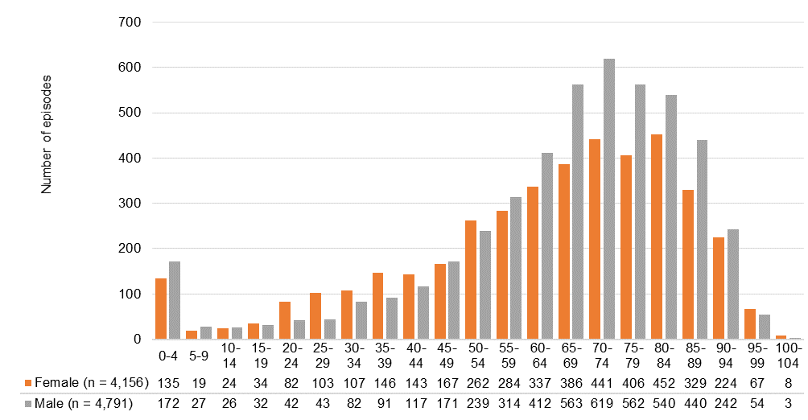

Note: x-axis = age group in years.

Figure 2: Number of episodes of bacteraemia due to *Enterococcus* species, by patient age group and sex, AGAR, 2021

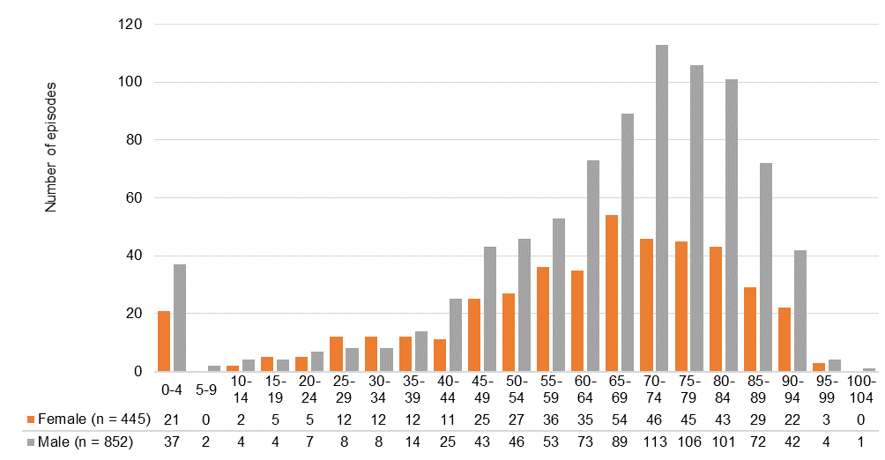

Figure 3: Number of episodes of bacteraemia due to *Staphylococcus aureus*, by patient age group and sex, AGAR, 2021

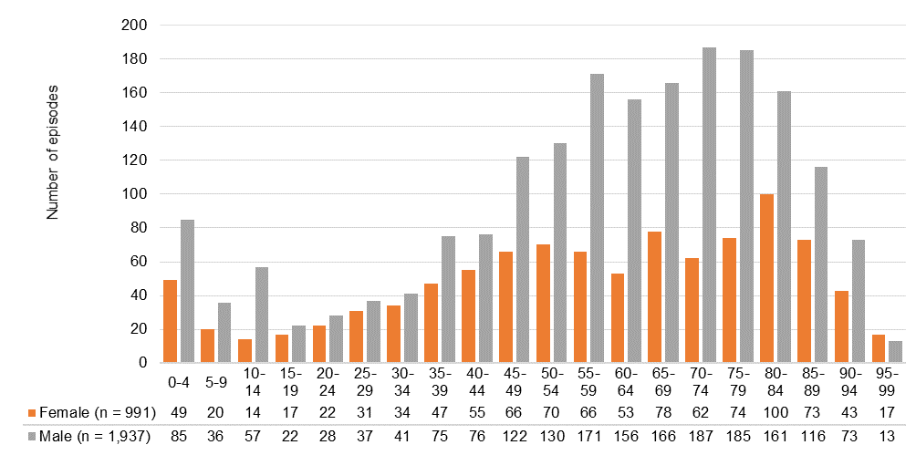

## Principal clinical manifestation

The principal clinical manifestations, which represent the most likely primary site or source for the origin of the bloodstream infection, are described below for patients with gram-negative, enterococcal and staphylococcal bacteraemia.

**Gram-negative bacteria**

The principal clinical manifestation was documented for 7,778 (86.9%) patient episodes of gram-negative bacteraemia. The most frequent clinical manifestations for episodes caused by *Enterobacterales* were urinary tract infection (45.0%) and biliary tract infection (15.6%); for *P. aeruginosa*, urinary tract infections (23.4%) and febrile neutropenia (20.9%) were the most common. For *Acinetobacter*, 25.6% had no identifiable focus (Table 5).

**Table 5:** Principal clinical manifestation for gram-negative bacteraemia, by patient sex, AGAR, 2021

|  |  |  |  |
| --- | --- | --- | --- |
| Principal clinical manifestation | Female % (*n*) | Male % (*n*) | Total % (*n*) |
| Gram-negative species* | 3,576 | 4,202 | 7,778 |
| *Acinetobacter* | 38 | 52 | 90 |
| No identifiable focus | 18.4 (7) | 30.8 (16) | 25.6 (23) |
| Other clinical syndrome | 23.7 (9) | 21.2 (11) | 22.2 (20) |
| Device-related infection without metastatic focus | 26.3 (10) | 15.4 (8) | 20.0 (18) |
| Skin and skin structure infection | 7.9 (3) | 9.6 (5) | 8.9 (8) |
| Urinary tract infection | 10.5 (4) | 5.8 (3) | 7.8 (7) |
| Intra-abdominal infection other than biliary tract | 5.3 (2) | 5.8 (3) | 5.6 (5) |
| Biliary tract infection (including cholangitis) | 5.3 (2) | 5.8 (3) | 5.6 (5) |
| Febrile neutropenia | 2.6 (1) | 3.8 (2) | 3.3 (3) |
| *Enterobacterales* | 3,313 | 3,716 | 7,029 |
| Urinary tract infection | 52.9 (1,752) | 37.9 (1,410) | 45.0 (3,162) |
| Biliary tract infection (including cholangitis) | 13.7 (454) | 17.2 (640) | 15.6 (1,094) |
| Intra-abdominal infection other than biliary tract | 9.3 (309) | 12.2 (454) | 10.9 (763) |
| Febrile neutropenia | 7.8 (259) | 10.0 (373) | 9.0 (632) |
| No identifiable focus | 6.4 (211) | 8.9 (331) | 7.7 (542) |
| Other clinical syndrome | 4.1 (137) | 5.8 (217) | 5.0 (354) |
| Device-related infection without metastatic focus | 3.7 (121) | 4.0 (149) | 3.8 (270) |
| Skin and skin structure infection | 1.4 (47) | 2.3 (86) | 1.9 (133) |
| Osteomyelitis/septic arthritis | 0.4 (13) | 1.1 (41) | 0.8 (54) |
| Device-related infection with metastatic focus | 0.3 (10) | 0.4 (15) | 0.4 (25) |
| *Pseudomonas aeruginosa* | 225 | 434 | 659 |
| Urinary tract infection | 19.6 (44) | 25.3 (110) | 23.4 (154) |
| Febrile neutropenia | 24.0 (54) | 19.4 (84) | 20.9 (138) |
| Other clinical syndrome | 8.4 (19) | 11.5 (50) | 10.5 (69) |
| Device-related infection without metastatic focus | 13.8 (31) | 8.5 (37) | 10.3 (68) |
| Skin and skin structure infection | 9.8 (22) | 9.4 (41) | 9.6 (63) |
| Intra-abdominal infection other than biliary tract | 7.6 (17) | 9.2 (40) | 8.6 (57) |
| No identifiable focus | 8.4 (19) | 8.5 (37) | 8.5 (56) |
| Biliary tract infection (including cholangitis) | 5.8 (13) | 6.5 (28) | 6.2 (41) |
| Device-related infection with metastatic focus | 1.3 (3) | 1.4 (6) | 1.4 (9) |
| Osteomyelitis/septic arthritis | 1.3 (3) | 0.2 (1) | 0.6 (4) |

* *Acinetobacter*, *Enterobacterales* and *Pseudomonas aeruginosa*

Urinary tract infection was the most frequent principal manifestation for community-onset episodes caused by *Enterobacterales* (51.7%) and *P. aeruginosa* (27.5%). For hospital-onset episodes, febrile neutropenia (*Enterobacterales* 24.3%, *P. aeruginosa* 24.8%) and urinary tract infection (*Enterobacterales* 20.5%, *P. aeruginosa* 17.2%) were the most common.

For *Enterobacterales* with urinary tract infection as the principal clinical manifestation, only a small proportion (340/3162, 11.0%) were regarded as a device-related infection. It was higher for hospital-onset than community-onset episodes (community-onset 270/2790, 9.7%; hospital-onset 70/305, 23.0%, *P* < 0.01).

***Enterococcus* species**

The principal clinical manifestation was known for 1,203 (92.8%) patient episodes of enterococcal bacteraemia. Overall, the most frequent principal clinical manifestations were urinary tract infection (15.0%), intra-abdominal infection other than biliary tract (14.4%), and biliary tract infections and those with no identifiable focus (14.1%) (Table 6). There were no significant gender differences in terms of principal clinical manifestation.

Of the hospital-onset episodes where data were available, the most frequent principal clinical manifestations were device-related infection without metastatic focus (19.0%) and intra-abdominal infection other than biliary tract (18.1%). Of the community-onset episodes where data were available, the most frequent principal clinical manifestations was urinary tract infection (22.0%) (data not shown).

The principal manifestation was known for 1,133 of the 1,225 (92.5%) *E. faecalis* and *E. faecium* episodes (Table 7). The most common clinical manifestation for *E. faecalis* was urinary tract infection (21.8%), whereas for *E. faecium* it was intra-abdominal infection other than biliary tract (19.3%), febrile neutropenia (19.1%), and biliary tract infection (including cholangitis (18.3%). Significant differences were seen between *E. faecalis* and *E. faecium* for a number of clinical manifestations.

**Table 6:** Principal clinical manifestation for enterococcal bacteraemia, by patient sex, AGAR, 2021

|  |  |  |  |  |
| --- | --- | --- | --- | --- |
| Principal clinical manifestation | Female % (*n*) | Male % (*n*) | Total % (*n*) | Significance* |
| Urinary tract infection | 13.8 (56) | 15.7 (125) | 15.0 (181) | ns |
| Intra-abdominal infection other than biliary tract | 15.8 (64) | 13.7 (109) | 14.4 (173) | ns |
| Biliary tract infection (including cholangitis) | 14.8 (60) | 13.8 (110) | 14.1 (170) | ns |
| No identifiable focus | 14.8 (60) | 13.8 (110) | 14.1 (170) | ns |
| Device-related infection without metastatic focus | 14.3 (58) | 12.3 (98) | 13.0 (156) | ns |
| Febrile neutropenia | 9.9 (40) | 8.6 (69) | 9.1 (109) | ns |
| Endocarditis (left-sided) | 5.9 (24) | 9.0 (72) | 8.0 (96) | ns |
| Other clinical syndrome | 4.7 (19) | 6.4 (51) | 5.8 (70) | ns |
| Skin and skin structure infection | 3.0 (12) | 2.9 (23) | 2.9 (35) | ns |
| Osteomyelitis/septic arthritis | 1.5 (6) | 1.6 (13) | 1.6 (19) | ns |
| Device-related infection with metastatic focus | 0.5 (2) | 1.3 (10) | 1.0 (12) | ns |
| Endocarditis (right-sided) | 1.0 (4) | 1.0 (8) | 1.0 (12) | ns |
| Total | 405 | 798 | 1,203 |  |

ns = not significant

* Fisher’s exact test for difference in principal clinical manifestation and sex

**Table 7:** Principal clinical manifestation for *Enterococcus faecalis* and *E. faecium* bacteraemia, AGAR, 2021

|  |  |  |  |  |
| --- | --- | --- | --- | --- |
| Principal clinical manifestation | *E. faecalis* % (*n*) | *E. faecium* % (*n*) | Total % (*n*) | Significance* |
| Urinary tract infection | 21.8 (143) | 7.1 (34) | 15.6 (177) | *P* < 0.01 |
| Intra-abdominal infection other than biliary tract | 11.0 (72) | 19.3 (92) | 14.5 (164) | *P* < 0.01 |
| No identifiable focus | 15.7 (103) | 10.9 (52) | 13.7 (155) | 0.01 < *P* < 0.05 |
| Device-related infection without metastatic focus | 12.5 (82) | 14.5 (69) | 13.3 (151) | ns |
| Biliary tract infection (including cholangitis) | 8.7 (57) | 18.3 (87) | 12.7 (144) | *P* < 0.01 |
| Febrile neutropenia | 1.8 (12) | 19.1 (91) | 9.1 (103) | *P* < 0.01 |
| Endocarditis (left-sided) | 12.6 (83) | 2.3 (11) | 8.3 (94) | *P* < 0.01 |
| Other clinical syndrome | 7.8 (51) | 4.0 (19) | 6.2 (70) | *P* < 0.01 |
| Skin and skin structure infection | 3.7 (24) | 1.9 (9) | 2.9 (33) | ns |
| Osteomyelitis/septic arthritis | 2.0 (13) | 1.1 (5) | 1.6 (18) | ns |
| Device-related infection with metastatic focus | 0.9 (6) | 1.3 (6) | 1.1 (12) | ns |
| Endocarditis (right-sided) | 1.7 (11) | 0.2 (1) | 1.1 (12) | 0.01 < *P* < 0.05 |
| Total | 657 | 476 | 1,133 |  |

ns = not significant

* Fisher’s exact test for difference in principal clinical manifestation between *E. faecalis* and *E. faecium*

***Staphylococcus aureus***

The principal clinical manifestation was known for 2,684 (91.7%) episodes of SAB (Table 8). Overall, the most frequent principal clinical manifestation was osteomyelitis/septic arthritis (22.6%) followed by skin and skin structure infection (19.0%). A little under one-half (42.8%, 118/276) of the clinical manifestations in children were due to osteomyelitis/septic arthritis (data not shown).

Of the hospital-onset SABs where data were available, the most common principal clinical manifestation was device-related infection without metastatic focus (34.8%, 202/581). Of the community-onset SABs where data were available, the most common principal clinical manifestation was osteomyelitis/septic arthritis (26.3%, 553/2,103).

**Table 8:** Principal clinical manifestation for *Staphylococcus aureus* bacteraemia, by patient sex, AGAR, 2021

|  |  |  |  |
| --- | --- | --- | --- |
| Principal clinical manifestation | Female % (*n*) | Male % (*n*) | Total % (*n*) |
| Osteomyelitis/septic arthritis | 20.2 (183) | 23.8 (423) | 22.6 (606) |
| Skin and skin structure infection | 17.0 (154) | 20.0 (355) | 19.0 (509) |
| Device-related infection without metastatic focus | 18.4 (167) | 16.0 (285) | 16.8 (452) |
| No identifiable focus | 15.1 (137) | 11.9 (212) | 13.0 (349) |
| Other clinical syndrome | 6.5 (59) | 7.9 (140) | 7.4 (199) |
| Endocarditis (left-sided) | 5.0 (45) | 6.0 (107) | 5.7 (152) |
| Pneumonia/empyema | 4.4 (40) | 3.7 (65) | 3.9 (105) |
| Deep abscess(es) excluding those in the CNS | 2.9 (26) | 4.0 (71) | 3.6 (97) |
| Device-related infection with metastatic focus | 2.1 (19) | 2.3 (40) | 2.2 (59) |
| Febrile neutropenia | 3.3 (30) | 1.3 (23) | 2.0 (53) |
| CNS infection (meningitis, abscess(es)) | 1.8 (16) | 2.0 (36) | 1.9 (52) |
| Endocarditis (right-sided) | 3.4 (31) | 1.1 (20) | 1.9 (51) |
| Total | 907 | 1,777 | 2,684 |

CNS = central nervous system

The most common principal clinical manifestation for MSSA was osteomyelitis/septic arthritis (23.8%, 532/2,233), whereas it was skin and skin structure infection for MRSA (26.4%, 119/451) (Table 9).

**Table 9:** Principal clinical manifestation for *Staphylococcus aureus* bacteraemia, by methicillin susceptibility, AGAR, 2021

|  |  |  |  |
| --- | --- | --- | --- |
| Principal clinical manifestation | Methicillin-resistant % (*n*) | Methicillin-susceptible % (*n*) | Total % (*n*) |
| Osteomyelitis/septic arthritis | 16.4 (74) | 23.8 (532) | 22.6 (606) |
| Skin and skin structure infection | 26.4 (119) | 17.5 (390) | 19.0 (509) |
| Device-related infection without metastatic focus | 13.7 (62) | 17.5 (390) | 16.8 (452) |
| No identifiable focus | 11.1 (50) | 13.4 (299) | 13.0 (349) |
| Other clinical syndrome | 8.6 (39) | 7.2 (160) | 7.4 (199) |
| Endocarditis (left-sided) | 6.4 (29) | 5.5 (123) | 5.7 (152) |
| Pneumonia/empyema | 4.9 (22) | 3.7 (83) | 3.9 (105) |
| Deep abscess(es) excluding those in the CNS | 6.0 (27) | 3.1 (70) | 3.6 (97) |
| Device-related infection with metastatic focus | 1.3 (6) | 2.4 (53) | 2.2 (59) |
| Febrile neutropenia | 1.3 (6) | 2.1 (47) | 2.0 (53) |
| CNS infection (meningitis, abscess(es)) | 2.2 (10) | 1.9 (42) | 1.9 (52) |
| Endocarditis (right-sided) | 1.6 (7) | 2.0 (44) | 1.9 (51) |
| Total | 451 | 2,233 | 2,684 |

CNS = central nervous system

## Length of hospital stay following bacteraemic episode

Information on length of stay following bacteraemia was available for 7,773 (86.9%) episodes involving gram-negative species, 1,204 (92.8%) episodes involving *Enterococcus* species, and 2,666 (91.1%) episodes involving *S. aureus*.

Over half (3,185/5,972, 53.3%) of patients with a community-onset gram-negative bacteraemia had a length of hospital stay less than seven days. A little under one-half of patients with hospital-onset bacteraemia caused by *Acinetobacter* remained in hospital for more than 30 days (12/28, 42.9%) (Table 10). Overall, 22.7% of patients remained in hospital for more than 30 days after enterococcal bacteraemia (Table 11) and 23.6% after staphylococcal bacteraemia (Table 12).

**Table 10:** Length of stay following gram-negative bacteraemia, by species and place of onset, AGAR, 2021

|  | Length of stay (days) | | | |  |
| --- | --- | --- | --- | --- | --- |
| Species | <7, % (*n*) | 7–14, % (*n*) | 15–30, % (*n*) | >30, % (*n*) | Total |
| Gram-negative species | 45.7 (3,551) | 30.5 (2,367) | 14.7 (1,139) | 9.2 (716) | 7,773 |
| Community-onset | 53.3 (3,185) | 30.8 (1,841) | 11.3 (674) | 4.6 (272) | 5,972 |
| Hospital-onset | 20.3 (366) | 29.2 (526) | 25.8 (465) | 24.7 (444) | 1,801 |
| *Acinetobacter* | 44.3 (39) | 27.3 (24) | 12.5 (11) | 15.9 (14) | 88 |
| Community-onset | 56.7 (34) | 30.0 (18) | 10.0 (6) | 3.3 (2) | 60 |
| Hospital-onset | 17.9 (5) | 21.4 (6) | 17.9 (5) | 42.9 (12) | 28 |
| *Enterobacterales* | 47.1 (3,312) | 30.0 (2,109) | 14.2 (997) | 8.7 (610) | 7,028 |
| Community-onset | 54.5 (3,008) | 30.1 (1,661) | 10.9 (602) | 4.5 (246) | 5,517 |
| Hospital-onset | 20.1 (304) | 29.6 (448) | 26.1 (395) | 24.1 (364) | 1,511 |
| *Escherichia coli* | 51.3 (2,206) | 29.5 (1,270) | 12.1 (520) | 7.1 (304) | 4,300 |
| Community-onset | 57.0 (2,072) | 29.0 (1,052) | 9.9 (358) | 4.1 (150) | 3,632 |
| Hospital-onset | 20.1 (134) | 32.6 (218) | 24.3 (162) | 23.1 (154) | 668 |
| *Klebsiella pneumoniae* complex | 42.3 (460) | 30.6 (333) | 17.8 (194) | 9.3 (101) | 1,088 |
| Community-onset | 50.6 (390) | 30.9 (238) | 13.7 (106) | 4.8 (37) | 771 |
| Hospital-onset | 22.1 (70) | 30.0 (95) | 27.8 (88) | 20.2 (64) | 317 |
| *Enterobacter cloacae* complex | 31.0 (126) | 32.8 (133) | 18.5 (75) | 17.7 (72) | 406 |
| Community-onset | 42.5 (96) | 35.4 (80) | 13.7 (31) | 8.4 (19) | 226 |
| Hospital-onset | 16.7 (30) | 29.4 (53) | 24.4 (44) | 29.4 (53) | 180 |
| Other *Enterobacterales* (*n*= 42) | 42.1 (520) | 30.2 (373) | 16.9 (208) | 10.8 (133) | 1,234 |
| *Pseudomonas aeruginosa* | 30.4 (200) | 35.6 (234) | 19.9 (131) | 14.0 (92) | 657 |
| Community-onset | 36.2 (143) | 41.0 (162) | 16.7 (66) | 6.1 (24) | 395 |
| Hospital-onset | 21.8 (57) | 27.5 (72) | 24.8 (65) | 26.0 (68) | 262 |

**Table 11:** Length of stay following *Enterococcus* species bacteraemia, by vancomycin resistance and place of onset, AGAR, 2021

|  | Length of stay following bacteraemia | | | |  |
| --- | --- | --- | --- | --- | --- |
| Species | <7 days % (*n*) | 7–14 % days (*n*) | 15–30 % days (*n*) | >30 days % (*n*) | Total |
| All species | 21.8 (262) | 28.8 (347) | 26.7 (322) | 22.7 (273) | 1,204 |
| *E. faecalis* | 23.5 (154) | 27.2 (178) | 25.2 (165) | 24.0 (157) | 654 |
| Vancomycin-resistant | –* (0) | –* (0) | –* (0) | –* (0) | 0 |
| Vancomycin-susceptible | 23.7 (154) | 27.0 (176) | 25.2 (164) | 24.1 (157) | 651 |
| *E. faecium* | 18.3 (88) | 30.2 (145) | 29.8 (143) | 21.7 (104) | 480 |
| Vancomycin-resistant | 19.4 (37) | 24.6 (47) | 31.9 (61) | 24.1 (46) | 191 |
| Vancomycin-susceptible | 17.7 (51) | 34.0 (98) | 28.5 (82) | 19.8 (57) | 288 |
| Other *Enterococcus* species (*n* = 8) | 28.6 (20) | 34.3 (24) | 20.0 (14) | 17.1 (12) | 70 |
| Community-onset |  |  |  |  |  |
| *E. faecalis* | 27.6 (123) | 30.6 (136) | 24.5 (109) | 17.3 (77) | 445 |
| Vancomycin-resistant | –* (0) | –* (0) | –* (0) | –* (0) | 0 |
| Vancomycin-susceptible | 27.8 (123) | 30.5 (135) | 24.4 (108) | 17.4 (77) | 443 |
| *E. faecium* | 25.5 (38) | 35.6 (53) | 24.8 (37) | 14.1 (21) | 149 |
| Vancomycin-resistant | 30.0 (12) | 25.0 (10) | 32.5 (13) | 12.5 (5) | 40 |
| Vancomycin-susceptible | 23.9 (26) | 39.4 (43) | 22.0 (24) | 14.7 (16) | 109 |
| Hospital-onset |  |  |  |  |  |
| *E. faecalis* | 14.8 (31) | 20.1 (42) | 26.8 (56) | 38.3 (80) | 209 |
| Vancomycin-resistant | –* (0) | –* (0) | –* (0) | –* (0) | 0 |
| Vancomycin-susceptible | 14.9 (31) | 19.7 (41) | 26.9 (56) | 38.5 (80) | 208 |
| *E. faecium* | 15.1 (50) | 27.8 (92) | 32.0 (106) | 25.1 (83) | 331 |
| Vancomycin-resistant* | 16.6 (25) | 24.5 (37) | 31.8 (48) | 27.2 (41) | 151 |
| Vancomycin-susceptible* | 14.0 (25) | 30.7 (55) | 32.4 (58) | 22.9 (41) | 179 |

* Insufficient numbers (<10) to calculate percentage

Note: Vancomycin susceptibility not available for three *E. faecalis* (community-onset [2]; hospital-onset [1]) and one *E. faecium* (hospital-onset).

**Table 12:** Length of stay following *Staphylococcus aureus* bacteraemia, by methicillin susceptibility and place of onset, AGAR, 2021

|  | Length of stay following bacteraemia | | | |  |
| --- | --- | --- | --- | --- | --- |
| Species | <7 days % (*n*) | 7–14 days % (*n*) | 15–30 days % (*n*) | >30 days % (*n*) | Total |
| *Staphylococcus aureus* | 18.3 (487) | 27.4 (731) | 30.8 (820) | 23.6 (628) | 2,666 |
| Methicillin-resistant | 16.0 (73) | 25.6 (117) | 33.3 (152) | 25.2 (115) | 457 |
| Community-onset | 17.0 (61) | 26.2 (94) | 34.8 (125) | 22.0 (79) | 359 |
| Hospital-onset | 12.2 (12) | 23.5 (23) | 27.6 (27) | 36.7 (36) | 98 |
| Methicillin-susceptible | 18.7 (414) | 27.8 (614) | 30.2 (668) | 23.2 (513) | 2,209 |
| Community-onset | 20.6 (356) | 29.7 (512) | 28.9 (498) | 20.8 (359) | 1,725 |
| Hospital-onset | 12.0 (58) | 21.1 (102) | 35.1 (170) | 31.8 (154) | 484 |

## Susceptibility testing results

The following sections present the results of susceptibility testing in priority indicator species, and the findings for antimicrobial resistance by place of onset and multi-drug resistance. Susceptibility testing methods are described in Appendix B.

**Percentages of non-susceptibility in national priority indicator species**

Overall percentages of resistance or non-susceptibility in the indicator species of national priority13 using both CLSI breakpoints and EUCAST breakpoints, are shown in Table 13. Resistance (as defined by EUCAST) by state and territory to key antimicrobial groups (fluoroquinolones, third-generation cephalosporins, aminoglycosides and carbapenems) for *E. coli* and *K. pneumoniae* complex are shown in Figures 4 and 5; key antipseudomonal agents in Figure 6; methicillin resistance in *S. aureus* (Figure 7); glycopeptide resistance in *E. faecium*, and high-level gentamicin resistance in *E. faecalis* in Figure 8. Detailed resistance by state and territory can be found in Appendix C.

**Table 13:** Activity of antimicrobial agents tested against isolates recovered from patients with bloodstream infections, AGAR, 2021

|  |  | CLSI | | EUCAST | |
| --- | --- | --- | --- | --- | --- |
| Species and antimicrobial | Isolates (*n*) | Intermediate % (*n*) | Resistant % (*n*) | Susceptible, increased exposure % (*n*) | Resistant % (*n*) |
| *Acinetobacter baumannii* complex |  |  |  |  |  |
| Piperacillin–tazobactam | 45 | 20.0 (9) | 4.4 (2) | –* | –* |
| Ceftriaxone | 45 | 75.6 (34) | 2.2 (1) | –* | –* |
| Ceftazidime | 45 | 17.8 (8) | 0.0 (0) | –* | –* |
| Cefepime | 44 | 2.3 (1) | 6.8 (3) | –* | –* |
| Gentamicin | 48 | 0.0 (0) | 0.0 (0) | –† | 0.0 (0) |
| Tobramycin | 48 | 0.0 (0) | 0.0 (0) | –† | 0.0 (0) |
| Amikacin | 41 | 0.0 (0) | 0.0 (0) | –† | 0.0 (0) |
| Ciprofloxacin | 36 | 2.8 (1) | 0.0 (0) | 97.2 (35) | 2.8 (1) |
| Meropenem | 48 | 0.0 (0) | 0.0 (0) | 0.0 (0) | 0.0 (0) |
| *Enterobacter cloacae* complex |  |  |  |  |  |
| Piperacillin–tazobactam | 441 | 6.6 (29) | 18.4 (81) | –† | 28.1 (124) |
| Ceftriaxone | 448 | 0.7 (3) | 26.3 (118) | 0.7 (3) | 26.3 (118) |
| Ceftazidime | 448 | 0.4 (2) | 23.2 (104) | 3.1 (14) | 23.7 (106) |
| Cefepime | 448 | 3.8 (17)§ | 2.7 (12) | 9.4 (42) | 4.0 (18) |
| Gentamicin | 448 | 0.2 (1) | 5.4 (24) | –† | 6.0 (27) |
| Tobramycin | 443 | 2.7 (12) | 3.2 (14) | –† | 6.1 (27) |
| Amikacin | 448 | 0.2 (1) | 0.2 (1) | –† | 1.1 (5) |
| Ciprofloxacin | 448 | 2.2 (10) | 5.4 (24) | 2.2 (10) | 5.4 (24) |
| Meropenem | 447 | 0.7 (3) | 2.2 (10) | 0.2 (1) | 2.0 (9) |
| *Enterococcus faecalis* |  |  |  |  |  |
| Ampicillin | 698 | –* | 0.1 (1) | 0.0 (0) | 0.1 (1) |
| Benzylpenicillin | 587 | –* | 0.9 (5) | –† | –† |
| Ciprofloxacin | 419 | 2.4 (10) | 5.0 (21) | –* | 2.0 (8)# |
| Daptomycin | 650 | 42.5 (276) | 0.3 (2) | –† | –† |
| Linezolid | 697 | 5.2 (36) | 0.3 (2) | –* | 0.3 (2) |
| Teicoplanin | 699 | 0.0 (0) | 0.0 (0) | –* | 0.1 (1) |
| Vancomycin | 699 | 0.0 (0) | 0.0 (0) | –* | 0.0 (0) |
| *Enterococcus faecium* |  |  |  |  |  |
| Ampicillin | 521 | –* | 89.3 (465) | 0.0 (0) | 89.3 (465) |
| Benzylpenicillin | 436 | –* | 90.1 (393) | –† | –† |
| Ciprofloxacin | 323 | 2.8 (9) | 88.2 (285) | –* | –** |
| Linezolid | 520 | 1.3 (7) | 0.4 (2) | –* | 0.4 (2) |
| Teicoplanin | 522 | 1.1 (6) | 10.3 (54) | –* | 13.2 (69) |
| Vancomycin | 522 | 1.5 (8) | 36.4 (190) | –* | 37.9 (198) |
| *Escherichia coli* |  |  |  |  |  |
| Ampicillin | 4,912 | 1.8 (88) | 51.4 (2,527) | –† | 53.2 (2,615) |
| Amoxicillin–clavulanic acid (2:1 ratio)‡ | 4,297 | 12.6 (543) | 7.7 (333) | –* | –* |
| Piperacillin–tazobactam | 4,883 | 2.5 (124) | 2.8 (139) | –† | 6.5 (317) |
| Cefazolin | 4,297 | –§§ | 23.1 (994) | 76.9 (3,303) | 23.1 (994) |
| Ceftriaxone | 4,912 | 0.1 (6) | 12.5 (612) | 0.1 (6) | 12.5 (612) |
| Ceftazidime | 4,912 | 0.7 (32) | 5.6 (277) | 6.9 (337) | 6.3 (309) |
| Cefepime | 4,913 | 2.0 (97)§ | 2.6 (128) | 5.7 (282) | 3.6 (175) |
| Gentamicin | 4,913 | 0.2 (11) | 7.9 (387) | –† | 8.6 (422) |
| Tobramycin | 4,896 | 5.8 (284) | 2.7 (130) | –† | 8.8 (431) |
| Amikacin | 4,913 | 0.1 (4) | 0.1 (5) | –† | 1.4 (68) |
| Ciprofloxacin | 4,910 | 4.2 (208) | 12.3 (606) | 4.2 (208) | 12.3 (606) |
| Meropenem | 4,911 | 0.0 (0) | 0.0 (2) | 0.0 (1) | 0.0 (1) |
| *Klebsiella aerogenes* |  |  |  |  |  |
| Piperacillin–tazobactam | 119 | 8.4 (10) | 27.7 (33) | –† | 42.9 (51) |
| Ceftriaxone | 119 | 0.8 (1) | 37.8 (45) | 0.8 (1) | 37.8 (45) |
| Ceftazidime | 119 | 3.4 (4) | 32.8 (39) | 3.4 (4) | 36.1 (43) |
| Cefepime | 119 | 0.8 (1)§ | 1.7 (2) | 2.5 (3) | 2.5 (3) |
| Gentamicin | 119 | 0.0 (0) | 1.7 (2) | –† | 2.5 (3) |
| Tobramycin | 119 | 1.7 (2) | 0.8 (1) | –† | 2.5 (3) |
| Amikacin | 119 | 0.0 (0) | 0.0 (0) | –† | 0.8 (1) |
| Ciprofloxacin | 119 | 0.0 (0) | 4.2 (5) | 0.0 (0) | 4.2 (5) |
| Meropenem | 119 | 0.0 (0) | 3.4 (4) | 0.8 (1) | 2.5 (3) |
| *Klebsiella oxytoca* |  |  |  |  |  |
| Amoxicillin–clavulanic acid (2:1 ratio) | 231 | 3.5 (8) | 7.4 (17) | –* | –* |
| Piperacillin–tazobactam | 264 | 0.4 (1) | 9.1 (24) | –† | 11.0 (29) |
| Ceftriaxone | 264 | 0.8 (2) | 6.8 (18) | 0.8 (2) | 6.8 (18) |
| Ceftazidime | 264 | 0.4 (1) | 0.4 (1) | 1.5 (4) | 0.8 (2) |
| Cefepime | 264 | 0.0 (0)§ | 0.0 (0) | 0.8 (2) | 0.0 (0) |
| Gentamicin | 264 | 0.0 (0) | 1.1 (3) | –† | 1.1 (3) |
| Tobramycin | 262 | 0.8 (2) | 0.4 (1) | –† | 1.1 (3) |
| Amikacin | 263 | 0.0 (0) | 0.0 (0) | –† | 0.0 (0) |
| Ciprofloxacin | 264 | 0.4 (1) | 0.8 (2) | 0.4 (1) | 0.8 (2) |
| Meropenem | 264 | 0.0 (0) | 0.4 (1) | 0.0 (0) | 0.4 (1) |
| *Klebsiella pneumoniae* complex |  |  |  |  |  |
| Amoxicillin–clavulanic acid (2:1 ratio) | 1,077 | 4.6 (50) | 3.8 (41) | –* | –* |
| Piperacillin–tazobactam | 1,237 | 2.7 (33) | 2.9 (36) | –† | 9.9 (123) |
| Cefazolin | 1,074 | –§§ | 10.0 (107) | 90.0 (967) | 10.0 (107) |
| Ceftriaxone | 1,239 | 0.1 (1) | 6.1 (75) | 0.1 (1) | 6.1 (75) |
| Ceftazidime | 1,239 | 1.1 (14) | 4.2 (52) | 2.3 (29) | 5.3 (66) |
| Cefepime | 1,239 | 1.0 (13)§ | 1.6 (20) | 3.1 (39) | 2.0 (25) |
| Gentamicin | 1,239 | 0.1 (1) | 3.6 (44) | –† | 3.7 (46) |
| Tobramycin | 1,235 | 2.1 (26) | 1.9 (23) | –† | 4.3 (53) |
| Amikacin | 1,239 | 0.0 (0) | 0.2 (2) | –† | 0.4 (5) |
| Ciprofloxacin | 1,239 | 2.2 (27) | 7.2 (89) | 2.2 (27) | 7.2 (89) |
| Meropenem | 1,239 | 0.2 (3) | 0.4 (5) | 0.1 (1) | 0.3 (4) |
| *Proteus mirabilis* |  |  |  |  |  |
| Ampicillin | 312 | 0.6 (2) | 14.7 (46) | –† | 15.4 (48) |
| Amoxicillin–clavulanic acid (2:1 ratio) | 279 | 9.0 (25) | 1.8 (5) | –* | –* |
| Piperacillin–tazobactam | 308 | 0.3 (1) | 0.0 (0) | –† | 0.3 (1) |
| Ceftriaxone | 312 | 0.0 (0) | 2.2 (7) | 0.0 (0) | 2.2 (7) |
| Ceftazidime | 312 | 0.3 (1) | 1.0 (3) | 1.3 (4) | 1.3 (4) |
| Cefepime | 312 | 1.3 (4)§ | 1.0 (3) | 1.0 (3) | 1.3 (4) |
| Gentamicin | 312 | 2.2 (7) | 2.6 (8) | –† | 10.6 (33) |
| Tobramycin | 310 | 1.6 (5) | 1.6 (5) | –† | 4.5 (14) |
| Amikacin | 312 | 0.6 (2) | 0.3 (1) | –† | 1.6 (5) |
| Ciprofloxacin | 312 | 0.3 (1) | 5.4 (17) | 0.3 (1) | 5.4 (17) |
| Meropenem | 311 | 0.0 (0) | 0.0 (0) | 0.0 (0) | 0.0 (0) |
| *Pseudomonas aeruginosa* |  |  |  |  |  |
| Piperacillin–tazobactam | 729 | 5.9 (43) | 6.9 (50) | 87.2 (636) | 12.8 (93) |
| Ceftazidime | 735 | 3.8 (28) | 6.0 (44) | 90.2 (663) | 9.8 (72) |
| Cefepime | 735 | 3.3 (24) | 3.0 (22) | 93.7 (689) | 6.3 (46) |
| Tobramycin | 732 | 0.7 (5) | 0.5 (4) | –† | 1.2 (9) |
| Amikacin | 735 | 0.4 (3) | 0.1 (1) | –† | 0.5 (4) |
| Ciprofloxacin | 735 | 4.4 (32) | 3.7 (27) | 92.0 (676) | 8.0 (59) |
| Meropenem | 733 | 3.3 (24) | 3.7 (27) | 4.6 (34) | 2.3 (17) |
| *Salmonella* species (non-typhoidal) |  |  |  |  |  |
| Ampicillin | 80 | 0.0 (0) | 3.8 (3) | –† | 3.8 (3) |
| Amoxicillin–clavulanic acid (2:1 ratio) | 79 | 0.0 (0) | 1.3 (1) | –* | –* |
| Piperacillin–tazobactam | 80 | 0.0 (0) | 0.0 (0) | –† | 0.0 (0) |
| Ceftriaxone | 80 | 0.0 (0) | 1.3 (1) | 0.0 (0) | 1.3 (1) |
| Ceftazidime | 80 | 0.0 (0) | 1.3 (1) | 0.0 (0) | 1.3 (1) |
| Cefepime | 80 | 0.0 (0)§ | 0.0 (0) | 0.0 (0) | 0.0 (0) |
| Ciprofloxacin## | 72 | 2.8 (2) | 0.0 (0) | –† | 2.8 (2) |
| Meropenem | 80 | 0.0 (0) | 0.0 (0) | 0.0 (0) | 0.0 (0) |
| *Serratia marcescens* |  |  |  |  |  |
| Piperacillin–tazobactam | 160 | 0.0 (0) | 0.0 (0) | –† | 1.9 (3) |
| Ceftriaxone | 200 | 1.5 (3) | 3.0 (6) | 1.5 (3) | 3.0 (6) |
| Ceftazidime | 200 | 0.0 (0) | 0.5 (1) | 0.5 (1) | 0.5 (1) |
| Cefepime | 200 | 0.0 (0)§ | 0.5 (1) | 0.0 (0) | 0.5 (1) |
| Gentamicin | 200 | 0.5 (1) | 0.0 (0) | –† | 2.5 (5) |
| Tobramycin | 197 | 17.8 (35) | 0.0 (0) | –† | 32.0 (63) |
| Amikacin | 200 | 0.5 (1) | 0.0 (0) | –† | 1.5 (3) |
| Ciprofloxacin | 200 | 0.5 (1) | 2.0 (4) | 0.5 (1) | 2.0 (4) |
| Meropenem | 199 | 0.0 (0) | 0.5 (1) | 0.5 (1) | 0.0 (0) |
| *Staphylococcus aureus* |  |  |  |  |  |
| Benzylpenicillin*** | 2,876 | –† | 82.9 (2,385) | –† | 82.9 (2,385) |
| Cefoxitin (methicillin)‡† | 2,928 | –† | 16.9 (495) | –† | 16.9 (495) |
| Ciprofloxacin | 2,923 | 0.6 (18) | 8.1 (236) | 91.3 (2,669) | 8.7 (254) |
| Clindamycin (constitutive) | 2,920 | 0.1 (2) | 2.3 (68) | –† | 2.9 (85) |
| Clindamycin (constitutive + inducible resistance) | 2,921 | 0.1 (2) | 12.5 (366) | –† | 13.6 (396) |
| Daptomycin | 2,926 | <0.1 (1)§§§ | –† | –† | <0.1 (1) |
| Erythromycin | 2,922 | 27.2 (796) | 15.8 (461) | 0.6 (17) | 16.3 (477) |
| Fusidic acid | 2,923 | –* | –* | –† | 2.6 (77) |
| Gentamicin | 2,923 | 1.5 (45) | 2.1 (61) | –† | 4.9 (144) |
| Linezolid | 2,927 | –† | 0.0 (0) | –† | 0.0 (0) |
| Mupirocin (high-level)### | 2,179 | –† | 1.1 (25) | –† | 1.1 (25) |
| Rifampicin | 2,920 | 0.1 (2) | 0.2 (5) | –† | 0.9 (10)**** |
| Teicoplanin | 2,913 | 0.0 (0) | 0.0 (0) | –* | 0.1 (3) |
| Tetracycline/doxycycline‡‡ | 2,923 | 0.2 (7) | 4.0 (117) | 0.7 (21) | 4.5 (132) |
| Trimethoprim–sulfamethoxazole§§§§ | 2,906 | 0.1 (2) | 0.7 (19) | 0.1 (4) | 0.7 (19) |
| Vancomycin | 2,927 | 0.0 (0) | 0.0 (0) | –† | 0.0 (0) |

CLSI = Clinical and Laboratory Standards Institute; EUCAST = European Committee on Antimicrobial Susceptibility Testing

* No guidelines for indicated species

† No category defined

§ Includes sensitive dose dependent category for CLSI

# The ciprofloxacin ECOFF (4 mg/L, *E. faecalis*) was used to distinguish between isolates with and without acquired resistance mechanisms, as breakpoints apply to uncomplicated urinary tract infections only

** The ciprofloxacin concentration range available on the Vitek® and Phoenix™ cards restricts the ability to determine non-wild type (ECOFF 8 mg/ for *E. faecium*

‡ For susceptibility testing purposes, EUCAST fixes the concentration of clavulanic acid at 2 mg/L, rather than the 2:1 ratio used in CLSI guidelines

§§ The cefazolin concentration range available on the Vitek® card used restricts the ability to accurately identify CLSI susceptible and intermediate categories

## The ciprofloxacin concentration range available on the Vitek® card used restricts the ability to accurately identify susceptible (CLSI/EUCAST) and intermediate (CLSI) categories for *Salmonella* species. Results of MIC gradient strips, where available, were provided

*** Benzylpenicillin resistance including β-lactamase producers

‡† Resistance as determined by cefoxitin screen (Vitek®) or cefoxitin MIC (Phoenix™)

§§§ Non-susceptible, resistance not defined

### Mupirocin high-level resistance screen

****The rifampicin concentration range on the Phoenix™ card and Vitek® card (AST-P612) restricts the ability to accurately determine susceptibility for EUCAST (*n* = 1,071)

‡‡ The doxycycline concentration range available on the Phoenix™ card used restricts the ability to accurately identify CLSI intermediate and resistant categories for enterococci and *S. aureus*

§§§§ Trimethoprim–sulfamethoxazole resistance, as determined by Vitek® or Phoenix™, confirmed by disc diffusion

Figure 4: Percentage of *Escherichia coli* from patients with bacteraemia with resistance, as defined by EUCAST, to fluoroquinolones (A), third-generation cephalosporins (B), aminoglycosides (C) and carbapenems (D), Australia, AGAR, 2021

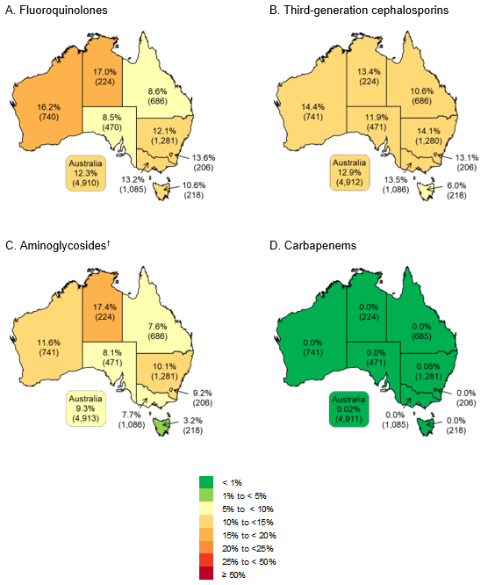

EUCAST = European Committee on Antimicrobial Susceptibility Testing

* Third-generation cephalosporins refers to ceftriaxone and/or ceftazidime

† Aminoglycosides refers to gentamicin or tobramycin

Figure 5: Percentage of *Klebsiella pneumoniae* complex from patients with bacteraemia with resistance, as defined by EUCAST, to fluoroquinolones (A), third-generation cephalosporins (B), aminoglycosides (C) and carbapenems (D), Australia, AGAR, 2021

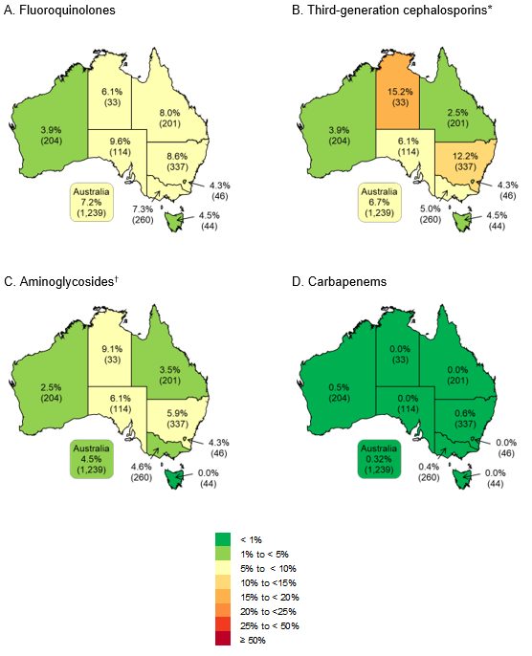

EUCAST = European Committee on Antimicrobial Susceptibility Testing

* Third-generation cephalosporins refers to ceftriaxone and/or ceftazidime

† Aminoglycosides refers to gentamicin or tobramycin

Figure 6: Percentage of *Pseudomonas aeruginosa* from patients with bacteraemia with resistance, as defined by EUCAST, to piperacillin–tazobactam (A), fluoroquinolones (B), ceftazidime (C) and carbapenems (D), Australia, AGAR, 2021

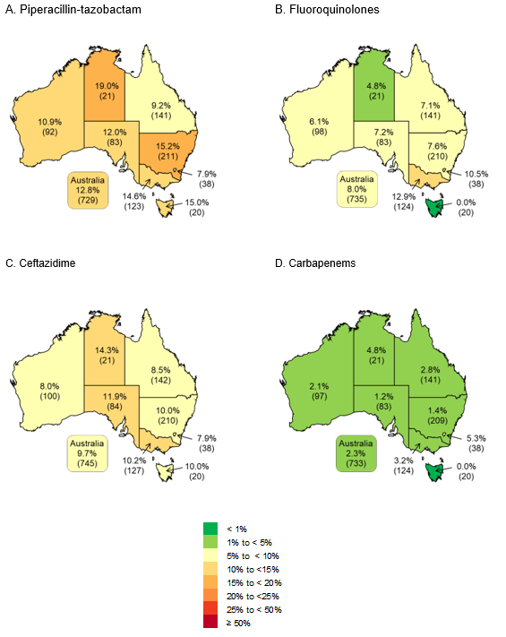

EUCAST = European Committee on Antimicrobial Susceptibility Testing

Figure 7: Percentage of *Staphylococcus aureus* from patients with bacteraemia with resistance, as defined by EUCAST, to methicillin, Australia, AGAR, 2021

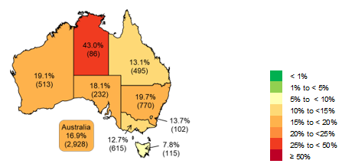

EUCAST = European Committee on Antimicrobial Susceptibility Testing

Figure 8: Percentage of *Enterococcus faecium* from patients with bacteraemia with resistance, as defined by EUCAST, to vancomycin (A) and teicoplanin (B), and *Enterococcus faecalis* with resistance to high-level gentamicin (C), Australia, AGAR, 2021

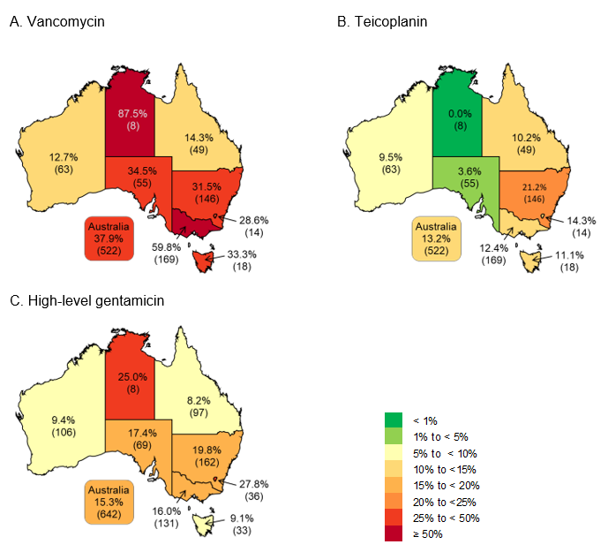

EUCAST = European Committee on Antimicrobial Susceptibility Testing

**Antimicrobial resistance by place of onset**

Antimicrobial resistances (CLSI and EUCAST) in indicator species by place of onset, if known, are shown in Table 14.

**Table 14:** Activity of antimicrobial agents tested against species recovered from patients with bloodstream infections, by place of onset, AGAR, 2021

|  | **Community-onset** | | | | | | | | **Hospital-onset** | | | | | | | | | |
| --- | --- | --- | --- | --- | --- | --- | --- | --- | --- | --- | --- | --- | --- | --- | --- | --- | --- | --- |
|  |  | | **CLSI, %** | | **EUCAST, %** | | | |  | | **CLSI, %** | | | | **EUCAST, %** | | | |
| **Species and antimicrobial** | **No.** | | **I** | **R** | **S, IE** | | **R** | | **No.** | | **I** | | | **R** | **S, IE** | | **R** | |
| *Acinetobacter baumannii* complex |  | |  |  |  | |  | |  | |  | | |  |  | |  | |
| Piperacillin–tazobactam | 26 | | 30.8 | 3.8 | –* | | –* | | 19 | | 5.3 | | | 5.3 | –* | | –* | |
| Ceftriaxone | 28 | | 78.6 | 3.6 | –* | | –* | | 17 | | 70.6 | | | 0.0 | –* | | –* | |
| Ceftazidime | 26 | | 26.9 | 0.0 | –* | | –* | | 19 | | 5.3 | | | 0.0 | –* | | –* | |
| Cefepime | 25 | | 4.0 | 12.0 | –* | | –* | | 19 | | 0.0 | | | 0.0 | –* | | –* | |
| Gentamicin | 29 | | 0.0 | 0.0 | –† | | 0.0 | | 19 | | 0.0 | | | 0.0 | –† | | 0.0 | |
| Tobramycin | 29 | | 0.0 | 0.0 | –† | | 0.0 | | 19 | | 0.0 | | | 0.0 | –† | | 0.0 | |
| Amikacin | 23 | | 0.0 | 0.0 | –† | | 0.0 | | 18 | | 0.0 | | | 0.0 | –† | | 0.0 | |
| Ciprofloxacin | 23 | | 4.3 | 0.0 | 95.7 | | 4.3 | | 13 | | 0.0 | | | 0.0 | 100.0 | | 0.0 | |
| Meropenem | 29 | | 0.0 | 0.0 | 0.0 | | 0.0 | | 19 | | 0.0 | | | 0.0 | 0.0 | | 0.0 | |
| *Enterobacter cloacae* complex |  | |  |  |  | |  | |  | |  | | |  |  | |  | |
| Piperacillin–tazobactam | 249 | | 4.8 | 11.2 | –† | | 18.9 | | 192 | | 8.9 | | | 27.6 | –† | | 40.1 | |
| Ceftriaxone | 253 | | 0.8 | 17.4 | 0.8 | | 17.4 | | 195 | | 0.5 | | | 37.9 | 0.5 | | 37.9 | |
| Ceftazidime | 253 | | 0.4 | 13.4 | 5.1 | | 13.8 | | 195 | | 0.5 | | | 35.9 | 0.5 | | 36.4 | |
| Cefepime | 253 | | 2.4§ | 1.6 | 6.3 | | 2.4 | | 195 | | 5.6§ | | | 4.1 | 13.3 | | 6.2 | |
| Gentamicin | 253 | | 0.4 | 3.2 | –† | | 4.0 | | 195 | | 0.0 | | | 8.2 | –† | | 8.7 | |
| Tobramycin | 250 | | 2.0 | 1.6 | –† | | 4.0 | | 193 | | 3.6 | | | 5.2 | –† | | 8.8 | |
| Amikacin | 253 | | 0.0 | 0.0 | –† | | 0.4 | | 195 | | 0.5 | | | 0.5 | –† | | 2.1 | |
| Ciprofloxacin | 253 | | 2.0 | 3.6 | 2.0 | | 3.6 | | 195 | | 2.6 | | | 7.7 | 2.6 | | 7.7 | |
| Meropenem | 253 | | 0.0 | 1.2 | 0.0 | | 1.2 | | 194 | | 1.5 | | | 3.6 | 0.5 | | 3.1 | |
| *Enterococcus faecalis* |  | |  |  |  | |  | |  | |  | | |  |  | |  | |
| Ampicillin | 479 | | –† | 0.2 | 0.0 | | 0.2 | | 219 | | –† | | | 0.0 | 0.0 | | 0.0 | |
| Benzylpenicillin | 406 | | –† | 0.2 | –* | | –* | | 181 | | –† | | | 2.2 | –* | | –* | |
| Ciprofloxacin | 291 | | 3.1 | 5.5 | –† | | 1.8# | | 128 | | 0.8 | | | 3.9 | –† | | 2.4# | |
| Daptomycin | 440 | | 41.8 | 0.2 | –* | | –* | | 210 | | 43.8 | | | 0.5 | –* | | –* | |
| Linezolid | 478 | | 5.0 | 0.4 | –† | | 0.4 | | 219 | | 5.5 | | | 0.0 | –† | | 0.0 | |
| Teicoplanin | 480 | | 0.0 | 0.0 | –† | | 0.2 | | 219 | | 0.0 | | | 0.0 | –† | | 0.0 | |
| Vancomycin | 480 | | 0.0 | 0.0 | –† | | 0.0 | | 219 | | 0.0 | | | 0.0 | –† | | 0.0 | |
| *Enterococcus faecium* |  | |  |  |  | |  | |  | |  | | |  |  | |  | |
| Ampicillin | 167 | | –† | 79.6 | 0.0 | | 79.6 | | 354 | | –† | | | 93.8 | 0.0 | | 93.8 | |
| Benzylpenicillin | 149 | | –† | 80.5 | –* | | –* | | 287 | | –† | | | 95.1 | –* | | –* | |
| Ciprofloxacin | 109 | | 5.5 | 77.1 | –† | | –** | | 214 | | 1.4 | | | 93.9 | –† | | –** | |
| Linezolid | 166 | | 3.0 | 0.6 | –† | | 0.6 | | 354 | | 0.6 | | | 0.3 | –† | | 0.3 | |
| Teicoplanin | 168 | | 0.6 | 4.8 | –† | | 5.4 | | 354 | | 1.4 | | | 13.0 | –† | | 16.9 | |
| Vancomycin | 168 | | 0.6 | 23.8 | –† | | 24.4 | | 354 | | 2.0 | | | 42.4 | –† | | 44.4 | |
| *Escherichia coli* |  | |  |  |  | |  | |  | |  | | |  |  | |  | |
| Ampicillin | 4,177 | | 1.8 | 49.5 | –† | | 51.3 | | 735 | | 1.5 | | | 62.7 | –† | | 64.2 | |
| Amoxicillin–clavulanic acid (2:1 ratio)‡ | 3,659 | | 12.5 | 6.7 | –* | | –* | | 638 | | 13.6 | | | 13.9 | –* | | –* | |
| Piperacillin–tazobactam | 4,153 | | 2.3 | 2.0 | –† | | 5.2 | | 730 | | 4.0 | | | 7.9 | –† | | 14.0 | |
| Cefazolin | 3,659 | | –§§ | 21.3 | 78.7 | | 21.3 | | 638 | | –§§ | | | 33.7 | 66.3 | | 33.7 | |
| Ceftriaxone | 4,177 | | 0.1 | 11.5 | 0.1 | | 11.5 | | 735 | | 0.3 | | | 17.8 | 0.3 | | 17.8 | |
| Ceftazidime | 4,177 | | 0.6 | 5.0 | 6.5 | | 5.6 | | 735 | | 1.2 | | | 9.3 | 8.7 | | 10.5 | |
| Cefepime | 4,178 | | 2.0§ | 2.2 | 5.4 | | 3.1 | | 735 | | 2.0§ | | | 4.9 | 7.8 | | 6.1 | |
| Gentamicin | 4,178 | | 0.2 | 7.3 | –† | | 8.0 | | 735 | | 0.3 | | | 10.9 | –† | | 11.7 | |
| Tobramycin | 4,165 | | 5.5 | 2.4 | –† | | 8.1 | | 731 | | 7.5 | | | 4.4 | –† | | 12.7 | |
| Amikacin | 4,178 | | 0.1 | 0.1 | –† | | 1.3 | | 735 | | 0.1 | | | 0.0 | –† | | 1.8 | |
| Ciprofloxacin | 4,175 | | 4.0 | 11.6 | 4.0 | | 11.6 | | 735 | | 5.4 | | | 16.7 | 5.4 | | 16.7 | |
| Meropenem | 4,176 | | 0.0 | 0.0 | 0.0 | | 0.0 | | 735 | | 0.0 | | | 0.0 | 0.0 | | 0.0 | |
| *Klebsiella aerogenes* |  | |  |  |  | |  | |  | |  | | |  |  | |  | |
| Piperacillin–tazobactam | 74 | | 10.8 | 18.9 | –† | | 36.5 | | 45 | | 4.4 | | | 42.2 | –† | | 53.3 | |
| Ceftriaxone | 74 | | 1.4 | 29.7 | 1.4 | | 29.7 | | 45 | | 0.0 | | | 51.1 | 0.0 | | 51.1 | |
| Ceftazidime | 74 | | 2.7 | 25.7 | 4.1 | | 28.4 | | 45 | | 4.4 | | | 44.4 | 2.2 | | 48.9 | |
| Cefepime | 74 | | 0.0§ | 0.0 | 1.4 | | 0.0 | | 45 | | 2.2§ | | | 4.4 | 4.4 | | 6.7 | |
| Gentamicin | 74 | | 0.0 | 1.4 | –† | | 2.7 | | 45 | | 0.0 | | | 2.2 | –† | | 2.2 | |
| Tobramycin | 74 | | 1.4 | 1.4 | –† | | 2.7 | | 45 | | 2.2 | | | 0.0 | –† | | 2.2 | |
| Amikacin | 74 | | 0.0 | 0.0 | –† | | 1.4 | | 45 | | 0.0 | | | 0.0 | –† | | 0.0 | |
| Ciprofloxacin | 74 | | 0.0 | 4.1 | 0.0 | | 4.1 | | 45 | | 0.0 | | | 4.4 | 0.0 | | 4.4 | |
| Meropenem | 74 | | 0.0 | 1.4 | 0.0 | | 1.4 | | 45 | | 0.0 | | | 6.7 | 2.2 | | 4.4 | |
| *Klebsiella oxytoca* |  | |  |  |  | |  | |  | |  | | |  |  | |  | |
| Amoxicillin–clavulanic acid (2:1 ratio) | 160 | | 3.1 | 3.8 | –* | | –* | | 71 | | 4.2 | | | 15.5 | –* | | –* | |
| Piperacillin–tazobactam | 182 | | 0.0 | 4.4 | –† | | 6.6 | | 82 | | 1.2 | | | 19.5 | –† | | 20.7 | |
| Ceftriaxone | 182 | | 0.5 | 3.3 | 0.5 | | 3.3 | | 82 | | 1.2 | | | 14.6 | 1.2 | | 14.6 | |
| Ceftazidime | 182 | | 0.5 | 0.0 | 1.1 | | 0.5 | | 82 | | 0.0 | | | 1.2 | 2.4 | | 1.2 | |
| Cefepime | 182 | | 0.0§ | 0.0 | 0.5 | | 0.0 | | 82 | | 0.0§ | | | 0.0 | 1.2 | | 0.0 | |
| Gentamicin | 182 | | 0.0 | 0.5 | –† | | 0.5 | | 82 | | 0.0 | | | 2.4 | –† | | 2.4 | |
| Tobramycin | 181 | | 0.6 | 0.0 | –† | | 0.6 | | 81 | | 1.2 | | | 1.2 | –† | | 2.5 | |
| Amikacin | 181 | | 0.0 | 0.0 | –† | | 0.0 | | 82 | | 0.0 | | | 0.0 | –† | | 0.0 | |
| Ciprofloxacin | 182 | | 0.5 | 1.1 | 0.5 | | 1.1 | | 82 | | 0.0 | | | 0.0 | 0.0 | | 0.0 | |
| Meropenem | 182 | | 0.0 | 0.0 | 0.0 | | 0.0 | | 82 | | 0.0 | | | 1.2 | 0.0 | | 1.2 | |
| *Klebsiella pneumoniae* complex |  | |  |  |  | |  | |  | |  | | |  |  | |  | |
| Amoxicillin–clavulanic acid (2:1 ratio) | 768 | | 4.3 | 3.6 | –* | | –* | | 309 | | 5.5 | | | 4.2 | –* | | –* | |
| Piperacillin–tazobactam | 884 | | 2.3 | 2.1 | –† | | 7.8 | | 353 | | 3.7 | | | 4.8 | –† | | 15.3 | |
| Cefazolin | 766 | | –§§ | 9.1 | 90.9 | | 9.1 | | 308 | | –§§ | | | 12.0 | 88.0 | | 12.0 | |
| Ceftriaxone | 886 | | 0.1 | 5.3 | 0.1 | | 5.3 | | 353 | | 0.0 | | | 7.9 | 0.0 | | 7.9 | |
| Ceftazidime | 886 | | 1.0 | 4.2 | 1.6 | | 5.2 | | 353 | | 1.4 | | | 4.2 | 4.2 | | 5.7 | |
| Cefepime | 886 | | 1.2§ | 1.5 | 2.6 | | 1.9 | | 353 | | 0.6§ | | | 2.0 | 4.5 | | 2.3 | |
| Gentamicin | 886 | | 0.1 | 2.7 | –† | | 2.9 | | 353 | | 0.0 | | | 5.7 | –† | | 5.7 | |
| Tobramycin | 883 | | 1.6 | 1.6 | –† | | 3.5 | | 352 | | 3.4 | | | 2.6 | –† | | 6.3 | |
| Amikacin | 886 | | 0.0 | 0.1 | –† | | 0.2 | | 353 | | 0.0 | | | 0.3 | –† | | 0.8 | |
| Ciprofloxacin | 886 | | 1.5 | 6.4 | 1.5 | | 6.4 | | 353 | | 4.0 | | | 9.1 | 4.0 | | 9.1 | |
| Meropenem | 886 | | 0.3 | 0.5 | 0.1 | | 0.3 | | 353 | | 0.0 | | | 0.3 | 0.0 | | 0.3 | |
| *Proteus mirabilis* |  | |  |  |  | |  | |  | |  | | |  |  | |  | |
| Ampicillin | 272 | 0.7 | | 13.6 | | –† | | 14.3 | | 40 | | 0.0 | 22.5 | | | –† | | 22.5 |
| Amoxicillin–clavulanic acid (2:1 ratio)‡ | 242 | 8.7 | | 1.2 | | –* | | –* | | 37 | | 10.8 | 5.4 | | | –* | | –* |
| Piperacillin–tazobactam | 270 | 0.0 | | 0.0 | | –† | | 0.0 | | 38 | | 2.6 | 0.0 | | | –† | | 2.6 |
| Ceftriaxone | 272 | 0.0 | | 1.5 | | 0.0 | | 1.5 | | 40 | | 0.0 | 7.5 | | | 0.0 | | 7.5 |
| Ceftazidime | 272 | 0.0 | | 1.1 | | 1.5 | | 1.1 | | 40 | | 2.5 | 0.0 | | | 0.0 | | 2.5 |
| Cefepime | 272 | 0.7§ | | 0.7 | | 0.4 | | 1.1 | | 40 | | 5.0§ | 2.5 | | | 5.0 | | 2.5 |
| Gentamicin | 272 | 2.2 | | 1.8 | | –† | | 9.9 | | 40 | | 2.5 | 7.5 | | | –† | | 15.0 |
| Tobramycin | 271 | 1.1 | | 1.5 | | –† | | 3.7 | | 39 | | 5.1 | 2.6 | | | –† | | 10.3 |
| Amikacin | 272 | 0.7 | | 0.4 | | –† | | 1.8 | | 40 | | 0.0 | 0.0 | | | –† | | 0.0 |
| Ciprofloxacin | 272 | 0.4 | | 5.5 | | 0.4 | | 5.5 | | 40 | | 0.0 | 5.0 | | | 0.0 | | 5.0 |
| Meropenem | 271 | 0.0 | | 0.0 | | 0.0 | | 0.0 | | 40 | | 0.0 | 0.0 | | | 0.0 | | 0.0 |
| *Pseudomonas aeruginosa* |  |  | |  | |  | |  | |  | |  |  | | |  | |  |
| Piperacillin–tazobactam | 440 | 5.0 | | 3.6 | | 91.4 | | 8.6 | | 289 | | 7.3 | 11.8 | | | 81.0 | | 19.0 |
| Ceftazidime | 444 | 3.2 | | 2.9 | | 93.9 | | 6.1 | | 291 | | 4.8 | 10.7 | | | 84.5 | | 15.5 |
| Cefepime | 444 | 2.5 | | 1.8 | | 95.7 | | 4.3 | | 291 | | 4.5 | 4.8 | | | 90.7 | | 9.3 |
| Tobramycin | 441 | 0.5 | | 0.5 | | –† | | 0.9 | | 291 | | 1.0 | 0.7 | | | –† | | 1.7 |
| Amikacin | 444 | 0.7 | | 0.0 | | –† | | 0.7 | | 291 | | 0.0 | 0.3 | | | –† | | 0.3 |
| Ciprofloxacin | 444 | 4.1 | | 4.1 | | 91.9 | | 8.1 | | 291 | | 4.8 | 3.1 | | | 92.1 | | 7.9 |
| Meropenem | 444 | 1.8 | | 2.9 | | 2.7 | | 2.0 | | 289 | | 5.5 | 4.8 | | | 7.6 | | 2.8 |
| *Salmonella* species (non-typhoidal) |  |  | |  | |  | |  | |  | |  |  | | |  | |  |
| Ampicillin | 79 | 0.0 | | 2.5 | | –† | | 2.5 | | 1 | | n/a | n/a | | | –† | | n/a |
| Amoxicillin–clavulanic acid (2:1 ratio)‡ | 78 | 0.0 | | 1.3 | | –* | | –* | | 1 | | n/a | n/a | | | –* | | –* |
| Piperacillin–tazobactam | 79 | 0.0 | | 0.0 | | –† | | 0.0 | | 1 | | n/a | n/a | | | –† | | n/a |
| Ceftriaxone | 79 | 0.0 | | 1.3 | | 0.0 | | 1.3 | | 1 | | n/a | n/a | | | n/a | | n/a |
| Ceftazidime | 79 | 0.0 | | 1.3 | | 0.0 | | 1.3 | | 1 | | n/a | n/a | | | n/a | | n/a |
| Cefepime | 79 | 0.0§ | | 0.0 | | 0.0 | | 0.0 | | 1 | | n/a | n/a | | | n/a | | n/a |
| Ciprofloxacin## | 71 | 1.4 | | 0.0 | | –† | | 1.4 | | 1 | | n/a | n/a | | | –† | | n/a |
| Meropenem | 79 | 0.0 | | 0.0 | | 0.0 | | 0.0 | | 1 | | n/a | n/a | | | n/a | | n/a |
| *Serratia marcescens* |  |  | |  | |  | |  | |  | |  |  | | |  | |  |
| Piperacillin–tazobactam | 79 | 0.0 | | 0.0 | | –† | | 2.5 | | 81 | | 0.0 | 0.0 | | | –† | | 1.2 |
| Ceftriaxone | 108 | 0.9 | | 3.7 | | 0.9 | | 3.7 | | 92 | | 2.2 | 2.2 | | | 2.2 | | 2.2 |
| Ceftazidime | 108 | 0.0 | | 0.0 | | 0.0 | | 0.0 | | 92 | | 0.0 | 1.1 | | | 1.1 | | 1.1 |
| Cefepime | 108 | 0.0§ | | 0.0 | | 0.0 | | 0.0 | | 92 | | 0.0§ | 1.1 | | | 0.0 | | 1.1 |
| Gentamicin | 108 | 0.9 | | 0.0 | | –† | | 1.9 | | 92 | | 0.0 | 0.0 | | | –† | | 3.3 |
| Tobramycin | 107 | 15.9 | | 0.0 | | –† | | 27.1 | | 90 | | 20.0 | 0.0 | | | –† | | 37.8 |
| Amikacin | 108 | 0.9 | | 0.0 | | –† | | 1.9 | | 92 | | 0.0 | 0.0 | | | –† | | 1.1 |
| Ciprofloxacin | 108 | 0.9 | | 3.7 | | 0.9 | | 3.7 | | 92 | | 0.0 | 0.0 | | | 0.0 | | 0.0 |
| Meropenem | 108 | 0.0 | | 0.0 | | 0.0 | | 0.0 | | 91 | | 0.0 | 1.1 | | | 1.1 | | 0.0 |
| *Staphylococcus aureus* |  |  | |  | |  | |  | |  | |  |  | | |  | |  |
| Benzylpenicillin*** | 2,261 | –† | | 81.9 | | –† | | 81.9 | | 615 | | –† | 86.8 | | | –† | | 86.8 |
| Cefoxitin (methicillin)‡† | 2,296 | –† | | 16.8 | | –† | | 16.8 | | 632 | | –† | 17.4 | | | –† | | 17.4 |
| Ciprofloxacin | 2,292 | 0.8 | | 7.6 | | 91.6 | | 8.4 | | 631 | | 0.0 | 9.7 | | | 90.3 | | 9.7 |
| Clindamycin (constitutive) | 2,289 | 0.0 | | 2.3 | | –† | | 2.8 | | 631 | | 0.2 | 2.5 | | | –† | | 3.2 |
| Clindamycin (constitutive + inducible resistance) | 2,290 | 0.0 | | 12.6 | | –† | | 13.5 | | 631 | | 0.2 | 12.4 | | | –† | | 13.6 |
| Daptomycin | 2,295 | <0.1§§§ | | –† | | –† | | <0.1 | | 631 | | 0.0§§§ | –† | | | –† | | 0.0 |
| Erythromycin | 2,291 | 26.1 | | 15.3 | | 0.6 | | 15.8 | | 631 | | 31.5 | 17.4 | | | 0.6 | | 18.2 |
| Fusidic acid | 2,292 | –* | | –* | | –† | | 2.6 | | 631 | | –* | –* | | | –† | | 2.9 |
| Gentamicin | 2,292 | 1.5 | | 2.3 | | –† | | 5.1 | | 631 | | 1.6 | 1.3 | | | –† | | 4.1 |
| Linezolid | 2,295 | –† | | 0.0 | | –† | | 0.0 | | 632 | | –† | 0.0 | | | –† | | 0.0 |
| Mupirocin (high-level) ### | 1,717 | –† | | 1.3 | | –† | | 1.3 | | 462 | | –† | 0.6 | | | –† | | 0.6 |
| Rifampicin | 2,289 | 0.0 | | 0.2 | | –† | | 1.0**** | | 631 | | 0.2 | 0.2 | | | –† | | 0.8**** |
| Teicoplanin | 2,283 | 0.0 | | 0.0 | | –† | | 0.1 | | 630 | | 0.0 | 0.0 | | | –† | | 0.2 |
| Tetracycline/doxycycline‡‡ | 2,292 | 0.1 | | 4.0 | | 0.5 | | 4.5 | | 631 | | 0.6 | 4.0 | | | 1.4 | | 4.8 |
| Trimethoprim–sulfamethoxazole§§§§ | 2,279 | 0.1 | | 0.7 | | 0.2 | | 0.7 | | 627 | | 0.0 | 0.6 | | | 0.0 | | 0.6 |
| Vancomycin | 2,295 | 0.0 | | 0.0 | | –† | | 0.0 | | 632 | | 0.0 | 0.0 | | | –† | | 0.0 |

CLSI = Clinical and Laboratory Standards Institute; EUCAST = European Committee on Antimicrobial Susceptibility Testing; I = intermediate; n/a = not applicable, insufficient numbers (<10) to calculate percentage; No. = number of isolates; R = resistant;   
S, IE = susceptible, increased exposure

* No guidelines for indicated species

† No category defined

§ Includes sensitive dose dependent category for CLSI

# The ciprofloxacin ECOFF (4 mg/L, *E. faecalis*) was used to distinguish between isolates with and without acquired resistance mechanisms, as breakpoints apply to uncomplicated urinary tract infections only

** The ciprofloxacin concentration range available on the VItek® and Phoenix™ cards restricts the ability to determine non-wild type (ECOFF 8 mg/ for *E. faecium*)

‡ For susceptibility testing purposes, EUCAST fixes the concentration of clavulanic acid at 2 mg/L, rather than the 2:1 ratio used in CLSI guidelines

§§ The cefazolin concentration range available on the Vitek® card used restricts the ability to accurately identify CLSI susceptible and intermediate categories

## The ciprofloxacin concentration range available on the Vitek® card used restricts the ability to accurately identify susceptible (CLSI/EUCAST) and intermediate (CLSI) categories for *Salmonella* species. Results of MIC gradient strips, where available, were provided

*** Benzylpenicillin resistance including β-lactamase producers

‡† Resistance as determined by cefoxitin screen (Vitek®) or cefoxitin MIC (Phoenix™)

§§§ Non-susceptible, resistance not defined

### Mupirocin high-level resistance screen

****The rifampicin concentration range on the Phoenix™ card and Vitek® card (AST-P612) restricts the ability to accurately determine susceptibility for EUCAST

‡‡ The doxycycline concentration range available on the Phoenix™ card used restricts the ability to accurately identify CLSI intermediate and resistant categories for enterococci and *S. aureus*

§§§§ Trimethoprim–sulfamethoxazole resistance, as determined by Vitek® or Phoenix™, confirmed by disc diffusion

## Multi-drug resistance

The most problematic pathogens are those with multiple acquired resistances. The definitions proposed by Magiorakos et al.36 were applied in this survey, where multi-drug resistance was defined as resistance to one or more agent in three or more antimicrobial categories. For each species, antimicrobials were excluded from the count if natural resistance mechanisms are present.

Only isolates for which the full range of antimicrobial categories was tested were included for determination of multi-drug resistance. EUCAST breakpoints were primarily used in the analysis.

Multiple acquired resistances for key species are shown in Tables 15 to 20. The agents included for each species are listed in the notes after each table. For other common species, refer to Appendix D.

Enterococci have expected resistant phenotypes to several antimicrobial classes and any additional acquired resistance severely limits the number of treatment options. Range of antimicrobials available on the test panels limits the ability to determine multiple acquired resistance in *E. faecalis* and *E.  faecium*. Vancomycin-resistant enterococcus are listed as a serious threat to public health37 and have been identified as a major AMR threat in Australian healthcare facilities.38

**Table 15:** Multiple acquired resistance in *Enterobacter cloacae* complex, by state and territory, AGAR, 2021

|  |  |  |  |  |  |  |  |  |  |  |
| --- | --- | --- | --- | --- | --- | --- | --- | --- | --- | --- |
| State or territory |  | Number of categories (non-multidrug-resistant) | | | | Number of categories (multidrug-resistant) | | | | |
| **Total** | **0** | **1** | **2** | **%** | **3** | **4** | **5** | **6** | **%** |
| NSW | 141 | 75 | 23 | 30 | 90.8 | 2 | 2 | 4 | 5 | 9.2 |
| Vic | 92 | 54 | 12 | 19 | 92.4 | 4 | 1 | 2 | 0 | 7.6 |
| Qld | 82 | 57 | 8 | 10 | 91.5 | 3 | 1 | 2 | 1 | 8.5 |
| SA | 24 | 14 | 3 | 6 | n/a | 0 | 1 | 0 | 0 | n/a |
| WA | 59 | 41 | 6 | 11 | 98.3 | 1 | 0 | 0 | 0 | 1.7 |
| Tas | 16 | 11 | 1 | 3 | n/a | 1 | 0 | 0 | 0 | n/a |
| NT | 7 | 4 | 1 | 1 | n/a | 1 | 0 | 0 | 0 | n/a |
| ACT | 19 | 10 | 1 | 5 | n/a | 1 | 0 | 1 | 1 | n/a |
| **Total** | **440** | **266** | **55** | **85** | **92.3** | **13** | **5** | **9** | **7** | **7.7** |

Multidrug-resistant = resistant to one or more agent in three or more antimicrobial categories; n/a = not applicable, insufficient numbers (<30) to calculate percentage

Notes:

1. Antimicrobial categories (agents) were aminoglycosides (gentamicin or tobramycin), antipseudomonal penicillins + β‑lactamase inhibitor (piperacillin–tazobactam), carbapenems (meropenem), extended-spectrum cephalosporins (ceftriaxone or ceftazidime), fluoroquinolones (ciprofloxacin), and folate pathway inhibitors (trimethoprim–sulfamethoxazole).
2. *Enterobacter cloacae* complex includes *E. bugandensis* (*n* = 9), *E. asburiae* (*n* = 7), *E. hormaechei* (*n* = 3), *E. kobei* (*n* = 1), and *E. ludwigii* (*n* = 1).

**Table 16:** Multiple acquired resistance in *Escherichia coli*, by state and territory, AGAR, 2021

|  |  |  |  |  |  |  |  |  |  |  |  |  |
| --- | --- | --- | --- | --- | --- | --- | --- | --- | --- | --- | --- | --- |
| State or territory |  | Number of categories (non-multidrug-resistant) | | | | Number of categories (multidrug-resistant) | | | | | | |
| **Total** | **0** | **1** | **2** | **%** | **3** | **4** | **5** | **6** | **7** | **8** | **%** |
| NSW | 1,275 | 544 | 262 | 210 | 79.7 | 126 | 73 | 45 | 13 | 2 | 0 | 20.3 |
| Vic | 1,083 | 456 | 220 | 201 | 81.0 | 89 | 75 | 32 | 9 | 1 | 0 | 19.0 |
| Qld | 683 | 297 | 139 | 133 | 83.3 | 52 | 43 | 17 | 1 | 1 | 0 | 16.7 |
| SA | 469 | 208 | 113 | 89 | 87.4 | 28 | 18 | 10 | 2 | 1 | 0 | 12.6 |
| WA | 723 | 271 | 156 | 128 | 76.8 | 80 | 45 | 28 | 15 | 0 | 0 | 23.2 |
| Tas | 217 | 118 | 43 | 31 | 88.5 | 21 | 2 | 2 | 0 | 0 | 0 | 11.5 |
| NT | 222 | 64 | 37 | 55 | 70.3 | 29 | 23 | 14 | 0 | 0 | 0 | 29.7 |
| ACT | 206 | 94 | 40 | 40 | 84.5 | 18 | 8 | 5 | 1 | 0 | 0 | 15.5 |
| **Total** | **4,878** | **2052** | **1010** | **887** | **81.0** | **443** | **287** | **153** | **41** | **5** | **0** | **19.0** |

Multidrug-resistant = resistant to one or more agent in three or more antimicrobial categories

Note: Antimicrobial categories (agents) were aminoglycosides (gentamicin or tobramycin), antipseudomonal penicillins + β‑lactamase inhibitor (piperacillin–tazobactam), carbapenems (meropenem), extended-spectrum cephalosporins (ceftriaxone or ceftazidime), cephamycins (cefoxitin), fluoroquinolones (ciprofloxacin), folate pathway inhibitors (trimethoprim–sulfamethoxazole), and penicillins (ampicillin).

**Table 17:** Multiple acquired resistance in *Klebsiella pneumoniae* complex, by state and territory, AGAR, 2021

|  |  |  |  |  |  |  |  |  |  |  |  |
| --- | --- | --- | --- | --- | --- | --- | --- | --- | --- | --- | --- |
| State or territory |  | Number of categories (non-multidrug-resistant) | | | | Number of categories (multidrug-resistant) | | | | | |
| **Total** | **0** | **1** | **2** | **%** | **3** | **4** | **5** | **6** | **7** | % |
| NSW | 336 | 243 | 34 | 29 | 91.1 | 8 | 8 | 13 | 1 | 0 | 8.9 |
| Vic | 260 | 205 | 25 | 16 | 94.6 | 5 | 3 | 5 | 0 | 1 | 5.4 |
| Qld | 201 | 154 | 24 | 13 | 95.0 | 6 | 1 | 3 | 0 | 0 | 5.0 |
| SA | 114 | 95 | 8 | 4 | 93.9 | 1 | 0 | 6 | 0 | 0 | 6.1 |
| WA | 202 | 169 | 16 | 9 | 96.0 | 4 | 2 | 1 | 1 | 0 | 4.0 |
| Tas | 44 | 37 | 2 | 3 | 95.5 | 1 | 1 | 0 | 0 | 0 | 4.5 |
| NT | 33 | 25 | 2 | 2 | 87.9 | 3 | 0 | 1 | 0 | 0 | 12.1 |
| ACT | 46 | 41 | 2 | 1 | 95.7 | 0 | 2 | 0 | 0 | 0 | 4.3 |
| **Total** | **1,236** | **969** | **113** | **77** | **93.8** | **28** | **17** | **29** | **2** | **1** | **6.2** |

Multidrug-resistant = resistant to one or more agent in three or more antimicrobial categories

Notes:

1. Antimicrobial categories (agents) were aminoglycosides (gentamicin or tobramycin), antipseudomonal penicillins + β‑lactamase inhibitor (piperacillin–tazobactam), carbapenems (meropenem), extended-spectrum cephalosporins (ceftriaxone or ceftazidime), cephamycins (cefoxitin), fluoroquinolones (ciprofloxacin), folate pathway inhibitors (trimethoprim–sulfamethoxazole).
2. *Klebsiella pneumoniae* complex includes *K. variicola* (*n* = 96), *K. quasipneumoniae* (*n* = 8).

**Table 18:** Multiple acquired resistance in *Pseudomonas aeruginosa*, by state and territory, AGAR, 2021

|  |  |  |  |  |  |  |  |  |  |  |  |  |  |  |  |  |
| --- | --- | --- | --- | --- | --- | --- | --- | --- | --- | --- | --- | --- | --- | --- | --- | --- |
| State or territory |  | Number of categories (non-multidrug-resistant) | | | | | | | Number of categories (multidrug-resistant) | | | | | | | |
| **Total** | **0** | **1** | | **2** | | **%** | | **3** | | **4** | | **5** | | **%** | |
| NSW | 258 | 208 | | 16 | | 18 | | 93.8 | | 7 | | 6 | | 3 | | 6.2 |
| Vic | 99 | 73 | | 13 | | 11 | | 98.0 | | 2 | | 0 | | 0 | | 2.0 |
| Qld | 160 | 134 | | 10 | | 12 | | 97.5 | | 3 | | 1 | | 0 | | 2.5 |
| SA | 71 | 55 | | 8 | | 5 | | 95.8 | | 2 | | 1 | | 0 | | 4.2 |
| WA | 100 | 90 | | 6 | | 3 | | 99.0 | | 1 | | 0 | | 0 | | 1.0 |
| Tas | 27 | 19 | | 2 | | 5 | | n/a | | 1 | | 0 | | 0 | | n/a |
| NT | 12 | 8 | | 2 | | 1 | | n/a | | 1 | | 0 | | 0 | | n/a |
| ACT | 31 | 23 | | 5 | | 2 | | 96.8 | | 1 | | 0 | | 0 | | 3.2 |
| **Total** | **758** | **610** | | **62** | | **57** | | **96.2** | | **18** | | **8** | | **3** | | **3.8** |

Multidrug-resistant = resistant to one or more agent in three or more antimicrobial categories; n/a = not applicable, insufficient numbers (<30) to calculate percentage

Note: Antimicrobial categories (agents) were aminoglycosides (tobramycin), antipseudomonal penicillins + β‑lactamase inhibitor (piperacillin–tazobactam), carbapenems (meropenem), extended-spectrum cephalosporins (ceftazidime), fluoroquinolones (ciprofloxacin).

**Table 19:** Multiple acquired resistance in *Staphylococcus aureus* (methicillin-resistant), by state and territory, AGAR, 2021

|  |  |  |  |  |  |  |  |  |  |  |  |  |  |  |  |
| --- | --- | --- | --- | --- | --- | --- | --- | --- | --- | --- | --- | --- | --- | --- | --- |
| State or territory |  | Number of categories (non-multidrug-resistant) | | | | Number of categories (multidrug-resistant) | | | | | | | | | |
| **Total** | **0** | **1** | **2** | **%** | **3** | **4** | **5** | **6** | **7** | **8** | **9** | **10** | **11** | **%** |
| NSW | 149 | 50 | 17 | 23 | 60.4 | 27 | 15 | 13 | 4 | 0 | 0 | 0 | 0 | 0 | 39.6 |
| Vic | 78 | 27 | 25 | 14 | 84.6 | 6 | 6 | 0 | 0 | 0 | 0 | 0 | 0 | 0 | 15.4 |
| Qld | 65 | 36 | 9 | 12 | 87.7 | 5 | 2 | 1 | 0 | 0 | 0 | 0 | 0 | 0 | 12.3 |
| SA | 39 | 13 | 13 | 7 | 84.6 | 4 | 1 | 1 | 0 | 0 | 0 | 0 | 0 | 0 | 15.4 |
| WA | 98 | 70 | 9 | 9 | 89.8 | 6 | 1 | 3 | 0 | 0 | 0 | 0 | 0 | 0 | 10.2 |
| Tas | 9 | 3 | 1 | 2 | n/a | 3 | 0 | 0 | 0 | 0 | 0 | 0 | 0 | 0 | n/a |
| NT | 36 | 20 | 5 | 8 | 91.7 | 3 | 0 | 0 | 0 | 0 | 0 | 0 | 0 | 0 | 8.3 |
| ACT | 13 | 4 | 2 | 3 | n/a | 1 | 1 | 2 | 0 | 0 | 0 | 0 | 0 | 0 | n/a |
| **Total** | **487** | **223** | **81** | **78** | **78.4** | **55** | **26** | **20** | **4** | **0** | **0** | **0** | **0** | **0** | **21.6** |

Multidrug-resistant = resistant to one or more agent in three or more antimicrobial categories; n/a = not applicable, insufficient numbers (<30) to calculate percentage

Note: Antimicrobials were aminoglycosides (gentamicin), ansamycins (rifampicin), fluoroquinolones (ciprofloxacin), folate pathway inhibitors (trimethoprim–sulfamethoxazole), fucidanes (fusidic acid), glycopeptides (vancomycin or teicoplanin), lincosamides (clindamycin), lipopeptides (daptomycin), macrolides (erythromycin), oxazolidinones (linezolid), and tetracyclines (tetracycline, Vitek®; doxycycline, Phoenix™).

**Table 20:** Multiple acquired resistance in *Staphylococcus aureus* (methicillin-susceptible), by state and territory, AGAR, 2021

|  |  |  |  |  |  |  |  |  |  |  |  |  |  |  |  |
| --- | --- | --- | --- | --- | --- | --- | --- | --- | --- | --- | --- | --- | --- | --- | --- |
| State or territory |  | Number of categories (non-multidrug-resistant) | | | | Number of categories (multidrug-resistant) | | | | | | | | | |
| **Total** | **0** | **1** | **2** | **%** | **3** | **4** | **5** | **6** | **7** | **8** | **9** | **10** | **11** | **%** |
| NSW | 617 | 490 | 47 | 66 | 97.7 | 9 | 2 | 2 | 1 | 0 | 0 | 0 | 0 | 0 | 2.3 |
| Vic | 536 | 431 | 41 | 46 | 96.6 | 15 | 3 | 0 | 0 | 0 | 0 | 0 | 0 | 0 | 3.4 |
| Qld | 422 | 334 | 23 | 50 | 96.4 | 13 | 1 | 1 | 0 | 0 | 0 | 0 | 0 | 0 | 3.6 |
| SA | 182 | 145 | 19 | 16 | 98.9 | 2 | 0 | 0 | 0 | 0 | 0 | 0 | 0 | 0 | 1.1 |
| WA | 414 | 337 | 22 | 45 | 97.6 | 10 | 0 | 0 | 0 | 0 | 0 | 0 | 0 | 0 | 2.4 |
| Tas | 105 | 93 | 6 | 6 | 100.0 | 0 | 0 | 0 | 0 | 0 | 0 | 0 | 0 | 0 | 0.0 |
| NT | 49 | 39 | 1 | 6 | 93.9 | 3 | 0 | 0 | 0 | 0 | 0 | 0 | 0 | 0 | 6.1 |
| ACT | 87 | 72 | 5 | 9 | 98.9 | 1 | 0 | 0 | 0 | 0 | 0 | 0 | 0 | 0 | 1.1 |
| **Total** | **2,412** | **1,941** | **164** | **244** | **97.4** | **53** | **6** | **3** | **1** | **0** | **0** | **0** | **0** | **0** | **2.6** |

Multidrug-resistant = resistant to one or more agent in three or more antimicrobial categories

Note: Antimicrobials were aminoglycosides (gentamicin), ansamycins (rifampicin), fluoroquinolones (ciprofloxacin), folate pathway inhibitors (trimethoprim–sulfamethoxazole), fucidanes (fusidic acid), glycopeptides (vancomycin or teicoplanin), lincosamides (clindamycin), lipopeptides (daptomycin), macrolides (erythromycin), oxazolidinones (linezolid), and tetracyclines (tetracycline, Vitek®; doxycycline, Phoenix™).

Nationally, 55.0% of all *E. coli* isolates were resistant to at least one of five key antimicrobial groups (aminopenicillins, fluoroquinolones, third-generation cephalosporins, aminoglycosides and carbapenems) (Table 21). For *K. pneumoniae* complex, 10.6% were resistant to at least one antimicrobial group (fluoroquinolones, third-generation cephalosporins, aminoglycosides and carbapenems) (Table 22). For *P. aeruginosa,* 18.7% were resistant to at least one antimicrobial group (piperacillin–tazobactam, fluoroquinolones, ceftazidime, aminoglycosides and carbapenems) (Table 23). For *S. aureus*, the most common resistance combination was resistance to methicillin and fluoroquinolones (Table 24).

**Table 21:** Resistance combinations among *Escherichia coli* tested against aminopenicillins, fluoroquinolones, third-generation cephalosporins, aminoglycosides and carbapenems, AGAR, 2021

| Resistance pattern | Number | % of total |
| --- | --- | --- |
| Fully susceptible | 2,206 | 45.0 |
| Single resistance | 1,742 | 35.5 |
| Aminopenicillins | 1,657 | 33.8 |
| Fluoroquinolones | 57 | 1.2 |
| Aminoglycosides | 25 | 0.5 |
| Third-generation cephalosporins | 3 | 0.1 |
| Resistance to two antimicrobial groups | 474 | 9.7 |
| Aminopenicillins + third-generation cephalosporins | 213 | 4.3 |
| Aminopenicillins + fluoroquinolones | 139 | 2.8 |
| Aminopenicillins + aminoglycosides | 118 | 2.4 |
| Fluoroquinolones + aminoglycosides | 4 | 0.1 |
| Resistance to three antimicrobial groups | 325 | 6.6 |
| Aminopenicillins + third-generation cephalosporins + fluoroquinolones | 178 | 3.6 |
| Aminopenicillins + third-generation cephalosporins + aminoglycosides | 79 | 1.6 |
| Aminopenicillins + fluoroquinolones + aminoglycosides | 68 | 1.4 |
| Resistance to four antimicrobial groups | 160 | 3.3 |
| Aminopenicillins + third-generation cephalosporins + fluoroquinolones + aminoglycosides | 159 | 3.2 |
| Aminopenicillins + third-generation cephalosporins + fluoroquinolones + carbapenems | 1 | 0.0 |

Note: Only data from isolates tested against all five antimicrobial groups were included (*n* = 4,907).

**Table 22:** Resistance combinations among *Klebsiella pneumoniae* complex tested against fluoroquinolones, third-generation cephalosporins, aminoglycosides and carbapenems, AGAR, 2021

|  |  |  |
| --- | --- | --- |
| Resistance pattern | Number | % of total |
| Fully susceptible | 1,108 | 89.4 |
| Single resistance | 64 | 5.2 |
| Fluoroquinolones | 33 | 2.7 |
| Third-generation cephalosporins | 23 | 1.9 |
| Aminoglycosides | 8 | 0.6 |
| Resistance to two antimicrobial groups | 34 | 2.7 |
| Third-generation cephalosporins + fluoroquinolones | 18 | 1.5 |
| Third-generation cephalosporins + aminoglycosides | 9 | 0.7 |
| Fluoroquinolones + aminoglycosides | 7 | 0.6 |
| Resistance to three antimicrobial groups | 32 | 2.6 |
| Third-generation cephalosporins + fluoroquinolones + aminoglycosides | 29 | 2.3 |
| Third-generation cephalosporins + aminoglycosides + carbapenems | 2 | 0.2 |
| Third-generation cephalosporins + fluoroquinolones + carbapenems | 1 | 0.1 |
| Resistance to four antimicrobial groups | 1 | 0.1 |
| Third-generation cephalosporins + fluoroquinolones + aminoglycosides + carbapenems | 1 | 0.1 |

Notes*:*

1. Only data from isolates tested against all four antimicrobial groups were included (*n* = 1,239).
2. *Klebsiella pneumoniae* complex includes *K. variicola* (*n* = 94), *K. quasipneumoniae* (*n* = 7).

**Table 23:** Resistance combinations among *Pseudomonas aeruginosa* tested against piperacillin–tazobactam, ceftazidime, fluoroquinolones, aminoglycosides and carbapenems, AGAR, 2021

| Resistance pattern | Number | % of total |
| --- | --- | --- |
| Fully susceptible | 591 | 81.3 |
| Single resistance | 59 | 8.1 |
| Fluoroquinolones | 33 | 4.5 |
| Piperacillin­–tazobactam | 19 | 2.6 |
| Aminoglycosides | 3 | 0.4 |
| Ceftazidime | 3 | 0.4 |
| Carbapemems | 1 | 0.1 |
| Resistance to two antimicrobial groups | 50 | 6.9 |
| Piperacillin–tazobactam + ceftazidime | 42 | 5.8 |
| Piperacillin–tazobactam + fluoroquinolones | 4 | 0.6 |
| Fluoroquinolones + carbapenems | 2 | 0.3 |
| Ceftazidime + aminoglycosides | 1 | 0.1 |
| Fluoroquinolones + aminoglycosides | 1 | 0.1 |
| Resistance to three antimicrobial groups | 23 | 3.2 |
| Piperacillin–tazobactam + ceftazidime + fluoroquinolones | 12 | 1.7 |
| Piperacillin–tazobactam + ceftazidime + carbapenems | 6 | 0.8 |
| Piperacillin–tazobactam + aminoglycosides + carbapenems | 2 | 0.3 |
| Fluoroquinolones + ceftazidime + carbapenems | 1 | 0.1 |
| Piperacillin–tazobactam + fluoroquinolones + carbapenems | 1 | 0.1 |
| Piperacillin–tazobactam + fluoroquinolones + aminoglycosides | 1 | 0.1 |
| Resistance to four antimicrobial groups | 4 | 0.6 |
| Piperacillin–tazobactam + ceftazidime + aminoglycosides + carbapenems | 2 | 0.3 |
| Piperacillin–tazobactam + ceftazidime + fluoroquinolones + carbapenems | 2 | 0.3 |
| Resistance to five antimicrobial groups | 0 | 0.0 |

Note: Only data from isolates tested against all five antimicrobial groups were included (*n* = 727).

**Table 24:** Resistance combinations among *Staphylococcus aureus* tested against methicillin, fluoroquinolones and rifampicin, AGAR, 2021

|  |  |  |
| --- | --- | --- |
| Resistance pattern | N | % of total |
| Fully susceptible | 2,333 | 80.5 |
| Single resistance | 390 | 13.5 |
| Methicillin | 312 | 10.8 |
| Fluoroquinolones | 73 | 2.5 |
| Rifampicin | 5 | 0.2 |
| Resistance to two antimicrobial groups | 175 | 6.0 |
| Methicillin + fluoroquinolones | 171 | 5.9 |
| Methicillin + rifampicin | 3 | 0.1 |
| Fluoroquinolones + rifampicin | 1 | 0.0 |
| Resistance to three antimicrobial groups | 1 | 0.0 |
| Methicillin + fluoroquinolones + rifampicin | 1 | 0.0 |

Note: Only data from isolates tested against all five antimicrobial groups were included (*n* = 2,899).

**Multi-drug resistance by onset setting and 30-day all-cause mortality**

Multi-drug resistances by onset setting (community or hospital) and 30-day all-cause mortality for the most common species are shown in Table 25.

*E. coli* had a significantly higher 30-day all-cause mortality for hospital-onset than for community-onset bacteraemia (hospital-onset 77/586, 13.1%; community-onset 266/2686, 9.9%, < 0.01 < *P*< 0.05). There was a significant association between multidrug-resistance and 30-day all-cause mortality for community-onset bacteraemia (multidrug-resistant [MDR]: 62/489, 12.7%; non-MDR: 204/2197, 9.3%, < 0.01 < *P*< 0.05).

**Table 25:** Multi-drug resistance, by onset setting and 30-day all-cause mortality, AGAR, 2021

|  |  | Total | | Community-onset | | Hospital-onset | |
| --- | --- | --- | --- | --- | --- | --- | --- |
| Species | Category | Number | Deaths, % (n) | Number | Deaths,% (n) | Number | Deaths, % (n) |
| *Escherichia coli* | Total | 3,272 | 10.5 (343) | 2,686 | 9.9 (266) | 586 | 13.1 (77) |
| Non-MDR (≤2) | 2,598 | **9.8 (255)** | 2,197 | **9.3 (204)** | 401 | 12.7 (51) |
| MDR (>2) | 674 | **13.1 (88)** | 489 | **12.7 (62)** | 185 | 14.1 (26) |
| *Enterobacter cloacae* complex | Total | 346 | 15.0 (52) | 188 | 14.9 (28) | 158 | 15.2 (24) |
| Non-MDR (≤2) | 319 | 15.0 (48) | 178 | 15.7 (28) | 141 | 14.2 (20) |
| MDR (>2) | 27 | 14.8 (4) | 10 | 0.0 (0) | 17 | 23.5 (4) |
| *Klebsiella pneumoniae* complex | Total | 891 | 14.4 (128) | 616 | 15.1 (93) | 275 | 12.7 (35) |
| Non-MDR (≤2) | 834 | 14.6 (122) | 580 | 15.0 (87) | 254 | 13.8 (35) |
| MDR (>2) | 57 | 10.5 (6) | 36 | 16.7 (6) | 21 | 0.0 (0) |
| *Staphylococcus aureus* | Total | 2,350 | 14.5 (340) | 1,823 | 14.0 (256) | 527 | 15.9 (84) |
| Non-MDR (≤2) | 2,148 | 14.1 (303) | 1,670 | 13.8 (230) | 478 | 15.3 (73) |
| MDR (>2) | 602 | 15.9 (96) | 466 | 13.9 (65) | 136 | 22.8 (31) |
| *Pseudomonas aeruginosa* | Total | 552 | 19.0 (105) | 322 | 18.0 (58) | 230 | 20.4 (47) |
| Non-MDR (≤2) | 532 | 18.2 (97) | 314 | 17.5 (55) | 218 | 19.3 (42) |
| MDR (>2) | 20 | 40.0 (8) | 8 | 37.5 (3) | 12 | 41.7 (5) |

MDR = multidrug-resistant; resistant to one or more agent in three or more antimicrobial categories. The agents included for each species are listed in the notes after each table (Tables 15 to 20)

Blue text indicates a significant association between onset and death (Fisher’s exact test, 0.01 < *P*< 0.05).

**Bold** text indicates a significant association between MDR and death (Fisher’s exact test, 0.01 < *P*< 0.05).

Notes:

1. Antimicrobial categories (agents) for each species are listed under Tables 15 to 20. For *Staphylococcus aureus,* anti-staphylococcal β-lactams (cefoxitin) is also included.
2. *Enterobacter cloacae* complex includes *E. bugandensis* (*n* = 9), *E. asburiae* (*n* = 6), *E. hormaechei* (*n* = 1), *E. kobei* (*n* = 1), and *E. ludwigii* (*n* = 1).
3. *Klebsiella pneumoniae* complex includes *K. variicola* (*n* = 79), *K. quasipneumoniae* (*n* = 6).

## PCR and whole genome sequencing

This section describes the resistance mechanisms of gram-negative organisms, and the molecular epidemiology of *E. faecium* and MRSA identified by WGS. The benefits of this method include increased accuracy in detecting the genetic mechanisms for AMR and clarifying the underlining epidemiology.

## Molecular epidemiology of *Enterococcus faecium*

***van* genes**

Results of PCR testing for *vanA* and *vanB* genes were available for 508 (97.1%) of the 523 *E. faecium* isolates. *van* genes were detected in 201/508 (39.6%) of *E. faecium*; *vanA* in 72 (14.2%), and *vanB* in 129 (25.4%) (Figure 9). No *E. faecium* contained both vanA and vanB genes.

For vancomycin-resistant *E. faecium* (MIC > 4 mg/L), *vanA* was detected in 71/195 (36.4%), and *vanB* in 124/195 (63.6%).

In 6 of 312 (1.9%) vancomycin-susceptible *E. faecium*, *van* genes were detected: five with *vanB* and one with *vanA*. All six isolates had vancomycin MIC ≤ 4 mg/L.

**Figure 9:** Vancomycin genotype of *Enterococcus faecium* isolates, by state and territory, and nationally, AGAR, 2021

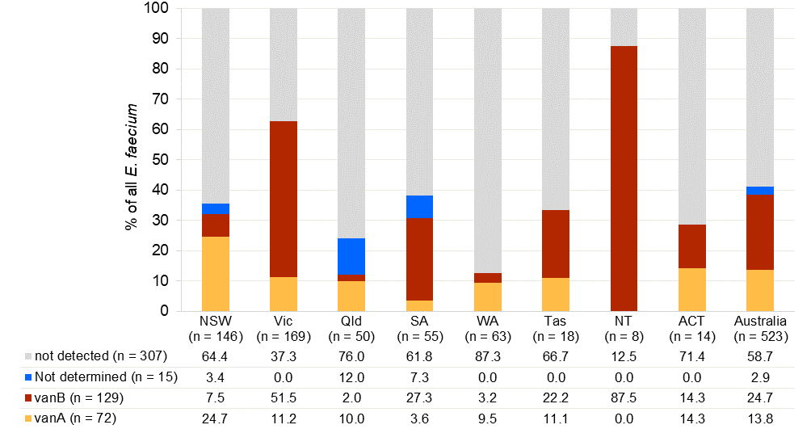

**Multi-locus sequence type**

Of the 523 *E. faecium* isolates reported, 496 (94.8%) were available for typing by WGS (Table 26). Based on the multi-locus sequence type (MLST), 73 sequence types were identified. Overall, 77.2% of *E. faecium* could be characterised into seven major sequence types (>10 isolates): ST17 (*n* = 124); ST1424, (*n* = 86); ST796 (*n* = 53); ST78 (*n* = 43); ST80 (*n* = 40); ST1421 (*n* = 24) and ST555 (*n* = 13). There were 45 sequence types with a single isolate.

ST17 was the predominant sequence type in Queensland, South Australia, Western Australia and Tasmania. ST1424 was the dominant sequence type in New South Wales and the Australian Capital Territory, ST796 in Victoria and the Northern Territory.

The distribution of vancomycin-resistant *E. faecium* sequence types throughout Australian states and territories are shown in Figure 10.

**Table 26:** *Enterococcus faecium* MLST, by state and territory, AGAR, 2021

|  | Percentage, % (*n*) | | | | | | | | |
| --- | --- | --- | --- | --- | --- | --- | --- | --- | --- |
| MLST | NSW | Vic | QLD | SA | WA | Tas | NT | ACT | Australia |
| ST17 | 14.0 (19) | 14.4 (24) | 58.1 (25) | 34.0 (17) | 54.1 (33) | 29.4 (5) | –* (0) | 7.1 (1) | 25.0 (124) |
| ST1424† | 39.0 (53) | 12.0 (20) | 4.7 (2) | 4.0 (2) | 0.0 (0) | 17.6 (3) | –* (0) | 42.9 (6) | 17.3 (86) |
| ST796 | 1.5 (2) | 24.6 (41) | 0.0 (0) | 8.0 (4) | 0.0 (0) | 11.8 (2) | –* (4) | 0.0 (0) | 10.7 (53) |
| ST78 | 3.7 (5) | 15.6 (26) | 0.0 (0) | 14.0 (7) | 3.3 (2) | 5.9 (1) | –* (0) | 14.3 (2) | 8.7 (43) |
| ST80 | 3.7 (5) | 9.6 (16) | 16.3 (7) | 8.0 (4) | 6.6 (4) | 5.9 (1) | –* (0) | 21.4 (3) | 8.1 (40) |
| ST1421† | 15.4 (21) | 0.6 (1) | 2.3 (1) | 0.0 (0) | 0.0 (0) | 0.0 (0) | –* (0) | 7.1 (1) | 4.8 (24) |
| ST555 | 0.7 (1) | 3.0 (5) | 0.0 (0) | 6.0 (3) | 3.3 (2) | 5.9 (1) | –* (1) | 0.0 (0) | 2.6 (13) |
| Other types (*n*= 66) | 22.1 (30) | 20.4 (34) | 18.6 (8) | 26.0 (13) | 32.8 (20) | 23.5 (4) | –* (3) | 7.1 (1) | 22.8 (113) |
| **Total** | **136** | **167** | **43** | **50** | **61** | **17** | **8** | **14** | **496** |

MLST = multi-locus sequence type

* Insufficient numbers (<10) to calculate percentage

† *pstS*-null

**Figure 10:** Distribution of vancomycin-resistant *Enterococcus faecium* sequence types, by state and territory, AGAR, 2021

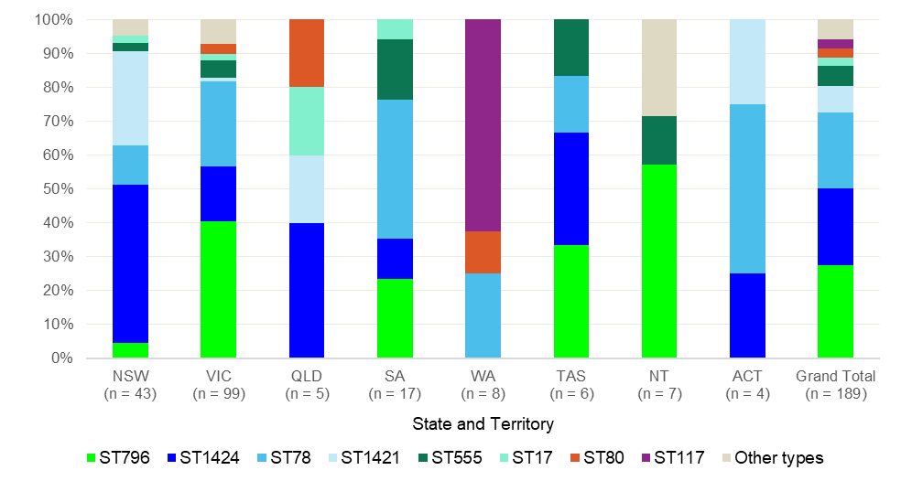

**MLST and *van* genes**

The *vanA* gene alone was detected in five sequence types; 85.5% (59/69) were found in two *pstS*-null sequence types (ST1424 (*n* = 44), and ST1421 (*n* = 15). The three other sequence types were ST117 (*n* = 5), ST80 (*n* = 3), and ST17 (*n* = 2).

The *vanB* gene alone was detected in 13 sequence types: ST796 (*n* = 53), ST78 (*n* = 43), ST555 (*n* = 11), ST17 (*n* = 5), ST203 (n = 3), ST80 (*n* = 2), ST1543 (*n* = 2), ST2217 (*n* = 2), and one each of ST18, ST233, ST538, ST789, and ST2082 (Table 27).

**Table 27:** *Enterococcus faecium* MLST harbouring *van* genes, AGAR, 2021

|  |  |  |  |  |
| --- | --- | --- | --- | --- |
|  | **Percentage* (*n*)** | | |  |
| **MLST** | ***vanA*** | ***vanB*** | ***Van* genes not detected** | **Total, *n*** |
| ST17 | 1.6 (2) | 4.0 (5) | 94.4 (117) | 124 |
| ST1424† | 51.2 (44) | 0.0 (0) | 48.8 (42) | 86 |
| ST796 | 0.0 (0) | 100.0 (53) | 0.0 (0) | 53 |
| ST78 | 0.0 (0) | 100.0 (43) | 0.0 (0) | 43 |
| ST80 | 7.5 (3) | 5.0 (2) | 87.5 (35) | 40 |
| ST1421† | 62.5 (15) | 0.0 (0) | 37.5 (9) | 24 |
| ST555 | 0.0 (0) | 84.6 (11) | 15.4 (2) | 13 |
| Other types (*n* = 66) | 4.4 (5) | 10.6 (12) | 85.0 (96) | 113 |
| **Total** | **13.9 (69)** | **25.4 (126)** | **60.7 (301)** | **496** |

MLST = multi-locus sequence type

* Percentage of total with *van* genes

† *pstS*-null

## Gram-negative organisms

All referred gram-negative isolates were sequenced and analysed for antimicrobial resistance mechanisms.

**Third-generation cephalosporin resistance**

##### ****Extended-spectrum β-lactamases****

Resistances conferred by ESBL-containing gram-negative organisms are important internationally, especially in hospital practice. Initially, ESBLs were more common in *Klebsiella* species than in *E. coli*. The emergence of specific types of ESBLs (CTX-M enzymes) in *E. coli* from the community is part of a global epidemic.2-4 It is unclear what is driving the community expansion of CTX-M ESBLs in Australia, as third-generation cephalosporins are not widely used in that setting; it is thought to be driven by cross-resistanceand co-resistance to agents used in community practice. There is also increasing recognition that ESBLs are becoming established in long-term care facilities in Australia.5

ESBLs are important because they compromise the efficacy of third-generation cephalosporins, which have been an important therapeutic alternative for infections in patients presenting from the community. ESBL-producing isolates often have co-resistance to other non-β-lactam agents. This can result in delays in the use of effective empirical therapy. The lack of available oral options for treatment can result in unnecessary hospitalisation and, in the setting of bacteraemia, increased mortality risk.

Most ESBL-producing isolates will be detected using the CLSI/EUCAST ceftriaxone ‘susceptible’ breakpoint of 1 mg/L. The CLSI ‘susceptible’ breakpoint of 4 mg/L for ceftazidime is less reliable for ESBL detection. Isolates with either ceftriaxone or ceftazidime MICs above 1 mg/L were referred and underwent sequencing.

Neither ceftriaxone nor ceftazidime testing will identify ESBL production in *Enterobacter* species because of their intrinsic chromosomal AmpC β-lactamase. In *Enterobacter*, cefepime MICs of greater than 0.25 mg/L suggest that an isolate of this genus harbours an ESBL.39 However, due to the cefepime concentration range available on the susceptibility cards, isolates with a cefepime MIC of greater than 1 mg/L were referred and underwent sequencing.

Sequences of all referred isolates were screened for the presence of β-lactamase genes using methods outlined in Appendix B.

*E. coli* and *K. pneumoniae* complex isolatesresistant to ceftriaxone and/or ceftazidime (MIC > 1 mg/L), and their variation across states and territories, are shown in Figure 11.

The percentage of *E. coli* with an ESBL phenotype was highest in Western Australia (16.1%, 119/741), and the Northern Territory (16.1%, 36/224), and lowest in Tasmania (6.9%, 15/218). The percentage of *K. pneumoniae* complex with an ESBL phenotype ranged from 15.2% (5/33) in the Northern Territory, to less than 5% in Queensland (4.0%, 8/201), the Australian Capital Territory (4.3%, 2/46), and Tasmania (4.5%, 2/44).

Figure 11: Percentage of *Escherichia coli* and *Klebsiella pneumoniae* complex with extended-spectrum β‑lactamase phenotype, by state and territory, and nationally, AGAR, 2021

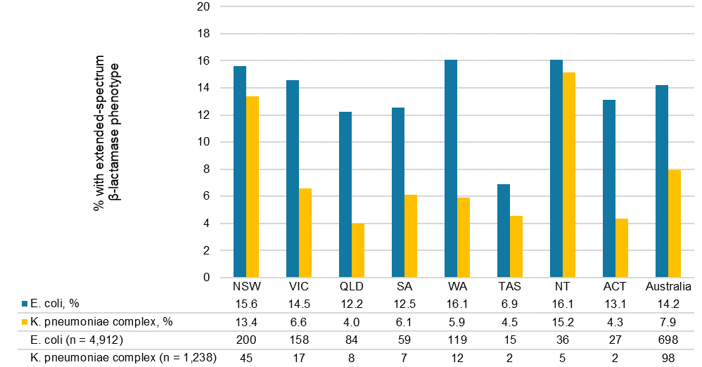

Note: Extended spectrum β-lactamase phenotype defined as ceftriaxone or ceftazidime MIC > 1 mg/L.

An ESBL phenotype was significantly more likely to be found among hospital-onset than community-onset episodes of *E. coli* bacteraemia (152/735 [20.7%] vs 546/4,177 [13.1%], *P* < 0.01). Paediatric patients were significantly more likely to have an ESBL-producing *K. pneumoniae* bacteraemia than adults (11/57 [19.3%] vs 87/1182 [7.4%], *P* < 0.01).

An ESBL phenotype was more common among *E. coli* (698/4912, 14.2%) than *K. pneumoniae* complex(98/1,239, 7.9%) (Table 28). For 57 *E. cloacae* complex with cefepime MIC > 1 mg/L, 19 contained β‑lactamase genes (33.0%; 4.2% overall): ESBL only (*n* = 10), ESBL + carbapenemase (*n* = 6), carbapenemase only (*n* = 2), and ESBL + pAmpC not intrinsic to that species (*n* = 1).

The vast majority (16/18, 88.9%) of *K. oxytoca* isolates with a ceftriaxone-resistant phenotype were presumably hyperproducers of OXY, the natural chromosomal β-lactamase in this species, with characteristic resistance to piperacillin–tazobactam and borderline resistance to cefepime, but susceptibility to ceftazidime (data not shown).40, 41 This pattern is not typical of other types of gram-negative β‑lactamases. blaIMP‑4 was detected in one *K. oxytoca* isolate from Victoria.

Plasmid-borne AmpC and/or carbapenemase genes were also detected in isolates that had an ESBL phenotype but no ESBL genes.

**Table 28:** β-lactamase genes detected in *Enterobacterales* with extended-spectrum β-lactamase phenotype, AGAR, 2021

|  |  |  |  |  |  |  |
| --- | --- | --- | --- | --- | --- | --- |
| β-lactamase mechanism | *Escherichia coli* | *Klebsiella pneumoniae* complex | *Enterobacter cloacae* complex | *Klebsiella oxytoca* | *Proteus mirabilis* | *Salmonella* spp.† |
| Total | 4,912 | 1,239 | 448 | 264 | 312 | 81 |
| ESBL phenotype*, % (n) | 14.2 (698) | 7.9 (98) | 13.4 (60) | 8.0 (21) | 3.2 (10) | 1.2 (1) |
| β-lactamase genes confirmed/number tested (%) | 628/659 (95.3) | 81/94 (86.2) | 19/57 (33.3) | 2/20 (10.0) | 3/9 (33.3) | 1/1 (100.0) |
| ESBL | 507 | 57 | 10 | 0 | 3 | 0 |
| ESBL, AmpC | 17 | 2 | 1 | 0 | 0 | 0 |
| ESBL, Carb | 0 | 1 | 6 | 0 | 0 | 0 |
| AmpC | 103 | 17 | 0 | 1 | 0 | 1 |
| Carb | 1 | 4 | 2 | 1 | 0 | 0 |
| Not detected | 31 | 13 | 38 | 18 | 6 | 0 |
| Not determined§ | 39 | 4 | 3 | 1 | 1 | 0 |

AmpC = plasmid-borne *ampC*; Carb = carbapenemase; ESBL = extended-spectrum β‑lactamase

* ESBL phenotype = ceftriaxone or ceftazidime MIC > 1 mg/L; for *E. cloacae* complex, cefepime MIC > 1 mg/L

† Non-typhoidal (*n*= 80), typhoidal (*n* = 1)

§ Isolate not available for confirmation

The β-lactamase genes confirmed in *Enterobacterales* with an ESBL phenotype are shown in Table 29. *bla*CTX-M types continue to be the dominant β-lactamase genes in *E. coli*. Of 628 with confirmed β‑lactamase genes, 524 (83.4%) had one or more *bla*CTX-M genes detected by WGS, either *bla*CTX-M group 9 (*n*= 265), *bla*CTX-M group 1 (*n*= 253), both *bla*CTX-M group 1 and group 9 (*n*= 4) or a CTX-M group 1/9/1 hybrid (*n* = 2). CTX-M group 9 types were more prevalent in Queensland and the Northern Territory. CTX-M group 1 types were dominant in the Australian Capital Territory and Tasmania. Among *K. pneumoniae* complex with confirmed β-lactamase genes, 57 of 81 (70.4%) contained a *bla*CTX-M gene: *bla*CTX-M group 1 (*n =*49), *bla*CTX-M group 9 (*n = 8*).

**Table 29:** β-lactamase genes among *Enterobacterales* with extended-spectrum β-lactamase phenotype, by state and territory, AGAR, 2021

| Species | NSW | Vic | Qld | SA | WA | Tas | NT | ACT | Australia |
| --- | --- | --- | --- | --- | --- | --- | --- | --- | --- |
| *Escherichia coli* | 1,280 | 1,086 | 686 | 471 | 741 | 218 | 224 | 206 | 4,912 |
| ESBL phenotype*, % (*n*) | 15.6 (200) | 14.5 (158) | 12.2 (84) | 12.5 (59) | 16.1 (119) | 6.9 (15) | 16.1 (36) | 13.1 (27) | 14.2 (698) |
| Confirmed β-lactamase genes/number tested (%) | 180/ 189 | 145/ 153 | 75/ 80 | 46/ 50 | 109/ 111 | 12/ 14 | 35/ 36 | 26/ 26 | 628/ 659 |
| ESBL types | 144 | 126 | 53 | 40 | 96 | 11 | 29 | 25 | 524 |
| CTX-M-types | 144 | 126 | 53 | 40 | 96 | 11 | 29 | 25 | 524 |
| group 1 | 70 | 61 | 21 | 18 | 50 | 8 | 11 | 14 | 253 |
| group 9 | 73 | 63 | 31 | 22 | 46 | 3 | 18 | 9 | 265 |
| group 1 + group 9 | 0 | 2 | 0 | 0 | 0 | 0 | 0 | 2 | 4 |
| group 1/9/1 hybrid | 1 | 0 | 1 | 0 | 0 | 0 | 0 | 0 | 2 |
| SHV (ESBL types) | 0 | 0 | 0 | 0 | 0 | 0 | 0 | 0 | 0 |
| Plasmid-borne AmpC | 39 | 22 | 23 | 9 | 16 | 1 | 9 | 1 | 120 |
| CMY-2-like | 19 | 11 | 11 | 5 | 3 | 0 | 2 | 1 | 52 |
| DHA-1 | 20 | 11 | 11 | 3 | 13 | 1 | 7 | 0 | 66 |
| CMY-2-like + DHA | 0 | 0 | 1 | 1 | 0 | 0 | 0 | 0 | 2 |
| Carbapenemases | 1 | 0 | 0 | 0 | 0 | 0 | 0 | 0 | 1 |
| IMP-4 | 1 | 0 | 0 | 0 | 0 | 0 | 0 | 0 | 1 |
| *Klebsiella pneumoniae* complex | 337 | 260 | 201 | 114 | 204 | 44 | 33 | 46 | 1,239 |
| ESBL phenotype*, % (*n*) | 13.4 (45) | 6.5 (17) | 4.0 (8) | 6.1 (7) | 5.9 (12) | 4.5 (2) | 15.2 (5) | 4.3 (2) | 7.9 (98) |
| Confirmed β-lactamase genes/number tested (%) | 38/41 | 14/17 | 6/8 | 5/7 | 10/12 | 2/2 | 4/5 | 2/2 | 81/94 |
| ESBL types | 27 | 12 | 4 | 5 | 4 | 2 | 4 | 2 | 60 |
| CTX-M-types | 26 | 11 | 4 | 5 | 4 | 2 | 3 | 2 | 57 |
| group 1 | 20 | 10 | 4 | 5 | 4 | 2 | 2 | 2 | 49 |
| group 9 | 6 | 1 | 0 | 0 | 0 | 0 | 1 | 0 | 8 |
| SHV (ESBL types) | 3 | 2 | 0 | 0 | 0 | 0 | 1 | 0 | 6 |
| Plasmid-borne AmpC | 9 | 2 | 2 | 0 | 5 | 0 | 1 | 0 | 19 |
| DHA-1 | 9 | 2 | 2 | 0 | 5 | 0 | 1 | 0 | 19 |
| Carbapenemases | 3 | 1 | 0 | 0 | 1 | 0 | 0 | 0 | 5 |
| IMP-4 | 2 | 0 | 0 | 0 | 1 | 0 | 0 | 0 | 3 |
| NDM-7 | 1 | 0 | 0 | 0 | 0 | 0 | 0 | 0 | 1 |
| KPC-2 | 0 | 1 | 0 | 0 | 0 | 0 | 0 | 0 | 1 |
| *Enterobacter cloacae* complex | 142 | 93 | 83 | 17 | 63 | 16 | 8 | 19 | 441 |
| ESBL phenotype*, % (*n*) | 18.3 (26) | 10.8 (10) | 10.8 (9) | 20.8 (5) | 4.8 (3) | 6.3 (1) | n/a (1) | 26.3 (5) | 13.4 (60) |
| Confirmed β-lactamase genes/number tested (%) | 8/23 | 4/10 | 3/9 | 1/5 | 1/3 | 1/1 | 0/1 | 1/5 | 19/57 |
| ESBL types | 23 | 10 | 9 | 0 | 3 | 1 | 1 | 5 | 52 |
| CTX-M-types | 3 | 4 | 3 | 0 | 0 | 1 | 0 | 0 | 11 |
| group 1 | 3 | 1 | 3 | 0 | 0 | 1 | 0 | 0 | 8 |
| group 9 | 0 | 3 | 0 | 0 | 0 | 0 | 0 | 0 | 3 |
| SHV (ESBL types) | 4 | 3 | 0 | 1 | 1 | 0 | 0 | 0 | 9 |
| Carbapenemases | 5 | 1 | 1 | 0 | 0 | 0 | 0 | 1 | 8 |
| IMP-4 | 4 | 1 | 0 | 0 | 0 | 0 | 0 | 1 | 6 |
| NDM-1 | 0 | 0 | 1 | 0 | 0 | 0 | 0 | 0 | 1 |
| NDM-7 | 1 | 0 | 0 | 0 | 0 | 0 | 0 | 0 | 1 |

ESBL = extended-spectrum β‑lactamase; n/a = Insufficient numbers (<10) to calculate percentage

* ESBL phenotype = ceftriaxone and/or ceftazidime MIC > 1 mg/L; for *E. cloacae* complex, cefepime MIC > 1 mg/L

Note: Isolates may possess more than one type of β-lactamase gene.

*bla*CTX-M genes were detected in 79.5% (524/659) of *E. coli* with an ESBL phenotype (Table 30). In the *bla*CTX-M-1 group, *bla*CTX-M-15 accounted for 89.7% (227/253). In the *bla*CTX-M-9 group, *bla*CTX-M-27 and *bla*CTX-M-14 were the major genotypes, accounting for 77.4% (205/265) and 20.0% (53/265), respectively.

In the *bla*CTX-M-positive isolates, SHV-type ESBLs were not detected. Among 135 *bla*CTX-M-negative isolates with an ESBL phenotype, 103 harboured pAmpC types (*bla*DHA-1 [60], *bla*CMY-2 [34], *bla*CMY-42 [4], *bla*CMY-4 [2], other *bla*CMY-2-like [1], *bla*CMY-2 + *bla*DHA-1 [1], *bla*CMY-4 + *bla*DHA-1 [1]). One harboured a carbapenemase gene alone (*bla*IMP-4). β-lactam resistance mechanisms were not detected in the remaining 31 isolates.

**Table 30:** *Escherichia coli*, CTX-M variants, ESBL phenotype, sequence type, AGAR, 2021

|  |  |  |  |  |  |  |  |  |  |  |  |  |
| --- | --- | --- | --- | --- | --- | --- | --- | --- | --- | --- | --- | --- |
|  |  | Phenotype | |  | Sequence type | | | | | | | |
| **CTX-M variant** | **Number** | **ESBL** | **Non-ESBL** |  | **131** | **69** | **1193** | **73** | **38** | **-\*** | **95** | **Other types (*n* = 95)** |
| Not detected | 221 | 135 | 86 |  | 25 | 29 | 11 | 16 | 8 | 15 | 16 | 114 |
| CTX-M-1 group | 253 | 253 | 0 |  | 117 | 16 | 20 | 22 | 8 | 11 | 8 | 54 |
| CTX-M-15 | 227 | 227 | 0 |  | 116 | 12 | 14 | 21 | 8 | 11 | 6 | 42 |
| CTX-M-55 | 18 | 18 | 0 |  | 1 | 3 | 5 | 0 | 0 | 0 | 1 | 8 |
| CTX-M-3 | 5 | 5 | 0 |  | 0 | 1 | 1 | 0 | 0 | 0 | 0 | 3 |
| CTX-M-42 | 1 | 1 | 0 |  | 0 | 0 | 0 | 0 | 0 | 0 | 1 | 0 |
| CTX-M-101 | 1 | 1 | 0 |  | 0 | 0 | 0 | 0 | 0 | 0 | 0 | 1 |
| CTX-M-231 | 1 | 1 | 0 |  | 0 | 0 | 0 | 1 | 0 | 0 | 0 | 0 |
| CTX-M-9 group | 265 | 265 | 0 |  | 177 | 11 | 18 | 2 | 19 | 9 | 1 | 28 |
| CTX-M-27 | 205 | 205 | 0 |  | 153 | 5 | 15 | 2 | 8 | 7 | 1 | 14 |
| CTX-M-14a | 48 | 48 | 0 |  | 21 | 6 | 3 | 0 | 3 | 2 | 0 | 13 |
| CTX-M-14b | 5 | 5 | 0 |  | 0 | 0 | 0 | 0 | 5 | 0 | 0 | 0 |
| CTX-M-24 | 6 | 6 | 0 |  | 3 | 0 | 0 | 0 | 3 | 0 | 0 | 0 |
| CTX-M-65 | 1 | 1 | 0 |  | 0 | 0 | 0 | 0 | 0 | 0 | 0 | 1 |
| CTX-M-1 and CTX-M-9 group | 4 | 4 | 0 |  | 2 | 0 | 2 | 0 | 0 | 0 | 0 | 0 |
| CTX-M-27, CTX-M-55 | 2 | 2 | 0 |  | 0 | 0 | 2 | 0 | 0 | 0 | 0 | 0 |
| CTX-M-15, CTX-M-27 | 2 | 2 | 0 |  | 2 | 0 | 0 | 0 | 0 | 0 | 0 | 0 |
| CTX-M group 1/9/1 hybrid | 2 | 2 | 0 |  | 0 | 0 | 2 | 0 | 0 | 0 | 0 | 0 |
| CTX-M-64 | 2 | 2 | 0 |  | 0 | 0 | 2 | 0 | 0 | 0 | 0 | 0 |
|  | 745 | 659 | 86 |  | 321 | 56 | 53 | 40 | 35 | 35 | 25 | 196 |

ESBL = extended-spectrum β-lactamase

* Not available

A little over one-half (56.1%, 294/524) of the ESBL-producing *E. coli* with confirmed ESBL types belong to sequence type 131 (ST131) (Table 31). The fluoroquinolone-resistant subclade, H30R, was the most prevalent subclade of ST131 (54.8%, 161/294). H30Rx (subclade C2) encompasses almost all (94/95) ST131 carrying *bla*CTX-M-15, a finding reported globally.42-44 Almost three-quarters (74.2%, 155/209) of isolates with *bla*CTX-M-27 were ST131; 93/209 belonged to H41 subclade A; 50/209 belonged to H30R subclade C1-M27, and 3/209 belonged to H30Rx subclade C2.

ST1193 has recently been identified as an emerging MDR type.4, 45, 46 All ST1193 isolates were ciprofloxacin-resistant, and 88.7% (47/53) harboured a *bla*CTX-M (42) or pAmpC (5) gene.

**Table 31:** ESBL-producing *Escherichia coli* subset, *fimH* allele, H30Rx, AGAR, 2021

|  |  |  |  |  |  |  |  |  |
| --- | --- | --- | --- | --- | --- | --- | --- | --- |
|  |  | ST131 | | | | | |  |
|  |  |  |  | **H30** | |  |  |  |
| **ESBL type** | **Number** | **All** | **H41\*** | **H30Rx** | **H30R** | **H54** | **Others§** | **Non-ST131** | |
| CTX-M-15 | 227 | 114 | 14 | 92 | 1 | 3 | 4 | 113 | |
| CTX-M-27 | 205 | 153 | 93 | 1 | 50 | 0 | 9 | 52 | |
| CTX-M-14a | 48 | 21 | 5 | 0 | 14 | 2 | 0 | 27 | |
| CTX-M-55 | 18 | 1 | 1 | 0 | 0 | 0 | 0 | 17 | |
| CTX-M-24 | 6 | 3 | 0 | 0 | 1 | 0 | 2 | 3 | |
| CTX-M-3 | 5 | 0 | 0 | 0 | 0 | 0 | 0 | 5 | |
| CTX-M-14b | 5 | 0 | 0 | 0 | 0 | 0 | 0 | 5 | |
| CTX-M-55, CTX-M-27 | 2 | 0 | 0 | 0 | 0 | 0 | 0 | 2 | |
| CTX-M-15, CTX-M-27 | 2 | 2 | 0 | 2 | 0 | 0 | 0 | 0 | |
| CTX-M-64 | 2 | 0 | 0 | 0 | 0 | 0 | 0 | 2 | |
| CTX-M-42 | 1 | 0 | 0 | 0 | 0 | 0 | 0 | 1 | |
| CTX-M-101 | 1 | 0 | 0 | 0 | 0 | 0 | 0 | 1 | |
| CTX-M-231 | 1 | 0 | 0 | 0 | 0 | 0 | 0 | 1 | |
| CTX-M-65 | 1 | 0 | 0 | 0 | 0 | 0 | 0 | 1 | |
|  | 524 | 294 | 113 | 95 | 66 | 5 | 15 | 230 | |

ESBL = extended-spectrum β-lactamase

* Includes H41-like (*n* = 2)

† Included H30-like (*n* = 2)

§ H89 (*n* = 4), H99 (*n* = 4), H99-like (*n* = 2), H141 (*n* = 2), H43 (*n* = 1), H487 (*n* = 1), H1194 (*n* = 1)

##### ****Plasmid-borne AmpC β-lactamases****

Plasmid-borne *ampC* β-lactamase genes have emerged internationally as a potential gram-negative resistance problem. They are the result of mobilisation of natural chromosomally located genes from common and uncommon species of *Enterobacterales* onto transmissible plasmids, and transmission into more common pathogens. There are currently six separate classes of plasmid‑encoded AmpC β-lactamases. Like ESBLs, these enzymes confer resistance to the important third-generation cephalosporins, such as ceftriaxone and ceftazidime. Routine phenotypic detection methods have not yet been developed. Nevertheless, it is possible to exploit a special feature of these enzymes: their ability to inactivate the cephamycins, represented by cefoxitin. *Enterobacter* species naturally possess a chromosomally encoded AmpC enzyme.

All referred isolates were examined for the presence of plasmid-borne *ampC* (CMY-2-like, DHA, FOX, MOX, ACT/MIR, ACC) genes using WGS methods outlined in Appendix B.

The proportions of *E. coli* and *K. pneumoniae* complex with a cefoxitin MIC > 8 mg/L (non-wild type) remain low. Just under half (119/255, 46.7%) of *E. coli* and one-quarter (18/72, 25.0%) of *K. pneumoniae* complex with cefoxitin MIC > 8 mg/L that were available for confirmation contained one or more plasmid-borne *ampC* genes (Table 32). A *bla*DHA gene was found in 55.5% (66/119) of *E. coli* and 100% (18/18) of *K. pneumoniae* complex with plasmid-borne *ampC* genes.

Of cefoxitin non-wild type (MIC > 8 mg/L) isolates that did not have a plasmid-encoded *ampC* gene, a carbapenemase gene was detected in one of 136 (0.7%) *E. coli* (*bla*IMP-4) and five of 54 (9.3%) *K. pneumoniae* complex (*bla*IMP-4 [3], *bla*NDM-7 [1], *bla*KPC-2 [1]). Two *E. coli* with a cefoxitin wild type (MIC ≤ 8 mg/L) contained *bla*CMY-4, and one *K. pneumoniae* complex with cefoxitin MIC ≤ 8 mg/L contained *bla*DHA-1 (data not shown).

**Table 32:** Numbers of isolates with presumptive plasmid-borne AmpC β-lactamase production, by state and territory, AGAR, 2021

|  |  |  |  |  |  |  |  |  |  |
| --- | --- | --- | --- | --- | --- | --- | --- | --- | --- |
| Species | NSW | Vic | Qld | SA | WA | Tas | NT | ACT | Total |
| *Escherichia coli* | 1,281 | 1,085 | 686 | 471 | 740 | 218 | 224 | 206 | 4,911 |
| Cefoxitin MIC > 8 mg/L (%) | 83 (6.5) | 49 (4.5) | 46 (6.7) | 20 (4.2) | 42 (5.7) | 10 (4.6) | 14 (6.3) | 8 (3.9) | 272 (5.5) |
| Confirmed/number tested | 38/76 | 22/49 | 24/45 | 8/17 | 16/37 | 1/9 | 9/14 | 1/8 | 119/255 |
| *bla*DHA-1 | 20 | 11 | 11 | 3 | 13 | 1 | 7 | 0 | 66 |
| *bla*CMY-2 | 16 | 7 | 10 | 2 | 2 | 0 | 1 | 1 | 39 |
| *bla*CMY-42 | 2 | 2 | 1 | 1 | 0 | 0 | 0 | 0 | 6 |
| *bla*CMY-4 | 0 | 2 | 0 | 0 | 1 | 0 | 1 | 0 | 4 |
| *bla*CMY-140 | 0 | 0 | 0 | 1 | 0 | 0 | 0 | 0 | 1 |
| Other *bla*CMY-2-like | 0 | 0 | 1 | 0 | 0 | 0 | 0 | 0 | 1 |
| *bla*CMY-2 + DHA-1 | 0 | 0 | 1 | 0 | 0 | 0 | 0 | 0 | 1 |
| *bla*CMY-4 + DHA-1 | 0 | 0 | 0 | 1 | 0 | 0 | 0 | 0 | 1 |
| *Klebsiella pneumoniae* complex | 337 | 260 | 201 | 114 | 204 | 44 | 33 | 46 | 1,239 |
| Cefoxitin MIC > 8 mg/L (%) | 23 (6.8) | 16 (6.2) | 13 (6.5) | 2 (1.8) | 14 (6.9) | 6 (13.6) | 1 (3.0) | 1 (2.2) | 76 (6.1) |
| Confirmed/number tested | 8/22 | 2/16 | 2/12 | 0/2 | 5/12 | 0/6 | 1/1 | 0/1 | 18/72 |
| *bla*DHA-1 | 8 | 2 | 2 | 0 | 5 | 0 | 1 | 0 | 18 |

MIC = minimum inhibitory concentration

**Carbapenem resistance**

Only 0.3% (*n* = 23) of *Enterobacterales* had a meropenem MIC > 2 mg/L; an additional 25 had meropenem MIC between 1 mg/L and 2 mg/L. For *P. aeruginosa*, meropenem resistance (MIC > 8 mg/L) was at 2.3% (17/733); no *Acinetobacter* isolates were meropenem-resistant (Table 33). Among meropenem-resistant (MIC > 8 mg/L) isolates that were available, carbapenemase genes were found in 82.4% (14/17) of *Enterobacterales*, and 0.0% (0/17) of *P. aeruginosa*. Carbapenemase genes were found in three *Enterobacterales* with meropenem MIC of 2 mg/L, *K. variicola* (*bla*OXA-181), *K. pneumoniae* (blaIMP‑4), and *K. michiganensis* (blaIMP‑4).

**Table 33:** Number of isolates with carbapenemase genes, organism group, meropenem MIC, AGAR, 2021

|  |  |  |  |  |  |  |  |  |  |  |
| --- | --- | --- | --- | --- | --- | --- | --- | --- | --- | --- |
|  | *Acinetobacter* (*n* = 83) | | | *Enterobacterales* (*n* = 8,020) | | | | *Pseudomonas* (*n* = 733) | | |
|  | Meropenem MIC (mg/L) | | | Meropenem MIC (mg/L) | | | | Meropenem MIC (mg/L) | | |
|  | ≤2 | 4-8 | >8 | ≤0.5 | 1-2 | 4-8 | >8 | ≤2 | 4-8 | >8 |
| Number | 83 | 0 | 0 | 7,972 | 25 | 5 | 18 | 682 | 34 | 17 |
| Confirmed/number tested | 0/0 | –* | –* | 0/1,045 | 3/22 | 0/5 | 14/17 | 0/1 | 0/9 | 0/17 |
| Carbapenemase type† | 0 | 0 | 0 | 0 | 3 | 0 | 14 | 0 | 0 | 0 |
| Class A (*bla*KPC-2) | 0 | 0 | 0 | 0 | 0 | 0 | 1 | 0 | 0 | 0 |
| Class B | 0 | 0 | 0 | 0 | 2 | 0 | 13 | 0 | 0 | 0 |
| blaIMP‑4 | 0 | 0 | 0 | 0 | 2 | 0 | 10 | 0 | 0 | 0 |
| blaNDM-1 | 0 | 0 | 0 | 0 | 0 | 0 | 1 | 0 | 0 | 0 |
| blaNDM-7 | 0 | 0 | 0 | 0 | 0 | 0 | 2 | 0 | 0 | 0 |
| Class D (*bla*OXA-181) | 0 | 0 | 0 | 0 | 1 | 0 | 0 | 0 | 0 | 0 |

MIC = minimum inhibitory concentration

* Not applicable

† Carbapenemase molecular class: class A (KPC); class B (metallo-β-lactamases - IMP, NDM); class D (oxacillinases – OXA-181)

Seventeen (0.19% overall) isolates from 17 patients were found to harbour a carbapenemase gene (Table 34). Overall prevalence of carbapenemase genes among *Enterobacterales* was 0.21% (17/8,104), although for *E. cloacae* complex it was 1.8% (8/450). *bla*IMP-4 accounted for 70.6% (12/17) of all CPE in 2021. Half of the blaIMP‑4 genes were found in *E. cloacae* complex (6/12, 50%). Other types detected in *Enterobacterales* were NDM (*n* = 3), KPC (*n* = 1) and OXA-48-like genes (*n* = 1).

No carbapenemase genes were detected among *P. aeruginosa* or *Acinetobacter* isolates in the 2021 survey.

**Table 34:** Carbapenemase-producing organisms, carbapenemase genes, AGAR, 2021

|  |  |  |  |  |  |  |  |
| --- | --- | --- | --- | --- | --- | --- | --- |
|  |  | **Carbapenemase type, number** | | | | |  |
| **Species** | **Total** | **IMP-4** | **NDM-7** | **NDM-1** | **KPC-2** | **OXA-181** | **% (n)** |
| *Enterobacterales* | 8,104 | 12 | 2 | 1 | 1 | 1 | 0.21 (17) |
| *Escherichia coli* | 4,969 | 1 | 0 | 0 | 0 | 0 | <0.1 (1) |
| *Klebsiella pneumoniae* complex† | 1,247 | 3 | 1 | 0 | 1 | 1 | 0.5 (6) |
| *Enterobacter cloacae* complex* | 450 | 6 | 1 | 1 | 0 | 0 | 1.8 (8) |
| *Klebsiella oxytoca* | 265 | 1 | 0 | 0 | 0 | 0 | 0.4 (1) |
| *Klebsiella michiganensis* | 4 | 1 | 0 | 0 | 0 | 0 | –§ (1) |
| *Pseudomonas aeruginosa* | 745 | 0 | 0 | 0 | 0 | 0 | 0.0 (0) |
| *Acinetobacter* | 98 | 0 | 0 | 0 | 0 | 0 | 0.0 (0) |
| All species | 8,947 | 12 | 2 | 1 | 1 | 1 | 0.19 (17) |

* *E. cloacae* (*n* = 5, blaIMP‑4); *E. hormaechei* (*n* = 3: blaIMP‑4 [1], blaNDM-7 [1], blaNDM-1 [1])

† *K. pneumoniae* (*n* = 4: blaIMP‑4 [2], blaNDM-7 [1], *bla*KPC-2 [1]); *K. variicola* (*n* = 2: blaIMP‑4 [1], *bla*OXA-181 [1])

§ Insufficient numbers (<10) to calculate percentage

Isolates carrying carbapenemase genes were detected in 13 hospitals from five states and territories. CPE infections are particularly notable in New South Wales (10/2194, 0.5%) and Victoria (4/1802, 0.2%), compared to other states and territories (Table 35). Just over two-thirds (9/13, 69.2%) of the hospitals had one carbapenemase-producing isolate only.

**Table 35:** Carbapenemase genes, organism group, state and territory, AGAR, 2021

|  |  |  |  |  |  |  |  |  |  |
| --- | --- | --- | --- | --- | --- | --- | --- | --- | --- |
| Organism group and carbapenemase | NSW | Vic | Qld | SA | WA | Tas | NT | ACT | Total |
| Total species, *n* | 2,425 | 1,948 | 1,330 | 870 | 1,332 | 361 | 318 | 363 | 8,947 |
| *Acinetobacter* | 18 | 19 | 19 | 9 | 22 | 5 | 5 | 1 | 98 |
| Carbapenemase, % (*n*) | 0.0 (0) | 0.0 (0) | 0.0 (0) | 0.0 (0) | 0.0 (0) | 0.0 (0) | 0.0 (0) | 0.0 (0) | 0.0 (0) |
| *Enterobacterales* | 2,194 | 1,802 | 1,169 | 777 | 1,210 | 336 | 292 | 324 | 8,104 |
| Carbapenemase, % (*n*) | 0.5 (10) | 0.2 (4) | <0.1 (1) | 0.0 (0) | <0.1 (1) | 0.0 (0) | 0.0 (0) | 0.3 (1) | 0.2 (17) |
| blaIMP‑4 | 8 | 2 | 0 | 0 | 1 | 0 | 0 | 1 | 12 |
| blaNDM-7 | 2 | 0 | 0 | 0 | 0 | 0 | 0 | 0 | 2 |
| blaNDM-1 | 0 | 0 | 1 | 0 | 0 | 0 | 0 | 0 | 1 |
| blaKPC-2 | 0 | 1 | 0 | 0 | 0 | 0 | 0 | 0 | 1 |
| *bla*OXA-181 | 0 | 1 | 0 | 0 | 0 | 0 | 0 | 0 | 1 |
| *Pseudomonas aeruginosa* | 213 | 127 | 142 | 84 | 100 | 20 | 21 | 38 | 745 |
| Carbapenemase, % (*n*) | 0.0 (0) | 0.0 (0) | 0.0 (0) | 0.0 (0) | 0.0 (0) | 0.0 (0) | 0.0 (0) | 0.0 (0) | 0.0 (0) |
| Overall prevalence, % (n) | 0.4 | 0.2 | <0.1 | 0.0 | <0.1 | 0.0 | 0.0 | 0.3 | 0.19 |

**Fluoroquinolone resistance**

Multiple resistance mechanisms against quinolones have been described. Resistance is most commonly due to mutations in DNA gyrase (*gyrA*, *gyrB*) and topoisomerase IV (*parC*, *parE*). Transmissible plasmid-mediated quinolone resistance (PMQR) has emerged in *Enterobacterales*. PMQR determinants include *qnr* genes (*qnrA, qnrB, qnrC, qnrD, qnrE, qnrS, qnrVC);* *aac(6')-Ib-cr*, coding for a variant aminoglycoside acetyltransferase enzyme or genes coding for efflux pumps (*qepA*, *oqxAB*).47, 48 *oqxAB* genes are intrinsic in *Klebsiella* and *Enterobacter*.

##### *Salmonella* species

Ciprofloxacin resistance (MIC > 0.06 mg/L) among non-typhoidal species was 2.8% (2/72 confirmed). There was only one typhoidal species (serovar Typhi) with a ciprofloxacin MIC = 0.5 mg/L (Table 36).

##### Table 36: *Salmonella* species, ciprofloxacin minimum inhibitory concentrations, AGAR, 2021

|  |  |  |  |  |  |  |  |  |  |
| --- | --- | --- | --- | --- | --- | --- | --- | --- | --- |
|  | Ciprofloxacin minimum inhibitory concentration (mg/L) | | | | | | |  |  |
| **Organism** | **≤0.06** | **0.125** | **0.25** | **0.5** | **1** | **2** | **≥4** | **n/a\*** | **Total** |
| *Salmonella* species (non-typhoidal) | 70 | 1 | 1 | 0 | 0 | 0 | 0 | 9 | 81 |
| *Salmonella* species (typhoidal) | 0 | 0 | 0 | 1 | 0 | 0 | 0 | 0 | 1 |
| *S*. Typhi | 0 | 0 | 0 | 1 | 0 | 0 | 0 | 0 | 1 |
| Total | 70 | 1 | 1 | 1 | 0 | 0 | 0 | 9 | 82 |

n/a = not applicable   
* MIC (≤ 0.25 mg/L) not confirmed

Notes:

1. MICs determined using MIC strips on Salmonella where Vitek® MIC ≤ 0.25 mg/L.
2. For some laboratories using EUCAST interpretative criteria, a perfloxacin disc was used to screen for ciprofloxacin resistance. If susceptible to a 5 mg/L disc, the isolate was recorded as MIC ≤ 0.06 mg/L (susceptible).

The *S*. Typhi that was resistant to ciprofloxacin harboured a mutation in the quinolone resistance-determining region (QRDR), in codon 83 of *gyrA*, a common mutation conferring quinolone resistance (Table 37).49

One non-typhoidal isolate had a pAmpC gene (*bla*CMY-2) (ceftriaxone MIC = 16 mg/L; ciprofloxacin MIC = 0.016 mg/L).

**Table 37:** Fluroquinolone resistance determinants in ciprofloxacin-resistant *Salmonella* species, AGAR, 2021

|  |  |  |  |  |
| --- | --- | --- | --- | --- |
|  | Mutations in QRDR | |  |  |
| **Species** | ***gyrA*** | ***parC*** | **PMQR genes** | **Total** |
| *Salmonella* (non-typhoidal) |  |  |  | 5 |
| *Salmonella* (non-typhoidal) (*n* = 2) | –* | T57S | –* | 3† |
| D83Y | –* | –* | 1 |
|  | –* | –* | *qnrS* | 1 |
| *Salmonella* (typhoidal) |  |  |  | 1 |
| *S*. Typhi (*n* = 1) | S83F | –* | –* | 1 |

PMQR = plasmid-mediated quinolone resistance; QRDR = quinolone resistance-determining region

* Not detected

† Ciprofloxacin MIC ≤ 0.25 mg/L (Vitek®); MIC not confirmed

Notes:

1. Fluoroquinolone-resistant determinants include mutations in either the quinolone resistance-determining region of the DNA gyrase and/or topoisomerase genes (*gyrA*, *gyrB*, *parC*, *parE*) identified by PointFinder50, and/or presence of plasmid-mediated quinolone resistance genes (*qnr* variants, *aac(6')-Ib-cr*, *qepA*).
2. Mutations in *gyrB* or *parE* were not detected.

##### *Escherichia coli*

Nationally, 16.6% (814/4,910) of *E. coli* had a ciprofloxacin MIC > 0.25 mg/L, ranging from 13.0% (61/470) in South Australia and 13.1% (90/686) in Queensland to 20.5% in the Northern Territory (46/224). A subset of 745 *E. coli* (15.2% of total) was referred and underwent WGS. This included 658 with an ESBL phenotype and 458 with ciprofloxacin MIC > 0.25 mg/L (Table 38).

**Table 38:** *Escherichia coli*, ciprofloxacin susceptibility, ESBL phenotype, AGAR, 2021

|  |  |  |  |  |  |  |
| --- | --- | --- | --- | --- | --- | --- |
|  |  | Ciprofloxacin MIC (mg/L) | | |  | % of total |
| **Subset** | **Phenotype** | **≤0.25** | **0.5** | **>0.5** | **Total** |
| Total | ESBL | 33.4 (233) | 16.5 (115) | 50.1 (349) | 697 | 14.2 |
|  | non-ESBL | 91.7 (3,863) | 2.2 (93) | 6.1 (256) | 4,212 | 85.8 |
|  | Total | 83.4 (4,096) | 4.2 (208) | 12.3 (605) | 4,909 |  |
| WGS | ESBL | 221 | 110 | 327 | 658 | 94.4 |
|  | non-ESBL | 66 | 2 | 18 | 86 | 2.0 |
|  | Unknown | 0 | 0 | 1 | 1 | n/a |
|  | Total | 287 | 112 | 346 | 745 | 15.2 |

ESBL = extended-spectrum β-lactamase; MIC = minimum inhibitory concentration; n/a = not applicable; WGS = whole genome sequencing

Note: ESBL phenotype = ceftriaxone or ceftazidime MIC > 1 mg/L.

Almost all (455/458, 99.3%) of the *E. coli* subset that had ciprofloxacin MIC > 0.25 mg/L harboured fluoroquinolone resistance determinants (Figure 12). The vast majority (93.7%, 429/458) of this group harboured a QRDR mutation in codon 83 of *gyrA*. A substantial majority (82.4%, 285/346) of isolates resistant to ciprofloxacin (MIC > 0.5 mg/L) also had a second mutation in *gyrA* (codon 87), and 83.8% (290/346) showed at least one mutation in *parC* (Table 39).

PMQR genes (*qnr* variants) alone were more common in ciprofloxacin-susceptible isolates. Of 110 *E. coli* with confirmed *qnr*, most had *qnrB* (*n* = 69, 62.7%), while some had *qnrS* (*n* = 36, 32.7%), *qnrB* + *qnrS* (*n* = 2) or *qnrD* (*n* = 3) (data not shown).

**Figure 12:** *Escherichia coli* (*n* = 745), fluoroquinolone resistance mechanisms, ciprofloxacin MIC, AGAR, 2021

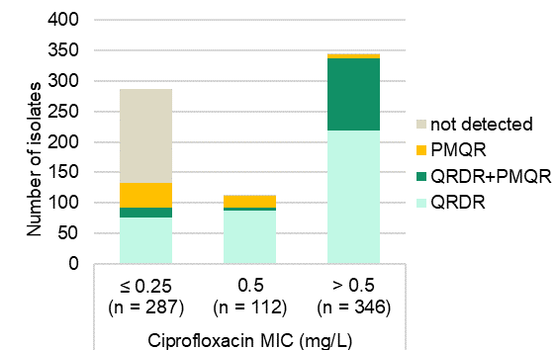

Note: Fluoroquinolone resistance mechanisms include mutations in either the quinolone resistance-determining region of the DNA gyrase and topoisomerase genes (*gyrA*, *gyrB*, *parC*, *parE*), and/or presence of plasmid-mediated quinolone resistance genes (*qnr* variants, *aac(6')-Ib-cr*, *qepA, oqxAB*) detected by whole genome sequence analyses.

MIC = minimum inhibitory concentration; PMQR = plasmid-mediated quinolone resistance; QRDR = quinolone resistance-determining region

A substantial majority (79.2%, 274/346) of the ciprofloxacin-resistant *E. coli* in the subset belonged to either ST131 (*n* = 216, 62.4%) or ST1193 (*n* = 58, 16.8%), both with reported distinguishing *parE* mutations.51 Just over one-quarter (100/346, 28.9%) harboured *aac(6')-Ib-cr*, almost all (98/100, 98.0%) of which harboured *bla*CTX-M-15 (data not shown).

Over 60% (94/155, 60.6%) of the ciprofloxacin-resistant isolates with *bla*CTX-M-15 belonged to the ST131-H30Rx clone (data not shown).

**Table 39:** Fluoroquinolone resistance determinants in *Escherichia coli* subset, AGAR, 2021

| QRDR mutations | | | | |  | Ciprofloxacin MIC (mg/L) | | | | |  |
| --- | --- | --- | --- | --- | --- | --- | --- | --- | --- | --- | --- |
| *gyrA* | *parC* | | | *parE* | *PMQR* | ≤0.25 | | 0.5 | >0.5 | | Total |
| –* | –* | | | –* | - | 154 | 1 | | | 2 | 157 |
| –* | –* | | | –* | *aac(6')-Ib-cr*, Qnr | 0 | 0 | | | 1 | 1 |
| –* | –* | | | –* | *qnr* | 41 | 19 | | | 6 | 66 |
| –* | –* | | | I355T | *qnr* | 1 | 0 | | | 0 | 1 |
| –* | –* | | | **I529L** | –* | 6 | 0 | | | 0 | 6 |
| –* | –* | | | **I529L** | *qnr* | 9 | 0 | | | 0 | 9 |
| –* | S57T | | | –* | –* | 2 | 0 | | | 0 | 2 |
| –* | S57T | | | –* | *qnr* | 1 | 0 | | | 0 | 1 |
| –* | S80I | | | –* | *qnr* | 1 | 0 | | | 0 | 1 |
| –* | T57S | | | –* | –* | 1 | 0 | | | 0 | 1 |
| D87N | –* | | | **I529L** | –* | 1 | 0 | | | 0 | 1 |
| S83A | –* | | | –* | –* | 1 | 0 | | | 0 | 1 |
| S83A | –* | | | –* | *qnr* | 4 | 0 | | | 0 | 4 |
| S83L | –* | | | –* | –* | 39 | 18 | | | 10 | 67 |
| S83L | –* | | | –* | *aac(6')-Ib-cr* | 0 | 0 | | | 1 | 1 |
| S83L | –* | | | –* | *qnr* | 0 | 4 | | | 9 | 13 |
| S83L | –* | | | D476N | –* | 1 | 0 | | | 0 | 1 |
| S83L | –* | | | I355T | *aac(6')-Ib-cr* | 0 | 0 | | | 1 | 1 |
| S83L | –* | | | **I529L** | –* | 23 | 67 | | | 21 | 111 |
| S83L | –* | | | **I529L** | *qnr* | 0 | 1 | | | 0 | 1 |
| S83L | –* | | | **L416F** | –* | 2 | 0 | | | 0 | 2 |
| S83L | –* | | | **L416F** | *qnr* | 0 | 0 | | | 2 | 2 |
| S83L | –* | | | S458A | –* | 0 | 0 | | | 1 | 1 |
| S83L | –* | | | S458A, **I529L** | –* | 0 | 1 | | | 2 | 3 |
| S83L | S57T | | | –* | –* | 0 | 1 | | | 0 | 1 |
| S83L | S80I | | | –* | –* | 0 | 0 | | | 4 | 4 |
| S83L | S80I, E84V | | | **I529L** | –* | 0 | 0 | | | 1 | 1 |
| S83L, D87N | S57T, S80I | | | I464F | –* | 0 | 0 | | | 1 | 1 |
| S83L, D87N | S57T, S80I | | | **L416F** | –* | 0 | 0 | | | 3 | 3 |
| S83L, D87N | S80I | | | –* | –* | 0 | 0 | | | 2 | 2 |
| S83L, D87N | S80I | | | E460D | –* | 0 | 0 | | | 7 | 7 |
| S83L, D87N | S80I | | | I464F | –* | 0 | 0 | | | 1 | 1 |
| S83L, D87N | S80I | | | **I529L** | –* | 0 | 0 | | | 1 | 1 |
| S83L, D87N | S80I | | | **L416F** | –* | 0 | 0 | | | 41 | 41 |
| S83L, D87N | S80I | | | **L416F** | *aac(6')-Ib-cr* | 0 | 0 | | | 8 | 8 |
| S83L, D87N | S80I | | | **L416F** | *qnr* | 0 | 0 | | | 3 | 3 |
| S83L, D87N | S80I | | | L445H | - | 0 | 0 | | | 3 | 3 |
| S83L, D87N | S80I | | | S458A | - | 0 | 0 | | | 8 | 8 |
| S83L, D87N | S80I | | | S458A | *aac(6')-Ib-cr* | 0 | 0 | | | 8 | 8 |
| S83L, D87N | S80I | | | S458A | *aac(6')-Ib-cr*, *qnr* | 0 | 0 | | | 1 | 1 |
| S83L, D87N | S80I, E84G | | | –* | –* | 0 | 0 | | | 1 | 1 |
| S83L, D87N | S80I, E84G | | | I355T | –* | 0 | 0 | | | 2 | 2 |
| S83L, D87N | S80I, E84V | | | **I529L** | –* | 0 | 0 | | | 107 | 107 |
| S83L, D87N | S80I, E84V | | | **I529L** | *aac(6')-Ib-cr* | 0 | 0 | | | 78 | 78 |
| S83L, D87N | S80I, E84V | | | **I529L** | *aac(6')-Ib-cr*, *qnr* | 0 | 0 | | | 1 | 1 |
| S83L, D87N | S80I, E84V | | | **I529L** | *qnr* | 0 | 0 | | | 5 | 5 |
| S83L, D87N | T57S, S80I | | | **L416F** | *aac(6')-Ib-cr* | 0 | 0 | | | 1 | 1 |
| S83L, D87Y | S80I | | | S458A | –* | 0 | 0 | | | 2 | 2 |
| S83V, D87N | S57T, S80I | | | –* | –* | 0 | 0 | | | 1 | 1 |
| Total | |  |  | |  | 287 | 112 | | | 346 | 745 |

MIC = minimum inhibitory concentration; PMQR = plasmid-mediated quinolone resistance; QRDR = quinolone resistance-determining region

* Not detected

Notes:

1. Fluoroquinolone-resistant determinants include mutations in either the quinolone resistance-determining region of the DNA gyrase and/or topoisomerase genes (*gyrA*, *gyrB*, *parC*, *parE*) identified by PointFinder50, and/or presence of plasmid-mediated quinolone resistance genes (*qnr* variants, *aac(6')-Ib-cr*, *qepA, oqxAB*) detected by whole genome sequence analysis.
2. Bold formatting highlights **ST131** (blue) and **ST1193** (red) isolates.
3. Mutations in *gyrB* were not detected.

##### *Klebsiella pneumoniae* complex

Nationally, 9.4% (116/1,239) of *K. pneumoniae* complex isolates had a ciprofloxacin MIC > 0.25 mg/L, ranging from 4.5% in Tasmania (2/44) to 12.5% in New South Wales (42/337). A subset of 136 *K. pneumoniae* complex(11.0% of total) was referred and underwent WGS. This included 94 with an ESBL phenotype and 73 with ciprofloxacin MIC > 0.25 mg/L (Table 40).

**Table 40:** *Klebsiella pneumoniae* complex, ciprofloxacin susceptibility, ESBL phenotype, AGAR, 2021

|  |  |  |  |  |  |  |
| --- | --- | --- | --- | --- | --- | --- |
|  |  | Ciprofloxacin MIC (mg/L) | | |  | % of total |
| **Subset** | **Phenotype** | **≤0.25** | **0.5** | **>0.5** | **Total** |
| Total | ESBL | 36.7 (36) | 11.2 (11) | 52.0 (51) | 98 | 7.9 |
|  | non-ESBL | 95.3 (1,087) | 1.4 (16) | 3.3 (38) | 1,141 | 92.1 |
|  | Total | 90.6 (1,123) | 2.2 (27) | 7.2 (89) | 1,239 |  |
| WGS | ESBL | 33 | 11 | 50 | 94 | 95.9 |
|  | non-ESBL | 30 | 2 | 10 | 42 | 3.7 |
|  | Total | 63 | 13 | 60 | 136 | 11.0 |

ESBL = extended-spectrum β-lactamase; MIC = minimum inhibitory concentration; n/a = not applicable; WGS = whole genome sequencing

Note: ESBL phenotype = ceftriaxone or ceftazidime MIC > 1 mg/L.

Of the *K. pneumoniae* complex subset that had ciprofloxacin MIC > 0.25 mg/L, 86.3% (63/73) harboured fluoroquinolone resistance determinants (Figure 13). PMQR genes either alone (74.6%, 47/63) or in combination with QRDR mutations in codon 83 of *gyrA* (14.3%, 9/63) were prevalent; only 7/63 had *gyrA* mutations alone. One *K. pneumoniae* complex harboured a *parC* mutation (ciprofloxacin MIC ≤ 0.25 mg/L) (Table 41).

In *K. pneumoniae* complex isolates, when PMQR genes (*qnr* variants) were found alone (45/66, 68.2%) they were usually in isolates with ciprofloxacin MIC > 0.25 mg/L (32/44, 72.7%). In 66 *K. pneumoniae* complex isolates with confirmed *qnr*, *qnrB* was dominant (*n* = 45, 68.2%) and some had *qnrS* (*n* = 19, 28.8%) or *qnrB* + *qnrS* (*n* = 2).

**Figure 13:** *Klebsiella pneumoniae* complex (*n* = 77), fluoroquinolone resistance mechanisms, ciprofloxacin MIC, AGAR, 2021

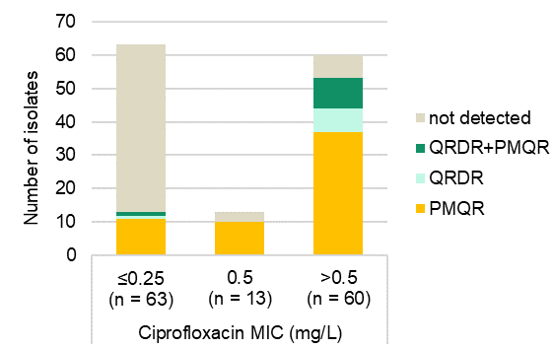

Note: Fluoroquinolone resistance mechanisms include mutations in either the quinolone resistance-determining region of the DNA gyrase or topoisomerase genes (*gyrA*, *gyrB*, *parC*, *parE*), and/or presence of plasmid-mediated quinolone resistance genes (*qnr* variants, *aac(6')-Ib-cr*, *qepA*) as detected by whole genome sequence analyses.

MIC = minimum inhibitory concentration; PMQR = plasmid-mediated quinolone resistance; QRDR = quinolone resistance-determining region

**Table 41:** Fluroquinolone resistance determinants in *Klebsiella pneumoniae* complex subset, AGAR, 2021

|  |  |  |  |  |  |  |
| --- | --- | --- | --- | --- | --- | --- |
| QRDR mutations | |  | Ciprofloxacin MIC (mg/L) | | |  |
| **gyrA** | **parC** | **PMQR** | **≤0.25** | **0.5** | **>0.5** | **Total** |
| –* | –* | –* | 50 | 3 | 7 | 60 |
| –* | –* | *aac(6')-Ib-cr* | 0 | 0 | 1 | 1 |
| –* | –* | *aac(6’)-Ib-cr*, *qnr* | 0 | 0 | 15 | 15 |
| –* | –* | *qnr* | 11 | 10 | 21 | 42 |
| –* | S80I, E84V | *qnr* | 1 | 0 | 0 | 1 |
| D87G | –* | –* | 0 | 0 | 1 | 1 |
| P95L | –* | *qnr* | 0 | 0 | 1 | 1 |
| S83F, D87A | –* | –* | 0 | 0 | 1 | 1 |
| S83F, D87A | –* | *aac(6')-Ib-cr* | 0 | 0 | 2 | 2 |
| S83F, D87A | –* | *aac(6')-Ib-cr*, *qnr* | 0 | 0 | 1 | 1 |
| S83I | –* | –* | 0 | 0 | 4 | 4 |
| S83I | –* | *aac(6')-Ib-cr*, *qnr* | 0 | 0 | 3 | 3 |
| S83T | –* | –* | 1 | 0 | 0 | 1 |
| S83Y | –* | *aac(6')-Ib-cr*, *qnr* | 0 | 0 | 1 | 1 |
| S83Y, D87A | –* | –* | 0 | 0 | 1 | 1 |
| S83Y, D87A | –* | *aac(6')-Ib-cr*, *qnr* | 0 | 0 | 1 | 1 |
| **Total** |  |  | **63** | **13** | **60** | **136** |

PMQR = plasmid-mediated quinolone resistance; QRDR = quinolone resistance-determining region

* Not detected

Notes:

1. Fluoroquinolone-resistant determinants include mutations in either the quinolone resistance-determining region of the DNA gyrase and/or topoisomerase genes (*gyrA*, *gyrB*, *parC*, *parE*) identified by PointFinder50, and/or presence of plasmid-mediated quinolone resistance genes (*qnr* variants, *aac(6')-Ib-cr*, *qepA*) detected by whole genome sequence analysis.
2. Mutations in *gyrB* or p*arE* were not detected.

##### *Pseudomonas aeruginosa*

Of 37 *P. aeruginosa* isolates referred for sequencing three harboured a QRDR mutation in codon 83 (T83I) of *gyrA*, and one also had a second mutation in codon 87 (S87L) of *gyrA*. The ciprofloxacin MIC for these isolates was not known. No PMQR genes were detected.

**Plasmid-mediated colistin determinants**

Seven isolates with the *bla*IMP-4 carbapenemase gene (*E. cloacae* complex[*n* = 5], *K. pneumoniae* [*n* = 1], *K. michiganensis* [*n* = 1]) and one *E. cloacae* complex with *bla*NDM-7 also harboured *mcr‑9*.

Seven additional isolates (*E. cloacae* complex [*n* = 6] and *K. pneumoniae* [*n* = 1]) that did not produce a carbapenemase gene had *mcr-9* (*n* = 6) or *mcr-10* (*n* = 1)*.* *mcr-9* has recently been found among several species of *Enterobacterales*. It is not associated with a resistant phenotype52, but is typically carried on HI2 plasmids.53, 54

**Ribosomal methyltransferases**

Six isolates were resistant to amikacin (MIC > 32 mg/L), gentamicin (MIC > 8 mg/L) and tobramycin (MIC > 8 mg/L). Ribosomal methyltransferase genes were detected in three of these; two *K. pneumoniae* (*rmtB1*) and one *E. hormaechei* (*rmtC*) that also harboured blaNDM-1.

## Molecular epidemiology of methicillin-resistant *Staphylococcus aureus*

Of the 495 MRSA reported, 472 (95.4%) were available for typing by WGS. There were marked differences among the states and territories in the percentage and types of MRSA clones. Prevalence of MRSA ranged from 7.8% (9/115) in Tasmania to 43.0% (37/86) in the Northern Territory (Figure 14).

**Figure 14:** Methicillin-resistant *Staphylococcus aureus* as a percentage of all *S. aureus* isolates, by state and territory, and nationally, AGAR, 2021

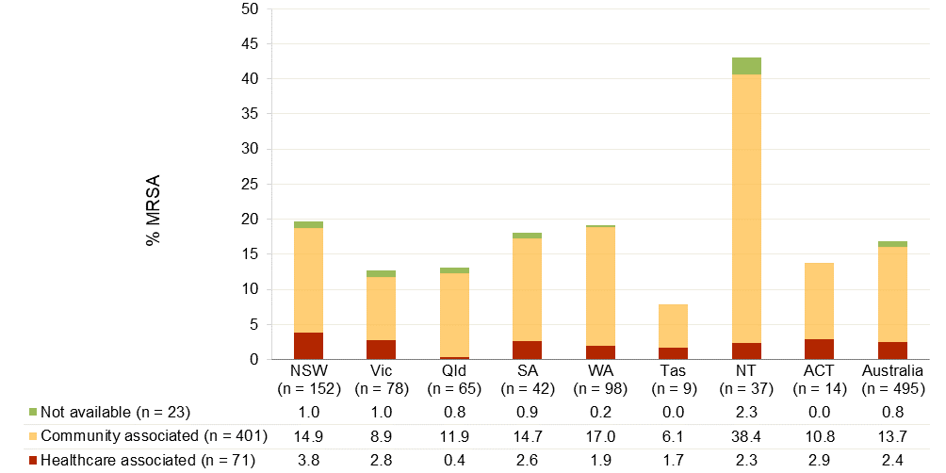

MRSA = methicillin-resistant *Staphylococcus aureus*

Notes:

1. *S. aureus* were categorised as MRSA based on cefoxitin screen (Vitek®) or cefoxitin MIC (Phoenix™).
2. Twenty-three MRSA were not available for whole genome sequencing.

**Healthcare-associated MRSA**

Based on the MLST and SCC*mec* type, three HA-MRSA clones were identified: ST22-IV (EMRSA-15), ST239-III (Aus 2/3 EMRSA), ST5-I (Cordoba) (Tables 42).

PVL-associated genes were not identified in HA-MRSA.

The most frequently isolated HA-MRSA clone, ST22-IV, was identified in all states and territories. ST239-III was identified in two states, New South Wales and South Australia (Table 43).

**Community-associated MRSA**

Based on the MLST and SCC*mec* type,67 CA-MRSA clones were identified. There were 40 sequence types with a single isolate. PVL was detected in 15 CA-MRSA clones. Overall, 37.9% (152/401) of CA-MRSA were PVL positive (Table 42). The most frequently isolated CA-MRSA clone, ST93-IV (Qld CA-MRSA), was isolated in all states except Tasmania (Table 44).

Nine PVL positive ST22-IV isolates were identified: three in South Australia, two each in Victoria and Queensland, and one each in New South Wales and the Australian Capital Territory (Table 42). PVL positive ST22-IV are frequently isolated in the South Asian subcontinent; they are not related to EMRSA-15, and are not considered to be a HA-MRSA clone.55

Of the hospital-onset MRSA, 78.1% (82/105) were caused by CA-MRSA.

**Table 42:** MRSA clones, association, place of onset and PVL carriage, AGAR, 2021

|  |  |  |  |  |  |
| --- | --- | --- | --- | --- | --- |
| Clone | Clonal complex | Total, *n* | Community-onset, % (*n*)* | Hospital-onset, % (*n*)* | PVL positive, % (*n*)* |
| **Healthcare-associated** |  |  |  |  |  |
| ST22-IV (EMRSA-15) | 22 | 64 | 68.8 (44) | 31.3 (20) | 0.0 (0) |
| ST239-III (Aus2/3 EMRSA) | 8 | 6 | –† (4) | –† (2) | –† (0) |
| ST5-I (Cordoba) | 5 | 1 | –† (0) | –† (1) | –† (0) |
| Total HA-MRSA |  | 71 | 67.6 (48) | 32.4 (23) | 0.0 (0) |
| **Community-associated** |  |  |  |  |  |
| ST93-IV (Qld CA-MRSA) | 93 | 99 | 91.9 (91) | 8.1 (8) | 94.9 (94) |
| ST45-V | 45 | 62 | 80.6 (50) | 19.4 (12) | 0.0 (0) |
| ST5-IV | 5 | 48 | 81.3 (39) | 18.8 (9) | 37.5 (18) |
| ST1-IV (WA-1 MRSA) | 1 | 28 | 75.0 (21) | 25.0 (7) | 7.1 (2) |
| ST30-IV (SWP MRSA) | 30 | 20 | 85.0 (17) | 15.0 (3) | 80.0 (16) |
| ST97-IV | 97 | 15 | 66.7 (10) | 33.3 (5) | 0.0 (0) |
| ST22-IV (PVL positive) | 22 | 9 | –† (5) | –† (4) | –† (9) |
| ST88-IV | 88 | 8 | –† (5) | –† (3) | –† (0) |
| ST6-IV | 6 | 7 | –† (6) | –† (1) | –† (0) |
| ST8-IV | 8 | 7 | –† (6) | –† (1) | –† (3) |
| ST59-IV | 59 | 7 | –† (1) | –† (6) | –† (0) |
| ST953-IV | 97 | 7 | –† (6) | –† (1) | –† (0) |
| ST78-IV | 88 | 5 | –† (3) | –† (2) | –† (0) |
| ST72-IV | 8 | 5 | –† (4) | –† (1) | –† (0) |
| Other (*n*= 53) |  | 74 | 74.3 (55) | 25.7 (19) | 13.5 (10) |
| Total CA-MRSA |  | 401 | 79.6 (319) | 20.4 (82) | 37.9 (152) |
| **MRSA** |  | **472** | **77.8 (367)** | **22.2 (105)** | **32.2 (152)** |

MRSA = methicillin-resistant *Staphylococcus aureus*; PVL = Panton-Valentine leucocidin

* Percentage of the clone

† Insufficient numbers (<10) to calculate percentage

**Table 43:** Healthcare-associated MRSA clones, by state and territory, AGAR, 2021

|  |  |  |  |  |  |  |  |  |  |  |  |  |  |  |  |  |
| --- | --- | --- | --- | --- | --- | --- | --- | --- | --- | --- | --- | --- | --- | --- | --- | --- |
|  | Percentage (*n*) | | | | | | | | | | | | | | | |
| **Clone** | **NSW** | | **Vic** | | **Qld** | | **SA** | | **WA** | | **Tas** | | **NT** | | **ACT** | **Australia** |
| ST22-IV (EMRSA-15) | 79.3 (23) | | 100.0 (17) | | –* (2) | | –* (5) | | 100.0 (10) | | –* (2) | | –* (2) | | –* (3) | 90.1 (64) |
| ST239-III (Aus2/3 EMRSA) | 17.2 (5) | | 0.0 (0) | | –* (0) | | –* (1) | | 0.0 (0) | | –* (0) | | –* (0) | | –* (0) | 8.5 (6) |
| ST5-I (Cordoba) | 3.4 (1) | | 0.0 (0) | | –* (0) | | –* (0) | | 0.0 (0) | | –* (0) | | –* (0) | | –* (0) | 1.4 (1) |
| **Total** | **29** | **17** | | **2** | | **6** | | **10** | | **2** | | **2** | | **3** | | **71** |

MRSA = methicillin-resistant *Staphylococcus aureus*; n/a = not applicable (no isolates)

*Insufficient numbers (<10) to calculate percentage

**Table 44:** Major community-associated MRSA clones (>10 isolates) by state and territory and PVL carriage, AGAR, 2021

|  | Percentage (*n*) | | | | | | | | |
| --- | --- | --- | --- | --- | --- | --- | --- | --- | --- |
| Clone | NSW | Vic | Qld | SA | WA | Tas | NT | ACT | Australia |
| ST93-IV (Qld CA-MRSA) | 10.4 (12) | 12.7 (7) | 30.5 (18) | 23.5 (8) | 37.9 (33) | –* (0) | 60.6 (20) | 9.1 (1) | 24.7 (99) |
| Number PVL positive | 12 | 7 | 17 | 7 | 31 | 0 | 20 | 0 | 94 |
| Number PVL negative | 0 | 0 | 1 | 1 | 2 | 0 | 0 | 1 | 5 |
| ST45-V | 31.3 (36) | 29.1 (16) | 5.1 (3) | 2.9 (1) | 2.3 (2) | –* (0) | 0.0 (0) | 36.4 (4) | 15.5 (62) |
| Number PVL positive | 0 | 0 | 0 | 0 | 0 | 0 | 0 | 0 | 0 |
| Number PVL negative | 36 | 16 | 3 | 1 | 2 | 0 | 0 | 4 | 62 |
| ST5-IV | 7.0 (8) | 7.3 (4) | 16.9 (10) | 8.8 (3) | 17.2 (15) | –* (3) | 15.2 (5) | 0.0 (0) | 12.0 (48) |
| Number PVL positive | 0 | 2 | 0 | 1 | 10 | 2 | 3 | 0 | 18 |
| Number PVL negative | 8 | 2 | 10 | 2 | 5 | 1 | 2 | 0 | 30 |
| ST1-IV | 7.0 (8) | 1.8 (1) | 10.2 (6) | 14.7 (5) | 3.4 (3) | –* (2) | 6.1 (2) | 9.1 (1) | 7.0 (28) |
| Number PVL positive | 0 | 0 | 2 | 0 | 0 | 0 | 0 | 0 | 2 |
| Number PVL negative | 8 | 1 | 4 | 5 | 3 | 2 | 2 | 1 | 26 |
| ST30-IV | 8.7 (10) | 7.3 (4) | 3.4 (2) | 0.0 (0) | 3.4 (3) | –* (1) | 0.0 (0) | 0.0 (0) | 5.0 (20) |
| Number PVL positive | 9 | 3 | 1 | 0 | 2 | 1 | 0 | 0 | 16 |
| Number PVL negative | 1 | 1 | 1 | 0 | 1 | 0 | 0 | 0 | 4 |
| ST97-IV | 6.1 (7) | 7.3 (4) | 5.1 (3) | 0.0 (0) | 1.1 (1) | –* (0) | 0.0 (0) | 0.0 (0) | 3.7 (15) |
| Number PVL positive | 0 | 0 | 0 | 0 | 0 | 0 | 0 | 0 | 0 |
| Number PVL negative | 7 | 4 | 3 | 0 | 1 | 0 | 0 | 0 | 15 |
| Other clones (*n* = 53) | 22.6 (26) | 25.5 (14) | 11.9 (7) | 20.6 (7) | 12.6 (11) | –* (1) | 15.2 (5) | 27.3 (3) | 18.5 (74) |
| Number PVL positive | 3 | 3 | 2 | 1 | 0 | 0 | 1 | 0 | 10 |
| Number PVL negative | 23 | 11 | 5 | 6 | 11 | 1 | 4 | 3 | 64 |
| **Total** | **115** | **55** | **59** | **34** | **87** | **7** | **33** | **11** | **401** |
| PVL positive | 26 | 18 | 24 | 12 | 44 | 3 | 24 | 1 | 152 |
| PVL negative | 89 | 37 | 35 | 22 | 43 | 4 | 9 | 10 | 249 |

CA-MRSA = community-associated methicillin-resistant *Staphylococcus aureus*; MRSA = methicillin-resistant *Staphylococcus aureus*; PVL = Panton-Valentine leucocidin

* Insufficient numbers (<10) to calculate percentage

## Trend analysis (2013–2021)

Trend data were available for *Enterobacterales, Enterococcus* species and *S. aureus* for the nine-year period 2013 to 2021. *Acinetobacter* species and *P. aeruginosa* were introduced to the program in 2015.

## *Enterococcus* species

The 2021 program focused on the proportions of E. faecium and E. faecalis bacteraemia isolates demonstrating resistance to ampicillin, glycopeptides and other anti-enterococcal agents. Important trends for the period 2013 to 2021 are described below.

***Enterococcus faecalis***

**National**

Resistance (EUCAST) to key antimicrobial agents for *E. faecalis* over the nine-year period from 2013 to 2021 is shown in Figure 15. Resistance to ampicillin, vancomycin, teicoplanin and linezolid remains rare. There was a decrease in the proportion of *E. faecalis* with acquired ciprofloxacin resistance in 2021 compared with 2020 (19/397, 4.8% in 2020; 8/408, 2.0% in 2021, *P* = 0.0308). In 2021, two linezolid-resistant *E. faecalis* were confirmed, both with MIC = 8 mg/L. One isolate from Western Australia harboured the *optrA* gene; no known mutations or linezolid resistance genes could be found in one isolate from the Australian Capital Territory.

Figure 15: *Enterococcus faecalis*, resistance (EUCAST), AGAR, 2013–2021

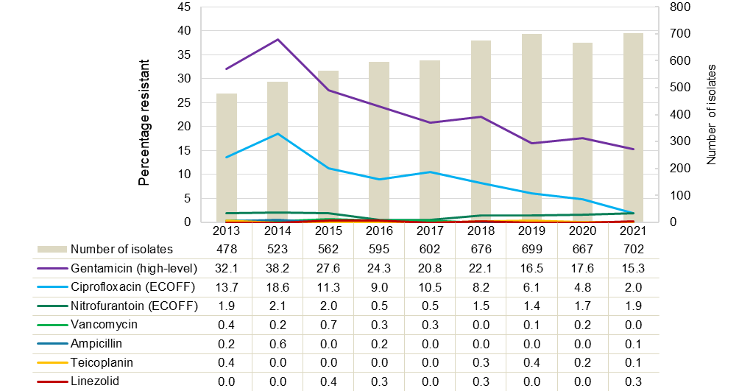

ECOFF = epidemiological cut-off value; EUCAST = European Committee on Antimicrobial Susceptibility Testing

Notes:

1. Percentage resistance determined using EUCAST 2021 breakpoints for all years.
2. Number of contributors per year: *n* = 27 in 2013 and 2014; *n* = 35 in 2015; *n* = 33 in 2016; *n* = 35 in 2017; *n* = 38 in 2018; *n* = 41 in 2019; *n* = 42 in 2020; *n* = 41 in 2021.
3. Ciprofloxacin susceptibility data only available for 26/39 (2020) institutions due to change in Vitek® card used.
4. The ciprofloxacin ECOFF (4 mg/L) was used to distinguish between isolates with and without acquired resistance mechanisms, as breakpoints apply to uncomplicated urinary tract infections only.
5. The nitrofurantoin ECOFF (32 mg/L) was used to distinguish between isolates with and without acquired resistance mechanisms, as breakpoints apply to uncomplicated urinary tract infections only.

**State and territory**

There was no significant change in antimicrobial resistance among *E. faecalis* in 2021, compared to 2020.

From 2017 to 2021, there was a significant decreasing trend in high-level gentamicin resistance in Queensland (Χ2 for linear trend = 9.132, *P* < 0.01), Western Australia (Χ2 for linear trend = 7.025, *P* < 0.01), and South Australia (Χ2 for linear trend = 4.106, *P* = 0.0427) (Table 45).

**Table 45:** *Enterococcus faecalis*, percentage resistant to gentamicin (high-level) (EUCAST) and number tested, state and territory, AGAR, 2013–2021

|  |  |  |  |  |  |  |  |  |  |  |
| --- | --- | --- | --- | --- | --- | --- | --- | --- | --- | --- |
|  | **Percentage resistant, (*n*) by year** | | | | | | | | | **Trend 2017–2021\*** |
| **State and territory** | **2013** | **2014** | **2015** | **2016** | **2017** | **2018** | **2019** | **2020** | **2021** |
| Queensland | 27.6 (87) | 34.3 (102) | 25.5 (94) | 28.6 (98) | **21.2 (99)** | **16.3 (129)** | **13.0 (123)** | **9.3 (97)** | **8.2 (97)** | ▼** |
| Tasmania | 18.2 (11) | 30.8 (13) | 25.0 (12) | 14.8 (27) | 19.4 (31) | 16.1 (31) | 12.2 (41) | 7.4 (27) | 9.1 (33) | ↔ |
| Western Australia | 28.2 (71) | 28.6 (63) | 23.3 (90) | 16.1 (87) | **22.5 (89)** | **21.1 (90)** | **12.8 (78)** | **15.9 (88)** | **9.4 (106)** | ▼** |
| Victoria | 34.0 (106) | 38.7 (119) | 27.4 (106) | 22.3 (130) | 19.7 (117) | 23.1 (117) | 22.2 (126) | 24.8 (133) | 16.0 (131) | ↔ |
| South Australia | 31.6 (19) | 35.3 (51) | 28.1 (57) | 29.4 (51) | **35.5 (31)** | **23.6 (55)** | **9.4 (64)** | **13.8 (58)** | **17.4 (69)** | ▼* |
| New South Wales | 40.0 (85) | 42.4 (132) | 29.3 (140) | 28.2 (149) | 16.7 (186) | 24.2 (207) | 15.3 (215) | 19.0 (221) | 19.8 (162) | ↔ |
| Northern Territory | –† (6) | –† (6) | 40.0 (10) | –† (7) | 10.0 (10) | 18.2 (11) | –† (7) | –† (5) | –† (8) | ↔ |
| Australian Capital Territory | 30.4 (23) | 54.5 (33) | 34.3 (35) | 22.5 (40) | 35.7 (28) | 38.5 (26) | 44.4 (36) | 19.4 (31) | 27.8 (36) | –† |
| Australia | 32.1 (408) | 38.2 (519) | 27.6 (544) | 24.3 (589) | **20.8 (591)** | **22.1 (666)** | **16.5 (690)** | **17.6 (660)** | **15.3 (642)** | ▼** |

* Chi-square test for trend for past five years (2017–2021), bold text significant decrease ▼ (*P*< 0.01, **), ▼ (0.01 < *P*< 0.05, *), ↔ no significant difference

† Not applicable, insufficient numbers (<10) to calculate percentage

Note: Percentage resistance determined using EUCAST 2022 breakpoints for all years.

***Enterococcus faecium***

**National**

The total number of *E. faecium* isolated from patients with bacteraemia increased 7.2% in 2021 compared to 2020 (*n* = 488 in 2020; *n* = 523 in 2021) (Figure 16). There were no significant changes in the proportion of *E. faecium* isolates resistant to vancomycin (32.6% in 2020; 37.9% in 2021) or teicoplanin (13.0% in 2020, 13.2% in 2021). There was a significant decrease in the proportion of *E. faecium* isolates resistant to gentamicin (high-level) (184/478, 38.5% in 2020; 146/480, 30.4% in 2021, *P* < 0.01). The decrease was seen in both vancomycin-resistant (63.5% in 2020, 52.0% in 2021), and vancomycin-susceptible (26.4% in 2020, 17.8% in 2021) *E. faecium* (Figure 17).

Two linezolid-resistant *E. faecium* were confirmed in 2021. The G2576T 23SrRNA mutation was detected in one isolate from New South Wales (MIC = 32 mg/L), and *poxtA* detected in one isolate from South Australia (MIC = 16 mg/L).

**Figure 16:** *Enterococcus faecium*, resistance (EUCAST), AGAR, 2013–2021

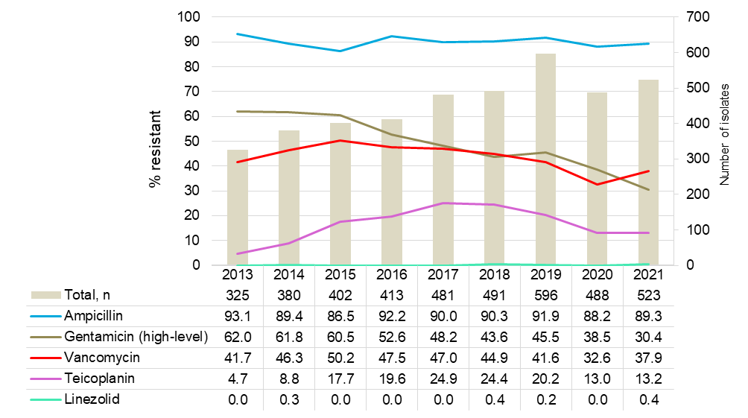

EUCAST = European Committee on Antimicrobial Susceptibility Testing

Notes:

1. Percentage resistance determined using EUCAST 2022 breakpoints for all years.
2. Number of contributors per year: *n* = 27 in 2013 and 2014; *n* = 35 in 2015; *n* = 33 in 2016; *n* = 35 in 2017; *n* = 38 in 2018; *n* = 41 in 2019; *n* = 42 in 2020; *n* = 41 in 2021.

**Figure 17:** *Enterococcus faecium,* resistance (EUCAST), by vancomycin susceptibility, AGAR, 2013–2021

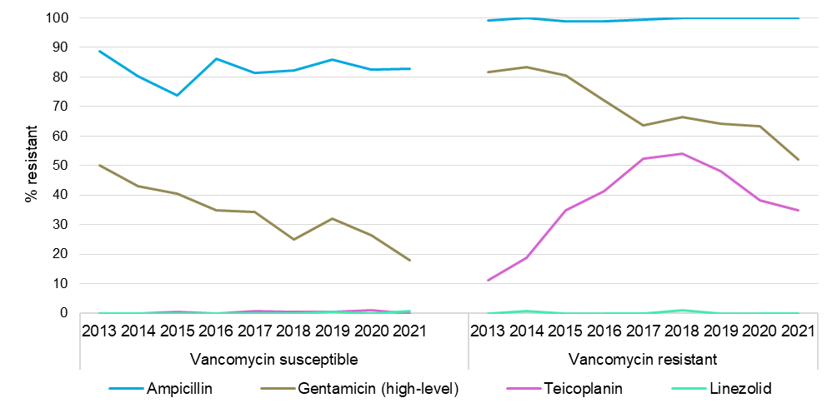

EUCAST = European Committee on Antimicrobial Susceptibility Testing

Notes:

1. Percentage resistance determined using EUCAST 2022 breakpoints for all years.
2. Number of contributors per year: *n* = 27 in 2013 and 2014; *n* = 35 in 2015; *n* = 33 in 2016; *n* = 35 in 2017; *n* = 38 in 2018; *n* = 41 in 2019; *n* = 42 in 2020; *n* = 41 in 2021.

**State and territory**

The proportion of glycoside-resistant *E.* *faecium* by state and territory is shown in Figure 18. Nationally, the proportion of vancomycin-resistant *E. faecium* increased from 32.6% (158/485), in 2020 to 37.9% (198/522) in 2021. The increase was notable in South Australia (3/38, 7.9% in 2020; 19/55, 34.5% in 2021, *P* < 0.01). Teicoplanin resistance in *E. faecium* was stable (63/485, 13.0% in 2020; 69/522, 13.6% in 2021).

Figure 18: *Enterococcus faecium*, glycopeptide resistance (EUCAST), by state and territory, and nationally, AGAR, 2013–2021

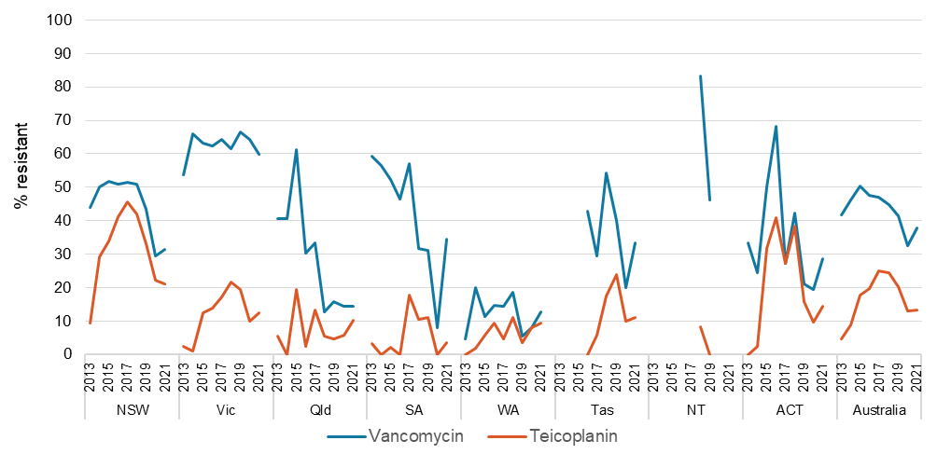

Notes:

1. Percentage resistance determined using EUCAST 2022 breakpoints for all years.
2. Number of contributors per year: *n* = 27 in 2013 and 2014; *n* = 35 in 2015; *n* = 33 in 2016; *n* = 35 in 2017; *n* = 38 in 2018; *n* = 41 in 2019; *n* = 42 in 2020; *n* = 41 in 2021.
3. Insufficient numbers (<10) to calculate percentage for Tasmania (2013–2015) and the Northern Territory (2013–2017, 2020, 2021).

Nationally, there were significantly decreasing trends in vancomycin resistance in *E. faecium* over the past five years (Χ2 for linear trend = 18.54, *P* < 0.01); most notably in New South Wales (Χ2 for linear trend = 25.33, *P* < 0.01), and South Australia (Χ2 for linear trend = 4.691, *P* = 0.0303) (Table 46). Over the same period, teicoplanin resistance in *E. faecium* decreased significantly nationally (Χ2 for linear trend = 38.91, *P* < 0.01); notably in New South Wales (Χ2 for linear trend = 34.15, *P* < 0.01), South Australia (Χ2 for linear trend = 7.201, *P* < 0.01), the Australian Capital Territory (Χ2 for linear trend = 4.749, *P* = 0.0293), and Victoria (Χ2 for linear trend = 4.561, *P* = 0.0327), (Table 47).

**Table 46:** *Enterococcus faecium*, percentage resistant to vancomycin (EUCAST) and number tested, state and territory, AGAR, 2013–2021

|  |  |  |  |  |  |  |  |  |  |  |
| --- | --- | --- | --- | --- | --- | --- | --- | --- | --- | --- |
|  | **Percentage resistant, (*n*) by year** | | | | | | | | | **Trend 2017–2021\*** |
| **State and territory** | **2013** | **2014** | **2015** | **2016** | **2017** | **2018** | **2019** | **2020** | **2021** |
| Western Australia | 4.8 (42) | 20.0 (50) | 11.3 (53) | 14.8 (54) | 14.3 (63) | 18.5 (54) | 5.4 (56) | 8.1 (62) | 12.7 (63) | ↔ |
| Queensland | 40.5 (37) | 40.5 (37) | 61.3 (31) | 30.2 (43) | 33.3 (45) | 12.7 (55) | 15.9 (63) | 14.3 (35) | 14.3 (49) | ↔ |
| Australian Capital Territory | 33.3 (18) | 24.4 (41) | 50.0 (22) | 68.2 (22) | 27.3 (22) | 42.3 (26) | 21.1 (19) | 19.4 (31) | 28.6 (14) | ↔ |
| New South Wales | 43.9 (107) | 50.0 (104) | 51.7 (116) | 50.8 (124) | **51.5 (167)** | **51.0 (151)** | **43.5 (209)** | **29.4 (180)** | **31.5 (146)** | ▼** |
| Tasmania | –† (5) | –† (7) | –† (8) | 42.9 (14) | 29.4 (17) | 54.2 (24) | 40.0 (25) | 20.0 (10) | 33.3 (18) | ↔ |
| South Australia | 59.4 (32) | 56.5 (46) | 52.3 (44) | 46.5 (43) | **57.1 (28)** | **31.6 (38)** | **31.1 (45)** | **7.9 (38)** | **34.5 (55)** | ▼* |
| Victoria | 53.8 (80) | 66.0 (94) | 63.3 (120) | 62.4 (109) | 64.2 (134) | 61.5 (130) | 66.5 (164) | 64.2 (123) | 59.8 (169) | ↔ |
| Northern Territory | –† (3) | –† (1) | –† (8) | –† (4) | –† (5) | 83.3 (12) | 46.2 (13) | –† (6) | –† (8) | ↔ |
| Australia | 41.7 (324) | 46.3 (380) | 50.2 (402) | 47.5 (413) | **47.0 (481)** | **44.9 (490)** | **41.6 (594)** | **32.6 (485)** | **37.9 (522)** | ▼** |

* Chi-square test for trend for past five years (2017–2021), bold text significant decrease ▼ (*P*< 0.01, **), ▼ (0.01 < *P*< 0.05, *), ↔ no significant difference

† Not applicable, insufficient numbers (<10) to calculate percentage

Note: Percentage resistance determined using EUCAST 2022 breakpoints for all years.

**Table 47:** *Enterococcus faecium*, percentage resistant to teicoplanin (EUCAST) and number tested, state and territory, AGAR, 2013–2021

|  |  |  |  |  |  |  |  |  |  |  |
| --- | --- | --- | --- | --- | --- | --- | --- | --- | --- | --- |
|  | **Percentage resistant, (*n*) by year** | | | | | | | | | **Trend 2017–2021\*** |
| **State and territory** | **2013** | **2014** | **2015** | **2016** | **2017** | **2018** | **2019** | **2020** | **2021** |
| Northern Territory | –† (3) | –† (1) | –† (8) | –† (4) | –† (5) | 8.3 (12) | 0.0 (13) | –† (6) | –† (8) | ↔ |
| South Australia | 3.1 (32) | 0.0 (45) | 2.3 (44) | 0.0 (43) | **17.9 (28)** | **10.5 (38)** | **11.1 (45)** | **0.0 (39)** | **3.6 (55)** | ▼** |
| Western Australia | 0.0 (42) | 2.0 (50) | 5.7 (53) | 9.3 (54) | 4.8 (63) | 11.1 (54) | 3.6 (56) | 8.1 (62) | 9.5 (63) | ↔ |
| Queensland | 5.6 (36) | 0.0 (36) | 19.4 (31) | 2.3 (43) | 13.3 (45) | 5.5 (55) | 4.8 (63) | 5.7 (35) | 10.2 (49) | ↔ |
| Tasmania | –† (5) | –† (7) | –† (8) | 0.0 (14) | 5.9 (17) | 17.4 (23) | 24.0 (25) | 10.0 (10) | 11.1 (18) | ↔ |
| Victoria | 2.5 (80) | 1.1 (94) | 12.5 (120) | 13.8 (109) | **17.2 (134)** | **21.5 (130)** | **19.5 (164)** | **9.8 (122)** | **12.4 (169)** | ▼* |
| Australian Capital Territory | 0.0 (16) | 2.4 (41) | 31.8 (22) | 40.9 (22) | **27.3 (22)** | **38.5 (26)** | **15.8 (19)** | **9.7 (31)** | **14.3 (14)** | ▼* |
| New South Wales | 9.3 (107) | 29.1 (103) | 33.9 (115) | 41.1 (124) | 45.5 (167) | 42.0 (150) | 33.0 (209) | 22.2 (180) | 21.2 (146) | ▼** |
| Australia | 4.7 (321) | 8.8 (377) | 17.7 (401) | 19.6 (413) | **24.9 (481)** | **24.4 (488)** | **20.2 (594)** | **13.0 (485)** | **13.2 (522)** | ▼** |

* Chi-square test for trend for past five years (2017–2021), bold text significant decrease ▼ (*P*< 0.01, **), ▼ (0.01 < *P*< 0.05, *), ↔ no significant difference

† Not applicable, insufficient numbers (<10) to calculate percentage

Note: Percentage resistance determined using EUCAST 2022 breakpoints for all years.

**Glycopeptide-resistance in *Enterococcus faecium***

In 2021, glycopeptide resistance was predominantly due to *vanB* genes. Overall, the proportion of both *vanA* and *vanB* *E. faecium* in 2021 remained stable compared to 2020. There was, however, a 3.8-fold increase in *vanB* *E. faecium* in South Australia in 2021 (3/39, 7.7% in 2020; 15/51, 29.4% in 2021, *P* = 0.0154).

There is considerable variation in the proportion of *E. faecium* with *van* genes by state and territory, and the *van* type (Figure 19). Over the past five-year period, there was a significantly decreasing trend in the proportion of *E. faecium* with *van* genes (Χ2 for linear trend = 23.29, *P* < 0.01); in New South Wales, Victoria, and South Australia *vanA* types decreased; in Western Australia and Queensland, the decrease was in *vanB* types. In the Australian Capital Territory, *vanA* types decreased and *vanB* types increased.

Figure 19: Proportion of *van* genes in *Enterococcus faecium* by state and territory, and nationally, AGAR, 2013–2021

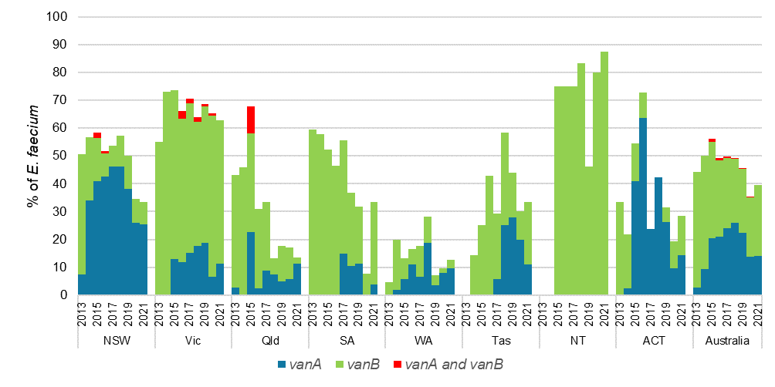

Note: Insufficient number of *E. faecium* isolates (<10) to calculate percentage for the Northern Territory (2013, 2014).

## Gram-negative species

The following sections describe the major trends observed for key gram-negative species for the period 2013 to 2021.

EUCAST interpretive criteriahave been used throughout, with the notable exception of amoxicillin–clavulanic acid. Ninety percent of the pathology services used Vitek® cards which have the CLSI formulation (2:1 ratio) for interpretation for susceptibility for this agent.

***Escherichia coli***

**National**

The percentage resistance for *E. coli* in 2021 was similar to 2020 for all antimicrobial agents tested, except for ciprofloxacin, where a 23.3% decrease in resistance was seen relative to 2020 (784/4870, 16.1% in 2020, 606/4910, 12.3% in 2021; *P* < 0.0001 (Figure 20).

From 2017, rates of resistance to key antimicrobial agents decreased for ampicillin (Χ2 for linear trend = 7.222, *P* < 0.01), trimethoprim–sulfamethoxazole (Χ2 for linear trend = 6.466, *P* = 0.011), ciprofloxacin (Χ2 for linear trend = 4.397, *P* = 0.036), and piperacillin–tazobactam (Χ2 for linear trend = 3.930, *P* = 0.0474) (Figure 20).

Figure 20: *Escherichia coli* resistance to key antimicrobials (EUCAST), bloodstream isolates, AGAR, 2013–2021

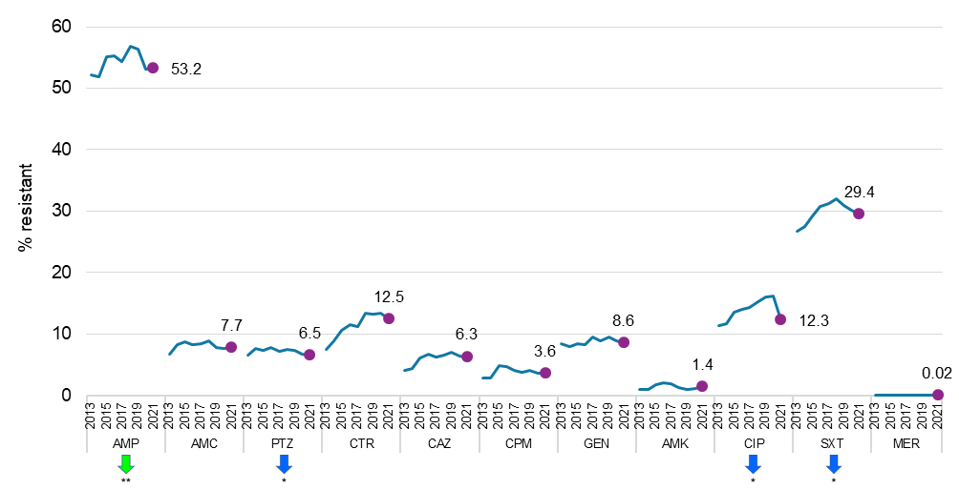

AMC = amoxicillin–clavulanic acid (2:1 ratio); AMK = amikacin; AMP = ampicillin; CAZ = ceftazidime; CIP = ciprofloxacin; CPM = cefepime; CTR = ceftriaxone; EUCAST = European Committee on Antimicrobial Susceptibility Testing; GEN = gentamicin; MER = meropenem; PTZ = piperacillin–tazobactam; SXT = trimethoprim–sulfamethoxazole

Notes:

1. Percentage resistance determined using EUCAST 2022 breakpoints for all years. Filled circles indicate values for 2021.
2. Green arrows indicate antimicrobial agents with significant decrease (*P* < 0.01, **) over the past five years (2017–2021).
3. Blue arrows indicate antimicrobial agents with significant decrease (0.01 < *P* < 0.05, *) over the past five years (2017–2021).

**By state and territory**

In 2021, fluoroquinolone resistance in *E. coli*, relative to 2020, declined in all states and territories except Tasmania, most notably in New South Wales (2020, 17.5%; 2021, 12.1%, down 30.8%, *P* < 0.01) and Victoria (20.0% in 2020; 13.2% in 2021, down 34.2%, *P* < 0.01). There were significantly decreasing trends in fluoroquinolone resistance in *E. coli* over the past five years in Queensland (Χ2 for linear trend = 4.421, *P* = 0.0355). There was a significantly decreasing trend in the overall data from New South Wales (Χ2 for linear trend = 4.089, *P* = 0.0432) from 2017, but it was not observed when only data from institutions consistently reporting for all five years was included (Table 48).

There was a significantly increasing trend in third-generation cephalosporin resistance in *E. coli* from 2017 to 2021 in South Australia (Χ2 for linear trend = 6.667, *P* < 0.01) (Table 49)

Over the past five years, aminoglycoside resistance in *E. coli* decreased in Victoria (Χ2 for linear trend = 9.021, *P* < 0.01) (Table 50).

**Table 48:** *Escherichia coli*, percentage resistant to fluoroquinolones (EUCAST) and number tested, state and territory, AGAR, 2013–2021

|  |  |  |  |  |  |  |  |  |  |  |
| --- | --- | --- | --- | --- | --- | --- | --- | --- | --- | --- |
|  | **Percentage resistant, (*n*) by year** | | | | | | | | | **Trend 2017–2021\*** |
| **State and territory** | **2013** | **2014** | **2015** | **2016** | **2017** | **2018** | **2019** | **2020** | **2021** |
| South Australia | 10.6 (379) | 10.9 (386) | 9.0 (454) | 13.3 (429) | 8.3 (288) | 11.6 (405) | 13.9 (440) | 9.8 (479) | 8.5 (470) | ↔ |
| Queensland | 8.1 (652) | 7.1 (742) | 8.7 (691) | 9.0 (811) | **12.9 (858)** | **10.3 (868)** | **10.4 (817)** | **11.6 (628)** | **8.6 (686)** | ▼* |
| Tasmania | 6.3 (79) | 7.6 (79) | 7.6 (79) | 10.7 (168) | 5.7 (174) | 7.6 (184) | 12.9 (201) | 8.0 (201) | 10.6 (218) | ↔ |
| New South Wales | 13.2 (555) | 11.8 (781) | 17.7 (1,107) | 17.3 (993) | **16.3 (1,170)** | **15.8 (1,224)** | **16.9 (1,379)** | **17.5 (1,492)** | **12.1 (1,281)** | ▼*† |
| Victoria | 11.7 (530) | 16.2 (722) | 14.4 (727) | 15.7 (709) | 15.6 (794) | 18.1 (770) | 18.3 (919) | 20.0 (899) | 13.2 (1,085) | ↔ |
| Australian Capital Territory | 13.6 (118) | 12.5 (168) | 10.7 (149) | 13.6 (154) | 12.0 (158) | 17.8 (157) | 20.5 (185) | 15.2 (198) | 13.6 (206) | ↔ |
| Western Australia | 13.9 (524) | 12.7 (510) | 16.2 (650) | 15.7 (677) | 16.2 (770) | 20.5 (801) | 17.3 (736) | 17.5 (776) | 16.2 (740) | ↔ |
| Northern Territory | 10.3 (78) | 8.2 (97) | 9.5 (137) | 9.8 (153) | 15.6 (141) | 12.5 (160) | 20.0 (205) | 20.8 (197) | 17.0 (224) | ↔ |
| Australia | 11.3 (2,915) | 11.6 (3,485) | 13.6 (3,994) | 14.0 (4,094) | **14.4 (4,353)** | **15.2 (4,569)** | **16.0 (4,882)** | **16.1 (4,870)** | **12.3 (4,910)** | ▼* |

* Chi-square test for trend for past five years (2017–2021), bold text significant decrease ▼ (0.01 < *P* < 0.05, *), ↔ no significant difference

† Significant trend in the overall data, which was not observed when only data from institutions consistently reporting for all five years (2017–2021) were included

Notes:

1. Percentage resistance determined using EUCAST 2022 breakpoints for all years.
2. Fluoroquinolones refer to ciprofloxacin.

**Table 49:** *Escherichia coli*, percentage resistant to third-generation cephalosporins (EUCAST) and number tested, state and territory, AGAR, 2013–2021

|  |  |  |  |  |  |  |  |  |  |  |
| --- | --- | --- | --- | --- | --- | --- | --- | --- | --- | --- |
|  | **Percentage resistant, (*n*) by year** | | | | | | | | | **Trend 2017–2021\*** |
| **State and territory** | **2013** | **2014** | **2015** | **2016** | **2017** | **2018** | **2019** | **2020** | **2021** |  | |
| Tasmania | 1.3 (80) | 10.1 (79) | 0.0 (79) | 6.5 (168) | 5.2 (174) | 7.6 (184) | 7.0 (201) | 6.0 (201) | 6.0 (218) | ↔ |
| Queensland | 5.4 (652) | 7.1 (742) | 6.1 (691) | 8.1 (811) | 9.4 (858) | 11.5 (868) | 8.4 (817) | 8.9 (628) | 10.6 (686) | ↔ |
| South Australia | 5.5 (379) | 6.2 (386) | 7.5 (454) | 12.3 (431) | **4.8 (289)** | **9.1 (405)** | **12.5 (440)** | **9.2 (479)** | **11.9 (471)** | ▲** |
| Australian Capital Territory | 5.1 (118) | 8.9 (168) | 10.7 (149) | 9.7 (154) | 12.0 (158) | 12.7 (157) | 16.7 (186) | 13.1 (198) | 13.1 (206) | ↔ |
| Northern Territory | 9.0 (78) | 9.3 (97) | 8.8 (137) | 9.2 (153) | 9.2 (141) | 17.5 (160) | 16.1 (205) | 19.8 (197) | 13.4 (224) | ↔ |
| Victoria | 11.1 (530) | 13.0 (722) | 12.5 (727) | 13.7 (709) | 14.2 (794) | 17.1 (770) | 16.9 (922) | 17.0 (899) | 13.5 (1,086) | ↔ |
| New South Wales | 11.2 (555) | 10.0 (781) | 15.4 (1,107) | 15.1 (993) | 14.4 (1,170) | 13.5 (1,224) | 15.4 (1,379) | 15.7 (1,493) | 14.1 (1,281) | ↔ |
| Western Australia | 6.3 (524) | 6.3 (510) | 9.7 (650) | 11.7 (677) | 11.5 (771) | 15.6 (801) | 12.2 (736) | 12.5 (776) | 14.4 (741) | ↔ |
| Australia | 7.7 (2,916) | 9.0 (3,485) | 10.7 (3,994) | 11.8 (4,096) | 11.6 (4,355) | 13.6 (4,569) | 13.5 (4,886) | 13.6 (4,871) | 12.9 (4,913) | ↔ |

* Chi-square test for trend for past five years (2017–2021), bold text significant increase ▲ (*P* < 0.01, **), ↔ no significant difference

Notes:

1. Percentage resistance determined using EUCAST 2022 breakpoints for all years.
2. Third-generation cephalosporins refer to ceftriaxone or ceftazidime.

**Table 50:** *Escherichia coli*, percentage resistant to aminoglycosides (EUCAST) and number tested, state and territory, AGAR, 2013–2021

|  |  |  |  |  |  |  |  |  |  |  |
| --- | --- | --- | --- | --- | --- | --- | --- | --- | --- | --- |
|  | **Percentage resistant, (*n*) by year** | | | | | | | | | **Trend 2017–2021\*** |
| **State and territory** | **2013** | **2014** | **2015** | **2016** | **2017** | **2018** | **2019** | **2020** | **2021** |
| Tasmania | 2.5 (80) | 8.9 (79) | 2.5 (79) | 6.0 (168) | 3.4 (174) | 3.8 (184) | 7.0 (201) | 4.5 (201) | 3.2 (218) | ↔ |
| Queensland | 7.5 (652) | 8.1 (742) | 7.7 (691) | 8.1 (811) | 9.8 (858) | 7.7 (868) | 8.4 (817) | 8.3 (628) | 7.6 (686) | ↔ |
| Victoria | 12.1 (530) | 11.1 (722) | 10.3 (727) | 9.4 (709) | **12.8 (794)** | **10.5 (770)** | **13.0 (922)** | **11.8 (899)** | **7.7 (1,086)** | ▼** |
| South Australia | 6.9 (379) | 6.7 (386) | 9.0 (454) | 10.7 (431) | 6.6 (289) | 9.6 (405) | 9.3 (440) | 8.1 (479) | 8.3 (471) | ↔ |
| Australian Capital Territory | 14.4 (118) | 10.7 (168) | 5.4 (149) | 7.1 (154) | 13.3 (158) | 8.9 (157) | 11.3 (186) | 10.1 (198) | 9.2 (206) | ↔ |
| New South Wales | 11.0 (555) | 9.5 (781) | 11.5 (1,107) | 9.0 (993) | 10.4 (1,170) | 10.8 (1,225) | 10.5 (1,379) | 9.8 (1,493) | 10.3 (1,281) | ↔ |
| Western Australia | 9.2 (524) | 7.8 (511) | 11.8 (650) | 14.9 (677) | 12.2 (771) | 13.0 (801) | 9.6 (736) | 9.8 (776) | 11.6 (741) | ↔ |
| Northern Territory | 14.1 (78) | 15.5 (97) | 11.7 (137) | 12.4 (153) | 12.8 (141) | 16.9 (160) | 18.5 (205) | 20.8 (197) | 17.4 (224) | ↔ |
| Australia | 9.5 (2,916) | 9.2 (3,486) | 10.0 (3,994) | 10.0 (4,096) | **10.7 (4,355)** | **10.3 (4,570)** | **10.6 (4,886)** | **10.0 (4,871)** | **9.3 (4,913)** | ▼* |

* Chi-square test for trend for past five years (2017–2021), bold text significant decrease ▼ (*P*< 0.01, **), ▼ (< 0.01 < *P*< 0.05, *), ↔ no significant difference

Notes:

1. Percentage resistance determined using EUCAST 2022 breakpoints for all years.
2. Aminoglycosides refer to gentamicin or tobramycin.

***Klebsiella pneumoniae* complex**

**National**

Relative to 2020, the percentage resistance for *K. pneumoniae* complex in 2021 decreased significantly for ceftriaxone (98/1141, 8.6% in 2020; 75/1239, 6.1% in 2021, *P* = 0.0178), ceftazidime (84/1141, 7.4% in 2020; 66/1239, 5.3% in 2021, *P* = 0.043), gentamicin (62/1141, 5.4% in 2020; 46/1239, 3.7% in 2021, *P* = 0.0486), and ciprofloxacin (113/1140, 9.9% in 2020; 89/1,239, 7.2% in 2021, *P* = 0.0184 (Figure 21).

There was a significant decreasing trend in resistance to piperacillin–tazobactam (Χ2 for linear trend = 11.43, *P* < 0.01), trimethoprim–sulfamethoxazole (Χ2 for linear trend = 6.627, *P* = 0.01), cefepime (Χ2 for linear trend = 6.008, P = 0.0142) and ceftriaxone (Χ2 for linear trend = 4.261, *P* = 0.039) since 2015 (Figure 21).

Figure 21: *Klebsiella pneumoniae* complex resistance to key antimicrobials (EUCAST), bloodstream isolates, AGAR, 2013–2021

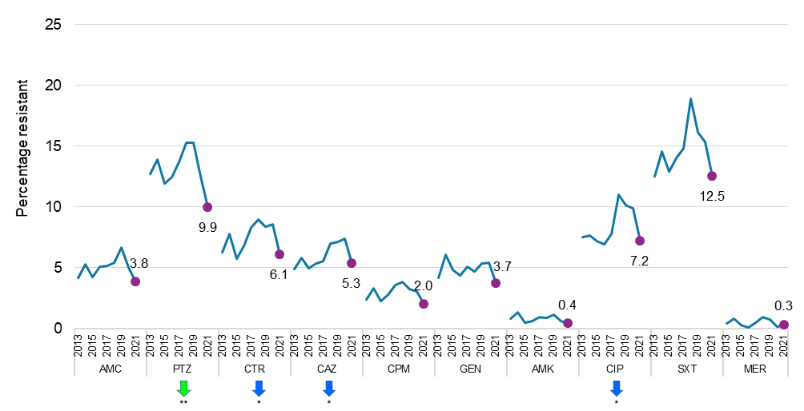

AMC = amoxicillin–clavulanic acid (2:1 ratio); AMK = amikacin; CAZ = ceftazidime; CIP = ciprofloxacin; CPM = cefepime; CTR = ceftriaxone; EUCAST = European Committee on Antimicrobial Susceptibility Testing; GEN = gentamicin; MER = meropenem; PTZ = piperacillin–tazobactam; SXT = trimethoprim–sulfamethoxazole

Notes:

1. Percentage resistance determined using EUCAST 2022 breakpoints for all years. Filled circles indicate values for 2021.
2. Green arrows indicate antimicrobial agents with significant decrease (*P* < 0.01, **) over the past five years (2017–2021).
3. Blue arrows indicate antimicrobial agents with significant decrease (0.01 < *P* < 0.05, *) over the past five years (2017–2021).

**By state and territory**

In 2021, fluoroquinolone resistance in *K. pneumoniae* complex, relative to 2020, declined in all states and territories, except Queensland and Western Australia (Table 51). The most notable decrease was in Victoria (17.7% in 2020; 7.3% in 2021; down 58.7%, *P* < 0.01). Third-generation cephalosporin resistance in 2021, relative to 2020, declined in all states and territories except New South Wales and remained stable in Western Australia (Table 52). The greatest decline was noted in Victoria (16.7% in 2020; 5.0% in 2021, down 70.0%; *P* < 0.01). Aminoglycoside resistance in 2021, relative to 2020, declined in all states and territories except in Queensland, South Australia, and Western Australia (Table 53). The greatest decline was noted in Victoria (11.0% in 2020;.6% in 2021, down 57.9%; *P* = 0.0127).

Over the past five years, Victoria was the only state with significantly decreasing trends in fluoroquinolone (Χ2 for linear trend = 14.23, *P* < 0.01), third-generation cephalosporin (Χ2 for linear trend = 20.10, *P* < 0.01), and aminoglycoside (Χ2 for linear trend = 19.85, *P* < 0.01) resistance in *K. pneumoniae* complex (Tables 48-50).

**Table 51:** *Klebsiella pneumoniae* complex, percentage resistant to fluoroquinolones (EUCAST) and number tested, state and territory, AGAR, 2013–2021

|  |  |  |  |  |  |  |  |  |  |  |
| --- | --- | --- | --- | --- | --- | --- | --- | --- | --- | --- |
|  | **Percentage resistant, (*n*) by year** | | | | | | | | | **Trend 2017–2021\*** |
| **State and territory** | **2013** | **2014** | **2015** | **2016** | **2017** | **2018** | **2019** | **2020** | **2021** |
| Western Australia | 4.8 (124) | 4.7 (149) | 5.9 (187) | 2.8 (181) | 6.3 (159) | 7.5 (186) | 5.0 (160) | 2.6 (189) | 3.9 (204) | ↔ |
| Australian Capital Territory | 4.5 (22) | 7.7 (26) | 5.7 (35) | 5.3 (38) | 7.7 (39) | 8.3 (36) | 8.3 (36) | 13.2 (38) | 4.3 (46) | ↔ |
| Tasmania | 7.1 (14) | 11.1 (9) | 5.6 (18) | 5.6 (36) | 0.0 (30) | 11.8 (34) | 7.8 (51) | 6.7 (30) | 4.5 (44) | ↔ |
| Northern Territory | 10.5 (19) | 16.1 (31) | 4.3 (47) | 2.6 (38) | 6.7 (30) | 13.5 (37) | 15.6 (45) | 16.2 (37) | 6.1 (33) | ↔ |
| Victoria | 12.4 (145) | 10.3 (174) | 11.9 (177) | 13.3 (180) | **17.6 (199)** | **24.3 (214)** | **17.0 (212)** | **17.7 (209)** | **7.3 (260)** | ▼** |
| Queensland | 5.8 (207) | 5.3 (208) | 6.3 (189) | 4.2 (189) | 6.1 (246) | 5.6 (270) | 5.2 (249) | 6.5 (185) | 8.0 (201) | ↔ |
| New South Wales | 3.5 (113) | 9.3 (205) | 7.2 (236) | 8.4 (226) | 5.5 (293) | 9.3 (301) | 10.4 (347) | 10.2 (371) | 8.6 (337) | ↔ |
| South Australia | 13.3 (75) | 5.4 (74) | 4.7 (85) | 7.4 (81) | 2.8 (71) | 8.8 (91) | 15.7 (89) | 9.9 (81) | 9.6 (114) | ↔ |
| Australia | 7.5 (719) | 7.6 (876) | 7.2 (974) | 6.9 (969) | 7.8 (1,067) | 11.0 (1,169) | 10.2 (1,189) | 9.9 (1,140) | 7.2 (1,239) | ↔ |

* Chi-square test for trend for past five years (2017–2021), bold text significant decrease ▼ (*P*< 0.01, **), ↔ no significant difference

Notes:

1. Percentage resistance determined using EUCAST 2022 breakpoints for all years.
2. Fluoroquinolones refer to ciprofloxacin.

**Table 52:** *Klebsiella pneumoniae* complex, percentage resistant to third-generation cephalosporins (EUCAST) and number tested, state and territory, AGAR, 2013–2021

|  |  |  |  |  |  |  |  |  |  |  |
| --- | --- | --- | --- | --- | --- | --- | --- | --- | --- | --- |
|  | **Percentage resistant, (*n*) by year** | | | | | | | | | **Trend 2017–2021\*** |
| **State and territory** | **2013** | **2014** | **2015** | **2016** | **2017** | **2018** | **2019** | **2020** | **2021** |
| Queensland | 6.3 (207) | 4.3 (208) | 3.7 (189) | 3.7 (189) | 3.7 (246) | 5.9 (270) | 4.4 (249) | 3.8 (185) | 2.5 (201) | ↔ |
| Western Australia | 4.0 (124) | 4.0 (149) | 3.7 (187) | 5.5 (181) | 5.7 (159) | 4.3 (186) | 4.4 (160) | 3.7 (189) | 3.9 (204) | ↔ |
| Australian Capital Territory | 0.0 (22) | 11.5 (26) | 2.9 (35) | 2.6 (38) | 10.3 (39) | 5.6 (36) | 11.1 (36) | 7.9 (38) | 4.3 (46) | ↔ |
| Tasmania | 7.1 (14) | 11.1 (9) | 5.6 (18) | 5.6 (36) | 3.3 (30) | 11.8 (34) | 7.8 (51) | 6.7 (30) | 4.5 (44) | ↔ |
| Victoria | 13.1 (145) | 10.9 (174) | 10.7 (177) | 13.9 (180) | **19.6 (199)** | **19.2 (214)** | **16.0 (212)** | **16.7 (210)** | **5.0 (260)** | ▼** |
| South Australia | 2.7 (75) | 4.1 (74) | 3.5 (85) | 7.4 (81) | 5.6 (72) | 9.9 (91) | 9.0 (89) | 7.4 (81) | 6.1 (114) | ↔ |
| New South Wales | 2.7 (113) | 12.1 (206) | 7.6 (236) | 9.7 (226) | 7.5 (293) | 8.9 (302) | 9.8 (348) | 9.4 (371) | 12.2 (337) | ↔ |
| Northern Territory | 15.8 (19) | 6.5 (31) | 6.4 (47) | 2.6 (38) | 6.7 (30) | 13.5 (37) | 15.6 (45) | 27.0 (37) | 15.2 (33) | ↔ |
| Australia | 6.4 (719) | 7.8 (877) | 6.1 (974) | 7.6 (969) | 8.4 (1,068) | 9.6 (1,170) | 9.2 (1,190) | 9.2 (1,141) | 6.7 (1,239) | ↔ |

* Chi-square test for trend for past five years (2017–2021), bold text significant decrease ▼ (*P*< 0.01, **), ↔ no significant difference

Notes:

1. Percentage resistance determined using EUCAST 2022 breakpoints for all years.
2. Third-generation cephalosporins refer to ceftriaxone or ceftazidime.

**Table 53:** *Klebsiella pneumoniae* complex, percentage resistant to aminoglycosides (EUCAST) and number tested, state and territory, AGAR, 2013–2021

|  |  |  |  |  |  |  |  |  |  |  |  |
| --- | --- | --- | --- | --- | --- | --- | --- | --- | --- | --- | --- |
|  | **Percentage resistant, (*n*) by year** | | | | | | | | | **Trend 2017–2021\*** | |
| **State and territory** | **2013** | **2014** | **2015** | **2016** | **2017** | **2018** | **2019** | **2020** | **2021** | |  |
| Tasmania | 7.1 (14) | 11.1 (9) | 11.1 (18) | 2.8 (36) | 3.3 (30) | 8.8 (34) | 5.9 (51) | 6.7 (30) | 0.0 (44) | | ↔ |
| Western Australia | 3.2 (124) | 2.7 (149) | 3.2 (187) | 5.0 (181) | 3.8 (159) | 3.8 (186) | 3.1 (160) | 2.1 (189) | 2.5 (204) | | ↔ |
| Queensland | 3.9 (207) | 4.3 (208) | 4.2 (189) | 3.7 (189) | 3.3 (246) | 3.0 (270) | 2.4 (249) | 2.7 (185) | 3.5 (201) | | ↔ |
| Australian Capital Territory | 0.0 (22) | 7.7 (26) | 2.9 (35) | 2.6 (38) | 7.7 (39) | 8.3 (36) | 11.1 (36) | 5.3 (38) | 4.3 (46) | | ↔ |
| Victoria | 11.0 (145) | 9.8 (174) | 7.9 (177) | 10.0 (180) | **15.6 (199)** | **18.7 (214)** | **14.2 (212)** | **11.0 (210)** | **4.6 (260)** | | ▼** |
| New South Wales | 2.7 (113) | 11.2 (206) | 8.1 (236) | 6.2 (226) | 5.5 (293) | 5.0 (302) | 9.5 (348) | 8.9 (371) | 5.9 (337) | | ↔ |
| South Australia | 5.3 (75) | 1.4 (74) | 5.9 (85) | 3.7 (81) | 4.2 (72) | 7.7 (91) | 7.9 (89) | 3.7 (81) | 6.1 (114) | | ↔ |
| Northern Territory | 15.8 (19) | 16.1 (31) | 10.6 (47) | 2.6 (38) | 6.7 (30) | 16.2 (37) | 13.3 (45) | 24.3 (37) | 9.1 (33) | | ↔ |
| Australia | 5.4 (719) | 7.1 (877) | 6.2 (974) | 5.6 (969) | **6.6 (1,068)** | **7.6 (1,170)** | **7.9 (1,190)** | **7.1 (1,141)** | **4.5 (1,239)** | | ▼* |

* Chi-square test for trend for past five years (2017–2021), bold text significant decrease ▼ (*P*< 0.01, **), ▼ (0.01 < *P*< 0.05, *), ↔ no significant difference

Notes:

1. Percentage resistance determined using EUCAST 2022 breakpoints for all years.
2. Aminoglycosides refer to gentamicin or tobramycin.

***Enterobacter cloacae* complex**

**National**

For *E. cloacae* complex, the percentage resistance to all key antimicrobials in 2021 was similar to 2020. There were no significant trends in resistance in *E. cloacae* complex over the past five-year period (Figure 22).

Figure 22: *Enterobacter cloacae* complex resistance to key antimicrobials (EUCAST), bloodstream isolates, AGAR, 2013–2021

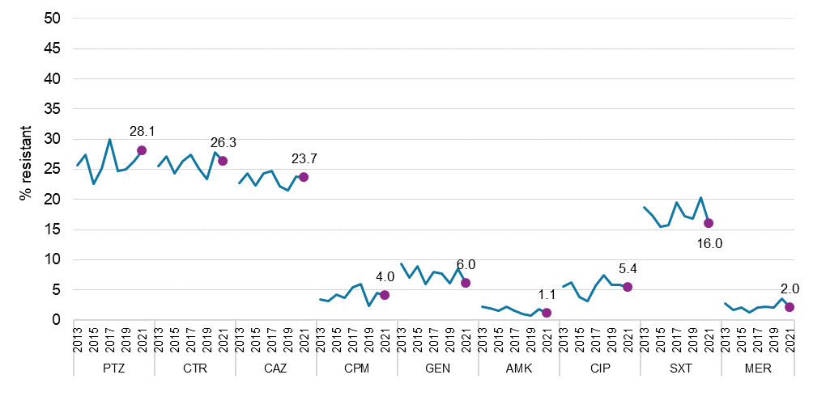

AMK = amikacin; CAZ = ceftazidime; CIP = ciprofloxacin; CPM = cefepime; CTR = ceftriaxone; EUCAST = European Committee on Antimicrobial Susceptibility Testing; GEN = gentamicin; MER = meropenem; PTZ = piperacillin–tazobactam; SXT = trimethoprim–sulfamethoxazole

Note: Percentage resistance determined using EUCAST 2022 breakpoints for all years. Filled circles indicate values for 2021.

**Extended-spectrum β-lactamases**

The frequency of *E. coli* with ESBL phenotypes increased from 8.4% in 2013 to 14.5% in 2018 and has remained at steady at 14% since 2019 (Figure 23). For *K. pneumoniae* complex, the frequency of ESBL phenotypes was lower than that observed among *E. coli* and increased from 6.8% in 2013 to 10% in 2018 to 2020, decreasing to 7.9% in 2021 (Figure 23).

ESBL-type β-lactamase genes (alone or with other genes) continue to be the dominate β-lactam resistance mechanism among *E. coli* and *K. pneumoniae* complex isolates with an ESBL phenotype, with considerable regional variation noted.

Overall, in the 2021 survey, there was little change in the proportion of *E. coli* with confirmed ESBL-types relative to 2020 (2020: 575/4842, 11.9%; 2021: 524/4873, 10.8% in 2021, down 9.4%). In *K. pneumoniae* complex, the proportion of confirmed ESBL types overall in 2021 declined by 31.1% relative to 2020 (2020: 76/1135, 6.7%; 2021: 57/1235, 4.6% in 2021). Victoria was the only state to have a significant decrease (2020: 22/208, 10.6%; 2021: 11/260, 4.2% in 2021, *P*= 0.0102).

Over the past five-year period, a significantly increasing trend in the proportion of *E. coli* with confirmed ESBL-types was seen overall (Χ2 for linear trend = 4.199, *P*= 0.0405), notably in South Australia (Χ2 for linear trend = 7.235, *P*< 0.01) (Figure 24); for *K. pneumoniae* complex isolates, Victoria had a significantly decreasing trend (Χ2 for linear trend = 21.52, *P*< 0.01) (Figure 25).

Figure 23: Nine-year trend in percent *Escherichia coli* and *Klebsiella pneumoniae* complex with extended spectrum β-lactamase phenotype, AGAR, 2013–2021

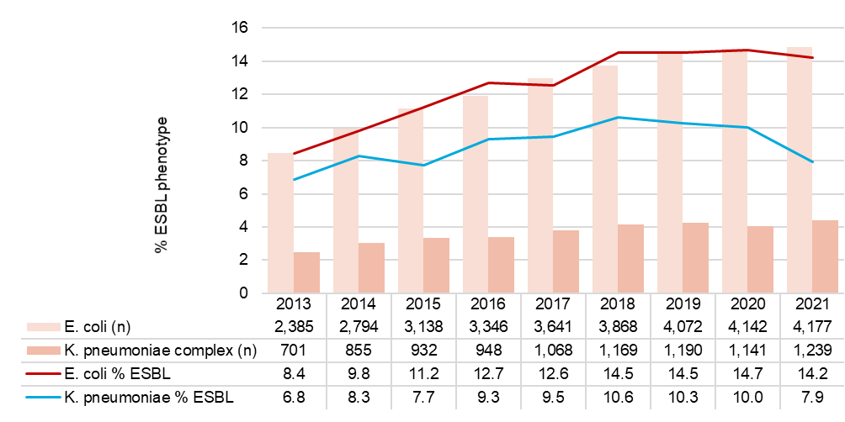

ESBL = extended-spectrum β-lactamase

Figure 24: Proportion of β-lactamase genes in *Escherichia coli* by state and territory, and nationally, AGAR, 2013–2021

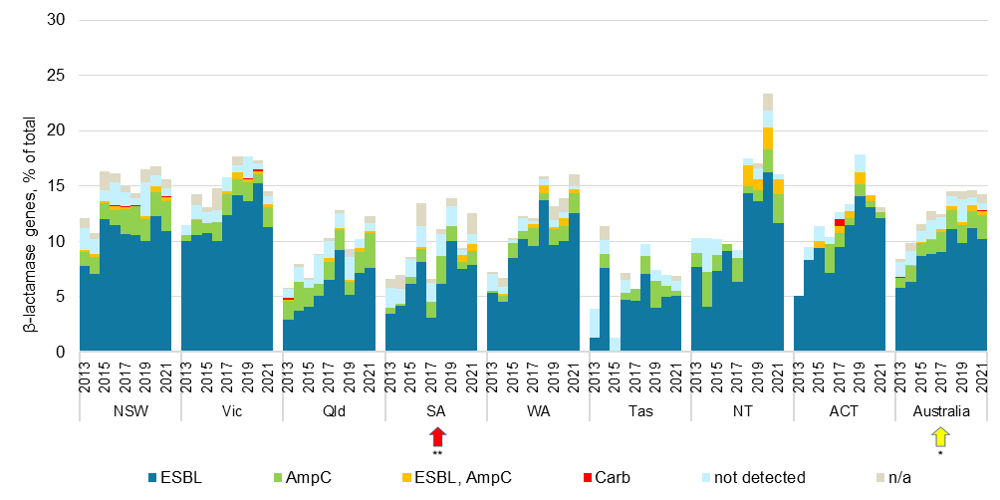

AmpC = plasmid-borne AmpC; Carb = carbapenemase; ESBL = extended spectrum β-lactamase; n/a = isolate not available for molecular confirmation

Notes:

1. β-lactamase genes (ESBL-types, AmpC, carbapenemase) detected among isolates with an ESBL phenotype.
2. Red arrows indicate states and territories with significant increase (*P* < 0.01, **) over the past five years (2017–2021).
3. Yellow arrows indicate states and territories with significant increase (0.01 < P < 0.05, *) over the past five years (2017–2021).

Figure 25: Proportion of β-lactamase genes in *Klebsiella pneumoniae* complex by state and territory, and nationally, AGAR, 2013–2021



AmpC = plasmid-borne AmpC; Carb = carbapenemase; ESBL = extended spectrum β-lactamase; n/a = isolate not available for molecular confirmation

Notes:

1. β-lactamase genes (ESBL-types, AmpC, carbapenemase) detected among isolates with an ESBL phenotype.
2. Green arrows indicate states and territories with significant decrease (*P* < 0.01, **) over the past five years (2017–2021).
3. Blue arrows indicate antimicrobial agents with significant decrease (0.01 < *P* < 0.05, *) over the past five years (2017–2021).

**Multi-drug resistance**

The frequency of MDR *E. coli* increased from 8.3% in 2013 to 11.1% in 2017, remained steady at 12% from 2018 to 2020, and decreased to 9.9% in 2021. It was highest among hospital-onset isolates (Figure 26).

For *K. pneumoniae* complex, the frequency of multi-drug resistance was more variable (Figure 27). For hospital-onset isolates, the highest frequency was observed from 2018 and 2019 (10.7%–11.2%). It fell sharply in 2020 to 5.4% and was 4.2% in 2021. There was little change in frequency among community-onset isolates; the lowest rate was observed in 2021 (2.6%), down from 4.4% in 2020.

Figure 26: Nine-year trend in percent multi-drug resistance among *Escherichia coli*, by onset, AGAR, 2013–2021

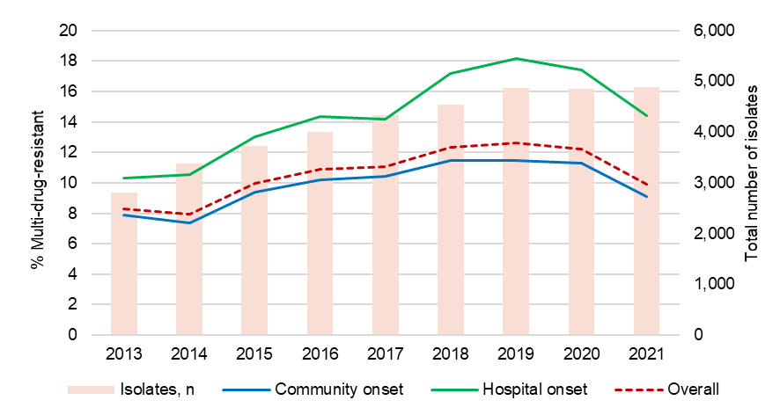

Notes:

1. Multi-drug resistance was defined as resistance to one or more agent in three or more antimicrobial categories.
2. Antimicrobial categories (agents) were aminoglycosides (gentamicin or tobramycin), carbapenems (meropenem), extended-spectrum cephalosporins (ceftriaxone or ceftazidime), fluoroquinolones (ciprofloxacin), and penicillins (ampicillin).

Figure 27: Nine-year trend in percent multi-drug resistance among *Klebsiella pneumoniae* complex by onset, AGAR, 2013–2021

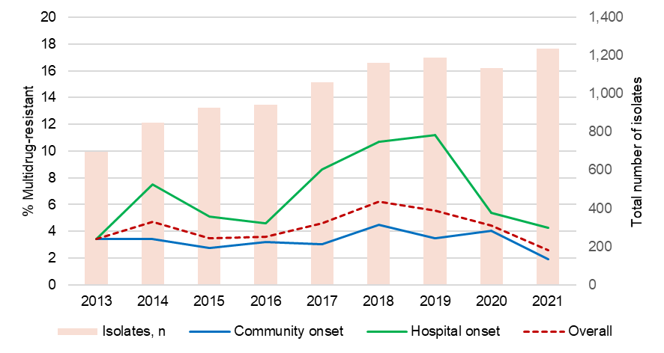

Notes:

1. Multi-drug resistance was defined as resistance to one or more agent in three or more antimicrobial categories.
2. Antimicrobial categories (agents) were aminoglycosides (gentamicin or tobramycin), carbapenems (meropenem), extended-spectrum cephalosporins (ceftriaxone or ceftazidime), fluoroquinolones (ciprofloxacin).

## *Staphylococcus aureus*

A primary objective of the ASSOP 2021 survey was to determine the proportion of SAB isolates demonstrating resistance to methicillin and other important anti-staphylococcal agents. The following sections describe the major trends observed for the period 2013 to 2021.

**Methicillin-resistant *Staphylococcus aureus***

The proportion of *S. aureus* that was methicillin-resistant throughout Australia remained stable over 2013 to 2021, although there were notable variations at state and territory level (Figure 28). Relative to 2020, there were no significant differences in the proportion of MRSA in the states and territories, except for South Australia (10.9% in 2020; 18.1% in 2021, *P* = 0266).

From 2017 to 2021, there was no significant trends either nationally or at state and territory level (Table 54).

**Figure 28:** Proportion of methicillin-resistant *Staphylococcus aureus*, by state and territory, and nationally, AGAR, 2013–2021

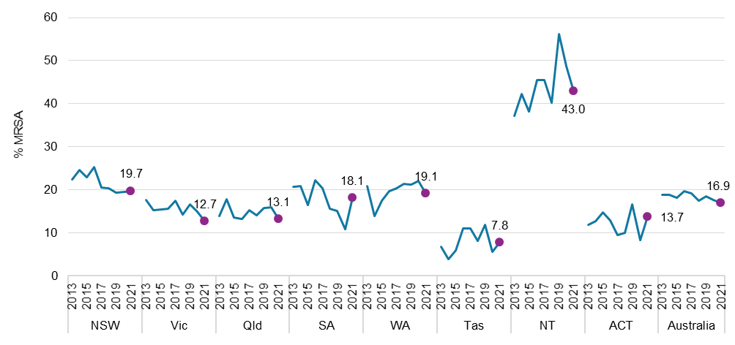

MRSA = methicillin-resistant *Staphylococcus aureus*

Notes:

1. Percentage resistance determined using EUCAST 2022 breakpoints for all years. Filled circles indicate values for 2021.
2. Number of contributors per year: *n* = 27 in 2013 and 2014; *n* = 36 in 2015; *n* = 35 in 2016; *n* = 41 in 2017 and 2018; *n* = 46 in 2019; *n* = 45 in 2020; *n* = 47 in 2021.

**Table 54:** *Staphylococcus aureus*, percentage resistant to methicillin (EUCAST) and number tested, state and territory, AGAR, 2013–2021

|  |  |  |  |  |  |  |  |  |  |  |
| --- | --- | --- | --- | --- | --- | --- | --- | --- | --- | --- |
|  | **Percentage resistant, (*n*) by year** | | | | | | | | | **Trend 2017–2021\*** |
| **State and territory** | **2013** | **2014** | **2015** | **2016** | **2017** | **2018** | **2019** | **2020** | **2021** |
| Tasmania | 6.8 (44) | 3.8 (52) | 5.9 (51) | 11.0 (109) | 11.0 (91) | 8.2 (110) | 11.9 (135) | 5.5 (127) | 7.8 (115) | ↔ |
| Victoria | 17.7 (373) | 15.3 (426) | 15.5 (407) | 15.6 (418) | 17.5 (365) | 14.3 (414) | 16.7 (546) | 15.0 (461) | 12.7 (615) | ↔ |
| Queensland | 13.8 (513) | 17.8 (550) | 13.5 (503) | 13.2 (494) | 15.2 (553) | 14.0 (571) | 15.8 (647) | 15.9 (473) | 13.1 (495) | ↔ |
| Australian Capital Territory | 11.8 (93) | 12.7 (79) | 14.8 (81) | 12.9 (101) | 9.5 (95) | 9.9 (111) | 16.5 (121) | 8.2 (97) | 13.7 (102) | ↔ |
| South Australia | 20.8 (236) | 20.9 (196) | 16.4 (262) | 22.3 (278) | 20.4 (167) | 15.6 (256) | 15.1 (238) | 10.9 (239) | 18.1 (232) | ↔ |
| Western Australia | 20.9 (311) | 13.9 (323) | 17.5 (394) | 19.6 (413) | 20.4 (466) | 21.4 (487) | 21.2 (499) | 22.1 (448) | 19.1 (513) | ↔ |
| New South Wales | 22.4 (459) | 24.7 (519) | 22.9 (590) | 25.3 (637) | 20.5 (679) | 20.4 (647) | 19.4 (907) | 19.5 (807) | 19.7 (770) | ↔ |
| Northern Territory | 37.1 (70) | 42.2 (64) | 38.2 (110) | 45.6 (90) | 45.5 (99) | 40.3 (77) | 56.3 (64) | 48.8 (82) | 43.0 (86) | ↔ |
| Australia | 18.8 (2,099) | 18.8 (2,209) | 18.1 (2,398) | 19.7 (2,540) | 19.1 (2,515) | 17.4 (2,673) | 18.5 (3,157) | 17.6 (2,734) | 16.9 (2,928) | ↔ |

* Chi-square test for trend for past five years (2017–2021), p-value < 0.5, ↔ no significant difference

Note: Percentage resistance determined using EUCAST 2022 breakpoints for all years.

Since 2013, there were significant increases in the proportion of CA-MRSA clones nationally (Χ2 for linear trend = 24.11, *P* < 0.01); notably in New South Wales, Western Australia and the Northern Territory (Figure 29). The proportion of HA-MRSA clones declined nationally (Χ2 for linear trend = 149.0, *P* < 0.01), in all states and territories with the exception of Tasmania.

**Figure 29:** Proportion of methicillin-resistant *Staphylococcus aureus*, by state and territory and association, AGAR, 2013–2021

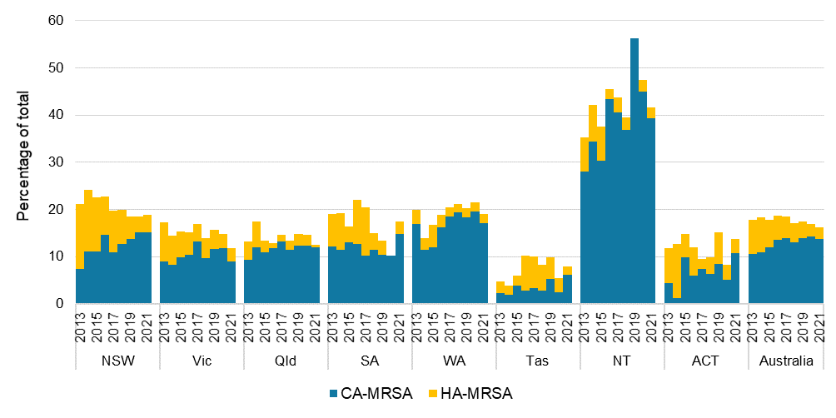

MRSA = methicillin-resistant *Staphylococcus aureus*; CA-MRSA = community-associated MRSA; HA‑MRSA = healthcare-associated MRSA

Relative to 2020, the percentage resistance to antimicrobial agents tested against MRSA in 2021 remained stable.

In 2021, one daptomycin-resistant MRSA isolate from Queensland was confirmed (MIC = 2 mg/L), however no known mutations or resistance genes could be found.

Rates of resistance in MRSA from 2017 to 2021 decreased for erythromycin (χ2 for linear trend = 14.74, *P*= < 0.01), clindamycin (inducible + constitutive resistance [χ2 for linear trend = 11.01, *P* < 0.01], and ciprofloxacin (χ2 for linear trend = 4.146, *P*= 0.0417) (Figure 30).

**Figure 30:** Methicillin-resistant *Staphylococcus aureus* resistance to key antimicrobials (EUCAST), AGAR, 2013–2021

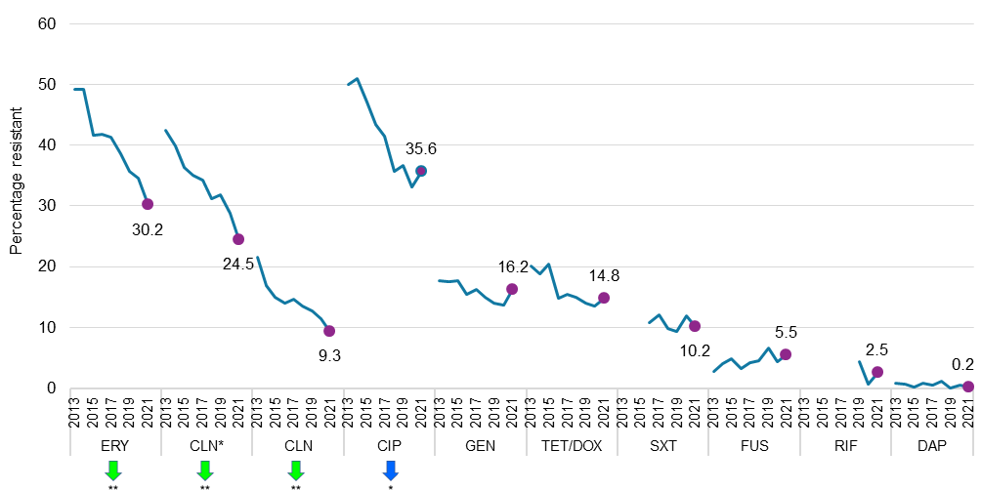

CIP = ciprofloxacin; CLN = clindamycin; CLN* = clindamycin (inducible and constitutive); DAP = daptomycin; ERY = erythromycin; EUCAST = European Committee on Antimicrobial Susceptibility Testing; FUS = fusidic acid; GEN = gentamicin; RIF = rifampicin; SXT = trimethoprim–sulfamethoxazole, TET/DOX = tetracyclines (tetracycline, Vitek®; doxycycline, and Phoenix™)

Notes:

1. Percentage resistance determined using EUCAST 2022 breakpoints for all years.
2. Green arrows indicate antimicrobial agents with significant decrease (*P* < 0.01, **) over the past five years (2017–2021).
3. Blue arrows indicate antimicrobial agents with significant decrease (0.01 < *P* < 0.05, *) over the past five years (2017– 2021).
4. Trimethoprim–sulfamethoxazole resistance (as determined by Vitek® or Phoenix™) was not confirmed by an alternative method in 2013 to 2015.
5. Rifampicin concentration on the Phoenix™ and one Vitek® card (AST-P612) restricts the ability to accurately determine susceptibility (EUCAST) from 2013 to 2018.

**Methicillin-susceptible *Staphylococcus aureus***

The percentage resistance for MSSA in 2021 was similar to 2020 for the antimicrobial agents tested, except for fusidic acid (3.0% in 2020, 2.1% in 2021, *P* = 0.0399) (Figure 31).

Rates of resistance in MSSA over the past five years increased for erythromycin (χ2 for linear trend = 12.32, *P* < 0.01), clindamycin (inducible + constitutive) (χ2 for linear trend = 14.08, *P* < 0.01), and gentamicin (χ2 for linear trend = 26.54, *P* < 0.01); and decreased for fusidic acid (χ2 for linear trend = 4.904, *P* = 0.0268) (Figure 31).

**Figure 31:** Methicillin-susceptible *Staphylococcus aureus* resistance to key antimicrobials (EUCAST), AGAR, 2013–2021

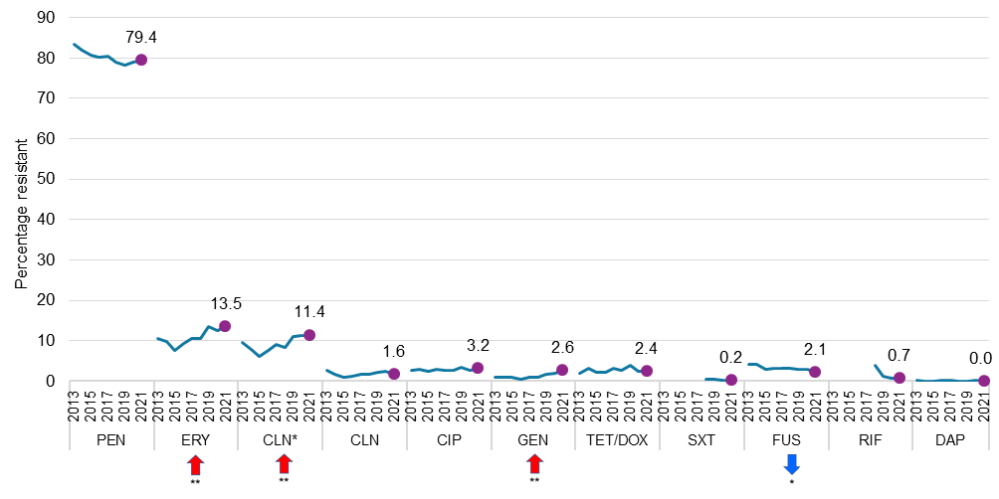

CIP = ciprofloxacin; CLN = clindamycin; CLN* = clindamycin (inducible + constitutive); DAP = daptomycin; ERY = erythromycin; EUCAST = European Committee on Antimicrobial Susceptibility Testing; FUS = fusidic acid; GEN = gentamicin; RIF = rifampicin; SXT = trimethoprim–sulfamethoxazole, TET/DOX = tetracyclines (tetracycline, Vitek®; doxycycline, Phoenix™)

Notes:

1. Percentage resistance determined using EUCAST 2022 breakpoints for all years.
2. Red arrows indicate antimicrobial agents with significant increase (*P* < 0.01, **) over the past five years (2017–2021).
3. Blue arrows indicate antimicrobial agents with significant decrease (0.01 < *P* < 0.05, *) over the past five years (2017–2021).
4. Trimethoprim–sulfamethoxazole resistance (as determined by Vitek® or Phoenix™) was not confirmed by an alternative method in 2013–2017.
5. Rifampicin concentration on the Phoenix™ and one Vitek® card (AST-P612) restricts the ability to accurately determine susceptibility (EUCAST) from 2013 to 2018.
6. International comparisons

Data from AGAR can be compared with data from the EARS-Net program, as both programs examine resistance in bacterial pathogens found in bloodstream infections.56

EARS-Net is based on routine clinical antimicrobial susceptibility data from local and clinical laboratories reported to the European Centre for Disease Prevention and Control by appointed representatives from the Member States. The data originate form national AMR surveillance initiatives and/or laboratory networks. Only data from invasive isolates (blood and cerebrospinal fluid) are included in EARS-Net.

Australia ranks in the top third in rates of resistance to vancomycin in *E. faecium* compared to all European countries (Figure 32), ranking eighth highest in 2021. In 2017, Australia was ranked first.

**Figure 32:** Comparison of *Enterococcus faecium* rates of resistance to vancomycin in Australia (AGAR) and European countries, blood culture isolates, 2017 and 2021

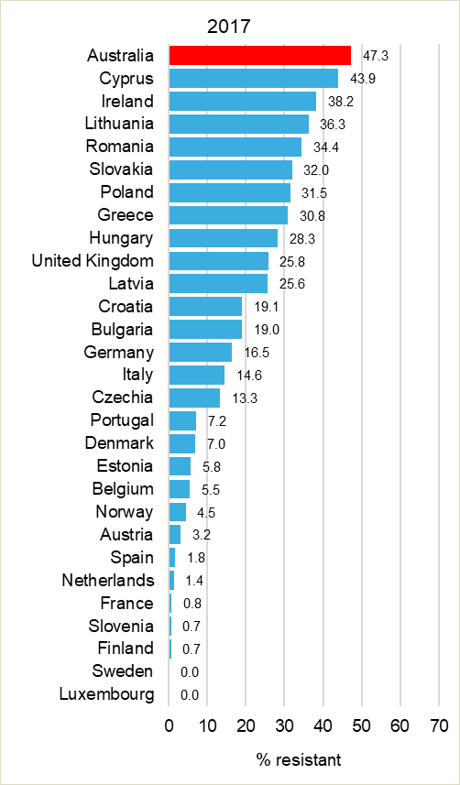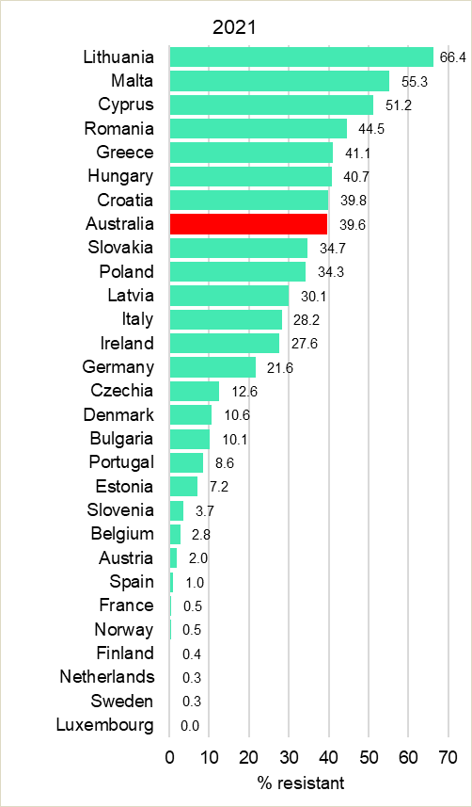

Note: European countries excludes the United Kingdom in 2021.

Source: European Centre for Disease Prevention and Control Surveillance Atlas – Antimicrobial resistance57

Rates of resistance to fluoroquinolone in *E. coli* and *K. pneumoniae* (represented by resistance to ciprofloxacin) remain low in Australia compared with most European countries (Figures 33 and 34). Australia ranked fifth lowest in rates of resistance to fluoroquinolones in *E. coli* compared with European countries in 2017 (14.4%), it was fourth lowest in 2021 (12.3%). For *K. pneumoniae*, Australia ranked the lowest in 2017 (7.8%); it was fourth lowest in 2021 (7.2%).

Australia now ranks towards the middle in rates of resistance to third-generation cephalosporins in *E. coli* compared to European countries (Figure 35). Third-generation cephalosporin resistance in *K. pneumoniae* is low by comparison (Figure 36).

**Figure 33:** Comparison of *Escherichia coli* rates of resistance to ciprofloxacin in Australia (AGAR) and European countries, blood culture isolates, 2017 and 2021

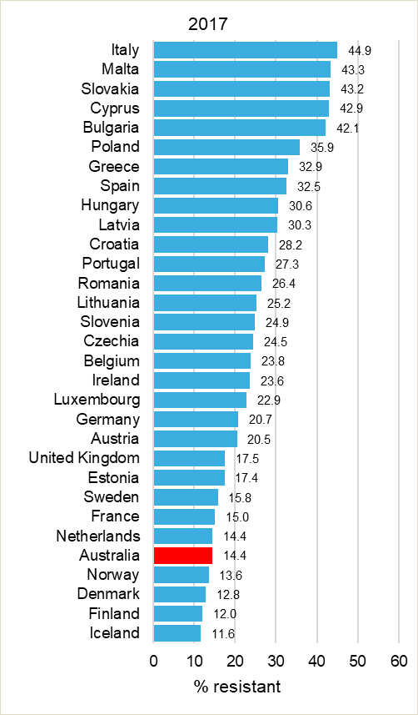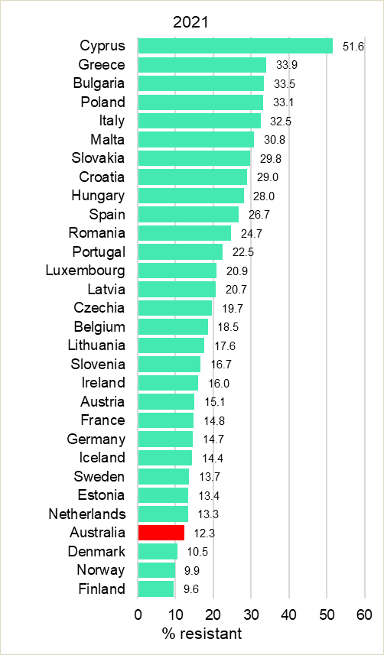

Note: European countries excludes the United Kingdom in 2021.

Source: European Centre for Disease Prevention and Control Surveillance Atlas – Antimicrobial resistance57

**Figure 34:** Comparison of *Klebsiella pneumoniae* rates of resistance to ciprofloxacin in Australia (AGAR) and European countries, blood culture isolates, 2017 and 2021

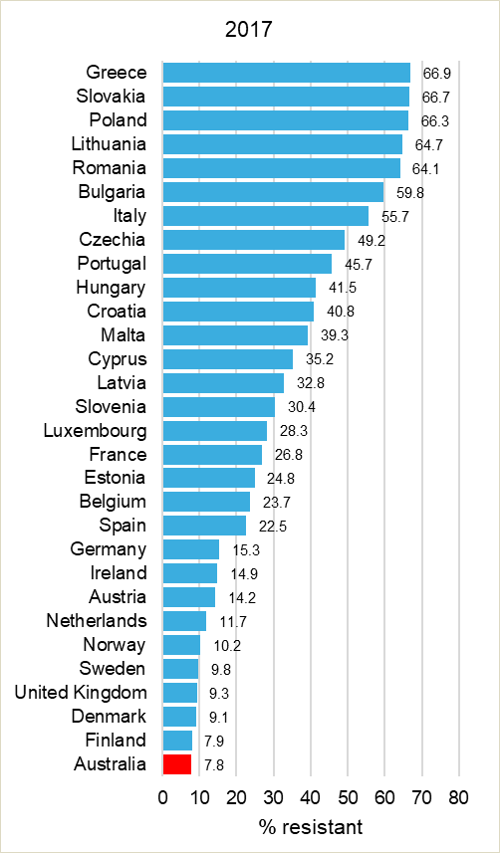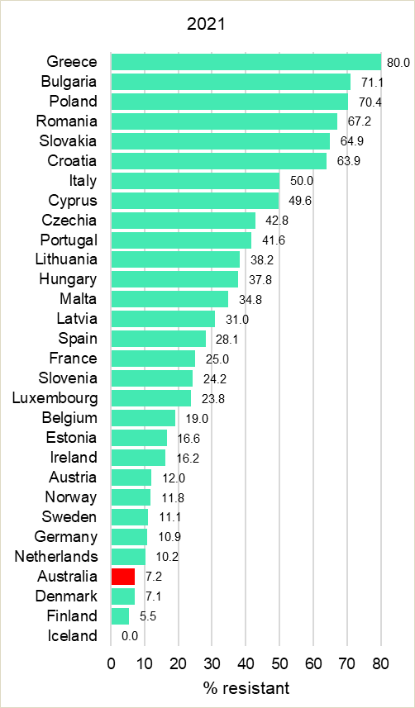

Note: European countries excludes the United Kingdom in 2021.

Source: European Centre for Disease Prevention and Control Surveillance Atlas – Antimicrobial resistance57

**Figure 35:** Comparison of *Escherichia coli* rates of resistance to third-generation cephalosporins in Australia (AGAR) and European countries, blood culture isolates, 2017 and 2021

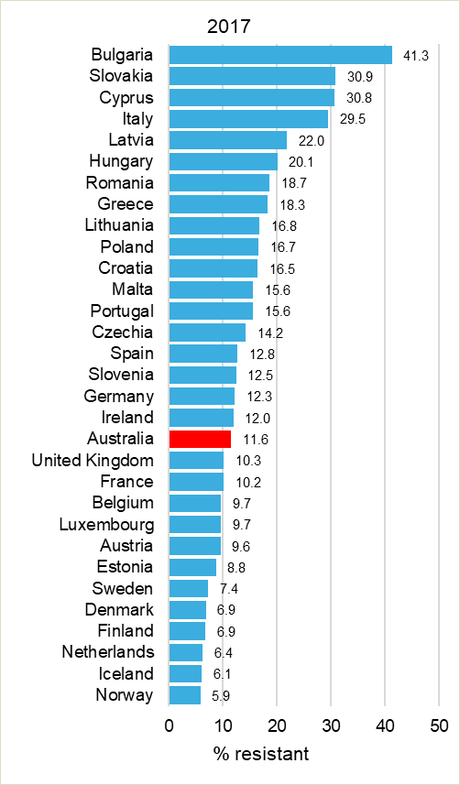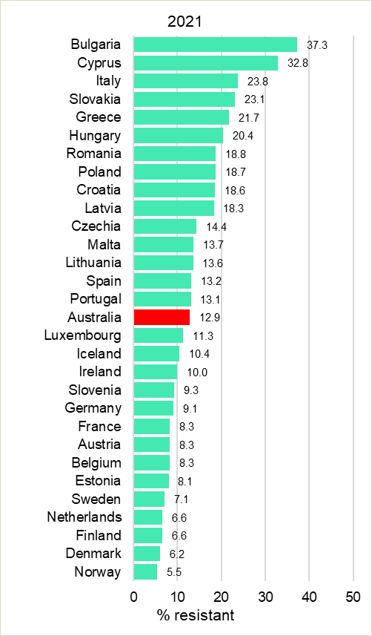

Note: European countries excludes the United Kingdom in 2021.

Source: European Centre for Disease Prevention and Control Surveillance Atlas – Antimicrobial resistance57

**Figure 36:** Comparison of *Klebsiella pneumoniae* rates of resistance to third-generation cephalosporins in Australia (AGAR) and European countries, blood culture isolates, 2017 and 2021

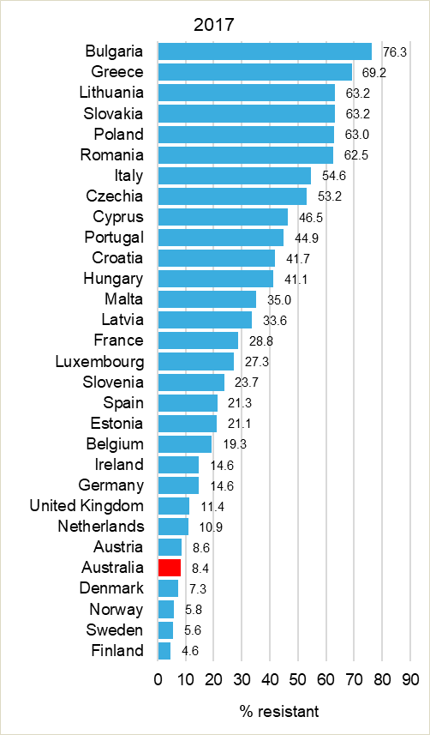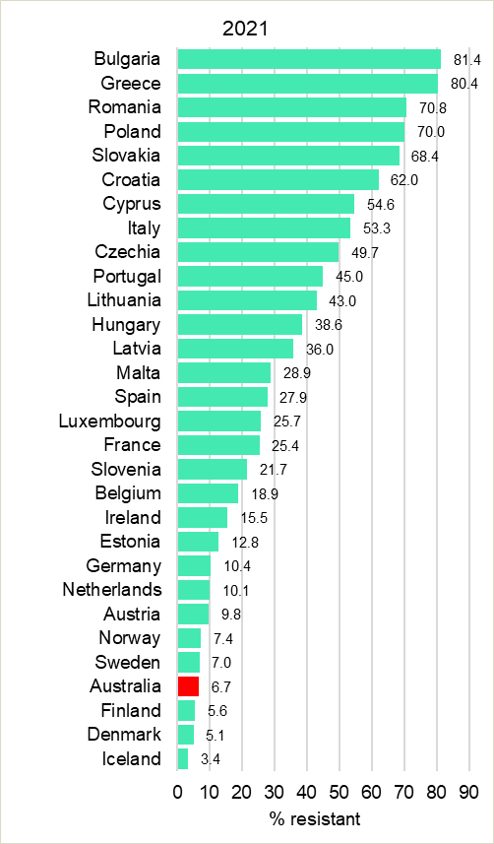

Note: European countries excludes the United Kingdom in 2021.

Source: European Centre for Disease Prevention and Control Surveillance Atlas – Antimicrobial resistance57

Australia ranks in the top third in rates of resistance to methicillin in *S. aureus* compared to all European countries (Figure 37).

**Figure 37:** Comparison of *Staphylococcus aureus* rates of resistance to methicillin in Australia (AGAR) and European countries, blood culture isolates, 2017 and 2021

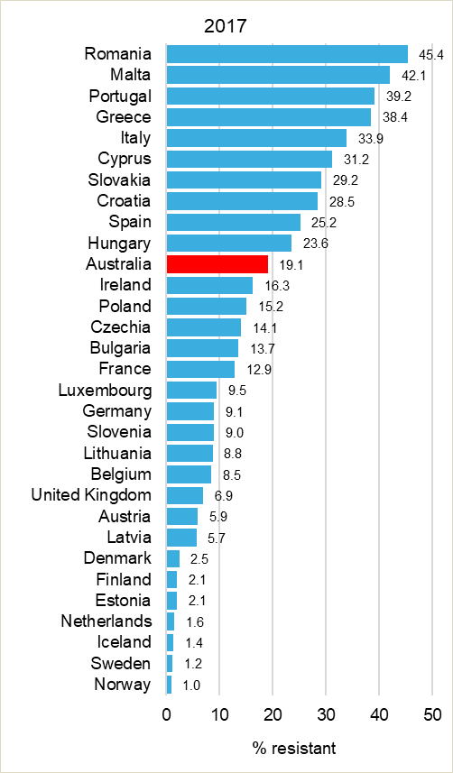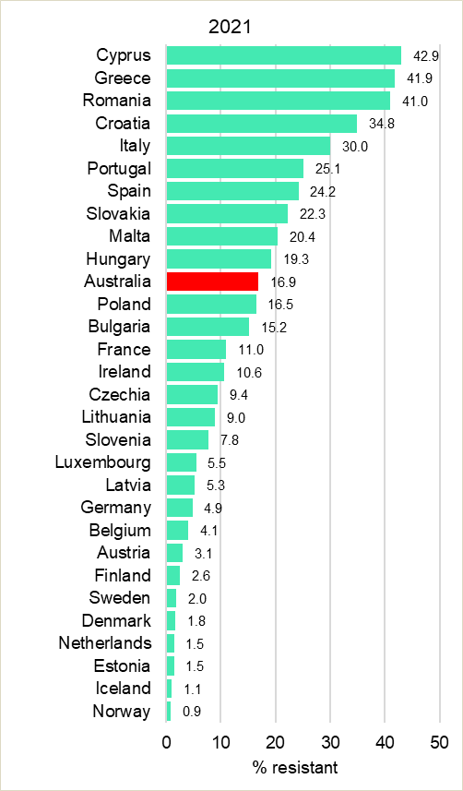

Note: European countries excludes the United Kingdom in 2021.

Source: European Centre for Disease Prevention and Control Surveillance Atlas – Antimicrobial resistance57

1. Limitations of the study

Although this study is considered comprehensive in its coverage of Australia, and the methods follow international standards, the data and their interpretation have a number of limitations:

* The data are not denominator controlled, and there is currently no consensus on an appropriate denominator for such surveys; hospital size, patient throughput, patient complexity and local antibiotic use patterns all influence the types of resistance that are likely to be observed
* Although data have been collected from 37 large hospitals and 11 regional or district hospitals from north-west Western Australia, it is not yet clear how representative the sample is of Australia as a whole, because the proportion of the population that is served by the laboratories that participate in AGAR is not accurately known. Further, it is likely that the proportion of the population served differs in each state and territory
* Because of the formulation of amoxicillin–clavulanic acid in the Vitek® cards used, interpretation using EUCAST guidelines for this agent was limited to data available from Phoenix™ cards. Only 10% of the laboratories used cards that contained the EUCAST formulation
* Concentration ranges of some antimicrobial agents in both the Vitek® and Phoenix™ cards limit the ability to accurately identify ‘susceptible’ for some combinations of antimicrobial agents and species
* Data are classified into hospital-onset and community-onset infections; healthcare-associated community-onset infections may be included in the community-onset group
* Association with relevant mobile genetic element/s (for example, plasmid/s) is not included in this report.

In 2021, methods used to screen referred GnSOP isolates for mechanisms of resistance changed as follows:

* All referred isolates, rather than a selected subset, underwent WGS

In 2021, the definition of antimicrobial categories for multi-drug resistance and antibiogram profiles was amended.

* Aminoglycoside category for *Enterobacterales* and *Acinetobacter* species includes only gentamicin and tobramycin. For *P. aeruginosa*, only tobramycin was included
* Third-generation cephalosporin category refers to ceftriaxone or ceftazidime.

1. Discussion and conclusions

AGAR data show that in 2021, episodes of bacteraemia in Australia had their onset overwhelmingly in the community, for *Enterobacterales*, *P. aeruginosa*, and *E. faecalis* episodes. In 2021, biliary and non-biliary intra-abdominal infections and febrile neutropenia, were the most common clinical manifestations associated with *E. faecium*. However, episodes where there was no detected focus and setting also contributed to high proportions of presentations for enterococcal bacteraemia overall, and for each of *E. faecalis* and *E. faecium*. For *S. aureus*, the most frequent principal clinical manifestations were osteomyelitis/septic arthritis, skin and skin structure and intravascular devices. Strategies to reduce bloodstream infections should take this information on clinical manifestation (sources of bacteraemia) into account and in healthcare, continue to have a focus on the prevention of intravascular device associated infections. With *E. coli* bloodstream infections, associations with indwelling urinary devices such as urinary catheters, appears to common and an increasing problem.

AGAR data show a longitudinal trend of increasing *E. coli* resistance to key anti-gram-negative antimicrobial agents, such as ceftriaxone and ciprofloxacin.31, 58 Resistance to both agents stabilised in 2018 to 2020 (ceftriaxone 13.3%–13.4% in 2020; ciprofloxacin 15.2%–16.1% in 2020); in 2021 the level of resistance declined substantially to 12.5% and 12.3%, respectively. The steady rise in resistance to fluoroquinolones is more striking in hospital-onset bacteraemia, with a change from 13.7% to 19.8% between 2013 and 2018, to 21.3% in 2019, and to 21.8% in 2020, and then falling to 16.7% in 2021. In *K. pneumoniae* complex, rates of resistance to ciprofloxacin were lower than for *E. coli,* 7.2% in 2021, and overall lower than 9.9% seen in 2020.

Ciprofloxacin resistance rates in *E. coli* have risen markedly over the last 10 years. A little over a decade ago, ciprofloxacin resistance rates were very low and consistently between 1% and 4%.31, 58 Despite this concerning recent increase (16.7% in 2021), the percentage of fluoroquinolone-resistant *E. coli* in Australia remains low in comparison to most European countries.11, 57 Because fluoroquinolone resistance is often linked to cephalosporin resistance caused by ESBLs of the CTX-M type, fluoroquinolone use alone may not be solely responsible for the increase. It is possible that the high use of oral cephalosporins in the community is driving this resistance.

Compared to 2020, there was little change in 2021 in the proportion of *E. coli* with an ESBL phenotype (714/4867, 14.7% in 2020; 698/4912, 14.2% in 2021). For *K. pneumoniae* complex, the proportion with an ESBL phenotype fell (114/1141, 10.0% in 2020; 98/1238, 7.9% in 2021). A substantial majority of ESBL-producing *E. coli* bacteraemias were community-onset (546/698, 78.2%). This indicates that a substantial reservoir of resistance exists in the community, known to be particularly in the elderly population and in long-term residential care settings.9 If the rate continues to rise, it will potentially affect the application of therapeutic guidelines for empirical treatment of severe infections. Current Australian guidelines recommend third-generation cephalosporins for empirical treatment for many conditions, partly to minimise prescribing of even broader-spectrum antimicrobials, especially carbapenems. The AGAR data suggest that customised patient risk assessment may be required in empirical treatment decisions. In *E. coli* rates of resistance to ceftriaxone in hospital-onset bacteraemia rose from 13.0% in 2016 to 20.2% in 2019, to 18.8% in 2020 and to 17.8% in 2021. Community-onset ceftriaxone resistance has remained steady (11.1% in 2016; 11.9% in 2019; 12.4% in 2020; 11.5% in 2021).

To date, CPE remain uncommon (<0.1% in *E. coli* and 0.5% in *K. pneumoniae* complex). The overall low rates of CPE bacteraemia are encouraging; however, some organisms harbour them more commonly; 1.8% of *E. cloacae* complex infections harboured a carbapenemase (2.6% hospital-onset; 1.2% community-onset) in 2021. Examining previous and current AGAR surveys, most CPEs are endemic in origin.59, 60 Twelve of the 17 CPEs had *bla*IMP-4, reported predominately from New South Wales (8/12, 47.4%). Thirteen hospitals had at least one isolate with a carbapenemase gene. This reinforces the importance of infection prevention and control programs and adherence to carbapenemase management guidelines to limit transmission of CPE.7 One *bla*KPC-2 was reported, the first since the 2018 survey.

The only *mcr* genes detected in isolates referred for WGS (*n* = 1,163) were *mcr-9* or *mcr-10*. *mcr-9* has recently been found among several species of *Enterobacterales*. It is not associated with a colistin-resistant phenotype52, but is typically found on HI2 plasmids that may carry carbapenemase genes.53, 54

*E. faecium* bacteraemia has significant clinical consequences and resource implications, due to increased length of hospital stay. Bacteraemia episodes contributed to increased length of hospital stay; the average length of stay in all Australian public hospitals in 2020–21 was 5.5 days.61 Thirty-day all-cause mortality due to *E. faecium* in 2021 was 25.2% (community-onset 25.4%; hospital-onset 25.4%); there was a significant difference in 30-day all-cause mortality between vancomycin-susceptible and resistant episodes (21.3% and 31.0%, respectively, *P* = 0.0267). The 30-day all-cause mortality associated with *E. coli* and methicillin-resistant *S. aureus* hospital-onset infections (13.3% and 22.5%, respectively) exceeds community-onset infections (9.8% and 12.9% respectively).

In the 2021 survey, 39.6% of *E. faecium* harboured *vanA* or *vanB* genes; in 2020 it was 35.2%. Vancomycin, which until recently was the mainstay of therapy for *E. faecium*, can no longer be recommended empirically; agents with less certain efficacy but much lower resistance rates, such as linezolid are the alternative.

For almost two decades, and unlike in most other countries where vancomycin resistance is a problem, vancomycin resistance in Australia has been dominated by the *vanB* genotype. However, in the 2018 survey, 48.8% of vancomycin-resistant *E. faecium* bacteraemias were due to *vanA*; increasing from 6.1% in 2013. Since 2017, *vanA* genotype has remained around 50% (52.7% in 2018; 48.2% in 2019), in 2020 it fell to 36.3%; it was 35.8% in 2021. This type of vancomycin resistance has emerged rapidly in the past seven years, particularly in New South Wales and the Australian Capital Territory, where it is now the dominant genotype. This in turn has reduced the overall teicoplanin susceptibility of *E. faecium* in Australia.

The percentage of *E. faecium* bacteraemia isolates that are resistant to vancomycin in Australia is higher than that seen in almost all European countries. In 2020, the European Union (EU) and European Economic Area (EEA) population-weighted mean percentage was 16.8%.11 Australia ranks in the top third in rates of resistance to vancomycin in *E. faecium* (39.6%) compared to all European countries, ranking eighth highest. In 2020, it was ranked 10th highest, and in 2019, fourth highest.57

Although infection prevention and control strategies are essential for control of this organism, many antimicrobials have been implicated in the development of vancomycin non-susceptible *E. faecium.* Vancomycin used commonly as an empiric therapeutic choice for MRSA, and other broad-spectrum antibiotics which select for enterococci due to intrinsic resistance, especially the third-generation cephalosporins, are widely used in Australia.

AGAR data show that in 2021, episodes of staphylococcal bacteraemia in Australia had their onset overwhelmingly in the community (78.4%). The most frequent principal clinical manifestations were osteomyelitis/septic arthritis and skin and skin structure infections. Strategies to reduce bloodstream infections should take this information on clinical manifestation (sources of bacteraemia) into account. In hospital-onset and other healthcare-associated infections, intravascular devices remain a common source for bloodstream infections.

The overall rates of MRSA fell slightly from 17.6% in 202062 to 16.9% in the 2021 study. This compares with the 2020 EU/EEA population-weighted mean MRSA percentage of 16.7%.11

The rate of community-onset SABs that are methicillin-resistant has remained steady. CA-MRSA clones are an increasing source of hospital-onset bacteraemia (particularly ST93‑IV, ST45‑V, and ST5‑IV). While HA-MRSA strain are decreasing significantly, HA-MRSA, in particular ST22-IV, were more frequently found in community-onset bacteraemia. The molecular characterisation of MRSA contained within this report aids in identifying opportunities for prevention and control of MRSA bacteraemia in the Australian setting.

The rapidly changing picture of MRSA in Australia, drawing from 15 years of AGAR surveillance, is further explored in *Methicillin-resistant* Staphylococcus aureus *in Australia. MRSA bacteraemia – 2013 to 2018*.55 This technical paper will be updated as appropriate by AGAR and the Commission to provide further information on the issue.

In this survey, multi-drug resistance did not appear to play a contributory role in the rates of 30-day all-cause mortality for *E. coli* (hospital-onset), *K. pneumoniae* complex, *E. cloacae* complex, *P. aeruginosa* or *S. aureus* bacteraemia. Mortality rates for community-onset *E. coli* were significantly higher for MDR (12.7%) than non-MDR isolates (9.3%).

It should be noted that outbreaks of MDR organisms occur in hospitals and other institutional care settings, and substantial transmission occurs before invasive bloodstream infections develop. AGAR data may therefore underestimate local or regional spread of MDR organisms and may not assist with early detection of sentinel resistances, such as certain CPEs. AGAR surveillance data need to be assessed with other sources of information to provide broader insights into antimicrobial resistance in Australia. The AURA Surveillance System enables these assessments via Australian Passive AMR Surveillance (APAS) and National Alert System for Critical Antimicrobial Resistances (CARAlert) data, which complement AGAR data.

The impact of COVID-19 on antimicrobial resistance remains unclear and may be influenced by a number of contributing factors. A combination of COVID-19-related travel restrictions on incoming travellers throughout much of 2020 and 2021, and an increasing awareness of and utilization of antimicrobial stewardship as part of the National Safety and Quality Health Service Standards1 implementation and accreditation Australia-wide, may have reduced some resistance, particularly for ESBLs.

Pharmaceutical Benefits Scheme (PBS) data indicate that the COVID-19 pandemic had a profound impact on antimicrobial use in 2020, with a 40% drop in antimicrobials dispensed between March and April in 2020, with use remaining at this lower level for the rest of the year.59 It is also possible that PBS policy changes (effective from 1 April 2020) contributed to this drop, as repeat prescriptions and maximum quantities were restricted for the five most com­monly dispensed antimicrobials: amoxicillin, amoxicillin–clavulanic acid, cefalexin, doxycycline and roxithromycin. In 2020, there was also a change in policy to stop repeats on key antibiotics.63

It is also possible that a reduction in elective surgery and, related to this, in post-surgical bloodstream infections, may have occurred during 2020 and 2021.

AGAR surveillance remains core to informing Australia’s response to the problem of increasing AMR and contribute to understanding AMR in Australian human health settings, and internationally through annual contribution of data on five pathogens from blood (*S. aureus*, *K. pneumoniae*, *E. coli*, *Acinetobacter* species and *Salmonella* species) to GLASS.

# Abbreviations

|  |  |
| --- | --- |
| Abbreviation | Term |
| AESOP | Australian Enterococcal Surveillance Outcome Program |
| AGAR | Australian Group on Antimicrobial Resistance |
| AMR | antimicrobial resistance |
| AMS | antimicrobial stewardship |
| APAS | Australian Passive AMR Surveillance |
| ASA | Australian Society for Antimicrobials |
| ASSOP | Australian *Staphylococcus aureus* Surveillance Outcome Program |
| AURA | Antimicrobial Use and Resistance in Australia |
| CA-MRSA | community-associated methicillin-resistant *Staphylococcus aureus* |
| CARAlert | National Alert System for Critical Antimicrobial Resistances |
| CI | confidence interval |
| CLSI | Clinical and Laboratory Standards Institute |
| CO | community-onset |
| EARS-Net | European Antimicrobial Resistance Surveillance Network |
| ECOFF | epidemiological cut-off value |
| ESBL | extended-spectrum β-lactamase |
| EUCAST | European Committee on Antimicrobial Susceptibility Testing |
| GLASS | Global Antimicrobial Resistance and Use Surveillance System |
| GnSOP | Gram-negative Surveillance Outcome Program |
| HA-MRSA | healthcare-associated methicillin-resistant *Staphylococcus aureus* |
| HO | hospital-onset |
| MDR | multidrug-resistant |
| MIC | minimum inhibitory concentration |
| MLST | multi-locus sequence type |
| MRSA | methicillin-resistant *Staphylococcus aureus* |
| MSSA | methicillin-susceptible *Staphylococcus aureus* |
| NSQHS | National Safety and Quality Health Service |
| PCR | polymerase chain reaction |
| PMQR | plasmid mediated quinolone resistance |
| QRDR | quinolone-resistant determining region |
| RMT | ribosomal methyltransferase |
| SAB | *Staphylococcus aureus* bacteraemia |
| WGS | whole genome sequencing |
| WHO | World Health Organization |

Acknowledgements

Participating members of AGAR in 2021:

|  |  |
| --- | --- |
| Institution | AGAR members |
| Alfred Hospital, Vic | Adam Jenney and Jacqueline Williams |
| Alice Springs Hospital, NT | James McLeod |
| Austin Hospital, Vic | Marcel Leroi and Elizabeth Grabsch |
| Canberra Hospital, ACT | Peter Collignon and Susan Bradbury |
| Children's Hospital Westmead, NSW | Alison Kesson and Andrew Jarrett |
| Concord Hospital, NSW | Thomas Gottlieb and John Huynh |
| John Hunter Hospital, NSW | Hemalatha Varadhan and Bree Harris |
| Joondalup Hospital, WA | Shalinie Perera and Ian Meyer |
| Launceston General Hospital, Tas | Pankaja Kalukottege and Kathy Wilcox |
| Liverpool Hospital, NSW | Michael Maley and Helen Ziochos |
| Monash Children’s Hospital, Vic | Tony Korman and Despina Kotsanas |
| Monash Health (Dandenong Hospital), Vic | Tony Korman and Kathryn Cisera |
| Monash Health (Monash Medical Centre), Vic | Tony Korman and Despina Kotsanas |
| Nepean Hospital, NSW | James Branley and Linda Douglass |
| Pathology Queensland Central Laboratory, Qld | Graeme Nimmo and Narelle George |
| Pathology Queensland Gold Coast University Hospital, Qld | Petra Derrington and Cheryl Curtis |
| Pathology Queensland Prince Charles Hospital, Qld | Robert Horvath and Laura Martin |
| Pathology Queensland Princess Alexandra Hospital, Qld | Naomi Runnegar and Joel Douglas |
| PathWest Laboratory Medicine – north-west regional WA | Michael Leung |
| PathWest Laboratory Medicine – WA, Fiona Stanley Hospital | Denise Daley |
| PathWest Laboratory Medicine – WA, Perth Children’s Hospital | Chris Blyth |
| PathWest Laboratory Medicine – WA, Queen Elizabeth II Medical Centre | Ronan Murray and Jacinta Bowman |
| PathWest Laboratory Medicine – WA, Royal Perth Hospital | Owen Robinson and Geoffrey Coombs |
| Royal Darwin Hospital, NT | Rob Baird and Jann Hennessy |
| Royal Hobart Hospital, Tas | Louise Cooley and David Jones |
| Royal Melbourne Hospital, Vic | Katherine Bond and Rose Cotronei |
| Royal North Shore Hospital, NSW | Angela Wong |
| Royal Women’s Hospital, Vic | Andrew Daley and Gena Gonis |
| SA Pathology, Flinders Medical Centre, SA | Kelly Papanaoum and Xiao Chen |
| SA Pathology, Royal Adelaide Hospital, SA | Morgyn Warner and Kija Smith |
| SA Pathology, Women’s and Children’s Hospital, SA | Morgyn Warner and Kija Smith |
| St John of God Hospital, Murdoch, WA | Sudha Pottumarthy-Boddu and Jacqueline Foster |
| St Vincent’s Hospital, Melbourne, Vic | Amy Crowe and Lisa Brenton |
| St Vincent’s Hospital, Sydney, NSW | David Lorenz |
| Sullivan Nicolaides Pathology, Qld | Jennifer Robson and Marianne Allen |
| Sydney Children’s Hospital, NSW | Monica Lahra and Peter Huntington |
| Westmead Hospital, NSW | Jon Iredell and Andrew Ginn |
| Wollongong Hospital, NSW | Peter Newton and Melissa Hoddle |

**Reference laboratories**

AGAR gratefully acknowledges the Antimicrobial Resistance Laboratory, Microbial Genomics Reference Laboratory, Centre for Infectious Diseases and Microbiology Laboratory Services (CIDMLS), Institute of Clinical Pathology and Medical Research (ICPMR), Westmead Hospital [Jenny Draper, Elena Martinez and Andrew Ginn] for performing whole genome sequencing on the referred isolates.

AGAR also gratefully acknowledges Dr Shakeel Mowlaboccus and Princy Shoby at the Antimicrobial Resistance and Infectious Disease Research Laboratory, Murdoch University, Western Australia for performing the whole genome sequencing on *E. faecium* and MRSA isolates.

**Funding**

The AGAR Surveillance Outcome Programs are funded by the Australian Government Department of Health and Aged Care.

# References

1. Australian Commission on Safety and Quality in Health Care. National Safety and Quality Health Service Standards. 2nd ed. - version 2. [Internet] Sydney: ACSQHC; 2021 Available from: <https://www.safetyandquality.gov.au/publications-and-resources/resource-library/national-safety-and-quality-health-service-standards-second-edition>.

2. Chen LF, Freeman JT, Nicholson B, Keiger A, Lancaster S, Joyce M, et al. Widespread dissemination of CTX-M-15 genotype extended-spectrum-β-lactamase-producing enterobacteriaceae among patients presenting to community hospitals in the southeastern United States. Antimicrob Agents Chemother. 2014;58(2):1200-1202.

3. Woodford N, Ward ME, Kaufmann ME, Turton J, Fagan EJ, James D, et al. Community and hospital spread of *Escherichia coli* producing CTX-M extended-spectrum β-lactamases in the UK. J Antimicrob Chemother. 2004;54(4):735-743.

4. Xia S, Fan X, Huang Z, Xia L, Xiao M, Chen R, et al. Dominance of CTX-M-type extended-spectrum β-lactamase (ESBL)-producing *Escherichia coli* isolated from patients with community-onset and hospital-onset infection in China. PLoS One. 2014;9(7):e100707.

5. Stuart RL, Kotsanas D, Webb B, Vandergraaf S, Gillespie EE, Hogg GG, et al. Prevalence of antimicrobial-resistant organisms in residential aged care facilities. Med J Aust. 2011;195(9):530-533.

6. National Health and Medical Research Council. Australian Guidelines for the Prevention and Control of Infection in Healthcare (2019). Canberra: NHMRC; 2019.

7. Australian Commission on Safety and Quality in Health Care. Recommendations for the control of carbapenemase-producing *Enterobacterales* (CPE). A guide for acute care health service organisations. Sydney: ACSQHC, 2021.

8. Australian Commission on Safety and Quality in Health Care. Management of Peripheral Intravenous Catheters Clinical Care Standard. Sydney: ACSQHC, 2021.

9. Australian Commission on Safety and Quality in Health Care. Australian Passive Antimicrobial Resistance Surveillance. First report: multi-resistant organisms. Sydney: 2018.

10. Australian Commission on Safety and Quality in Health Care. Australian Passive Antimicrobial Resistance Surveillance - third-generation cephalosporin resistance in *Escherichia coli* and *Klebsiella* *pneumoniae*: prevalence of extended-spectrum β-lactamase (ESBL) phenotype. Sydney: 2022.

11. European Centre for Disease Prevention and Control. Antimicrobial resistance in the EU/EEA (EARS-Net) - Annual Epidemiological Report 2020. Stockholm: ECDC, 2022 July 2022. Report No.

12. Antibiotic Expert Groups. Therapeutic guidelines: antibiotic. Melbourne: Therapeutic Guidelines Limited; 2021.

13. Australian Commission on Safety and Quality in Health Care. Priority Antibacterial List for antimicrobial resistance containment: a stewardship resource for human health. [Internet] Sydney: ACSQHC; 2020 [cited 2022 May 5] Available from: <https://www.safetyandquality.gov.au/publications-and-resources/resource-library/priority-antibacterial-list-antimicrobial-resistance-containment>.

14. Diekema DJ, Hsueh PR, Mendes RE, Pfaller MA, Rolston KV, Sader HS, et al. The Microbiology of Bloodstream Infection: 20-Year Trends from the SENTRY Antimicrobial Surveillance Program. Antimicrob Agents Chemother. 2019;63(7).

15. Pinholt M, Ostergaard C, Arpi M, Bruun NE, Schonheyder HC, Gradel KO, et al. Incidence, clinical characteristics and 30-day mortality of enterococcal bacteraemia in Denmark 2006-2009: a population-based cohort study. Clin Microbiol Infect. 2014;20(2):145-151.

16. Murray BE. The life and times of the Enterococcus. Clin Microbiol Rev. 1990;3(1):46-65.

17. Simonsen GS, Smabrekke L, Monnet DL, Sorensen TL, Moller JK, Kristinsson KG, et al. Prevalence of resistance to ampicillin, gentamicin and vancomycin in *Enterococcus faecalis* and *Enterococcus faecium* isolates from clinical specimens and use of antimicrobials in five Nordic hospitals. J Antimicrob Chemother. 2003;51(2):323-331.

18. Treitman AN, Yarnold PR, Warren J, Noskin GA. Emerging incidence of *Enterococcus faecium* among hospital isolates (1993 to 2002). J Clin Microbiol. 2005;43(1):462-463.

19. Boucher HW, Talbot GH, Bradley JS, Edwards JE, Gilbert D, Rice LB, et al. Bad bugs, no drugs: no ESKAPE! An update from the Infectious Diseases Society of America. Clin Infect Dis. 2009;48(1):1-12.

20. Christiansen KJ, Turnidge JD, Bell JM, George NM, Pearson JC, Australian Group on Antimicrobial Resistance. Prevalence of antimicrobial resistance in Enterococcus isolates in Australia, 2005: report from the Australian Group on Antimicrobial Resistance. Commun Dis Intell Q Rep. 2007;31(4):392-397.

21. Coombs GW, Daley D, Pearson JC, Ingram PR. A change in the molecular epidemiology of vancomycin resistant enterococci in Western Australia. Pathology. 2014;46(1):73-75.

22. Laupland KB. Incidence of bloodstream infection: a review of population-based studies. Clin Microbiol Infect. 2013;19(6):492-500.

23. Johnson AP, Pearson A, Duckworth G. Surveillance and epidemiology of MRSA bacteraemia in the UK. J Antimicrob Chemother. 2005;56(3):455-462.

24. Thwaites GE, Edgeworth JD, Gkrania-Klotsas E, Kirby A, Tilley R, Torok ME, et al. Clinical management of *Staphylococcus aureus* bacteraemia. Lancet Infect Dis. 2011;11(3):208-222.

25. Benfield T, Espersen F, Frimodt-Moller N, Jensen AG, Larsen AR, Pallesen LV, et al. Increasing incidence but decreasing in-hospital mortality of adult *Staphylococcus aureus* bacteraemia between 1981 and 2000. Clin Microbiol Infect. 2007;13(3):257-263.

26. Collignon P, Nimmo GR, Gottlieb T, Gosbell IB, Australian Group on Antimicrobial Resistance. *Staphylococcus aureus* bacteremia, Australia. Emerg Infect Dis. 2005;11(4):554-561.

27. Frederiksen MS, Espersen F, Frimodt-Moller N, Jensen AG, Larsen AR, Pallesen LV, et al. Changing epidemiology of pediatric *Staphylococcus aureus* bacteremia in Denmark from 1971 through 2000. Pediatr Infect Dis J. 2007;26(5):398-405.

28. Kaasch AJ, Barlow G, Edgeworth JD, Fowler VG, Jr., Hellmich M, Hopkins S, et al. *Staphylococcus aureus* bloodstream infection: a pooled analysis of five prospective, observational studies. J Infect. 2014;68(3):242-251.

29. van Hal SJ, Jensen SO, Vaska VL, Espedido BA, Paterson DL, Gosbell IB. Predictors of mortality in *Staphylococcus aureus* Bacteremia. Clin Microbiol Rev. 2012;25(2):362-386.

30. Turnidge JD, Kotsanas D, Munckhof W, Roberts S, Bennett CM, Nimmo GR, et al. *Staphylococcus aureus* bacteraemia: a major cause of mortality in Australia and New Zealand. Med J Aust. 2009;191(7):368-373.

31. Nimmo GR, Bell JM, Collignon PJ, Australian Group for Antimicrobial R. Fifteen years of surveillance by the Australian Group for Antimicrobial Resistance (AGAR). Commun Dis Intell Q Rep. 2003;27 Suppl:S47-54.

32. Coombs GW, Nimmo GR, Daly DA, Le TT, Pearson JC, Tan HL, et al. Australian *Staphylococcus aureus* Sepsis Outcome Programme annual report, 2013. Commun Dis Intell Q Rep. 2014;38(4):E309-319.

33. CLSI. Performance standards for antimicrobial susceptibility testing. 32nd ed. CLSI supplement M100. Wayne, PA: Clinical and Laboratory Standards Institute; 2022.

34. European Committee on Antimicrobial Susceptibility Testing. Breakpoint tables for interpretation of MICs and zone diameters. Version 12.0, valid from 2022-01-01. 2022.

35. Seemann T, Goncalves da Silva A, Bulach DM, Schultz MB, Kwong JC, Howden BP. *Nullarbor* Github. [Internet] 2020 Available from: <https://github.com/tseemann/nullarbor>.

36. Magiorakos AP, Srinivasan A, Carey RB, Carmeli Y, Falagas ME, Giske CG, et al. Multidrug-resistant, extensively drug-resistant and pandrug-resistant bacteria: an international expert proposal for interim standard definitions for acquired resistance. Clin Microbiol Infect. 2012;18(3):268-281.

37. Centers for Disease Control and Prevention. Antibiotic resistance threats in the United States, 2019. Atlanta, GA: CDC, 2019.

38. Williamson DA, Howden BP, Paterson DL. The risk of resistance: what are the major antimicrobial resistance threats facing Australia? Med J Aust. 2019;211(3):103-105 e101.

39. Bell JM, Turnidge JD, Jones RN, SENTRY Asia-Pacific Participants. Prevalence of extended-spectrum beta-lactamase-producing *Enterobacter cloacae* in the Asia-Pacific region: results from the SENTRY Antimicrobial Surveillance Program, 1998 to 2001. Antimicrob Agents Chemother. 2003;47(12):3989-3993.

40. Livermore DM. β-lactamases in laboratory and clinical resistance. Clin Microbiol Rev. 1995;8(4):557-584.

41. Potz NA, Colman M, Warner M, Reynolds R, Livermore DM. False-positive extended-spectrum β-lactamase tests for *Klebsiella oxytoca* strains hyperproducing K1 β-lactamase. J Antimicrob Chemother. 2004;53(3):545-547.

42. Johnson JR, Porter S, Thuras P, Castanheira M. The pandemic H30 subclone of sequence type 131 (ST131) as the leading cause of multidrug-resistant *Escherichia coli* infections in the United States (2011-2012). Open Forum Infect Dis. 2017;4(2):ofx089.

43. Merino I, Hernandez-Garcia M, Turrientes MC, Perez-Viso B, Lopez-Fresnena N, Diaz-Agero C, et al. Emergence of ESBL-producing *Escherichia coli* ST131-C1-M27 clade colonizing patients in Europe. J Antimicrob Chemother. 2018;73(11):2973-2980.

44. Pitout JD, DeVinney R. *Escherichia coli* ST131: a multidrug-resistant clone primed for global domination. F1000Res. 2017;6:195.

45. Flament-Simon SC, Garcia V, Duprilot M, Mayer N, Alonso MP, Garcia-Menino I, et al. High prevalence of ST131 subclades C2-H30Rx and C1-M27 among extended-spectrum β-lactamase-producing *Escherichia coli* causing human extraintestinal infections in patients from two hospitals of Spain and France during 2015. Front Cell Infect Microbiol. 2020;10:125.

46. Johnson JR, Johnston BD, Porter SB, Clabots C, Bender TL, Thuras P, et al. Rapid emergence, subsidence, and molecular detection of *Escherichia coli* sequence type 1193-*fimH64*, a new disseminated multidrug-resistant commensal and extraintestinal pathogen. J Clin Microbiol. 2019;57(5):e01664-01618.

47. Albornoz E, Tijet N, De Belder D, Gomez S, Martino F, Corso A, et al. *qnrE1*, a member of a new family of plasmid-located quinolone resistance genes, originated from the chromosome of *Enterobacter* species. Antimicrob Agents Chemother. 2017;61(5):e02555-02516.

48. Hooper DC, Jacoby GA. Mechanisms of drug resistance: quinolone resistance. Ann N Y Acad Sci. 2015;1354:12-31.

49. Cuypers WL, Jacobs J, Wong V, Klemm EJ, Deborggraeve S, Van Puyvelde S. Fluoroquinolone resistance in *Salmonella*: insights by whole-genome sequencing. Microb Genom. 2018;4(7):e000195.

50. Zankari E, Allesoe R, Joensen KG, Cavaco LM, Lund O, Aarestrup FM. PointFinder: a novel web tool for WGS-based detection of antimicrobial resistance associated with chromosomal point mutations in bacterial pathogens. J Antimicrob Chemother. 2017;72(10):2764-2768.

51. Paltansing S, Kraakman ME, Ras JM, Wessels E, Bernards AT. Characterization of fluoroquinolone and cephalosporin resistance mechanisms in Enterobacteriaceae isolated in a Dutch teaching hospital reveals the presence of an *Escherichia coli* ST131 clone with a specific mutation in parE. J Antimicrob Chemother. 2013;68(1):40-45.

52. Tyson GH, Li C, Hsu CH, Ayers S, Borenstein S, Mukherjee S, et al. The *mcr-9* Gene of *Salmonella* and *Escherichia coli* Is not associated with colistin resistance in the United States. Antimicrob Agents Chemother. 2020;64(8).

53. Kieffer N, Royer G, Decousser JW, Bourrel AS, Palmieri M, Ortiz De La Rosa JM, et al. *mcr-9*, an inducible gene encoding an acquired phosphoethanolamine transferase in *Escherichia coli*, and its origin. Antimicrob Agents Chemother. 2019;63(9):e00965-00919.

54. Li Y, Dai X, Zeng J, Gao Y, Zhang Z, Zhang L. Characterization of the global distribution and diversified plasmid reservoirs of the colistin resistance gene *mcr-9*. Sci Rep. 2020;10(1):8113.

55. Coombs G, Daley D, Nimmo G, Collignon P, Bell JM, Daveson K. *Staphylococcus aureus* in Australia: MRSA bacteraemia - 2013 to 2018. Sydney: Australian Group on Antimicrobial Resistance (AGAR) and the Australian Commission on Safety and Quality in Health Care, 2020.

56. European Centre for Disease Prevention and Control. European Antimicrobial Resistance Surveillance Network (EARS-Net). Data collection and analysis. [Internet] Stockholm: ECDC; 2022 [cited 2022 May 5] Available from: <https://www.ecdc.europa.eu/en/about-us/networks/disease-networks-and-laboratory-networks/ears-net-data>.

57. Data from the ECDC Surveillance Atlas - Antimicrobial resistance [database on the Internet]. European Centre for Disease Prevention and Control. 2022 [cited 18 Oct 2022]. Available from: <https://www.ecdc.europa.eu/en/antimicrobial-resistance/surveillance-and-disease-data/data-ecdc>.

58. Pearson J, Turnidge J, Franklin C, Bell J, Australian Group on Antimicrobial R. Prevalence of antimicrobial resistances in common pathogenic Enterobacteriaceae in Australia, 2004: report from the Australian Group on Antimicrobial Resistance. Commun Dis Intell Q Rep. 2007;31(1):106-112.

59. Australian Commission on Safety and Quality in Health Care. AURA 2021: fourth Australian report on antimicrobial use and resistance in human health. Sydney: ACSQHC, 2021.

60. Australian Group for Antimicrobial Resistance. The evolution of carbapenemases in major gram-negative bacteria in Australia. 2016.

61. Australian Institute of Health and Welfare. Australia’s hospitals at a glance. [Internet] Canberra: AIHW; 2022 [updated 25/7/2022 v8.0; cited 02 August 2022] Available from: <https://www.aihw.gov.au/reports/hospitals/australias-hospitals-at-a-glance/contents/about>.

62. Coombs G, Bell JM, Daley D, Collignon P, Cooley L, Gottlieb T, et al. Australian Group on Antimicrobial Resistance: Sepsis Outcome Programs: 2020 report. Sydney: Australian Commission on Safety and Quality in Health Care, 2021.

63. Australian Government Department of Health and Aged Care, Pharmaceutical Benefits Scheme. PBS News. Revised PBS listings for Antibiotic use from 1 April 2020. [Internet]: Australian Government; 2020 Available from: <https://www.pbs.gov.au/info/news/2020/03/revised_pbs_listings_for_antibiotic_use_from_1_april_2020>.

64. Australian Institute of Health and Welfare. Australian hospital peer groups. Health services series no 66. Cat. no. HSE 170. Canberra: AIHW, 2015.

65. Coombs GW, Mowlaboccus S, Daley D, Lee T, Pearson J, Pang S, et al. Sulfamethoxazole/trimethoprim resistance overcall by VITEK(R) 2 and BD Phoenix in community-associated MRSA and MSSA. J Antimicrob Chemother. 2019;74(12):3639-3641.

66. Harris TM, Bowen AC, Holt DC, Sarovich DS, Stevens K, Currie BJ, et al. Investigation of trimethoprim/sulfamethoxazole resistance in an emerging sequence type 5 methicillin-resistant *Staphylococcus aureus* clone reveals discrepant resistance reporting. Clin Microbiol Infect. 2018;24(9):1027-1029.

67. Weber RE, Layer F, Klare I, Werner G, Strommenger B. Comparative evaluation of VITEK(R) 2 and three commercial gradient strip assays for daptomycin susceptibility testing of *Staphylococcus aureus*. J Antimicrob Chemother. 2017;72(11):3059-3062.

68. Seemann T. *Abricate*, Github. [Internet] 2020 Available from: <https://github.com/tseemann/abricate>.

69. National Center for Biotechnology Information. AMRFinder. [Internet]: NCBI; 2020 Available from: <https://ncbi.nlm.nih.gov/pathogens/antimicrobial-resistance/AMRFinder/>

70. Hunt M, Mather AE, Sanchez-Buso L, Page AJ, Parkhill J, Keane JA, et al. ARIBA: rapid antimicrobial resistance genotyping directly from sequencing reads. Microb Genom. 2017;3(10):e000131.

71. Alcock BP, Raphenya AR, Lau TTY, Tsang KK, Bouchard M, Edalatmand A, et al. CARD 2020: antibiotic resistome surveillance with the comprehensive antibiotic resistance database. Nucleic Acids Res. 2020;48(D1):D517-D525.

72. Roer L, Tchesnokova V, Allesoe R, Muradova M, Chattopadhyay S, Ahrenfeldt J, et al. Development of a web tool for *Escherichia coli* subtyping based on *fimH* alleles. J Clin Microbiol. 2017;55(8):2538-2543.

73. Price LB, Johnson JR, Aziz M, Clabots C, Johnston B, Tchesnokova V, et al. The epidemic of extended-spectrum-β-lactamase-producing *Escherichia coli* ST131 is driven by a single highly pathogenic subclone, H30-Rx. mBio. 2013;4(6):e00377-00313.

# Study design

Forty-eight institutions participated in the 2021 survey, 42 adult and six children’s hospitals. All states and territories were represented. The hospital peer group/type64 represented were:

Principal referral hospitals (*n* = 25)

Public acute group A hospitals (*n* = 4)

Children’s hospitals (*n* = 5)

Combined Women’s and children’s hospitals (*n* = 1)

Private acute group A hospitals (*n* = 2)

Regional and district hospitals from north-west regional Western Australia (*n* = 11)

* Public acute group C hospitals (*n* = 6)
* Public acute group D hospitals (*n* = 5)

The 30 laboratories that serviced the hospitals participating in AGAR collected all isolates from different patient episodes of bacteraemia for either all isolates or up to 200 isolates for the Gram-negative Surveillance Outcome Program (GnSOP). In patients with more than one isolate, a new episode was defined as a new positive blood culture more than two weeks after the initial positive culture.

An episode was defined as community-onset if the first positive blood culture was collected 48 hours or less after admission, and as hospital-onset if collected greater than 48 hours after admission.

All laboratories that participated in AGAR obtained basic laboratory information for each patient episode plus varying demographic information, depending on the level at which they are enrolled in the program. There are two levels of enrolment: Bronze and Silver (Tables A1–A3). At Bronze level, participating laboratories provided date of collection, date of birth, sex, postcode and admission date. At Silver level, participating laboratories provided discharge date, device-related infection, principal clinical manifestation, outcome at seven and 30 days, and date of death if appropriate.

In 2021, three hospitals, two from Queensland and one from New South Wales were unable to participate, and one new hospital from Victoria contributed data.

**Table A1:** Level of participation of laboratories that contributed data on gram-negative* bacteraemia, by state and territory, 2021

|  |  |  |  |
| --- | --- | --- | --- |
| State or territory |  | Level of participation | |
| **Number of institutions** | **Bronze** | **Silver** |
| New South Wales | 10 | 1 | 9 |
| Victoria | 8 | 0 | 8 |
| Queensland | 5 | 0 | 5 |
| South Australia | 3 | 1.5† | 1.5† |
| Western Australia | 17§ | 2 | 15 |
| Tasmania | 2 | 0 | 2 |
| Northern Territory | 2 | 1 | 1 |
| Australian Capital Territory | 1 | 0 | 1 |
| Total | 48 | 5.5 | 42.5 |

* *Enterobacterales*, *Acinetobacter* species and *Pseudomonas aeruginosa*

† Two institutions participated at Silver for one quarter only

§ Includes 11 regional and district hospitals from north-west Western Australia

**Table A2:** Level of participation of laboratories that contributed data on *Staphylococcus aureus* bacteraemia, by state and territory, 2021

|  |  |  |  |
| --- | --- | --- | --- |
| State or territory |  | Level of participation | |
| **Number of institutions** | **Bronze** | **Silver** |
| New South Wales | 10 | 1 | 9 |
| Victoria | 8 | 0 | 8 |
| Queensland | 5 | 0 | 5 |
| South Australia | 3 | 0 | 3 |
| Western Australia | 17* | 2 | 15* |
| Tasmania | 2 | 0 | 2 |
| Northern Territory | 2 | 1 | 1 |
| Australian Capital Territory | 1 | 0 | 1 |
| Total | 48 | 4 | 44 |

* Includes 11 regional and district hospitals from north-west Western Australia

**Table A3:** Level of participation of laboratories that contributed data on enterococcal bacteraemia, by state and territory, 2021

|  |  |  |  |
| --- | --- | --- | --- |
| State or territory |  | Level of participation | |
| **Number of institutions** | **Bronze** | **Silver** |
| New South Wales | 10 | 1 | 9 |
| Victoria | 8 | 0 | 8 |
| Queensland | 5 | 0 | 5 |
| South Australia | 3 | 0 | 3 |
| Western Australia | 17* | 2 | 15 |
| Tasmania | 2 | 0 | 2 |
| Northern Territory | 2 | 1 | 1 |
| Australian Capital Territory | 1 | 0 | 1 |
| Total | 48 | 4 | 44 |

* Includes 11 regional and district hospitals from north-west Western Australia

# Methods

**Species identification**

Isolates were identified using the routine methods for each institution. These included the Vitek® and Phoenix™ automated microbiology systems, and, if available, mass spectrometry (MALDI-TOF).

**Clinical and outcome data**

**Device-related infection**

Device-related bacteraemia is defined as a bacteraemia derived from central (which includes portacaths, PICC lines) or peripheral (venous and arterial) intravascular devices, from catheter-associated urinary tract infection (including nephrostomy tubes and stents), or ventilator-associated respiratory tract infection or bacteraemias associated with biliary stents.

**Principal clinical manifestation**

For AGAR surveys, the principal clinical manifestation for each patient episode was classified for each program as indicated in Table B1.

**Table B1:** Principal clinical manifestations for patient episodes of bloodstream infection, AGAR, 2021

|  |  |  |  |
| --- | --- | --- | --- |
| Principal Clinical Manifestation | ASSOP | AESOP | GnSOP |
| Biliary tract infection (including cholangitis) | No | Yes | Yes |
| CNS infection (meningitis, abscess(es)) | Yes | No | No |
| Deep abscess(es) excluding those in the CNS | Yes | No | No |
| Device-related infection with metastatic focus | Yes | Yes | Yes |
| Device-related infection without metastatic focus | Yes | Yes | Yes |
| Endocarditis (left-sided) | Yes | Yes | No |
| Endocarditis (right-sided) | Yes | Yes | No |
| Febrile neutropenia | Yes | Yes | Yes |
| Intra-abdominal infection other than biliary tract | No | Yes | Yes |
| No identifiable focus | Yes | Yes | Yes |
| Osteomyelitis/septic arthritis | Yes | Yes | Yes |
| Other clinical syndrome | Yes | Yes | Yes |
| Pneumonia/empyema | Yes | No | No |
| Skin and skin structure infection | Yes | Yes | Yes |
| Urinary tract infection | No | Yes | Yes |

AESOP = Australian Enterococcal Surveillance Outcome Program; ASSOP = Australian Staphylococcus aureus Surveillance Outcome Program; CNS = central nervous system; GnSOP = Gram-negative Surveillance Outcome Program

**Length of hospital stay following bacteraemia**

Length of hospital stay following bacteraemia is calculated from the date of blood culture collection to patient discharge or death.

**All-cause mortality**

All-cause mortality refers to outcome (died, survived, unknown) at 7- and 30-days from blood culture date of collection.

**Susceptibility testing**

Testing was performed using two commercial semi-automated methods: Vitek 2 (bioMérieux) (*n =*27) and Phoenix (BD) (*n =*3), which are calibrated to the ISO (International Organization for Standardization) reference standard method of broth microdilution. Commercially available Vitek 2 (AST-N246, AST-N410, AST-P612, AST-P643, or AST-P656) or Phoenix™ (NMIC-422, or PMIC-84) cards were used by all participants throughout the survey period.

The CLSI M10033 and the EUCAST v12.034 breakpoints from January 2022 were used in the analysis.

*S. aureus* were classified as MRSA if cefoxitin screen positive (Vitek®) or cefoxitin MIC > 4 mg/L (Phoenix™). Cefoxitin screen negative isolates that were oxacillin-resistant underwent mecA/nuc PCR. If mecA was detected, the isolate was reported as MRSA. All *S. aureus* with penicillin MIC ≤ 0.12 mg/L and no β-lactamase results provided were tested for penicillinase by disc diffusion. A sharp zone edge around a penicillin disc (1 unit, EUCAST; 10 unit, CLSI) was recorded as a penicillinase producer.33, 34

Additional tests were performed on *S. aureus* to confirm unusual resistances or to provide additional information for antimicrobials where issues have been reported with Vitek®/Phoenix™ panels.65-67

* E-test MIC if:
  + Linezolid MIC > 4 mg/L, or if MIC not provided
  + Daptomycin MIC > 1 mg/L or if MIC not provided
  + Vancomycin MIC > 2 mg/L or if MIC not provided
  + Teicoplanin MIC > 2 mg/L or if MIC not provided
* High-level mupirocin
  + Mupirocin MIC > 2 mg/L (Vitek® AST-P612)
* Trimethoprim–sulfamethoxazole disc (SXT 25 µg)
  + Trimethoprim–sulfamethoxazole-resistant (Vitek® or Phoenix™)

Additional tests performed on *E*. faecalis and *E. faecium* include:

* E-test MIC if:
  + Linezolid MIC > 4 mg/L, or if MIC not provided
  + Daptomycin MIC > 4 mg/L
  + Vancomycin and teicoplanin if MIC not provided or discrepant with *van* gene
  + Ampicillin MIC > 8 mg/L (*E. faecalis*) or ampicillin MIC ≤ 4 mg/L (*E. faecium*), or if MIC not provided
* *van* gene PCR on *E. faecalis*, if not provided:
  + Vancomycin MIC > 4 mg/L or teicoplanin MIC > 2 mg/L, or vancomycin or teicoplanin MIC not provided.

**Antimicrobials tested**

The antimicrobials tested is shown in Table B2.

**Table B2:** Antimicrobials available on susceptibility testing cards and interpretive guidelines for CLSI and EUCAST

| Antimicrobial agent | Breakpoint (mg/L) | | | | | | | | |
| --- | --- | --- | --- | --- | --- | --- | --- | --- | --- |
| CLSI M100* | | | | EUCAST v12.0† | | | | |
| S | SDD | I | R | | S, SD | S, IE | R |
| Benzylpenicillin |  |  |  |  | |  |  |  |
| *Enterococcus* spp. | ≤8 |  | –§ | ≥16 | | –# | –# | –# |
| *Staphylococcus aureus* | ≤0.12 |  | –§ | ≥0.25 | | ≤0.125 | –§ | >0.125 |
| Amikacin |  |  |  |  | |  |  |  |
| *Acinetobacter* spp. | ≤16 |  | 32 | ≥64 | | ≤8 | –§ | >8 |
| *Enterobacterales* | ≤16 |  | 32 | ≥64 | | ≤8 | –§ | >8 |
| *Pseudomonas* spp. | ≤16 |  | 32 | ≥64 | | ≤16 | –§ | >16 |
| Amoxicillin–clavulanic acid (2:1 ratio) |  |  |  |  | |  |  |  |
| *Enterobacterales* | ≤8/4 |  | 16/8 | ≥32/16 | | ≤8** | –§ | >8** |
| *Enterococcus* spp. | –# |  | –# | –# | | ≤4** | 8** | >8** |
| Ampicillin |  |  |  |  | |  |  |  |
| *Enterobacterales* | ≤8 |  | 16 | ≥32 | | ≤8 | –§ | >8 |
| *Enterococcus* spp. | ≤8 |  | –§ | ≥16 | | ≤4 | 8 | >8 |
| Aztreonam (Phoenix™ card) |  |  |  |  | |  |  |  |
| *Enterobacterales* | ≤4 |  | 8 | ≥16 | | ≤1 | 2–4 | >4 |
| *Pseudomonas* spp. | ≤8 |  | 16 | ≥32 | | ≤0.001 | 0.002–16 | >16 |
| Cefazolin |  |  |  |  | |  |  |  |
| *Enterobacterales* | ≤2 |  | 4 | ≥8 | | ≤0.001 | 0.002–4 | >4 |
| Cefepime |  |  |  |  | |  |  |  |
| *Acinetobacter* spp. | ≤8 |  | 16 | ≥32 | | –# | –# | –# |
| *Enterobacterales* | ≤2 | 4–8 | –§ | ≥16 | | ≤1 | 2–4 | >4 |
| *Pseudomonas* spp. | ≤8 |  | 16 | ≥32 | | ≤0.001 | 0.002–8 | >8 |
| Cefalexin | –# |  | –# | –# | | ≤16 | –§ | >16 |
| Cefuroxime (Phoenix™ card) |  |  |  |  | |  |  |  |
| *Enterobacterales* (parental) | ≤8 |  | 16 | ≥32 | | ≤0.001 | 0.002–8 | >8 |
| *Enterobacterales* (oral) | ≤4 |  | 8–16 | ≥32 | | ≤8 | –§ | >8 |
| Cefoxitin |  |  |  |  | |  |  |  |
| Enterobacterales | ≤8 |  | 16 | ≥32 | | –# | –# | –# |
| Ceftazidime |  |  |  |  | |  |  |  |
| *Acinetobacter* spp. | ≤8 |  | 16 | ≥32 | | –# | –# | –# |
| *Enterobacterales* | ≤4 |  | 8 | ≥16 | | ≤1 | 2–4 | >4 |
| *Pseudomonas* spp. | ≤8 |  | 16 | ≥32 | | ≤0.001 | 0.002–8 | >8 |
| Ceftolozane–tazobactam |  |  |  |  | |  |  |  |
| *Enterobacterales* | ≤2/4 |  | 4/4 | ≥8/4 | | ≤2 | –§ | >2 |
| *Pseudomonas* spp. | ≤4/4 |  | 8/4 | ≥16/4 | | ≤4 | –§ | >4 |
| Ceftriaxone |  |  |  |  | |  |  |  |
| *Acinetobacter* spp. | ≤8 |  | 16–32 | ≥64 | | –# | –# | –# |
| *Enterobacterales* | ≤1 |  | 2 | ≥4 | | ≤1 | 2 | >2 |
| Chloramphenicol (Phoenix™ card) |  |  |  |  | |  |  |  |
| *Staphylococcus aureus* | ≤8 |  | 16 | ≥32 | | ≤8 | –§ | >8 |
| Ciprofloxacin |  |  |  |  | |  |  |  |
| *Acinetobacter* spp. | ≤1 |  | 2 | ≥4 | | ≤0.001 | 0.002–1 | >1 |
| Enterobacterales | ≤0.25 |  | 0.5 | ≥1 | | ≤0.25 | 0.5 | >0.5 |
| *Salmonella* spp.‡ | ≤0.06 |  | 0.12–0.5 | ≥1 | | ≤0.06 | –§ | >0.06 |
| *Enterococcus* spp.§§ | ≤1 |  | 2 | ≥4 | | ≤4## | –## | >4## |
| *E. faecalis* (ECOFF)## |  |  |  |  | | ≤4 | –§ | >4 |
| *E. faecium* (ECOFF)## |  |  |  |  | | ≤8 | –§ | >8 |
| *Staphylococcus aureus* | ≤1 |  | 2 | ≥4 | | ≤0.001 | 0.002–1 | >1 |
| *Pseudomonas* spp. | ≤0.5 |  | 1 | ≥2 | | ≤0.001 | 0.002–0.5 | >0.5 |
| Clindamycin |  |  |  |  | |  |  |  |
| *Staphylococcus aureus* | ≤0.5 |  | 1–2 | ≥4 | | ≤0.25 | –§ | **>0.25** |
| Colistin (Phoenix™ card) |  |  |  |  | |  |  |  |
| *Acinetobacter* spp. | –# |  | ≤2 | ≥4 | | ≤2 | –§ | >2 |
| *Enterobacterales* | –# |  | ≤2 | ≥4 | | ≤2 | –§ | >2 |
| *Pseudomonas* spp. | –# |  | ≤2 | ≥4 | | ≤2 | –§ | >2 |
| Daptomycin |  |  |  |  | |  |  |  |
| *Enterococcus* *faecium* |  | ≤4 | – | ≥8 | | –# | –# | –# |
| *Enterococcus* spp.other than *E. faecium* | ≤2 |  | 4 | ≥8 | | –# | –# | –# |
| *Staphylococcus aureus* | ≤1 |  | –# | –# | | ≤1 | –§ | >1 |
| Doxycycline (Phoenix™ card) |  |  |  |  | |  |  |  |
| *Enterococcus* spp. | ≤4 |  | 8*** | ≥16*** | | –# | –# | –# |
| *Staphylococcus aureus* | ≤4 |  | 8*** | ≥16*** | | ≤1 | 2 | >2 |
| Ertapenem (Phoenix™ card) | ≤0.5 |  | 1 | ≥2 | | ≤0.5 | –§ | >0.5 |
| Erythromycin |  |  |  |  | |  |  |  |
| *Enterococcus* spp. | ≤0.5 |  | 1–4 | ≥8 | | –# | –# | –# |
| *Staphylococcus aureus* | ≤0.5 |  | 1–4 | ≥8 | | ≤1 | 1 | >2 |
| Fosfomycin (Phoenix™ card) |  |  |  |  | |  |  |  |
| *Enterobacterales* | ≤64 |  | 128 | ≥256 | | ≤32 | –§ | >32 |
| Fusidic acid |  |  |  |  | |  |  |  |
| *Staphylococcus aureus* | –# |  | –# | –# | | ≤1 | –§ | >1 |
| Gentamicin |  |  |  |  | |  |  |  |
| *Acinetobacter* spp. | ≤4 |  | 8 | ≥16 | | ≤4 | –§ | >4 |
| *Enterobacterales* | ≤4 |  | 8 | ≥16 | | ≤2 | –§ | >2 |
| *Pseudomonas* spp. | ≤4 |  | 8 | ≥16 | | –# | –# | –# |
| *Staphylococcus aureus* | ≤4 |  | 8 | ≥16 | | **≤2** | –§ | **>2** |
| Imipenem (Phoenix™ card) |  |  |  |  | |  |  |  |
| *Acinetobacter* spp. | ≤2 |  | 4 | ≥8 | | ≤2 | 4 | >4 |
| *Enterobacterales* | ≤1 |  | 2 | ≥4 | | ≤2 | 4 | >4 |
| *Enterococcus* spp. | –# |  | –# | –# | | ≤0.001 | 0.002–4 | >4 |
| *Pseudomonas* spp. | ≤2 |  | 4 | ≥8 | | ≤0.001 | 0.002–4 | >4 |
| Linezolid |  |  |  |  | |  |  |  |
| *Enterococcus* spp. | ≤2 |  | 4 | ≥8 | | ≤4 | –§ | >4 |
| *Staphylococcus aureus* | ≤4 |  | –§ | ≥8 | | ≤4 | –§ | >4 |
| Meropenem |  |  |  |  | |  |  |  |
| *Acinetobacter* spp. | ≤2 |  | 4 | ≥8 | | ≤2 | 4–8 | >8 |
| *Enterobacterales* | ≤1 |  | 2 | ≥4 | | ≤2 | 4–8 | >8 |
| *Pseudomonas* spp. | ≤2 |  | 4 | ≥8 | | ≤2 | 4–8 | >8 |
| Nitrofurantoin |  |  |  |  | |  |  |  |
| *Enterobacterales* | ≤32 |  | 64 | ≥128 | | ≤64†‡ | –§ | >64†‡ |
| *Enterococcus* spp. | ≤32 |  | 64 | ≥128 | | –# | –# | –# |
| *Staphylococcus aureus* | ≤32 |  | 64 | ≥128 | | –# | –# | –# |
| Norfloxacin |  |  |  |  | |  |  |  |
| *Enterobacterales* | ≤4 |  | 8 | ≥16 | | ≤0.5 | –§ | >0.5 |
| *Pseudomonas* spp. | ≤4 |  | 8 | ≥16 | | –# | –# | –# |
| Oxacillin |  |  |  |  | |  |  |  |
| *Staphylococcus aureus* | ≤2 |  | –§ | ≥4 | | –# | –# | –# |
| Piperacillin–tazobactam |  |  |  |  | |  |  |  |
| *Acinetobacter* spp. | ≤16/4 |  | 32/4–64/4 | ≥128/4 | | –# | –# | –# |
| *Enterobacterales* | ≤16/4 |  | 32/4–64/4 | ≥128/4 | | ≤8 | –§ | **>8** |
| *Pseudomonas* spp. | ≤16/4 |  | 32/4–64/4 | ≥128/4 | | ≤0.001 | 0.002–16 | >16 |
| Rifampicin |  |  |  |  | |  |  |  |
| *Enterococcus* spp. | ≤1 |  | 2 | ≥4 | | –# | –# | –# |
| *Staphylococcus aureus* | ≤1 |  | 2 | ≥4 | | ≤0.06§§§ | **–§** | **>0.06** |
| Teicoplanin |  |  |  |  | |  |  |  |
| *Enterococcus* spp. | ≤8 |  | 16 | ≥32 | | ≤2 | –§ | >2 |
| *Staphylococcus aureus* | ≤8 |  | 16 | ≥32 | | ≤2 | –§ | >2 |
| Tetracycline |  |  |  |  | |  |  |  |
| *Acinetobacter* spp. | ≤4 |  | 8 | ≥16 | | –# | –# | –# |
| *Enterobacterales* | ≤4 |  | 8 | ≥16 | | –# | –# | –# |
| *Enterococcus* spp. | ≤4 |  | 8 | ≥16 | | –# | –# | –# |
| *Staphylococcus aureus* | ≤4 |  | 8 | ≥16 | | ≤1 | 1 | >2 |
| Ticarcillin–clavulanate |  |  |  |  | |  |  |  |
| *Acinetobacter* spp. | ≤16/2 |  | 32/2–64/2 | ≥128/2 | | –# | –# | –# |
| *Enterobacterales* | ≤16/2 |  | 32/2–64/2 | ≥128/2 | | ≤8 | 16 | >16 |
| *Pseudomonas* spp. | ≤16/2 |  | 32/2–64/2 | ≥128/2 | | ≤0.001 | 0.002–16 | >16 |
| Tigecycline (Phoenix™ card) | –# |  | –# | –# | | ≤0.5 | –§ | >0.5 |
| Tobramycin |  |  |  |  | |  |  |  |
| *Acinetobacter* spp. | ≤4 |  | 8 | ≥16 | | ≤4 | –§ | >4 |
| *Enterobacterales* | ≤4 |  | 8 | ≥16 | | ≤2 | –§ | >2 |
| *Pseudomonas* spp. | ≤4 |  | 8 | ≥16 | | ≤2 | –§ | >2 |
| Trimethoprim |  |  |  |  | |  |  |  |
| *Enterobacterales* | ≤8 |  | –§ | ≥16 | | ≤4 | –§ | >4 |
| *Staphylococcus aureus* | ≤8 |  | –§ | ≥16 | | –# | –# | –# |
| Trimethoprim–sulfamethoxazole |  |  |  |  | |  |  |  |
| *Acinetobacter* spp. | ≤2/38 |  | –§ | ≥4/76 | | ≤2/38 | 4/76 | >4/76 |
| *Enterobacterales* | ≤2/38 |  | –§ | ≥4/76 | | ≤2/38 | 4/76 | >4/76 |
| *Staphylococcus aureus* | ≤2/38 |  | –§ | ≥4/76 | | ≤2 | 4 | >4 |
| Vancomycin |  |  |  |  | |  |  |  |
| *Enterococcus* spp. | ≤4 |  | 8–16 | ≥32 | | ≤4 | –§ | >4 |
| *Staphylococcus aureus* | ≤2 |  | 4–8 | ≥16 | | ≤2 | –§ | >2 |

CLSI = Clinical and Laboratory Standards Institute; EUCAST = European Committee on Antimicrobial Susceptibility Testing; I = intermediate (CLSI); R = resistant; S = susceptible (CLSI); S, IE = susceptible, increased exposure (EUCAST); S, SD = sensitive, standard dosing (EUCAST); SDD = sensitive dose dependent (CLSI)

Note: Information in **blue** boldface type is new or modified since 2021.

* The breakpoints selected to identify resistance are described in the *Performance Standards for Antimicrobial Susceptibility Testing.* 32nd *ed. CLSI supplement* M100, 2022

† EUCAST breakpoint tables for interpretation of MICs and zone diameters, version 12.0, 2022 (www.eucast.org)

§ No category defined

# No guidelines for indicated species

** For susceptibility testing purposes, EUCAST fixes the concentration of clavulanate at 2 mg/L, rather than the 2:1 ratio used in CLSI guidelines. The EUCAST breakpoint is based in intravenous administration

‡ The cefazolin concentration range available on the current Vitek® card restricts the ability to identify the CLSI susceptible and intermediate categories.

§§ The ciprofloxacin concentration range available on the cards used restricts the ability to accurately identify susceptible (CLSI/EUCAST) and intermediate (CLSI) categories for *Salmonella* species. MIC strips were used to determine susceptibility on all *Salmonella* or on those where Vitek® MIC ≤ 0.25 mg/L

## The ciprofloxacin concentration range on the Phoenix™ card restricts the ability to categorise *Enterococcus* species

†† Breakpoints apply to *E. coli* only

‡‡ Breakpoints apply to *E. faecalis* only

*** The rifampicin concentration on the cards restricts category interpretation to non-resistant or resistant

§§§ The trimethoprim–sulfamethoxazole concentration on the cards restricts category interpretation to non-resistant or resistant.

**Molecular confirmation of resistance**

*E. coli*, *Klebsiella* species, and *Proteus* species and *Salmonella* species with ceftazidime or ceftriaxone MIC > 1 mg/L, or cefoxitin MIC > 8 mg/L; any other *Enterobacterales* with cefepime MIC > 1 mg/L; all *Enterobacterales* with meropenem MIC > 0.125 mg/L (> 0.25 mg/L if tested using Vitek®); all *Acinetobacter* isolates and *P. aeruginosa* with meropenem MIC ≥ 8 mg/L; all isolates with amikacin MIC > 32 mg/L, and all isolates with colistin MIC > 4 mg/L were referred to a central laboratory (Centre for Infectious Diseases and Microbiology, The Westmead Institute for Medical Research) for whole genome sequencing (WGS).

For GnSOP WGS was performed by the Antimicrobial Resistance Laboratory, Microbial Genomics Reference Laboratory, CIDMLS, ICPMR, Westmead Hospital using the Illumina NextSeq™ 500 platform. Data were analysed using a modification of the Nullarbor bioinformatic pipeline35, incorporating searching contigs against the NCBI AMRFinder database (<https://www.ncbi.nlm.nih.gov/bioproject/PRJNA313047>)using ABRicate68 and AMRFinder69, followed by a custom AMR-specific pipeline which includes a read-based search using ARIBA70 against the CARD71 and NCBI databases. Ambiguities and potential multiple gene copies/variants were checked manually by mapping reads to reference genes from <https://www.ncbi.nlm.nih.gov/pathogens/isolates#/refgene/> using Geneious. Reported chromosomal mutations were derived from ARIBA result tables (quinolone mutations) or its mapping-based reassemblies (all other mutations). Additional mutations in *gyr* and *par* genes identified by PointFinder50 potentially contributing to resistance were also examined manually. *FimH* typing was predicted by FimTyper.72 Detection of *H30-Rx* specific SNPs were carried out by in silico PCR.73

For ASSOP and AESOP WGS was performed by the Antimicrobial Resistance Infectious Diseases (AMRID) Research Laboratory at Murdoch University using the Illumina NextSeq™ 500 platform. The Nullarbor bioinformatic pipeline35 was used to identify the multi-locus sequence type, *van* gene (*E. faecium*), and Panton-Valentine leucocidin (MRSA). For MRSA SCC*mec* was determined using KmerFinder v3.2 and the SCCmec database curated from the Center for Genomic Epidemiology database ([www.genomicepidemiology.org](http://www.genomicepidemiology.org)).

**Quality control**

Quality control strains used were those recommended by CLSI and EUCAST standards.

**Data validation**

Various checks were made to ensure that the data were valid. These included:

* Null values in the mandatory fields
* Missing MIC data
* Patient age if ≥100 years or <0 days
* Confirm dates when:
  + Specimen collected after patient discharged or died
  + Patient discharged or died before admitted
  + Patient admitted before born
  + Patient admitted more than two days after specimen collected
  + Patient admitted more than six months before specimen collected

# Susceptibility to antimicrobial agents

Overall percentages of resistance or non-susceptibility for the indicator species of national priority13 are shown in Table C1. For some antimicrobials, the concentration range tested did not distinguish between intermediate susceptibility (I, CLSI) and resistant (R), and the term non-susceptible (NS) was used to describe these isolates.

**Table C1:** Activity of antimicrobial agents tested against isolates recovered from patients with bloodstream infections, by state and territory, AGAR, 2021

| Antimicrobial agent and species | Category* | CLSI and EUCAST percentage susceptibility at indicated category | | | | | | | | |
| --- | --- | --- | --- | --- | --- | --- | --- | --- | --- | --- |
| NSW | Vic | Qld | SA | WA | Tas | NT | ACT | Australia |
| Amikacin |  |  |  |  |  |  |  |  |  |  |
| *Acinetobacter baumannii* complex | n | 9 | 5 | 13 | 2 | 9 | 1 | 1 | 1 | 41 |
| %R | n/a | n/a | 0.0, 0.0 | n/a | n/a | n/a | n/a | n/a | 0.0, 0.0 |
| *Enterobacter cloacae* complex | n | 142 | 93 | 83 | 24 | 63 | 16 | 8 | 19 | 448 |
| %R | 0.0, 2.1 | 0.0, 0.0 | 1.2, 1.2 | 0.0, 0.0 | 0.0, 0.0 | 0.0, 0.0 | n/a | 0.0, 5.3 | 0.2, 1.1 |
| *Escherichia coli* | n | 1,281 | 1,086 | 686 | 471 | 741 | 218 | 224 | 206 | 4,913 |
| %R | 0.0, 1.3 | 0.0, 0.8 | 0.1, 0.9 | 0.2, 1.1 | 0.3, 2.4 | 0.0, 0.0 | 0.0, 3.6 | 0.5, 2.4 | 0.1, 1.4 |
| *Klebsiella aerogenes* | n | 42 | 32 | 12 | 10 | 16 | 0 | 2 | 5 | 119 |
| %R | 0.0, 0.0 | 0.0, 3.1 | 0.0, 0.0 | 0.0, 0.0 | 0.0, 0.0 | n/a | n/a | n/a | 0.0, 0.8 |
| *Klebsiella oxytoca* | n | 76 | 67 | 28 | 27 | 35 | 12 | 4 | 14 | 263 |
| %R | 0.0, 0.0 | 0.0, 0.0 | 0.0, 0.0 | 0.0, 0.0 | 0.0, 0.0 | 0.0, 0.0 | n/a | 0.0, 0.0 | 0.0, 0.0 |
| *Klebsiella pneumoniae* complex | n | 337 | 260 | 201 | 114 | 204 | 44 | 33 | 46 | 1,239 |
| %R | 0.0, 0.0 | 0.0, 1.2 | 0.0, 0.0 | 0.9, 0.9 | 0.0, 0.0 | 0.0, 0.0 | 0.0, 0.0 | 2.2, 2.2 | 0.2, 0.4 |
| *Proteus mirabilis* | n | 86 | 84 | 44 | 30 | 44 | 12 | 4 | 8 | 312 |
| %R | 1.2, 3.5 | 0.0, 1.2 | 0.0, 0.0 | 0.0, 3.3 | 0.0, 0.0 | 0.0, 0.0 | n/a | n/a | 0.3, 1.6 |
| *Pseudomonas aeruginosa* | n | 210 | 124 | 141 | 83 | 98 | 20 | 21 | 38 | 735 |
| %R | 0.0, 0.5 | 0.0, 0.8 | 0.0, 0.0 | 0.0, 0.0 | 0.0, 1.0 | 5.0, 5.0 | 0.0, 0.0 | 0.0, 0.0 | 0.1, 0.5 |
| *Salmonella* species (non-typhoidal) | n | 19 | 22 | 15 | 3 | 7 | 2 | 8 | 4 | 80 |
| %R | 0.0, 0.0 | 0.0, 0.0 | 0.0, 0.0 | n/a | n/a | n/a | n/a | n/a | 0.0, 0.0 |
| *Salmonella* species (typhoidal) | n | 1 | 0 | 0 | 0 | 0 | 0 | 0 | 0 | 1 |
| %R | n/a | n/a | n/a | n/a | n/a | n/a | n/a | n/a | n/a |
| *Serratia marcescens* | n | 59 | 42 | 35 | 15 | 34 | 4 | 1 | 10 | 200 |
| %R | 0.0, 0.0 | 0.0, 4.8 | 0.0, 2.9 | 0.0, 0.0 | 0.0, 0.0 | n/a | n/a | 0.0, 0.0 | 0.0, 1.5 |
| Amoxicillin–clavulanic acid (2:1 ratio)† |  |  |  |  |  |  |  |  |  |  |
| *Escherichia coli* | n | 952 | 1,086 | 686 | 185 | 740 | 218 | 224 | 206 | 4,297 |
| %I | 11.0, –§ | 14.1, –§ | 8.6, –§ | 16.2, –§ | 15.4, –§ | 10.1, –§ | 18.3, –§ | 9.2, –§ | 12.6, –§ |
| %R | 8.9, –§ | 7.3, –§ | 8.0, –§ | 4.9, –§ | 9.3, –§ | 4.6, –§ | 7.6, –§ | 4.4, –§ | 7.7, –§ |
| *Klebsiella oxytoca* | n | 58 | 67 | 28 | 13 | 35 | 12 | 4 | 14 | 231 |
| %I | 3.4, –§ | 1.5, –§ | 3.6, –§ | 7.7, –§ | 0.0, –§ | 16.7, –§ | n/a | 7.1, –§ | 3.5, –§ |
| %R | 3.4, –§ | 11.9, –§ | 3.6, –§ | 7.7, –§ | 11.4, –§ | 8.3, –§ | n/a | 0.0, –§ | 7.4, –§ |
| *Klebsiella pneumoniae* complex | n | 243 | 260 | 201 | 46 | 204 | 44 | 33 | 46 | 1,077 |
| %I | 5.8, –§ | 4.2, –§ | 4.5, –§ | 8.7, –§ | 1.0, –§ | 11.4, –§ | 12.1, –§ | 2.2, –§ | 4.6, –§ |
| %R | 7.0, –§ | 3.5, –§ | 2.0, –§ | 2.2, –§ | 4.4, –§ | 0.0, –§ | 3.0, –§ | 0.0, –§ | 3.8, –§ |
| *Proteus mirabilis* | n | 69 | 84 | 44 | 14 | 44 | 12 | 4 | 8 | 279 |
| %I | 7.2, –§ | 13.1, –§ | 6.8, –§ | 0.0, –§ | 9.1, –§ | 16.7, –§ | n/a | n/a | 9.0, –§ |
| %R | 1.4, –§ | 1.2, –§ | 0.0, –§ | 7.1, –§ | 2.3, –§ | 8.3, –§ | n/a | n/a | 1.8, –§ |
| *Salmonella* species (non-typhoidal) | n | 18 | 22 | 15 | 3 | 7 | 2 | 8 | 4 | 79 |
| %I | 0.0, –§ | 0.0, –§ | 0.0, –§ | n/a | n/a | n/a | n/a | n/a | 0.0, –§ |
| %R | 0.0, –§ | 0.0, –§ | 6.7, –§ | n/a | n/a | n/a | n/a | n/a | 1.3, –§ |
| *Salmonella* species (typhoidal) | n | 1 | 0 | 0 | 0 | 0 | 0 | 0 | 0 | 1 |
| %I | n/a | n/a | n/a | n/a | n/a | n/a | n/a | n/a | n/a |
| %R | n/a | n/a | n/a | n/a | n/a | n/a | n/a | n/a | n/a |
| Ampicillin |  |  |  |  |  |  |  |  |  |  |
| *Enterococcus faecalis* | n | 177 | 169 | 98 | 70 | 107 | 33 | 8 | 36 | 698 |
| %R | 0.6, 0.6 | 0.0, 0.0 | 0.0, 0.0 | 0.0, 0.0 | 0.0, 0.0 | 0.0, 0.0 | n/a | 0.0, 0.0 | 0.1, 0.1 |
| *Enterococcus faecium* | n | 145 | 169 | 49 | 55 | 63 | 18 | 8 | 14 | 521 |
| %R | 89.0, 89.0 | 90.5, 90.5 | 93.9, 93.9 | 83.6, 83.6 | 88.9, 88.9 | 72.2, 72.2 | n/a | 100.0, 100.0 | 89.3, 89.3 |
| *Escherichia coli* | n | 1,280 | 1,086 | 686 | 471 | 741 | 218 | 224 | 206 | 4,912 |
| %I | 1.3, –# | 1.6, –# | 1.9, –# | 0.8, –# | 2.6, –# | 4.1, –# | 1.8, –# | 2.4, –# | 1.8, –# |
| %R | 51.4, 52.7 | 52.6, 54.1 | 48.8, 50.7 | 49.3, 50.1 | 55.3, 57.9 | 36.2, 40.4 | 65.2, 67.0 | 46.6, 49.0 | 51.4, 53.2 |
| *Proteus mirabilis* | n | 86 | 84 | 44 | 30 | 44 | 12 | 4 | 8 | 312 |
| %I | 0.0, –# | 1.2, –# | 0.0, –# | 0.0, –# | 2.3, –# | 0.0, –# | n/a | n/a | 0.6, –# |
| %R | 16.3, 16.3 | 17.9, 19.0 | 4.5, 4.5 | 13.3, 13.3 | 18.2, 20.5 | 16.7, 16.7 | n/a | n/a | 14.7, 15.4 |
| *Salmonella* species (non-typhoidal) | n | 19 | 22 | 15 | 3 | 7 | 2 | 8 | 4 | 80 |
| %I | 0.0, –# | 0.0, –# | 0.0, –# | n/a | n/a | n/a | n/a | n/a | 0.0, –# |
| %R | 0.0, 0.0 | 4.5, 4.5 | 6.7, 6.7 | n/a | n/a | n/a | n/a | n/a | 3.8, 3.8 |
| *Salmonella* species (typhoidal) | n | 1 | 0 | 0 | 0 | 0 | 0 | 0 | 0 | 1 |
| %I | n/a | n/a | n/a | n/a | n/a | n/a | n/a | n/a | n/a |
| %R | n/a | n/a | n/a | n/a | n/a | n/a | n/a | n/a | n/a |
| Benzylpenicillin |  |  |  |  |  |  |  |  |  |  |
| *Enterococcus faecalis* | n | 163 | 96 | 97 | 68 | 106 | 13 | 8 | 36 | 587 |
| %R | 1.8, –† | 0.0, –† | 0.0, –† | 0.0, –† | 1.9, –† | 0.0, –† | n/a | 0.0, –† | 0.9, –† |
| *Enterococcus faecium* | n | 139 | 101 | 49 | 53 | 62 | 10 | 8 | 14 | 436 |
| %R | 91.4, –† | 89.1, –† | 93.9, –† | 83.0, –† | 91.9, –† | 70.0, –† | n/a | 100.0, –† | 90.1, –† |
| *Staphylococcus aureus* | n | 769 | 614 | 447 | 230 | 513 | 115 | 86 | 102 | 2,876 |
| %R** | 83.5, 83.5 | 82.2, 82.2 | 88.6, 88.6 | 83.9, 83.9 | 80.9, 80.9 | 75.7, 75.7 | 86.0, 86.0 | 71.6, 71.6 | 82.9, 82.9 |
| Cefazolin |  |  |  |  |  |  |  |  |  |  |
| *Escherichia coli* | n | 952 | 1,085 | 686 | 185 | 741 | 218 | 224 | 206 | 4,297 |
| %R | 23.8, 23.8 | 23.3, 23.3 | 20.6, 20.6 | 23.2, 23.2 | 27.1, 27.1 | 11.9, 11.9 | 28.6, 28.6 | 18.9, 18.9 | 23.1, 23.1 |
| *Klebsiella oxytoca* | n | 58 | 67 | 28 | 13 | 35 | 12 | 4 | 14 | 231 |
| %R | 51.7, 51.7 | 55.2, 55.2 | 39.3, 39.3 | 61.5, 61.5 | 60.0, 60.0 | 66.7, 66.7 | n/a | 28.6, 28.6 | 52.4, 52.4 |
| *Klebsiella pneumoniae* complex | n | 240 | 260 | 201 | 46 | 204 | 44 | 33 | 46 | 1,074 |
| %R | 15.4, 15.4 | 8.5, 8.5 | 6.5, 6.5 | 13.0, 13.0 | 8.8, 8.8 | 6.8, 6.8 | 15.2, 15.2 | 6.5, 6.5 | 10.0, 10.0 |
| *Proteus mirabilis* | n | 66 | 84 | 44 | 14 | 44 | 12 | 4 | 8 | 276 |
| %R | 16.7, 16.7 | 22.6, 22.6 | 20.5, 20.5 | 14.3, 14.3 | 18.2, 18.2 | 25.0, 25.0 | n/a | n/a | 19.2, 19.2 |
| Cefepime |  |  |  |  |  |  |  |  |  |  |
| *Acinetobacter baumannii* | n | 10 | 7 | 13 | 2 | 9 | 2 | 1 | 0 | 44 |
| %I | 0.0, –§ | n/a | 0.0, –§ | n/a | n/a | n/a | n/a | n/a | 2.3, –§ |
| %R | 10.0, –§ | n/a | 7.7, –§ | n/a | n/a | n/a | n/a | n/a | 6.8, –§ |
| *Enterobacter cloacae* complex | n | 142 | 93 | 83 | 24 | 63 | 16 | 8 | 19 | 448 |
| %SDD/I | 5.6, 10.6 | 2.2, 8.6 | 3.6, 7.2 | 12.5, 16.7 | 0.0, 4.8 | 0.0, 6.3 | n/a | 5.3, 21.1 | 3.8, 9.4 |
| %R | 5.6, 7.7 | 1.1, 2.2 | 1.2, 3.6 | 4.2, 4.2 | 0.0, 0.0 | 0.0, 0.0 | n/a | 5.3, 5.3 | 2.7, 4.0 |
| *Escherichia coli* | n | 1,281 | 1,086 | 686 | 471 | 741 | 218 | 224 | 206 | 4,913 |
| %SDD/I | 2.4, 5.4 | 1.4, 6.5 | 1.3, 5.2 | 1.9, 3.4 | 2.4, 7.8 | 1.4, 2.3 | 2.7, 6.3 | 2.9, 6.3 | 2.0, 5.7 |
| %R | 3.7, 4.9 | 2.2, 3.0 | 1.0, 1.5 | 5.1, 6.2 | 2.3, 3.1 | 0.9, 1.4 | 1.3, 2.7 | 1.9, 3.9 | 2.6, 3.6 |
| *Klebsiella aerogenes* | n | 42 | 32 | 12 | 10 | 16 | 0 | 2 | 5 | 119 |
| %SDD/I | 0.0, 2.4 | 0.0, 6.3 | 8.3, 0.0 | 0.0, 0.0 | 0.0, 0.0 | n/a | n/a | n/a | 0.8, 2.5 |
| %R | 2.4, 2.4 | 3.1, 3.1 | 0.0, 8.3 | 0.0, 0.0 | 0.0, 0.0 | n/a | n/a | n/a | 1.7, 2.5 |
| *Klebsiella oxytoca* | n | 76 | 67 | 28 | 28 | 35 | 12 | 4 | 14 | 264 |
| %SDD/I | 0.0, 0.0 | 0.0, 1.5 | 0.0, 0.0 | 0.0, 0.0 | 0.0, 0.0 | 0.0, 0.0 | n/a | 0.0, 0.0 | 0.0, 0.8 |
| %R | 0.0, 0.0 | 0.0, 0.0 | 0.0, 0.0 | 0.0, 0.0 | 0.0, 0.0 | 0.0, 0.0 | n/a | 0.0, 0.0 | 0.0, 0.0 |
| *Klebsiella pneumoniae* complex | n | 337 | 260 | 201 | 114 | 204 | 44 | 33 | 46 | 1,239 |
| %SDD/I | 2.4, 5.0 | 0.4, 3.1 | 0.0, 2.0 | 0.9, 1.8 | 0.0, 1.5 | 0.0, 4.5 | 3.0, 6.1 | 4.3, 2.2 | 1.0, 3.1 |
| %R | 3.0, 3.9 | 1.5, 1.5 | 0.5, 0.5 | 2.6, 3.5 | 1.0, 1.0 | 0.0, 0.0 | 0.0, 0.0 | 0.0, 2.2 | 1.6, 2.0 |
| *Proteus mirabilis* | n | 86 | 84 | 44 | 30 | 44 | 12 | 4 | 8 | 312 |
| %SDD/I | 3.5, 2.3 | 0.0, 0.0 | 0.0, 0.0 | 0.0, 0.0 | 2.3, 2.3 | 0.0, 0.0 | n/a | n/a | 1.3, 1.0 |
| %R | 1.2, 2.3 | 1.2, 1.2 | 2.3, 2.3 | 0.0, 0.0 | 0.0, 0.0 | 0.0, 0.0 | n/a | n/a | 1.0, 1.3 |
| *Pseudomonas aeruginosa* | n | 210 | 124 | 141 | 83 | 98 | 20 | 21 | 38 | 735 |
| %I | 3.3, 95.2 | 3.2, 92.7 | 2.1, 93.6 | 2.4, 91.6 | 8.2, 90.8 | 0.0, 100.0 | 0.0, 95.2 | 0.0, 97.4 | 3.3, 93.7 |
| %R | 1.4, 4.8 | 4.0, 7.3 | 4.3, 6.4 | 6.0, 8.4 | 1.0, 9.2 | 0.0, 0.0 | 4.8, 4.8 | 2.6, 2.6 | 3.0, 6.3 |
| *Salmonella* species (non-typhoidal) | n | 19 | 22 | 15 | 3 | 7 | 2 | 8 | 4 | 80 |
| %SDD/I | 0.0, 0.0 | 0.0, 0.0 | 0.0, 0.0 | n/a | n/a | n/a | n/a | n/a | 0.0, 0.0 |
| %R | 0.0, 0.0 | 0.0, 0.0 | 0.0, 0.0 | n/a | n/a | n/a | n/a | n/a | 0.0, 0.0 |
| *Salmonella* species (typhoidal) | n | 1 | 0 | 0 | 0 | 0 | 0 | 0 | 0 | 1 |
| %SDD/I | n/a | n/a | n/a | n/a | n/a | n/a | n/a | n/a | n/a |
| %R | n/a | n/a | n/a | n/a | n/a | n/a | n/a | n/a | n/a |
| *Serratia marcescens* | n | 59 | 42 | 35 | 15 | 34 | 4 | 1 | 10 | 200 |
| %SDD/I | 0.0, 1.7 | 0.0, 0.0 | 0.0, 0.0 | 0.0, 0.0 | 0.0, 0.0 | n/a | n/a | 0.0, 0.0 | 0.0, 0.5 |
| %R | 1.7, 1.7 | 0.0, 0.0 | 0.0, 0.0 | 0.0, 0.0 | 0.0, 0.0 | n/a | n/a | 0.0, 0.0 | 0.5, 0.5 |
| Cefoxitin |  |  |  |  |  |  |  |  |  |  |
| *Escherichia coli* | n | 1,281 | 1,085 | 686 | 471 | 740 | 218 | 224 | 206 | 4,911 |
| %R/ECOFF | 3.9, 6.5 | 2.8, 4.5 | 4.1, 6.7 | 2.3, 4.2 | 3.2, 5.7 | 2.3, 4.6 | 4.0, 6.3 | 0.5, 3.9 | 3.2, 5.5 |
| *Klebsiella oxytoca* | n | 76 | 67 | 28 | 28 | 35 | 12 | 4 | 14 | 264 |
| %R/ECOFF | 1.3, 2.6 | 1.5, 1.5 | 3.6, 3.6 | 0.0, 0.0 | 0.0, 0.0 | 0.0, 0.0 | n/a | 0.0, 0.0 | 1.1, 1.5 |
| *Klebsiella pneumoniae* complex | n | 337 | 260 | 201 | 114 | 204 | 44 | 33 | 46 | 1,239 |
| %R/ECOFF | 5.3, 6.8 | 3.8, 6.2 | 4.5, 6.5 | 0.9, 1.8 | 6.4, 6.9 | 6.8, 13.6 | 3.0, 3.0 | 0.0, 2.2 | 4.4, 6.1 |
| *Proteus mirabilis* | n | 86 | 84 | 44 | 30 | 44 | 12 | 4 | 8 | 312 |
| %R/ECOFF | 1.2, 1.2 | 0.0, 1.2 | 0.0, 4.5 | 0.0, 0.0 | 0.0, 4.5 | 0.0, 8.3 | n/a | n/a | 0.3, 2.2 |
| *Salmonella* species (non-typhoidal) | n | 19 | 22 | 15 | 3 | 7 | 2 | 8 | 4 | 80 |
| %R/ECOFF | 0.0, 0.0 | 0.0, 0.0 | 6.7, 6.7 | n/a | n/a | n/a | n/a | n/a | 1.3, 1.3 |
| *Salmonella* species (typhoidal) | n | 1 | 0 | 0 | 0 | 0 | 0 | 0 | 0 | 1 |
| %R/ECOFF | n/a | n/a | n/a | n/a | n/a | n/a | n/a | n/a | n/a |
| Ceftazidime |  |  |  |  |  |  |  |  |  |  |
| *Acinetobacter baumannii* complex | n | 10 | 7 | 13 | 2 | 9 | 2 | 1 | 1 | 45 |
| %I | 20.0, –§ | n/a | 23.1, –§ | n/a | n/a | n/a | n/a | n/a | 17.8, –§ |
| %R | 0.0, –§ | n/a | 0.0, –§ | n/a | n/a | n/a | n/a | n/a | 0.0, –§ |
| *Enterobacter cloacae* complex | n | 142 | 93 | 83 | 24 | 63 | 16 | 8 | 19 | 448 |
| %I | 0.0, 2.8 | 0.0, 2.2 | 0.0, 2.4 | 0.0, 4.2 | 1.6, 1.6 | 0.0, 18.8 | n/a | 5.3, 0.0 | 0.4, 3.1 |
| %R | 23.9, 23.9 | 26.9, 26.9 | 20.5, 20.5 | 33.3, 33.3 | 19.0, 20.6 | 6.3, 6.3 | n/a | 31.6, 36.8 | 23.2, 23.7 |
| *Escherichia coli* | n | 1,280 | 1,086 | 686 | 471 | 741 | 218 | 224 | 206 | 4,912 |
| %I | 1.1, 6.8 | 0.5, 6.9 | 0.4, 7.1 | 1.5, 5.1 | 0.3, 8.6 | 0.5, 1.8 | 0.0, 9.4 | 0.0, 6.3 | 0.7, 6.9 |
| %R | 6.7, 7.8 | 6.1, 6.5 | 4.4, 4.8 | 5.1, 6.6 | 5.8, 6.1 | 3.7, 4.1 | 4.5, 4.5 | 4.9, 4.9 | 5.6, 6.3 |
| *Klebsiella aerogenes* | n | 42 | 32 | 12 | 10 | 16 | 0 | 2 | 5 | 119 |
| %I | 0.0, 4.8 | 0.0, 6.3 | 16.7, 0.0 | 0.0, 0.0 | 6.3, 0.0 | n/a | n/a | n/a | 3.4, 3.4 |
| %R | 35.7, 35.7 | 37.5, 37.5 | 33.3, 50.0 | 50.0, 50.0 | 18.8, 25.0 | n/a | n/a | n/a | 32.8, 36.1 |
| *Klebsiella oxytoca* | n | 76 | 67 | 28 | 28 | 35 | 12 | 4 | 14 | 264 |
| %I | 1.3, 0.0 | 0.0, 3.0 | 0.0, 3.6 | 0.0, 0.0 | 0.0, 0.0 | 0.0, 0.0 | n/a | 0.0, 0.0 | 0.4, 1.5 |
| %R | 0.0, 1.3 | 1.5, 1.5 | 0.0, 0.0 | 0.0, 0.0 | 0.0, 0.0 | 0.0, 0.0 | n/a | 0.0, 0.0 | 0.4, 0.8 |
| *Klebsiella pneumoniae* complex | n | 337 | 260 | 201 | 114 | 204 | 44 | 33 | 46 | 1,239 |
| %I | 1.5, 3.9 | 1.5, 1.9 | 0.0, 2.0 | 0.9, 1.8 | 1.5, 2.0 | 0.0, 0.0 | 3.0, 3.0 | 0.0, 0.0 | 1.1, 2.3 |
| %R | 7.4, 8.9 | 3.1, 4.6 | 2.0, 2.0 | 3.5, 4.4 | 2.5, 3.9 | 4.5, 4.5 | 6.1, 9.1 | 4.3, 4.3 | 4.2, 5.3 |
| *Proteus mirabilis* | n | 86 | 84 | 44 | 30 | 44 | 12 | 4 | 8 | 312 |
| %I | 1.2, 4.7 | 0.0, 0.0 | 0.0, 0.0 | 0.0, 0.0 | 0.0, 0.0 | 0.0, 0.0 | n/a | n/a | 0.3, 1.3 |
| %R | 1.2, 2.3 | 1.2, 1.2 | 2.3, 2.3 | 0.0, 0.0 | 0.0, 0.0 | 0.0, 0.0 | n/a | n/a | 1.0, 1.3 |
| *Pseudomonas aeruginosa* | n | 210 | 124 | 141 | 83 | 98 | 20 | 21 | 38 | 735 |
| %I | 5.2, 90.0 | 4.0, 89.5 | 0.7, 91.5 | 6.0, 88.0 | 2.0, 91.8 | 10.0, 90.0 | 4.8, 85.7 | 2.6, 92.1 | 3.8, 90.2 |
| %R | 4.8, 10.0 | 6.5, 10.5 | 7.8, 8.5 | 6.0, 12.0 | 6.1, 8.2 | 0.0, 10.0 | 9.5, 14.3 | 5.3, 7.9 | 6.0, 9.8 |
| *Salmonella* species (non-typhoidal) | n | 19 | 22 | 15 | 3 | 7 | 2 | 8 | 4 | 80 |
| %I | 0.0, 0.0 | 0.0, 0.0 | 0.0, 0.0 | n/a | n/a | n/a | n/a | n/a | 0.0, 0.0 |
| %R | 0.0, 0.0 | 0.0, 0.0 | 6.7, 6.7 | n/a | n/a | n/a | n/a | n/a | 1.3, 1.3 |
| *Salmonella* species (typhoidal) | n | 1 | 0 | 0 | 0 | 0 | 0 | 0 | 0 | 1 |
| %I | n/a | n/a | n/a | n/a | n/a | n/a | n/a | n/a | n/a |
| %R | n/a | n/a | n/a | n/a | n/a | n/a | n/a | n/a | n/a |
| *Serratia marcescens* | n | 59 | 42 | 35 | 15 | 34 | 4 | 1 | 10 | 200 |
| %I | 0.0, 0.0 | 0.0, 0.0 | 0.0, 2.9 | 0.0, 0.0 | 0.0, 0.0 | n/a | n/a | 0.0, 0.0 | 0.0, 0.5 |
| %R | 1.7, 1.7 | 0.0, 0.0 | 0.0, 0.0 | 0.0, 0.0 | 0.0, 0.0 | n/a | n/a | 0.0, 0.0 | 0.5, 0.5 |
| Ceftriaxone |  |  |  |  |  |  |  |  |  |  |
| *Acinetobacter baumannii* complex | n | 8 | 9 | 13 | 1 | 9 | 3 | 1 | 1 | 45 |
| %I | n/a | n/a | 61.5, –§ | n/a | n/a | n/a | n/a | n/a | 70.8, –§ |
| %R | n/a | n/a | 7.7, –§ | n/a | n/a | n/a | n/a | n/a | 2.1, –§ |
| *Enterobacter cloacae* complex | n | 142 | 93 | 83 | 24 | 63 | 16 | 8 | 19 | 448 |
| %I | 0.7, 0.7 | 1.1, 1.1 | 0.0, 0.0 | 0.0, 0.0 | 0.0, 0.0 | 6.3, 6.3 | n/a | 0.0, 0.0 | 0.7, 0.7 |
| %R | 27.5, 27.5 | 29.0, 29.0 | 20.5, 20.5 | 37.5, 37.5 | 19.0, 19.0 | 18.8, 18.8 | n/a | 42.1, 42.1 | 26.3, 26.3 |
| *Escherichia coli* | n | 1,280 | 1,086 | 686 | 471 | 741 | 218 | 224 | 206 | 4,912 |
| %I | 0.2, 0.2 | 0.0, 0.0 | 0.1, 0.1 | 0.0, 0.0 | 0.1, 0.1 | 0.0, 0.0 | 0.4, 0.4 | 0.0, 0.0 | 0.1, 0.1 |
| %R | 13.6, 13.6 | 13.0, 13.0 | 10.3, 10.3 | 11.0, 11.0 | 14.2, 14.2 | 5.5, 5.5 | 13.4, 13.4 | 13.1, 13.1 | 12.5, 12.5 |
| *Klebsiella aerogenes* | n | 42 | 32 | 12 | 10 | 16 | 0 | 2 | 5 | 119 |
| %I | 0.0, 0.0 | 3.1, 3.1 | 0.0, 0.0 | 0.0, 0.0 | 0.0, 0.0 | n/a | n/a | n/a | 0.8, 0.8 |
| %R | 38.1, 38.1 | 40.6, 40.6 | 50.0, 50.0 | 50.0, 50.0 | 25.0, 25.0 | n/a | n/a | n/a | 37.8, 37.8 |
| *Klebsiella oxytoca* | n | 76 | 67 | 28 | 28 | 35 | 12 | 4 | 14 | 264 |
| %I | 0.0, 0.0 | 0.0, 0.0 | 0.0, 0.0 | 3.6, 3.6 | 0.0, 0.0 | 8.3, 8.3 | n/a | 0.0, 0.0 | 0.8, 0.8 |
| %R | 3.9, 3.9 | 13.4, 13.4 | 0.0, 0.0 | 7.1, 7.1 | 5.7, 5.7 | 0.0, 0.0 | n/a | 7.1, 7.1 | 6.8, 6.8 |
| *Klebsiella pneumoniae* complex | n | 337 | 260 | 201 | 114 | 204 | 44 | 33 | 46 | 1,239 |
| %I | 0.0, 0.0 | 0.0, 0.0 | 0.0, 0.0 | 0.0, 0.0 | 0.5, 0.5 | 0.0, 0.0 | 0.0, 0.0 | 0.0, 0.0 | 0.1, 0.1 |
| %R | 10.7, 10.7 | 4.6, 4.6 | 2.5, 2.5 | 6.1, 6.1 | 2.9, 2.9 | 4.5, 4.5 | 15.2, 15.2 | 4.3, 4.3 | 6.1, 6.1 |
| *Proteus mirabilis* | n | 86 | 84 | 44 | 30 | 44 | 12 | 4 | 8 | 312 |
| %I | 0.0, 0.0 | 0.0, 0.0 | 0.0, 0.0 | 0.0, 0.0 | 0.0, 0.0 | 0.0, 0.0 | n/a | n/a | 0.0, 0.0 |
| %R | 4.7, 4.7 | 1.2, 1.2 | 2.3, 2.3 | 0.0, 0.0 | 2.3, 2.3 | 0.0, 0.0 | n/a | n/a | 2.2, 2.2 |
| *Salmonella* species (non-typhoidal) | n | 19 | 22 | 15 | 3 | 7 | 2 | 8 | 4 | 80 |
| %I | 0.0, 0.0 | 0.0, 0.0 | 0.0, 0.0 | n/a | n/a | n/a | n/a | n/a | 0.0, 0.0 |
| %R | 0.0, 0.0 | 0.0, 0.0 | 6.7, 6.7 | n/a | n/a | n/a | n/a | n/a | 1.3, 1.3 |
| *Salmonella* species (typhoidal) | n | 1 | 0 | 0 | 0 | 0 | 0 | 0 | 0 | 1 |
| %I | n/a | n/a | n/a | n/a | n/a | n/a | n/a | n/a | n/a |
| %R | n/a | n/a | n/a | n/a | n/a | n/a | n/a | n/a | n/a |
| *Serratia marcescens* | n | 59 | 42 | 35 | 15 | 34 | 4 | 1 | 10 | 200 |
| %I | 0.0, 0.0 | 2.4, 2.4 | 0.0, 0.0 | 13.3, 13.3 | 0.0, 0.0 | n/a | n/a | 0.0, 0.0 | 1.5, 1.5 |
| %R | 1.7, 1.7 | 2.4, 2.4 | 5.7, 5.7 | 0.0, 0.0 | 2.9, 2.9 | n/a | n/a | 10.0, 10.0 | 3.0, 3.0 |
| Ciprofloxacin |  |  |  |  |  |  |  |  |  |  |
| *Acinetobacter baumannii* complex | n | 10 | 9 | 1 | 2 | 9 | 3 | 1 | 1 | 36 |
| %I | 0.0, 100.0 | n/a | n/a | n/a | n/a | n/a | n/a | n/a | 2.8, 97.2 |
| %R | 0.0, 0.0 | n/a | n/a | n/a | n/a | n/a | n/a | n/a | 0.0, 2.8 |
| *Enterococcus faecalis* | n | 109 | 140 | 0 | 43 | 106 | 13 | 8 | 0 | 419 |
| %R/ECOFF‡ | 9.2, 1.0 | 2.1, 1.4 | n/a | 4.7, 0.0 | 5.7, 4.7 | 0.0, 0.0 | n/a | n/a | 5.0, 2.0 |
| *Enterococcus faecium* | n | 96 | 122 | 1 | 24 | 62 | 10 | 8 | 0 | 323 |
| %R/ECOFF§§ | 88.5, n/a | 90.2, n/a | n/a | 79.2, n/a | 90.3, n/a | n/a | n/a | n/a | 88.2, n/a |
| *Staphylococcus aureus* | n | 769 | 615 | 495 | 229 | 513 | 114 | 86 | 102 | 2,923 |
| %R | 13.0, 13.4 | 8.9, 9.8 | 3.2, 4.6 | 9.6, 10.0 | 4.9, 5.1 | 2.6, 2.6 | 4.7, 5.8 | 10.8, 10.8 | 8.1, 8.7 |
| Methicillin-resistant *S. aureus* | n | 152 | 78 | 65 | 41 | 98 | 9 | 37 | 14 | 494 |
| %R | 52.6, 53.9 | 53.8, 55.1 | 10.8, 10.8 | 36.6, 36.6 | 14.3, 14.3 | n/a, n/a | 8.1, 10.8 | 64.3, 64.3 | 34.8, 35.6 |
| Methicillin-susceptible *S. aureus* | n | 617 | 537 | 430 | 188 | 415 | 105 | 49 | 88 | 2,429 |
| %R | 3.2, 3.4 | 2.4, 3.2 | 2.1, 3.7 | 3.7, 4.3 | 2.7, 2.9 | 1.0, 1.0 | 2.0, 2.0 | 2.3, 2.3 | 2.6, 3.2 |
| *Enterobacter cloacae* complex | n | 142 | 93 | 83 | 24 | 63 | 16 | 8 | 19 | 448 |
| %I | 2.1, 2.1 | 3.2, 3.2 | 0.0, 0.0 | 8.3, 8.3 | 1.6, 1.6 | 0.0, 0.0 | n/a | 0.0, 0.0 | 2.2, 2.2 |
| %R | 8.5, 8.5 | 3.2, 3.2 | 6.0, 6.0 | 0.0, 0.0 | 3.2, 3.2 | 0.0, 0.0 | n/a | 10.5, 10.5 | 5.4, 5.4 |
| *Escherichia coli* | n | 1,281 | 1,085 | 686 | 470 | 740 | 218 | 224 | 206 | 4,910 |
| %I | 6.0, 6.0 | 2.9, 2.9 | 4.5, 4.5 | 4.5, 4.5 | 3.6, 3.6 | 3.7, 3.7 | 3.6, 3.6 | 1.9, 1.9 | 4.2, 4.2 |
| %R | 12.1, 12.1 | 13.2, 13.2 | 8.6, 8.6 | 8.5, 8.5 | 16.2, 16.2 | 10.6, 10.6 | 17.0, 17.0 | 13.6, 13.6 | 12.3, 12.3 |
| *Klebsiella aerogenes* | n | 42 | 32 | 12 | 10 | 16 | 0 | 2 | 5 | 119 |
| %I | 0.0, 0.0 | 0.0, 0.0 | 0.0, 0.0 | 0.0, 0.0 | 0.0, 0.0 | n/a | n/a | n/a | 0.0, 0.0 |
| %R | 0.0, 0.0 | 9.4, 9.4 | 0.0, 0.0 | 0.0, 0.0 | 12.5, 12.5 | n/a | n/a | n/a | 4.2, 4.2 |
| *Klebsiella oxytoca* | n | 76 | 67 | 28 | 28 | 35 | 12 | 4 | 14 | 264 |
| %I | 1.3, 1.3 | 0.0, 0.0 | 0.0, 0.0 | 0.0, 0.0 | 0.0, 0.0 | 0.0, 0.0 | n/a | 0.0, 0.0 | 0.4, 0.4 |
| %R | 0.0, 0.0 | 0.0, 0.0 | 0.0, 0.0 | 3.6, 3.6 | 0.0, 0.0 | 0.0, 0.0 | n/a | 0.0, 0.0 | 0.8, 0.8 |
| *Klebsiella pneumoniae* complex | n | 337 | 260 | 201 | 114 | 204 | 44 | 33 | 46 | 1,239 |
| %I | 3.9, 3.9 | 1.5, 1.5 | 1.0, 1.0 | 1.8, 1.8 | 2.0, 2.0 | 0.0, 0.0 | 3.0, 3.0 | 2.2, 2.2 | 2.2, 2.2 |
| %R | 8.6, 8.6 | 7.3, 7.3 | 8.0, 8.0 | 9.6, 9.6 | 3.9, 3.9 | 4.5, 4.5 | 6.1, 6.1 | 4.3, 4.3 | 7.2, 7.2 |
| *Proteus mirabilis* | n | 86 | 84 | 44 | 30 | 44 | 12 | 4 | 8 | 312 |
| %I | 0.0, 0.0 | 0.0, 0.0 | 0.0, 0.0 | 0.0, 0.0 | 2.3, 2.3 | 0.0, 0.0 | n/a | n/a | 0.3, 0.3 |
| %R | 7.0, 7.0 | 9.5, 9.5 | 2.3, 2.3 | 3.3, 3.3 | 2.3, 2.3 | 0.0, 0.0 | n/a | n/a | 5.4, 5.4 |
| *Pseudomonas aeruginosa* | n | 210 | 124 | 141 | 83 | 98 | 20 | 21 | 38 | 735 |
| %I | 2.9, 92.4 | 8.1, 87.1 | 6.4, 92.9 | 3.6, 92.8 | 2.0, 93.9 | 0.0, 100.0 | 4.8, 95.2 | 2.6, 89.5 | 4.4, 92.0 |
| %R | 4.8, 7.6 | 4.8, 12.9 | 0.7, 7.1 | 3.6, 7.2 | 4.1, 6.1 | 0.0, 0.0 | 0.0, 4.8 | 7.9, 10.5 | 3.7, 8.0 |
| *Salmonella* species (non-typhoidal)## | n | 20 | 22 | 15 | 3 | 7 | 2 | 8 | 4 | 81 |
| %I | 0.0, –# | 4.5, –# | 0.0, –# | n/a | n/a | n/a | n/a | n/a | 2.5, –# |
| %R | 0.0, 0.0 | 0.0, 4.5 | 0.0, 0.0 | n/a | n/a | n/a | n/a | n/a | 0.0, 2.5 |
| *Salmonella* species (typhoidal)## | n | 1 | 0 | 0 | 0 | 0 | 0 | 0 | 0 | 1 |
| %I | n/a | n/a | n/a | n/a | n/a | n/a | n/a | n/a | n/a |
| %R | n/a | n/a | n/a | n/a | n/a | n/a | n/a | n/a | n/a |
| *Serratia marcescens* | n | 59 | 42 | 35 | 15 | 34 | 4 | 1 | 10 | 200 |
| %I | 0.0, 0.0 | 0.0, 0.0 | 2.9, 2.9 | 0.0, 0.0 | 0.0, 0.0 | n/a | n/a | 0.0, 0.0 | 0.5, 0.5 |
| %R | 0.0, 0.0 | 0.0, 0.0 | 0.0, 0.0 | 20.0, 20.0 | 2.9, 2.9 | n/a | n/a | 0.0, 0.0 | 2.0, 2.0 |
| Clindamycin (inducible + constitutive resistance) |  |  |  |  |  |  |  |  |  |  |
| *Staphylococcus aureus* | n | 769 | 615 | 495 | 228 | 512 | 114 | 86 | 102 | 2,921 |
| %R | 13.3, 15.2 | 11.1, 11.7 | 15.2, 15.8 | 7.5, 9.2 | 12.5, 13.3 | 8.8, 8.8 | 17.4, 17.4 | 14.7, 14.7 | 12.5, 13.6 |
| Methicillin-resistant *S. aureus* | n | 152 | 78 | 65 | 41 | 98 | 9 | 37 | 14 | 494 |
| %R | 26.3, 30.3 | 17.9, 17.9 | 23.1, 24.6 | 17.1, 17.1 | 18.4, 19.4 | n/a, n/a | 21.6, 21.6 | 35.7, 35.7 | 22.7, 24.3 |
| Methicillin-susceptible *S. aureus* | n | 617 | 537 | 430 | 187 | 414 | 105 | 49 | 88 | 2,427 |
| %R | 10.0, 11.5 | 10.1, 10.8 | 14.0, 14.4 | 5.3, 7.5 | 11.1, 11.8 | 4.8, 4.8 | 14.3, 14.3 | 11.4, 11.4 | 10.5, 11.4 |
| Daptomycin |  |  |  |  |  |  |  |  |  |  |
| *Enterococcus faecalis* | n | 175 | 169 | 96 | 47 | 106 | 13 | 8 | 36 | 650 |
| %R | 0.6, –† | 0.0, –† | 1.0, –† | 0.0, –† | 0.0, –† | 0.0, –† | n/a | 0.0, –† | 0.3, –† |
| *Enterococcus faecium* | n | 34 | 0 | 0 | 25 | 3 | 0 | 0 | 0 | 62 |
| %R | 0.0, –† | n/a | n/a | 4.0, –† | n/a | n/a | n/a | n/a | 1.6, –† |
| *Staphylococcus aureus* | n | 769 | 615 | 495 | 231 | 513 | 115 | 86 | 102 | 2,926 |
| %NS***/R | 0.0, 0.0 | 0.0, 0.0 | 0.2, 0.2 | 0.0, 0.0 | 0.0, 0.0 | 0.0, 0.0 | 0.0, 0.0 | 0.0, 0.0 | <0.1, <0.1 |
| Methicillin-resistant *S. aureus* | n | 151 | 78 | 65 | 42 | 98 | 9 | 37 | 14 | 494 |
| %NS***/R | 0.0, 0.0 | 0.0, 0.0 | 1.5, 1.5 | 0.0, 0.0 | 0.0, 0.0 | n/a, n/a | 0.0, 0.0 | 0.0, 0.0 | 0.2, 0.2 |
| Methicillin-susceptible *S. aureus* | n | 618 | 537 | 430 | 189 | 415 | 106 | 49 | 88 | 2,432 |
| %NS***/R | 0.0, 0.0 | 0.0, 0.0 | 0.0, 0.0 | 0.0, 0.0 | 0.0, 0.0 | 0.0, 0.0 | 0.0, 0.0 | 0.0, 0.0 | 0.0, 0.0 |
| Erythromycin |  |  |  |  |  |  |  |  |  |  |
| *Staphylococcus aureus* | n | 769 | 615 | 495 | 229 | 512 | 114 | 86 | 102 | 2,922 |
| %R | 19.0, 19.8 | 12.8, 13.7 | 17.2, 17.4 | 17.5, 17.5 | 13.1, 13.9 | 11.4, 11.4 | 17.4, 17.4 | 15.7, 15.7 | 15.8, 16.3 |
| Methicillin-resistant *S. aureus* | n | 152 | 78 | 65 | 41 | 98 | 9 | 37 | 14 | 494 |
| %R | 36.8, 37.5 | 20.5, 21.8 | 33.8, 33.8 | 39.0, 39.0 | 18.4, 19.4 | n/a, n/a | 21.6, 21.6 | 35.7, 35.7 | 29.6, 30.2 |
| Methicillin-susceptible *S. aureus* | n | 617 | 537 | 430 | 188 | 414 | 105 | 49 | 88 | 2,428 |
| %R | 14.6, 15.4 | 11.7, 12.5 | 14.7, 14.9 | 12.8, 12.8 | 11.8, 12.6 | 7.6, 7.6 | 14.3, 14.3 | 12.5, 12.5 | 13.0, 13.5 |
| Fusidic acid |  |  |  |  |  |  |  |  |  |  |
| *Staphylococcus aureus* | n | 769 | 615 | 495 | 229 | 513 | 114 | 86 | 102 | 2,923 |
| %R | –§, 2.5 | –§, 2.6 | –§, 3.6 | –§, 3.1 | –§, 2.1 | –§, 1.8 | –§, 4.7 | –§, 0.0 | –§, 2.6 |
| Methicillin-resistant *S. aureus* | n | 152 | 78 | 65 | 41 | 98 | 9 | 37 | 14 | 494 |
| %R | –§, 7.2 | –§, 3.8 | –§, 4.6 | –§, 9.8 | –§, 2.0 | –§, n/a | –§, 8.1 | –§, 0.0 | –§, 5.5 |
| Methicillin-susceptible *S. aureus* | n | 617 | 537 | 430 | 188 | 415 | 105 | 49 | 88 | 2,429 |
| %R | –§, 1.3 | –§, 2.4 | –§, 3.5 | –§, 1.6 | –§, 2.2 | –§, 1.0 | –§, 2.0 | –§, 0.0 | –§, 2.1 |
| Gentamicin |  |  |  |  |  |  |  |  |  |  |
| *Acinetobacter baumannii* complex | n | 10 | 9 | 13 | 2 | 9 | 3 | 1 | 1 | 48 |
| %R | 0.0, 0.0 | n/a | 0.0, 0.0 | n/a | n/a | n/a | n/a | n/a | 0.0, 0.0 |
| *Enterobacter cloacae* complex | n | 142 | 93 | 83 | 24 | 63 | 16 | 8 | 19 | 448 |
| %R | 9.9, 9.9 | 1.1, 3.2 | 3.6, 3.6 | 12.5, 12.5 | 0.0, 0.0 | 6.3, 6.3 | n/a | 10.5, 10.5 | 5.4, 6.0 |
| *Escherichia coli* | n | 1,281 | 1,086 | 686 | 471 | 741 | 218 | 224 | 206 | 4,913 |
| %R | 8.9, 9.4 | 6.5, 7.2 | 7.1, 7.4 | 5.9, 7.9 | 9.9, 10.3 | 3.2, 3.2 | 14.3, 15.2 | 6.3, 8.7 | 7.9, 8.6 |
| *Klebsiella aerogenes* | n | 42 | 32 | 12 | 10 | 16 | 0 | 2 | 5 | 119 |
| %R | 0.0, 0.0 | 6.3, 9.4 | 0.0, 0.0 | 0.0, 0.0 | 0.0, 0.0 | n/a | n/a | n/a | 1.7, 2.5 |
| *Klebsiella oxytoca* | n | 76 | 67 | 28 | 28 | 35 | 12 | 4 | 14 | 264 |
| %R | 2.6, 2.6 | 1.5, 1.5 | 0.0, 0.0 | 0.0, 0.0 | 0.0, 0.0 | 0.0, 0.0 | n/a | 0.0, 0.0 | 1.1, 1.1 |
| *Klebsiella pneumoniae* complex | n | 337 | 260 | 201 | 114 | 204 | 44 | 33 | 46 | 1,239 |
| %R | 4.2, 4.2 | 4.2, 4.2 | 3.0, 3.5 | 4.4, 4.4 | 2.0, 2.5 | 0.0, 0.0 | 9.1, 9.1 | 2.2, 2.2 | 3.6, 3.7 |
| *Proteus mirabilis* | n | 86 | 84 | 44 | 30 | 44 | 12 | 4 | 8 | 312 |
| %R | 4.7, 18.6 | 2.4, 6.0 | 0.0, 0.0 | 0.0, 33.3 | 2.3, 2.3 | 0.0, 0.0 | n/a | n/a | 2.6, 10.6 |
| *Serratia marcescens* | n | 59 | 42 | 35 | 15 | 34 | 4 | 1 | 10 | 200 |
| %R | 0.0, 0.0 | 0.0, 4.8 | 0.0, 2.9 | 0.0, 13.3 | 0.0, 0.0 | n/a | n/a | 0.0, 0.0 | 0.0, 2.5 |
| *Staphylococcus aureus* | n | 769 | 615 | 495 | 229 | 513 | 114 | 86 | 102 | 2,923 |
| %R | 4.7, 8.6 | 0.5, 3.7 | 0.6, 2.8 | 3.9, 4.4 | 1.2, 2.7 | 0.0, 0.9 | 2.3, 10.5 | 2.0, 6.9 | 2.1, 4.9 |
| Methicillin-resistant *S. aureus* | n | 152 | 78 | 65 | 41 | 98 | 9 | 37 | 14 | 494 |
| %R | 18.4, 32.2 | 0.0, 6.4 | 1.5, 7.7 | 14.6, 17.1 | 3.1, 4.1 | n/a, n/a | 0.0, 10.8 | 14.3, 42.9 | 8.1, 16.2 |
| Methicillin-susceptible *S. aureus* | n | 617 | 537 | 430 | 188 | 415 | 105 | 49 | 88 | 2,429 |
| %R | 1.3, 2.8 | 0.6, 3.4 | 0.5, 2.1 | 1.6, 1.6 | 0.7, 2.4 | 0.0, 1.0 | 4.1, 10.2 | 0.0, 1.1 | 0.9, 2.6 |
| Linezolid |  |  |  |  |  |  |  |  |  |  |
| *Enterococcus faecalis* | n | 176 | 169 | 98 | 70 | 107 | 33 | 8 | 36 | 697 |
| %R | 0.0, 0.0 | 0.0, 0.0 | 0.0, 0.0 | 0.0, 0.0 | 0.9, 0.9 | 0.0, 0.0 | n/a | 2.8, 2.8 | 0.3, 0.3 |
| *Enterococcus faecium* | n | 144 | 169 | 49 | 55 | 63 | 18 | 8 | 14 | 520 |
| %R | 0.7, 0.7 | 0.0, 0.0 | 0.0, 0.0 | 1.8, 1.8 | 0.0, 0.0 | 0.0, 0.0 | n/a | 0.0, 0.0 | 0.4, 0.4 |
| *Staphylococcus aureus* | n | 770 | 615 | 494 | 232 | 513 | 115 | 86 | 102 | 2,927 |
| %R | 0.0, 0.0 | 0.0, 0.0 | 0.0, 0.0 | 0.0, 0.0 | 0.0, 0.0 | 0.0, 0.0 | 0.0, 0.0 | 0.0, 0.0 | 0.0, 0.0 |
| Methicillin-resistant *S. aureus* | n | 152 | 78 | 65 | 42 | 98 | 9 | 37 | 14 | 495 |
| %R | 0.0, 0.0 | 0.0, 0.0 | 0.0, 0.0 | 0.0, 0.0 | 0.0, 0.0 | n/a, n/a | 0.0, 0.0 | 0.0, 0.0 | 0.0, 0.0 |
| Methicillin-susceptible *S. aureus* | n | 618 | 537 | 429 | 190 | 415 | 106 | 49 | 88 | 2,432 |
| %R | 0.0, 0.0 | 0.0, 0.0 | 0.0, 0.0 | 0.0, 0.0 | 0.0, 0.0 | 0.0, 0.0 | 0.0, 0.0 | 0.0, 0.0 | 0.0, 0.0 |
| Meropenem |  |  |  |  |  |  |  |  |  |  |
| *Acinetobacter baumannii* complex | n | 10 | 9 | 13 | 2 | 9 | 3 | 1 | 1 | 48 |
| %I | 0.0, 0.0 | n/a | 0.0, 0.0 | n/a | n/a | n/a | n/a | n/a | 0.0, 0.0 |
| %R | 0.0, 0.0 | n/a | 0.0, 0.0 | n/a | n/a | n/a | n/a | n/a | 0.0, 0.0 |
| *Enterobacter cloacae* complex | n | 142 | 92 | 83 | 24 | 63 | 16 | 8 | 19 | 447 |
| %I | 1.4, 0.7 | 0.0, 0.0 | 1.2, 0.0 | 0.0, 0.0 | 0.0, 0.0 | 0.0, 0.0 | n/a | 0.0, 0.0 | 0.7, 0.2 |
| %R | 4.9, 4.2 | 1.1, 1.1 | 1.2, 1.2 | 0.0, 0.0 | 0.0, 0.0 | 0.0, 0.0 | n/a | 5.3, 5.3 | 2.2, 2.0 |
| *Escherichia coli* | n | 1,281 | 1,085 | 685 | 471 | 741 | 218 | 224 | 206 | 4,911 |
| %I | 0.0, 0.0 | 0.0, 0.0 | 0.0, 0.0 | 0.0, 0.2 | 0.0, 0.0 | 0.0, 0.0 | 0.0, 0.0 | 0.0, 0.0 | 0.0, 0.0 |
| %R | 0.1, 0.1 | 0.0, 0.0 | 0.0, 0.0 | 0.2, 0.0 | 0.0, 0.0 | 0.0, 0.0 | 0.0, 0.0 | 0.0, 0.0 | 0.0, 0.0 |
| *Klebsiella aerogenes* | n | 42 | 32 | 12 | 10 | 16 | 0 | 2 | 5 | 119 |
| %I | 0.0, 0.0 | 0.0, 3.1 | 0.0, 0.0 | 0.0, 0.0 | 0.0, 0.0 | n/a | n/a | n/a | 0.0, 0.8 |
| %R | 0.0, 0.0 | 9.4, 6.3 | 8.3, 8.3 | 0.0, 0.0 | 0.0, 0.0 | n/a | n/a | n/a | 3.4, 2.5 |
| *Klebsiella oxytoca* | n | 76 | 67 | 28 | 28 | 35 | 12 | 4 | 14 | 264 |
| %I | 1.3, 0.0 | 0.0, 0.0 | 0.0, 0.0 | 0.0, 0.0 | 0.0, 0.0 | 0.0, 0.0 | n/a | 0.0, 0.0 | 0.4, 0.0 |
| %R | 0.0, 0.0 | 1.5, 1.5 | 0.0, 0.0 | 0.0, 0.0 | 0.0, 0.0 | 0.0, 0.0 | n/a | 0.0, 0.0 | 0.4, 0.4 |
| *Klebsiella pneumoniae* complex | n | 337 | 260 | 201 | 114 | 204 | 44 | 33 | 46 | 1,239 |
| %I | 0.3, 0.3 | 0.4, 0.0 | 0.0, 0.0 | 0.0, 0.0 | 0.5, 0.0 | 0.0, 0.0 | 0.0, 0.0 | 0.0, 0.0 | 0.2, 0.1 |
| %R | 0.9, 0.6 | 0.4, 0.4 | 0.0, 0.0 | 0.0, 0.0 | 0.5, 0.5 | 0.0, 0.0 | 0.0, 0.0 | 0.0, 0.0 | 0.4, 0.3 |
| *Proteus mirabilis* | n | 86 | 84 | 44 | 29 | 44 | 12 | 4 | 8 | 311 |
| %I | 0.0, 0.0 | 0.0, 0.0 | 0.0, 0.0 | 0.0, 0.0 | 0.0, 0.0 | 0.0, 0.0 | n/a | n/a | 0.0, 0.0 |
| %R | 0.0, 0.0 | 0.0, 0.0 | 0.0, 0.0 | 0.0, 0.0 | 0.0, 0.0 | 0.0, 0.0 | n/a | n/a | 0.0, 0.0 |
| *Pseudomonas aeruginosa* | n | 209 | 124 | 141 | 83 | 97 | 20 | 21 | 38 | 733 |
| %I | 3.8, 6.2 | 4.0, 4.0 | 2.1, 3.5 | 2.4, 3.6 | 5.2, 7.2 | 0.0, 0.0 | 4.8, 4.8 | 0.0, 0.0 | 3.3, 4.6 |
| %R | 3.8, 1.4 | 3.2, 3.2 | 4.3, 2.8 | 2.4, 1.2 | 4.1, 2.1 | 0.0, 0.0 | 4.8, 4.8 | 5.3, 5.3 | 3.7, 2.3 |
| *Salmonella* species (non-typhoidal) | n | 19 | 22 | 15 | 3 | 7 | 2 | 8 | 4 | 80 |
| %I | 0.0, 0.0 | 0.0, 0.0 | 0.0, 0.0 | n/a | n/a | n/a | n/a | n/a | 0.0, 0.0 |
| %R | 0.0, 0.0 | 0.0, 0.0 | 0.0, 0.0 | n/a | n/a | n/a | n/a | n/a | 0.0, 0.0 |
| *Salmonella* species (typhoidal) | n | 1 | 0 | 0 | 0 | 0 | 0 | 0 | 0 | 1 |
| %I | n/a | n/a | n/a | n/a | n/a | n/a | n/a | n/a | n/a |
| %R | n/a | n/a | n/a | n/a | n/a | n/a | n/a | n/a | n/a |
| *Serratia marcescens* | n | 59 | 41 | 35 | 15 | 34 | 4 | 1 | 10 | 199 |
| %I | 0.0, 1.7 | 0.0, 0.0 | 0.0, 0.0 | 0.0, 0.0 | 0.0, 0.0 | n/a | n/a | 0.0, 0.0 | 0.0, 0.5 |
| %R | 1.7, 0.0 | 0.0, 0.0 | 0.0, 0.0 | 0.0, 0.0 | 0.0, 0.0 | n/a | n/a | 0.0, 0.0 | 0.5, 0.0 |
| Mupirocin (high-level)†† |  |  |  |  |  |  |  |  |  |  |
| *Staphylococcus aureus* | n | 409 | 363 | 495 | 229 | 513 | 68 | 0 | 102 | 2,179 |
| %R | 0.2, 0.2 | 0.8, 0.8 | 3.2, 3.2 | 0.4, 0.4 | 0.8, 0.8 | 0.0, 0.0 | n/a, n/a | 0.0, 0.0 | 1.1, 1.1 |
| Methicillin-resistant *S. aureus* | n | 68 | 41 | 65 | 41 | 98 | 3 | 0 | 14 | 330 |
| %R | 0.0, 0.0 | 0.0, 0.0 | 3.1, 3.1 | 2.4, 2.4 | 0.0, 0.0 | n/a, n/a | n/a, n/a | 0.0, 0.0 | 0.9, 0.9 |
| Methicillin-susceptible *S. aureus* | n | 341 | 322 | 430 | 188 | 415 | 65 | 0 | 88 | 1,849 |
| %R | 0.3, 0.3 | 0.9, 0.9 | 3.3, 3.3 | 0.0, 0.0 | 1.0, 1.0 | 0.0, 0.0 | n/a, n/a | 0.0, 0.0 | 1.2, 1.2 |
| Nitrofurantoin |  |  |  |  |  |  |  |  |  |  |
| *Enterococcus faecalis* | n | 177 | 169 | 97 | 67 | 106 | 33 | 8 | 36 | 693 |
| %R/ECOFF§§§ | 1.1, 1.7 | 0.6, 1.2 | 0.0, 1.0 | 1.5, 1.5 | 0.9, 2.8 | 0.0, 3.0 | n/a | 0.0, 2.8 | 0.7, 1.9 |
| *Enterococcus faecium* | n | 114 | 104 | 41 | 53 | 62 | 10 | 8 | 14 | 406 |
| %R | 76.3, –† | 31.7, –† | 75.6, –† | 43.4, –† | 51.6, –† | 50.0, –† | n/a | 78.6, –† | 54.7, –† |
| *Enterobacter cloacae* complex | n | 119 | 65 | 83 | 24 | 63 | 16 | 8 | 19 | 397 |
| %R | 11.8, –§ | 10.8, –§ | 8.4, –§ | 16.7, –§ | 9.5, –§ | 6.3, –§ | n/a | 15.8, –§ | 10.8, –§ |
| *Escherichia coli* | n | 1,281 | 1,085 | 686 | 471 | 741 | 218 | 224 | 206 | 4,912 |
| %R | 1.0, 1.0 | 0.2, 0.2 | 0.7, 0.7 | 0.2, 0.2 | 0.7, 0.7 | 0.0, 0.0 | 0.4, 0.4 | 1.0, 1.0 | 0.6, 0.6 |
| *Klebsiella aerogenes* | n | 38 | 23 | 12 | 10 | 16 | 0 | 2 | 5 | 106 |
| %R | 42.1, –§ | 52.2, –§ | 16.7, –§ | 50.0, –§ | 37.5, –§ | n/a | n/a | n/a | 41.5, –§ |
| *Klebsiella oxytoca* | n | 65 | 55 | 28 | 28 | 35 | 12 | 4 | 14 | 241 |
| %R | 0.0, –§ | 0.0, –§ | 0.0, –§ | 0.0, –§ | 0.0, –§ | 0.0, –§ | n/a | 0.0, –§ | 0.0, –§ |
| *Klebsiella pneumoniae* complex | n | 290 | 173 | 201 | 114 | 204 | 44 | 33 | 46 | 1,105 |
| %R | 34.5, –§ | 39.9, –§ | 36.8, –§ | 23.7, –§ | 45.1, –§ | 29.5, –§ | 15.2, –§ | 43.5, –§ | 36.2, –§ |
| *Proteus mirabilis* | n | 75 | 76 | 44 | 30 | 44 | 12 | 4 | 0 | 285 |
| %R | 94.7, –§ | 89.5, –§ | 88.6, –§ | 93.3, –§ | 90.9, –§ | 91.7, –§ | n/a | n/a | 91.6, –§ |
| *Salmonella* species (non-typhoidal) | n | 14 | 17 | 15 | 3 | 7 | 2 | 8 | 0 | 66 |
| %R | 0.0, –§ | 5.9, –§ | 0.0, –§ | n/a | n/a | n/a | n/a | n/a | 1.5, –§ |
| *Salmonella* species (typhoidal) | n | 1 | 0 | 0 | 0 | 0 | 0 | 0 | 0 | 1 |
| %R | n/a | n/a | n/a | n/a | n/a | n/a | n/a | n/a | n/a |
| *Serratia marcescens* | n | 42 | 36 | 35 | 15 | 34 | 4 | 1 | 10 | 177 |
| %R | 97.6, –§ | 97.2, –§ | 100.0, –§ | 100.0, –§ | 97.1, –§ | n/a | n/a | 100.0, –§ | 98.3, –§ |
| Oxacillin/methicillin |  |  |  |  |  |  |  |  |  |  |
| *Staphylococcus aureus* | n | 770 | 615 | 495 | 232 | 513 | 115 | 86 | 102 | 2,928 |
| %R | 19.7, 19.7 | 12.7, 12.7 | 13.1, 13.1 | 18.1, 18.1 | 19.1, 19.1 | 7.8, 7.8 | 43.0, 43.0 | 13.7, 13.7 | 16.9, 16.9 |
| Piperacillin–tazobactam |  |  |  |  |  |  |  |  |  |  |
| *Acinetobacter baumannii* complex | n | 10 | 7 | 13 | 2 | 9 | 2 | 1 | 1 | 45 |
| %R | 10.0, –§ | n/a | 7.7, –§ | n/a | n/a | n/a | n/a | n/a | 4.4, –§ |
| *Enterobacter cloacae* complex | n | 141 | 92 | 82 | 24 | 60 | 16 | 7 | 19 | 441 |
| %R | 17.7, 31.9 | 18.5, 30.4 | 19.5, 24.4 | 20.8, 25.0 | 11.7, 20.0 | 18.8, 25.0 | n/a | 36.8, 42.1 | 18.4, 28.1 |
| *Escherichia coli* | n | 1,276 | 1,083 | 683 | 471 | 725 | 217 | 222 | 206 | 4,883 |
| %R | 3.1, 6.0 | 3.3, 7.6 | 1.3, 6.0 | 1.5, 3.2 | 4.3, 9.4 | 2.3, 4.1 | 2.7, 8.1 | 2.4, 3.4 | 2.8, 6.5 |
| *Klebsiella aerogenes* | n | 42 | 32 | 12 | 10 | 16 | 0 | 2 | 5 | 119  APPENDIX C: SUSCEPTIBILITY TO ANTIMICROBIAL AGENTS |
| %R | 26.2, 42.9 | 34.4, 43.8 | 50.0, 50.0 | 10.0, 50.0 | 18.8, 43.8 | n/a | n/a | n/a | 27.7, 42.9 |
| *Klebsiella oxytoca* | n | 76 | 67 | 28 | 28 | 35 | 12 | 4 | 14 | 264 |
| %R | 5.3, 11.8 | 13.4, 13.4 | 0.0, 0.0 | 17.9, 17.9 | 11.4, 11.4 | 8.3, 8.3 | n/a | 7.1, 7.1 | 9.1, 11.0 |
| *Klebsiella pneumoniae* complex | n | 337 | 260 | 201 | 114 | 202 | 44 | 33 | 46 | 1,237 |
| %R | 4.7, 13.1 | 4.2, 10.4 | 1.5, 10.9 | 1.8, 7.0 | 1.5, 6.9 | 0.0, 6.8 | 0.0, 9.1 | 2.2, 4.3 | 2.9, 9.9 |
| *Proteus mirabilis* | n | 86 | 83 | 44 | 30 | 41 | 12 | 4 | 8 | 308 |
| %R | 0.0, 0.0 | 0.0, 1.2 | 0.0, 0.0 | 0.0, 0.0 | 0.0, 0.0 | 0.0, 0.0 | n/a | n/a | 0.0, 0.3 |
| *Pseudomonas aeruginosa* | n | 211 | 123 | 141 | 83 | 92 | 20 | 21 | 38 | 729 |
| %R | 8.1, 15.2 | 8.1, 14.6 | 7.1, 9.2 | 6.0, 12.0 | 3.3, 10.9 | 10.0, 15.0 | 9.5, 19.0 | 2.6, 7.9 | 6.9, 12.8 |
| *Salmonella* species (non-typhoidal) | n | 19 | 22 | 15 | 3 | 7 | 2 | 8 | 4 | 80 |
| %R | 0.0, 0.0 | 0.0, 0.0 | 0.0, 0.0 | n/a | n/a | n/a | n/a | n/a | 0.0, 0.0 |
| *Salmonella* species (typhoidal) | n | 1 | 0 | 0 | 0 | 0 | 0 | 0 | 0 | 1 |
| %R | n/a | n/a | n/a | n/a | n/a | n/a | n/a | n/a | n/a |
| *Serratia marcescens* | n | 50 | 41 | 35 | 15 | 5 | 4 | 0 | 10 | 160 |
| %R | 0.0, 0.0 | 0.0, 2.4 | 0.0, 2.9 | 0.0, 0.0 | n/a | n/a | n/a | 0.0, 10.0 | 0.0, 1.9 |
| Rifampicin |  |  |  |  |  |  |  |  |  |  |
| *Staphylococcus aureus* | n | 769 | 615 | 495 | 226 | 513 | 114 | 86 | 102 | 2,920 |
| %R | 0.1, 1.0 | 0.0, 1.1 | 0.4, 0.4 | 0.0, 1.2 | n/a, n/a | 0.0, 0.0 | 0.0, 0.0 | 1.0, 1.0 | 0.2, 0.4 |
| Methicillin-resistant *S. aureus* | n | 152 | 78 | 65 | 41 | 98 | 9 | 37 | 14 | 494 |
| %R | 0.7, 1.3 | 0.0, 0.0 | 1.5, 1.5 | 0.0, 0.0 | 0.0, 1.0 | n/a, n/a | 0.0, 0.0 | 0.0, 0.0 | 0.4, 0.8 |
| Methicillin-susceptible *S. aureus* | n | 617 | 537 | 430 | 185 | 415 | 105 | 49 | 88 | 2,426 |
| %R | 0.0, 0.2 | 0.0, 0.2 | 0.2, 0.2 | 0.0, 0.5 | 0.2, 0.2 | 0.0, 0.0 | 0.0, 0.0 | 1.1, 1.1 | 0.1, 0.2 |
| Teicoplanin |  |  |  |  |  |  |  |  |  |  |
| *Enterococcus faecalis* | n | 178 | 169 | 98 | 70 | 107 | 33 | 8 | 36 | 699 |
| %R | 0.0, 0.6 | 0.0, 0.0 | 0.0, 0.0 | 0.0, 0.0 | 0.0, 0.0 | 0.0, 0.0 | n/a | 0.0, 0.0 | 0.0, 0.1 |
| *Enterococcus faecium* | n | 146 | 169 | 49 | 55 | 63 | 18 | 8 | 14 | 522 |
| %R | 17.8, 21.2 | 7.7, 12.4 | 10.2, 10.2 | 3.6, 3.6 | 7.9, 9.5 | 5.6, 11.1 | n/a | 14.3, 14.3 | 10.3, 13.2 |
| *Staphylococcus aureus* | n | 770 | 615 | 481 | 231 | 513 | 115 | 86 | 102 | 2,913 |
| %R | 0.0, 0.1 | 0.0, 0.0 | 0.0, 0.0 | 0.0, 0.0 | 0.0, 0.4 | 0.0, 0.0 | 0.0, 0.0 | 0.0, 0.0 | 0.0, 0.1 |
| Tetracycline/doxycycline### |  |  |  |  |  |  |  |  |  |  |
| *Enterococcus faecalis* | n | 123 | 97 | 75 | 45 | 106 | 13 | 8 | 0 | 467 |
| %NS | 61.0, –† | 68.0, –† | 64.0, –† | 66.7, –† | 65.1, –† | 92.3, –† | n/a | n/a | 65.1, –† |
| *Enterococcus faecium* | n | 114 | 101 | 46 | 24 | 62 | 10 | 8 | 0 | 365 |
| %NS | 64.0, –† | 80.2, –† | 89.1, –† | 45.8, –† | 69.4, –† | 40.0, –† | n/a | n/a | 71.2, –† |
| *Staphylococcus aureus* | n | 769 | 615 | 495 | 229 | 513 | 114 | 86 | 102 | 2,923 |
| %R | 6.2, 7.5 | 5.0, 5.0 | 3.4, 3.4 | 0.4, 2.6 | 2.5, 2.5 | 2.6, 2.6 | 0.0, 0.0 | 3.9, 3.9 | 4.0, 4.5 |
| Methicillin-resistant *S. aureus* | n | 152 | 78 | 65 | 41 | 98 | 9 | 37 | 14 | 494 |
| %R | 24.3, 28.9 | 16.7, 16.7 | 9.2, 9.2 | 0.0, 7.3 | 3.1, 3.1 | n/a, n/a | 0.0, 0.0 | 21.4, 21.4 | 12.8, 14.8 |
| Methicillin-susceptible *S. aureus* | n | 617 | 537 | 430 | 188 | 415 | 105 | 49 | 88 | 2,429 |
| %R | 1.8, 2.3 | 3.4, 3.4 | 2.6, 2.6 | 0.5, 1.6 | 2.4, 2.4 | 1.9, 1.9 | 0.0, 0.0 | 1.1, 1.1 | 2.2, 2.4 |
| Ticarcillin–clavulanic acid |  |  |  |  |  |  |  |  |  |  |
| *Acinetobacter baumannii* complex | n | 8 | 7 | 13 | 1 | 9 | 2 | 1 | 1 | 42 |
| %R | n/a | n/a | 0.0, –§ | n/a | n/a | n/a | n/a | n/a | 0.0, –§ |
| *Enterobacter cloacae* complex | n | 95 | 93 | 83 | 11 | 60 | 16 | 8 | 19 | 385 |
| %R | 26.3, 32.6 | 25.8, 31.2 | 20.5, 22.9 | 9.1, 9.1 | 18.3, 21.7 | 18.8, 31.3 | n/a | 42.1, 42.1 | 23.6, 28.1 |
| *Escherichia coli* | n | 815 | 1,086 | 686 | 185 | 729 | 218 | 224 | 206 | 4,149 |
| %R | 6.9, 15.0 | 6.8, 15.7 | 6.0, 12.8 | 6.5, 15.1 | 7.1, 18.0 | 1.4, 6.0 | 7.1, 18.8 | 3.4, 9.2 | 6.3, 14.8 |
| *Klebsiella aerogenes* | n | 34 | 32 | 12 | 4 | 16 | 0 | 2 | 5 | 105 |
| %R | 23.5, 38.2 | 31.3, 37.5 | 33.3, 50.0 | n/a | 31.3, 43.8 | n/a | n/a | n/a | 26.7, 39.0 |
| *Klebsiella oxytoca* | n | 51 | 67 | 28 | 13 | 35 | 12 | 4 | 14 | 224 |
| %R | 5.9, 7.8 | 11.9, 13.4 | 0.0, 0.0 | 15.4, 15.4 | 11.4, 11.4 | 8.3, 8.3 | n/a | 0.0, 0.0 | 8.0, 8.9 |
| *Klebsiella pneumoniae* complex | n | 213 | 260 | 201 | 46 | 202 | 44 | 33 | 46 | 1,045 |
| %R | 6.6, 11.3 | 4.2, 8.8 | 3.0, 6.0 | 4.3, 8.7 | 2.5, 6.4 | 0.0, 2.3 | 3.0, 9.1 | 0.0, 4.3 | 3.7, 7.8 |
| *Proteus mirabilis* | n | 65 | 84 | 44 | 14 | 42 | 12 | 4 | 8 | 273 |
| %R | 0.0, 0.0 | 0.0, 0.0 | 0.0, 0.0 | 0.0, 0.0 | 0.0, 0.0 | 0.0, 0.0 | n/a | n/a | 0.0, 0.0 |
| *Pseudomonas aeruginosa* | n | 143 | 122 | 141 | 42 | 95 | 20 | 21 | 38 | 622 |
| %R | 18.2, 46.9 | 15.6, 52.5 | 9.9, 53.2 | 16.7, 40.5 | 11.6, 38.9 | 15.0, 35.0 | 19.0, 57.1 | 13.2, 44.7 | 14.3, 47.6 |
| *Salmonella* species (non-typhoidal) | n | 18 | 22 | 15 | 3 | 7 | 2 | 8 | 4 | 79 |
| %R | 0.0, 0.0 | 0.0, 0.0 | 0.0, 6.7 | n/a | n/a | n/a | n/a | n/a | 0.0, 1.3 |
| *Salmonella* species (typhoidal) | n | 1 | 0 | 0 | 0 | 0 | 0 | 0 | 0 | 1 |
| %R | n/a | n/a | n/a | n/a | n/a | n/a | n/a | n/a | n/a |
| *Serratia marcescens* | n | 27 | 18 | 35 | 5 | 32 | 4 | 1 | 10 | 132 |
| %R | 0.0, 0.0 | 0.0, 0.0 | 2.9, 5.7 | n/a | 0.0, 3.1 | n/a | n/a | 0.0, 0.0 | 0.8, 2.3 |
| Tobramycin |  |  |  |  |  |  |  |  |  |  |
| *Acinetobacter baumannii* complex | n | 10 | 9 | 13 | 2 | 9 | 3 | 1 | 1 | 48 |
| %R | 0.0, 0.0 | n/a | 0.0, 0.0 | n/a | n/a | n/a | n/a | n/a | 0.0, 0.0 |
| *Enterobacter cloacae* complex | n | 140 | 93 | 83 | 24 | 60 | 16 | 8 | 19 | 443 |
| %R | 5.7, 10.0 | 1.1, 3.2 | 3.6, 3.6 | 0.0, 12.5 | 0.0, 0.0 | 0.0, 6.3 | n/a | 10.5, 10.5 | 3.2, 6.1 |
| *Escherichia coli* | n | 1,276 | 1,086 | 686 | 471 | 729 | 218 | 224 | 206 | 4,896 |
| %R | 2.3, 9.6 | 2.6, 7.6 | 1.6, 7.1 | 1.7, 6.8 | 5.6, 11.5 | 0.9, 3.2 | 3.1, 17.0 | 1.9, 7.3 | 2.7, 8.8 |
| *Klebsiella aerogenes* | n | 42 | 32 | 12 | 10 | 16 | 0 | 2 | 5 | 119 |
| %R | 0.0, 0.0 | 3.1, 9.4 | 0.0, 0.0 | 0.0, 0.0 | 0.0, 0.0 | n/a | n/a | n/a | 0.8, 2.5 |
| *Klebsiella oxytoca* | n | 74 | 67 | 28 | 28 | 35 | 12 | 4 | 14 | 262 |
| %R | 1.4, 2.7 | 0.0, 1.5 | 0.0, 0.0 | 0.0, 0.0 | 0.0, 0.0 | 0.0, 0.0 | n/a | 0.0, 0.0 | 0.4, 1.1 |
| *Klebsiella pneumoniae* complex | n | 335 | 260 | 201 | 114 | 202 | 44 | 33 | 46 | 1,235 |
| %R | 2.7, 6.0 | 1.5, 3.8 | 1.5, 3.5 | 3.5, 6.1 | 0.5, 2.0 | 0.0, 0.0 | 3.0, 9.1 | 2.2, 4.3 | 1.9, 4.3 |
| *Proteus mirabilis* | n | 86 | 84 | 44 | 30 | 42 | 12 | 4 | 8 | 310 |
| %R | 4.7, 10.5 | 1.2, 2.4 | 0.0, 2.3 | 0.0, 3.3 | 0.0, 2.4 | 0.0, 0.0 | n/a | n/a | 1.6, 4.5 |
| *Pseudomonas aeruginosa* | n | 210 | 124 | 141 | 83 | 95 | 20 | 21 | 38 | 732 |
| %R | 0.5, 1.9 | 0.0, 0.0 | 0.7, 0.7 | 0.0, 0.0 | 2.1, 2.1 | 0.0, 5.0 | 0.0, 0.0 | 0.0, 2.6 | 0.5, 1.2 |
| *Serratia marcescens* | n | 58 | 42 | 35 | 15 | 32 | 4 | 1 | 10 | 197 |
| %R | 0.0, 39.7 | 0.0, 31.0 | 0.0, 28.6 | 0.0, 60.0 | 0.0, 15.6 | n/a | n/a | 0.0, 10.0 | 0.0, 32.0 |
| Trimethoprim |  |  |  |  |  |  |  |  |  |  |
| *Enterobacter cloacae* complex | n | 142 | 93 | 83 | 24 | 60 | 16 | 8 | 19 | 445 |
| %R | 22.5, 22.5 | 19.4, 19.4 | 13.3, 14.5 | 8.3, 8.3 | 8.3, 8.3 | 12.5, 12.5 | n/a | 21.1, 21.1 | 17.1, 17.3 |
| *Escherichia coli* | n | 1,281 | 1,086 | 686 | 471 | 729 | 218 | 224 | 206 | 4,901 |
| %R | 31.4, 31.4 | 32.2, 32.5 | 35.0, 35.1 | 28.9, 28.9 | 33.9, 33.9 | 19.3, 19.3 | 51.3, 51.3 | 22.8, 22.8 | 32.2, 32.3 |
| *Klebsiella aerogenes* | n | 42 | 32 | 12 | 10 | 16 | 0 | 2 | 5 | 119 |
| %R | 0.0, 0.0 | 6.3, 6.3 | 0.0, 0.0 | 0.0, 0.0 | 12.5, 12.5 | n/a | n/a | n/a | 3.4, 3.4 |
| *Klebsiella oxytoca* | n | 76 | 67 | 28 | 28 | 35 | 12 | 4 | 14 | 264 |
| %R | 9.2, 9.2 | 1.5, 1.5 | 10.7, 10.7 | 0.0, 0.0 | 2.9, 2.9 | 0.0, 0.0 | n/a | 0.0, 0.0 | 5.3, 5.3 |
| *Klebsiella pneumoniae* complex | n | 337 | 260 | 201 | 114 | 202 | 44 | 33 | 46 | 1,237 |
| %R | 23.7, 24.3 | 15.8, 16.9 | 14.9, 16.9 | 15.8, 16.7 | 10.4, 10.9 | 4.5, 4.5 | 18.2, 18.2 | 6.5, 6.5 | 16.2, 17.1 |
| *Proteus mirabilis* | n | 86 | 84 | 44 | 30 | 42 | 12 | 4 | 8 | 310 |
| %R | 22.1, 22.1 | 26.2, 27.4 | 15.9, 15.9 | 20.0, 23.3 | 19.0, 19.0 | 8.3, 8.3 | n/a | n/a | 21.3, 21.9 |
| *Salmonella* species (non-typhoidal) | n | 19 | 22 | 15 | 3 | 7 | 2 | 8 | 4 | 80 |
| %R | 0.0, 0.0 | 0.0, 0.0 | 0.0, 0.0 | n/a | n/a | n/a | n/a | n/a | 0.0, 0.0 |
| *Salmonella* species (typhoidal) | n | 1 | 0 | 0 | 0 | 0 | 0 | 0 | 0 | 1 |
| %R | n/a | n/a | n/a | n/a | n/a | n/a | n/a | n/a | n/a |
| *Serratia marcescens* | n | 59 | 42 | 35 | 15 | 32 | 4 | 1 | 10 | 198 |
| %R | 0.0, 0.0 | 0.0, 0.0 | 0.0, 0.0 | 0.0, 6.7 | 0.0, 0.0 | n/a | n/a | 0.0, 0.0 | 0.0, 0.5 |
| Trimethoprim–sulfamethoxazole |  |  |  |  |  |  |  |  |  |  |
| *Acinetobacter baumannii* complex | n | 10 | 9 | 13 | 2 | 9 | 3 | 1 | 1 | 48 |
| %R | 0.0, 0.0 | n/a | 0.0, 0.0 | n/a | n/a | n/a | n/a | n/a | 4.2, 4.2 |
| *Enterobacter cloacae* complex | n | 142 | 93 | 83 | 24 | 59 | 16 | 8 | 19 | 444 |
| %R | 22.5, 22.5 | 16.1, 16.1 | 14.5, 13.3 | 4.2, 4.2 | 8.5, 8.5 | 12.5, 12.5 | n/a | 21.1, 21.1 | 16.2, 16.0 |
| *Escherichia coli* | n | 1,281 | 1,085 | 685 | 471 | 729 | 218 | 224 | 206 | 4,899 |
| %R | 29.2, 29.0 | 29.7, 29.7 | 31.1, 31.1 | 24.6, 24.2 | 31.1, 31.1 | 17.4, 17.4 | 49.1, 48.7 | 22.8, 22.8 | 29.5, 29.4 |
| *Klebsiella aerogenes* | n | 42 | 32 | 12 | 10 | 16 | 0 | 2 | 5 | 119 |
| %R | 0.0, 0.0 | 0.0, 0.0 | 0.0, 0.0 | 0.0, 0.0 | 12.5, 12.5 | n/a | n/a | n/a | 1.7, 1.7 |
| *Klebsiella oxytoca* | n | 76 | 67 | 28 | 28 | 35 | 12 | 4 | 14 | 264 |
| %R | 7.9, 7.9 | 1.5, 1.5 | 10.7, 10.7 | 0.0, 0.0 | 2.9, 2.9 | 0.0, 0.0 | n/a | 0.0, 0.0 | 4.9, 4.9 |
| *Klebsiella pneumoniae* complex | n | 336 | 260 | 201 | 114 | 202 | 44 | 33 | 46 | 1,236 |
| %R | 19.0, 18.8 | 11.9, 10.8 | 12.4, 11.9 | 13.2, 12.3 | 7.4, 7.4 | 4.5, 4.5 | 18.2, 18.2 | 6.5, 6.5 | 13.0, 12.5 |
| *Proteus mirabilis* | n | 86 | 84 | 44 | 30 | 42 | 12 | 4 | 8 | 310 |
| %R | 14.0, 14.0 | 22.6, 22.6 | 13.6, 13.6 | 13.3, 13.3 | 14.3, 14.3 | 8.3, 8.3 | n/a | n/a | 16.1, 16.1 |
| *Salmonella* species (non-typhoidal) | n | 19 | 22 | 15 | 3 | 7 | 2 | 8 | 4 | 80 |
| %R | 0.0, 0.0 | 0.0, 0.0 | 0.0, 0.0 | n/a | n/a | n/a | n/a | n/a | 0.0, 0.0 |
| *Salmonella* species (typhoidal) | n | 1 | 0 | 0 | 0 | 0 | 0 | 0 | 0 | 1 |
| %R | n/a | n/a | n/a | n/a | n/a | n/a | n/a | n/a | n/a |
| *Serratia marcescens* | n | 59 | 42 | 35 | 15 | 32 | 4 | 1 | 10 | 198 |
| %R | 0.0, 0.0 | 0.0, 0.0 | 0.0, 0.0 | 0.0, 0.0 | 0.0, 0.0 | n/a | n/a | 0.0, 0.0 | 0.0, 0.0 |
| *Staphylococcus aureus* | n | 766 | 615 | 487 | 224 | 513 | 114 | 85 | 102 | 2,906 |
| %R | 1.2, 1.2 | 0.2, 0.2 | 0.0, 0.0 | 0.9, 0.9 | 0.4, 0.4 | 0.0, 0.0 | 4.7, 4.7 | 1.0, 1.0 | 0.7, 0.7 |
| Methicillin-resistant *S. aureus* | n | 149 | 78 | 65 | 39 | 98 | 9 | 36 | 14 | 488 |
| %R | 4.0, 4.0 | 0.0, 0.0 | 0.0, 0.0 | 2.6, 2.6 | 2.0, 2.0 | n/a, n/a | 8.3, 8.3 | 7.1, 7.1 | 2.7, 2.7 |
| Methicillin-susceptible *S. aureus* | n | 617 | 537 | 422 | 185 | 415 | 105 | 49 | 88 | 2,418 |
| %R | 0.5, 0.5 | 0.2, 0.2 | 0.0, 0.0 | 0.5, 0.5 | 0.0, 0.0 | 0.0, 0.0 | 2.0, 2.0 | 0.0, 0.0 | 0.2, 0.2 |
| Vancomycin |  |  |  |  |  |  |  |  |  |  |
| *Enterococcus faecalis* | n | 178 | 169 | 98 | 70 | 107 | 33 | 8 | 36 | 699 |
| %R | 0.0, 0.0 | 0.0, 0.0 | 0.0, 0.0 | 0.0, 0.0 | 0.0, 0.0 | 0.0, 0.0 | n/a | 0.0, 0.0 | 0.0, 0.0 |
| *Enterococcus faecium* | n | 146 | 169 | 49 | 55 | 63 | 18 | 8 | 14 | 522 |
| %R | 28.8, 31.5 | 57.4, 59.8 | 14.3, 14.3 | 34.5, 34.5 | 12.7, 12.7 | 33.3, 33.3 | n/a | 28.6, 28.6 | 36.4, 37.9 |
| *Staphylococcus aureus* | n | 770 | 615 | 495 | 231 | 513 | 115 | 86 | 102 | 2,927 |
| %R | 0.0, 0.0 | 0.0, 0.0 | 0.0, 0.0 | 0.0, 0.0 | 0.0, 0.0 | 0.0, 0.0 | 0.0, 0.0 | 0.0, 0.0 | 0.0, 0.0 |

CLSI = Clinical and Laboratory Standards Institute; ECOFF = epidemiological cut-off value; EUCAST = European Committee on Antimicrobial Susceptibility Testing; I = intermediate (CLSI) or susceptible, increased exposure (EUCAST); n/a = insufficient numbers (<10) to calculate; NS = intermediate plus resistant; R = resistant; SDD = sensitive dose dependent (CLSI)

* Category analysed for each organism. If different for CLSI and EUCAST, they are separated by a comma.

† For susceptibility testing purposes, EUCAST fixes the concentration of clavulanic acid at 2 mg/L, rather than the 2:1 ratio used in CLSI guidelines

§ No category defined

# No breakpoints defined for indicated species

** Benzylpenicillin resistance including β-lactamase producers

‡ The ciprofloxacin ECOFF (4 mg/L, *E. faecalis*) was used to distinguish between isolates with and without acquired resistance mechanisms, as breakpoints apply to uncomplicated urinary tract infections only

§§ The ciprofloxacin concentration range available on Vitek® and Phoenix™ cards restricts the ability to determine non-wild type (ECOFF 8 mg/L) *E. faecium*

## The ciprofloxacin concentration range available on the Vitek® card used restricts the ability to accurately identify susceptible (CLSI/EUCAST) and intermediate (CLSI) categories for *Salmonella* species. Results of MIC strips, where available, were provided

*** Resistance not defined

†† Mupirocin high-level resistance screen

§§§ The nitrofurantoin ECOFF (32 mg/L, *E. faecalis*) was used to distinguish between isolates with and without acquired resistance mechanisms, as breakpoints apply to uncomplicated urinary tract infections only

### The doxycycline concentration range available on the Phoenix™ card used restricts the ability to accurately identify intermediate and resistant (CLSI) categories for enterococci

# Multiple acquired resistance by species and state or territory

The most problematic pathogens are those with multiple acquired resistances. The definitions proposed by Magiorakos et al.36 were applied in this survey, where multi-drug resistance was defined as resistance to one or more agent in three or more antimicrobial categories. For each species, antimicrobials were excluded from the count if natural resistance mechanisms are present.

Only isolates for which the full range of antimicrobial categories was tested were included for determination of multi-drug resistance. EUCAST breakpoints were primarily used in the analysis.

Tables D1 to D10 show multiple acquired resistances for a number of species. The agents included for each species are listed in the notes after each table. EUCAST breakpoints were used throughout the analysis.

**Table D1:** Multiple acquired resistance in *Acinetobacter baumannii* complex, by state and territory, AGAR, 2021

|  |  |  |  |  |  |  |  |  |
| --- | --- | --- | --- | --- | --- | --- | --- | --- |
| State or territory |  | Number of categories (non-multidrug-resistant) | | | | Number of categories (multidrug-resistant) | | |
| **Total** | **0** | **1** | **2** | **%** | **3** | **4** | **%** |
| NSW | 10 | 10 | 0 | 0 | –* | 0 | 0 | –* |
| Vic | 9 | 8 | 0 | 1 | –* | 0 | 0 | –* |
| Qld | 1 | 1 | 0 | 0 | –* | 0 | 0 | –* |
| SA | 2 | 2 | 0 | 0 | –* | 0 | 0 | –* |
| WA | 9 | 8 | 1 | 0 | –* | 0 | 0 | –* |
| Tas | 3 | 3 | 0 | 0 | –* | 0 | 0 | –* |
| NT | 1 | 1 | 0 | 0 | –* | 0 | 0 | –* |
| ACT | 1 | 1 | 0 | 0 | –* | 0 | 0 | –* |
| **Total** | **36** | **34** | **1** | **1** | **100.0** | **0** | **0** | **0.0** |

Multidrug-resistant = resistant to one or more agent in three or more antimicrobial categories

* Not applicable, insufficient numbers (<30) to calculate

Notes:

1. Antimicrobial categories (agents) were aminoglycosides (gentamicin or tobramycin), carbapenems (meropenem), fluoroquinolones (ciprofloxacin), folate pathway inhibitors (trimethoprim–sulfamethoxazole).
2. *Acinetobacter baumannii* complex includes *A. pittii* (*n* = 3), *A. nosocomialis* (*n* = 3).

**Table D2:** Multiple acquired resistance in *Citrobacter koseri,* by state and territory, AGAR, 2021

|  |  |  |  |  |  |  |  |  |  |  |  |
| --- | --- | --- | --- | --- | --- | --- | --- | --- | --- | --- | --- |
| State or territory |  | Number of categories (non-multidrug-resistant) | | | | Number of categories (multidrug-resistant) | | | | | |
| **Total** | **0** | **1** | **2** | **%** | **3** | **4** | **5** | **6** | **7** | % |
| NSW | 19 | 16 | 2 | 1 | –* | 0 | 0 | 0 | 0 | 0 | –* |
| Vic | 19 | 18 | 1 | 0 | –* | 0 | 0 | 0 | 0 | 0 | –* |
| Qld | 17 | 17 | 0 | 0 | –* | 0 | 0 | 0 | 0 | 0 | –* |
| SA | 14 | 14 | 0 | 0 | –* | 0 | 0 | 0 | 0 | 0 | –* |
| WA | 15 | 15 | 0 | 0 | –* | 0 | 0 | 0 | 0 | 0 | –* |
| Tas | 3 | 3 | 0 | 0 | –* | 0 | 0 | 0 | 0 | 0 | –* |
| NT | 3 | 3 | 0 | 0 | –* | 0 | 0 | 0 | 0 | 0 | –* |
| ACT | 4 | 3 | 0 | 1 | –* | 0 | 0 | 0 | 0 | 0 | –* |
| **Total** | **94** | **89** | **3** | **2** | **100.0** | **0** | **0** | **0** | **0** | **0** | **0.0** |

Multidrug-resistant = resistant to one or more agent in three or more antimicrobial categories

* Not applicable, insufficient numbers (<30) to calculate

Note: Antimicrobial categories (agents) were aminoglycosides (gentamicin or tobramycin), antipseudomonal penicillins + β‑lactamase inhibitor (piperacillin–tazobactam), carbapenems (meropenem), extended-spectrum cephalosporins (ceftriaxone or ceftazidime), cephamycins (cefoxitin), fluoroquinolones (ciprofloxacin), and folate pathway inhibitors (trimethoprim–sulfamethoxazole).

**Table D3:** Multiple acquired resistance in *Citrobacter freundii* complex, by state and territory, AGAR, 2021

|  |  |  |  |  |  |  |  |  |  |  |
| --- | --- | --- | --- | --- | --- | --- | --- | --- | --- | --- |
| State or territory |  | Number of categories (non-multidrug-resistant) | | | | Number of categories (multidrug-resistant) | | | | |
| **Total** | **0** | **1** | **2** | **%** | **3** | **4** | **5** | **6** | **%** |
| NSW | 23 | 21 | 0 | 1 | –* | 1 | 0 | 0 | 0 | –* |
| Vic | 22 | 15 | 4 | 3 | –* | 0 | 0 | 0 | 0 | –* |
| Qld | 10 | 7 | 0 | 3 | –* | 0 | 0 | 0 | 0 | –* |
| SA | 7 | 6 | 1 | 0 | –* | 0 | 0 | 0 | 0 | –* |
| WA | 19 | 16 | 2 | 1 | –* | 0 | 0 | 0 | 0 | –* |
| Tas | 6 | 5 | 0 | 1 | –* | 0 | 0 | 0 | 0 | –* |
| NT | 0 | 0 | 0 | 0 | n/a | 0 | 0 | 0 | 0 | n/a |
| ACT | 1 | 1 | 0 | 0 | –* | 0 | 0 | 0 | 0 | –* |
| **Total** | **88** | **71** | **7** | **9** | **98.9** | **1** | **0** | **0** | **0** | **1.1** |

Multidrug-resistant = resistant to one or more agent in three or more antimicrobial categories; n/a = not applicable (no isolates)

* Not applicable, insufficient numbers (<30) to calculate

Notes:

1. Antimicrobial categories (agents) were aminoglycosides (gentamicin or tobramycin), antipseudomonal penicillins + β‑lactamase inhibitor (piperacillin–tazobactam), carbapenems (meropenem), extended-spectrum cephalosporins (ceftriaxone or ceftazidime), fluoroquinolones (ciprofloxacin), and folate pathway inhibitors (trimethoprim–sulfamethoxazole).
2. *Citrobacter freundii* complex includes *C. braakii* (*n* = 8), *C. youngae* (*n* = 2).

**Table D4**: Multiple acquired resistance in *Klebsiella aerogenes*, by state and territory, AGAR, 2021

|  |  |  |  |  |  |  |  |  |  |  |
| --- | --- | --- | --- | --- | --- | --- | --- | --- | --- | --- |
| State or territory |  | Number of categories (non-multidrug-resistant) | | | | Number of categories (multidrug-resistant) | | | | |
| **Total** | **0** | **1** | **2** | **%** | **3** | **4** | **5** | **6** | **%** |
| NSW | 42 | 24 | 2 | 16 | 100.0 | 0 | 0 | 0 | 0 | 0.0 |
| Vic | 32 | 17 | 1 | 11 | 90.6 | 1 | 1 | 1 | 0 | 9.4 |
| Qld | 12 | 6 | 0 | 5 | –* | 1 | 0 | 0 | 0 | –* |
| SA | 10 | 5 | 0 | 5 | –* | 0 | 0 | 0 | 0 | –* |
| WA | 16 | 8 | 3 | 3 | –* | 2 | 0 | 0 | 0 | –* |
| Tas | 0 | 0 | 0 | 0 | –* | 0 | 0 | 0 | 0 | –* |
| NT | 2 | 1 | 0 | 1 | –* | 0 | 0 | 0 | 0 | –* |
| ACT | 5 | 5 | 0 | 0 | –* | 0 | 0 | 0 | 0 | –* |
| **Total** | **119** | **66** | **6** | **41** | **95.0** | **4** | **1** | **1** | **0** | **5.0** |

Multidrug-resistant = resistant to one or more agent in three or more antimicrobial categories

* Not applicable, insufficient numbers (<30) to calculate

Note: Antimicrobial categories (agents) were aminoglycosides (gentamicin or tobramycin), antipseudomonal penicillins + β‑lactamase inhibitor (piperacillin–tazobactam), carbapenems (meropenem), extended-spectrum cephalosporins (ceftriaxone or ceftazidime), fluoroquinolones (ciprofloxacin), and folate pathway inhibitors (trimethoprim–sulfamethoxazole).

**Table D5**: Multiple acquired resistance in *Klebsiella oxytoca*, by state and territory, AGAR, 2021

|  |  |  |  |  |  |  |  |  |  |  |  |
| --- | --- | --- | --- | --- | --- | --- | --- | --- | --- | --- | --- |
|  |  | Number of categories (non-multidrug-resistant) | | | | Number of categories (multidrug-resistant) | | | | | |
|  | **Total** | **0** | **1** | **2** | **%** | **3** | **4** | **5** | **6** | **7** | **%** |
| NSW | 76 | 62 | 7 | 6 | 98.7 | 1 | 0 | 0 | 0 | 0 | 1.3 |
| Vic | 67 | 57 | 1 | 8 | 98.5 | 0 | 0 | 1 | 0 | 0 | 1.5 |
| Qld | 28 | 25 | 2 | 1 | –* | 0 | 0 | 0 | 0 | 0 | –* |
| SA | 28 | 23 | 2 | 3 | –* | 0 | 0 | 0 | 0 | 0 | –* |
| WA | 35 | 30 | 3 | 2 | 100.0 | 0 | 0 | 0 | 0 | 0 | 0.0 |
| Tas | 12 | 11 | 1 | 0 | –* | 0 | 0 | 0 | 0 | 0 | –* |
| NT | 4 | 2 | 1 | 0 | –* | 1 | 0 | 0 | 0 | 0 | –* |
| ACT | 14 | 13 | 0 | 1 | –* | 0 | 0 | 0 | 0 | 0 | –* |
| **Total** | **264** | **223** | **17** | **21** | **98.9** | **2** | **0** | **1** | **0** | **0** | **1.1** |

Multidrug-resistant = resistant to one or more agent in three or more antimicrobial categories

* Not applicable, insufficient numbers (<30) to calculate

Note: Antimicrobial categories (agents) were aminoglycosides (gentamicin or tobramycin), antipseudomonal penicillins + β‑lactamase inhibitor (piperacillin–tazobactam), carbapenems (meropenem), extended-spectrum cephalosporins (ceftriaxone or ceftazidime), cephamycins (cefoxitin), fluoroquinolones (ciprofloxacin), and folate pathway inhibitors (trimethoprim–sulfamethoxazole).

**Table D6:** Multiple acquired resistance in *Morganella morganii*, by state and territory, AGAR, 2021

|  |  |  |  |  |  |  |  |  |  |  |  |
| --- | --- | --- | --- | --- | --- | --- | --- | --- | --- | --- | --- |
| State or territory |  | Number of categories (non-multidrug-resistant) | | | | Number of categories (multidrug-resistant) | | | | | |
| **Total** | **0** | **1** | **2** | **%** | **3** | **4** | **5** | **6** | **7** | **%** |
| NSW | 31 | 15 | 12 | 3 | 96.8 | 1 | 0 | 0 | 0 | 0 | 3.2 |
| Vic | 18 | 4 | 8 | 4 | –* | 2 | 0 | 0 | 0 | 0 | –* |
| Qld | 10 | 5 | 3 | 1 | –* | 1 | 0 | 0 | 0 | 0 | –* |
| SA | 10 | 5 | 4 | 1 | –* | 0 | 0 | 0 | 0 | 0 | –* |
| WA | 7 | 1 | 4 | 2 | –* | 0 | 0 | 0 | 0 | 0 | –* |
| Tas | 6 | 5 | 1 | 0 | –* | 0 | 0 | 0 | 0 | 0 | –* |
| NT | 2 | 0 | 2 | 0 | –* | 0 | 0 | 0 | 0 | 0 | –* |
| ACT | 3 | 0 | 3 | 0 | –* | 0 | 0 | 0 | 0 | 0 | –* |
| **Total** | **87** | **35** | **37** | **11** | **95.4** | **4** | **0** | **0** | **0** | **0** | **4.6** |

Multidrug-resistant = resistant to one or more agent in three or more antimicrobial categories

* Not applicable, insufficient numbers (<30) to calculate

Note: Antimicrobial categories (agents) were aminoglycosides (gentamicin or tobramycin), antipseudomonal penicillins + β‑lactamase inhibitor (piperacillin–tazobactam), carbapenems (meropenem), extended-spectrum cephalosporins (ceftriaxone or ceftazidime), cephamycins (cefoxitin), fluoroquinolones (ciprofloxacin), and folate pathway inhibitors (trimethoprim–sulfamethoxazole).

**Table D7:** Multiple acquired resistance in *Proteus mirabilis*, by state and territory, AGAR, 2021

|  |  |  |  |  |  |  |  |  |  |  |  |  |
| --- | --- | --- | --- | --- | --- | --- | --- | --- | --- | --- | --- | --- |
| State or territory |  | Number of categories (non-multidrug-resistant) | | | | Number of categories (multidrug-resistant) | | | | | | |
| **Total** | **0** | **1** | **2** | **%** | **3** | **4** | **5** | **6** | **7** | **8** | **%** |
| NSW | 86 | 61 | 12 | 3 | 88.4 | 6 | 3 | 1 | 0 | 0 | 0 | 11.6 |
| Vic | 83 | 55 | 11 | 14 | 96.4 | 2 | 0 | 0 | 1 | 0 | 0 | 3.6 |
| Qld | 44 | 37 | 4 | 2 | 97.7 | 0 | 0 | 1 | 0 | 0 | 0 | 2.3 |
| SA | 29 | 16 | 10 | 1 | –* | 1 | 1 | 0 | 0 | 0 | 0 | –* |
| WA | 41 | 31 | 4 | 4 | 95.1 | 1 | 0 | 1 | 0 | 0 | 0 | 4.9 |
| Tas | 12 | 9 | 2 | 1 | –* | 0 | 0 | 0 | 0 | 0 | 0 | –* |
| NT | 4 | 4 | 0 | 0 | –* | 0 | 0 | 0 | 0 | 0 | 0 | –* |
| ACT | 8 | 5 | 2 | 1 | –* | 0 | 0 | 0 | 0 | 0 | 0 | –* |
| **Total** | **307** | **218** | **45** | **26** | **94.1** | **10** | **4** | **3** | **1** | **0** | **0** | **5.9** |

Multidrug-resistant = resistant to one or more agent in three or more antimicrobial categories

* Not applicable, insufficient numbers (<30) to calculate

Note: Antimicrobial categories (agents) were aminoglycosides (gentamicin or tobramycin), antipseudomonal penicillins + β-lactamase inhibitor (piperacillin–tazobactam), carbapenems (meropenem), extended-spectrum cephalosporins (ceftriaxone or ceftazidime), cephamycins (cefoxitin), fluoroquinolones (ciprofloxacin), and folate pathway inhibitors (trimethoprim–sulfamethoxazole), penicillins (ampicillin).

**Table D8**: Multiple acquired resistance in *Salmonella* species (non-typhoidal), by state and territory, AGAR, 2021

|  |  |  |  |  |  |  |  |  |  |  |  |
| --- | --- | --- | --- | --- | --- | --- | --- | --- | --- | --- | --- |
| State or territory |  | Number of categories (non-multidrug-resistant) | | | | Number of categories (multidrug-resistant) | | | | | |
| **Total** | **0** | **1** | **2** | **%** | **3** | **4** | **5** | **6** | **7** | **%** |
| NSW | 19 | 19 | 0 | 0 | –* | 0 | 0 | 0 | 0 | 0 | –* |
| Vic | 22 | 21 | 0 | 1 | –* | 0 | 0 | 0 | 0 | 0 | –* |
| Qld | 15 | 14 | 0 | 0 | –* | 1 | 0 | 0 | 0 | 0 | –* |
| SA | 3 | 3 | 0 | 0 | –* | 0 | 0 | 0 | 0 | 0 | –* |
| WA | 7 | 7 | 0 | 0 | –* | 0 | 0 | 0 | 0 | 0 | –* |
| Tas | 2 | 2 | 0 | 0 | –* | 0 | 0 | 0 | 0 | 0 | –* |
| NT | 8 | 8 | 0 | 0 | –* | 0 | 0 | 0 | 0 | 0 | –* |
| ACT | 4 | 3 | 0 | 1 | –* | 0 | 0 | 0 | 0 | 0 | –* |
| **Total** | **80** | **77** | **0** | **2** | **98.8** | **1** | **0** | **0** | **0** | **0** | **1.3** |

Multidrug-resistant = resistant to one or more agent in three or more antimicrobial categories

* Not applicable (insufficient numbers)

Note: Antimicrobial categories (agents) were antipseudomonal penicillins + β-lactamase inhibitor (piperacillin–tazobactam), carbapenems (meropenem), extended-spectrum cephalosporins (ceftriaxone or ceftazidime), cephamycins (cefoxitin), fluoroquinolones (ciprofloxacin), folate pathway inhibitors (trimethoprim–sulfamethoxazole), and penicillins (ampicillin).

**Table D9:** Multiple acquired resistance in *Salmonella* species (typhoidal), by state and territory, AGAR, 2021

|  |  |  |  |  |  |  |  |  |  |  |  |
| --- | --- | --- | --- | --- | --- | --- | --- | --- | --- | --- | --- |
| State or territory |  | Number of categories (non-multidrug-resistant) | | | | Number of categories (multidrug-resistant) | | | | | |
| **Total** | **0** | **1** | **2** | **%** | **3** | **4** | **5** | **6** | **7** | **%** |
| NSW | 1 | 0 | 1 | 0 | –* | 0 | 0 | 0 | 0 | 0 | –* |
| Vic | 0 | 0 | 0 | 0 | n/a | 0 | 0 | 0 | 0 | 0 | n/a |
| Qld | 0 | 0 | 0 | 0 | n/a | 0 | 0 | 0 | 0 | 0 | n/a |
| SA | 0 | 0 | 0 | 0 | n/a | 0 | 0 | 0 | 0 | 0 | n/a |
| WA | 0 | 0 | 0 | 0 | n/a | 0 | 0 | 0 | 0 | 0 | n/a |
| Tas | 0 | 0 | 0 | 0 | n/a | 0 | 0 | 0 | 0 | 0 | n/a |
| NT | 0 | 0 | 0 | 0 | n/a | 0 | 0 | 0 | 0 | 0 | n/a |
| ACT | 0 | 0 | 0 | 0 | n/a | 0 | 0 | 0 | 0 | 0 | n/a |
| **Total** | **1** | **0** | **1** | **0** | **100.0** | **0** | **0** | **0** | **0** | **0** | **0.0** |

Multidrug-resistant = resistant to one or more agent in three or more antimicrobial categories; n/a = not applicable (no isolates)

* Not applicable (insufficient numbers)

Note: Antimicrobial categories (agents) were antipseudomonal penicillins + β-lactamase inhibitor (piperacillin–tazobactam), carbapenems (meropenem), extended-spectrum cephalosporins (ceftriaxone or ceftazidime), cephamycins (cefoxitin), fluoroquinolones (ciprofloxacin), folate pathway inhibitors (trimethoprim–sulfamethoxazole), and penicillins (ampicillin).

**Table D10:** Multiple acquired resistance in *Serratia marcescens*, by state and territory, AGAR, 2021

|  |  |  |  |  |  |  |  |  |  |  |  |
| --- | --- | --- | --- | --- | --- | --- | --- | --- | --- | --- | --- |
| State or territory |  | Number of categories (non-multidrug-resistant) | | | | Number of categories (multidrug-resistant) | | | | | |
| **Total** | **0** | **1** | **2** | **%** | **3** | **4** | **5** | **6** | **7** | **%** |
| NSW | 50 | 12 | 25 | 13 | 100.0 | 0 | 0 | 0 | 0 | 0 | 0.0 |
| Vic | 41 | 12 | 25 | 3 | 97.6 | 1 | 0 | 0 | 0 | 0 | 2.4 |
| Qld | 35 | 13 | 18 | 3 | 97.1 | 0 | 1 | 0 | 0 | 0 | 2.9 |
| SA | 15 | 3 | 5 | 7 | –* | 0 | 0 | 0 | 0 | 0 | –* |
| WA | 5 | 2 | 3 | 0 | –* | 0 | 0 | 0 | 0 | 0 | –* |
| Tas | 4 | 1 | 2 | 1 | –* | 0 | 0 | 0 | 0 | 0 | –* |
| NT | 0 | 0 | 0 | 0 | n/a | 0 | 0 | 0 | 0 | 0 | n/a |
| ACT | 10 | 5 | 4 | 0 | –* | 0 | 1 | 0 | 0 | 0 | –* |
| **Total** | **160** | **48** | **82** | **27** | **98.1** | **1** | **2** | **0** | **0** | **0** | **1.9** |

Multidrug-resistant = resistant to one or more agent in three or more antimicrobial categories; n/a = not applicable (no isolates)

* Not applicable (insufficient numbers)

Note: Antimicrobial categories (agents) were aminoglycosides (gentamicin or tobramycin), antipseudomonal penicillins + β‑lactamase inhibitor (piperacillin–tazobactam), carbapenems (meropenem), extended-spectrum cephalosporins (ceftriaxone or ceftazidime), cephamycins (cefoxitin), fluoroquinolones (ciprofloxacin), folate pathway inhibitors (trimethoprim–sulfamethoxazole).





Level 5, 255 Elizabeth Street, Sydney NSW 2000

GPO Box 5480, Sydney NSW 2001

**PHONE:** (02) 9126 3600

Twitter logo @ACSQHC