Australian Commission on Safety and Quality in Health Care logo 




CARAlert data update 32

1 March 2023–30 April 2023

June 2023

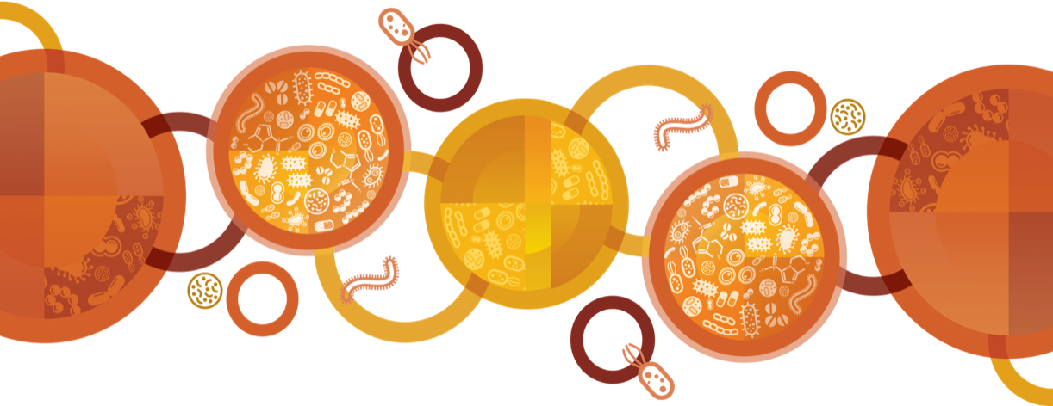

Published by the Australian Commission on Safety and Quality in Health Care  
Level 5, 255 Elizabeth Street, Sydney NSW 2000

Phone: (02) 9126 3600

Email: caralert@safetyandquality.gov.au   
Website: www.safetyandquality.gov.au

© Australian Commission on Safety and Quality in Health Care 2023

All material and work produced by the Australian Commission on Safety and Quality in Health Care (the Commission) is protected by copyright. The Commission reserves the right to set out the terms and conditions for the use of such material.

As far as practicable, material for which the copyright is owned by a third party will be clearly labelled. The Commission has made all reasonable efforts to ensure that this material has been reproduced in this publication with the full consent of the copyright owners.

With the exception of any material protected by a trademark, any content provided by third parties and where otherwise noted, all material presented in this publication is licensed under a [https://creativecommons.org/licenses/by-nc-nd/4.0/](http://creativecommons.org/licenses/by-nc-nd/4.0/).

Creative Commons Licence

Enquiries about the licence and any use of this publication are welcome and can be sent to [communications@safetyandquality.gov.au](mailto:communications@safetyandquality.gov.au).

The Commission’s preference is that you attribute this publication (and any material sourced from it) using the following citation:

Australian Commission on Safety and Quality in Health Care. CARAlert data update 32: 1 March 2023–30 April 2023. Sydney: ACSQHC; 2023

**Disclaimer**

The content of this document is published in good faith by the Commission for information purposes. The document is not intended to provide guidance on particular healthcare choices. You should contact your healthcare provider for information or advice on particular healthcare choices.

The Commission does not accept any legal liability for any injury, loss or damage incurred by the use of, or reliance on, this document.

Contents

Data Summary 4

National summary 6

Summary by CAR 9

*Acinetobacter baumannii* complex 9

*Candida auris* 10

*Enterobacterales* 11

*Enterococcus* species 17

*Mycobacterium tuberculosis* 18

*Neisseria gonorrhoeae* 18

*Pseudomonas aeruginosa* 19

*Salmonella* species 21

*Shigella* species 21

*Staphylococcus aureus* 23

Appendix 24

Data Notes 24

About AURA and CARAlert 24

## Data Summary

This report provides an update on data submitted to the National Alert System for Critical Antimicrobial Resistances (CARAlert) for the reporting period: 1 March 2023 to 30 April 2023, and complements previous analyses of and updates on [CARAlert data](https://www.safetyandquality.gov.au/antimicrobial-use-and-resistance-in-australia/what-is-aura/national-alert-system-for-critical-antimicrobial-resistances-caralert/).

**National overview**

* The total number of critical antimicrobial resistances (CARs) reported was up 4.7% compared to the previous two-month reporting period (*n* = 401 versus *n* = 383) (excluding CARs that were introduced or removed in January 2023)
* Just under one-half of the CARs reported were carbapenemase-producing *Enterobacterales* (CPE) (including those with ribosomal methyltransferase) (180/402, 44.8%)
* The total number of CPE (either alone or in combination with other CARs) reported to date this year, compared with the same period last year, increased by 51.3% (*n =*363 versus *n =*240)
* Multidrug-resistant (MDR) *Shigella* species was the second most reported CAR (92/402, 22.9%). The number of reports almost doubled compared to the previous two-month reporting period (*n* = 92 versus *n* = 49, up 87.8%)
* The same number of ceftriaxone-nonsusceptible *Neisseria gonorrhoeae* was reported (either alone or with azithromycin-nonsusceptible) as the previous two-month period (*n* = 5)
* Where the setting was known, the majority of CARs (excluding *N. gonorrhoeae*) were reported from public hospitals (189/298, 63.4%). There were 86 (28.9%) reports from community settings, 23 (7.7%) from private hospitals, and no reports from aged care homes.

**Carbapenemase-producing *Enterobacterales***

* IMP (85/180, 47.2%), NDM (51/180, 28.3%), OXA-48-like (20/180, 11.1%), and NDM+OXA-48-like (11/180, 6.1%) types accounted for 92.7% of all CPE reported during this period
* The total number of CPE (either alone or in combination with other CARs) was slightly lower compared to the previous two-month period (*n* = 180 versus *n* = 183, down 1.6%). The total number of IMP-types reported decreased during this reporting period (*n* = 85) compared to the previous reporting period (*n* = 92)
* The total number of NDM-types (either alone or with OXA-48-like) was the same as the number reported for previous two-month period (*n* = 65)
* Six KPC-producing *Klebsiella* specieswere reported: three *K. pneumoniae* from one hospital in Queensland, one *K. pneumoniae* from Victoria, one *K. aerogenes* from South Australia, and one *K. pneumoniae* from New South Wales that also harboured NDM and OXA-181
* Where the setting was known, 16.0% (28/175) of CPE were reported from the community. There were no reports from aged care homes
* Seven hospitals (*n* = 4 in NSW; *n* = 3 in Queensland) had more than two reports of IMP-types. A further 11 hospitals had two notifications of IMP-types: Queensland (*n* = 5), NSW (*n* = 4) and Victoria (*n* = 2). Two hospitals from NSW and one from Queensland had five or more reports
* Ten hospitals had more than one report of NDM-types; these were in Victoria (*n* = 6), NSW (*n* = 3) and SA (*n* = 1).

***Salmonella* and *Shigella* species**

* There were 13 ceftriaxone-nonsusceptible *Salmonella* species reported during this period: 12 non-typhoidal species from Western Australia (*n* = 6, extended-spectrum β-lactamase [ESBL]), Victoria (*n* = 4, ESBL), SA (*n* = 1, ESBL), and NSW (*n* = 1, AmpC); and one *S*. Typhi from Victoria with an ESBL
* There were 92 MDR *Shigella* species reported in this period: 76 *S. sonnei*, 15 *S. flexneri* and one *S. dysenteriae*. Almost all (74/76, 97.4%) *S. sonnei* isolates were ceftriaxone/cefotaxime resistant and produced an ESBL. A little over half (9/15, 60.0%) of MDR *S. flexneri* were susceptible to ceftriaxone/cefotaxime.

**Azithromycin-nonsusceptible (low-level resistance, MIC < 256 mg/L) *Neisseria gonorrhoeae***

* The total number of reports of this CAR decreased compared with the previous two-month reporting period (*n* = 79 versus *n* = 109, down 27.5%). Reports were from NSW (*n* = 13 versus *n* = 33), Victoria (*n* = 54 versus *n* = 68), Queensland (*n* = 4 versus *n* = 3), SA (*n* = 5 versus *n* = 2), WA (*n* = 3 versus *n* = 2) and Tasmania (*n* = 0 versus *n* = 1).

**Ceftriaxone- and/or azithromycin-nonsusceptible *Neisseria gonorrhoeae***

* There were five reports of ceftriaxone-nonsusceptible *N. gonorrhoeae*; one each from NSW, Queensland and WA; and two from Victoria that also had high-level resistance to azithromycin
* Three *N. gonorrhoeae* with high-level resistance to azithromycin were reported from WA (*n* = 2) and Queensland (*n* = 1).

**Gentamicin-resistant *Neisseria gonorrhoeae***

* No gentamicin-resistant *N. gonorrhoeae* were reported in this period.

**Ciprofloxacin-nonsusceptible *Nesiseria meningitidis***

* There was one report of ciprofloxacin-nonsusceptible *N. meningitidis* from Victoria.

**Carbapenemase-producing *Acinetobacter baumannii* complex and *Pseudomonas aeruginosa***

* Five carbapenemase-producing *Acinetobacter baumannii* complex were reported during this period. The reports were from NSW (IMP, *n* = 1; IMP + OXA-23-like, *n* = 1; IMP + OXA-58, *n* = 1; OXA-24/40-like, *n* = 1) and WA (OXA-24/40-like, *n* = 1)
* The number of carbapenemase-producing *Pseudomonas aeruginosa* reports increased compared to the previous two-month reporting period (*n* = 12 versus *n* = 7). Reports were from NSW (GES, *n* = 7), Victoria (*bla*VIM‑1, *n* = 1; *bla*VIM-2, *n* = 1; *bla*NDM-1, *n* = 1), Queensland (NDM, *n* = 1) and SA (NDM, *n* = 1).

**Linezolid-resistant *Enterococcus* species**

* Five linezolid-resistant *Enterococcus* species were reported during this period, three *E. faecalis* (*optrA*) and two *E. faecium* (*optrA*, *n* = 1; other, *n* = 1). All were from Victoria.

***Candida auris***

* Six *Candida auris* were reported during this period. The reports were from WA (*n* = 3), SA (*n* = 2) and NSW (*n* = 1).

**Linezolid-, or vancomycin-nonsusceptible *Staphylococcus aureus* complex**

* There were no reports of linezolid- or vancomycin-nonsusceptible *S. aureus* in this period.

**Transmissible colistin resistance**

* There was one report from Victoria of an *Escherichia coli* with *mcr-1.1* which also harboured *bla*NDM-1.

***Streptococcus pyogenes* with reduced susceptibility to penicillin**

* No cases of *Streptococcus pyogenes* withreduced susceptibility to penicillin were reported during this period.

## National summary

**Table 1:** Number of critical antimicrobial resistances, by state and territory, 1 March 2023–30 April 2023, and year to date 2022 and 2023

|  |  |  |  |  |  |  |  |  |  |  |  |  |  |  |  |
| --- | --- | --- | --- | --- | --- | --- | --- | --- | --- | --- | --- | --- | --- | --- | --- |
|  |  | State or Territory (March–April 2023) | | | | | | | | Bi-monthly | | | Year to date | | |
|  |  | **2023** | **2023** |  |
| **Species** | **Critical resistance** | **NSW** | **Vic** | **Qld** | **SA** | **WA** | **Tas** | **NT** | **ACT** | **Jan-Feb** | **Mar-Apr** | **Relative change\*** | **2022** | **2023** | **Relative change\*** |
| *Acinetobacter baumannii* complex | Carbapenemase-producing | 4 | 0 | 0 | 0 | 1 | 0 | 0 | 0 | 5 | 5 | 0.0% | 5 | 10 | ▲ 100% |
|  | Carbapenemase- and ribosomal methyltransferase-producing | 0 | 0 | 0 | 0 | 0 | 0 | 0 | 0 | 0 | 0 | – | 0 | 0 | – |
| *Candida auris* | – | 1 | 0 | 0 | 2 | 3 | 0 | 0 | 0 | 4 | 6 | ▲ 50.0% | 2 | 10 | ▲ 400% |
| *Enterobacterales* | Carbapenemase-producing | 68 | 42 | 44 | 6 | 8 | 0 | 0 | 0 | 168 | 168 | 0.0% | 235 | 336 | ▲ 43.0% |
|  | Carbapenemase- and ribosomal methyltransferase-producing | 1 | 5 | 1 | 1 | 3 | 0 | 0 | 0 | 15 | 11 | ▼ 26.7% | 5 | 26 | ▲ 420% |
|  | Carbapenemase- producing and transmissible resistance to colistin | 0 | 1 | 0 | 0 | 0 | 0 | 0 | 0 | 0 | 1 | – | 0 | 1 | – |
|  | Ribosomal methyltransferase-producing | 0 | 1 | 0 | 0 | 0 | 0 | 0 | 0 | 3 | 1 | ▼ 66.7% | 1 | 4 | ▲ 300% |
|  | Transmissible resistance to colistin | 0 | 0 | 0 | 0 | 0 | 0 | 0 | 0 | 0 | 0 | – | 0 | 0 | – |
| *Enterococcus* species | Linezolid-resistant | 0 | 5 | 0 | 0 | 0 | 0 | 0 | 0 | 4 | 5 | ▲ 25.0% | 5 | 9 | ▲ 80.0% |
| *Mycobacterium tuberculosis* | Multidrug-resistant – at least rifampicin- and isoniazid-resistant strains | 0 | 0 | 0 | 0 | 0 | 0 | 0 | 0 | 2 | 0 | ▼ 100% | 4 | 2 | ▼ 50.0% |
| *Neisseria gonorrhoeae* | Azithromycin-nonsusceptible (low-level)† | 13 | 54 | 4 | 5 | 3 | 0 | 0 | 0 | 109 | 79 | ▼ 27.5% | 25 | 188 | ▲ 652% |
|  | Azithromycin-nonsusceptible (high-level)§ | 0 | 0 | 1 | 0 | 2 | 0 | 0 | 0 | 1 | 3 | ▲ 200% | 3 | 4 | ▲ 33.3% |
|  | Ceftriaxone-nonsusceptible | 1 | 0 | 1 | 0 | 1 | 0 | 0 | 0 | 3 | 3 | 0.0% | 6 | 6 | 0.0% |
|  | Ceftriaxone-nonsusceptible and azithromycin-nonsusceptible | 0 | 2 | 0 | 0 | 0 | 0 | 0 | 0 | 2 | 2 | 0.0% | 1 | 4 | ▲ 300% |
|  | Gentamicin-resistant# | 0 | 0 | 0 | 0 | 0 | 0 | 0 | 0 | 0 | 0 | – | – | 0 | – |

– = not applicable

Note: For this report, transmissible resistance to colistin refers to the presence of *mcr* genes other than *mcr-9*. This variant is not associated with a colistin resistant phenotype, but is typically found on H12 plasmids which may carry *bla*IMP-4.

Table 1 (continued)

|  |  |  |  |  |  |  |  |  |  |  |  |  |  |  |  |
| --- | --- | --- | --- | --- | --- | --- | --- | --- | --- | --- | --- | --- | --- | --- | --- |
|  |  | State or territory (March–April 2023) | | | | | | | | Bi-monthly | | | Year to date | | |
|  |  | **2023** | **2023** |  |
| **Species** | **Critical resistance** | **NSW** | **Vic** | **Qld** | **SA** | **WA** | **Tas** | **NT** | **ACT** | **Jan-Feb** | **Mar-Apr** | **Relative change\*** | **2022** | **2023** | **Relative change\*** |
| *Neisseria meningitidis* | Ciprofloxacin-nonsusceptible# | 0 | 1 | 0 | 0 | 0 | 0 | 0 | 0 | 2 | 1 | ▼ 50.0% | – | 3 | – |
| *Pseudomonas aeruginosa* | Carbapenemase-producing | 7 | 3 | 1 | 0 | 0 | 0 | 0 | 0 | 7 | 11 | ▲ 57.1% | 23 | 18 | ▼ 21.7% |
|  | Carbapenemase- and ribosomal methyltransferase-producing | 0 | 0 | 0 | 1 | 0 | 0 | 0 | 0 | 0 | 1 | – | 2 | 1 | ▼ 50.0% |
| *Salmonella* species | Ceftriaxone-nonsusceptible | 1 | 5 | 0 | 1 | 6 | 0 | 0 | 0 | 11 | 13 | ▲ 18.2% | 12 | 24 | ▲ 100% |
| *Shigella* species | Multidrug-resistant | 23 | 53 | 5 | 1 | 7 | 1 | 0 | 2 | 49 | 92 | ▲ 87.8% | 18 | 141 | ▲ 683% |
| *Staphylococcus aureus* complex | Daptomycin-nonsusceptible** | – | – | – | – | – | – | – | – | – | – | – | 49 | – | – |
| Linezolid-nonsusceptible | 0 | 0 | 0 | 0 | 0 | 0 | 0 | 0 | 0 | 0 | – | 1 | 0 | ▼ 100% |
| Vancomycin-nonsusceptible | 0 | 0 | 0 | 0 | 0 | 0 | 0 | 0 | 0 | 0 | – | 0 | 0 | – |
| *Streptococcus pyogenes* | Penicillin reduced susceptibility | 0 | 0 | 0 | 0 | 0 | 0 | 0 | 0 | 0 | 0 | – | 0 | 0 | – |
|  | **Total (reported by 31 May 2023)** | 119 | 172 | 57 | 17 | 34 | 1 | 0 | 2 | **385** | **402** | ▲ **4.4** | **397** | **787** | ▲ **98.2%** |
|  | Excluding CARs added or removed in 2023 |  |  |  |  |  |  |  |  | **383** | **401** | ▲ **4.7** | **348** | **784** | ▲ **125%** |

MIC = minimum inhibitory concentration; ▲ = increase; ▼ = decrease; – = not applicable

* Relative change = absolute change between period in 2022 and same period in 2023, for each CAR, expressed as a percentage of 2022 base

† Azithromycin MIC < 256 mg/L

§ Azithromycin MIC ≥ 256 mg/L

# Reported from January 2023

** Reporting of daptomycin-nonsusceptible *S. aureus* was suspended from January 2023

Note: The number of CARs have been updated to include additional submissions received after the previous publication date.

**Table 2:** Number of critical antimicrobial resistance isolates, by setting, national, 1 March 2023–30 April 2023

|  |  |  |  |  |  |  |  |
| --- | --- | --- | --- | --- | --- | --- | --- |
|  |  | Setting | | | | |  |
| **Species** | **Critical resistance** | **Public hospital** | **Private hospital** | **Aged care home** | **Community** | **Unknown** | **Total** |
| *Acinetobacter baumannii* complex | Carbapenemase-producing | 5 | 0 | 0 | 0 | 0 | 5 |
| Carbapenemase- and ribosomal methyltransferase-producing | 0 | 0 | 0 | 0 | 0 | 0 |
| *Candida auris* | – | 6 | 0 | 0 | 0 | 0 | 6 |
| *Enterobacterales* | Carbapenemase-producing | 121 | 18 | 0 | 25 | 4 | 168 |
| Carbapenemase- and ribosomal methyltransferase-producing | 8 | 0 | 0 | 3 | 0 | 11 |
| Carbapenemase- producing and transmissible resistance to colistin | 0 | 0 | 0 | 0 | 1 | 1 |
| Ribosomal methyltransferase-producing | 1 | 0 | 0 | 0 | 0 | 1 |
| Transmissible resistance to colistin | 0 | 0 | 0 | 0 | 0 | 0 |
| *Enterococcus* species | Linezolid-resistant | 5 | 0 | 0 | 0 | 0 | 5 |
| *Mycobacterium tuberculosis* | Multidrug-resistant – at least rifampicin- and isoniazid-resistant strains | 0 | 0 | 0 | 0 | 0 | 0 |
| *Neisseria gonorrhoeae* | Azithromycin-nonsusceptible (low-level)* | 4 | 1 | 0 | 47 | 27 | 79 |
| Azithromycin-nonsusceptible (high-level)† | 0 | 0 | 0 | 3 | 0 | 3 |
| Ceftriaxone-nonsusceptible | 1 | 0 | 0 | 1 | 1 | 3 |
| Ceftriaxone-nonsusceptible and azithromycin-nonsusceptible | 0 | 0 | 0 | 1 | 1 | 2 |
| Gentamicin-resistant§ | 0 | 0 | 0 | 0 | 0 | 0 |
| *Neisseria meningitidis* | Ciprofloxacin-nonsusceptible§ | 0 | 0 | 0 | 0 | 1 | 1 |
| *Pseudomonas aeruginosa* | Carbapenemase-producing | 6 | 2 | 0 | 2 | 1 | 11 |
|  | Carbapenemase- and ribosomal methyltransferase-producing | 0 | 0 | 0 | 1 | 0 | 1 |
| *Salmonella* species | Ceftriaxone-nonsusceptible | 2 | 3 | 0 | 7 | 1 | 13 |
| *Shigella* species | Multidrug-resistant | 35 | 0 | 0 | 48 | 9 | 92 |
| *Staphylococcus aureus* complex | Linezolid-nonsusceptible | 0 | 0 | 0 | 0 | 0 | 0 |
| Vancomycin-nonsusceptible | 0 | 0 | 0 | 0 | 0 | 0 |
| *Streptococcus pyogenes* | Penicillin reduced susceptibility | 0 | 0 | 0 | 0 | 0 | 0 |
|  | **Total (reported by 31 May 2023)** | **194** | **24** | **0** | **138** | **46** | **402** |

* Azithromycin MIC < 256 mg/L

† Azithromycin MIC ≥ 256 mg/L

§ Reported from January 2023

Notes:

1. Reporting of daptomycin-nonsusceptible *S. aureus* was suspended from January 2023.
2. Information on setting for *N. gonorrhoeae* is often not available.

## Summary by CAR

### *Acinetobacter baumannii* complex

#### National data

**Figure 1:** Carbapenemase-producing *Acinetobacter baumannii* complex, 24-month trend by specimen type, national, 1 May 2021–30 April 2023

#### State and territory data

Figure 2: Carbapenemase-producing *Acinetobacter baumannii* complex, number reported by carbapenemase type and specimen type, by state and territory, 1 March 2023–30 April 2023

Table 3: Carbapenemase-producing *Acinetobacter baumannii* complex, number reported by setting, by state and territory, 1 March 2023–30 April 2023

|  |  |  |  |  |  |  |  |  |  |
| --- | --- | --- | --- | --- | --- | --- | --- | --- | --- |
|  | State or territory | | | | | | | |  |
| **Setting** | **NSW** | **Vic** | **Qld** | **SA** | **WA** | **Tas** | **NT** | **ACT** | **Total** |
| Total | 4 | 0 | 0 | 0 | 1 | 0 | 0 | 0 | 5 |
| Public hospital | 4 | 0 | 0 | 0 | 1 | 0 | 0 | 0 | 5 |
| Private hospital | 0 | 0 | 0 | 0 | 0 | 0 | 0 | 0 | 0 |
| Aged care home | 0 | 0 | 0 | 0 | 0 | 0 | 0 | 0 | 0 |
| Community | 0 | 0 | 0 | 0 | 0 | 0 | 0 | 0 | 0 |
| Unknown | 0 | 0 | 0 | 0 | 0 | 0 | 0 | 0 | 0 |

### *Candida auris*

#### National data

**Figure 3:** *Candida auris*, 24-month trend by specimen type, national, 1 July 2021–30 April 2023

### *Enterobacterales*

#### National data

Figure 4: Carbapenemase-producing *Enterobacterales*\*, 24-month trend by specimen type, national, 1 May 2021–30 April 2023

* Carbapenemase-producing alone or in combination with ribosomal methyltransferases or transmissible resistance to colistin

Figure 5: Ribosomal methyltransferase-producing *Enterobacterales*\*, 24-month trend, national, 1 May 2021–30 April 2023

* Ribosomal methyltransferases alone, or in combination with carbapenemase(s)

**Figure 6:** Carbapenemase-producing *Enterobacterales*\*, number reported by carbapenemase type and species, national, 1 March 2023–30 April 2023

* Carbapenemase-producing (n = 168), carbapenemase and ribosomal methyltransferase-producing (n = 11), carbapenemase-producing and transmissible resistance to colistin (n = 1)

Figure 7: Top four reported carbapenemase types*, 24-month trend, national, 1 May 2021–30 April 2023

* Alone or in combination with another type for the reporting period indicated

#### State and territory data

Figure 8: Carbapenemase-producing *Enterobacterales*\**,* number reported by month, state and territory, 1 March 2023–30 April 2023

* Carbapenemase-producing (n = 168), carbapenemase and ribosomal methyltransferase-producing (n = 11), carbapenemase-producing and transmissible resistance to colistin (*n* = 1)

**Figure 9:** Two-year trend for the top four reported carbapenemase types from *Enterobacterales*, by state and territory andnationally, (three-month moving average), 1 May 2021–30 April 2023

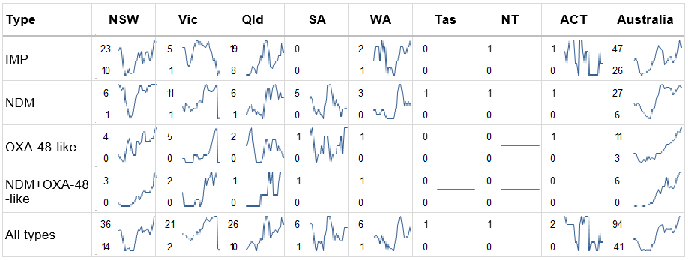Straight green line in cell = no carbapenemase type for that state or territory during the reporting period;   
Blank cell = maximum monthly average was one or less  
Note: Line graphs represent three-month moving average for the period 1 May 2021 to 30 April 2023, for each type, where maximum monthly average was greater than one.

Figure 10: Carbapenemase-producing *Enterobacterales*\*, number reported by carbapenemase type and specimen type, by state and territory, 1 March 2023–30 April 2023

* Carbapenemase-producing (n = 168), carbapenemase and ribosomal methyltransferase-producing (n = 11), carbapenemase-producing and transmissible resistance to colistin (*n* = 1)

Figure 11: Top four reported carbapenemase-producing *Enterobacterales* types by specimen type, by state and territory, 1 March 2023–30 April 2023

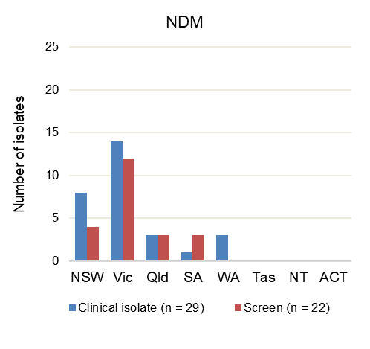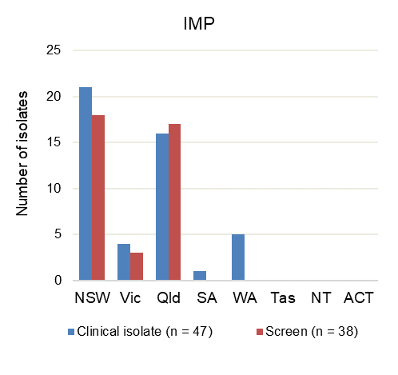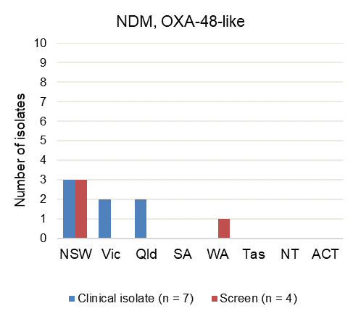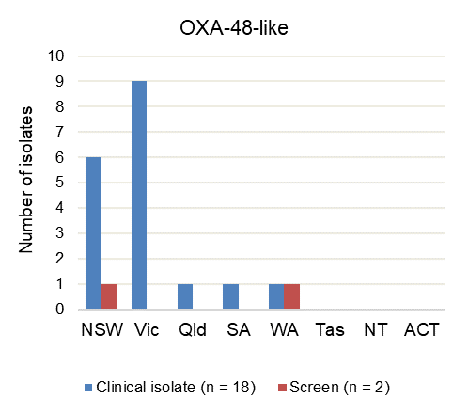

Note: Other types include KPC (*n* = 5; Qld clinical [2], screen [1]; Vic clinical [1]; SA screen [1]); OXA-23-like (*n* = 3, NSW clinical [2]; Vic clinical [1]); IMP+NDM (*n* = 2; NSW clinical [1]; Vic clinical [1]); IMI (*n* = 2, NSW screen [1]; Vic clinical [1]); KPC+NDM+OXA-48-like (*n* = 1, NSW [clinical]).

Table 4: Top five carbapenemase types from *Enterobacterales*, number reported by setting, by state and territory, 1 March 2023–30 April 2023

|  |  |  |  |  |  |  |  |  |  |  |
| --- | --- | --- | --- | --- | --- | --- | --- | --- | --- | --- |
| Carbapenemase type |  | State or territory | | | | | | | |  |
| **Setting** | **NSW** | **Vic** | **Qld** | **SA** | **WA** | **Tas** | **NT** | **ACT** | **Total** |
| IMP | Total | 39 | 7 | 33 | 1 | 5 | 0 | 0 | 0 | 85 |
|  | Public hospitals | 39 | 5 | 20 | 0 | 2 | 0 | 0 | 0 | 66 |
|  | Private hospitals | 0 | 1 | 12 | 1 | 1 | 0 | 0 | 0 | 15 |
|  | Aged care homes | 0 | 0 | 0 | 0 | 0 | 0 | 0 | 0 | 0 |
|  | Community | 0 | 1 | 1 | 0 | 2 | 0 | 0 | 0 | 4 |
|  | Unknown | 0 | 0 | 0 | 0 | 0 | 0 | 0 | 0 | 0 |
| NDM | Total | 12 | 26 | 6 | 4 | 3 | 0 | 0 | 0 | 51 |
|  | Public hospitals | 10 | 16 | 3 | 4 | 0 | 0 | 0 | 0 | 33 |
|  | Private hospitals | 0 | 0 | 1 | 0 | 1 | 0 | 0 | 0 | 2 |
|  | Aged care homes | 0 | 0 | 0 | 0 | 0 | 0 | 0 | 0 | 0 |
|  | Community | 2 | 7 | 2 | 0 | 2 | 0 | 0 | 0 | 13 |
|  | Unknown | 0 | 3 | 0 | 0 | 0 | 0 | 0 | 0 | 3 |
| OXA-48-like | Total | 7 | 9 | 1 | 1 | 2 | 0 | 0 | 0 | 20 |
|  | Public hospitals | 4 | 6 | 0 | 0 | 1 | 0 | 0 | 0 | 11 |
|  | Private hospitals | 0 | 0 | 0 | 0 | 0 | 0 | 0 | 0 | 0 |
|  | Aged care homes | 0 | 0 | 0 | 0 | 0 | 0 | 0 | 0 | 0 |
|  | Community | 1 | 3 | 1 | 1 | 1 | 0 | 0 | 0 | 7 |
|  | Unknown | 2 | 0 | 0 | 0 | 0 | 0 | 0 | 0 | 2 |
| NDM, OXA-48-like | Total | 6 | 2 | 2 | 0 | 1 | 0 | 0 | 0 | 11 |
|  | Public hospitals | 6 | 1 | 0 | 0 | 1 | 0 | 0 | 0 | 8 |
|  | Private hospitals | 0 | 0 | 1 | 0 | 0 | 0 | 0 | 0 | 1 |
|  | Aged care homes | 0 | 0 | 0 | 0 | 0 | 0 | 0 | 0 | 0 |
|  | Community | 0 | 1 | 1 | 0 | 0 | 0 | 0 | 0 | 2 |
|  | Unknown | 0 | 0 | 0 | 0 | 0 | 0 | 0 | 0 | 0 |
| KPC | Total | 0 | 1 | 3 | 1 | 0 | 0 | 0 | 0 | 5 |
|  | Public hospitals | 0 | 0 | 3 | 1 | 0 | 0 | 0 | 0 | 4 |
|  | Private hospitals | 0 | 0 | 0 | 0 | 0 | 0 | 0 | 0 | 0 |
|  | Aged care homes | 0 | 0 | 0 | 0 | 0 | 0 | 0 | 0 | 0 |
|  | Community | 0 | 1 | 0 | 0 | 0 | 0 | 0 | 0 | 1 |
|  | Unknown | 0 | 0 | 0 | 0 | 0 | 0 | 0 | 0 | 0 |

Note: Top four carbapenemase types account for 92.8% (167/180) of all carbapenemase-producing Enterobacterales reported for this period. Other types were KPC (n = 5, Qld [3], Vic [1], SA [1]); OXA-23-like (n = 3, NSW [2], Vic [1]); IMP+NDM (n = 2, NSW, Vic); IMI (n = 2, NSW, Vic); KPC+NDM+OXA-48-like (n = 1, NSW).

### *Enterococcus* species

#### National data

Figure 12: Linezolid-nonsusceptible *Enterococcus* species, 24-month trend, national, 1 May 2021–30 April 2023

#### State and territory data

Figure 13: Linezolid-nonsusceptible *Enterococcus* species, number reported by state and territory, 1 March 2023–30 April 2023

### *Mycobacterium tuberculosis*

#### National data

Figure 14: Multidrug-resistant *Mycobacterium tuberculosis,* 24-month trend, national, 1 May 2021–30 April 2023

### *Neisseria gonorrhoeae*

#### National data

Figure 15: Ceftriaxone- and/or azithromycin-nonsusceptible *Neisseria gonorrhoeae*, 24-month trend, national, 1 May 2021–30 April 2023

Note: Low-level = azithromycin MIC < 256 mg/L; high-level = azithromycin MIC ≥ 256 mg/L.

#### State and territory data

Figure 16: Ceftriaxone- and/or azithromycin-nonsusceptible *Neisseria gonorrhoeae,* number reported by month, state and territory, 1 March 2023–30 April 2023

Note: Low-level = azithromycin MIC < 256 mg/L; high-level = azithromycin MIC ≥ 256 mg/L.

### *Pseudomonas aeruginosa*

#### National data

**Figure 17:** Carbapenemase-producing *Pseudomonas aeruginosa*, 24-month trend by specimen type, national, 1 May 2021–30 April 2023

#### State and territory data

Figure 18: Carbapenemase-producing *Pseudomonas aeruginosa*, number reported by carbapenemase type and specimen type, by state and territory, 1 March 2023–30 April 2023

Table 5: Carbapenemase-producing *Pseudomonas aeruginosa*, number reported by setting, by state and territory, 1 March 2023–30 April 2023

|  |  |  |  |  |  |  |  |  |  |
| --- | --- | --- | --- | --- | --- | --- | --- | --- | --- |
|  | State or territory | | | | | | | |  |
| **Setting** | **NSW** | **Vic** | **Qld** | **SA** | **WA** | **Tas** | **NT** | **ACT** | **Total** |
| Total | 7 | 3 | 1 | 1 | 0 | 0 | 0 | 0 | 12 |
| Public hospital | 5 | 1 | 0 | 0 | 0 | 0 | 0 | 0 | 6 |
| Private hospital | 2 | 0 | 0 | 0 | 0 | 0 | 0 | 0 | 2 |
| Aged care home | 0 | 0 | 0 | 0 | 0 | 0 | 0 | 0 | 0 |
| Community | 0 | 2 | 0 | 1 | 0 | 0 | 0 | 0 | 3 |
| Unknown | 0 | 0 | 1 | 0 | 0 | 0 | 0 | 0 | 1 |

### *Salmonella* species

#### National data

Figure 19: Ceftriaxone-nonsusceptible *Salmonella* species, 24-month trend, national, 1 May 2021–30 April 2023

Note: (1 March 2023–30 April 2023) non-typhoidal *Salmonella* species (*n* = 12) and typhoidal *Salmonella* species (*n* = 1).

### *Shigella* species

#### National data

Figure 20: Multidrug-resistant *Shigella* species, 24-month trend, national, 1 May 2021–30 April 2023

Figure 21: Multidrug-resistant *Shigella* species, number reported by month, national, 1 March 2023–30 April 2023

Note: Not determined = multidrug-resistant, ceftriaxone/cefotaxime-susceptible.

#### State and territory data

Figure 22: Multidrug-resistant *Shigella* species, number reported by state and territory, 1 March 2023–30 April 2023

### *Staphylococcus aureus*

#### National data

Figure 23: Daptomycin-, linezolid- or vancomycin-nonsusceptible *Staphylococcus aureus,* 24‑month trend, national, 1 May 2021–30 April 2023

#### Note: Reporting of daptomycin-nonsusceptible *S. aureus* was suspended from January 2023.

#### State and territory data

There was no linezolid- or vancomycin nonsusceptible S. aureus reported during this period.

## Appendix

### Data Notes

The following are important considerations for interpreting National Alert System for Critical Antimicrobial Resistances (CARAlert) data:

* The data are based on the date that the isolate with the confirmed critical antimicrobial resistance (CAR) was collected
* States and territories refer to the state or territory within which the hospital is located, or within which the patient resides for isolates from the community. If place of residence is unknown or overseas, the state or territory of the originating laboratory is reported
* Comparison between reports may be influenced by delayed detection or late submissions of CARs
* The same CAR/type/species is not submitted where the sample originated from the same patient who had the previous CAR, and the isolate was collected on the same day, or collected in the same admission or within three months
* Number of CARs reported does not always equal the number of patients, as patients may have more than one CAR, or species, detected in a specimen
* Cut-off date for data that are included in updates and reports is four weeks after the end of each reporting period
* National summary data is provided; comparison across states and territories is provided for organisms where there are large numbers reported and a comparison is meaningful
* Authorised officers in each state and territory health department can access the CARAlert web portal directly for further information about their jurisdiction, including the name of the public hospital in which a patient with a confirmed CAR was cared for, and to extract reports on their data.

### About AURA and CARAlert

The Antimicrobial Use and Resistance in Australia (AURA) Surveillance System provides essential information to develop and implement strategies to prevent and contain antimicrobial resistance in human health and improve antimicrobial use across the acute and community healthcare settings. AURA also supports the [National Safety and Quality Health Service (NSQHS) Preventing and Controlling Infections Standard](https://www.safetyandquality.gov.au/our-work/healthcare-associated-infection-program/preventing-and-controlling-infections-standard) and [Australia’s National Antimicrobial Resistance Strategy – 2020 and beyond](https://www.amr.gov.au/news/australias-national-antimicrobial-resistance-strategy-2020-and-beyond).

The National Alert System for Critical Antimicrobial Resistances (CARAlert) was established by the Australian Commission on Safety and Quality in Health Care (the Commission) in March 2016 as a component of the AURA Surveillance System. Funding for CARAlert is provided by the Australian Government Department of Health and Aged Care, with contributions from the states and territories for the laboratory analysis and data submission processes.

Participating confirming laboratories submit data to CARAlert on priority organisms with critical resistance to last-line antimicrobial agents (CARs) which can result in significant morbidity and mortality. Isolates collected from patients are reported to CARAlert as either a clinical isolate, that is a specimen (e.g., from blood, urine, wound) taken to guide clinical diagnosis, or as a screen for infection prevention and control purposes. No patient-level data are held in the CARAlert system.

The CARs reported to CARAlert are listed in Table A1. These CARs were drawn from the list of high-priority organisms and antimicrobials which are the focus of the AURA Surveillance System.[1]

**Table A1: List of critical antimicrobial resistances reported to CARAlert**

|  |  |
| --- | --- |
| Species | Critical resistance |
| *Acinetobacter baumannii* complex | Carbapenemase-producing* |
| *Candida auris\** | – |
| *Enterobacterales* | Carbapenemase-, and/or ribosomal methyltransferase-producing |
| *Enterobacterales* | Transmissible colistin resistance* |
| *Enterococcus* species | Linezolid-resistant |
| *Mycobacterium tuberculosis* | Multidrug-resistant – resistant to at least rifampicin and isoniazid |
| *Neisseria gonorrhoeae* | Ceftriaxone- or azithromycin-nonsusceptible |
| Gentamicin-resistant† |
| *Neisseria meningitidis* | Ciprofloxacin-nonsusceptible† |
| *Pseudomonas aeruginosa* | Carbapenemase-producing* |
| *Salmonella* species | Ceftriaxone-nonsusceptible |
| *Shigella* species | Multidrug-resistant |
| *Staphylococcus aureus* complex§ | Vancomycin- or linezolid-nonsusceptible# |
| *Streptococcus pyogenes* | Penicillin reduced susceptibility |

* Reported from July 2019

† Reported from January 2023

§ For CARAlert, *S. aureus* includes *S. argenteus* and *S. schweitzeri*

# Reporting of daptomycin-nonsusceptible *S. aureus* was suspended from January 2023

Note: Low level-azithromycin-nonsusceptible *N. gonorrhoeae* was excluded from the weekly digest following review in 2018.

In 2022, the Commission conducted a review of CARAlert to assess whether currently reported CARs continue to be priorities, and to identify any additional CARs for inclusion. The review followed a similar process to previous reviews in 2016 and 2018. In consultation with states and territories and a range of clinical experts, the 2022 review identified two new CARs that have been reported to CARAlert since 1 January 2023:

* Ciprofloxacin-nonsusceptible *Neisseria meningitidis*
* Gentamicin-resistant *N. gonorrhoeae*.

Additionally, reporting of daptomycin-nonsusceptible *Staphylococcus aureus* (DNSA) was suspended from 2023. Reintroduction of reporting of DNSA will be considered when more reliable testing methods are available.

The CARAlert system is based on the following routine processes used by pathology laboratories for identifying and confirming potential CARs:

1. Collection and routine testing – the isolate is collected from the patient and sent to the originating laboratory for routine testing
2. Confirmation – if the originating laboratory suspects that the isolate is a CAR, the isolate is sent to a confirming laboratory that has the capacity to confirm the CAR
3. Reporting to clinicians in accordance with usual laboratory processes – the confirming laboratory reports back to the originating laboratory, which in turn reports to the clinician who initially requested the microbiological testing
4. Submission to the CARAlert system – the confirming laboratory advises the originating laboratory of the result of the test, and the originating laboratory reports back to the health service that cared for the patient from whom the specimen was collected; the confirming laboratory then submits the details of the resistance and organism into the secure CARAlert web portal.

This page is left intentionally blank





Level 5, 255 Elizabeth Street, Sydney NSW 2000  
GPO Box 5480, Sydney NSW 2001

Phone: (02) 9126 3600

Email: CARAlert@safetyandquality.gov.au

Website: [www.safetyandquality.gov.au](http://www.safetyandquality.gov.au)

0BTwitter logo @ACSQHC

1. Australian Commission on Safety and Quality in Health Care. AURA 2021: fourth Australian report on antimicrobial use and resistance in human health. Sydney: ACSQHC; 2021.