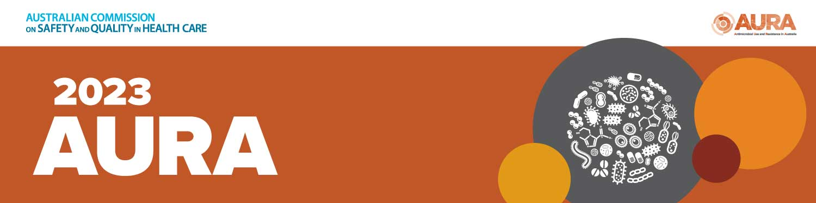

NEWSLETTER CONTENT – FOR INTERNAL AND EXTERNAL USE
The newsletter copy below may be adapted to your context and audience.
16 November 2023
New AURA 2023 report highlights need for vigilance

The nation’s latest major report on antimicrobial use and resistances has revealed that Australia is heading in the right direction – but there’s still a lot of work to do.

AURA 2023: Fifth Australian report on antimicrobial use and resistance in human health was released by the Australian Commission on Safety and Quality in Health Care on 16 November 2023.

The report highlights trends and analyses in antimicrobial use in hospitals, aged care and primary care settings, as well as changes in resistance that are important for infection prevention and control, and antimicrobial prescribing.

In 2022, 21.8 million antimicrobial prescriptions were dispensed in the community in Australia, and 1 in 3 people had at least one antibiotic dispensed.

AURA 2023 reveals community antimicrobial use has declined 18% overall in the three years since 2020 during the COVID-19 response; with a significant 25% fall in 2020 and 2021, followed by a 10% upswing in 2022.

The volume of antimicrobial use in Australian hospitals is estimated to be substantially higher than in comparable European countries and Canada. Rates of critical antimicrobial resistances (CARs) are also rising in hospitals, which is concerning.

Other issues highlighted in AURA 2023 are inappropriate surgical prophylaxis and COPD prescribing, as well the chronic problem of PRN antibiotics (prescribed ’just in case’) in residential aged care, which has not improved since 2015.

The report also found that onset of bacterial infection Clostridioides difficile infection (CDI) in the community is a greater problem than previously understood and is often associated with antimicrobial use.
With inappropriate prescribing of antibiotics continuing across healthcare settings – we need a cultural shift to evoke change, and to sustain decreased antimicrobial use.

We can build on the learnings from COVID-19 to improve understanding that antibiotics do not treat viral infections, and basic infection prevention and control practices such as hand hygiene and staying home when you are sick can help keep people safe from infections.

Read AURA 2023 and supporting resources at: safetyandquality.gov.au/aura2023

