# Australian Commission on Safety and Quality logotypeOn the Radar

Issue 683

3 February 2025

*On the Radar* is a summary of some of the recent publications in the areas of safety and quality in health care. Inclusion in this document is not an endorsement or recommendation of any publication or provider. Access to particular documents may depend on whether they are Open Access or not, and/or your individual or institutional access to subscription sites/services. Material that may require subscription is included as it is considered relevant.

*On the Radar* is available online, via email or as a PDF or Word document from <https://www.safetyandquality.gov.au/newsroom/subscribe-news/radar>

If you would like to receive *On the Radar* via email, you can subscribe on our website <https://www.safetyandquality.gov.au/newsroom/subscribe-news>  
or by emailing us at H[Umail@safetyandquality.gov.auU](mailto:mail@safetyandquality.gov.au).  
You can also send feedback and comments to H[Umail@safetyandquality.gov.auU](mailto:mail@safetyandquality.gov.au).

For information about the Commission and its programs and publications, please visit <https://www.safetyandquality.gov.au>

**On the Radar**

Editor: Dr Niall Johnson, Diana Shipp, Rosa Jun

***New fact sheets on insulin discontinuation***

[https://www.safetyandquality.gov.au/our-work/medication-safety/medication-safety-and-medicines-shortages-alerts-and-guidance](https://www.safetyandquality.gov.au/our-work/medication-safety/medication-safety-and-medicines-shortages-alerts-and-guidanceu)

Australia is experiencing discontinuations of some insulin products. Alternative insulin products are available for some of the discontinued products. Clinicians play a crucial role in managing these discontinuations and ensuring patient safety.

The Commission has developed fact sheets for clinicians and consumers to provide information on strategies and safety considerations to minimise the impact on people with diabetes.

The factsheets for clinicians are:

* [Discontinuation of insulin products: Strategies and safety considerations](https://www.safetyandquality.gov.au/publications-and-resources/resource-library/discontinuation-insulin-products-strategies-and-safety-considerations) and
* [Discontinuation of Protaphane® InnoLet®: Strategies and safety considerations](https://www.safetyandquality.gov.au/publications-and-resources/resource-library/discontinuation-protaphaner-innoletr-strategies-and-safety-considerations).

The factsheet for consumers is [Important changes for people who use insulin](https://www.safetyandquality.gov.au/publications-and-resources/resource-library/important-changes-people-who-use-insulin).

**Reports**

*Mental health inpatient settings: Creating conditions for learning from deaths in mental health inpatient services and when patients die within 30 days of discharge*

Investigation report

Health Services Safety Investigation Body

Poole: HSSIB; 2025.

|  |  |
| --- | --- |
| URL | <https://www.hssib.org.uk/patient-safety-investigations/mental-health-inpatient-settings/fourth-investigation-report/> |
| Notes | This latest report from the Health Services Safety Investigation Body (HSSIB) in the UK is the fourth in a series of reports examining mental health inpatient settings. The investigation that led to this report examined how mental health providers in the UK conduct investigations into deaths of patients receiving care in inpatient units or within 30 days of discharge. The aim of the investigation was ‘to understand how providers learn from deaths, and how they use that learning to improve. The investigation sought to understand the impact on individuals involved in the care of patients who died while in mental health inpatient care or shortly after discharge. It reflects the experiences of families, carers and staff.’ The report includes a number of observations and recommendations. |

**Journal articles**

*Theory-informed refinement and tailored implementation of a quality improvement program in maternity care to reduce unwarranted clinical variation across a health service network*

Warhurst K, Tyack Z, Beckmann M, Abell B

BMC Health Services Research. 2025;25(1):142.

|  |  |
| --- | --- |
| DOI | <https://doi.org/10.1186/s12913-025-12267-x> |
| Notes | Paper describing the ‘development and implementation of a program to address unwarranted clinical variation across a multi-site maternity network’ in Australia. The project was called Practice Improvement with Clinicians eNgaged in Improving Care (PICNIC). The goals of the program were ‘to engage clinicians to identify and reduce unwarranted clinical variation and enhance the delivery of evidence-based care, with the intention of improving care quality, clinical outcomes, and efficiency of the health service.’ The program had ‘300 clinicians participating in 18 audit topics over four years (2020–2023)’. The authors report that ‘Observed benefits of the program include the development and implementation of clinician co-designed system-level improvements that are tailored to context, to improve the delivery of best-practice healthcare and improve outcomes.’ |

For information on the Commission’s work on healthcare variation, including the *Australian Atlas of Healthcare Variation* series, see <https://www.safetyandquality.gov.au/our-work/healthcare-variation>

*Healthcare*

Special Issue

|  |  |
| --- | --- |
| URL | <https://www.mdpi.com/journal/healthcare/special_issues/C5M46LAD0V> |
| Notes | A special issue of *Healthcare* has been published with a focus on **Innovative Approaches for Safety Culture Improvement in Healthcare Systems**. Articles in this special issue of *Healthcare* include:   * **Restorative Just Culture**: An Exploration of the Enabling Conditions for Successful Implementation (Leonie Boskeljon-Horst, Vincent Steinmetz and Sidney Dekker) * Unpacking **Perceptions on Patient Safety**: A Study of Nursing Home Staff in Italy (Ilaria Tocco Tussardi, Stefano Tardivo, Maria Angela Mazzi, Michela Rimondini, Donatella Visentin, Isolde Martina Busch, Emanuele Torri, Francesca Moretti) * **Speaking Up and Taking Action**: Psychological Safety and Joint Problem-Solving Orientation in Safety Improvement (Hassina Bahadurzada, Michaela Kerrissey, Amy C Edmondson) * Exploring **Safety Culture** in the ICU of a Large Acute Teaching Hospital through Triangulating Different Data Sources (Ellen Liston,Enda O’Connor, Marie E Ward) * What Is Truly **Informed Consent** in Medical Practice and What Has the Perception of Risk Got to Do with It? (Catherine Jane Calderwood, Geir Sverre Braut, Siri Wiig) * Sailing Too Close to the Wind? How **Harnessing Patient Voice** Can Identify Drift towards Boundaries of Acceptable Performance (Siri Wiig, Catherine Jane Calderwood, Jane O’Hara) * Why Talking Is Not Cheap: **Adverse Events** and Informal Communication (Anthony Montgomery, Olga Lainidi, Katerina Georganta) |

*BMJ Quality & Safety*

Volume 34, Issue 2, February 2025

|  |  |
| --- | --- |
| URL | <https://qualitysafety.bmj.com/content/34/2> |
| Notes | A new issue of *BMJ Quality & Safety* has been published. Many of the papers in this issue have been referred to in previous editions of *On the Radar* (when they were released online). Articles in this issue of *BMJ Quality & Safety* include:   * Editorial: Rising above the strain? Adaptive strategies used by healthcare providers in **intensive care units to promote safety** (Debbie Massey, Brigid M Gillespie) * Editorial: Are **‘hybrid’ interventions** inherently self-sabotaging? (P Hawe) * Editorial: **Large language models in healthcare information research**: making progress in an emerging field (Harish Tayyar Madabushi, M D Jones) * Editorial: From insight to action: tackling **underperformance in health professionals** (William Martinez) * **Strategies for adapting under pressure**: an interview study in intensive care units (Bethan Page, Dulcie Irving, Jane Carthey, John Welch, Helen Higham, Charles Vincent) * Understanding the challenges and successes of implementing **‘hybrid’ interventions in healthcare settings**: findings from a process evaluation of a patient involvement trial (Sarah Hampton, Jenni Murray, Rebecca Lawton, Laura Sheard) * **Artificial intelligence-powered chatbots** in search engines: a cross-sectional study on the quality and risks of drug information for patients (Wahram Andrikyan, Sophie Marie Sametinger, Frithjof Kosfeld, Lea Jung-Poppe, Martin F Fromm, Renke Maas, Hagen F Nicolaus) * Role of remediation in cases of **serious misconduct** before UK healthcare regulators: a qualitative study (Tristan Price, Ellie Reynolds, Tim O’Brien, Thomas Gale, Oliver Quick, Marie Bryce) * Closing the gap on healthcare quality for equity-deserving groups: a scoping review of **equity-focused quality improvement interventions** in medicine (Jane Jomy, Ke Xin Lin, Ryan S Huang, Alisia Chen, Aleena Malik, Michelle Hwang, Tahara D Bhate, Nazia Sharfuddin) * Development of a **Preliminary Patient Safety Classification System for Generative AI** (Bat-Zion Hose, Jessica L Handley, Joshua Biro, Sahithi Reddy, Seth Krevat, Aaron Zachary Hettinger, Raj M Ratwani) * Reducing the value/burden ratio: a key to **high performance in value-based care** (Patrick Runnels, Peter J Pronovost) |

*Nursing Leadership*

Volume 37, Number 3, February 2025

|  |  |
| --- | --- |
| URL | <https://www.longwoods.com/publications/nursing-leadership/27504/> |
| Notes | A new issue of *Nursing Leadership* has been published with a focus on **nursing retention**. Articles in this issue of *Nursing Leadership* include:   * Editorial: Grounded in the Present and Anticipating the Future (Ruth Martin-Misener) * Organizational Initiatives for the **Recruitment, Retention and Advancement of Black Nurses**: A Rapid Review (Keisha Jefferies, Meaghan Sim, Andrea Carson, Leah Boulos, Alliyah John-DeGrace, Tara Sampalli and Gail Tomblin Murphy) * **How Whiteness Shapes Nursing** in Canada – What Does the Literature Say? A Rapid Review (Mandy Walker, Hannah Mahar-Klassen, Bernice Yanful, Carolina Jimenez and Claire Betker) * Commentary: Understanding and Disrupting **Whiteness in Nursing** (Rani Srivastava) * From Federal Policy to Bedside Care: A Canadian Perspective on Key Considerations for **Nurse Executive Action for AI Adoption** – A Commentary (Bren Cardiff, Cameron S.S. Irani, Tracie Risling, Richard G. Booth, Gillian Strudwick, Jennifer Lounsbury, Debbie Pinter, Karen Martin, Alison Girouard, Judy Fleming and Rachel Howe) * BSN Learning Pathways: A Leadership Collaboration to **Prepare and Retain New Nurses in Specialized Practice Areas** (Michelle House-Kokan, Kathryn Kennedy and Connie Clark) |

*Health Policy*

Volume 152, February 2025

|  |  |
| --- | --- |
| URL | <https://www.sciencedirect.com/journal/health-policy/vol/152/> |
| Notes | A new issue of *Health Policy* has been published. Articles in this issue of *Health Policy* include:   * **National COVID-19 plans**: Equity is unlikely without public participation and transparency (Alain Braillon) * Could hospitals operating through a **value-based healthcare** policy overcome potential management drawbacks in European healthcare? (Cristina Caramés, Javier Arcos, Bernadette Pfang, Ion Cristóbal, Juan Antonio Álvaro) * Key stakeholder's attitudes towards the professional accountabilities and responsibilities of newly qualified **Pharmacist Independent Prescribers** (IPs) in England and enablers to implementation at scale? (Bruce Warner, Tracey Thornley, Claire Anderson, Anthony Avery) * Policies and strategies to control **antimicrobial resistance in livestock production**: A comparative analysis of national action plans in European Union Member States (Caetano Luiz Beber, Maurizio Aragrande, M Canali) * **Public reporting** in five health care areas: A comparative content analysis across nine countries (Maxime Sapin, David Ehlig, A Geissler, J Vogel) * The **right to health** for socioeconomically disadvantaged TB patients in South Korea: An AAAQ framework analysis (Juyeon Lee, Yeori Park, M-H Kim) * The role of **socio-economic determinants** in the interregional allocation of healthcare resources: Some insights from the 2023 reform in the Italian NHS (Roberto Fantozzi, Stefania Gabriele, Alberto Zanardi) * Projected **costs of long-term care** for older people in England: The impacts of housing quality improvements (Bo Hu, Nicola Brimblecombe, Javiera Cartagena-Farias, Wagner Silva-Ribeiro) * **Immigration of medical personnel** from Ukraine to Poland – Context, regulations, and trends (Liudmyla Andriiashenko, Michał Zabdyr-Jamróz, Paweł Lipowski, Alicja Domagała) * **Gendered employment trajectories and later life health** in liberal regime countries: A quantitative study in the United States, England, Switzerland and Chile (Ignacio Cabib, Ariel Azar, Isabel Baumann, Andr Biehl, Laurie Corna, Eric Mautz, Martina Yopo-Díaz) * A good start for all children: Integrating **early-life course medical and social care** through Solid Start, the Netherlands’ nationwide action programme (Eric A P Steegers, Jeroen N Struijs, Angela J M Uijtdewilligen, Tessa J Roseboom) * How beliefs and policy characteristics shape the public **acceptability of nutritional policies**—A survey study in Germany (Marike Andreas, Anna K Kaiser, Raenhha Dhami, Vincent Brugger, Falko F Sniehotta) * A historical overview of policy perspectives towards **informal care** in Taiwan (1996-2023) (Yu-Ching Liu, Chen-Fen Chen) * A conceptual framework to assess the health, socioeconomic and environmental burden of **chronic kidney disease** (Charlotte Johnston-Webber, Isaac Bencomo-Bermudez, George Wharton, Robin van Kessel, Salvatore Barone, Francisco Brotons Muntó, Steven Chadban, Juan Jose Garcia Sanchez, Janwillem W H Kocks, Kyra Obolensky, P Sandow, N Skolnik, Ming-Hui Zhao, A Volaco, D C Wheeler, A McGuire, E Mossialos) * Public contributions to **R&D of medical innovations**: A framework for analysis (Claudia Wild, Ozren Sehic, Louise Schmidt, Daniel Fabian) * Development of an organizational typology of **interprofessional primary care teams** in Quebec, Canada: A multivariate analysis (Maria Alejandra Rodriguez-Duarte, Pamela Fernainy, Lise Gauvin, Géraldine Layani, Marie-Eve Poitras, Mylaine Breton, Claire Godard-Sebillotte, Catherine Hudon, J Kaczorowski, Y Couturier, A Lacasse, M-T Lussier, C Longo, N Sourial) * **Variation in day surgery rates** across Irish public hospitals (Aoife Brick, Brendan Walsh, Theano Kakoulidou, Harry Humes) * **Innovations in primary healthcare** in Slovenia 2011–2020: Exploring the stepwise process behind effective implementation (Katherine Polin, Giada Scarpetti, Pia Vracko) * Caregiver preferences and willingness-to-pay for **home care services for older people with dementia**: A discrete choice experiment in the Milan metropolitan area (Michela Meregaglia, Simone Manfredi, Eleonora Perobelli, Andrea Rotolo, Elisabetta Donati, Elisabetta Notarnicola) * **Equity in healthcare financing**: A review of evidence (Emilia Luyten, Sandy Tubeuf) |

*BMJ Quality & Safety* online first articles

|  |  |
| --- | --- |
| URL | <https://qualitysafety.bmj.com/content/early/recent> |
| Notes | *BMJ Quality &Safety* has published a number of ‘online first’ articles, including:   * Editorial: **Choosing ‘Less’ Wisely** as a marker of decisional conflict (Karen Okrainec, Melissa Roy) * Understanding **patient safety during earthquakes**: a phenomenological study of disaster response (Tunçay Palteki, Saleh Salimi, Ahtisham Younas, Selahattin Taylan, Emre Aydın) * Doing ‘detective work’ to find a cancer: how are **non-specific symptom pathways for cancer investigation** organised, and what are the implications for safety and quality of care? A multisite qualitative approach (Georgia B Black, Brian D Nicholson, Julie-Ann Moreland, Naomi J Fulop, Georgios Lyratzopoulos, Ruth Baxter) |

*International Journal for Quality in Health Care* online first articles

|  |  |
| --- | --- |
| URL | <https://academic.oup.com/intqhc/advance-articles> |
| Notes | *International Journal for Quality in Health Care* has published a number of ‘online first’ articles, including:   * **Transforming Emergency** Care: Lessons from Innovations Beyond Healthcare (Poonam Gupta, Anuradha Pichumani, Azhar Ali, David Greenfield) |

**Online resources**

***Australian Living Evidence Collaboration***

<https://livingevidence.org.au/>

***[UK] NICE Guidelines and Quality Standards***

<https://www.nice.org.uk/guidance>

The UK’s National Institute for Health and Care Excellence (NICE) has published new (or updated) guidelines and quality standards The latest reviews or updates include:

* NICE Guideline NG217 ***Epilepsies*** *in children, young people and adults* <https://www.nice.org.uk/guidance/ng217>
* NICE Guideline NG248 ***Gambling-related harms****: identification, assessment and management* <https://www.nice.org.uk/guidance/ng248>

***[UK] NIHR Evidence***

https://evidence.nihr.ac.uk/

The UK’s National Institute for Health Research (NIHR) has posted new evidence alerts on its site. Evidence alerts are short, accessible summaries of health and care research which is funded or supported by NIHR. This is research which could influence practice and each Alert has a message for people commissioning, providing or receiving care. The latest alerts <https://evidence.nihr.ac.uk/browse-content/?_sft_articletype=alert> include:

* **Water births** do not increase risks for mother or baby
* How to help the NHS reduce or stop **low value surgery**
* What is the impact of admitting a young person to a **psychiatric unit far from home**?
* Older people who take **statins** live longer in better health
* What is the impact of a gradual reduction of **antipsychotics**?
* What is the impact of **COVID-19** on memory and thinking?
* Hospitalisation for **COVID-19** is linked with long-term mental health and thinking problems
* What support do people with **long COVID** need to return to work?

***[USA] Patient Safety Primers***

<https://psnet.ahrq.gov/primers-0>

The Patient Safety Primers from the (US) Agency for Healthcare Research and Quality (AHRQ) discuss key concepts in patient safety. Each primer defines a topic, offers background information on its epidemiology and context, and provides links to relevant materials.

* ***Failure to Rescue*** <https://psnet.ahrq.gov/primer/failure-rescue>

**Infection prevention and control and COVID-19 resources**

The Australian Commission on Safety and Quality in Health Care has developed a number of resources to assist healthcare organisations, facilities and clinicians. These resources include:

* ***Poster – Combined contact and droplet precautions*** <https://www.safetyandquality.gov.au/publications-and-resources/resource-library/infection-prevention-and-control-poster-combined-contact-and-droplet-precautions>  
  [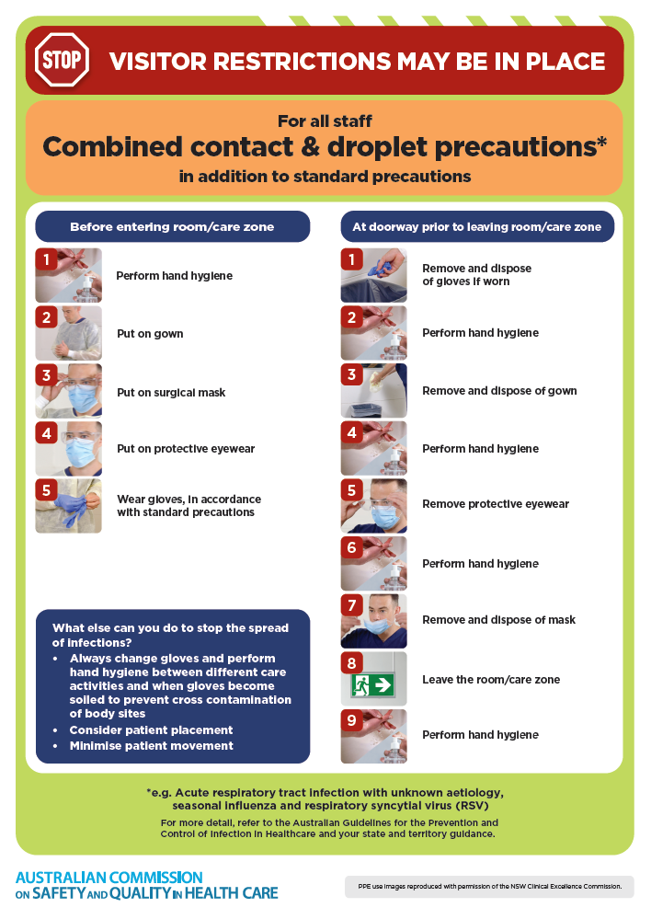](https://www.safetyandquality.gov.au/publications-and-resources/resource-library/infection-prevention-and-control-poster-combined-contact-and-droplet-precautions)
* ***Poster – Combined airborne and contact precautions***<https://www.safetyandquality.gov.au/publications-and-resources/resource-library/infection-prevention-and-control-poster-combined-airborne-and-contact-precautions>  
  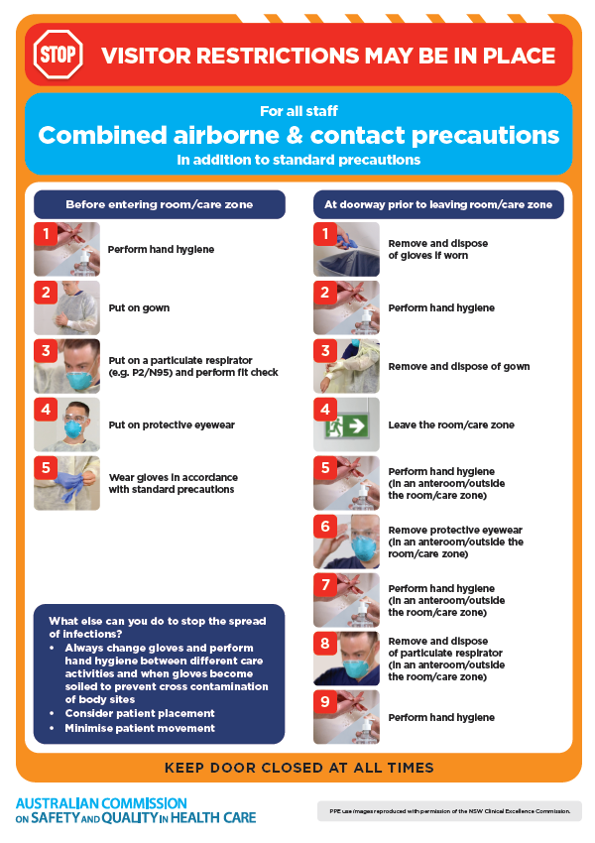
* ***Environmental Cleaning and Infection Prevention and Control*** [www.safetyandquality.gov.au/environmental-cleaning](http://www.safetyandquality.gov.au/environmental-cleaning)
* ***Break the chain of infection*** poster  
  <https://www.safetyandquality.gov.au/publications-and-resources/resource-library/break-chain-infection-poster>  
    
  **[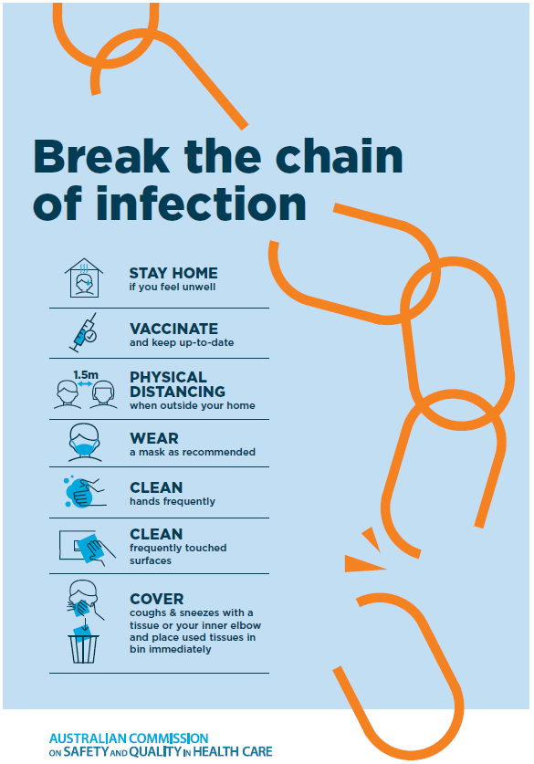](https://www.safetyandquality.gov.au/publications-and-resources/resource-library/break-chain-poster-a3https:/www.safetyandquality.gov.au/publications-and-resources/resource-library/break-chain-poster-a3)**

**Disclaimer**

On the Radar is an information resource of the Australian Commission on Safety and Quality in Health Care. The Commission is not responsible for the content of, nor does it endorse, any articles or sites listed. The Commission accepts no liability for the information or advice provided by these external links. Links are provided on the basis that users make their own decisions about the accuracy, currency and reliability of the information contained therein. Any opinions expressed are not necessarily those of the Australian Commission on Safety and Quality in Health Care.