# Australian Commission on Safety and Quality logotypeOn the Radar

Issue 684

10 February 2025

*On the Radar* is a summary of some of the recent publications in the areas of safety and quality in health care. Inclusion in this document is not an endorsement or recommendation of any publication or provider. Access to particular documents may depend on whether they are Open Access or not, and/or your individual or institutional access to subscription sites/services. Material that may require subscription is included as it is considered relevant.

*On the Radar* is available online, via email or as a PDF or Word document from <https://www.safetyandquality.gov.au/newsroom/subscribe-news/radar>

If you would like to receive *On the Radar* via email, you can subscribe on our website <https://www.safetyandquality.gov.au/newsroom/subscribe-news>  
or by emailing us at H[Umail@safetyandquality.gov.auU](mailto:mail@safetyandquality.gov.au).  
You can also send feedback and comments to H[Umail@safetyandquality.gov.auU](mailto:mail@safetyandquality.gov.au).

For information about the Commission and its programs and publications, please visit <https://www.safetyandquality.gov.au>

**On the Radar**

Editor: Dr Niall Johnson

**Reports**

*Designing inclusive and trusted digital health services with people and communities*

Wills E, Mistry P, Gowar C

London: The King's Fund; 2025.

|  |  |
| --- | --- |
| URL | <https://www.kingsfund.org.uk/insight-and-analysis/long-reads/inclusive-digital-services-people-communities> |
| Notes | The implementation of digital health technologies needs to consider the various affected populations, including the clinical and non-clinical workforce, patients and their families and carers. This ‘long read’ from The King’s Fund in the UK looks particularly to the role of patients and communities in optimising the value of digitally enabled services. |

**Journal articles**

*Bulletin of the World Health Organization*

Volume 103, Number 2, February 2025

|  |  |
| --- | --- |
| URL | <https://www.who.int/publications/journals/bulletin/> |
| Notes | A new issue of the *Bulletin of the World Health Organization* has been published. This is a theme issue with a focus on **digital technologies to improve health services.** Articles in this issue of the *Bulletin of the World Health Organization* include:   * Harnessing digital health to achieve equitable and efficient health systems <https://doi.org/10.2471/BLT.24.293051> * A scoping review and expert consensus on digital determinants of health <https://doi.org/10.2471/BLT.24.292057> * From infrastructure to impact: why foundations matter in digital health <https://doi.org/10.2471/BLT.24.293085> * Towards an inclusive digital health ecosystem <https://doi.org/10.2471/BLT.24.292020> * Digitalization of health care in low- and middle-income countries <https://doi.org/10.2471/BLT.24.291643> |

*Australian Health Review*

Volume 49 Number 1 2025

|  |  |
| --- | --- |
| URL | <https://www.publish.csiro.au/ah> |
| Notes | The *Australian Health* *Review* has moved to a continuous publication model. In the continuous publication model, once an article is ready for publication, it is immediately published online with final citation details (<https://www.publish.csiro.au/journals/continuouspublication>). Recent articles in the *Australian Health Review* include:   * **Consumer involvement**; the system says ‘No.’ (Kylie Hill, Sarah Hug, Vinicius Cavalheri and Ben Horgan * **Lived Experience Advisor Program** initiative: harnessing consumer leadership for best care (Rebecca Barbara, J Lydeker, A Potter and D Kerr) * An illustrative guide to a **Policy Lab model**: contributing to evidence-informed policies for digital technology in youth mental health care (David G Baker, B Kenny, S C Prober, A Sabo, M P Hamilton, C X Gao and S Cross) * Factors influencing participation in **clinical supervision**: a qualitative study reflecting physiotherapist and manager perspectives (Sarah Osiurak, Nicholas F Taylor, Katherine Lawler, K Williams, T Albiston and D A Snowdon) * The impact of **COVID-19 on public and private emergency departments** in Queensland, Australia (Amy L Sweeny, Emma Hall, Anthony Padowitz, Ben Walters, Ping Zhang, K Alcorn, G Keijzers, A P Marshall, J Ranse and J Crilly) * **Translational research in Australian mental health policy**: a scoping review (Caroline Robertson, Justin J Chapman, Vicky Stewart, C Castles, V J Palmer, H Lovelock, K Hawkins, M Banfield, The ALIVE National Centre for Mental Health Research Translation Investigator Group, The ALIVE National Centre Intersectoral Policy and Practice Committee and A J Wheeler) * **Oral health services provided for Aboriginal and Torres Strait Islander peoples** in Australia: a scoping review (Lisa Hai My Do, Yvonne Dimitropoulos, John Skinner and Woosung Sohn) * **Value-based health care for Aboriginal peoples with chronic conditions** in the Northern Territory: a cohort study (Maya Cherian, Yuejen Zhao, Antonio Ahumada-Canale, P Nihill, M VanBruggen, D Butler and P Burgess) * Mapping **essential oral healthcare** for the Australian context (Tan Minh Nguyen, Clare Lin, Martin Hall and Hanny Calache) * The incidence of **cardiac surgery in adults with treated kidney failure** in Australia: a retrospective cohort study (Dominic Keuskamp, Christopher E Davies, Robert A Baker, Kevan R Polkinghorne, Christopher M Reid, Julian A Smith, Lavinia Tran, Jenni Williams-Spence, Rory Wolfe and S P Mcdonald) * Trajectories of **hospital service use in the last 12months of life** by people with chronic kidney disease: a retrospective cohort study (Tolesa Okuba, Zhisheng Sa, Tim Badgery-Parker, Janet C Long, Jeffrey Braithwaite, Angela Makris, A Hutton, J-F Levesque, D E Watson, J I Westbrook and R Mitchell) * Evaluating the outcomes of Australia’s first all-age **public hospital Sport and Exercise Medicine Outpatient Clinic**: a retrospective cross-sectional study (Dougal Middleton, Fintan Thompson and Kira James) * **Patients’ reasons for leaving an emergency department without being seen**: results from a survey-based cohort study during the COVID-19 pandemic (Irene Bryan, Anthony Austen-Wishart, Pratibha Ranjan, Luke Plant, Dana Forcey and Robert Millar) * Can I record this? A scoping review of Australian hospital policies governing **consultation recording** (Megan Prictor, Nikka Milani and Amelia Hyatt) |

*Health Expectations*

Volume 28, Issue 1, February 2025

|  |  |
| --- | --- |
| URL | <https://onlinelibrary.wiley.com/toc/13697625/2025/28/1> |
| Notes | A new issue of *Health Expectations* has been published. Articles in this issue of *Health Expectations* include:   * A Socioecological Approach to Support the **Transition to Adult Care** for Youth With Medical Complexity: Family Perspectives and Recommendations (Lin Li, Nancy Carter, Jan Willem Gorter, Linda Till, M White, P H Strachan) * Recognition at the Heart of the Complex Situations Experienced by People With **Chronic Musculoskeletal Pain** (Mellier Jessica, Balis Aurélie, Defraine Fabian, Vanderhofstadt Quentin, Di Biagi Léa, Schetgen Marco, D'Ans Pierre, Foucart Jennifer, Mahieu Céline, Bengoetxea Ana) * Investigating the Factors Behind Patients' Desire and Decision to be Accompanied: A Cross-Sectional Analysis (Mehmet Göktuğ Kılınçarslan, Büşra Dönmez, Yasemin Kaya Beştepe, Büşra Nur Kırıkcıoğlu, Merve Akbaşoğlu, Bezar Karakaya, Erkan Melih Şahin) * **HIV Care Seeking** Pathways and Barriers to the Continuum of Care Faced by Persons Living With HIV in Rural Nepal: A Qualitative Study (Amit Timilsina, A Shrestha, P Neupane, S Nepal, B Kandel, S Devkota, S Thapa) * Development of a **User-Centred Chronic Care Model** for Patients With Heart Failure in a Limited-Resource Setting: A Codesign Study (Apinya Koontalay, Mari Botti, Anastasia Hutchinson) * The Challenging Process of Developing an **Antenatal Social Intervention** for Parents From Culturally Diverse Backgrounds to Reduce Postnatal Distress: A Participatory Action Research Study (Sophie Isobel, Kahala Dixon, Alison Tutt, Bridget Clay, Sylvia Lim-Gibson) * Finding the Value: Identifying the Key Elements of **Recorded Clinic Visits** From the Perspective of Patients, Clinicians, and Caregivers (Paul J Barr, Garrett T Wasp, Michelle D Dannenberg, Lisa A Mistler, Kanak Verma, Kyra Bonasia, William R Haslett, Craig H Ganoe, R W Bratches, K Schifferdecker) * What I Wish I Had Known: Examining Parent Accounts of Managing the Health of Their **Child With Intellectual Disability** (Thom Nevill, Jessica Keely, Rachel Skoss, Rachel Collins, Katherine Langdon, J Mills, J Downs) * Migrant Farmworkers' **Acceptability of Health Services** in Spain: Barriers and Facilitators Identified by Professionals (Lena van Selm, Iratxe Pérez-Urdiales, M Úbeda-Pavia, J Tomás-Mateos, M del Mar Jiménez-Lasserrotte, M del Mar Pastor-Bravo, A Requena-Méndez, E Briones-Vozmediano) * “After Cutting It, Things Have Never Remained the Same”: A Qualitative Study of the **Perspectives of Amputees** and Their Caregivers (Esther Ohenewa, Joana Salifu Yendork, Benjamin Amponsah, F E Owusu-Ansah) * Editorial: **Patient Engagement in Integrated Care**: What Matters and Why? (Marissa Bird, Nick Zonneveld, Francine Buchanan, Kerry Kuluski) * The Building Blocks for Successful Hub Implementation for **Migrant and Refugee Families** and Their Children in the First 2000 Days of Life (Michael Hodgins, Katarina Ostojic, Tania Rimes, Karen Edwards, Kenny Lawson, Mevni Fonseka, Carmen Crespo, Kim Lyle, Ann Dadich, Valsamma Eapen, Rebekah Grace, Melissa Green, Amanda Henry, Nick Hopwood, Catherine Kaplun, Jane Kohlhoff, Shanti Raman, Tracey Szanto, Sue Woolfenden) * The Relationship Between **Healthcare System Distrust and Intention to Use Violence Against Health Professionals**: The Mediating Role of Health News Perceptions (Selman Kızılkaya, Büşra Buğdali) * Public Involvement to Enhance **Care Home Research**; Collaboration on a Minimum Data Set for Care Homes (Anne Killett, Kerry Micklewright, Rachael Carroll, Gizdem Akdur, Emily Allinson, Liz Crellin, Kaat de Corte, Margaret Fox, Barbara Hanratty, Lisa Irvine, Liz Jones, Marlene Kelly, Therese Lloyd, J Meyer, K Spilsbury, A-M Towers, F Tracey, J Willmott, C Goodman) * How to Approach a Child About Concerns for Their Mental Health and Seeking Help: A Delphi Expert Consensus Study to Develop Guidelines on **Mental Health First Aid for Supporting Children** (Catherine L Johnson, Claire M Kelly, Anthony F Jorm, William Garvey, Laura M Hart) * Understanding the Needs of Young and Middle-Aged **Chinese People Who Have Experienced a Stroke** Who Have Not Successfully Returned to Work: A Qualitative Study (Ziwei Liu, Shu Liu, Jiaxing Shi, Y Yang, Y Zhong, J Li) * Clusters of Patient Empowerment and Mental Health Literacy Differentiate Professional Help-Seeking Attitudes in **Online Mental Health Communities** Users (Nicole Bizzotto, Gert-Jan de Bruijn, Peter Johannes Schulz) * Engaging With a **Community of Practice in Dementia**: Impacts on Skills, Knowledge, Networks and Accessing Support (Clarissa Giebel, James Watson, Megan Polden, Megan Readman, Hilary Tetlow, Mark Gabbay) * Editorial: **Access to Inclusion** Thinking Beyond Reasonable Adjustments (Sandra Paget, Agata Pacho) * Developing, Piloting and Evaluating a **Patient Support Portal** for Men With Prostate Cancer in Victoria: An Action Research Study (Benjamin Shemesh, Jacinta L Opie, Rodney L Dunn, Garth Mclaughlin, Vivek Argawal, Amanda Pomery, Chris Mac Manus, Colin O'Brien, Katrina Lewis, Max Shub, Paula Wilton, Prassannah Satasivam, Melanie Evans, Jeremy Millar, Sue M Evans) * Patients' Attitudes Towards **Integrating Environmental Sustainability Into Healthcare Decision-Making**: An Interview Study (Eva S Cohen, Dionne S Kringos, Fleur Grandiek, Lisanne H J A Kouwenberg, Nicolaas H Sperna Weiland, Cristina Richie, Wouter J K Hehenkamp, Johanna W M Aarts) * Best Practices Guidelines for the Engagement of People With Lived Experience and Family Members in **Mental Health and Substance Use Health Research**: A Modified Delphi Consensus Study (Lisa D Hawke, Wuraola Dada-Phillips, Hajar Seiyad, Josh Orson, Lianne Goldsmith, Susan Conway, Adam Jordan, Natasha Y Sheikhan, M Hiebert, S Kidd, K Kuluski) * Evaluating Process and Outcomes of Public Involvement in **Applied Health and Social Care Research**: A Rapid Systematic Review (Angela Wearn, Kerry Brennan-Tovey, Emma A Adams, Hayley Alderson, Judy Baariu, Mandy Cheetham, V Bartle, L Palfreyman, V Rook, F Shenton, S E Ramsay, E Kaner) * Amplifying Women's Voices in **Menopause Research**: The Importance of Inclusive Perspectives (Camille Cronin, Sara Donevant, Kerri-ann Hughes, Marja Kaunonen, Jette Marcussen, Rhonda Wilson) * ‘You Can't Muck Around With Transplant’: Young People's Experiences of Clinical Care Following **Lung Transplant** (Miranda Paraskeva, Hannah Gulline, S West, L Walsh, B Tarrant, K Hatzikiriakidis, H Morris, D Ayton) * Perceptions and Attitudes of People With **Cancer and Diabetes** Towards Patient Guidelines: A Mixed Methods Study (Lijiao Yan, Ning Liang, Zeyu Yu, Loraine Cook, Sarah E Scott, K Graham, X Liao, H Zhang, J Hu, N Shi, J Liu) * Women's **Menopausal Experiences** in the UK: A Systemic Literature Review of Qualitative Studies (Ailin Anto, A Basu, R Selim, A B Eisingerich) * Implementing and Delivering **Culturally Centred Pharmacy Services** Tailored to Ethnically Minoritised Populations: A Qualitative Systematic Review and Meta-Ethnography (Caitlin Shaw, Ghalib Khan, Thorrun Govind, Anna Robinson-Barella) * Bringing Young People, Health and Social Care Professionals, Transition Champions and Policymakers Together Through Hybrid Methods of Participation: Creating a Space for Shared Understanding of What Is Required to Improve **Young People's Healthcare Transition** (Louise Porter, Faith Gibson, Susie Aldiss, Sue Morgan, Alexandra Stanton, Stella Carney, Aishah Farooq, Isabel Barlow, Haris Sultan, Pippa Sipanoun) |

*Health Affairs*

Volume 44, Number 2, February 2025

|  |  |
| --- | --- |
| URL | <https://www.healthaffairs.org/toc/hlthaff/44/2> |
| Notes | A new issue of *Health Affairs* has been published. Articles in this issue of *Health Affairs* include:   * **Vital Directions For Health And Health Care**: Priorities For 2025 (Victor J Dzau and J Michael McGinnis) * Four Opportunities To Revitalize The US **Biomedical Research Enterprise** (E Albert Reece, Jeffrey R Balser, Kirsten Bibbins-Domingo, Claire M Fraser, Linda P Fried, Ann Kurth, Sudip Parikh, Randall L Rutta, Mary Woolley, Keith R Yamamoto, Elias Zerhouni, Huda Y Zoghbi, and Victor J Dzau) * Updating US **Public Health** For Healthier Communities (Mark McClellan, Karen B DeSalvo, Georges C Benjamin, Frederick P Cerise, Bechara Choucair, Carlos del Rio, Marc Harrison, Rhonda Medows, M L Ranney, and A Zink) * New Directions For **Women’s Health**: Expanding Understanding, Improving Research, Addressing Workforce Limitations (Paula A Johnson, Claire D Brindis, Karen Donelan, Michele Goodwin, Lisa Harris, Katy Backes Kozhimannil, Sara Rosenbaum, and Tracy A Weitz) * **Artificial Intelligence In Health** And Health Care: Priorities For Action (Michael E Matheny, J C Goldsack, S Saria, N H Shah, J Gerhart, I G Cohen, W N Price, B Patel, P R O Payne, P J Embí, B Anderson, and E Horvitz) * Critical Steps To Address **Climate, Health, And Equity** (William H Frist, Sonia Y Angell, Kristie L Ebi, Mary Hayden, Katharine Hayhoe, Paul Locke, Kari Nadeau, Lisa Patel, J A Patz, J B Perlin, L Rudolph, and W B Vernon) * From Laggard To Leader: Why **Health Care In The United States Is Failing**, And How To Fix It (Donald M Berwick, Elaine Batchlor, Dave A Chokshi, Patricia Gabow, R Gilfillan, F Isasi, A Milstein, and L M Nichols) * The Number Of **Family Caregivers** Helping Older US Adults Increased From 18 Million To 24 Million, 2011–22 (Jennifer L Wolff, Jennifer C Cornman, and Vicki A Freedman) * Oregon Community Benefit Reform Influenced **Not-For-Profit Hospitals’ Charity Care** And Medical Debt Write-Off (Tatiane Santos, Richard C Lindrooth, Shoou-Yih Daniel Lee, Kelsey Owsley, and Gary J Young) * Variation In **Hospital Salary Expenditures And Utilization** Changes After Private Equity Acquisition, 2005–19 (Sneha Kannan and Zirui Song) * Increases In **Physician Professional** Fees In Private Equity–Owned Gastroenterology Practices (Y Singh, Z Song, D Polsky, and J M Zhu) * Abortion Rate Increased And Birth Rate Decreased After Introduction Of **Medicaid Abortion Coverage** In Illinois (Taehyun Kim, Jacqueline Ellison, Julia R Steinberg, and Michel H Boudreaux) * **Asian American Invisibility** In Public Health (Cevadne Lee) |

*International Journal for Quality in Health Care* online first articles

|  |  |
| --- | --- |
| URL | <https://academic.oup.com/intqhc/advance-articles> |
| Notes | *International Journal for Quality in Health Care* has published a number of ‘online first’ articles, including:   * Developing and validating a global trigger tool for assessing frequency, level of harm, and preventability of **adverse drug events in pediatric inpatients units** (Amit Gutkind et al) * Prevalence and contributing factors of **intravenous medication administration errors in emergency departments**: a prospective observational study (Tan Shirlyn et al) * Comparative Analysis of **Routine Clinical Debriefings and Incident Reports**: Insights for Patient Safety and Teamwork Enhancement (Méryl Paquay et al) * Use of Wireless Geographic Locating System to Improve **medical equipment utilization** and medical quality (Tien-Lin Huang et al) * **Patient safety in Low and Middle-Income Countries (**LMICs): How can we do better? (Anuradha Pichumani et al) * Using space technology approach to improve **quality in emergency departments** in India: a quality improvement program (Saravana Kumar et al) * **Protocols for ischemic stroke** in Flemish hospitals: correlation between availability and content versus adherence (Charlotte Lens et al) |

**Online resources**

***Advanced care planning: your final footprints***

<https://healthbulletin.org.au/key-resources/resources/50506/>

Cairns and Hinterland Hospital and Health Service have produced this booklet to help Aboriginal and Torres Strait Islander people in the region understand the importance of advance care planning. It is designed to help individuals plan the final chapter of their lives. It highlights the importance of having conversations early with family or substitute-decision makers to ensure wishes, worries, personal values and preferences are honoured.

***Australian Living Evidence Collaboration***

<https://livingevidence.org.au/>

***[UK] NICE Guidelines and Quality Standards***

<https://www.nice.org.uk/guidance>

The UK’s National Institute for Health and Care Excellence (NICE) has published new (or updated) guidelines and quality standards The latest reviews or updates include:

* NICE Guideline NG209 ***Tobacco****: preventing uptake, promoting quitting and treating dependence* <https://www.nice.org.uk/guidance/ng209>
* Quality Standard QS18 ***Ovarian cancer*** <https://www.nice.org.uk/guidance/qs18>

**Infection prevention and control and COVID-19 resources**

The Australian Commission on Safety and Quality in Health Care has developed a number of resources to assist healthcare organisations, facilities and clinicians. These resources include:

* ***Poster – Combined contact and droplet precautions*** <https://www.safetyandquality.gov.au/publications-and-resources/resource-library/infection-prevention-and-control-poster-combined-contact-and-droplet-precautions>  
  [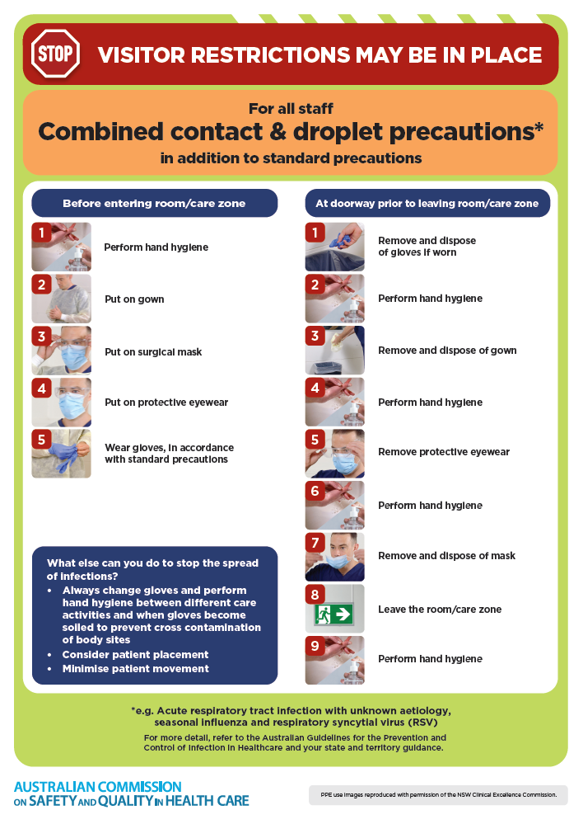](https://www.safetyandquality.gov.au/publications-and-resources/resource-library/infection-prevention-and-control-poster-combined-contact-and-droplet-precautions)
* ***Poster – Combined airborne and contact precautions***<https://www.safetyandquality.gov.au/publications-and-resources/resource-library/infection-prevention-and-control-poster-combined-airborne-and-contact-precautions>  
  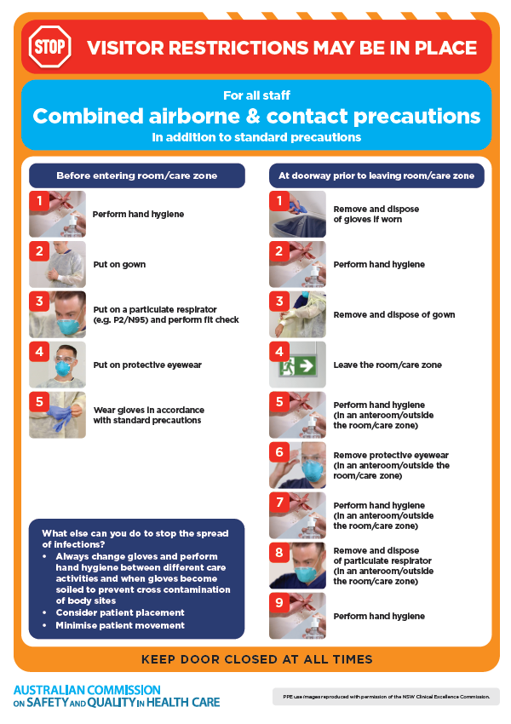
* ***Environmental Cleaning and Infection Prevention and Control*** [www.safetyandquality.gov.au/environmental-cleaning](http://www.safetyandquality.gov.au/environmental-cleaning)
* ***Break the chain of infection*** poster  
  <https://www.safetyandquality.gov.au/publications-and-resources/resource-library/break-chain-infection-poster>  
    
  **[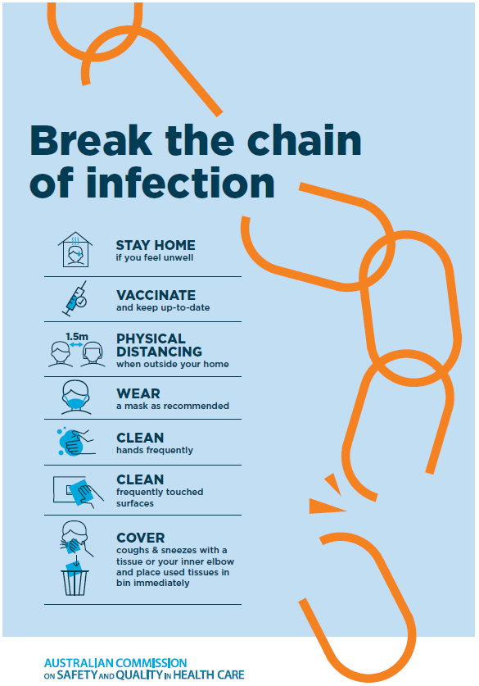](https://www.safetyandquality.gov.au/publications-and-resources/resource-library/break-chain-poster-a3https:/www.safetyandquality.gov.au/publications-and-resources/resource-library/break-chain-poster-a3)**

**Disclaimer**

On the Radar is an information resource of the Australian Commission on Safety and Quality in Health Care. The Commission is not responsible for the content of, nor does it endorse, any articles or sites listed. The Commission accepts no liability for the information or advice provided by these external links. Links are provided on the basis that users make their own decisions about the accuracy, currency and reliability of the information contained therein. Any opinions expressed are not necessarily those of the Australian Commission on Safety and Quality in Health Care.