# Australian Commission on Safety and Quality logotypeOn the Radar

Issue 685

17 February 2025

*On the Radar* is a summary of some of the recent publications in the areas of safety and quality in health care. Inclusion in this document is not an endorsement or recommendation of any publication or provider. Access to particular documents may depend on whether they are Open Access or not, and/or your individual or institutional access to subscription sites/services. Material that may require subscription is included as it is considered relevant.

*On the Radar* is available online, via email or as a PDF or Word document from <https://www.safetyandquality.gov.au/newsroom/subscribe-news/radar>

If you would like to receive *On the Radar* via email, you can subscribe on our website <https://www.safetyandquality.gov.au/newsroom/subscribe-news>  
or by emailing us at H[Umail@safetyandquality.gov.auU](mailto:mail@safetyandquality.gov.au).  
You can also send feedback and comments to H[Umail@safetyandquality.gov.auU](mailto:mail@safetyandquality.gov.au).

For information about the Commission and its programs and publications, please visit <https://www.safetyandquality.gov.au>

**On the Radar**

Editor: Dr Niall Johnson

**Reports**

*Safety management: accountability across organisational boundaries*

Investigation report

Health Services Safety Investigation Body

Poole: HSSIB; 2025.

|  |  |
| --- | --- |
| URL | <https://www.hssib.org.uk/patient-safety-investigations/safety-management/investigation-report/> |
| Notes | This latest report from the Health Services Safety Investigation Body (HSSIB) in the UK ‘explores how patient safety is managed across different organisational boundaries, such as multiple providers within an integrated care system.’ The report observes that ‘Everyone working in health and care has some measure of responsibility for patient safety. When an organisation is accountable for patient safety, it should ensure that systems and processes are in place to effectively manage safety. Organisations should be able to proactively manage recurring or emerging safety risks and should not rely on waiting for harm to occur before taking action.’ This investigation looked particularly at the issues for the UK’s integrated care boards (ICBs). HSSIB reports include a number of recommendations, observations and suggestions. |

**Journal articles**

*FUTURE-AI: international consensus guideline for trustworthy and deployable artificial intelligence in healthcare*

Lekadir K, Frangi AF, Porras AR, Glocker B, Cintas C, Langlotz CP, et al.

BMJ. 2025;388:e081554.

*AI in the Health Sector: Systematic Review of Key Skills for Future Health Professionals*

Gazquez-Garcia J, Sánchez-Bocanegra CL, Sevillano JL

JMIR Med Educ. 2025;11:e58161.

|  |  |
| --- | --- |
| DOI | Lekadir <https://doi.org/10.1136/bmj-2024-081554>  Gazquez-Garcia et al <https://doi.org/10.2196/58161> |
| Notes | The potential uses of AI across health care are many. Some AI applications are already being widely used in health care. AI is used to assess images in areas such as dermatology and diagnostic imaging, in ambient scribes that document consultations, and in analysing patient satisfaction data. There are also many other uses that are being actively investigated and developed. Some of the potential uses engender less risk than others and the real and potential benefits of AI in health care is recognised. However, there are also potential risks in the use of AI in health care.  There are various efforts to shepherd the beneficial uses of AI in health, including the Australian Alliance for Artificial Intelligence in Healthcare (<https://aihealthalliance.org/>) the Trustworthy and Responsible AI Network (TRAIN) (<https://doi.org/10.1001/jama.2025.1331>), the European TRAIN Initiative (<https://doi.org/10.1001/jama.2025.1335>) and many others.  Gazquez-Garcia et al offer a review of the skills future health professionals may need to realise AI in health care (<https://doi.org/10.2196/58161>)  Lekadir et al present the output of a two-year effort of the FUTURE-AI Consortium. The Consortium ‘comprises 117 interdisciplinary experts from 50 countries’. Through a process that has been based on six guiding principles—fairness, universality, traceability, usability, robustness, and explainability’, the Consortium has defined ‘a set of 30 best practices… addressing technical, clinical, socioethical, and legal dimensions’. These ‘recommendations cover the entire lifecycle of healthcare AI, from design, development, and validation to regulation, deployment, and monitoring.’ |

*JBI Evidence Synthesis*

Volume 23, Issue 2, February 2025

|  |  |
| --- | --- |
| URL | <https://journals.lww.com/jbisrir/toc/2025/02000> |
| Notes | A new issue of *JBI Evidence Synthesis* has been published. Articles in this issue of *JBI Evidence Synthesis* include:   * Prophylactic embolization vs observation for high-grade **blunt trauma splenic injury**: a systematic review with meta-analysis (Silas Nann, Molly Clark, Joshua Kovoor, Shivangi Jog, Edoardo Aromataris) * Parental experiences of caring for their **preschool children after declining vaccines**: a qualitative systematic review (Christine Huel, Karen MacKinnon, Jillian Harding, Roya Haghiri-Vijeh, Carol Gordon, Shannon E. MacDonald) * Experiences of African women who migrate to a developed country and encounter **intimate partner violence**: a systematic review of qualitative evidence (Olayide Ogunsiji, Jann Foster, Heidi Green, Nqobile Sikhosana, Patricia Gauci, Naomi Kayesa, Ritin Fernandez) * Effectiveness of cognitive behavioral therapy vs conservative pain management for occupational performance in patients with **low back pain**: a systematic review protocol (Gemiele Elaine Delasas, Ninfa Mae Delgado, Isabelle Kezia Mojica, Stepanie Ragasa, Valentin Dones III, D Manlapaz) * Early introduction of oral feeding and its impact on **full oral feeding and discharge in preterm infants**: a systematic review protocol (Maki Fujitsuka, Kenji Takao, Shingo Ueki, Seiichi Morokuma) * Effect of aspiration during **intramuscular injection** on the occurrence of adverse effects in adults: a systematic review protocol (Marluce Rodrigues Godinho, Fábio da Costa Carbogim, Angélica da Conceição Oliveira Coelho, Gabriela Do Nascimento Martins de Araujo, Amanda Damasceno de Souza, Helen Vaz da Silva Gomes, Alice Maria Das Graças de Sousa, Herlander Jesus Borges Tomás Rodrigues, Kelli Borges Dos Santos, Rui Pedro Gomes Pereira) * Fathers’ **lived experiences of fatherhood** during the child’s first 1000 days: a qualitative systematic review protocol (Telma Vidinha, Diana Santos, Daniela Pinto, Filipa Margarida Duque, Daniela Cardoso, Ana Filipa Cardoso, Maria José Magalhães, Tatiana Moura, Maria Neto) * Online peer-to-peer health communities for individuals affected by **chronic kidney disease**: a scoping review protocol (Neil Coulson, Sarah Beach, Heather Buchanan) * Characteristics of a**dvanced practice nurses’ clinical competence** in primary health care settings: a scoping review protocol (Bernardita Troncoso-Valenzuela, Diná de Almeida Lopes Monteiro da Cruz, Natalia Quiroga Toledo) * **Growth curve models** for weight among infants: a scoping review protocol (Marta Alves, Sofia Serra, Teresa Costa, Carlos Brás-Geraldes, Ana Luisa Papoila, Bruno Heleno) * Children’s involvement in the development and evaluation of **parent-focused mental health interventions**: a scoping review protocol (Rebecca Nowland, Danielle L. Christian, Georgia Aspinall, Kathryn Berzins, Sundus Khalid, Shalini Ahuja, Lucy Gallagher, Brioney Gee, Ella Mickleburgh, Blossom Fernandes, Afra Kelsall, Becca Randell, Daniel Michelson) |

*BMJ Quality & Safety* online first articles

|  |  |
| --- | --- |
| URL | <https://qualitysafety.bmj.com/content/early/recent> |
| Notes | *BMJ Quality &Safety* has published a number of ‘online first’ articles, including:   * Problem with the existing **reporting standards for adverse event and medical error research** (Christopher R Carpenter, Richard T. Griffey, Anne W S Rutjes, Maria Unbeck, Lee M Adler, David C Stockwell, David Classen SESAME Statement Development Team) * **Investigators are human too**: outcome bias and perceptions of individual culpability in patient safety incident investigations (William Lea, Luke Budworth, Jane O'Hara, Charles Vincent, Rebecca Lawton) |

*International Journal for Quality in Health Care* online first articles

|  |  |
| --- | --- |
| URL | <https://academic.oup.com/intqhc/advance-articles> |
| Notes | *International Journal for Quality in Health Care* has published a number of ‘online first’ articles, including:   * **Indirect Effects of the COVID-19 Pandemic** on Healthcare Contacts, Quality of Care, and Social Disparities Across Essential Healthcare Domains (Søren Valgreen Knudsen et al) * Applying the **Human Factors Analysis and Classification System (HFACS) within Root Cause Analysis (RCA)** to Prevent Medical Errors and Enhancing Patient Safety Culture: Insights from a Medical Center (Jiun-Yih Lee et al) * Factors associated with harm in reported patient safety incidents and characteristics during **health screenings** in Korea: a secondary data analysis (Jeongin Choe and Kyungmi Woo) |

**Online resources**

***Australian Living Evidence Collaboration***

<https://livingevidence.org.au/>

***Guidance***

A number of guidelines or guidance have recently been published or updated. These include:

* *Australian and New Zealand Living Clinical Guidelines for Stroke Management* <https://informme.org.au/guidelines/living-clinical-guidelines-for-stroke-management>
* *Australian Pregnancy Care Guidelines* <https://app.magicapp.org/#/guideline/9584>
* *Australian Postnatal Care Guidelines* <https://app.magicapp.org/#/guideline/9582>
* *Consensus recommendations on multiple sclerosis management in Australia and New Zealand: part 1* <https://doi.org/10.5694/mja2.52578>

***[USA] AHRQ PSNet Curated libraries***

<https://psnet.ahrq.gov/curated-article-libraries>

The US Agency for Healthcare Research and Quality (AHRQ) PSNet (Patient Safety Network) has created a number of ‘curated libraries’ on various topics. More recent additions include:

* National Pharmacist Day 2025 (9 articles)
* Patient as a Team Member in Clinical Care (19 articles)

**Infection prevention and control and COVID-19 resources**

The Australian Commission on Safety and Quality in Health Care has developed a number of resources to assist healthcare organisations, facilities and clinicians. These resources include:

* ***Poster – Combined contact and droplet precautions*** <https://www.safetyandquality.gov.au/publications-and-resources/resource-library/infection-prevention-and-control-poster-combined-contact-and-droplet-precautions>  
  [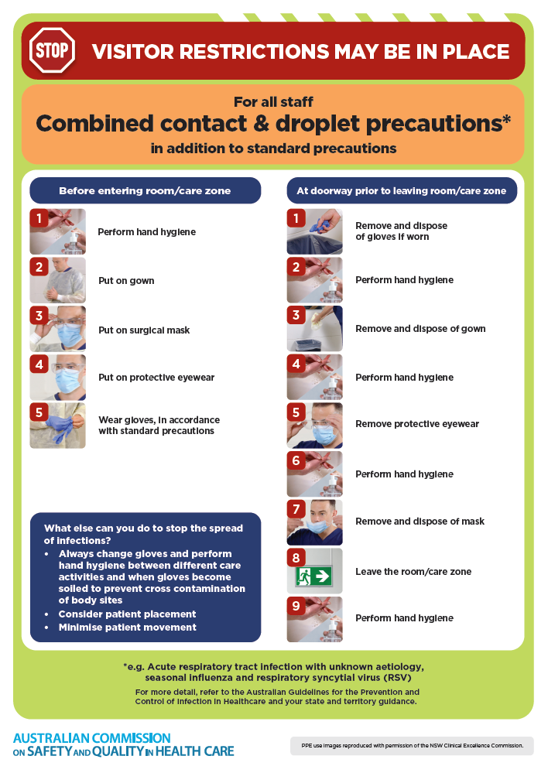](https://www.safetyandquality.gov.au/publications-and-resources/resource-library/infection-prevention-and-control-poster-combined-contact-and-droplet-precautions)
* ***Poster – Combined airborne and contact precautions***<https://www.safetyandquality.gov.au/publications-and-resources/resource-library/infection-prevention-and-control-poster-combined-airborne-and-contact-precautions>  
  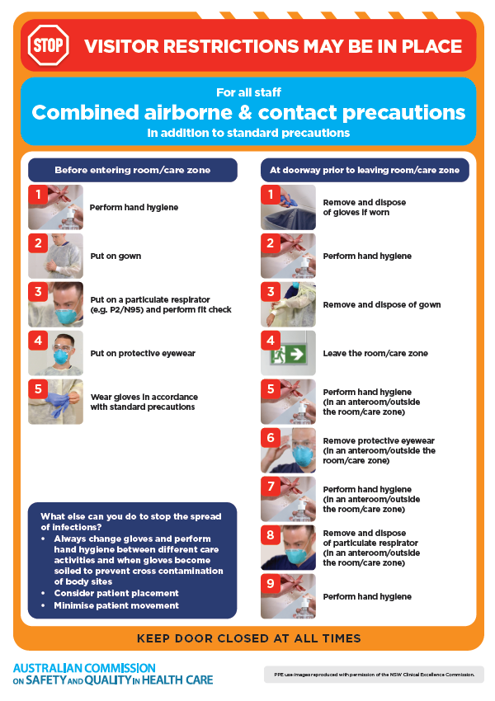
* ***Environmental Cleaning and Infection Prevention and Control*** [www.safetyandquality.gov.au/environmental-cleaning](http://www.safetyandquality.gov.au/environmental-cleaning)
* ***Break the chain of infection*** poster  
  <https://www.safetyandquality.gov.au/publications-and-resources/resource-library/break-chain-infection-poster>  
    
  **[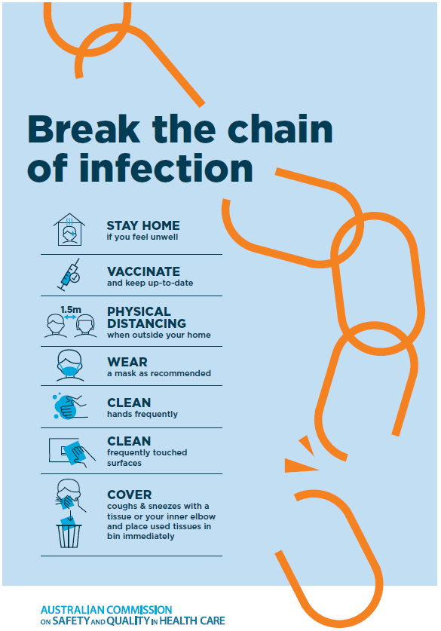](https://www.safetyandquality.gov.au/publications-and-resources/resource-library/break-chain-poster-a3https:/www.safetyandquality.gov.au/publications-and-resources/resource-library/break-chain-poster-a3)**

**Disclaimer**

On the Radar is an information resource of the Australian Commission on Safety and Quality in Health Care. The Commission is not responsible for the content of, nor does it endorse, any articles or sites listed. The Commission accepts no liability for the information or advice provided by these external links. Links are provided on the basis that users make their own decisions about the accuracy, currency and reliability of the information contained therein. Any opinions expressed are not necessarily those of the Australian Commission on Safety and Quality in Health Care.