# Australian Commission on Safety and Quality logotypeOn the Radar

Issue 686

24 February 2025

*On the Radar* is a summary of some of the recent publications in the areas of safety and quality in health care. Inclusion in this document is not an endorsement or recommendation of any publication or provider. Access to particular documents may depend on whether they are Open Access or not, and/or your individual or institutional access to subscription sites/services. Material that may require subscription is included as it is considered relevant.

*On the Radar* is available online, via email or as a PDF or Word document from <https://www.safetyandquality.gov.au/newsroom/subscribe-news/radar>

If you would like to receive *On the Radar* via email, you can subscribe on our website <https://www.safetyandquality.gov.au/newsroom/subscribe-news>  
or by emailing us at H[Umail@safetyandquality.gov.auU](mailto:mail@safetyandquality.gov.au).  
You can also send feedback and comments to H[Umail@safetyandquality.gov.auU](mailto:mail@safetyandquality.gov.au).

For information about the Commission and its programs and publications, please visit <https://www.safetyandquality.gov.au>

**On the Radar**

Editor: Dr Niall Johnson, Brighid Carey, Kerry Viana

***Does Healthcare Deliver? Results from the Patient-Reported Indicator Surveys (PaRIS)***

OECD

Paris: OECD Publishing; 2025. p.289.

<https://doi.org/10.1787/c8af05a5-en>

The OECD has released the *Does Healthcare Deliver? Results from the Patient-Reported Indicator Surveys (PaRIS)* flagship report. The report presents the OECD’s analysis of a ground-breaking international initiative – the PaRIS international survey of people living with chronic conditions. The report reveals how people aged 45 years and older, living with chronic conditions experience healthcare and how this affects their lives. The report also provides valuable insights on how healthcare systems deliver primary care services for people, regardless of gender, level of income or education.

The PaRIS study includes the world largest international data collection on patient-reported outcomes and experiences of primary care patients: 107 011 primary care patients completed the patient questionnaire and have valid data, representing 104 million primary care users while 1 816 primary care practices completed the primary care practice questionnaire.

Australia was one of 19 countries that participated in the survey. A country note highlighting the results of each of the 19 participating nations will also be published on the OECD website.

The Australian Commission on Safety and Quality in Health Care implemented the PaRIS Survey in Australia on behalf of the Australian Government Department of Health and Aged Care (<https://www.safetyandquality.gov.au/our-work/indicators-measurement-and-reporting/patient-reported-indicator-survey-paris>).

***The AGAR Surveillance Outcome Programs 2023 Report***

Coombs GW, Bell JM, Blyth CC, Bond K, Daley D, Cooley L, Gottlieb T, Iredell J, Warner M, Robson J, and van Hal S on behalf of the Australian Commission on Safety and Quality in Health Care.

Sydney: ACSQHC; 2024.

<https://www.safetyandquality.gov.au/publications-and-resources/resource-library/agar-surveillance-outcome-programs-2023-report>

The Commission has collaborated with the Australian Group on Antimicrobial Resistance (AGAR) to bring together important findings on antimicrobial resistance (AMR) in bloodstream infections across Australia in the AGAR Surveillance Outcome Programs 2023 Report.

Key findings on the targeted surveillance of select pathogens captured by the three AGAR Surveillance Outcome Programs include:

* ***Enterococcus* species**: A slim majority (51%) of *Enterococcus faecium* bloodstream infections were vancomycin-resistant in 2023, continuing an upward trend.
* ***Staphylococcus aureus***: Just over three-quarters (77%) of *S. aureus* bloodstream infections were acquired in the community. Of all cases, 16% were methicillin resistant.
* **Gram-negative species**: 25% of *Escherichia coli* and 9% of *Klebsiella pneumoniae* bloodstream infections were multidrug-resistant. While carbapenem-resistant *Enterobacterales* in bloodstream infections remain very low in Australia (0.3%), they are a significant risk to patient safety.

The AGAR Surveillance Outcome Programs 2023 Report complements four other [antimicrobial use and resistance reports](https://www.safetyandquality.gov.au/our-work/antimicrobial-resistance/antimicrobial-use-and-resistance-australia-aura) published by the Commission in 2024 to highlight priorities for addressing AMR in Australia and for the safety of care provided to patients.

**Reports**

*Leading practices for the future of telemedicine: Implementing telemedicine post-pandemic*

OECD Health Working Papers, No. 173

Keelara R, Sutherland E, Almyranti M

Paris: OECD Publishing; 2025. p. 47.

|  |  |
| --- | --- |
| DOI | <https://doi.org/10.1787/496a8ffe-en> |
| Notes | The COVID-19 pandemic saw a rapid increase in the availability and use of telemedicine in many nations, including Australia. This has consolidated into a regular form of health care delivery. According to the OECD’s website, this report ‘explores how OECD countries have embedded telemedicine into everyday care and the implications on equitable access, sustainable funding, and data-driven decision-making.’ The report also examines leading practices in the post-pandemic implementation of telemedicine across a of group of OECD nations. |

*"Just a Period": Calling time on heavy and painful periods*

Wellbeing of Women

London: Wellbeing of Women; 2025. p. 20.

|  |  |
| --- | --- |
| URL | <https://www.wellbeingofwomen.org.uk/news/just-a-period-calling-time-on-heavy-and-painful-periods/> |
| Notes | The UK charity Wellbeing of Women has released this report that uses information from a number of surveys to reveal ‘the shocking extent to which women are putting up with pain, heavy bleeding and other symptoms without access to trusted information or treatment.’ Wellbeing of Women has also produced a Period Symptom Checker to assist individuals ‘to seek treatment if needed, challenge dismissal, and learn more about their periods’. In 2024, the Australian Commission on Safety and Quality in Health Care released an updated *Heavy Menstrual Bleeding Clinical Care Standard* <https://www.safetyandquality.gov.au/standards/clinical-care-standards/heavy-menstrual-bleeding-clinical-care-standard> |

For information on the Commission’s work on maternity and women's health, including the [*Women's Health Focus Report*](https://www.safetyandquality.gov.au/our-work/healthcare-variation/womens-health-focus-report) see <https://www.safetyandquality.gov.au/our-work/healthcare-variation/maternity-and-womens-health#women-s-health>

*The preventative shift: How we can embed prevention and achieve long term missions*

A Demos-Health Foundation discussion paper

O'Brien A, Curtis P, Finch D

London: Demos; 2025. p. 29.

|  |  |
| --- | --- |
| URL | <https://demos.co.uk/research/the-preventative-shift-how-can-we-embed-prevention-and-achieve-long-term-missions/> |
| Notes | The UK thinktank Demos ‘has been making the case for a fundamental shift in the purpose of government away from firefighting in public services towards preventing problems arriving’. This discussion paper, developed in partnership with the Health Foundation, examines changing the culture of public bodies to think ‘prevention first’ and to target spending at activities which promise value for money and improve outcomes. |

**Journal articles**

*Australian Journal of Primary Health*

|  |  |
| --- | --- |
| URL | <https://www.publish.csiro.au/py/#Latest> |
| Notes | The *Australian Journal of Primary Health* has moved to a continuous publication model. In the continuous publication model, once an article is ready for publication, it is immediately published online with final citation details (<https://www.publish.csiro.au/PY/Continuouspublication>).  Recent articles in the *Australian Journal of Primary Health* include:   * Investigating men’s perspectives on **preventive health care** within general practice: a qualitative study (Ruth Mursa, Gemma McErlean, Christopher Patterson and Elizabeth Halcomb) * Senior staff experiences of implementing a **reablement model in community care** (Sarah J Prior, Hazel Maxwell, Marguerite Bramble, Annette Marlow, Douglass Doherty and Steven Campbell) * **Oral COVID-19 antiviral prescribing** in Australian general practice – a retrospective observational study (Judith Thomas, Abbish Kamalakkannan, Mirela Prgomet, Karina Gardner, P McGuire, G Campbell and A Georgiou) * **Community healthcare** system and its practice for Indigenous elders in Taiwan (Hui-Chuan Chiu, Chun-Yen Kuo and Chin-ying Lai) * General practice registrar evaluation of **long COVID** in patients presenting with fatigue (David Wilkins, Amanda Tapley, Jason Dizon, Elizabeth Holliday, Andrew Davey, Alison Fielding, Dominica Moad, Mieke van Driel, Anna Ralston, Katie Fisher, Parker Magin and Nigel Stocks) * Facilitators and barriers to adopting a multifaceted **chlamydia management intervention** in general practice: qualitative findings from Management of Chlamydia Cases in Australia (MoCCA) (Stephanie C Munari, Jacqueline Coombe, Helen Bittleston, M Temple-Smith, C K Fairley, D Bateson, M Hellard, J L Goller, J S Hocking and on behalf of the MoCCA Investigators) * **Culturally safe physiotherapy care**: how this looks and feels for Aboriginal and Torres Strait Islander peoples (C Nelson, R Forbes and A Mandrusiak) * Implementation of a data-driven quality improvement program in primary care for patients with **coronary heart disease**: a mixed methods evaluation of acceptability, satisfaction, barriers and enablers (Nashid Hafiz, Karice Hyun, Qiang Tu, Andrew Knight, Clara K Chow, Charlotte Hespe, Tom Briffa, Robyn Gallagher, Christopher M Reid, David L Hare, Nicholas Zwar, Mark Woodward, Stephen Jan, Emily R Atkins, Tracey-Lea Laba, Elizabeth Halcomb, Tracey Johnson, Deborah Manandi, Tim Usherwood and J Redfern) * Exploring the associative relationship between general practice engagement and hospitalisation in **older carers** to potentially reduce hospital burden (Anthony Azer, Margo Barr, George Azer and Ben Harris-Roxas) |

*Australian Prescriber*

Volume 48, Issue 1, February 2025

|  |  |
| --- | --- |
| URL | <https://australianprescriber.tg.org.au/> |
| Notes | A new issue of *Australian Prescriber* has been published. Content in this issue of *Australian Prescriber* includes:   * Editorial: ***Australian Prescriber***: celebrating 50 years of growth and change (R Scott) * Editorial: **New drug comments**: aiming to deliver useful, timely, independent information for health professionals (T Thynne, R Elliott) * **Drug safety in pregnancy** (D Kennedy, R Batagol) * Device-assisted therapies for **Parkinson disease** (N Mouchaileh, J Cameron) * The role of triple antithrombotic therapy in **patients with atrial fibrillation and coronary stent insertion** (K Ziser, S Rahman, R Soro, N Falconer, D Harrop) * **Propranolol overdose** following prescription for anxiety (E Browne, J Huber, B Murnion) * **New drugs**:  Etrasimod for moderate to severe ulcerative colitis  Mavacamten for symptomatic obstructive hypertrophic cardiomyopathy  Teclistamab for relapsed or refractory multiple myeloma |

*BMJ Quality & Safety*

Volume 34, Issue 3, March 2025

|  |  |
| --- | --- |
| URL | <https://qualitysafety.bmj.com/content/34/3> |
| Notes | A new issue of *BMJ Quality & Safety* has been published. Many of the papers in this issue have been referred to in previous editions of *On the Radar* (when they were released online). Articles in this issue of *BMJ Quality & Safety* include:   * Editorial: Art of **leading quality improvement** (Maitreya Coffey, K Smith) * Editorial: The beast and the burden: will pruning **performance measurement** improve quality? (Eric C Schneider) * Editorial: Global perspectives on **opioid use**: shifting the conversation from deprescribing to quality use of medicines (Aili Veronica Langford, Chung-Wei Christine Lin, Suzanne Nielsen) * ‘We listened and supported and depended on each other’: a qualitative study of how leadership influences **implementation of QI interventions** (Liane Ginsburg, Adam Easterbrook, Ariane Geerts, Whitney Berta, Lynda van Dreumel, Carole A Estabrooks, Peter G Norton, Adrian Wagg) * Reducing administrative burden by implementing a core set of **quality indicators in the ICU**: a multicentre longitudinal intervention study (Gijs Hesselink, Rutger Verhage, Brigitte Westerhof, Eva Verweij, Malaika Fuchs, Inge Janssen, Catrien van der Meer, Iwan C C van der Horst, Paul de Jong, Johannes G van der Hoeven, Marieke Zegers) * Decoding behaviour change techniques in **opioid deprescribing** strategies following major surgery: a systematic review of interventions to reduce postoperative opioid use (Neetu Bansal, Christopher J Armitage, Rhiannon E Hawkes, Sarah Tinsley, Darren M Ashcroft, Li-Chia Chen) * Preventing **urinary tract infection** in older people living in care homes: the ‘StOP UTI’ realist synthesis (Jacqui Prieto, Jennie Wilson, Alison Tingle, Emily Cooper, Melanie Handley, Jo Rycroft Malone, Jennifer Bostock, H Loveday) * Experiences with **diagnostic delay** among underserved racial and ethnic patients: a systematic review of the qualitative literature (Elena Faugno, Alison A Galbraith, Kathleen Walsh, Paul J Maglione, Jocelyn R Farmer, M-S Ong) * **Measuring the quality of surgery**: should textbook outcomes be an off-the-shelf or a bespoke metric? (Kjetil Søreide) |

*Journal of Patient Safety*

Volume 21, Issue 2, March 2025

|  |  |
| --- | --- |
| URL | <https://journals.lww.com/journalpatientsafety/toc/2025/03000> |
| Notes | A new issue of *Journal of Patient Safety* has been published. Articles in this issue of *Journal of Patient Safety* include:   * Application of the IMB Model in the Vision of Zero Harm Caused by **Magnetic Resonance Ferromagnetic Projection Accidents** (Meng Gong, Lei Qin, Longbiao Cai) * Intelligent Verification Tool for **Surgical Information of Ophthalmic Patients**: A Study Based on Artificial Intelligence Technology (Hui Lin, Xiaofang Huang, Yaying Sheng, Ning Tang, Hengli Lian, Wenjie Zhang, Lvjun Zhao, Hanqing Zhu, Pingjun Chang, Yingxuan Guo) * A Framework for the Analysis of **Communication Errors in Health Care** (John A Bender, Sreedevi Thiyagarajan, Wendy Morrish, M Mims, E E Yackel) * Relations Between **Suicide Risk** and Patient Safety Attitudes Among the Nursing Team in a Brazilian Context (Kariciele Cristina Corrêa, Lúcio Borges de Araújo, Helenitta Melo da Silva Alves, Liz Marina Corrêa Ferreira, Frank José Silveira Miranda, Marcelle Aparecida de Barros Junqueira) * It’s Called “Informed Consent,” But How “Informed” Are Patients? A Patient Perspective on **Informed Consent** in a Tertiary Care Hospital in Saudi Arabia (Jenny L Gray, Iskandar C Mrad, Aseel M AlAyed, Fadwa A AlHawas, Najlaa M Faiq AbdulHameed, Zubeda B Mahomed, Mashail A AlWtaid, Abdullah A Bany Hamdan, AlWaleed M AlHarbi, Mohammed AlHasani) * The Implementation of Perioperative Geriatric Management Could Decrease the Incidence of **Postoperative Delirium** in the Elderly Undergoing Major Orthopedic Surgeries (Yan Zou, Tingzhi Deng, Yu Xu, Qing Zheng, Yuan Wu, Shan Hui, Cuizhong Liu, An Wei) * Implementation of a Standardized Tool for **Root Cause Analysis** Selection (Eric Wahlstedt, B E Levy, E Scott, W Stephens, K E Fletcher, A Harris) * The Optimized Use of a **Contact-Free Continuous Monitoring System** on Clinical Outcomes During COVID-19 (Alice Kim, Patricia C Dykes, Darren Scully, Paula Wolski, C Franz, S Lipsitz, G Lowenthal, M Wien, D W Bates) * Ambulatory Medication Errors and Adverse Events Involved in **Medicine-Related Malpractice Cases** From 2011 to 2021 (Susan Boisvert, Melissa Nelson, Jacqueline Ross) |

*Pediatric Quality & Safety*

Volume 10, Number 1, January/February 2025

|  |  |
| --- | --- |
| URL | <https://journals.lww.com/pqs/toc/2025/01000> |
| Notes | A new issue of *Pediatric Quality & Safety* has been published. Articles in this issue of *Pediatric Quality & Safety* include:   * Increasing Premedication for **Neonatal Intubation**: A Quality Improvement Initiative (Michelle H Lucena, Toshiba Morgan-Joseph, A Thompson-Branch) * **Reducing Intubations** and Related Risks in Neonates with Retinopathy of Prematurity Undergoing Laser Photocoagulation (Vilmaris Quinones Cardona, Emma McNell Byrne, Novisi Arthur, Megan Young, Diane Lavery, Amanda Carroll, Swosti Joshi, Folasade Kehinde, Ogechukwu Menkiti) * Reducing Sedation for **Pediatric Thoracic CT Imaging** Using Volumetric Target-mode EKG Gating (Summit H Shah, Cody M Young, Jessica Morrison, Margarita Chmil, Lynne Ruess, Rajesh Krishnamurthy) * Improved Adherence to **Lipid Screening** in the Pediatric Cardiology Clinic: A Quality Improvement Project (Rachel A Magnan, T Murphy, L Rosenthal, A Prasad, A Chelliah, S Kaufman, D Timchak, L McPhillips, S Siddiqui) * A Quality Improvement Initiative to Reduce **Surgical Site Infections** in Pediatric Patients Undergoing Cardiothoracic Surgery (C Golden, K Murphy, J M Rosenblum, C Eriksson, P Dunaway, M Lukacs, L Newberry, M E Gleason, C J Calamaro, M Basu, N K Chanani, S Shashidharan, M P Fundora) * Keep Moving: Sustainability of an **Early Mobility Protocol** in an Academic Pediatric ICU (Jenna E Domann, Lindsay E Davies, Elizabeth E Zivick, Laken Johnson, Everette P Keller, Alice A Walz) * Lessons Learned from a Quality Improvement Initiative to Increase **COVID-19 Vaccination** in Hospitalized Children (Daniel G Young, Cortney S Rogers, Isaac Mayefsky, T Neufeld, A Niesen, P J Reich, C M Kao, M Srinivasan) * A Standardized Approach to Transition Improves Care of Young Adults with **Inflammatory Bowel Disease** (Daphna Katz, Stephanie Lee, Vidiya Sathananthan, Liz Bayes Santos, Amber Langshaw) * Addressing Late-arriving Surgeons in Support of **First-case On-time Starts** (Jonathan B Ida, Jamie H Schechter, John Olmstead, Archana Menon, Mary Beth Iafelice, Amod Sawardekar, Olga Leavitt, Jennifer M Lavin) * Decreasing Unnecessary Resource Utilization for **New-onset, Unprovoked, Afebrile Seizure** in the Emergency Department (Laura A Santry, K Giordano, A Mower, J Hubbard, J Thomas, R C Scott, K Chara, J Zent, A Zomorrodi) * Improving Access to **Early Developmental Evaluation** in Academic Primary Care Centers (Zeina M Samaan, Pamela Williams-Arya, Kristen Copeland, M C Burkhardt, J Schumacher, J Hardie, C White, A Reyner, M Taylor, J Ehrhardt) * **Pediatric Health Assessment Tracker**: A Quality Improvement Initiative to Obtain Weights Consistently and Appropriately in a Tertiary Pediatric Intensive Care Unit (Alonso Marron, Abhinav Totapally, Allison Weatherly, Subhendu De, Madeline Barber, Allyson Lifsey, Katharine Boyle) * Reducing Employee Injuries from **Aggressive Patient Behavior** at Children’s Hospital by Implementing a Behavioral Response Team (Julia A Martorana, Debrea M Griffith, Carmel Eiger, James J Maurer, Amanda Burnside, Aron C Janssen, Alba Pergjika, Jennifer A Hoffmann) * Leveraging Quality Improvement Tools to Improve Administration of **First-line Surgical Antibiotic Prophylaxis** in Patients Labeled as Penicillin Allergic (Madeline Mock, David Morris, Jessica Foley, Mellissa Mahabee, J Michael Klatte, Beth Williams, Daniel Robie) * Improving **Evidenced-based Outpatient Order Set Utilization** in the Gastrointestinal Division of a Large Pediatric Health System (Kevin L Watson, Jr, April M Love, Hanna Lemerman, Cathy Gustaevel, Prabi Rajbhandari) * Improving Adherence to the **Lead Exposure Protocol** at Boston Medical Center’s Pediatric Clinic (Julie R Barzilay, Anthony J Mell, MaryKate Driscoll, Priscilla Gonzalez, Sarah Meyers, Noah Buncher) * **Improving Antibiotic Use** in Argentine Pediatric Hospitals: A Process Evaluation Using Normalization Process Theory (Javier Roberti, Facundo Jorro-Barón, Natalí Ini, Marina Guglielmino, Ana Paula Rodríguez, Cecilia Echave, Andrea Falaschi, Viviana E Rodríguez, E García-Elorrio, J P Alonso) * Transitioning to **Opioid-free Anesthesia** for Pediatric Supracondylar Fracture Repairs: A Patient Safety Report (Laurence O. Henson, Jennifer Chiem, Emmanuella Joseph, Fiona Patrao, Daniel King-Wai Low) |

*Journal for Healthcare Quality*

Volume 47, Number 1, February/April 2025

|  |  |
| --- | --- |
| URL | <https://journals.lww.com/jhqonline/toc/2025/04000> |
| Notes | A new issue of *The Journal for Healthcare Quality (JHQ)* has been published. Articles in this issue of *The Journal for Healthcare Quality* include:   * **State-Level Hospital Quality** in the United States: Analyzing Variation and Trends From 2013 to 2021 (Arjun Teotia, Brent D Fulton, Dan R Arnold, Richard M Scheffler) * A **Composite Score** Reflecting an Initiative to Reduce Harm, Protect Patients, and Promote Safety (Katelynd Smith, Julia McAvoy, J D Six, L Goss) * Personalizing Quality Improvement: Addressing Anticoagulation Gaps in **Atrial Fibrillation** (Gary D Owen, Christopher J Terry, Erin B Neal, Scott D Nelson, Mohamed Omar, Mariah J Pettapiece-Phillips, Sunil Kripalani) * **Preoperative Optimization** of Patients Undergoing Orthopedic Foot and Ankle Surgery: A Single Institution Cohort (Julia Kessel, Rebecca J Cleveland, Trapper Lalli, Joshua Tennant, Jennifer Woody) * Pharmacist-Led Population Health Initiative to Address **Statin Care Gaps**: A Quality Improvement Project (Danielle Raymer, Anna Everhart, D Baker) * Reducing **Emergency Department Hold Hours**: A Hospital-wide Effort (Jill McCormick, Faith Kinsinger, Ritika J Patel, Grant Wicklund, Deb Roybal) * Electronic Clinical Quality Measures for **Prosthetic Joint Infection** Diagnosis: Pitfalls and Potential (Andy O Miller, Amy S Chin, Alberto V Carli, George Sayegh, Diana Chee, Daniel B Buchalter, Sam Simon, C H Maclean) * Continuous Quality Improvement in **Social Needs Screening**: Evaluation of an Intervention in Bariatric Specialty Care (Claire Chang, Samantha Cooley, Bradley Iott, Jordan Greene, Dilhara Muthukuda, Renuka Tipirneni) |

*BMJ Quality & Safety* online first articles

|  |  |
| --- | --- |
| URL | <https://qualitysafety.bmj.com/content/early/recent> |
| Notes | *BMJ Quality &Safety* has published a number of ‘online first’ articles, including:   * Relative importance and interactions of factors influencing **low-value care provision**: a factorial survey experiment among Swedish primary care physicians (Marta Roczniewska, Hanna Augustsson, Sara Ingvarsson, Emma Hedberg Rundgren, Kamil Szymański, Ulrica von Thiele Schwarz, Per Nilsen, Henna Hasson) * Quality improvement collaborative to increase **access to caesarean sections**: lessons from Bihar, India (Abha Mehndiratta, Prabir Ranjan Moharana, Tanmay Mahapatra, Sridhar Srikantiah, Sunil Babu, Sarita Simba, Sanjiv Daulatrao Sanjiv Daulatrao, Vikas Pandey, Rahul Shastri, Srinivas Kodiyath, Sulagna Mukherjee, Pramod Sah, Pierre Barke) |

*International Journal for Quality in Health Care* online first articles

|  |  |
| --- | --- |
| URL | <https://academic.oup.com/intqhc/advance-articles> |
| Notes | *International Journal for Quality in Health Care* has published a number of ‘online first’ articles, including:   * The sustainability of **hospital accreditation models**: A cross-sectional study (Mohammed Hussein) * **HemeTEAM** India: Together Everyone Achieves More (Bhargava Rahul et al) |

**Online resources**

***Australian Living Evidence Collaboration***

<https://livingevidence.org.au/>

***[UK] NICE Guidelines and Quality Standards***

<https://www.nice.org.uk/guidance>

The UK’s National Institute for Health and Care Excellence (NICE) has published new (or updated) guidelines and quality standards The latest reviews or updates include:

* Clinical Guideline CG81 ***Advanced breast cancer****: diagnosis and treatment* <https://www.nice.org.uk/guidance/cg81>
* NICE Guideline NG101 *Early and locally* ***advanced breast cancer****: diagnosis and management* <https://www.nice.org.uk/guidance/ng101>

***[Canada] Promising practices to support appropriate, safe and equitable virtual care***

<https://www.healthcareexcellence.ca/en/what-we-do/all-programs/partnering-on-appropriate-virtual-care/promising-practices-for-partnering-on-appropriate-virtual-care/>

Healthcare Excellence Canada launched the Partnering on Appropriate Virtual Care initiative to support healthcare providers and patients to work together to ensure virtual care is provided in an appropriate, safe and equitable way. This summary profiles promising practices developed by participating teams that aim to improve healthcare access and outcomes, reduce avoidable emergency department visits, foster patient-provider partnerships and ensure virtual care access for diverse populations.

**Infection prevention and control and COVID-19 resources**

The Australian Commission on Safety and Quality in Health Care has developed a number of resources to assist healthcare organisations, facilities and clinicians. These resources include:

* ***Poster – Combined contact and droplet precautions*** <https://www.safetyandquality.gov.au/publications-and-resources/resource-library/infection-prevention-and-control-poster-combined-contact-and-droplet-precautions>  
  [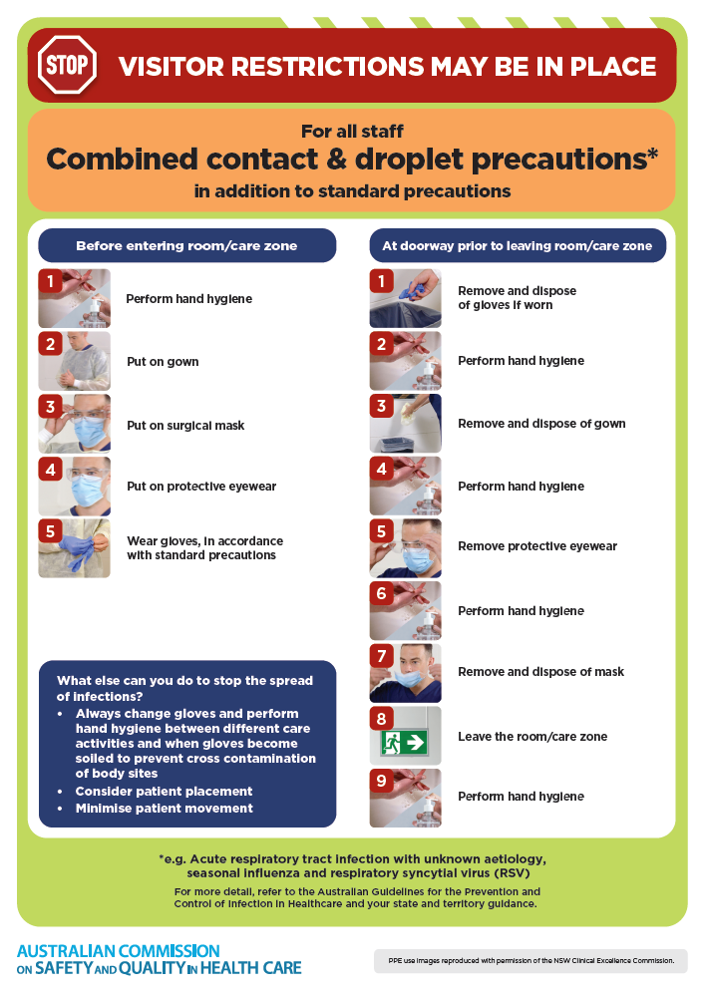](https://www.safetyandquality.gov.au/publications-and-resources/resource-library/infection-prevention-and-control-poster-combined-contact-and-droplet-precautions)
* ***Poster – Combined airborne and contact precautions***<https://www.safetyandquality.gov.au/publications-and-resources/resource-library/infection-prevention-and-control-poster-combined-airborne-and-contact-precautions>  
  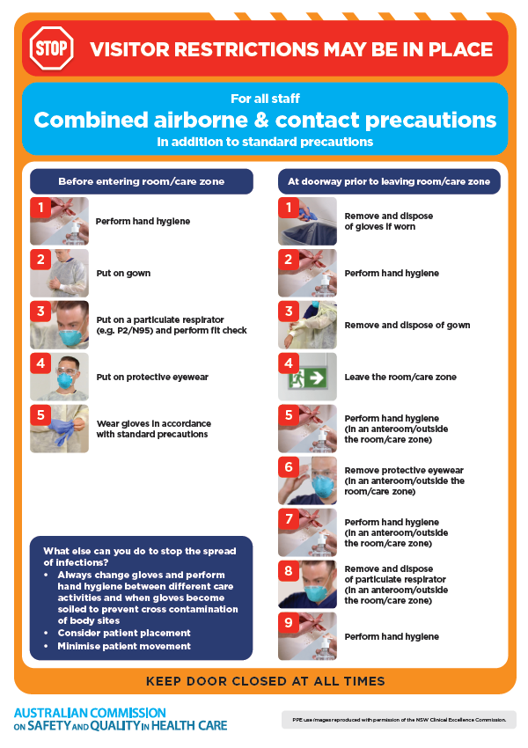
* ***Environmental Cleaning and Infection Prevention and Control*** [www.safetyandquality.gov.au/environmental-cleaning](http://www.safetyandquality.gov.au/environmental-cleaning)
* ***Break the chain of infection*** poster  
  <https://www.safetyandquality.gov.au/publications-and-resources/resource-library/break-chain-infection-poster>  
    
  **[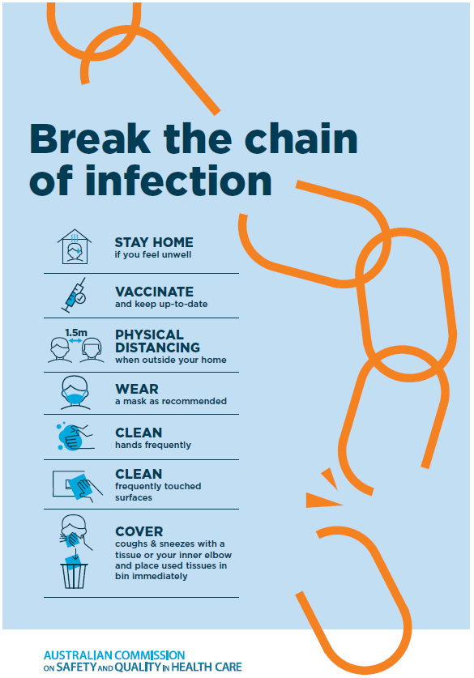](https://www.safetyandquality.gov.au/publications-and-resources/resource-library/break-chain-poster-a3https:/www.safetyandquality.gov.au/publications-and-resources/resource-library/break-chain-poster-a3)**

**Disclaimer**

On the Radar is an information resource of the Australian Commission on Safety and Quality in Health Care. The Commission is not responsible for the content of, nor does it endorse, any articles or sites listed. The Commission accepts no liability for the information or advice provided by these external links. Links are provided on the basis that users make their own decisions about the accuracy, currency and reliability of the information contained therein. Any opinions expressed are not necessarily those of the Australian Commission on Safety and Quality in Health Care.