# Australian Commission on Safety and Quality logotypeOn the Radar

Issue 689

17 March 2025

*On the Radar* is a summary of some of the recent publications in the areas of safety and quality in health care. Inclusion in this document is not an endorsement or recommendation of any publication or provider. Access to particular documents may depend on whether they are Open Access or not, and/or your individual or institutional access to subscription sites/services. Material that may require subscription is included as it is considered relevant.

*On the Radar* is available online, via email or as a PDF or Word document from <https://www.safetyandquality.gov.au/newsroom/subscribe-news/radar>

If you would like to receive *On the Radar* via email, you can subscribe on our website <https://www.safetyandquality.gov.au/newsroom/subscribe-news>  
or by emailing us at H[Umail@safetyandquality.gov.auU](mailto:mail@safetyandquality.gov.au).  
You can also send feedback and comments to H[Umail@safetyandquality.gov.auU](mailto:mail@safetyandquality.gov.au).

For information about the Commission and its programs and publications, please visit <https://www.safetyandquality.gov.au>

**On the Radar**

Editor: Dr Niall Johnson

**Reports**

*Handbook of tools to support medicine management in multimorbidity and polypharmacy*

Roughead L, Widagdo I, Kemp-Casey A

Adelaide: University of South Australia; 2025.

|  |  |
| --- | --- |
| URL | <https://www.health.gov.au/resources/publications/handbook-of-tools-to-support-medicine-management-in-multimorbidity-and-polypharmacy?language=en> |
| Notes | The Australian Department of Health and Aged Care commissioned the Quality Use of Medicines and Pharmacy Research Centre at the University of South Australia to develop this handbook. The handbook collates examples of tools designed to aid health professionals manage concurrent use of medicines and reduce the risk of harm across the spectrum of factors where problems with medicine use can develop. The handbook includes tools designed to:   * reduce medicine regimen complexity; * identify non-adherence; * identify medicines that are considered generally inappropriate in older people; * identify medicines that may have been omitted but are considered beneficial in older people; * detect medicine related side effects; * identify the potential for harms due to the cumulative effects of medicine use; * support cessation of medicines; and * support medication switching and tapering. |

For information on the Commission’s work on medication safety see <https://www.safetyandquality.gov.au/our-work/medication-safety>

*Medication not given: anticoagulation before and after a procedure. Investigation report*

Health Services Safety Investigation Body

Poole: HSSIB; 2025.

|  |  |
| --- | --- |
| URL | <https://www.hssib.org.uk/patient-safety-investigations/medication-related-harm/second-investigation-report/> |
| Notes | This latest report from the Health Services Safety Investigation Body (HSSIB) in the UK is the second in a series of investigations exploring why medications intended to be provided to patients were not provided. The investigation examined the systems and processes in place to support staff when a patient who is usually taking an anticoagulant undergoes a procedure. The investigation was prompted by a case where a patient had their anticoagulant medication paused on admission to hospital ahead of a procedure. After the procedure the medication was not resumed as intended and the patient had a stroke and died. The report includes a number of observations, findings and recommendations. It also includes a local-level learning prompts for health service organisations and facilities. |

*Top 10 Patient Safety Concerns for 2025*

ECRI

Plymouth Meeting, PA: ECRI; 2025.

|  |  |
| --- | --- |
| URL | <https://home.ecri.org/blogs/ecri-thought-leadership-resources/top-10-patient-safety-concerns-2025>  <https://assets.ecri.org/PDF/Top10PatientSafetyConcerns_2025_final.pdf> |
| Notes | ECRI (originally the Emergency Care Research Institute) in the USA produces an annual list of hazards. Their list of the top 10 patient safety concerns for 2025 is:   1. Risks of Dismissing Patient, Family, and Caregiver Concerns 2. Insufficient Governance of Artificial Intelligence in Healthcare 3. The Wide Availability and Viral Spread of Medical Misinformation: Empowering Patients through Health Literacy 4. Medical Error and Delay in Care Resulting from Cybersecurity Breaches 5. Unique Healthcare Challenges in Caring for Veterans 6. The Growing Threat of Substandard and Falsified Drugs 7. Diagnostic Error: The Big Three—Cancers, Major Vascular Events, and Infections 8. Persistence of Healthcare-Associated Infections in Long-Term Care Facilities 9. Inadequate Communication and Coordination during Discharge 10. Deteriorating Community Pharmacy Working Conditions Contribute to Medication Errors and Compromise Patient and Staff Safety. |

**Journal articles**

*Co-Designing a Framework for Social Media Health Communication to Young People: A Participatory Research Study*

Taba M, Ayre J, McCaffery K, Vassilenko D, Ma ICK, Haynes T, et al

Health Expectations. 2025;28(2):e70203.

|  |  |
| --- | --- |
| DOI | <https://doi.org/10.1111/hex.70203> |
| Notes | Following the item in last week’s *On the Radar* on social media and [“social media influencers’ posting on diagnostic tests](https://doi.org/10.1001/jamanetworkopen.2024.61940) is this piece on co-design of social media content. The paper describes the co-design of a social media communication framework for health messaging to young people. In this instance the approach saw young people involved in study recruitment, workshop facilitation, data analysis and manuscript preparation as co-researchers. The authors argue that ‘By incorporating a variety of messaging approaches and actively involving young people in content development, public health agencies can better reach and engage young people, including during public health emergencies.’ |

*Association Between Surgeon Stress and Major Surgical Complications*

Awtry J, Skinner S, Polazzi S, Lifante J-C, Dey T, Duclos A, et al

JAMA Surgery. 2025.

*Surgeon Perception and Attitude Toward the Moral Imperative of Institutionally Addressing Second Victim Syndrome in Surgery*

Hsiao L-H, Kopar PK

Journal of the American College of Surgeons. 2025;240(2):221-228.

|  |  |
| --- | --- |
| DOI | Awtry et al <https://doi.org/10.1001/jamasurg.2024.6072>  Hsiao et al <https://doi.org/10.1097/xcs.0000000000001191> |
| Notes | A pair of items examining the experiences and perspectives of surgeons.  Awtry et al measured surgeons’ stress to examine the associations between stress and major surgical complications. This was a ‘multicenter prospective cohort study included 14 surgical departments involving 7 specialties within 4 university hospitals’ in France. The analysis examined 793 surgical procedures performed by 38 attending surgeons. Perhaps somewhat counterintuitively they report finding that ‘Increased surgeon stress at the beginning of a procedure was associated with improved clinical patient outcomes’.  Hsiao et al looked at surgeons’ views on ‘second victim syndrome (SVS)’. This was a single site study ‘conducted at a tertiary-care university hospital using a mixed-methods approach coupling quantitative and qualitative assessments including a 13-item survey, follow-up focus group, and semistructured interviews’. The authors report that ‘Surgeons believe SVS is a universal experience among surgeons that healthcare institutions have a moral obligation to address.’ They also report that surgeons ‘agreed that healthcare organizations have a moral imperative to assist surgeons in navigating the psychosocial impacts of SVS after adverse surgical outcomes. The success of mitigation strategies was viewed as ethically relevant to patients and surgeons and dependent on the culture, tenor, and tone of the process.’ |

*Pharmacy prevalence of second victim syndrome in a comprehensive cancer center*

Johnson TN, Tucker AM

American Journal of Health-System Pharmacy. 2025;82(6):297-305.

*Opening the door for second victims*

Nicol N, Vaught R

American Journal of Health-System Pharmacy. 2025;82(6):251-252.

*First, Do No Harm—A Career-Long Struggle With Iatrogenesis*

Elmunzer BJ

JAMA Internal Medicine. 2025.

|  |  |
| --- | --- |
| DOI | Johnson et al <https://doi.org/10.1093/ajhp/zxae267>  Nicol and Vaught <https://doi.org/10.1093/ajhp/zxae312>  Elmunzer <https://doi.org/10.1001/jamainternmed.2024.7839> |
| Notes | One of the articles focusing on surgeons above examined [surgeons’ experiences of second victim syndrome (SVS)](https://doi.org/10.1097/xcs.0000000000001191) Two articles in *the American Journal of Health-System Pharmacy* look at SVS in a different clinical cohort: pharmacists.  Johnson et al report on a survey in a comprehensive cancer centre that sought to ‘determine the pharmacy prevalence of second victim syndrome (SVS)’. The survey achieved a 95% response rate ‘with self-perceived SVS reported in 37% of all respondents. Overall, 53% of pharmacists and 15% of pharmacy technicians reported having experienced SVS in their lifetime’.  In an editorial in the same issue of the *American Journal of Health-System Pharmacy*, Nicol and Vaught describe the realities of ‘what it means to be an unwilling member of what we liken to an exclusive club that no one wants to join, and membership can never be canceled’. However, recognising the second victim should not mean losing sight of the first victim.  Nicol and Vaught observe: ‘As long as we, fallible humans, continue to work in healthcare, errors will continue to happen. When we harm a patient, they become the “first victim.” We become the “second victim.”  “Second victim” describes healthcare providers involved in an unanticipated, adverse patient-related event that is traumatizing to the provider. Both of us know this all too well. We know what it means to be an unwilling member of what we liken to an exclusive club that no one wants to join, and membership can never be canceled. Among the inclusionary requirements? Shame, fear, sadness, guilt, depression, and loss of confidence—many of which define the physical and psychological symptoms of what has become known as second victim syndrome (SVS). Equally important to note is that clinicians may experience SVS even if they weren’t directly involved in the event; just knowing about a patient being accidentally harmed is enough.  We both were involved in medication errors that resulted in the death of a patient. We both still think about those patients constantly and think about the millions of “what ifs” that could have or should have occurred to avoid it all. We both can identify with the 10% of respondents from a recent survey at a comprehensive cancer center who reported they still have not fully recovered from the trauma of their events.’  Second Victim Syndrome (SVS) may seem to be having something of a moment as there is also Elmunzer’s piece. Here the author, ‘a gastroenterologist who specializes in complex endoscopic procedures’, reflects on their experience and behaviours and a couple of recent papers on the subject. Elmunzer observes ‘I can execute a perfect procedure, but complications can still happen; in this profession of uncertainty, the only thing I can control with 100% confidence is how kindly I treat patients and how hard I try to help them. This is the only thing that has ever made me feel better about complications.’ |

*Addressing global inequities in surgery with the FAIR and CARE principles*

Collins JW, Dasgupta P

British Journal of Surgery. 2025;112(3):znaf026.

|  |  |
| --- | --- |
| DOI | <https://doi.org/10.1093/bjs/znaf026> |
| Notes | Also in the realm of surgery is this piece looking at equity and access to surgery.  The authors ‘return to one of the central tenets of the National Institute of Health–American College of Surgeons Symposium on Surgical Disparities Research: ‘No quality without access’.’  The authors focus on the FAIR and CARE principles and ‘the potential impact of applying these complimentary sets of guidelines in surgical training’.  ‘The FAIR principles stand for Findable, Accessible, Interoperable, and Reusable. These principles focus on the characteristics of data that make it easier to share, while avoiding issues related to power dynamics or historical contexts. The FAIR principles have been used in multiple settings and have potential to guide data sharing in surgery.’  ‘The CARE principles stand for Collective Benefit, Authority to Control, Responsibility, and Ethics. These principles are people- and purpose-oriented, and focus on how data can be used to advance Indigenous innovation, self-determination, and governance.’ |

*In-hospital versus postdischarge 30-day mortality in patients admitted after acute myocardial infarction (AMI), cerebral stroke or hip fracture: a cohort study based on registry data*

Blixt JP, Kristoffersen DT, Helgeland J, Thoresen C, Aylin PP, Tjomsland O

BMJ Open Quality. 2025;14(1):e003030.

|  |  |
| --- | --- |
| DOI | <https://doi.org/10.1136/bmjoq-2024-003030> |
| Notes | Thirty-day mortality is a common measure of hospital performance and patient safety. This study sought to examine ‘e 30-day mortality according to place of death, that is, during admission (in-hospital), postdischarge or after readmission for patients with acute myocardial infarction (AMI), cerebral stroke and hip fracture’. The study used Norwegian registry data covering 84,212 admissions between 2017 and 2019. The author report that ‘a significant proportion of deaths occur postdischarge (23.4% for AMI, 32.8% for stroke and 59.0% for hip fracture)’ Among their observations, the authors suggest ‘Incorporating postdischarge mortality into quality metrics could provide a more comprehensive evaluation of patient safety and the effectiveness of care during and after hospitalisation.’ |

*Australian Health Review*

Aboriginal and Torres Strait Islander – beyond Closing the Gap collection

|  |  |
| --- | --- |
| URL | <https://www.publish.csiro.au/ah/collection/12798> |
| Notes | The *Australian Health Review* has released a collection of articles examining the health and wellbeing of First Nations Australians. The collection, ‘Beyond Closing the Gap’, focuses on the health challenges faced by Aboriginal and Torres Strait Islander communities, alongside policy and service innovations aimed at improving health outcomes and equity. Articles in this collection from the *Australian Health Review* include:   * **Rheumatic heart disease** 2025 – current status and future challenges (Benjamin Jones and David S Celermajer) * **Beyond social determinants of health** (Alicia E Veasey) * Experiences of occupational therapy students undertaking an Aboriginal and Torres Strait Islander health module: **embedding cultural responsiveness in professional curricula** (Lynette Mackenzie, Josephine Gwynn, John Gilroy) * Reporting Indigenous status, ethnicity, language and country of birth to build equity in **international paediatric clinical trials** with Australian sites: a scoping review (Jacqueline Cunninghame, Mari Takashima, Lorelle Holland, Linda Nguyen, Abbey Diaz, S Guo, M Dufficy, C F Munns and A Ullman) * Pattern of hospital admissions and costs associated with **acute rheumatic fever and rheumatic heart disease** in Australia, 2012–2017 (Ingrid Stacey, Judith Katzenellenbogen, Joseph Hung, Rebecca Seth, Carl Francia, Bradley MacDonald, James Marangou, Kevin Murray and Jeffrey Cannon) * Aboriginal and Torres Strait Islander peoples' perspectives on **community pharmacists prescribing**: a co-designed study protocol (Cara Cross, Vita Christie, Leanne Holt, Boe Rambaldini, Katrina Ward, John Skinner, Connie Henson, D McCowen, S (Charlie) Benrimoj, S Dineen-Griffin and K Gwynne) * **Oral health services** provided for Aboriginal and Torres Strait Islander peoples in Australia: a scoping review (Lisa Hai My Do, Yvonne Dimitropoulos, John Skinner and Woosung Sohn) * Improving equitable access to publicly funded **bariatric surgery** in Queensland, Australia (Megan Cross, Jody Paxton, Katie Wykes, Viral Chikani, George Hopkins, Srinivas Teppala, Paul Scuffham and on behalf of the Clinical and Operational Reference Group) * Exploring equity of care for Aboriginal and Torres Strait Islander peoples within the state-wide **Musculoskeletal Physiotherapy** Screening Clinic and Multi-disciplinary Service in Queensland Health (A McDougall, M Raymer, P Window, M Cottrell, C Nelson, C Francia, E Watson and S O’Leary) * Are we missing opportunities to detect **acute rheumatic fever and rheumatic heart disease** in hospital care? A multijurisdictional cohort study (John A Woods, Nita Sodhi-Berry, Bradley R MacDonald, Anna P Ralph, Carl Francia, Ingrid Stacey and Judith M Katzenellenbogen) * Estimating the true number of people with **acute rheumatic fever and rheumatic heart disease** from two data sources using capture–recapture methodology (Joanne Thandrayen, Ingrid Stacey, Jane Oliver, Carl Francia, Judith M Katzenellenbogen and Rosemary Wyber) * Comparison of a **visiting subspecialist ophthalmology service** to Royal Darwin Hospital with interstate transfers: costs and clinical outcomes of treatment (Danny Lam, Madelaine Moore, Michelle Cunich, Stewart Lake, I Van Ho, Peter McCluskey and Tharmalingam Mahendrarajah) * Workforce training needs to address social and emotional wellbeing in **home-based Aboriginal and Torres Strait Islander aged care** (Adriana Parrella, Jonathon Zagler, Matilda D’Antoine, Tina Brodie, Kate Smith, Aunty Martha Watts, Tameeka Ieremia, Graham Aitken, Alex Brown and Odette Pearson) * **Value-based health care for Aboriginal peoples with chronic conditions** in the Northern Territory: a cohort study (Maya Cherian, Yuejen Zhao, Antonio Ahumada-Canale, P Nihill, M VanBruggen, D Butler and P Burgess) |

*JBI Evidence Synthesis*

Volume 23, Issue 3, March 2025

|  |  |
| --- | --- |
| URL | <https://journals.lww.com/jbisrir/toc/2025/03000> |
| Notes | A new issue of *JBI Evidence Synthesis* has been published. Articles in this issue of *JBI Evidence Synthesis* include:   * Textual evidence systematic reviews series paper 1: introduction to the **revised JBI methodology** and overview of recent changes (Alexa McArthur, Adam Cooper, Deborah Edwards, Jitka Klugarova, Hu Yan, Brittany V Barber, Emily E Gregg, Lori E Weeks, Zoe Jordan) * Methods for data extraction and data transformation in **convergent integrated mixed methods systematic reviews** (Lucylynn Lizarondo, Cindy Stern, Susan Salmond, Judith Carrier, Kay Cooper, Christina Godfrey, Manda Vandyk, Danielle Pollock, Kendra Rieger, Joao Apostolo, Pamela Kirkpatrick, Kelli Borges Dos Santos, Heather Loveday) * The revised **JBI critical appraisal tool** for the assessment of risk of bias for cohort studies (Timothy H Barker, Sabira Hasanoff, Edoardo Aromataris, Jennifer C Stone, Jo Leonardi-Bee, Kim Sears, Nahal Habibi, Miloslav Klugar, Catalin Tufanaru, Sandeep Moola, Xian-Liang Liu, Zachary Munn) * Addressing equity, diversity, and inclusion in **JBI qualitative systematic reviews**: a methodological scoping review (Catrin Evans, Zeinab M Hassanein, Manpreet Bains, Clare Bennett, Merete Bjerrum, Alison Edgley, Deborah Edwards, Kylie Porritt, Susan Salmond) * Defining the **exit meta-analysis** (Jazeel Abdulmajeed, Luis Furuya-Kanamori, Tawanda Chivese, Chang Xu, Lukman Thalib, Suhail A R Doi) * Methodological components, structure, and quality assessment tools for **evidence summaries**: a scoping review (Ashley Whitehorn, Craig Lockwood, Yan Hu, Weijie Xing, Zheng Zhu, Kylie Porritt) * Update to the **PRISMA guidelines** for network meta-analyses and scoping reviews and development of guidelines for rapid reviews: a scoping review protocol (Areti Angeliki Veroniki, Brian Hutton, Adrienne Stevens, Joanne E McKenzie, Matthew J Page, David Moher, Jessie McGowan, Sharon E Straus, Tianjing Li, Zachary Munn, Danielle Pollock, Heather Colquhoun, Christina Godfrey, Maureen Smith, Janice Tufte, Sherrie Logan, Ferrán Catalá-López, David Tovey, Juan V A Franco, Stephanie Chang, Chantelle Garritty, Lisa Hartling, Tanya Horsley, Etienne V Langlois, Matthew McInnes, M Offringa, V Welch, C Pritchard, H Khalil, N Mittmann, M Peters, M Konstantinidis, E B M Elsman, S E Kelly, A Aldcroft, S S Thirugnanasampanthar, J Dourka, D Neupane, G Well, E Akl, M Wilson, K Soares-Weiser, A C Tricco) * Conducting pairwise and network meta-analyses in **updated and living systematic reviews**: a scoping review protocol (Menelaos Konstantinidis, Catherine Stratton, Sofia Tsokani, Julian Elliott, Mark Simmonds, Jessie McGowan, David Moher, Andrea C Tricco, Areti-Angeliki Veroniki) * Tools, techniques, methods, and processes for the detection and mitigation of **fraudulent or erroneous data in evidence synthesis**: a scoping review protocol (Timothy Hugh Barker, Grace McKenzie McBride, Amanda Ross-White, Danielle Pollock, Cindy Stern, Sabira Hasanoff, Raju Kanukula, Mafalda Dias, Anna Scott, Edoardo Aromataris, Ashley Whitehorn, Jennifer C. Stone, Larissa Shamseer, Patrick Palmieri, Miloslav Klugar, Zachary Munn) * Barriers and facilitators to designing, maintaining, and utilizing **rare disease patient registries**: a scoping review protocol (Catherine Stratton, Andrew Taylor, Menelaos Konstantinidis, Vanda McNiven, Peter Kannu, Peter Gill, Ian Stedman, Areti Angeliki Veroniki, M Offringa, B Potter, D Wong-Rieger, J Adams, K Hodgkinson, A M Elliott, A Neville, M Faughnan, S Dyack, P Zhelnov, J Daly-Cyr, J McGowan, S Straus, M Smith, L Rosella, A C Tricco) * **Long-term care insurance** and implementation for older people in China: a systematic review of textual evidence protocol (Xiaoman Yang, Shuqi Yuan, Yan Hu) |

*BMJ Quality & Safety* online first articles

|  |  |
| --- | --- |
| URL | <https://qualitysafety.bmj.com/content/early/recent> |
| Notes | *BMJ Quality &Safety* has published a number of ‘online first’ articles, including:   * Equity in action: a scoping review and meta-framework for **embedding equity in quality improvement** (Tara A Burra, Bourne Auguste, Lisha Lo, Toluwanimi Durowaye, Haben Dawit, Susanna Fung, Christine Shea, Terri Rodak, Noor Ramji, Sanjeev Sockalingam, Brian M Wong) * The problem with the existing **reporting standards for adverse event and medical error research** (Christopher R Carpenter, Richard T Griffey, Anne W S Rutjes, Maria Unbeck, Lee M Adler, David C Stockwell, David Classen SESAME Statement Development Team) |

*International Journal for Quality in Health Care* online first articles

|  |  |
| --- | --- |
| URL | <https://academic.oup.com/intqhc/advance-articles> |
| Notes | *International Journal for Quality in Health Care* has published a number of ‘online first’ articles, including:   * **Improving primary care** through multidisciplinary teamwork: possibilities and challenges (Michael Kidd, Shona Bates, David Greenfield) * Creating **transformative change in the disabilities field**: promoting both bottom-up and top-down inclusion through the UNCRPD and QualityRights Toolkit (Michela Atzeni, Mauro Giovanni Carta, David Greenfield) |

**Online resources**

***Australian Living Evidence Collaboration***

<https://livingevidence.org.au/>

***[USA] Effective Health Care Program reports***

<https://effectivehealthcare.ahrq.gov/>

The US Agency for Healthcare Research and Quality (AHRQ) has an Effective Health Care (EHC) Program The EHC has released the following final reports and updates:

* *Interventions To Improve Care of Bereaved Persons* <https://effectivehealthcare.ahrq.gov/products/bereaved-persons/research>

**Infection prevention and control and COVID-19 resources**

The Australian Commission on Safety and Quality in Health Care has developed a number of resources to assist healthcare organisations, facilities and clinicians. These resources include:

* ***Poster – Combined contact and droplet precautions*** <https://www.safetyandquality.gov.au/publications-and-resources/resource-library/infection-prevention-and-control-poster-combined-contact-and-droplet-precautions>  
  [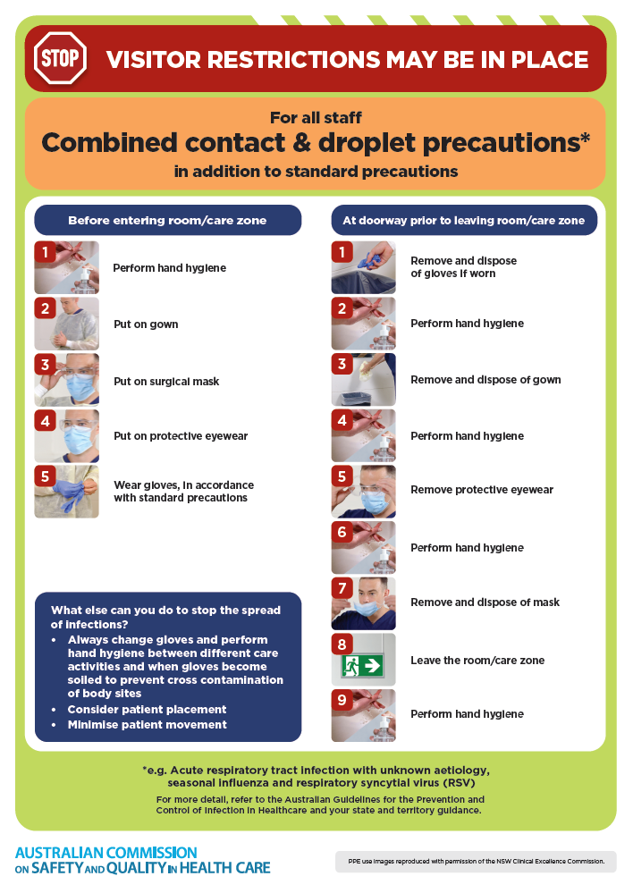](https://www.safetyandquality.gov.au/publications-and-resources/resource-library/infection-prevention-and-control-poster-combined-contact-and-droplet-precautions)
* ***Poster – Combined airborne and contact precautions***<https://www.safetyandquality.gov.au/publications-and-resources/resource-library/infection-prevention-and-control-poster-combined-airborne-and-contact-precautions>  
  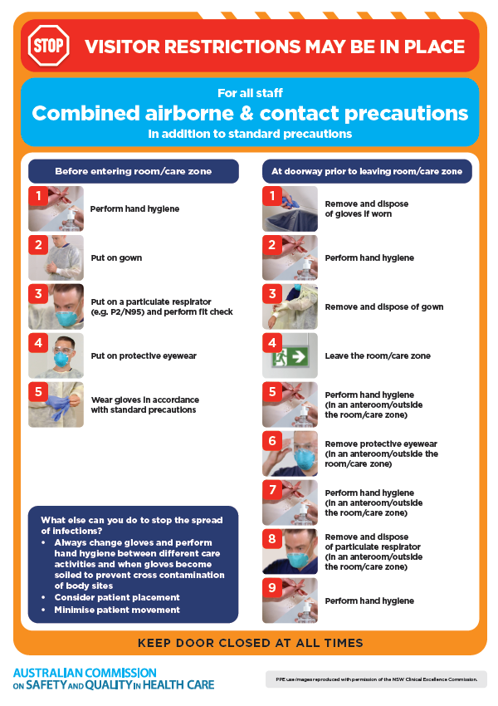
* ***Environmental Cleaning and Infection Prevention and Control*** [www.safetyandquality.gov.au/environmental-cleaning](http://www.safetyandquality.gov.au/environmental-cleaning)
* ***Break the chain of infection*** poster  
  <https://www.safetyandquality.gov.au/publications-and-resources/resource-library/break-chain-infection-poster>  
    
  **[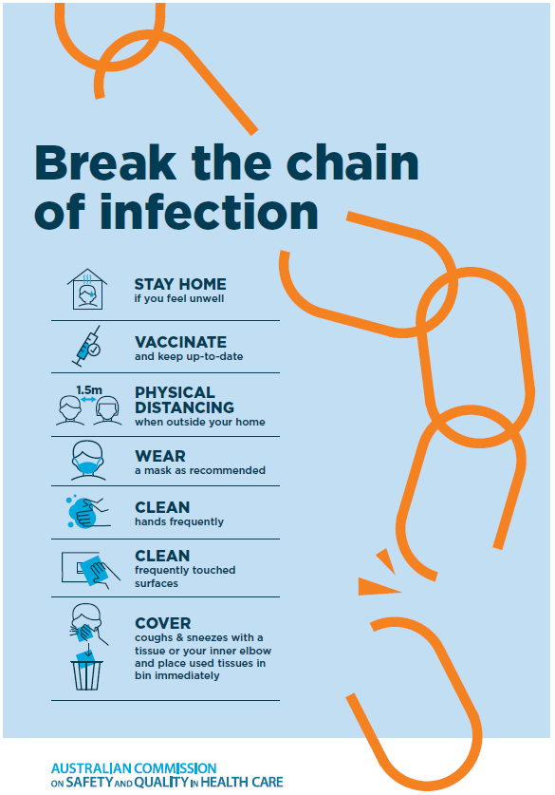](https://www.safetyandquality.gov.au/publications-and-resources/resource-library/break-chain-poster-a3https:/www.safetyandquality.gov.au/publications-and-resources/resource-library/break-chain-poster-a3)**

**Disclaimer**

On the Radar is an information resource of the Australian Commission on Safety and Quality in Health Care. The Commission is not responsible for the content of, nor does it endorse, any articles or sites listed. The Commission accepts no liability for the information or advice provided by these external links. Links are provided on the basis that users make their own decisions about the accuracy, currency and reliability of the information contained therein. Any opinions expressed are not necessarily those of the Australian Commission on Safety and Quality in Health Care.