**Australian Safety and Quality Medical Imaging Accreditation Scheme**

Consultation Paper

## Introduction

Since 2008, the Diagnostic Imaging Accreditation Scheme (DIAS) has been the mechanism by which the Australian Government Department of Health and Aged Care ensures medical imaging practices accessing public funding programs are providing safe and high-quality services.

To support the introduction of a revised set of standards for medical imaging the Commission is proposing changes to the accreditation of imaging practices. Reasons for these changes include:

* The current paper-based desktop assessment methodology is not robust and does not achieve the Department’s aim of assuring the provision of safe, high-quality services
* It is not possible to effectively assess the new National Safety and Quality Medical Imaging (NSQMI) Standards using desktop audit.
* Desktop audits create unnecessary administrative burden on medical imaging practices as they rely on generating documentation that is not associated with patient care.
* Some medical imaging practices are accredited to multiple sets of standards, increasing their administrative burden. A revised scheme provides an opportunity to remove duplication and focus on quality improvement.
* External assessments can drive quality improvement. Imaging practices that provide safe, high-quality services are more effective businesses, resulting in fewer complaints, better staff retention and better patient outcomes.

## Accreditation cycle

The proposed accreditation cycle will be 3 years. In a three-year cycle there is generally one assessment per accreditation cycle. Where the assessment is four years or longer, there is usually an additional review required to ensure ongoing maintenance of standards over the cycle.

## Notification of Assessments

It is proposed that the assessment format will be matched to the size, complexity and risks to patients, from providing an imaging service. The assessment can be announced or short notice.

|  |
| --- |
| Announced assessment   * An imaging provider is given notice well in advance of assessment, allowing the provider to prepare for accreditation * Places the focus on the accreditation process, rather than the implementing standards and quality improvement. * Has been shown in other accreditation schemes to increase the administration burden, with the assessment on processes, systems and responses that have been prepared, rather than ongoing quality improvement. |

|  |
| --- |
| Short notice assessment   * An imaging provider is given notice of the assessment in the days immediately before the assessment. * Places the emphasis on continuously meeting standards and improving the quality of care * Assesses day to day patient care * Assessments focus on clinical and operational areas rather than concentrating on documentation reviews * Has been found to reduce the administrative burden and stress on staff in other accreditation programs. |

## Assessment cycle

An assessment takes between one to four months, dependent on whether a remediation period is required. It involves an initial assessment, and if all the relevant actions of the standards are met, the approved accrediting agency has 20 business days to finalise the outcome report and issue an accreditation award to the imaging provider.

If at initial assessment one or more actions of the standards are not met, the imaging provider has a remediation period of 60 business days before a final assessment occurs. This assessment is to confirm the requirements of the standards are fully met. The approved accrediting agency has 20 business days from the final assessment to finalise recommendations, provide an outcome report and accreditation awarded, where appropriate.

**Diagram 1: Assessment cycle**

Final report

Up to 20 business days

Remediation period. Up to 60 business days.

Initial report

Up to five business days

Initial assessment

A medical imaging provider can appeal accreditation decisions. First, to their accrediting agency and then to the Commission. Appeals to the Commission can only be made on the basis that the accrediting agency did not follow the agreed process for the ASQMI accreditation scheme

## Sampling

Sampling could be considered when an imaging provider operates a large number of services under a single governance structure.

Sampling involves a selection of the imaging provider’s practices undergoing assessment rather than all of them. The sampling methodology will ensure the selected imaging practices appropriately represent the service of the imaging provider being assessed. Implementing sampling will be subject to regulatory requirements

## Assessment methodology

Assessment can be conducted in a variety of ways, as outlined below

## Current method

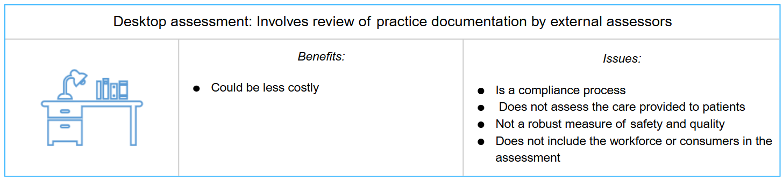

## Proposed approach

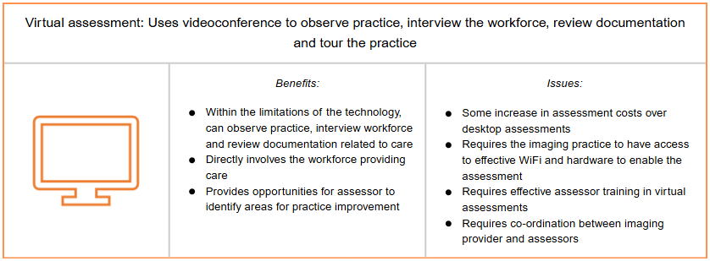

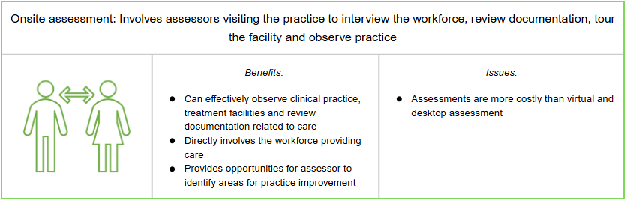

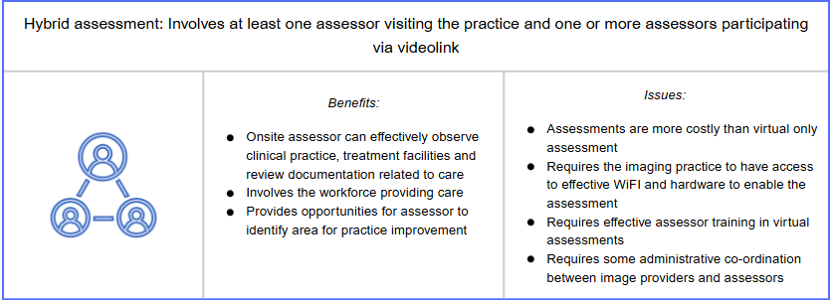

In virtual, hybrid and onsite assessments, assessors will gather evidence from a variety of sources including:

* Interviews with members of the workforce, consenting consumers and their nominated representatives, health care providers, allied health workers, volunteers and contractors.
* Observation of workforce practices and interactions with consenting consumers across all operational and clinical areas
* Review of documents and records to confirm that safety and quality systems are described in policies and procedures, to assess and review reported outcomes.
* Examination of how the image providers quality improvement system is used to reduce risks

Virtual, hybrid and onsite assessments are currently conducted nationally within acute care, general practices, primary and community health and digital mental health services, pathology, as well as in international accreditation schemes. The privacy of consumers is maintained, informed consent is always obtained before assessors engage with consumers and/or carers. Assessors sign confidentiality agreements, and no organisational materials leave the imaging practice.

## Costs

The costs of assessment is the responsibility of the image provider and is set by the accrediting agencies.

A regulatory impact assessment of the proposed scheme will be undertaken to assess the costs of the proposed changes. Costs associated with providing a safe and good quality service are not attributable to the accreditation process.

## Proposal

To increase the effectiveness and efficiency of assessments, the Commission is proposing changes to the Medical Imaging Accreditation Scheme, see proposed changes below.

| Service type | Characteristics | Assessment mode | Assessment schedule |
| --- | --- | --- | --- |
| Group 1:  Low risk imaging services | * Ultrasound | * Virtual assessments * Could include sampling where there are multiple networked sites | * Assessment of relevant actions in the NSQMI Standards announced * Three-year accreditation cycle |
| Group 2:  Higher risk imaging services | * Radiology (including MRI), nuclear medicine and interventional imaging* practices | * Hybrid assessments * Could include sampling where there are multiple networked sites | * First assessment of relevant actions in the NSQMI Standards announced * All subsequent assessments at short notice to relevant actions in the NSQMI Standards * Three-year accreditation cycle |
| Group 3  Imaging services operated in facilities already accreditation to the NSQHS standards | * Ultrasound, radiology(including MRI), nuclear medicine and interventional imaging* practices | * Short notice, onsite assessment | * Assessment aligned with the NSQHS assessment cycle * Assessed to the NSQHS Standards and Medical Imaging Module** * Assessment at short notice * Three-year accreditation cycle |

*Interventional imaging is the clinical subspecialty that uses medical imaging such as x-ray fluoroscopy, Computed Tomography (CT), Magnetic Resonance Imaging (MRI)and ultrasound to guide percutaneous procedures.

** The Medical Imaging Module is developed by mapping the NSQHS and NSQMI Standards and including in the module only those actions that are unique to the Medical Imaging, removing duplication and reducing the compliance burden for health service organisations that need to meet both sets of standards.

## Call-to-action

For more information, please visit: safetyandquality.gov.au/standards/diagnostic-imaging

You can also contact the project team at: [diagnosticimaging@safetyandquality.gov.au](mailto:Diagnostic%20Imaging%20Standards%20%3cdiagnosticimaging@safetyandquality.gov.au%3e)

[**safetyandquality.gov.au**](http://www.safetyandquality.gov.au)

© Australian Commission on Safety   
and Quality in Health Care 2025