# Australian Commission on Safety and Quality logotypeOn the Radar

Issue 694

5 May 2025

*On the Radar* is a summary of some of the recent publications in the areas of safety and quality in health care. Inclusion in this document is not an endorsement or recommendation of any publication or provider. Access to particular documents may depend on whether they are Open Access or not, and/or your individual or institutional access to subscription sites/services. Material that may require subscription is included as it is considered relevant.

*On the Radar* is available online, via email or as a PDF or Word document from <https://www.safetyandquality.gov.au/newsroom/subscribe-news/radar>

If you would like to receive *On the Radar* via email, you can subscribe on our website <https://www.safetyandquality.gov.au/newsroom/subscribe-news>  
or by emailing us at [mail@safetyandquality.gov.au](mailto:mail@safetyandquality.gov.au).  
You can also send feedback and comments to [mail@safetyandquality.gov.au](mailto:mail@safetyandquality.gov.au).

For information about the Commission and its programs and publications, please visit <https://www.safetyandquality.gov.au>

**On the Radar**

Editor: Dr Niall Johnson  
Contributors: Niall Johnson, Elise Campbell, Rosa Jun, Helen Dowling

***World Hand Hygiene Day (WHHD) 2025***

<https://www.safetyandquality.gov.au/our-work/infection-prevention-and-control/national-hand-hygiene-initiative/world-hand-hygiene-day>

Each year on 5 May, health organisations across the world rally to promote proper hand hygiene for WHHD. The [WHO](https://www.who.int/campaigns/world-hand-hygiene-day/2025) theme for WHHD 2025 is, *It might be gloves. It's always hand hygiene*. In Australia, the Australian Commission on Safety and Quality in Health Care’s [WHHD 2025](https://www.safetyandquality.gov.au/our-work/infection-prevention-and-control/national-hand-hygiene-initiative/world-hand-hygiene-day) awareness campaign is aligned in our focus on the critical role of effective hand hygiene, and the appropriate use of gloves. Our theme is, *Gloves at the right time. Hand hygiene all the time: A sustainable path to better hand hygiene*.

Inappropriate use of gloves can negatively impact hand hygiene compliance, increase the infection transmission risk, and contribute to unnecessary healthcare waste. Gloves should only be used when there is a risk of contact with blood, body fluids, mucous membranes, non-intact skin, or contaminated equipment and surfaces and are not a substitute for proper hand hygiene. The Commission's new fact sheet on [Sustainable glove use for healthcare workers](https://www.safetyandquality.gov.au/publications-and-resources/resource-library/sustainable-glove-use-healthcare-workers-fact-sheet) and [5 Steps for Appropriate Glove Use](https://www.safetyandquality.gov.au/publications-and-resources/resource-library/5-easy-steps-glove-use-poster) poster offer a practical checklist on glove use and the impact of inappropriate glove use.

The [*Gloves Off!*](https://www.safetyandquality.gov.au/publications-and-resources/resource-library/hunter-new-england-gloves) campaign at John Hunter Hospital offers an example of how hand hygiene practices can be improved and unnecessary glove use be reduced in a healthcare setting.

To read more about this case study, and view WHHD 2025 resources, including fact sheets and educational materials, visit the Commission’s [World Hand Hygiene Day](https://www.safetyandquality.gov.au/our-work/infection-prevention-and-control/national-hand-hygiene-initiative/world-hand-hygiene-day) and [Sustainability and infection prevention and control](https://www.safetyandquality.gov.au/our-work/infection-prevention-and-control/sustainability-and-infection-prevention-and-control) webpages. Additionally, check out the suite of research and clinical guidance related to the WHHD 2025 theme:

* Environmental impact of personal protective equipment distributed for use by health and social care services in England in the first six months of the COVID-19 pandemic (Rizan C, Reed M, Bhutta MF. J R Soc Med. 2021;114(5):250–263.) <https://doi.org/10.1177/01410768211001583>
* [Environmental sustainability practices in emergency departments (ACEM, 2024)](https://acem.org.au/getmedia/4e106709-0948-4a4d-a9d5-4d46d681f833/ACEM-EPA_-Environmental-sustainability-practices-in-EDs)
* [Hand hygiene with glove use](https://www.racgp.org.au/running-a-practice/practice-standards/racgp-infection-prevention-and-control-guidelines/2-hand-hygiene/hand-hygiene-with-glove-use) (RACGP, 2024)
* Have gloves and gowns had their day? An Australian and New Zealand practice and attitudes survey about contact precautions for MRSA and VRE colonisation (Browning S, Davis JS, Mitchell BG. Infect Dis Health. 2023;28(3):221–225.) <https://doi.org/10.1016/j.idh.2023.03.006>
* How much do we throw away in the intensive care unit? An observational point prevalence study of Australian and New Zealand ICUs (Matthew HA, Louise T, Deepak B, Naomi EH, Serena K, Forbes M, et al. Crit Care Resusc. 2023;25(2):78–83.) <https://doi.org/10.1016/j.ccrj.2023.05.004>
* [Plastics in healthcare: The case for circularity](https://circularaustralia.com.au/wp-content/uploads/2021/11/NSW-Circular_Plastics-in-Healthcare-Report_-Case-for-Circularity.pdf) (NSW Health. NSW Health. October 2021.)
* Providing care to patients in contact isolation: is the systematic use of gloves still indicated? (Bellini C, Eder M, Senn L, Sommerstein R, Vuichard-Gysin D, Schmiedel Y, et al. Swiss Med Wkly. 2022;152:w30110.) <https://doi.org/10.4414/SMW.2022.w30110>
* World Hand Hygiene Day 2025 campaign page (World Health Organization, 2025) <https://www.who.int/campaigns/world-hand-hygiene-day/2025>

**Books**

*Clinical Microsystems and Team Coaching*

Elements of Improving Quality and Safety in Healthcare

Harrison S, Finn R, Godfrey MM

Cambridge: Cambridge University Press; 2025.

|  |  |
| --- | --- |
| DOI | <https://dx.doi.org/10.1017/9781009326360> |
| Notes | This volume is the latest release in the [Elements of Improving Quality and Safety in Healthcare](https://www.cambridge.org/core/publications/elements/elements-of-improving-quality-and-safety-in-healthcare) series from The Healthcare Improvement Studies Institute (the THIS Institute) in Cambridge, England. This volume looks at the role of clinical microsystems and team coaching in improvement activities. From the abstract, ‘Microsystems are the building blocks of the healthcare system. They are the small functional frontline units that provide most healthcare to most people, be it a clinic or a ward. The microsystem improvement approach engages teams at the frontline of care with patients and families in a structured process to improve the quality of care and outcomes. This Element offers an overview of the theory of the microsystems, mesosystems, and team coaching improvement approaches, using case studies to demonstrate how the approaches have been used in practice.’ |

*Safe Care is the Right Care. ISQua White Paper on Patient Safety for Healthcare Organisations*

ISQua

Dublin: ISQua; 2025. p. 44.

|  |  |
| --- | --- |
| URL | <https://isqua.org/resources-blog/isqua-white-paper-on-patient-safety.html> |
| Notes | The International Society for Quality in Health Care (ISQua) have published this white paper aims to address the issues that can lead to unsafe patient care ‘by providing a comprehensive framework to improve patient safety in hospitals and other healthcare settings.’ The document describes four ‘Foundation Pillars for Patient Safety in Healthcare Organisations’”   1. Advocacy and leadership 2. Health worker education and safety 3. Patient, family and carer engagement and empowerment 4. Improvement in clinical processes. |

**Reports**

*The impact of staff fatigue on patient safety*

Investigation report

Health Services Safety Investigation Body

Poole: HSSIB; 2025.

|  |  |
| --- | --- |
| URL | <https://www.hssib.org.uk/patient-safety-investigations/the-impact-of-staff-fatigue-on-patient-safety/investigation-report/> |
| Notes | This report from the Health Services Safety Investigation Body (HSSIB) in the UK examines the impact fatigue had on patient safety in acute NHS hospitals. The report includes a number of findings, observations and recommendations. The report also has a number of ‘local-level learning prompts’.  The findings included:   * **Staff fatigue contributes directly and indirectly to patient harm**. However, there is little evidence available to help understand the size and scale of the risk, how it impacts on patient safety, and those staff groups who may be most at risk of fatigue. * There was variation in how the concept of fatigue was understood and the impact it could have on patient safety and staff safety across the healthcare system. This inconsistent understanding prevented fatigue risks being addressed. * **The risks posed by staff fatigue are not always clear** to trusts. The systems and processes needed to provide the information to assess staff fatigue risk are not always well developed or well used. However, some trusts were starting to explore these risks. * **A positive safety culture was a key enabler** to support healthcare organisations **to recognise and manage fatigue risk**. * Staff fatigue is not routinely captured as part of patient safety event reporting or routinely considered as part of patient safety event learning, or other governance processes. * **Fatigue was perceived by organisations and staff as an individual staff risk,** with limited organisational accountability. This sometimes led to a blame culture and punitive actions when staff were fatigued, and limited actions to drive improvement. * **Fatigue arises from a number of personal and organisational factors**, which can overlap. Organisational factors that contributed to staff fatigue included workload, long shifts, insufficient rest facilities and inadequate rest breaks during and between shifts. Personal factors that contributed to an increased risk of fatigue included caring responsibilities, menopause, pregnancy, religious practices and socioeconomic factors. * **Fatigue was found to have a negative impact on staff safety**. A key risk related to this was staff driving home after a long shift and being involved in fatal car accidents or near misses. * There are **barriers to acknowledging the risk** posed by staff fatigue. These include historical beliefs and norms around working long and additional hours, pride and ‘heroism’ of NHS staff. * The demands on healthcare services, and workforce and financial constraints, limited the ability of some organisations to address fatigue risks. * There is limited regulatory and national oversight of the risks posed to patient safety by staff fatigue in healthcare. * There was limited consideration of the risk of staff fatigue in national initiatives addressing workforce challenges and care delays. * The systems-based approach and supporting materials provided to trusts implementing the NHS England Patient Safety Incident Response Framework (PSIRF) helped to prompt consideration of staff fatigue in safety event learning, but this was not routine in all organisations.   It is noted that ‘While the investigation focused on staff working in acute hospitals, the findings will be relevant to providers and staff in other health and care settings.’ This could be extended to recognise that while this was an investigation in the UK, the issues and findings are relevant elsewhere. |

*Workforce and patient safety: primary and community care co-ordination for people with long-term conditions*

Investigation report

Health Services Safety Investigation Body

Poole: HSSIB; 2025.

|  |  |
| --- | --- |
| URL | <https://www.hssib.org.uk/patient-safety-investigations/workforce-and-patient-safety/fourth-investigation-report/> |
| Notes | Coordination of and continuity of care have been increasingly recognised as important, especially for people with chronic or long-term conditions. This report from the Health Services Safety Investigation Body (HSSIB) in the UK examined the co-ordination of care in the UK’s NHS, including the role of ‘care co-ordinator’ in the NHS. The investigation found that there was considerable variation in the implementation and impact of these approaches. The report includes a number of observations, findings and recommendations. |

**Journal articles**

*Do healthcare professionals work around safety standards, and should we be worried? A scoping review*

Clark D, Lawton R, Baxter R, Sheard L, Hara JK

BMJ Quality & Safety. 2025;34(5):317-329.

|  |  |
| --- | --- |
| DOI | <https://doi.org/10.1136/bmjqs-2024-017546> |
| Notes | Work-arounds or deviation from standard practice are thought to be rather common but also pose risks. This UK study reviewed the literature to ‘explore the circumstances and perceived implications of safety standard workarounds (SSWAs) conducted in the delivery of frontline care’. Based on 27 papers, the authors found that ‘SSWAs are used frequently during the delivery of everyday care, particularly during medication-related processes. These workarounds are often used to balance different risks and, in some circumstances, to achieve safe care.’ |

*Voluntary Assisted Dying*

Pharmacy Practice Update

AdPha VAD Working Group, Burgess T, Ferreira N, Haw J, Li C, Maddern N, et al.

Melbourne: Advanced Pharmacy Australia; 2025. p. 7.

|  |  |
| --- | --- |
| URL | <https://adpha.au/article/practice-update-supporting-vad-conversations> |
| Notes | Advanced Pharmacy Australia has developed this pharmacy practice update to assist the pharmacy workforce be prepared for discussions that may arise about Voluntary Assisted Dying (VAD). The practice update reviews the legal frameworks, ethical considerations and practical aspects of VAD across Australian jurisdictions. The practice update includes links to resources, including a checklist to assist pharmacists in assessing their readiness for conversations about VAD. |

***Updates to the Therapeutic Guidelines: Antibiotic***

Therapeutic Guidelines

Melbourne: Therapeutic Guidelines Limited; 2025

|  |  |
| --- | --- |
| URL | <https://www.tg.org.au/products/therapeutic-guidelines/updates/antibiotic/> |
| Notes | [Therapeutic Guidelines](https://www.tg.org.au/) has released the updated [*Antibiotic guidelines*](https://tgldcdp.tg.org.au/viewTopic/?guidelinePage=Antibiotic&etgAccess=true). This release [updates](https://www.tg.org.au/products/therapeutic-guidelines/updates/antibiotic/) more than 200 clinical topics including the treatment of sepsis, pneumonia, urinary tract infections and cellulitis.  This review of the guidelines has been staggered, with 3 main groupings of topics:   * [Topics completely revised or newly developed for the March 2025 release.](https://www.tg.org.au/products/therapeutic-guidelines/updates/antibiotic/revised-or-new/) * [Topics under revision](https://www.tg.org.au/products/therapeutic-guidelines/updates/antibiotic/under-revision) that will be published later in 2025 or 2026. To ensure alignment across the guidelines, some of these topics have been amended in the March 2025 release (identified by an amended date on the topic’s page). * [Topics that have recently undergone a complete review](https://www.tg.org.au/products/therapeutic-guidelines/updates/antibiotic/previously-revised) and did not require further comprehensive review for the March 2025 release. To ensure alignment across the guidelines, some of these topics have been amended in the March 2025 release (identified by an amended date on the topic’s page).   The changes were presented by several clinicians from the Antibiotic expert group at the preconference symposium held before the Australasian Society for Infectious Diseases (ASID) Annual Scientific Meeting in April 2025. The presentations are available online on the Therapeutic Guidelines YouTube channel at <https://www.youtube.com/playlist?list=PLhGLYnOZ0tzbaAxDVgowScwpNVPZO2XBJ> |

*BMJ Quality & Safety*

Volume 34, Issue 5, May 2025

|  |  |
| --- | --- |
| URL | <https://qualitysafety.bmj.com/content/34/5> |
| Notes | A new issue of *BMJ Quality & Safety* has been published. Many of the papers in this issue have been referred to in previous editions of *On the Radar* (when they were released online). Articles in this issue of *BMJ Quality & Safety* include:   * Editorial: **Diagnostic delay**: lessons learnt from marginalised voices (Farah Acher Kaiksow) * Editorial: Audit and feedback to improve **antibiotic prescribing in primary care**—the time is now (Bradley J Langford, Kevin L Schwartz) * Editorial: **Co-production in maternal health services**: creating culturally safe spaces, respecting difference and supporting collaborative solutions (Jennifer MacLellan, Carmen Byrne, Catherine Pope) * Editorial: Using data science to improve patient care: rethinking **clinician responsibility** (Irene Grossmann, Perla J Marang-van de Mheen) * Editorial: **Increasing vaccine uptake** in underserved populations using text message interventions: considerations and recommendations (Gaby Judah) * Pragmatic randomised trial assessing the impact of peer comparison and therapeutic recommendations, including repetition, on **antibiotic prescribing patterns of family physicians** across British Columbia for uncomplicated lower urinary tract infections (Greg Carney, Malcolm Maclure, David M Patrick, Jessica Otte, Anshula Ambasta, Wade Thompson, Colin Dormuth) * **Improving the maternity experience** for Black, African, Caribbean and mixed-Black families in an integrated care system: a multigroup community and interprofessional co-production prioritisation exercise using nominal group technique (Sarindi Aryasinghe, Phoebe Averill, Carole Waithe, Susan Ibuanokpe, Rhianna Newby-Mayers, Nawal Lakhdar, Moussa Amine Sylla, Elizabeth Cox, Sabrina Das, Erik Mayer) * **Do healthcare professionals work around safety standards**, and should we be worried? A scoping review (Debbie Clark, Rebecca Lawton, Ruth Baxter, Laura Sheard, Jane. K. O'Hara) * Risk-adjusted observed minus expected cumulative sum (RA O-E CUSUM) chart for visualisation and **monitoring of surgical outcomes** (Quentin Cordier, Hugo Prieur, Antoine Duclos) * Effect of text message reminders to improve **paediatric immunisation** rates: a randomised controlled quality improvement project (Kyra Rosen, Holly Krelle, William C King, Nathan Klapheke, Paulo Pina, Judd Anderman, Alicia Chung, Felicia Mendoza, Ashley Bagheri, J Stadelman, S Tsuruo, L I Horwitz) |

*Australian Prescriber*

Volume 48, Issue 2, April 2025

|  |  |
| --- | --- |
| URL | <https://australianprescriber.tg.org.au/volumes/48/issues/2.html> |
| Notes | A new issue of *Australian Prescriber* has been published. Content in this issue of *Australian Prescriber* includes:   * **RSV**: an update on prevention and management (David A Foley, L K Phuong) * Calcitonin gene-related peptide–targeted therapies for **migraine** (Stephanie Barnes, Lucie Aldous, Bronwyn Jenkins) * **Noninvasive prenatal testing**: an overview (Alice Poulton, Lisa Hui) * Safe and effective use of **vancomycin** (Amy Legg, Felicia Devchand, Amanda Gwee, Indy Sandaradura, Tony Lai) * **Clonazepam** oral liquid: confusion between drops, milligrams and millilitres (Joey Chan, Abigail E Franklin) * **New drugs**:  Lenacapavir for multidrug-resistant HIV-1 infection Nelarabine for T-cell acute lymphoblastic leukaemia and T-cell lymphoblastic lymphoma Osilodrostat for Cushing syndrome |

*Nursing Leadership*

Volume 37, special issue, 2025

|  |  |
| --- | --- |
| URL | <https://www.longwoods.com/publications/nursing-leadership/27543/> |
| Notes | A new issue of *Nursing Leadership* has been published. This is a special issue focused on ‘Optimizing Registered Nurses in Primary Care’. Articles in this issue of *Nursing Leadership* include:   * **Registered Nurses in Primary Care**: Your Time Is Now (Ruth Martin-Misener) * Commentary: **Optimizing Nursing Roles in Team-Based Primary Care** Is Imperative (Ivy Bourgeault and Ivy Oandasan) * Theory-Informed Strategies to Guide Policy, Practice, Education and Research About **Registered Nurses in Primary Care** (Allison A Norful, Jacqueline A Nikpour, Sophia Myles and Julia Lukewich) * **Education for Registered Nurses in Primary Care**: Current and Future Trends (Julia Lukewich, Sophia Myles, Dana Ryan, Suzanne Braithwaite, Marie-Eve Poitras, Deanne Curnew and Maria Mathews) * Key Elements for Implementing a Train-the-Trainer Intervention for **Registered Nurses and Social Workers in Primary Care** (Marie-Eve Poitras, Yves Couturier, Anaëlle Morin, Marie-Dominique Poirier, Vanessa T Vaillancourt,. Maude-Émilie Pépin, Sylvie Massé and Emmanuelle Doucet) * **Primary Care Team Funding, Compensation and Practice Models** Across Canadian Jurisdictions: An Environmental Scan (Sarah Spencer, Lindsay Hedden, Julia Lukewich, Maria Mathews, Marie-Eve Poitras, Cloé Beaulieu, Tai Hollingbery, Leslie Meredith, Dana Ryan, Vanessa T Vaillancourt, Emily Gard Marshall, Nelly D Oelke and Joan Tranmer) * **Nurses Leading the Way**: A Qualitative Study of Nursing Leadership, Innovation and Opportunity in Primary Care During a Public Health Crisis (Julia Lukewich, Dana Ryan, Maria Mathews, Lindsay Hedden, Emily Gard Marshall, Crystal Vaughan, Samina Idrees, Donna Bulman, Lauren R Renaud, Cheryl Cusack, Ruth Martin-Misener, Jill Bruneau, Jamie Wickett, Shabnam Asghari, Leslie Meredith, Sarah Spencer and Gillian Young) * Implementation of **Registered Nurse Prescribers** in Nova Scotia (Cindy MacQuarrie, Nancy Cashen and Sohani Welcher) * Measuring **Registered Nurse’s Scope of Practice** in Primary Care: A Scoping Review of Available Self-Reported Questionnaires (Anaëlle Morin, Cynthia Gagnon, Marie-Josée Émond, Marie-Eve Perron, Monica McGraw, Pierre-Henri Roux-Levy and Marie-Eve Poitras) * The Future of **Registered Nurses in Primary Care**: The Patients’ Perspectives (Toni Leamon and Marie-Dominique Poirier) * **Registered Nurse Leadership** in Primary Care: Embracing “Every Nurse a Leader” (Suzanne Braithwaite, Cyndi Gilmer, Julia Lukewich and S Myles) * Commentary: **Empowering Primary Care Nurses** – Unlocking Access, Enhancing Quality and Addressing Social Determinants of Health (Sylvain Brousseau) |

*The Joint Commission Journal on Quality and Patient Safety*

Volume 51, Issue 5, May 2025

|  |  |
| --- | --- |
| URL | <https://www.sciencedirect.com/journal/the-joint-commission-journal-on-quality-and-patient-safety/vol/51/issue/5> |
| Notes | A new issue of *The Joint Commission Journal on Quality and Patient Safety* has been published. Articles in this issue of *The Joint Commission Journal on Quality and Patient Safety* include:   * Use of the Model for Improvement to Reduce **Hyperglycemia** in Adult Patients Admitted to a Public Tertiary Care Hospital (Gabriela Berlanda, Luiza Daniel de Souza, Juliana da Silva Lima, Caroline Tortato, Simone Silveira Pasin, Eloni Rotta, M Hemesath, T Ortiz Hammes, F R Indriunas Perdomini, C C Schnorr, H Barreto dos Santos, C Bauermann Leitao, B D Schaan) * **Reducing Hospital Length of Stay**: A Multimodal Prospective Quality Improvement Intervention (Joseph Walker Keach, Mara Prandi-Abrams, Allison S Sabel, Romana Hasnain-Wynia, J M Mroch, T D MacKenzie) * Mixed Methods Study of the **Interfacility Transfer System** Utilizing Both Patient-Reported Experiences and Direct Observation of the Transfer Consent Process (Lauren K Stewart, Dillon Bille, Beth Fields, Leah Kemper, Connor Pappa, Eric S Orman, Malaz A Boustani, Edmond Ramly, Andrew Hybarger, Andrew K Watters, Nancy K Glober) * Evaluating the Prevalence of **Suicide Risk Screening** Practices in Accredited Hospitals (Salome O Chitavi, Scott C Williams, Jamie Patrianakos, Stephen P Schmaltz, Edwin D Boudreaux, Brian K Ahmedani, Kimberly Roaten, Katherine Anne (Kate) Comtois, Farzana Akkas, Gregory K Brown) * **Patient Safety Culture Among Nurses** in Hospital Settings Worldwide: A Systematic Review and Meta-Analysis (Georgia Kyriakeli, Anastasia Georgiadou, Agapi Symeonidou, Zoi Tsimtsiou, T Dardavesis, V Kotsis) * Developing a Standardized Process to Visualize, Analyze, and Communicate **NSQIP Data** Using an Advanced Visual Data Analytics Tool (Linda C Alongi, Brady Alsaker, David J Willis, William A Burns, Charles R Watts) * Utilizing Recorded **Resuscitations for Neonatal Team Process Improvement** (Audrey Moore, Louis P Halamek, Janene H Fuerch, Rodrigo B Galindo, Nicole K Yamada) * Change in US Hospital Practice After the Joint Commission Requirement to Use Distinct Methods of **Newborn Identification**: A Cross-Sectional 10-Year Follow-Up Survey (Jason S Adelman, Jo R Applebaum, Nicole Krenitsky, Dena Goffman, Saud Khan, Baruch S Fertel, Judy L Aschner) * Demographic Profile and Oversight Duties of Today's **Health Care Quality Leaders** (Kimiyoshi J Kobayashi, Amy C Lu, Christopher S Kim, Bela Patel, Jennifer Wiler, Mbonu Ikezuagu, Jodi L Eisenberg, David M Safley) * Advancing **Measurement of Diagnostic Excellence** for Better Healthcare (Jenna Williams-Bader, Kathryn M McDonald, Elizabeth E Drye) |

*Patient Experience Journal*

Volume 12, Issue 1, 2025

|  |  |
| --- | --- |
| URL | <https://pxjournal.org/journal/vol12/iss1/> |
| Notes | A new issue of the *Patient Experience Journal* (PXJ)has been published Articles in this issue of the *Patient Experience Journal* include:   * Editorial: **Leading in Turbulent Times**: Why Experience is Essential to Healthcare's Future (Jason A Wolf) * **Re-Recruitment**: An Essential Aspect of Human Experience (Thom Mayer, David Fessell, and Amy Young) * Escuchame: A Story of **Patient Resilience** (D M Armenta and J P Braun) * Beyond the White Coat: **Mental Health in the Life of a Junior Doctor** (Araya Gautam) * The Patient Ombudsperson's Experience of **Patient Partnership and Mutual Understanding of Rights** (Sanna Ryynänen) * **Patient Perspectives on Health Care Utilization** at Two Free Clinics – A Qualitative Study (Patrick Fagan, D Guillen Perez, R D Baer, and J Petrilli) * A Qualitative Study: **Patients' Expectation of Private Hospitals** (Sarah Jada, Jessy Jacob, and Ahmad Nasrallah) * The Impact of Learners on **Patient Satisfaction in the Orthopedic Setting** (Sydney Boike, Kevin Hodge, Lynsey Malin, Timothy Nyangacha, Rebekah Kleinsmith, Megan Reams, Julia Stumpf, and Bradley Nelson) * My Life, My Story and Life Recovery among **Veterans with Substance Use Problems** (Grace Chang; Martha J Duffy; and Susan Nathan) * Patient Perspectives on Implementing a **Person-Centered Care System**: Experiences From the U.S. Veterans Health Administration's Whole Health System of Care (Ekaterina Anderson, Renda S Wiener, Brianne Molloy-Paolillo, M McCullough, B Kim, J I Harris, S T Rinne, and B G Bokhour) * **Experiences of Women in the Labour Room**: The Untold Story (Emmanuel Dziwornu, B Kpodo, O Anarfi, E Afi Adzato, and A F Dartey) * Study on **Doctor-Patient Identity Construction** from the Perspective of Narrative Medicine (Fuxian Lin) * Effectiveness of **Incident Reporting Tools** in Ensuring Patient Safety: A Systematic-Narrative Hybrid Review (Valentina Cerrone, Vincenzo Andretta, Angela Prendin, Bernadette Ilardi, C Bonetti, M Capunzo, and M Cascella) * **Patient Similarity Analysis and Decision Support Dashboards** in Cancer Care: Patients' and Other Stakeholders' Perspectives (Karol Jan Czuba, Te Hao Apaapa-Timu, Rachel B Owens, Robert Matthew Strother, and R P Radecki) * **Unveiling Patient Satisfaction**: Exploring Demographics, Interactions, and Health-Seeking Behavior (Vanessa B Crowther, Cassandra Shaw-Johnson, R R Green-Weir, P S Woodley, M A Weatherspoon, E D Farmer, and A L Mathis) * Understanding the Care Experiences and Support Needs of UK Adults Treated in Hospital for **Meningitis** (Harriet Hay, Amy Tallett, Bec Aeddi, Beverley Corbett, Claire Donovan, Jane Blewitt, and Juan Abad Madroñero) * Voices From the Journey: Exploring **Rehabilitation Experience** of Individuals with Disabilities in a South African Province (Senzelwe M Mazibuko, Thayananthee Nadasan, and Pragashnie Govender) * Opportunities and Challenges for **E-health in Hip and Knee Arthroplasty** - A Summary of Recent Literature Review (José Miguel Seguro and M P Santos) * Adolescents with **Cystic Fibrosis** Expressing their Possible Selves through Photovoice: A Longitudinal Interpretative Phenomenological Analysis to Prepare a Peer Support Intervention for Healthcare Transition (Maxime Morsa, Adélaïde Vincent-Lardy, Julie Haesebaert, Catherine Llerena, Lucie Pelz, Philippe Reix, Rémi Gagnayre, and Quitterie Reynaud) * What Makes a **Hospital Gown** Functional? A Comparative Case Study of Effective Patient-Centered Design Practices in Four (n = 4) Hospital Gowns (Robmarie Lopez) * Contrasting **Patients' and Healthcare Professionals' Experience in Hematological Cancer** Care Pathway: A Narrative Study (Karine Bilodeau, Cynthia Henriksen, Camilia Aloisio Alves, Charlotte Gélinas-Gagné, Lynda Piché, Jacinthe Pepin, Virginia Lee, Marie-France Vachon, Nathalie Folch, Marie-Pascale Pomey, and Nicolas Fernandez) * **Cancer Partnerships Hub (CPH) Model**: Implementing an Organizational Innovation to Enhance Engagement of Patient-Partner in Cancer Care Services (Deborah Pascale, Sandie Oberoi, Charlotte Gélinas-Gagné, Pegah Torabi, Ludovic Tamaro, and Karine Bilodeau) * **HOPE Experience Essentials**: The Next Generation of Service Standards at Mayo Clinic (Jennifer Packard, Richard M Elias, Thomas J (Tripp) Welch, Karee A Munson, and Jonathan A Leighton) |

*Healthcare Policy*

Volume 20, Number 2, 2025

|  |  |
| --- | --- |
| URL | <https://www.longwoods.com/publications/healthcare-policy/27477/> |
| Notes | A new issue of *Healthcare Policy* has been published. Articles in this issue of *Healthcare Policy* include:   * Editorial: From Talking to Action: **Changing Healthcare** in Provinces and Territories (Fiona Clement and Jason Sutherland) * **Advance Requests for Medical Assistance in Dying** in the International Context: Some Legal Issues for the Canadian Case (Luis Espericueta) * Commentary: **Ethics and Advance Requests for MAiD**: Thresholds and Applicability (Cameron Cattell and Cheryl Mack) * The **Fraying at the Edges of the** **Public Healthcare System** in Canada (Deborah Milinkovic and Jeremiah Hurley) * Commentary: **Fixing Fraying**? A Response to Milinkovic and Hurley (Stephen Duckett) * **Medicine List for Public Funding** From Existing Lists (Ronan Murphy, Amal Rizvi, Moizza Zia Ul Haq and Nav Persaud) * The Role and Influence of **Federally Established Health Policy Advisory Bodies** in Canada (Amity E. Quinn, Rachelle Drummond, Tom Noseworthy, Fiona Clement, Stephana Moss, Emily Fitzgerald, Melanie Columbus, Brenlea Farkas and Henry T Stelfox) * **Health Worker Protests** in Canada: A Descriptive Analysis of Protest Events from 2021-2022 (Veena Sriram, Meena Rakasi, Kartik Sharma, Michael R. Law and Sorcha A. Brophy) |

*Health Policy*

Volume 155, May 2025

|  |  |
| --- | --- |
| URL | <https://www.sciencedirect.com/journal/health-policy/vol/155/> |
| Notes | A new issue of *Health Policy* has been published. Articles in this issue of *Health Policy* include:   * Commentary on “The **learning rehabilitation system**: Strengthening an intersectoral strategy to improve functioning of an ageing population” by Bickenbach et al.(Nicola Manocchio, Concetta Ljoka, Valerio Ferdinandi, Lucia Cicchi, Calogero Foti) * **Strengthening diagnostic services** in Latin America requires regional leadership, sustainable funding, and enhanced data sharing (Andres Moreira-Soto, Nils Gade, Bert Hoffmann, Jan Felix Drexler) * **Global health and care worker migration** requires a global response (Ellen Kuhlmann, Michelle Falkenbach, Tiago Correia, Niamh Humphries, ... Julia Lohmann) * Twenty years evaluating the **health impact of urban policies** in the city of Barcelona (María-José López, Katherine Pérez, Xavier Continente, Carme Borrell) * Rapid evaluation of the **NHS Recovery Support Programme (RSP)** in England: Implementing intensive national improvement support for challenged healthcare providers and systems (Maartje Kletter, Stephanie Gillibrand, Elaine Harkness, Jo Dumville, Paul Wilson) * The introduction of maximum reimbursement prices for **digital health applications** in Germany in 2022: Current developments (Hendrikje Rödiger, Reinhard Busse, Cornelia Henschke) * **Forgone Care of doctor's visits** in Germany – Results from three cross-sectional surveys (Christine Haeger, Raphael Kohl, Julie L. O'Sullivan, Susanne Schnitzer) * Factors influencing the **experience of empowerment** in Flemish (proxy) budget holders: A regression analysis (Eva Pattyn, Paul Gemmel, Ruben Willems, Susan Lagaert, Jeroen Trybou) * The impact of eliminating **out-of-pocket payments for medicines** on low-income households: a controlled interrupted time series analysis using linked administrative data from British Columbia (Kartik Sharma, Lucy Cheng, Colin R. Dormuth, Kimberlyn M. McGrail, ... Michael R. Law) * Medicare **austerity reforms and patient out-of-pocket costs**: The experience from Australian cancer patients (Maryam Naghsh-Nejad, Kees Van Gool, Phil Haywood, Jane Hall) * **Multiple job holding** and its influencing factors among Belgian nurses: A cross-sectional study (Senne Vleminckx, Anke Sevenans, Manal Bouchatta, Ive Verbeeck, ... Filip Haegdorens) * From policy to practice: Rolling out the **clinical nurse specialist** role in Portugal (Mário Amorim-Lopes, Sofia Cruz-Gomes, Elisa Doldi, Bernardo Almada-Lobo) * Identification of health-related needs: The **needs examination, evaluation and dissemination (NEED) assessment framework** (Charline Maertens de Noordhout, Muriel Levy, Rani Claerman, Mats de Jaeger, ... Irina Cleemput) * **Participatory policy processes** in a black box? Stakeholder interviews about the development of Germany´s national nutrition strategy (Marike Andreas, Anna K. Kaiser, Falko F. Sniehotta) * Identifying the most effective policies for **minimising inappropriate use of antibiotics**: A replicability study using three WHO datasets (Kathleen A. Holloway, David Henry) * Quantitative trend analysis of well-established use mutual recognition and decentralised products indicates **codified disharmonisation** in the European Economic Area (Péter Szabó) * How does **OTC drugs consumption** relate to prescribed drugs and health care consultations in Europe? (Aida Isabel Tavares) * Time to completion of conditions required by Health Canada after **approving new drugs**: A cohort study (Joel Lexchin) * Understanding the impact of **minimum staff level policies** on the ward nursing team: Insights from a qualitative research study conducted in Germany (Felix Miedaner, Werner Barbara, Bernhard Roth, Linda Metzner) * **Physicians’ responses to time pressure**: Experimental evidence on treatment quality and documentation behaviour (Claudia Souček, Tommaso Reggiani, Nadja Kairies-Schwarz) * **Hospital resilience** in the Face of Covid-19 in France: A multilevel analysis of the impact of past practice quality on cancer surgery resumption (Noémie Malléjac, Zeynep Or) * Promoting **outpatient medication safety** in Finland: A mid-term review of a national medication safety programme for community pharmacies (2021–2026) (Emilia Mäkinen, Tiina Koskenkorva, Anna-Riia Holmström, Marja Airaksinen, ... Charlotta Sandler) * Long-term public healthcare burden associated with **intimate partner violence** among Canadian women: A cohort study (Gabriel John Dusing, Beverley M. Essue, Patricia O'Campo, Nicholas Metheny) * Framing the loss: Preferences for **vaccine hesitancy** and gender effect in France and Italy (Anna Rinaldi, Pierfrancesco Dellino, Massimo Paradiso) * **Private equity** expansion and impacts in united states healthcare (Lynn Unruh, Thomas Rice) |

*American Journal of Medical Quality*

Volume 40, Issue 3, May/June 2025

|  |  |
| --- | --- |
| URL | <https://journals.lww.com/ajmqonline/toc/2025/05000> |
| Notes | A new issue of the *American Journal of Medical Quality* has been published. Articles in this issue of the *American Journal of Medical Quality* include:   * **Clinician Views of an Opioid Prescribing Report** with Peer Comparisons and Patient-Reported Outcomes (Jeffrey P Ebert, E Madeline Grenader, Rachel E Gonzales, Evan A Spencer, Devon M Schroeder, Lauren Southwick, Frances S Shofer, M. Kit Delgado, Anish K Agarwal) * Improving the **Physician Inbox Management in Electronic Health Record** by a Multifaceted Bundled Intervention (Abdul Waheed, Mudasir Umer, Anousheh Paracha, Asfandyar Latif, Nabiha Malik, Hira Fatima, Syed M Atif, Erum Azhar) * **Fragmented Ambulatory Care and Medication Count** among Older Adults (Indrani Guzman Das, Joanna Bryan Ringel, Mangala Rajan, Lisandro D Colantonio, Monika M Safford, Lisa M Kern) * The Impact of a Novel Use of Volunteers on **Patient Satisfaction** (John Marshall, Haley Manella) * **Value-Based Care in Medical Specialties**: Improving Hierarchical Condition Category Capture (Joseph A Randy Englert III, C J White) * Improving Management of **Chest Pain** with a High Sensitivity Troponin-Based Protocol (Kristin Lohr, Colleen O’Connor, Timothy Shapiro, Steven Gamburg, Pradeep Bhagat, Francis Colangelo, Mary Reich Cooper) * How **Hospitalists in Training** Are Improving Quality of Patient Care in Dutch Hospitals (Renske Labordus-van Helvoirt, Julia Mangione, on behalf of the Quality Committee and Science Committee of the Association of Hospitalists – Vereniging voor ZiekenhuisGeneeskunde (VvZG)) * Improving Delivery of **Sepsis Care** in a Veterans Affairs Emergency Department (Jacob Elias Khoury, David Beran, Angela Hamilton, David Ronnenburg, Caitlin Martin-Klinger) * Let Us Communicate: Improving **Resident and Nursing Communication** in a Veterans Affairs Intensive Care Unit (Kaan Raif, Grant Gosden, Alexander Ryden, Alicia Bowles, Lynn M Keenan) * Evaluating Resident Physicians’ Perceptions of and Improving Utilization of **Alcohol Use Disorder Pharmacotherapy**: A Quality Improvement Initiative (Alan Abboud, Michael Jorgensen, Ann Mary Hanna, Lisa Fisher) |

*BMJ Quality & Safety* online first articles

|  |  |
| --- | --- |
| URL | <https://qualitysafety.bmj.com/content/early/recent> |
| Notes | *BMJ Quality &Safety* has published a number of ‘online first’ articles, including:   * Use of **structured handoff protocols** for within-hospital unit transitions: a systematic review from Making Healthcare Safer IV (Sean McCarthy, Aneesa Motala, Emily Lawson, Paul G Shekelle) * Cost-effectiveness of **eliminating hospital understaffing by nursing staff**: a retrospective longitudinal study and economic evaluation (Christina Saville, Jeremy Jones, Paul Meredith, Chiara Dall’Ora, Peter Griffiths) * Does the use of structured interventions to guide **ward rounds** affect patient outcomes? A systematic review (Victoria Ando, Alexia Cavin-Trombert, David Gachoud, Matteo Monti) * Editorial: Better bottom lines: **patient satisfaction associated with addressing sexual and gender minority health** (Carl Streed, Jessica Halem, Amy LeClair) * Editorial: **Increasing surgical volumes** in resource limited-healthcare systems: team-based quality improvement as a novel approach to quantity improvement (Nobhojit Roy, Asad Latif) * Editorial :Why **hospital falls prevention** remains a global healthcare priority (Meg E Morris) * Implementation of national guidelines on antenatal magnesium sulfate for **neonatal neuroprotection**: extended evaluation of the effectiveness and cost-effectiveness of the National PReCePT Programme in England (Hannah B Edwards, Carlos Sillero-Rejon, Hugh McLeod, Elizabeth M Hill, Brent C Opmeer, Colin Peters, David Odd, Frank de Vocht, Karen Luyt) * **Economic evaluations of quality improvement interventions**: towards simpler analyses and more informative publications (Teryl K Nuckols) * Editorial: Understanding the evidence for **artificial intelligence in healthcare** (Gretchen Purcell Jackson, Edward H Shortliffe) * Support for **hospital doctors’ workplace well-being** in England: the Care Under Pressure 3 realist evaluation (Anna Melvin, Alison Pearson, Daniele Carrieri, Charlotte Bramwell, Jason Hancock, Jessica Scott, Helen Foster Collins, Stuart McPhail, Mark Pearson, Chrysanthi Papoutsi, Geoff Wong, Karen Mattick) |

*International Journal for Quality in Health Care* online first articles

|  |  |
| --- | --- |
| URL | <https://academic.oup.com/intqhc/advance-articles> |
| Notes | *International Journal for Quality in Health Care* has published a number of ‘online first’ articles, including:   * Barriers, facilitators and implementation strategies to implement **‘Patient’s Own Medication’ and ‘Self-administration of Medication’ in hospitals** (Elisabeth M Smale et al) * Innate Psychological Needs of Autonomy, Competence, and Provider Communication as Determinants of **Patient’s Satisfaction and Self-Rated Health** (Helen Omuya et al) * Key lessons for **excellent healthcare leadership** – a systems lens to drive safe, quality outcomes (Kathy Eljiz et al) * **Cost-Related Medication Nonadherence** in Adults with Hypertension in the United States: Implications for Healthcare Quality (Raghuram V Reddy et al) * The evolution of **patient-reported safety concerns during the COVID-19 pandemic** within a series of study questionnaires: a multi-method analysis (Ij McFadzean et al) * Some Important Principles for Implementing **Lean Management in Healthcare** Organizations (Hongnan Ye) |

**Online resources**

***Australian Living Evidence Collaboration***

<https://livingevidence.org.au/>

***Guidance***

A number of guidelines or guidance have recently been published or updated. These include:

* 2024 Royal Australian College of General Practitioners and Healthy Bones Australia guideline for **osteoporosis management and fracture prevention** in postmenopausal women and men over 50 years of age (Summary) <https://doi.org/10.5694/mja2.52637>   
  <https://healthybonesaustralia.org.au/health-care-professionals/gp-resources/ng>
* INTEGRATE: international guidelines for the algorithmic treatment of **schizophrenia**   
  <https://doi.org/10.1016/S2215-0366(25)00031-8>

***[UK] NIHR Evidence***

https://evidence.nihr.ac.uk/

The UK’s National Institute for Health Research (NIHR) has posted new evidence alerts on its site. Evidence alerts are short, accessible summaries of health and care research which is funded or supported by NIHR. This is research which could influence practice and each Alert has a message for people commissioning, providing or receiving care. The latest alerts <https://evidence.nihr.ac.uk/browse-content/?_sft_articletype=alert> include:

* **Hospital at home** is a good option for many older people
* **Care home app** reduced residents’ hospital admissions
* People on **long waiting lists** use more healthcare resources than others
* **Children with anxiety problems**: online therapy led by parents, supported by therapists, was effective
* **Gallstones**: surgery might not always be needed
* Online CBT for **post-traumatic stress disorder** is as effective as face-to-face therapy
* Pills that reduce **stomach acid** do not improve persistent throat symptoms
* Most people undergoing planned surgery do not need **compression stockings**
* No benefit from the switch to more expensive **anticoagulation in intensive care**
* Plaster cast is as good as surgery for a **broken scaphoid** bone in the wrist
* **Pelvic organ prolapse**: self-management of pessaries can be a good option.

***UK] NICE Guidelines and Quality Standards***

<https://www.nice.org.uk/guidance>

The UK’s National Institute for Health and Care Excellence (NICE) has published new (or updated) guidelines and quality standards The latest reviews or updates include:

* NICE Guideline NG101 *Early and locally advanced* ***breast cancer****: diagnosis and management* <https://www.nice.org.uk/guidance/ng101>

***USA] Effective Health Care Program reports***

<https://effectivehealthcare.ahrq.gov/>

The US Agency for Healthcare Research and Quality (AHRQ) has an Effective Health Care (EHC) Program The EHC has released the following final reports and updates:

* ***Acute Care Nursing Staff Shortages*** *That Compromise Patient-to-Nurse Ratios* <https://effectivehealthcare.ahrq.gov/products/nursing-staff-shortages/rapid-research>
* *Research Protocol: Outcomes of* ***Alternative Payment Models****: A Systematic Review* <https://effectivehealthcare.ahrq.gov/products/alternative-payment-models/protocol>
* ***Supply Chain Disruption*** *Monitoring Programs* <https://effectivehealthcare.ahrq.gov/products/monitoring-programs/rapid-research>
* *Measure Criteria for the Agency for Healthcare Research and Quality’s National Healthcare* ***Quality and Disparities Report*** <https://effectivehealthcare.ahrq.gov/products/measurement-criteria-qdr/tech-brief>

**Infection prevention and control and COVID-19 resources**

The Australian Commission on Safety and Quality in Health Care has developed a number of resources to assist healthcare organisations, facilities and clinicians. These resources include:

* ***Poster – Combined contact and droplet precautions*** <https://www.safetyandquality.gov.au/publications-and-resources/resource-library/infection-prevention-and-control-poster-combined-contact-and-droplet-precautions>  
  [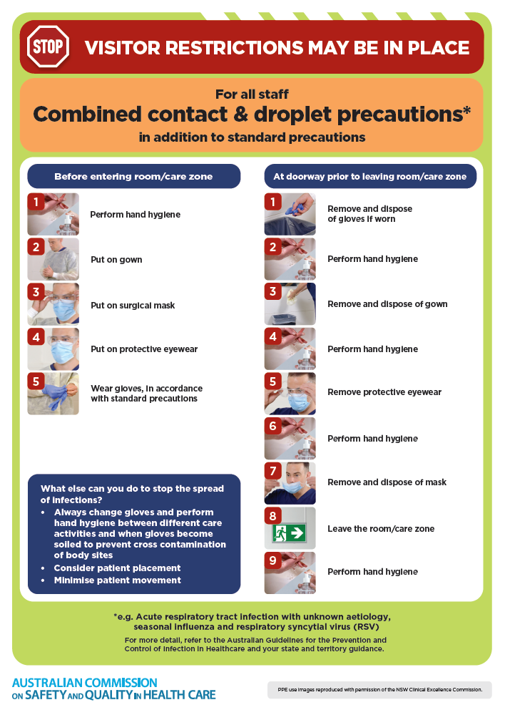](https://www.safetyandquality.gov.au/publications-and-resources/resource-library/infection-prevention-and-control-poster-combined-contact-and-droplet-precautions)
* ***Poster – Combined airborne and contact precautions***<https://www.safetyandquality.gov.au/publications-and-resources/resource-library/infection-prevention-and-control-poster-combined-airborne-and-contact-precautions>  
  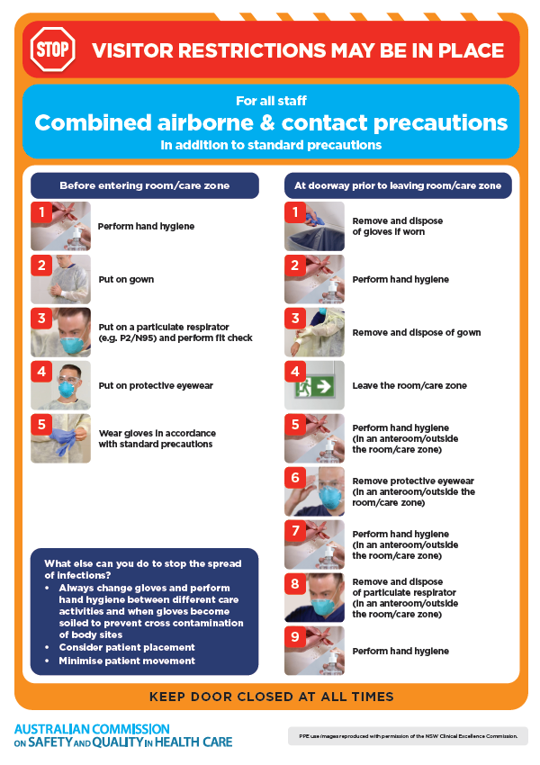
* ***Environmental Cleaning and Infection Prevention and Control*** [www.safetyandquality.gov.au/environmental-cleaning](http://www.safetyandquality.gov.au/environmental-cleaning)
* ***Break the chain of infection*** poster  
  <https://www.safetyandquality.gov.au/publications-and-resources/resource-library/break-chain-infection-poster>  
    
  **[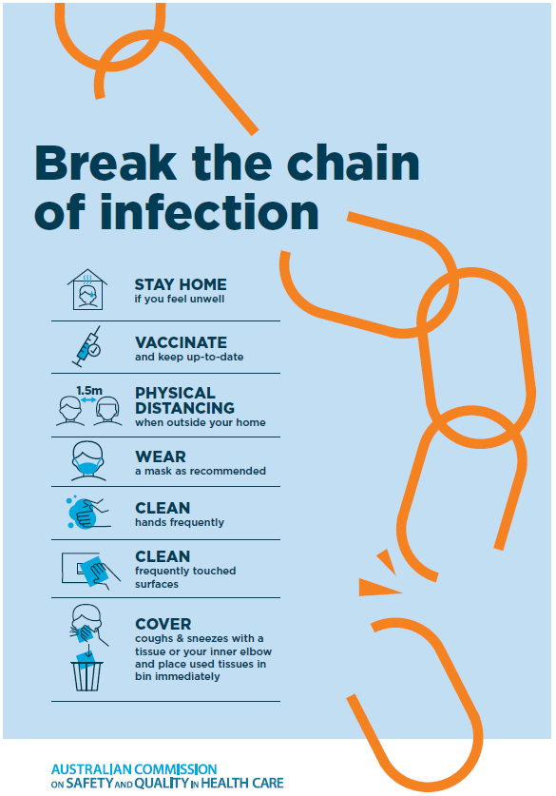](https://www.safetyandquality.gov.au/publications-and-resources/resource-library/break-chain-poster-a3https:/www.safetyandquality.gov.au/publications-and-resources/resource-library/break-chain-poster-a3)**

**Disclaimer**

On the Radar is an information resource of the Australian Commission on Safety and Quality in Health Care. The Commission is not responsible for the content of, nor does it endorse, any articles or sites listed. The Commission accepts no liability for the information or advice provided by these external links. Links are provided on the basis that users make their own decisions about the accuracy, currency and reliability of the information contained therein. Any opinions expressed are not necessarily those of the Australian Commission on Safety and Quality in Health Care.