# Australian Commission on Safety and Quality logotypeOn the Radar

Issue 697

26 May 2025

*On the Radar* is a summary of some of the recent publications in the areas of safety and quality in health care. Inclusion in this document is not an endorsement or recommendation of any publication or provider. Access to particular documents may depend on whether they are Open Access or not, and/or your individual or institutional access to subscription sites/services. Material that may require subscription is included as it is considered relevant.

*On the Radar* is available online, via email or as a PDF or Word document from <https://www.safetyandquality.gov.au/newsroom/subscribe-news/radar>

If you would like to receive *On the Radar* via email, you can subscribe on our website <https://www.safetyandquality.gov.au/newsroom/subscribe-news>  
or by emailing us at [mail@safetyandquality.gov.au](mailto:mail@safetyandquality.gov.au).  
You can also send feedback and comments to [mail@safetyandquality.gov.au](mailto:mail@safetyandquality.gov.au).

For information about the Commission and its programs and publications, please visit <https://www.safetyandquality.gov.au>

**On the Radar**

Editor: Dr Niall Johnson  
Contributors: Niall Johnson

**Journal articles**

*Antidepressant prescribing in Australian primary care: time to reevaluate*

Wallis KA, King A, Moncrieff J

Medical Journal of Australia. 2025;222(9): 430–432.

|  |  |
| --- | --- |
| DOI | <https://doi.org/10.5694/mja2.52645> |
| Notes | Piece in the *Medical Journal of Australia* noting that ‘Around one in seven Australians is now taking antidepressants’ and ‘Two antidepressants, sertraline and escitalopram, are now in the top ten drugs by defined daily dose per 1000 population per day.’ The authors also observe that ‘Social issues such as loneliness, grief or abuse are not resolved by antidepressants’, they suggest ‘it is timely that we reevaluate antidepressant prescribing in primary care’ noting that ‘given the limited efficacy of antidepressants in mild to moderate mental illness, the risk of adverse effects and the difficulties that people can experience stopping antidepressants, there needs to be better decision support and informed consent for starting antidepressants.’ |

For information on the Commission’s work on medicines safety and quality, see <https://www.safetyandquality.gov.au/our-work/medicines-safety-and-quality>

*BMJ Quality & Safety*

Volume 34, Issue 6, June 2025

|  |  |
| --- | --- |
| URL | <https://qualitysafety.bmj.com/content/34/6> |
| Notes | A new issue of *BMJ Quality & Safety* has been published. Many of the papers in this issue have been referred to in previous editions of *On the Radar* (when they were released online). Articles in this issue of *BMJ Quality & Safety* include:   * Editorial: **Testing and cancer diagnosis in general practice** (Stephen Bradley, Jessica Watson) * Editorial: Just how many **diagnostic errors and harms** are out there, really? It depends on how you count (David E Newman-Toker) * Editorial: Learning from an **allied health perspective on quality and safety** (Nicole Müller, Amr El Refaie, Margaret McGrath, Joseph McVeigh) * Editorial: Increasing **surgical volumes** in resource limited-healthcare systems: team-based quality improvement as a novel approach to quantity improvement (Nobhojit Roy, Asad Latif) * Variation in the use of **primary care-led investigations prior to a cancer diagnosis**: analysis of the National Cancer Diagnosis (Nurunnahar Akter, Georgios Lyratzopoulos, Ruth Swann, Greg Rubin, Sean McPhail, Meena Rafiq, Abodunrin Aminu, Nadine Zakkak, Gary Abel) * **Adverse diagnostic events** in hospitalised patients: a single-centre, retrospective cohort study (Anuj K Dalal, Savanna Plombon, Kaitlyn Konieczny, Daniel Motta-Calderon, Maria Malik, Alison Garber, Alyssa Lam, Nicholas Piniella, Marie Leeson, Pamela Garabedian, Abhishek Goyal, Stephanie Roulier, Cathy Yoon, Julie M Fiskio, Kumiko O Schnock, Ronen Rozenblum, Jacqueline Griffin, Jeffrey L Schnipper, Stuart Lipsitz, D W Bates) * Developing the **allied health professionals workforce within mental health, learning disability and autism inpatient services**: rapid review of learning from quality and safety incidents (Ceri Wilson, Rachel Wakefield, Louise Prothero, Gillian Janes, Fiona Nolan, Sally Fowler-Davis) * Quality improvement collaborative to increase **access to caesarean sections**: lessons from Bihar, India (Abha Mehndiratta, Prabir Ranjan Moharana, Tanmay Mahapatra, Sridhar Srikantiah, Sunil Babu, Sarita Simba, Sanjiv Daulatrao, Vikas Pandey, Rahul Shastri, Srinivas Kodiyath, Sulagna Mukherjee, Pramod Sah, Pierre Barker) * Systems analysis of clinical incidents: development of a new edition of the **London Protocol** (Charles Vincent, Dulcie Irving, Tommaso Bellandi, Helen Higham, Philippe Michel, Anthony Staines, Sally Adams, Jeff Brown, Peter Damian Hibbert, Carole Hemmelgarn, Lallu Joseph, Karina Pires, Susan Sheridan, Rosa Sunol, Shin Ushiro, Albert W Wu, Lucas Zambon |

Journal of the Australian Indigenous *HealthInfoNet*

Volume 6, Issue 1, 2025

|  |  |
| --- | --- |
| URL | <https://ro.ecu.edu.au/aihjournal/> |
| Notes | A new issue of the Journal of the Australian Indigenous *HealthInfoNet* has been published. Articles in this issue of *the Journal of the Australian Indigenous HealthInfoNet* include:   * Observed and Reported Outcomes Following Experiential **Cultural Capability and Clinical Yarning Training for Clinicians** Treating Aboriginal and Torres Strait Islander People with Persistent Pain (Stuart Ekberg, Renata F IMeuter, Ivan Lin, Roslyn Rowen, Angela Kinnell, Eva Malacova, Tania Waring, Kushla Houkamau, Marayah Taylor, Matthew Bryant, Jermaine Isua, Andrew Claus, Paul Gray, Joseph Kluver, Christina M Bernardes, and Greg Pratt) * Centralising Local Aboriginal Language and Culture in **Healthy Skin Books on the See Treat Prevent (SToP) Trial** in the Kimberley Region of Western Australia: A Process and Impact Inquiry (Tracy McRae, Kelli McIntosh, Hannah M M Thomas, Stephanie Enkel, Abbey Ford, John Jacky, Slade Sibosado, Marianne Mullane, Alexandra Whelan, Rebecca Dalton, Juli Coffin, Jonathan R Carapetis, Roz Walker, and Asha C Bowen) * **Climate Change Impacts on Drinking Water Security**: A Comparative Study in Australia’s Remote Central Australia and Torres Strait Islands (Nina Lansbury, Julia Bradford, Sandra J Creamer, and Geoffrey Evans) * Considering the Need for Congruence in Closing the Gap, Target 10: Reducing High Rates of **Adult Aboriginal Incarceration** (Jane Anderson, Narelle Carroll, and Boobaditj (also known as Phillip Ugle) * **Integrating Social Work in an Aboriginal Community Controlled Health Service** Primary Health Care Setting: The First Three Months of Data (Ines Sofia Zuchowski, Erin Waters, Albert Kuruvila, Brodie Kuhn, and Rebecca Lee) |

*Healthcare Quarterly*

Volume 27, Number 4, 2025

|  |  |
| --- | --- |
| URL | <https://www.longwoods.com/publications/healthcare-quarterly/27541/1/vol-27-no.-4-2025> |
| Notes | A new issue of *Healthcare Quarterly* has been published. This issue has a focus on Mental Health and the Justice System. Articles in this issue of *Healthcare Quarterly* include:   * Recent Stresses and Underlying System Causes of the **Primary Care Crisis** Point Toward Policy Solutions (Richard H Glazier and Michael E. Green) * **Canada’s Shared Health Priorities**: Measuring Progress and Bridging Data Gaps With Common Indicators (Rachel Latus, Audrey Kim, Winnie Chan and Babita Gupta) * Essential Readings and Continuous Learning in **Healthcare Policy** (Neil Seeman) * Introduction – **Mental Health and the Justice System** (Ruby Brown and Anne Wojtak) * Issues in **Mental Health Law for Health Leaders** (Gail Czukar) * Rehabilitating the **Forensic Psychiatric System**: What’s Really Broken? (Anita Szigeti) * **Mental Health in the Court System**: An Interview With Judge Renee Cochard (Ruby Brown and Anne Wojtak) * A Contemporary Model of Care for **Forensic Mental Health Services** in Ontario (Treena Wilkie, Stephanie Penney, Roland Jones, Sumeeta Chatterjee, Tania Saccoccio and Alexander I F Simpson) * **Reintegration After Incarceration** for People with Mental Illness: A Pilot Community Mental Health Bridging Service (Roland M Jones, Kiran Patel, Alexander I F Simpson, Cory Gerritsen, Tanya Connors, Tania Saccoccio and Treena Wilkie) * Health Quality 5.0: The Counterforce in **Advancing Integrated Care** – Our Path to Transformation (Leslee J Thompson and Jodeme Goldhar) * IFIC Canada: **Transforming Care Through Integration** (Anne Wojtak and Richard Lewanczuk) * How Primary Healthcare Can Support Municipalities in **Service Planning** (Juliana Shemanchuk, Mary V Modayil, Sharon Tahir and Kassandra Squires) * Developing Personas to Enable **Tailored Public Health Communications**: The Case of Organ Donation in Québec (Malvina Klag, Annie-Carole Martel, Matthew Weiss and Martine Bouchard) * Analyses of the Effectiveness of Participation in the Ontario **Surgical Quality Improvement Network** (Priya May, Kerri Bennett, Ivan Yuen and Timothy Jackson) * Examining the **Meaning and Value of Prayer Shawls** Received in Hospital (Pamela Lucas, Natalie Weiser, Joel Aguirre and Daniela Bellicoso) |

*Health Policy*

Volume 157, July 2025

|  |  |
| --- | --- |
| URL | <https://www.sciencedirect.com/journal/health-policy/vol/157/> |
| Notes | A new issue of *Health Policy* has been published. Articles in this issue of *Health Policy* include:   * “That’s a tricky question”: perceptions of **mandatory vaccination** among parents and paediatricians in Austria (Nora Hansl, Katharina T Paul) * From clicks to care: Exploring the digital strategies of Italian health authorities in communicating **‘General Practitioner Selection’ service** (Alessandro Vinci, Luca Pirrotta, Giulia Venturi, Milena Vainieri) * The role of **community pharmacists in natural disasters**: Experiences from the 2023 Türkiye earthquakes (Samet Dinçer, Fatma Gündüz, Ezgi Atalay, Galip Usta, Sare Peçe Göktaş) * **Early access to medicines with added therapeutic value**: Measuring and comparing time to medicines access in England, France, Germany, Italy and Spain (Sophie Delcroix-Lopes, Nadia Amer, Christophe Chaignot, Charlotte Pelletan) * Price regulation and competition among on-**patent anticancer drugs** in Italy (Michele Caimmi, Beatrice Canali, Laura Candelora, Alessandra Di Costanzo, Francesca Fiorentino, Chiara Vassallo, Maria Luisa Mancusi) * The **impact of C-level positions on hospital performance**: A scoping review of top management team outcomes (Matthias Lukas Zuchowski, Dennis Henzler, Mark Dominik Alscher, Eckhard Nagel) * **Availability of primary care and avoidable attendance at English emergency departments**: A regression analysis (Timothy Jamieson, Hugh Gravelle, Rita Santos) * Examining **COVID-19 mortality inequalities** across 169 countries: Insights from the COVID-19 mortality inequality curve (CMIC) and Theil index analysis (Emiliano Lopez Barrera, Kristina Miljkovic, Kodjo Barnor, Dragan Miljkovic) * Munich goes viral: Measuring the impact of the Oktoberfest on **COVID-19 infection rates** using difference-in-differences (Daniel Herold, Phil-Adrian Klotz, Jan Thomas Schäfer) |

*BMJ Quality & Safety* online first articles

|  |  |
| --- | --- |
| URL | <https://qualitysafety.bmj.com/content/early/recent> |
| Notes | *BMJ Quality &Safety* has published a number of ‘online first’ articles, including:   * Time to de-implementation of **low-value cancer screening practices**: a narrative review (Jennifer H LeLaurin, Kathryn Pluta, Wynne E Norton, Ramzi G Salloum, Naykky Singh Ospina) * Editorial: **Workforce well-being** is workforce readiness: it is time to advance from describing the problem to solving it (Bryan Sexton, Jochen Profit) |

*International Journal for Quality in Health Care* online first articles

|  |  |
| --- | --- |
| URL | <https://academic.oup.com/intqhc/advance-articles> |
| Notes | *International Journal for Quality in Health Care* has published a number of ‘online first’ articles, including:   * **Safety Rounds** as a Strategy for Continuous Quality and Safety Improvement in Healthcare Processes Julio J Lopez-Picazo et al) |

**Online resources**

***Australian Living Evidence Collaboration***

<https://livingevidence.org.au/>

***Guidance***

A number of guidelines or guidance have recently been published or updated. These include:

* *Australian Guidelines for Assessment and Diagnosis of FASD* (Fetal Alcohol Spectrum Disorder) <https://fasdhub.org.au/fasd-information/australian-guidelines-for-assessment-and-diagnosis-of-fasd/>
* *National Heart Foundation of Australia & Cardiac Society of Australia and New Zealand: Comprehensive Australian* ***Clinical Guideline for Diagnosing and Managing Acute Coronary Syndromes*** *2025*. Heart, Lung and Circulation. 2025;34(4):309-397. <https://doi.org/10.1016/j.hlc.2025.02.102>   
  For the Commission’s *Acute Coronary Syndromes Clinical Care Standard* see <https://www.safetyandquality.gov.au/standards/clinical-care-standards/acute-coronary-syndromes-clinical-care-standard>

***[USA] Effective Health Care Program reports***

<https://effectivehealthcare.ahrq.gov/>

The US Agency for Healthcare Research and Quality (AHRQ) has an Effective Health Care (EHC) Program The EHC has released the following final reports and updates:

* *Association Between Outcomes and* ***Dental Services in People Receiving Treatment for Human Immunodeficiency Virus****: A Rapid Response Review* <https://effectivehealthcare.ahrq.gov/products/dental-immunodeficiency-virus/rapid-research>
* *Association Between Outcomes and Dental Services in People Receiving Treatments That Cause* ***Medication-Related Osteonecrosis of the Jaw****: A Rapid Response Review* <https://effectivehealthcare.ahrq.gov/products/dental-jaw/rapid-research>

**Infection prevention and control and COVID-19 resources**

The Australian Commission on Safety and Quality in Health Care has developed a number of resources to assist healthcare organisations, facilities and clinicians. These resources include:

* ***Poster – Combined contact and droplet precautions*** <https://www.safetyandquality.gov.au/publications-and-resources/resource-library/infection-prevention-and-control-poster-combined-contact-and-droplet-precautions>  
  [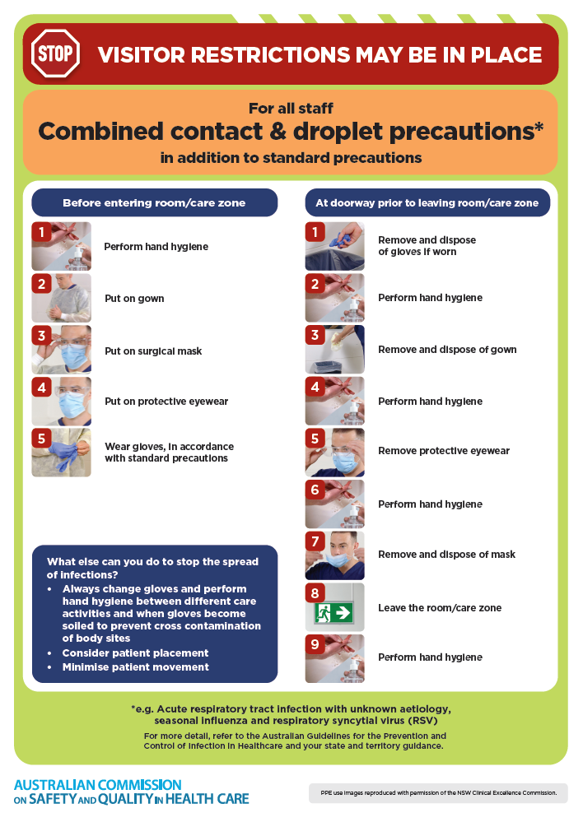](https://www.safetyandquality.gov.au/publications-and-resources/resource-library/infection-prevention-and-control-poster-combined-contact-and-droplet-precautions)
* ***Poster – Combined airborne and contact precautions***<https://www.safetyandquality.gov.au/publications-and-resources/resource-library/infection-prevention-and-control-poster-combined-airborne-and-contact-precautions>  
  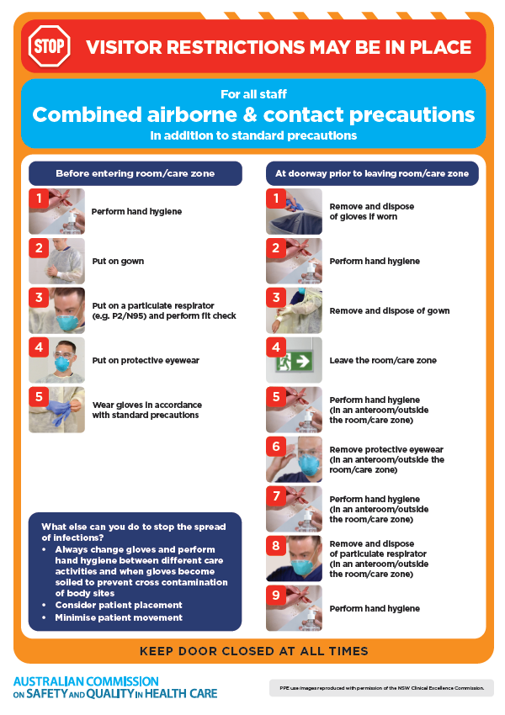
* ***Environmental Cleaning and Infection Prevention and Control*** [www.safetyandquality.gov.au/environmental-cleaning](http://www.safetyandquality.gov.au/environmental-cleaning)
* ***Break the chain of infection*** poster  
  <https://www.safetyandquality.gov.au/publications-and-resources/resource-library/break-chain-infection-poster>  
    
  **[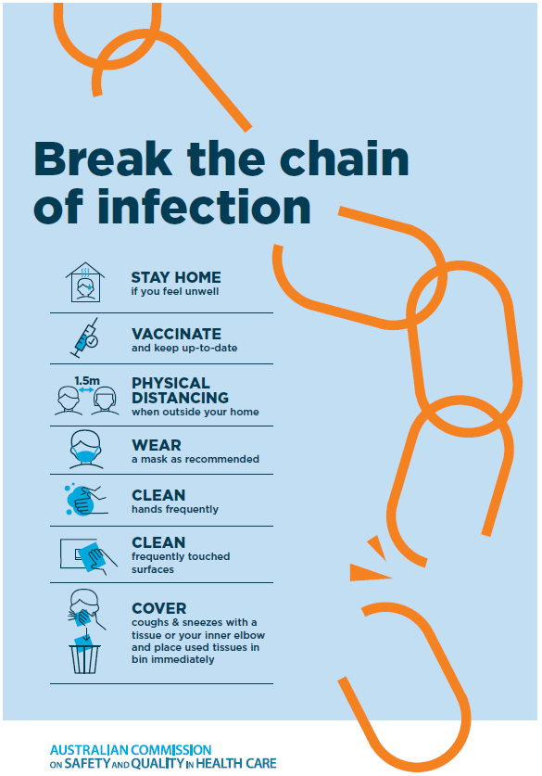](https://www.safetyandquality.gov.au/publications-and-resources/resource-library/break-chain-poster-a3https:/www.safetyandquality.gov.au/publications-and-resources/resource-library/break-chain-poster-a3)**

**Disclaimer**

On the Radar is an information resource of the Australian Commission on Safety and Quality in Health Care. The Commission is not responsible for the content of, nor does it endorse, any articles or sites listed. The Commission accepts no liability for the information or advice provided by these external links. Links are provided on the basis that users make their own decisions about the accuracy, currency and reliability of the information contained therein. Any opinions expressed are not necessarily those of the Australian Commission on Safety and Quality in Health Care.