# Australian Commission on Safety and Quality logotypeOn the Radar

Issue 698

2 June 2025

*On the Radar* is a summary of some of the recent publications in the areas of safety and quality in health care. Inclusion in this document is not an endorsement or recommendation of any publication or provider. Access to particular documents may depend on whether they are Open Access or not, and/or your individual or institutional access to subscription sites/services. Material that may require subscription is included as it is considered relevant.

*On the Radar* is available online, via email or as a PDF or Word document from <https://www.safetyandquality.gov.au/newsroom/subscribe-news/radar>

If you would like to receive *On the Radar* via email, you can subscribe on our website <https://www.safetyandquality.gov.au/newsroom/subscribe-news>  
or by emailing us at [mail@safetyandquality.gov.au](mailto:mail@safetyandquality.gov.au).  
You can also send feedback and comments to [mail@safetyandquality.gov.au](mailto:mail@safetyandquality.gov.au).

For information about the Commission and its programs and publications, please visit <https://www.safetyandquality.gov.au>

**On the Radar**

Editor: Dr Niall Johnson  
Contributors: Niall Johnson, Maushmi Powar

***Newly released PREM - AHPEQS Parent***

<https://www.safetyandquality.gov.au/our-work/indicators-measurement-and-reporting/patient-experience>

A free patient-reported experience measure (PREM) tool is now available for hospitals to ask the parents and carers of children admitted to hospital about their experience of care. The Australian Hospital Patient Experience Question Set for parents and carers (AHPEQS-Parent) was developed and validated by the Perth Children’s Hospital in partnership with Australian Commission on Safety and Quality in Health Care.

For more information on AHPEQS-Parent, PREMs and how to implement them, visit the Commission’s newly updated [Patient Experience webpage](https://www.safetyandquality.gov.au/our-work/indicators-measurement-and-reporting/patient-experience) and watch the Person-centred Care in Practice webinar episode, [*Giving consumers a voice in paediatric care*](https://www.youtube.com/watch?v=J0SOKT5QwaE&list=PLhp7VzGsl66l_HYdDuR0nUIwKsdhrSYJe&index=9).

The development of AHPEQS-Parent has been described in a published journal article (Nelson et al):  
Nelson HJ, Pienaar C, McKenzie K, Williams AM, Swaminathan G, Mӧrelius E

Development of the Australian hospital patient experience question set for parents. Collegian. 2023;30(2):213-221.

<https://doi.org/10.1016/j.colegn.2022.09.003>

The article outlines the process that was undertaken to adapt and validate AHPEQS (Australian Hospital Patient Experience Question Set) for parents and carers of children admitted into hospitals. The two main qualitative categories of care identified were ‘parent experience’ and ‘children being heard’. Emotional support was also identified as an integral aspect of parent experience. AHPEQS-Parent provides a validated tool which reflects the unique experience of parents and carers to facilitate consistent monitoring and improvement in hospitals.

**Reports**

*Patient safety healthcare inequalities reduction framework*

NHS England

London: NHS England; 2025.

|  |  |
| --- | --- |
| URL | <https://www.england.nhs.uk/publication/patient-safety-healthcare-inequalities-reduction-framework/> |
| Notes | NHS England has published this framework that sets out five key principles to reduce patient safety healthcare inequalities across the NHS. The framework includes national actions and suggested local implementation steps for each principle. The 5 principles are:   1. All staff, patients, service users, families and carers have access to information, translation and interpretation services when needed. 2. All healthcare staff receive undergraduate patient safety training, ongoing training, and accessible resources that improve their awareness and understanding of healthcare inequalities related to patient safety risks. 3. Accurate and complete diversity data are collected for protected characteristics and inclusion health groups on digital platforms. This work includes making disaggregated data available so evaluation can drive improvements in patient safety and healthcare inequalities. 4. Representatives of diverse communities are involved in the design and delivery of improvements aimed at reducing patient safety healthcare inequalities. This co-production involves drawing on the knowledge and experience of patients, service users, carers, families, communities and staff. 5. Improve the understanding of patient safety healthcare inequalities and drive improvement through identifying priority areas for research. |

*Improving clinical co-ordination of care for people with multiple long-term conditions. The art of the possible*

Fenney D, Gowar C, Baird B, Scott S

London: The King's Fund; 2025.

|  |  |
| --- | --- |
| URL | <https://www.kingsfund.org.uk/insight-and-analysis/long-reads/improving-clinical-coordination-multiple-long-term-conditions> |
| Notes | The prevalence of chronic conditions has been growing, as has the number of patients with multiple long-term or chronic conditions. These have led to calls for better guidance on multi-morbidity whereas much guidance, such as pathways or guidelines, has tended to focus on single conditions. This policy brief from The King’s Fund in the UK ‘focuses on the clinical co-ordination of care for people with multiple long-term conditions as part of a wider holistic approach. It outlines a set of principles on clinical co-ordination for commissioners and clinicians (by which we mean any health care professional) that we believe should underline a new approach to care for people with multiple long-term conditions.’ |

**Journal articles**

*The Joint Commission Journal on Quality and Patient Safety*

Volume 51, Issue 6, June 2025

|  |  |
| --- | --- |
| URL | <https://www.sciencedirect.com/journal/the-joint-commission-journal-on-quality-and-patient-safety/vol/51/issue/6> |
| Notes | A new issue of *The Joint Commission Journal on Quality and Patient Safety* has been published. Articles in this issue of *The Joint Commission Journal on Quality and Patient Safety* include:   * Nutrition Optimization in **Early Dialysis** (Aditya A Khanijo, Lorenzo Olivero, Mireille H Hamdan, Karen D Stoner, Angela C Majerus, D B Patel, S Allen, C L Trautman, L M Heath, L L Meeusen, C J Hemeyer, S R Jenkins, P Dautaj, M M Rose, E M Flores, M D McGhee, P Moreno Franco, J B Cowart) * Modeling Incremental Benefit of **Medication Reconciliation** on ICU Outcomes (Helen A Harris, David M Chan, Laura Ellwein Fix, Melissa Chouinard, Teresa M Salgado, Le Kang, Gonzalo Bearman) * **Enhanced Antibiotic Stewardship Program**'s Effect on Antibiotic Stewardship in Four Thai Hospitals (Kittiya Jantarathaneewat, Anucha Thatrimontrichai, Nattapol Pruetpongpun, Siriththin Chansirikarnjana, Sasinuch Rutjanawech, David J Weber, Anucha Apisarnthanarak) * Overcoming Professional Silos and Threats to Psychological Safety: A Conceptual Framework for Successful Team-Based **Morbidity and Mortality Conferences** (Brian A Campos, Mary E Brindle, Emily Cummins, Alexander Hannenberg, Danielle Salley, Yves Sonnay, Aubrey Samost-Williams) * **In-Hospital Adverse Events** in Heart Failure Patients: Incidence and Association with 90-Day Mortality (Mohammed Yousufuddin, Mohamad H Yamani, Daniel DeSimone, Ebrahim Barkoudah, Muhammad Waqas Tahir, Zeliang Ma, Fatmaelzahraa Badr, Ibrahim A Gomaa, Sara Aboelmaaty, Sumit Bhagra, Gregg C Fonarow, Mohammad H Murad) * **Patient Safety Event Risk and Language Barriers**: A Scoping Review (Lucy B Schulson, Jorge A Rodriguez, Ricardo Cruz, David Flynn, Alicia Fernandez) * **Patient Engagement in Safety**: Are We There Yet? (Tejal Gandhi, Urmimala Sarkar) |

*BMJ Quality & Safety* online first articles

|  |  |
| --- | --- |
| URL | <https://qualitysafety.bmj.com/content/early/recent> |
| Notes | *BMJ Quality &Safety* has published a number of ‘online first’ articles, including:   * **What do people do in the aftermath of healthcare-related harm?** A qualitative study on experiences and factors influencing decision-making (Lavanya Thana, Helen Crocker, Shivali Modha, Linda Mulcahy, Catherine Pope, Charles Vincent, Helen Hogan, Michele Peters) * Implementing quality and safety regulations in **residential disability services**: a qualitative interview study (Paul Dunbar, Laura Keyes, John Browne) * Metrics used in quality improvement publications addressing **environmental sustainability in healthcare**: a scoping review (Colin Sue-Chue-Lam, Sezgi Yanikomeroglu, Darius Baginskis, Doulia M Hamad, Brian M Wong, Nicole Simms, Karen B Born) |

**Online resources**

***Australian Living Evidence Collaboration***

<https://livingevidence.org.au/>

***Residential Aged Care Communiqué***

<https://www.thecommuniques.com/post/residential-aged-care-communiqu%C3%A9-volume-20-issue-2-may-2025>

Volume 20, Issue 1, May 2025

This issue of *Residential Aged Care Communiqué* ‘focusses on the complex and difficult issues around medical treatment decision-making at the end of life care in people with cognitive impairment.’

***Guidance***

A number of guidelines or guidance have recently been published or updated. These include:

* Stroke Foundation. *Australian and New Zealand Living Clinical Guidelines for Stroke Management* <https://informme.org.au/guidelines/living-clinical-guidelines-for-stroke-management>

***[UK] NICE Guidelines and Quality Standards***

<https://www.nice.org.uk/guidance>

The UK’s National Institute for Health and Care Excellence (NICE) has published new (or updated) guidelines and quality standards The latest reviews or updates include:

* NICE Guideline NG140 ***Abortion care*** <https://www.nice.org.uk/guidance/ng140>

***[USA] Effective Health Care Program reports***

<https://effectivehealthcare.ahrq.gov/>

The US Agency for Healthcare Research and Quality (AHRQ) has an Effective Health Care (EHC) Program The EHC has released the following final reports and updates:

* *Making Healthcare Safer IV: Summary of Findings on* ***Patient Safety Practices*** *and Ratings by a Technical Expert Panel, 2024-2025*   
  <https://effectivehealthcare.ahrq.gov/products/patient-safety-practices/white-paper>
* *Research Protocol: Pharmacologic and Nonpharmacologic Treatments for* ***Posttraumatic Stress Disorder****: An Update of the PTSD Repository Evidence Base* <https://effectivehealthcare.ahrq.gov/products/ptsd-pharm-non-pharm-treatment-6-update/protocol>

**Infection prevention and control and COVID-19 resources**

The Australian Commission on Safety and Quality in Health Care has developed a number of resources to assist healthcare organisations, facilities and clinicians. These resources include:

* ***Poster – Combined contact and droplet precautions*** <https://www.safetyandquality.gov.au/publications-and-resources/resource-library/infection-prevention-and-control-poster-combined-contact-and-droplet-precautions>  
  [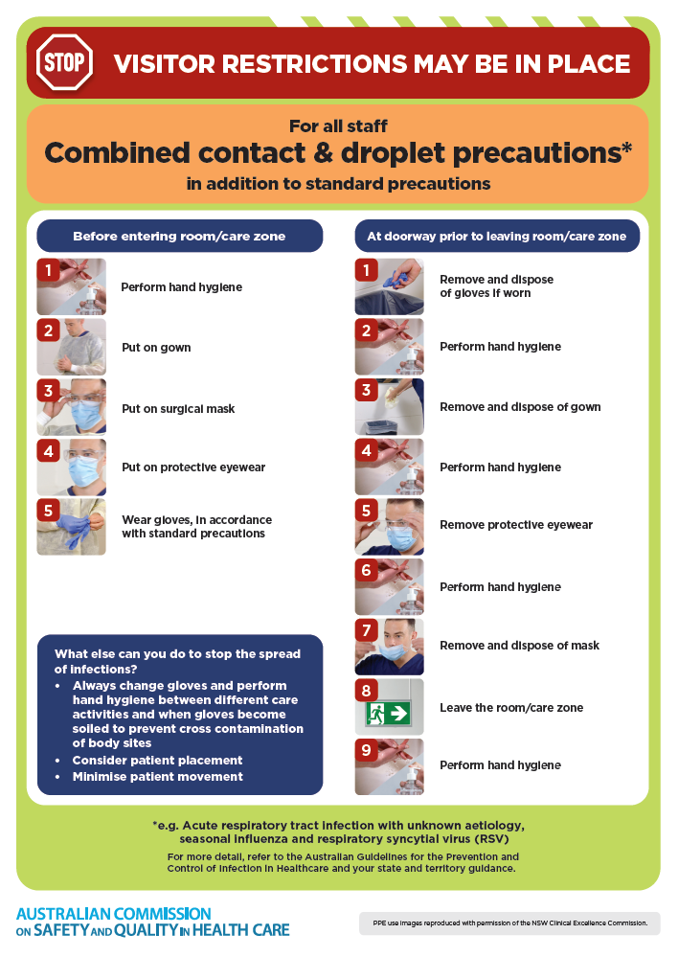](https://www.safetyandquality.gov.au/publications-and-resources/resource-library/infection-prevention-and-control-poster-combined-contact-and-droplet-precautions)
* ***Poster – Combined airborne and contact precautions***<https://www.safetyandquality.gov.au/publications-and-resources/resource-library/infection-prevention-and-control-poster-combined-airborne-and-contact-precautions>  
  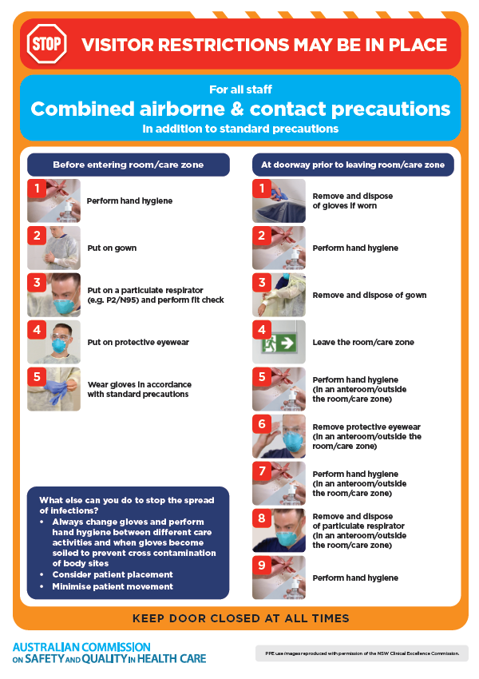
* ***Environmental Cleaning and Infection Prevention and Control*** [www.safetyandquality.gov.au/environmental-cleaning](http://www.safetyandquality.gov.au/environmental-cleaning)
* ***Break the chain of infection*** poster  
  <https://www.safetyandquality.gov.au/publications-and-resources/resource-library/break-chain-infection-poster>  
    
  **[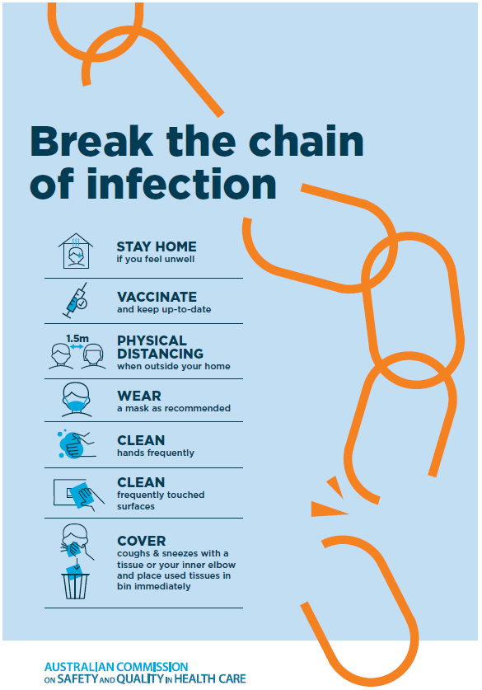](https://www.safetyandquality.gov.au/publications-and-resources/resource-library/break-chain-poster-a3https:/www.safetyandquality.gov.au/publications-and-resources/resource-library/break-chain-poster-a3)**

**Disclaimer**

On the Radar is an information resource of the Australian Commission on Safety and Quality in Health Care. The Commission is not responsible for the content of, nor does it endorse, any articles or sites listed. The Commission accepts no liability for the information or advice provided by these external links. Links are provided on the basis that users make their own decisions about the accuracy, currency and reliability of the information contained therein. Any opinions expressed are not necessarily those of the Australian Commission on Safety and Quality in Health Care.