April 2025

CARAlert annual report

**2024**

2024

Published by the Australian Commission on Safety and Quality in Health Care

Level 5, 255 Elizabeth Street, Sydney NSW 2000  
Phone: (02) 9126 3600   
Email: [mail@safetyandquality.gov.au](mailto:mail@safetyandquality.gov.au)   
Website: [www.safetyandquality.gov.au](http://www.safetyandquality.gov.au)

ISBN: 978-1-923353-07-7

© Australian Commission on Safety and Quality in Health Care 2025

All material and work produced by the Australian Commission on Safety and Quality in Health Care is protected by copyright. The Commission reserves the right to set out the terms and conditions for the use of such material.

As far as practicable, material for which the copyright is owned by a third party will be clearly labelled. The Commission has made all reasonable efforts to ensure that this material has been reproduced in this publication with the full consent of the copyright owners.

With the exception of any material protected by a trademark, any content provided by third parties, and where otherwise noted, all material presented in this publication is licensed under a [Creative Commons Attribution-NonCommercial-NoDerivatives 4.0 International licence](https://creativecommons.org/licenses/by-nc-nd/4.0/).

Creative Common logo

Enquiries about the licence and any use of this publication are welcome and can be sent to [communications@safetyandquality.gov.au](mailto:communications@safetyandquality.gov.au?subject=Enquiry).

The Commission’s preference is that you attribute this publication (and any material sourced from it) using the following citation:

Australian Commission on Safety and Quality in Health Care. CARAlert annual report: 2024. Sydney; ACSQHC, 2025.

**Disclaimer**

The content of this document is published in good faith by the Australian Commission on Safety and Quality in Health Care for information purposes. The document is not intended to provide guidance on particular healthcare choices. You should contact your healthcare provider on particular healthcare choices.

The Commission does not accept any legal liability for any injury, loss or damage incurred by the use of, or reliance on, this document.

**Note regarding alternative descriptions**

No alternative descriptions have been provided. If you need assistance with the structure of any graphs or charts, please email the Australian Commission on Safety and Quality in Health Care at [CARAlert@safetyandquality.gov.au](mailto:CARAlert@safetyandquality.gov.au).

Contents

Executive Summary 4

National overview of key findings: 2024 compared to 2023 4

What will be done to improve patient safety? 5

Results from CARAlert, 2024 6

Critical antimicrobial resistances by state and territory 6

Critical antimicrobial resistances by age group 9

Critical antimicrobial resistances by facility type 10

Critical antimicrobial resistances by specimen type 11

Summary by CAR, with trend data for 2017–2024 12

*Acinetobacter baumannii* complex 12

*Candida auris* 13

*Enterobacterales* 15

*Enterococcus* species 23

*Mycobacterium tuberculosis* 24

*Neisseria gonorrhoeae* 26

*Neisseria meningitidis* 28

*Pseudomonas aeruginosa* 28

*Salmonella* species 30

*Shigella* species 33

*Staphylococcus aureus* 36

*Streptococcus pyogenes* 37

Discussion 38

References 41

Appendix 1 About CARAlert 43

Appendix 2 Methodology 45

Appendix 3 CARAlert confirming laboratories, 2024 47

## Executive Summary

This report provides analyses of data on confirmed critical antimicrobial resistances (CARs) submitted to the National Alert System for Critical Antimicrobial Resistances (CARAlert) for 2024, and trend data between 2017 and 2024.

There was an overall 25.1% increase in CARs reported between 2023 (*n* = 2,706) and 2024 (*n* = 3,385). Carbapenemase-producing *Enterobacterales* (CPE), which are the most frequently reported CARs to CARAlert, continue to be a concern for patient safety. Bacteria that produce carbapenemase enzymes are almost always resistant to other important antibiotic classes, such as other β-lactams, β-lactamase inhibitor combinations, fluoroquinolones and aminoglycosides. This means that effective treatment options for infections may be very limited, and lengths of stay for hospital admissions may increase.

Issues for health care and patient safety identified by 2024 CARAlert data analyses include:

* Increasing rates of CPE and linezolid-resistant *Enterococcus* species in Australian hospitals
* Upward trends in community-onset CARs, including *Neisseria gonorrhoeae, Shigella* species and *Salmonella* species, corresponding with the easing of travel restrictions following the COVID-19 pandemic
* Ongoing reports of CARs in aged care home residents albeit at very low levels
* Ongoing implications for increased health service demand and complexity of care due to CARs.

### National overview of key findings: 2024 compared to 2023

* CPE (including those with ribosomal methyltransferase or transmissible colistin resistance) were the most frequently reported CARs (45.1%) in 2024, followed by azithromycin-nonsusceptible *N. gonorrhoeae* (low-level resistance [LLR], minimum inhibitory concentration [MIC] < 256 mg/L) (29.8%).
* The total number of CPE (either alone or in combination with other CARs) reported in 2024, compared to 2023, increased by 26.8%. The increase was mostly seen in Queensland   
  (up 51.0%), South Australia (SA; up 36.5%), and Victoria (up 31.5%). NDM types are increasing while IMP types have remained stable.
* The total number of *N. gonorrhoeae* reports in 2024 increased compared to 2023 (up 51.0%).   
  Of these reports, 39 were ceftriaxone-nonsusceptible (MIC ≥ 0.125 mg/L) and 30 were azithromycin-nonsusceptible (high-level resistance, MIC ≥ 256 mg/L). The remaining *N. gonorrhoeae* reports were azithromycin-nonsusceptible (LLR, MIC < 256 mg/L).
* From 2023 to 2024, the number of reports of carbapenemase-producing *Pseudomonas aeruginosa* and carbapenemase-producing *Acinetobacter baumannii* complex increased slightly.
* There was a decrease in the overall number of reports of multidrug-resistant (MDR) *Shigella* species from 2023 to 2024 (down 22.2%). There was a 2-fold increase in numbers from Western Australia, and a slight increase from Queensland. The number of reports decreased from Victoria, New South Wales, and SA.
* Reports of linezolid-resistant *Enterococcus* species increased substantially in 2024 compared to 2023, which in turn showed higher cases in the preceding six years.
* There was a slight increase in the number of ceftriaxone-nonsusceptible *Salmonella* species   
  (up 8.3%) with both years showing a substantial increase compared to previous years. There were five (4.8%) ceftriaxone-nonsusceptible typhoidal species reported in 2024.
* There were 16 reports of MDR *Mycobacterium tuberculosis* in 2024, compared to 21 reports   
  in 2023.
* There were 16 reports of *Candida auris* in 2024, compared to 17 reports in 2023.
* Where the setting was known, the majority of CARs were reported from hospitals (54.2%) followed by community settings (45.5%). Less than 1% of CARs were reported from aged care homes.

### What will be done to improve patient safety?

In response to the issues identified in analyses of CARAlert data between 2017 and 2024, the Australian Commission on Safety and Quality in Health Care will continue to:

* Monitor and report on CARs reported to CARAlert, maintain the CARAlert system and communicate CARAlert and other Antimicrobial Use and Resistance in Australia (AURA) surveillance data and key findings to states, territories, the Australian Government Department of Health and Aged Care and relevant experts
* Maintain the currency of and promote compliance with the *Australian Guidelines for the Prevention and Control of Infection in Healthcare*1 as required by the National Safety and Quality Health Service (NSQHS) Standards2 and National Safety and Quality Primary and Community Healthcare Standards3 (Primary and Community Healthcare Standards)
* Maintain the currency of and promote implementation of guidance for specific organisms, such as the *Recommendations for the control of carbapenemase-producing* Enterobacterales *(CPE): A guide for acute care health service organisations*4and promote consistency of screening and infection prevention and control practices, and outbreak responses to improve containment of CPE and other carbapenemase-producing organisms
* Use CARAlert and other AURA data to refine and strengthen approaches to infection prevention and control and antimicrobial stewardship (AMS), and support implementation of the NSQHS Standards2, the Primary and Community Healthcare Standards3 and the AMS Clinical Care Standard5
* Liaise with the Aged Care Quality and Safety Commission and aged care provider organisations and promote use of *The Aged Care Infection Prevention and Control Guide*6 to support implementation of infection prevention and control and AMS programs in aged care homes to meet the requirements of the strengthened Aged Care Quality Standards7, particularly the Aged Care Clinical Standard8
* Support collaboration between the states and territories and hospital and community care settings to prevent and control CARs
* Prepare analyses of antimicrobial resistance data for and liaise with Therapeutic Guidelines Limited, the organisation that develops guidance on antimicrobial prescribing in Australia.

## Results from CARAlert, 2024

Information about the National Alert System for Critical Antimicrobial Resistances (CARAlert), and methods used for the analyses presented in this report are included in Appendices 1 and 2.

Between 1 January 2024 and 31 December 2024, a total of 3,389 critical antimicrobial resistances (CARs) from 74 originating laboratories across Australia were entered into CARAlert by 22 of the 27 confirming laboratories nationally that participate in CARAlert (Appendix 3). There was an average of 282 entries per month (range: 230 in January to 331 in October).

### Critical antimicrobial resistances by state and territory

Most CARs were reported for patients who lived in the most populous states (New South Wales [NSW], *n =*947, 27.9%; Victoria, *n =*1,567, 46.2%; Queensland, *n =*445, 13.1%). There were fewer than 20 reports from Tasmania and the Northern Territory (NT) (Table 1).

Carbapenemase-producing *Enterobacterales* (CPE) (including those with ribosomal methyltransferase or transmissible resistance to colistin) was the most frequently reported CAR (1,527/3,389, 45.1%) in 2024. Compared to 2023 (*n* = 1,204), there was a 26.8% increase in overall reports of CPE in 2024; the greatest increase was seen in Queensland (up 51.0%), South Australia (SA; up 36.5%), and Victoria (up 31.5%).

Compared to 2023, the number of azithromycin-nonsusceptible *Neisseria gonorrhoeae* (low-level resistance [LLR], minimum inhibitory concentration [MIC] < 256 mg/L) reports increased 1.5-fold in 2024. The greatest increase was seen in Victoria (up 1.9-fold), and SA (up 1.8-fold). There was a decrease in reports from NSW.

Ceftriaxone-nonsusceptible and azithromycin-nonsusceptible (high-level resistance [HLR], MIC ≥ 256 mg/L) *N. gonorrhoeae* increased in 2024 (*n* = 69 in 2024; *n* = 45 in 2023). There was a 2.4-fold increase in reports from NSW. Reports from Victoria decreased.

There was a decrease in the overall number of multidrug-resistant (MDR) *Shigella* species reported in 2024 (down 21.3%). Decreases were seen in SA (down 76.2%), Victoria (down 42.1%), and NSW (down 21.9%). Reports from Western Australia (WA) doubled in 2024.

There was a 2.3-fold increase in the number of linezolid-resistant *Enterococcus* species reported in 2024. The greatest increase was seen in reports from Victoria (up 3.6-fold).

The number of ceftriaxone-nonsusceptible *Salmonella* species reported in 2024 was similar to 2023 (*n* = 104 in 2024; *n* = 96 in 2023). There was an increase in reports from WA, and a decrease in reports from NSW. Less than 1 in 20 (5/104, 4.8%) of all reports were typhoidal species.

Carbapenemase-producing *Pseudomonas aeruginosa* were reported predominantly from NSW (39/97, 40.2%).

*Candida auris* was reported from five states and the Australian Capital Territory (ACT), with no reports from Tasmania or the NT.

Enterobacterales with transmissible resistance to colistin (*mcr-1.1*) were reported from NSW (n = 1) and Victoria (*n* = 1); both isolates also harboured a *bla*NDM gene.

**Table 1:** Number of critical antimicrobial resistances reported to CARAlert, by state and territory, 2024 and 2023

|  |  |  |  |  |  |  |  |  |  |  |  |  |
| --- | --- | --- | --- | --- | --- | --- | --- | --- | --- | --- | --- | --- |
|  |  | State or territory, 2024 | | | | | | | | Year | |  |
| **Species** | **Critical resistance** | **NSW** | **Vic** | **Qld** | **SA** | **WA** | **Tas** | **NT** | **ACT** | **2023** | **2024** | **Relative change\*** |
| *Acinetobacter baumannii* complex | Carbapenemase-producing | 7 | 7 | 2 | 1 | 4 | 0 | 0 | 0 | 27 | 21 | ▼ 22.2% |
| Carbapenemase- and ribosomal methyltransferase-producing | 3 | 14 | 4 | 1 | 4 | 0 | 0 | 0 | 10 | 26 | ▲ 160% |
| *Candida auris* | – | 2 | 5 | 2 | 1 | 5 | 0 | 0 | 1 | 17 | 16 | ▼ 5.9% |
| *Enterobacterales* | Carbapenemase-producing (alone or in combination with other CARs) | 595 | 468 | 290 | 71 | 71 | 12 | 10 | 10 | 1,204 | 1,527 | ▲ 26.8% |
| Carbapenemase-producing | 591 | 399 | 277 | 54 | 65 | 12 | 10 | 10 | 1,101 | 1,418 | ▲ 28.8% |
| Carbapenemase- and ribosomal methyltransferase-producing | 3 | 68 | 13 | 17 | 6 | 0 | 0 | 0 | 102 | 107 | ▲ 4.9% |
| Carbapenemase-producing and transmissible resistance to colistin | 1 | 1 | 0 | 0 | 0 | 0 | 0 | 0 | 1 | 2 | – |
| Ribosomal methyltransferase-producing | 3 | 7 | 0 | 0 | 2 | 0 | 0 | 0 | 16 | 12 | ▼25.0% |
| Transmissible colistin resistance† | 0 | 0 | 0 | 0 | 0 | 0 | 0 | 0 | 1 | 0 | – |
| *Enterococcus* species | Linezolid-resistant | 11 | 72 | 24 | 2 | 8 | 0 | 0 | 1 | 51 | 118 | ▲ 131% |
| *Mycobacterium tuberculosis* | Multidrug-resistant – at least rifampicin- and isoniazid-resistant strains | 2 | 7 | 6 | 0 | 0 | 0 | 0 | 1 | 21 | 16 | ▼ 23.8% |
| *Neisseria gonorrhoeae* | Azithromycin-nonsusceptible (low-level) | 92 | 793 | 44 | 30 | 46 | 1 | 1 | 2 | 669 | 1,009 | ▲ 50.8% |
| Azithromycin-nonsusceptible (high-level) | 20 | 3 | 5 | 1 | 0 | 0 | 0 | 1 | 22 | 30 | ▲ 36.4% |
| Ceftriaxone-nonsusceptible | 22 | 0 | 2 | 0 | 3 | 1 | 0 | 0 | 14 | 28 | ▲ 100% |
| Ceftriaxone-nonsusceptible and azithromycin-nonsusceptible (low-level) | 0 | 2 | 0 | 2 | 0 | 1 | 0 | 0 | 3 | 5 | – |
| Ceftriaxone-nonsusceptible and azithromycin-nonsusceptible (high-level) | 1 | 1 | 0 | 1 | 3 | 0 | 0 | 0 | 5 | 6 | – |
| Gentamicin-resistant | 0 | 0 | 0 | 0 | 0 | 0 | 0 | 0 | 0 | 0 | – |
| *Neisseria meningitidis* | Ciprofloxacin-nonsusceptible | 2 | 3 | 0 | 0 | 0 | 0 | 0 | 0 | 4 | 5 | – |

*Continued*

Table 1: *continued*

|  |  |  |  |  |  |  |  |  |  |  |  |  |
| --- | --- | --- | --- | --- | --- | --- | --- | --- | --- | --- | --- | --- |
|  |  | State or territory, 2024 | | | | | | | | Year | |  |
| **Species** | **Critical resistance** | **NSW** | **Vic** | **Qld** | **SA** | **WA** | **Tas** | **NT** | **ACT** | **2023** | **2024** | **Relative change\*** |
| *Pseudomonas aeruginosa* | Carbapenemase-producing | 39 | 16 | 11 | 2 | 9 | 2 | 0 | 3 | 67 | 82 | ▲ 22.4% |
| Carbapenemase- and ribosomal methyltransferase-producing | 0 | 8 | 1 | 2 | 3 | 0 | 0 | 1 | 8 | 15 | ▲ 87.5% |
| *Salmonella* species | Ceftriaxone-nonsusceptible | 9 | 44 | 18 | 6 | 22 | 1 | 2 | 2 | 96 | 104 | ▲ 8.3% |
| *Shigella* species | Multidrug-resistant | 139 | 117 | 36 | 5 | 62 | 1 | 4 | 5 | 469 | 369 | ▼ 21.3% |
| *Staphylococcus aureus* | Linezolid-nonsusceptible | 0 | 0 | 0 | 0 | 0 | 0 | 0 | 0 | 0 | 0 | – |
| Vancomycin-nonsusceptible | 0 | 0 | 0 | 0 | 0 | 0 | 0 | 0 | 1 | 0 | – |
| *Streptococcus pyogenes* | Penicillin reduced susceptibility | 0 | 0 | 0 | 0 | 0 | 0 | 0 | 0 | 0 | 0 | – |
|  | **Total (reported by 18 February 2025)** | **947** | **1,567** | **445** | **125** | **242** | **19** | **17** | **27** | **2,706** | **3,389** | ▲ **25.2%** |

CAR = critical antimicrobial resistance; High-level = azithromycin MIC ≥ 256 mg/L; Low-level = azithromycin MIC < 256 mg/L; MIC = minimum inhibitory concentration; ▲ = increase; ▼ = decrease; – = not applicable

* Relative change = absolute change between 2023 and 2024, for each CAR, expressed as a percentage of 2023 base reported, where 10 or more CARs were reported per year

† When not seen in combination with carbapenemase-producing *Enterobacterales*

### Critical antimicrobial resistances by age group

CARs were isolated from patients of all age groups; the median age was 40–49 years (Figure 1). Almost three-quarters of CPE were isolated from people aged 50 years and older (1,129/1,528, 73.9%). Most of ceftriaxone- and/or azithromycin-nonsusceptible *N. gonorrhoeae* was reported for people aged 15–59 years (1,036/1,077, 96.2%); and 79.2% (289/365) of MDR *Shigella* species were in people aged 20–59 years.

Only 4.2% (143/3,385) of all CARs were reported in children aged less than 15 years; CPE (*n* = 80), MDR *Shigella* species (*n* = 30) and ceftriaxone-nonsusceptible *Salmonella* species (*n* = 22) were most frequently reported for this age group (132/143, 92.3%). For the 0–4-year age group, CPE was the most frequently reported CAR (*n* = 57); followed by MDR *Shigella* species (*n*= 14), and ceftriaxone-nonsusceptible *Salmonella* species (*n* = 13).

**Figure 1:** Critical antimicrobial resistances reported to CARAlert, by age groups, 2024



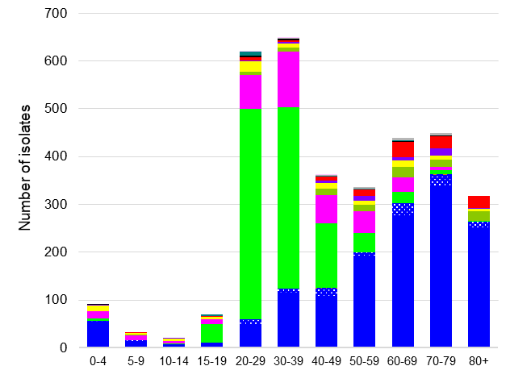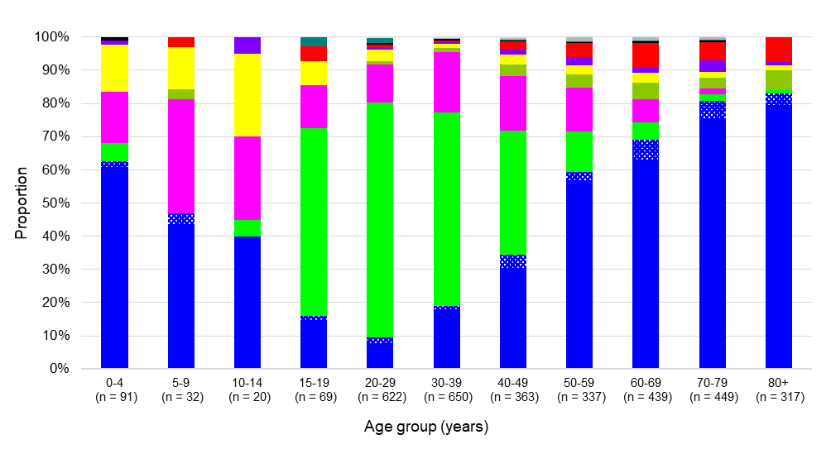

### Critical antimicrobial resistances by facility type

Where the setting was known, just over one-half of CARs were detected in either hospitalised patients or hospital outpatients (1,672/3,086, 54.2%). Smaller proportions were isolated in the community (1,404/3,086, 45.5%) and in aged care homes (10/3,086, 0.3%) (Table 2).

**Table 2:** Number of critical antimicrobial resistance isolates reported to CARAlert, by setting, national, 2024

|  |  |  |  |  |  |  |  |
| --- | --- | --- | --- | --- | --- | --- | --- |
|  |  | Setting | | | | |  |
| **Species** | **Critical resistance** | **Public hospitals** | **Private hospitals** | **Aged care homes** | **Community** | **Unknown** | **Total** |
| *Acinetobacter baumannii* complex | Carbapenemase-producing | 19 | 0 | 0 | 0 | 2 | 21 |
| Carbapenemase- and ribosomal methyltransferase-producing | 22 | 2 | 0 | 1 | 1 | 26 |
| *Candida auris* | – | 11 | 0 | 0 | 5 | 0 | 16 |
| *Enterobacterales* | Carbapenemase-producing | 1,066 | 81 | 8 | 212 | 51 | 1,418 |
| Carbapenemase and ribosomal methyltransferase-producing | 66 | 1 | 0 | 37 | 3 | 107 |
| Carbapenemase-producing and transmissible colistin resistance | 2 | 0 | 0 | 0 | 0 | 2 |
| Ribosomal methyltransferase-producing | 11 | 0 | 0 | 1 | 0 | 12 |
| Transmissible colistin resistance | 0 | 0 | 0 | 0 | 0 | 0 |
| *Enterococcus* species | Linezolid-resistant | 78 | 0 | 1 | 36 | 3 | 118 |
| *Mycobacterium tuberculosis* | Multidrug-resistant – at least rifampicin- and isoniazid-resistant | 12 | 0 | 0 | 1 | 3 | 16 |
| *Neisseria gonorrhoeae* | Azithromycin-nonsusceptible (low-level) | 44 | 0 | 0 | 845 | 120 | 1,009 |
| Azithromycin-nonsusceptible (high-level) | 3 | 0 | 0 | 16 | 11 | 30 |
| Ceftriaxone-nonsusceptible | 5 | 0 | 0 | 5 | 18 | 28 |
| Ceftriaxone-nonsusceptible and azithromycin-nonsusceptible (low-level) | 1 | 0 | 0 | 4 | 0 | 5 |
| Ceftriaxone-nonsusceptible and azithromycin-nonsusceptible (high-level) | 0 | 0 | 0 | 5 | 1 | 6 |
| Gentamicin-resistant | 0 | 0 | 0 | 0 | 0 | 0 |
| *Neisseria meningitidis* | Ciprofloxacin-nonsusceptible | 1 | 0 | 0 | 4 | 0 | 5 |
| *Pseudomonas aeruginosa* | Carbapenemase-producing | 57 | 2 | 0 | 16 | 7 | 82 |
| Carbapenemase- and ribosomal methyltransferase-producing | 11 | 0 | 0 | 4 | 0 | 15 |
| *Salmonella* species | Ceftriaxone-nonsusceptible | 28 | 3 | 1 | 58 | 14 | 104 |
| *Shigella* species | Multidrug-resistant | 140 | 6 | 0 | 154 | 69 | 369 |
| *Staphylococcus aureus* | Linezolid-nonsusceptible | 0 | 0 | 0 | 0 | 0 | 0 |
| Vancomycin-nonsusceptible | 0 | 0 | 0 | 0 | 0 | 0 |
| *Streptococcus pyogenes* | Penicillin reduced susceptibility | 0 | 0 | 0 | 0 | 0 | 0 |
|  | **Total (reported by 18 February 2025)** | **1,577** | **95** | **10** | **1,404** | **303** | **3,389** |

High-level = azithromycin MIC ≥ 256 mg/L; Low-level = azithromycin MIC < 256 mg/L; MIC = minimum inhibitory concentration

Note: Information on setting for *N. gonorrhoeae* is often not available.

CPE accounted for a just over two-thirds of all reports from hospitals (1,216/1,672, 72.7%). In the community, a vast majority of reports were ceftriaxone and/or azithromycin-nonsusceptible *N. gonorrhoeae* (875/1,404, 62.3%), MDR *Shigella* species (154/1,404, 11.0%) or CPE (249/1,404, 17.7%). There were 10 reports from aged care homes, eight of which were CPE.

### Critical antimicrobial resistances by specimen type

Just over two-thirds of all CARs reported in 2023 were from clinical specimens (2,310/3,389, 68.2%), which are specimens collected for diagnostic purposes, rather than for screening. These included urine (*n* = 524), blood (*n* = 58), wound (*n* = 46), and other (*n* = 1,682) such as genital or respiratory specimens (Figure 2).

Of CPE reports, 54.0% (824/1,527) were from clinical specimens. Just over one-half of CPE isolates from clinical specimens were from urine (441/824, 53.5%) – an important specimen for *Enterobacterales* as the urinary tract is a common site of infection. Almost 1 in 20 (43/824, 5.2%) CPE from clinical specimens were from blood cultures. CPE comprised 74.1% (43/58) of all CARs confirmed from blood specimens.

Three other CARs were also reported from blood cultures in 2024: carbapenemase-producing *P. aeruginosa* (*n* = 6), ceftriaxone-nonsusceptible *Salmonella* species (*n* = 5) and linezolid-resistant *Enterococcus* species (*n*= 4).

**Figure 2:** Critical antimicrobial resistances reported to CARAlert, by specimen type, 2024

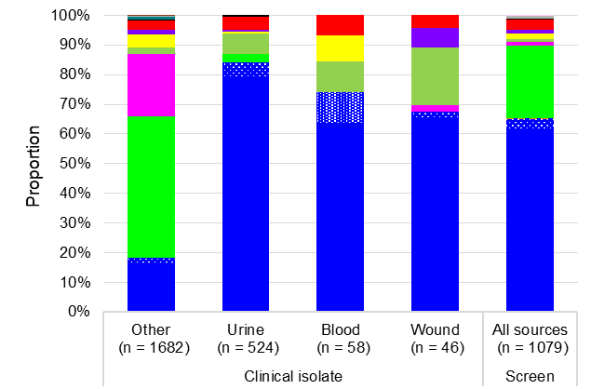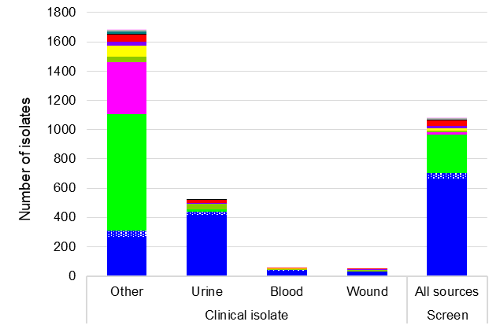

Note: 'Other’ refers to specimen types other than urine, wound or blood, such as genital, faecal or respiratory tract.

## Summary by CAR, with trend data for 2017–2024

Data for each CAR for 2024, nationally and by state and territory, are shown in Figures 3 to 32. Trend data for 2017 to 2024 are also presented, where applicable.

### *Acinetobacter baumannii* complex

*Acinetobacter baumannii* complex is a group of environmental organisms that have caused prolonged outbreaks in hospital settings, such as intensive care and severe burns units. *A. baumannii* infections are associated with patients with compromised physical barriers and immunity, most commonly in hospital. The most common infections caused by this species complex are ventilator-associated pneumonia and severe burn infections. Reporting of carbapenemase-producing *A. baumannii* complex to CARAlert began in July 2019.

There were 47 reports of carbapenemase-producing *A. baumannii* complex in 2024, from all states and territories except Tasmania, the ACT, and the NT (Figures 3 and 4). OXA-23-like types were dominant (*n*= 40; alone, *n* = 33). NDM types were mostly reported in combination with OXA-23-like (*n* = 6), one NDM in combination with IMP and OXA-58, and one NDM alone were reported. Five OXA-24/40-like types were also reported.

Where setting was known, almost all (43/44, 97.7%) of carbapenemase-producing *A. baumannii* complex were reported from hospitals (Table 3).

**Figure 3:** Carbapenemase-producing *Acinetobacter baumannii* complex, number reported to CARAlert by specimen type, national, 2019–2024

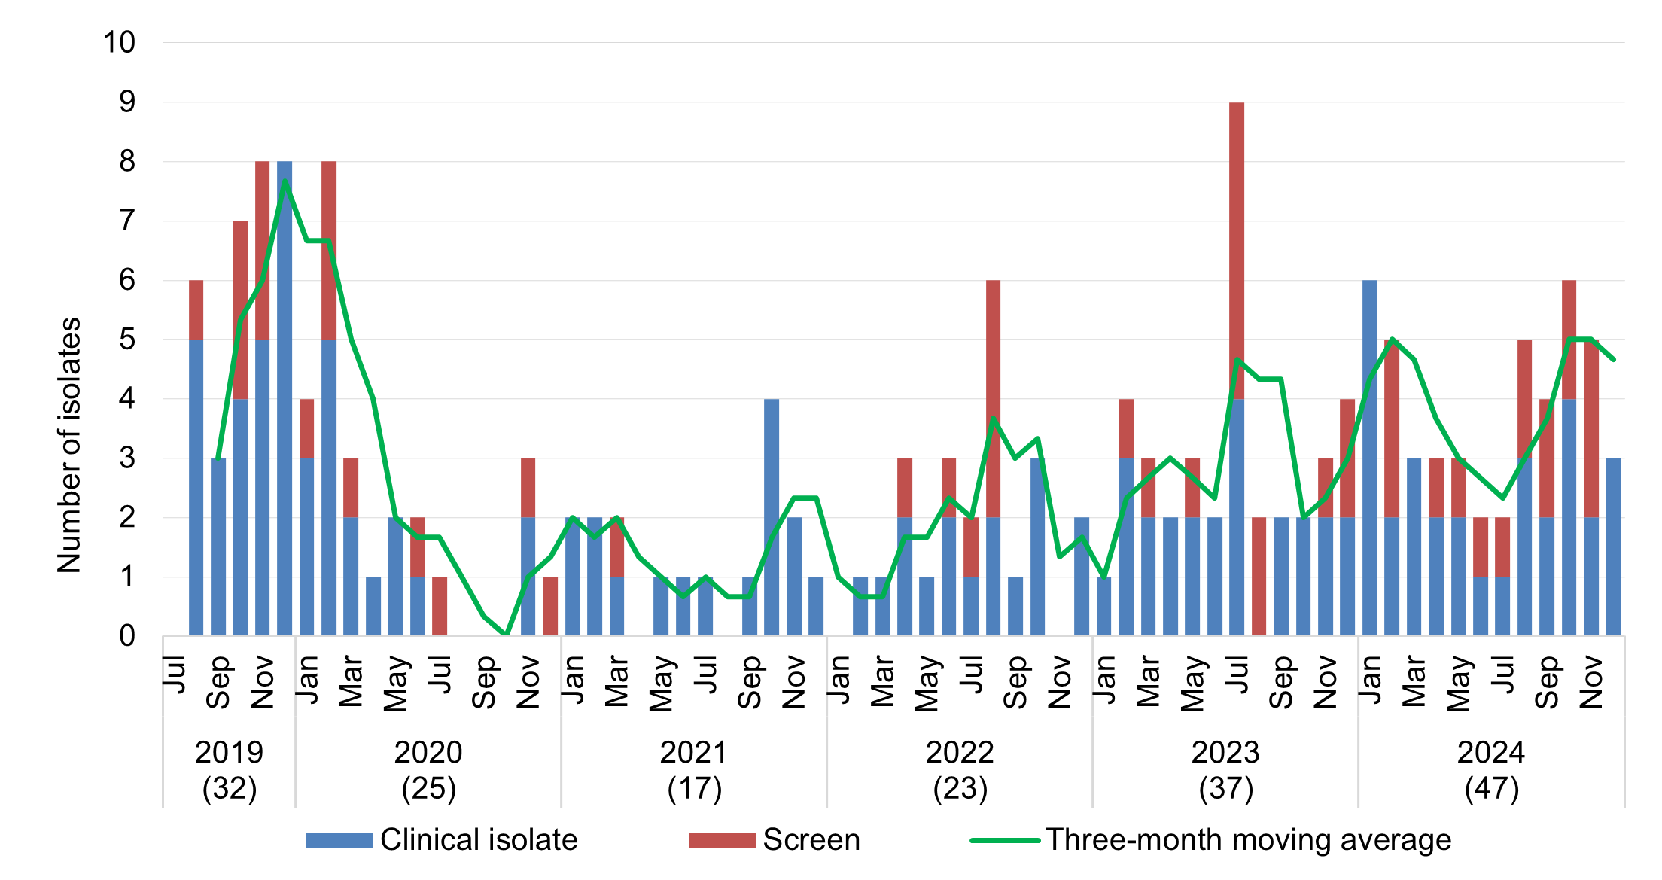

Note: Reported from July 2019.

Figure 4: Carbapenemase-producing *Acinetobacter baumannii* complex, number reported to CARAlert by carbapenemase type and specimen type, state and territory, 2024

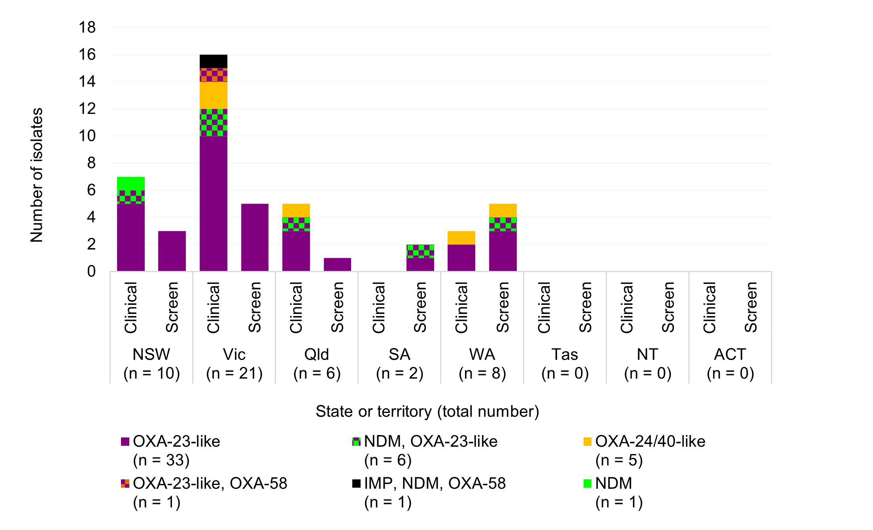

Table 3: Carbapenemase-producing *Acinetobacter baumannii* complex, number reported to CARAlert by setting, state and territory, 2024

|  |  |  |  |  |  |  |  |  |  |
| --- | --- | --- | --- | --- | --- | --- | --- | --- | --- |
|  | State or territory | | | | | | | |  |
| **Setting** | **NSW** | **Vic** | **Qld** | **SA** | **WA** | **Tas** | **NT** | **ACT** | **Total** |
| **Total** | **10** | **21** | **6** | **2** | **8** | **0** | **0** | **0** | **47** |
| Public hospital | 9 | 19 | 5 | 2 | 6 | 0 | 0 | 0 | 41 |
| Private hospital | 0 | 0 | 0 | 0 | 2 | 0 | 0 | 0 | 2 |
| Aged care home | 0 | 0 | 0 | 0 | 0 | 0 | 0 | 0 | 0 |
| Community | 0 | 1 | 0 | 0 | 0 | 0 | 0 | 0 | 1 |
| Unknown | 1 | 1 | 1 | 0 | 0 | 0 | 0 | 0 | 3 |

### *Candida auris*

*C. auris* is an emerging MDR *Candida* species that has been associated with international outbreaks of invasive infections in healthcare facilities. Reporting to CARAlert for *C. auris* began in July 2019.

The number of reports of *C. auris* in 2024were similar to 2023 (*n* = 16 versus *n* = 17) (Figure 5).

*C. auris* reported in 2024 were from all states and territories except Tasmania and the NT: five reports each from Victoria and WA, two reports each from NSW and Queensland, and one report each from SA and the ACT (Figure 6).

Figure 5: *Candida auris,* number reported to CARAlert by month, national, 2019–2024

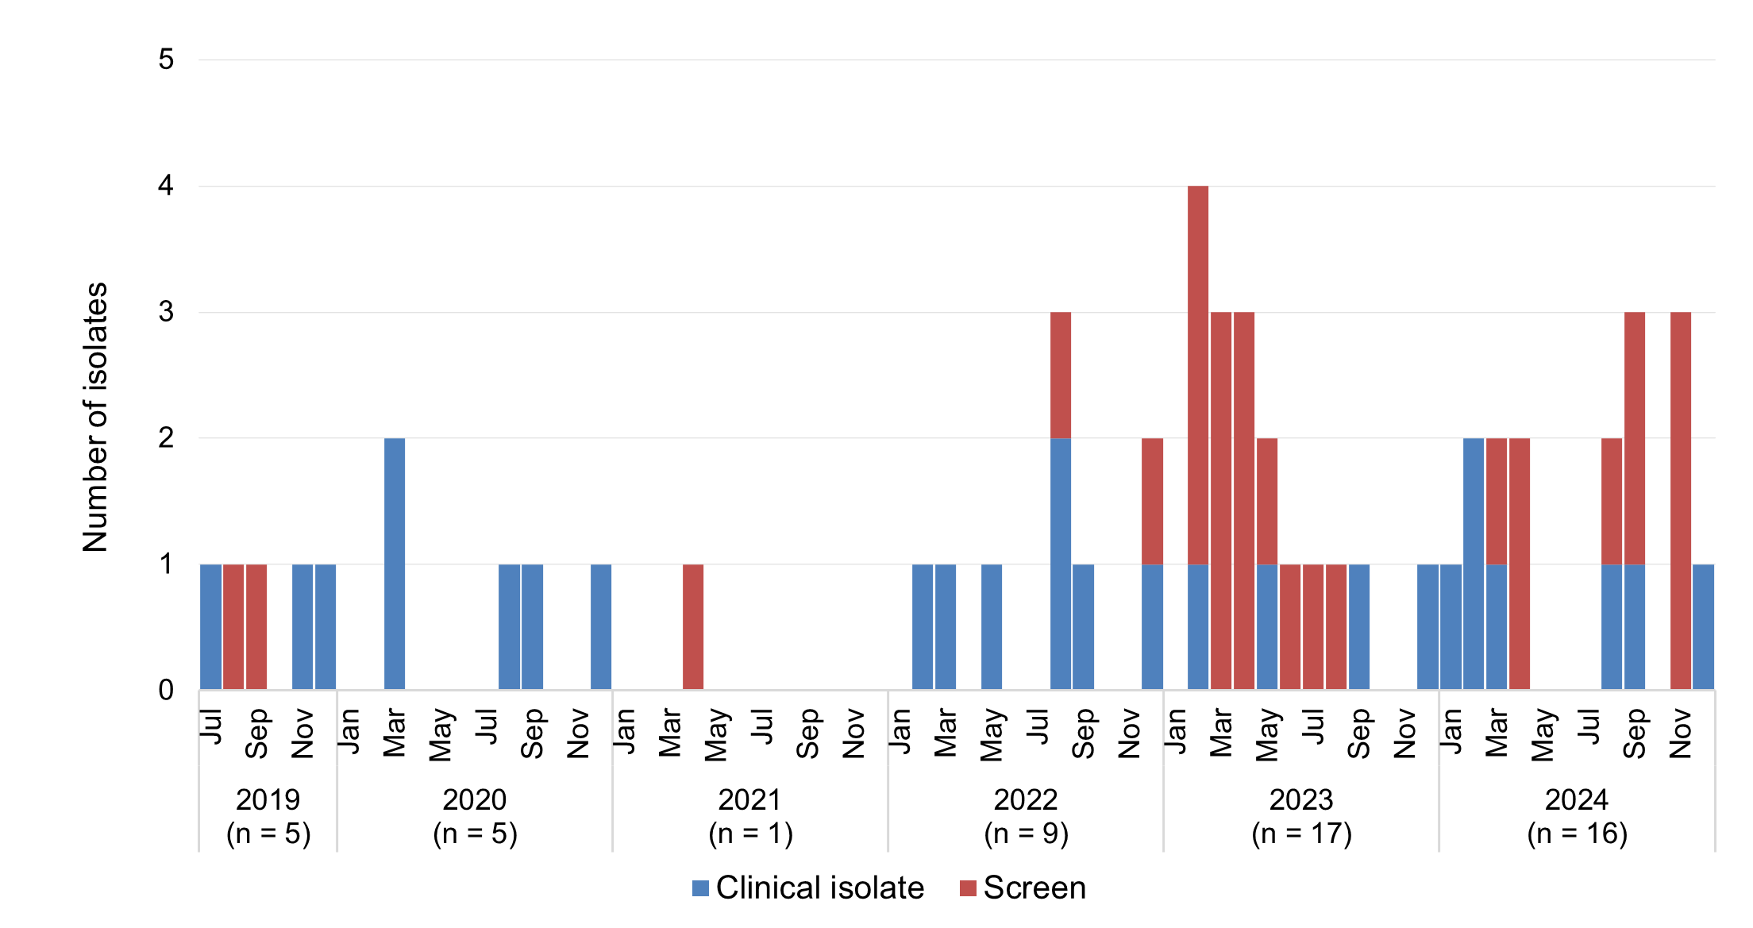

Note: Reported from July 2019.

Figure 6: *Candida auris*, numberreported to CARAlert by state and territory, 2019–2024

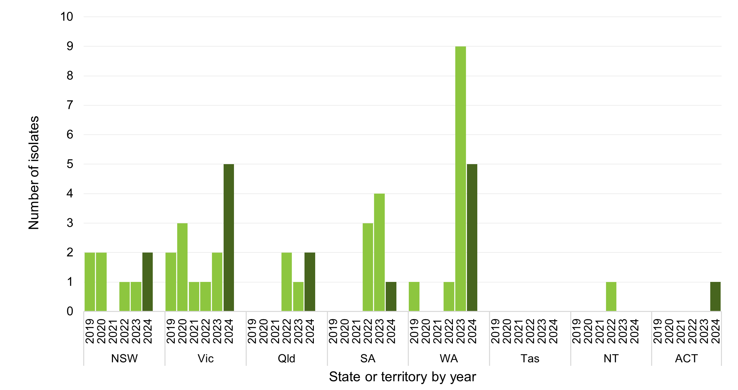

Notes:

1. Reported from July 2019.
2. Dark bars indicate values for 2024.

### *Enterobacterales*

Infections of the urinary tract, biliary tract, intra-abdomen, and bloodstream are commonly associated with *Enterobacterales*. Following a gradual decline from 2019 to 2021, there was an increase in the number of reports of carbapenemase- and/or ribosomal methyltransferase-producing *Enterobacterales* in 2022, which continued into 2024 (Figures 7 and 8).

There were 1,527 overall reports of CPE in 2024, an increase of 26.8% compared to 2023 (*n* = 1,204); there were 600 reports in 2021. Carbapenemases were found in 29 species (12 genera) of *Enterobacterales*, with eight carbapenemase types reported (Figure 9). Three carbapenemase types – NDM (603/1,527, 39.5%), IMP (583/1,527, 38.2%), and OXA-48-like (204/1,527, 13.4%) – when produced alone, accounted for 91.0% (1,390/1,527) of all *Enterobacterales* with a confirmed carbapenemase.

IMP types alone accounted for 38.2% (583/1,527) of all carbapenemases; they were found in 22 different species (Figure 9). Enterobacter cloacae complex isolates accounted for 50.4% (294/583) of all IMP types and 19.3% (294/1,527) of all CPE. NDM types were found mainly in *Escherichia* coli (360/603, 59.7%), as were OXA-48-like types (122/204, 59.8%).

Monthly trends for the top five carbapenemase types (IMP, NDM, OXA-48-like, NDM-OXA-48-like, and KPC) reported over seven years are shown in Figure 10 (national).

All states and territories, except the ACT, reported an increase in the number of reports in 2024, most notably Queensland (*n* = 290 versus *n* = 192, up 51.0%) and Tasmania (*n* = 12, from 10 patients; *n* = 3 in 2023) (Figure 11). Three-year trends by state and territory are shown in Figure 12.

The number of IMP types (alone or co-produced with other types) reported in 2024 (*n*= 599), increased by 26.9% compared to 2023 (*n* = 472). IMP-types accounted for two-thirds of all CPE reported from Queensland (190/290, 65.5%) and just over one-half from NSW (315/595, 52.9%), and 40.8% (29/71) from WA. In Victoria, only 13.2% (62/468) of all CPE were IMP-types. There were no IMP-types reported from SA, Tasmania or the NT. Nearly all isolates that have been genetically sequenced (244/599, 40.7%) were blaIMP‑4 (*n* = 242); other genes reported were blaIMP‑26 (*n* = 1) and blaIMP‑27 (*n* = 1).

The number of NDM types reported in 2024 (alone or co-produced with other types) continued to increase (*n* = 675 in 2024; *n* = 504 in 2023, up 33.9%). NDM types, either alone or in combination, were found in all states and territories. In SA, NDM types accounted for just over three-quarters (54/71, 76.1%) of all CPE reported, up from 65.4% (34/52) in 2023. Similarly, in Victoria, NDM types accounted for 63.2% (296/468) of all CPE reported, up from 56.7% (202/256) in 2023. Five different genes were found in the isolates sequenced (450/675, 66.7%): blaNDM-5 (263/450; 58.4%), blaNDM-1(145/450; 32.2%), blaNDM-7(29/450; 6.4%), blaNDM‑4(11/450; 2.4%), and *bla*NDM-6 (*n* = 2).

In 2024, the number of reports of OXA-48-like CPE (alone or co-produced) nationally decreased slightly (*n* = 255) compared with 2023 (*n* = 270). However, there was an increase in the number of reports from Queensland (*n* = 25 in 2024; *n* = 16 in 2023, up 56.3%) and WA (*n* = 15 in 2024; *n* = 11 in 2023, up 36.4%). Among isolates that were sequenced (175/255, 68.6%); the most common genes were *bla*OXA-181-like (93/175, 53.1%; *bla*OXA-181 [*n* = 68], *bla*OXA-232 [*n* = 17], *bla*OXA-484 [*n* = 8]), or *bla*OXA-48-like (72/175, 41.1%; *bla*OXA-48 [*n* = 47], *bla*OXA-244 [*n* = 25]).

Reports of KPC-producing *Enterobacterales* increased in 2024 compared to 2023 (*n* = 41 in 2024; *n* = 27 in 2023, up 51.9%). KPC types were predominantly reported from Victoria (*n*= 23, up from *n* = 11 in 2023) and NSW (*n* = 13) mostly from different hospitals. Two other states reported cases (Queensland [3] and WA [2]). Two KPC variants were detected from the 32 isolates that were sequenced: *bla*KPC-2 (*n*= 24) and blaKPC-3 (*n*= 8).

Other carbapenemase types reported were IMI (*n* = 13), OXA-23-like (*n* = 12), VIM (*n* = 5) and SME (*n* = 1).

Co-production of carbapenemase decreased to 4.8% in 2024 (74/1,527), down from 7.2% in 2023 (87/1,204). The majority of co-produced genes in 2024 were NDM+OXA-48-like (*n* = 50, down from *n* = 67 in 2023), IMP+NDM (*n* = 15, up from *n* = 9 in 2023), and NDM+KPC (*n* = 5).

In 2024, there was variation in the proportion of isolates reported from clinical and screening specimens by state and territory (Figure 13). This may be due to differences in local infection prevention and control policies or in response to local outbreaks. Relatively fewer reports from screening specimens were identified in Victoria.

There were notable regional differences in the distribution of the top five carbapenemases by specimen type (Figure 14) and by setting (Table 4).

The CPE crude rate (clinical isolates) per 100,000 population increased to 3.0 nationally. The highest rate was in Victoria (4.8, up from 3.9 in 2023) (Figure 15).

The clinical impact of each of the CPE types, and the potential impact of co-infection, are not well understood.9 This aspect of the data provided by CARAlert will be monitored.

Since 2016, 313 hospitals have reported at least one CPE. CPE were reported from 164 hospitals during 2024. Of these hospitals 14.0% (23/164) did not report a CPE during the period 2016 to 2023. Of the hospitals that reported CPE prior to 2024, 149 did not have any reports in 2024.

In 2024, ribosomal methyltransferases were detected in 119 isolates of *Enterobacterales*, representing 10 species; 89.9% (107/119) of these also had a carbapenemase. The ribosomal methyltransferases were mostly found among *Klebsiella pneumoniae* complex (61/119, 51.3%) and E. coli (46/119, 38.7%). Four ribosomal methyltransferase genes were found in the isolates sequenced: rmtB (76/119, 63.9%), armA (17/119, 14.3%), *rmtF* (13/119, 10.9%), rmtC (*n*= 5), *rmtB*+*rmtF* (*n*= 6), and *armA*+*rmtB* (*n*= 2).

Transmissible resistance to colistin refers to the presence of mcr genes other than mcr‑9. This variant is not associated with a colistin-resistant phenotype but is typically found on HI2 plasmids which may carry blaIMP-4.10 Two *E. coli* isolates with *mcr-1.1* were reported from NSW and Victoria in 2024. Both isolates also harboured *bla*NDM gene. This CAR has been reported to CARAlert since July 2019.

#### National data

Figure 7: Carbapenemase-producing *Enterobacterales*, number reported to CARAlert by month and specimen type, national, 2017–2024

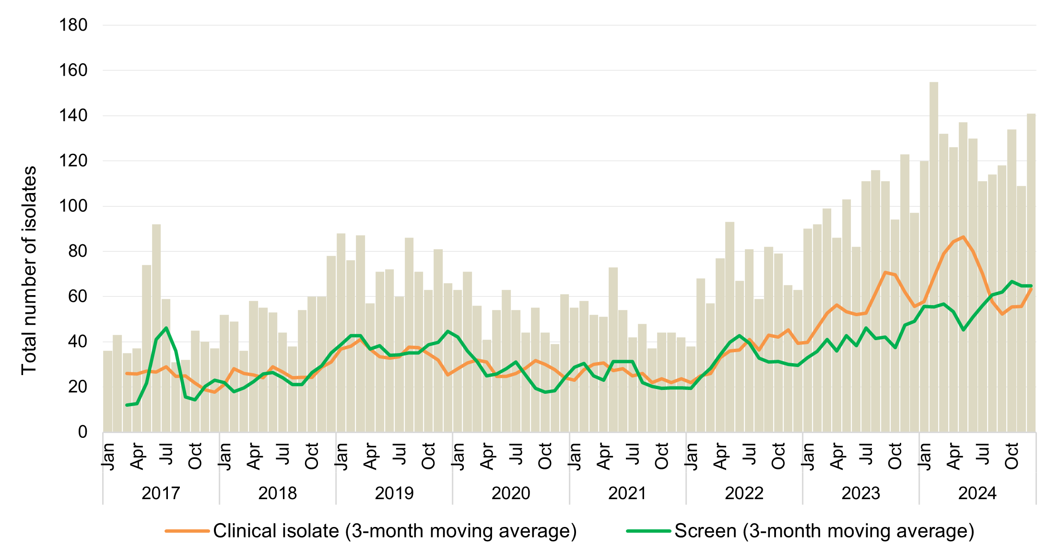

Note: Carbapenemase-producing *Enterobacterales*, includes those co-producing ribosomal methyltransferase and/or transmissible colistin resistance.

Figure 8: Ribosomal methyltransferase-producing *Enterobacterales*, number reported to CARAlert by month, national, 2017–2024

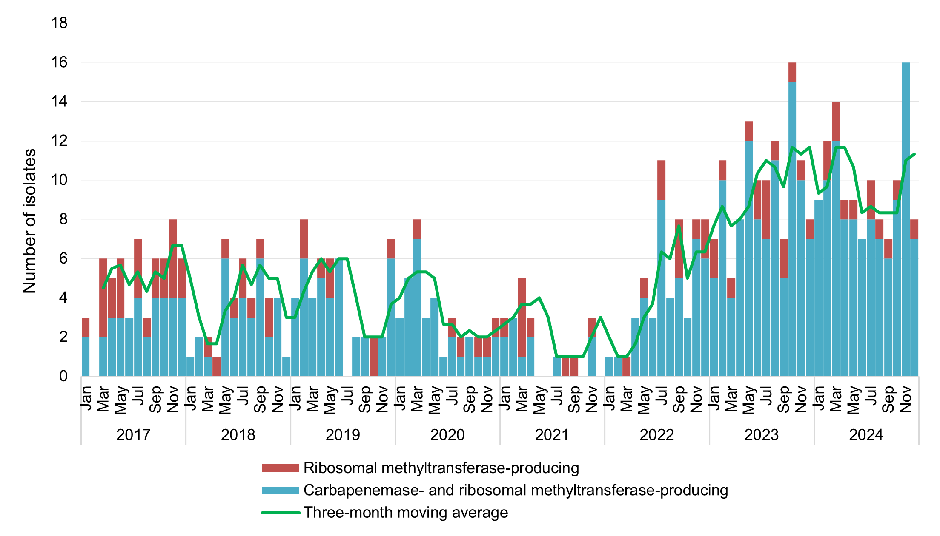

Note: Ribosomal methyltransferase-producing Enterobacterales, includes those that also produced carbapenemase.

**Figure 9:** Carbapenemase-producing *Enterobacterales*\*, number reported to CARAlert by species and carbapenemase type, national, 2024

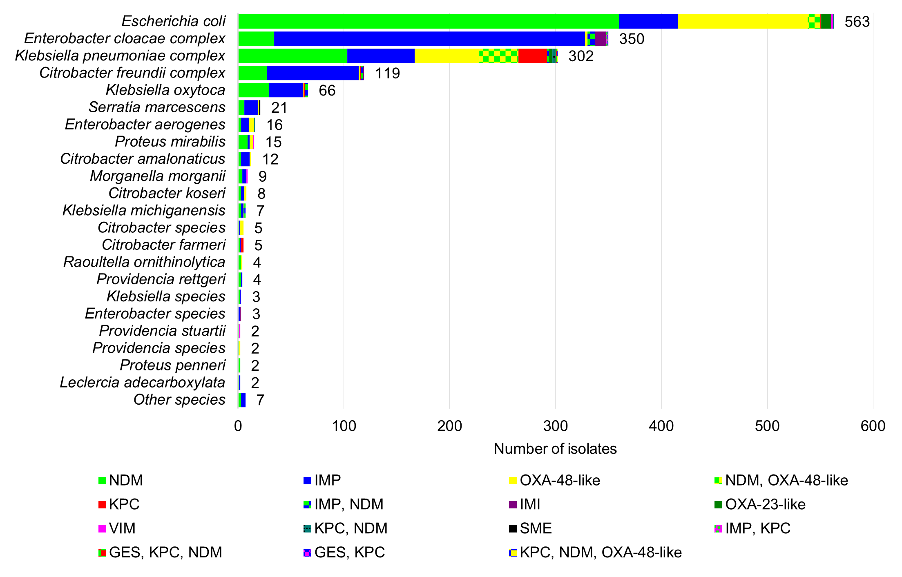

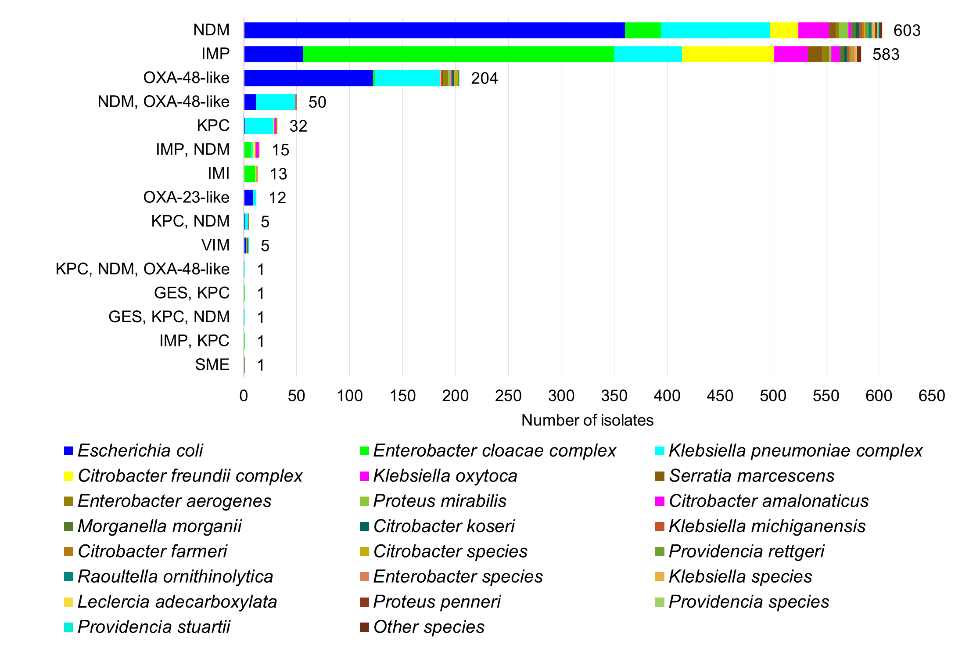

* Carbapenemase-producing (n = 1,418), carbapenemase- and ribosomal methyltransferase-producing (n = 107), carbapenemase-producing plus transmissible colistin resistance (n = 2)

Figure 10: Trend for the top five carbapenemase types* reported to CARAlert, by month, national, 2017–2024

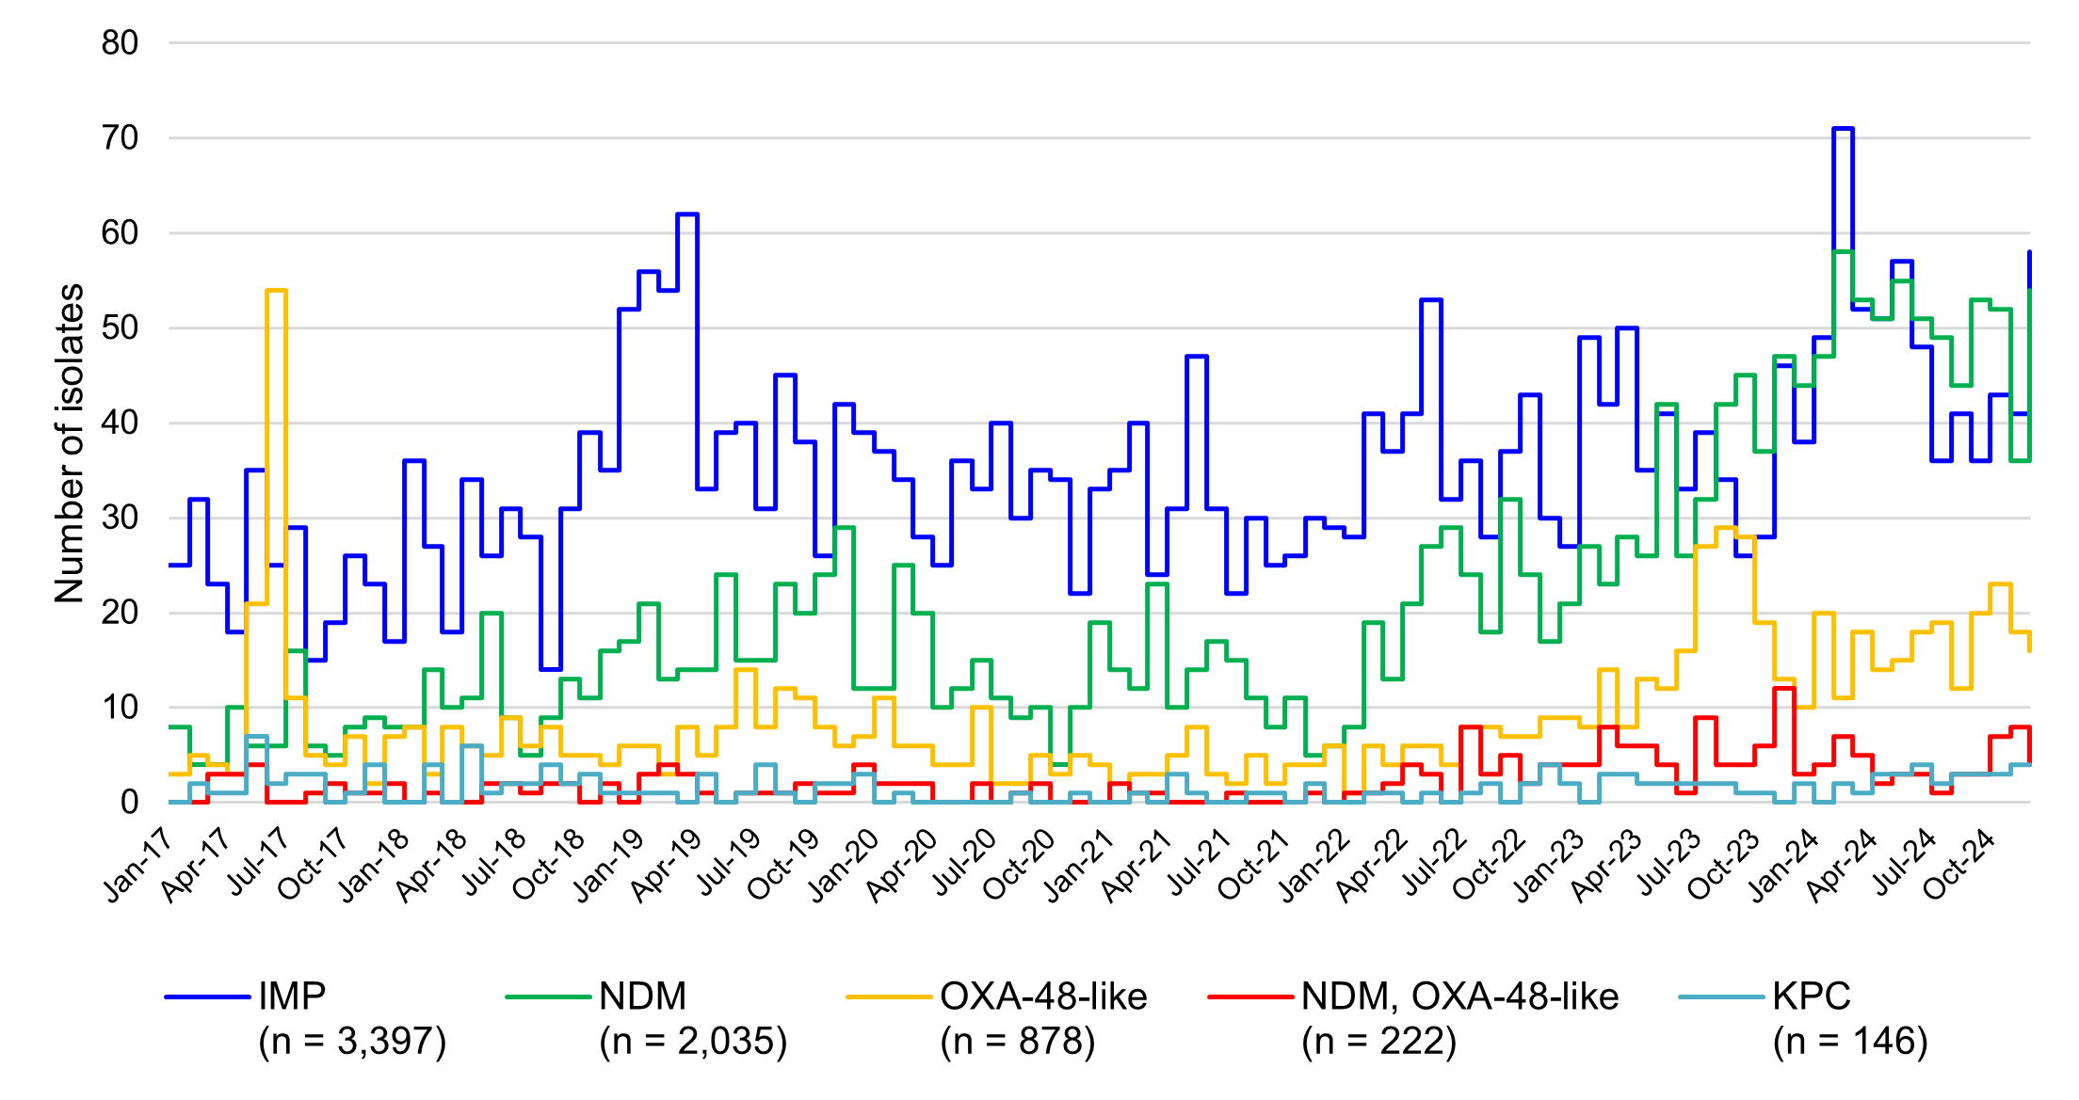

* Alone or in combination with another type for the reporting period indicated

#### State and territory data

Figure 11: Carbapenemase-producing *Enterobacterales,* number reported to CARAlert by state and territory, 2017–2024

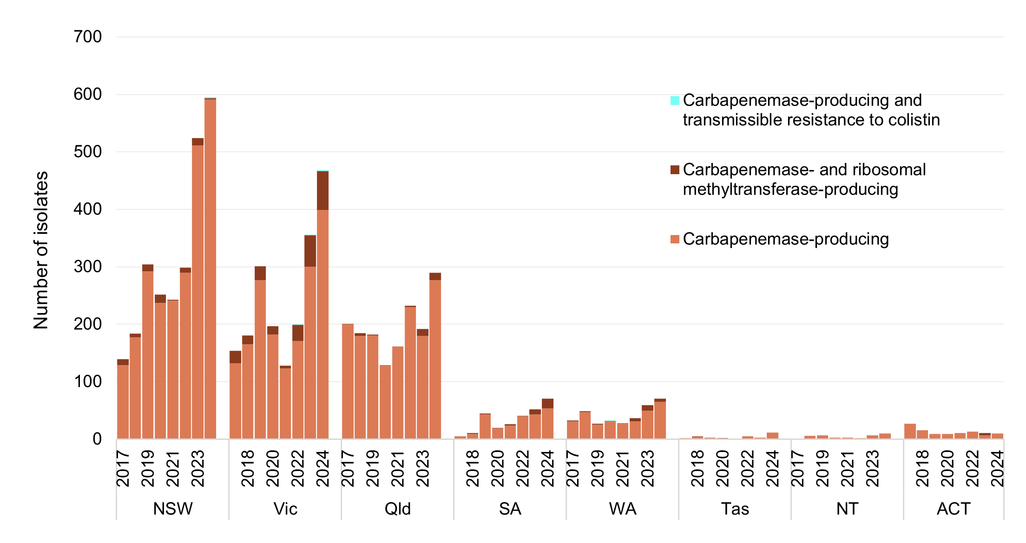

Note: Transmissible colistin resistance reported from July 2019.

**Figure 12:** Three-year trend for the top five carbapenemase types from *Enterobacterales* reported to CARAlert, by state and territory andnationally, (three-month moving average), 2022–2024

|  |  |  |  |  |  |  |  |  |  |
| --- | --- | --- | --- | --- | --- | --- | --- | --- | --- |
| **Type** | **NSW** | **Vic** | **Qld** | **SA** | **WA** | **Tas** | **NT** | **ACT** | **Australia** |
| IMP |  |  |  |  |  |  |  |  |  |
| NDM |  |  |  |  |  |  |  |  |  |
| OXA-48-like |  |  |  |  |  |  |  |  |  |
| NDM+OXA-48-like |  |  |  |  |  |  |  |  |  |
| KPC |  |  |  |  |  |  |  |  |  |
| All types |  |  |  |  |  |  |  |  |  |

Straight green line in cell = no carbapenemase type for that state or territory during the reporting period;   
Blank cell = maximum three-month average was one or less

Note: Line graphs represent three-month moving average for the period 1 January 2022 to 31 December 2024, for each type (reported alone or in combination with another type), where maximum monthly average was greater than one.

Figure 13: Carbapenemase-producing *Enterobacterales*\*, number reported to CARAlert by carbapenemase type and specimen type, by state and territory, 2024

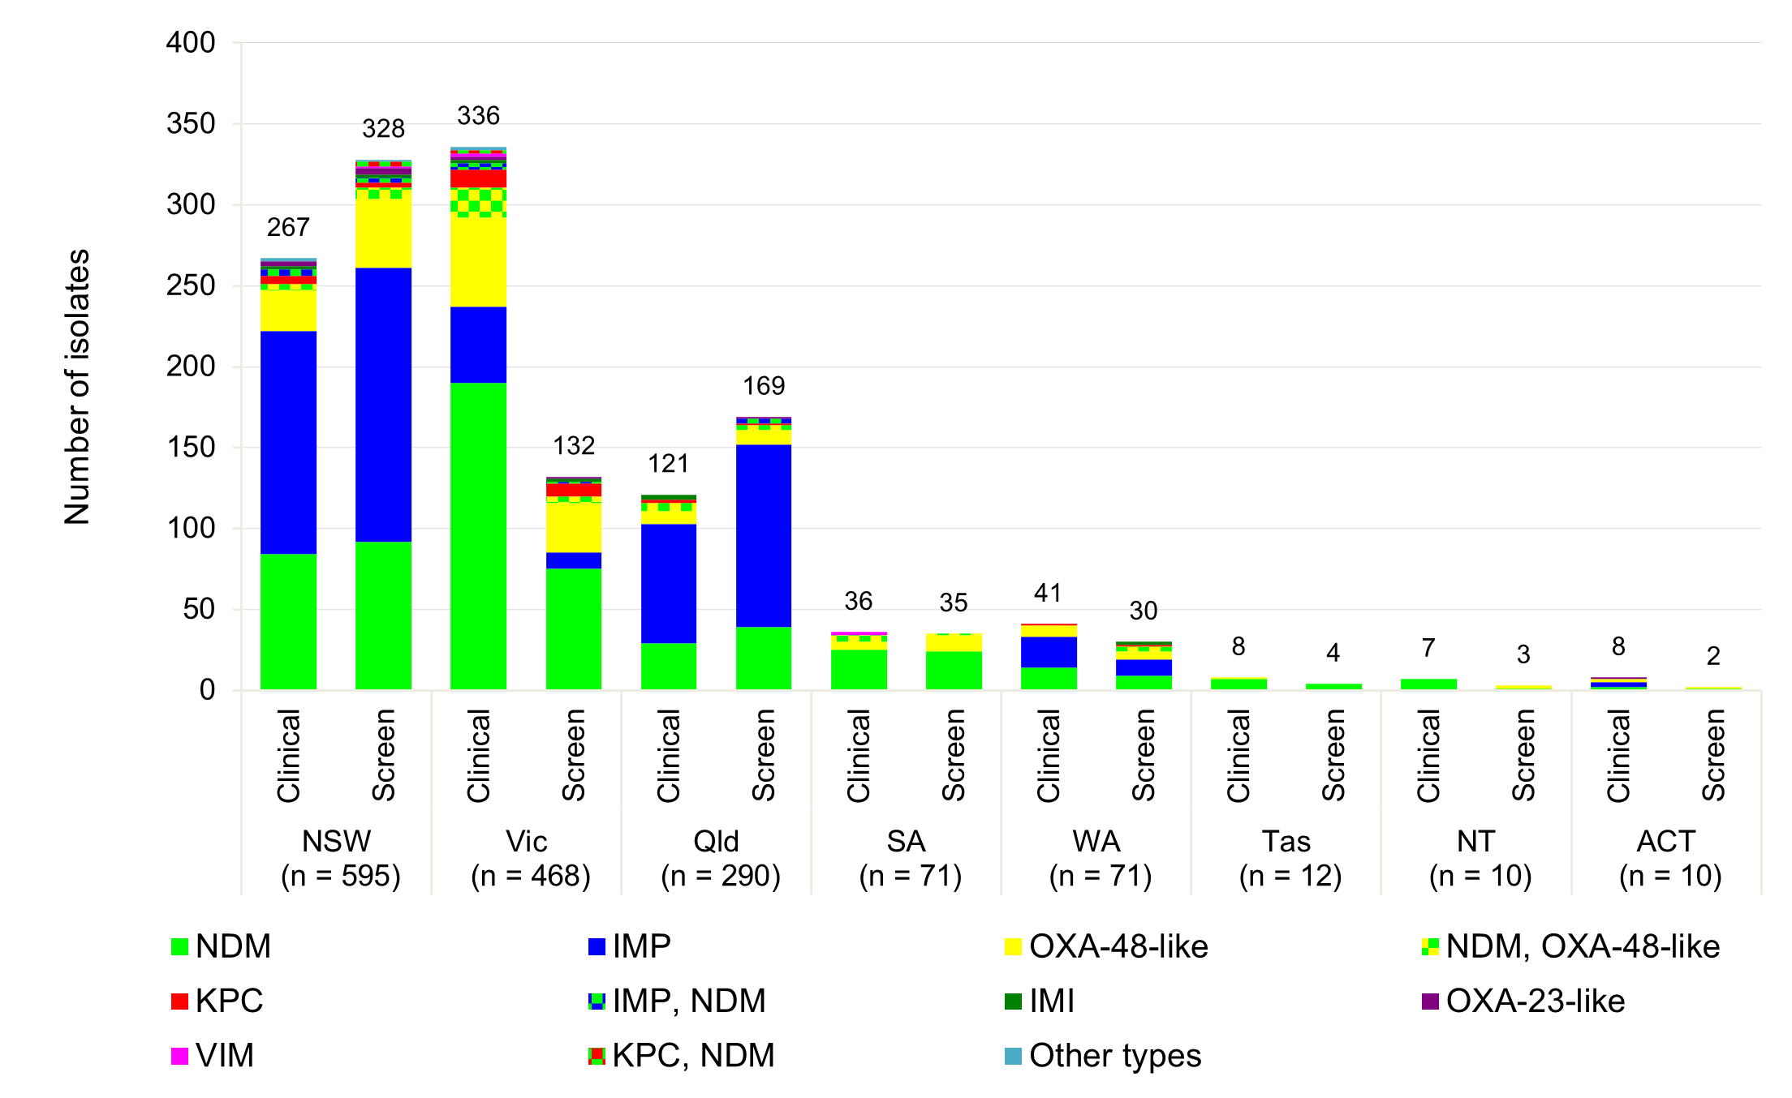

* Carbapenemase-producing (n = 1,418), carbapenemase- and ribosomal methyltransferase-producing (n = 107), carbapenemase-producing plus transmissible colistin resistance (n = 2); Other types: SME (NSW [1]); KPC, IMP (NSW [1]; KPC, GES (Vic [1]); KPC, NDM, GES (Vic [1]); KPC, NDM, OXA‑48-like (NSW [1])

**Figure 14**: Top five carbapenemase-producing *Enterobacterales* types reported to CARAlert, by state and territory, 2017–2024

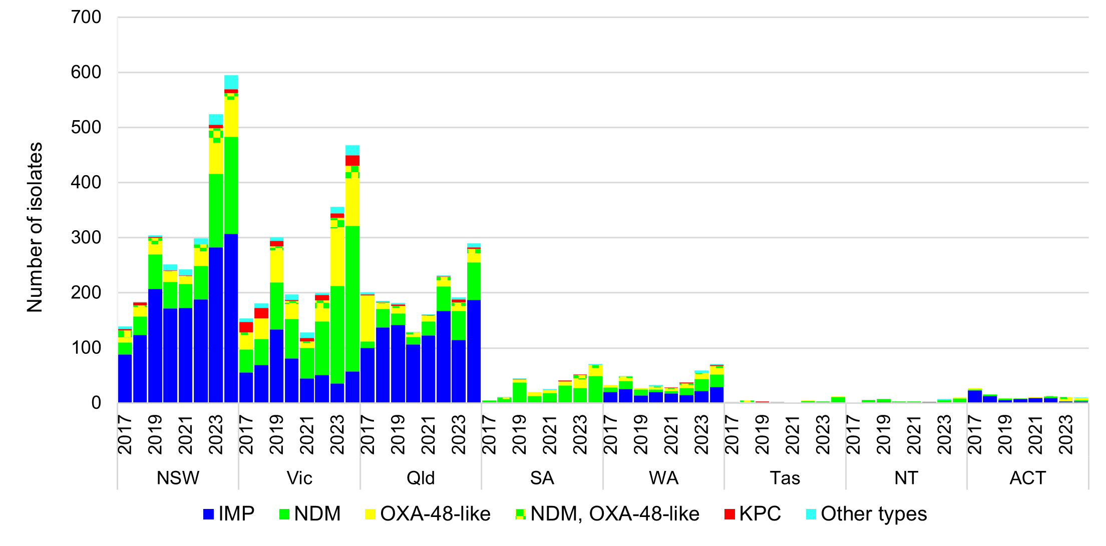

**Figure 15:** Carbapenemase-producing *Enterobacterales* reported to CARAlert, by specimen type and by state and territory, 2017–2024

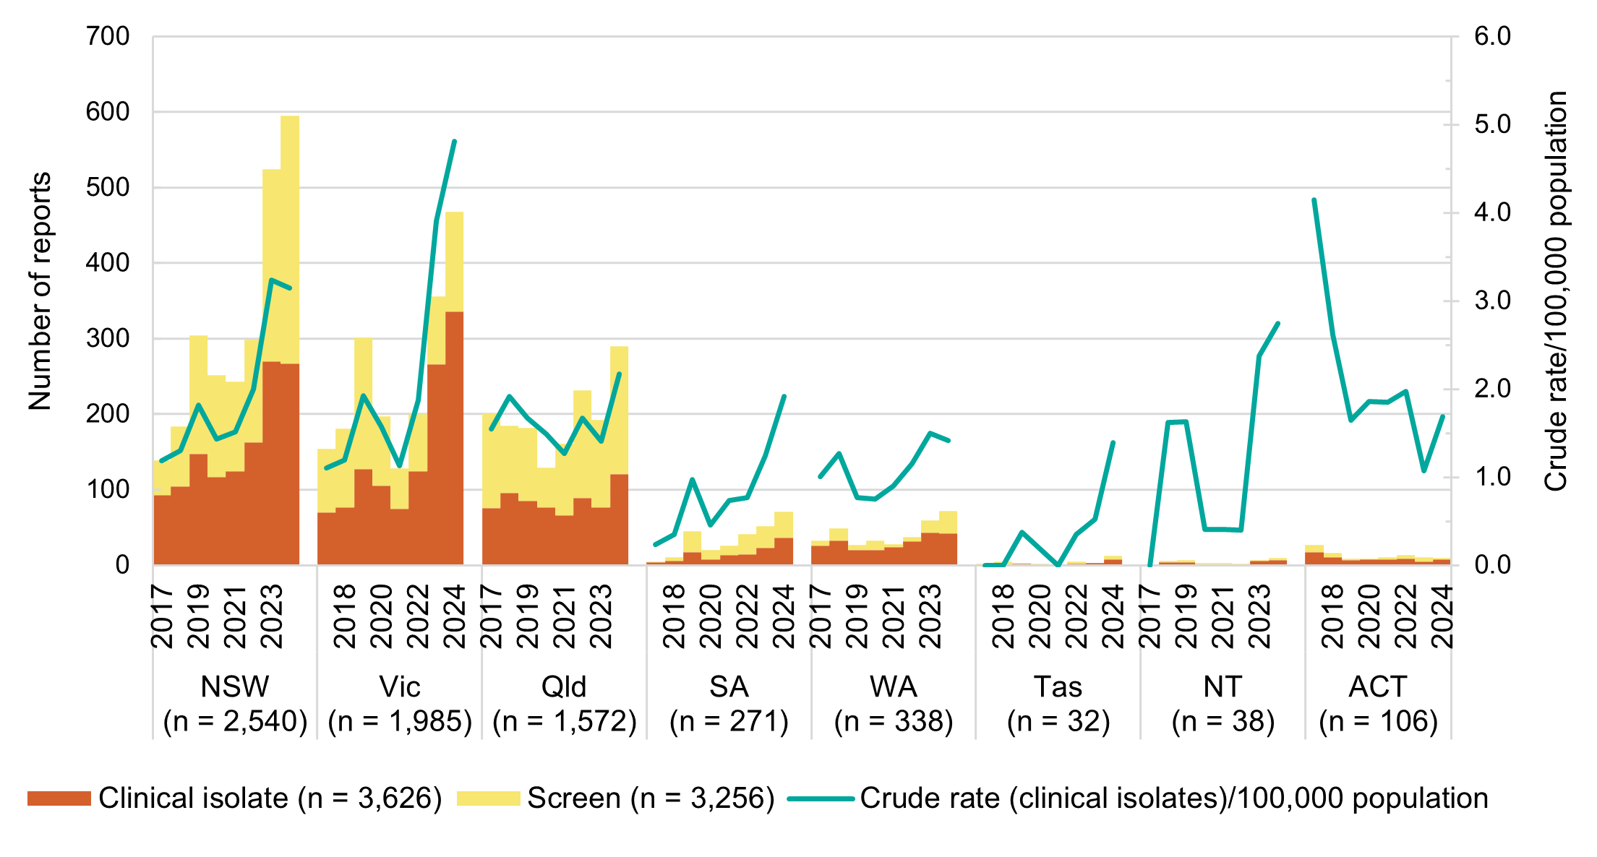

Note: Crude rate based on mid-year population for each State and Territory (available at [National, state and territory population | Australian Bureau of Statistics](https://www.abs.gov.au/statistics/people/population/national-state-and-territory-population))

Table 4: Top five carbapenemase types from *Enterobacterales*\*, number reported to CARAlert by setting, state and territory, 2024

|  |  |  |  |  |  |  |  |  |  |  |
| --- | --- | --- | --- | --- | --- | --- | --- | --- | --- | --- |
| Carbapenemase type† |  | State or territory | | | | | | | |  |
| **Setting** | **NSW** | **Vic** | **Qld** | **SA** | **WA** | **Tas** | **NT** | **ACT** | **Total** |
| NDM | **Total** | **176** | **265** | **68** | **49** | **23** | **11** | **8** | **3** | **603** |
| Public hospital | 137 | 158 | 54 | 35 | 11 | 5 | 5 | 1 | 406 |
| Private hospital | 3 | 9 | 5 | 0 | 2 | 0 | 0 | 0 | 19 |
| Aged care home | 0 | 1 | 0 | 0 | 0 | 2 | 0 | 0 | 3 |
| Community | 22 | 88 | 9 | 13 | 10 | 4 | 3 | 1 | 150 |
| Unknown | 14 | 9 | 0 | 1 | 0 | 0 | 0 | 1 | 25 |
| IMP | **Total** | **307** | **57** | **187** | **0** | **29** | **0** | **0** | **3** | **583** |
| Public hospital | 266 | 42 | 136 | 0 | 18 | 0 | 0 | 3 | 465 |
| Private hospital | 2 | 3 | 43 | 0 | 7 | 0 | 0 | 0 | 55 |
| Aged care home | 3 | 0 | 1 | 0 | 0 | 0 | 0 | 0 | 4 |
| Community | 20 | 12 | 6 | 0 | 4 | 0 | 0 | 0 | 42 |
| Unknown | 16 | 0 | 1 | 0 | 0 | 0 | 0 | 0 | 17 |
| OXA-48-like | **Total** | **68** | **86** | **17** | **15** | **12** | **1** | **2** | **3** | **204** |
| Public hospital | 61 | 66 | 13 | 13 | 6 | 1 | 1 | 1 | 162 |
| Private hospital | 1 | 2 | 1 | 0 | 2 | 0 | 0 | 0 | 6 |
| Aged care home | 0 | 0 | 0 | 0 | 0 | 0 | 0 | 0 | 0 |
| Community | 1 | 18 | 1 | 2 | 4 | 0 | 1 | 1 | 28 |
| Unknown | 5 | 0 | 2 | 0 | 0 | 0 | 0 | 1 | 8 |
| NDM, OXA-48-like | **Total** | **11** | **23** | **8** | **5** | **3** | **0** | **0** | **0** | **50** |
| Public hospital | 8 | 12 | 3 | 3 | 3 | 0 | 0 | 0 | 29 |
| Private hospital | 0 | 0 | 1 | 0 | 0 | 0 | 0 | 0 | 1 |
| Aged care home | 0 | 1 | 0 | 0 | 0 | 0 | 0 | 0 | 1 |
| Community | 2 | 10 | 4 | 1 | 0 | 0 | 0 | 0 | 17 |
| Unknown | 1 | 0 | 0 | 1 | 0 | 0 | 0 | 0 | 2 |
| KPC | **Total** | **8** | **19** | **3** | **0** | **2** | **0** | **0** | **0** | **32** |
| Public hospital | 5 | 15 | 3 | 0 | 1 | 0 | 0 | 0 | 24 |
| Private hospital | 1 | 0 | 0 | 0 | 0 | 0 | 0 | 0 | 1 |
| Aged care home | 0 | 0 | 0 | 0 | 0 | 0 | 0 | 0 | 0 |
| Community | 1 | 4 | 0 | 0 | 1 | 0 | 0 | 0 | 6 |
| Unknown | 1 | 0 | 0 | 0 | 0 | 0 | 0 | 0 | 1 |

* The top five carbapenemase types account for 96.1% (1,472/1,527) of all CPE reported for this period. Other types were IMP+NDM (n = 15: NSW, Victoria, Queensland); IMI (n = 13: NSW, Victoria, Queensland, WA); OXA-23-like (n = 12: NSW, Victoria, Queensland, ACT); VIM (n = 5: NSW, Victoria, Queensland, SA); KPC+NDM (n = 5: NSW, Victoria); SME (n = 1: NSW); KPC+IMP (n = 1: NSW); KPC+NDM+GES (n = 1: Victoria); KPC+GES (n = 1: Victoria); and KPC+NDM+OXA-48-like (n = 1: NSW)

† Alone or coproduced with another type for the reporting period indicated

### *Enterococcus* species

*Enterococcus* species including *E. faecalis* and *E. faecium*, commonly cause urinary tract, biliary tract and other intra-abdominal infections, and bloodstream infections. In 2024, reports of linezolid-resistant *Enterococcus* species(*n*= 118)increased 2.3-fold compared to 2023 (*n*= 51) (Figure 16).

Linezolid-resistant *Enterococccus* species were reported from all states and territories except Tasmania and the NT in 2024 (Figure 17). Variation in the number of reports from the states and territories may be due to differences in testing and reporting practices by the originating laboratories. Some laboratories may only test linezolid on *Enterococcus* species if other resistances are detected. Notwithstanding that variation, there is a clear upswing in numbers in 2023 and 2024 compared to previous years (Figure 16), mostly from Victoria and Queensland (Figure 17).

In 2024, almost all linezolid-resistant *E. faecalis* (36/37, 97.3%) and a little over one-half of linezolid-resistant *E. faecium* (39/81, 60.5%) harboured *optrA* genes. A vast majority of linezolid-resistant enterococci from Victoria harboured *optrA* genes (67/72, 93.1%); while those from Queensland harboured *poxtA* and *cfr*(D) genes (19/24, 79.2%).

Figure 16: Linezolid-resistant *Enterococcus* species, number reported to CARAlert by month, national, 2017–2024

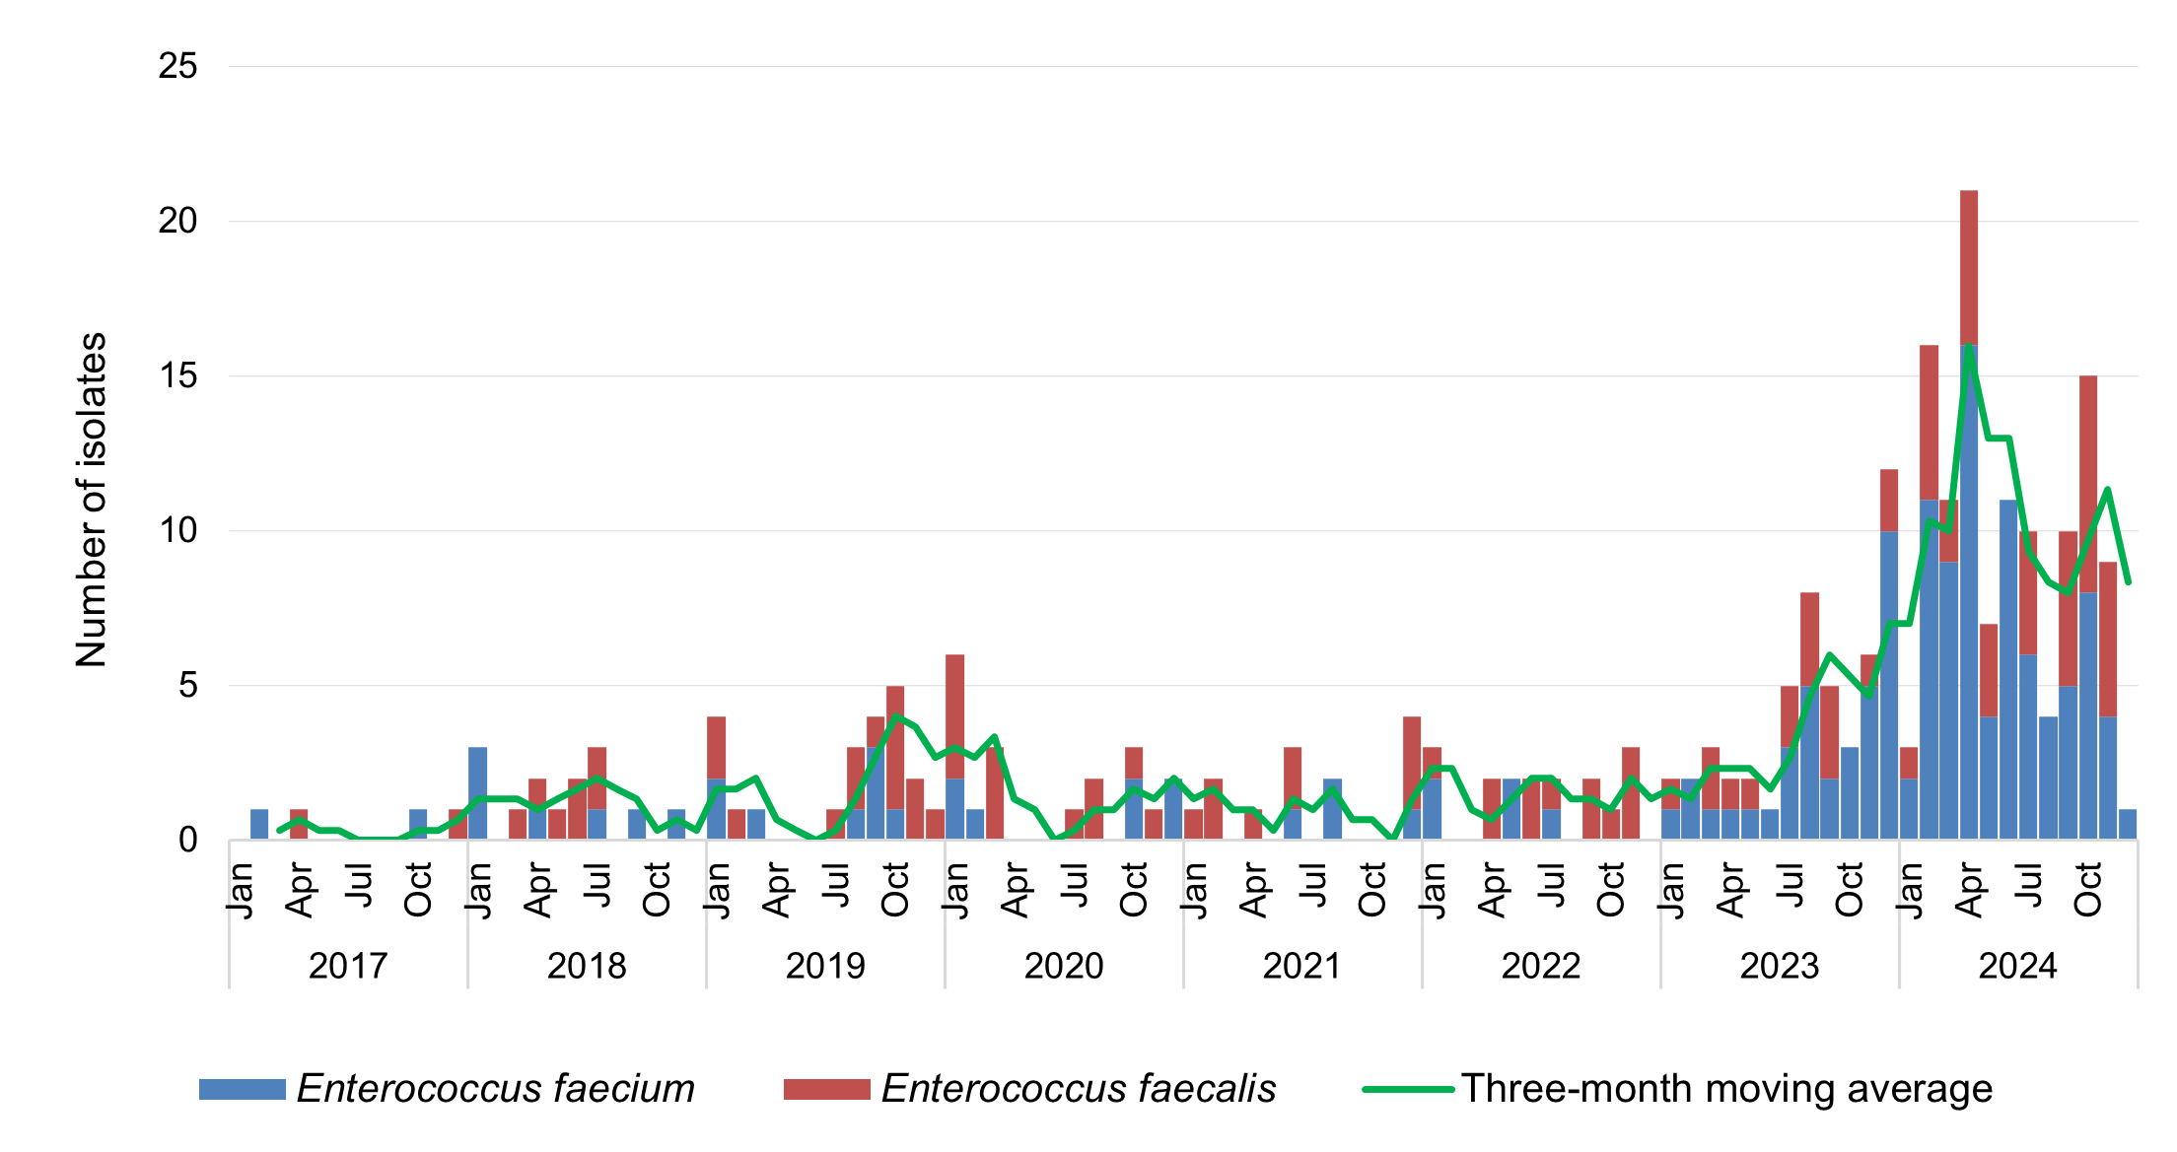

Figure 17: Linezolid-resistant *Enterococcus* species, number reported to CARAlert by state and territory, 2017–2024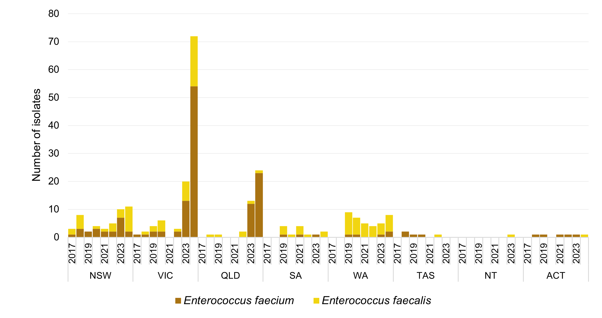

### *Mycobacterium tuberculosis*

*Mycobacterium tuberculosis* causes tuberculosis, which has a variety of clinical manifestations, but most commonly presents as lung disease. Low numbers of MDR *M. tuberculosis* were reported to CARAlert from 2017 to 2024 (Figure 18). In 2024, the majority of the MDR *M. tuberculosis* reports were from Victoria (7/16, 43.8%) and Queensland (6/16, 37.5%) (Figure 19).

Figure 18: Multidrug-resistant *Mycobacterium tuberculosis,* number reported to CARAlert by month, national, 2017–2024

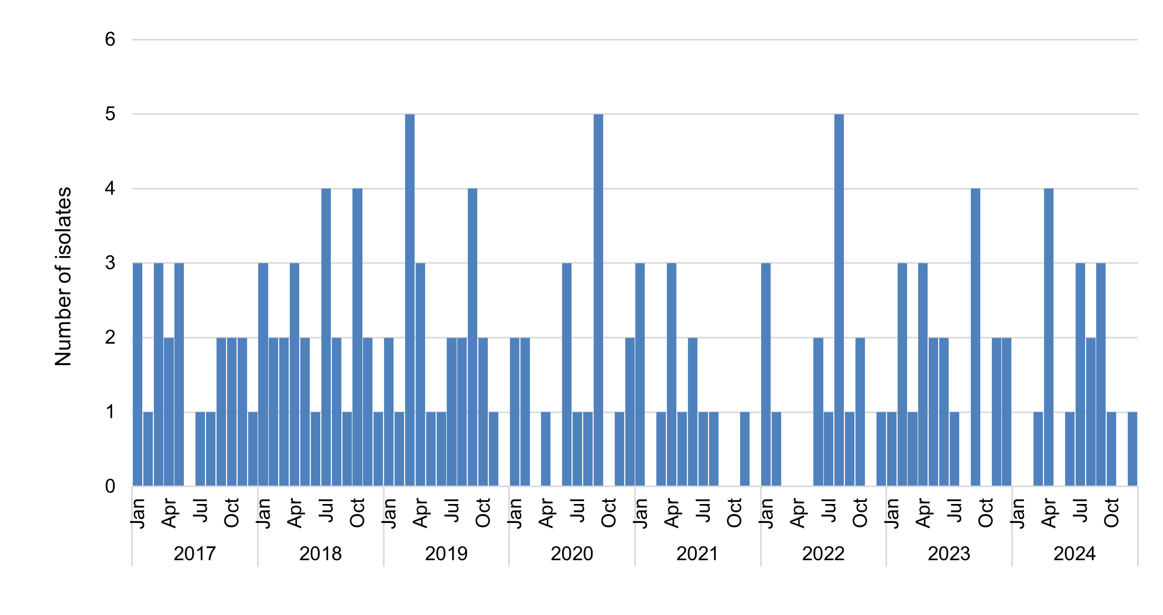

Figure 19: Multidrug-resistant *Mycobacterium tuberculosis*, numberreported to CARAlert by state and territory, 2017–2024

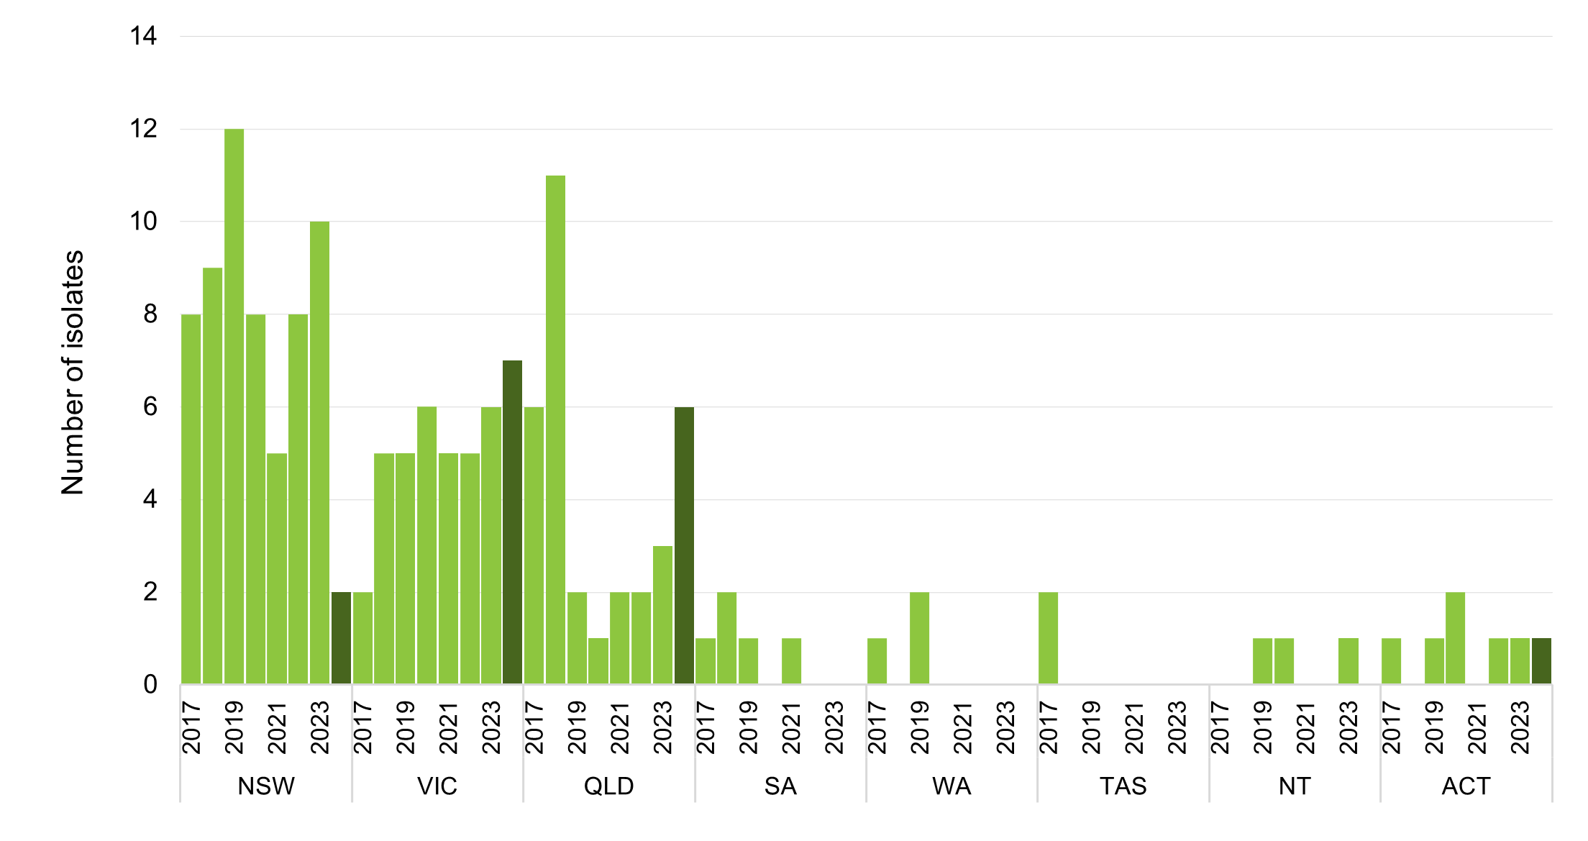

Note: Dark bars indicate values for 2024.

### *Neisseria gonorrhoeae*

*N. gonorrhoeae* causes gonorrhoea, a largely sexually transmitted infection that most commonly manifests as urethritis in men and cervicitis in women.

There were sporadic reports of ceftriaxone-nonsusceptible and/or azithromycin-nonsusceptible (HLR) *N. gonorrhoeae* between 2017 and 2021 (Figure 20). Ceftriaxone-nonsusceptible isolates were reported to CARAlert for the first time in 2016 (*n* = 4); there were six reports in 2018, four reports in 2019, three in 2020, one in 2021.There was a sharp increase in the number of reports in 2022 (*n* = 37) and 2023 (*n* = 23). There were 39 reports made to CARAlert in 2024 from NSW (*n* = 23, up from 7 in 2023), WA (*n* = 6), Victoria (*n* = 3), SA (*n* = 3), Queensland (*n* = 2), and Tasmania (*n* = 2). Of these reports, 11 were also azithromycin-nonsusceptible (HLR, *n* = 6; LLR, *n* = 5).

Thirty-six azithromycin-nonsusceptible N. gonorrhoeae (HLR), including those that were also ceftriaxone-nonsusceptible (*n* = 6), were reported in 2024; there were 27 reported in 2023.

Figure 20: Ceftriaxone-nonsusceptible and/or azithromycin-nonsusceptible *Neisseria gonorrhoeae,* number reported to CARAlert by month, national, 2017–2024

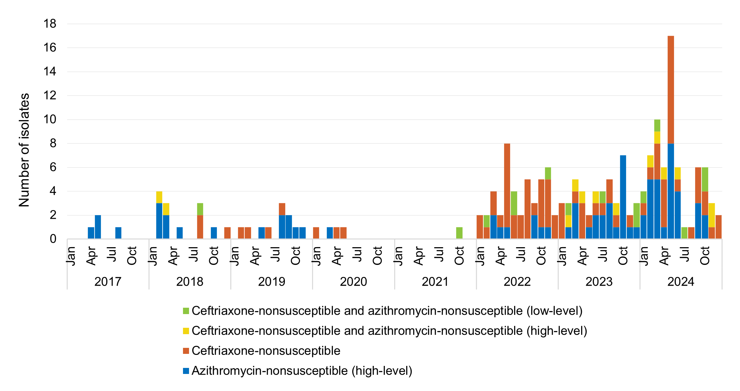

High-level = azithromycin MIC ≥ 256 mg/L; Low-level = azithromycin MIC < 256 mg/L; MIC = minimum inhibitory concentration

There was a 1.5-fold increase in the number of reports of azithromycin-nonsusceptible *N. gonorrhoeae* (LLR) in 2024 (*n* = 1,009) compared to 2023 (*n* = 669) (Figure 21). A substantial majority of these reports were from Victoria (793/1,009, 78.6%), where the number increased from 415 in 2023 to 793 in 2024 (Figure 22). Reports from NSW decreased (*n* = 157 in 2023; *n* = 92 in 2024).

Gentamicin-resistant *N. gonorrhoeae* was added to reporting from 2023. This CAR is yet to be reported to CARAlert.

**Figure 21:** Azithromycin-nonsusceptible *Neisseria gonorrhoeae* (low-level resistance), number reported to CARAlert by month, national, 2017–2024

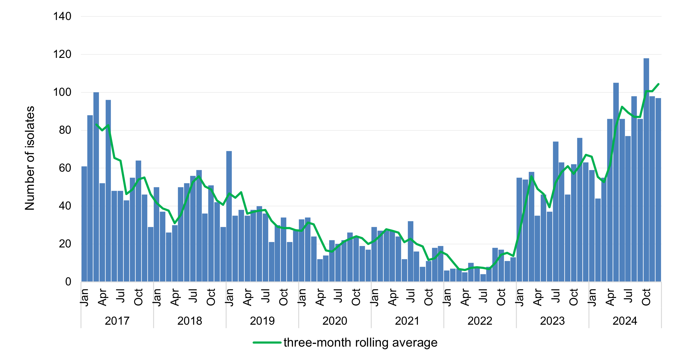

Low-level = azithromycin MIC < 256 mg/L; MIC = minimum inhibitory concentration

**Figure 22:** Azithromycin-nonsusceptible *Neisseria gonorrhoeae* (low-level resistance),number reported to CARAlert by state and territory, 2017–2024

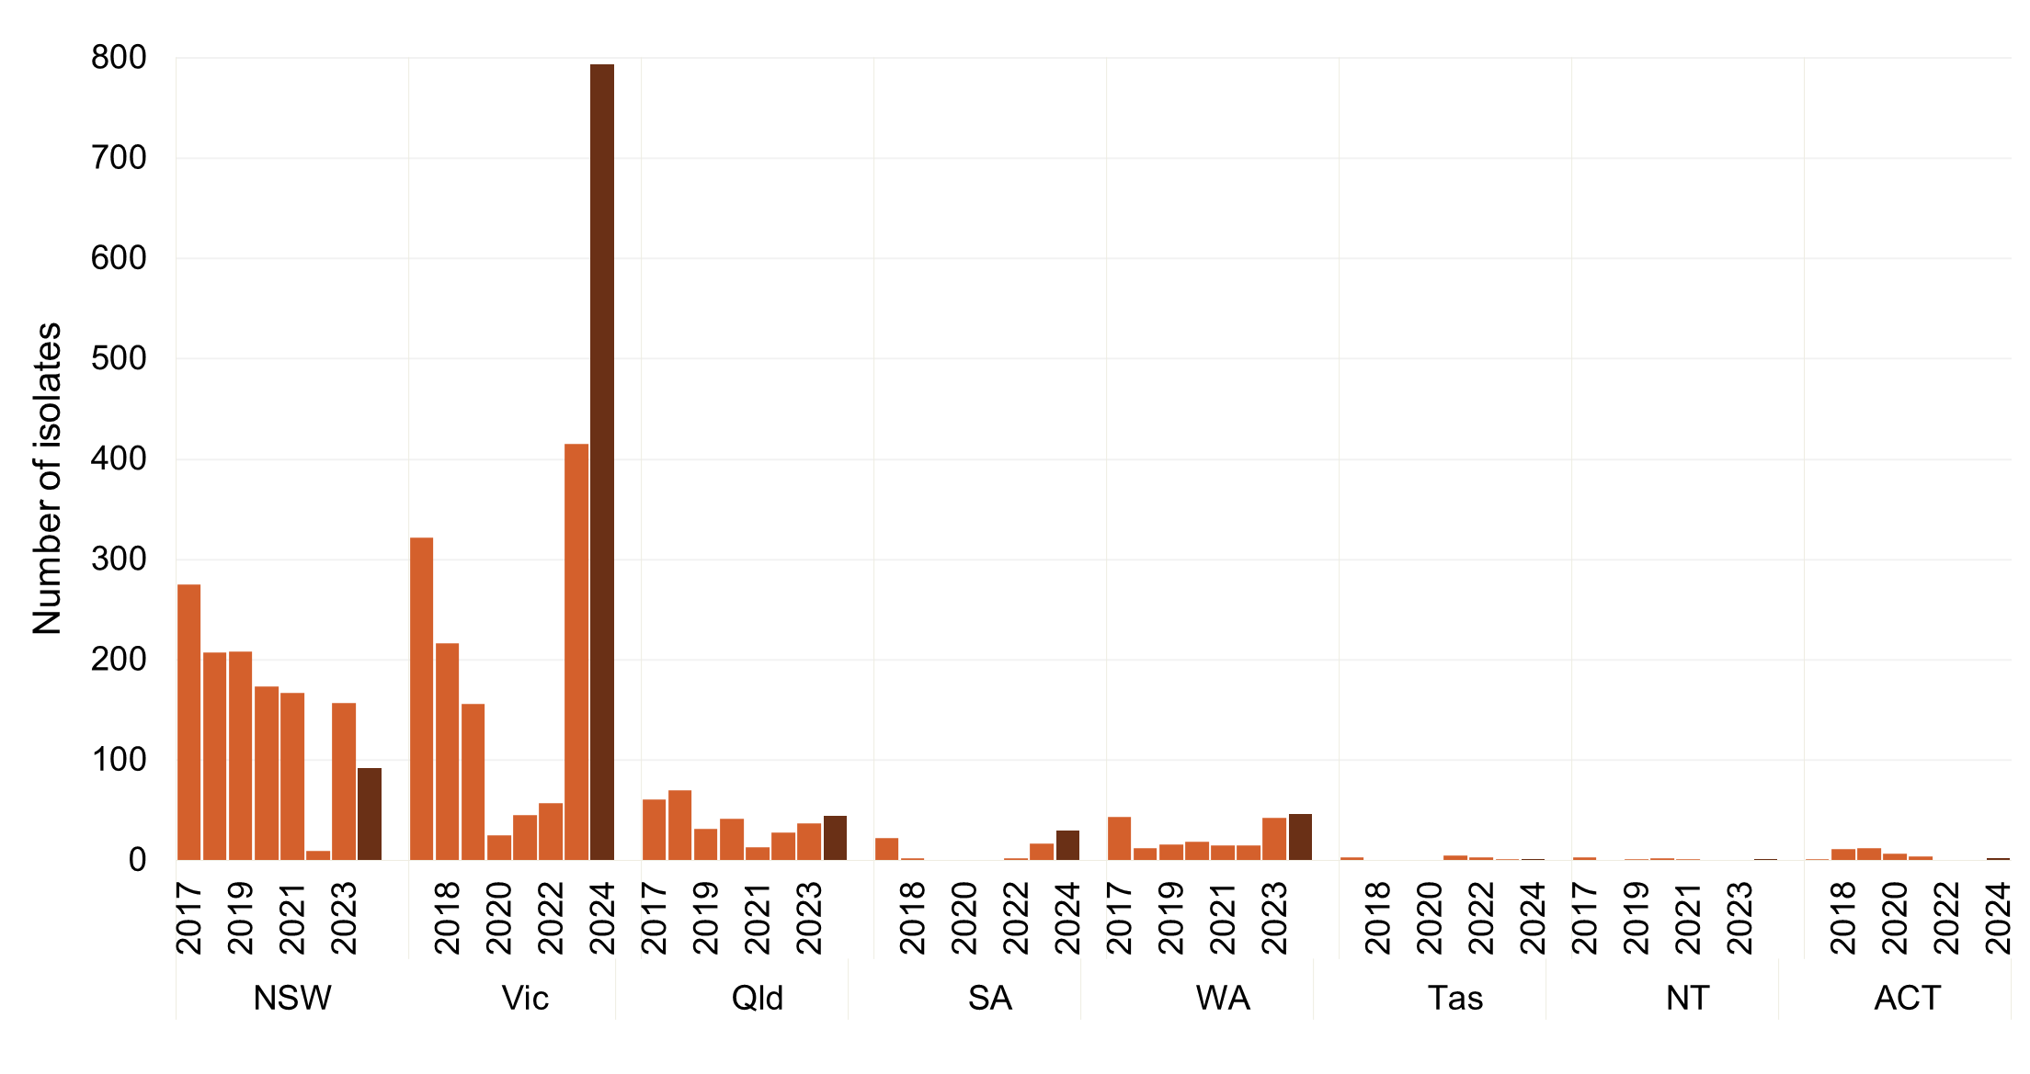

Low-level = azithromycin MIC < 256 mg/L; MIC = minimum inhibitory concentration

Note: Dark bars indicate values for 2024.

### *Neisseria meningitidis*

*N. meningitidis* causes meningococcal disease, commonly meningitis, which is an infection of the membrane covering of the brain and spinal cord known as the meninges. Ciprofloxacin-nonsusceptible *N.* *meningitidis* was added to reporting to CARAlert from 2023. There were four reports of this CAR in 2023, and five reports in 2024 from Victoria (*n* = 3) and NSW (*n* = 2).

### *Pseudomonas aeruginosa*

*P. aeruginosa* infections primarily affect hospitalised or immunocompromised patients. Patients with catheters or drains are considered at high risk for carbapenemase acquisition. Reporting for carbapenemase-producing *P. aeruginosa* began in July 2019.

In 2024, 97 carbapenemase-producing *P. aeruginosa* were reported, an increase from 2023 (*n* = 75, up 29.3%) (Figures 23 and 24). The majority (82/97, 84.5%) of isolates produced either NDM (*n* = 32), GES (*n* = 27), or VIM (*n* = 23). GES-types dominated the reports from NSW (24/39, 61.5%), while NDM-types were most common in reports from WA (7/12, 58.3%). DIM was reported from Queensland (*n* = 1) and the ACT (*n* = 1) where it was co-produced with KPC and NDM.

Where setting was known (90/97, 92.8%), a substantial majority (70/90, 77.8%) of carbapenemase-producing *P. aeruginosa* were reported from hospitals (Table 5).

**Figure 23:** Carbapenemase-producing *Pseudomonas aeruginosa*, number reported to CARAlert by specimen type, national, 2019–2024

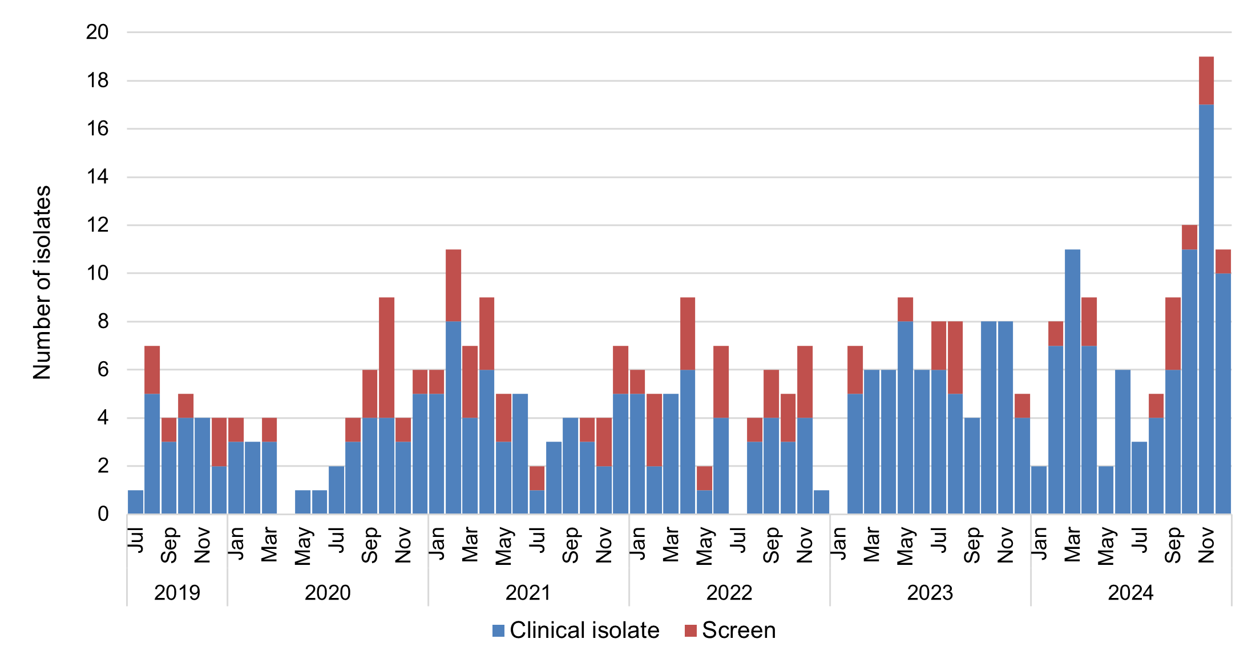

Note: Reported from July 2019.

**Figure 24:** Carbapenemase-producing *Pseudomonas aeruginosa*, number reported to CARAlert by carbapenemase type and specimen type, by state and territory, 2024

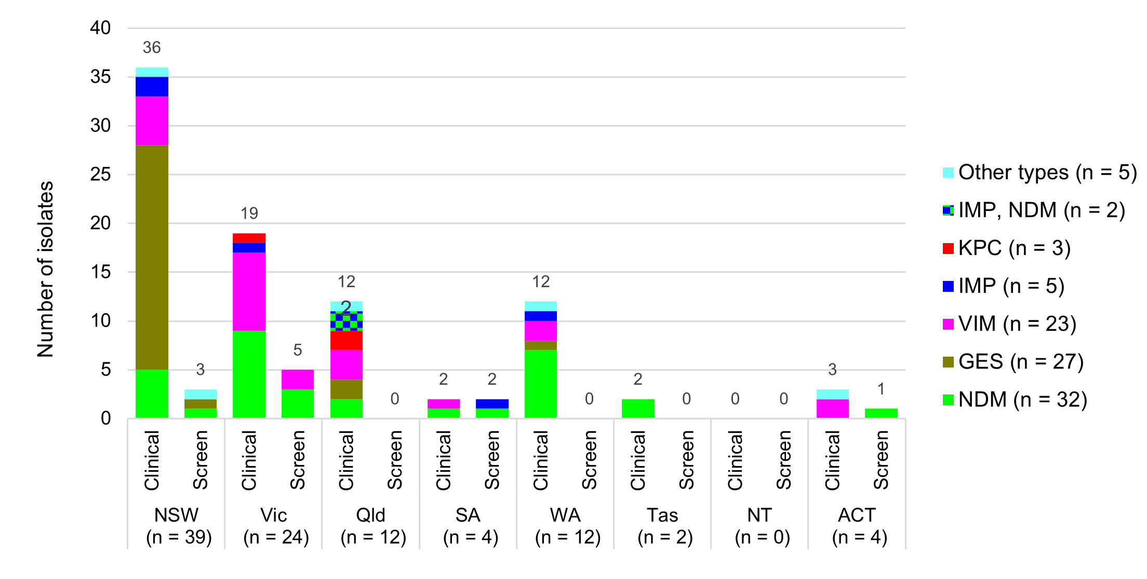

Other types: NDM, VIM (WA [1]); GES, NDM (NSW [1]); IMP, VIM (NSW [1]); DIM (Queensland [1]); KPC, NDM, DIM (ACT [1])

**Table 5:** Carbapenemase-producing *Pseudomonas aeruginosa*, number reported to CARAlert by setting and state and territory, 2024

|  |  |  |  |  |  |  |  |  |  |
| --- | --- | --- | --- | --- | --- | --- | --- | --- | --- |
|  | State or territory | | | | | | | |  |
| **Setting** | **NSW** | **Vic** | **Qld** | **SA** | **WA** | **Tas** | **NT** | **ACT** | **Total** |
| **Total** | **39** | **24** | **12** | **4** | **12** | **2** | **0** | **4** | **97** |
| Public hospitals | 32 | 16 | 7 | 2 | 8 | 0 | 0 | 3 | 68 |
| Private hospitals | 0 | 1 | 1 | 0 | 0 | 0 | 0 | 0 | 2 |
| Aged care homes | 0 | 0 | 0 | 0 | 0 | 0 | 0 | 0 | 0 |
| Community | 2 | 7 | 3 | 2 | 4 | 2 | 0 | 0 | 20 |
| Unknown | 5 | 0 | 1 | 0 | 0 | 0 | 0 | 1 | 7 |

### *Salmonella* species

*Salmonella* species are important causes of bacterial gastroenteritis. Most cases are acquired through food-borne transmission. Reports of ceftriaxone-nonsusceptible *Salmonella* species in 2024 (*n* = 104) was similar to the number reported in 2023 (*n* = 96) (Figure 25).

A vast majority of the ceftriaxone-nonsusceptible *Salmonella* reports were from non-typhoidal species (99/104, 95.2%). The non-typhoidal species contained an extended-spectrum β-lactamase (ESBL) (92/99, 92.9%), a plasmid-mediated AmpC (pAmpC) (6/99, 6.1%), or ESBL+AmpC (1/99, 1.0%) (Figure 26).

There were five typhoidal species reported in 2024 (from Victoria [3], Queensland [1] and WA [1]); the majority harboured an ESBL (*bla*CTX-M-15 [*n* = 4]) and one harboured pAmpC (*bla*CMY-2) (Figure 26). Thirteen typhoidal species were reported in both 2022 and 2023, and sporadic reports in the preceding five years (*n* = 12). The proportion of ceftriaxone-nonsusceptible typhoidal species, as reported to CARAlert, to the number of paratyphoidal or typhoid fever notifications11 was 1.5 (5/344) in 2024; it was 3.2 (13/408) in 2023.

Ceftriaxone-nonsusceptible *Salmonella* were reported from all states and territories in 2024. The number of reports decreased in NSW (*n* = 9 in 2024; *n* = 17 in 2023) and Queensland (*n* = 18 in 2024; *n* = 23 in 2023) but increased in Victoria (*n* = 44 in 2024; *n* = 39 in 2023) and WA (*n* = 22 in 2024; *n* = 15 in 2023) (Figure 27).

Reports from public hospitals are likely due to admissions associated with severe disease acquired in the community (Table 6).

#### National data

**Figure 25:** Ceftriaxone-nonsusceptible *Salmonella* species, number reported to CARAlert by month, national, 2017–2024

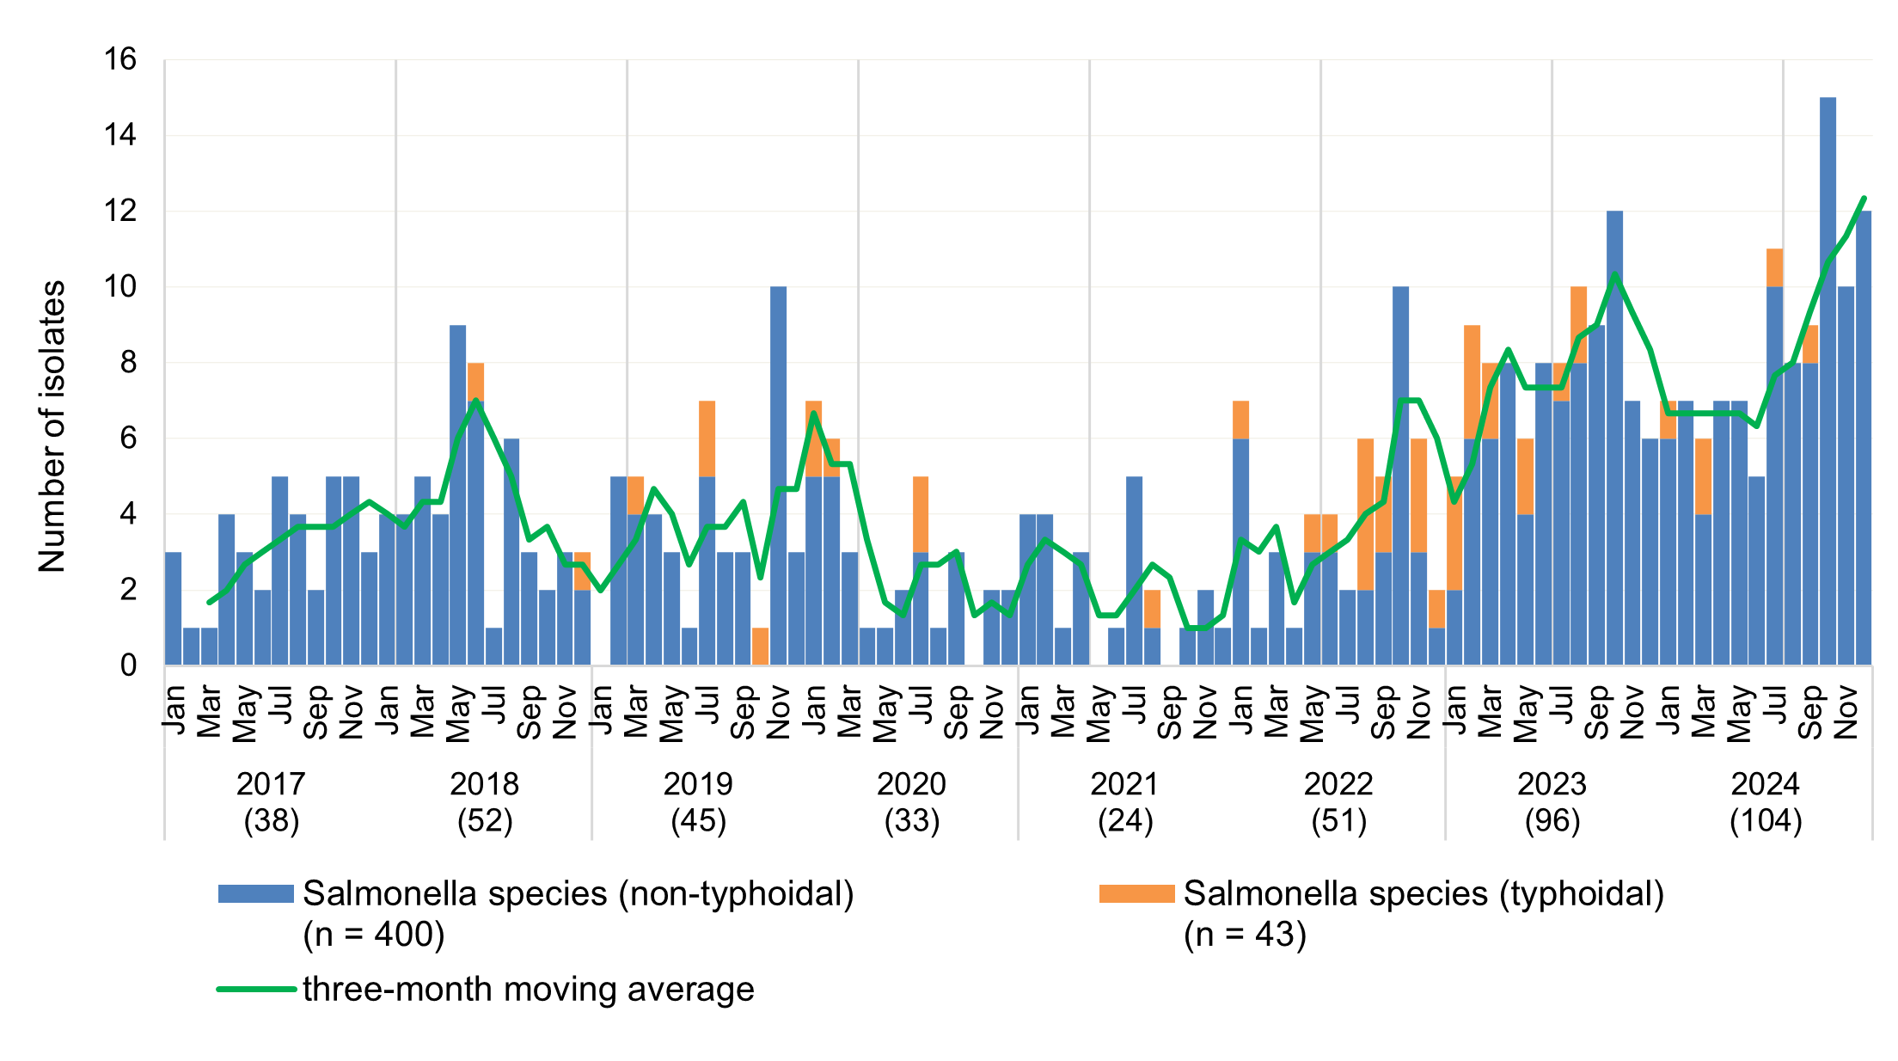

**Figure 26:** Ceftriaxone-nonsusceptible *Salmonella* species, by resistance phenotype, national, 2017–2024

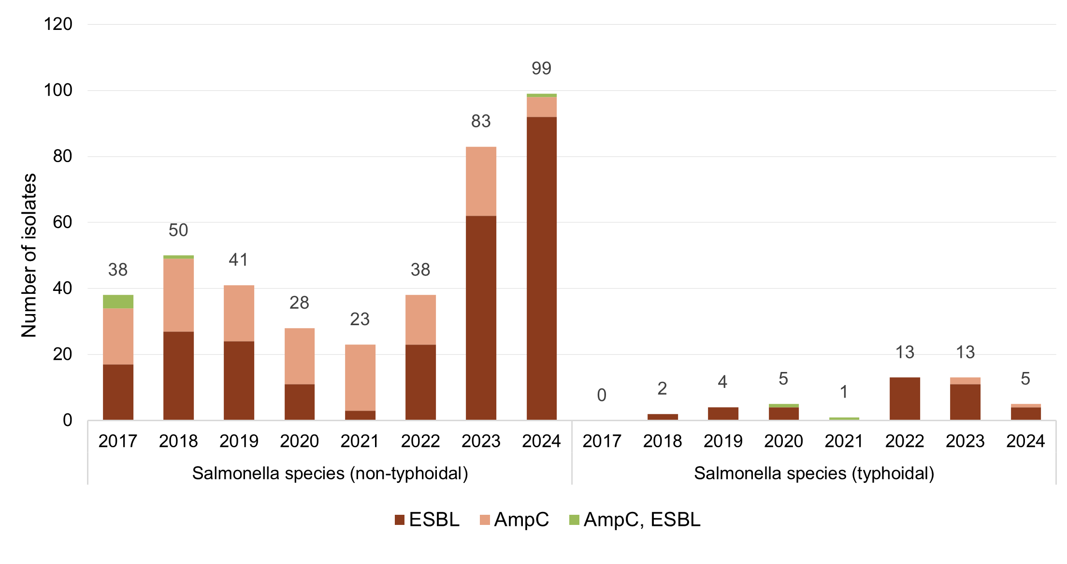

AmpC = plasmid-mediated AmpC; ESBL = extended-spectrum β-lactamase

#### State and territory data

**Figure 27:** Ceftriaxone-nonsusceptible *Salmonella* species, number reported to CARAlert by state and territory, 2017–2024

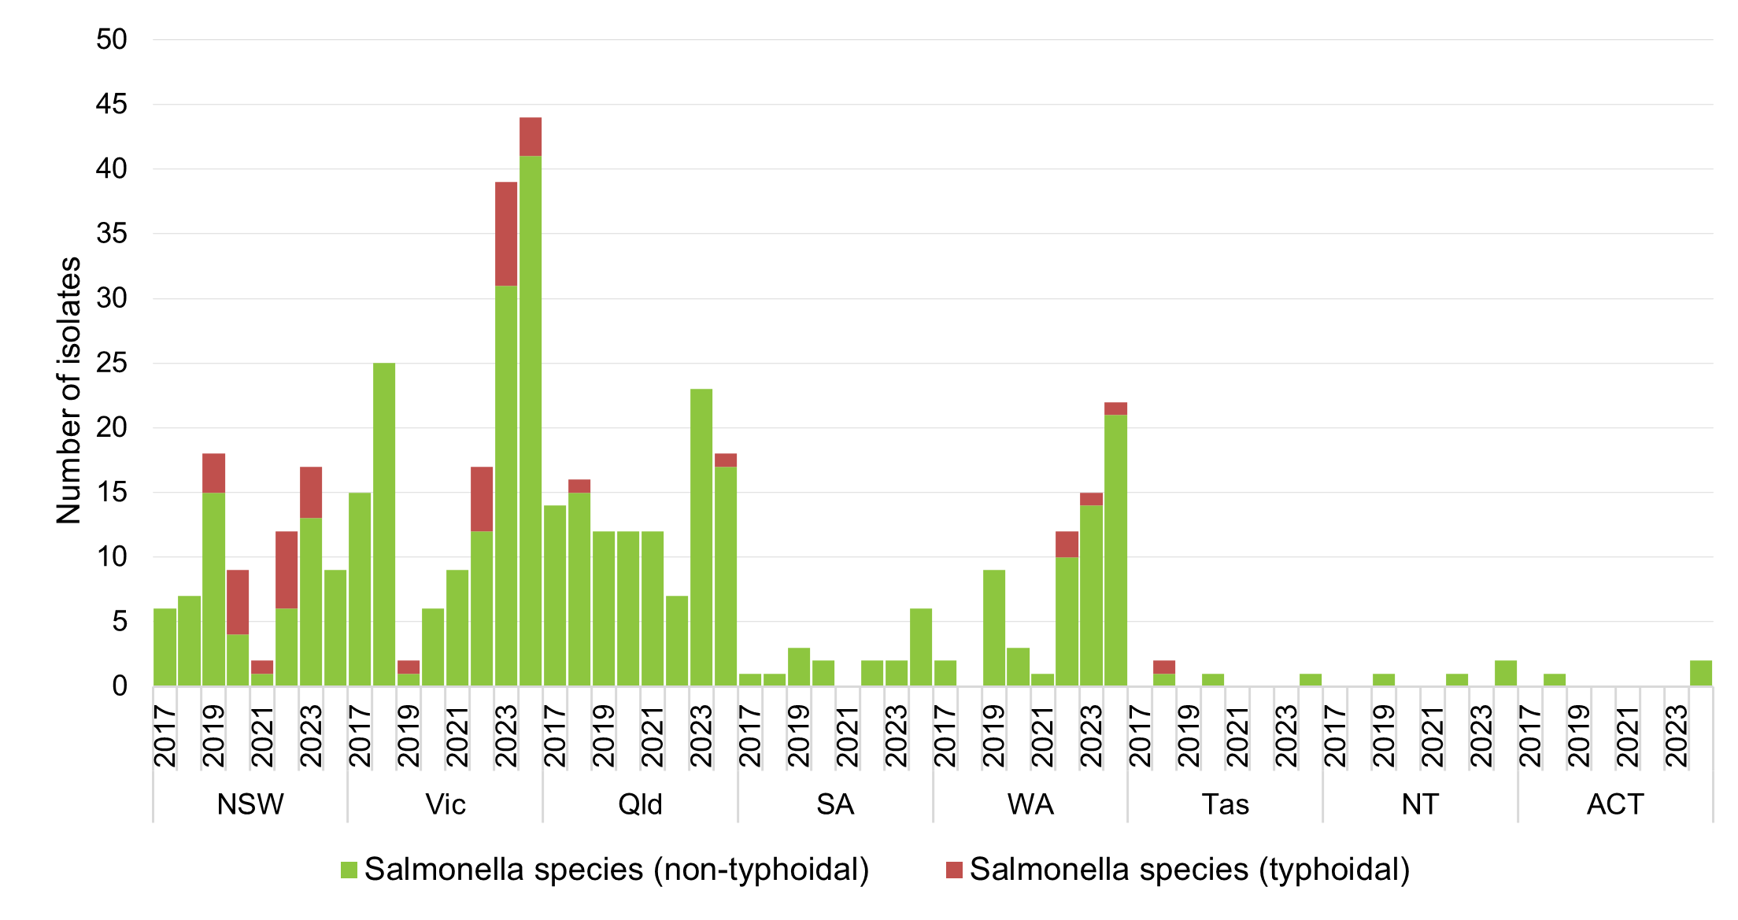

Table 6: Ceftriaxone-nonsusceptible *Salmonella* species, number reported to CARAlert by setting, state and territory, 2024

|  |  |  |  |  |  |  |  |  |  |
| --- | --- | --- | --- | --- | --- | --- | --- | --- | --- |
|  | State or territory | | | | | | | |  |
| **Setting** | **NSW** | **Vic** | **Qld** | **SA** | **WA** | **Tas** | **NT** | **ACT** | **Total** |
| **Total** | **9** | **44** | **18** | **6** | **22** | **1** | **2** | **2** | **104** |
| Public hospital | 3 | 10 | 7 | 3 | 3 | 0 | 1 | 1 | 28 |
| Private hospital | 0 | 0 | 0 | 0 | 2 | 1 | 0 | 0 | 3 |
| Aged care home | 0 | 0 | 1 | 0 | 0 | 0 | 0 | 0 | 1 |
| Community | 1 | 26 | 10 | 3 | 17 | 0 | 1 | 0 | 58 |
| Unknown | 5 | 8 | 0 | 0 | 0 | 0 | 0 | 1 | 14 |

### *Shigella* species

*Shigella* species infections are commonly food-borne or sexually transmitted. In 2024, there was a decrease in the number of MDR *Shigella* species reports compared to 2023 (*n* = 369 in 2024; *n* = 469 in 2023); there were 99 reports in 2022 (Figure 28). The reports were predominantly from NSW (139/369, 37.7%), Victoria (117/369, 32.7%), and WA (62/369, 16.8%). The number of reports of MDR *Shigella* from WA increased 2.1-fold in 2024 (*n* = 62, *n* = 30 in 2023), predominantly due to a 3.2-fold increase in MDR *S. sonnei* (*n* = 54 in 2024, *n* = 17 in 2023) (Figure 29).

The estimated proportion of shigellosis notifications to the National Notifiable Diseases Surveillance System11 that were MDR decreased from 16.1% (469/2,915) nationally in 2023 to 12.4% in 2024 (369/2,974: range 2.8% [5/181] in SA to 18.3% [117/639] in Victoria) (Figure 30). In 2022, the proportion was 7.0% (99/1,407).

Where setting was known (300/369, 81.3%), over one-half (154/300, 51.3%) of the MDR *Shigella* species were reported from community settings (Table 7).

Reports of MDR *Shigella* species increased rapidly from 2018 due to a prolonged clonal outbreak of *S. sonnei* with *bla*CTX‑M‑27 associated with men who have sex with men. There were two large outbreaks across two states, with a peak in numbers in April 2019 (74.5% from Victoria) and another in January 2020 (61.4% from NSW). There was a sharp fall in the monthly number of reports of this CAR from April 2020 onwards, continuing throughout 2021 to reach the lowest level since CARAlert began. This fall coincided with the introduction of COVID-19 restrictions throughout Australia. However, as borders re-opened, the number of reports of ESBL-producing *S. sonnei* has increased from 17 in 2021, 62 in 2022 to 321 in 2023. In 2024, the number of reports decreased to 224. Almost all of the ESBL-producing *S. sonnei* that were sequenced in 2024 harboured *bla*CTX‑M‑15 (187/191, 97.9%); whereas, in 2023, a little over two-thirds of ceftriaxone-nonsusceptible *S. sonnei* harboured *bla*CTX-M-27 (198/282, 70.2%).

The majority of MDR S. flexneri were ceftriaxone-susceptible (73/115, 63.5% in 2024; 97/124, 78.2% in 2023). In 2024, almost one-third of MDR *S. flexneri* were ESBL (CTX-M) (34/115, 29.6%, up from 20/124, 16.1% in 2023). pAmpC types were detected in low numbers.

#### National data

**Figure 28:** Multidrug-resistant *Shigella* species, number reported to CARAlert by month, national, 2017–2024

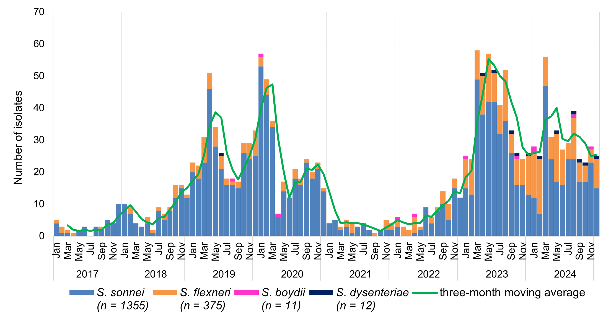

#### State and territory data

**Figure 29:** Multidrug-resistant *Shigella* species, number reported to CARAlert by state and territory, 2017–2024

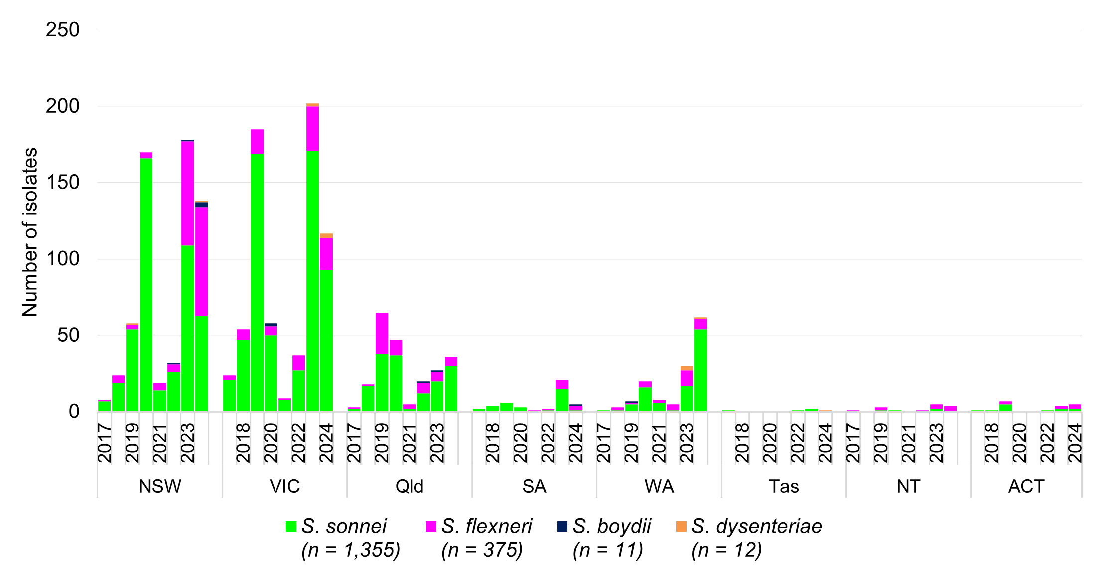

Table 7: Multidrug-resistant *Shigella* species, number reported to CARAlert by setting, state and territory, 2024

|  |  |  |  |  |  |  |  |  |  |
| --- | --- | --- | --- | --- | --- | --- | --- | --- | --- |
|  | State or territory | | | | | | | |  |
| **Setting** | **NSW** | **Vic** | **Qld** | **SA** | **WA** | **Tas** | **NT** | **ACT** | **Total** |
| **Total** | **139** | **117** | **36** | **5** | **62** | **1** | **4** | **5** | **369** |
| Public hospitals | 67 | 30 | 17 | 4 | 18 | 1 | 0 | 3 | 140 |
| Private hospitals | 0 | 1 | 2 | 0 | 3 | 0 | 0 | 0 | 6 |
| Aged care homes | 0 | 0 | 0 | 0 | 0 | 0 | 0 | 0 | 0 |
| Community | 11 | 82 | 14 | 1 | 41 | 0 | 4 | 1 | 154 |
| Unknown | 61 | 4 | 3 | 0 | 0 | 0 | 0 | 1 | 69 |

**Figure 30:** Multidrug-resistant *Shigella* species as reported to CARAlert as a percentage of shigellosis notifications, by state and territory, 2017–2024

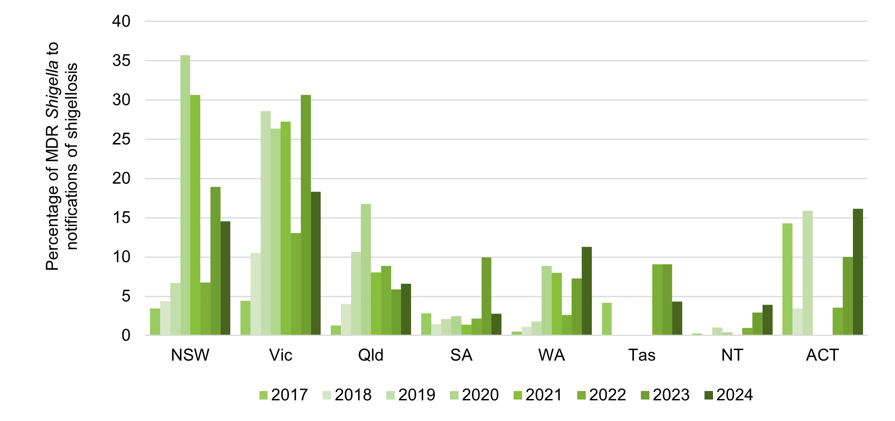

Note: Notifications of shigellosis may include diagnosis by PCR only.

Source: National Notifiable Diseases Surveillance System11

### *Staphylococcus aureus*

*Staphylococcus aureus* is a common pathogen causing a wide variety of infections of varying severity.

Reporting of daptomycin-nonsusceptible *Staphylococcus aureus* (DNSA) to CARAlert was suspended from 1 January 2023 given variation in testing and reporting practices by originating laboratories and difficulty in interpreting phenotypic data (Appendix 1).

No vancomycin-nonsusceptible or linezolid-nonsusceptible *S. aureus* were reported in 2024; one vancomycin-nonsusceptible *S. aureus* was confirmed in 2023 (Figures 31 and 32).

#### National data

**Figure 31:** Vancomycin-, linezolid- or daptomycin-nonsusceptible *Staphylococcus aureus,* number reported to CARAlert by month, national, 2017–2024

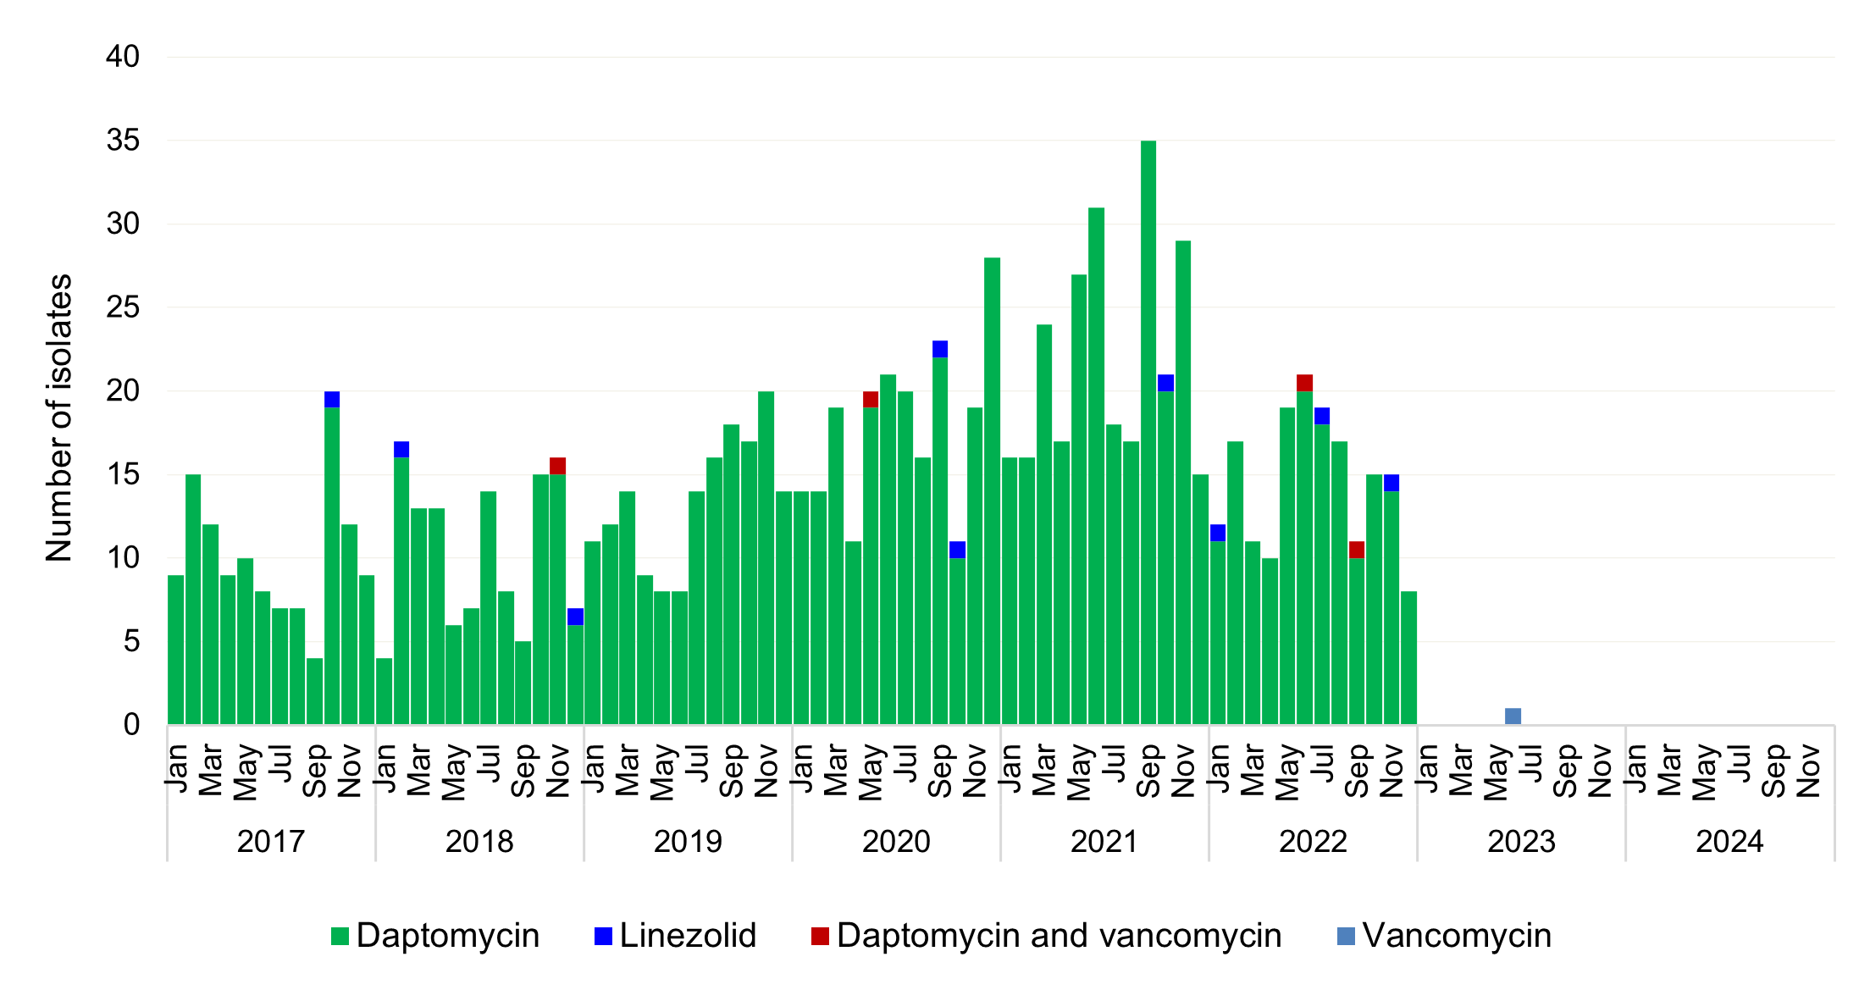

Notes:

1. No *S. argenteus* and *S. schweitzeri* were reported from 2017 to 2024.
2. Daptomycin-nonsusceptible *S. aureus* was suspended from reporting to CARAlert on 1 January 2023.

#### State and territory data

Figure 32: Vancomycin- or linezolid-nonsusceptible *Staphylococcus aureus,* number reported to CARAlert, national, 2017–2024

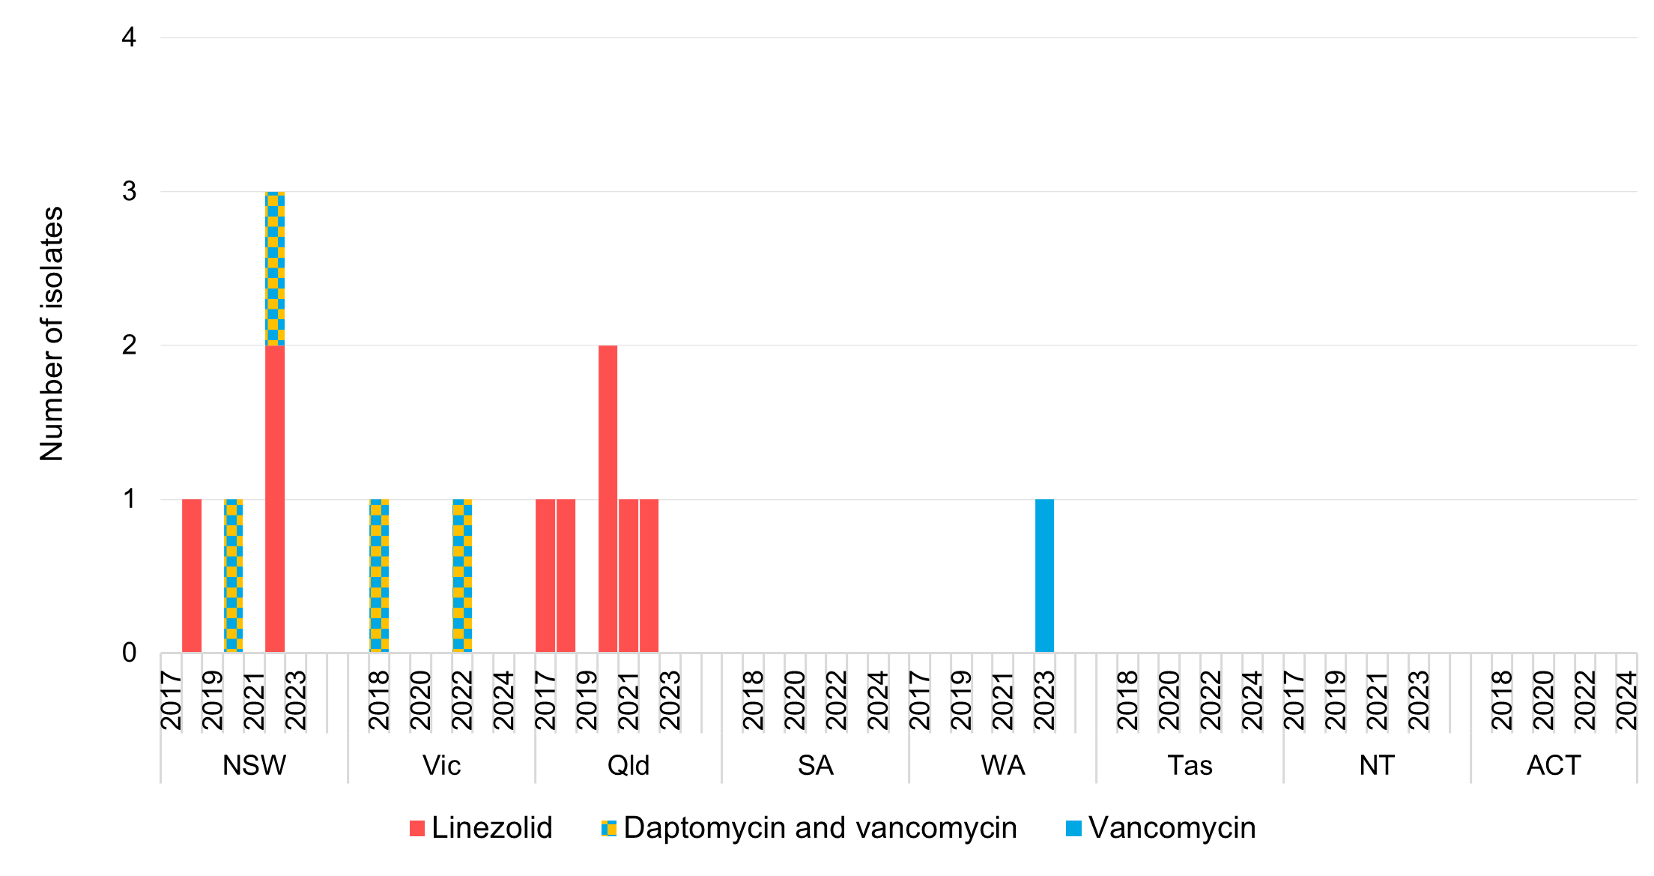

Note: Daptomycin-nonsusceptible *S. aureus* was suspended from reporting to CARAlert on 1 January 2023.

### *Streptococcus pyogenes*

*Streptococcus pyogenes* most commonly causes skin and soft tissue infections, and acute pharyngitis, but may cause serious and life-threatening infections such as scarlet fever, bloodstream infections, bone and joint infections, toxic shock syndrome, necrotising fasciitis and pneumonia.

There have been no reports of *S. pyogenes* with reduced susceptibility to penicillin between 2017 and 2024.

## Discussion

#### Rates of carbapenemase-producing *Enterobacterales* in Australian hospitals

*Enterobacterales* commonly cause urinary tract, biliary tract and other intra-abdominal infections, and bloodstream infections. Patients are most likely to be affected by CPE in hospital settings, particularly those who experience prolonged hospitalisation.

There was a 26.8% increase in the number of carbapenemase- and/or ribosomal methyltransferase-producing *Enterobacterales* reports from 2023 to 2024. This increase was evident in isolates from hospitals and continues the upward trend observed since early 2022, which followed a decline of CPE reports since 2019. Factors that may have contributed to the decline of CPE reported to CARAlert from 2019 to 2021 include improvements in recognition and infection prevention and control efforts over this period, including the public health measures introduced during the COVID-19 pandemic response. It is possible resumption of international travel has contributed to the increase in reports of CPE to CARAlert since 2022. CPE have also become notifiable in some states and territories, which may have contributed to this upward trend.

In 2024, CPE were dominated by IMP-types and NDM-types alone. NDM-producing *Enterobacterales* were reported across all states and territories and showed an increasing trend over 2021 to 2024. By contrast, reporting of IMP-types remained relatively steady over the period 2018 to 2022 (between 52.8% and 63.8%) but decreased to 39.2% in both 2023 and 2024. The decline in reports of IMP types was notably in Victoria. Although NDM types are generally thought to be acquired overseas, identification of local transmission and appropriate infection prevention and control actions are important priorities. The range and number of CPE types will continue to evolve because of changing local and global epidemiology. Each carbapenemase type has a slightly different spectrum of activity against different β-lactam antimicrobials. Typing of CPE is important for supporting appropriate antimicrobial prescribing to treat infections caused by CPE.

The differences between states and territories in the proportion of screening isolates may indicate local variations in surveillance, infection prevention and control, and screening practices. Local outbreaks are likely to have required increased infection prevention and control and surveillance resources in affected hospitals over short periods of time. The impact of outbreaks on other aspects of hospital work and patient flows may be substantial in the absence of timely infection prevention and control action. The variation between states and territories in reports of CPE as a proportion of all CARs, and the frequency of reporting of CPE, indicates the need for local decisions about containment priorities.

In 2024, 3.7% of all CPE reports occurred in the 0–4-year age group. The mode of acquisition of these CARs is not known; however, CPE outbreaks can occur in the neonatal intensive care unit setting. The long-term impact of this type of resistance on neonates is unknown. Education of clinicians on the risks of neonatal acquisition of antimicrobial-resistant organisms, and review of the appropriateness of antimicrobial use and infection prevention and control in the neonatal care setting are encouraged.

Patients are likely to be affected by CPE if they are hospitalised for a prolonged period; have been hospitalised or had surgery overseas; have had multiple, or recent exposure to different antimicrobial agents, especially cephalosporins, fluoroquinolones and carbapenems; have diabetes mellitus; are on mechanical ventilation; are admitted to the intensive care unit; or have an indwelling medical device (such as a central venous catheter, urinary catheter or biliary catheter).

Ongoing reports of CPE, and other carbapenemase-producing organisms to CARAlert, albeit at low levels, highlight the value of active surveillance and the importance of compliance with the *Australian Guidelines for the Prevention and Control of Infection in Healthcare*1, and use of guidance for specific organisms, such as *Recommendations for the control of carbapenemase-producing* Enterobacterales *(CPE): A guide for acute health service organisations*.4

Arrangements for specialist oversight of and access to restricted antimicrobials, such as carbapenems, should continue to be a priority for all Australian hospitals, along with the implementation of systems that meet the antimicrobial stewardship (AMS) actions of the National Safety and Quality Health Service (NSQHS) Standards.2

#### Changes in community-onset critical antimicrobial resistances

*N. gonorrhoeae* was the most commonly reported CAR from the community setting for all years since CARAlert commenced. Reports of azithromycin-nonsusceptible *N. gonorrhoeae* (LLR) increased in 2024 in all states and territories except NSW. Both ceftriaxone-nonsusceptible *N. gonorrhoeae* and azithromycin-nonsusceptible *N. gonorrhoeae* (HLR) increased in 2024, with the majority of the reports from NSW, a trend that started in 2022.

Reports of MDR *Shigella* species decreased from 2023 to 2024, with 2023 having the largest number of reports since 2017. The proportion of shigellosis notifications that were MDR decreased overall in 2024 compared to 2023. The decrease was noted in all states and territories where there were five or more reports, except in WA and Queensland, where the proportion increased.

The ongoing overall increase in reports of these CARs in 2024 corresponds with the increased resumption of usual social interaction and international travel following easing of COVID-19 restrictions from late 2021. These changes indicate that ongoing monitoring of resistance in gonococcal disease and shigellosis is required because of the importance of emerging changes in susceptibility for treatment guidelines.

Increases in reports of MDR *Shigella* suggest that empirical antimicrobial therapy recommendations for shigellosis may need to be reconsidered. Increases also require ongoing close review by states and territories. Public health messaging should continue to highlight the risk of sexual transmission of *Shigella* species, particularly in men who have sex with men, and provide guidance on ways to reduce the risk of transmission.

The emergence of gonococcal antimicrobial resistance (AMR) in Australia has long been influenced by the introduction of MDR strains from overseas.12, 13 A number of reports from other countries of ceftriaxone-resistant *N. gonorrhoeae* strains have raised global concerns about the effectiveness of current recommended treatments.14-16 This also prompted the addition of reporting of gentamicin-resistant *N. gonorrhoeae* to CARAlert from 2023. In Australia, the recommended treatment for *N. gonorrhoeae* is ceftriaxone in conjunction with azithromycin. This regimen was introduced in Australia in 2014 to limit further development of resistance to ceftriaxone.17 The low background rate of azithromycin-nonsusceptible *N. gonorrhoeae* (LLR) in Australia is well established.18 Reports of this CAR declined from 2017 to 2022, and increased dramatically in 2023, particularly in NSW and Victoria.11 In 2024, reports from Victoria almost doubled those from 2023. The clinical implications of this low-level resistance are not clear. Despite low numbers, continuing reports of ceftriaxone-nonsusceptibility are concerning.

Also of recent concern is the emergence of ESBL-producing non-typhoidal *Salmonella* species, lower numbers of these were seen from 2017, but appear to have increased substantially in 2023 and 2024. How this relates to the epidemiology and sources of *Salmonella* infections overall across Australia remains to be explored.

#### Critical antimicrobial resistances in aged care homes

In 2024, ten CARs were reported from aged care homes; all of which were from clinical isolates. This marks a decline from 24 reports in 2022, following the suspension of reporting DNSA to CARAlert. While the number of reports is very low, aged care home residents have increased vulnerability to infections, and are at risk of acquiring or transmitting infections due to the frequent movement of aged care home residents between acute settings.

In aged care homes, infections of the skin and soft tissue and urinary tract are the most common reason for antimicrobial prescriptions19, and are commonly caused by *S. aureus* and *Enterobacterales*, respectively. These organisms may be spread by contact with contaminated surfaces or medical equipment and hands of healthcare workers, visitors and residents. Environmental cleaning and hand hygiene are important prevention and control strategies. In group living situations, infectionsmay also be inadvertently spread from person to person, for example by sharing personal items such as bed linen, towels or clothing.

Specific measures are required in all care settings for CPE. To support the capacity to prevent and control transmission of CPE, aged care homes should comply with the infection prevention and control requirements of the strengthened Aged Care Quality Standards7, which include compliance with national guidelines.1 In August 2024, the Commission published *The Aged Care Infection Prevention and Control Guide*6 to support implementation of the strengthened standards and to supplement national guidelines1for the aged care workforce and those providing care for older people.

#### Health service demand and complexity of care

CARs increase hospital length of stay, deaths, and health service resource needs. Estimates of the impacts of AMR vary by organism and are not available for the majority of CARs. Recent estimates of the impact of CPE include an additional 29 inpatient days, compared to non-CPE cases, after the isolation of the organism.20 Patients with MDR infections were also less likely to receive appropriate antimicrobial therapy initially.20 For vancomycin-resistant enterococci, when they first emerged, estimated increases per case were 61.9% for hospital costs and an additional 13.8 days length of stay.21

Increases in CARs also require ongoing close review by states and territories as there are limited oral antimicrobial options, and intravenous antimicrobials may be required to treat MDR infections. There may also be resource implications for the health system because of increased testing, hospital admissions and transmission in the community.

## References

1. National Health and Medical Research Council, Australian Commission on Safety and Quality in Health Care. Australian Guidelines for the Prevention and Control of Infection in Healthcare. Sydney: NHMRC, 2019.

2. Australian Commission on Safety and Quality in Health Care. National Safety and Quality Health Service Standards. 2nd ed. - version 2. Sydney: ACSQHC, 2021.

3. Australian Commission on Safety and Quality in Health Care. National Safety and Quality Primary and Community Healthcare Standards. Sydney: ACSQHC, 2021.

4. Australian Commission on Safety and Quality in Health Care. Recommendations for the control of carbapenemase-producing *Enterobacterales* (CPE). A guide for acute care health service organisations. Sydney: ACSQHC, 2021.

5. Australian Commission on Safety and Quality in Health Care. Antimicrobial Stewardship Clinical Care Standard. Sydney: ACQSC, 2020.

6. Australian Commission on Safety and Quality in Health Care. The Aged Care Infection Prevention and Control Guide. Sydney: ACQSC, 2024.

7. Australian Commission on Safety and Quality in Health Care. Aged Care Quality Standards: Standard 5 - Clinical Care. [Internet] Sydney: ACSQHC; 2024 [cited 20 March 2025] Available from: <https://www.safetyandquality.gov.au/standards/aged-care-quality-standards-standard-5-clinical-care>.

8. Aged Care Quality and Safety Commission. Strengthened Quality Standards. [Internet] Sydney: ACSQHC; 2025 [cited 20 March 2025] Available from: <https://www.agedcarequality.gov.au/providers/quality-standards/strengthened-quality-standards>.

9. Assis R, Lasnoy M, Adler A. Clinical and epidemiological features of patients colonised by different types of carbapenemase-producing *Enterobacterales*. J Glob Antimicrob Resist. 2021;26:108-113.

10. Tyson GH, Li C, Hsu CH, Ayers S, Borenstein S, Mukherjee S, et al. The *mcr-9* Gene of *Salmonella* and *Escherichia coli* Is not associated with colistin resistance in the United States. Antimicrob Agents Chemother. 2020;64(8).

11. Australian Government Department of Health and Aged Care. National Notifiable Diseases Surveillance Dashboard. [Internet] Canberra: Australian Government; 2025 [cited 25 Feb 2025] Available from: <https://nindss.health.gov.au/pbi-dashboard/>.

12. Hanrahan JK, Hogan TR, Buckley C, Trembizki E, Mitchell H, Lau CL, et al. Emergence and spread of ciprofloxacin-resistant *Neisseria gonorrhoeae* in New South Wales, Australia: lessons from history. J Antimicrob Chemother. 2019;74(8):2214-2219.

13. Tapsall JW, Limnios EA, Murphy D, Australian Gonococcal Surveillance P. Analysis of trends in antimicrobial resistance in *Neisseria gonorrhoeae* isolated in Australia, 1997 2006. J Antimicrob Chemother. 2008;61(1):150-155.

14. Eyre DW, Town K, Street T, Barker L, Sanderson N, Cole MJ, et al. Detection in the United Kingdom of the *Neisseria gonorrhoeae* FC428 clone, with ceftriaxone resistance and intermediate resistance to azithromycin, October to December 2018. Euro Surveill. 2019;24(10).

15. Fifer H, Hughes G, Whiley D, Lahra MM. Lessons learnt from ceftriaxone-resistant gonorrhoea in the UK and Australia. Lancet Infect Dis. 2020;20(3):276-278.

16. Unemo M, Golparian D, Eyre DW. Antimicrobial Resistance in *Neisseria gonorrhoeae* and Treatment of Gonorrhea. Methods Mol Biol. 2019;1997:37-58.

17. Lahra MM, Hogan TR, Shoushtari M, Armstrong BH. Australian Gonococcal Surveillance Programme Annual Report, 2020. Commun Dis Intell (2018). 2021;45.

18. Lahra MM, van Hal S, Hogan TR. Australian Gonococcal Surveillance Programme Annual Report, 2022. Commun Dis Intell (2018). 2023;47.

19. Australian Commission on Safety and Quality in Health Care. AURA 2023: fifth Australian report on antimicrobial use and resistance in human health. Sydney: ACSQHC, 2023.

20. Hayakawa K, Nakano R, Hase R, Shimatani M, Kato H, Hasumi J, et al. Comparison between IMP carbapenemase-producing Enterobacteriaceae and non-carbapenemase-producing Enterobacteriaceae: a multicentre prospective study of the clinical and molecular epidemiology of carbapenem-resistant Enterobacteriaceae. J Antimicrob Chemother. 2020;75(3):697-708.

21. Lloyd-Smith P, Younger J, Lloyd-Smith E, Green H, Leung V, Romney MG. Economic analysis of vancomycin-resistant enterococci at a Canadian hospital: assessing attributable cost and length of stay. J Hosp Infect. 2013;85(1):54-59.

## Appendix 1 About CARAlert

The National Alert System for Critical Antimicrobial Resistances (CARAlert) was established by the Australian Commission on Safety and Quality in Health Care (the Commission) in March 2016 as a component of the Antimicrobial Use and Resistance in Australia (AURA) surveillance program.

Funding for CARAlert and development of this report and the Commission’s AURA Project is provided by the Australian Government Department of Health and Aged Care (the Department), with contributions from the states and territories by meeting the costs of confirmatory testing and data submission processes.

CARAlert is based on routine processes used by pathology laboratories for identifying and confirming potential critical antimicrobial resistances (CARs), in which participating confirming laboratories submit data to CARAlert on priority organisms with critical resistance to last-line antimicrobials. Isolates collected from patients are reported to CARAlert as either a clinical isolate, that is a specimen (e.g., from blood, urine, wound) taken to guide clinical diagnosis, or as a screen for infection prevention and control purposes. No patient-level data are held in the CARAlert system.

In 2024, 27 confirming laboratories participated in CARAlert (Appendix 3) and there have been over 16,000 reports to CARAlert since reporting began.

CARAlert data on confirmed cases of CARs can be used to identify seasonal, geographic and national trends. The potential for CARAlert to act as an early warning system for CAR outbreaks to enable timely infection prevention and control responses is dependent on timely reporting of CARs by confirming laboratories.

The CARs reported to CARAlert are listed in Table A1. These CARs were drawn from the list of high-priority organisms and antimicrobials that are the focus of the AURA surveillance program.

**Table A1: Critical antimicrobial resistances reported to CARAlert, 2024**

|  |  |
| --- | --- |
| Species | Critical Resistance |
| *Acinetobacter baumannii* complex* | Carbapenemase-producing† |
| *Candida auris*† | – |
| *Enterobacterales* | Carbapenemase-producing and/or ribosomal methyltransferase-producing |
| Transmissible colistin resistance† |
| *Enterococcus* species | Linezolid-resistant |
| *Mycobacterium tuberculosis* | Multidrug-resistant – resistant to at least rifampicin and isoniazid |
| *Neisseria gonorrhoeae* | Ceftriaxone-nonsusceptible and/or azithromycin-nonsusceptible |
| Gentamicin-resistant§ |
| *Neisseria meningitidis* | Ciprofloxacin-nonsusceptible§ |
| *Pseudomonas aeruginosa* | Carbapenemase-producing† |
| *Salmonella* species | Ceftriaxone-nonsusceptible |
| *Shigella* species | Multidrug-resistant |
| *Staphylococcus aureus*# | Vancomycin- or linezolid-nonsusceptible** |
| *Streptococcus pyogenes* | Penicillin reduced susceptibility |

* For CARAlert, *A. baumannii* complex includes *A. baumannii*, *A. calcoaceticus*, *A. dijkshoorniae*, *A. nosocomialis*, *A. pittii* and *A. seifertii*

† Reported to CARAlert from July 2019

§ Reported to CARAlert from January 2023

# For CARAlert, *S. aureus* includes *S. argenteus* and *S. schweitzeri*

** Reporting of daptomycin-nonsusceptible *S. aureus* was suspended from January 2023

Note: Low level-azithromycin-nonsusceptible *N. gonorrhoeae* was excluded from the weekly summary following review in 2018.

The CARAlert system generates a weekly summary email to report information on confirmed CARs to state and territory health authorities, the Department and confirming laboratories.

The Commission publishes data submitted to CARAlert in the form of [data updates and annual reports](https://www.safetyandquality.gov.au/caralert-reports). The Commission has also developed the CARAlert Data Explorer (in press), which is an interactive dashboard that provides more timely access to data consistent with static CARAlert data updates and annual reports.

CARAlert data can support timely responses to CARs by hospitals, and state and territory health departments. Some states have made selected CARs, such as carbapenemase-producing *Enterobacterales* and *Candida auris*, notifiable either using their public health legislation or by policy. Some states and territories have standalone systems for monitoring selected CARs, which complement CARAlert, but these are not widespread. Over time, CARAlert data has the potential to inform a broad range of safety and quality improvement programs.

The Commission reviewed the CARs reported to CARAlert in 2018, in conjunction with the states and territories and a range of clinical experts. The review identified four new CARs that were reported to CARAlert from July 2019:

* Carbapenemase-producing *Acinetobacter baumannii* complex
* *C. auris*
* Transmissible resistance to colistin in *Enterobacterales*
* Carbapenemase-producing *Pseudomonas aeruginosa*.

The Commission completed another review of the CARs reported to CARAlert in 2022. This review followed a similar process to the 2018 review. The 2022 review identified two new CARs that were reported to CARAlert from January 2023:

* Gentamicin-resistant *Neisseria gonorrhoeae*
* Ciprofloxacin-nonsusceptible *N. meningitidis*.

Reporting of daptomycin-nonsusceptible *Staphylococcus aureus* was suspended from 1 January 2023, as recommended. Reporting of this CAR will be reconsidered when more reliable testing methods are available.

The Department regularly evaluates national surveillance systems to ensure they continue to meet their purpose and objectives. In 2022–2023, the Department conducted an evaluation of CARAlert, which complements the Commission’s review of CARs. The purpose of the CARAlert evaluation was to examine:

* How well the system operates to meet its purposes and objectives
* The appropriateness of the system’s purposes and objectives
* Improvements to enhance the system’s ability to meet these objectives.

The United States Centers for Disease Control and Prevention *Updated Guidelines for Evaluating Public Health Surveillance Systems* as used to evaluate the system’s usefulness and performance against system attributes. The Commission will collaborate with the Department, states and territories and confirming laboratories to consider the recommendations of the evaluation and feasibility for implementation.

Information on CARAlert processes and considerations for interpreting CARAlert data is in Appendix 2.

## Appendix 2 Methodology

#### CARAlert reporting processes

All of the following criteria must be met for organisms and resistances to be categorised as a critical antimicrobial resistance (CAR) for reporting to the National Alert System for Critical Antimicrobial Resistances (CARAlert):

* Inclusion as a priority organism for national reporting as part of the Antimicrobial Use and Resistance in Australia (AURA) surveillance program19
* A serious threat to last-line antimicrobial agents
* Strongly associated with resistance to other antimicrobial classes
* At low prevalence in, or currently absent from, Australia and potentially containable
* Data not otherwise collected nationally in a timely way.

*Candida auris* was added as a CAR for reporting to CARAlert in 2019 despite not being an AURA surveillance program priority organism.19 This change was in response to feedback from respondents to the 2018 review of CARs, and international concerns for its multi-drug resistance and association with invasive infection outbreaks in healthcare facilities in 2017.

CARAlert is based on the following routine processes used by pathology laboratories for identifying and confirming potential CARs:

* Collection and routine testing – the isolate is collected from the patient and sent to the originating laboratory for routine testing
* Confirmation – if the originating laboratory suspects that the isolate is a CAR, it sends the isolate to a confirming laboratory that has the capacity to confirm the CAR
* Reporting to clinicians in accordance with usual laboratory processes – the confirming laboratory reports back to the originating laboratory, which in turn reports to the clinician who initially requested the microbiological testing
* Submission to CARAlert – the confirming laboratory advises the originating laboratory of the result of the test, and the originating laboratory reports back to the health service that cared for the patient from whom the specimen was collected; the confirming laboratory then submits the details of the resistance and organism to the secure CARAlert web portal.

The results of confirmatory testing are provided to the originating laboratory as soon as possible after confirmation. Generally, confirming laboratories submit a CAR report within seven days of the isolate being confirmed as a CAR.

Information collected in CARAlert includes: the originating and confirmatory laboratory, specimen identifier, specimen collection date, CAR, CAR type or subtype if applicable, organism name, specimen type, facility type, patient age range, patient sex, and state or territory of patient residence and state or territory of record.

No patient-level data are held in the CARAlert system. Authorised officers in each state and territory health department have direct access to the CARAlert web portal directly for further information about their jurisdiction, including the name of the public hospital where a patient with a confirmed CAR was cared for, and to extract reports on their data.

Australian public and private laboratories that have the capacity to confirm CARs were identified through consultation with state and territory health authorities, the Public Health Laboratory Network and the Australian Group on Antimicrobial Resistance. In 2024, 27 confirming laboratories submitted data to CARAlert (Appendix 3), and there was at least one confirming laboratory in each state and territory. The CARs that each of the confirming laboratories are able to confirm are regularly reviewed.

All data analyses for this report were performed using Microsoft Excel 365.

#### Data considerations

The following are important considerations for interpreting CARAlert data:

* Participation in CARAlert is voluntary
* The data are based on the date that the isolate with the confirmed CAR was collected
* State or territory refers to the jurisdiction within which the hospital is located, or within which the patient resides for isolates from the community. If place of residence is unknown or overseas, the state or territory of the originating laboratory is reported
* The same CAR/type/species is not submitted where the sample originated from the same patient who had the same previous CAR, and the isolate was collected on the same day, or collected in the same admission or within three months
* Number of CARs reported does not always equal the number of patients, as patients may have more than one CAR, or species, detected in a specimen
* Cut-off date for data that are included in the CARAlert Data Explorer, data updates and reports is four weeks after the end of each reporting period
* Data may vary from that previously published as the reported number of CARs may have been updated to include additional submissions received or removed after the previous publication date; Comparison between reports may be influenced by delays in confirming laboratories reporting CARs to CARAlert due to late submission, which also means that the data analysed for this report may not be complete for the 2024 calendar year at the time of publication
* National summary data are provided; comparison across states and territories is provided for organisms where large numbers are reported and a comparison is meaningful
* Local operating procedures for laboratories may not currently include testing for all the critical resistances included in CARAlert; however, all laboratories are encouraged to actively screen for CARs
* Authorised officers in each state and territory health department have direct access to the CARAlert web portal for further information about their jurisdiction, including the name of the public hospital in which a patient with a confirmed CAR was cared for, and to extract reports on their data.

## Appendix 3 CARAlert confirming laboratories, 2024

The Commission thanks all originating and confirming laboratories for their support for the National Alert System for Critical Antimicrobial Resistances (CARAlert) and the Antimicrobial Use and Resistance in Australia (AURA) surveillance program. The following confirming laboratories participated in CARAlert in 2024:

|  |  |
| --- | --- |
| State or Territory | Institution |
| New South Wales | NSW Health Pathology, Children’s Hospital Westmead, Westmead |
| NSW Health Pathology, Concord Hospital, Concord |
| NSW Health Pathology, Gosford Hospital, Gosford |
| NSW Health Pathology, John Hunter Hospital, New Lambton Heights |
| NSW Health Pathology, Liverpool Hospital, Liverpool |
| NSW Health Pathology, Royal North Shore Hospital, St Leonards |
| NSW Health Pathology, Royal Prince Alfred Hospital, Camperdown |
| NSW Health Pathology, St George Hospital, Kogarah |
| NSW Health Pathology, The Prince of Wales Hospital, Randwick |
| NSW Health Pathology, Westmead Hospital, Westmead |
| St Vincent's Pathology (SydPath), Darlinghurst |
| Victoria | Alfred Pathology Service, Melbourne |
| Dorevitch Pathology, Heidelberg |
| Melbourne Pathology, Collingwood |
| Microbiological Diagnostic Unit Public Health Laboratory, Melbourne |
| Monash Pathology, Clayton |
| Victorian Infectious Diseases Reference Laboratory (VIDRL), Melbourne |
| Queensland | Pathology Queensland, Central laboratory, Royal Brisbane and Women’s Hospital, Herston |
| Pathology Queensland, Forensic & Scientific Services, Coopers Plains |
| QML Pathology, Murarrie |
| Sullivan Nicolaides Pathology, Bowen Hills |
| South Australia | SA Pathology, Royal Adelaide Hospital, Adelaide |
| Western Australia | PathWest Laboratory Medicine WA, Fiona Stanley Hospital, Murdoch |
| PathWest Laboratory Medicine WA, QEII Medical Centre, Nedlands |
| Tasmania | Royal Hobart Hospital, Hobart |
| Northern Territory | Territory Pathology, Tiwi |
| Australian Capital Territory | ACT Pathology, Garran |



Level 5, 255 Elizabeth Street, Sydney NSW 2000  
GPO Box 5480, Sydney NSW 2001

Phone: (02) 9126 3600

Email: [mail@safetyandquality.gov.au](mailto:mail@safetyandquality.gov.au)  
Website: [www.safetyandquality.gov.au](http://www.safetyandquality.gov.au/)