# Australian Commission on Safety and Quality logotypeOn the Radar

Issue 700

16 June 2025

*On the Radar* is a summary of some of the recent publications in the areas of safety and quality in health care. Inclusion in this document is not an endorsement or recommendation of any publication or provider. Access to particular documents may depend on whether they are Open Access or not, and/or your individual or institutional access to subscription sites/services. Material that may require subscription is included as it is considered relevant.

*On the Radar* is available online, via email or as a PDF or Word document from <https://www.safetyandquality.gov.au/newsroom/subscribe-news/radar>

If you would like to receive *On the Radar* via email, you can subscribe on our website <https://www.safetyandquality.gov.au/newsroom/subscribe-news>  
or by emailing us at [mail@safetyandquality.gov.au](mailto:mail@safetyandquality.gov.au).  
You can also send feedback and comments to [mail@safetyandquality.gov.au](mailto:mail@safetyandquality.gov.au).

For information about the Commission and its programs and publications, please visit <https://www.safetyandquality.gov.au>

**On the Radar**

Editor: Dr Niall Johnson  
Contributors: Niall Johnson, Helen Dowling

**Reports**

*Aboriginal and/or Torres Strait Islander health workers and health practitioners in primary health care: guide for general practice*

National Association of Aboriginal and Torres Strait Islander Health Workers and Practitioners, Royal Australian College of General Practitioners

Canberra: National Association of Aboriginal and Torres Strait Islander Health Workers and Practitioners; 2025. p. 24.

|  |  |
| --- | --- |
| URL | <https://www.naatsihwp.org.au/resource/aboriginal-and-or-torres-strait-islander-health-workers-and-health-practitioners-in-primary-health-care-a-guide-for-general-practice> |
| Notes | The National Association of Aboriginal and Torres Strait Islander Health Workers and Practitioners has developed this guide to support general practices understand the benefits of Aboriginal and/or Torres Strait Islander Health Workers and Health Practitioners, and promote the effective utilisation of this workforce into their models of care. The guide provides:   * information on the role, skills and qualifications of Aboriginal and/or Torres Strait Islander Health Workers and Health Practitioners, * suggests how general practices can enhance their high quality clinical care through their provision of Aboriginal and Torres Strait Islander Health Checks, GP Management Plans, Team Care Arrangements, and follow-up care, and * insights on how to nurture and retain workforce members in culturally safe general practices. |

*Urgent and emergency care plan 2025/26*

NHS England

London: Department of Health & Social Care, NHS England.; 2025.

|  |  |
| --- | --- |
| URL | <https://www.england.nhs.uk/publication/urgent-and-emergency-care-plan-2025-26/> |
| Notes | Many health systems face challenges in their urgent and emergency care settings. NHS England has published this plan setting out how they will ‘resuscitate urgent and emergency care’. The plan has ‘a focus on getting patients out of corridors, keeping more ambulances on the road, and enable those ready to leave hospital to do so as soon as possible.’ |

*Healthcare Quarterly, January to March 2025*

Bureau of Health Information

St Leonards: BHI; 2025.

*Patients’ experiences of virtual care with NSW public hospital outpatient clinics*

The Insights Series

Bureau of Health Information

St Leonards: BHI; 2025.

|  |  |
| --- | --- |
| URL | <https://www.bhi.nsw.gov.au/BHI_reports/healthcare_quarterly/Jan-Mar2025>  <https://www.bhi.nsw.gov.au/BHI_reports/Insights_Series/patients-experiences-of-virtual-care-with-NSW-public-hospital-outpatient-clinics> |
| Notes | The Bureau of Health Information (BHI) in New South Wales have released two new reports on the performance and patient experience in the state’s public health system.   * *Healthcare Quarterly, January to March 2025* is the BHI’s latest quarterly performance report describing activity and performance for public hospital and ambulance services in NSW from January to March 2025. This issue features insights into emergency department (ED) performance based on NSW Health Hospital Access Targets for the time patients spend in the ED. * *Patients’ experiences of virtual care with NSW public hospital outpatient clinics* is the latest in the BHI’s Insight series. This report uses information from more than 12,000 patients' experiences of virtual care services with NSW public hospital outpatient clinics from 2020 to 2024. It includes information about the experiences of more than 6,000 outpatients who also had virtual care appointments with general practitioners. |

*100,000 Lives program: Impact report 2023–24*

Safer Care Victoria

Melbourne: SCV; 2025

|  |  |
| --- | --- |
| URL | <https://www.safercare.vic.gov.au/news/100000-lives-impact-report-2023-24-released> |
| Notes | Safer Care Victoria (SCV) have released this report on heir 100,000 Lives program. The program is a 5-year initiative dedicated to transforming healthcare and improving outcomes for 100,000 Victorians. The report showcases the program’s key achievements, ‘highlighting collaborations with health services, consumers, and experts that have driven meaningful change in healthcare quality and safety’. |

**Journal articles**

*National audit of the structure and function of Australian residential care medication advisory committees*

Cross AJ, Blakeley B, Dowling HV, Laver K, Haines TP, Hilmer SN, et al

Australasian Journal on Ageing. 2025 2025/06/01;44(2):e70048.

|  |  |
| --- | --- |
| DOI | <https://doi.org/10.1111/ajag.70048> |
| Notes | Paper shedding light on how medication use is governed in Australian residential aged care which provides key insights into the structure and function of Medical Advisory Committees (MACs) from a survey of Australian residential aged care facilities. The survey results revealed wide variation in the structure and function of Medication Advisory Committees (MACs) across the country. The presence of MACs has been identified as a key intervention to managing the issue of polypharmacy. The survey was based on the Australian Department of Health, Disability and Ageing’s [*User Guide: Role of a Medication Advisory Committee*](https://www.health.gov.au/resources/publications/user-guide-role-of-a-medication-advisory-committee) and [*Audit tool and checklist for a Medication Advisory Committee*](https://www.health.gov.au/resources/publications/audit-tool-and-checklist-for-a-medication-advisory-committee-mac?language=en).  For information on polypharmacy and medication safety, including the relevant standards, see [*Status report Medication without harm – WHO Global Patient Safety Challenge: Australia’s response*](https://www.safetyandquality.gov.au/publications-and-resources/resource-library/status-report-medication-without-harm-who-global-patient-safety-challenge-australias-response) |

*Lived experience of out-of-pocket costs of health care and medicines by people with chronic conditions and their families in Australia: a systematic review of the qualitative literature*

Desborough J, Maskell-Knight C, Wang S, Parkinson A, Butler D, Law H-D, et al.

Health Policy. 2025;158:105359.

|  |  |
| --- | --- |
| DOI | <https://doi.org/10.1016/j.healthpol.2025.105359> |
| Notes | On many measures health care in Australia rates highly. In comparisons across nations, such as those done by the OECD or The Commonwealth Fund, Australia almost invariably compares favourably. Cost is one dimension that is becoming apparent as a concern – the cost of publicly funded health care as well as the cost and viability of parts of the privately operated elements of the health care sector and cost to individuals This paper reports on a study that examined the qualitative literature on the cost burdens that chronic conditions can impose. The authors note that ‘Despite Australia’s universal health insurance scheme, Medicare, out-of-pocket costs (OOPC) for health care comprises 14 % of total health expenditure. People with chronic conditions spend a greater proportion of their incomes on health care than people without a chronic condition.’ Focused on 37 studies ‘examining OOPC for people with chronic conditions in Australia’, the authors report:   * Many Australians with chronic conditions suffer health-related financial burden. * Health costs are often prioritised at the expense of basic living needs. |

*Australian Prescriber*

Volume 48, Issue 3, June 2025

|  |  |
| --- | --- |
| URL | <https://australianprescriber.tg.org.au/volumes/48/issues/3.html> |
| Notes | A new issue of *Australian Prescriber* has been published. Content in this issue of *Australian Prescriber* includes:   * Update on long- and short-acting **contraceptive methods** (E Mason, K Black) * Using **pharmacogenomics to personalise drug therapy**: which drugs, when and how (SL Stocker, TM Polasek) * **Psoriasis**: an update on topical and systemic therapies (JJ Chan) * Male and female pattern **hair loss** (L Iyengar, J Li) * Medicines used in the treatment of **opioid dependence** (HHK Wilson, J Kanck) * More **dual labelled medicines** transition to sole names * New safety warnings for **isotretinoin (Roaccutane)** * Updated warnings for **respiratory syncytial virus vaccines** Arexvy and Abrysvo * **New drugs**:  Semaglutide for cardiovascular risk reduction Spesolimab for generalised pustular psoriasis Talazoparib for prostate cancer and breast cancer |

*Health Policy*

Volume 158, August 2025

|  |  |
| --- | --- |
| URL | <https://www.sciencedirect.com/journal/health-policy/vol/158/> |
| Notes | A new issue of *Health Policy* has been published. Articles in this issue of *Health Policy* include:   * The **second Trump administration**: A policy analysis of challenges and opportunities for European health policymakers (Scott L Greer, Holly Jarman, Rachel Kulikoff, Dimitra Panteli, Ewout van Ginneken, Matthias Wismar) * **Equal access to primary care** – A reference for spatial allocation in Germany (Alexander Haering, Matthias Kaeding, Anna Werbeck) * **Private provision of health services in Ukraine**: A qualitative exploration of current policy challenges, and considerations for reform (Mark Hellowell, Olga Demeshko, R Hrevtsova, T Roubal, K Fishchuk, S Kasyanchuk, J Habicht) * Initiatives to increase **childhood vaccination coverage**: an international comparison (Madelon Kroneman, Alfons Fermin, Bernd Rechel, Sara Allin, Anders Anell, Daiga Behmane, Theresa Bengough, Miriam Blümel, Lucie Bryndová, Krisztina Davidovics, Antonio Giulio De Belvis, Chrystala Charalambous, Charalambos Economou, Shaza Fadel, Inês Fronteira, Petér Gaál, Michel Grignon, I Kowalska-Bobko, I Lukačević Lovrenčić, S Mantwill) * Policy recommendations for healthcare authorities, organizations and professionals on **vaccine hesitancy** in Europe: From evidence to practice (Tiago Correia, Ana Patrícia Hilário, Cátia Guerreiro, Joana Mendonça, Rita Morais, Fábio Rafael Augusto, André Beja) * Lived experience of **out-of-pocket costs of health care and medicines** by people with chronic conditions and their families in Australia: a systematic review of the qualitative literature (Jane Desborough, Charles Maskell-Knight, Shelley Wang, Anne Parkinson, Danielle Butler, Hsei-Di Law, Kamania Butler, Leanne Watts, Elisabeth Huynh, Fiona Hodson, Samar Ibrahim, Julie Veitch, Jillian Kingsford-Smith, Michael Kidd, Cam Donaldson) |

*Journal of Health Services Research & Policy*

Volume 30, Number 3, July 2025

|  |  |
| --- | --- |
| URL | <https://journals.sagepub.com/toc/hsrb/30/3> |
| Notes | A new issue of the *Journal of Health Services Research & Policy* has been published.. Articles in this issue of the *Journal of Health Services Research & Policy* include:   * Editorial: Looking back as thoughts turn to the **future of the *Journal of Health Services Research & Policy*** (Jacqueline Cumming and Ellen Nolte) * Editorial: Learning from the past and building for the future: **Who is *Journal of Health Services Research & Policy* for**? (Gemma Hughes and Gregory Maniatopoulos) * ‘Misfit’ and ‘jack of all trades’: A qualitative exploration of the structure and functions of a **network administrative organisation** in Ontario, Canada (Jenna M Evans, Elana Commisso and Meena Andiappan) * Use of digital facilitation to support the use of **digital services in general practice in England**: An interview study with key stakeholders (Bethan Mair Treadgold, Rachel Winder, Helen Atherton, Carol Bryce, John Campbell, Christine Marriott, Jenny Newbould, Stephanie Stockwell and E Pitchforth) * The impact of COVID-19 policy stringency on **patient satisfaction with community pharmacies** in China: A cross-sectional standardized patient study (Ruijian Huang, Dong Roman Xu, Jay Pan, Xiaohui Wang, Yingsong Chen, Qingyuan Xue, Jiamei Liu, Jingyun Xu, Yue Xiao, Feng Jiang, Yanfei Chen, Siyu Ding, Di Wang and Jifang Zhou) * ‘Come and work here!’ a qualitative exploration of local community-led initiatives to **recruit and retain health care staff in remote and rural areas of the UK** (Andrew Maclaren, Louise Locock, Zoë Skea, Lorraine Angell, Jennifer Cleland, Topher Dawson, Alan Denison, Christina Dobson, Rosemary Hollick, Peter Murchie, Diane Skåtun and Verity Watson) * The appropriateness of self-care policy for **urinary tract infections** among women from racialised minorities and low-income households in the United Kingdom: A qualitative study (Agata Pacho, Nicholas Mays and R E Glover) * Public perspectives on the benefits and harms of **lung cancer screening**: A systematic review and mixed-method integrative synthesis (Manisha Pahwa, Alexandra Cernat, Julia Abelson, Paul A Demers, Lisa Schwartz, Katrina Shen, Mehreen Chowdhury, Caroline Higgins and Meredith Vanstone) |

*BMJ Quality & Safety* online first articles

|  |  |
| --- | --- |
| URL | <https://qualitysafety.bmj.com/content/early/recent> |
| Notes | *BMJ Quality &Safety* has published a number of ‘online first’ articles, including:   * Editorial: **Workforce well-being is workforce readiness**: it is time to advance from describing the problem to solving it (Bryan Sexton, Jochen Profit) * **Better without catheter**: the nationwide spread of a **deimplementation** strategy in clinical practice (Eva Willemiek Verkerk, Maike WM Raasing, Rudolf Bertijn Kool, Bart J Laan) * Implementation of a patient-centred complex intervention to improve **Initial Medication Adherence** to cardiovascular disease and diabetes treatments in primary care (the IMA-cRCT study): a mixed-methods process evaluation (Carmen Corral-Partearroyo, Alba Sánchez-Viñas, María Teresa Peñarrubia-María, Montserrat Gil-Girbau, Ignacio Aznar-Lou, Claudia Palma-Vasquez, Carmen Gallardo-González, María del Carmen Olmos-Palenzuela, Maria Rubio-Valera) * Editorial: Eliminating **hospital nurse understaffing** is a cost-effective patient safety intervention (Karen B Lasater) * Patient and clinician perspectives on **misgendering in healthcare** (Kyle Okamuro, Alan Card, Hanna J Barton, Falisha Kanji, Victor Trasvina, Jill Blumenthal, Tara Cohen, Jennifer T Anger) |

*International Journal for Quality in Health Care* online first articles

|  |  |
| --- | --- |
| URL | <https://academic.oup.com/intqhc/advance-articles> |
| Notes | *International Journal for Quality in Health Care* has published a number of ‘online first’ articles, including:   * Impact of **Pay-for-Performance** Program on Postoperative Infection and Revision Risk in Diabetic Patients with Hip Replacement: A Taiwanese Cohort Study (Hsiu-Ling Huang et al) * Identification of Key Factors Influencing **Patient Satisfaction for Practical Prioritization** in Healthcare Settings: A Nationwide Survey Analysis (Jinhee Park and Jinhyun Kim) * The Power of Words: what if the health system lived up to its role in **addressing frequent use of services**? (Catherine Hudon and Donna Rubenstein) * Enhancing Outpatient Layouts and Services in Tertiary Hospitals: Innovations for **Elderly-Friendly Care** (Weiwei Lu et al) |

**Online resources**

***Australian Living Evidence Collaboration***

<https://livingevidence.org.au/>

***[UK] NICE Guidelines and Quality Standards***

<https://www.nice.org.uk/guidance>

The UK’s National Institute for Health and Care Excellence (NICE) has published new (or updated) guidelines and quality standards The latest reviews or updates include:

* NICE Guideline NG192 ***Caesarean birth*** <https://www.nice.org.uk/guidance/ng192>

**Infection prevention and control and COVID-19 resources**

The Australian Commission on Safety and Quality in Health Care has developed a number of resources to assist healthcare organisations, facilities and clinicians. These resources include:

* ***Poster – Combined contact and droplet precautions*** <https://www.safetyandquality.gov.au/publications-and-resources/resource-library/infection-prevention-and-control-poster-combined-contact-and-droplet-precautions>  
  [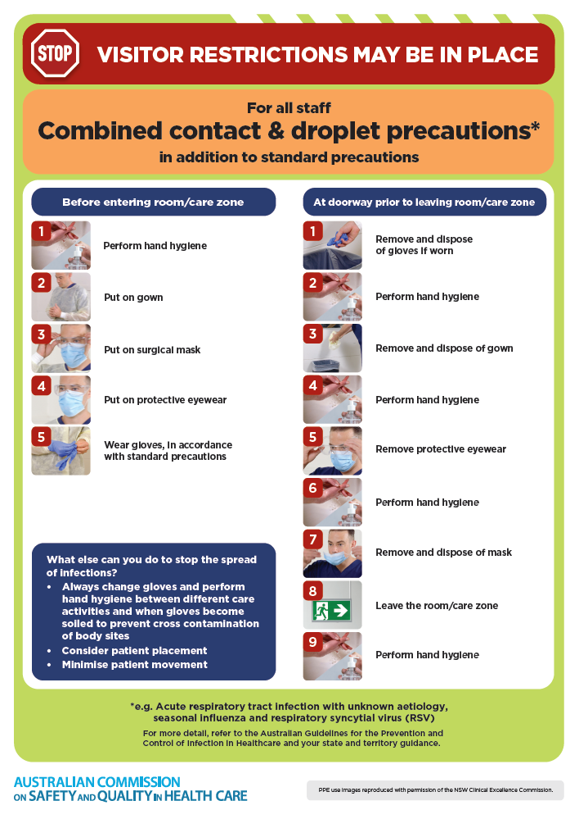](https://www.safetyandquality.gov.au/publications-and-resources/resource-library/infection-prevention-and-control-poster-combined-contact-and-droplet-precautions)
* ***Poster – Combined airborne and contact precautions***<https://www.safetyandquality.gov.au/publications-and-resources/resource-library/infection-prevention-and-control-poster-combined-airborne-and-contact-precautions>  
  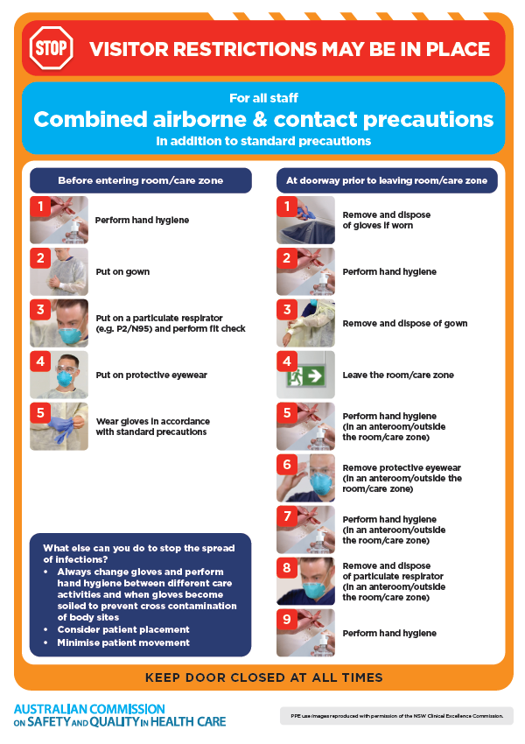
* ***Environmental Cleaning and Infection Prevention and Control*** [www.safetyandquality.gov.au/environmental-cleaning](http://www.safetyandquality.gov.au/environmental-cleaning)
* ***Break the chain of infection*** poster  
  <https://www.safetyandquality.gov.au/publications-and-resources/resource-library/break-chain-infection-poster>  
    
  **[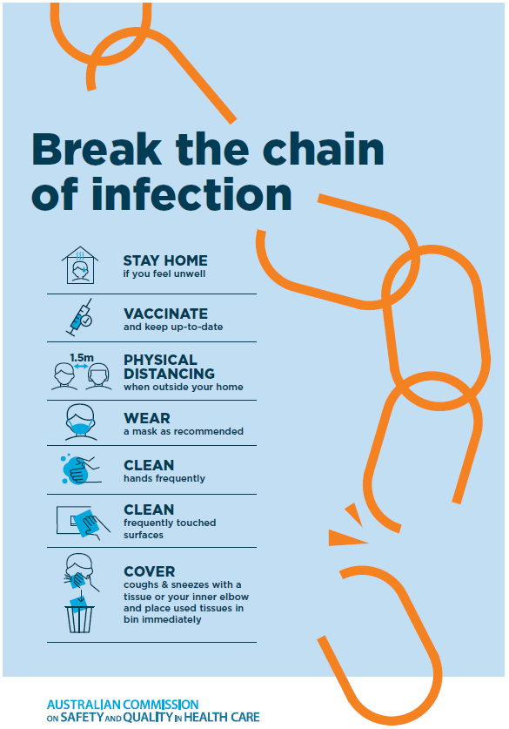](https://www.safetyandquality.gov.au/publications-and-resources/resource-library/break-chain-poster-a3https:/www.safetyandquality.gov.au/publications-and-resources/resource-library/break-chain-poster-a3)**

**Disclaimer**

On the Radar is an information resource of the Australian Commission on Safety and Quality in Health Care. The Commission is not responsible for the content of, nor does it endorse, any articles or sites listed. The Commission accepts no liability for the information or advice provided by these external links. Links are provided on the basis that users make their own decisions about the accuracy, currency and reliability of the information contained therein. Any opinions expressed are not necessarily those of the Australian Commission on Safety and Quality in Health Care.