# Australian Commission on Safety and Quality logotypeOn the Radar

Issue 702

30 June 2025

*On the Radar* is a summary of some of the recent publications in the areas of safety and quality in health care. Inclusion in this document is not an endorsement or recommendation of any publication or provider. Access to particular documents may depend on whether they are Open Access or not, and/or your individual or institutional access to subscription sites/services. Material that may require subscription is included as it is considered relevant.

*On the Radar* is available online, via email or as a PDF or Word document from <https://www.safetyandquality.gov.au/newsroom/subscribe-news/radar>

If you would like to receive *On the Radar* via email, you can subscribe on our website <https://www.safetyandquality.gov.au/newsroom/subscribe-news>  
or by emailing us at [mail@safetyandquality.gov.au](mailto:mail@safetyandquality.gov.au).  
You can also send feedback and comments to [mail@safetyandquality.gov.au](mailto:mail@safetyandquality.gov.au).

For information about the Commission and its programs and publications, please visit <https://www.safetyandquality.gov.au>

**On the Radar**

Editor: Dr Niall Johnson  
Contributors: Niall Johnson, Julie Nguyen

***Preventing falls and harm from falls best practice in older people: Best Practice Guidelines***

<https://www.safetyandquality.gov.au/our-work/falls-prevention>

Falls are the leading cause of injury-related hospitalisations in Australia. Falls remain a major safety and quality risk and can cause significant harm to older people in hospital, aged care services, care delivered in the community and the home.

The Australian Commission on Safety and Quality in Health Care has released revised national guidance on how to prevent falls and fall-related injury. This is the first revision of the Falls Guidelines since 2009.

*Preventing falls and harm from falls best practice in older people: Best Practice Guidelines* (Falls Guidelines 2025) have been updated to provide clear recommendations and good practice points based on evidence from systematic reviews and expert opinion.

The Falls Guidelines have been updated with supporting resources for each setting:

* Residential Aged Care Services
* Hospitals
* Community Care.

Health professionals can use this guidance to work with people at risk of harm from falls to reduce risk factors and tailor interventions for a person-centred approach.

The evidence base for the revised Falls Guidelines has been developed in collaboration with Neuroscience Research Australia (NeuRA) and the Australia and New Zealand Falls Prevention Society (ANZFPS). A public consultation provided important feedback from the sector in 2024, with subject matter experts refining the guidance

The new guidelines and supporting resources for each setting are available from the [Falls Prevention webpage](https://safetyandquality.createsend1.com/t/j-i-wdrjtjd-l-y/)

***Australian Atlas of Healthcare Variation Focus Report: Chronic Obstructive Pulmonary Disease (COPD)***

<https://www.safetyandquality.gov.au/our-work/healthcare-variation/atlas-focus-report-chronic-obstructive-pulmonary-disease>

The Australian Commission on Safety and Quality in Health Care (the Commission) has released the latest *Atlas Focus Report:* *Chronic Obstructive Pulmonary Disease (COPD).*

The interactive report examines trends for two elements of COPD care covered in the [*Chronic Obstructive Pulmonary Disease Clinical Care Standard*](https://www.safetyandquality.gov.au/standards/clinical-care-standards/chronic-obstructive-pulmonary-disease-clinical-care-standard): spirometry, which is essential for accurate diagnosis, and pharmacotherapy, which should be stepped up (or down) according to severity of symptoms.

Key findings from the report includes a 31% decrease in national rate of spirometry services and a 130% increase in prescriptions dispensed for triple therapy – a combination of inhaled corticosteroids (ICS) with long-acting dual bronchodilators (LAMA and LABA) – between 2015–16 and 2022–23. The report shows increases in geographical variation and discusses potential reasons for the changes in rates and what could be done to address it.

The Commission is calling on healthcare leaders, primary care providers and policy makers to review the findings and consider actions that improve access to spirometry, support appropriate prescribing and ensure equitable, high-quality care for people with COPD.

Explore the rates for your local area at [*Atlas Focus Report: Chronic Obstructive Pulmonary Disease*](https://www.safetyandquality.gov.au/our-work/healthcare-variation/atlas-focus-report-chronic-obstructive-pulmonary-disease) or download the [*Highlights Report: COPD*](https://www.safetyandquality.gov.au/publications-and-resources/resource-library/highlights-report-copd) for a national summary of the report.

**Books**

*Audit, Feedback, and Behaviour Change*

Elements of Improving Quality and Safety in Healthcare

Ivers N, Foy R

Cambridge: Cambridge University Press; 2025.

|  |  |
| --- | --- |
| DOI | <https://doi.org/10.1017/9781009604697> |
| Notes | This volume is the latest release in the [Elements of Improving Quality and Safety in Healthcare](https://www.cambridge.org/core/publications/elements/elements-of-improving-quality-and-safety-in-healthcare) series from The Healthcare Improvement Studies Institute (the THIS Institute) in Cambridge, England. This volume examines the evidence base for using audit and feedback to support improvement in health care, covering its origins, theoretical foundations, and the evidence that supports it. The authors also review limitations and risks of the approach. |

**Reports**

*Rebuilding Public Health: Restoring the Foundations of Prevention*

British Medical Association

London: BMA; 2025. p. 39.

*What is prevention in health?*

Arnold S, Holden J

London: The King's Fund; 2025

|  |  |
| --- | --- |
| URL | BMA <https://www.bma.org.uk/what-we-do/population-health/investment-in-public-health/resourcing-prevention-the-urgent-need-to-invest-in-public-health>  Arnold and Holden <https://www.kingsfund.org.uk/insight-and-analysis/long-reads/what-is-prevention-in-health> |
| Notes | Prevention or preventive (or even preventative) health occasionally attracts some attention, and these two reports suggest another such moment, particularly in the UK context.  The report from the British Medical Association (BMA) calls for a greater focus on public health. The report opens with the observation that ‘Public health in the UK has been gutted. Years of insufficient funding and resourcing has left it unable to meet the exponentially growing needs of an increasingly sick and economically inactive population. Investing in public health will help prevent more ill health, reduce pressures on the NHS, tackle health inequalities, and grow the economy’ It is also noted that there needs to a focus on prevention, as ‘Prevention will always be better, and cheaper, than a cure, but preventing illness will not happen without investing in the public health services and expertise with a track record of protecting and promoting health’  In their long read for The King’s Fund in the UK, Arnold and Holden offer something of introduction to what is prevention in health, including the apparent lack of attention paid to prevention. |

**Journal articles**

*Asking patients to share a short biography establishes a better connection and improves care*

Majno-Hurst P, Fadda M, Taddei L, Cristaudi A

BMJ. 2025;389:r1157.

|  |  |
| --- | --- |
| DOI | <https://doi.org/10.1136/bmj.r1157> |
| Notes | Paper describing a Swiss project in which they ‘have been asking patients who are scheduled for major surgery to write and share a short biography with the healthcare team: “Introduce yourself as you want to be known by the people who will look after you. Tell us also what is important to you, and what is important that the staff knows to care for you as a person and not just as the bearer of your disease.”’ The authors assert that the practice has changed the nature of their interactions with patients and changed the working culture. This is reminiscent of similar programs elsewhere, such as ‘What Matters To You’ where the positive impacts for patients and clinicians have also been noted. |

For information on the Commission’s work on partnering with consumers, see <https://www.safetyandquality.gov.au/our-work/partnering-consumers>

*Perceptions and Experiences of Consumer Representatives on Patient Safety Investigation Teams: A Qualitative Analysis*

Hibbert PD, Yu Y, Molloy CJ, Ames M, Brown D, Berrill J, et al

Health Expectations. 2025;28(3):e70281.

|  |  |
| --- | --- |
| DOI | <https://doi.org/10.1111/hex.70281> |
| Notes | Paper reporting on a qualitative study of the experience of including consumer representatives in patient safety investigation teams. Using interviews with consumer representatives and focus groups of health service staff in Victoria, Australia the authors report:   * Consumer representatives ‘have positive experiences in patient safety investigation teams, and their involvement often leads to more patient-focused reviews and outcomes, and use of plain language.’ * ‘…they also experienced some challenges, such as not being fully respected as equal members of the team, feeling uncomfortable speaking up, and practical issues such as payments and access to documents.’   Training, support and resourcing can be important determinants to how such initiatives are borne out. |

*Screening for Intimate Partner Violence and Caregiver Abuse of Older or Vulnerable Adults: US Preventive Services Task Force Recommendation Statement*

U. S. Preventive Services Task Force

JAMA. 2025

*Screening for Intimate Partner Violence and for Caregiver Abuse of Older or Vulnerable Adults: An Evidence Report and Systematic Review for the US Preventive Services Task Force*

Feltner C, Peat C, Asher GN, Wright S, Vaughan J, Middleton JC, et al.

JAMA. 2025.

*The Evidence for Intimate Partner Violence and Elder Abuse Screening: Stagnation at a Critical Juncture*

Simon MA

JAMA. 2025.

*Updated USPSTF Guidelines on Screening for Intimate Partner Violence and Caregiver Abuse*

Rittenberg E, Covinsky KE, Grady D

JAMA Internal Medicine. 2025.

|  |  |
| --- | --- |
| DOI | U. S. Preventive Services Task Force <https://doi.org/10.1001/jama.2025.9009>  Feltner et al <https://doi.org/10.1001/jama.2025.2449>  Simon <https://doi.org/10.1001/jama.2025.10085>  Rittenberg <https://doi.org/10.1001/jamainternmed.2025.3095> |
| Notes | The U. S. Preventive Services Task Force has developed a Recommendation Statement supported by an [evidence report and systematic review](https://doi.org/10.1001/jama.2025.2449) on the benefits and harms of screening for intimate partner violence (IPV), abuse of older adults, and abuse of vulnerable adults. Along with the publication of these items in *JAMA*, there are related editorials in [*JAMA*](https://doi.org/10.1001/jama.2025.10085) and [*JAMA Internal Medicine*](https://doi.org/10.1001/jamainternmed.2025.3095).  ‘The USPSTF **recommends that clinicians screen for IPV in women of reproductive age, including those who are pregnant and postpartum**. (B recommendation) The USPSTF concludes that the current evidence is insufficient to assess the balance of benefits and harms of screening for caregiver abuse and neglect in older or vulnerable adults. (I statement)’ |

*BMJ Leader*

Volume 9, Issue 2, June 2025

|  |  |
| --- | --- |
| URL | <https://bmjleader.bmj.com/content/9/2> |
| Notes | A new issue of *BMJ Leader* has been published. Articles in this issue of *BMJ Leader* include:   * **Adaptive leadership in crisis**: a healthcare system's resilience journey (Marie Aouad, Maya Jalbout Hastie, Vanda Yazbeck Karam) * **Lived experience matters**: transforming healthcare through kindness and collaboration (Jason Wolf) * Cultivating the **next generation of healthcare leaders**: reflections from an established healthcare leader (Rakhshan Kamran, Andrea S Doria) * 'Can you have it all?' Exploring **perceived gender roles in leadership** through the lens of the Chief Pharmaceutical Officer's clinical fellows 2023/24 (Ashifa Trivedi, Kaniksha Aggarwal, Amira Chaudry, Summer Ibrahim, Amna Khan-Patel, Natasha Lal, Maria Nasim, HoJan Senya, Shy Teli, Nisha Thakrar, Clare Thomson) * Development of home-based care educational programme for the family caregivers of activity limited older people: an **educational programme model for community nurses** (H S Maliga S K Wijesiri) * Professional development scheme: a tool to measure **health research competencies in healthcare professionals** (Davide Bilardi, Elizabeth Rapa, Kehkashan Shah, Salvia Zeeshan, Bonny Louise Baker, Trudie Lang) * **Obesity**, laypeople's beliefs and implications for clinicians and leaders of healthcare organisations (Aneel Karnani, Brent McFerran, A Mukhopadhyay) * What can healthcare organisations do to improve **medical engagement**? A systematic review (Jen Perry) * **Interprofessional collaboration in primary care** for patients with chronic illness: a scoping review mapping leadership and followership (Guoyang Zhang, Renée E Stalmeijer, Fury Maulina, Frank W J M Smeenk, C Sehlbach) * **Performance-related pay** for NHS consultants: exploring views and perceived impacts in one NHS Trust in England (Mark Exworthy, Julia Gauly, Jo Parsons, Katlyn Green, Nick Murphy) * Evaluation of the first 5 years of the **Next Generation GP leadership programme**: balancing autonomy and accountability (Steve Gulati, Judith A Smith) * Perspectives on **leadership for medical educators**: a qualitative study of leadership qualities identified by US medical school deans (Michael J Orrick, Steven Durning, Joshua Hartzell, Anita Samuel) * **Logistics and administration-related stressors** among young physicians working in the emergency medicine (EM) department and their perceived job satisfaction in EM department across hospitals of India: a nationwide multicentric digital survey (Murtuza Ghiya, Alok A Gangurde, Jilshy Varghese, Mohamed M A Hishaam, Balamurali Krishna, Jeffrey Pradeep Raj, M M Lal) * **Resident doctors**: return of the lost tribe (Waqas Akhtar, Vivek Trivedi) * Improvisation versus protocol: navigating the benefits and pitfalls of **leadership jazz in healthcare settings** (Maximilian Kalyuzhnov, Olena Khlystova, Benjamin Laker) * Key to **successful global health collaborations**: research, ethics and community engagement and involvement (Athula Sumathipala, Oshini Sri Jayasinghe, Buddhika Fernando) * Ten years on: The **Snowy White Peaks of the NHS** (Roger Kline) * **Same-day service**: why healthcare cannot continue to be the exception (Allen M Chen) * Engaging nursing and midwifery policymakers and practitioners in **digital transformation**: an international nursing and midwifery perspective (Vanessa Ann Heaslip, Michael Shannon, Gillian Janes, Natasha Phillips, Clayton Hamilton, Joanne Reid, Rolf A Oxholm, B Lüdemann, J Gentil, M Langins) * Without medical education, a **learning healthcare system** cannot learn (Michael A Barone, Carol Carraccio, Alison Lentz, Robert Englander) * Role of medical regulators in **physician wellness**: leading or lagging? A brief report on physician wellness practices (Iris Reijmerink, Maarten J van der Laan, Dave Dongelmans, Fokie Cnossen, Ian Leistikow) * Building **allied health professions' leadership self-efficacy** through authentic experiential learning: a participatory evaluation of allied health professions leadership fellow secondments (Deborah Harding, Helen Lycett, Leila Avery, Tania Kumaresan, Venus Madden) * **Transforming safety culture** in neonatal intensive care teams (Zheng Jing Hu, Gerhard Fusch, Enas El Gouhary, Jennifer Twiss, Amneet Sidhu, Elias Chappell, Emmeline Sheehan, Zoe el Helou, Robert Robson, Kemi Salawu Anazodo, Lehana Thabane, Peter Lachman, Salhab el Helou) |

*Emergency Medicine Australasia*

Volume 37, Issue 3, June 2025

|  |  |
| --- | --- |
| URL | <https://onlinelibrary.wiley.com/toc/17426723/2025/37/3> |
| Notes | A new issue of *Emergency Medicine Australasia* has been published. Articles in this issue of *Emergency Medicine Australasia* include:   * Evaluation of a **virtual emergency care service** to avoid unnecessary emergency department presentations and provide specialist‐led definitive care (Laura R Joyce, Marc Gutenstein, Mark Gilbert, James Weaver, Scott Pearson, John W Pickering, Martin Than) * Clinical characteristics of **mental health presentations of children and young adults to the emergency department** during the COVID‐19 pandemic in Sydney, Australia (Saartje Berendsen Russell, Shanti Pun, Farina Jeyaraj, Margaret Murphy, Nicole Bohlken, Emma Jenkins, Kerrie Bubb, Naomi Derrick, William Royle, Radhika V Seimon, Kendall Bein, M M Dinh) * Establishing research priorities in **emergency medicine telehealth** (Muhuntha Sri-Ganeshan, Ruth Large, Michael Ben-Meir, Frances Kinnear) * Performance characteristics and complications of an Inter‐Changeable Operator Model for **intubation** in an Australian helicopter emergency medical service (Alan A Garner, Andrew Scognamiglio, Anna Lee) * Use of **prehospital early warning scores** to predict short‐term mortality: A systematic review (David Naylor, Bridget Dicker, Graham Howie, Verity Todd) * The incidence and determinants of **traumatic brain injury deaths** occurring outside hospital in Australia (Gerard M O'Reilly, Afsana Afroz, Kate Curtis, Biswadev Mitra, Yesul Kim, Emma Solly, Courtney Ryder, Kate Hunter, Delia V Hendrie, Nick Rushworth, Jin Tee, Mark C Fitzgerald) * **Atrial fibrillation patients** presenting to an emergency department successfully managed with a next‐day community follow‐up pathway: A before‐and‐after cohort study (Finn Brokenshire, John W Pickering, Ibrahim S Al-Busaidi, Martin Than, Richard Troughton, Kaleb Addy, Laura R Joyce) * Does **frailty scoring** help to predict outcomes in older patients with major trauma? A retrospective study at a major trauma centre (Charlotte G Underwood, Andrew McCombie, Maria Nonis, Laura R Joyce) * **Emergency Department Presentations in Culturally and Linguistically Diverse Populations** Based on Preferred Language. Characteristics and Outcomes in New South Wales Australia (Michael M Dinh, Saartje Berendsen Russell, Michele Fiorentino, Radhika Seimon, Kendall Bein) * Is Radiological Reporting of ‘Tension’ in **Spontaneous Pneumothorax** Driving Unnecessary Intervention? (Anne Maree Kelly, Roland Bammer, Y C Gary Lee, Julian A Smith, Ethan Bacon, Diana Egerton-Warburton) * A Physiotherapy‐Led Emergency Department Guideline (PLEDGE) for Patients Presenting With **Low Back Pain**: Pre‐ and Post‐Implementation Study (Rosalie Gan, Caitlin Farmer, Alisha da Silva, Katharine Drummond, Lucinda Marr, John H Y Moi, Mark Putland) * A Mixed Methods Exploration of Patient and Clinician Perspectives of **Pelvic Examinations** in Emergency Departments (Cara Frain, Caitlin Brandenburg, Eve Purdy, Graeme Walker, Gerben Keijzers) * Supraglottic Airway Device Use During **Paediatric Airway Management** in the Emergency Department: A Registry Study (Sarah Rathe, Hatem Alkhouri, Katie Reeves, Andrew Tagg, Bernard McCarthy, Sharon O'Brien, Eleanor Loughhead, Ben Lawton, Jeremy Furyk, Frances B. Kinnear, Matthew O'Gorman, Eunicia Tan, Andrew Brainard, Shane George, Amit Kochar, Simon Craig, Stefano Sabato, Franz E Babl, Elliot Long) * Can Non‐Neurosurgeons Operate on **Traumatic Brain Injuries** in Non‐Metropolitan Areas? A Scoping Review (Lauren Bosley, Clinton Gibbs, Eunah Joo, Geoffrey Dobson) * Doctors' and Nurses' Perceptions on Barriers and Facilitators to Implementing **Clinical Pharmacy Services in the Emergency Department** in Singapore (Glen Qin Yi Mun, Ruth Kait Rae Kwan, Chuan Poh Lim, Jie Lin Soong) * **Integrating** **Research Practice Into Resuscitation Simulation Training** Improves Recruitment Into Complex Clinical Trials (Daniel M Fatovich, Samantha Carey, John Iliff, Thomas Jowitt, Dieter G Weber, Jennifer S Vance) * Evaluation of a Novel **Clinical Assistant Model of Care** on Patient Flow and Emergency Department Length of Stay (Jeremy Chou, Namankit Gupta, Alvin Lim, Josh Bryan, Katie Walker, Diana Egerton-Warburton, Jeniffer Kim-Blackmore, Rachel Rosler, Andy Lim) * Using a Partnership‐Based Approach to Strengthen **Acute Care Systems in the Pacific and Timor‐Leste** (Sarah Bornstein, Rob Mitchell, Steven McGloughlin, Melanie Wratten, Karen Hammad, Colin Banks, Peter Cameron, Benjamin Dingle, Ann-Maree Guirguis, Chris Guy, Lamour Hansell, Jennifer Jamieson, Arabella Koliwan, Lewis McLean, Naomi McLean, Silina Motofaga, Georgina Phillips, Sally Reid, Cath Tacon, Gerard O'Reilly) * SUPraclavicular Block for **Emergency Reduction of Upper Limb Injuries** Versus Bier Block (SUPERB): An Open‐Label, Noninferiority Randomised Controlled Trial (Henry Tsao, Christopher Tang, Adam Cureton, Laura Maskell, Mark Trembath, Philip Jones, Peter J Snelling) * Case Series of **Resuscitative Hysterotomy in Pregnant Trauma Patients** Performed in the Emergency Department of a Level One Major Trauma Service (Thomas A G Shanahan, Jason Gabriel-Anyassor, Stefan C Kane, Kellie Gumm, David J Read, Elyssia Bourke) * A **Virtual Emergency Department** Reduces Unnecessary Transfers to Hospital of Residential Aged Care Residents Who Fall With Headstrike (Tim Tse, Alan George Mackenzie Jardine, Lorcan Taylor, Suzanne M Miller, Jason Talevski, Adam Semciw, Hazel Heng, Jennie E Hutton, Loren Sher) * **Extracorporeal CPR**: What Future FACEMs Need to Know (Joshua I Smith, Daphne Cohen) * **ECPR** in the Emergency Department (Julia Coull, Brooke Riley, David Anderson, Sacha Richardson) * **Prehospital ECPR** for Out‐Of‐Hospital Cardiac Arrest (Brian Burns, Natalie Kruit, Mark Dennis, Alice Hutin, Dinis Reis Miranda, Demetris Yannopoulos) * Reflections on **ECPR** in New Zealand: Past, Present and Future (S Wiebe, A Boehm) * **Phlebotomists on Emergency Department Performance**: A Retrospective Comparative Study (Abdi D Osman, Jahar Bhowmik, Daryl Yeak, Michael Ben-Meir, Negar Mansouri, George Braitberg) * **Emergency Department Presentations by International Migrants** Requiring Interpreter Service: An Observational Study (Ya-Ling Huang, Amy Lynn Sweeny, Dinesh Palipana, Robert Lee, Brooke Calcagno, Shahina Braganza, Julia Crilly) * **Learning Shifts of Clinicians Who Become Clinician‐Coaches**: An Exploratory Qualitative Study of Emergency Physicians (Andrew Rixon, Victoria Lister, Lee Yung Wong, Elizabeth Elder, Samuel Wilson) * **Clinical Debriefing Characteristics** in Australian and New Zealand Paediatric Emergency Departments: A PREDICT Study Revisited (Dami Denbali, Meredith L. Borland, Sharon O'Brien) * Performance Review of **Emergency Care Management Plans Pre‐ and Post‐Implementation of Electronic Records** (Daryl Yeak, Abdi D. Osman, Paul MacGibbon, A Van Der End, N Mansouri, M Matarazzo, G Braitberg) * Balancing Act: **Digoxin Antidote** Supply and Demand in New South Wales, Australia (Julia Jeong, Nicholas A Buckley, Rose Cairns, Betty S Chan) * Validation of Rapid Rule‐Out Criteria Using the Beckman Access hsTnI Assay for Patients With Suspected **Myocardial Infarction** in a Cardiac Emergency Department (Robert Meek, Oliver Weiner, Somesh Venkatesan, Georgina Hayden, Adam Damianopoulos, Tippiporn Morgan, Elise McLeod, Alex Duong, Diana Egerton-Warburton) |

*International Journal for Quality in Health Care* online first articles

|  |  |
| --- | --- |
| URL | <https://academic.oup.com/intqhc/advance-articles> |
| Notes | *International Journal for Quality in Health Care* has published a number of ‘online first’ articles, including:   * Inpatient Falls and Pressure Ulcers as **Nursing Quality Indicators** in National Benchmarking—A Retrospective Observational Registry Study (Terhi Lemetti et al) * **Coproducing data-driven organisational safety with patients**: development and cognitive testing of a multi-setting patient-reported safety concern tool (Abubakar Sha’aban et al) |

**Online resources**

***Clinical Communiqué***

<https://www.thecommuniques.com/post/clinical-communiqu%C3%A9-volume-12-issue-1-winter-2025>

Volume 12, Issue 1, Winter 2025

This issue of *Clinical Communiqué* examines the cases of two patients who died as a result of overwhelming **necrotising fasciitis** (also known as necrotising soft tissue infection, NSTI). The expert commentary focuses on the diagnostic challenges and management principles for NSTI.

***Australian Living Evidence Collaboration***

<https://livingevidence.org.au/>

***Guidance***

A number of guidelines or guidance have recently been published or updated. These include:

* *Australasian Diabetes in Pregnancy Society (ADIPS) 2025 consensus recommendations for the* ***screening, diagnosis and classification of gestational diabetes****,* Medical Journal of Australia <https://doi.org/10.5694/mja2.52696>

**Infection prevention and control and COVID-19 resources**

The Australian Commission on Safety and Quality in Health Care has developed a number of resources to assist healthcare organisations, facilities and clinicians. These resources include:

* ***Poster – Combined contact and droplet precautions*** <https://www.safetyandquality.gov.au/publications-and-resources/resource-library/infection-prevention-and-control-poster-combined-contact-and-droplet-precautions>  
  [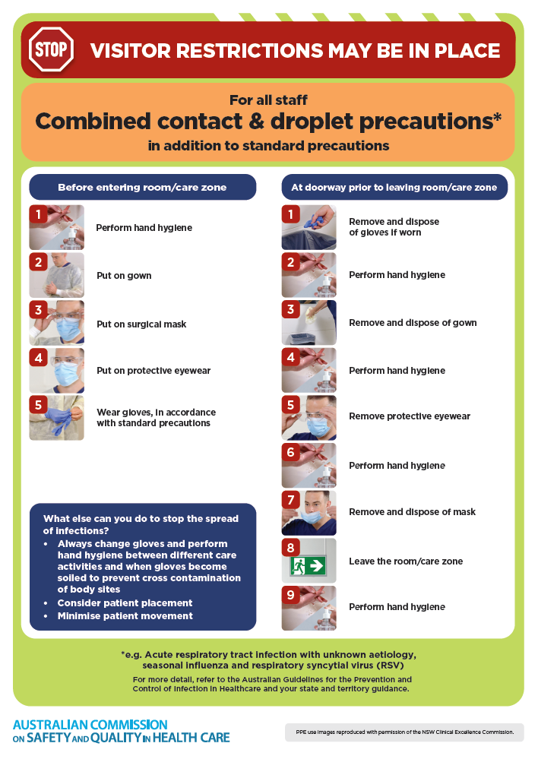](https://www.safetyandquality.gov.au/publications-and-resources/resource-library/infection-prevention-and-control-poster-combined-contact-and-droplet-precautions)
* ***Poster – Combined airborne and contact precautions***<https://www.safetyandquality.gov.au/publications-and-resources/resource-library/infection-prevention-and-control-poster-combined-airborne-and-contact-precautions>  
  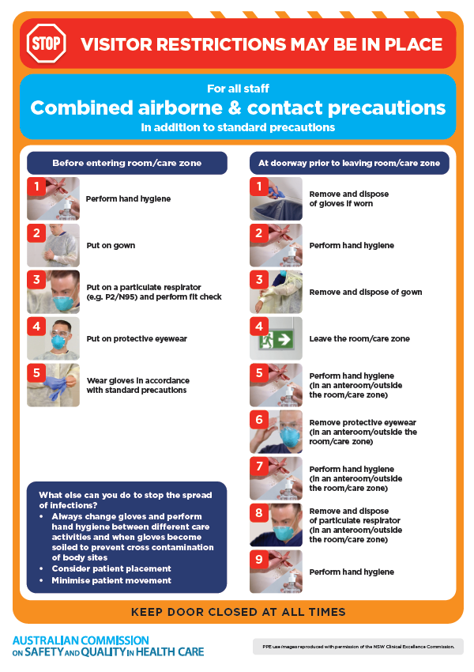
* ***Environmental Cleaning and Infection Prevention and Control*** [www.safetyandquality.gov.au/environmental-cleaning](http://www.safetyandquality.gov.au/environmental-cleaning)
* ***Break the chain of infection*** poster  
  <https://www.safetyandquality.gov.au/publications-and-resources/resource-library/break-chain-infection-poster>  
    
  **[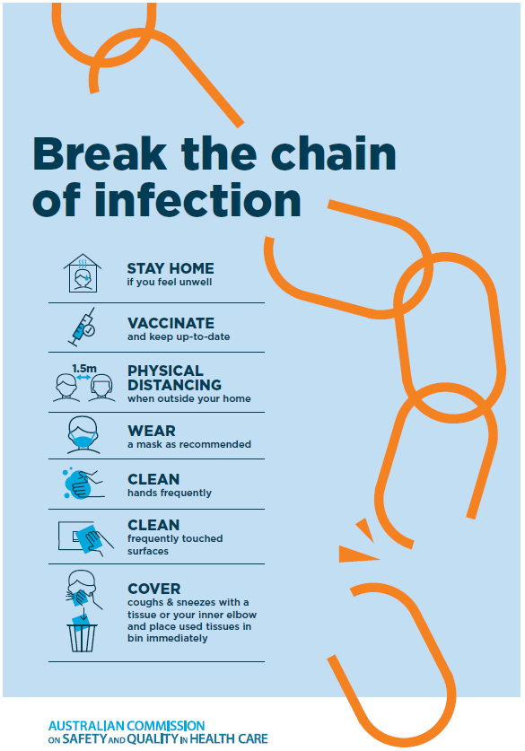](https://www.safetyandquality.gov.au/publications-and-resources/resource-library/break-chain-poster-a3https:/www.safetyandquality.gov.au/publications-and-resources/resource-library/break-chain-poster-a3)**

**Disclaimer**

On the Radar is an information resource of the Australian Commission on Safety and Quality in Health Care. The Commission is not responsible for the content of, nor does it endorse, any articles or sites listed. The Commission accepts no liability for the information or advice provided by these external links. Links are provided on the basis that users make their own decisions about the accuracy, currency and reliability of the information contained therein. Any opinions expressed are not necessarily those of the Australian Commission on Safety and Quality in Health Care.