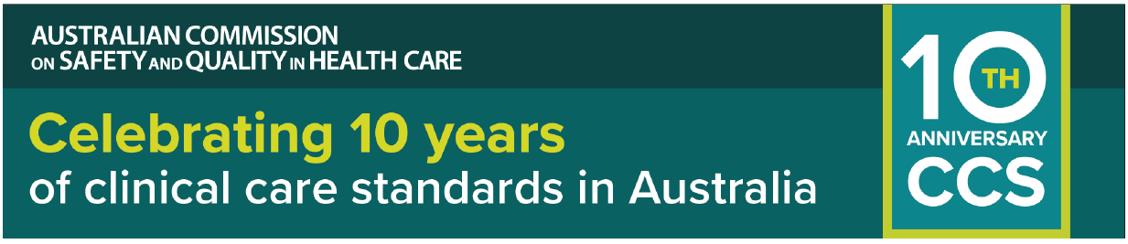
NEWSLETTER CONTENT – FOR INTERNAL AND EXTERNAL USE
The newsletter copy below may be adapted to your context and audience.
July 2025
Health services recognised for excellence in Clinical Care Standards
To mark the 10-year anniversary of the Clinical Care Standards, the Australian Commission on Safety and Quality in Health Care has recognised excellence in implementing these standards to improve patient care.
Five health services from across Australia have been selected for an Excellence Award for demonstrating successful implementation of a national Clinical Care Standard.
Their stories were chosen from submissions received from across Australia.
Commission Board Chair, Professor Christine Kilpatrick AO, congratulated Award recipients.
“Each service offered a unique story, with evidence of how meaningful change can be achieved by effectively implementing a Clinical Care Standard. This inevitably meant innovating to overcome hurdles,” Professor Kilpatrick said.
The Commission is showcasing these five ‘Stories of Excellence’ for other health services to learn from their experiences.
The five Award recipients are:
- Acute Stroke Clinical Care Standard
Stroke Services, University Hospital Geelong, Barwon Health
- Antimicrobial Stewardship Clinical Care Standard
Canberra Health Services Antimicrobial Stewardship Team, Canberra Hospital
- Colonoscopy Clinical Care Standard
Northern NSW Local Health District
- Opioid Analgesic Stewardship in Acute Pain Clinical Care Standard
Medicines Optimisation Service (Austin Health, Heidelberg)
- Sepsis Clinical Care Standard
Flinders and Upper North Local Health Network
Register for the webinar on 19 August 2025 to hear representatives from these health services share their experiences of improving patient care.
Learn more about each of these Stories of Excellence at safetyandquality.gov.au/CCS-10
Read the congratulatory Message from the Board Chair.
ENDS

