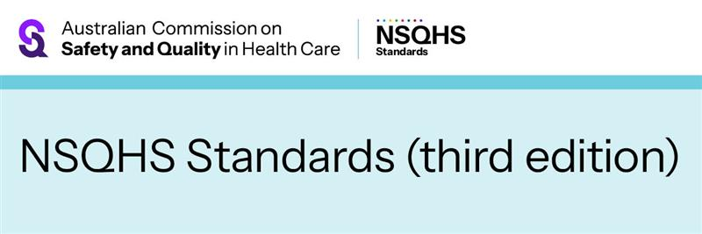

**NEWSLETTER CONTENT – FOR INTERNAL AND EXTERNAL USE**

July 2025

**Consultation open for third edition of the NSQHS Standards**

As the national agency responsible for leading safety and quality improvement, the [Australian Commission on Safety and Quality in Health Care](https://www.safetyandquality.gov.au) (the Commission) develops national standards in collaboration with the healthcare system and community representatives.

The Commission is developing the National Safety and Quality Health Service (NSQHS) Standards (third edition).

In July 2025, public consultation opened to capture information on the health sector’s needs for the next edition of the standards. Consultation is open from 9 July to 30 September 2025.

By consulting broadly, the Commission aims to identify:

* focus areas for the NSQHS Standards (3rd ed.)
* emerging and existing safety and quality issues
* key learnings from the [NSQHS Standards (second edition)](https://www.safetyandquality.gov.au/publications-and-resources/resource-library/national-safety-and-quality-health-service-standards-second-edition)
* opportunities to improve the NSQHS Standards structure
* ways to improve engagement with and implementation of the NSQHS Standards.

The NSQHS Standards (3rd ed.) will incorporate new evidence-based practices, emerging evidence and contemporary clinical governance approaches.

The Commission is seeking feedback in several ways, including written submissions, online surveys, face-to-face meetings and online focus groups.

To participate in the national consultation, go to the Commission’s Engagement Hub at [safetyandquality.gov.au/NSQHSS-thirdedition](https://www.safetyandquality.gov.au/NSQHSS-third)

The Commission anticipates releasing the draft NSQHS standards (3rd ed.) in 2026 for comment and launching the standards in 2028. Assessment to the NSQHS Standards (3rd ed.) is scheduled to commence in 2030.

[Subscribe to receive news updates](https://www.safetyandquality.gov.au/newsroom/subscribe-news) on how to get involved in the consultations.

ENDS