INFORMATION
for CMO mental health
service providers

July 2025

How-to Guide: self-assessment tool
  - National Safety and Quality Mental Health Standards for Community Managed Organisations (NSQMHCMO Standards)

Contents
The NSQMHCMO Standards 3
Introduction to the self-assessment tool 3
Using the tool 3
Overview 4
Printing 9
Things to avoid when using the self-assessment tool 9
Further information 9

The NSQMHCMO Standards
The National Safety and Quality Mental Health Standards for Community Managed Organisations (NSQMHCMO Standards) aim to improve the quality of mental health service provision, and to protect consumers, their families and carers from harm.
The three NSQMHCMO Standards include 82 actions related to delivery of mental health services by Community Managed Organisations (CMOs). They describe the level of care and the safeguards that a CMO should provide.
Service providers using the NSQMHCMO Standards should have systems and processes in place to reduce the risk of harm, protect privacy and increase confidence and assurance in the quality of their mental health services.
By conducting a self-assessment, you can identify both areas where your organisation meets the standards and areas where improvement is required.

Introduction to the self-assessment tool
The Commission has developed the self-assessment tool as part of a suite of resources to assist community-managed mental health service providers to implement the NSQMHCMO Standards.
The self-assessment tool is a resource that initially helps you to determine how well you meet the NSQMHCMO Standards and monitor progress towards full implementation. You are encouraged to review the NSQMHCMO Standards and assess and record your progress using the self-assessment tool.
Each of the 82 actions in the NSQMHCMO Standards is listed in the self-assessment tool, along with reflective questions that help you to focus on the key requirements of each action. Each of the three standards has its own worksheet in the self-assessment tool.
The tool allows you to assess and decide which, if any, actions do not apply in the type of mental health services that you provide.
The self-assessment tool allows service providers to track the progress of implementing each standard. It should be used together with the NSQMHCMO Standards and the Guide for service providers.
Service providers will use the tool to:
- Rate their performance against each action
- List examples of evidence that support the performance rating for each action
- Identify actions, or parts of actions, that are not applicable to services provided and list a rationale supporting this claim.
This guide provides step-by-step instructions for completing the self-assessment tool.
You can download the self-assessment tool from http://www.safetyandquality.gov.au/mh-cmos.

Using the tool
The self-assessment tool is a good place to record your plan for improvement for each applicable NSQMHCMO Standards action. It allows you to assign tasks to a specific person or team, and to set a timeframe for completing tasks.
When you implement the actions, you will need to apply a risk management approach (see the Using a risk management approach fact sheet). You can then estimate the extent to which each action is met and record these estimates as percentages in the self-assessment tool. The tool will then auto-populate the ‘performance rating’ column to match the ‘estimate of percentage complete’ for each action.
The self-assessment tool allows you to list or link the documents, policies and reports that show your progress on the implementation of each action. The documents that are included should:
- Align with your assessed risk for that action
- Reflect the variety and types of mental health services that your organisation offers.
The tool lists the types of documents or evidence that can demonstrate you are meeting the requirements in the standards. The list is not exhaustive, and you do not need to include all of the examples given (or any at all) if you have other examples that support your assessment.

A note on accreditation
Service providers must not declare that they meet the NSQMHCMO Standards until they have successfully completed an independent assessment with an approved accrediting agency. Contact details of Commission approved accrediting agencies are located here.

Overview
There is a worksheet for each of the three NSQMHCMO Standards:
- Practice Governance
- Partnering with Consumers, Families and Carers
- Model of Care.
The worksheet includes columns for the actions, reflective questions, examples of evidence, performance rating, estimate of percentage complete, action plan or comments, responsible person or area, due date and priority rating.
There is a row for each action in the NSQMHCMO Standards. Actions (columns A and B) list action numbers and requirements.
Image 1 shows the worksheet for the Practice Governance Standard:
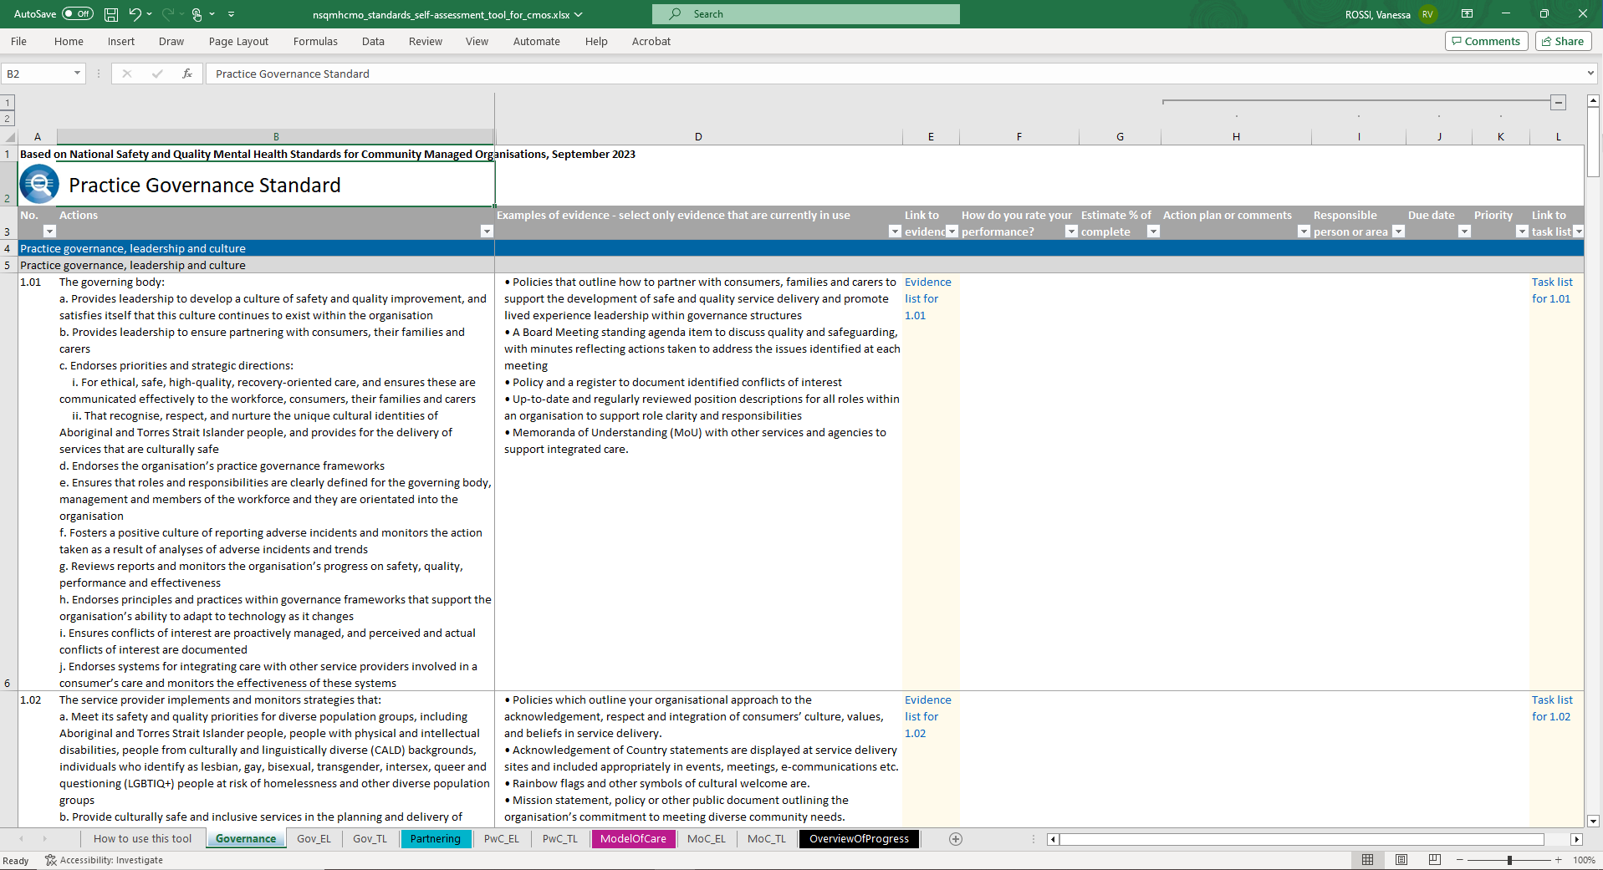
Image 1: Practice Governance Standard worksheet

Listing your examples of evidence

Reflective questions
Reflective questions (column C) assist in helping you consider the intent of the action.
If you are familiar with the purpose of the action, you may choose to hide this column by clicking on the Hide Button located above column D. The button looks like a minus sign. If the column is hidden and you need it displayed, click on the Show Button located above column D. The button looks like a plus sign.

Examples of evidence
Examples of evidence (column D) are given as a guide only. You do not need to produce all of the examples of evidence listed: you can produce one, some or none if you have other forms of evidence that demonstrates conformance with the action.

Link to evidence
Link to evidence (column E) lists hyperlinks to the evidence list worksheet. Hyperlink cells are shaded with a pale-yellow colour.
Use the hyperlinks in column E to navigate to the corresponding evidence list worksheet (e.g., Gov-EL). The evidence list worksheet has the following columns:
- No. (column B) - lists the action numbers, which are hyperlinks to the respective Standard worksheet. Hyperlink cells are shaded with a pale-yellow colour
- Evidence (column C) - a free text column to list evidence
- Comments (column D) - a free text column to list additional information about the evidence, such as validity dates, or status and location of a document.
Evidence can be listed in separate rows and more rows can be added, if needed. To do this select the row/s below where you want the additional row/s to appear, right click on your mouse and select ‘Insert’.
To remove rows that are no longer required, select the relevant row/s right click on the mouse and select ‘Delete’.

Add a hyperlink
If you want to provide a hyperlink for one of your examples of evidence, select the relevant cell, right click on your mouse and select the ‘Link’ function. A dialogue box titled ‘Insert Hyperlink’ will open, navigate and select the relevant document you want to link to.
Notice that the contents of your cell have changed to a blue-coloured font to show that is now a hyperlink. Click on the hyperlink to open the linked file.
You can also hyperlink to a web page, such as your organisation's intranet page. In the ‘Insert Hyperlink’ dialogue box, enter the web address in the ‘Address’ field located at the bottom of the dialogue box.

Rate your performance

How do you rate your performance
How do you rate your performance (column F) requires you to rate the performance of your services in meeting the requirements of each action. The available evidence should assist you with determining the ratings in this column.
Use the drop-down list for the relevant cell in column F to choose the applicable rating for each action (see Images 2 and 3).

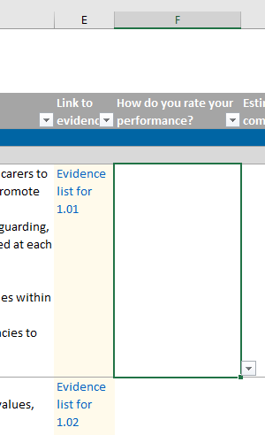 Image 2 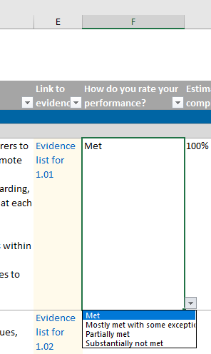Image 3

Estimate of percentage complete
Estimate of percentage complete (column G) is a percentage which should appear automatically when you enter a rating in column F (see Images 4 and 5).
- Met – 100%
- Mostly met with some exceptions – 80%
- Partially met – 50%
- Substantially not met – 20%
- Not applicable – N/A.
NB: do not delete the percentage is this column as this will clear the formula. Changing the rating in column F should automatically update the percentage.

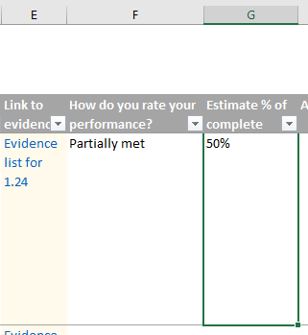 Image 4 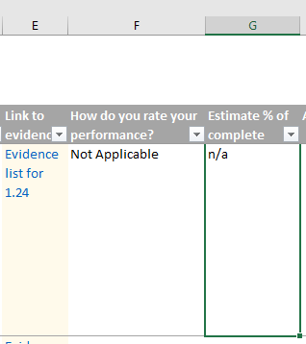 Image 5

Action plan

Action plan or comments
Action plan or comments (column H) is a free text column that allows you to note any tasks that may be needed to complete the action.

Responsible person or area
Responsible person or area (column I) is another free text column that allows you to add the name of the person or group of people with responsibility for ensuring that action is taken.

Due date
Due date (column J) allows you to add a target date of completion for the action. Entries in this column are limited to dates only.

Priority
Priority (column K) allows you to allocate a priority rating to a task. Use the drop-down list for the relevant cell in column K to choose the applicable priority rate of High, Medium or Low.

Link to task list
Link to task list (column L) lists hyperlinks to the task list worksheet. Hyperlink cells are shaded with a pale-yellow colour.
There are two ways to update the task list:
Option 1: Use the available columns in the standard worksheet
Columns H to K in the standard worksheet relates to the task list to meet the requirements of the actions. The disadvantage of listing tasks in the standard worksheet is that you are limited to updating information within a single row.
Option 2: Use the task list worksheet
Hide columns H to K in the standard worksheet by clicking on the Hide Button located above column L.
Use the hyperlinks in the Link to task list column (column L) to navigate to the corresponding task list worksheet (TL tab name). The task list worksheet has the following columns:
- No. (column B) lists the action numbers, which are hyperlinks to the respective Standard worksheet. Hyperlink cells are shaded with a pale-yellow colour.
- Action plan or comments (column C) is equivalent to column H in the Standard worksheet
- Responsible person or area (column D) is equivalent to column I in the Standard worksheet
- Due date (column E) is the equivalent of column J in the Standard worksheet
- Priority (column F) is the equivalent of column K in the Standard worksheet.
Unlike the first option, you can list tasks in separate rows. You can add more rows if needed. To do this select the row/s below where you want the additional row/s to appear, right click on your mouse and select ‘Insert’.
To remove rows that are no longer required, select the relevant row/s right click on the mouse and select ‘Delete’.

Overview of progress
The ‘Overview of progress’ worksheet provides a summary report on the percentage completion for each action.
You do not need to enter any information in this worksheet. The 'Overview of Progress' worksheet is populated automatically based on the entries from the individual NSQMHCMO Standards worksheets. The worksheet is password protected.
Each Standard has a table of actions. The table has the following headings:
- Action (column B) lists action numbers as hyperlinks to the relevant Standard worksheet
- % column (columns C to N) shows the percentage of completion for each action in figures (column C) and as traffic-light colour shaded cells (columns D to N).
At the end of each Standard table is a summary table which shows the number and percentage of actions by rating (e.g., meets all requirements, meets some requirements).
A few summary tables are located at the right side of the worksheet:
- Number of actions updated against the number of actions in the NSQMHCMO Standards
- Summary of action ratings in raw figures and in percent figures (based on updated actions).

Printing
By default, each ‘Standard’ worksheet is set to print A3 size to accommodate all columns.
The ‘Overview of progress’, ‘Task list’ and ‘Evidence list’ worksheets are set to print A4 size.

Things to avoid when using the self-assessment tool
For best functionality of the self-assessment tool, avoid:
- Deleting worksheets. Hide nonessential worksheets instead.
- Renaming worksheets. This breaks hyperlinks.
- Deleting rows for hyperlinked cells shaded with a pale-yellow colour. This also breaks hyperlinks.
- Deleting hyperlinks. Again, this breaks hyperlinks from that cell.
- Sorting columns. It affects the placement of hyperlinks.
- Overwriting the formula in the estimate percentage complete column. This happens when you manually change the percent value in that column. When this happens, the column is no longer linked with the 'How do you rate your performance?' column.
- Forgetting to back up your self-assessment tool!

Further information
Further information on the NSQMHCMO Standards and accreditation can be found at:
www.safetyandquality.gov.au/mh-cmos
Email: Advice.Centre@safetyandquality.gov.au
Phone: 1800 304 056
safetyandquality.gov.au
© Australian Commission on Safety
and Quality in Health Care 2025

