# Australian Commission on Safety and Quality logotypeOn the Radar

Issue 703

7 July 2025

Fifteen years of On the Radar

The first issue of *On the Radar* appeared on 5 July 2010 – just after I returned to work after the birth of my daughter. Initially produced as an internal resource for the Commission it quickly developed an audience beyond the Commission. Fifteen years and more than 700 issues later my editorial task remains much the same – compiling a succinct synopsis of recent material relevant to safety and quality in health care. I hope you find it useful and relevant to your work.

Dr Niall Johnson

Editor

*On the Radar* is a summary of some of the recent publications in the areas of safety and quality in health care. Inclusion in this document is not an endorsement or recommendation of any publication or provider. Access to particular documents may depend on whether they are Open Access or not, and/or your individual or institutional access to subscription sites/services. Material that may require subscription is included as it is considered relevant.

*On the Radar* is available online, via email or as a PDF or Word document from <https://www.safetyandquality.gov.au/newsroom/subscribe-news/radar>

If you would like to receive *On the Radar* via email, you can subscribe on our website <https://www.safetyandquality.gov.au/newsroom/subscribe-news>  
or by emailing us at [mail@safetyandquality.gov.au](mailto:mail@safetyandquality.gov.au).  
You can also send feedback and comments to [mail@safetyandquality.gov.au](mailto:mail@safetyandquality.gov.au).

For information about the Commission and its programs and publications, please visit <https://www.safetyandquality.gov.au>

**On the Radar**

Editor: Dr Niall Johnson  
Contributors: Niall Johnson

**Journal articles**

*Effect of UK Quality and Outcomes Framework pay-for-performance programme on quality of primary care: systematic review with quantitative synthesis*

Ho L, Mercer SW, Henderson D, Donaghy E, Guthrie B

BMJ. 2025;389:e083424.

|  |  |
| --- | --- |
| DOI | <https://doi.org/10.1136/bmj-2024-083424> |
| Notes | A number of years ago the UK saw the introduction of a pay for performance scheme for primary care, the Quality and Outcomes Framework. This paper reports on a systematic review of the literature on that programme. The authors set out to ‘review the one and three year impact on quality of care of the introduction and withdrawal of financial incentives in the UK Quality and Outcomes Framework pay-for-performance programme’. Based on 30 studies, they found while there was an initial impact, this was not sustained. The related editorial (<https://doi.org/10.1136/bmj.r1171>) observes that the ‘study found that the introduction of QOF incentives was associated with an initial improvement in recorded quality of care at one year (median increase 6.1%), although this effect decreased by three years (median increase 0.7%). Conversely, incentive withdrawal led to a decline in recorded quality at both one and three years (median decreases of 10.7% and 12.8%, respectively). This suggests that the effects of pay-for-performance programmes are often not sustained without financial motivation.’ |

*International Journal for Quality in Health Care*

Volume 37, Issue 2, 2025

|  |  |
| --- | --- |
| URL | <https://academic.oup.com/intqhc/issue/37/2> |
| Notes | A new issue of *International Journal for Quality in Health Care* has been published. Many of the papers in this issue have been referred to in previous editions of On the Radar (when they were released online). Articles in this issue of *International Journal for Quality in Health Care* include:   * Systematic recording and discussion of **intraoperative adverse events** using ClassIntra: results of a qualitative context analysis before implementation (Monika Finsterwald et al) * **Dying in hospital**: a retrospective medical record analysis on care in the dying phase in intensive care units and general wards (Sophie Meesters et al) * Implementation of **regional Acute Stroke Care Map** increases thrombolysis rates in urban areas of China: an interrupted time series analysis (Rui Wen et al) * Disparities in the **quality of care for adults with type 2 diabetes** according to socioeconomic level and ethnicity in Mexico (Sergio Flores-Hernández et al) * Associations of hospital unit occupancy with **inpatient falls and fall-risk assessment** completion: a retrospective cohort study (Jared Chiu et al) * **Dedicated rapid response team implementation** associated with reductions in hospital mortality and hospital expenses: a retrospective cohort analysis (Jacob Sessim-Filho et al) * Barriers, facilitators and implementation strategies to implement **‘patient’s own medication’ and ‘self-administration of medication’** in hospitals (Elisabeth M Smale et al) * Innate psychological needs of autonomy, competence, and provider communication as determinants of **patients’ satisfaction and self-rated health** (Helen Omuya et al) * **Cost-related medication nonadherence** in adults with hypertension in the USA: implications for healthcare quality (Raghuram V Reddy et al) * The evolution of **patient-reported safety concerns during the COVID-19 pandemic** within a series of study questionnaires: a multi-method analysis (Isobel Joy McFadzean et al) * Editorial: **Patient safety in Low- and Middle-Income Countries**: how can we do better? (Anuradha Pichumani et al) * Editorial: From compliance to excellence: how can ISO 13485 standards transform quality, safety, and innovation in **medical devices**? (Usman Iqbal et al) * Editorial: Key lessons for **excellent healthcare leadership**—a systems lens to drive safe, quality outcomes (Kathy Eljiz et al) * Editorial: A multifocused approach to drive improvement in **acute stroke care**: enhance organizational systems, practice cultures, and individual clinician capabilities (Menglu Ouyang and David Greenfield) * Evaluation of **temporomandibular disorder self-management apps** in Australia: a systematic review to inform clinical use (Anita Lim et al) * A systematic review of **occupational stress and burnout in emergency medical technician and paramedic population**s and associated consequences (Simran K Gill and Kennedy-Metz Lauren R) * The **second victim** phenomenon´s impact in male and female healthcare workers: a scoping review (Vanessa Ribeiro Neves et al) * Enhancing **outpatient layouts and services** in tertiary hospitals: innovations for elderly-friendly care (Weiwei Lu et al) |

*Public Health Research and Practice*

|  |  |
| --- | --- |
| URL | <https://www.publish.csiro.au/pu/Collection/12769> |
| Notes | *Public Health Research & Practice* are also marking a milestone, 10 years. To mark the milestone they have compiled a Collection - A Decade of Insight: 10th Anniversary Collection of Public Health Research & Practice. Articles in the collectioninclude:   * Ten years of *Public Health Research & Practice* (Don Nutbeam) * 10 years of preventive health in Australia. Part 1 – **lessons for policy and implementation** (Ben J Smith) * 10 years of preventive health in Australia. Part 2 – **centring First Nations sovereignty** (Khwanruethai Ngampromwongse and Alana Gall) * 10 years of preventive health in Australia. Part 3 – **engaging primary health care** (Mark F Harris ) * 10 years of preventive health in Australia. Part 4 – extending gains in **tobacco control** (Becky Freeman) * Advancing evidence to enable optimal **communicable disease control** (Catherine M. Bennett and Meru Sheel) * **Planetary health**: increasingly embraced but not yet fully realised (Angie Bone, Francis Nona, Selina Namchee Lo and Anthony Capon) * **Artificial intelligence and public health**: prospects, hype and challenges (Don Nutbeam and Andrew J Milat) * Is Australia’s current **public health education** fit-for-purpose? A reflection on past, present and future (Priscilla Robinson and Vivian Lin) |

*American Journal of Medical Quality*

Volume 40, Number 4, July/August 2025

|  |  |
| --- | --- |
| URL | <https://journals.lww.com/ajmqonline/toc/2025/07000> |
| Notes | A new issue of *American Journal of Medical Quality* has been published. Articles in this issue of *American Journal of Medical Quality* include:   * Independent Risk Factors for Less Than “Top Box” **Doctor Communication Patient Experience Survey Scores** in an Urban Teaching Hospital (Richard H Savel, Payam Benson, Carmen Collins, Srinivas Gongireddy, Christina Oquendo, Kwaku Gyekye, Eva Villar-Trinidad, Jill Fennimore, Ije Akunyili) * Achieving a **High-Reliability Laboratory**: Operational Strategies Designed to Promote Patient Safety and Heighten Quality in the Clinical Lab (Candice Freeman) * A Platform Designed to Empower Quality Improvement for Patients with **Atrial Fibrillation** (Thomas F Deering, Anne Marie Smith, John A Gillespie, Julie Simonson, Julie Gouveia-Pisano, Marcia Jackson, Tracy Blithe, Heather Somand, Charles J Medico, K H Schuleri, M L Budzyn, R Zand, D Chaudhary, S K Jain, J C Coons, E M Byers, E Dueweke, F Solano, J N Catanzaro) * Development and Early Validation of A Survey Instrument for Measuring **Patient Engagement in Pain Management** (Yea-Jen Hsu, Traci J Speed, Ariana Prinzbach, Olivia Sutton, Eileen M McDonald, Amro Khasawneh, Samuel Kim, Ima Samba, Ronen Shechter, M N Hanna, J A Marsteller, A Xie) * An Analysis of Exposure Keratopathy Cases to Promote Changes in **Eye Care Practice in Intensive Care Units** (Susanna Betti, Harrison Bell, Jonathan Glatt, Erika J Yoo, David A Oxman) * Quality Improvement Interventions to Enhance **Physician Billing**: A Systematic Review (Rebecca Theal, Annabel Chan, Akshay Rajaram) * **To Err Is Human: Failing to Reduce Overall Harm Is Inhumane** (Peter J Pronovost, J Matthew Austin, Arnold Milstein) * Use of **Inpatient Subspecialty Consults** Among Hospitalists (Nikhil Sood, Gagan Dhillon, Ritesh Kanotra, Farzana Hoque) * Jefferson Weight Loss Program: The Effectiveness of a Student-Delivered **Weight Loss Program** (Alexandra DeMichele, Scott Kozarsky, Alexis Metoyer, Nicholas DeMario, Amitoj Nagaich, Michael Fleming, C Cheng) * **Peer Support for Caregivers**: An Acute Care Quality Improvement Initiative (Adrianne Smiley, Joan M Griffin, Lynne M Vitagliano, Angela K Wold, Tish Mailloux, Beverly B Hansen, Kelli D Strader, S Chesak, N Khera, M R Burns) * Evaluating Bias in **Substance Use Screening** for Hospitalized Obstetric Patients (Julia Liu, Makenzie Perdue, Rebecca Mercier) |

*Health Expectations*

Volume 28, Issue 3, June 2025

|  |  |
| --- | --- |
| URL | <https://onlinelibrary.wiley.com/toc/13697625/2025/28/3> |
| Notes | A new issue of *Health Expectations* has been published. Articles in this issue of *Health Expectations* include:   * The Coproduced Youth Priorities Project: **Australian Youth Priorities for Mental Health and Substance Use Prevention** Research (Kate Ross, Jessica Houston, Emma Barrett, Felicity Duong, Tanya Dearle, Smrithi Ravindra, Cheryl Ou, Kirsty Rowlinson, Marlee Bower, Louise Birrell, Katrina Prior, Lucinda Grummitt, Chloe Conroy, Anna Grager, Maree Teesson, C Chapman) * ‘The Second Arrow’: A Collaborative Autoethnographic Exploration of What Can Be Learned From One **Long COVID** Journey (S Belton, K Sheridan) * ‘I Have Never Been in That Kind of All‐Consuming Pain … I Did Not Know What Else to Do’: The Journey to Hospital Admission With **Low Back Pain** From the Perspectives of Patients (Joseph F Orlando, Matthew Beard, Anne L J Burke, Michelle Guerin, Saravana Kumar) * Experiences and Perceptions of **Self‐Harm in Rural‐Dwelling Adults**: A Rapid Review of Qualitative Evidence (Katie Saunders, William Nicholls, N Corp, T Kingstone, F Mughal, C A Chew-Graham, J Southam, T Fisher) * Patient and Clinician Perspectives on **Communication in Primary Care Centres** in Qatar—A Focus Group Study (Nancy Dixon, Liz Cox, Bayan Fraihat, Tareq Khalil Alzeq, Mohammed Abdalla, Nawal Khattabi) * Multimodal Analysis of Stories Told by **Mental Health Influencers on TikTok** (Alex Christiansen, Shioma-Lei Craythorne, Paul Crawford, Michael Larkin, Aalok Gohil, Spencer Strutt, Ruth Page) * Synergies, Discrepancies, and Action Priorities: A Statewide Engagement Study to Strengthen Clinical Research in **Cerebral Palsy** (Melissa M Murphy, Gavin T Colquitt, Paige S Ryals, Katie Shin, William C Kjeldsen, Allison McIntyre, Sydni V W Whitten, Christopher M Modlesky, Nathalie L Maitre) * Stakeholder Involvement in the Development of a New Proactive Clinical Review of Patients Prescribed **Opioid Medicines Long‐Term** for Persistent Pain in Primary Care (Sarah A Harrisson, Clare Jinks, Nicola Cornwall, Charlotte Woodcock, Lisa Dikomitis, Toby Helliwell, Adele Higginbottom, Janet Lefroy, Roger Knaggs, Tamar Pincus, Miriam Santar, Claire Sillitto, Matthew Webb, Simon White, Christian D Mallen, Julie Ashworth) * **Digital Long Covid Communities**—Shaping Diagnoses, Treatment Strategies and Modes of Expertise (Petter Almqvist-Ingersoll) * ‘They Were Talking to Each Other but Not to Me’: Examining the Drivers of **Patients' Poor Experiences During the Transition** From the Hospital to Skilled Nursing Facility (James D Harrison, Margaret C Fang, Rebecca L Sudore, Andrew D Auerbach, Tasce Bongiovanni, Audrey Lyndon) * **Consumers' Contribution to Health Research**: Australian Research Organisations' Perspectives (Mingming Zhou, Julia Dray, Anne Parkinson, Alice Richardson, Lucy Clynes, Jane Desborough) * Adapting **Experience‐Based Co‐Design to Disability Research**: Co‐Producing the CycLink Co‐Design Study (John Joseph Carey, Alicia Spittle, C Imms, N Shields, M Wallen, F O'Keefe, M J Yates, H Skilbeck, R Toovey) * Understanding Barriers to Engagement With a **Prostate Cancer Research and Genetic Risk Service** Among UK Men of Black African or Black Caribbean Ancestry (Hall Rose, Emma Hainsworth, Jeff Thompson, Saran Green, McGrowder Eva, James Denzil, Eeles Rosalind, Elizabeth Bancroft) * Perceptions and Experiences of a **Multimodal Rehabilitation Program for People With Post‐Acute COVID‐19**: A Qualitative Study (Beatriz Carpallo-Porcar, Sandra Calvo, Sara Pérez-Palomares, Laura Blázquez-Pérez, Natalia Brandín-de la Cruz, Carolina Jiménez-Sánchez) * Evaluating the Involvement of People With Cancer and Informal Caregivers in the Development Process of a New Set of **Quality of Life Questionnaires** (Merel Engelaar, Femke van Schelven, Nanne Bos, Marion L'Hote, Clémentine Rialland, Norbert Couespel, Carina Dantas, Caitriona Higgins, Tapani Kalmi, Inke Minnée-van Braak, Laura Pinnavaia, Giovanni Apolone, Cinzia Brunelli, A Caraceni, M Ferrer, M Groenvold, S Kaasa, G Ciliberto, C Lombardo, R Pietrobon, G Pravettoni, A Sirven, H Vachon, G Velikova, J Rademakers) * Co‐Producing Resources to Help Improve Access to Primary Care for Young People With **Attention Deficit Hyperactivity Disorder** (Rebecca Gudka, Anita Salimi, Rachel Gaywood, Dale Hendrick, Kieran Becker, O Medzinskii, F Mughal, G J Melendez-Torres, J Smith, T Newlove-Delgado, A Price) * Perceptions and Experiences of **Consumer Representatives on Patient Safety Investigation Teams**: A Qualitative Analysis (Peter D Hibbert, Yinghua Yu, Charlotte J. Molloy, Matthew Ames, Duncan Brown, Jenny Berrill, Zoe Fernance, Jennifer Morris, Liat Watson) * Personalisation at the Core of Success: Process Evaluation of the LISTEN Randomised Controlled Trial Evaluating a **Personalised Self‐Management Support Intervention** for People Living With Long Covid (Fiona Leggat, Anna Torrens-Burton, Bernadette Sewell, Nick Sevdalis, Monica Busse, Anne Domeney, Judith Parsons, Maria Ines de Sousa de Abreu, Fiona Jones) * From Doubt to Diagnosis: Canadian Patient Perspectives on a **Limb‐Girdle Muscular Dystrophy Diagnosis** (Homira Osman, Zainab Adamji, Gerald Pfeffer, Jodi Warman-Chardon, Pryamvada Varma, Jenna Keindel, S Lintern) * **Illness Expectations and Asthma Symptoms**: A 6‐Month Longitudinal Study (Eleonora Volpato, Valentina Poletti, P Banfi, A Bonanomi, F Pagnini) * Addressing the **Health Needs of Underserved Populations** Through Public Contribution: Prioritisation and Development of a Peer Support Intervention for Sexual and Gender Minority Forced Migrants (Tommy Carlsson, Rogers Kissiti, Maria Jirwe, Elisabet Mattsson, Louise von Essen, Maria Gottvall) * **Long Covid** Symptom Clusters, Correlates and Predictors in a Highly Vaccinated Australian Population in 2023 (Essa Tawfiq, Rosalie Chen, Damian Alexander Honeyman, Rebecca Dawson, Mohana Kunasekaran, Adriana Notaras, Deepti Gurdasani, Helen Skouteris, Darshini Ayton, C R MacIntyre) * Families' Perceptions of Powered Mobility for Participation in Children With **Spinal Muscular Atrophy Type 1**: A Photovoice Study (María Coello-Villalón, Cristina I. Díaz-López, P López-Muñoz, H Romay-Barrero, S Pacheco-da-Costa, M Plasencia-Robledo, E Longo, R Palomo-Carrión) * Implementation, Processes and Outcomes of **Advance Care Planning**: A Culturally and Contextually Appropriate Programme Theory Developed in Chinese Long‐Term Care Facilities (Yuxin Zhou, Ariel Wang, Clare Ellis-Smith, Debbie Braybrook, Haixia Feng, Richard Harding) * **Reimagining Dementia Care**: A Complex Intervention Systematic Review on Optimising Social Prescribing (SP) for Carers of People Living With Dementia (PLWD) in the United Kingdom (Jessica Marshall, Evie Papavasiliou, Louise Allan, Katherine Bradbury, Chris Fox, Matthew Hawkes, Anne Irvine, Esme Moniz-Cook, Aimee Pick, Marie Polley, Amy Rathbone, Joanne Reeve, Dame Louise Robinson, George Rook, Euan Sadler, Emma Wolverson, Sarah Walker, Jane Cross, the SPLENDID Collaboration) * Reporting on a Partnership to **Co‐Design a Digital Health Intervention** With Young People Who Have Experienced Technology‐Assisted Sexual Abuse (Sandra Bucci, Alice Newton, Pauline Whelan, Kim Cartwright, Prathiba Chitsabsean, Simon Foster, Victoria Green, Amanda Larkin, Rhiannon-Faye McDonald, Ethel Quayle, M Schwannauer, V Selby, F Varese) * Listening to Women's Voices: A Patient and Public Involvement Exercise Exploring Vulval Reconstructive Surgery for UK Women With **Female Genital Mutilation (FGM)** (Juliet Albert, Janet Fyle, Njomeza Kartallozi, Christie Coho, Naana Otoo-Oyortey, Hekate Papadaki, Catrin Evans, Dalia Saidan, S Elneil, N Anderson-Foster, J Abdulcadir, H Mohamed, A Almadori) * **Reimagining Dementia Care**: A Complex Intervention Systematic Review on Optimising Social Prescribing (SP) for People Living With Dementia (PLWD) in the United Kingdom (Evie Papavasiliou, Jessica Marshall, Louise Allan, Katherine Bradbury, Chris Fox, Matthew Hawkes, Anne Irvine, Esme Moniz-Cook, A Pick, M Polley, A Rathbone, J Reeve, Dame L Robinson, G Rook, E Sadler, E Wolverson, S Walker, J Cross, SPLENDID Collaboration) * Living With **Long COVID**: Everyday Experiences, Health Information Barriers and Patients' Quality of Life (Esther Ortega-Martin, J Alvarez-Galvez) * Children and Young People's Priorities for **Mental Health Research** in Northern Ireland (Siobhan O'Neill, Carol Rhonda Burns, Edel Ennis, Raymond Bond, Maurice Mulvenna, Elaine Murray, Thomas Wilson) * Time for a New Norm: Experiences of ‘Being Informed’ and ‘Having Choice’ for **Prenatal Screening for Chromosomal Conditions**: A Qualitative Study (Niamh Ireland-Blake, Fiona Cram, Kevin Dew, Sondra Bacharach, Peter Stone, Jeanne Snelling, Christina Buchanan, Sara Filoche) * **Perceptions of** **Hospital Care Quality** According to People Living With Multiple Long‐Term Conditions: A Scoping Review (Freya Thompson, Sue Bellass, Thomas Scharf, Miles D Witham, Rachel Cooper) * Development and Psychometric Testing of EPAT‐16: A Short and Valid Measure for **Patient‐Centeredness From the Patient's Perspective** (Eva Christalle, Levente Kriston, Stefan Zeh, Hannah Führes, Alica Schellhorn, Pola Hahlweg, Jördis Maria Zill, Martin Härter, Isabelle Scholl) * ‘Before and After’. The Journey of Patients With **Low Back Pain** Consulting in Elective Spine Surgery Clinics. A Qualitative Study Protocol (Matthew Fernandez, Deb Lees, Katie de Luca, Dawn Dane, Peter Stilwell, Leanda McKenna, Brigitte Tampin, Caroline Bulsara, Tamar Pincus, Michelle Kendell) * **Improving Diversity in Recruitment**: Lessons Learned During the REACH Pregnancy Circles Pilot Trial (Octavia Wiseman, Sidera Tahir, Christine McCourt, Anita Mehay, Helliner Robinson, Kade Mondeh, Lorna Sweeney, Meg Wiggins, Mary Sawtell, Angela Harden, the REACH Research Team) * ‘All I Do Is Sit in a Chair Until the Pain Fades’—Experiences of Living With **Gout** (Helene Sedelius, Renée Flacking, Mats Dehlin, Anna Svärd, M Tistad) * Processes Underpinning **Successful Co‐Design**: Lessons From a Digital Health Project (Catherine Burns, Monique F. Kilkenny, Tara Purvis, Seana L. Gall, Christine Farmer, Seamus Barker, Brenda Booth, Janet E. Bray, Dominique A. Cadilhac, Jan Cameron, Lachlan L. Dalli, Stephanie Ho, Eleanor Horton, Timothy Kleinig, Lisa Murphy, Mark R. Nelson, Muideen T. Olaiya, Amanda G. Thrift, Rosanne Freak-Poli) * **Co‐Designing a Digital Stroke Prevention Platform**: Leveraging Lived Experience and Expert Advice (Tara Purvis, Catherine Burns, Seamus Barker, Monique F. Kilkenny, Seana L. Gall, Christine Farmer, Vaishnavi Sudhakar, Dominique A. Cadilhac, Brenda Booth, Janet E. Bray, Jan Cameron, Lachlan L. Dalli, Stephanie Ho, Eleanor Horton, Timothy Kleinig, Lisa Murphy, Mark R. Nelson, Muideen T. Olaiya, Amanda G. Thrift, Rosanne Freak-Poli) * Understanding **Inclusion and Participation of People From Black African Diaspora Communities in Health and Care Research**: A Realist Review (Eleanor Hoverd, Sophie Staniszewska, Jeremy Dale, Dawn Edge, Rachel Spencer, Violet Effiom, Dionne Gravesande, Lorna Hollowood, Samantha Johnson, Tony Kelly, Roy McFarlane, Esther Mukuka, Shane Ward) * Anticipating the Future in an Uncertain Present: How Individuals Living With **Medically Unexplained Cognitive Complaints** Value Biomarker‐Based Prognostics (Anne-Fleur van der Meer, M Knippenberg, D Visser, M Boenink) * Barriers to Care for Adults With **Sickle Cell Disease**: A Qualitative Descriptive Study (Chanell Grismore, Lisa R Roberts, Zephon D Lister, Akshat Jain, Julio Silvestre, Ja'Nece Dickerson, Susanne B Montgomery) * Protocol for the Process Evaluation of the SENSE‐Cog Sensory Support Intervention Field Trial to Improve **Quality of Life for Older People Receiving Home Care** in Australia (Helen Gurteen, Melinda Toomey, Bronwyn Franco, Rebecca Bennett, Dayna R Cenin, Najwan El-Saifi, Melanie Ferguson, Yuanyuan Gu, Chyrisse Heine, Lisa Keay, Sheela Kumaran, Sabrina Lenzen, Iracema Leroi, Judy A Lowthian, C J Meyer, L K Mitchell, J Newall, N A Pachana, M Piano, S Raichand, E Scanlan, H R Sohrabi, P Dawes) * A Mixed‐Methods Study Exploring the Feasibility of a Digital Combined Lifestyle Intervention for Patients With **Post Covid‐19 Condition** (Debbie Gach, Charlotte D C Born, Lisanne L T Schuurman, Frits H M van Osch, Joop P van den Bergh, Sanne M P L Gerards, Rik Crutzen, Annemie M W J Schols, Rosanne J H C G Beijers, the P4O2 Consortium) * Consumers' Perspectives on the Design of a New **Digital Frailty Education Course**, ‘Focus on Frailty’: A Qualitative Co‐Design Study (Kristiana Ludlow, Benignus Logan, Jhalak Arora, Sarah Martin, Elizabeth Miller, Ruth E Hubbard, Nicola Warren, Olivia Gallagher, Rosemary Saunders) * Developing an Inclusive Dance Guide for Children With **Cerebral Palsy**: A Co‐Design Process and Initial Feasibility Study (Eduardo Duarte Machado, Laura Miller, Joanna Nicholas, Joanne Cross, Rhyannon Orr, Michael H Cole) * Co‐Producing and Evaluating a **Culturally Inclusive Dementia Education Initiative**: A Multimethod Study Protocol (Gabriela Caballero, Ann Dadich, Michelle DiGiacomo, Nicky Morrison, Charles Okafor, Joyce Siette, G Z Steiner-Lim, Dementia Friends Unite Stakeholders , D Karamacoska) * Collaborating With Young People: Identifying the Barriers and Facilitators in **Co‐Designed Research** (Briony Lipton, Helen Dickinson, Jodie Bailie, Belinda Hewitt, Anne Kavanagh, Zoe Aitken, Marissa Shields) * **What Is Important to Older People When Accessing Urgent Health Care**: Key Considerations and Recommendations From Consumer Consultations (Miia Rahja, Sharmilla Zaluski, Leanne Greene, Maria Crotty, Craig Whitehead, Kate Laver) * Improving How Healthcare Staff Support the Psychological Well‐Being of People Living With **Post‐Stroke Aphasia**: A Co‐Created Study (Sarah Northcott, Amanda Comer, Abi Roper, Lydia Davis, Katerina Hilari) * Recognising **Consumers' Contributions to Health Research**: Co‐Designing a Remuneration Framework for the Australian Context (Mingming Zhou, Anne Parkinson, Lucy Clynes, Jane Desborough) * A Qualitative Study to Improve How We **Partner With Patients and Families in Healthcare Improvement Collaboratives** (Cassandra B. Iroz, M M Godfrey, C Early, B Dell, A Boyle, E Tallarico, J E Reed, J K Johnson) * Perceptions and Significance of **Long Covid** Diagnoses From the Perspectives of Children and Young People With Long Covid, Their Parents and Professionals (Alice Faux-Nightingale, Benjamin Saunders, Claire Burton, Carolyn A. Chew-Graham, Glenys Somayajula, Helen Twohig, Victoria Welsh) * **Operationalising Patient Engagement** Through the Alberta Cancer Diagnosis Initiative: Recruitment Strategies for Diverse Populations in Health System Improvement (Anna Pujadas Botey, Meaghan Brierley, Michelle Stiphout, Paula J Robson) * ‘Nobody Has Ever Spoken to Me About PCD and Fertility Issues’: Fertility Experiences of People With **Primary Ciliary Dyskinesia** and Their Family Caregivers (Leonie D Schreck, Sophie Meyer, Eva S L Pedersen, Yin Ting Lam, Hansruedi Silberschmidt, Sara Bellu, Living with PCD patient advisory group, Sofía C Zambrano, Claudia E Kuehni, Myrofora Goutaki) * Codesigning Solutions for **Assistive Technology Service Provision** in Queensland, Australia (Tammy Aplin, Louise Gustafsson, Christy Hogan, Michelle Owens, Hayden Boyd, Tenelle Hodson, Camila Shirota, M Bissett) * Codeveloping a Novel Intervention for People With **Post‐COVID Condition**: The Balance‐ACT Study (Lily Felton, Michail Kalfas, Debbie Brewin, Carole Beckwith, Tasbiha Khan, Caroline Jolley, Nicholas Hart, Emma L Duncan, Timothy Nicholson, Oliver Witard, Julie Moore, Alan Metcalfe, Gerrard F Rafferty, Trudie Chalder) * Can a **Public and Patient Involvement (PPI) Informed Participant Information Leaflet (PIL)** Improve Trial Recruitment, Retention, and Quality of Decision Making? Results of a Randomised Controlled Double‐Blind Study Within a Trial (SWAT) (Linda O'Neill, Peter Knapp, Suzanne L. Doyle, Sanela Begic, Emily Smyth, Neil Kearney, Sophie Grehan, Adwoa Parker, Peter Browne, Ricardo Segurado, Deirdre Connolly, Jacintha O'Sullivan, John V. Reynolds, Emer Guinan, Juliette Hussey) * Including **Prisoners in Research Design**: Codevelopment of a Practical Guidance Toolkit to Support Intervention Delivery to Address the Physical and Mental Health of Older Prisoners (PAMHOP) Study (Amanda E Perry, Thirimon Moe-Byrne, John Schofield, Lisa Ashton, Noemia Siqueria, Sarah Knowles, Rachel Churchill, Tim Colman, Steve Parrott, Kevin Williamson) * ‘They Just Said It Was My Mood. I Was Trying to Get Attention’: Exploring Barriers to Psychological Support for People Impacted by **Contaminated Blood** in England (Eva Cyhlarova, Jessica Carlisle, Emily Warren, Martin Knapp, Ellen Nolte) * **Promoting Patient Safety Through Patient Engagement at the Organisational Level**: A Delphi‐Based Needs Assessment Among Patient and Family Advisory Councils (Larissa Brust, Yannick Blum, Matthias Weigl) * The Feasibility and Relevance of Collecting **Adolescent Health Indicators in Humanitarian Settings**: Results From the West Bank (Aisha Shalash, Niveen Abu Rmeileh, Dervla Kelly, Khalifa Elmusharaf) * Designing a Flexible and Inclusive Approach for **Public and Community Involvement in Research With People Who Are Homeless or Vulnerably Housed**: Critical Reflections From the I Am More Than… Project (Mel Hughes, Kate Jupp, Cathy Beresford, Jim Robertson, Annabel Wathen, Tanya Bailey, Siobhan Lennon-Patience, Mike Graham, Deano Pickering, H Posnett) * Using **Codesign to Develop a Health Literacy Intervention** to Improve the Accessibility and Acceptability of Cardiac Services: The Equal Hearts Study (Denise Azar, Sofia Wang, Liz Flemming-Judge, Anna Wong Shee, Rebecca Jessup, Laveena Sharma, Shihoko Fukumori, Jason Talevski, Stephen J. Nicholls, J Harris, L Alston, C Martin, E Oqueli, W van Gaal, A Beauchamp) * A Different Way of Working: Embedding **Clinical Psychology Placements in Third Sector Organisations** Supporting People Experiencing Homelessness (Hannah Frith, Mary John, Leah Sharkah, Jane Iles) * Co‐Production and Implementation of ‘Count Me In’: A Bottom‐Up Approach to **Inclusive Research and Participation in a National Health Service** in England (Oladayo Bifarin, Jahanara Miah, Michelle Harvey, Gail Faragher, Jade Thai, Dennis Dewar, Jenny Garden, Lindsey Nicholson, Nicola Wilson, Nusrat Husain, Dan W. Joyce) * Transforming **Community‐Based Rehabilitation Services**: A National Redesign Using Experience‐Based Co‐Design (Shamala Thilarajah, Karina Dancza, Zhen Zhen Chen, Clara X. Q. Wong, Clement C. Yan, Susan Niam, Yee Sien Ng, Elizabeth Lynch, Leonid Churilov, Wei Kang Tan, Emelin Tan, Li Khim Kwah) |

*BMJ Quality & Safety* online first articles

|  |  |
| --- | --- |
| URL | <https://qualitysafety.bmj.com/content/early/recent> |
| Notes | *BMJ Quality &Safety* has published a number of ‘online first’ articles, including:   * Effectiveness of a patient-centred complex intervention to improve **Initial Medication Adherence** to cardiovascular disease and diabetes treatments in primary care (the IMA-cRCT study): a pragmatic cluster randomised controlled trial using real-world data (Carmen Corral-Partearroyo, Alba Sánchez-Viñas, Ignacio Aznar-Lou, María Teresa Peñarrubia-María, Montserrat Gil-Girbau, Carmen Gallardo-González, María del Carmen Olmos-Palenzuela, Maria Rubio-Valera) |

*International Journal for Quality in Health Care* online first articles

|  |  |
| --- | --- |
| URL | <https://academic.oup.com/intqhc/advance-articles> |
| Notes | *International Journal for Quality in Health Care* has published a number of ‘online first’ articles, including:   * The Application of Full-Scale Mock-up in **Simulation-Based Design Evaluations of Trauma Rooms** (Hamid Estejab et al) * **Assessing surgical non-technical skills**: a paradigm shift for improved patient care and outcomes (Jesse Ey et al) * Variations in Length of Stay and Cost of **Pediatric Pneumonia Hospitalizations** According to Patient and Institutional Factors (Hyejin Lee et al) |

**Online resources**

***Australian Living Evidence Collaboration***

<https://livingevidence.org.au/>

***Guidance***

A number of guidelines or guidance have recently been published or updated. These include:

* *Australian clinical guideline for diagnosing and managing* ***acute coronary syndromes*** *2025* <https://www.heartfoundation.org.au/for-professionals/acs-guideline>

For information on the Commission’s *Acute Coronary Syndromes Clinical Care Standard* see <https://www.safetyandquality.gov.au/standards/clinical-care-standards/acute-coronary-syndromes-clinical-care-standard>

***[UK] NIHR Evidence***

https://evidence.nihr.ac.uk/

The UK’s National Institute for Health Research (NIHR) has posted new evidence alerts on its site. Evidence alerts are short, accessible summaries of health and care research which is funded or supported by NIHR. This is research which could influence practice and each Alert has a message for people commissioning, providing or receiving care. The latest alerts <https://evidence.nihr.ac.uk/browse-content/?_sft_articletype=alert> and evidence summaries include:

* People with **high genetic risk of heart disease** benefit most from switching sitting for physical activity
* Increasing thrombolysis use after **stroke**: lessons from machine learning
* Aspirin could reduce the risk of heart attack or stroke in people with **pneumonia**
* **Brain training** improved thinking, memory and attention in older people
* **E-cigarettes** may be better than nicotine patches in helping pregnant women stop smoking
* How to identify dementia in people with **hearing loss**
* Gastrointestinal symptoms may be a sign of **early ovarian cancer** in postmenopausal women
* **Cervical cancer**: women with HPV may benefit from more intense screening
* **Catching cancer early**: how research could help us improve.

**Infection prevention and control and COVID-19 resources**

The Australian Commission on Safety and Quality in Health Care has developed a number of resources to assist healthcare organisations, facilities and clinicians. These resources include:

* ***Poster – Combined contact and droplet precautions*** <https://www.safetyandquality.gov.au/publications-and-resources/resource-library/infection-prevention-and-control-poster-combined-contact-and-droplet-precautions>  
  [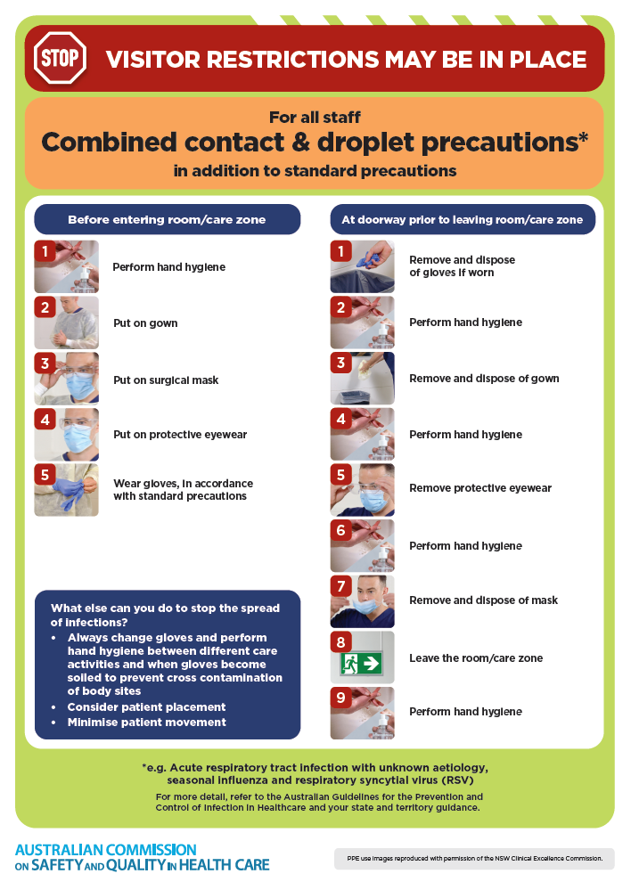](https://www.safetyandquality.gov.au/publications-and-resources/resource-library/infection-prevention-and-control-poster-combined-contact-and-droplet-precautions)
* ***Poster – Combined airborne and contact precautions***<https://www.safetyandquality.gov.au/publications-and-resources/resource-library/infection-prevention-and-control-poster-combined-airborne-and-contact-precautions>  
  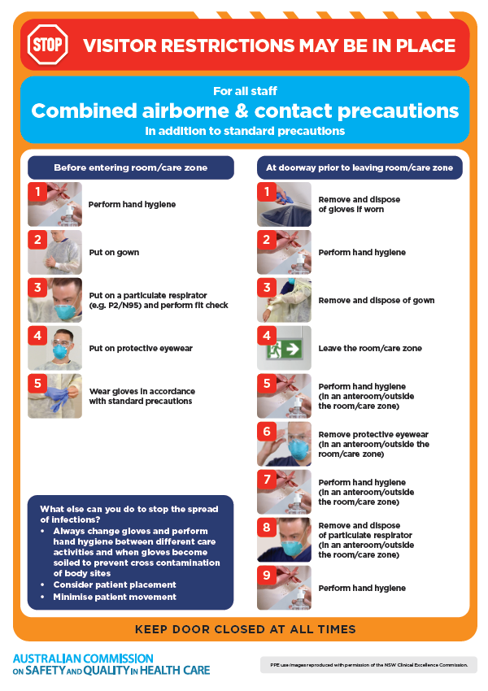
* ***Environmental Cleaning and Infection Prevention and Control*** [www.safetyandquality.gov.au/environmental-cleaning](http://www.safetyandquality.gov.au/environmental-cleaning)
* ***Break the chain of infection*** poster  
  <https://www.safetyandquality.gov.au/publications-and-resources/resource-library/break-chain-infection-poster>  
    
  **[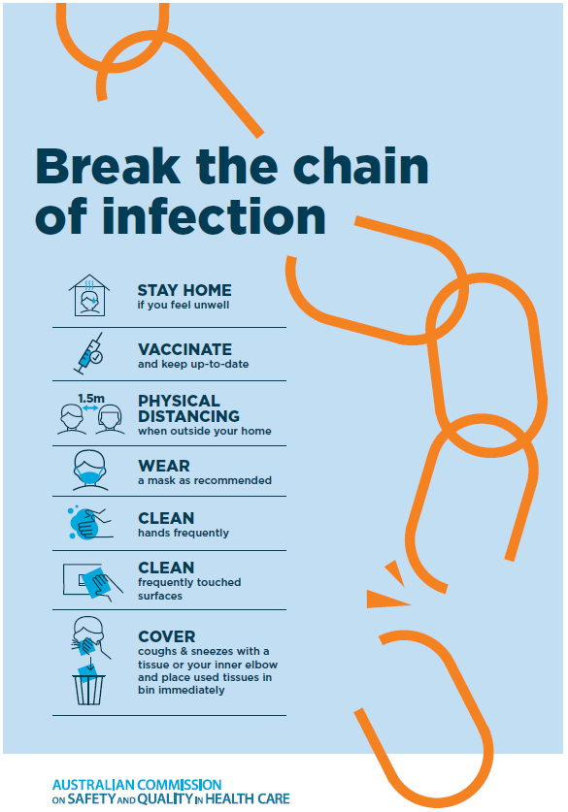](https://www.safetyandquality.gov.au/publications-and-resources/resource-library/break-chain-poster-a3https:/www.safetyandquality.gov.au/publications-and-resources/resource-library/break-chain-poster-a3)**

**Disclaimer**

On the Radar is an information resource of the Australian Commission on Safety and Quality in Health Care. The Commission is not responsible for the content of, nor does it endorse, any articles or sites listed. The Commission accepts no liability for the information or advice provided by these external links. Links are provided on the basis that users make their own decisions about the accuracy, currency and reliability of the information contained therein. Any opinions expressed are not necessarily those of the Australian Commission on Safety and Quality in Health Care.