# Australian Commission on Safety and Quality logotypeOn the Radar

Issue 706

28 July 2025

*On the Radar* is a summary of some of the recent publications in the areas of safety and quality in health care. Inclusion in this document is not an endorsement or recommendation of any publication or provider. Access to particular documents may depend on whether they are Open Access or not, and/or your individual or institutional access to subscription sites/services. Material that may require subscription is included as it is considered relevant.

*On the Radar* is available online, via email or as a PDF or Word document from <https://www.safetyandquality.gov.au/newsroom/subscribe-news/radar>

If you would like to receive *On the Radar* via email, you can subscribe on our website <https://www.safetyandquality.gov.au/newsroom/subscribe-news>  
or by emailing us at [mail@safetyandquality.gov.au](mailto:mail@safetyandquality.gov.au).  
You can also send feedback and comments to [mail@safetyandquality.gov.au](mailto:mail@safetyandquality.gov.au).

For information about the Commission and its programs and publications, please visit <https://www.safetyandquality.gov.au>

**On the Radar**

Editor: Dr Niall Johnson  
Contributors: Niall Johnson

**Reports**

*Healthcare provision in prisons: data sharing and IT*

Investigation report

Health Services Safety Investigation Body

Poole: HSSIB; 2025.

|  |  |
| --- | --- |
| URL | <https://www.hssib.org.uk/patient-safety-investigations/healthcare-provision-in-prisons/third-investigation-report/> |
| Notes | This report from the Health Services Safety Investigation Body (HSSIB) in the UK examines some of the issues around the sharing of healthcare information within prisons. Just as the interoperability of information systems has been recognised as in issue elsewhere, how information is shared in carceral settings can have implications for the health care delivery for prisoners. The sharing of information between the operational and health care domains – and failures in that sharing – can have a range of impacts. For example, the report notes that, ‘Important patient information, such as risks they pose to themselves or others, is not readily available to healthcare staff when seeing patients.’ There are also impacts on accuracy and completeness of records, continuity and coordination of care. The report includes a number of findings, recommendations and observations. |

**Journal articles**

*Could Low-Value Diagnostic Tests be Compounding Access Block? A Single-Site, Cross-Sectional Study*

Walker H, West C, Lawton L, Emeto TI, Gangathimmaiah V

Emergency Medicine Australasia. 2025 2025/08/01;37(4):e70100.

|  |  |
| --- | --- |
| DOI | <https://doi.org/10.1111/1742-6723.70100> |
| Notes | Paper reporting on a study that sought to examine the ‘prevalence and impact of low-value diagnostic tests at a regional, major-referral, mixed Emergency Department (ED).’ This ‘single-site, cross-sectional study was conducted at Townsville University Hospital in April 2022’ and included adult patients who underwent one of 10 specified diagnostic tests. The authors assert that ‘Of all diagnostic tests performed, **48.2%** (276/572) **were deemed low-value**, including 50.6% of laboratory tests (246/486) and 24.4% of imaging tests (21/86).’ They also report that ‘The median ED length of stay was 6.1?h (IQR 3.9?8.5). Low-value imaging tests contributed to 152 lost bed-hours per 100 tests.’ These led the authors to conclude that ‘ substantial proportion of diagnostic tests were low-value, exacerbating access block and reducing the availability of ED beds, thereby delaying timely emergency care. The implementation of evidence-based, effective strategies is imperative to mitigate patient harm associated with low-value diagnostic tests.’ |

*BMJ Quality & Safety*

Volume 34, Issue 8, August 2025

|  |  |
| --- | --- |
| URL | <https://qualitysafety.bmj.com/content/34/8> |
| Notes | A new issue of *BMJ Quality & Safety* has been published. Many of the papers in this issue have been referred to in previous editions of *On the Radar* (when they were released online). Articles in this issue of *BMJ Quality & Safety* include:   * Editorial: Why **hospital falls prevention** remains a global healthcare priority (Meg E Morris) * **Under-reporting of falls in hospitals**: a multisite study in South Korea (Insook Cho, Joon-myoung Kwon, Whasuk Choe, Jiseon Cho, Sook Hyun Park, David W Bates) * Frequency and preventability of **adverse drug events in the outpatient setting** (Rachel L Wasserman, Heba H Edrees, Mary G Amato, Diane L Seger, Michelle L Frits, Andrew Y Hwang, Christine Iannaccone, David W Bates) * Patient and caregiver perspectives on causes and prevention of **ambulatory adverse events**: multilingual qualitative study (Anjana E Sharma, Amber S Tran, Marika Dy, Adriana L. Najmabadi, Kristan Olazo, Beatrice Huang, Urmimala Sarkar) * **General practitioners retiring or relocating** and its association with healthcare use and mortality: a cohort study using Norwegian national data (Kristin Hestmann Vinjerui, Andreas Asheim, Kjartan Sarheim Anthun, Fredrik Carlsen, Bente Prytz Mjølstad, Sara Marie Nilsen, Kristine Pape, Johan Håkon Bjørngaard) * Development of the **Patient-Reported Indicator Surveys (PaRIS)** conceptual framework to monitor and improve the performance of primary care for people living with chronic conditions (Jose M Valderas, Ian Porter, Jimmy Martin-Delgado, Mieke Rijken, Judith de Jong, Oliver Groene, Janika Bloemeke-Cammin, Rosa Sunol, Rachel Williams, Marta Ballester, Katherine de Bienassis, Candan Kendir, Frederico Guanais, Dolf de Boer, Michael van den Berg) * A realist review of how, why, for whom and in which contexts **quality improvement in healthcare impacts inequalities** (Lucy Lara Johnson, Geoff Wong, Isla Kuhn, Graham P Martin, Anuj Kapilashrami, Laura Lennox, Georgia Bell Black, Matthew Hill, Ryan Swiers, Hashum Mahmood, Linda Jones, Jude Beng, John Ford) * Time to **de-implementation of low-value** cancer screening practices: a narrative review (Jennifer H LeLaurin, Kathryn Pluta, Wynne E Norton, Ramzi G Salloum, Naykky Singh Ospina) * **Economic evaluations of quality improvement interventions**: towards simpler analyses and more informative publications (Teryl K Nuckols) * Ending **nuclear weapons**, before they end us (Chris Zielinski) |

*Journal of Health Services Research & Policy*

Volume 30, Number 1 Supplement, July 2025

|  |  |
| --- | --- |
| URL | <https://journals.sagepub.com/toc/hsrb/30/1_suppl> |
| Notes | A new issue of *Journal of Health Services Research & Policy* has been published. This is a special issue with a theme of ‘Integrated Care and Support Pioneers: Evaluation of Multi-Disciplinary Team Working’. Articles in this issue of *Journal of Health Services Research & Policy* include:   * Evaluating the role of **community-based multi-disciplinary teams** in England’s Pioneer integrated health and social care programme: Setting the scene (Mary Alison Durand, Gerald Wistow and Nicholas Mays) * **Evaluating health and social care integration** in England’s Pioneer programme: The challenges of undertaking research in service delivery and research regulatory systems that are not fit for purpose (Mary Alison Durand, Bob Erens, Gerald Wistow, Ties Hoomans, Tommaso Manacorda and Nicholas Mays) * The **role and functions of community-based multidisciplinary teams** in two integrated care and support Pioneers: Perspectives from local system leaders (Agata Pacho, Gerald Wistow, Nicholas Mays, Lavanya Thana, Lucia Rehackova, Nick Douglas, Mustafa Al-Haboubi and Mary Alison Durand) * **Frontline staff perspectives on multi-disciplinary team working** and the effectiveness of integrated service delivery: Findings from the evaluation of the Integrated Care and Support Pioneers in England (Lavanya Thana, Gerald Wistow, Mary Alison Durand, Agata Pacho, Lucia Rehackova, Nick Douglas, Mustafa Al-Haboubi and Nicholas Mays) * The views of older people on **community-based multi-disciplinary team caseloads and informal carers** about health and care services in two Integrated Care Pioneer sites in England (Mary Alison Durand, Lavanya Thana, Mustafa Al-Haboubi, Agata Pacho, Lucia Rehackova, Gerald Wistow, Nick Douglas and Nicholas Mays) * The impact and legacy of COVID-19 on **community-based multidisciplinary teams organising integrated health and social care for older people** with long-term conditions: Findings from the evaluation of the integrated care and support Pioneers (Lucia Rehackova, Mary Alison Durand, Agata Pacho, Gerald Wistow, Lavanya Thana, Mustafa Al-Haboubi and Nicholas Mays) * Evaluating the **role of community-based multi-disciplinary teams in integrated health and social care** in England: Overview of findings from the Pioneer evaluation and their implications for health and social care integration (Mary Alison Durand, Gerald Wistow, Mustafa Al Haboubi, Nick Douglas, Bob Erens, Ties Hoomans, Tommaso Manacorda, Robin Miller, Agata Pacho, Lucia Rehackova, Judith Smith, Lavanya Thana and Nicholas Mays) |

*BMJ Quality & Safety* online first articles

|  |  |
| --- | --- |
| URL | <https://qualitysafety.bmj.com/content/early/recent> |
| Notes | *BMJ Quality &Safety* has published a number of ‘online first’ articles, including:   * Effectiveness of clinician-directed default nudges on **reducing overuse of tests and treatments** in healthcare: a systematic review of randomised controlled trials (Gemma Altinger, Caitlin M P Jones, Giovanni E Ferreira, Jason Soon, Tammy C Hoffmann, Christopher Maher, Rui Chang, Jeffrey A Linder, Adrian Traeger) * Grand rounds in methodology: improving the design of **staggered implementation cluster randomised trials** (Samuel I Watson, Richard Hooper) |

*International Journal for Quality in Health Care* online first articles

|  |  |
| --- | --- |
| URL | <https://academic.oup.com/intqhc/advance-articles> |
| Notes | *International Journal for Quality in Health Care* has published a number of ‘online first’ articles, including:   * Multisector Collaborations at Children’s Hospitals in the United States to Address **Social Drivers of Health** (Ulfat Shaikh et al) * Barriers and Facilitators to the Use of **Virtual Wards**: A Systematic Review of the Qualitative Evidence (Sara Cucurachi et al) * Barriers and breakthroughs: Policy reflections on **healthcare for persons with disability** in the Philippines (Danilo V Rogayan and Ivan N Palencia) * A unified approach assessing **Hospitals’ Quality and Patient Safety Compliance** at organizational and national level using an evidence-based Mapping Tool (Angeliki Katsapi et al) * PCPI-S SF: Development and psychometric assessment of the **Person-centred Practice Inventory Staff—Short Form** (Vaibhav Tyagi et al) * A unified approach assessing **Hospitals’ Quality and Patient Safety Compliance** at organizational and national level using an evidence-based Mapping Tool (Angeliki Katsapi et al) * A Macroergonomic Analysis to Identify Improvements to **Postpartum Hemorrhage** Anticipation, Identification, and Management (Kaitlyn L Hale-Lopez (et al) * **Interdisciplinary Collaboration**: Driving Better Outcomes and Efficiency (Poonam Gupta et al) |

**Online resources**

***[UK] NICE Guidelines and Quality Standards***

<https://www.nice.org.uk/guidance>

The UK’s National Institute for Health and Care Excellence (NICE) has published new (or updated) guidelines and quality standards The latest reviews or updates include:

* Quality Standard QS100 ***Cardiovascular risk*** *assessment and lipid modification* <https://www.nice.org.uk/guidance/qs100>

**Infection prevention and control and COVID-19 resources**

The Australian Commission on Safety and Quality in Health Care has developed a number of resources to assist healthcare organisations, facilities and clinicians. These resources include:

* ***Poster – Combined contact and droplet precautions*** <https://www.safetyandquality.gov.au/publications-and-resources/resource-library/infection-prevention-and-control-poster-combined-contact-and-droplet-precautions>  
  [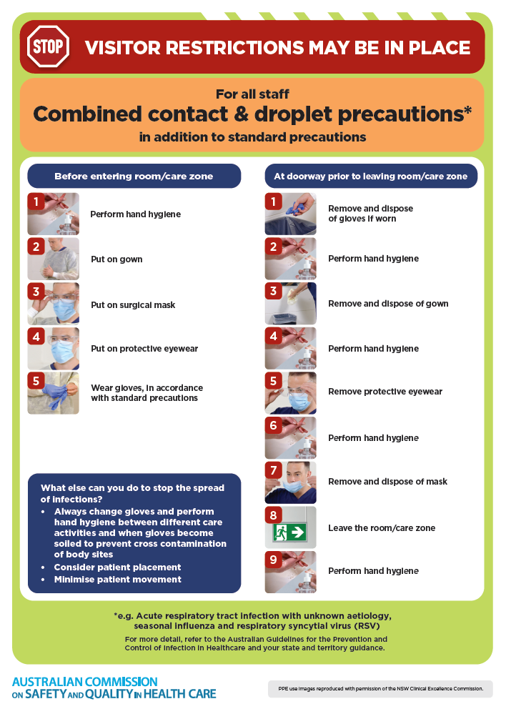](https://www.safetyandquality.gov.au/publications-and-resources/resource-library/infection-prevention-and-control-poster-combined-contact-and-droplet-precautions)
* ***Poster – Combined airborne and contact precautions***<https://www.safetyandquality.gov.au/publications-and-resources/resource-library/infection-prevention-and-control-poster-combined-airborne-and-contact-precautions>  
  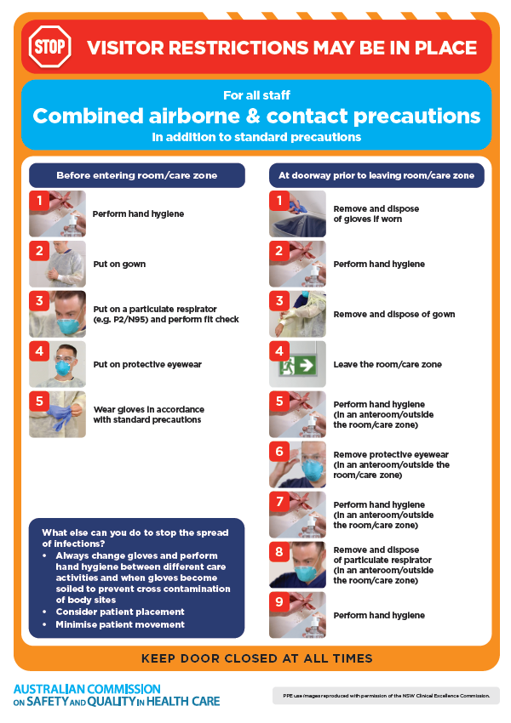
* ***Environmental Cleaning and Infection Prevention and Control*** [www.safetyandquality.gov.au/environmental-cleaning](http://www.safetyandquality.gov.au/environmental-cleaning)
* ***Break the chain of infection*** poster  
  <https://www.safetyandquality.gov.au/publications-and-resources/resource-library/break-chain-infection-poster>  
    
  **[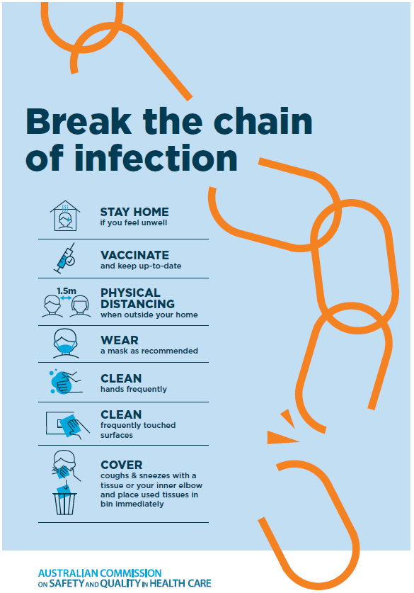](https://www.safetyandquality.gov.au/publications-and-resources/resource-library/break-chain-poster-a3https:/www.safetyandquality.gov.au/publications-and-resources/resource-library/break-chain-poster-a3)**

**Disclaimer**

On the Radar is an information resource of the Australian Commission on Safety and Quality in Health Care. The Commission is not responsible for the content of, nor does it endorse, any articles or sites listed. The Commission accepts no liability for the information or advice provided by these external links. Links are provided on the basis that users make their own decisions about the accuracy, currency and reliability of the information contained therein. Any opinions expressed are not necessarily those of the Australian Commission on Safety and Quality in Health Care.