# Banner image for On the Radar including the Australian Commission on Safety and Quality in Health Care logotype On the Radar

Issue 707

4 August 2025

*On the Radar* is a summary of some of the recent publications in the areas of safety and quality in health care. Inclusion in this document is not an endorsement or recommendation of any publication or provider. Access to particular documents may depend on whether they are Open Access or not, and/or your individual or institutional access to subscription sites/services. Material that may require subscription is included as it is considered relevant.

*On the Radar* is available online, via email or as a PDF or Word document from <https://www.safetyandquality.gov.au/newsroom/subscribe-news/radar>

If you would like to receive *On the Radar* via email, you can subscribe on our website <https://www.safetyandquality.gov.au/newsroom/subscribe-news>  
or by emailing us at [mail@safetyandquality.gov.au](mailto:mail@safetyandquality.gov.au).  
You can also send feedback and comments to [mail@safetyandquality.gov.au](mailto:mail@safetyandquality.gov.au).

For information about the Commission and its programs and publications, please visit <https://www.safetyandquality.gov.au>

**On the Radar**

Editor: Dr Niall Johnson  
Contributors: Niall Johnson, Sally Keane

**Reports**

*Enhancing Community Clinician Confidence in Child and Adolescent Mental Health: Insights from the COMPASS Collaborative Model*

Deeble Institute for Health Policy Research Perspectives Brief no: 36

Hiscock H, Prakash C, Iqbal S, Khano S, D’Abaco E, Dhaliwal J

Canberra: Australian Healthcare and Hospitals Association; 2025. p. 6.

|  |  |
| --- | --- |
| URL | <https://ahha.asn.au/resource/enhancing-community-clinician-confidence-in-child-and-adolescent-mental-health-insights-from-the-compass-collaborative-model/> |
| Notes | This perspectives brief from the Australian Healthcare and Hospitals Association’s Deeble Institute for Health Policy examines the COMPASS (COnnecting Mental-health PAediatric Specialists and community Services) model that was developed in Melbourne as the COVID-19 pandemic ‘intensified the mental health crisis among children and adolescents, straining access to specialist care. Community clinicians, often the first point of contact, faced increased responsibility without adequate training or support.’ The model ‘was developed in partnership with the regional primary care network, local clinicians, and the local child and adolescent mental health service. COMPASS provides:   * A multidisciplinary online Community of Practice (CoP) * Access to primary and secondary consultations with a child psychiatrist for community clinicians who needed extra advice and support.’ |

*Country preparedness for the introduction and appropriate use of antibiotics: Operational guidance*

World Health Organization

Geneva: WHO; 2025. p. 204.

|  |  |
| --- | --- |
| URL | <https://www.who.int/publications/b/74301> |
| Notes | The World Health Organization (WHO) has published this operational guidance for the introduction and appropriate use of antibiotics. It focuses on ‘Watch and Reserve antibiotics’ used to treat multidrug-resistant organisms while recognising that these can ‘face specific access challenges, especially in low- and middle-income countries (LMICs). This guidance outlines an approach to planning the introduction and implementation of these products, considering their unique characteristics and associated needs, with the goal of enhancing treatment access for patients and promoting appropriate overall antibiotic use.’ |

*Safety Spotlight: Neonatal Exchange Blood Transfusion*

Maternity and Newborn Safety Investigations

London: MNSI; 2025.

|  |  |
| --- | --- |
| URL | <https://www.mnsi.org.uk/news/safety-spotlight-neonatal-exchange-blood-transfusion/> |
| Notes | The MNSI (Maternity and Newborn Safety Investigations) in the UK has released a ‘safety spotlight’. This spotlight examines an exchange blood transfusion that saw the baby’s condition deteriorate leading to cardiac arrest. The spotlight examines exchange blood transfusions and notes issues and poses questions to prompt reflection on how to ensure appropriate and safe care. |

**Journal articles**

*Information standards for innovative surgery: what patients need to know*

Hoffmann C, Elliott D, Rooshenas L, Ochieng C, Main B, Wheatstone P, et al

BJS. 2025;112(7):znaf140.

|  |  |
| --- | --- |
| DOI | <https://doi.org/10.1093/bjs/znaf140> |
| Notes | The authors of this piece observe that ‘There are repeated and ongoing failures in shared decision-making and informed consent for innovative surgical procedures. Governments and regulatory bodies internationally recommend establishing information standards to support safe and transparent surgical innovation.’ The aim of this study was to develop a core information set (CIS) for surgical innovation. Based on consultations and interviews and analysis of policy documents and published studies, the final CIS comprised seven themes that included:   * what is ‘new’ about the procedure; * potential conflicts of interest; * reasons for the innovation (including why the innovation is believed to be appropriate for the patient); * treatment alternatives; * unknowns (including uncertain safety/efficacy and that the procedure may be abandoned/modified); * expertise with the innovation; and * governance, oversight, and accountability (including how safety will be monitored and recompense if anything goes wrong). |

*Prevalence and severity of pain, anxiety, stress, and sleep disturbances among surgical patients: a nationwide single-day multicentre flash mob study*

Stoop JM, Geensen R, Adam SC, van Dam KAM, van Dessel E, Dolmans-Zwartjes A, et al

BJS. 2025;112(7):znaf124.

|  |  |
| --- | --- |
| DOI | <https://doi.org/10.1093/bjs/znaf124> |
| Notes | Paper reporting on a ‘nationwide single-day multicentre cross-sectional flash mob study was conducted in 29 Dutch hospitals’ that included data from 733 adult surgical patients. The authors observe that ‘Pain, anxiety, stress, and sleep disturbances are highly frequent complications among surgical patients’. Among the results noted:   * **Moderate to severe pain** was prevalent in 509 patients (**69.7%)** and occurred most frequently **post-surgery** * **Anxiety** occurred in 278 patients (**38.1%)** and was **more prevalent preoperatively**. * Moderate to severe **stress** was reported by 272 patients (**37.8%)** with similar findings pre- and post-surgery. * **Sleep disturbances** were prevalent in 440 patients (**64.1%**). * Pain and anxiety were more severe in females. * Sleep disturbances were more severe in patients with lower socioeconomic status |

*Maternal and Neonatal Outcomes and Health System Costs in Standard Public Maternity Care Compared to Private Obstetric-Led Care: A Population-Level Matched Cohort Study*

Callander EJ, Enticott J, Mol BW, Thangaratinam S, Gamble J, Robson S, et al

BJOG: An International Journal of Obstetrics & Gynaecology. 2025 2025/07/14.

|  |  |
| --- | --- |
| DOI | <https://doi.org/10.1111/1471-0528.18286> |
| Notes | Paper reporting on an observational study that sought to ‘compare health outcomes and costs in standard public maternity care compared to private obstetric-led maternity care.’ Using data on 867,334 births in three Australian states between 2106 and 2019, the authors of this piece claim to have demonstrated ‘lower adverse health outcomes and costs in private obstetric-led care compared to standard public maternity care.’. This claim has been contested with various observations (for example on a recent edition of the [Health Report](https://www.abc.net.au/listen/programs/healthreport/maternal-neonatal-public-private/105574438) on Radio National and an item at [The Conversation](https://theconversation.com/is-childbirth-really-safer-for-women-and-babies-in-private-hospitals-261179) website), including a lack of consideration of different models of care, different patient populations, etc. It has been suggested that public hospitals are more likely to have to provide care for patients who are less well-off, have more chronic and/or co-morbid conditions and have more complex pregnancies and complications. A number of these limitations are noted in the paper. The authors ‘propose that a National Maternity Learning Health System and Clinical Quality Registry are vital to embed implementation and comparative effectiveness research in routine practice, identify underlying drivers and enable rapid improvement in models of care and outcomes for all women.’ |

*Advancing health system accountability: A scoping review of cultural security and Indigenous health.*

Poirier B, Cachagee M, Jamieson L

First Nations Health and Wellbeing. The Lowitja Journal. 2025;3:100073.

|  |  |
| --- | --- |
| DOI | <https://doi.org/10.1016/j.fnhli.2025.100073> |
| Notes | Paper reporting on a scoping review of cultural security and indigenous health. It is noted that ‘Cultural security goes beyond cultural safety awareness competency; by its demand for action at a systems level, the establishment of accountability frameworks is necessary to ensure sustainability of these changes.’ Focused on 28 items, ‘Evidence related to the understanding and implementation of cultural security was synthesised into 12 shared principles of cultural security.’ The authors observe that ‘Commitment to culturally secure provision of care at both an institutional and individual level is both an ethical and moral necessity for all healthcare providers.’ |

*The Joint Commission Journal on Quality and Patient Safety*

Volume 51, Issue 7, July–August 2025

|  |  |
| --- | --- |
| URL | <https://www.sciencedirect.com/journal/the-joint-commission-journal-on-quality-and-patient-safety/vol/51/issue/7> |
| Notes | A new issue of *The Joint Commission Journal on Quality and Patient Safety* has been published. Articles in this issue of *The Joint Commission Journal on Quality and Patient Safety* include:   * **Emergency Department Crowding**: A Patient Safety Crisis Hidden in Plain Sight (Timothy M Loftus, Emily G Wessling Tofovic) * Achieving **Safe Telehealth** (Jorge A Rodriguez, David W Bates) * Using In Situ Simulation to Identify Latent Safety Threats Prior to the Opening of **Novel Patient Care Spaces in the Emergency Department** (Briana D Miller, Andrew D Bloom, Helena Kons, Marjorie Lee White) * **Mortality and Return Visit Frequency Among Emergency Department Patients** Who Leave Without Being Seen at a Regional Health Care System (Joshua W Joseph, Alice K Bukhman, Da’Marcus E Baymon, Melisa W Lai-Becker, Dana D Im, Lauren M Nentwich, Paul C Chen, León D Sánchez) * Utilizing Quality Improvement Methodology to Decrease **Surgical Delays** (Marina E Robson Chase, Madeline J Anderson, Wesley A Stephens, Brittany E Levy, Sherry Lantz, Jennifer Goforth, Melissa R Newcomb, A M Harris) * **Adverse Events Involving Telehealth** in the Veterans Health Administration (Peter D Mills, Anne Tomolo, Edward E Yackel) * The Frequency of **Multiple Central Line–Associated Bloodstream Infections (CLABSIs)** Occurring in the Same Child: A Five-Year Experience (Tara P Sotak, Heidi B Troxler, Amber M Kirkley, Benny L Joyner, Michael J Steiner, Lane F Donnelly) * A Systems-Based Framework for Integrating **Health Equity and Patient Safety** (Jeannette Tsuei, Julia I Bandini, Angela D Thomas, Kortney Floyd James, Jason Michel Etchegaray, Lucy Schulson) * Navigating the Pathway to **Quality Leadership**: Perspectives from Contemporary Quality Executives (Christopher S Kim, Kimiyoshi J Kobayashi, D M Safley, B Patel, J Wiler, M Ikezuagu, J L Eisenberg, A C Lu) |

*The Lancet Primary Care*

Volume 1, Number 1, July 2025

|  |  |
| --- | --- |
| URL | <https://www.thelancet.com/journals/lanprc/issue/vol1no1/PIIS3050-5143(25)X0002-9> |
| Notes | *The Lancet Primary Care* is a new open access journal. Articles in this first issue of *The Lancet Primary Care* include:   * Editorial: **A better future through primary health care** * Effectiveness, safety, and cost-effectiveness of the **ALABAMA trial** (Kimberly G Blumenthal, Jason A Trubiano) * Urgent need for mental health care for **Ukrainian children affected by war** (Elisa Pfeiffer, Dmytro Martsenkovskyi) * Strengthening **primary health care leadership**: responding to a global need (Faraz Khalid, Andrew McLellan, Katherine Rouleau, Erica Barbazza, Nataliya Bukhanova, Marcus Pedersen, Vibhuti Khara, Shamsuzzoha Babar Syed, Asiya Odugleh-Kolev, Denis Porginon, Bart Janssens, Suraya Dalil) * Advancing **person-centred care for people living with chronic conditions** through patient-reported quality information in primary care (Mieke Rijken, Oliver Groene, Rosa Suñol, Jose M Valderas) * Primary care: a crucial catalyst to build a **healthier USA** (Kameron Matthews, Lauren Hughes, Candace Sprott, Katherine Gergen Barnett) * CRISP Checklist advances primary care through **responsive research reporting** (William R Phillips, Elizabeth Ann Sturgiss) * **Penicillin allergy** assessment pathway versus usual clinical care for primary care patients with a penicillin allergy record in the UK (ALABAMA): an open-label, multicentre, randomised controlled trial (Jonathan A T Sandoe, Shadia Ahmed, Kelsey Armitage, Chris Bates, Rebecca Bestwick, Jenny Boards, Christopher C Butler, Johanna Cook, Joanne Fielding, Ushma Galal, Philip Howard, Daniel Howdon, Sam Mort, Ruben Mujica-Mota, Alina Negut, Catherine E Porter, Neil Powell, Marta Santillo, Ravishankar Sargur,Sinisa Savic, Sarah Tonkin-Crine, Marta Wanat, Robert M West, Miaoqing Yang, Ly-Mee Yu, Susan H Pavitt on behalf of the ALABAMA Trial Research Group) * Effects of a brief digital problem-solving intervention on **depression and anxiety symptoms in Ukrainian children** and adolescents displaced by war: a crossover, randomised controlled trial (John R Weisz, Joshua S Steinberg, Jingxuan Sun, Patrick Mair, Olivia M Fitzpatrick, Nataliia Karapata, Maryna Yusyn, Gauri Sood, Andrea Danese, Kate M Adams, Dennis Ougrin) * Pilot implementation of intermittent preventive treatment with dihydroartemisinin–piperaquine to prevent **adverse birth outcomes in Papua**, Indonesia: a mixed-method evaluation (Firdaus Hafidz, Freis Candrawati, Jenna Hoyt, Enny Kenangalem, James Dodd, Maia Lesosky, Ida Safitri Laksanawati, Reynold Ubra, Minerva Simatupang, Feiko O ter Kuile, Eve Worrall, Jeanne Rini Poespoprodjo, Jenny Hill) * Estimating inequality in **alcohol-related liver disease burden** in the UK, 2009 to 2020: a population-based study using routinely collected data (Zhaonan Wang, Krishnarajah Nirantharakumar, Arlene Copland, Darren Quelch, Rasiah Thayakaran, Joht Singh Chandan, James Ferguson, Matthew Brookes, Matthew Lewis, Neil Rajoriya, Nigel Trudgill, Ramesh Arasaradnam, Sally Bradberry, Shamil Haroon, Neeraj Bhala, Nicola J Adderley) * How major **international development organisations operationalise primary health care**: a thematic content analysis of strategy documents (Luke N Allen, Erica Barbazza, Tova Tampe, Suraya Dalil, Shamsuzzoha Syed ,Faraz Khalid) * Preventing, identifying, and managing **sepsis in the community**: research and clinical priorities (Kristina E Rudd, Adrienne G Randolph, Derek C Angus, Michael Bauer, Christopher F Chesley, Michael R Filbin, Grace Jenq, Jordan A Kempker, Adam C Levine, Phillip Levy, Flavia R Machado, Nicholas M Mohr, Robert Quinn, Kathryn Rowan, Manu Shankar-Hari, Fatima Sheikh, Patrycja Sleboda, Jeb S Teichman, Thierry Calandra, Hallie C Prescott on behalf of the International Sepsis Forum) |

Healthcare*Papers*

Volume 23, Number 1, 2025

|  |  |
| --- | --- |
| URL | <https://www.longwoods.com/publications/healthcarepapers/27641/1/> |
| Notes | A new issue of Healthcare*Papers* has been published. Articles in this issue of Healthcare*Papers* include:   * We Should Not Settle for **Mediocre Medicare** (Audrey LaPorte and Sara Allin) * Is There **a Third Way for Healthcare** in Canada? (Katherine Fierlbeck and Peter Berman) * Is a **Third Way** Enough to Tame Hidden Forces? (Benoit Morin) * **Canada Can Find a Third Way**, but Private Insurance Is Not a Silver Bullet (Zeynep Or) * We Need to Do the Hard Work to **Strengthen Public Healthcare** (Joss Reimer) * Piercing the Public-Private Debate: An **Asset-Based Approach to Transforming Canadian Healthcare** (Danyaal Raza) * New Law and More Money Cannot Fix **Canadian Healthcare** (Steven Lewis) * Beyond the Binary: **Acknowledging Complexity, Enabling Innovation, Preserving the Positive** (Katherine Fierlbeck and Peter Berman) |

*Health Affairs Scholar*

Volume 3, Issue 7, July 2025

|  |  |
| --- | --- |
| URL | <https://academic.oup.com/healthaffairsscholar/issue/3/7> |
| Notes | A new issue of *Health Affairs Scholar* has been published. Articles in this issue of *Health Affairs Scholar* include:   * Local population characteristics and access equity of **340B contract pharmacies** (Maura Coughlin and Dibya Deepta Mishra) * Income, health, and racial gaps between **340B hospitals**, child sites, and nearby neighborhoods (Neal Masia et al) * The potential for patient-reported data and narratives to improve quality during **emergency department boarding** (Kelly T Gleason et al) * **Medicaid managed care organization** service coverage and diagnosis and treatment of opioid use disorder: evidence from quasi-random auto-assignment in Kentucky (Shelby R Steuart et al) * The changing landscape of **primary care**: an analysis of payer-primary care integration (Loren Adler et al) * Geographic variation in Medicare Advantage **nonemergency medical transportation benefits** 2020-2024 (Chuan Angel Lu et al) * **The American fentanyl epidemic**: geographic variation in mortality and policy implications (Thomas M Wickizer et al0 * Assessing the value of **health information exchange organizations** to hospital interoperability (Chelsea Richwine et al) * **Geographical variation in physician supply** and its relationship to utilization of care across older adults in the United States (M Barnard et al) * The effect of providing **Medicare Advantage enrollees diagnosed with cancer** additional time to reassess enrollment (Emma M Achola-Kothari et al) * A 10-year comparative analysis of **medical and surgical specialty lobbying by physician professional organizations** (Max Bouvette et al) * What drug characteristics explain the wide range of **manufacturer rebates**? (Molly T Beinfeld et al) * **Research and development investments for biologics** independently developed by US biotechnology startups, 2017–2023 (Ilina C Odouard et al) * Interventions that **strengthen the care workforce**: a realist synthesis review (Christine Kelly et al) * **Off-label policy** through the lens of trazodone usage and spending in the United States (Srikanth Kadiyala et al) * The disability mismatch: the case for a **comprehensive disability status measure** (Scott D Landes et al) * Strategic pathways to **International Classification of Diseases, 11th Revision,** adoption in France and the United States (Bastien Boussat et al) * The fragile core of care: reframing the **well-being of health professionals** as critical infrastructure (Md Doulotuzzaman Xames) * Prescription for made in America? **Tariffs and U.S. drug manufacturing** (Mariana P Socal and others) * The cost of misaligned incentives in the **pharmaceutical supply chain** (Geoffrey Joyce) * Prevalence of **interstate telehealth** comparing internet protocol and home address (Kaustav P Shah et al) |

*BMJ Quality & Safety* online first articles

|  |  |
| --- | --- |
| URL | <https://qualitysafety.bmj.com/content/early/recent> |
| Notes | *BMJ Quality &Safety* has published a number of ‘online first’ articles, including:   * Editorial: **Can handoffs bridge the interprofessional divide** to build a team? (Aubrey Samost-Williams, Eric J Thomas) * **Patient safety measures for virtual consultations** in primary care: a systematic review (Tetiana Lunova, Katherine-Helen Hurndall, Ulrik Bak Kirk, Bryony Dean Franklin, Ara Darzi, Ana Luisa Neves) * Editorial: How to scale and spread **catheter avoidance** nationwide (Jerome A Leis) |

**Online resources**

***Stop racism. It starts with me campaign resources***

[**https://metronorth.health.qld.gov.au/better-together-van/stop-racism**](https://metronorth.health.qld.gov.au/better-together-van/stop-racism)

Metro North Health in Queensland has developed a suite of resources for its *Stop Racism. It Starts with Me* campaign. The campaign is part of their Health Equity Strategy and has been developed through co-design with Aboriginal and Torres Strait Islander staff, patients, and community members.

***Australian Living Evidence Collaboration***

<https://livingevidence.org.au/>

***[USA] Effective Health Care Program reports***

<https://effectivehealthcare.ahrq.gov/>

The US Agency for Healthcare Research and Quality (AHRQ) has an Effective Health Care (EHC) Program The EHC has released the following final reports and updates:

* *Misuse of* ***ADHD Prescription Stimulants*** *in Adults: Rapid evidence product* <https://effectivehealthcare.ahrq.gov/products/misuse-prescription/rapid-research>

**Infection prevention and control and COVID-19 resources**

The Australian Commission on Safety and Quality in Health Care has developed a number of resources to assist healthcare organisations, facilities and clinicians. These resources include:

* ***Poster – Combined contact and droplet precautions*** <https://www.safetyandquality.gov.au/publications-and-resources/resource-library/infection-prevention-and-control-poster-combined-contact-and-droplet-precautions>  
  [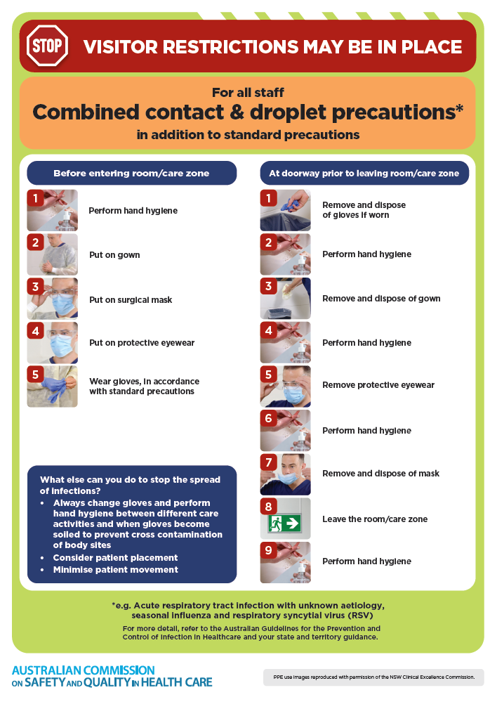](https://www.safetyandquality.gov.au/publications-and-resources/resource-library/infection-prevention-and-control-poster-combined-contact-and-droplet-precautions)
* ***Poster – Combined airborne and contact precautions***<https://www.safetyandquality.gov.au/publications-and-resources/resource-library/infection-prevention-and-control-poster-combined-airborne-and-contact-precautions>  
  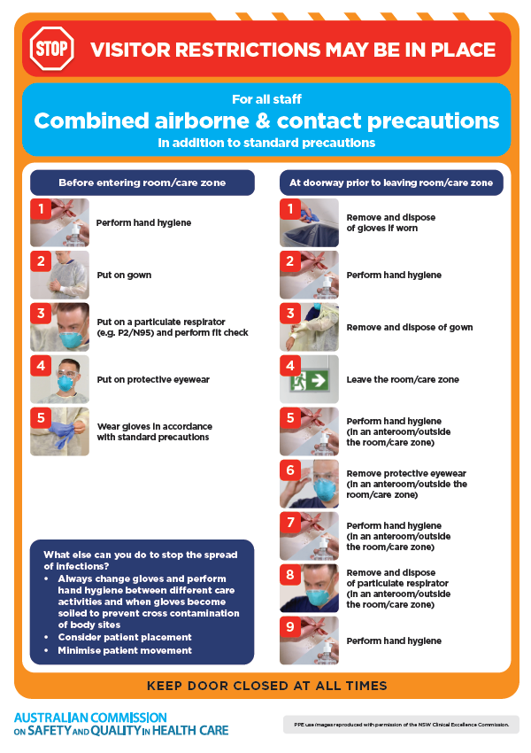
* ***Environmental Cleaning and Infection Prevention and Control*** [www.safetyandquality.gov.au/environmental-cleaning](http://www.safetyandquality.gov.au/environmental-cleaning)
* ***Break the chain of infection*** poster  
  <https://www.safetyandquality.gov.au/publications-and-resources/resource-library/break-chain-infection-poster>  
    
  **[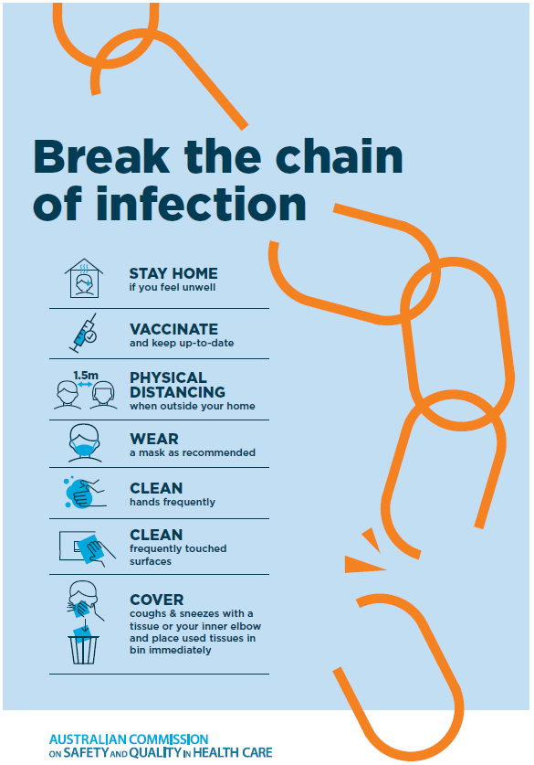](https://www.safetyandquality.gov.au/publications-and-resources/resource-library/break-chain-poster-a3https:/www.safetyandquality.gov.au/publications-and-resources/resource-library/break-chain-poster-a3)**

**Disclaimer**

On the Radar is an information resource of the Australian Commission on Safety and Quality in Health Care. The Commission is not responsible for the content of, nor does it endorse, any articles or sites listed. The Commission accepts no liability for the information or advice provided by these external links. Links are provided on the basis that users make their own decisions about the accuracy, currency and reliability of the information contained therein. Any opinions expressed are not necessarily those of the Australian Commission on Safety and Quality in Health Care.