# Banner image for On the Radar including the Australian Commission on Safety and Quality in Health Care logotype On the Radar

Issue 710

25 August 2025

*On the Radar* is a summary of some of the recent publications in the areas of safety and quality in health care. Inclusion in this document is not an endorsement or recommendation of any publication or provider. Access to particular documents may depend on whether they are Open Access or not, and/or your individual or institutional access to subscription sites/services. Material that may require subscription is included as it is considered relevant.

*On the Radar* is available online, via email or as a PDF or Word document from <https://www.safetyandquality.gov.au/newsroom/subscribe-news/radar>

If you would like to receive *On the Radar* via email, you can subscribe on our website <https://www.safetyandquality.gov.au/newsroom/subscribe-news>  
or by emailing us at [mail@safetyandquality.gov.au](mailto:mail@safetyandquality.gov.au).  
You can also send feedback and comments to [mail@safetyandquality.gov.au](mailto:mail@safetyandquality.gov.au).

For information about the Commission and its programs and publications, please visit <https://www.safetyandquality.gov.au>

**On the Radar**

Editor: Dr Niall Johnson  
Contributors: Niall Johnson

**Reports**

*NHMRC Good Institutional Practice Guide*

A guide for promoting an institutional research culture that supports the conduct of high-quality research

National Health and Medical Research Council

Canberra: National Health and Medical Research Council; 2025. p. 67.

|  |  |
| --- | --- |
| URL | <https://www.nhmrc.gov.au/about-us/publications/good-institutional-practice-guide> |
| Notes | The National Health and Medical Research Council (NHMRC) has published their *Good Institutional Practice Guide.* The guide ‘is designed as a resource for institutional and research leaders … seeking to promote an open, honest, supportive and respectful institutional research culture that supports the conduct of high-quality research’. |

*Promoting a just culture*

Parliamentary and Health Service Ombudsman

London: Parliamentary and Health Service Ombudsman; 2025. p. 15.

|  |  |
| --- | --- |
| URL | <https://www.ombudsman.org.uk/organisations-we-investigate/complaint-standards/uk-central-government-complaint-standards/uk-central-government-good-complaint-handling-guides/promoting-just-culture> |
| Notes | The Parliamentary and Health Service Ombudsman in the UK has produced this short guide that ‘sets out how to develop an organisation-wide culture that openly welcomes complaints and is accountable when mistakes happen’. The guide provides advice on embedding cultural values that encourage colleagues to: view complaints as a vital tool for getting feedback; and using this feedback to improve organisational performance. |

*The art and science of promoting evidence-informed decision-making: a global living evidence map*

World Health Organization

Geneva: WHO; 2024. p. 58.

|  |  |
| --- | --- |
| URL | <https://iris.who.int/handle/10665/382279> |
| Notes | The World Health Organization has published this resource to support evidence-informed decision-making (EIDM). From the executive summary:  ‘Effective policy design and implementation are central to socioeconomic development and reduction of inequities. The systematic use of data and evidence to guide decision-making for policy and practice is a major pathway to arriving at more effective policies, programmes, and practices. A range of interventions are applied to enhance such evidence-informed decision-making (EIDM). These include capacity-building for decision-makers, evidence platforms to ease access to evidence for decision-makers and building evidence-to-policy communities of practice. In the context of the COVID-19 pandemic, the profile of EIDM has grown not just in the health sector but also across most social systems, leading to a corresponding growth of interventions to support EIDM. Little is known, however, about the relative effectiveness of different EIDM interventions resulting in an evidence gap on the evidence for supporting the use of evidence.  To address this gap, we set out to collect, organize, and visualize all the available empirical evidence on what works to support EIDM globally. This evidence map aimed to assess the existing evidence on interventions that support decision-makers’ use of evidence to examine the size and nature of the existing evidence base.’ |

*Medication not given: discharge from an acute hospital to the community. Investigation report*

Health Services Safety Investigation Body

Poole: HSSIB; 2025.

|  |  |
| --- | --- |
| URL | <https://www.hssib.org.uk/patient-safety-investigations/medication-related-harm/third-investigation-report/> |
| Notes | This report from the Health Services Safety Investigation Body (HSSIB) in the UK is the third in a series examined medication-related harms. This report ‘explored the systems and processes in place to support staff when a patient spends time in hospital and is then discharged into the community with medications. The investigation also explored the role played by electronic prescribing and medicines administration (ePMA) systems and electronic patient record (EPR) systems in supporting care in this area.’ In this instance the investigation centred around a patient safety event involving an adult patient with diabetes. The report includes a number of findings, recommendations and observations, including ‘local-level learning prompts’ that are designed ‘to help organisations improve the safety of patients who need insulin and are being discharged from an acute hospital to the community’. |

*An exploratory review of maternity and neonatal services*

Health Services Safety Investigation Body

Poole: HSSIB; 2025.

|  |  |
| --- | --- |
| URL | <https://www.hssib.org.uk/patient-safety-investigations/an-exploratory-review-of-maternity-and-neonatal-services/> |
| Notes | Another recent report from the Health Services Safety Investigation Body (HSSIB) in the UK is this report that summarises information ‘HSSIB collected during an exploratory review of maternity and neonatal services’ that included involved meetings with 17 stakeholders and a review of 35 safety concerns submitted to HSSIB’. The UK Secretary of State for Health and Social Care has announced a national investigation into maternity and neonatal services. This exploratory review ‘as identified the following areas that require further investigation:   * the national architecture responsible for providing direction and oversight for maternity services * local governance arrangements for NHS maternity services and their relationship to national bodies * the standards and approach of local investigations when things go wrong * education, training and professional standards for clinicians providing maternity and neonatal services.’ |

**Journal articles**

*BMJ Quality & Safety*

Volume 34, Issue 9, September 2025

|  |  |
| --- | --- |
| URL | <https://qualitysafety.bmj.com/content/34/9> |
| Notes | A new issue of *BMJ Quality & Safety* has been published. Many of the papers in this issue have been referred to in previous editions of *On the Radar* (when they were released online). Articles in this issue of *BMJ Quality & Safety* include:   * Editorial: **Why tackling overuse will not succeed without changing our culture** (Rudolf Bertijn Kool, Andrea M Patey) * Editorial: Unreasonable effectiveness of **training AI models** locally (Gabriel Wardi, Christopher A Longhurst) * Relative importance and interactions of factors influencing **low-value care provision**: a factorial survey experiment among Swedish primary care physicians (Marta Roczniewska, Hanna Augustsson, Sara Ingvarsson, Emma Hedberg Rundgren, Kamil Szymański, Ulrica von Thiele Schwarz, Per Nilsen, Henna Hasson) * False hope of a single generalisable AI sepsis prediction model: **bias and proposed mitigation strategies** for improving performance based on a retrospective multisite cohort study (Rudolf Schnetler, Anton van der Vegt, Vikrant R Kalke, Paul Lane, Ian Scott) * **Optimising antibacterial utilisation** in Argentine intensive care units: a quality improvement collaborative (Facundo Jorro-Baron, Cecilia Inés Loudet, Wanda Cornistein, Inés Suarez-Anzorena, Pilar Arias-Lopez, Carina Balasini, Laura Cabana, Eleonora Cunto, Pablo Rodrigo Jorge Corral, Luz Gibbons, Marina Guglielmino, Gabriela Izzo, Marianela Lescano, Claudia Meregalli, Cristina Orlandi, Fernando Perre, Maria Elena Ratto, Mariano Rivet, Ana Paula Rodriguez, Viviana Monica Rodriguez, Jacqueline Vilca Becerra, Paula Romina Villegas, Emilse Vitar, Javier Roberti, Ezequiel García-Elorrio, COST Collaborative Group, Viviana Rodriguez) * Impact of a **financial incentive on early rehabilitation** and outcomes in ICU patients: a retrospective database study in Japan (Yudai Honda, Jung-ho Shin, Susumu Kunisawa, Kiyohide Fushimi, Yuichi Imanaka) * WHO research agenda on the role of the institutional **safety climate for hand hygiene improvement**: a Delphi consensus-building study (Ermira Tartari, Julie Storr, Nita Bellare, Claire Kilpatrick, Maryanne McGuckin, Mitchell J Schwaber, Didier Pittet, Benedetta Allegranzi) * Cluster randomised evaluation of a training intervention to increase the use of **statistical process control charts** for hospitals in England: making data count (Kelly Ann Schmidtke, Laura Kudrna, Laura Quinn, Paul Bird, Karla Hemming, Zoe Venable, Richard Lilford) * Grand rounds in methodology: improving the design of **staggered implementation cluster randomised trials** (Samuel I Watson, Richard Hooper) |

*International Journal for Quality in Health Care* online first articles

|  |  |
| --- | --- |
| URL | <https://academic.oup.com/intqhc/advance-articles> |
| Notes | *International Journal for Quality in Health Care* has published a number of ‘online first’ articles, including:   * Quality of **Clinical Practice Guidelines** in Japan: A Time Trend Analysis Using AGREE II Scores (Yosuke Hatakeyama et al) |

**Online resources**

***Australian Living Evidence Collaboration***

<https://livingevidence.org.au/>

***Guidance***

A number of guidelines or guidance have recently been published or updated. These include:

* *An Australian and New Zealand clinical practice guideline for the* ***physiotherapy management of people with spinal cord injuries*** <https://doi.org/10.1038/s41393-025-01088-8>

***[USA] Effective Health Care Program reports***

<https://effectivehealthcare.ahrq.gov/>

The US Agency for Healthcare Research and Quality (AHRQ) has an Effective Health Care (EHC) Program The EHC has released the following final reports and updates:

* *Peripheral Nerve Blocks for* ***Postoperative Pain Management*** *in Cardiothoracic Surgery: A Systematic Review* <https://doi.org/10.23970/AHRQEPCSRNERVE>

**Infection prevention and control and COVID-19 resources**

The Australian Commission on Safety and Quality in Health Care has developed a number of resources to assist healthcare organisations, facilities and clinicians. These resources include:

* ***Poster – Combined contact and droplet precautions*** <https://www.safetyandquality.gov.au/publications-and-resources/resource-library/infection-prevention-and-control-poster-combined-contact-and-droplet-precautions>  
  [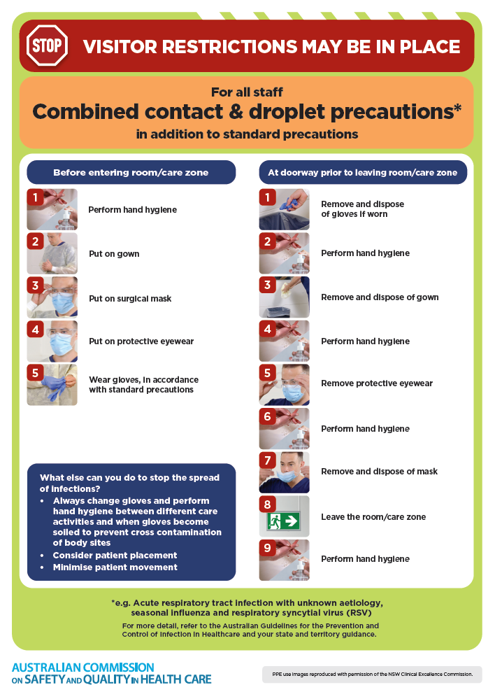](https://www.safetyandquality.gov.au/publications-and-resources/resource-library/infection-prevention-and-control-poster-combined-contact-and-droplet-precautions)
* ***Poster – Combined airborne and contact precautions***<https://www.safetyandquality.gov.au/publications-and-resources/resource-library/infection-prevention-and-control-poster-combined-airborne-and-contact-precautions>  
  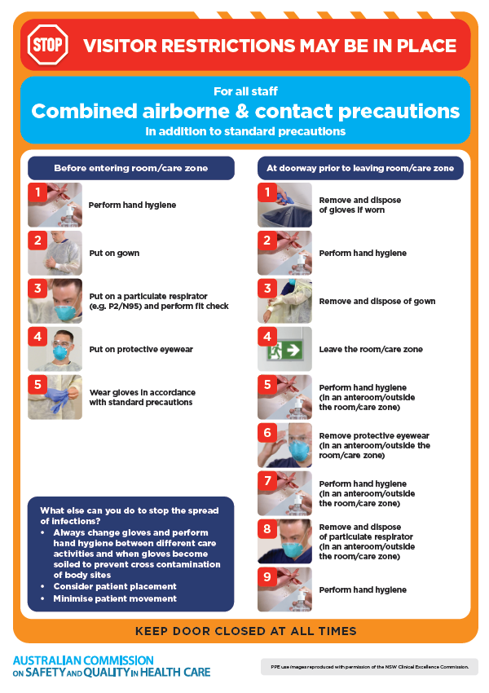
* ***Environmental Cleaning and Infection Prevention and Control*** [www.safetyandquality.gov.au/environmental-cleaning](http://www.safetyandquality.gov.au/environmental-cleaning)
* ***Break the chain of infection*** poster  
  <https://www.safetyandquality.gov.au/publications-and-resources/resource-library/break-chain-infection-poster>  
  **[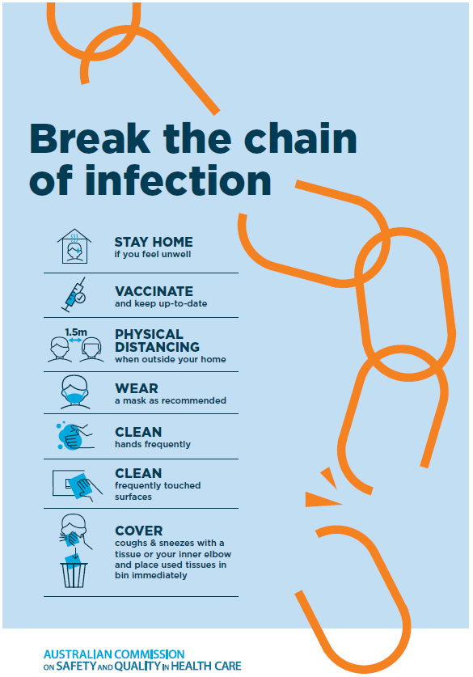](https://www.safetyandquality.gov.au/publications-and-resources/resource-library/break-chain-poster-a3https:/www.safetyandquality.gov.au/publications-and-resources/resource-library/break-chain-poster-a3)**

**Disclaimer**

On the Radar is an information resource of the Australian Commission on Safety and Quality in Health Care. The Commission is not responsible for the content of, nor does it endorse, any articles or sites listed. The Commission accepts no liability for the information or advice provided by these external links. Links are provided on the basis that users make their own decisions about the accuracy, currency and reliability of the information contained therein. Any opinions expressed are not necessarily those of the Australian Commission on Safety and Quality in Health Care.