# Banner image for On the Radar including the Australian Commission on Safety and Quality in Health Care logotype On the Radar

Issue 713

15 September 2025

*On the Radar* is a summary of some of the recent publications in the areas of safety and quality in health care Inclusion in this document is not an endorsement or recommendation of any publication or provider Access to particular documents may depend on whether they are Open Access or not, and/or your individual or institutional access to subscription sites/services Material that may require subscription is included as it is considered relevant.

*On the Radar* is available online, via email or as a PDF or Word document from <https://www.safetyandquality.gov.au/newsroom/subscribe-news/radar>

If you would like to receive *On the Radar* via email, you can subscribe on our website <https://www.safetyandquality.gov.au/newsroom/subscribe-news>  
or by emailing us at [mail@safetyandquality.gov.au](mailto:mail@safetyandquality.gov.au).  
You can also send feedback and comments to [mail@safetyandquality.gov.au](mailto:mail@safetyandquality.gov.au).

For information about the Commission and its programs and publications, please visit <https://www.safetyandquality.gov.au>

**On the Radar**

Editor: Dr Niall Johnson  
Contributors: Niall Johnson, Lisa Quirk, Leanne Cox

***National Sepsis Program Extension, Epidemiology Report, A national analysis of the sepsis patient journey in Australian public hospital admitted care***

Australian Commission on Safety and Quality in Health Care

Sydney: ACSQHC; 2025. p. 80.

<https://www.safetyandquality.gov.au/publications-and-resources/resource-library/national-sepsis-program-extension-epidemiology-report>

A new national report released ahead of World Sepsis Day 2025 (13 September) shows that sepsis is more widespread, deadly and costly than previously understood – prompting renewed calls for early detection and better clinical care.

Released by the Australian Commission on Safety and Quality in Health Care, the Sepsis Epidemiology Report analysed over 900,000 hospitalisations involving sepsis in Australian public hospitals over 10 years.

In 2022–23 alone, there were over 84,000 hospitalisations related to sepsis – far exceeding previous estimates of 55,000 cases annually. One in seven of these cases resulted in death.

The report offers new insights into which patients are most at risk, including:

* 1 in 3 people admitted to hospital for sepsis also had diabetes
* 1 in 6 people admitted to hospital for sepsis also had renal (kidney) disease
* sepsis hospitalisations for First Nations people were double that of non-indigenous people
* older people or aged care residents were more likely to be admitted to hospital and treated for sepsis
* rural living and socio-economic disadvantage are additional risk factors associated with 30 day readmission.

The report also shows early signs of improvement, including a decline in the proportion of sepsis-related deaths occurring in emergency departments – suggesting that sepsis pathways and awareness efforts are having an impact.

The report supports the work of the National Sepsis Program and highlights the need for consistent national data. A National Sepsis Data Plan is in development to provide recommendations on how sepsis is identified, coded and tracked in the future.

[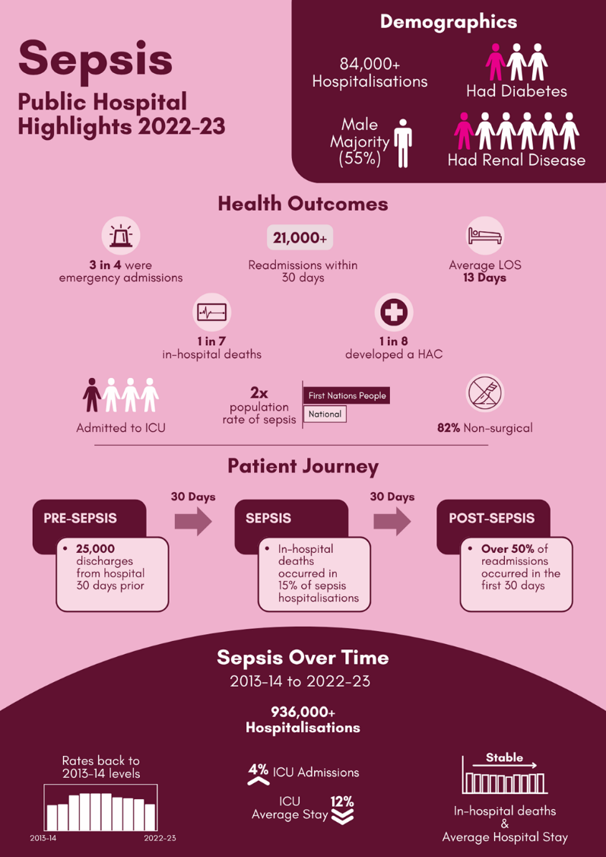](https://www.safetyandquality.gov.au/publications-and-resources/resource-library/national-sepsis-program-extension-epidemiology-report)

**Consultation open on draft *Emergency Laparotomy Clinical Care Standard***

[safetyandquality.gov.au/el-ccs](https://safetyandquality.cmail20.com/t/j-l-wullrkl-hjikktndj-t/)

The Australian Commission on Safety and Quality in Health Care has released the draft *Emergency Laparotomy Clinical Care Standard* for public consultation.

Emergency laparotomy is a high-risk, high-cost procedure with significant variation in outcomes and in the way that care is delivered. The new Clinical Care Standard aims to drive quality improvement in care processes and outcomes for people undergoing emergency laparotomy in Australia.

Public consultation is open until **5pm AEDT Tuesday 14 October 2025**. The draft *Emergency Laparotomy Clinical Care Standard* and instructions for submitting comments are available at [safetyandquality.gov.au/el-ccs-consultation](https://www.safetyandquality.gov.au/newsroom/consultations/emergency-laparotomy-clinical-care-standard-public-consultation)

**Reports**

*Mental health atlas 2024*

World Health Organization

Geneva: World Health Organization; 2025. p. 98.

*World mental health today: latest data*

World Health Organization

Geneva: World Health Organization; 2025. p. 64.

*Improving access to mental health care for children and adolescents: lessons from Finland*

World Health Organization

Copenhagen: WHO Regional Office for Europe; 2025. p. 30.

|  |  |
| --- | --- |
| URL | *Mental health atlas 2024* <https://www.who.int/publications/i/item/9789240114487>  *World mental health today* <https://www.who.int/publications/i/item/9789240113817>  *Lessons from Finland* [*https://www.who.int/europe/publications/i/item/9789289062213*](https://www.who.int/europe/publications/i/item/9789289062213) |
| Notes | The World Health Organization (WHO) has released a number of new resources on mental health.  The *Mental health atlas 2024* is the seventhedition of this ‘periodic survey and report of countries’ mental health policies and programmes, laws, information systems, financing, workforce and services’. This report ‘his latest report provides an overview of global mental health systems and services, tracks progress towards the targets of WHO’s Comprehensive Mental Health Action Plan 2013–2030, and identifies key gaps in mental health service development across the world.’  The WHO has also published *World mental health today: latest data,* providing ‘an update of mental health epidemiology, economic consequences and gaps in public mental health, drawing on the latest evidence.’ The report ‘shows that mental health conditions remain highly prevalent, with more than a billion people worldwide living with a mental disorder. The prevalence of different mental disorders varies with sex, with females most affected overall. In both males and females, anxiety disorders and depressive disorders are the most common.’  *Improving access to mental health care for children and adolescents: lessons from Finland* is a brief report from the WHO’s Regional Office for Europe that examines the Finnish government’s response to t a growing need for mental health care, particularly in younger people. The measure the Finnish government have taken have ‘focused on strengthening waiting time guarantees, increasing mental health service delivery in primary health care and adopting a national mental health strategy, and have been supported by targeted funding, training in psychosocial interventions, digital tools and a structural reform to centralize health system governance.’ This brief ‘highlights Finland’s experience and identifies lessons learned for Finland and for other countries.’ |

For information on the Commission’s on mental health, see <https://www.safetyandquality.gov.au/our-work/mental-health>

**Journal articles**

*Interventions for preventing falls in older people in care facilities*

Dyer SM, Kwok WS, Suen J, Dawson R, Kneale D, Sutcliffe K, et al

Cochrane Database of Systematic Reviews. 2025 (8).

|  |  |
| --- | --- |
| DOI | <https://doi.org/10.1002/14651858.CD016064> |
| Notes | This is an update to the Cochrane review on preventing falls in residential aged care. Based on a review of 104 studies, the reviewers report that ‘Falls in care facilities are likely reduced by: multifactorial … interventions that are put in place with the help of facility staff and delivered based on residents' individual circumstances (e.g. living with dementia); exercise; and vitamin D supplementation. The number of people falling may be reduced by: increasing servings of dairy through dietitian assistance with menu design; and exercise in residents with cognitive impairment. It is unclear if single interventions aiming to increase the appropriateness of medication delivery reduce falls.’ |

For information on the Commission’s on falls prevention, including the *Preventing falls and harm from falls in older people: Best Practice Guidelines* (Falls Guidelines 2025), see <https://www.safetyandquality.gov.au/our-work/falls-prevention>

*Protecting Canada’s youth from the risks of exposure to gambling advertising*

Charlebois S, Kelly S

Canadian Medical Association Journal. 2025;197(29):E918.

|  |  |
| --- | --- |
| DOI | <https://doi.org/10.1503/cmaj.251227> |
| Notes | Editorial in the *Canadian Medical Association Journal* (CMJA) suggesting that Canadians are encountering an issue that Australians recognise – the proliferation of gambling advertising that targets younger people. |

*Journal of Health Services Research & Policy*

Volume 30, Number 4, October 2025

|  |  |
| --- | --- |
| URL | <https://journals.sagepub.com/toc/hsrb/30/4> |
| Notes | A new issue of the *Journal of Health Services Research & Policy* has been published. Articles in this issue of the *Journal of Health Services Research & Policy* include:   * Editorial: Trump and the **future of health services research and policy** in Europe: A view from the US (Scott L Greer) * Editorial: From purges to broken partnerships: an international response to the global impact of Trump’s **war on science** (Christina Pagel) * Editorial: On the contribution of health care service provision to reducing **health inequalities** (Gerry McCartney) * A qualitative exploration of the perceived barriers and enablers of providing **mental health care in rural Australian general practice** (Belinda Fuss, Tania Shelby-James, Sharon Lawn, Paul Worley, Sam Manger, Caroline Phegan and Megan Rattray) * We can evaluate rapidly, but should we? Researchers’ and research funders’ perspectives on the uses, challenges and limitations of **rapid health care evaluation** (Jo Ellins, Kelly Daniel and Manbinder Sidhu) * **Tackling health inequalities**: What exactly do we mean? Evidence from health policy in England (Kath Checkland, Donna Bramwell, Jonathan Hammond, Simon Bailey and Lynsey Warwick-Giles) * Exploring risk factors for **COVID-19 mortality and infection in care homes** in the west of England: A mixed-methods study (Rebecca Wilson, Selin Siviş, Paul Scott, Jeremy Dixon, Karen Green, Judith Westcott, Alice Marriott, Jonathan Banks and Maria Theresa Redaniel) * Counseling and other factors associated with **contraceptive use** among active duty US military servicewomen (Kyle E Manetz, Anwar E Ahmed, Catherine T Witkop, Jaqueline E Hamrick and James D Mancuso) * **Exercise prescription** in the management of chronic disease falling through an evidence-practice gap: Perspectives of doctors and nurses in specialist settings (Shelley E. Keating, Shelley A. Wilkinson, Graeme A. Macdonald, Ingrid J. Hickman and Hannah L. Mayr) * Health care service interventions to improve the health care outcomes of hospitalised patients with **extreme obesity**: An evidence and gap map (Caz Hales, Rebecca Chrystall, Mona Jeffreys, Ruth Weatherall and Anne M Haase) |

*International Journal for Quality in Health Care* online first articles

|  |  |
| --- | --- |
| URL | <https://academic.oup.com/intqhc/advance-articles> |
| Notes | *International Journal for Quality in Health Care* has published a number of ‘online first’ articles, including:   * **Patient Complaints Differ for Male and Female Obstetrician-Gynecologists**: an exploration of 20 years of complaints data in Alberta, Canada (Erin A Brennand, Nancy Hernandez-Ceron, Iryna Hurava, N Kain) * Prioritizing **Patient Satisfaction**: A Strategic Analysis and Its Relevance to the Philippines (John Patrick C Toledo) |

**Online resources**

***Australian Living Evidence Collaboration***

<https://livingevidence.org.au/>

***[UK] NICE Guidelines and Quality Standards***

<https://www.nice.org.uk/guidance>

The UK’s National Institute for Health and Care Excellence (NICE) has published new (or updated) guidelines and quality standards The latest reviews or updates include:

* NICE Guideline NG251 *DMD* [**Duchenne muscular dystrophy**] *Care UK's guideline on cardiac care of children with* ***dystrophinopathy*** *and females carrying DMD-gene variations: NICE review* <https://www.nice.org.uk/guidance/ng251>

***Developing a framework and core indicators for measuring good quality perioperative care***

<https://www.thisinstitute.cam.ac.uk/research/outputs/developing-a-framework-for-measuring-good-quality-perioperative-care/>

The THIS Institute (The Healthcare Improvement Studies Institute) in the UK developed this framework drawing on patients, carers, clinicians and health staff and managers. The final framework of evidence-based measures is organised into 10 domains designed to monitor quality before, during, and after surgery, with a focus on preparing patients well for surgery, supporting staff and welcoming services.

The work is also available in a preprint article  
Wanyonyi-Kay K, Martin G, Ball S, Cunnington P, Boney O, Moonesinghe SR, et al.  
A quality framework for perioperative care: rapid review and participatory exercise  
medRxiv. 2025:2025.2008.2013.25333583.  
<https://doi.org/10.1101/2025.08.13.25333583>

[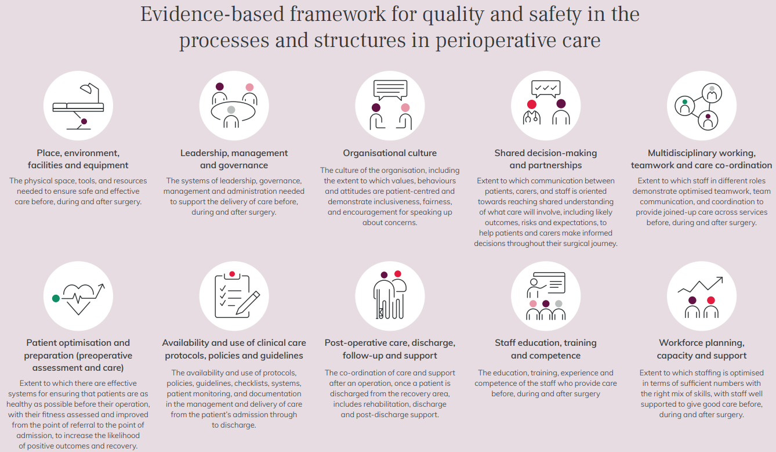](https://www.thisinstitute.cam.ac.uk/research/outputs/developing-a-framework-for-measuring-good-quality-perioperative-care/)

**Infection prevention and control and COVID-19 resources**

The Australian Commission on Safety and Quality in Health Care has developed a number of resources to assist healthcare organisations, facilities and clinicians These resources include:

* ***Poster – Combined contact and droplet precautions*** <https://www.safetyandquality.gov.au/publications-and-resources/resource-library/infection-prevention-and-control-poster-combined-contact-and-droplet-precautions>  
  [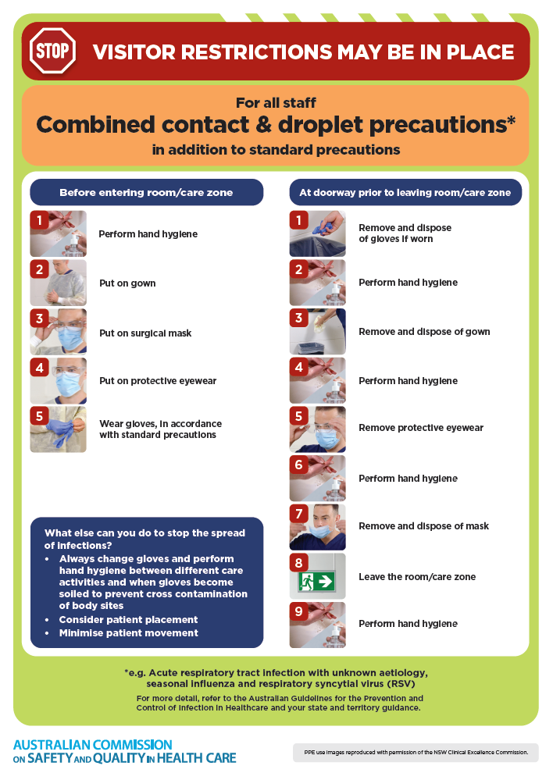](https://www.safetyandquality.gov.au/publications-and-resources/resource-library/infection-prevention-and-control-poster-combined-contact-and-droplet-precautions)
* ***Poster – Combined airborne and contact precautions***<https://www.safetyandquality.gov.au/publications-and-resources/resource-library/infection-prevention-and-control-poster-combined-airborne-and-contact-precautions>  
  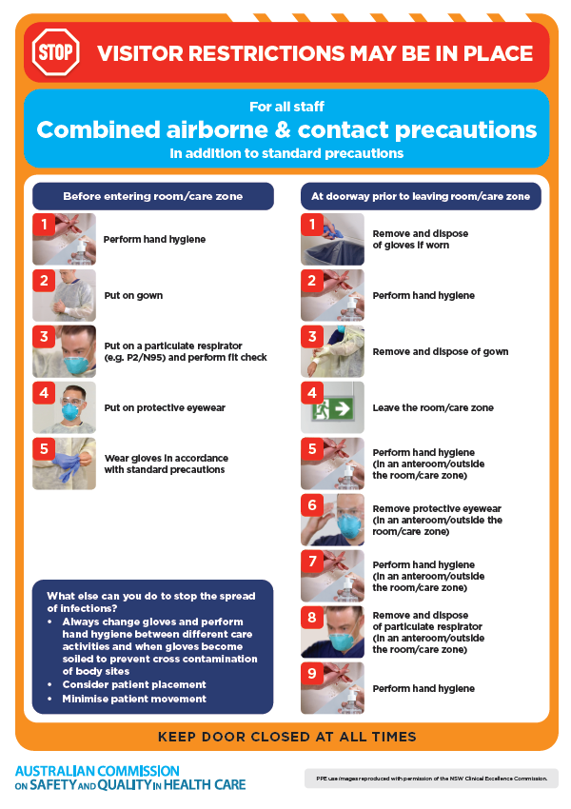
* ***Environmental Cleaning and Infection Prevention and Control*** [www.safetyandquality.gov.au/environmental-cleaning](http://www.safetyandquality.gov.au/environmental-cleaning)
* ***Break the chain of infection*** poster  
  <https://www.safetyandquality.gov.au/publications-and-resources/resource-library/break-chain-infection-poster>  
    
  **[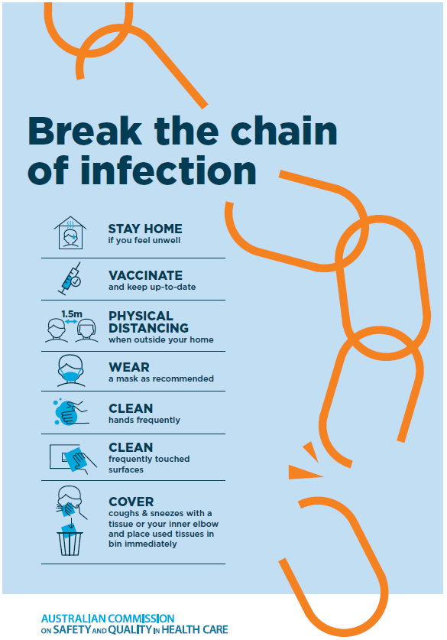](https://www.safetyandquality.gov.au/publications-and-resources/resource-library/break-chain-poster-a3https:/www.safetyandquality.gov.au/publications-and-resources/resource-library/break-chain-poster-a3)**

**Disclaimer**

On the Radar is an information resource of the Australian Commission on Safety and Quality in Health Care The Commission is not responsible for the content of, nor does it endorse, any articles or sites listed The Commission accepts no liability for the information or advice provided by these external links Links are provided on the basis that users make their own decisions about the accuracy, currency and reliability of the information contained therein Any opinions expressed are not necessarily those of the Australian Commission on Safety and Quality in Health Care.