# Banner image for On the Radar including the Australian Commission on Safety and Quality in Health Care logotype On the Radar

Issue 715

29 September 2025

*On the Radar* is a summary of some of the recent publications in the areas of safety and quality in health care Inclusion in this document is not an endorsement or recommendation of any publication or provider Access to particular documents may depend on whether they are Open Access or not, and/or your individual or institutional access to subscription sites/services Material that may require subscription is included as it is considered relevant.

*On the Radar* is available online, via email or as a PDF or Word document from <https://www.safetyandquality.gov.au/newsroom/subscribe-news/radar>

If you would like to receive *On the Radar* via email, you can subscribe on our website <https://www.safetyandquality.gov.au/newsroom/subscribe-news>  
or by emailing us at [mail@safetyandquality.gov.au](mailto:mail@safetyandquality.gov.au).  
You can also send feedback and comments to [mail@safetyandquality.gov.au](mailto:mail@safetyandquality.gov.au).

For information about the Commission and its programs and publications, please visit <https://www.safetyandquality.gov.au>

**On the Radar**

Editor: Dr Niall Johnson  
Contributors: Niall Johnson, Craig Burke, Megan Wigham

***Colonoscopy Clinical Care Standard and Atlas Focus Report: Colonoscopy***

The Australian Commission on Safety and Quality in Health Care (the Commission) launched the updated *Colonoscopy Clinical Care Standard* *(2025)* and the *Atlas Focus Report: Colonoscopy* at the World Congress of Gastroenterology and Australian Gastroenterology Week conference on 21 September 2025 in Melbourne.

New data from the *Atlas Focus Report: Colonoscopy* show over the past decade, the national rate of MBS-subsidised repeat colonoscopy before 3 years fell by 8%. The decrease may reflect improved alignment with guidelines in some local areas, such as major cities. However, large falls in disadvantaged areas and in remote areas raise concerns about growing inequity of access to colonoscopy.

The *Colonoscopy Clinical Care Standard* provides updated guidance for the safe, appropriate and high-quality use of colonoscopy. Key updates to the Standard include strengthened guidance to improve communication at the point of referral and for follow-up, the use of My Health Record, new guidance on sedation options and the addition of photo documentation as a minimum requirement for the procedure. The Standard now also includes recommendations for clinicians and healthcare services to deliver culturally safe care for Aboriginal and Torres Strait Islander people.

For more information on the Standard, implementation resources, and to discover the rates for your local area using interactive maps and graphs in *the Atlas Focus Report: Colonoscopy*, visit the Commission’s [Colonoscopy Hub](https://www.safetyandquality.gov.au/newsroom/colonoscopy-hub).

*Colonoscopy Clinical Care Standard*  
Australian Commission on Safety and Quality in Health Care

Sydney: ACSQHC; 2025. p. 66.

<https://www.safetyandquality.gov.au/standards/clinical-care-standards/colonoscopy-clinical-care-standard>

*Atlas Focus Report: Colonoscopy*

Australian Commission on Safety and Quality in Health Care

Sydney: ACSQHC; 2025. Available from: <https://www.safetyandquality.gov.au/our-work/healthcare-variation/atlas-focus-report-colonoscopy>

**Reports**

*A Rare Kind of Care: An agenda to deliver health equity for Australians living with rare disease*

Milne K, Lefebvre M, Cavanough E

Sydney: McKell Institute; 2025. p. 76.

|  |  |
| --- | --- |
| URL | <https://mckellinstitute.org.au/research/reports/a-rare-kind-of-care/> |
| Notes | Report from the think tank the McKell Institute examining rare disease incidence and policy in Australia. The report makes a number of recommendations, including to various tiers of government. |

**Journal articles**

*Unwarranted variation – warranted change*

Langeland H, Tjomsland O, Kandiah P, Kalstad S, Grongstad LS, Pedersen E, et al

Tidsskrift for Den norske legeforening. 2025;145.

|  |  |
| --- | --- |
| DOI | English version <https://tidsskriftet.no/en/2025/08/perspectives/unwarranted-variation-warranted-change>  Norwegian version <https://doi.org/10.4045/tidsskr.25.0308> |
| Notes | Paper describing the development of the *Norwegian Health Atlas* that, as with many other similar projects, ‘reveals surprisingly large geographic variation in evaluation and treatment’. The authors of this piece observe ‘If the variation cannot be attributed to differences in morbidity, it suggests that parts of the population are being under- or overtreated. Both are classified as unwarranted variation and are a cause for concern, especially since inappropriate methods and incorrect indications are the main factors behind compensation paid by the Norwegian System of Patient Injury Compensation, and because patient harm occurs in approximately 12 % of hospital stays in Norway.’  As was noted in the first [*Australian Atlas of Healthcare Variation*](https://www.safetyandquality.gov.au/our-work/healthcare-variation/australian-atlas-healthcare-variation-series), ‘the safety and quality of health care varies, both across geographic areas and among individual clinicians. Understanding this variation is critical to improving the quality, value and appropriateness of health care. Some variation is desirable and warranted – it reflects differences in people’s need for health care. But where variation is unwarranted, it signals that people are not getting appropriate care.’  The Norwegian authors of this piece recognise that ‘Knowledge alone does not change practice’ and the connections between variation, value, best practice, appropriateness choice and need. The challenge of going from knowledge of variation to changing practice in order to deliver high-value, appropriate and sustainable care was also a focus of a 2024 piece (<https://doi.org/10.1007/s43999-024-00056-8>) written by a group who worked on the Australian Atlas of Healthcare Variation series. |

*Public Health Research and Practice*

|  |  |
| --- | --- |
| URL | <https://www.publish.csiro.au/pu> |
| Notes | *Public Health Research & Practice* has moved toa continuous publication model.  Recent articles in *Public Health Research & Practice* include:   * **Co-creating health interventions** for adolescents: strategies for meaningful involvement (Louise Thornton, Matthew L. Watt, Florens de Groot, Sarah Y Ford and Angela Webster) * Why public health practitioners and researchers must stop using the term **‘culturally and linguistically diverse (CALD)’** (Davoud Pourmarzi, Linda Murray, Tehzeeb Zulfiqar, Guddu Kaur and Anna Olsen) * Demographic differences in Australia’s **local government adaptation planning for health and climate change** (Barbara P F Davis, Paul J Beggs and Petra L Graham) * A critical review of long-term funding for **reducing violence against women** in Australia (Lauren Sheppard, Vicki Brown, Kim Robinson and Marj Moodie) * Australasian **public health alumni employment** outcomes (Bethany Howard, Holly Wild, Rochelle Scheid, Holly Donaldson, D Ilic and J Choate) |

*Healthcare Policy*

Volume 20, Number 4, 2025

|  |  |
| --- | --- |
| URL | <https://www.longwoods.com/publications/healthcare-policy/27619/> |
| Notes | A new issue of *Healthcare Policy* has been published Articles in this issue of *Healthcare Policy* include:   * Editorial: The Opportunity for **Canada and Australia to Learn from One Another’s Health Systems** (Michael Pervan and Jason M Sutherland) * Are **Therapeutically Important Drugs No Longer Available** in Canada? (Joel Lexchin) * Access, Value, and Reform: An Analysis of **Canada’s Pharmaceutical Policy Framework** (Douglas Clark) * **Employment in the Canadian Medical Profession** by Immigrant Status, Racialized Group and Gender (Christoph Schimmele and Feng Hou) * Virtual Care: Evidence from the Pandemic Regarding Changes in **Access to Psychiatric Care** in Canada (Angel Ruhil, Mina Alizadehsadrdaneshpour, Turjoy Ghose and Eric Nauenberg) * **Healthcare Access Gaps** Persist for French-Preferring Citizens in Canada’s Only Officially Bilingual Province: Analysis of New Brunswick Patient Care Experience Survey Data (François Gallant, Lise Babin and James Ted McDonald) * Canadian Family Physician Preferences on Updating the **Classification System for Health Conditions** and Related Issues (Stephanie Garies, Dewdunee Himasara Pathiraja, Kerry McBrien, James A. Dickinson, Noah Crampton, Cathy A. Eastwood, Danielle A. Southern, Kees Van Boven, Huib Ten Napel, Maeve O’Beirne, Alexander Singer, Olawunmi Olagundoye, Keith Denny, David J. T. Campbell, Terrence McDonald, Neil Drummond, Hude Quan, Aimie Lee, Michelle Smekal, William Ghali, Rubee Dev and Tyler Williamson) |

*The Joint Commission Journal on Quality and Patient Safety*

Volume 51, Issue 10, October 2025

|  |  |
| --- | --- |
| URL | <https://www.sciencedirect.com/journal/the-joint-commission-journal-on-quality-and-patient-safety/vol/51/issue/10> |
| Notes | A new issue of *The Joint Commission Journal on Quality and Patient Safety* has been published. Articles in this issue of *The Joint Commission Journal on Quality and Patient Safety* include:   * **Simulation for Targeted Education, Process Improvement, and Systems Integration (STEPS)**: A Novel Approach to Health Care Quality Improvement Using In Situ Simulation (Jessica C Schoen, Janee M Klipfel, Shelley M Wolfe, Valerie D Willis, Vanessa E Torbenson, Jason J DeWitt, Jennifer L Fang, Regan N Theiler) * Super-Facilitators for Implementation of Leading **Antimicrobial Stewardship** Practices in Hospitals: A Qualitative Study (Salome O Chitavi, Michael Kohut, Barbara I Braun, David Y Hyun) * **Telehealth for Pediatric Patients**: Facilitators, Barriers, and Impact on Disparities (Courtney Sump, Hadley Sauers-Ford, Sinem Toraman Turk, Kylee Denker, Carlos Casillas, Joanna Thomson) * Enhancing Clinical Guideline Adherence in **Diabetic Foot Ulcer Prevention**: A Case Study on Quality Improvement Interventions (Maja Ahlberg, Ulla Hellstrand Tang, Christina Petersson) * Improving the Treatment of **Preoperative Anemia** in Colorectal and Hepato-Pancreato-Biliary Patients: A Quality Improvement Initiative (Helen Jingshu Jin, Tsan-Hua Tung, Sydney Selznick, Christine Cotton, Madeline Lemke, Lily J Park, Christopher C Harle, Bradley Moffat, Patrick Colquhoun, T M Zwiep) * Improving Screening for **Alpha-1 Antitrypsin Deficiency** in Adults with COPD (Margery Dell Smith, Kimberly A Couch) * The DRIP Criteria: Reducing the Frequency of **Peripheral Intravenous Catheter** Insertion in Hospitalized Patients (Nick May, Lucia Gillman) * **Generating Value** Through Structural Investment: Rebalancing Value-Based Payment, Pay for Transformation, and Fee-for-Service (Jeffrey J Geppert, Peta M A Alexander, Nicole Brennan, Kedar S Mate, Kathy J Jenkins) |

*International Journal for Quality in Health Care* online first articles

|  |  |
| --- | --- |
| URL | <https://academic.oup.com/intqhc/advance-articles> |
| Notes | *International Journal for Quality in Health Care* has published a number of ‘online first’ articles, including:   * Words in action: **centering the patient voice** to achieve an efficient and compassionate healthcare system (Poonam Gupta and David Greenfield) * **Knowledge dissemination**: essential work in quality and safety innovation (Reece Hinchcliff, Dilantha Dharmagunawardene, David Greenfield) * Don’t blame the **organisational culture** for poor performance (Dinesh K Arya) * Freezing while preserving achievements: **Suspending quality indicators** in healthcare, Israel’s experience (Yaron Niv et al) * **Quality Certifications in Andalusian Primary Care**: Current Status, Barriers, and Facilitators (Bonachela-Solás Patricia et al) * From Readiness to Results: **Clinical Audit** as a Strategic Tool for Quality Health Care in Nepal (Amrit Pokhrel et al) * Identifying hazards for **psychological harm in cancer care** using incident reports: searching for the invisible (Yvonne Pfeiffer et al) * Evolution and Challenges of **Physician-Led Home Visits** in Japan (Kyohei Daigo et al) |

**Online resources**

***Australian Living Evidence Collaboration***

<https://livingevidence.org.au/>

***Guidance***

A number of guidelines or guidance have recently been published or updated These include:

* ***Deprescribing in older people: a clinical practice guideline.***  
  Quek HW, Perello XR, Lee K, Etherton-Beer C, Page AT, on behalf of the Guideline Development Group. Perth: The University of Western Australia; 2025. p. 299.  
  <https://doi.org/10.26182/xtsx-3r73>  
  <https://deprescribing.com/>

***[UK] NICE Guidelines and Quality Standards***

<https://www.nice.org.uk/guidance>

The UK’s National Institute for Health and Care Excellence (NICE) has published new (or updated) guidelines and quality standards The latest reviews or updates include:

* Clinical Guideline CG57 ***Atopic eczema*** *in under 12s: diagnosis and management* <https://www.nice.org.uk/guidance/cg57>

***[USA] Evidence-to-Action Hub***

<https://www.chcs.org/evidence-to-action/>

What has previously been the Better Care Playbook has a new name and a new home at the Center for Health Care Strategies (CHCS). The Evidence-to-Action Hub will continue to curate peer-reviewed research, case examples, implementation tools, and policy insights.

**Infection prevention and control and COVID-19 resources**

The Australian Commission on Safety and Quality in Health Care has developed a number of resources to assist healthcare organisations, facilities and clinicians These resources include:

* ***Poster – Combined contact and droplet precautions*** <https://www.safetyandquality.gov.au/publications-and-resources/resource-library/infection-prevention-and-control-poster-combined-contact-and-droplet-precautions>  
  [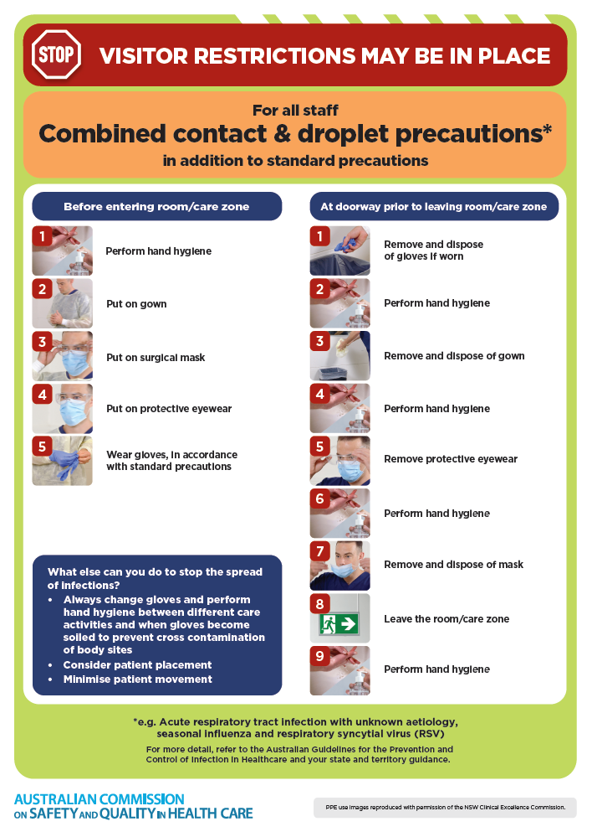](https://www.safetyandquality.gov.au/publications-and-resources/resource-library/infection-prevention-and-control-poster-combined-contact-and-droplet-precautions)
* ***Poster – Combined airborne and contact precautions***<https://www.safetyandquality.gov.au/publications-and-resources/resource-library/infection-prevention-and-control-poster-combined-airborne-and-contact-precautions>  
  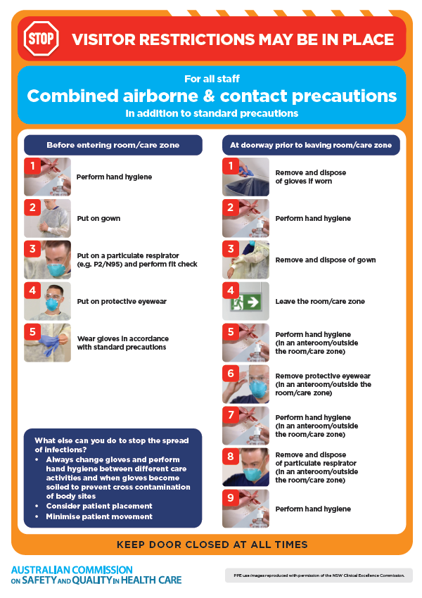
* ***Environmental Cleaning and Infection Prevention and Control*** [www.safetyandquality.gov.au/environmental-cleaning](http://www.safetyandquality.gov.au/environmental-cleaning)
* ***Break the chain of infection*** poster  
  <https://www.safetyandquality.gov.au/publications-and-resources/resource-library/break-chain-infection-poster>  
    
  **[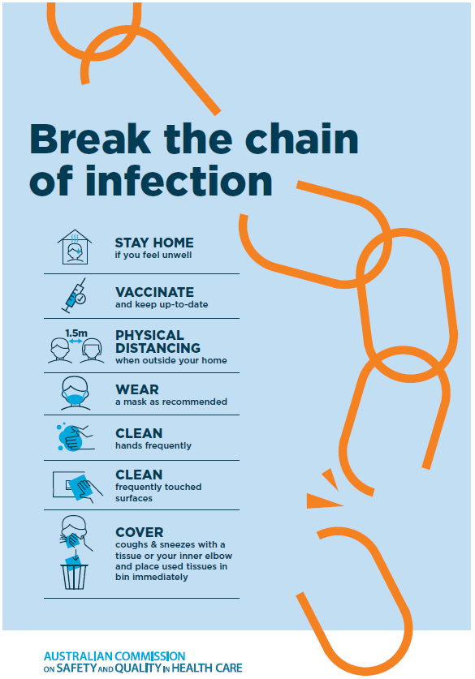](https://www.safetyandquality.gov.au/publications-and-resources/resource-library/break-chain-poster-a3https:/www.safetyandquality.gov.au/publications-and-resources/resource-library/break-chain-poster-a3)**

**Disclaimer**

On the Radar is an information resource of the Australian Commission on Safety and Quality in Health Care The Commission is not responsible for the content of, nor does it endorse, any articles or sites listed The Commission accepts no liability for the information or advice provided by these external links Links are provided on the basis that users make their own decisions about the accuracy, currency and reliability of the information contained therein Any opinions expressed are not necessarily those of the Australian Commission on Safety and Quality in Health Care.