# Banner image for On the Radar including the Australian Commission on Safety and Quality in Health Care logotype On the Radar

Issue 716

6 October 2025

*On the Radar* is a summary of some of the recent publications in the areas of safety and quality in health care Inclusion in this document is not an endorsement or recommendation of any publication or provider Access to particular documents may depend on whether they are Open Access or not, and/or your individual or institutional access to subscription sites/services Material that may require subscription is included as it is considered relevant.

*On the Radar* is available online, via email or as a PDF or Word document from <https://www.safetyandquality.gov.au/newsroom/subscribe-news/radar>

If you would like to receive *On the Radar* via email, you can subscribe on our website <https://www.safetyandquality.gov.au/newsroom/subscribe-news>  
or by emailing us at [mail@safetyandquality.gov.au](mailto:mail@safetyandquality.gov.au).  
You can also send feedback and comments to [mail@safetyandquality.gov.au](mailto:mail@safetyandquality.gov.au).

For information about the Commission and its programs and publications, please visit <https://www.safetyandquality.gov.au>

**On the Radar**

Editor: Dr Niall Johnson  
Contributors: Niall Johnson

**Reports**

*The Insights Series – Aboriginal people’s experiences of hospital care 2019 to 2024*

Bureau of Health Information

St Leonards: BHI; 2025.

|  |  |
| --- | --- |
| URL | <https://www.bhi.nsw.gov.au/BHI_reports/Insights_Series/Aboriginal-peoples-experience-of-hospital-care-2019-2024> |
| Notes | The Bureau of Health Information (BHI) in New South Wales (NSW) has released their latest report on patient experiences in NSW public hospitals. This report provides insights into the experiences of more than 12,000 Aboriginal people who were admitted to NSW public hospitals between 2019 and 2024 and shared their experiences of hospital care through the Adult Admitted Patient Survey. The report also includes results comparing Aboriginal patients’ experiences in urban and larger rural hospitals, Aboriginal and non-Aboriginal patients’ experiences, factors contributing to positive overall hospital experiences for Aboriginal people and the impact of Aboriginal health workers. |

**Journal articles**

*International Journal for Quality in Health Care*

Volume 37, Issue 3, 2025

|  |  |
| --- | --- |
| URL | <https://academic.oup.com/intqhc/issue/37/3> |
| Notes | A new issue of *International Journal for Quality in Health Care* has been published. Many of the papers in this issue have been referred to in previous editions of On the Radar (when they were released online). Articles in this issue of *International Journal for Quality in Health Care* include:   * Editorial: **Interdisciplinary collaboration**: driving better outcomes and efficiency (Gupta Poonam et al) * A white paper to guide **patient safety strategies** at the facility level (Carsten Engel and Anuradha Pichumani) * Challenges around the **quality of care provided during the last days of life** * Key lessons in **caring for caregivers**: Acknowledging identity to strengthen second victim support (Annelise Brochier et al) * Quality of care for newly diagnosed patients with **rheumatoid arthritis** in South Korea: a nationwide cohort study (Jun Won Park et al) * Comparing continuity of care before and after **disability registration**: a retrospective cohort study (Zhaoyan Piao et al) * Association between **patient experience and medical dispute costs** (Do Hee Kim et al) * **Safety rounds** as a strategy for continuous quality and safety improvement in healthcare processes (Julio J Lopez-Picazo et al) * Toward a **greener healthcare**: unveiling the carbon costs of dialysis in China and the path to sustainability (Junxiong Ma et al) * Impact of **pay-for-performance** program on postoperative infection and revision risk in diabetic patients with hip replacement: a Taiwanese Cohort Study (Hsiu-Ling Huang et al) * Coproducing data-driven organizational safety with patients: development and cognitive testing of a multisetting **patient-reported safety concern tool** (Abubakar Sha’aban et al) * Inpatient falls and pressure ulcers as **nursing quality indicators** in national benchmarking—a retrospective observational registry study (Terhi Lemetti et al) * Identification of key factors influencing **patient satisfaction** for practical prioritization in healthcare settings: a nationwide survey analysis (Jinhee Park and Jinhyun Kim * Variations in length of stay and cost of **pediatric pneumonia hospitalizations** according to patient and institutional factors (Hyejin Lee et al) * The application of full-scale mock-up in **simulation-based design evaluations of trauma rooms** (Hamid Estejab et al) * PCPI-S SF: development and psychometric assessment of the **Person-centred Practice Inventory Staff-Short Form** (Vaibhav Tyagi et al) * Multisector collaborations at children’s hospitals to address **social drivers of health** (Ulfat Shaikh et al) * A macroergonomic analysis to identify improvements to **postpartum hemorrhage** anticipation, identification, and management (Kaitlyn L Hale-Lopez et al) * Did the introduction of an electronic booking form for **elective caesarean section** improve compliance with guidelines for gestational age at delivery? (Julian Vitali et al) * Temporal dynamics of **patient complaints** in new hospitals: a dynamic time warping and impulse response function analysis of the South Korean healthcare system (Young Gyu Kwon et al) * A unified approach assessing **Hospitals’ Quality and Patient Safety Compliance** at organizational and national level using an evidence-based Mapping Tool (Angeliki Katsapi et al) * Improving therapeutic engagement and observations on **inpatient mental health wards** in the English National Health Service: lessons from using quality improvement to scale up interventions (Marco Aurelio et al) * Factors that influence the **implementation of quality improvement programmes** (Joseph Adrien Emmanuel Demes et al) * Impact of early interruption from **pay-for-performance** program on progression and medical utilization for patients with early chronic kidney disease (Yeong-Ruey Chu et al) * Using **FRAM visualisations in quality improvement projects**: identifying and testing strategies to improve anticoagulant use in the perioperative process (Nienke M Luijcks et al) * Voices from homes: a mixed methods study on gaps in **palliative care** for patients and their families in rural Alappuzha, Kerala (Anjum John et al) * Quality of **clinical practice guidelines** in Japan: a time trend analysis using AGREE II scores (Yosuke Hatakeyama et al) * Controlling **nosocomial transmission of respiratory infections in neurological wards**: insights from COVID-19 pandemic data (Wanji Xie et al) * Getting valuable and valid insight in **life after ICU**: evaluating the representativeness of a large cohort of ICU survivors (Julian van Gemert et al) * Patient perspectives on the **quality of primary care for chronic conditions** in Slovenia: evidence from the PaRIS survey (Ksenija Tušek-Bunc et al) * **Satisfaction with healthcare services** in Dubai: findings from the 2023 Household Survey (Gamal M Ibrahim et al) * **Equity in universal health coverage**: do individuals with disabilities benefit equally? (Szu-Han Chen et al) * **Continuous glucose monitoring in type 2 diabetes**: a systematic review of barriers and opportunities for care improvement (Maria Assunta Barchiesi et al) * Barriers and facilitators to the use of **virtual wards**: a systematic review of the qualitative evidence (Sara Cucurachi et al) * Barriers and facilitators to **disseminating quality improvement and patient safety research**: a scoping review (Aisling Byrne et al) * The Power of  Words: what if the health system lived up to its role in **addressing frequent use of services**? (Catherine Hudon and Donna Rubenstein) * Availability of **Six Sigma trials for quality improvement in healthcare**: an emerging challenge (Ivan David Lozada-Martinez et al) * **Assessing surgical non-technical skills**: a paradigm shift for improved patient care and outcomes (Jesse Ey et al) * From innovation to influence: **publishing quality improvement projects**—key issues to address to enable successful publishing (Poonam Gupta et al) * **Optimizing Goals of Care research** in general medicine: a multifaceted problem (Andy K H Lim) |

*Australian Health Review*

|  |  |
| --- | --- |
| URL | <https://www.publish.csiro.au/ah> |
| Notes | The *Australian Health* *Review* has moved to a continuous publication model. In the continuous publication model, once an article is ready for publication, it is immediately published online with final citation details (<https://www.publish.csiro.au/journals/continuouspublication>). Recent articles in the *Australian Health Review* include:   * **Australia’s healthcare workforce** at breaking point: time for bold reform (Sonj Elizabeth Hall) * Is a wholistic quality improvement program to reduce **hospital-acquired complications** economically viable in an Australian local health service? (Qun Catherine Li, Jonathan Karnon, Dana A Hince and Jim Codde) * What kind of intelligence belongs in aged care? Why values – not just data – must drive **artificial intelligence adoption in aged care systems** (Jane Barratt) * Driving **excellence in aged care** and healthy ageing (Leonie M Short) * Reflections of a former Chief Economist on the past 25years of Australian Government **aged care policy** (David Cullen) * Too few **health library workers**: a national benchmarking study of staffing and structure in health libraries (Alice Anderson and Caroline Ondracek) * **Environmental impact of travel** to neurosurgery outpatient appointments in South Australia (Mason Crossman, Joshua Kovoor, Lewis Hains, Haelynn Gim, Christopher Ovenden, Brandon Stretton, Aashray Gupta, Ishith Seth, Christina Gao, Rudy Goh, Shaddy El-Masri, Weng Onn Chan, Lindy Jeffree, Amal Abou-Hamden and Stephen Bacchi) * Evolution of the **health workforce**: lessons from the past for the future (Anthony Scott and Peter Brooks) * **Population dynamics, health expenditure growth and the workforce** (Paul Scuffham and A Wilson AO) * Allied health matters for people with **young-onset dementia** on the National Disability Insurance Scheme (Clare Beard, Priscilla Tjokrowijoto, Jade Cartwright, Naomi Moylan, Monica Cations and Samantha M Loi) * Assessing the implementation of a career development framework targeting **early career allied health professionals** (Matthew Webb, Margaret Holyday, Marianna Milosavljevic, Tiana-lee Elphick and Patrick Dunn) * Relation between **emergency department patient volume** at time of patient arrival and likelihood of patient to ‘wait’ for clinical care. A state-wide data linkage analysis from New South Wales, Australia (Michele Fiorentino, Michael M. Dinh, Radhika Seimon and Kendall Bein) * **Retention and attrition of chiropractors** in Australia: the Workforce Retention and Attrition Project (Timothy Lathlean, Abbey Chilcott, Michael Shobbrook AM, Colleen Papadopoulos, Rechu Divakar, Lee Barclay, Kirsten Hibberd, Eva Saar and Jade Tan) * **Emergency care requirements in alcohol-related presentations**: a multi-site observational study (Josea Arneli Polong Brown, Katie East, Ping Zhang, Josh Byrnes, Jill Duncan, Leonie Jones, Nathan J Brown, David Rosengren, Jeremy Furyk, David Green, Sean Rothwell and Julia Crilly) * Red tape delays **maternal morbidity study**: problems and possible solutions (Joanne Frost, Edward Weaver and Leonie Callaway) |

*BMJ Leader*

Volume 9, Issue 3, September 2025

|  |  |
| --- | --- |
| URL | <https://bmjleader.bmj.com/content/9/3> |
| Notes | A new issue of *BMJ Leader* has been published. Articles in this issue of *BMJ Leader* include:   * Editorial: **Planetary health leadership**: why *BMJ Leader* will focus on it (Rammina Yassaie, Andrew N Garman) * Quiet effect of **lacking** **leadership in healthcare education** (Nithya Arigapudi) * Winding up to wind down: **designing the end of one's medical career** with intentionality (James K Stoller, Gerard Rabalais) * **Healthcare workers' well-being** and perspectives on support during the COVID-19 pandemic: a systematic review and meta-synthesis of qualitative studies (Siyuan Zhang, Xiuzhu Gu) * Can compassionate leadership of senior hospital leaders help **retain trainee doctors**? (Wen Wang, Jennifer Creese, Maria Karanika-Murray, Kevin Harris, Mark McCarthy, Christopher Leng, Christopher King) * Building towards **organisational resilience and complexity leadership**: a case study of impacts and changes in a Dutch blood establishment during COVID-19 (Praiseldy K Langi Sasongko, Mart Janssen, Martine de Bruijne) * Evolving role of the **health system CIO**: perspectives from 33 health systems (Dae Hyun Kim, Christy Lemak, Douglas Jones, Dalton Pena) * **Ivory tower in MD/PhD programmes**: sticky floor, broken ladder and glass ceiling (Achint Lail, Jeffrey Ding, Brayden K Leyva, Sabeena Jalal, Sunny Nakae, Saleh Fares, Faisal Khosa) * Role of **emotions in change and change management** in an emergency department: a qualitative study (Savithiri Ratnapalan, Daniel Lang, Katharine Janzen, Linda Muzzin) * Innovative management strategies for addressing **paediatric medical staff shortages** in underdeveloped cities in developing countries (Xingxue Yan, Jinshi Yu, Peng Zhang, Jinrui Zhang, Shuying Luo, Yingying Yu) * **Gender disparity** in Canadian Institutes of Health Research funding within neurology (Brendan Tao, Chia-Chen Tsai, Catherine Wang, Amir R Vosoughi, Esther Bui, Kristine M Chapman, Susan Fox, Faisal Khosa) * **Religious identity-based discrimination** in the physician workforce: findings from a survey of Muslim physicians in the UK (Laila Azam, Sohad Murrar, Usman Maravia, Omar Davila, Aasim I Padela) * **Distinct journeys and unique stories**: how individuals from multiple professions cultivate careers in healthcare leadership (Sarah Gregor, Alannah Delaine Mulholland, Ryan Brydges, Beverly Bulmer, Emilia Kangasjarvi, Betty Onyura, Susan Lieff, Stella Ng) * Impact of **competency training on medical administrators**: an evaluation of medical management and leadership development programme (Shuyuan Cheng, Fengying He, Xiaoxin Su, Yanxin Liu, Mingyen Cheung, A P Mah) * **Productivity in mental health services**. Why does it matter and what do we measure? (Derek K Tracy, Christopher Hilton) * Bridging the divide? Why the **integration of standardisation and individualisation of care** remains paramount during turbulent times (Buddhika S W Samarasinghe, Ross Millar, Mark Exworthy) * Current state and future directions for **improvement science**: reflections from the 2024 International Forum on Quality and Safety in Healthcare (Amar Shah, James M Hoffman, Nana Twum-Danso, Jonathan Burlison, P Barker) * Why BMJ Leader is focusing on **healthcare leadership in Africa** (Mumta Hargovan, Shrikant Maurice Peters, Jamiu O Busari) * We need more **NHS Pirates** (Anna Yarlini Allan, Shehan Hettiaratchy) * Research agenda for **integrated care**: supporting collaboration in turbulent times (Sam van Elk, Kirsten Armit, Juan Baeza, Alec Fraser, Ruth Harris, Lorelei Jones, Jessica Lubin, Gerry McGivern, Justin Waring) * Advancing **racial equity** within an academic medical centre: a model of strategic planning to make change happen (Douglas V Easterling, Goldie S Byrd, Julie Ann Freischlag, Laura McDuffee, Amy J McMichael, S B Gesell) * Roadmap for the transition to **robotic radial cystectomy** for patients with bladder cancer in a tertiary urology unit: planning for change (R A Keenan) * What's in a leader? Association of **perceived leadership effectiveness and psychological safety** among clinical physician faculty (Celestine He, Eleonore de Guillebon, Saadia Akhtar, Robert H Pietrzak, Jonathan Ripp, L Peccoralo) * **Leadership knowledge and behaviours**: outcomes of a full-day leadership workshop focusing on personal growth in foundation doctors (Claudia Juliette Jansen van Vuuren, Sharlini Sathananthan, Dina Hamalis, James Fenwick, Martin Patrick Griffiths, Ankur Thapar, Shiva Dindyal) * **Diversity, community engagement and co-design in research**: a rapid review (Nagina Khan, Lily Keck, Claudia Sykes, Cassidy Rowden, Julia Simister, Stephen Fenlon, Edyta Mccallum, Madeline Bell, David Whiting, Claire Shelton, Gary Wells, Richard Giles, Jane Howard, Stephen Peckham) |

*Health Affairs Scholar*

Volume 3, Issue 9, September 2025

|  |  |
| --- | --- |
| URL | <https://academic.oup.com/healthaffairsscholar/issue/3/9> |
| Notes | A new issue of *Health Affairs Scholar* has been published. Articles in this issue of *Health Affairs Scholar* include:   * Systemic solutions to **emergency department boarding**: the hospitalist's perspective on the need for broader alignment and collaboration (Dahlia Rizk et al) * Inflation reduction act impact on **pharmaceutical investment**: insights from investor interviews (William J Canestaro et al) * “It's confusing as hell”: a qualitative study of **barriers accessing poverty alleviation benefits** through the US Earned Income Tax Credit (Wendi Gosliner et al) * **Mental health crises and help-seeking** among US adults in 2024-2025 (Andrew Anderson et al) * Breast biopsy rates and market dynamics: how provider environment shaped **diagnostic practice** in 2023 (Jacob Wiesenthal et al) * **Synthetic data and health equity**: accounting for racism and sexism in health care delivery (Stephanie Teeple et al) * Understanding **burnout in physician assistants/associates** through the lens of Conservation of Resources theory (Andrzej Kozikowski et al) * Who chooses **consumer-directed personal care**? Characterizing users and switchers under New York Medicaid (Julia G Burgdorf et al) * **Zero-premium Medicare Advantage plans**: trends in areas with socioeconomic vulnerability and health needs (Changchuan Jiang et al) * **Unfairness toward rural beneficiaries** in Medicare's hierarchical conditions categories score (Ravi B Parikh et al) * **Management of low back pain** among Medicaid beneficiaries: modalities, patterns, and perspectives across states (Kayla N Tormohlen et al) * Supporting **older-adult behavioral health**: building the first state Center of Excellence for Behavioral Health and Aging (Walter D Dawson et al) * Making the **“Birthing-Friendly”** hospital designation better (Amanda Bonheur et al) * How time is accounted for when **modeling pharmaceutical impacts**: investment vs assessment perspectives (Melanie D Whittington et al) |

*BMJ Quality & Safety* online first articles

|  |  |
| --- | --- |
| URL | <https://qualitysafety.bmj.com/content/early/recent> |
| Notes | *BMJ Quality &Safety* has published a number of ‘online first’ articles, including:   * International **survey of people living with chronic conditions**: development and evaluation of the PaRIS Patient Questionnaire (PaRIS-PQ) in 18 countries (Jose M Valderas, Ian Porter, Jonathan P Evans, Monique Heijmans, Mieke Rijken, Oliver Groene, Janika Bloemeke-Cammin, Rosa Sunol, Rachel Williams, Marta Ballester, Katherine de Bienassis, Candan Kendir, Frederico Guanais, Dolf de Boer, Michael van den Berg) * Digital quality measure of **potentially avoidable emergency presentations** among patients with colorectal cancer (Natalia Khalaf, Basim Ali, Andrew Zimolzak, Yan Liu, Li Wei, Fasiha Kanwal, Hardeep Singh) * Impact of **medical safety huddles** on patient safety: a stepped-wedge cluster randomised study (Meiqi Guo, Mark Bayley, Xiang Y Ye, Richard Dunbar-Yaffe, Chris Fortin, Katharyn Go, Alyssa Macedo, John Matelski, Amanda Mayo, Jordan Pelc, Lawrence R Robinson, Leahora Rotteau, Jesse Wolfstadt, Peter Cram, Lauren Linett, Christine Soong) * Factors associated with **well-being and burnout among US internal medicine physicians**: a cross-sectional survey (Nathan Houchens, M Todd Greene, Srijan Sen, Elizabeth Harry, David Ratz, Karen E Fowler, Sanjay Saint) |

*International Journal for Quality in Health Care* online first articles

|  |  |
| --- | --- |
| URL | <https://academic.oup.com/intqhc/advance-articles> |
| Notes | *International Journal for Quality in Health Care* has published a number of ‘online first’ articles, including:   * Characteristics of **Paediatric Patients Requiring Rapid Response System Activations** (Taiki Hag, Takaaki Sakaguchi, Takuya Matsuda, Masahiro Yamane, Junji Maruyama, Hitomi Mori, Ikue Nishimine, Tadako Hidari, Takaya Morooka, Hiroshi Rinka) * Words in action: **centering the patient voice** to achieve an efficient and compassionate healthcare system (Poonam Gupta and David Greenfield) * Factors associated with the utilization of **home hospice care at end-of-life** in patients with cancer: A nationwide analysis (Woorim Kim, Kyuwoong Kim, Eun Jeong Nam, Su Yeon Kye, Jihae Park, Jin Young Choi) |

**Online resources**

***Australian Living Evidence Collaboration***

<https://livingevidence.org.au/>

***National Prescribing Competencies Framework***

<https://www.ahpra.gov.au/About-Ahpra/Our-engagement-activities/National-Prescribing-Competencies-Framework.aspx>

Australia’s prescribing framework has been updated and published, improving the focus on patient-centred care and an evolving healthcare system.

The third edition of the *National Prescribing Competencies Framework – Embedding quality use of medicines into practice* describes the competencies and expectations for appropriate, safe and effective prescribing across relevant health professions.

The Department of Health, Disability and Ageing contracted Ahpra to review the *National Prescribing Competencies Framework* as part of its ongoing commitment to quality use of medicines.

Updates include adding considerations around prescribing unapproved therapeutic goods, compounded products and medicines for unregistered indications.

***[UK] NIHR Evidence***

<https://evidence.nihr.ac.uk/>

The UK’s National Institute for Health Research (NIHR) has posted new evidence alerts on its site. Evidence alerts are short, accessible summaries of health and care research which is funded or supported by NIHR. This is research which could influence practice and each Alert has a message for people commissioning, providing or receiving care. The latest alerts <https://evidence.nihr.ac.uk/browse-content/?_sft_articletype=alert> and evidence summaries include:

* Population-level policies on risk factors for **dementia** could reduce costs
* What impact does **hearing loss** have on dementia risk?
* Negative attitudes to **dementia** are widespread on Twitter
* **Adult social care**: how to improve support for people at risk through homelessness, learning disabilities or dementia
* Care home staff saw long-term benefits from an intervention to help people with **dementia**
* Carers of people with **dementia** benefit from online help for anxiety and depression

***[UK] NICE Guidelines and Quality Standards***

<https://www.nice.org.uk/guidance>

The UK’s National Institute for Health and Care Excellence (NICE) has published new (or updated) guidelines and quality standards The latest reviews or updates include:

* NICE Guideline NG60 ***HIV testing****: increasing uptake among people who may have undiagnosed HIV* <https://www.nice.org.uk/guidance/ng60>

***[USA] Effective Health Care Program reports***

<https://effectivehealthcare.ahrq.gov/>

The US Agency for Healthcare Research and Quality (AHRQ) has an Effective Health Care (EHC) Program The EHC has released the following final reports and updates:

* *Pharmacologic and Nonpharmacologic Treatments for* ***Posttraumatic Stress Disorder****: An Update of the PTSD Repository Evidence Base*   
  <https://doi.org/10.23970/AHRQEPCPTSD2025>  
  <https://effectivehealthcare.ahrq.gov/products/ptsd-pharm-non-pharm-treatment/research>

**Infection prevention and control and COVID-19 resources**

The Australian Commission on Safety and Quality in Health Care has developed a number of resources to assist healthcare organisations, facilities and clinicians These resources include:

* ***Poster – Combined contact and droplet precautions*** <https://www.safetyandquality.gov.au/publications-and-resources/resource-library/infection-prevention-and-control-poster-combined-contact-and-droplet-precautions>  
  [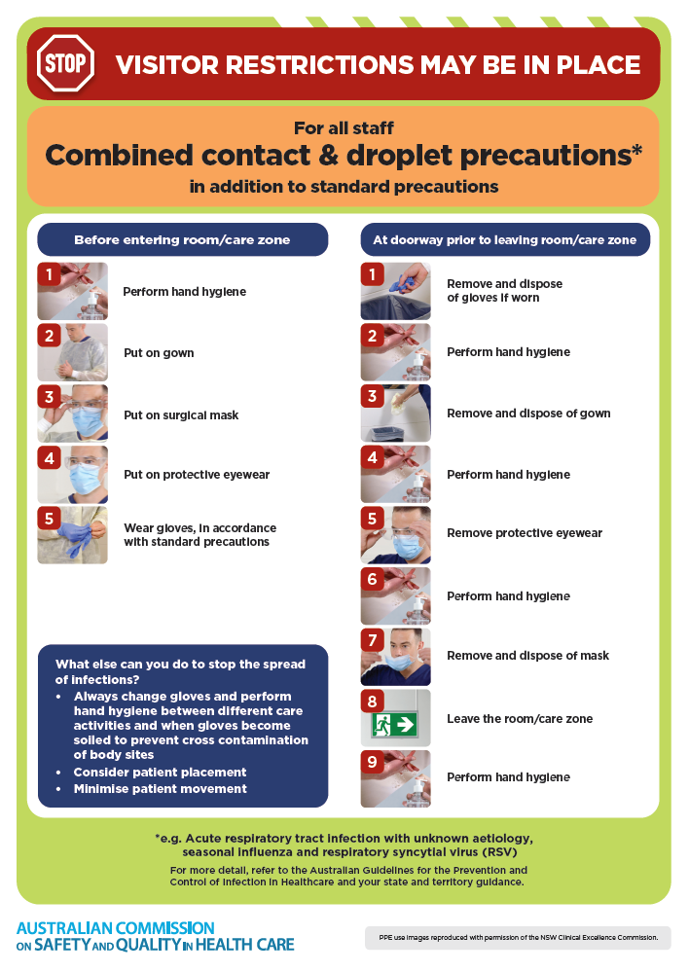](https://www.safetyandquality.gov.au/publications-and-resources/resource-library/infection-prevention-and-control-poster-combined-contact-and-droplet-precautions)
* ***Poster – Combined airborne and contact precautions***<https://www.safetyandquality.gov.au/publications-and-resources/resource-library/infection-prevention-and-control-poster-combined-airborne-and-contact-precautions>  
  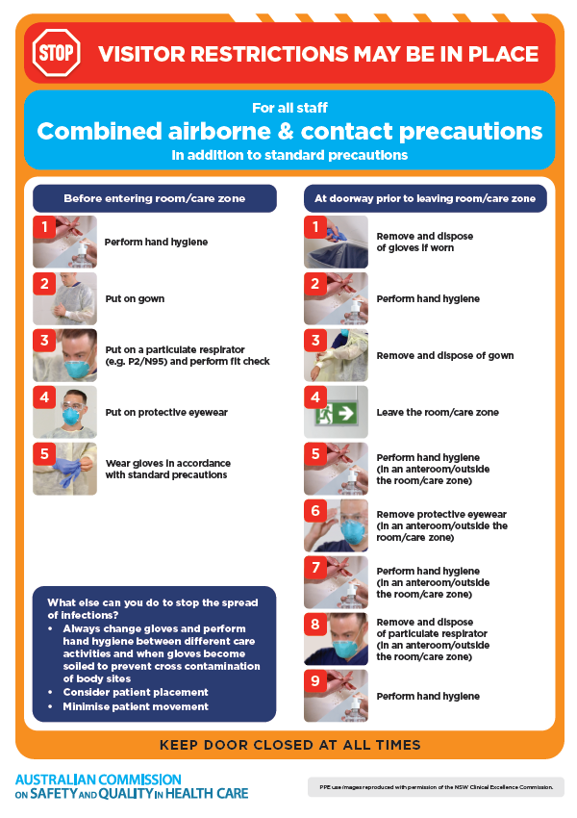
* ***Environmental Cleaning and Infection Prevention and Control*** [www.safetyandquality.gov.au/environmental-cleaning](http://www.safetyandquality.gov.au/environmental-cleaning)
* ***Break the chain of infection*** poster  
  <https://www.safetyandquality.gov.au/publications-and-resources/resource-library/break-chain-infection-poster>  
    
  **[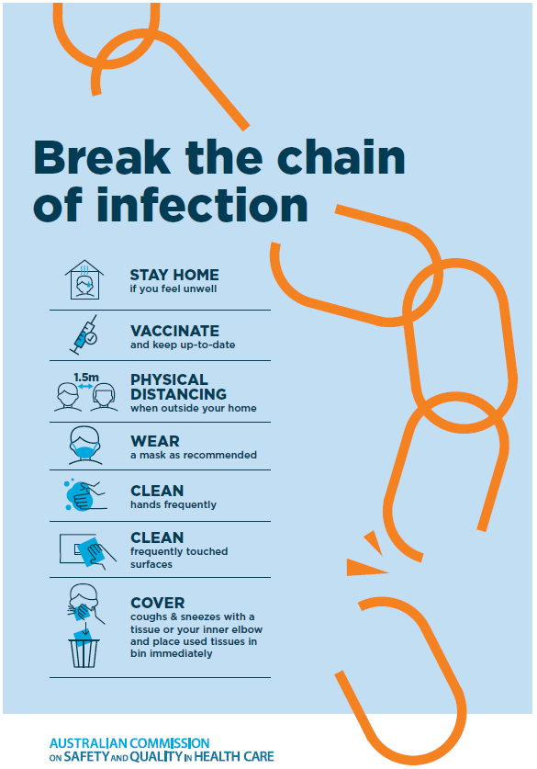](https://www.safetyandquality.gov.au/publications-and-resources/resource-library/break-chain-poster-a3https:/www.safetyandquality.gov.au/publications-and-resources/resource-library/break-chain-poster-a3)**

**Disclaimer**

On the Radar is an information resource of the Australian Commission on Safety and Quality in Health Care The Commission is not responsible for the content of, nor does it endorse, any articles or sites listed The Commission accepts no liability for the information or advice provided by these external links Links are provided on the basis that users make their own decisions about the accuracy, currency and reliability of the information contained therein Any opinions expressed are not necessarily those of the Australian Commission on Safety and Quality in Health Care.