
On the Radar
Issue 736
16 March 2026

On the Radar is a summary of some of the recent publications in the areas of safety and quality in health care Inclusion in this document is not an endorsement or recommendation of any publication or provider Access to particular documents may depend on whether they are Open Access or not, and/or your individual or institutional access to subscription sites/services Material that may require subscription is included as it is considered relevant.

On the Radar is available online, via email or as a PDF or Word document from https://www.safetyandquality.gov.au/newsroom/subscribe-news/radar

If you would like to receive On the Radar via email, you can subscribe on our website https://www.safetyandquality.gov.au/newsroom/subscribe-news
or by emailing us at mail@safetyandquality.gov.au.
You can also send feedback and comments to mail@safetyandquality.gov.au.

For information about the Commission and its programs and publications, please visit https://www.safetyandquality.gov.au

On the Radar
Editor: Dr Niall Johnson
Contributors: Niall Johnson

Reports

Delivering quality care more efficiently
Inquiry report no. 112
Productivity Commission
Canberra: Productivity Commission; 2025. p. 126.
URL | https://www.pc.gov.au/inquiries-and-research/quality-care/report/
Notes | Late in 2025 the Productivity Commission published its final Delivering quality care more efficiently report. The interim report had been noted in On the Radar in August. Th e Productivity Commission see that ‘the care and support economy is coming under increasing pressure to deliver high-quality services at a sustainable cost. Without decisive action, future generations will face deeper health inequities and a care system increasingly unable to meet their needs.’ Furthermore, ‘Now is the time for governments to shape the future of the care economy.’ The report includes a number of recommendations, including:  - Reform of quality and safety regulation to support a more cohesive care economy  - Recommendation 1.1 Align quality and safety regulation of workers across the care economy  - Recommendation 1.2 Align quality and safety regulation of providers and services and assess the case for a single regulator  - Recommendation 1.3 Lead the implementation process and provide relevant agencies with direction.  - Embed collaborative commissioning to increase the integration of care services  - Recommendation 2.1 Establish stronger joint governance arrangements  - Recommendation 2.2 Enable more flexible funding  - Recommendation 2.3 Provide dedicated funding based on outcomes  - Recommendation 2.4 Take a strategic leadership role and ensure sufficient capability.  - A national framework to support government investment in prevention and early intervention  - Recommendation 3.1 Establish a National Prevention and Early Intervention Framework  - Recommendation 3.2 Ensure better evaluation of prevention and early intervention  - Recommendation 3.3 Enable collaboration between Australian, state and territory governments.

Top 10 Patient Safety Concerns for 2026
ECRI
Willow Grove, PA: ECRI; 2026.

Top 10 Health Technology Hazards for 2026
ECRI
Willow Grove, PA: ECRI; 2026.
URL | https://home.ecri.org/pages/top-10-patient-safety-concerns  https://home.ecri.org/blogs/ecri-thought-leadership-resources/top-10-health-technology-hazards-for-2026-executive-brief
Notes | ECRI (originally the Emergency Care Research Institute) in the USA produces an annual list of hazards. Their list of the top 10 patient safety concerns for the USA is 2026 is:  - Navigating the AI diagnostic dilemma  - Reduced access to rural healthcare increases health risks and disparities  - Increasing rates of preventable Acute Diseases in Communities and Healthcare Settings  - Effects of Federal Funding Cuts on Healthcare Operations and Patient Safety  - Lack of Recognition and Reporting of Harm Events  - Structural and Systemic Barriers Inhibit Equitable Pain Management for Women  - Persistent Workforce Shortages Continue to Burden Staff and Restrict Access to Care  - The Impact on System Improvement When a Culture of Blame Hinders Learning  - Emergency Department Boarding Contributes to Worse Patient Outcomes  - Persistent Gaps in Manufacturer Packaging and Labeling Design Continues to Undermine Medication Safety Efforts.  ECRI also produce a Top 10 Health Technology Hazards for 2026 list. That list includes:  - The Misuse of AI Chatbots in Healthcare  - Unpreparedness for a “Digital Darkness” Event  - The Growing Challenge of Combating Substandard and Falsified Medical Products  - Recall Communication Failures for Home Diabetes Management Technologies  - Tubing Misconnections Remain a Threat Amid Slow ENFit and NRFit Adoption  - Underutilizing Medication Safety Technologies in Perioperative Settings  - Deficient Device Cleaning Instructions Continue to Endanger Patients  - Cybersecurity Risks from Legacy Medical Devices  - Technology Designs or Configurations That Prompt Unsafe Clinical Workflows  - Water Quality Issues During Instrument Sterilization.

National Strategic Framework for Chronic Conditions 2026–35
Department of Health, Disability and Ageing
Canberra: Department of Health, Disability and Ageing; 2026. p. 85.
URL | https://www.health.gov.au/resources/publications/national-strategic-framework-for-chronic-conditions
Notes | The Australian Government Department of Health, Disability and Ageing has released the National Strategic Framework for Chronic Conditions 2026–35. This Framework ‘sets out an approach to one of Australia’s most significant health challenges, chronic conditions’. The framework’s vision and purpose are given as:  ‘Vision All people living in Australia experience a healthier and improved quality of life through effective prevention, early detection and intervention, and management of all chronic conditions.  Purpose To guide the development and prioritisation of policies, strategies, actions, and services to address chronic conditions in Australia.’  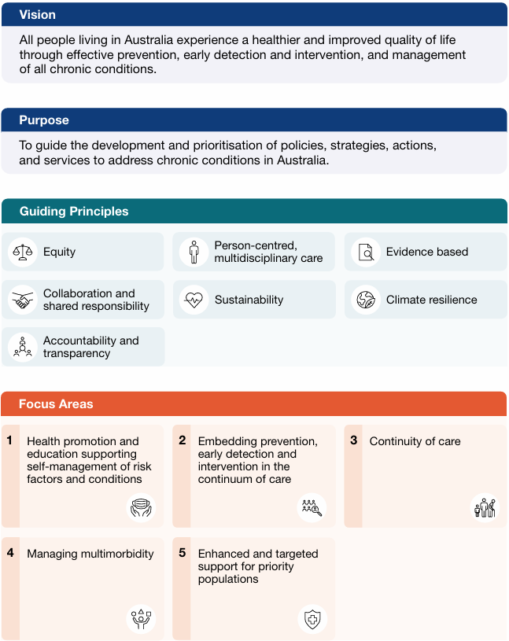
Attitudes to technology and AI in health care
Findings from our 2025 survey
Binesmael A, Horton T, Marks T, Thornton N
London: The Health Foundation; 2026.
URL | https://www.health.org.uk/reports-and-analysis/analysis/attitudes-to-technology-and-ai-in-health-care
Notes | Recent (March 2026) analysis from The Health Foundation in the UK following surveying 8,000 members of the UK public and 2,000 NHS staff to explore attitudes to technology and AI in health care. Among the key findings:  - Sentiment towards technology in health care remains broadly positive… 55% of the public says technology improves care quality….  - Support for AI in health care has seen a small increase, with the balance of sentiment remaining broadly positive. 38% of the public says AI will improve care quality, up from 33% in 2024….  - NHS staff are more positive about tech and AI in health care than the public. For example, 80% of staff surveyed supported the use of AI for patient care compared with 54% of the public.  - Public attitudes towards the regulation, oversight and use of AI in health care are generally cautious.  There are echoes here of what has been found in Australia. For example, the University of Melbourne and KPMG found in their Trust, attitudes and use of Artificial Intelligence: A global study 2025 project that in the global study ‘Trust in AI systems remains a significant challenge: over half (54%) are wary about trusting AI.’ Among the results for Australia it is noted that:  - 77% believe AI regulation is required  - 10% aware of AI regulations and policies in their country  - 30% believe current safeguards are sufficient  - Australians expect oversight by government and existing regulators, co-regulation with industry, and international laws and regulations.  An article in the Medical Journal of Australia describing an earlier citizen jury exercise reported that ‘a diverse sample of Australian citizens recommended a national charter for health care AI and an independent decision-making body. They also emphasised that rigorous evaluation, fairness and patient rights, clinical governance and training, technical and data requirements, and community education and involvement were also critical areas requiring attention.’ It is essential for the successful deployment, implementation and scaling up of AI in Australian health care that a sense of trust and purpose be created and maintained.

For information on the Commission’s work on the safe and responsible use of Artificial Intelligence (AI) in healthcare, see https://www.safetyandquality.gov.au/our-work/e-health-safety/artificial-intelligence

Action for climate change: Examples from the WHO Regions for Health Network
World Health Organization Regional Office for Europe
Copenhagen: WHO Regional Office For Europe; 2026. p. 20.
URL | https://www.who.int/europe/publications/i/item/WHO-EURO-2026-9634-49406-73902
Notes | Policy brief from the World Health Organization’s Regional Office for Europe that provides six case studies that ‘highlight regional approaches to, lessons learned about, and recommended actions on integrating health into climate action’. The brief notes that ‘Lessons learned from this analysis of regional policies on climate change underline that strategies must be tailored to regional realities, equity must be central, and health systems must act both as responders and leaders in climate action.’

For information on the Commission’s work on environmentally sustainable healthcare, see https://www.safetyandquality.gov.au/our-work/environmentally-sustainable-healthcare

Healthcare Quarterly, October to December 2025
Bureau of Health Information
St Leonards: BHI; 2026.
URL | https://www.bhi.nsw.gov.au/BHI_reports/healthcare_quarterly/Oct-Dec2025
Notes | The Bureau of Health Information (BHI) in New South Wales has released that latest activity and performance information for NSW public hospitals and ambulance services. Healthcare Quarterly, October to December 2025 reports on activity and performance information for public hospital and ambulance services in NSW in late 2025.Also available are reports on seclusion and restraint in NSW public hospitals, a technical supplement and activity and performance profiles.

Journals

American Journal of Medical Quality
Volume 41, Issue 2, March/April 2026
URL | https://journals.lww.com/ajmqonline/toc/2026/03000
Notes | A new issue of the American Journal of Medical Quality has been published. Articles in this issue of the American Journal of Medical Quality include:  - Editorial: Inviting You to Submit Research and Stories, With More Article Types to Choose (Pranavi V Sreeramoju)  - Physician Practices Promoting Effective Communication with Nurses: A Qualitative Study (Claire Howlett, Esther Y Hsiang, M A Kantor, S J Flynn)  - Utilizing a Stakeholder Driven Approach in Developing a Regional Perinatal Psychiatry Access Program (Meredith Spada, Colleen Gianneski, Shivali Hariharan, Chiamaka Ejinaka, Shinnyi Chou, Elizabeth Krans, A Schlesinger, H M Joseph, J B Glance, B Sirianni, A Boast, R Ferguson, P Gopalan)  - Best Practices for Diagnostic Evaluation of Unintentional Weight Loss (Goutham Rao, Kelsey Ufholz, Sarah Koopman-Gonzalez, Harry Menegay, Sunah Song, Beverly Koepf, Mark Beno)  - Determining Causes of Insulin-Induced Hypoglycemia Using an Electronic-Based Trigger (Kamil Evy A Bantol, Yingchao Zhong, Joanne Bruno, Nandini Nair, Nathan Gollogly, Pradyuman Jhala, Brianna Knoll)  - Advance Care Planning, Race, and Age (Rebecca E Berger, Monika M Safford, Jennifer I Lee, Mangala Rajan, M L McNairy, A Card, L M Kern)  - Automation in Surgical Adverse Event Documentation: Improving Completeness and Accuracy (Francis D Graziano, Charles Z Jiang, Bracha L Pollack, Arielle Roberts, Adana-Christine Campbell, Ronnie L Shammas, Lillian A Boe, Babak J Mehrara, Jonas A Nelson, Carrie S Stern)  - Pharmacoequity: What Should be Done to Improve It? (Elizabeth Sottung, Vietbao Phan, Willie H Oglesby, Vittorio Maio)  - Bridging the Methodological Gap: Integrating Implementation Science With HFACS to Move From Diagnosis to Intervention Design (Daren Zhao)  - Implementing High-Value Care with Daily Labs in Internal Medicine Resident Driven Hospital Medicine: A Quality Improvement Project (Nudar Bhuiya, Olivera Drobac, Kaynat Khalid, Maidah Raja, Madeline Stull, David Sullivan, Nagaraju Sarabu, William Cook)  - Quality Improvement Assessment on Diversity, Equity, and Inclusion Initiatives in US Medical Schools (Munifa King, Maryam Edris, Renee Bicaba, Zavia King, Byron Scott)  - Targeted Deprescribing of PPIs in Ambulatory Care: Outcomes From a Resident-Led, Pharmacist Supported Intervention (Himsikhar Khataniar, Hany Habib, Ikram Khaliq, Helene Bloom, Kevin Taffe)

The Lancet Primary Care
Volume 2, Number 2, February 2026
URL | https://www.thelancet.com/issue/S3050514326X20027
Notes | The Lancet Primary Care is a relatively new open access journal. Articles in this issue of The Lancet Primary Care include:  - Editorial: PEN-Plus: a first step to better care  - Point-of-care testing to support antimicrobial stewardship: contextualised strategies are needed (Andreas Plate, Oliver Senn)  - Frailty, polypharmacy, and the case for pragmatic prescribing in primary care (Peter Hanlon, Emma Wallace, Anthony J Avery, Kenneth Rockwood)  - Corporatisation of primary care: the need for critical analysis (Lisa Jansen, Michael Anderson, Lilian H D van Tuyl, Maximilian Schwarz, J De Maeseneer)  - Family physicians as key agents in integrating mental health services into primary care (Erin K Ferenchick, Larry A Green, Christopher Dowrick, Christos Lionis, Cindy L K Lam, S Randenikumara, B Jortberg, E Gilchrist  - Our commitments to diversity and inclusion (Yaiza del Pozo Martín)  - Community health workers and tuberculosis services integration within primary health care: from adequate compensation to comprehensive, reliable support (Nadine Muller, Fortress Y Aku, O G Ravololohanitra, A Neumann)  - Increasing equity of access to mental health support: greater investment in community partners is needed (Samuel P Trethewey, T Newlove-Delgado)  - Prioritising primary care during ceasefire in Gaza (Richard Armitage)  - Point-of-care testing strategy versus usual care to safely reduce antibiotic prescribing for acute respiratory tract infections in primary care (PRUDENCE): a pragmatic, randomised controlled trial in 13 countries (Alike W van der Velden, Samuel Coenen, Emma Harper, Marilena Anastasaki, Sibyl Anthierens, Femke Böhmer, Emily Bongard, Julie Domen, Ana Garcia-Sangenis, Gail N Hayward, Bernadett Kovacs, Anna Kowalczyk, Carl Llor, Lile Malania, Fulvia Mazzaferri, Sam Mort, Joanna Moschandreas, L Rossignol, B R Saville, M Shanyinde, E Tacconelli, S Tonkin-Crine, P J Turner, A Vellinga, M Wanat, L-M Yu, A Zerda, S Emmerich, H Goossens, C C Butler)  - Clinician and patient experiences with point-of-care testing for acute respiratory infections in primary care: a qualitative process evaluation of the PRUDENCE trial (Marta Wanat, Melanie E Hoste, Marilena Anastasaki, Femke Böhmer, Annelies Colliers, Maria Gkamaletsou, Herman Goossens, Christin Löffler, Christos Lionis, Lile Malania, Mala Shah, Anja Wollny, Akke Vellinga, C C Butler, A W van der Velden, S Anthierens, S Tonkin-Crine)  - Defining recurrent urinary tract infections and quantifying bladder cancer risk in primary care in England: a nationwide case–control study (Sikhuphukile G Mahati, Jianhua Wu, Fiona M Walter, Yin Zhou)  - Multiplex PCR testing for Treponema pallidum and herpes simplex virus in primary care to detect primary syphilis in Victoria, Australia: a prospective cohort study (Rebecca Wigan, Yasmin Hughes, Lynette Waring, Eric P F Chow, Shivani Pasricha, Jason J Ong, Marcus Maisano, Christopher K Fairley, M Temple-Smith, L Sanci, J S Hocking, J Tomnay, B Donovan, D Hewson, A Diprose, J Bilardi, D Williamson, J M Towns, N Ryder, J Kaldor, M Y Chen)  - Evidence-based blood tests for monitoring adults with chronic kidney disease stage G3 in primary care: rapid review, routine data analysis, and consensus study (Martha M C Elwenspoek, Rachel O’Donnell, Catalina Lopez Manzano, Lewis Buss, Sarah Dawson, Katie Charlwood, Thomas A Harding, Christina Stokes, Francesco Palma, Alastair D Hay, Jessica Watson, P Whiting)  - Safeguarding planetary health: the contribution of community health workers to climate stability, global equity, and social justice (Cornelia Junghans Minton, Cleo Baskin, Joerg Schmid, Matthew Harris)

BMJ Quality & Safety online first articles
URL | https://qualitysafety.bmj.com/content/early/recent
Notes | BMJ Quality &Safety has published a number of ‘online first’ articles, including:  - Does bypassing nearby hospitals for high-quality care reduce case fatality among inpatients who had a stroke? A retrospective study of 328 206 cases (Qingyu Wang, Lu Ao, Kun Tan, Xiang Yan, Jay Pan)

International Journal for Quality in Health Care online first articles
URL | https://academic.oup.com/intqhc/advance-articles
Notes | International Journal for Quality in Health Care has published a number of ‘online first’ articles, including:  - The Relationship Between Indigenous Health and Relevant Sector Standards in Aotearoa New Zealand, Australia and Canada: A Scoping Review (Dean Cowles, Jan Dewar, Catherine Cook)  - Association between hospital accreditation and patient safety management systems in Japan: A secondary analysis of nationwide surveys, 2015—2023 (Ryo Onishi, Yosuke Hatakeyama, Kunichika Matsumoto, Ryosuke Hayashi, Kanako Seto, Tomonori Hasegawa)

Infection prevention and control resources
The Australian Commission on Safety and Quality in Health Care has developed a number of resources to assist healthcare organisations, facilities and clinicians These resources include:
- Poster – Combined contact and droplet precautions https://www.safetyandquality.gov.au/publications-and-resources/resource-library/infection-prevention-and-control-poster-combined-contact-and-droplet-precautions
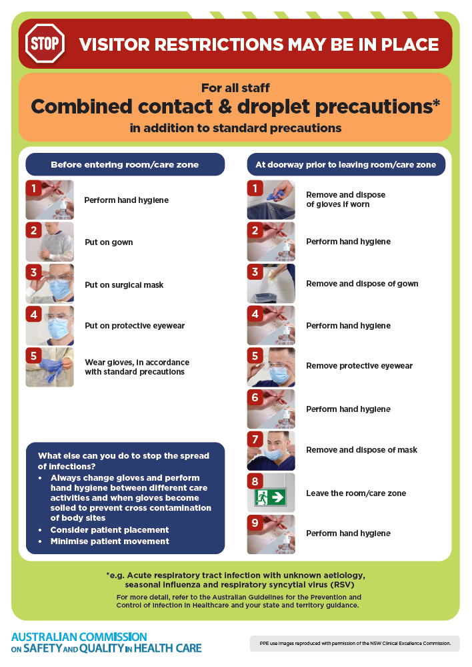
- Poster – Combined airborne and contact precautions
https://www.safetyandquality.gov.au/publications-and-resources/resource-library/infection-prevention-and-control-poster-combined-airborne-and-contact-precautions
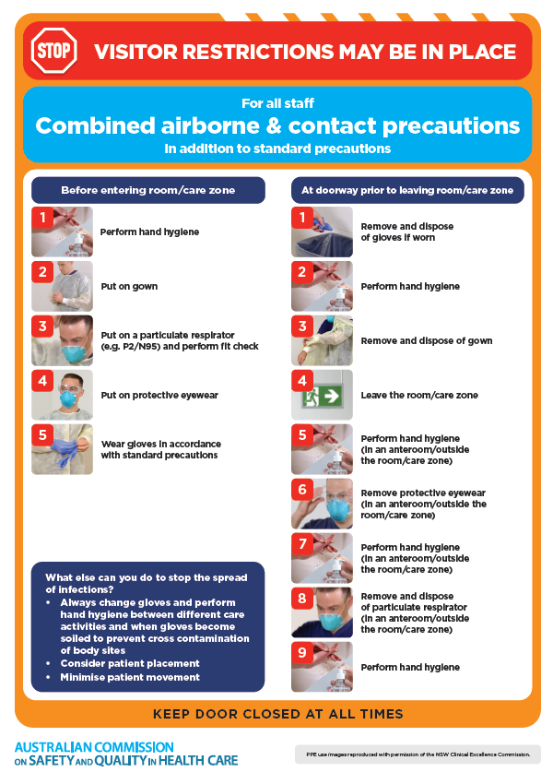
- Environmental Cleaning and Infection Prevention and Control www.safetyandquality.gov.au/environmental-cleaning
- Break the chain of infection poster
https://www.safetyandquality.gov.au/publications-and-resources/resource-library/break-chain-infection-poster
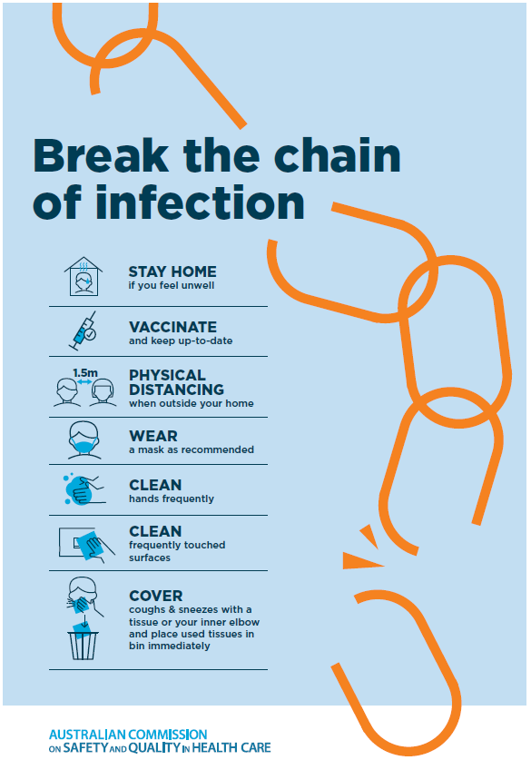

Disclaimer
On the Radar is an information resource of the Australian Commission on Safety and Quality in Health Care The Commission is not responsible for the content of, nor does it endorse, any articles or sites listed The Commission accepts no liability for the information or advice provided by these external links. Links are provided on the basis that users make their own decisions about the accuracy, currency and reliability of the information contained therein Any opinions expressed are not necessarily those of the Australian Commission on Safety and Quality in Health Care.

