
On the Radar
Issue 737
23 March 2026

On the Radar is a summary of some of the recent publications in the areas of safety and quality in health care Inclusion in this document is not an endorsement or recommendation of any publication or provider Access to particular documents may depend on whether they are Open Access or not, and/or your individual or institutional access to subscription sites/services Material that may require subscription is included as it is considered relevant.

On the Radar is available online, via email or as a PDF or Word document from https://www.safetyandquality.gov.au/newsroom/subscribe-news/radar

If you would like to receive On the Radar via email, you can subscribe on our website https://www.safetyandquality.gov.au/newsroom/subscribe-news
or by emailing us at mail@safetyandquality.gov.au.
You can also send feedback and comments to mail@safetyandquality.gov.au.

For information about the Commission and its programs and publications, please visit https://www.safetyandquality.gov.au

On the Radar
Editor: Dr Niall Johnson
Contributors: Niall Johnson

Reports

Equity across the regulation, implementation and evaluation of digital health: Scoping review
World Health Organization
Copenhagen: WHO Regional Office for Europe; 2026. p.104
URL | https://www.who.int/europe/publications/i/item/WHO-EURO-2026-13153-52927-82472
Notes | The World Health Organization’s Regional Office for Europe in Copenhagen has published this scoping review on equity in digital health. From the document’s abstract (emphasis added):  ‘Digital health has the potential to improve health-care delivery and population health outcomes. To ensure equitable benefits, its development and implementation must address potential health inequities arising from biased technologies and systemic factors. A scoping review used a sociotechnical lens to examine how equity is considered in digital health regulation, implementation and evaluation within the WHO European Region. Equity is increasingly acknowledged in digital health, but its integration into practice remains inconsistent. Regulatory frameworks primarily emphasize safety, privacy and performance, with limited focus on inclusion of underserved populations or adaptability to low resource settings. Implementation strategies often overlook structural barriers. Standardized equity metrics and robust bias auditing for artificial intelligence-driven technologies are lacking. The review highlighted the need for an equity-by-design approach to embed equity throughout the digital health life cycle. Advancing equity requires inclusive governance, participatory design and cross-sectoral collaboration. Recommendations include establishing a shared understanding of equitable digital health, integrating equity metrics into maturity models, and reinforcing regulation, governance and sustainable financing. The Region is positioned to lead harmonization efforts and support Member States to embed equity within digital health policies and practices, ensuring that digital health contributes to improved health outcomes, stronger health systems and reduced health inequities.’

Delivering High Value Cancer Care: European Cancer Inequalities Registry Analytical Report
OECD/European Commission
Paris: OECD Publishing; 2026. p.297.
URL | https://doi.org/10.1787/060869fe-en
Notes | The OECD and European Commission have published this report on cancer care. It has been noted that cancer incidence has apparently been increasing in recent years. As the report’s abstract notes, ‘The global burden of cancer continues to rise, with an increasing number of cancer cases over the past two decades – particularly among younger women – placing sustained pressure on healthcare services and affecting well-being and economic outcomes.’ For cancer care in Europe, it is observed that ‘Cancer care could deliver better value for patients and health systems’, particularly as  - ‘Delays in access to cancer diagnosis and treatment continue to cost lives.’  - ‘Unnecessary variations in medical practice and care quality lead to poorer survival or quality of life for some patients and contribute to health system waste.’  - ‘people living with cancer are more vulnerable than other primary healthcare patients.’
Policies for people with dementia across OECD countries
OECD Health Working Papers, No. 190
Kim S, Llena-Nozal A, Milstein R, Rauet-Tejeda J
Paris: OECD Publishing; 2026. p. 100.
URL | https://doi.org/10.1787/e41e6eaa-en
Notes | This working paper on dementia ‘provides an overview of the most recent dementia policies across OECD countries and changes in the past decade’.  The abstract observes ‘Across the OECD, on average, 61 people per 1 000 population aged 65 and over were estimated to be living with dementia in 2023. … analysis suggests that national dementia policies increasingly emphasise prevention through modifiable risks, early diagnosis, and non-pharmaceutical treatment approaches. The paper summarises approaches towards improving awareness while pointing to limited efforts to improve diagnostics. Developments in managing behavioural and psychological symptoms of dementia, along with related workforce training, are more prominent. Additionally, services and support for dementia carers and progress towards more coordinated and inclusive care pathways are present in most national strategies and plans.’

How can co-ordination improve long-term care delivery?
OECD Health Working Papers, No. 192
Kim S, Llena-Nozal A, Lorenzoni L, Patrini V
Paris: OECD Publishing; 2026. p. 74.
URL | https://doi.org/10.1787/38332894-en
Notes | A second OECD health working paper examines long-term care, looking at ‘different policies to improve the co-ordination of health and care services across different parts of government, providers and organisations to help individuals perform everyday activities (long-term care, LTC)’. Focussing on four case studies: Canada (Quebec), Costa Rica, France and Japan, ‘which represent diverse LTC models at different stages of implementation’. The paper ‘discusses four key policy dimensions: governance, funding, workforce and mechanisms for data-sharing in the long term-care sector. It finds that co-ordination mechanisms are important to have adequate care provision across different sectors (horizontal co-ordination) and ensure alignment across different levels of governments (vertical co-ordination).’

Journal articles

Antibiotic use in older Australians with and without dementia in primary care
Burvenich R, Broder JC, Wang Y, Verbakel JY, Ryan J, Orchard SG, et al.
Age and Ageing. 2026;55(2):afag014.
DOI | https://doi.org/10.1093/ageing/afag014
Notes | Paper reporting on a study that sought to ‘describe trends in antibiotic dispensing and prevalence amongst Australians aged ≥70 years, compare dispensing between those with and without dementia and identify factors associated with dispensing’. From the analysis of 13,659 study participants over the period 2010–2020, the authors report ‘Dispensing rates increased to 1651 per 1000 person-years (95% CI: 1604–99) by year 9. Annual prevalence averaged 47%. Broad-spectrum antibiotics were dispensed twice as often as narrow-spectrum. Individuals with dementia had higher dispensing both before and after diagnosis, but dementia was not independently associated with dispensing (IRR 1.06, 95% CI: 0.95–1.18). Female sex, polypharmacy, pre-frailty and higher depressive symptom scores were linked to higher dispensing, whilst hypertension, dyslipidaemia and alcohol use were linked to lower dispensing.’

For information on the Commission’s work on antimicrobial stewardship, see https://www.safetyandquality.gov.au/our-work/antimicrobial-stewardship

Is independent double-checking superior to single-checking in medication administration error detection? A randomised controlled simulation trial
Westbrook JI, McMullan RD, Fitzpatrick E, Merchant A, Wiggins M, Aryal N, et al
BMJ Quality & Safety. 2026.
DOI | https://doi.org/10.1136/bmjqs-2025-019743
Notes | Paper reporting on a study featuring a ‘multicentre randomised controlled simulation trial with 82 nurses from two paediatric hospitals’ that sought to ‘compare the effectiveness of IDC [Independent double-checking] versus single-checking in detecting medication errors during administration, assess the time required and explore factors influencing performance, including nurse experience and social dynamics’. The authors note that the while ‘Double-checking of medication administration is a safety practice used in hospitals around the world’, ‘There is no empirical evidence that IDC is more effective in error detection than a single-nurse check.’ From the 41 2-hour simulations, the authors report ‘IDC improved error detection for experienced nurses, but not for early career nurses’. The authors suggest that ‘Given its inconsistent benefits, resource demands and susceptibility to social loafing, IDC may be unsuitable as a universal safety strategy.’  A 2021 evidence briefing prepared for the Australian Commission on Safety and Quality in Health Care by some of the authors of this article examined double-checking medication administration as an intervention to improve medication safety. That had suggested ‘Better quality studies are required to determine if, and when, targeted use of double-checking is most effective in reducing errors’.

For information on the Commission’s work on medicines safety and quality, see https://www.safetyandquality.gov.au/our-work/medicines-safety-and-quality

Journal of Health Services Research & Policy
Volume: 31, Number: 2, April 2026
URL | https://journals.sagepub.com/toc/hsrb/31/2
Notes | A new issue of the Journal of Health Services Research & Policy been published. Articles in this issue of the Journal of Health Services Research & Policy include:  - Editorial: Does the English NHS 10-year health plan offer transformational change and a break with the past or more of the same? (David J Hunter)  - Review of residential and nursing care home policies on safety incident reporting in England (Mel Steer, Kate Sykes, Justin Waring, Celia Mason, Pamela Dawson, Craig Newman, L Young-Murphy, M Spencer and J Scott)  - What is the quality of care at the end of life? Qualitative findings from a nationally-representative post-bereavement survey across England and Wales (Joanna Goodrich, S Pask, C Okwuosa, T Johansson, L Laidlaw, C Ghiglieri, R Chambers, A E Bone, S Barclay, F E M Murtagh and K E Sleeman)  - Maternity staff opinions on perinatal death reviews: Parent involvement and changes to standardising the system (Emily O’Connor, Aenne Helps, Richard Greene, Keelin O’Donoghue and Sara Leitao)  - Navigating North Carolina’s Medicaid transformation: Caregivers’ perspectives through a family-centered lens (Brittany J Raffa, Monisa Aijaz, Brenda Amezquita-Castro, Paula H Song, Valerie A Lewis and C M Shea)  - Taskification in general practice: A solution to, or an aggravator of, the workforce crisis? (Amanda N Rasmussen, Imelda Mcdermott and S Spooner)  - Understanding why health professionals are leaving the UK national health service (NHS) – A systematic review and narrative synthesis (Chukwunwuba R Onyejesi, Tiffeny James and Kalpa Kharicha)

JBI Evidence Synthesis
Volume 24, Issue 3, March 2026
URL | https://journals.lww.com/jbisrir/toc/2026/03000
Notes | A new issue of JBI Evidence Synthesis has been published. Articles in this issue of JBI Evidence Synthesis include:  - Digital media campaigns for knowledge transfer: reflections on JBI Methodology Month (Heather McCulloch, Bianca Pilla)  - The revised JBI critical appraisal tool for the assessment of risk of bias for analytical cross-sectional studies (Timothy H Barker, Sabira Hasanoff, Edoardo Aromataris, Jennifer C Stone, Jo Leonardi-Bee, Kim Sears, Miloslav Klugar, Catalin Tufanaru, Sandeep Moola, Xian-Liang Liu, Zachary Munn)  - Individual participant data meta-analysis tips and tricks: troubleshooting commonly encountered issues of contacting trialists for individual participant data (M Flanagan, L C Gurrin, W Li, M Patabendige, D L Rolnik, B W Mol)  - Bias-adjusted meta-analysis using the quality effects model: a Stata tutorial (Jennifer C Stone, Cindy Stern, R M Jia, A Whitehorn, H T Ho, S A R Doi)  - Evaluating the proper use of weighted mean difference in evidence synthesis: a meta-epidemiology study (Xing Xing, Y Wang, J Tong, L Lin)  - Real-world evaluation of inter-consensus agreement on the Murad tool for appraising the methodological quality of case reports and case series (Moustafa Hegazi, Samer Saadi, Adel Kabbara Allababidi, Magdoleen H Farah, Mohamed Abusalih, Ayla S Basha, B Hasan, T Rajjo, Z Wang, M H Murad)  - Evidence synthesis methodology for questions relating to barriers and enablers in health care: a scoping review (Cindy Stern, Chelsea Valenzuela, Ashley Whitehorn, Danielle Pollock, Sonia Minooee, Dilan Arun Gohil, Zheng Zhu, Pamela Kirkpatrick, Ricardo Loureiro, Ellen Davies, Daniela Cardoso, Zachary Munn, Judith Carrier, Dawid Pieper, Kay Cooper, Romy M Jia, H Loveday, P Martin, S Salmond, K Borges dos Santos, N Habibi, L Lizarondo)  - User experience and adoption of automation and AI for evidence synthesis: a scoping review protocol (C Valenzuela, C Stern, E Aromataris)  - Simulation-based education to support new graduate nurses during transition to practice in critical care: a mixed methods systematic review protocol (Laura Freeman, Caroline Sabotig, Andria Phillips, Aleasha Naggyah, Brandi Vanderspank-Wright, Jane Tyerman  - Interventions for promoting climate actions and enhancing psychological health: a scoping review protocol (M Yong, Y Xu, A von Hagen, S S Ho)  - Effectiveness of play therapy vs non-play interventions in palliative care for children and adolescents with cancer: a systematic review protocol (Nikka Karla R Santos, Jon Timothy M Rivero, V C Dones III, R M Jia, S J Hines)  - Non-synthetic vs synthetic local drug delivery agents for the treatment of periodontitis in adults: a systematic review and meta-analysis protocol (Pallavi Menon, Vineetha Karuveettil, Shilpa Ramachandran)  - Implementation of vancomycin area under the curve therapeutic drug monitoring with model-informed precision dosing: a scoping review protocol (Brett Ritchie, Stephanie E Reuter, Kylie Porritt)  - Midwifery students’ experiences with practicing the midwifery philosophy of care during clinical practice in the hospital settings: a qualitative systematic review protocol (D Waller, P Thomas, M Serex, A Abderhalden-Zellweger)  - Afrocentric approaches to primary health care provision with Black populations: a scoping review protocol (Vivian Yejide Kilanko, Martha M Whitfield, Mustofa W Jemal, Amanda Ross-White, R Wilson, C Davison)  - Signs and symptoms of acute tacrolimus toxicity in solid organ transplant recipients: a scoping review protocol (Lídia Einsfeld, K Asturian, D Pilger)

BMJ Quality & Safety online first articles
URL | https://qualitysafety.bmj.com/content/early/recent
Notes | BMJ Quality &Safety has published a number of ‘online first’ articles, including:  - Is independent double-checking superior to single-checking in medication administration error detection? A randomised controlled simulation trial (Johanna I Westbrook, Ryan Daniel McMullan, Erin Fitzpatrick, Alison Merchant, Mark Wiggins, Nanda Aryal, Magdalena Z Raban, Alan Gardo, Caleb Lapointe, Philip Williams, XLing Li)

International Journal for Quality in Health Care online first articles
URL | https://academic.oup.com/intqhc/advance-articles
Notes | International Journal for Quality in Health Care has published a number of ‘online first’ articles, including:  - Countdown to Lobectomy: Interventions to Improve Waiting Times for Lung Cancer Resection (Donovan Campbell et al)  - Low-Value Preoperative Care in Low-Risk Procedures: Clinical and Economic Burden for Health System Sustainability (Josiane F John et al)  - Resilience practices of healthcare professionals during the hospital discharge process: A qualitative study (Jee-In Hwang et al)  - Beyond accuracy scores: Toward process-oriented evaluation of AI clinical reasoning in clinical workflow integration (Zhong-Rui Ma et al)  - Can you please hold? An assessment of the impact of reporting room assistants on interruptions in the reporting room of a major trauma tertiary Centre (Hanna Mari Chang et al)  - When Donor Funding Ends: Reflections from Jordan’s HCAC on Sustainable Health System Strengthening (Salma Jaouni et al)  - Development and early implementation of automated audit and feedback monitoring instruments in Belgian primary care: lessons for scalable systems (Willem Raat et al)  - Diagnostic Errors in Clinical Laboratory Testing Process: Incidence and Impacts on Patient Safety—A 3-Year Voluntary Incident Report Analysis (Montri Saengpattrachai et al)  - Evaluating Emergency Code Use and Integrating Clinical Codes for Emergency Conditions to Improve Coordination in a Tertiary Care Hospital (Tanushree Bora et al)
Online resources

Reporting of medical device adverse events by healthcare facilities
https://www.tga.gov.au/resources/guidance/reporting-medical-device-adverse-events-healthcare-facilities
Mandatory reporting of medical device adverse events by healthcare facilities commences Saturday 21 March 2026. This includes private hospitals, public hospitals and day hospital facilities (both public and private). Mandatory reporting requirements do not apply to facilities that fall outside of the Therapeutic Goods Act 1989 or the declared facilities in the Private Health Insurance Act 2007, such as general practices or residential aged care facilities. The first stage of the reporting requirement (21 March 2026 to 31 March 2028) requires facilities to report all adverse events resulting in death or serious deterioration associated with high-risk medical devices.

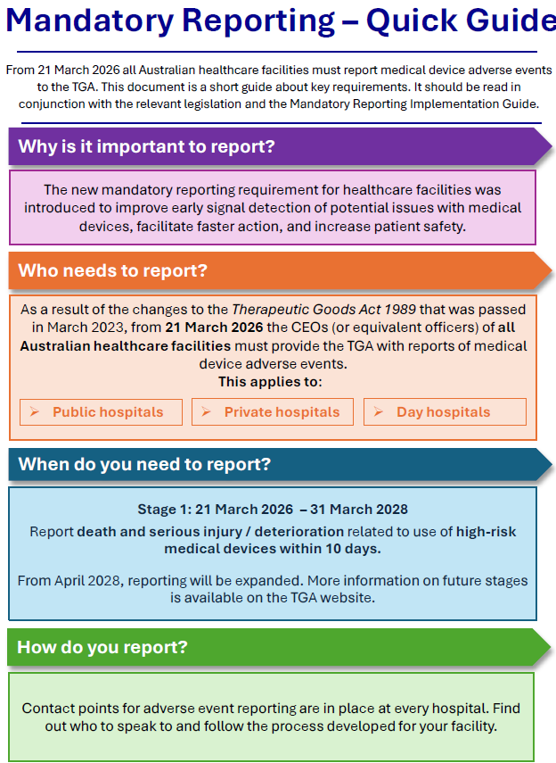

A National Safety and Quality Health Service (NSQHS) Standards Advisory on Mandatory reporting of medical device adverse events has been published https://www.safetyandquality.gov.au/newsroom/national-standards-updates/advisory-as2501-mandatory-reporting-medical-device-adverse-events
Australian Living Evidence Collaboration
https://livingevidence.org.au/

Guidance
A number of guidelines or guidance have recently been published or updated These include:
- Australasian Bronchiolitis Guideline: 2025 Update https://doi.org/10.1111/jpc.70144
https://www.predict.org.au/wp-content/uploads/2025/02/ABG2025-Report-final.pdf

[UK] NICE Guidelines and Quality Standards
https://www.nice.org.uk/guidance
The UK’s National Institute for Health and Care Excellence (NICE) has published new (or updated) guidelines and quality standards The latest reviews or updates include:
- Quality Standard QS215 Kidney cancer https://www.nice.org.uk/guidance/qs215
- NICE Guideline NG256 Kidney cancer: diagnosis and management https://www.nice.org.uk/guidance/ng256

Explain THIS
https://www.thisinstitute.cam.ac.uk/explain-this/
The THIS Institute (The Healthcare Improvement Studies Institute) in the UK has developed a series of short, accessible microlearning resources to help people working in healthcare improvement understand key concepts and approaches. Current and forthcoming topics include:
- Governance and leadership
- Implementation science
- Collaboration-based approaches
- Spread, scale-up, and sustainability
- Values and ethics
- Making culture change happen
- Measurement for improvement.

Infection prevention and control resources
The Australian Commission on Safety and Quality in Health Care has developed a number of resources to assist healthcare organisations, facilities and clinicians These resources include:
- Poster – Combined contact and droplet precautions https://www.safetyandquality.gov.au/publications-and-resources/resource-library/infection-prevention-and-control-poster-combined-contact-and-droplet-precautions
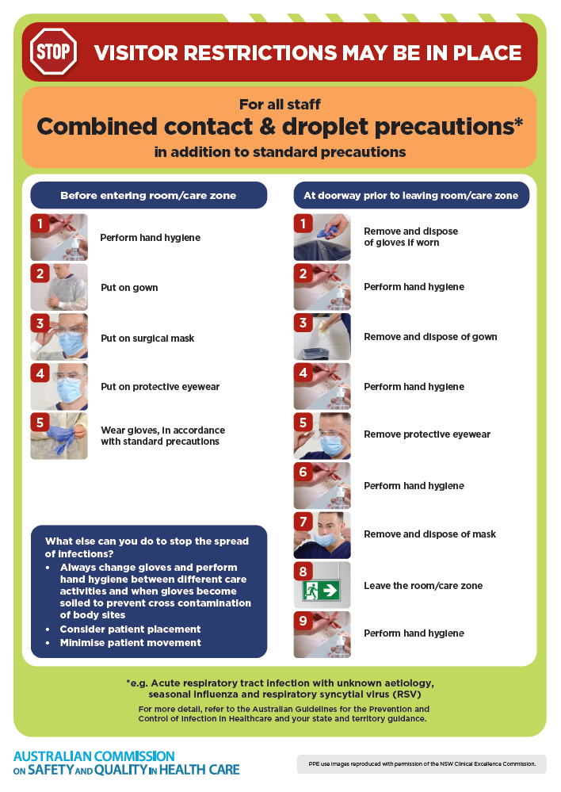
- Poster – Combined airborne and contact precautions
https://www.safetyandquality.gov.au/publications-and-resources/resource-library/infection-prevention-and-control-poster-combined-airborne-and-contact-precautions
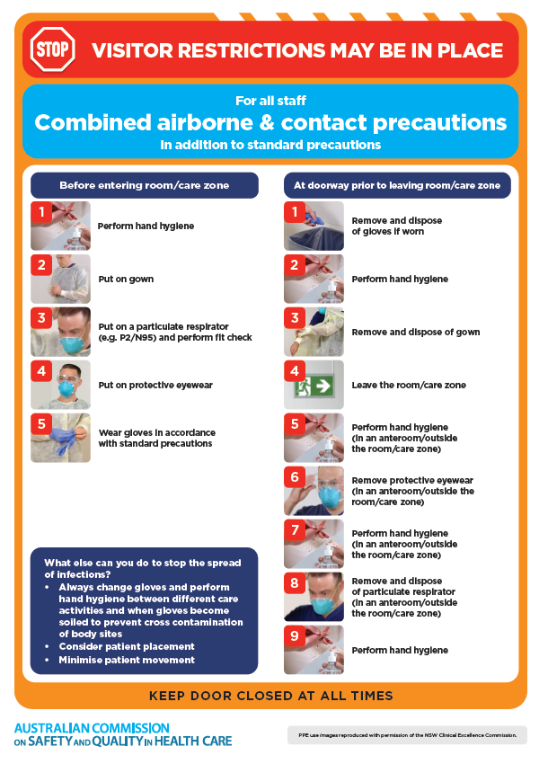
- Environmental Cleaning and Infection Prevention and Control www.safetyandquality.gov.au/environmental-cleaning
- Break the chain of infection poster
https://www.safetyandquality.gov.au/publications-and-resources/resource-library/break-chain-infection-poster
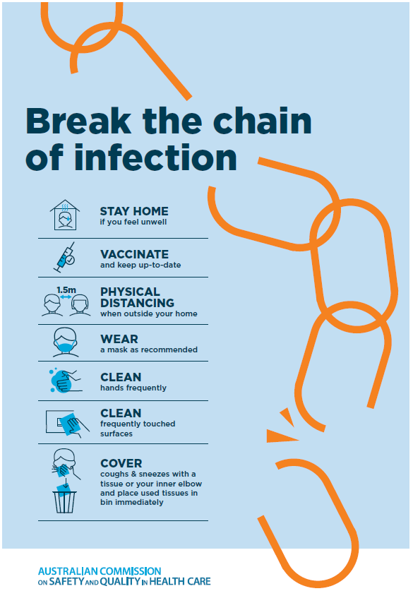

Disclaimer
On the Radar is an information resource of the Australian Commission on Safety and Quality in Health Care The Commission is not responsible for the content of, nor does it endorse, any articles or sites listed The Commission accepts no liability for the information or advice provided by these external links. Links are provided on the basis that users make their own decisions about the accuracy, currency and reliability of the information contained therein Any opinions expressed are not necessarily those of the Australian Commission on Safety and Quality in Health Care.

