
On the Radar
Issue 738
30 March 2026

On the Radar is a summary of some of the recent publications in the areas of safety and quality in health care Inclusion in this document is not an endorsement or recommendation of any publication or provider Access to particular documents may depend on whether they are Open Access or not, and/or your individual or institutional access to subscription sites/services Material that may require subscription is included as it is considered relevant.

On the Radar is available online, via email or as a PDF or Word document from https://www.safetyandquality.gov.au/newsroom/subscribe-news/radar

If you would like to receive On the Radar via email, you can subscribe on our website https://www.safetyandquality.gov.au/newsroom/subscribe-news
or by emailing us at mail@safetyandquality.gov.au.
You can also send feedback and comments to mail@safetyandquality.gov.au.

For information about the Commission and its programs and publications, please visit https://www.safetyandquality.gov.au

On the Radar
Editor: Dr Niall Johnson
Contributors: Niall Johnson


Safety of personalised medical devices in Australia survey
The Therapeutic Goods Administration (TGA) wants to hear from members of the public about their experiences with personalised medical devices. You do not need to have used a personalised device to take part. The survey takes 5–10 minutes and is anonymous. Scan the QR code to access the TGA’s survey.
The survey closes 24 April 2026.
Reports

Quadripartite guidance on One Health integrated surveillance of antimicrobial resistance and use
Geneva: World Health Organization, Food and Agriculture Organization of the United Nations, United Nations Environment Programme and World Organisation for Animal Health; 2025. p. 74.
URL | https://iris.who.int/handle/10665/385032
Notes | This guidance has been produced under the auspices of four entities, the World Health Organization (WHO), the Food and Agriculture Organization of the United Nations (FAO), the United Nations Environment Programme (UNEP) and the World Organisation for Animal Health (WOAH). The document provides a framework for antimicrobial resistance (AMR) and antimicrobial use (AMU) surveillance across human, animal, plant, and environmental sectors. The guidance offers direction on designing surveillance systems based on specific objectives, available resources, and national contexts.

For information on the Commission’s work on antimicrobial resistance, see https://www.safetyandquality.gov.au/our-work/antimicrobial-resistance
For information on the Commission’s work on antimicrobial stewardship, see https://www.safetyandquality.gov.au/our-work/antimicrobial-stewardship

Insulin: supporting safe administration in inpatient settings
Investigation report
Health Services Safety Investigation Body
Poole: HSSIB; 2026.
URL | https://www.hssib.org.uk/patient-safety-investigations/insulin-supporting-safe-administration-in-inpatient-settings/investigation-report/
Notes | The Health Services Safety Investigations Body (HSSIB) in the UK has released a new investigation report, the second on insulin. This report focuses on the safety of patients in hospital in England who have diabetes requiring treatment with insulin. It considers issues around the management of diabetes care and the safe administration of insulin for inpatients.  It is noted that insulin is regarded as a high-risk medication and is among the most common causes of harm from medication errors in the NHS. Diabetes affects a growing proportion of the inpatient population and is associated with significant risks when care is not managed effectively.  Going into hospital can create risks for patients with diabetes. Patients have come to harm or died in hospital because their diabetes requiring treatment with insulin has not been appropriately managed.  The report includes a number of observations, findings and recommendations.

For information on the Commission’s work on high-risk medicines resources including safer prescribing, dispensing and use of insulin, see https://www.safetyandquality.gov.au/our-work/medicines-safety-and-quality/high-risk-medicines/high-risk-medicines-resources

Journal articles

Opportunity for Improved Menopausal Hormone Therapy Prescribing
Bartz D, Tadikonda A, Manson JE
JAMA. 2026.
DOI | https://doi.org/10.1001/jama.2026.1891
Notes | Bartz et al start this piece by observing that ‘More than 1.3 million US women enter menopause each year,1 with a resulting 55 million currently living in the postmenopausal life stage’. Furthermore, ‘the average US age at menopause is 51 years, with most women living in this life phase for decades, often with long-term or even exacerbating symptoms’ which means ‘women spend close to 40% of their lives in the perimenopausal and postmenopausal periods, making these life stages a critical aspect of most adult medicine practices’. The piece argues the need to improve menopause education, symptom recognition, and treatment access, ensuring care is truly patient-centred and considers the breadth of treatment options.

High-Risk Medicines and Technology-Related Prescribing Errors in 2 Pediatric Hospitals
Merchant A, Fitzpatrick E, Westbrook JI, Baysari MT, Rahman B, Li L, et al
Pediatrics. 2026;157(2):e2024070043.
DOI | https://doi.org/10.1542/peds.2024-070043
Notes | Paper reporting on an Australian study that examined what are deemed ‘high-risk medicines’ (HRMs) and prescribing errors, particularly ‘Technology-related errors (TREs) [that] occur when the design of computerized provider order entry (CPOE) facilitates errors’. The study ‘identified 7014 HRM orders from retrospective medical record review of 18 951 medication orders for 2192 pediatric inpatients at 2 hospitals with the same CPOE in 2020’ and found that ‘Of the HRM orders, 20% (n = 1404) had at least 1 error.’ Further, ‘One in 4 HRM prescribing errors was technology related, one-third were potentially serious, and almost half were duplicate drug errors. Understanding HRM TREs can inform CPOE optimization to mitigate these errors and improve safety.’

For information on the Commission’s work on medicines safety and quality, see https://www.safetyandquality.gov.au/our-work/medicines-safety-and-quality

Evaluating an integrated quality improvement and research approach: the Just Cos Initiative
Bishop JD, Ottrey ED, Fitzgerald AM, Romein JM, Conlin MM
International Journal for Quality in Health Care. 2026:mzag041.
DOI | https://doi.org/10.1093/intqhc/mzag041
Notes | Paper reporting on how a rural health service in western Victoria, East Grampians Health Service, developed its ‘Just Cos’ initiative and the evaluation ‘whether this integrated quality improvement and research approach can identify low-value practices and where identified, whether these practices can be minimised’. The authors concluded that ‘An integrated model using research evidence combined with quality improvement identified two low value practices that required practice change. It provided a psychologically safe mechanism through which staff could be curious about their practice. There is the opportunity to scale this approach to further improve the uptake of evidence based or informed practices within the healthcare setting’.

National Estimates of Pediatric Sepsis in US Hospitals Using Clinical Data
Rhee C, Balamuth F, Dysart K, Miller E, Li Z, Huang J, et al
JAMA. 2026.

Surveillance of Sepsis in Children—Making Every Case Count
Schlapbach LJ, Chong S-L, Luethi N
JAMA. 2026.
DOI | Rhee et al https://doi.org/10.1001/jama.2026.3100  Schlapbach et al https://doi.org/10.1001/jama.2026.2814
Notes | Paper on an American study that sought to estimate the ‘burden of nonneonatal pediatric sepsis in US hospitals’ by undertaking a ‘retrospective cohort study of more than 3.9 million pediatric hospitalizations’ and applying a ‘Pediatric Sepsis Event (PSE) definition’. The authors report that they ‘identified sepsis in 1.3% of encounters with 10.1% in-hospital mortality and in 17.8% of hospitalizations that culminated in death, corresponding to more than 18 000 US cases and more than 1800 deaths annually’. The accompanying editorial by Schlapbach et al acknowledges that ‘the PSE definition …sets a pragmatic standard to facilitate electronic health record–based surveillance of pediatric sepsis’ and that ‘One of the leading causes of death as well as short- and long-term morbidity in children can thereby be robustly monitored for public health. This should spur advances in quality improvement and research both in the US and internationally to reduce the excessive burden of sepsis on child health.’

For information on the Commission’s work on the National Sepsis Program, see https://www.safetyandquality.gov.au/our-work/national-sepsis-program

Quality indicators for structure and process in peri-operative care: a systematic review
Kelly S, Cunnington P, Dunn H, Kuhn I, Martin G, Dixon-Woods M, et al.
Anaesthesia. 2026.
DOI | https://doi.org/10.1111/anae.70185
Notes | Paper reporting on a review that updated an earlier review of quality indicators for peri-operative care. The review ‘found over 600 different quality indicators about care before, during and after surgery.’ The reviewers report ‘Overall, there are too many indicators that overlap and cause confusion. We found that quality indicators need clearer definitions, better testing and more patient involvement so they can be more useful for improving care around surgery.’ A summary web page for the project is available https://www.thisinstitute.cam.ac.uk/research/outputs/quality-indicators-for-structure-and-process-in-perioperative-care-a-systematic-review/

Healthcare Policy
Volume 21, Number 2, 2026
URL | https://www.longwoods.com/publications/healthcare-policy/27651/
Notes | A new issue of Healthcare Policy has been published. Articles in this issue of Healthcare Policy include:  - Editorial: Do Politics and Healthcare Intersect in 2026? (J M Sutherland)  - Barriers and Solutions to Healthcare Access for Immigrants in Canada (Michael Y Guo, Ahmer A Karimuddin, Michael Bond and J M Sutherland)  - Authentically and Effectively Addressing Migrant Health Needs (A N Arya)  - Electronic Access to and Exchange of Patient Information Among Physicians Practising in Canada (Waldo Beausejour, Bobby Gheorghiu, Owen Adams, Rashaad Bhyat and Simon Hagens)  - Tears, Suffering and System Failure: What My Father’s Pain Revealed About the Canadian Healthcare System (Natalie Giannotti)

Public Health Research & Practice
Volume 36, Issue 1, March 2026
URL | https://connectsci.au/pu/issue/36/1
Notes | A new issue of Public Health Research & Practice has been published. Articles in this issue of Public Health Research & Practice include:  - Communicate uncertainty and prepare for the worst: learning from healthcare workers’ perceptions of an early rural hospital-centred COVID-19 outbreak response in Tasmania, Australia (Jennifer K Makin; Louise A Clark; Louise A Parry; Tara Anderson; Nicola Stephens; Fay Johnston)  - Creating an environment for virtual care in the Australian health system: a document analysis of infrastructure and capability frameworks (Ramya Walsan; Rebecca Mitchell; Ashfaq Chauhan; Alexander Cardenas; Michelle Moscova; Natalie Taylor; Virginia Mumford; Maryam Sina; Tracey Webster; R Harrison)  - Deaths caused by non-communicable diseases among Australian adolescents in the 2001–2019 period (Lucas Calais-Ferreira; Tricia Mhey R Rivas; Peter Azzopardi; Alex Brown; Stuart A Kinner; Susan M Sawyer)  - Visualising pathways to youth engagement: mapping of youth advisory groups across Australia (Amani Fuad; Cham Kei Kwong; Emma Soo; K. Connor; Stephanie Partridge, Allyson R Todd)  - ‘Meeting people where they’re at’: user profile, acceptability, and impact of an integrated mobile health service for people experiencing disadvantage (Alysia M Robertson; Anna Olsen; Liana Leach; Tegan Cruwys)  - The growth of rural and remote Aboriginal and Torres Strait Islander community laundries: an integrative scoping review (K Summer; D Nguyen; B Jones; J Daw; R Burgess; R Wyber)  - Reporting of pregnancy vaccinations across two data sources, New South Wales, Australia, 2017–2022 (Nicole Sonneveld; Elizabeth Wilson; Sonya Ennis; Jocelynne McRae; Kristine Macartney; Bette Liu)  - Admissions and readmissions among patients with congestive heart failure: the impact of pandemic waves in New South Wales, Australia (Diane E Watson; Sadaf Marashi-Pour; Alison Witchard)  - General practitioners’ perspectives on Direct Access Colonoscopy services in New South Wales: a mixed-methods study using implementation science to improve a value-based healthcare initiative (Sarah Gerritsen; Tara Dimopoulos-Bick; Katleho Limakatso; Bruce Czerniec; Christopher Horn; Nicola Scott; Matthew Warner-Smith; Sarah McGill; J-F Levesque; T O’Brien)  - Uptake of Shingrix vaccine in its first year on the National Immunisation Program: an analysis of Australian Immunisation Register data (Annabeth Simpson; Alexandra J Hendry; Kristine Macartney; Frank H. Beard)  - Effectiveness of a comprehensive bystander anti-racism intervention for healthcare staff in Australia (Lisa Woodland; Marguerite Green; Joanne Corcoran; Monique McEwan; R Sharples; Z Sarwari; K Dunn; N Denson)  - Jurisdictional movement among people with hepatitis B and C in Australia: implications for national data (Jennifer H MacLachlan; Nicole Romero; Stephen B Lambert; Gregory J Dore; Richard T Gray; J A Kwon; B C Cowie)  - Factors associated with delayed diagnosis of hepatitis B in southeastern Sydney (Eunice Stiboy; Heather Valerio; Shane Tillakeratne; Vicky Sheppeard; Amy E Parry; Anthea L Katelaris; Gregory J Dore)  - Prevalent, prominent and powerful: alcohol and unhealthy food and drink advertising at a major Melbourne public transport hub (Ashleigh Haynes; Alison McAleese; Ashlee Ball; Jane Martin)

Journal of Primary Health Care
Volume 18, Issue 1, March 2026
URL | https://connectsci.au/hc/issue/18/1
Notes | A new issue of Journal of Primary Health Care has been published. Articles in this issue of Journal of Primary Health Care include:  - From general practice to primary health care: the importance of interprofessional collaborative practice (Tim Stokes; F Goodyear-Smith)  - Light in the darkness – accessibility to palliative care for cancer patients of Chinese background and their families (Chi Eung Danforn Lim; Carmen Sanchez; Hui Chen)  - Launching a new interprofessional education programme in a rural setting: a qualitative study of the first two years (Eileen McKinlay; Melanie Brown; Louise Beckingsale; Fiona Doolan-Noble; Amanda Garnett et al)  - Are dementia services meeting the needs of Chinese New Zealanders? A qualitative study of Chinese general practitioners (Hoi Kay Kwan; G Cheung)  - General practitioners’ views on community pharmacists in supporting equitable cardiovascular health outcomes for Pacific peoples: a qualitative study (Jessie Lagaluga Hutchings; Corina Grey; Karen Brewer; Trudi Aspden)  - Feasibility and outcomes of a collaborative pharmacy and general practice service for people with type 2 diabetes with high HbA1c: a mixed methods study (N. Gauld; J. Faletau; M. Bentley; S. Tutty)  - Providing over-the-counter vaginal oestrogen in New Zealand: a cross-sectional study of pharmacists’ views (Tylah Maniapoto; A Young; A Smith)  - Primary health care nurses and their suspicion of child abuse: the importance of relationship-building with families and interdisciplinary networks (Susan Platt; Shelaine Zambas; Deb Spence; Catherine Cook)  - ‘Piki te Ora’, a qualitative exploratory study of a primary care-led, interprofessional team for supporting patients with type 2 diabetes in rural communities (Sara Mustafa; Karis Gordon ; Hamish Crocket; Keimarire Tibble-Brown; Shemana Cassim et al)  - A survey of prefilled, bolus-dose syringes containing single medications compounded in community pharmacies for palliative care patients in Tāmaki Makaurau Auckland, Aotearoa New Zealand (E C Griffiths; S M Hanning; S S Thakur; D A Gargiulo)  - Impact of a clinical diabetes specialist mentoring programme on type 2 diabetes management among nurses in primary care: a qualitative study (Sara Mustafa; Hamish Crocket; Timothy Kenealy; R Murphy; J Scott-Jones et al)  - Using AI scribes in New Zealand primary care consultations: an exploratory survey (Angela Ballantyne; Rochelle Style; Maria Stubbe; Samantha Murton; Tony Dowell)  - Improving National Bowel Screening participation through primary care engagement: a quality improvement report (John McMenamin ; Susan Parry; Bronwyn Rendle; Cathy Whiteside)  - Interprofessional collaboration in general practice (Kylie Vuong; Frances Barraclough; Mina Bakhit; Parker Magin; Catherine Stephen)  - Smarter referrals: why AI-assisted triage should begin in primary care (Steven Lillis; Vithya Yogarajan)  - Is intermittent fasting an effective intervention for adults living with obesity? (Vanessa Jordan)

BMJ Quality & Safety online first articles
URL | https://qualitysafety.bmj.com/content/early/recent
Notes | BMJ Quality &Safety has published a number of ‘online first’ articles, including:  - Editorial: Tools to engage patients and family members in diagnostic safety: we see the trees, but what about the forest? (Aubrey Samost-Williams, Sigall K Bell, Eric J Thomas)  - Thinking critically about AI documentation quality in primary care (Gordon D Schiff, Maram Khazen)

International Journal for Quality in Health Care online first articles
URL | https://academic.oup.com/intqhc/advance-articles
Notes | International Journal for Quality in Health Care has published a number of ‘online first’ articles, including:  - Elective Orthopaedic Surgery Cancellations: Insights into Avoidable and Unavoidable Causes, Consequences and Solutions (Sam Barrow et al)  - Evaluating an integrated quality improvement and research approach: the Just Cos Initiative (Jaclyn Bishop et al)  - Framework for Improving Patient Safety Outcomes in African Health Systems (Elom Hillary Otchi et al)

Online resources

Deadly Voices
https://healthinfonet.ecu.edu.au/about/deadly-voices/
Australian Indigenous HealthInfoNet has released it first collection of Deadly Voices showcasing deadly work in the sector that is making a difference. The collection is designed to give a voice to those who work in Aboriginal and Torres Strait Islander health. This first series includes:
- Alana Gall: Cultural medicine: NACCHO leading the way
- Danni Cameron: Weaving stories of belonging and healing during environmental disasters
- Rob McPhee: The power of Aboriginal Health Workers in delivering a culturally safe exercise program.

Australian Living Evidence Collaboration
https://livingevidence.org.au/

Guidance
A number of guidelines or guidance have recently been published or updated These include:
- 2025 Australian guidelines for the assessment and diagnosis of fetal alcohol spectrum disorder
https://child-health-research.centre.uq.edu.au/fasd-guidelines
https://fasdhub.org.au/fasd-information/australian-guidelines-for-assessment-and-diagnosis-of-fasd/

[UK] Improving postnatal care: a toolkit for integrated care boards, partners and providers
https://www.england.nhs.uk/long-read/improving-postnatal-care-a-toolkit-for-integrated-care-boards-partners-and-providers/
NHS England has published a new toolkit to help integrated care boards (ICBs) and provider organisations improve postnatal care. The toolkit sets out evidence-based actions to deliver joined-up, high-quality care in the critical weeks after birth. The toolkit helps ICB leaders understand what an effective, collaborative approach looks like and shows how services can work together across organisational boundaries to achieve the standards set out in the National Institute for Health and Care Excellence (NICE) guidelines.

[UK] NICE Guidelines and Quality Standards
https://www.nice.org.uk/guidance
The UK’s National Institute for Health and Care Excellence (NICE) has published new (or updated) guidelines and quality standards The latest reviews or updates include:
- NICE Guideline NG229 Fetal monitoring in labour https://www.nice.org.uk/guidance/ng229

[USA] Effective Health Care Program reports
https://effectivehealthcare.ahrq.gov/
The US Agency for Healthcare Research and Quality (AHRQ) has an Effective Health Care (EHC) Program. The EHC has released the following final reports and updates:
- Systematic Review: Medical Care for Adults With Down Syndrome https://effectivehealthcare.ahrq.gov/products/care-adults-down-syndrome/research

Infection prevention and control resources
The Australian Commission on Safety and Quality in Health Care has developed a number of resources to assist healthcare organisations, facilities and clinicians These resources include:
- Poster – Combined contact and droplet precautions https://www.safetyandquality.gov.au/publications-and-resources/resource-library/infection-prevention-and-control-poster-combined-contact-and-droplet-precautions
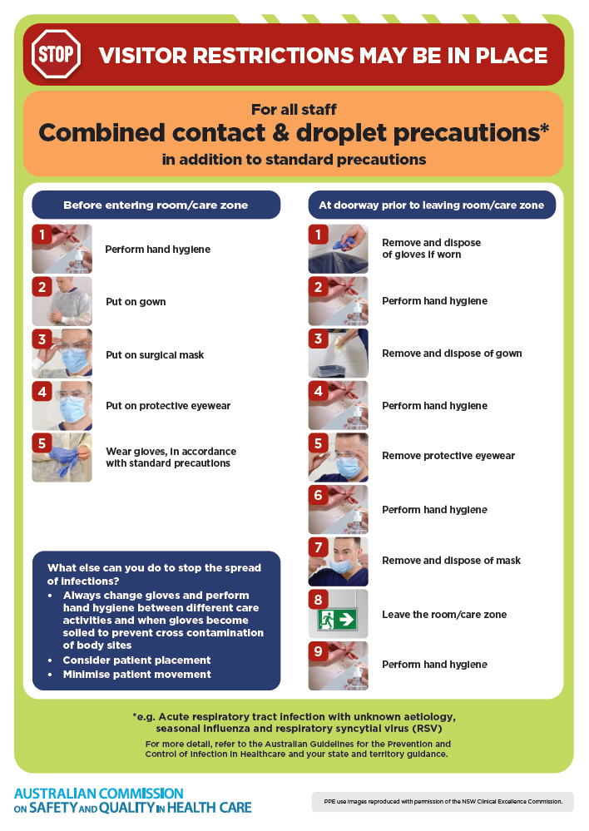
- Poster – Combined airborne and contact precautions
https://www.safetyandquality.gov.au/publications-and-resources/resource-library/infection-prevention-and-control-poster-combined-airborne-and-contact-precautions
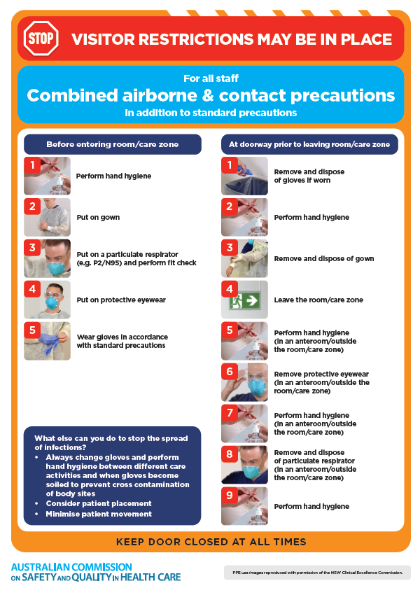
- Environmental Cleaning and Infection Prevention and Control www.safetyandquality.gov.au/environmental-cleaning
- Break the chain of infection poster
https://www.safetyandquality.gov.au/publications-and-resources/resource-library/break-chain-infection-poster
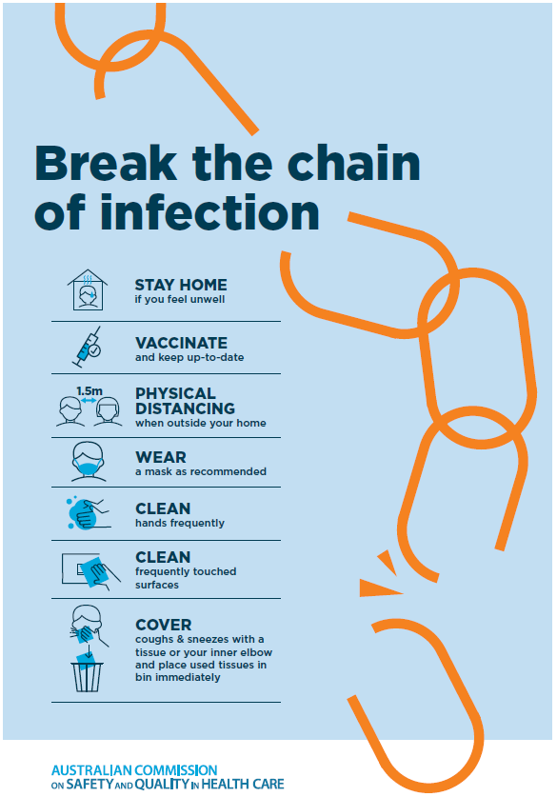

Disclaimer
On the Radar is an information resource of the Australian Commission on Safety and Quality in Health Care The Commission is not responsible for the content of, nor does it endorse, any articles or sites listed The Commission accepts no liability for the information or advice provided by these external links. Links are provided on the basis that users make their own decisions about the accuracy, currency and reliability of the information contained therein Any opinions expressed are not necessarily those of the Australian Commission on Safety and Quality in Health Care.

