
On the Radar
Issue 739
20 April 2026

On the Radar is a summary of some of the recent publications in the areas of safety and quality in health care Inclusion in this document is not an endorsement or recommendation of any publication or provider Access to particular documents may depend on whether they are Open Access or not, and/or your individual or institutional access to subscription sites/services Material that may require subscription is included as it is considered relevant.

On the Radar is available online, via email or as a PDF or Word document from https://www.safetyandquality.gov.au/newsroom/subscribe-news/radar

If you would like to receive On the Radar via email, you can subscribe on our website https://www.safetyandquality.gov.au/newsroom/subscribe-news
or by emailing us at mail@safetyandquality.gov.au.
You can also send feedback and comments to mail@safetyandquality.gov.au.

For information about the Commission and its programs and publications, please visit https://www.safetyandquality.gov.au

On the Radar
Editor: Dr Niall Johnson
Contributors: Niall Johnson, Rachael Simons

Reports

Overview of Aboriginal and Torres Strait Islander health status 2025
Anderton E, Atthowe J, Barrett M, Deves D, Durbin M, Elwell M, et al
Perth: Australian Indigenous HealthInfoNet; 2026. p102.

First Nations Burden of Disease Study 2022
Australian Institute of Health and Welfare
Canberra: AIHW; 2026
URL | Anderton et al https://healthinfonet.ecu.edu.au/healthinfonet/getContent.php?linkid=737483&title=Overview+of+Aboriginal+and+Torres+Strait+Islander+health+status+2025&contentid=52293_1  AIHW https://www.aihw.gov.au/reports/burden-of-disease/first-nations-burden-of-disease-study-2022/
Notes | The Australian Indigenous HealthInfoNet’s annual Overview of Aboriginal and Torres Strait Islander health status 2025 was recently released. The document provides a comprehensive summary of the most recent indicators of the health and wellbeing of Aboriginal and Torres Strait Islander people. Continuing with the HealthInfoNet’s commitment to principles of Aboriginal and Torres Strait Islander Data Sovereignty, this year’s Overview is structured around the Social and Emotional Wellbeing model to capture all aspects of Aboriginal and Torres Strait Islander health.  Also recently released was the Australian Institute of Health and Welfare’s First Nations Burden of Disease Study 2022 report. The First Nations Burden of Disease Study 2022 includes estimates for 220 diseases and injuries for the Aboriginal and Torres Strait Islander population. Updates will be made to the report to include content on the gap in burden of disease between First Nations people and non-Indigenous Australians, geographical differences and risk factors.

Usability Guidance for Optimising My Health Record Viewing Platforms in Acute Care
Australian Commission on Safety and Quality in Health Care & Australian Digital Health Agency
Sydney: ACSQHC & ADHA; 2026. p. 36.
URL | https://www.safetyandquality.gov.au/publications-and-resources/resource-library/usability-guidance-optimising-my-health-record-viewing-platforms-acute-care
Notes | The Usability Guidance for Optimising My Health Record Viewing Platforms in Acute Care (the Guide) provides advice to software vendors and viewing platform owners on how to improve the user experience of viewing platforms that interface with My Health Record – Australia’s national electronic health record platform.  The Guide was developed by the Australian Digital Health Agency (the Agency) and the Australian Commission on Safety and Quality in Health Care (the Commission) and includes best-practice recommendations in user experience design to enable the optimisation of viewing platforms integrated within clinical workflows.  This Guide identifies six areas of opportunity to improve the user experience of viewing platforms that interface with My Health Record and provides supporting recommendations on how to deliver these improvements under each opportunity area:  - Best practice product design processes and standards  - Transparency and visibility of record status and content  - Intuitive navigation and wayfinding  - User-centred information flow and display  - Clear and consistent labelling and terminology  - Usable and understandable emergency and restricted access controls.
Mental health crisis care: legislative challenges in emergency departments
Investigation report
Health Services Safety Investigation Body
Poole: HSSIB; 2026.
URL | https://www.hssib.org.uk/patient-safety-investigations/safety-issues-for-people-experiencing-a-mental-health-crisis-who-come-into-contact-with-urgent-and-emergency-care-services/investigation-report-1-of-2/
Notes | The Health Services Safety Investigations Body (HSSIB) in the UK has released a new investigation report, the first of two on mental health. This report ‘focuses on the significant legal, policy and safety gap in the care of people in [UK] emergency departments (EDs) in mental health crisis.’  The report includes a number of findings and recommendations.

Healthcare provision in prisons: needs assessments and disability access
Investigation report
Health Services Safety Investigation Body
Poole: HSSIB; 2026.
URL | https://www.hssib.org.uk/patient-safety-investigations/healthcare-provision-in-prisons/fourth-investigation-report/
Notes | Also from the Health Services Safety Investigations Body (HSSIB) in the UK is this investigation report examining the provision of healthcare in UK prisons, specifically provision of care to wheelchair users and people with mobility issues, including how the health needs of people in prison are assessed.  The report includes a number of findings and recommendations.

Journal articles

What Do Consumers Need Before, During and After a Patient Safety Incident Review? A Qualitative Study
Bierbaum M, Yu Y, Molloy CJ, Bowditch L, Hibbert PD
Health Expectations. 2026;29(2):e70646.
DOI | https://doi.org/10.1111/hex.70646
Notes | This is the latest paper from a project looking at the role, contributions, potential and experiences of consumers and consumer representatives in patient safety investigations. This paper reports that ‘This study aimed to understand what is important to consumers before, during and after patient safety incident reviews, as framed by their experiences.’ The project was informed by the experiences of 28 participants who ‘were recruited and participated in 21 interviews and one focus group, across four states and territories in Australia (New South Wales, Victoria, the Australian Capital Territory and Queensland)’ The authors report that consumers want  - more empathetic, practical and inclusive support throughout patient safety incident reviews, with clearer communication, transparency and accountability.  - their voices heard, valued and documented across the review.  - opportunities for greater and more flexible involvement in the review process, and a structured mechanism to track, report and communicate implementation changes, driven by a desire to prevent patient safety incidents from recurring.

For information on the Commission’s work on person-centred care, see https://www.safetyandquality.gov.au/our-work/partnering-consumers/person-centred-care

From theory to measurement: Development and initial validation of the Resilience in Healthcare Capacities Assessment (RHCA)
Ellis LA, Lyng HB, Haraldseid-Driftland C, Saba M, Clay-Williams R, Hibbert PD, et al
Applied Ergonomics. 2026 2026/09/01/;135:104768.
DOI | https://doi.org/10.1016/j.apergo.2026.104768
Notes | Resilience has become something of a theme in recent with various people identifying it as a desirable characteristic of both individuals and systems (and the implication of our failing to be resilient enough). The authors of this piece suggest ‘In recent years, the role of resilient healthcare systems has gained prominence. The quantitative assessment of resilience systems is vital for understanding and enhancing their ability to maintain high-quality patient care under strain.’ The paper ‘reports the development and initial validation of the Resilience in Healthcare Capacities Assessment (RHCA), a multidimensional survey instrument designed to support healthcare organisations in measuring resilience.’ Developed in Australia, the RHCA, with its 33-item, ten-factor structure, is claimed to offer ‘a psychometrically robust, multidimensional tool for assessing resilience capacities at the micro- and meso-levels of healthcare systems. It enables organisations to identify strengths and areas for improvement, supporting targeted interventions and longitudinal monitoring.’

[Translated article] Is patient safety still a strategic priority?
¿Sigue siendo la seguridad del paciente una prioridad estratégica?
Otero MJ, Poveda JL
Farmacia Hospitalaria 2026;50:T67-T9.
DOI | https://doi.org/10.1016/j.farma.2026.02.010
Notes | Article published in the journal Farmacia Hospitalaria reflecting on ‘whether patient safety still occupies a central and explicit place on strategic agendas or whether, on the contrary, it has come to be regarded as an assumed value rather than a true priority’, particularly with regard to medication safety.

Safety signals and near misses: exposing the design failures we can prevent.
Clark J, Guttman O, Kok J
BMJ Leader. 2026.
DOI | https://doi.org/10.1136/leader-2025-001381
Notes | Commentary piece in BMJ Leader that argues ‘healthcare must treat near misses and early ‘safety signals’ as essential system-level intelligence and must build the infrastructure, processes and culture to learn from them at scale. We define proactive safety as the systematic identification, analysis and mitigation of risks before harm occurs, an approach widely used in other high-reliability industries but still underdeveloped in healthcare.’ The authors argue that a health system that is seeking to be a learning and high reliability system is also one that needs to proactively seek information that can help identify issues and opportunities for improvement.

Australian Prescriber
Volume 49, Issue 2, April 2026
URL | https://australianprescriber.tg.org.au/volumes/49/issues/2.html
Notes | A new issue of Australian Prescriber has been published. Content in this issue of Australian Prescriber includes:  - Metabolic dysfunction–associated fatty liver disease: an update (R O’Halloran, LA Adams, G Deed, JS Lubel)  - Measuring blood pressure accurately (AS Mihailidou)  - Vitamin B12 deficiency: testing and treatment (D Bedz, C Forsyth)  - Cytomegalovirus in pregnancy: prevention, maternal screening, and the role of antivirals (L Hui, NE Holmes, ML Giles, W Rawlinson)  - Toxic interaction between atorvastatin and clarithromycin causing myositis and rhabdomyolysis (M Hurlbert, T Tay, CJ Holloway, L Girgis)  - TGA Medicines Safety Update summary:  Medicines containing vitamin B6 (pyridoxine, pyridoxal or pyridoxamine)  - New drugs:  – Adrenaline (epinephrine) nasal spray for severe allergic reactions  – Foslevodopa+foscarbidopa for advanced Parkinson disease

The Joint Commission Journal on Quality and Patient Safety
Volume 52, Issue 4, April 2026
URL | https://www.sciencedirect.com/journal/the-joint-commission-journal-on-quality-and-patient-safety/vol/52/issue/4
Notes | A new issue of The Joint Commission Journal on Quality and Patient Safety has been published. Articles in this issue of The Joint Commission Journal on Quality and Patient Safety include:  - Process Variation as Friend and Foe: Rethinking Safety in Complex Adaptive Systems (Anthony P Weiss)  - Reducing Postoperative Acute Kidney Injury: A Regional Quality Improvement Initiative of 26 Community-Based Hospitals (Aarthi Vijaykumar, David Goodman, Robert Whitcomb, Michelle Ruther, ... Debra O’Connor)  - Natural Language Processing in Clinical Quality Measures of Diagnostic Performance: Learnings from Three Case Reports (Abigail Evans, Meridith Eastman, Patricia C Dykes, Barbara E Jones, ... Jeffrey Geppert)  - FRAM Analysis of Successful Hospital Discharge: A Case Study on Putting Safety-II Principles into Practice (Milou Steenbergen, Sigrid Vervoort, Lisette Schoonhoven, Bas de Vries, ... Dorien Zwart)  - Longitudinal Reliability of Rheumatology Patient Safety Measures and Implications for CMS Case Minimums (Eric T Roberts, Gabriela Schmajuk, Jessica Fitzpatrick, Jing Li, Jinoos Yazdany)  - Association of Vital Sign and Laboratory Abnormalities Detected via Remote Monitoring with ICU Readmission and Mortality: An Observational Cohort Study (Neil E Rens, Johanna J Rajotte, Hao Deng, Jiawei Meng, ... K J Ruscic)  - Enhancing Quality in Patient Transfers: A Dashboard Approach to Track Interhospital Medical ICU Transfers (Rohan Bhargava, Susan R Russell, Gabrielle Matias, Michelle L Prickett, ... Nandita R Nadig)  - The Current Framework to Distinguish Research from Quality Improvement Is Stalling Improvement of Care (Peter J Pronovost, Nancy E Kass, Ruth R Faden)

The Lancet Primary Care
Volume 2, Number 3, March 2026
URL | https://www.thelancet.com/journals/lanprc/issue/vol2no3/PIIS3050-5143(26)X2003-9
Notes | The Lancet Primary Care is a relatively new open access journal. Articles in this issue of The Lancet Primary Care include:  - Editorial: Generative AI chatbots in primary care  - Scaling depression and PTSD care in primary care across LMICs: beyond feasibility to implementation and choice (Yang Jae Lee, Jürgen Unützer)  - A new approach to artificial intelligence safety in primary care (Joshua Biro, Yalda Jabbarpour, Raj Ratwani)  - Patients are not waiting for permission: the rise of the AI-empowered patient (Sara Riggare, David Sundemo, Marcus Lewis, Charlotte Blease)  - Regulating artificial intelligence in community pharmacy: aligning primary care governance with clinical function (Esteban Zavaleta-Monestel, Jeaustin Mora-Jimenez, Sebastian Arguedas-Chacon)  - Governance, scale, and integration: building community health worker systems ready for artificial intelligence (Community Health Impact Coalition Research Group)  - Equity by design in artificial intelligence for primary care in low-income and middle-income countries (Zameer Brey, Shikoh Gitau, Melissa Miles, Asaf Bitton)  - Using artificial intelligence to create meaning (Rupal Shah, Amit Singh)  - The mandate for clinical artificial intelligence education in primary care (Alexander T Deng, James Freed, Haris Shuaib)  - Artificial intelligence-assisted cervical cancer screening for 9 million women in China (Yunfei Li, Lu Ji, Xiaohui Hou, Kun Tang, Quinette Abegail Louw, Johan Lundin, Lan Yao, Shanquan Chen)  - Artificial intelligence in Catalan primary care (Antoni Sisó-Almirall, Manuel Ramos-Casals)  - If primary care evidence is local, what does equity mean? (R Armitage)  - If primary care evidence is local, what does equity mean? (Diego Garcia-Huidobro, Esther M Johnston on behalf of the authors)  - Primary care mental health trends during COVID-19: lessons for Latin America (Esteban Zavaleta-Monestel, Ricardo Millán-González)  - Artificial intelligence in primary care: the health equity and levelling-down objection (Richard Armitage)  - Non-specialist interpersonal psychotherapy versus fluoxetine for major depression and post-traumatic stress disorder in Kenyan public-sector primary care: a sequential, multiple-assignment, randomised trial (Susan M Meffert, Muthoni A Mathai, Linnet Ongeri, Thomas C Neylan, Daniel Mwai, Dickens Onyango, Dickens Akena, Grace Rota, Ammon Otieno, Anne Mbwayo, James G Kahn, Craig R Cohen, David Bukusi, Gregory A Aarons, Rachel L Burger, Chengshi Jin, Charles E McCulloch, S Njuguna Kahonge)  - Artificial intelligence-based glaucoma screening in primary care: a cross-sectional study and economic viability analysis of an ongoing trial (Afonso Lima-Cabrita, Zahi Wehbi, Joana Pargana, Rafael Whitfield, Vasco Lobo, Bernardo Monteiro, Joana Ferreira, Quirina Ferreira, Federico Felizzi, Matilde Ourique, Sanna Leinonen, Marta Pazos, Ana Miguel, Panayiota Founti, Rafael Barão, Sophie Lemmens, A Tuulonen, E Vandewalle, S Theriaga, R Marques, R Hemelings, C Marques-Neves, M Faria, I Stalmans, L Abegão Pinto)  - Prebronchodilator simplified spirometry for screening spirometry-defined chronic obstructive pulmonary disease in primary care settings: a prospective cross-sectional diagnostic accuracy study (Fan Wu, Gaoying Tang, Qi Wan, Zhishan Deng, Kunning Zhou, Xiaohui Wu, Lifei Lu, Cuiqiong Dai, Jieqi Peng, Jianmin Chen, Zihui Wang, Suyin Huang, Junfeng Lin, Guannan Cai, Xianliang Zeng, Jincong Gan, Huixian Lin, Fangyan Wu, Changli Yang, Shuqing Yu, Miaozhen Jiang, D Tian, H Zhou, N Zhong, Y Zhou, P Ran)  - The effectiveness of HPV vaccination against invasive cervical cancer and related precancerous lesions: a multinational target trial emulation study (Marta Alcalde-Herraiz, Mike Du, Aina Sanchez-Parada, Talita Duarte-Salles, Anna Palomar-Cros, Agustina Giuliodori, A Delmestri, H M Egeland Nordeng, N T H Trinh, S Hayati, D Prieto-Alhambra, M Catala, A Prats-Uribe)  - Artificial intelligence in primary care: innovation at a crossroads (Liliana Laranjo, Lorainne Tudor Car, Rebecca Elizabeth Payne, Ana Luisa Neves, Michael Kidd, J Jaime Miranda)  - Artificial intelligence in primary care: frameworks, challenges, and guardrails (Luke N Allen, Jialing Lin, Bradley Max Segal, Kagiso Ndlovu, Davide Bilardi, Luisa M Pettigrew)

JBI Evidence Synthesis
Volume 24, Issue 4, April 2026
URL | https://journals.lww.com/jbisrir/toc/2026/04000
Notes | A new issue of JBI Evidence Synthesis has been published. Articles in this issue of JBI Evidence Synthesis include:  - Editorial: Leveling the playing field: supporting authors from resource-limited settings to conduct and publish systematic reviews in JBI Evidence Synthesis (Hien Thi Ho, Tara Crandon, Sonia Hines, Mara Lambert, Melanie Dankel, Emilie May Francis, Edoardo Aromataris)  - Informal caregivers’ experiences of feeding children with cancer: a systematic review of qualitative evidence (Donruedee Kamkhoad, Tippawan Srichalerm, Porawan Witwaranukool)  - Effectiveness of preventive parental education delivered from pregnancy to 1 month postpartum for improving infant sleep and parental sleep and depression: a systematic review (Eriko Matsunaka, Narumi Ooshige, Shingo Ueki, Seiichi Morokuma)  - Methods of training lay individuals in the use of evidence-based services for the management of mental and behavioral health disorders: a scoping review (Ann D Bagchi, P Hargwood, Y Jadotte, A Saravana, A M DiBello)  - Integration of One Health competencies in medical curricula: a scoping review protocol (Dian Puspita Sari, Yoga Pamungkas Susani, G R Rahayu)  - Prognostic significance of the dysplastic margin for predicting recurrence and survival in patients with primary oral squamous cell carcinoma resected with curative intent: a systematic review protocol (Belinda Liu, Gary Brierly, Omar Breik, Matthew Stephenson)  - Hospital-based rehabilitation for proximal hip fragility fractures in older adults: a scoping review protocol (Hugo Fernandes, Inês Rodrigues, Elisabete Peixoto, Ricardo Salgado, Daniel Ferreira, Carmen Queirós)  - Medical inpatient experiences and perceptions of discharge education provided by health care professionals: a qualitative systematic review protocol (Ariane Sabina Stieven, Sonia Hines, R Jia, C Stern, M do Carmo F L Haddad)  - Facilitators and barriers to recruiting pregnant people with anxiety and depression for a group-based intervention: a mixed methods systematic review protocol (Sudjit Liblub, Karen McLaughlin, K Pringle, A Cummins)  - Global characteristics of the use of complementary and alternative medicine for autism spectrum disorder: a scoping review protocol (Georgia Mae Willcox, Dorothy Agnes Shead, Busisiwe Constance Maseko)  - Barriers and facilitators for the adoption of digital technologies for tuberculosis medication adherence: a qualitative systematic review protocol (Zipporah Dery, Celso Pagatpatan, Jr., Margel Bonifacio)  - Characteristics, pathophysiology, and management of Galassi III arachnoid cysts: a scoping review protocol (Hector R Martinez, Misael Salazar-Alejo, Angélica Navarro-Serment, Ana Ballesteros-Suarez, Ryan A Luna-Fernández, Mario Benvenutti-Regato, R Flores-Salcido, J A Moran-Guerrero, L E Perez-Martinez, E Barajas-De-Leon, P J Ávalos-Montes, J A Figueroa-Sanchez)  - Characteristics of available datasets for public mental health surveillance in Australia and evaluation of the National Mental Health and Suicide Prevention Agreement: a scoping review protocol (Hiroko Fujimoto, Narendar Manohar, Samuel B Harvey, Peter A Baldwin)  - Incidence and prevalence of atopic disease in second and subsequent generation immigrants from Asia in Australia: a systematic review protocol (Danielle Lee, Sonia Hines, Romy Menghao Jia)

Health Policy
Volume 167, May 2026
URL | https://www.sciencedirect.com/journal/health-policy/vol/167/
Notes | A new issue of Health Policy has been published. Articles in this issue of Health Policy include:  - Addressing the challenge of post-approval regulation of pharmaceuticals: The case for independent third-party evaluations (Itai Bavli, Yair Sadaka, Chen Yanover, Joel Lexchin)  - Health security needs a European health and care workforce strategy, and it needs it now (Ellen Kuhlmann, Tiago Correia, Katarzyna Czabanowska, Michelle Falkenbach, ... Tomas Zapata)  - Valuing health system resilience: The limits of conventional economic evaluation under catastrophic risk (George Wharton, Alistair Mcguire)  - Patient representatives’ perspectives on the centralisation of inpatient healthcare services - A focus group study in Germany (Stefanie Pfisterer-Heise, Julia Scharfe, Alexander Pachanov, Charlotte Mareike Kugler, D Pieper)  - Governance for health system resilience: Lessons from Brazil’s decentralized health system (Marco Antonio Catussi Paschoalotto, Alessandro Bigoni, Andreza Carolina Davidian, Karen Sarmento Costa, ... A Massuda)  - Policy innovation in voluntary hospital private health insurance: Combining risk adjustment and risk sharing in Australia (Josefa Henriquez, Thomas McGuire, Richard van Kleef, Francesco Paolucci, Andrew Matthews)  - Feeling lonely? Preferences for support programmes to reduce loneliness among older adults in Australia: A discrete choice experiment (Mesfin G Genie, Allison W Boyes, Francesco Paolucci)  - Impact of the U.S. 2025 tariff policy on Canadian pharmaceutical exports to the U.S. (Yufan Hu, Wei Zhang, Daphne Guh, Aslam H Anis)

Health Affairs
Volume 45, Number 4, April 2026
URL | https://www.healthaffairs.org/toc/hlthaff/45/4
Notes | A new issue of Health Affairs has been published with themes of ‘Drug Prices, Behavioral Health, Hospitals and more’. Articles in this issue of Health Affairs include:  - ‘Most Favored Nation’ Drug Pricing Is An Idea Whose Time Has Come (James C Robinson)  - ‘Most Favored Nation’ Drug Pricing: An Idea To What End? (Andrew W Mulcahy)  - ‘Most Favored Nation’ Policies And Value-Based Drug Pricing: A European View (Francis Megerlin)  - US National Spending On Mental Health And Substance Use Disorder Treatment Driven By Case Growth, 2000–21 (Tami L Mark, Lasanthi Fernando, Peter Shieh, and Abe Dunn)  - Trends In Patient Cost Sharing For Hospital Care And Implications For Urban And Rural Hospital Revenue (Erin Duffy, Bich Ly, and Erin Trish)  - Under Global Budgets, Hospital Utilization In Maryland Decreased By 11 Percentage Points More Than In Other States, 2013–23 (Timothy Bulat, Sean R McClellan, and Matthew J Trombley)  - Lingering Effects Of The COVID-19 Pandemic On Non-COVID-19 Death Rates In The US, 2020–24 (Christopher J Ruhm)  - Double Bonuses Increased MA Spending In Puerto Rico By $865 Million But Did Not Achieve Plan Improvement Goals (Daeho Kim, Maricruz Rivera-Hernandez, David J Meyers, Andrew M Ryan, and Amal N Trivedi)  - First Year Of ACO Realizing Equity, Access, And Community Health Program Yields Good Quality, Savings Results (Sunny C Lin, G Hammond, B A Davis, F Wang, R J Waken, K J Johnston, and K E Joynt Maddox)  - Variation In Medicaid And Medicare Payment Rates To Community Health Centers, 2023 (J H Markowski, A Vandenbroeck, and C D Ndumele)  - Medicare Advantage Star Rating Quality Gains Were Concentrated In A Narrow Set Of Clinical And Medication Measures, 2015–25 (Andrew Anderson, Rajesh Satpathy-Horton, and Mark Katz Meiselbach)  - Massachusetts Medicaid Housing Supports Reduced Health Care Costs Among Adults With Behavioral Health Conditions (M J Sabatino, K Hager, A S Ash, G Sing, J Bowman, S Buckler, A Rich, J Himmelstein, and M J Alcusky)  - Inflation Reduction Act Changes To Part D Plan Design: Lower Premiums, Higher Deductibles, And Some Smaller Formularies (David M Anderson, Matthew McEnany, Sarah E Petry, and Kelly E Anderson)  - Terror Kingdom (Henneh Kwaku Kyereh)  - Informed Hesitancy (Henneh Kwaku Kyereh)

BMJ Quality & Safety online first articles
URL | https://qualitysafety.bmj.com/content/early/recent
Notes | BMJ Quality &Safety has published a number of ‘online first’ articles, including:  - How do community advocates address racial inequities in maternity care for Black, African, Caribbean and mixed-Black families? A realist review (Sarindi Aryasinghe, Ruchi Wadhwa, Phoebe Averill, Gabriella Sarpong, Susan Ibuanokpe, Phayza Fudlalla, Carole Waithe, Rhianna Newby-Mayers, Abimbola Ayorinde, Sabrina Das, Helen Ward)  - Radiology reporting in the age of artificial intelligence: implications for patient safety (Igor Toker, Sven Jansen, Julius Knoche, Daniel Lorenz)  - Editorial: Widening of the ‘technical/practical’ divide: New advances in statistical process control bring new capabilities and new challenges (Brant J Oliver)  - Integrating ‘What Matters’ conversations into preoperative care: a qualitative evaluation of surgical team workflows and barriers (Kirstin Manges Piazza, Lindsay R Pelcher, Phoebe Whiteside, Morgan Cribbin, Amanda D Peeples, Caroline Pascal, Laura Ellen Ashcraft, Robert E Burke, Daniel Hall)

International Journal for Quality in Health Care online first articles
URL | https://academic.oup.com/intqhc/advance-articles
Notes | International Journal for Quality in Health Care has published a number of ‘online first’ articles, including:  - Evaluation of breast cancer coding quality and its influence on diagnosis-related groupings: a cross-sectional study (Lemin Feng et al)  - AI-First, Expert-Verified: Validating Generative AI for HFACS-Based Coding of Healthcare RCA Transcripts with Governance Considerations (Jiun-Yih Lee et al)  - Navigating Regulatory Pathways for Access to Innovative Medicines in Tunisia (Sarah Zerei et al)  - Advancing Oncology Care Excellence through Timely, Multidisciplinary-Navigation Models for Non-Palliative Breast and Colorectal Cancer (Sultanah Alharbi et al)  - High Quality Primary Healthcare: Addressing The Challenges Here and Now (J Brennan et al)  - Quality development driven by health care complaints (Søren Birkeland et al)

Online resources

Australian Living Evidence Collaboration
https://livingevidence.org.au/

Guidance
A number of guidelines or guidance have recently been published or updated These include:
- Communicating safe eating and drinking, Safer Care Victoria https://www.safercare.vic.gov.au/best-practice-improvement/clinical-guidance/older-people/safe-eating-and-drinking
This guidance explains how to share information about a patient’s eating, drinking and swallowing needs. It outlines how to document and communicate support requirements such as supervision, food and drink textures, and any patient or environmental adaptations.
- Best practice guidelines for the diagnosis, evaluation, and management of cognitive disorders in Parkinson’s disease
Pourzinal D, Brooks D, Sriram D, McCann E, King JM, Pachana NA, et al. Age and Ageing. 2026;55(3):afag063. https://doi.org/10.1093/ageing/afag063
The best practice guidelines are provided in the supplementary materials to this article.

[UK] NICE Guidelines and Quality Standards
https://www.nice.org.uk/guidance
The UK’s National Institute for Health and Care Excellence (NICE) has published new (or updated) guidelines and quality standards The latest reviews or updates include:
- NICE Guideline NG229 Fetal monitoring in labour https://www.nice.org.uk/guidance/ng229
- NICE Guideline NG257 Fertility problems: assessment and treatment https://www.nice.org.uk/guidance/ng257
- Quality Standard QS73 Fertility problems https://www.nice.org.uk/guidance/qs73
- NICE Guideline NG23 Menopause: identification and management https://www.nice.org.uk/guidance/ng23
- NICE Guideline NG12 Suspected cancer: recognition and referral https://www.nice.org.uk/guidance/ng12
- Quality Standard QS18 Ovarian cancer https://www.nice.org.uk/guidance/qs18
- Clinical guideline CG122 Ovarian cancer: recognition and initial management https://www.nice.org.uk/guidance/cg122

Infection prevention and control resources
The Australian Commission on Safety and Quality in Health Care has developed a number of resources to assist healthcare organisations, facilities and clinicians These resources include:
- Poster – Combined contact and droplet precautions https://www.safetyandquality.gov.au/publications-and-resources/resource-library/infection-prevention-and-control-poster-combined-contact-and-droplet-precautions
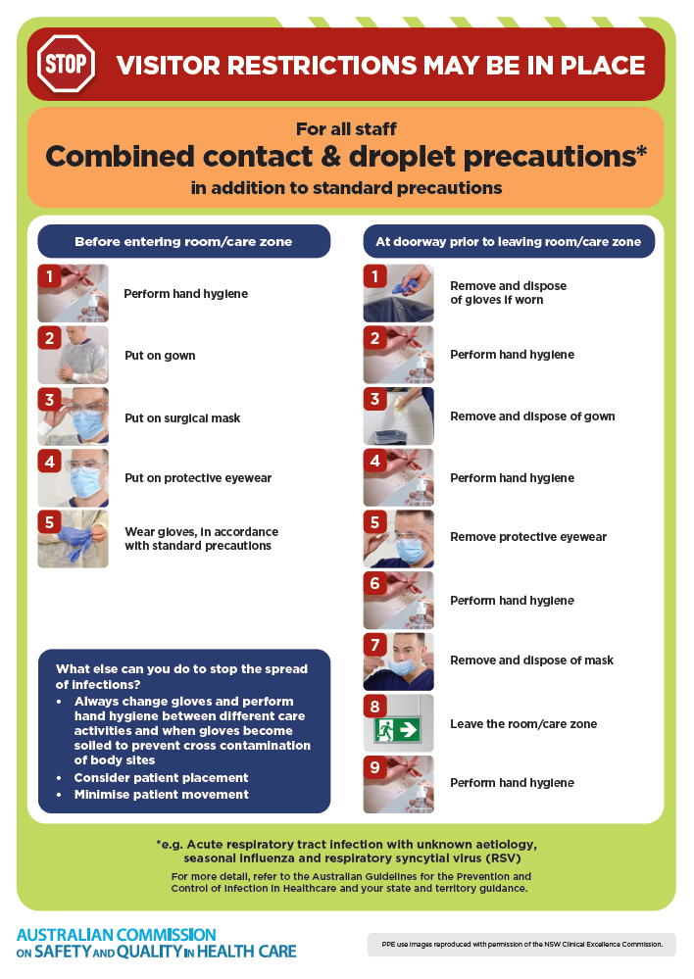
- Poster – Combined airborne and contact precautions
https://www.safetyandquality.gov.au/publications-and-resources/resource-library/infection-prevention-and-control-poster-combined-airborne-and-contact-precautions
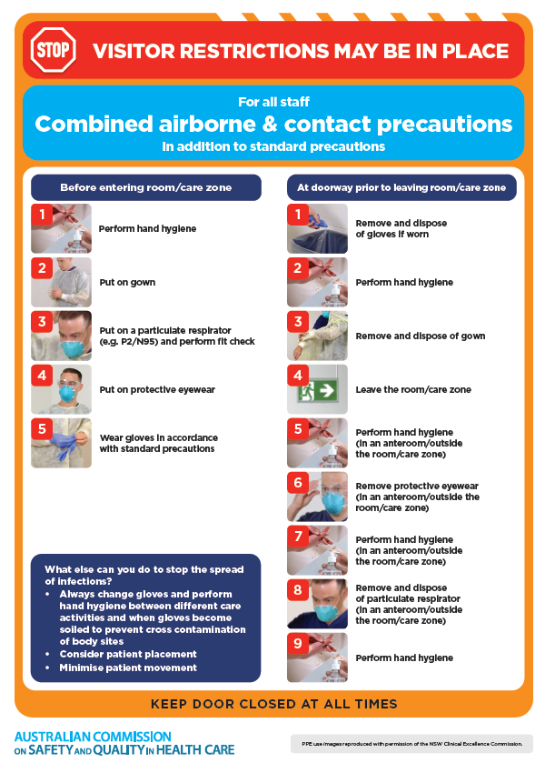
- Environmental Cleaning and Infection Prevention and Control www.safetyandquality.gov.au/environmental-cleaning
- Break the chain of infection poster
https://www.safetyandquality.gov.au/publications-and-resources/resource-library/break-chain-infection-poster
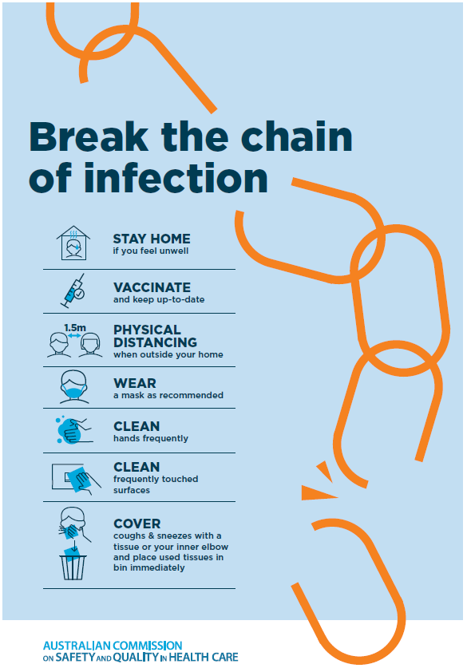

Disclaimer
On the Radar is an information resource of the Australian Commission on Safety and Quality in Health Care. The Commission is not responsible for the content of, nor does it endorse, any articles or sites listed The Commission accepts no liability for the information or advice provided by these external links. Links are provided on the basis that users make their own decisions about the accuracy, currency and reliability of the information contained therein Any opinions expressed are not necessarily those of the Australian Commission on Safety and Quality in Health Care.

