
On the Radar
Issue 740
27 April 2026

On the Radar is a summary of some of the recent publications in the areas of safety and quality in health care Inclusion in this document is not an endorsement or recommendation of any publication or provider Access to particular documents may depend on whether they are Open Access or not, and/or your individual or institutional access to subscription sites/services Material that may require subscription is included as it is considered relevant.

On the Radar is available online, via email or as a PDF or Word document from https://www.safetyandquality.gov.au/newsroom/subscribe-news/radar

If you would like to receive On the Radar via email, you can subscribe on our website https://www.safetyandquality.gov.au/newsroom/subscribe-news
or by emailing us at mail@safetyandquality.gov.au.
You can also send feedback and comments to mail@safetyandquality.gov.au.

For information about the Commission and its programs and publications, please visit https://www.safetyandquality.gov.au

On the Radar
Editor: Dr Niall Johnson
Contributors: Niall Johnson

Reports

What makes care outstanding?
The King’s Fund’s report on principles for outstanding care for the Care Quality Commission
Wenzel L, Morris L, Chikwira L, Nwasike CJ
London: The King's Fund; 2026. p. 65.
URL | https://www.kingsfund.org.uk/insight-and-analysis/reports/what-makes-care-outstanding-cqc
Notes | Report from The King’s Fund in the UK that was commissioned as part of the Care Quality Commission’s review of its regulatory model. The project involved a review of the literature, interviews and a series of workshops to examine what outstanding care looks like. This report includes the findings of the research project and outlines key principles for outstanding care.  From the report: ‘Five principles for outstanding care  - Delivering truly person-centred care: outstanding care is always highly responsive to individuals’ needs, preferences and aspirations, recognising what is important to people who use services, their strengths, cultures and histories.  - Embedding a culture of compassionate and inclusive leadership: outstanding care happens when leaders foster an open, psychologically safe, inclusive and values-driven culture that is focused on people who use services and empowers staff.  - Prioritising equity and inclusion: Outstanding care happens in an environment that is inclusive, prioritises equity and actively embraces diversity among people who use services and staff.  - Continuously integrating learning into practice to drive improvement and innovation: outstanding care happens when a learning mindset is embedded in teams and organisations, with a focus on evolving practice and continuously sharing knowledge.  - Having a purposeful approach to making a positive difference for people who use services: Outstanding care comes from a clear and deliberate focus on making a positive difference for people who use services, staff and the wider system and is evidenced in key outcome measures and feedback from people who use services and staff.’

Improving health outcomes through hospital funding arrangements
PC research paper
Productivity Commission
Canberra: Productivity Commission; 2026. p. 37.
URL | https://www.pc.gov.au/inquiries-and-research/hospital-funding/
Notes | Research paper from the Productivity Commission that examined the impact of reducing payments to public hospitals where patients suffered hospital-acquired complications (HACs). The key points that the Productivity Commission identify in their report include:  - ‘Hospitals are funded primarily through activity-based funding, which incentivises higher volumes of care and cost controls, but does not directly promote the safety or quality of care.  - In 2017, the Australian Government introduced funding adjustments intended to reduce the rate of hospital acquired complications (HACs). The PC used data on admissions to public hospitals to establish whether this adjustment affected the rate of HACs.  - The HAC funding adjustment had a sizeable effect, and was associated with about a 25% reduction in the likelihood of a complication occurring in those states and territories where the financial penalties were passed on to the relevant local hospital networks.  - These initial findings suggest financial mechanisms could be effective in lifting the quality of care. These tentative conclusions, however, should be interpreted with caution and further work is needed before expanding the use of these measures.’

For information on the Commission’s work on Hospital-acquired complications (HACs), including the national list, see https://www.safetyandquality.gov.au/our-work/indicators-measurement-and-reporting/hospital-acquired-complications-hacs

Scaling Artificial Intelligence in Health
OECD
Paris: OECD Publishing; 2026. p. 64.
URL | https://doi.org/10.1787/a436e12d-en
Notes | Latest report from the OECD on artificial intelligence (AI) in health care. The report’s authors observe that ‘Artificial Intelligence (AI) holds significant potential for the healthcare system. That potential is not being fully realised due to fragmented data foundations, non-aligned policies and practices, and structural and governance barriers to scalability. Although AI is universally used in administration across OECD Member countries (100%), national-level scale-up remains limited, (e.g. only 10% for medical imaging applications).’ [Emphasis in the original]  The report reviews some of the activities in OECD member countries and offers a policy checklist that ‘identifies policymaker, technologist, and health workforce actions to responsibly scale AI in health. Critically, the checklist can be used to identify blind spots in those actions. The checklist is not prescriptive; however, it provides a prompt for decision makers to consider a full range of action across relevant policy categories and areas.’ The ‘The four pillars of the checklist focus on establishing enablers (for data foundations, assuring and scaling AI, and capacity building); implementing guardrails (to oversee and monitor progress towards agreed objectives); engaging meaningfully with the public, providers, and industry; and deploying trustworthy AI.’

For information on the Commission’s work on artificial intelligence, see https://www.safetyandquality.gov.au/our-work/e-health-safety/artificial-intelligence

Journal articles

Surviving Sepsis Campaign: International Guidelines for Management of Sepsis and Septic Shock 2026
Prescott HC, Antonelli M, Alhazzani W, Møller MH, Alshamsi F, Azevedo LCP, et al
Critical Care Medicine. 2026;54(4).

Surviving Sepsis Campaign International Guidelines for the Management of Sepsis and Septic Shock in Children 2026
Weiss SL, Peters MJ, Oczkowski SJW, Belley-Cote E, Buysse C, Choong KLM, et al
Pediatric Critical Care Medicine. 2026;27(4).

Surviving Sepsis Campaign International Guidelines for the Management of Sepsis and Septic Shock in Children 2026
Weiss SL, Peters MJ, Oczkowski SJW, Belley-Cote E, Buysse C, Choong KLM, et al
Intensive Care Medicine. 2026 2026/03/23.
DOI | Prescott et al https://doi.org/10.1097/CCM.0000000000007075  Weiss et al https://doi.org/10.1097/PCC.0000000000003927 and https://doi.org/10.1007/s00134-026-08360-2
Notes | The Surviving Sepsis Campaign is a collaboration between the (US) Society of Critical Care Medicine and the European Society of Intensive Care Medicine. The campaign has published updated guidelines on sepsis management in adults and children. The guidance on children has been simultaneously published in the journals Pediatric Critical Care Medicine and Intensive Care Medicine.  The Surviving Sepsis Campaign (SSC) guidelines are intended to support clinicians caring for adult patients with sepsis, focusing on management in the hospital, the immediate prehospital setting, and the immediate post-hospital setting.  The updated management guidelines for the best care of children with sepsis or septic shock were issued, acknowledging that most aspects of care continue to have relatively low quality of evidence.

For information on the Commission’s work on sepsis, including the National Sepsis Program, see https://www.safetyandquality.gov.au/our-work/national-sepsis-program

“You're listening but you're not hearing”: qualitative exploration of parents' lived experience of paediatric sepsis
O’Keefe M, Crowe L, Lister P, Schlapbach LJ, Simons M
Frontiers in Pediatrics. 2025;Volume 13 - 2025.
URL | https://www.frontiersin.org/journals/pediatrics/articles/10.3389/fped.2025.1655224
Notes | Also on the subject of sepsis is this paper reporting on an Australian qualitative study exploring the lived experiences of parents whose children survived or died from paediatric sepsis. Those experiences identify gaps in communication, trauma informed care, awareness and access to ongoing support. The authors suggest that the findings highlight priorities for improving safety and quality in paediatric care, including early recognition of sepsis, family centred communication, and the development of specialised post-sepsis support services. The publication is relevant to national sepsis priorities and broader safety and quality initiatives, particularly in relation to consumer partnership, trauma informed care, and improving outcomes and experiences for children and families affected by sepsis.  The Australian Sepsis Network held the Best Sepsis Care for our Kids on 22 April 2026. This was a national online forum during Paediatric Sepsis Week. In a collaboration between Alfred Health, Sepsis Australia and Safer Care Victoria the Australian Sepsis Grand Round: Sepsis in Specific Populations will be held on 5 May 2026.

Optimising professional support for doctors who experience work performance issues: a realist evaluation
Brennan N, Reynolds E, Price T, Wong G, Cleland J, Lloyd H, et al
BMJ Quality & Safety. 2026.
DOI | https://doi.org/10.1136/bmjqs-2025-019749
Notes | Study published online in BMJ Quality & Safety that examined professional supports offered to doctors in the UK, including through interviews with professional support staff and doctors who had undertaken professional support. The authors ‘identified six principles of effective professional support’:  - ‘Work-place culture influences support-seeking behaviour.  - Trust and psychological safety are central to enable candid conversations and engagement.  - Doctors can then develop self-awareness and situational awareness, reframe challenges, accept responsibility where appropriate and recognise structural factors underpinning their difficulties.  - Doctors are more likely to feel motivated to engage through positive framing.  - Personal and professional growth occurs when doctors are empowered to make changes to their practice.  - Cultures that stigmatise help-seeking undermine support, while those that model vulnerability and normalise support enhance the likelihood of positive outcomes.’

Patient Safety Begins With Access: Safety Events That Occur Before Meeting the Patient
Hassid VJ, Kaafarani HM
JAMA. 2026;335(13):1117-8.
DOI | https://doi.org/10.1001/jama.2026.1286
Notes | Access or accessibility has long been considered one of the dimensions of quality, but it may be considered that it has been somewhat overlooked. This viewpoint piece in JAMA (Journal of the American Medical Association) takes a particular case as the catalyst for a reflection on the significance of access. It could be argued that some of the aspects of this case are a reflection of the health system in the USA, but conversely, access is a universal issue. The authors of this piece closes with the observation that ‘Access is not an administrative prelude to care. It is the first—and most fragile—link in the chain of patient safety. Until access failures are recognized as safety failures and high-reliability principles are applied accordingly, patients will continue to bear the consequences of systems that function acceptably on paper but fail them in practice.’

Doctors’ Conflict-of-Interest; What it Looks Like and What to do About it
Lexchin J
International Journal of Social Determinants of Health and Health Services. 2026:27551938261431289.
DOI | https://doi.org/10.1177/27551938261431289
Notes | Narrative review piece that examines conflict-on-interest (COI) between doctors and drug and medical device companies, particularly from a North American perspective. The author lives in Canada and notes that ‘The best data come from the United States (US) where over 57% of doctors received payments from drug companies from 2013 to 2022.’ The author argues that ‘COI between doctors and companies …degrades medical practice and the health of patients.’  The article ‘summarizes the widespread nature of COI and then examines what forms it takes and how doctors view COI’ and also looks at ‘ways that have been used to try and limit its influence’ and reviews ‘measures that have been shown to be beneficial, particularly policies and legislation restricting or prohibiting certain types of COI among medical students, residents and practicing doctors’.
BMJ Quality & Safety
Volume 35, Issue 4, April 2026
URL | https://qualitysafety.bmj.com/content/35/4
Notes | A new issue of BMJ Quality & Safety has been published. Many of the papers in this issue have been referred to in previous editions of On the Radar (when they were released online). Articles in this issue of BMJ Quality & Safety include:  - Editorial: Quality as a catalyst to achieve environmentally sustainable healthcare (Sara Ehsan, Hardeep Singh)  - Editorial: Near-wins in the pursuit of quality: does transparency matter if no one is looking? (Sigall K Bell, Catherine DesRoches)  - Association of volume and prehospital paediatric care quality in emergency medical services: retrospective analysis of a national sample (Sriram Ramgopal, Caleb E Ward, Rebecca E Cash, C Martin-Gill, K A Michelson)  - Measuring guideline concordance via electronic health records: a new model for estimating concordance scores (Stephanie C C van der Lubbe, Lay Hoon Goh, Evangelos Kontopantelis, Wilson WS Tam, Jose M Valderas)  - Selecting and tailoring implementation strategies for deimplementing fall prevention alarms in US hospitals: a group concept mapping study (Kea Turner, Mona Al Taweel, Carrie Petrucci, Scott Rosas, Catima Potter, Emily Cramer, Ronald I. Shorr, Lorraine C Mion, Molly McNett)  - Patient and clinician perspectives on misgendering in healthcare (Kyle Okamuro, Alan Card, Hanna J Barton, Falisha Kanji, Victor Trasvina, Jill Blumenthal, Tara Cohen, Jennifer T Anger)  - Impact of online patient access to clinical notes on quality of care: a systematic review (Yoko Yoshimura, Geva Greenfield, Elena Lammila-Escalera, Brian Mcmillan, Benedict Hayhoe, Azeem Majeed, Ana Luisa Neves)  - Implementing and evaluating a low-carbon, high-quality perioperative patient warming pathway (Karina Spoyalo, Thais Ayres Rebello, Christina Schwarz, Gyan Chhipi Shrestha, Kasun Hewage, Rehan Sadiq, Shawn E Mondoux, Matthew Walker, Kelly Mayson, Andrea J MacNeill)  - How can we promote greater adoption of AI in healthcare? (Ian Scott, Kathrin Cresswell, Robin Williams, Anton van der Vegt)

BMJ Quality & Safety
Volume 35, Issue 5, May 2026
URL | https://qualitysafety.bmj.com/content/35/5
Notes | A new issue of BMJ Quality & Safety has been published. Many of the papers in this issue have been referred to in previous editions of On the Radar (when they were released online). Articles in this issue of BMJ Quality & Safety include:  - Editorial: Learning to forget: deimplementation and the science of sustainability in healthcare (Rachel Flynn, Christine Cassidy, S D Scott)  - Editorial: Physician participation in pre-emptive patient safety huddles (Allison Bond, Andrew D Auerbach)  - Editorial: Inappropriate prescribing for older people with reduced kidney function: can we do better at the primary care level? (Laetitia Hattingh, Matt Percival)  - Sustainability of the de-implementation of low-value care in infants with bronchiolitis: 2-year follow-up of a cluster randomised controlled trial (Victoria Ramsden, Franz E Babl, Libby Haskell, Catherine Wilson, Sandy Middleton, Rachel Schembri, Alex King, Alexandra Wallace, Alison Partyka, Casey Baldock, J Wong, K Steinmann, L Mills, N Phillips, NPoulter, S Jani, S Kenny, E Oakley, A Lithgow, P Wilson, E McInnes, S Dalziel, E Tavender)  - Understanding factors influencing sustainability and sustainment of evidence-based bronchiolitis management of infants in Australian and New Zealand hospital settings: a qualitative process evaluation (Victoria Ramsden, Franz E Babl, Libby Haskell, Catherine Wilson, Elizabeth McInnes, Sandy Middleton, Lisa Kuhn, Alexandra Wallace, Elyssia Bourke, Faye Jordan, Julian Wong, Kai Steinmann, Lauren Shumack, Lisa Kane, Natalie Phillips, Paige Marsh, Shefali Jani, Trevor Kuang, Yvonne Janiszewski, Ed Oakley, Anna Lithgow, Peter Wilson, Rachel Schembri, Stuart Dalziel, E Tavender)  - Impact of medical safety huddles on patient safety: a stepped-wedge cluster randomised study (Meiqi Guo, Mark Bayley, Xiang Y Ye, Richard Dunbar-Yaffe, Chris Fortin, Katharyn Go, Alyssa Macedo, John Matelski, Amanda Mayo, Jordan Pelc, Lawrence R Robinson, Leahora Rotteau, Jesse Wolfstadt, Peter Cram, Lauren Linett, Christine Soong)  - What do people do in the aftermath of healthcare-related harm? A qualitative study on experiences and factors influencing decision-making (Lavanya Thana, Helen Crocker, Shivali Modha, Linda Mulcahy, Catherine Pope, Charles Vincent, Helen Hogan, Michele Peters)  - Widespread inappropriate prescribing for older people with reduced kidney function: what are the harms and how do we tackle them? A scoping review for primary care (Owen Thomas, Liz Glidewell, Sarah Alderson, David K Raynor, Su Wood)  - When students run the clinic, who’s watching? A call for a framework to evaluate student-run clinics (Nicholas Peoples, Alireza Ahmadvand)

BMJ Leader
Volume 10, Issue 1, March 2026
URL | https://bmjleader.bmj.com/content/10/1
Notes | A new issue of BMJ Leader has been published. Articles in this issue of BMJ Leader include:  - Editorial: Case for managerial academic careers (Jenny Shand, C French)  - Editorial: Planetary health leadership: the journey so far (Rammina Yassaie, Samantha Holmes, Andrew N Garman)  - Hermeneutic clinical leadership (Jo-Anne Johnson, Rupal Shah, Bob Clarke, Sanjiv Ahluwalia)  - Key metaphors in understanding career and leadership barriers in healthcare (Jacqueline Harley)  - Dyad leadership blueprint: nine strategies for effective collaboration (Rylee Linhardt, Courtney L Holladay, Avani Shah, Anoushka Rustagi, E Salas)  - Attention-based view of leadership (Amit Nigam, Zuhur Balayah)  - Using Statistical Process Control through the Making Data Count approach to visualise data in NHS Trusts: a mixed-methods (N Kroll, H W W Potts)  - Developing nursing and allied health professional leaders: the wider impact of a professional development initiative on leadership (Gemma Phillips, Claire Armitage, K Hawker, K Barber, D Rennie, L Bernhardt)  - Huddles for unprofessional behaviours in the healthcare setting that may require immediate investigation, inquiry or intervention (Cynthia A Baldwin, Thomas F Catron, Gerald B Hickson, Scott Aberson, Rebecca M Anderson, Sandy Bledsoe, Michael Brodman, Jeremy Cauwels, Roger Dmochowski, Thomas Hemmen, Brian Hoenerman, Rochelle Johnson, Sonam Kapoor, Daniel Lee, Dustin Lillie, Kristen Mekeel, Steven Meranze, Diane Moate, William Perry, Shira L Robbins, Thomas J Savides, Brijen J Shah, Kimberly Thillman, Craig Uthe, C Tomaszewski, B Wade, L Webb, W O Cooper)  - Community, courage, culture and care: a qualitative study exploring the experiences of planetary health leadership in the UK health context (Rammina Yassaie, Carrie Stephenson)  - Current landscape and future directions: a cross-sectional study of diversity among dermatology leadership in Canada (Grace Xiong, Ted Zhou, Reetesh Bose, Monica Li, Boluwaji Ogunyemi, Mohannad Abu-Hilal)  - Emergency Medical Commander: a multimethod case study applying the lens of Path-Goal leadership theory (Adelaide Joan F Michael, R Smithson)  - Association between incident occurrence and bed configuration: a retrospective observational study in a Japanese academic hospital during the COVID-19 pandemic (Mutsuko Moriwaki, Mikayo Toba, Chihiro Takahashi, M Tanaka, M Kakehashi, S Obayashi, K Wakabayashi, A Kudo, K Fushimi)  - Transformative leadership in education: integrating sustainable healthcare into undergraduate primary care curriculum (Neha Ahuja, Nikul Kotecha, Alexandra Cardoso Pinto, Hollie Meyers, Arti Maini)  - Transforming healthcare: the PEACH Approach to reducing emissions and achieving net-zero (Casey Qian, Fiona Parascandalo, Iliya Khakban, Sujane Kandasamy, Russell de Souza, Myles Sergeant)  - A journey of leading a healthcare start-up in India: from the National Health Service to a corporate leadership culture (Gurpreet Singh Kalra, David Cahill, Oscar Lyons)  - Emergence of Greener Practice: planetary health leadership in a grassroots organisation (Honey Smith)  - Chief residency: challenges and future directions (B Amundson, D R Soled)  - Planetary health leadership: overcoming the triple bind to achieve clarity and confidence (Janaka Jayawickrama, Arnab Chakraborty, Yong-an Zhang)  - Beyond the numbers: redefining quality in the boardroom (Ashifa Trivedi, B Moxley-Wyles, C Blanshard, J Gardner, V Harilal, N Stevenson, K Wood)  - American healthcare workforce is not indestructible: treating it as such is a mistake (Daniel Marchalik, Tait Shanafelt)  - Integrating planetary health considerations into health guidelines: decision-making bodies must show leadership (Maria-Inti Metzendorf, Mehdi Aloosh, Lorna Benton, Javier Bracchiglione Pérez, Miranda Cumpston, Francesca K de’Donato, S Laot, T Piggott, K M Saif-Ur Rahman, A T Stein)  - Evaluating diabetes camps for children with type 1 diabetes in Japan: leaders’ perspectives from a qualitative study (Xinyi Chang, Atsushi Ogihara)  - Leadership in Preceptorship: Allied Health Professional programmes as a catalyst for early career support and development (Hannah Laura Tomkins, Felicity Anne Devereux)  - Putting environmental sustainability and planetary health into practice: through leadership standards for health professionals (Sarah C Walpole)

Health Policy
Volume 168, June 2026
URL | https://www.sciencedirect.com/journal/health-policy/vol/168/
Notes | A new issue of Health Policy has been published. Articles in this issue of Health Policy include:  - Accessing the risks: A mixed methods study of risk management in Australian pharmaceutical market access (Zachary Tirrell, Sean Lybrand, Neil Soderlund, Bonny Parkinson)  - Waiting times and admissions policies in England and Scotland before and after privatisation of services for NHS elective hip and knee replacement surgery in England between 2008 and 2019 (Graham Kirkwood, A M Pollock)  - Counting costs and carbon: A decision model for greener healthcare policy (Matthias Brunn, Michael Padget, Guilhem Molinie, Odessa Dariel, K Zarca)  - A method for testing health system resilience: Development, application and lessons learned (Julia Zimmermann, P Haywood, M Karanikolos, J Cylus)  - Factors associated with changes in DALYs in five Asian health systems, 2000-2019 (Sungchul Park, Jianchao Quan, Cynthia Chen, Karen Eggleston)  - Plant-based foods in healthcare sustainability policy: A scoping review of policy tools, gaps, and implementation challenges (Diane Heart, Carina Anderson, Sachithra Lokuge, Jeffrey Soar)  - Germany’s 2024 Hospital Transparency Act: A step towards enhanced accountability and quality in healthcare? (Ugbedeojo Sule, Reinhard Busse, Claus-Dieter Heidecke, Roman Prinz, Wilm Quentin)  - Somebody get me a doctor: Voluntary health insurance, social background and subjective health in Europe, 2002–2022 (Pål E Martinussen, Oda Nordheim)  - High inflation rates can induce significant disparities in Dutch hospital margins: a mixed methods study (M J den Besten, N W Stadhouders, J Cylus, P P T Jeurissen)  - Excess work incapacity during and after the COVID-19 pandemic in Poland: evidence from population-level social insurance data (Błażej Łyszczarz, Jakub Wojtasik)  - Policies and initiatives to facilitate timely discharge from hospitals: a comparison of six European countries (Astrid Eriksen, Bernd Rechel, Emma Dodsworth, Sarah Reed, ... Natasha Curry)  - Description and nomenclature of ‘outpatient’ in medicine: A scoping review (Olivier Bory, Philippe Martin, Elisabeth Aslangul, J Kivits, M Michel)  - Trust and the impact of state interventions on healthcare utilization during the COVID-19 pandemic in Germany: An instrumental variables approach (Esra Eren Bayindir, Jonas Schreyögg)  - Do all respond alike? A difference-in-differences analysis of how GPs’ financial motivation impacted contacts when the COVID-19 pandemic hit Denmark (Dimitar Yordanov, Line Bjørnskov Pedersen, Dorte Gyrd-Hansen, Anne Sophie Oxholm)

Healthcare Quarterly
Volume 28, Number 4, January 2026
URL | https://www.longwoods.com/publications/healthcare-quarterly/27804/
Notes | A new issue of Healthcare Quarterly has been published with a focus on integrated care. Articles in this issue of Healthcare Quarterly include:  - Editorial: From The Editors (Anne Wojtak and Richard Lewanczuk)  - Reproductive Pathways Across the Lifespan and Their Mental Health Impacts (Maria P Velez, Natalie Dayan, Simone N Vigod and Joel G Ray)  - Meeting the Needs of an Aging Population: How Older Adults’ Healthcare Experiences in Canada Compare Internationally (Rachel Latus, Ina Sugay, Xinbei Zhao, Abby Thomas, Yasmine Leger, Winnie Chan and X-K Chen)  - Big New Metrics that Matter for Health System Integration (Neil Seeman)  - A Framework for Sensemaking and Advancing the Continuum of Integrated Care: From Condition-Based Pathways to Population Health (Anne Wojtak and Jodeme Goldhar)  - Advancing Integrated Care: Harnessing Research, Knowledge Mobilization and Collective Impact as Levers of Transformation (Meghan McMahon, Jessica Nadigel, Bahar Kasaai, Nida Shahid, Rhonda Boateng and R H Glazier)  - Expanding Access to Team-Based Care: Insights from British Columbia’s Nursing Initiatives for Primary Care Program (Patti Telford, Angela Wignall, Carly Mann and Alayna Payne)  - A Journey of Integrating Indigenous Ways of Knowing in an Urban Integrated Youth Service in Manitoba (Stephanie Ens, Kendra Monk, Corey Mohr, Kathleen MacDonald, Gina Marandola and Srividya N Iyer)  - Warmth When It Matters Most: Addressing the Overnight Needs of Homeless Emergency Room Patients (Melissa McCallum, Jennifer Bonner, Leslie Gillies, Brooke Cowell, Alim Pardhan and Andriana Lukich)  - Local Innovation, National Potential: The Community Wellness Hub, a Ready-to-Implement Model for Integrated Care (Reham Abdelhalim, Lauren MacEachern, Meghan O'Neill, Adeeta Aulakh and Kathy Peters)  - Community First: A Scalable Approach to Integrated Care in Naturally Occurring Retirement Communities (Melissa Chang and Jen Recknagel)  - Advancing Integrated Care for Youth: The Role of Family Physicians in an Urban, Multidisciplinary Service (Anne-Sophie Thommeret-Carrière, Julie Cotton, Nicolas Girard, Kathleen MacDonald, Sarah Ben-Nouna, Jérémy Boisvert-Viens, Martin Goyette and Srividya N Iyer)

BMJ Quality & Safety online first articles
URL | https://qualitysafety.bmj.com/content/early/recent
Notes | BMJ Quality &Safety has published a number of ‘online first’ articles, including:  - Editorial: Widening global gap in safe surgery: revisiting the surgical safety checklist at the 20th anniversary of the WHO Surgical Safety Checklist (Karolina Kogut, Nobhojit Roy, Mary E Brindle)  - Surgical safety checklist awareness and safety attitudes in the Eastern Mediterranean region: a cross-sectional study (Assem Gebreal, Fatma Badr El Dine, Albaraa Abdulsalam, Doaa Hamdy Aly, Shaimaa Abdelaziz Abdelmoneim, Walid M Abd El Maksoud, Siwar Belhaj Salem, Alaa Nadir Mohamed Abdelrahim, Saja A Albanaa, Saja Alasaad, Rajiv Yussuf Ali, Ramez M Odat, Noha Taymour, Tabraiz Amin Malik, Abdelrahman Zaki Ali Mohammed, Notaila Mohammed Fayed, Khlood Saleh Mohammed Al-Ansi, Majda Attar, Ibrahim Mutwakil Gamal Ahmed, Ramy Mohamed Ghazy)  - Impact of financial incentive for team-based dementia care on patient outcomes in acute-care hospitals in Japan: a difference-in-differences analysis (Jinyan Wu, Kojiro Morita, Ayumi Igarashi, Hideo Yasunaga, Taisuke Yasaka, Yuya Kimura, Taro Kojima, Hiroki Matsui, K Fushimi, N Yamamoto-Mitani)  - Optimising professional support for doctors who experience work performance issues: a realist evaluation (Nicola Brennan, Ellie Reynolds, Tristan Price, Geoff Wong, Jennifer Cleland, Helen Lloyd, L Withers, T Gale)

International Journal for Quality in Health Care online first articles
URL | https://academic.oup.com/intqhc/advance-articles
Notes | International Journal for Quality in Health Care has published a number of ‘online first’ articles, including:  - Using the patient voice to improve patient safety within healthcare settings — The strengths of a new patient reported safety concern tool (Grace Scott, Anne Hogden, Robyn Taylor, David Greenfield)  - Comparing Private and Public Ambulance Services: A Scoping Review of Quality Outcomes Purchased (Qian Wei, Melody Hsiao-San Yeh, Ya-Mei Chen, John Tayu Lee)

Online resources

Australian Living Evidence Collaboration
https://livingevidence.org.au/

Spotlight on patient-reported measures
https://aci.health.nsw.gov.au/statewide-programs/prms/spotlight/strengthening-nursing-and-medical-workforce
The Agency for Clinical Innovation (ACI) in New South Wales has developed this online resource on digital Patient Reported Outcome Measures (PROMs). Following a virtual roundtable of nurses, clinicians and experts the resource has been developed and includes tools and implementation tips.

Quality Use of Medicines Alliance
https://medcast.com.au/qhub
The Quality Use of Medicines Alliance is a consortium of 16 consumer, health professional and research organisations who have joined forces to improve the quality use of medicines. With funding from the Australian Government under the Quality Use of Diagnostics, Therapeutics and Pathology (QUDTP) Program, the Alliance seeks to address health priorities through national programs of health professional education and consumer health literacy.
Over the last 2 years, the Alliance has developed programs for eczema, gout, anticoagulants and antidepressants in older adults. The current focus for the Alliance is on antidepressants use in teens and young adults and menopause.

Infection prevention and control resources
The Australian Commission on Safety and Quality in Health Care has developed a number of resources to assist healthcare organisations, facilities and clinicians These resources include:
- Poster – Combined contact and droplet precautions https://www.safetyandquality.gov.au/publications-and-resources/resource-library/infection-prevention-and-control-poster-combined-contact-and-droplet-precautions
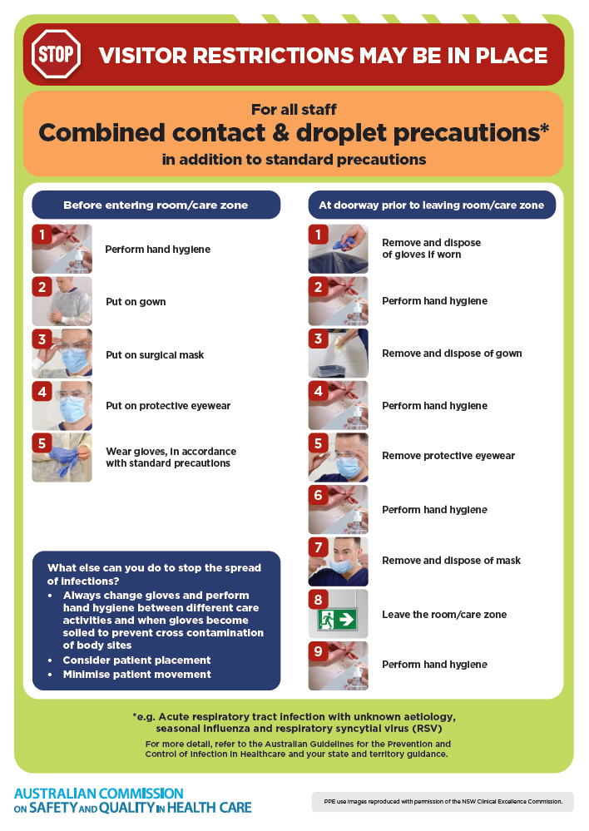
- Poster – Combined airborne and contact precautions
https://www.safetyandquality.gov.au/publications-and-resources/resource-library/infection-prevention-and-control-poster-combined-airborne-and-contact-precautions
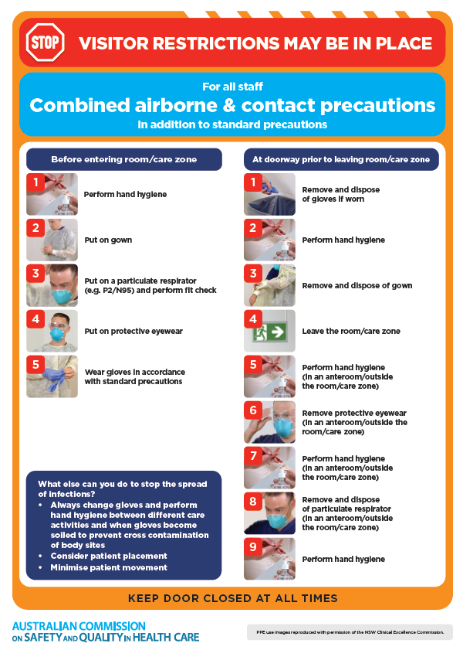
- Environmental Cleaning and Infection Prevention and Control www.safetyandquality.gov.au/environmental-cleaning
- Break the chain of infection poster
https://www.safetyandquality.gov.au/publications-and-resources/resource-library/break-chain-infection-poster
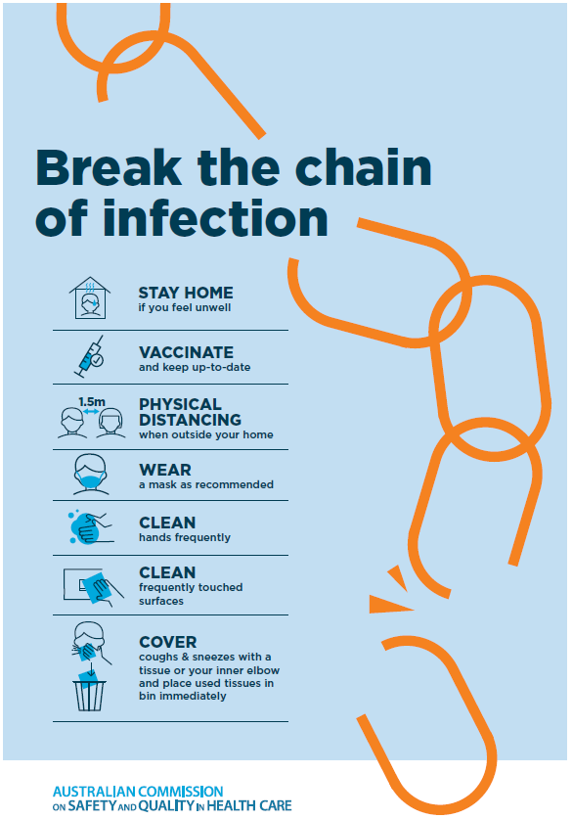

Disclaimer
On the Radar is an information resource of the Australian Commission on Safety and Quality in Health Care. The Commission is not responsible for the content of, nor does it endorse, any articles or sites listed The Commission accepts no liability for the information or advice provided by these external links. Links are provided on the basis that users make their own decisions about the accuracy, currency and reliability of the information contained therein Any opinions expressed are not necessarily those of the Australian Commission on Safety and Quality in Health Care.

