
On the Radar
Issue 741
4 May 2026

On the Radar is a summary of some of the recent publications in the areas of safety and quality in health care Inclusion in this document is not an endorsement or recommendation of any publication or provider Access to particular documents may depend on whether they are Open Access or not, and/or your individual or institutional access to subscription sites/services Material that may require subscription is included as it is considered relevant.

On the Radar is available online, via email or as a PDF or Word document from https://www.safetyandquality.gov.au/news-and-media/subscribe-news/on-the-radar

If you would like to receive On the Radar via email, you can subscribe on our website
https://www.safetyandquality.gov.au/news-and-media/newsletters
or by emailing us at mail@safetyandquality.gov.au.
You can also send feedback and comments to mail@safetyandquality.gov.au.

For information about the Commission and its programs and publications, please visit https://www.safetyandquality.gov.au

On the Radar
Editor: Dr Niall Johnson
Contributors: Niall Johnson, Brad McEntee, Sam Allingham, Gabby Griggs

World Hand Hygiene Day (WHHD) 2026
https://www.safetyandquality.gov.au/WHHD

Each year on 5 May, health services around the world unite for World Hand Hygiene Day (WHHD)—a global reminder that clean hands save lives.

The WHO theme for WHHD 2026 is “Action saves lives”
The Commission have adopted this for the Australian 2026 theme which is “Action saves lives – Safer care starts with clean hands.”
To support this year’s campaign available at https://www.safetyandquality.gov.au/WHHD, the Commission has launched a refreshed suite of resources designed to prompt action across healthcare settings, including:
- an updated hand hygiene infographic
- a stakeholder newsletter
- an engaging true/false quiz
- an updated presentation on the basics of hand hygiene.
These resources aim to strengthen hand hygiene knowledge, reduce the spread of harmful germs, and keep patients and healthcare workers safe.

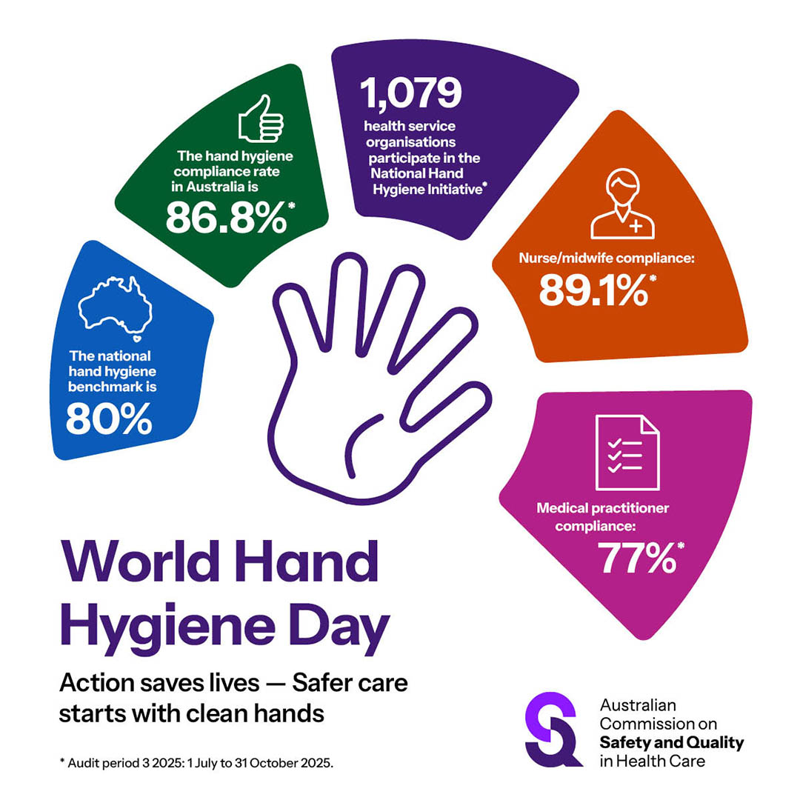

In addition, check out the following research and clinical guidance related to the WHHD 2026 theme:
- Guidelines on Hand Hygiene in Community Settings
Geneva: World Health Organization and the United Nations Children’s Fund (UNICEF); 2025. p. 78.
https://www.who.int/publications/i/item/9789240116559
The World Health Organization (WHO) and the United Nations Children’s Fund (UNICEF) released hand hygiene guidelines designed for non−health care settings, including homes, schools, and other public and institutional settings. According to the WHO’s website, the ‘Guidelines are concerned with the practice of hand hygiene to protect community health outcomes, in particular, the reduction of diarrhoeal diseases and acute respiratory infections’.
- WHO research agenda on the role of the institutional safety climate for hand hygiene improvement: a Delphi consensus-building study
Tartari E, Storr J, Bellare N, Kilpatrick C, McGuckin M, Schwaber MJ, et al
BMJ Quality & Safety. 2024;34(9):609-20.
https://doi.org/10.1136/bmjqs-2024-017162
- Becoming hand hygiene heroes: Implementation of an infection prevention and control campaign for patient and family hospital safety
Cheng B, Chan M, Abi-Farrage D, Braschel M, Harrison P, Srigley JA.
American Journal of Infection Control 2025;53:181-7. https://doi.org/10.1016/j.ajic.2024.10.026

Priorities for high-quality digitally enabled care
https://www.safetyandquality.gov.au/clinical-topics/digital-health/priorities-high-quality-digitally-enabled-care

The Australian Commission on Safety and Quality in Health Care has identified Priorities for high-quality digitally enabled care as a roadmap to strengthen care in an evolving digital health environment.

As digitally enabled care continues to expand at pace, there is an increasing risk of variability in practice, fragmented care and patient harm – without a clear and coordinated focus on high-quality care.
The Commission's four Priorities will help to:
- Embed digitally enabled care in clinical governance
- Strengthen virtual care quality
- Advance connected care through standardised data
- Lead system-wide quality improvement in digitally enabled care.

Reports

The Health and Economic Benefits of Tackling Non-Communicable Diseases
OECD Health Policy Studies
OECD
Paris: OECD Publishing; 2026.
DOI | https://doi.org/10.1787/e20cbbc3-en
Notes | Report from the OECD on the importance of non-communicable diseases (NCD) and the benefits of reading their incidence and prevalence. From the report’s abstract: ‘NCDs cut lives short, affect quality of people’s life, and reduce their ability to work. This raises health expenditure and reduces workers’ productivity and economic output. Yet many of these impacts are avoidable, through action on health risk factors, early diagnosis of disease and improved treatment.  The analyses in this report show that preventing illness delivers far greater social and economic benefits than treating it later. Countries that succeed in reducing key health risks such as obesity and tobacco use can save lives, ease pressure on health budgets and unlock substantial economic gains.’

Environmental sustainability in the NHS A new approach to national leadership and accountability
Naylor C, Wills E, Hillson R
London: The King's Fund and Centre for Sustainable Healthcare; 2026. p. 54.
URL | https://www.kingsfund.org.uk/insight-and-analysis/reports/environmental-sustainability-nhs
Notes | Report (and associated policy brief) from The King’s Fund and the Centre for Sustainable Healthcare in the UK that used expert interviews, literature review, and analysis of existing sustainability metrics to examine how UK national and local NHS bodies are held to account for sustainability. The report also included recommendations for strengthening accountability.

For information on the Commission’s work on sustainable healthcare, see https://www.safetyandquality.gov.au/clinical-topics/sustainable-healthcare

Mental health: attempted suicide while under the care of community services
Investigation report
Health Services Safety Investigation Body
Poole: HSSIB; 2026.
URL | https://www.hssib.org.uk/patient-safety-investigations/mental-health-investigating-under-the-patient-safety-incident-response-framework-psirf/investigation-report/
Notes | The latest investigation report from the Health Services Safety Investigations Body (HSSIB) in the UK examines the use of a particular approach to investigating safety incidents – the Patient Safety Incident Response Framework (PSIRF) – and its use in mental health safety incidents.

Partnering for Prevention: Strengthening Australia’s chronic disease prevention system for primary prevention in the health sector
Findings brief from The Australian Prevention Partnership Centre. McGill B, Shahid M, Smiedt J, Cluff S, Mastersson N
Sydney: The Sax Institute; 2026.
URL | https://preventioncentre.org.au/wp-content/uploads/2026/04/partnering-for-prevention-phase-1-findings-primary-prevention.pdf
Notes | Findings brief from the Australian Prevention Partnership Centre that summarises insights from the first phase of the centre’s Partnering for Prevention initiative. This phase focused on primary prevention within the health sector and brought together senior leaders from across Australia in two workshops. Participants worked together to identify how the prevention system operates and where it can be strengthened. The work also identified a range of action areas ‘that together provide a clear structure for strengthening the primary chronic disease prevention system’.

Journal articles

A comparative analysis of hospital-acquired complications and sentinel event reporting across Australia, Canada, New Zealand, England, and the United States
Southerland LT, van Oppen JD, Chartier LB, Allingham SF, MacLullich AMJ, Hullick C.
The Joint Commission Journal on Quality and Patient Safety 2026.
DOI | https://doi.org/10.1016/j.jcjq.2026.04.011
Notes | Hospital acquired complications (HACs) and Sentinel Events (SEs) are important safety and quality measures for many hospital systems, with monitoring contributing to safer stays and experiences for patients. This paper highlights similarities and differences in the definition and reporting of HACs and SEs across five countries: Australia, Canada, New Zealand, England, and the United States of America. While the current level of overlap in definitions and differences in reporting practices may pose a barrier to the comparison of the safety and quality of the respective hospital systems, the authors highlight opportunities for these countries to learn from best practices and shared challenges. The authors also offer recommendations for countries in the process of developing their hospital quality monitoring systems.  This work resulted from Dr Lauren Southerland’s time as a Visiting Fullbright Scholar with the Australian Commission on Safety and Quality in Health Care in 2025.

For information on the Commission’s work on hospital-acquired complications (HACs)HACs, see https://www.safetyandquality.gov.au/our-work/indicators-measurement-and-reporting/hospital-acquired-complications-hacs
For information on the Commission’s work on sentinel events, see https://www.safetyandquality.gov.au/our-work/indicators-measurement-and-reporting/incident-management-and-sentinel-events

Health Expectations
Volume 29, Issue 2, April 2026
URL | https://onlinelibrary.wiley.com/toc/13697625/2026/29/2
Notes | A new issue of Health Expectations has been published. Articles in this issue of Health Expectations include:  - Beyond Tokenism: Making Lived Experience Leadership Visible in Co-Produced Research Authorship (Patte Randal, Stefan Heinz)  - Prevalence of Hearing, Vision and Cognitive Impairment and Impact in Older Adults in Home Care: A Study Protocol (Melinda Toomey, Lana Wilson, Helen Gurteen, Bronwyn Franco, Rebecca Bennett, Dayna Cenin, Najwan El-Saifi, Melanie Ferguson, Yuanyuan Gu, Chyrisse Heine, Lisa Keay, Sheela Kumaran, Sabrina Lenzen, Iracema Leroi, J A Lowthian, C Meyer, L Mitchell, J Newall, N A Pachana, M Piano, S Raichand, E Scanlan, H Sohrabi, P Dawes)  - A Pre–Post Study of the Feasibility, Acceptability and Benefits of a Co-Design Approach for the Development of a Digital Suicide Prevention App for International Students (Christina Ng, Tanvi Shaikh, Jo Robinson, Jennifer Nicholas, Vivienne Browne, Gina Chinnery, Isabella Choi, B Nation-Ingle, K Allison, E Perlow, M Lamblin, E Brown, G Armstrong, M Mani, S McKay)  - Understanding the Psychological Impacts of Shielding From COVID-19 for Immunocompromised Individuals (A Gray, J Barnett, L Bernardi, J Daniels)  - Symptom Management in Chronic Heart Failure: Strategies and Behaviours From Patients’ Perspectives—A Scoping Review (Severin Pietsch, Sascha Köpke, Christa Büker, Irene Müller)  - Co-Design of a Unified, International Aphasia Awareness Campaign (Claire Bennington, Ciara Shiggins, Jytte Isaksen, Emma Beesley, Kim Beesley, Jean-Marie Annoni, Jude Czerenkowski, Carly Davey, Natalie Douglas, Alexia Kountouri, Caitlin Longman, A Paurinak, S Scott, K Shelley, S J Wallace)  - Lived Experiences of Returning to Participation After Mild Stroke: A Phenomenological Study in Spain (Cristina de Diego-Alonso, Almudena Buesa Estéllez, Javier Güeita-Rodriguez, Pablo Bellosta-López, P Roldán-Pérez)  - ‘What Do People With Long Covid Want From Healthcare Services?’ A Qualitative Exploration From Lived Experience (Clare Rayner, Nikki Smith, R Milne, G Mir, J de Kock, N D Bakerly, The LOCOMOTION Consortium)  - Vital yet Fragile: Informal Networks of Support Among Young People Navigating Long Covid (Zaira Clarke, Hannah Cowan, Tim Rhodes, Praveena Fernes, A. Haines, Lucinda Leal)  - Preconception Perceptions, Knowledge and Behaviours of Women With Gestational Diabetes Mellitus: A Qualitative Study (E Payne, D Schoenaker, K Turner, H R Murphy, H Skouteris, K Ismail, S A Silverio, M Benton)  - Public Involvement in the Evaluation of Local Government Public Health Interventions in the UK: Lessons From PHIRST Insight (Georgina Kathryn Wort, H Robinson, C Forte, H Littlecott, J Hawkins, R Campbell, P Jessiman)  - Social Needs Screening Tools for Clinical Populations in Australia and New Zealand: A Scoping Review and Critical Analysis (Isabelle Weld-Blundell, Yvonne C Learmonth, Marlena Klaic, Jodi Haartsen, Darshini Ayton, Anne Kavanagh, Megan R Hawkins, Claudia H Marck)  - Socio-Ecological Factors Influencing Maternal and Child Health Outcomes During Floods in South Punjab Pakistan 2025: A Mixed-Methods Approach (Muhammad Muneeb Hassan, Badr S Alnssyan, Muhammad Aman Ullah, Muhammad Ameeq, Alpha Kargbo)  - Co-Design of a Community of Practice for People With Personal and Professional Expertise or Interest in Dementia in Australia (Eliza Watson, Sadia Afrin, Clarissa Giebel, Katrina M Long, Jane Thompson, Matthew F., Chris Moran, Yen Ying Lim, Darshini Ayton)  - Development and Validation of a Culturally Adapted Patient-Reported Experience Measure for Diabetes Care in Thailand: Mixed-Methods Study (Soe Sandi Tint, Nida Buawangpong, Wichuda Jiraporncharoen, Myo Zin Oo, Nutchar Wiwatkunupakarn, Kittipan Rerkasem, Kanokwan Kulprachakarn, Hataichanok Chuljerm, Timothy E O'Brien, Rohini Mathur, Petch Rawdaree, Chaisiri Angkurawaranon)  - Developing a Measure to Assess General Knowledge for Coeliac Disease (Tiffany Lavis, K Ann Horsburgh, Jacqueline F Gould, E Bingham Thomas)  - Towards Meaningful Consumer and Community Involvement in Health Research: A Qualitative Study of Consumer and Researcher Experiences (Kimberley A Baxter, Jennifer Muller, David A Copland, Nadine E Foster, E Doig, J A Schults, K R Charles, A Young, S Manzanero, T Smyth, L Anemaat)  - From Dismissal to Partnership: Patient Experiences of Recurrent Urinary Tract Infection Healthcare Informed by the Theoretical Domains Framework and Behaviour Change Theory (Abigail F Newlands, Melissa L Kramer, Sarah Snuggs, Katherine A Finlay)  - Move to Improve: Co-Designing a Hospital-Based Physical Activity Program for Children With Chronic Health Conditions (Hamsini Sivaramakrishnan, Amy Finlay Jones, T Long, L Naylor, J Valentine, L Martin, L Haustead, V Shetty, F Wood, E Davis, Move to Improve Author Group)

Emergency Medicine Australasia
Volume 38, Issue 2, April 2026
URL | https://onlinelibrary.wiley.com/toc/17426723/2026/38/2
Notes | A new issue of Emergency Medicine Australasia has been published. Articles in this issue of Emergency Medicine Australasia include:  - Anticoagulation Practices Surrounding Emergency Department Cardioversion for Atrial Fibrillation and Flutter (Thomas Maouris, Peter Del Mar, Nathan Brown, Lachlan Abbot, Mathilda Thorrowgood)  - Exploring Advanced Practice Physiotherapist Scope of Practice by Discharge Diagnosis: A Review of 10 Years of Data From a Tertiary Hospital Emergency Department (Piers Truter, Louise Giglia-Smith, Luke Bongiascia, Andrew Moffat, James Wrightson, Susan Brooker, Paul Atkinson, P Flanagan)  - Paediatric Nasogastric Tube Insertion Practices Across Australia and New Zealand: A Survey of Clinicians (Alfred K S Liu, Dianne Crellin, Sarah McNab, Franz E Babl, Phyllis Lin, Simon S Craig)  - The Sydney Triage to Admission Risk Tool With Artificial Intelligence (START-AI): Prediction of Inpatient Admission From Emergency Departments Using Ensemble Machine Learning (Michael Dinh, Elizabeth Corbett, Eliot Salmon, Saleem Ahmed Khan, Nicholas Moore, Sreenadh Brahmapuram, R Seimon, N Derrick, S B Russell, T T Ngo, I Koprinska)  - Time to Analgesia Provision for Abdominal Pain Presentations in the Emergency Department: The Effect of Biological Sex—A Retrospective Cohort Study (Lisa Walker, Hannah Pennicott, Chris J Selman, E M Bourke)  - Somatisation Scores Associated With Healthcare Costs and Utilisation in a Sample of Emergency Department Patients (Ben Britton, Ria Mittal, Keira Barnard, Samantha Chapman, D Chen, B De Berg, V Raveendran, E Pepper)  - Sustaining Emergency Medicine: Workforce Wellbeing, Moral Integrity and the Power of Action (Sonia Chanchlani)  - Clinical Handover as Craft, Not Checklist (Aloha Hufana Ambe, Nathan Brown, Daniel Bodnar, Tobias Grundgeiger, Sean Rothwell, Ben Matthews)  - Sustainability in Swedish Healthcare: Balancing Individual and System Responsibility—And Some Practical Examples From Sweden (Cechael Sebghati Sparrfelt)  - Threats to Humanity and Doctors' Duties (Neil Pickering)  - Retrospective Evaluation of the STONE Score and Modified Stone Score for Prediction of Renal Tract Stones (Kezia Mansfield, A-M Kelly, F Resendez)  - Time to Sedation and Analgesia After Rapid Sequence Intubation in the Emergency Department (Callum Barnden, B Mitra, A Maini, C Groombridge)  - Exploring Patterns of D-Dimer Assay Ordering at an Australian Rural Referral Hospital: A Retrospective Audit (Suzanne Hill, E Webster, D Stewart)  - The Potential for Artificial Intelligence to Augment Peer Review (W Kenneth Milne, Daniel Fatovich)  - The Content of Major Haemorrhage Protocols (MHP) in Public Hospitals Throughout Queensland—Are We Following the Evidence? (Josea Brown, Elizabeth Wake, S George, J Winearls, M C Reade, M Jeffress, D Bodnar, C Gibbs, A Hamilton, C Brandenburg, J Casey, N Adams, P Cresswell, J Forbes)  - Are We Measuring What Matters? Re-Examining National Out-of-Hospital Cardiac Arrest Outcome Indicators (Jason Belcher, Stephen Ball, J Finn)  - Acute Suspected Stroke Clinical Pathway Use in Tasmanian Emergency Departments: A Retrospective Study (Innocent Tawanda Mudzingwa, Sarah Jane Prior, Phoebe Griffin, Emma Tavender, Viet Tran)  - One-Year Retrospective Evaluation of Blood Administration Practices Within LifeFlight Medicine (Bradley Robert Richardson, Tara Pidgeon, Susanna Cramb, Ben Powell, Ben Aston)

Health Policy
Volume 169, July 2026
URL | https://www.sciencedirect.com/journal/health-policy/vol/169/
Notes | A new issue of Health Policy has been published. Articles in this issue of Health Policy include:  - Health system sustainability and resilience: Navigating perpetual tensions? (George Wharton, Alistair McGuire)  - When low benefit-cost ratios mean we need to invest more, not less: The social determinants of value in health (Chris Desmond, Kathryn Watt, Dhyan Saravanja, William E Rudgard)  - Cultivating compassion in the midwifery workplace culture to strengthen workforce resilience: An ecological futures approach and qualitative Scottish study (Alix Aitken-Arbuckle, Yvonne Kuipers)  - Megatrends and equity gaps in global digital health: A bibliometric review (2010–2025) (Alex S Borromeo, Allan M Manaloto, Rhealeen V Vicedo)  - Inter- and intranational variation of vaccine hesitancy: a survey in Denmark and Saudi Arabia (Kamal Dhafer Hussein Alansari, Caroline Buhl, Abrar K Thabit, Aisha F Badr, Ramune Jacobsen)  - Health financing and population ageing: evidence on the links between financial sustainability and financial hardship from the PASH simulator (Jonathan Cylus, Sarah Thomson, Maria Serrano Gregori, Marcos Gallardo Martínez, Jorge Alejandro Garcia-Ramirez, Tamás Evetovits)  - The cost of inequality: income and life expectancy at birth in Spain (Jose M Pavía, Josep Lledó, Rosa Roig)  - An essential medicines list in Ireland: A qualitative interview study of interest-holders (James Larkin, Matthew Preteroti, Logan T Murry, Michelle Flood, Barbara Clyne, Sara Burke, Tom Fahey, Nav Persaud, Frank Moriarty)  - Are gaps in the time of submissions and approvals of new drugs between Health Canada and the Food and Drug Administration related to therapeutic value? A cross-sectional study (Joel Lexchin)  - The Spanish long-term care system reaches majority of age: A narrative review of evidence and lessons obtained (Helena M Hernández-Pizarro, Albert Prades-Colomé)  - Nationwide implementation of Watch-and-Wait in rectal cancer patients in the Netherlands: Encountered barriers and lessons learned in 20 years (C Ceuppens, B A Grotenhuis, D M J Lambregts, M Maas, B M Geubels, R G H Beets-Tan, G L Beets, I L Huibregtse, M van Leerdam, B van Triest, J (Jarno) Melenhorst, S O Breukink, D J A Sonneveld, J J van den Broek, K C M J Peeters, J J Boonstra, H L van Westreenen, W H de Vos Tot Nederveen Cappel, J W A Burger, J G Bloemen)

International Journal for Quality in Health Care online first articles
URL | https://academic.oup.com/intqhc/advance-articles
Notes | International Journal for Quality in Health Care has published a number of ‘online first’ articles, including:  - Evaluation of Professional Pharmacy Activities Under Advanced Practice Agreements for Inpatients at the McGill University Health Centre (Marc-Alexandre Duceppe et al)  - Enhancing Patient Safety in the Emergency Care of Poisoned Patients: A Participatory Systems Approach (Mecit Can Emre Simsekler et al)  - Exploring the Causal Relationship Between Workplace Factors and Emotional Exhaustion Among Healthcare Professionals: An fsQCA Approach (Yao-Te Tsai et al)  - From leadership perception to reporting action: unpacking the mediation pathway in nursing safety (Chun-Ya Li et al)  - Association between Physiological Abnormalities on General Ward and Patient Outcomes after Intensive Care Unit Readmission: A Cross-Sectional Study (Chia-Kuei Lin et al)  - Evaluating the impact of 360-degree assessment management based on information technology on improving service quality and satisfaction of operating room staff (Yongqing Zhou et al)

Online resources

Australian Living Evidence Collaboration
https://livingevidence.org.au/

[UK] NICE Guidelines and Quality Standards
https://www.nice.org.uk/guidance
The UK’s National Institute for Health and Care Excellence (NICE) has published new (or updated) guidelines and quality standards The latest reviews or updates include:
- NICE Guideline NG198 Acne vulgaris: management
https://www.nice.org.uk/guidance/ng198

Infection prevention and control resources
The Australian Commission on Safety and Quality in Health Care has developed a number of resources to assist healthcare organisations, facilities and clinicians These resources include:
- Poster – Combined contact and droplet precautions https://www.safetyandquality.gov.au/publications-and-resources/resource-library/infection-prevention-and-control-poster-combined-contact-and-droplet-precautions
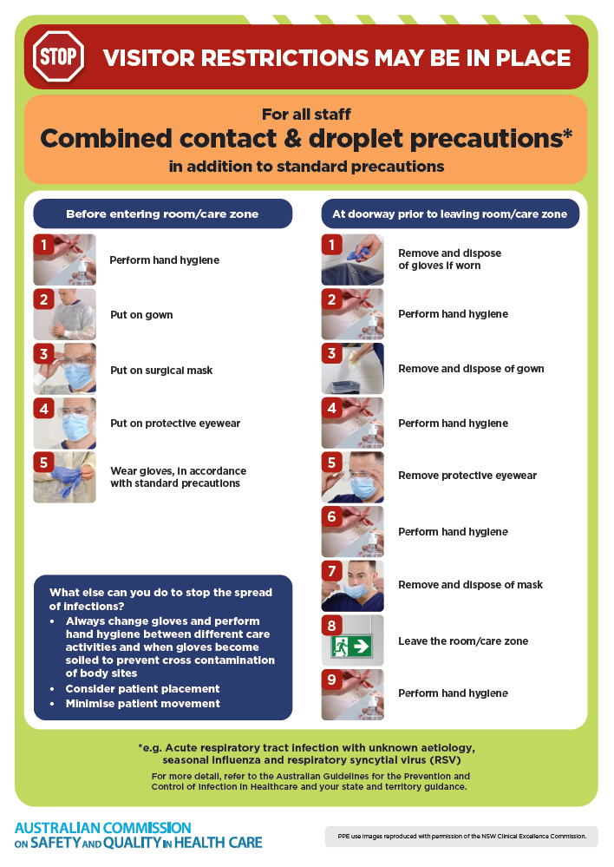
- Poster – Combined airborne and contact precautions
https://www.safetyandquality.gov.au/publications-and-resources/resource-library/infection-prevention-and-control-poster-combined-airborne-and-contact-precautions
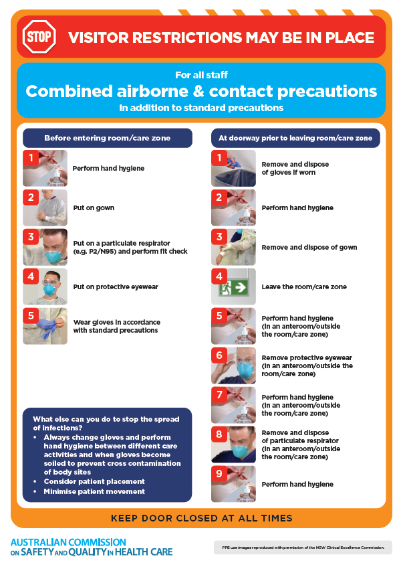
- Environmental Cleaning and Infection Prevention and Control
https://www.safetyandquality.gov.au/clinical-topics/infection-prevention-and-control/standard-and-transmission-based-precautions
- Break the chain of infection poster
https://www.safetyandquality.gov.au/publications-and-resources/resource-library/break-chain-infection-poster
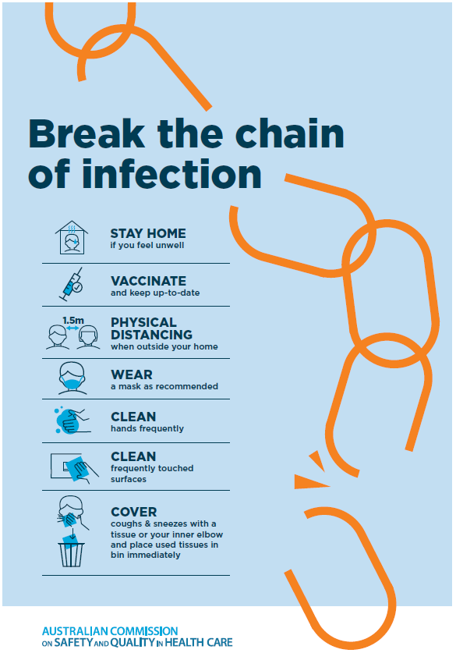

Disclaimer
On the Radar is an information resource of the Australian Commission on Safety and Quality in Health Care The Commission is not responsible for the content of, nor does it endorse, any articles or sites listed The Commission accepts no liability for the information or advice provided by these external links. Links are provided on the basis that users make their own decisions about the accuracy, currency and reliability of the information contained therein Any opinions expressed are not necessarily those of the Australian Commission on Safety and Quality in Health Care.

