
On the Radar
Issue 742
11 May 2026

On the Radar is a summary of some of the recent publications in the areas of safety and quality in health care Inclusion in this document is not an endorsement or recommendation of any publication or provider Access to particular documents may depend on whether they are Open Access or not, and/or your individual or institutional access to subscription sites/services Material that may require subscription is included as it is considered relevant.

On the Radar is available online, via email or as a PDF or Word document from https://www.safetyandquality.gov.au/newsroom/subscribe-news/radar

If you would like to receive On the Radar via email, you can subscribe on our website https://www.safetyandquality.gov.au/newsroom/subscribe-news
or by emailing us at mail@safetyandquality.gov.au.
You can also send feedback and comments to mail@safetyandquality.gov.au.

For information about the Commission and its programs and publications, please visit https://www.safetyandquality.gov.au

On the Radar
Editor: Dr Niall Johnson
Contributors: Niall Johnson, Nicola Bunt

Emergency Laparotomy Clinical Care Standard
Australian Commission on Safety and Quality in Health Care
Sydney: ACSQHC; 2026. p. 67.
https://www.safetyandquality.gov.au/resources/emergency-laparotomy-clinical-care-standard

The Australian Commission on Safety and Quality in Health Care (the Commission) launched the Emergency Laparotomy Clinical Care Standard at the Royal Australasian College of Surgeons (RACS) Annual Scientific Congress on 1 May 2026. An article about the new Standard was published in MJA Insight on 4 May.

Emergency laparotomy for time-critical abdominal conditions, such as bowel obstruction, perforation, ischaemia or sepsis, is among the highest-risk emergency surgical procedures, especially for older or frail adults and those with significant comorbidities. In Australia, mortality is approximately 7%, and the average hospital stay exceeds 12 days. Postoperative complications are common, and many patients experience poor functional outcomes.

The new Standard aims to improve outcomes by building on a substantial and growing evidence base demonstrating the benefits of standardised approaches to emergency laparotomy care including insights from the Australian and New Zealand Emergency Laparotomy Audit – Quality Improvement (ANZELA-QI) and the UK’s National Emergency Laparotomy Audit (NELA). It outlines nine key components of care for quality improvement and includes a set of indicators – aligned with ANZELA-QI key performance indicators – to help services monitor local implementation and quality improvement.

More information about the Standard is available on the Commission’s website.

Journal articles

Patient Experience Journal
Volume 13, Issue 1, 2026
URL | https://pxjournal.org/journal/vol13/iss1/
Notes | A new issue of the Patient Experience Journal (PXJ)has been published Articles in this issue of the Patient Experience Journal include:  - Editorial: Human Experience: A Catalyst for Global Connection (J A Wolf)  - Human Experience, The Boarding Crisis, and Moral Injury-A Call to Action (Thom Mayer and Wendy Dean)  - Navigating Medical Ambiguity: A Patient's Perspective on Communication, Timing, and Risk (J Hansen)  - The Quiet End of the Visit (Avinav Biswas)  - The Voices I Never Heard: Reflections from a Public Health Advocate on Representation, Silence, and Struggle (Araya Gautam)  - Beliefs Regarding Patient Experience in the Emergency Department Among Individuals With Sickle Cell Disease (E A Ibiloye, G N Odonkor, A A Aiyeolemi, J C Barner, C M Brown, H Ah Kang, and B A Bamgbade)  - Preventing Delirium After Surgery: A Qualitative Study of Patients, Caregivers, and Providers (Jennifer O'Brien, Maria Cruz, Heather Dyck, Hassan Yassin, Una Goncin, Lei Xia, Huma Aftab, L Thorpe, and P Hedlin)  - Capturing Patient-Centered Quality of Life: Usability and Initial Validation of the Pediatric Patient-Generated Index Following Esophageal Atresia Repair (Zanib Nafees, Julia Ferreira, Elena Guadagno, Nikki Ow, Nancy Mayo, Jean-Martin Laberge, and Dan Poenaru)  - Improving Patients' Experience Through Nurturing Care for Patients Undergoing Kidney Biopsies: A Feedback Survey (Molefe Rapalai, Mahmoud Elshehawy, Johann Nicholas, Patrick Anthony Ball, and Hana Morrissey)  - Using Artificial Intelligence to Enhance Patient Comprehension and Risk Perception of Pathology Reports: Findings From a Survey of Patients and Pathologists (J Franco, O Koulong Leussa, A K Abu Alfa, and M K Fung)  - The Implementation of Family-Centered Care and Family Satisfaction in Caring for Children With Cancer (Lenny Gannika, Mulyadi Mulyadi, and Jeanette Irene Christie Manoppo)  - Expanding Family Participation in Inpatient Rounds Through Remote Access: A Feasibility Study Using Automated Messaging (Praveen Meka, Susan Ayers, and Jayme Wilder)  - No One-Size-Fits-All: Patient Perspectives of Key Factors Influencing Their Inpatient Rehabilitation Experience (Mirline Milien, Megan Bewernitz, Katherine Stallings, and Mary Ellen Young)  - Applying a Patient Journey Mapping Approach to Understand Maternal Care Patient Journeys: A Pilot Study (Nicole Hicks, Kristin Tully, Christopher Goodier, Sreenath Chalil Madathil, Ayaba Logan, and Myrtede Alfred)  - The Patient's Lived Experience: A Phenomenological Study on Factors Influencing Tuberculosis Treatment Outcomes in Medan, Indonesia (Erida Novriani, Urip Harahap, Khairunnisa Khairunnisa, and Wiryanto Wiryanto)  - Inaccessibility and performative inclusivity: higher-weight Francophone and Newcomer adults' experiences in a Canadian Atlantic province (Andrea E Bombak, N Chinho, K O'Keefe, S Akhter, L Thomson, C Burk, and L Turner)  - Development and Psychometric Assessment of the Sub-scales of the Ontario Perception of Care tool for Mental Health and Addictions (OPOC-MHA) (Brian Rush and Karen Urbanoski)  - Veteran Emergency Waiting Areas and Turned-Off Televisions: An Overlooked Variable (Randall Vanadisson)  - Cartoon-Printed Uniforms: A Strategy to Ease Pediatric Hospital Anxiety (Karnellya R Ohol and Janaki P Shinde)  - Patient-Centered Care to Improve Recruitment and Retention in Clinical Trials: Insights from a Real-Time Interview-Based Satisfaction Study (Christina Zhuang, Aishwarya Prasad, Anshu Arora, Arun Arora, Jeena Vaid, Wisam AlJumaili, and Arif Khan)  - A Study to Assess PROM and PREM of CLD Patients in a Tertiary Care Hospital (Anagha Nandakumar, Rubasree M, Priya Nair, Dinesh Nair, and Krishnapriya S)  - Validation of a COPD Patient-Reported Experience Measure (PREM-C9) in Ontario, Canada (Elaine Zibrowski, Floriana Islami, Alyson Kellar, Christopher Licskai, Madonna Ferrone, and Shannon L Sibbald)  - Supporting Families of Children With Craniosynostosis: A Qualitative Exploration of Parental Usage of Online Forums (Elisha L Rea, Rachel M Roberts, and Amanda J Osborn)  - Leveraging Digital Patient and Family Advisory Councils to Drive Patient Engagement (Priya Radhakrishnan, Shambhavi Mishra, M Price, C Sanders, F Bekele, K Zarubi, C Kartchner, A Singh Johal, C Mayer, and C Norquist)  - Virtual Caregiving and The Evolving Role of Carers and Patients: Virtual Hospital Interview Analysis (Kanesha Ward, Tim Jackson, Jenna Bartyn, Shannon Saad, Sue Amanatidis, Owen Hutchings, and Annie Y S Lau)  - System-Level Barriers to Patient Engagement with Electronic Medical Records (Corey Adams, Reema Harrison, Guncag Ozavci, Kathleen Gray, Nilmini Wickramasinghe, Vicky Yuan, Tracey Bucknall, and Elizabeth Manias)  - Patient Satisfaction and Perceived Quality of Care: A Population-Based Cross-Sectional Study of United States Adults (Samuel Ofei-Dodoo, Carter Altenbernt, Yessin Wael, H Okut, A Watkins, N Tran, and A Rojas-Addari)  - Exploring Patient Satisfaction: Descriptive and Predictive Insights from HCAHPS Surveys in U.S. Hospitals (Naveen Gudigantala, Tanush Sistla, Ramu Gudigantala, and Naga Vemprala)  - Investigating the Effectiveness of Different Modalities in Interprofessional Training (Rose Ann Mathai, Sean Lopez, Maureen Emlund, Jim Scherrer, Elisa Buzinski, Julia Sonnichsen, and Myra Carew)  - Do Allied Health Professionals' Workplace Experiences Affect Their Decisions to Stay? A Quantitative Investigation Into the Relationship Between Wellness and Employee Retention in United States Hospitals (Dina Jarjees and Lihua Dishman)  - Nursing Staff Attitude Towards Nurse-Physician Collaboration in the Neonatal Intensive Care Unit in Al Ahsa City, Saudi Arabia (Makarim Taqi Al Helal and Yaqoub Yousef Al Mousa)  - Factors Influencing Patient Satisfaction in Health Services: A Cross-Sectional Study in the Holy City of Najaf (Ahmed Abdul Hasan Mohsin, Lamees A. Abdul-Lateef, and Noor Ismeal Nasser)  - Multilevel Factors Shaping the Patient Experience with Health Services in Torbat Heydarieh, Iran (Fatemeh Pourhaji and Mohammad Hossein Delshad)  - Patient Experience (PX) in Low- and Middle-Income Countries (LMICs): A Scoping Review (Yara Abou Harb and Geoffrey A Silvera)  - Utilization of Visual Metaphors for Improving Health Literacy (Kadir Alp Özler, Morgan Dressel, Madeline Weiner, Robert D Lucito, and Alice Fornari)  - Patient Engagement in Developing Radiology Patient Education Materials (T Arleo, Harris D Harris D, J Hislop, J Moon, H Li, and N Kadom)  - Improving Human Experience in Health Care: Leveraging ``Humanistic Learning Health Systems'' to Accelerate Change at Scale (Brant J Oliver and Jason A Wolf)  - From Talking the Talk to Walking the Walk: Reflection on Dartmouth Health's Care Experience Week (Rosie Bartel, Corey Kimpson, Tanya Lord, Victoria Lyons, Tony Serge, and Brant Oliver)  - ``We'll be Right With You'', Improving Patient Experience With Complaint Management within a Learning Health System Collaborative (James J Perry, Mackenzie Hahn, Angela Kmiec, and Brant J Oliver)  - Documentation and Dashboard Driven Quality and Safety Improvement in Interpreter Services for Limited English Proficient Patients (Richard T Dillehay, Samuel Verkhovsky, Andrew Bohm, Harley Friedman, Dawn Welshman, Ann Morong, V Karthikeyan, J Dampier, A Racine, and B Oliver)  - A Hybrid Coaching Model in a Multi-Center Networked Care Experience Learning Collaborative (Elizabeth Rizzo, Victoria Adams, James Perry, Nicole Szalay, S Verkhovsky, M M Holthoff, A M Kennedy, and B Oliver)  - Enhancing Provider Engagement through Peer-to-Peer Coaching: The Provider Ambassador Program (Jason Vallee, Jodi Stewart, Sam Verkhovsky, Steve Del Giudice, Janet Aug, A Higgins, J Perry, A Kennedy, and B Oliver)

Health Affairs
Volume 45, Number 5, May 2026
URL | https://www.healthaffairs.org/toc/hlthaff/45/5
Notes | A new issue of Health Affairs has been published with themes of ‘Climate, Health & Equity’. Articles in this issue of Health Affairs include:  - Climate-Related Health Risks In US Hospital Community Health Needs Assessments: A Mixed-Methods Analysis (S Locke, G S Silva, C Arnés-Sanz, M J Eckelman, M Marino, A Ong, S Vartany, J R Ickovics, and J D Sherman)  - Health Insurance As Climate Adaptation: A Practical Framework (Carlos F Gould, An-Chi Tsou, Shiv Puliady, and Sara B McMenamin)  - Extreme Heat, Health Care Use, And Costs: Evidence From Commercial Insurance, Medicaid, And Medicare Advantage (Jeff Romine, Amy Liu, Daniel Cullen, K Tang, H Mattson, M Talavera, A Nazarian, M Clarke, and W C Chi)  - From Crisis To Strategy: Mainstreaming Climate Risk In Health Systems Planning (Cecilia Sorensen, Josephine Borghi, and Sebastian Bauhoff)  - Aligning Health Policy With Climate Action: Evidence-Based Interventions To Decarbonize Care, Improve Climate Resilience (Stefan Wheat, Kristie L Ebi, Jeremy J Hess, Lawrence Rosen, E Cerceo, and H Singh)  - Who Pays When Temperatures Soar? (Kartikeya Bhatotia, Owen Gow, Lisa A Robinson, Shouro Dasgupta, and Satchit Balsari)  - Cold-Related Illness In An Era Of Extreme Climate Events: US Trends, 1998–2022 (Dhara Patel, Steffie Woolhandler, Lenore S Azaroff, Samuel L Dickman, David H Bor, David U Himmelstein, and Danny McCormick)  - Participatory Systems Science To Identify Local Adaptation Strategies For Extreme Heat In King County, Washington (Saria Hassan, Cat Hartwell, Jeremy J Hess, and C Bradley Kramer)  - Unequal Exposure: Examining Outdoor Work And Climate Exposure In The US (Lisa Clemans-Cope, Lisa Dubay, V Pancini, and A Pugazhendhi)  - Reimagining Disaster Response: A New Vision For Community Resilience In The Texas And Louisiana Gulf Coast (Cori Cohen Grant, Summer Chavez, Denae King, Reginald Vicks, Huey German Wilson, Doris Brown, Chara L Bowie, P Grace Tee Lewis, and Omolola E Adepoju)  - Assessing The Implementation Of Climate And Health Adaptation In Pacific Island Jurisdictions (Christopher J Boyer, Kristie L Ebi, Jeremy J Hess, Kathryn Bowen, K Dolan, C Johanes, M H Smith, and N A Errett)  - Farmers And Ranchers: The Stress And Anxiety Fueled By Climate Change, And Interventions That Could Help (Maud Powell, Mary Halbleib, David Rothwell, and Chad Reznicek)  - Latino Climate And Health Dashboard: Community-Informed Implementation, Data, And Policy Action (Arturo Vargas Bustamante, Silvia R González, Julia Silver, Rosario Majano, and Samantha Alejandre)  - Empowering South Los Angeles Tenants To Advance Climate Policies That Protect Their Rights (Cynthia Miki Strathmann)  - Menu Changes Under NYC’s Revised Food Standards Were Associated With A Reduction In Greenhouse Gas Emissions (E R H Moore, Alyssa J Moran, Laura Stadler, Elizabeth Solomon, Sonia Y Angell and Roni A Neff)  - Creating Climate Change Action Within Communities (M Winchester)  - A ‘Communiversity’ Seeks To Reduce Local Environmental Hazards (Marianne Amoss)  - Health Care Workers In A Storm’s Path (Erin N Marcus)  - how fouled the senses (Jason P Burnham)

BMJ Quality & Safety online first articles
URL | https://qualitysafety.bmj.com/content/early/recent
Notes | BMJ Quality &Safety has published a number of ‘online first’ articles, including:  - Four key things to know about the reliability of measurements (Timothy P Hofer)  - We need a new paradigm to think about generative AI (Adam Rodman, Laura Zwaan)  - How can we prevent clinical deskilling when using AI? (Ian Scott, Anton van der Vegt, Peter Douglas)

International Journal for Quality in Health Care online first articles
URL | https://academic.oup.com/intqhc/advance-articles
Notes | International Journal for Quality in Health Care has published a number of ‘online first’ articles, including:  - Taking multidisciplinary team care from policy into primary care practice (Shona Bates, and others Deborah Saltman, Patricia Davidson, Michael Wright)  - Enhancing Intraoperative Safety Through an Intelligent Surgical Instrument Verification System Based on Computer Vision Technologies (Tsan-Wen Huang, Jing Ting Wong, Ming-Chuan Chiu, Shao-Jen Weng)  - The sustainability of the healthcare: a cross-sectional study among Italian JCI-accredited hospitals (Pier Mario Perrone, M Lauria, F Tediosi, S Castaldi)  - From Silos to Synergy: Building a Cross-Functional ISO 9001 Group to Enhance Climate Resilience in a Paediatric Research Hospital (Ines Lorenzi, Sara Palmerino, Giuseppe Spiga)  - Interventions to improve Cultural Safety in healthcare in CANZUS countries: a systematic mixed studies review of First Nations Peoples’ experiences (Anne van der Breggen, Stuart Leske, Judith A Dean, Saira Sanjida, Jane Wallace, Yiman, Bidjara, Natasha Lee, Mualgal, Yidinji, Kullilli, Thunghutti, James Ward, Pitjantjatjara, Narungga)

Infection prevention and control resources
The Australian Commission on Safety and Quality in Health Care has developed a number of resources to assist healthcare organisations, facilities and clinicians These resources include:
- Poster – Combined contact and droplet precautions https://www.safetyandquality.gov.au/publications-and-resources/resource-library/infection-prevention-and-control-poster-combined-contact-and-droplet-precautions
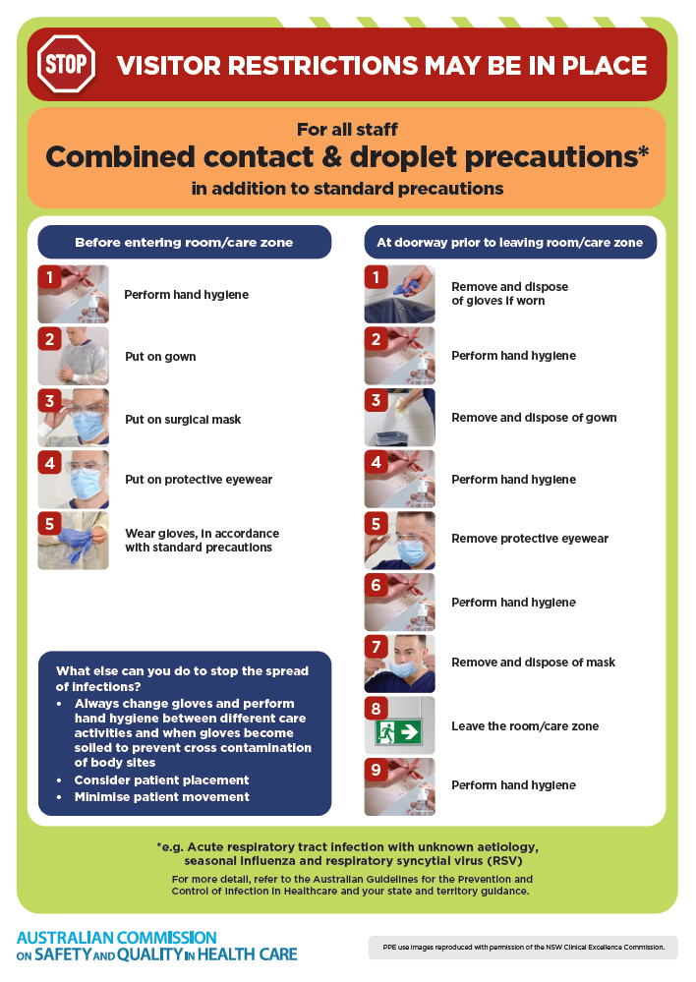
- Poster – Combined airborne and contact precautions
https://www.safetyandquality.gov.au/publications-and-resources/resource-library/infection-prevention-and-control-poster-combined-airborne-and-contact-precautions
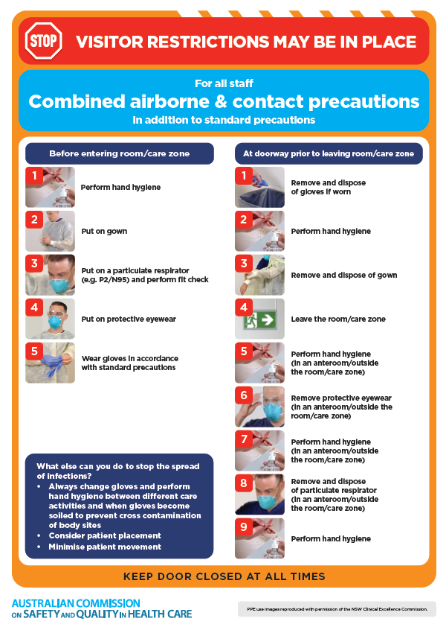
- Environmental Cleaning and Infection Prevention and Control www.safetyandquality.gov.au/environmental-cleaning
- Break the chain of infection poster
https://www.safetyandquality.gov.au/publications-and-resources/resource-library/break-chain-infection-poster
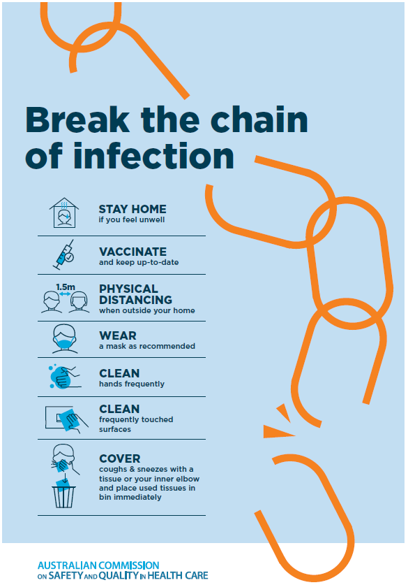

Disclaimer
On the Radar is an information resource of the Australian Commission on Safety and Quality in Health Care The Commission is not responsible for the content of, nor does it endorse, any articles or sites listed. The Commission accepts no liability for the information or advice provided by these external links. Links are provided on the basis that users make their own decisions about the accuracy, currency and reliability of the information contained therein Any opinions expressed are not necessarily those of the Australian Commission on Safety and Quality in Health Care.

