
On the Radar
Issue 743
18 May 2026

On the Radar is a summary of some of the recent publications in the areas of safety and quality in health care Inclusion in this document is not an endorsement or recommendation of any publication or provider Access to particular documents may depend on whether they are Open Access or not, and/or your individual or institutional access to subscription sites/services Material that may require subscription is included as it is considered relevant.

On the Radar is available online, via email or as a PDF or Word document from
https://www.safetyandquality.gov.au/news-and-media/newsletters/on-the-radar

If you would like to receive On the Radar via email, you can subscribe on our website https://www.safetyandquality.gov.au/news-and-media/newsletters/on-the-radar
or by emailing us at mail@safetyandquality.gov.au.
You can also send feedback and comments to mail@safetyandquality.gov.au.

For information about the Commission and its programs and publications, please visit https://www.safetyandquality.gov.au

On the Radar
Editor: Dr Niall Johnson
Contributors: Niall Johnson

Reports

Statement on consumer and community involvement in health and medical research
National Health and Medical Research Council
Canberra: NHMRC; 2026. p. 29.
URL | https://www.nhmrc.gov.au/about-us/publications/statement-consumer-and-community-involvement-health-medical-research
Notes | The National Health and Medical Research Council (NHMRC) and the Consumers Health Forum of Australia (CHF) have released the new joint Statement on Consumer and Community Involvement in Health and Medical Research. The new Statement replaces the 2016 version and reflects NHMRC and CHF’s commitment to embedding consumer and community involvement in all health and medical research.

For information on the Commission’s work on partnering with consumers, see https://www.safetyandquality.gov.au/your-health-service/partnering-consumers

Artificial intelligence and evidence-informed policy – emerging challenges and opportunities: Discussion paper
World Health Organization
Geneva: WHO; 2026. p. 34.
URL | https://iris.who.int/handle/10665/385387
Notes | Artificial intelligence (AI) has many potential uses across the gamut of health activities. The World Health Organization (WHO) has published this discussion paper examining the potential for AI to aid in the development of evidence-informed or evidenced-based health policy. The paper ‘synthesizes current knowledge and emerging insights on the application of AI across the EIP [evidence-informed policy-making] cycle’ while also examining some of the challenges, ‘including risks of algorithmic opacity, bias amplification, equity concerns, data privacy issues, cybersecurity threats, resource demands and regulatory uncertainty’.

For information on the Commission’s work on artificial intelligence, see
https://www.safetyandquality.gov.au/clinical-topics/digital-health/artificial-intelligence

International Health Care System Profiles
The Commonwealth Fund
New York
URL | https://www.commonwealthfund.org/international-health-policy-center/system-profiles
Notes | The Commonwealth Fund in the USA have updated and added to their International Health Care System Profiles web page to now include 31 countries reflecting the variety of approaches to health care around the world. Users can interactively access or download profiles of the health systems of various nations. There is also a comparison function to compare health systems.

WHO guideline on public health and social measures for mitigating the risk and impact of epidemic and pandemic influenza
World Health Organization
Geneva: WHO; 2026. p. 161.
URL | https://iris.who.int/handle/10665/385377
Notes | As the recent hantavirus outbreak has reminded people, infectious disease is a reality in the 21st century as much as it has ever been.  [Ed: A reality a prominent public health leader attempted to convince me was no longer the case in the early years of the century, rather contradicting my recently completed PhD on pandemic influenza and failing to anticipate COVID-19. But he was by no means alone.]  While hantavirus appears an unlikely pandemic candidate, influenza retains its potential for epidemic and pandemic forms. COVID-19 has been the most significant pandemic for a century, the 1918 influenza pandemic is estimated to have caused more than 50 million deaths. As this new World Health Organization (WHO) guideline notes, ‘Each year, seasonal influenza epidemics cause considerable morbidity and mortality, while influenza pandemics, which occur sporadically when a new influenza virus emerges and spreads in populations which lack immunity against it, are public health emergencies.’ The WHO has released this guideline on measures for reducing the impact of a significant influenza outbreak. The ‘guideline examines the role of public health and social measures (PHSM) as non-pharmaceutical interventions [NPIs] to mitigate the spread and consequences of influenza in community settings, particularly when vaccines and antivirals are unavailable or limited.’ This guideline ‘is intended for use by national and local health authorities, and stakeholders from other sectors involved in the decision-making or implementation of PHSM during an influenza epidemic or pandemic. It can also serve as a supporting resource for the development and updating of national influenza pandemic preparedness plans.’

Journal articles

Digital Media Use and Child Health and Development: A Systematic Review and Meta-Analysis
Teague S, Somoray K, Shatte A, Miller D, Moss K, Crawford A, et al
JAMA Pediatrics. 2026;180(5):510-517.
DOI | https://doi.org/10.1001/jamapediatrics.2026.0085
Notes | Australian study published in JAMA Pediatrics that reports on the systematic review and meta-analysis of up to 153 longitudinal studies sought to examine the question, How is digital media use, including social media and video games, associated with child health and development? The authors report ‘poorer developmental outcomes were associated with digital media use in children and adolescents. Social media use was associated with higher depression, behavioral problems, self-injury, and substance use, and lower self-perception and academic achievement; video gaming was linked to greater aggression and externalizing behavior, but modestly higher attention and executive functioning.’

Nursing Leadership
Volume 38, Number 4, 2026
URL | https://www.longwoods.com/publications/nursing-leadership/27820
Notes | A new issue of Nursing Leadership has been published with a focus on ‘internationally educated nurses’. Articles in this issue of Nursing Leadership include:  - Global Nursing Workforce at a Crossroads: A Canadian Policy Lens on the 2026 International Workforce Forum (Valerie Grdisa and Kimberly LeBlanc)  - Leading the Way to Successful Internationally Educated Nurse Integration – CARE Centre for Internationally Educated Nurses’ Workplace Integration Program (R Lee, R Wojtiuk, R El Moubadder and B Nasiopoulos)  - Internationally Educated Nurses Supporting Internationally Educated Nurses: A Leadership Profile of the Integrated Filipino Canadian Nurses Association (Austine Enriquez Gaqui, Mark A Gravoso, E Cruz and A Indar)  - Nurse Practitioners and Mental Health: A Call to Action for Nursing Leadership (Sherry A Weiler and Gillian Strudwick)  - Exploring the Associations Between Empowering Leadership, Work Environment and Moral Injury Among Nurses: A Cross-Sectional Study (Stefano Ardenghi, Selena Russo, Rossana De Palma, Michela Luciani, Giulia Rampoldi, D Fabrizi, D Ausili, M Bani, S Di Mauro and M G Strepparava)  - Trauma-Informed Organizational and Leadership Practices to Support Workforce Mental Health: A Rapid Evidence Synthesis (Rosanra Yoon, Yemisi Onilude and Michael Butac)  - What Nurse Leaders Can Learn from the Pre-Pandemic Literature Regarding Occupational Stress in Hospital-Based Healthcare Workers (R G Maunder, G Strudwick, N D Heeney, A Lawson, D Chaukos and N Margolese)  - Finding the Sweet Spot: Exploring Nurse Practitioner Job Satisfaction, Burnout and Resilience (Lori Harwood, J Crandall and W Koopman)

The Lancet Primary Care
Volume 2, Number 4, April 2026
URL | https://www.thelancet.com/journals/lanprc/issue/vol2no4/PIIS3050-5143(26)X2004-0
Notes | The Lancet Primary Care is a relatively new open access journal. Articles in this issue of The Lancet Primary Care include:  - Editorial: Challenges in escalating social prescribing where most needed  - Social prescribing and UK austerity (Kate Mulligan)  - The Pathway Domains Framework for social prescribing (Xiaoqi Feng, Thomas Astell-Burt)  - Interprofessional collaboration in primary care: a call for equity within multidisciplinary teams (Mike Harald Traub, Sirje Sammul, Elif Sule Bicerler, Ülkü Sur Ünal, Maria van den Muijsenbergh)  - How a lack of visual fidelity in patient-generated images risks compromising care (Rebecca Payne, Alexander Woywodt, Z Wang, U Bak Kirk, M Brady, M Joishy, K King, A Mahdi, A Fischer Pedersen, L Huibers)  - Nationwide audit and feedback to reduce overuse of pathology tests among high-requesting general practitioners in Australia: a factorial, cluster-randomised, controlled trial (Denise A O’Connor, Paul Glasziou, Dina Schram, A Gorelik, A Elwick, K McCaffery, R Thomas, R Buchbinder)  - Kidney outcomes with GLP-1 receptor agonists in people with type 2 diabetes already receiving SGLT2 inhibitors: a target trial emulation study using UK primary care data (Thijs T Jansz, Andrew P McGovern, Katherine G Young, Martha M Dinsdale, Pedro Cardoso, Beverley M Shields, Andrew T Hattersley, Angus G Jones, E R Pearson, C Bingham, R A Oram, J M Dennis)  - A knowledge translation programme for the detection and coding of chronic kidney disease in primary care in Australia (CKD Discovery Drive): an interim, prospective, observational cohort study with an embedded implementation study (Bobby Chacko, Ralph Audehm, Darren Magick, Peter Everett, Zanzi Hocknell, Eugenia Pedagogos)  - Embedding social prescribing in primary care in England and Scotland: a qualitative study of experiences, roles, challenges, and sustainability (Eddie Donaghy, Stewart W Mercer, Heather Brant, Hilllary Collins, Manal Etemadi, Y Hamashima, H McLeod, C A O'Donnell, C Sanders, M Sirisena, P Wilson)  - Palliative care integration in primary health care across the life course: a global health imperative (William E Rosa, Jacopo D’Andria Ursoleo, Stephen Connor, Oladayo Afolabi, Shrikant Atreya, Lindsay Farrant, Adrian E Go, Richard Harding, Matthew Maddocks, Scott Murray, David K Musyoki, Roselyne A Omolo, Katherine Pettus, Kateřina Rusinová, Grant M Smith, P Tanuseputro, F I L Ting, W C W Wong, M Allsop, A Bhadelia, R Buitrago, J E Correa-Morales, E C Dee, J Downing, L Sallnow, D R Sullivan, E L Krakauer)  - Organisation of health services for the delivery of primary health care in the WHO African region: a future perspective (Humphrey Karamagi, A Mamo, B Droti, B Tsofa, S Sy, S Kidane, N Cabral, J Nabyonga, P Tumusiime)

JBI Evidence Synthesis
Volume 24, Issue 5, May 2026
URL | https://journals.lww.com/jbisrir/toc/2026/05000
Notes | A new issue of JBI Evidence Synthesis has been published. Articles in this issue of JBI Evidence Synthesis include:  - Submission declined: an analysis of reasons for rejection in JBI Evidence Synthesis (Sonia Hines, Emilie May Francis)  - Women’s experiences of maternity waiting homes in sub-Saharan Africa: a qualitative systematic review (Teklemariam Ergat Yarinbab, Hailay Abrha Gesesew, Margo Shawn Harrison, Desta Hiko Gemeda, Tefera Belachew)  - Technology-assisted methods to assess the quality of the therapeutic alliance between health care providers and patients: a scoping review (Plaiphon Vaidyanuvatti, Maxwell Geiger, Emily Nelson, Vineet Sadarangani, Megan DeArmond, Sherli Koshy-Chenthittayil, Cheryl E Hightower)  - Contemporary clinical incident analysis methods used within acute care settings: a scoping review (Kathryn Kynoch, Xianliang Liu, Jing-Yu (Benjamin) Tan, Judeil Krlan Teus, Mary-Anne Ramis)  - Characteristics and outcome measures of indwelling urinary catheter care bundles in adult populations: a scoping review protocol (Joan Ostaszkiewicz, Jarrod Clarke, Elizabeth Watt, Caitlin Tay, Micah D J Peters)  - Effectiveness of Sentimag technology (Magseed and Magtrace localization) compared to traditional care for the management of early breast cancer: a systematic review protocol (William Rumble, Sonia Hines, I Ng, A Whitehorn)  - Structure and implementation of school-based nursing programs for children with special health care needs: a scoping review protocol (Sarah Keeping, Simonne Collins, Leah Boulos, Audrey Steenbeek, Janet Curran)  - Effectiveness of various dosage parameters of Wii Fit Plus exergames for enhancing balance and postural control among people post-stroke: a systematic review protocol (Sayan Pratihar, Karthiga Rajasekaran, Balamurugan Janakiraman)  - Non-transport of patients following assessment and care by paramedics: a scoping review protocol (Amanda Hlushak, Michelle Kidd, Jason Bendall, Kingsley Agho, Robin Pap, Paul Simpson)  - Effectiveness of support interventions for improving well-being outcomes in parents of preterm infants: an umbrella review protocol (Tippawan Srichalerm, Ratchanok Phonyiam, Donruedee Kamkhoad)  - Perspectives of health care professionals and policymakers on antimicrobial stewardship and implementation challenges in low- and middle-income country hospital settings: a qualitative systematic review protocol (R Rajalakshmi, M Kavya, Swapna Nayak, Shruthi Bhandarkar, Jayaraj Mymbilly Balakrishnan, Sreedharan Nair, Sohil Khan, Karattuthodi Mohammed Salim, Sneh Shalini, R Uday Kumar, N V Vajid, Girish Thunga)  - Internationalization of medical education in low- and middle-income countries: a scoping review protocol (Thuy Minh Ha, Yan Chen, Rain Lamdin, Lillian Ng, Marcus A Henning)  - Pressure injury risk screening and care planning in hospitals using clinical information systems: a scoping review protocol (Willoughby Hay, Rowena Forsyth, Melissa Baysari, Michelle Barakat-Johnson)  - Economic evaluations of interventions for acute ischemic stroke: a systematic review protocol (Madhusudan Prasad Singh, Ekta Krishna, Meenalotchini Prakash Gurunthalingam, Denny John)  - Caveats for systematic reviews of prevalence studies (Yen-Fu Chen)

International Journal for Quality in Health Care online first articles
URL | https://academic.oup.com/intqhc/advance-articles
Notes | International Journal for Quality in Health Care has published a number of ‘online first’ articles, including:  - Methodological evaluation of the psychometric properties of medication-related quality indicators in residential aged care homes: A systematic review (Lakeesha S Liyanage, Mark Naunton, Louise S Cox, Thilini Sudeshika, Gregory M Peterson, Sam Kosari)  - Anticholinergic burden and quality of life: Expanding the evidence for person‑centred care (Tesfahun C Eshetie , David Greenfield)  - AI-in-the-Loop to Turbocharge Learning Health Systems (Phillip Phan and David Patric Werner Rastall)  - Bridging Compliance and Efficiency: Leveraging Lean Manufacturing for ISO 13485 Implementation in Medical Device Firms (Diego Augusto de Jesus Pacheco, Samuel Vinícius Bonato, Isaac Pergher)

BMJ Quality & Safety online first articles
URL | https://qualitysafety.bmj.com/content/early/recent
Notes | BMJ Quality &Safety has published a number of ‘online first’ articles, including:  - The incidence of avoidable healthcare-associated harm in prisons in England: a retrospective case note review (Isobel Joy McFadzean, Saied Ibrahim, Verity Wainwright, Maria Panagioti, Melanie Jordan, Sandra Flynn, Richard N Keers, Tim Millar, Darren M Ashcroft, Adrian Edwards, Anthony J Avery, Jenny Shaw, Andrew Carson-Stevens)

Online resources

Australian Living Evidence Collaboration
https://livingevidence.org.au/

[UK] NICE Guidelines and Quality Standards
https://www.nice.org.uk/guidance
The UK’s National Institute for Health and Care Excellence (NICE) has published new (or updated) guidelines and quality standards The latest reviews or updates include:
- NICE Guideline NG195 Neonatal infection: antibiotics for prevention and treatment https://www.nice.org.uk/guidance/ng195

Infection prevention and control resources
The Australian Commission on Safety and Quality in Health Care has developed a number of resources to assist healthcare organisations, facilities and clinicians These resources include:
- Poster – Combined contact and droplet precautions https://www.safetyandquality.gov.au/publications-and-resources/resource-library/infection-prevention-and-control-poster-combined-contact-and-droplet-precautions
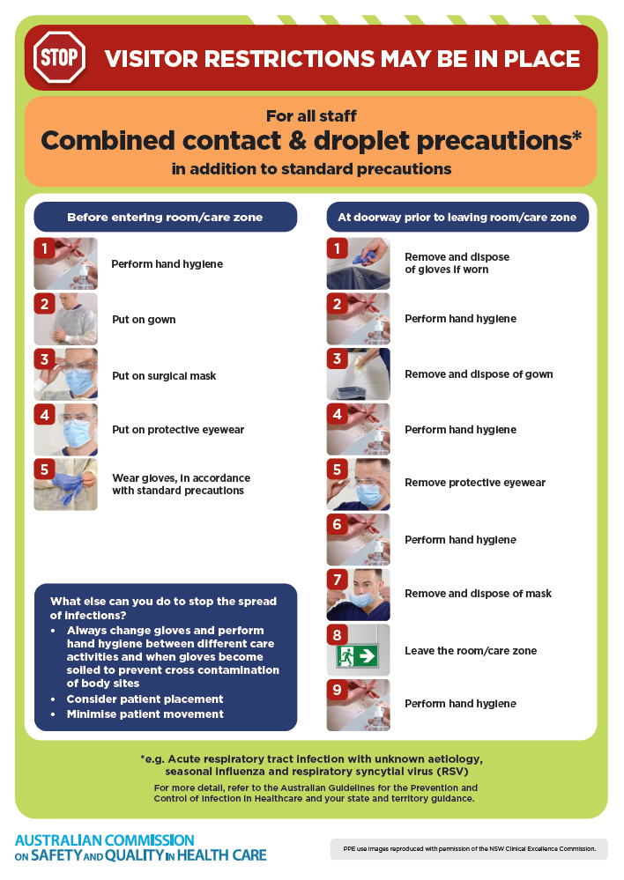
- Poster – Combined airborne and contact precautions
https://www.safetyandquality.gov.au/publications-and-resources/resource-library/infection-prevention-and-control-poster-combined-airborne-and-contact-precautions
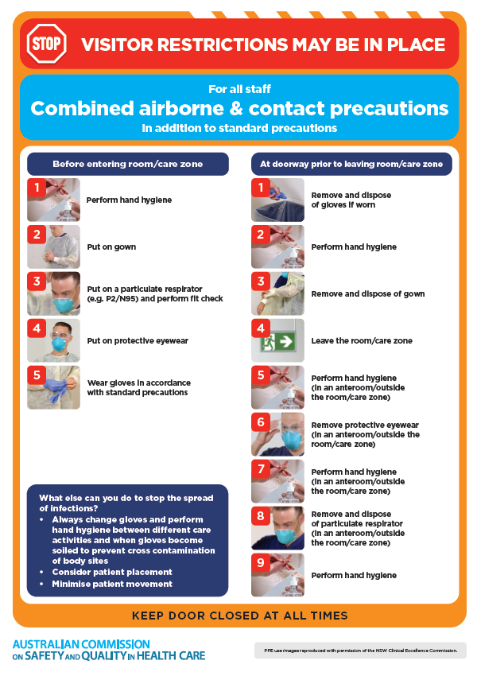
- Standard and transmission-based precautions https://www.safetyandquality.gov.au/clinical-topics/infection-prevention-and-control/standard-and-transmission-based-precautions
- Break the chain of infection poster
https://www.safetyandquality.gov.au/publications-and-resources/resource-library/break-chain-infection-poster
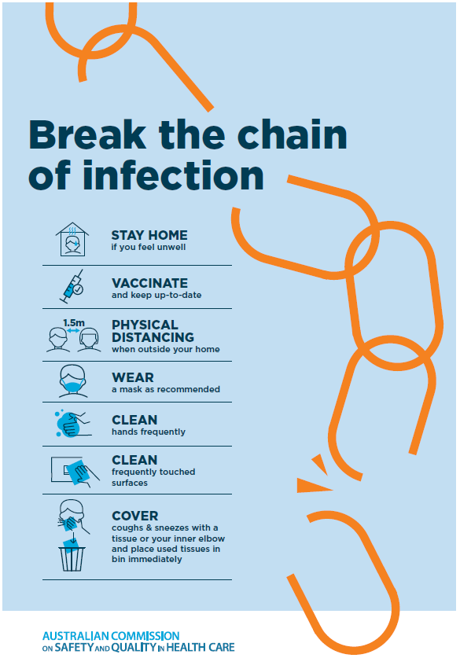
Disclaimer
On the Radar is an information resource of the Australian Commission on Safety and Quality in Health Care. The Commission is not responsible for the content of, nor does it endorse, any articles or sites listed. The Commission accepts no liability for the information or advice provided by these external links. Links are provided on the basis that users make their own decisions about the accuracy, currency and reliability of the information contained therein Any opinions expressed are not necessarily those of the Australian Commission on Safety and Quality in Health Care.

