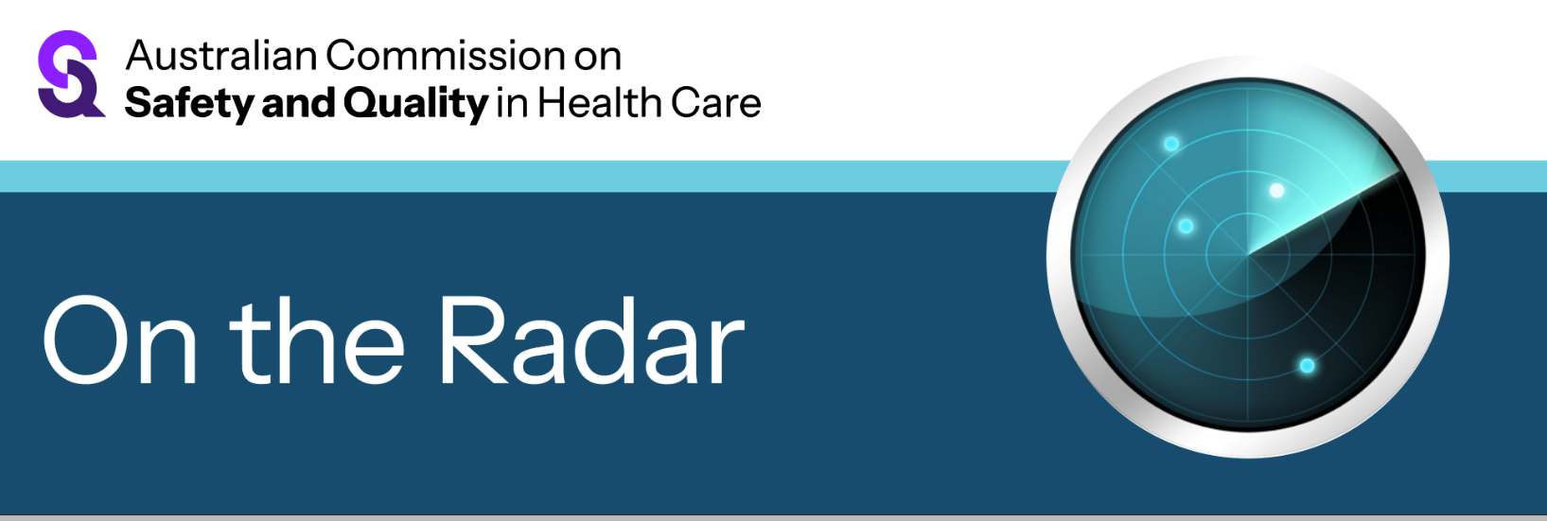
On the Radar
Issue 744
25 May 2026

On the Radar is a summary of some of the recent publications in the areas of safety and quality in health care Inclusion in this document is not an endorsement or recommendation of any publication or provider Access to particular documents may depend on whether they are Open Access or not, and/or your individual or institutional access to subscription sites/services Material that may require subscription is included as it is considered relevant.

On the Radar is available online, via email or as a PDF or Word document from
https://www.safetyandquality.gov.au/news-and-media/newsletters/on-the-radar

If you would like to receive On the Radar via email, you can subscribe on our website https://www.safetyandquality.gov.au/news-and-media/newsletters/on-the-radar
or by emailing us at mail@safetyandquality.gov.au.
You can also send feedback and comments to mail@safetyandquality.gov.au.

For information about the Commission and its programs and publications, please visit https://www.safetyandquality.gov.au

On the Radar
Editor: Dr Niall Johnson
Contributors: Niall Johnson

Reports

Insulin: supporting safe self-administration for patients in the community with a disability
Investigation report
Health Services Safety Investigation Body
Poole: HSSIB; 2026.
DOI | https://www.hssib.org.uk/patient-safety-investigations/insulin-supporting-safe-self-administration-in-vulnerable-patient-groups-in-the-community/second-investigation-report/
Notes | The latest investigation report from the Health Services Safety Investigations Body (HSSIB) in the UK examines the safe use of insulin in the community. This is the second ‘in a series considering the self-administration of insulin by people with diabetes mellitus (diabetes) in community settings. Each report in the series focuses on specific groups of people who, due to their circumstances, may be at increased risk of harm because of the way they self-administer insulin.’ This report focuses on diabetic adults who use insulin and ‘who have not been supported to self-manage (including self-administer) insulin as intended alongside a disability or impairment’.  This investigation ‘explored the following areas in relation to the patient safety issue:  - supporting the development of people’s competency – that is, their skills, experience, knowledge and ability – to manage insulin  - recognising and responding when people’s circumstances change, such as deterioration in a disability  - assessment of people’s mental capacity to make decisions in relation to insulin.’  The report includes findings, safety recommendations, observations and learnings that are applicable at various levels.

For information on the Commission’s work on high-risk medicines resources including safer prescribing, dispensing and use of insulin, see High risk medicines and systems | Australian Commission on Safety and Quality in Health Care

The National Medicines Symposium 2025 focused on the Quality use of medicines in people with diabetes. Resources from the National Medicines Symposium and recordings of the sessions are available at https://www.safetyandquality.gov.au/clinical-topics/medicines-safety-and-quality/national-medicines-symposium

Temperature monitoring during newborn cooling practice
Briefing Paper
Maternity and Newborn Safety Investigations
London: MNSI; 2026. p. 5.

Nitrous oxide decommissioning
Safety spotlight
Maternity and Newborn Safety Investigations
London: MNSI; 2026.
DOI | Newborn cooling practices https://www.mnsi.org.uk/publications/briefing-paper-newborn-cooling-practices/  Nitrous oxide https://www.mnsi.org.uk/publications/safety-spotlight-nitrous-oxide/
Notes | The Maternity & Newborn Safety Investigation (MNSI) agency in the UK has published two brief documents:  - A briefing paper based on 20 investigations that highlighted ‘national guidance on continuous temperature monitoring during cooling was not followed in half of cases’.  - A safety spotlight that ‘shares what we found regarding nitrous oxide decommissioning and offers prompts to help providers keep staff informed and equipment checks consistent.’

Emergency ready primary health care framework
World Health Organization
Geneva: WHO; 2026. p. 72.

WHO consolidated guidelines for the management of common childhood illness: Management of asthma in children and adolescents and bronchiolitis in infants and young children
World Health Organization
Geneva: WHO; 2026. p. 107.
DOI | Emergency ready primary health care framework https://www.who.int/publications/i/item/B09750  WHO consolidated guidelines for the management of common childhood illness
Notes | The World Health Organization has recently published a number of documents, including:  - Emergency ready primary health care framework – This framework ‘presents a comprehensive, all‑hazards approach to embedding emergency readiness within routine primary health care systems.’ The framework defines the core capacities required for emergency ready PHC. The accompanying Emergency ready primary health care operational guide ‘translates them into practical, adaptable steps for countries to contextualize, prioritize and implement according to their governance structures, risks and resources.’  - WHO consolidated guidelines for the management of common childhood illness: Management of asthma in children and adolescents and bronchiolitis in infants and young children –‘This document presents consolidated World Health Organization guidelines addressing the management of asthma in children and adolescents and bronchiolitis in infants and young children, two of the most common causes of paediatric respiratory illness and wheezing presentations.’
Journal articles

BMJ Quality & Safety
Volume 35, Issue 6, June 2026
URL | https://qualitysafety.bmj.com/content/35/6
Notes | A new issue of BMJ Quality & Safety has been published. Many of the papers in this issue have been referred to in previous editions of On the Radar (when they were released online). Articles in this issue of BMJ Quality & Safety include:  - Editorial: Are we careless about continuity of care? (Persijn Honkoop, Marco Krukerink)  - Editorial: From measurement to improvement: new evidence towards reducing emergency diagnosis of cancer (Marta Berglund, Matthew E Barclay, Georgios Lyratzopoulos)  - Less continuity with more complaints: a repeated cross-sectional study of the association between relational continuity of care and patient complaints in English general practice (Jinyang Chen, Panos Kasteridis, Zecharias Anteneh, Sheila Greenfield, F Scheibl, K Sterniczuk, B H Willis, I Williams, T Marshall)  - Digital quality measure of potentially avoidable emergency presentations among patients with colorectal cancer (Natalia Khalaf, Basim Ali, Andrew Zimolzak, Yan Liu, Li Wei, Fasiha Kanwal, Hardeep Singh)  - Regulating voluntary assisted dying at the clinical coalface: a qualitative interview study in Victoria, Australia (C M Haining, L Willmott, B P White)  - Metrics used in quality improvement publications addressing environmental sustainability in healthcare: a scoping review (Colin Sue-Chue-Lam, Sezgi Yanikomeroglu, D Baginskis, D M Hamad, B M Wong, N Simms, K B Born)  - Patient safety measures for virtual consultations in primary care: a systematic review (Tetiana Lunova, Katherine-Helen Hurndall, Ulrik Bak Kirk, Bryony Dean Franklin, Ara Darzi, Ana Luisa Neves)  - Retrospective validation study of a large language model approach to screening for intraabdominal surgical site infections for quality and safety reporting (Logan Pierce, Christy Pak, Kim Stanley, Lusha Wang, Caroline Erickson, Deborah S Yokoe, Elizabeth Wick)  - Tailoring improvement to the evidence-practice relationship (R Howard)  - Lucian Leape’s legacy for patient safety (Atul A Gawande)

Health Policy
Volume 170, August 2026
URL | https://www.sciencedirect.com/journal/health-policy/vol/170/
Notes | A new issue of Health Policy has been published. Articles in this issue of Health Policy include:  - Violence against healthcare workers as a signal of health system strain: Implications for health policy and governance (Laurent Boyer, Martin Postzich, P-M Llorca, V Pauly, S Zhang, J Blanc, B Boussat, A Duclos)  - Paying family carers requires a fit-for-purpose instrument: Lessons from Switzerland (Armin Gemperli)  - Healthcare reforms in the United Arab Emirates from 2017 to 2024: A systematic review on progress and strategic priorities (Yufei Gu, Erik Koornneef, Khalid A Alnaqbi)  - The second Trump presidency: Health care themes, policies, and impacts in his first year back in office (T Rice, L Y Unruh, A J Barnes, E Richardson)  - Gender concordance and its association with communication and the doctor-patient relationship: a systematic review (Cecilia Maria Esposito, Cristina Bizzotto, Roberta Gualtierotti, Giuseppe Delvecchio, C Bressi, P Brambilla)  - General practitioners’ incentives and practice style: A descriptive registry study of earnings variation in Norway (Kristian B Kraft, Mari Grøsland, Eivor H Hoff, Arnstein Mykletun, Kristian Østby)  - Deeming Doesn't Deliver: Reliance on foreign regulators targets the wrong stage of Canadian drug access (Daniel Eisenkraft Klein, A S Kesselheim)

BMJ Quality & Safety online first articles
URL | https://qualitysafety.bmj.com/content/early/recent
Notes | BMJ Quality &Safety has published a number of ‘online first’ articles, including:  - Editorial: Operationalising ‘what matters’—will we ever find a way to patient-centred care? (Margaret Schwarze, Kate Telma, Lauren J Taylor)

International Journal for Quality in Health Care online first articles
URL | https://academic.oup.com/intqhc/advance-articles
Notes | International Journal for Quality in Health Care has published a number of ‘online first’ articles, including:  - The costs of canceled surgeries. What to do about them? (Soo-Hoon Lee, Siobhán E McCarthy, Poonam Gupta, Phillip Phan)  - How Can the Greece National Strategy for Quality of Care and Patient Safety be Taken Forward? (Immaculate S Tenza, H Saleh, R G Greenhill))  - Pharmacist-led continuity of care interventions for patients receiving oral anticancer therapy: a systematic review and meta-analysis (Ting Liu, Xingyu Long, Junhao Luo, Qing Wang, Jie Xiao, Zhaojian Wang, Lin Wang, Wenzheng Xie, Ke Sai, Wenhui Zhang, Ping Xu)  - Evaluating the Effectiveness of the “Patient Transport” App in Improving Healthcare Quality, Patient Safety, and Workflow Efficiency (Ye-Eun Park, Sunghwan Ji, Hee-Won Jung, Youn-Jung Kim, Jae-Ho Lee, Yura Lee)

Online resources

Australian Living Evidence Collaboration
https://livingevidence.org.au/

Guidance
A number of guidelines or guidance have recently been published or updated These include:
- Australian Consensus Statement on the Prevention and Management of Frailty Among Community-Dwelling Older Adults: A Modified Delphi Study
Chopra S, Tornvall I, Reid N, Whiting E, Hilmer SN, Job J, et al
Medical Journal of Australia. 2026;224(5):e70182.
https://doi.org/10.5694/mja2.70182

Making health care decisions for others: A guide for substitute decision-makers
https://ellc.edu.au/
This resource has been developed by the End of Life Law for Clinicians (ELLC), a National Palliative Care Project funded by the Australian Department of Health, Disability and Ageing. This is a guide for families and substitute decision-makers on how to make health care decisions for someone else at end of life.

[UK] NICE Guidelines and Quality Standards
https://www.nice.org.uk/guidance
The UK’s National Institute for Health and Care Excellence (NICE) has published new (or updated) guidelines and quality standards The latest reviews or updates include:
- NICE Review NR3 UK Achondroplasia Network’s consensus guideline for multidisciplinary care of children and young people with achondroplasia: NICE review https://www.nice.org.uk/advice/nr3

[USA] Effective Health Care Program reports
https://effectivehealthcare.ahrq.gov/
The US Agency for Healthcare Research and Quality (AHRQ) has an Effective Health Care (EHC) Program. The EHC has released the following final reports and updates:
- Mindfulness-Based Interventions for Well-Being and Mental Health in Children and Adolescents: Systematic review https://doi.org/10.23970/AHRQEPC_SR_MINDFULNESS

Infection prevention and control resources
The Australian Commission on Safety and Quality in Health Care has developed a number of resources to assist healthcare organisations, facilities and clinicians These resources include:
- Poster – Combined contact and droplet precautions https://www.safetyandquality.gov.au/publications-and-resources/resource-library/infection-prevention-and-control-poster-combined-contact-and-droplet-precautions
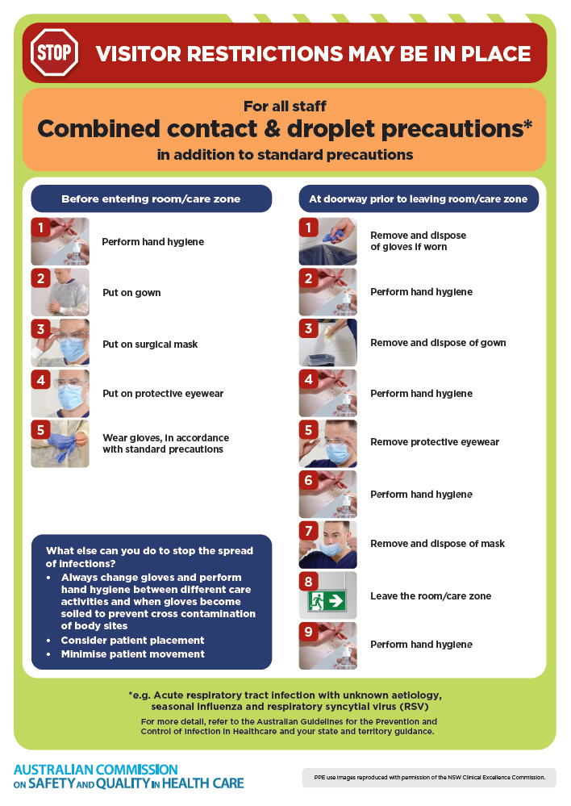
- Poster – Combined airborne and contact precautions
https://www.safetyandquality.gov.au/publications-and-resources/resource-library/infection-prevention-and-control-poster-combined-airborne-and-contact-precautions
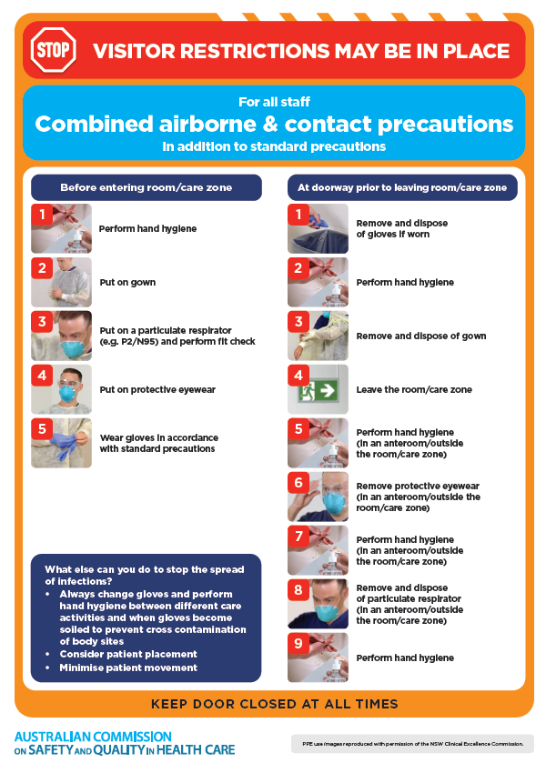
- Environmental Cleaning and Infection Prevention and Control www.safetyandquality.gov.au/environmental-cleaning
- Break the chain of infection poster
https://www.safetyandquality.gov.au/publications-and-resources/resource-library/break-chain-infection-poster
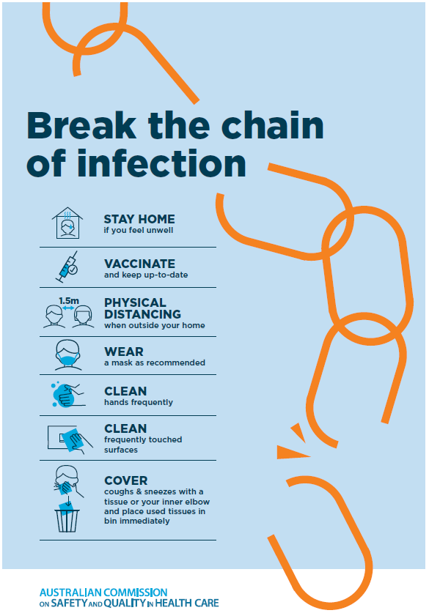
Disclaimer
On the Radar is an information resource of the Australian Commission on Safety and Quality in Health Care. The Commission is not responsible for the content of, nor does it endorse, any articles or sites listed. The Commission accepts no liability for the information or advice provided by these external links. Links are provided on the basis that users make their own decisions about the accuracy, currency and reliability of the information contained therein Any opinions expressed are not necessarily those of the Australian Commission on Safety and Quality in Health Care.

