
On the Radar
Issue 745
1 June 2026

On the Radar is a summary of some of the recent publications in the areas of safety and quality in health care Inclusion in this document is not an endorsement or recommendation of any publication or provider Access to particular documents may depend on whether they are Open Access or not, and/or your individual or institutional access to subscription sites/services Material that may require subscription is included as it is considered relevant.

On the Radar is available online, via email or as a PDF or Word document from
https://www.safetyandquality.gov.au/news-and-media/newsletters/on-the-radar

If you would like to receive On the Radar via email, you can subscribe on our website https://www.safetyandquality.gov.au/news-and-media/newsletters/on-the-radar
or by emailing us at mail@safetyandquality.gov.au.
You can also send feedback and comments to mail@safetyandquality.gov.au.

For information about the Commission and its programs and publications, please visit https://www.safetyandquality.gov.au

On the Radar
Editor: Dr Niall Johnson
Contributors: Niall Johnson

Credentialing and defining scope of practice. Guidance for health services and clinicians
Australian Commission on Safety and Quality in Health Care
Sydney: ACSQHC; 2026. p. 42.
https://www.safetyandquality.gov.au/resources/credentialing-and-defining-scope-practice-guidance-health-professionals-and-clinicians

The Australian Commission on Safety and Quality in Health Care has published updated national guidance on credentialing and defining scope of clinical practice to support safe high-quality care for patients.
The updated guidance for public and private health services and clinicians strengthens the process for credentialing, recredentialing and defining scope of clinical practice.
It promotes a risk-based approach for identifying which clinicians should be credentialed. It also describes systems and processes to ensure that clinicians have the necessary qualifications and expertise to deliver high-quality care.
The guidance complements the new National Model for Clinical Governance, which will be released shortly, and supports implementation of the National Safety and Quality Health Service Standards Clinical Governance Standard.

Reports

Child, Adolescent and Youth Mental Health in the 21st Century
OECD
Paris: OECD Publishing; 2026. p.88.
DOI | https://doi.org/10.1787/1092c3cb-en
Notes | The OECD has published this report on the mental health of young people. The abstract states:  ‘Young people’s mental health is getting worse, with rising rates of depression, anxiety, psychological distress and poor well-being. Drawing on international data, recent scientific literature and insights from clinical and policy experts, this report shows that deteriorating youth mental health is a long-running trend that predates the COVID-19 pandemic, but that has intensified in recent years. The report highlights the complex, intersecting drivers behind this decline, from digitalisation and social media, to climate anxiety, fears about global conflicts, socioeconomic pressures, bullying and academic stress, and inequality and poverty. The report shows the importance of a comprehensive, multi-sectoral response including strengthening early prevention, improving access to low-threshold and peer-supported services, embedding socioemotional learning in schools, and developing balanced policies around digital technology. It also stresses the need for better, more frequent data collection and for listening directly to young people to understand their needs and priorities. The report aims to support OECD governments in designing more effective, evidence-informed strategies to stem the decline in young people’s mental health.’  The latest paper from the Global Burden of Disease Study is titled Updated trends in the global prevalence and burden of mental disorders, 1990–2023: a systematic analysis for the Global Burden of Disease Study 2023 and reports that ‘A significant health burden was imposed by mental disorders in all countries and territories in 2023, irrespective of the health resources available. In some instances, this burden has increased over time and is unevenly distributed across populations.’

Psychological self-help interventions: delivering self-help for individuals, featuring Step-by-Step and Doing What Matters in Times of Stress
World Health Organization
Geneva: WHO; 2026.

Clinical audit tool to strengthen quality of child and youth mental health services
World Health Organization
Copenhagen: WHO Regional Office for Europe; 2026. p. 60.

Measurement of self-reported forgone health care and its reasons: Towards tackling unmet health care need
World Health Organization
Geneva: WHO; 2026. p. 171.
DOI | Psychological self-help interventions https://iris.who.int/handle/10665/385628  Clinical audit tool https://www.who.int/europe/publications/i/item/WHO-EURO-2026-13229-53003-82665  Measurement of self-reported forgone health care https://www.who.int/publications/i/item/9789240120723
Notes | The World Health Organization (WHO) has recently published a number of documents, including:  - Psychological self-help interventions: delivering self-help for individuals, featuring Step-by-Step and Doing What Matters in Times of Stress – ‘Addressing the global treatment gap for common mental health conditions requires scalable, evidence-based approaches that can be delivered beyond specialist care settings. This manual provides operational guidance for planning and implementing individually delivered psychological self-help interventions to expand access to mental health care. It outlines how structured self-help techniques can support individuals in managing psychological distress, drawing on evidence of effectiveness, particularly for depression and anxiety, and situates these interventions within comprehensive mental health systems adaptable to diverse contexts and delivery formats.’  - Clinical audit tool to strengthen quality of child and youth mental health services – ‘This tool aims to facilitate the systematic evaluation of care processes, identify areas for improvement and guide the implementation of strategies to strengthen the quality of care, as part of a wider quality strengthening initiative.’  - Measurement of self-reported forgone health care and its reasons: towards tackling unmet health care need – ‘Access to needed health services remains a central challenge for achieving universal health coverage, with unmet health care need reflecting gaps in service delivery, equity and health system performance. This working paper examines the measurement of self-reported forgone health care and its underlying reasons, contributing to WHO’s efforts to standardize approaches to measuring unmet health care need’.

Bias and Discrimination in Patient Safety Investigations
Health Services Safety Investigation Body
Poole: HSSIB; 2026. p.13.
URL | https://www.hssib.org.uk/news-events-blog/roundtable-explores-bias-and-discrimination-in-nhs-patient-safety-investigations/
Notes | The Health Services Safety Investigations Board (HSSIB) in the UK have released this briefing that reflects on the process of undertaking patient safety investigations itself. The briefing ‘argues that equity should not be an afterthought to patient safety, but a prerequisite for it. Structural, institutional, and interpersonal racism shapes what is investigated, by whom investigations are conducted, and what outcomes they produce. When equity is treated as an optional or downstream consideration, patient safety systems risk reproducing the very harms they are intended to address. We believe that equity should not be an afterthought to patient safety, but a prerequisite for it.’

Electronic prescribing and medicines administration: procurement and safety learning in acute hospitals
Investigation report
Health Services Safety Investigation Body
Poole: HSSIB; 2026.
URL | https://www.hssib.org.uk/patient-safety-investigations/medication-related-harm/fourth-investigation-report/
Notes | Also released by The Health Services Safety Investigations Board (HSSIB) in the UK is this investigation report that looks at issues around electronic prescribing and medicines administration (ePMA) in acute hospitals in the UK. The report ‘ocuses on procurement of new ePMA functionality and/or upgrades of existing ePMA functionality and how patient safety learning related to ePMA is identified and shared across the healthcare system’ in acute NHS hospitals in the UK. The report includes findings, observations and recommendations applicable at various levels, including national and local to facilities.

For information on the Commission’s work on digital health, including electronic medication management, see https://www.safetyandquality.gov.au/clinical-topics/digital-health
For information on the Commission’s work on medicines safety and quality, see https://www.safetyandquality.gov.au/clinical-topics/medicines-safety-and-quality

Journal articles

Prevalence of chemical restraint use in hospital care. A consensus and cross-sectional study
Hillen JB, Canning ML, Ailabouni NJ, Alker H, Hart G, Soen D, et al
International Journal for Quality in Health Care. 2026:mzag074.

Governance framework for reducing restrictive practices in healthcare settings
Safer Care Victoria
Melbourne: SCV; 2026. p. 29.
DOI | Hillen et al https://doi.org/10.1093/intqhc/mzag074  Safer Care Victoria https://www.safercare.vic.gov.au/publications/governance-framework-for-reducing-restrictive-practices-in-healthcare-settings
Notes | Paper reporting on a study that examined the use of chemical restraint in the hospital inpatient setting. This was a ‘modified-Delphi consensus and cross-sectional period prevalence study was undertaken across a large health service in Australia’ The authors report that ‘Chemical restraint was prevalent across a range of clinical specialties with mental health patients 17 times more likely to be exposed’ and that there were ‘low rates of documented consent.’  Safer Care Victoria (SCV) has published their Governance Framework for Reducing Restrictive Practices in Healthcare Settings that ‘sets clear expectations for minimising (and where possible, eliminating) restraint, governing its use in accordance with legislation, and reporting to service governing bodies’ in Voctoria. The SCV Framework aligns with the National Safety and Quality Health Service (NSQHS) Comprehensive Care Standard, Action 5.35.

Reducing unwarranted variation in low-value health care in Norway: description of the NOR programme
Tjomsland O, Drewes C, Langeland H, Noremark KAL, Thoresen C, Bøe B, et al
Research in Health Services & Regions. 2026 2026/05/28;5(1):7.
DOI | https://doi.org/10.1007/s43999-026-00089-1
Notes | The last decade or more has seen increasing interest in issues of variation in health care delivery and linking to discussions of appropriateness and value. This paper reports on an approach taken in Norway. The ‘Norwegian Operational Group for Reassessment (NOR) Programme is a Norwegian national initiative…to reduce the use of low-value procedures’ and unwarranted clinical variation. The authors seek to ‘describe the … method for selecting low-value procedures amenable to national, multifaceted interventions to reduce utilisation rates, and to present the initial recommendations and share learning points from planning the implementation.’ The programme targeted three identified high-impact areas: shoulder surgery, upper GI endoscopy in younger patients, and invasive cardiac diagnostics. The authors argue that meaningful reduction of overuse requires clinical ownership, governance tools, and redesigned care pathways and suggest that this programme offers a practical blueprint for shifting resources from low- to high-value care—improving patient outcomes while supporting a more sustainable health system.

For information on the Commission’s work on healthcare variation, including the Better Care Everywhere initiative, see https://www.safetyandquality.gov.au/about-us/our-key-areas/healthcare-variation
The Joint Commission Journal on Quality and Patient Safety
Volume 52, Issues 5–6, May–June 2026
URL | https://www.sciencedirect.com/journal/the-joint-commission-journal-on-quality-and-patient-safety/vol/52/issue/5
Notes | A new issue of The Joint Commission Journal on Quality and Patient Safety has been published. Articles in this issue of The Joint Commission Journal on Quality and Patient Safety include:  - From Sentinel Event to Systemwide Improvement: Development of the Behavioral Health No Harm Index (Norman Ng, Linda Durst, Omar Hasan, Mike Sirois, Tania Strout)  - Personalized Video Education in Surgical Consent: Lessons from a Diverse Safety-Net Population (Diego Monasterio, Nicole Hanson, Graal Diaz, June Yao, Javier Romero, Shawn Steen)  - Validation of the Charité Alarm Fatigue Questionnaire (CAFQa–Eng) for Use with English-Speaking Critical Care Clinicians (Halley Ruppel, Elena Hinz, Nicolas Frey, Maximilian Markus Wunderlich, Akira-Sebastian Poncette)  - Push Notifications Can Be Used for Safe and Timely Communication of Critical Lab Results in the Emergency Department (Dhara P Amin, Matthew Bonomo, Lorena Chesebro, Charlotte Farley, Melissa S Pessin)  - Surgical Advance Care Planning: Initial Validation of Patient Portal Messages for a Multisite Randomized Controlled Trial (Lindsay Welton, R L Sudore, C Botsford, S O’Brien, J C Carmichael, G B Melton, E Wick)  - Use of Knee MRI to Assess Osteoarthritis—Room for Improvement? (Eric R Bohm, Sarah Slagerman, C H Righolt, C Poitras, S Gregoire, J Woodmass)  - Implementation of a Clinical Event Debriefing Program in a Large Urban Tertiary Care Center (Svetlana Duvidovich, Julie Goodfriend, Patrick J Maher, Samuel Wurzelmann, Shefali Trivedi, Jared Kutzin, J E Mathieu, L E Zinns)  - Healthcare Ethics Is a Key Underrecognized Step on the Road to High Reliability (Lindsay R Semler, William B Feldman)  - Beyond Awareness: Building Human Factors Capability in Healthcare Through Shared Resources (Tara N Cohen, Yuval Bitan)

Pediatric Quality & Safety
Volume 11, Issue 2, March/April 2026
URL | https://journals.lww.com/pqs/toc/2026/03000
Notes | A new issue of Pediatric Quality & Safety has been published. Articles in this issue of Pediatric Quality & Safety include:  - Implementing Participation-level Goals to Improve Patient-Centeredness in Pediatric Rehabilitation (Tanner, Kelly; Boster, Jamie B; Gates, Erin; Rospert, Alex; Coleman Casto, Shelley; O’Rourke, Sara; Gillespie, J; Bican, R)  - Emergency Department Undertriage: Using Multidisciplinary Case Review to Drive Quality Improvement (McCollum, N L; Chamberlain, J M; Williams, K; Kappy, B; Jones, T; Stein, L Thomas, A; Alleyne, A; Berkowitz, D D)  - Improving Compliance With Safe Sleep Guidelines for Vulnerable Patients in a Community Safety Net Hospital Neonatal Intensive Care Unit (Beverstock, Andrew; Carlton, Samantha; Lee, H; Lu, T; Morgan, K; Smith-Patel, A; Phillips, K; Hagan, J; Lohmann, P; Fernandes, C; Owens, L; Dinu, D)  - Improving Diagnostic Quality of Anogenital Photodocumentation in Emergency Department Evaluations for Acute Child Sexual Assault (Miller, Z E; Digirolamo, S J; Molnar, J; Bennett, C; Darwiche, S; Ku, B; Scribano, P)  - Massachusetts Multisite Quality Improvement to Address Family Engagement in Level 2–3 Neonatal Intensive Care Units (Parker, Margaret G.; Peaceman, Aviel; Kubicka, Zuzanna; Fraust-Wylie, Molly; Lomerson, Nicole; Goldstein, J; Marshall, A; Singh, R; Ayturk, D; Cordova-Ramos, E G)

Healthcare Policy
Volume 21, Number 3, May 2026
URL | https://www.longwoods.com/publications/healthcare-policy/27770/
Notes | A new issue of Healthcare Policy has been published. Articles in this issue of Healthcare Policy include:  - Editorial: The Urgent Call for Reform in Surgical Policy Making in Canada (Jason M Sutherland)  - Improving Surgical Outcomes While Lowering Costs: The Case for a Bundled Payment Model for Surgical Episodes of Care (Stephen Pinney and Glen Sumner)  - Commentary: Cost Savings Are Possible, But Success Is Not Guaranteed: Challenges of Bundled Payment in Canada (Tim Zhang and Amity E Quinn)  - Unlocking Surgical Capacity Through Collectable Time: A Multi-Level Policy Framework for Canadian Health Systems (Jean-Pierre Eskander and Trevor Bardell)  - Commentary: Improving Access to Surgical Care in Canadian Health Systems: Technology or Culture? (David R Urbach)  - When Safety Promotion Impairs Access to Care: Lessons From Endoscopy Across Canada (Simon Houston and Amanda Porter)  - Commentary: Simple Policy, Entrenched System: Lessons From Post-Sedation Accompaniment (Hemant A Shah)  - Efficiency Through Equity: Prioritizing Gynecologic Surgery to Improve Health System Performance (Amity E Quinn and Erin A Brennand)  - Commentary: Gender Equity is Essential for Optimal Surgical Prioritization: A Response to Quinn and Brennand (Alana M Flexman and Gianni R Lorello)  - Expanding Surgical Access in Canada Through Self-Governing First Nations (Trafford Crump and Mariam Hegazy)  - A Population-Based Comparison of Wait Times for Common Elective General Surgery Procedures Between Immigrants and Non-Immigrants in British Columbia (Michael Y Guo, Christine Li, Ahmer A Karimuddin and Jason M Sutherland)  - Use of Publicly Reported Surgical Wait Time Information by Community Family Physicians in Toronto, Canada (Olivia J S Varkul, Noah Ivers, Julie L Takata, Vasily Giannakeas and David R Urbach)

International Journal for Quality in Health Care online first articles
URL | https://academic.oup.com/intqhc/advance-articles
Notes | International Journal for Quality in Health Care has published a number of ‘online first’ articles, including:  - Assessing the quality of patient safety incident investigation reports (Lorelle Bowditch, Charlotte J Molloy, Brandon King, Masoumeh Abedi, Samantha Jackson, Mia Bierbaum, Y Yu, L Raggett, P Salmon, R Lingam, S Middleton, J Braithwaite, J Westbrook, R Clay-Williams, P D Hibbert)  - When the Doctor Became the Second Victim: Reflections from a Physician (Deva Priya Appan)  - Addressing the challenge of low value preoperative care: the need to change systems, mindsets and practices towards quality care (Valter R Fonseca and David Greenfield)  - The Role of Surgical Margins as Outcome Metrics in a Quality Assurance Program for Robot-Assisted Radical Prostatectomy (Sophia H van der Graaf, Bas W Becker, Suze L van der Aa, Pim J van Leeuwen, R Jeroen A van Moorselaar, Jakko A Nieuwenhuijzen, Ton A Roeleveld, André N Vis, Esther M K Wit, Sierk Ybema, Henk G van der Poel)  - Prevalence of chemical restraint use in hospital care. A consensus and cross-sectional study (Jodie B Hillen, Martin L Canning, Nagham J Ailabouni, Hunter Alker, Grace Hart, Dicky Soen, Christopher R Freeman)  - Augmenting Healthcare Systems for Pandemic Preparedness: A Lean Six Sigma Perspective (Utkarsh Chadha, Artem Kushnirenko, Darren Charles Fernandes, Krisha Bhavesh Patel, Norah Jean Crothers, Harpreet Singh, Mete Isiksalan, Ibrahim Nasir, Stephen Armstrong, Kamran Behdinan)  - Quality and Performance of Primary Care for Chronic Conditions in Mendoza: Population-Based Findings (Javier Roberti, Agustina Mazzoni, Marina Guglielmino, Ana María Nadal, Yanina Mazzaresi, Andrea Falaschi, Hannah H Leslie, J M Gómez-Portillo, M Gabriela Masier, E García-Elorrio)  - Reframing patient complaints as a quality and governance function in healthcare (Judit Pripkó and Henriette Pusztafalvi)

Online resources

Residential Aged Care Communiqué
Volume 21, Issue 2, May 2026
https://www.thecommuniques.com/post/residential-aged-care-communiqu%C3%A9-volume-21-issue-2-may-2026
This issue of Residential Aged Care Communiqué examines two cases ‘s involving residents who lacked decision-making capacity. These cases raise important questions about the authorisation of restrictive practices and whether dignity of risk can justify suboptimal care’.

Australian Living Evidence Collaboration
https://livingevidence.org.au/

Guidance
A number of guidelines or guidance have recently been published or updated These include:
- New and updated clinical practice guidelines endorsed by the Australian Paediatric Clinical Practice Guidelines Collaborative, formerly the Paediatric Improvement Collaborative, are available at https://www.rch.org.au/clinicalguide/ Recent additions include
  - Acute scrotal pain
  - Brief resolved unexplained event (BRUE)
  - Dehydration
  - Febrile seizure
  - Influenza
  - Intussusception
  - Nasogastric fluids.

The use of less invasive methods, including ultrasound, for the diagnosis of Endometriosis
https://www.safercare.vic.gov.au/publications/the-use-of-less-invasive-methods-including-ultrasound-for-the-diagnosis-of-endometriosis
Safer Care Victoria (SCV) has published this clinical practice point to ‘highlight the role of less invasive diagnostic methods to health professionals caring for people with symptoms suggestive of endometriosis, such as ultrasound and magnetic resonance imaging (MRI), for the diagnosis of endometriosis.’

Testicular torsion – Clinical practice points
https://www.safercare.vic.gov.au/publications/testicular-torsion-clinical-practice-points
Also from Safer Care Victoria (SCV) are these clinical practice points on testicular torsion.

[UK] NICE Guidelines and Quality Standards
https://www.nice.org.uk/guidance
The UK’s National Institute for Health and Care Excellence (NICE) has published new (or updated) guidelines and quality standards The latest reviews or updates include:
- NICE Guideline NG258 Anaphylaxis: assessment and referral after emergency treatment https://www.nice.org.uk/guidance/ng258

Infection prevention and control resources
The Australian Commission on Safety and Quality in Health Care has developed a number of resources to assist healthcare organisations, facilities and clinicians These resources include:
- Poster – Combined contact and droplet precautions https://www.safetyandquality.gov.au/publications-and-resources/resource-library/infection-prevention-and-control-poster-combined-contact-and-droplet-precautions
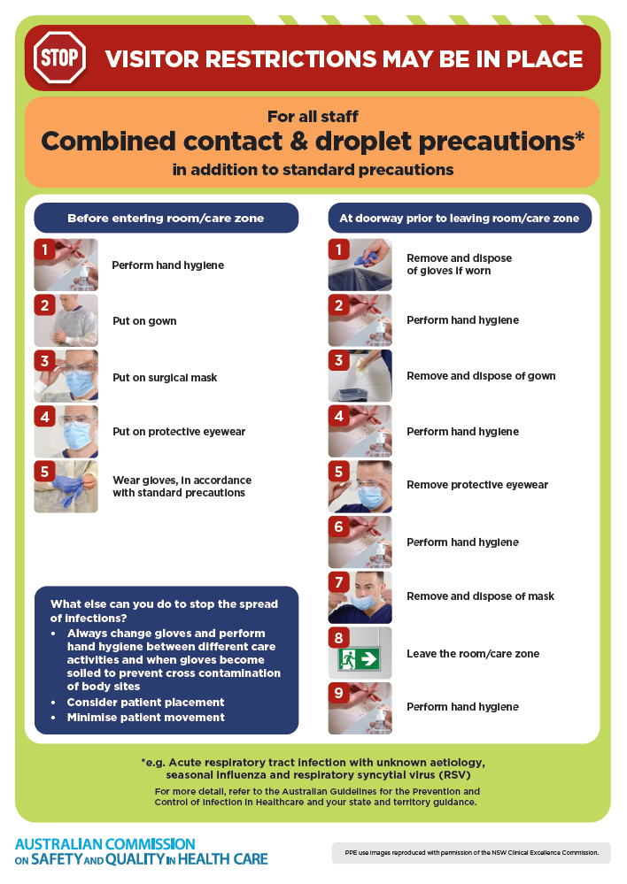
- Poster – Combined airborne and contact precautions
https://www.safetyandquality.gov.au/publications-and-resources/resource-library/infection-prevention-and-control-poster-combined-airborne-and-contact-precautions
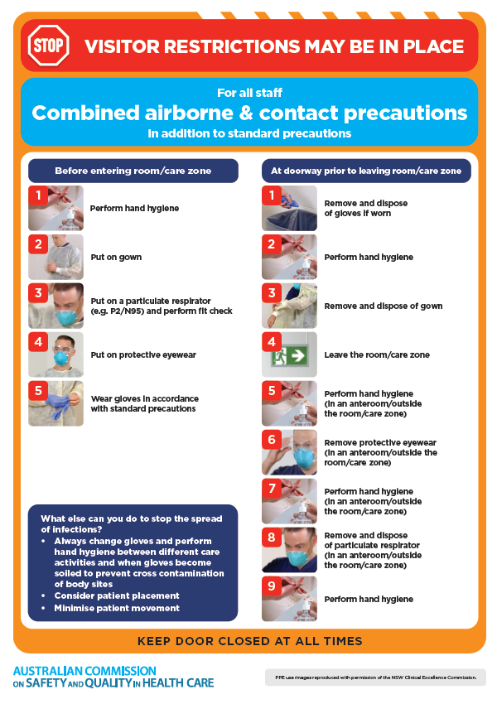
- Environmental Cleaning and Infection Prevention and Control www.safetyandquality.gov.au/environmental-cleaning
- Break the chain of infection poster
https://www.safetyandquality.gov.au/publications-and-resources/resource-library/break-chain-infection-poster
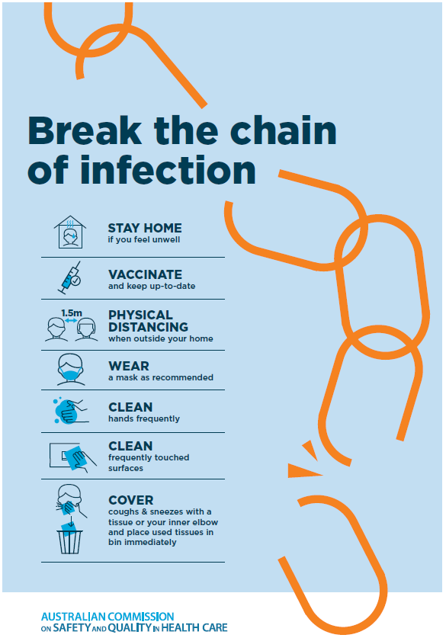
Disclaimer
On the Radar is an information resource of the Australian Commission on Safety and Quality in Health Care. The Commission is not responsible for the content of, nor does it endorse, any articles or sites listed. The Commission accepts no liability for the information or advice provided by these external links. Links are provided on the basis that users make their own decisions about the accuracy, currency and reliability of the information contained therein Any opinions expressed are not necessarily those of the Australian Commission on Safety and Quality in Health Care.

