

The Australian Commission on Safety and Quality in Health Care pays respect to the Gadigal people as the Traditional Custodians of Country where the Commission’s office is located. We extend that respect to all Aboriginal and Torres Strait Islander peoples, and their deep time connections to land, water and sky.
We recognise that knowledge about healthy Country, community and culture has been developed by Aboriginal and Torres Strait Islander peoples over tens of thousands of years and has been shared for generations. We are committed to partnering with and learning from Aboriginal and Torres Strait Islander peoples through the work that we do.
Published by the Australian Commission on Safety and Quality in Health Care.
Level 5, 255 Elizabeth Street, Sydney NSW 2000
Phone: (02) 9126 3600
Email: mail@safetyandquality.gov.au
Website: http://www.safetyandquality.gov.au/
ISBN: 978-1-923353-42-8
© Australian Commission on Safety and Quality in Health Care 2026
All material and work produced by the Australian Commission on Safety and Quality in Health Care (the Commission) is protected by copyright. The Commission reserves the right to set out the terms and conditions for the use of such material.
As far as practicable, material for which the copyright is owned by a third party will be clearly labelled. The Commission has made all reasonable efforts to ensure that this material has been reproduced in this publication with the full consent of the copyright owners.
With the exception of any material protected by a trademark, any content provided by third parties and where otherwise noted, all material presented in this publication is licensed under a
Creative Commons Attribution-NonCommercial-NoDerivatives 4.0 International licence.

If you would like to reproduce all or part of this resource, please complete our online form at safetyandquality.gov.au/permission-request.
The Commission’s preference is that you attribute this publication (and any material sourced from it) using the following citation:
Australian Commission on Safety and Quality in Health Care. National Model for Clinical Governance. The foundations of high-quality care. ACSQHC; 2026.
This work was led by Conjoint Professor Anne Duggan, CEO; coordinated and authored by the Clinical Governance team – Heather Buchan, Lucia Chiappini, Gillian Giles, Ella Makovec, Katherine Norden-Ash, Marge Overs and Helen Signy; with expertise from staff across the Commission.
Disclaimer
The content of this document is published in good faith by the Commission for information purposes. The document is not intended to provide guidance on particular healthcare choices. You should contact your health care provider for information or advice on particular healthcare choices.
The Commission does not accept any legal liability for any injury, loss or damage incurred by the use of, or reliance on, this document.

Foreword
Effective clinical governance unites everyone in a health service to deliver high-quality care every day.
The Australian Commission on Safety and Quality in Health Care (the Commission) provides national leadership and guidance to support health services to strengthen their clinical governance systems.
Australia needs a unified national approach to clinical governance to steer the health system to provide high-quality care in the face of evolving challenges – workforce shortages, growing demand for health care, the need for environmentally sustainable care, changing patterns of disease, and constrained resources.
While many health services have been able to embed strong clinical governance in this changing environment, some have found it difficult to implement systems that engage the workforce and make a difference to the care that patients receive. In response to these issues, we present this new National Model for Clinical Governance (national model) to replace the 2017 National Model Clinical Governance Framework.
Our aim is to reshape Australia’s approach to clinical governance, shifting the main focus from complying with accreditation requirements to building the culture of the whole organisation to support the delivery of high-quality care every day.
The national model reflects contemporary thinking about best practice clinical governance. It places patient outcomes at the centre and increases the focus on accountability and workforce wellbeing. It also emphasises the crucial role of health service boards and executives in governing and leading for high-quality care.
While implementing the national model will help health services to meet current challenges, it also provides a structured way to harness the opportunities and manage the risks of new models of care and technologies, such as artificial intelligence.
In developing the national model, we reviewed the latest evidence and talked to leaders and clinicians across Australia to understand how clinical governance is understood and applied, gaps in capability and delivery, and what high-performing organisations do differently. We worked closely with state and territory health departments to design a national model that meets the needs of diverse services and settings. We used a collaborative approach to test and refine the model with public and private health services across Australia.
I would like to thank all who took part in our consultation for generously sharing their insights and enthusiasm for the crucial role of clinical governance in high-quality care. I also thank the Clinical Governance Advisory Committee for their valued leadership and expert advice.
It is my vision that Aboriginal and Torres Strait Islander patients experience care that is culturally safe, and that ultimately all patients experience care that better meets their needs.
The national model outlines how boards, executives and all the workforce can be confident that they have the right systems, structures and culture in place for high-quality care in their organisation.

Conjoint Professor Anne Duggan
Chief Executive Officer, Australian Commission on Safety and Quality in Health Care.

Clinical Governance Advisory Committee members
Name | Position
Mr Michael Gorton AM (Chair) | - Consultant, Russell Kennedy Lawyers  - Board Chair, Monash Health, Wellways Australia and Holmesglen Institute and Victorian TAFE Association  - Board member, Latrobe Regional Hospital
Professor Christine Kilpatrick AO | - Board Chair, Australian Commission on Safety and Quality in Health Care, Healthdirect Australia and The Royal Children’s Hospital Melbourne  - Professor (Enterprise), Faculty of Medicine, University of Melbourne
Dr Cathy Balding | - Director, Qualityworks PL  - Adjunct Professor, James Cook University  - Board Director, RSL LifeCare
Mrs Elleni Bereded Samuel AM | - Executive Manager, Diversity and Inclusion, Great Care Pty Ltd  - Board member, The Royal Children’s Hospital and Wellways Australia
Dr Peggy Brown AO | - Consultant psychiatrist  - Board Chair, Mental Health Australia
Ms Suzanne Cadigan | - Board member, Children’s Health Queensland and Ronald McDonald House Charities
Ms Christine Gee AM | - Chair, Australian Commission on Safety and Quality in Health Care Private Hospital Sector Committee  - Director, Ramsay Mental Health Australia
Professor David Greenfield | - Professor of Health Leadership and Management, School of Population Health, Faculty of Medicine and Health, University of New South Wales
Mr Tony Kiessler | - Chief Executive Officer, Australian Indigenous Psychologists Association (AIPA)  - AIPA Representative, National Indigenous Health Leadership Alliance
Dr Audrey Koay | - Chair, Australian Commission on Safety and Quality in Health Care Inter-Jurisdictional Committee  - Executive Director, Patient Safety and Quality, Clinical Excellence Division, Department of Health, Western Australia
Professor Jennifer Martin | - Chair of Clinical Pharmacology, School of Medicine and Public Health, University of Newcastle  - President, Royal Australasian College of Physicians
Ms Louise McKinlay | - Deputy Chair, Australian Commission on Safety and Quality in Health Care Inter-Jurisdictional Committee  - Chief Executive Officer, Safer Care Victoria  - Chief Quality and Safety Officer Victoria
Professor Carmen Parter | - Chief Executive Officer, Girudala Community Cooperative Society  - Casual Associate Professor, Djurali Centre for Aboriginal and Torres Strait Islander Health Research and Education  - Board member, Ahpra
Professor Judy Searle | - Chair, Northern Adelaide Local Health Network Governing Board
Ms Maureen Williams | - Consumer representative, Emergency Medicine Foundation  - Consumer consultant, Institute for Communication in Health Care, Australian National University

Contents
Foreword 3
About the national model 6
Purpose of the national model 6
Who this model is for 6
How to use the national model 7
Applying the national standards with purpose 7
About clinical governance 8
Good governance 8
Clinical governance for digitally enabled care 8
High-quality care 9
About high-quality care 10
Roles in supporting high-quality care 11
The six foundations of clinical governance 14
1. Leading systems and organisational culture 16
2. Partnering with patients, carers and consumers 18
3. Building a healthy workforce culture 20
4. Enabling high-quality and integrated clinical practice 22
5. Managing and reducing risk 24
6. Using data for better care 26
Glossary 28

About the national model

Purpose of the national model
Clinical governance establishes the conditions for high-quality care. It builds an environment and culture where everyone in a health service works together and with patients and consumers to deliver high-quality care.
The National Model for Clinical Governance (national model) provides updated national guidance on clinical governance that is clear, relevant and effective in helping health services to strive for consistently high-quality care.
Health service leaders can use the national model to review and strengthen their clinical governance systems and to identify and monitor what their organisation needs to achieve consistently high-quality care.
The national model provides a definition of high-quality care and describes the six foundations of clinical governance required to achieve this care:
- Leading systems and organisational culture
- Partnering with patients, carers and consumers
- Building a healthy workforce culture
- Enabling high-quality and integrated clinical practice
- Managing and reducing risk
- Using data for better care.

Who this model is for
The national model is for public and private health services in the acute sector, including day hospitals.
It is primarily intended for health service board members and executives or equivalent who are responsible for directing and implementing clinical governance systems essential for high-quality care. At the same time, the national model is designed to be understood by all the workforce as everyone has a role in providing or supporting the delivery of high-quality care.
“When board members, executives and clinical leaders champion clinical governance as fundamental to achieving high-quality care, it sets the tone for the rest of the organisation.”
Professor Christine Kilpatrick AO, Board Chair,
Australian Commission on Safety and Quality in Health care

How to use the national model
Boards and executives (or equivalent) can use the model to govern, lead and plan for high-quality care through:
- building a shared language and understanding across the workforce of the definition of high-quality care and the six foundations of clinical governance required to support it
- designing systems and processes and shaping organisational culture to achieve consistently high-quality care
- enhancing accountability and clarifying roles and responsibilities
- guiding their approach to meeting safety and quality standards.
State and territory health departments and private hospital groups can use the national model to inform clinical governance systems and to shape detailed guidance for health services.
“The national model provides a structured way for me to conduct a gap analysis with the board and executive team to sharpen our clinical governance strategy – to visualise and articulate where we need to be.”
Lynne Walker, Chief Executive Officer, Perth Clinic, Western Australia

Implementing the national model
The national model is a principles-based document. Health services can apply the six foundations of clinical governance in a way that meets the needs of their organisation, no matter their size, type or location. An implementation guide offers practical steps for how health services can adapt the model.

Applying the national standards with purpose
The national model describes the systems, structures and culture for effective clinical governance in health services. As a principles-based document, the national model supports health services to review and strengthen their clinical governance arrangements and address the requirements of both the current and next edition of the National Safety and Quality Health Service (NSQHS) Standards. The six foundations of clinical governance will form the structure of the Clinical Governance Standard in the third edition.
Boards and executives should use the six foundations of clinical governance to check that their organisation’s strategy, systems and culture are aligned to deliver care that is consistently high quality and improving, no matter which safety and quality standards are in place.
The national model guides health services’ approach to applying NSQHS Standards in a meaningful way. By orienting every role and every system in the organisation to focus on high-quality care, and allocating resources to enable effective action, everyone in a health service can be confident that standards are being met every day – not just during accreditation assessments.

About clinical governance
What is clinical governance?
Clinical governance is central to providing the best possible outcomes for patients. It is the combination of organisational culture, systems and structures that enables everyone in a health service to deliver care that is consistently high quality and improving.
Effective clinical governance means that boards, executives, clinical leaders and the workforce are clearly accountable to patients and the community for providing high-quality care – care that is person-centred, safe, effective, accessible and integrated, provided in a way that is equitable, efficient and sustainable.
When done well, clinical governance builds trust across a health service. Patients experience care that better meets their needs. The workforce is confident that their organisation backs them with the right culture, structures, support and leadership to provide consistently high-quality care. Boards and executives have the oversight and tools they need to realise their strategy for achieving high-quality care.
Public inquiries into suboptimal care show that weak clinical governance can result in normalisation of poor care, ignored patient concerns, a culture of blame, a disengaged workforce, and overemphasis on legal and financial matters at the expense of care quality
and patient outcomes.

Good governance
Corporate governance refers to the systems that direct and control – or govern – an organisation, including financial and legal functions.
Clinical governance and corporate governance are interdependent in a health service. Every board member and executive needs to understand that the core business of a health service is providing high-quality care, and that financial and operational decisions determine how resources are allocated to deliver that care.
“There is no corporate governance without clinical governance, because we are in the business of providing clinical care.”
Adjunct Professor Frank Tracey, Chief Executive, Children’s Health Queensland

Clinical governance for digitally enabled care
Robust clinical governance is needed for all types of care, whether delivered face to face or digitally enabled. Digitally enabled care includes virtual care, remote monitoring, and decision-making supported by artificial intelligence. Governance structures and systems must adapt to allow for changes in digitally enabled models of care, clinical workflows and technical requirements.
Clinical governance systems and frameworks must continue to evolve to harness the benefit of digitally enabled care – such as enhanced diagnostic accuracy, seamless information exchange across settings and support for personalised care – while safeguarding the safety and quality of care for patients.

High-quality care

About high-quality care
The central aim of clinical governance is to deliver care to patients that is consistently high quality and improving. The Commission defines high-quality care as person-centred, safe, effective, accessible and integrated, provided in a way that is equitable, efficient and sustainable (Figure 1).
Cultural safety, as determined by Aboriginal and Torres Strait Islander people, is necessary for high-quality care. Cultural safety must be embedded in each domain of high-quality care to improve health outcomes for Aboriginal and Torres Strait Islander people.
- Domains of high-quality care

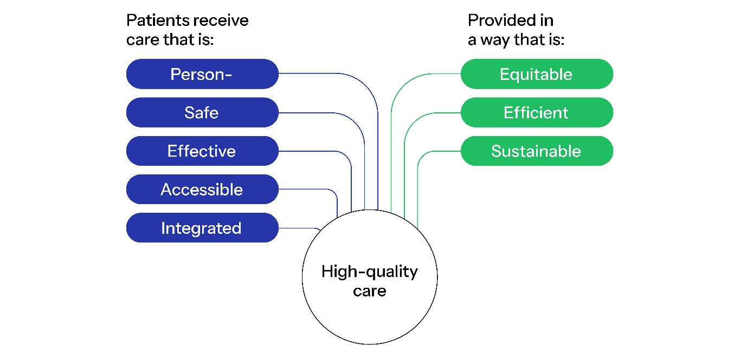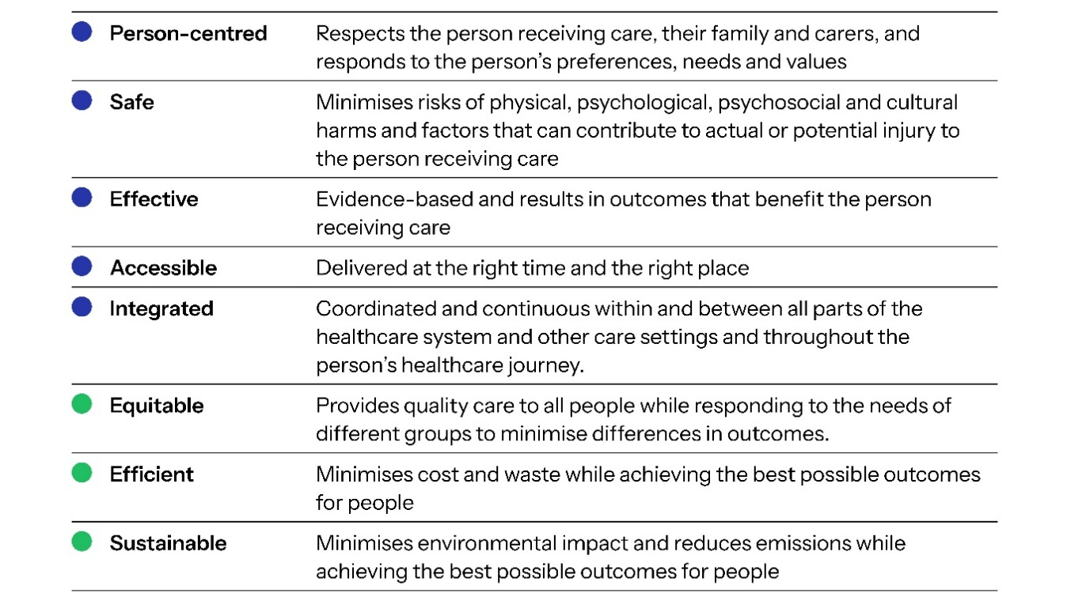

Roles in supporting high-quality care
Everyone in a health service – whether directly or indirectly involved in patient care – is responsible for achieving consistently high-quality care for every patient. To be effective, clinical governance needs to involve the board, executive and the workforce at all levels in a health service (Figure 2). Engagement and partnerships with patients, carers and consumers are critical to achieving high-quality care and better patient outcomes.
- Roles in supporting high-quality care in a health service (This illustration has been adapted from an Australasian Institute of Clinical Governance resource – ‘I take responsibility’)

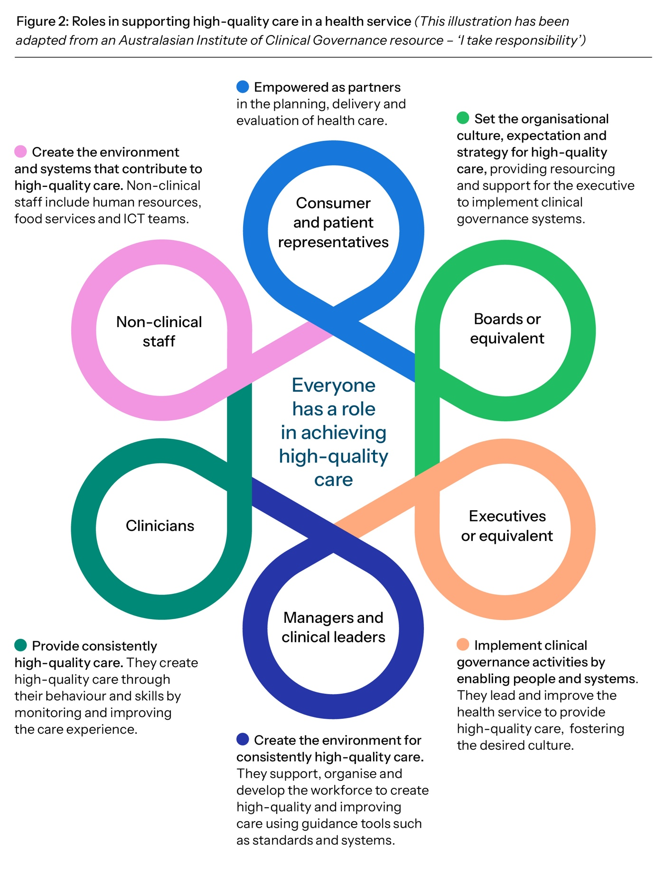
“Our CEO promotes all the time that our vision of best care is everyone’s business. You may not be providing direct clinical care, but you’re still providing best care, and everything you do contributes to providing best care.”
Alison Rule, Director Best Care Governance Compliance and Assurance, Western Health, Victoria

A note about patients and consumers
This model uses the term ‘patient’ for the person receiving care. It uses ‘consumer’ when referring to a consumer advocate or representative involved
in clinical governance activities.

The six foundations
of clinical governance
Clinical governance is the set of organisational systems aimed at supporting health services to deliver high-quality care. In this national model, these systems are structured into six foundations of clinical governance (Figure 3) that, when combined, underpin an organisational approach to delivering consistently high-quality and improving care.
The six foundations are connected and interdependent. As a health service’s priorities change, continuous monitoring, evaluation and improvement are required to check that activities are aligned with each foundation and achieve the purpose of providing consistently high-quality care.
Of the six foundations, leadership is a critical enabler of effective clinical governance. The board and executive provide clear strategic direction while creating an organisational culture in which there is leadership and accountability for providing high-quality care at all levels of the organisation.

Cultural safety for Aboriginal and Torres Strait Islander patients and health service staff
All foundations of clinical governance emphasise that cultural safety is essential in achieving high-quality care for Aboriginal and Torres Strait Islander patients and communities and in creating and maintaining a safe environment for Aboriginal and Torres Strait Islander health service staff.

“There can be no safe health care without cultural safety. It must be embedded into every aspect of how a health service plans and provides health care for Aboriginal and Torres Strait Islander patients.”
Justine Swan-Castine, former director, Aboriginal Engagement and Strategy Unit,
Alice Springs Hospital, Northern Territory

- The six foundations of clinical governance

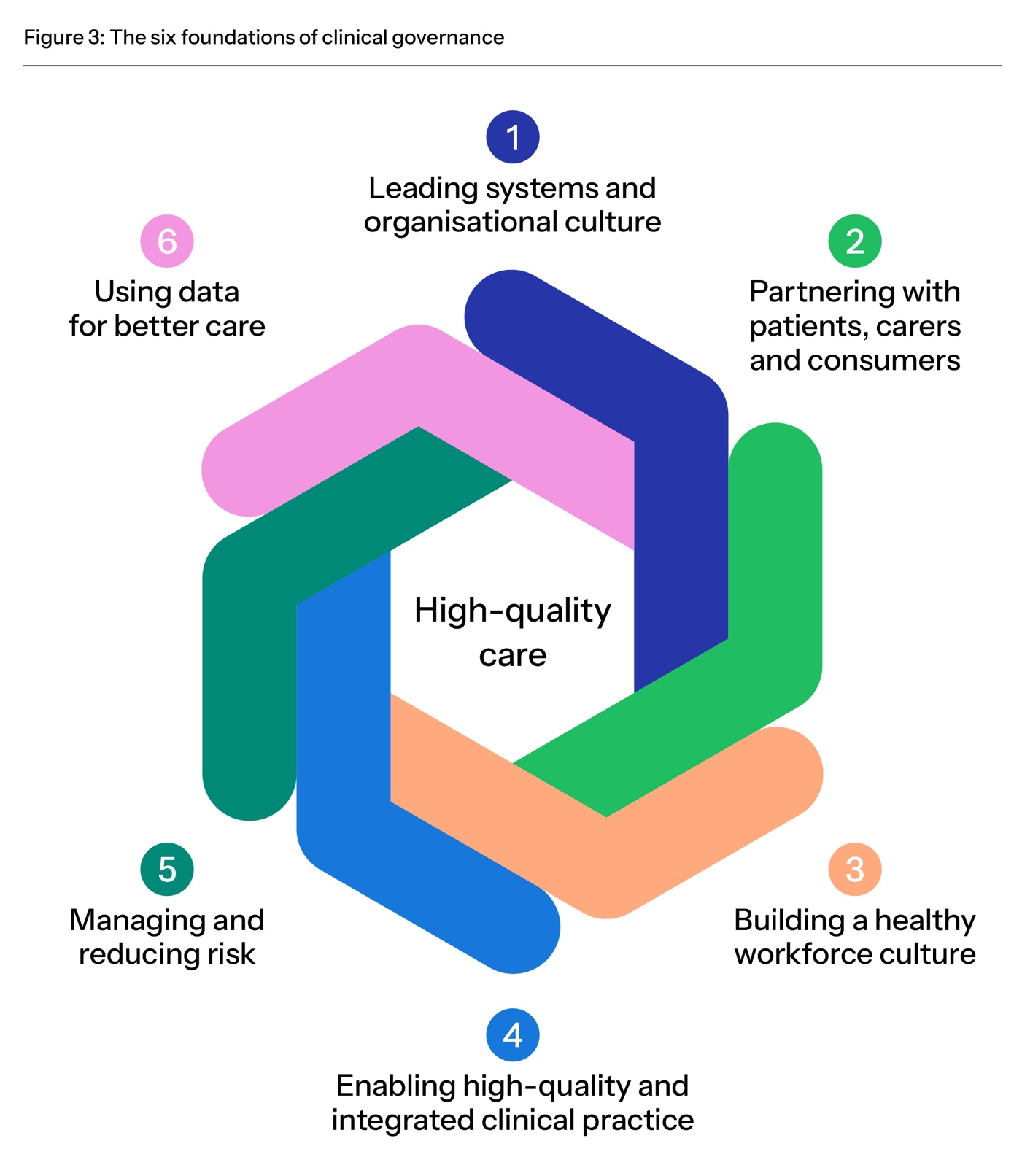

Good practice and warning signs
The foundations of clinical governance set out key examples of good practice. The examples are not a complete list – rather they are designed so that health services can assess their performance in each foundation area. Each foundation also includes warning signs that can alert boards and executives to weaknesses in their clinical governance systems. Practical resources are available on the website.

1. Leading systems and organisational culture

Leadership of a health service’s systems and organisational culture is central to how care is delivered and the outcomes of that care.
Inquiries into safety and quality failings in health services have highlighted that leadership actions – or lack of action – have a major impact on the culture of a health service and how it operates. Ineffective systems and negative organisational culture contribute to suboptimal care, poor staff morale and higher costs, while robust systems and positive organisational culture are associated with a satisfied and motivated workforce and better patient outcomes.
The board and executive are accountable for establishing, maintaining and continually improving systems for high-quality care. They set the strategy and culture for high-quality care, and support the workforce and patients, carers and consumers to achieve better patient outcomes and experiences. The board and executive have a legal duty to provide a psychosocially safe environment for the workforce and patients.

What good practice looks like – key examples
- The board and executive have a clear vision and strategy for high-quality care that is communicated and understood across the organisation. They use a clinical governance framework to achieve the strategy.
- Board members understand their responsibilities for high-quality care as part of their governance role and receive education and training to fulfil their responsibilities.
- The board and executive lead an organisation-wide approach to continuous
systems improvement, driven by high-quality data that support decision-making
and high-quality care.
- The board, executive and committees establish the systems and organisational culture
to achieve consistently high-quality care and provide adequate resources for collaboration and accountability.
- The board and executive monitor the organisation’s safety culture, including patient
and workforce perception of safety culture, and findings inform improvement strategies. Clinicians have leadership roles in establishing and maintaining the safety culture.
- Board decision-making considers the perspectives of patients, carers and community members, including people with lived experience.
- The board and executive are accountable for cultural safety in governance and across the organisation. Health care is culturally safe for Aboriginal and Torres Strait Islander patients, and the workplace is culturally safe for Aboriginal and Torres Strait Islander staff.
- Aboriginal and Torres Strait Islander leadership roles are embedded in governance structures. Partnerships with Aboriginal and Torres Strait Islander patients, staff, communities and organisations enable Aboriginal leadership and self-determination that achieves culturally safe health care that is free from racism.
- Clinical governance activities are inclusive and representative. Systematic engagement with, and representation from, patients, carers and consumers of diverse cultures, identities and experiences is used to improve care.
- The board and executive lead strategies to deliver environmentally sustainable health care through minimising unwarranted healthcare variation and low-value care.
- The board and executive have oversight of digitally enabled models of care, including digital tools and technologies that support those tools. They are accountable for enabling a trusted environment that ensures data privacy and security and the safe and ethical use of automated systems, such as artificial intelligence, in clinical decision-making and patient care.
“Culture is the hardest thing to sustain. Reputations are hard to earn and easy to lose. You need to stay vigilant.”
The Hon Martin Foley, Board Chair, Bayside Health, Victoria

Warning signs
Board meeting agendas have a disproportionate focus on legal and financial matters without due consideration of clinical governance.
There is high turnover in key leadership roles.
The board does not engage with clinical issues, e.g. the board rarely or never hears from clinicians and there are no board directors with clinical backgrounds.
The board, executive and workforce do not reflect the community they serve.
Responsibility for digital tools is siloed within Information and Communications Technology (ICT) functions and is not integrated with clinical governance systems.

2. Partnering with patients, carers and consumers

Partnering with consumers in clinical governance – and with patients in their own care – is critical to achieving high-quality care and contributes to better outcomes and experiences for patients, carers and consumers.
Governance systems at all levels of the health service enable patients, carers and consumers to shape their care. The board and executive lead systems that build a culture of person-centred care so that everyone in a health service partners with patients, carers and consumers to provide or support the delivery of high-quality care.
What is person-centred care?
Person-centred care is health care that respects the patient, their family and carers, and responds to the person’s preferences, needs and values.
Person-centred care is equitable, culturally safe and free from racism and all other forms of discrimination. Patients, carers and consumers are treated with dignity, respect and kindness.

What good practice looks like – key examples
- There are meaningful and active partnerships with patients, carers and consumers at all levels of the health service. The consumer voice informs board and executive strategic priorities and decision-making.
- An engagement strategy outlines how consumers are recruited, trained and supported. Consumers partner in planning, designing (including co-design where possible) and reviewing health service activities.
- As part of a learning culture, the board and executive act on patient-reported experience and outcome measures, alongside other measures of quality, and allocate resources to improve care.
- The organisation’s systems, structures and culture enable clinicians and patients to share decision-making about the patient’s care. Clinicians communicate with patients, families, carers and consumers in a way they understand.
- The organisation partners with consumers who reflect the diversity of the wider community, including priority groups who are at higher risk of poor health outcomes.
- Partnerships with Aboriginal and Torres Strait Islander people and communities prioritise self-determination and cultural authority and use community-led engagement methods.
- Insights from patients, carers and consumers, including people with lived experience are used to improve care.
- Patients, carers and consumers are encouraged and supported to speak up for safety. Their concerns about deterioration during clinical care are escalated.
- The organisation encourages positive feedback, complaints and suggestions for improvement. There are systems to use patient and consumer feedback to improve care. Patients, carers and consumers receive information about the outcomes of their feedback.
- Open disclosure processes are championed, supported and embedded at all levels of the organisation.
- The organisation partners with patients, carers and consumers to share decision-making about ways to achieve environmentally sustainable health care through minimising low-value care.
- Consumers are partners in the design, implementation and governance of digitally enabled systems and are supported to build their digital health literacy.

“We have used the Kitchen Tea Conversations model, which we called
Tea for Ten, to listen to and understand community sentiment and feedback about our health service. Community volunteers hosted morning tea conversations with 8 to 10 people to get community feedback on our services. It built trust and gave us important information that we could respond to.”
Maree Cuddihy, Chief Executive Officer, Central Highlands Rural Health, Victoria

Warning signs
Consumers are engaged to satisfy representation requirements for committees rather than to meaningfully inform clinical governance decisions.
Patient-reported measures and outcomes are not monitored or, if monitored, areas for improvement are not identified or acted on.
There are consistently low scores in patient experience surveys. Patient and consumer feedback is not acted on.
The organisation fails to recognise diverse cultures, identities and experiences and to tailor responses and models of care to meet patients’ unique needs.

3. Building a healthy workforce culture

A supported, engaged and empowered workforce is essential for delivering high-quality care and improving patient outcomes. A positive workforce culture in which staff feel respected, valued and safe to speak up for safety is a critical factor in boosting workforce morale and enabling staff to provide or support consistently high-quality care.
Constraints such as workforce shortages and turnover and fewer senior staff mean it is more important than ever to build and support an effective and engaged workforce.
Many factors contribute to building and maintaining a workforce culture in which all staff feel responsible for the care provided and feel that they can raise issues. These factors include a physically, psychosocially and culturally safe workplace, effective supervision, development and performance management systems, management of workload and adequate staffing.

What good practice looks like – key examples
- The board and executive define the workforce’s responsibilities for delivering high-quality care and provide appropriate and effective workforce planning and resourcing to meet them.
- The board, executive, clinical leaders and managers are responsible for workforce health and wellbeing. They understand the link between workforce wellbeing and quality of care and systematically measure workforce culture, including psychosocial safety and cultural safety, and act on the findings.
- All members of the workforce, regardless of role or seniority, feel safe to speak up for safety. A just and learning culture encourages identifying and reporting risks, incidents and complaints and acting to improve care. There is accountability without blame.
- There are systems to respond to staff concerns appropriately and transparently to reduce risks and learn from mistakes.
- Cultural safety is embedded in workforce recruitment and training processes, including in orientation, supervision and performance review. The organisation measures indicators of cultural safety, has culturally safe processes for the workforce to escalate concerns, and acts on racism and culturally unsafe behaviour.
- The organisation attracts, recruits and retains a diverse workforce that reflects the community it serves. Everyone in the organisation acknowledges, respects and accommodates difference. Racism and discrimination are not tolerated.
- The board receives regular reports on workforce risks and gaps. There is regular succession planning to fill key roles with minimum delay.
- Operational systems and rostering enable the workforce to provide high-quality care by balancing clinical responsibilities with protected time for non-clinical responsibilities.
- Tailored education and training programs, high-quality supervision, competency frameworks and performance reviews enable the workforce to provide, support and be accountable for high-quality care.
- Strong leadership and mentorship enable the workforce to work effectively in teams and to reach their potential by fostering emerging talent and strengthening capability, confidence and career pathways.
- The workforce receives practical support to select, develop, integrate and evaluate digital tools and technologies into their practice.

“You can never communicate enough with your workforce about the purpose of clinical governance – keep communicating the ‘why’.”
Dr Lesley Bennett, Chief Executive, East Metropolitan Health Service, Western Australia

“Our Restorative Just Culture policy creates psychological safety after incidents. We openly discuss who’s been harmed – both patients and staff – and ensure support and healing for those people. We are removing the blame, but there is still shared accountability for failures.”
Dr Diana Lawrence, Executive Director of Medical Services,
Southern Adelaide Local Health Network, South Australia

Warning signs
There is inadequate board oversight of workforce indicators, such as engagement surveys, feedback about cultural safety, retention rates and absenteeism.
Workplace culture issues, such as low response rates to staff surveys and poor engagement with safety culture questions, are not recognised as risks to patient safety.
The workforce is not encouraged to report problems and does not feel empowered to make change to improve outcomes.
The organisation has a high priority on meeting financial targets at the expense of workforce wellbeing and quality of care.
Digital health systems do not support clinical workflows, leading to workarounds and inefficiency.

4. Enabling high-quality and integrated clinical practice

The primary purpose of a health service is to provide clinical care to achieve the best possible patient outcomes. Patients are likely to have the best outcomes when their clinical care respects their needs and preferences, is informed by the best available evidence, and is integrated across clinical care providers and settings, both in the health service and in the community, including in general practice.
Clinicians are enabled to provide care that achieves the best possible outcomes for patients across the continuum of care. They use insights gained from data to improve care. Clinicians communicate clearly and respectfully and work collaboratively. Clinicians contribute to, and participate in, the organisation’s clinical governance systems. Leaders and managers create the systems and environment that support clinicians to provide consistently high-quality care.

What good practice looks like – key examples
- There are effective systems that support clinicians to use evidence-based clinical guidance and standards at the point of care.
- The organisation is accountable for coordinating a patient’s care across providers and settings, including the seamless sharing of information, particularly at transitions of care. Clinicians communicate clearly with patients, within teams and between providers to reduce risks and improve care.
- The board and executive recognise that racism and a lack of cultural safety are risks to clinical care, and lead strategies to eliminate systemic, structural and institutional racism, discrimination and bias throughout the organisation.
- The organisation’s culture, systems and structure reinforce and support clinicians’ dual roles – as healthcare professionals and stewards of system improvement. Clinicians participate in peer review systems and quality improvement activities.
- Clinicians’ leadership, teamwork and communication skills are developed to enable them to work in multidisciplinary clinical teams and with non-clinical staff to deliver high-quality care and system improvements.
- There are robust and transparent systems to protect patient safety through credentialing, re-credentialing and defining scope of practice within the organisation, and the effectiveness of these systems is monitored.
- A range of clinician groups is represented in clinical governance roles. The reporting system provides the board and executive with an accurate view of clinical perspectives on care quality.
- Clinicians in training receive the supervision they need to feel supported and to provide safe clinical care. Their work schedules support education and ongoing training.
- Clinical teams are supported to adopt evidence-based, environmentally sustainable models of care that reduce emissions while improving patient outcomes.
- Clear governance arrangements ensure digital tools and technologies are selected and used to address clinical needs and to enhance the quality of care. Clinical and information and communications technology (ICT) teams work together for quality, safety and accountability in the use of these tools.

“For clinicians, clinical governance is about how we’re set up and what
we wrap around both clinicians and patients to get the best possible outcomes for patients.”
Adjunct Professor Michael Nicholl, Chief Executive,
NSW Clinical Excellence Commission

“Clinicians need to have time and space to lead on quality.”
Lee Gregory, Executive Director of Operations,
Northern Sydney Local Health District, NSW

Warning signs
There is inadequate use of comparative data on clinical performance,
e.g. how healthcare use, clinical outcomes and patient experiences compare with similar organisations or trends over time.
The organisation tolerates poor outcomes with no clear improvement actions or systematic monitoring of their effectiveness.
There are problems in the culture of escalation – e.g. junior staff are hesitant to raise concerns and have variable access to senior clinician support; there is a tendency to minimise or dismiss red flags instead of triggering escalation pathways.
There is a lack of systems and structures that allow clinicians to raise concerns with management.
Digital solutions are implemented before the clinical problem is clearly defined or are used to replicate paper-based workflows rather than
improve care.

5. Managing and reducing risk

Health services are, by their nature, high-risk environments. A strategic approach to risk management informs monitoring, planning and allocation of resources across all parts of the organisation. Risk management involves oversight of clinical, financial, digital, operational and strategic risks, because all affect each other and the quality of care delivered. It also involves review and analysis of risks to look for trends and drive improvement.
Effective risk management requires systems and a culture in which everyone in a health service understands how the organisation defines risk and is accountable for identifying circumstances in which patients or the workforce could be harmed and acting to prevent or control those risks. The health service promotes a safety culture that allows people to openly share lessons from safety investigations, and to contribute to responses to reduce risk. Risk management systems need to be robust and adaptable as new technologies and digitally enabled health care evolve.

What good practice looks like – key examples
- The organisation’s approach to managing risk aligns with key strategic priorities. The board agrees on the risk appetite – the level of risk the organisation is willing to tolerate to achieve its strategic vision for high-quality care.
- A systematic approach to risk management focuses on risks to quality of care across all clinical and business functions.
- The board understands risks to patient safety at the point of care, including at transitions of care. Issues that patients and the workforce identify are included in the risk register, and management addresses these issues.
- The organisation identifies, reports on and acts to minimise risk and harm to patients and the workforce, including anticipating emerging risks. The effectiveness of risk management systems is regularly reviewed.
- Investigations into safety incidents identify contributing factors and draw together findings from related investigations to develop systematic and effective responses. Clinical and technical incidents, near misses, risk reports and complaints are analysed to look for trends and drive improvement efforts.
- Results of investigations into safety incidents and risk reports are communicated throughout the workforce to share lessons and improve practices. Clinicians receive feedback about incidents they are involved in.
- The organisation recognises that racism is a clinical and organisational risk. It monitors and reports on that risk and embeds anti-racist practices and cultural safety in clinical governance systems and processes.
- Governance structures and reporting processes help to identify and reduce risk:
  - Committees are structured to increase communication about risk, e.g. the chair of the safety and quality committee sits on the audit and risk committee
  - The board receives summarised risk reports that enable a strategic response.
- The organisation has a comprehensive approach to maintaining healthcare delivery during emergencies. It assesses and integrates climate-related risks – such as floods, heatwaves, bushfire smoke and supply chain disruptions – into emergency preparedness and response frameworks.
- A risk management plan is used to assess and mitigate risks before introducing digital tools and technologies, including cyber security and artificial intelligence tools, and implementation of the risk management plan is monitored.

“You can get lost in data and in irrelevant points. A red flag in one month might signify a single issue rather than a trend or a systemic problem.
I try to bring it back by saying ‘What are the things that keep us awake
at night?’.”
Professor Judy Searle, Chair, Northern Adelaide Local Health Network Governing Board, South Australia

“We spend a lot of time categorising and framing risks and setting appetite for risk. Our risk register is used as a reference for resource allocation and planning. We bring the risk register to life by including patient stories.”
Frances Diver, Chief Executive, Barwon Health, Victoria

Warning signs
Clinical care risks emerge ‘without warning’ – the board spends more time reacting to emergencies than on anticipating and addressing potential risks.
There is a focus on individual incidents rather than identifying patterns or system issues.
Excessive reporting of risks dilutes the focus on key risks and leads to a significant reporting burden.
There is a failure to respond to incident reports, complaints and suggestions for improvement from the workforce.
The organisation implements major programs of work without a risk-based approach.

6. Using data for better care

Collecting, analysing and acting on data about health service systems and performance, patient and workforce experience and patient outcomes is fundamental to providing high-quality care. Data are key to a planned and systematic program for continuous improvement across the health service.
Responsive governance is needed to use findings across the health service to inform learning, improvement and accountability. The board and executive champion a data-driven improvement culture by making data-informed decisions and providing information to all who need it.
High-quality data are used to identify areas for improvement and to provide feedback to the workforce to prompt behaviour change.
Insights from multiple data sources (quantitative and qualitative performance, experience and outcome measures, and patient and workforce feedback) are triangulated to provide a deeper understanding of the quality of health care and the impact of efforts to improve care. The organisation learns from other health services and sectors to improve their systems and quality of care.

What good practice looks like – key examples
- The board and executive systematically use data to determine whether the organisation is providing all the dimensions of high-quality care. They allocate resources to improve care based on the findings.
- The board receives quality and risk data that are summarised and communicated so that trends and issues are clear to all, including managers and board members who do not have a clinical background.
- Multiple sources of trend and comparative data are used to identify and reduce unwarranted healthcare variation, manage risk, monitor workforce culture, measure performance and drive innovation to promote high-quality care. Improvement efforts are monitored and evaluated.
- The organisation develops the capability of all parts of the organisation to use data to improve care.
- Clinicians receive timely information about the quality of care they provide and patient outcomes so they can improve care. Priority areas and outcomes of improvement efforts are reported to the board.
- The organisation works with Aboriginal and Torres Strait Islander people and communities to collect, interpret and respond to data, including data on racism, in a culturally appropriate way. Aboriginal and Torres Strait Islander people and communities have the right to govern the collection, ownership, application and reporting of data about their communities (data sovereignty).
- Data on markers of equity are used to identify and act on disparities in care.
- The organisation measures and reports on how effectively patient care is integrated within
the health service and with providers outside the health service, and acts to improve that care.
- The organisation collects and analyses data on the environmental impact of clinical care to inform improvement and sustainability initiatives, including reducing low-value care.
- The board and executive are accountable for the governance, quality and appropriateness of data generated by digital systems to support high-quality care, and relevant data are provided to clinicians for improving quality of care.

“Quality and risk data that are summarised and easy to understand are important to show what’s going on and provide evidence for a future direction. Things can always go wrong – but they are preventable if you have the information at your fingertips.”
Suzanne Cadigan, Board member, Children’s Health Queensland

Warning signs
A compliance mindset leads to excessive data collection (‘drowning in data’). There is a high reporting burden but lack of flexibility to respond to key risks and emerging issues.
Data reports to the board are high on detail and lack insights, key messages and visualisations.
The board and executive focus on positive data rather than pursuing data that reveal inconvenient truths, missing opportunities for improvement.
Security controls do not keep pace with increasing volume and sources of data, resulting in data breaches.

Glossary
Glossary
Accreditation A formal program where trained independent reviewers assess evidence of implementation for specified standards. In this document, the relevant standards are the National Safety and Quality Health Service (NSQHS) Standards.
Artificial intelligence Computer systems able to perform tasks that normally require human intelligence, such as visual perception, speech recognition, decision making and translation between languages.
Board or equivalent Directors (or key decision-makers/accountable people) whose responsibilities include governing, directing and monitoring a health service’s business, affairs and operations, including overall organisational performance and compliance.
Carer A person who provides personal care, support and assistance to another individual who needs it because they have a disability, medical condition (including a terminal or chronic illness) or mental illness, or they are frail or aged. An individual is not a carer merely because they are a spouse, de facto partner, parent, child, other relative or guardian of an individual, or live with an individual who requires care. A person is not considered a carer if they are paid, a volunteer for an organisation, or caring as part of a training or education program. For Aboriginal and Torres Strait Islander people, there may be a collective approach to carer responsibilities.
Clinical governance Clinical governance is central to providing the best possible outcomes for patients. It is the combination of organisational culture, systems and structures that enables everyone in a health service to deliver care that is consistently high quality and improving. Effective clinical governance means that boards, executives, clinical leaders and the workforce are clearly accountable to patients and the community for providing high-quality care – care that is person-centred, safe, effective, accessible and integrated, provided in a way that is equitable, efficient and sustainable.
Clinician A trained health professional who provides direct clinical care to patients. Includes registered and non-registered practitioners, nurses, midwives, medical practitioners, allied health professionals, paramedics and other professionals who provide health care, and students who provide health care under supervision.
Co-design A process where people who are traditionally considered experts in a field work in partnership with patients, consumers or other users to design a policy, process, service or service improvement.
Consumer A consumer advocate or representative who provides a consumer perspective, contributes consumer experiences, advocates for the interests of current and potential health service users, and takes part in decision-making processes.
Corporate governance The framework of rules, relationships and processes that directs and controls the overall direction of an organisation. It includes clinical governance, financial and legal functions, and stakeholder accountability.
Credentialing A process that verifies the qualifications and experience of a clinician to determine their ability to provide safe, high-quality healthcare services within a specific healthcare setting and role.
Cultural safety Cultural safety is determined by Aboriginal and Torres Strait Islander individuals, families and communities. Culturally safe practice is the ongoing critical reflection of health practitioner knowledge, skills, attitudes, practising behaviours and power differentials in delivering safe, accessible and responsive health care free from racism.
Data sovereignty Indigenous data sovereignty is the right of Aboriginal and Torres Strait Islander people, communities and organisations to maintain, control, protect, develop and use data as it relates to them.
Digital health The use of technology to help Australians live healthier lives with greater control and better access to their information. It includes My Health Record, electronic prescriptions and telehealth.
Digital health literacy The ability to access, understand, critically evaluate, and use digital tools and technologies to make informed health decisions and engage effectively with health services.
Digitally enabled care The appropriate integration and application of digital health in clinical settings to deliver, augment or coordinate patient care.
Environmentally sustainable health care Health care that minimises environmental impact and reduces emissions while providing high-quality care.
Equity The absence of unfair, avoidable or remediable differences among groups of people, whether those groups are defined socially, economically, demographically or geographically or by other dimensions of inequality (e.g. sex, gender, ethnicity, disability or sexual orientation).
Evidence-based practice Health care that integrates the best available research evidence with clinical expertise and the patient’s unique values and circumstances.
Executive or equivalent The executive team, or key decision-makers/accountable people, who manage the day-to-day operations of the organisation, its people and resources. It is headed by the chief executive officer (or equivalent), who implements the strategy approved by the board.
Foundations of clinical governance A set of organisational systems that enable health services to deliver high-quality care.
High-quality care Health care that is person-centred, safe, effective, accessible and integrated, provided in a way that is equitable, efficient and sustainable.
Integrated care Where all parts of the health system work together to deliver person-centred care that is seamless, comprehensive, coordinated and efficient across the continuum of care.
Just culture A just culture looks beyond human error as a root cause to identify system-based improvements that address contributing factors across all levels of the organisation.
Learning culture An environment that actively encourages curiosity, growth and knowledge sharing, in which everyone feels empowered to ask questions, learn from mistakes, and discuss ways to improve care.
Lived experience Someone with personal experience of ill-health, including mental, chronic or acute illness.
Low-value care Care that provides little or no benefit, may cause patient harm, or yields marginal benefits at a disproportionately high cost.
National Safety and Quality Health Service (NSQHS) Standards Accreditation standards operated by the Commission as a quality assurance mechanism. The Standards test whether relevant systems are in place to ensure that expected standards of safety and quality are met.
Open disclosure An open discussion between a healthcare provider and a patient when things go wrong that have harmed or had the potential to cause harm to the patient. The discussion may include an expression of regret by the provider, an explanation of what happened and its consequences, and steps to prevent it happening again.
Organisational culture A set of values, expectations, formal and informal practices, and behaviours that define the unique organisational environment. ‘The way things are done around here.’
Patient A person receiving health care.
Patient outcome The status of a patient that is wholly or partially attributable to an action, agent or circumstance.
Patient-reported experience and outcome measures Information collected directly from patients about their experience of health services, and the outcomes of health services.
- Patient-reported experience measures (PREMs) include patients’ views and observations on matters such as the accessibility and physical environment of services and aspects of the patient–clinician interaction.
- Patient-reported outcome measures (PROMs) are used to obtain information from patients on their health status such as overall health and wellbeing, the severity of symptoms such as pain, measures of daily functioning and psychological symptoms.
Person-centred care Health care that respects the patient, their family and carers, and responds to the person’s preferences, needs and values. Person-centred care is equitable, culturally safe and free from racism and all other forms of discrimination.
Priority group Specific population group at elevated risk of poorer health outcomes, including Aboriginal and Torres Strait Islander people, people with mental health conditions, those living in rural/remote or lower socioeconomic areas, and people identifying as gay, lesbian, bisexual, transgender or intersex.
Psychosocial safety Protection from hazards and risks in the workplace that may negatively influence mental health and emotional wellbeing.
Remote monitoring A system that uses software and medical devices to allow healthcare professionals to assess, monitor and care for patients virtually (such as in the home or remote areas).
Safety culture A culture in which everyone enables and cares for each other to adopt patient safety as part of routine business, with the wellbeing of the workforce and consumers at the centre.
Safe workplace A workplace that is physically, psychosocially and culturally safe.
Transitions of care A transition of care is when all or part of a person’s health care is transferred between care providers.
Triangulated data Using multiple sources of data, with awareness of their strengths and limitations for specific purposes (as in taking bearings from at least two reference points on a map).
Unwarranted healthcare variation Differences in clinical practices, treatments, or outcomes that cannot be explained by differences in patient needs, preferences or evidence-based guidelines.
Virtual care Any interaction between a patient and clinician, or between clinicians, occurring remotely with the use of information technologies.
Workforce All people working in a health service, including clinicians and any other employed or contracted, locum, agency, student, volunteer or peer workers.

Governance models differ across Australia. Some public and private health services do not have boards. Where an organisation does not have a board and executive, these roles fall to the key decision-maker and accountable person or group at the organisation.
The national model provides practical guidance for health service leaders and does not replace legal and regulatory requirements.

