
On the Radar
Issue 747
15 June 2026

On the Radar is a summary of some of the recent publications in the areas of safety and quality in health care Inclusion in this document is not an endorsement or recommendation of any publication or provider Access to particular documents may depend on whether they are Open Access or not, and/or your individual or institutional access to subscription sites/services Material that may require subscription is included as it is considered relevant.

On the Radar is available online, via email or as a PDF or Word document from
https://www.safetyandquality.gov.au/news-and-media/newsletters/on-the-radar

If you would like to receive On the Radar via email, you can subscribe on our website https://www.safetyandquality.gov.au/news-and-media/newsletters/on-the-radar
or by emailing us at mail@safetyandquality.gov.au.
You can also send feedback and comments to mail@safetyandquality.gov.au.

For information about the Commission and its programs and publications, please visit https://www.safetyandquality.gov.au

On the Radar
Editor: Dr Niall Johnson
Contributors: Niall Johnson, Kylie Tran, Fiona Doukas



Stroke Clinical Care Standard
Australian Commission on Safety and Quality in Health Care
ACSQHC; 2026. p. 66.
https://www.safetyandquality.gov.au/clinical-care-standards/stroke

The Australian Commission on Safety and Quality in Health Care has updated the national Stroke Clinical Care Standard to improve care for people who have a stroke, from emergency treatment through to recovery and follow-up care. The Standard was first introduced in 2015 and last revised in 2019.

Stroke remains a leading cause of death and disability in Australia and requires rapid, coordinated care to optimise outcomes.

The 2026 update reflects current evidence and clinical guidelines, with a stronger emphasis on rehabilitation, coordinated multidisciplinary care, personalised discharge planning and follow-up. The Standard emphasises continuity of care beyond the acute hospital, including review and support within six months of a stroke.

The updated Standard also highlights the importance of effective communication at transitions of care and improving access to services, particularly for people in regional and remote areas through telehealth models such as telestroke and telerehabilitation.

Indicators are included to support monitoring and improvement, including through the Australian Stroke Clinical Quality Registry.

Timely recognition and treatment, combined with coordinated ongoing care, remain critical to improving outcomes for people affected by stroke.

QUM learning modules
https://learn.safetyandquality.gov.au/

The Australian Commission on Safety and Quality in Health Care is pleased to announce the release of the updated antimicrobial modules on the QUM Learning platform.

The refreshed suite includes the therapeutic module Urinary tract infection (UTI) in residential aged care and two case study modules, Otitis media: Clarifying the role of antibiotics and UTI: Exploring antibiotic treatment.

The modules feature engaging animations and a modern redesign, with streamlined content aligned to the latest update of the Therapeutic Guidelines: Antibiotic.. Through interactive, scenario-based learning, learners can follow realistic patient journeys to build confidence in diagnosing, managing, and prescribing antimicrobials for common infections.

The modules are designed to provide practical, evidence-based guidance for early career medical practitioners, pharmacist and nurses to apply in clinical practice.

Access the updated modules at https://learn.safetyandquality.gov.au/

Reports

The Economic Case for Preventing Mental Ill Health
OECD Health Policy Studies
OECD
Paris: OECD Publishing; 2026.
DOI | https://doi.org/10.1787/16668f16-en
Notes | This report from the OECD examines the economic impacts of poor mental health. The abstract reads: ‘Poor mental health affects more than one in five people across OECD and EU27 countries and is estimated to reduce healthy life expectancy by 2.5 years, with young people, women, and those with low socio‑economic status particularly affected. Focusing on depression and anxiety, this report sets out the strong economic case for investing in better mental health policies. It shows how evidence‑based interventions in primary care, schools, and workplaces can improve health outcomes and boost economic growth through improved productivity and labour market participation. Many of these interventions are cost‑effective and some cost‑saving. However, the overall impact of these interventions remains low due to lack of implementation at scale. To deliver meaningful improvements, countries must adopt a more systemic approach that enhances intervention design and implementation, expands coverage and investment and tackles the root causes of mental distress.’

Principles to support anti-racism in midwifery and nursing education and practice
The Nursing and Midwifery Council
London: NMC: 2026.
URL | https://www.nmc.org.uk/standards/guidance/principles-to-support-anti-racism-in-midwifery-and-nursing-education-and-practice/
Notes | The Nursing and Midwifery Council in the UK has published these principles that ‘set out some of the ways educators, organisations, registrants and employers can address concerns around inequities in care and racism across health and social care practice, education, and regulation.’ According to the Council, the ‘principles are designed to:  - Strengthen cultural safety, curiosity and respect in practice and education  - Explicitly advance meaningful, sustained anti-racist, bias-aware practice.’

Healthcare Quarterly, January to March 2026
Bureau of Health Information
St Leonards: BHI; 2026.

Healthcare in Focus
Bureau of Health Information
St Leonards: BHI; 2026.
Notes | The Bureau of Health Information (BHI) in New South Wales has recently released a couple of its periodical reports. These have included:  - Healthcare Quarterly, January to March 2026 reports on reports on activity and performance information for public hospital and ambulance services in NSW from October to December 2025.  - Healthcare in Focus is BHI’s annual report to the NSW Minister for Health and NSW Parliament. This year, the report focuses on hospital capacity and patient flow; and selected safety and quality measures, in the context of record levels of growth in demand for hospital services.
Journal articles

Effectiveness of oral care for the prevention of non-ventilator hospital-acquired pneumonia (HAPPEN): a multicentre, stepped-wedge, cluster-randomised trial in Australia
White NM, Russo PL, Matterson G, Browne K, Cheng AC, Kiernan M, et al.
The Lancet Infectious Diseases. 2026.
DOI | https://doi.org/10.1016/S1473-3099(26)00235-5
Notes | Report of an Australian study that examined the impact or oral hygiene on the incidence of on-ventilator hospital-acquired pneumonia. Tye authors observe that ‘Non-ventilator hospital-acquired pneumonia (NV-HAP) is among the most prevalent health-care-associated infections’. While ‘Oral care is considered a key preventive measure’ there have been few high-quality studies and this study sought ‘to evaluate whether an enhanced oral care intervention reduces the incidence of NV-HAP.’ The study, the Hospital Acquired Pneumonia Prevention (HAPPEN) trial, was ‘an open-cohort, stepped-wedge, cluster-randomised trial conducted across three Australian hospitals’ that involved 8870 patients. From their analyses, the authors argue that their ‘multicentre randomised controlled trial demonstrates that improving oral care reduces NV-HAP incidence among hospitalised patients, compared with usual care.’

JBI Evidence Synthesis
Volume 24, Issue 6, June 2026
URL | https://journals.lww.com/jbisrir/toc/2026/06000
Notes | A new issue of JBI Evidence Synthesis has been published. Articles in this issue of JBI Evidence Synthesis include:  - Editorial: Evidence synthesis without equity: a missed opportunity to promote health and improve health care (Fran Baum, Jennie Popay)  - Growth curve models for weight among children up to 2 years: a scoping review (Marta Alves, Sofia Serra, Teresa Costa, Carlos Brás-Geraldes, Ana Luisa Papoila, Bruno Heleno)  - Experiences of people with diabetes mellitus during the COVID-19 pandemic utilizing telehealth for diabetes management: a qualitative systematic review (Alexander Gerrie, Susan Bellman, Danielle Pollock)  - Models and input parameters for the estimation of heat-related excess mortality: a scoping review (Barbara Kovács, Elisabeth Dottolo, Katharina Brugger, Norbert Handra, Alena Chalupka, J Miklós, L Richter, J Wipplinger)  - Association between pesticide use and cancer incidence among farm workers: a systematic review protocol (Dipak K Das, Samyukta Shivshankar, Atul M Budukh, Denny John)  - Understanding digital navigators in health care: a scoping review protocol (Gillian Strudwick, Hwayeon Danielle Shin, Iman Kassam, Charlotte Pape, Terri Rodak, John Torous, Venkat Bhat, Jessica Kemp, B Rosen, S A Kidd)  - Understanding the perceptions, experiences, and behaviors related to nurses’ and midwives’ sleep: a qualitative systematic review protocol (Lisa Matricciani, Jarrod Clarke, Jennifer Fereday, Micah D J Peters)  - Mapping the use of covert medication administration: a scoping review protocol (Michelle Cleary, Cathal Cadogan, Carmel Doyle)  - Evaluation of patient-reported outcome assessment tools for lung cancer: protocol for a systematic review of measurement properties (Yan Liang, Yunyu Du, Jijin Yang, Miaoqing Xia, Sang Zhu, Fangfang Xu, Suhua Zeng)  - Mapping nursing competencies for disaster response within the civil defense context: a scoping review protocol (Gabriele Caggianelli, Marco Iorfida, Giovanni Cangelosi, Maurizio Fiorda, Samanda Pettinari, Francesca Marfella, R Accettone, V Vanzi, G Rocco, Y Jadotte, S Mancin, M Zega)  - Exploring stress relief spaces in health care facilities: a scoping review protocol (Xiaoshan Z Gordy, Michelle Palokas, Elizabeth Hinton, Melissa Klamm, Carly Stogner)  - Midwives' and obstetricians' perspectives on collaborative practice in antenatal care: a qualitative systematic review protocol (Camilla Neubauer-Bruckner, Isolde Sommer, Martin Fangmeyer, Irma Klerings, Linda Biesty, Chris Cooper, Harald Stummer)  - Tissue-based biomarkers of clinical relevance at the invasive tumor front in oral squamous cell carcinoma: a scoping review protocol (Mahija Janardhanan, Vineetha Karuveettil, Venkitachalam Ramanarayanan, Chandrasekhar Janakiram, Rajalakshmi Geetha, Subramania Iyer K)  - Nursing support for mothers experiencing excessive infant crying: a scoping review protocol (Sayo Kikuchi, Yoshie Kotegawa, Ryohei Kimura)

International Journal for Quality in Health Care online first articles
URL | https://academic.oup.com/intqhc/advance-articles
Notes | International Journal for Quality in Health Care has published a number of ‘online first’ articles, including:  - Assessment of a novel semi-automated dataset for large scale surveillance of Central venous catheter–related mechanical complications (Emilia Ängeby, Maria Adrian, Mathias Lazarevic Lindblad, Ola Borgquist, T Kander)  - Implementing Occupational Therapy Quality Indicators in a Large HealthCare System: Lessons From a Five-Year Performance Monitoring Study (Khawla Loubani, O Segev-Jacubovski, D Comaneshter, A D Cohen, A Zur, D Netzer)  - Implementing an ISO 9001–based Quality Management System in a Clinical Simulation Centre: Integration of Training Delivery, Governance, and Research (Mireia Arnedo , Jordi Bañeras , Michelle Laurens Acevedo , Marta Sánchez , Ignasi Maspons , Mónica Rodríguez Carballeria)

Online resources

Guidance
A number of guidelines or guidance have recently been published or updated These include:
- Artificial Intelligence in Victorian Public Health Services https://www.health.vic.gov.au/digital-health/artificial-intelligence-in-victorian-public-health-services
Updated guidance for Victorian Public Health Services on the safe and effective use of artificial intelligence.
- Artificial Intelligence Framework https://aci.health.nsw.gov.au/ai-framework
A guide for the responsible adoption of artificial intelligence (AI) within NSW Health. The framework ‘outlines a consistent, risk-based approach to using AI across the NSW public health system. It is guided by consumer-centred care, transparency, accountability and trust.’

[UK] NICE Guidelines and Quality Standards
https://www.nice.org.uk/guidance
The UK’s National Institute for Health and Care Excellence (NICE) has published new (or updated) guidelines and quality standards The latest reviews or updates include:
- NICE Guideline NG194 Postnatal care https://www.nice.org.uk/guidance/ng194
- NICE Guideline NG235 Intrapartum care https://www.nice.org.uk/guidance/ng235

Infection prevention and control resources
The Australian Commission on Safety and Quality in Health Care has developed a number of resources to assist healthcare organisations, facilities and clinicians These resources include:
- Poster – Combined contact and droplet precautions https://www.safetyandquality.gov.au/publications-and-resources/resource-library/infection-prevention-and-control-poster-combined-contact-and-droplet-precautions
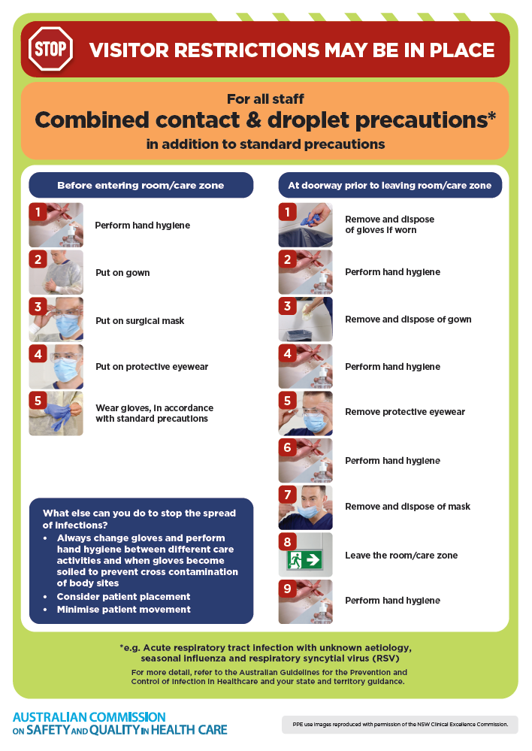
- Poster – Combined airborne and contact precautions
https://www.safetyandquality.gov.au/publications-and-resources/resource-library/infection-prevention-and-control-poster-combined-airborne-and-contact-precautions
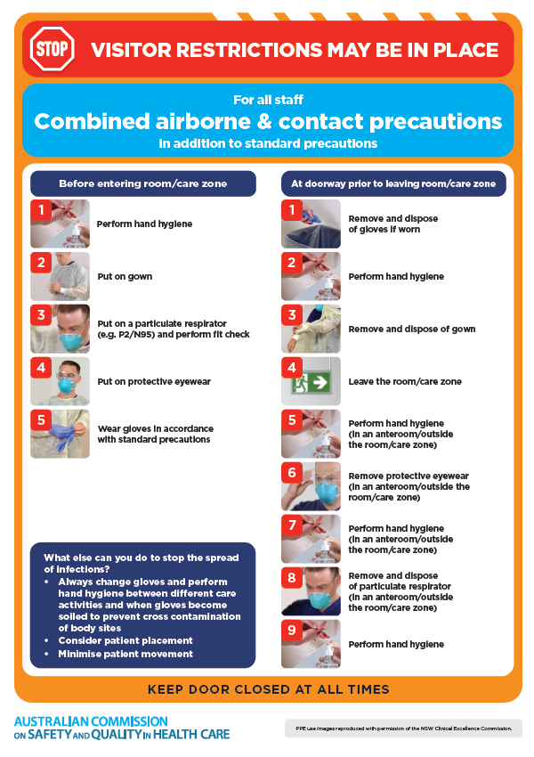
- Environmental Cleaning and Infection Prevention and Control www.safetyandquality.gov.au/environmental-cleaning
- Break the chain of infection poster
https://www.safetyandquality.gov.au/publications-and-resources/resource-library/break-chain-infection-poster
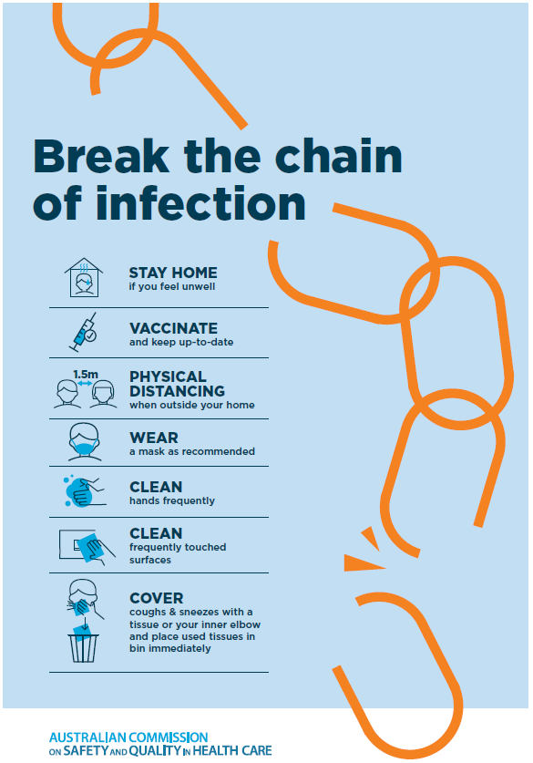
Disclaimer
On the Radar is an information resource of the Australian Commission on Safety and Quality in Health Care. The Commission is not responsible for the content of, nor does it endorse, any articles or sites listed. The Commission accepts no liability for the information or advice provided by these external links. Links are provided on the basis that users make their own decisions about the accuracy, currency and reliability of the information contained therein Any opinions expressed are not necessarily those of the Australian Commission on Safety and Quality in Health Care.

